Name of Journal: World Journal of Clinical Cases
Manuscript NO: 47927
Manuscript Type: CASE REPORT

Giant squamous cell carcinoma of the gallbladder: A case report

Ribeiro Junior MA et al. Giant squamous cell carcinoma of gallbladder

Marcelo AF Ribeiro Junior, Murillo de Lima Favaro, Stephanie Santin, Cintia Magalhaes Silva, Ana Paula Marconi Iamarino
Marcelo AF Ribeiro Junior, Department of Acute Care and Trauma Surgery, Hospital Moriah, São Paulo 04081000, Brazil

Murillo de Lima Favaro, Department of Surgery, University of Santo Amaro, São Paulo 04829-300, Brazil

Stephanie Santin, Department of Surgery, Hospital Moriah, University of Santo Amaro, São Paulo 04829-300, Brazil
Cintia Magalhães Silva, Medical Student, University of Santo Amaro, São Paulo 04829-300, Brazil

Ana Paula Marconi Iamarino, Department of Surgery, Hospital Moriah, Hospital Moriah, São Paulo 04829-300, Brazil

ORCID number: Marcelo AF Ribeiro Junior (0000-0003-0247-494X); Murillo de Lima Favaro (0000-0003-4865-8904); Stephanie Santin (0000-0003-2083-4136); Cintia Magalhaes Silva (0000-003-4686-1829); Ana Paula Marconi Iamarino (0000-0003-0954-0049).

Author contributions: Ribeiro Junior MAF and Favaro ML contributed equally to this work; Ribeiro Junior MAF designed the research; Iamarino APM, Silva CM and Santin S performed the research; Ribeiro Junior MAF and Favaro ML analyzed the data; and Ribeiro Junior MAF, Silva CM and Iamarino APM wrote the paper.

Informed consent statement: Written informed consent was obtained from the patient for publication of this manuscript and any accompanying images.

Conflict-of-interest statement: None of authors have any kind of conflict of interest to declare.

CARE Checklist (2016) statement: The authors have read the CARE Checklist (2016), and the manuscript was prepared and revised according to the CARE Checklist (2016).

Open-Access: This article is an open-access article that was selected by an in-house editor and fully peer-reviewed by external reviewers. It is distributed in accordance with the Creative Commons Attribution Non Commercial (CC BY-NC 4.0) license, which permits others to distribute, remix, adapt, build upon this work non-commercially, and license their derivative works on different terms, provided the original work is properly cited and the use is non-commercial. See: http://creativecommons.org/licenses/by-nc/4.0/

Manuscript source: Invited manuscript

Corresponding author: Marcelo AF Ribeiro Junior, MD, MSc, PhD, Chairman, Full Professor, Department of Acute Care and Trauma Surgery, Hospital Moriah, Avenida Aratas, 200, São Paulo 04081000, Brazil. drmribeiro@gmail.com
Telephone: +55-11-968439911

Received: April 2, 2019
Peer-review started: April 4, 2019
First decision: August 1, 2019
Revised: August 17, 2019
Accepted: August 27, 2019
Article in press: August 26, 2019
Published online: September 26, 2019

Abstract
BACKGROUND
Gallbladder cancer is the most common malignant tumor of the biliary tract. The majority of cases are adenocarcinoma. Squamous cell carcinoma is the histological type present in 12% of all neoplasias accounting for approximately 12% of gallbladder neoplasms. It can occur in its pure form reaching 1%-3% of the tumors. Many patients are at an advanced stage when diagnosed and have bad therapeutic efficacy.

CASE SUMMARY
A 45-year-old male patient presented with left flank pain for 1 year and irradiated to the mesogastric region. He denied fever, vomiting, and any other intestinal changes. He reported a weight loss of 10 kg in a period of 7 mo. He denied alcoholism, smoking, drug use, or prior illness. Computed tomography of the abdomen showed in the gallbladder fossa a voluminous mesogastric heterogeneous collection that had a thick and irregular capsule with liquid and gaseous contents. A predominantly hypoattenuating rounded material with partially calcified margins measuring about 2.0 cm related to gallstone was also emphasized. No lymphadenomegalies or free fluid was observed in the abdominal cavity. Patient underwent laparotomy where a huge tumor was observed affecting the transverse colon and gallbladder. This mass was resected en bloc removing gallbladder and transverse colon together with corresponding mesocolon and regional lymphadenectomy. There were no complications in the postoperative period. Although oncological treatment was performed, the patient died 6 mo after surgery.

CONCLUSION
Squamous cell carcinoma represents a rare disease. Patients often present with large, bulky tumors with involvement of adjacent organs. In spite of progress in surgical techniques and adjuvant chemotherapy, the prognosis remains poor.

Key words: Squamous cell; Carcinoma; Gallbladder neoplasm; Treatment; Case report

© The Author(s) 2019. Published by Baishideng Publishing Group Inc. All rights reserved.

Core tip: Pure squamous cell carcinoma represents a very rare condition. Usually the patient will present with a huge mass in the upper right quadrant involving other organs. A high index of suspicion is fundamental for the surgical planning because the surgical removal of the lesion respecting the oncological surgical principles may be the only chance of cure for this aggressive disease. Patients must be submitted to adjuvant chemotherapy in order to increase the survival rates. The prognosis remains poor.

Citation: Ribeiro Junior MAF, Favaro ML, Santin S, Iamarino APM. Giant squamous cell carcinoma of the gallbladder: A case report. World J Clin Cases 2019; 7(18): 2787-2793
URL: https://www.wjgnet.com/2307-8960/full/v7/i18/2787.htm
DOI: https://dx.doi.org/10.12998/wjcc.v7.i18.2787

INTRODUCTION
Squamous cell carcinoma (SCC) is the histological type present in 12% of neoplasias accounting for approximately 12% of gallbladder neoplasms. This can occur in a pure form reaching 1%-3% of the gallbladder neoplasms^{[1-3]}. Without well-understood etiology, pure SCC can be derived from glandular metaplasia, heterotopic tissue, and mixed types originating from differentiated adenocarcinoma. It is about three times more common in women than in men and has its most frequent appearance after the fifth decade of life^{[2,4]}.
The pure SCC of the gallbladder is characterized by invasive growth and less tendency to metastasize compared to adenocarcinoma of the gallbladder. This invasion mainly affects the liver, and its growth laterally to the vesicular fossa invades adjacent organs such as the stomach, pancreas, duodenum, and less frequently the transverse colon^{[2-5]}.
The suspicion occurs in elderly patients with pain in the right hypochondrium, and physical examination is a palpable tumor. In the initial cases, the symptoms resemble those of cholelithiasis. Upper abdominal ultrasonography may suggest the presence of thickening of the gallbladder wall and involvement of other organs, but computed tomography and magnetic resonance imaging are more sensitive and specific^{[6]}.
There is no consensus regarding treatment, and most reports observe mixed-type SCC arising from adenocarcinomas. However, pure SCC seems to benefit from the initial surgical treatment with aggressive resections independent of the compromised organ and non-anatomical hepatectomies, which are usually not performed in adenocarcinoma. There is no clear role of the importance of locoregional lymphadenectomy as well as adjuvant treatment with radiotherapy and chemotherapy^{[2-5]}.

CASE PRESENTATION
Chief complaints
A 45-year-old male patient presented with left flank pain for 1 year and irradiated to the mesogastric region.

History of present illness
Patient denied fever, vomiting, and any other intestinal changes. He reported a weight loss of 10 kg in a period of 7 mo.

History of past illness
The patient denied alcoholism, smoking, drug use, or prior illness. Any other relevant or additional aspects on his personal and/or familiar history related to tumors were identified during clinical investigation.

Physical examination
At the physical examination, he presented a regular general condition, stained, dehydrated +/4 +, anicteric, and afebrile. Abdomen was flaccid and painful on the right flank surface palpation with palpable hardening bulging. The initial diagnostic suspicions were of complicated cholecystitis or gallbladder neoplasia.

Laboratory examinations
Laboratory examinations included general blood tests, liver function tests and tumors markers (CEA and CA 19-9). All the results were within normal values.

Imaging examinations
Radiograph of the abdomen: tumor in the epigastric region, rejecting adjacent loops (Figure 1).
Ultrasonogram: heterogeneous mass of large volume predominantly hyperechogenic with areas of central necrosis with infiltrative aspect occupying almost every abdominal cavity.
Computed tomography scan: in the location of the gallbladder was evidenced a voluminous mesogastric heterogeneous collection that had a thick and irregular capsule with liquid and gaseous contents. A predominantly hypoattenuating rounded material with partially calcified margins measuring about 2.0 cm related to gallstone was also highlighted. No lymphadenomegalies or free fluid was observed in the abdominal cavity (Figure 2).

FINAL DIAGNOSIS
Based on the images, the final diagnosis was gallbladder neoplasm.

TREATMENT
Patient underwent laparotomy where a massive tumor was seen affecting the transverse colon and gallbladder. This mass was resected en bloc removing gallbladder and transverse colon together with corresponding mesocolon and regional lymphadenectomy (Figure 3).
Anatomopathological: well-differentiated SCC of the gallbladder (Figure 4). Immunohistochemistry confirmed the diagnosis (Figure 5 and Figure 6).

OUTCOME AND FOLLOW-UP
Patient was discharged on the sixth postoperative day and then followed up with an oncologist who indicated chemotherapy and radiotherapy. Patient died 6 mo after the procedure.

DISCUSSION
Due to the rarity of pure gallbladder SCC, its etiology is still not well understood. Muto et al^{[7]} analyzed 1000 bile vesicles and did not find the presence of mucosal metaplasia contrary to the SCC theory if it originated from this metaplasia. A second study attempted to clarify this etiology by analyzing approximately 600 gallbladder neoplasms with 41 of them been pure SCC. The authors suggested a classification by the presence of epidermoid cells: spinocellular differentiation, pure SCC, adenosquamous carcinoma, and focal SCC^{[2]}.
Regardless of the etiology, the gallbladder neoplasm is very aggressive. Because the survival outcomes of gallbladder SCC are worse than that found in gallbladder adenocarcinomas, it has been reported in most cases for months and is related to tumor staging and resection performed^{[5]}.
In most of the reports the carcinomas found were anatomopathological findings, and the diagnosis of cancer was rarely suspected. When there was suspicion, there are reports of diagnostic biopsy. It is known that this procedure increases the risk of tumor implantation in the path of the needle and should be avoided. In the diagnostic suspicion after imaging, surgical removal with free margins should be indicated in order to achieve R0 resection with removal of adjacent organs if necessary. Freezing of the surgical specimen should always be performed to better program the surgical procedure with the use of more adequate resections^{[2,3,8,9]}. In the present study, the resection performed was considered by the team as R0, but no intraoperative freezing was performed. Anatomopathological examination demonstrated free margins without compromised lymph nodes (16 lymph nodes resected).
In the Roa et al^{[2]} study, SCC and adeno-squamous carcinomas were three times less frequent than gallbladder adenocarcinomas.

CONCLUSION
Pure gallbladder SCC is rare and should be suspected in the presence of large volume tumors in the right hypochondrium. Radical surgical treatment remains the only chance for a cure. Its survival results are usually low giving a poor prognosis for the disease.

REFERENCES
1 Karasawa T, Itoh K, Komukai M, Ozawa U, Sakurai I, Shikata T. Squamous cell carcinoma of gallbladder--report of two cases and review of literature. Acta Pathol Jpn 1981; 31: 299-308 [PMID: 7257770 DOI: 10.1111/j.1440-1827.1981.tb01374.x]
2 Roa JC, Tapia O, Cakir A, Basturk O, Dursun N, Akdemir D, Saka B, Losada H, Bagci P, Adsay NV. Squamous cell and adenosquamous carcinomas of the gallbladder: clinicopathological analysis of 34 cases identified in 606 carcinomas. Mod Pathol 2011; 24: 1069-1078 [PMID: 21532545 DOI: 10.1038/modpathol.2011.68]
3 Roppongi T, Takeyoshi I, Ohwada S, Sato Y, Fujii T, Honma M, Morishita Y. Minute squamous cell carcinoma of the gallbladder: a case report. Jpn J Clin Oncol 2000; 30: 43-45 [PMID: 10770570 DOI: 10.1093/jjco/hyd010]
4 Hanada M, Shimizu H, Takami M. Squamous cell carcinoma of the gallbladder associated with squamous metaplasia and adenocarcinoma in situ of the mucosal columnar epithelium. Acta Pathol Jpn 1986; 36: 1879-1886 [PMID: 3825536 DOI: 10.1111/j.1440-1827.1986.tb02252.x]
5 Soyama A, Tajima Y, Kuroki T, Tsuneoka N, Ohno S, Adachi T, Eguchi S, Kanematsu T. Radical surgery for advanced pure squamous cell carcinoma of the gallbladder: report of a case. Hepatogastroenterology 2011; 58: 2118-2120 [PMID: 22234081 DOI: 10.5754/hge10140]
6 Rooholamini SA, Tehrani NS, Razavi MK, Au AH, Hansen GC, Ostrzega N, Verma RC. Imaging of gallbladder carcinoma. Radiographics 1994; 14: 291-306 [PMID: 8190955 DOI: 10.1148/radiographics.14.2.8190955]
7 Muto Y, Uchimara M, Waki S, Hayashi T, Samejima K, Okamoto K. Clinicopathologic study of adenosquamous carcinoma of the gall bladder and bile duct. Jpn J Cancer Clin 1982; 28: 440–444
8 Aloia TA, Járufe N, Javle M, Maithel SK, Roa JC, Adsay V, Coimbra FJ, Jarnagin WR. Gallbladder cancer: expert consensus statement. HPB (Oxford) 2015; 17: 681-690 [PMID: 26172135 DOI: 10.1111/hpb.12444]
9 Chakrabarti I, Giri A, Ghosh N. Cytohistopathological correlation of a case of squamous cell carcinoma of gallbladder with lymph node metastasis. Turk Patoloji Derg 2014; 30: 81-84 [PMID: 24101354 DOI: 10.5146/tjpath.2014.01169]

P-Reviewer: Guo YM S-Editor: Wang JL L-Editor: Filipodia E-Editor: Liu JH

Specialty type: Medicine, research and experimental
Country of origin: Brazil
Peer-review report classification
Grade A (Excellent): 0
Grade B (Very good): 0
Grade C (Good): C
Grade D (Fair): 0
Grade E (Poor): 0

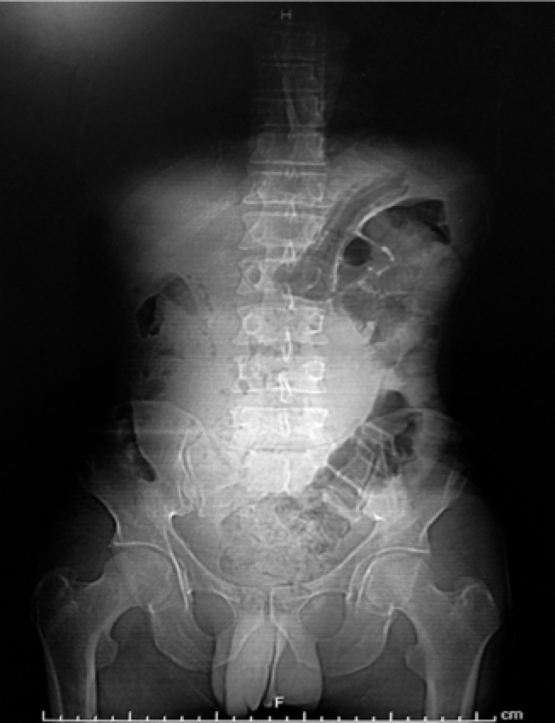
Figure 1 Abdominal radiography with radiopaque area in mesogastrium.

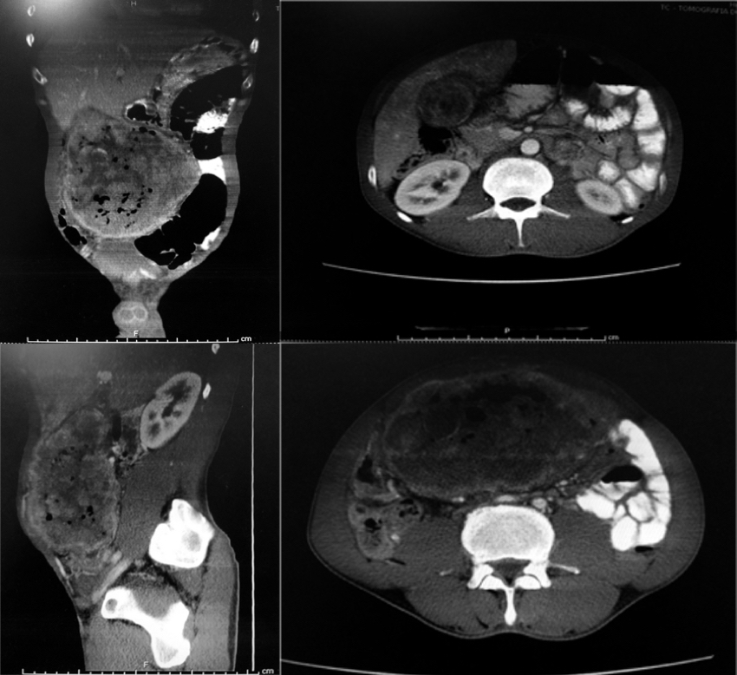
Figure 2 Computed tomography with a coronal, sagittal, and axial image showing a large tumor in the hepatic bed.
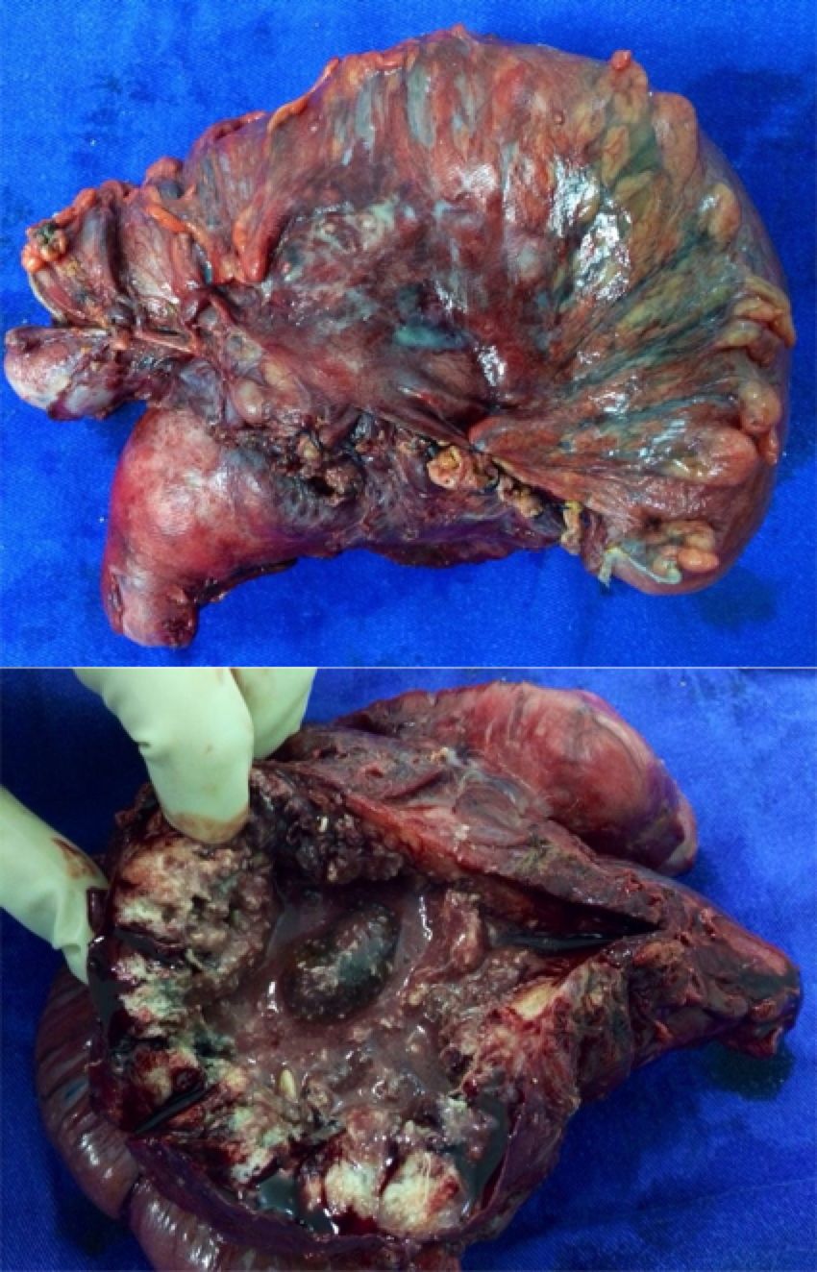
Figure 3 Surgical specimen with en bloc resection of gallbladder and transverse colon segment.
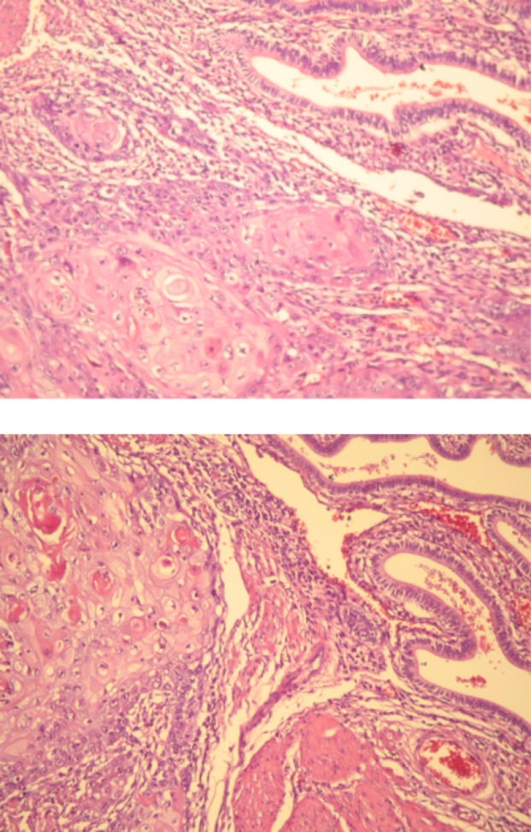
Figure 4 Transition from spinocellular carcinoma to extensive blocks with formation of horny pearls, and the gallbladder mucosa presenting the columnar epithelium. Hematoxylin-eosin staining, 100 ×.

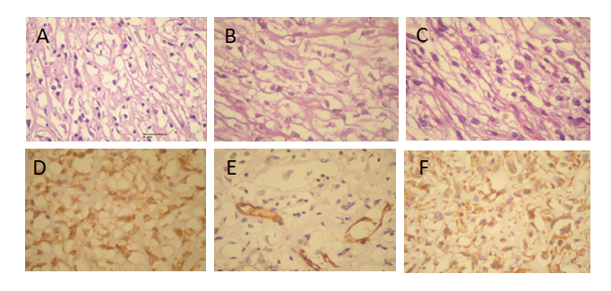
Figure 5 Plexiform fibromyxoma of the gastric wall. A, B, C: The image shows a fusocellular neoplasm with elongate or oval nuclei and clear cytoplasm with basophilic base of myxoid aspect. Hematoxylin-eosin staining, 400 ×; D: Immunoexpression of actin antibody of smooth muscle in neoplastic cells; E: Immunoexpression of CD31 antibody in blood vessel walls; F: Immunoexpression of vimentin in neoplastic cells.

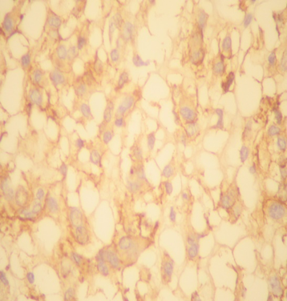
Figure 6 Immunoexpression of CD56 antibody and anti-neuron specify enolase antibody in neoplastic cells. Absence of immunoexpression of CD117 antibody. Positivity of KI-67 to the nuclei of the neoplastic cells (low index of mitotic proliferation).

