Name of Journal: World Journal of Clinical Cases
Manuscript NO: 70686
Manuscript Type: ORIGINAL ARTICLE

Retrospective Study
Acute kidney injury in traumatic brain injury intensive care unit patients

Huang ZY et al. AKI in TBI intensive care unit patients

Zheng-Yang Huang, Yong Liu, Hao-Fan Huang, Shu-Hua Huang, Jing-Xin Wang, Jin-Fei Tian, Wen-Xian Zeng, Rong-Gui Lv, Song Jiang, Jun-Ling Gao, Yi Gao, Xia-Xia Yu

Zheng-Yang Huang, Hao-Fan Huang, Shu-Hua Huang, Yi Gao, Xia-Xia Yu, School of Biomedical Engineering, Health Science Center, Shenzhen University, Shenzhen 518037, Guangdong Province, China

Yong Liu, Jing-Xin Wang, Jin-Fei Tian, Wen-Xian Zeng, Rong-Gui Lv, Song Jiang, Intensive Care Unit, Shenzhen Hospital, Southern Medical University, Shenzhen 518101, Guangdong Province, China

Jun-Ling Gao, Department of Medicine, LKS Medical Faculty, The University of Hong Kong, Hongkong 999077, China

Author contributions: Yu XX and Liu Y conceived and coordinated the study, designed, performed and analyzed the experiments, wrote the paper; Wang JX, Tian JF, Zeng WX, Jiang S and Lv RG carried out the data collection and preprocess of the raw data; Huang ZY, Huang HF and Huang SH performed the data analysis; Liu Y and Gao JL revised the paper; all authors reviewed the results and approved the final version of the manuscript.

Corresponding author: Xia-Xia Yu, PhD, Assistant Professor, School of Biomedical Engineering, Health Science Center, Shenzhen University, No. 1066 Xueyuan Avenue, Nanshan District, Shenzhen 518037, Guangdong Province, China. xiaxiayu@szu.edu.cn

Received: August 11, 2021
Revised: November 30, 2021
Accepted: February 12, 2022
Published online:

Abstract
BACKGROUND
The exact definition of Acute kidney injury (AKI) for patients with traumatic brain injury (TBI) is unknown.

AIM
To compare the power of the “Risk, Injury, Failure, Loss of kidney function, and End-stage kidney disease” (RIFLE), Acute Kidney Injury Network (AKIN), Creatinine kinetics (CK), and Kidney Disease Improving Global Outcomes (KDIGO) to determine AKI incidence/stage and their association with the in-hospital mortality rate of patients with TBI.

METHODS
This retrospective study collected the data of patients admitted to the intensive care unit for neurotrauma from 2001 to 2012, and 1648 patients were included. The subjects in this study were assessed for the presence and stage of AKI using RIFLE, AKIN, CK, and KDIGO. In addition, the propensity score matching method was used.

RESULTS
Among the 1648 patients, 291 (17.7%) had AKI, according to KDIGO. The highest incidence of AKI was found by KDIGO (17.7%), followed by AKIN (17.1%), RIFLE (12.7%), and CK (11.5%) (P = 0.97). Concordance between KDIGO and RIFLE/AKIN/CK was 99.3%/99.1%/99.3% for stage 0, 36.0%/91.5%/44.5% for stage 1, 35.9%/90.6%/11.3% for stage 2, and 47.4%/89.5%/36.8% for stage 3. The in-hospital mortality rates increased with the AKI stage in all four definitions. The severity of AKI by all definitions and stages was not associated with in-hospital mortality in the multivariable analyses (all P > 0.05).

CONCLUSION
Differences are seen in AKI diagnosis and in-hospital mortality among the four AKI definitions or stages. This study revealed that KDIGO is the best method to define AKI in patients with TBI.

Key Words: Kidney Disease Improving Global Outcomes; Acute Kidney Injury; Traumatic brain injury; Evaluation; In-hospital mortality

Huang ZY, Liu Y, Huang HF, Huang SH, Wang JX, Tian JF, Zeng WX, Lv RG, Jiang S, Gao JL, Gao Y, Yu XX. Acute kidney injury in traumatic brain injury intensive care unit patients. World J Clin Cases 2022; In press

Core Tip: Because the exact definition of Acute Kidney Injury (AKI) for patients with Traumatic brain injury (TBI) is unknown, this study compared the power of four different AKI diagnose criteria to determine AKI incidence/stage and their association with the in-hospital mortality rate of patients with TBI.

INTRODUCTION
Traumatic brain injury (TBI) is a debilitating condition that can be exacerbated by the co-occurrence of acute kidney injury (AKI), which is a clinical syndrome characterized by the abrupt loss of the kidney's excretory function and is often combined with oliguria. The development of AKI usually occurs over the course of hours to days^{[1]}. AKI is observed in 9% of the patients with TBI, and 42% of those patients die in the hospital^{[2]}. Thus, early identification and subsequent clinical intervention of AKI in TBI patients are critical to survival^{[3]}.
Nevertheless, it is difficult to determine the true incidence and outcomes of AKI due to the use of different validation criteria^{[4-6]}. The reported incidence of AKI varies greatly, ranging from 15% to 74.2%^{[7-10]}. Moreover, serum creatinine (SCr) and urine output (UO) in patients with TBI are greatly impacted by muscle injury or breakdown secondary to decreased perfusion pressure and the use of osmotic diuretics like mannitol^{[4-6]}. Therefore, sensitive and reliable criteria for AKI are needed for diagnosis and staging, especially in TBI patients.
Since 2004, at least four different AKI definitions and criteria have been proposed. The “Risk, Injury, Failure, Loss of kidney function, and End-stage kidney disease” (RIFLE) classification was the first validated tool for AKI identification^{[11]}. It is based on SCr levels and UO and defines three severity classes of AKI (risk, injury, and failure) and two outcome classes (Loss of kidney function and End-stage kidney disease). Following that, the Acute Kidney Injury Network (AKIN) criteria were proposed in 2007 as a modification of the RIFLE criteria^{[12]}. The AKIN is based on evidence that suggests that even small increases in SCr are associated with a poor outcome. It is also based on SCr and UO and defines three stages (1, 2, and 3). Following the evidence for small changes in SCr and outcomes, the creatinine kinetics (CK) model was proposed by Waikar and Bonventre^{[13]}, who defined AKI based on the absolute changes in baseline SCr levels over 24-48 h. In 2012, an updated consensus definition of AKI was further proposed by the Kidney Disease Improving Global Outcomes (KDIGO) group to reconcile the subtle differences in the RIFLE and AKIN criteria and to establish a common definition known as the KDIGO criteria^{[14]}. Nevertheless, currently, there are no widely accepted criteria to determine the severity of AKI for patients with TBI in the intensive care unit (ICU)^{[2,7,15]}, and the power of the criteria above among TBI patients’ needs further exploration.
Therefore, the present study aimed to explore the compatibility among the RIFLE, AKIN, CK, and KDIGO definitions, and to compare the power of these criteria in determining the incidence and stage of AKI and explore the association between severity of AKI by all definitions/stages and in-hospital mortality of patients admitted to ICU for TBI.

MATERIALS AND METHODS
Subjects
This was a retrospective study of patients admitted to the ICU for neurotrauma from 2001 to 2012. The exclusion criteria were: (1) Discharged within 24 h; or (2) < 18 years of age; or (3) missing data; or (4) history of end-stage renal disease (ESRD). The patients were included in the AKI and non-AKI groups according to whether they were diagnosed with AKI based on the KDIGO criteria^{[16]}.
The data for this study were extracted from the Medical Information Mart for Intensive Care (MIMIC-III, https://mimic.physionet.org/about/mimic/). It is a large public single-center database^{[17]} that contains information relating to patients admitted to the critical care units at Beth Israel Deaconess Medical Center during 2001-2012. The presence of TBI was defined by diagnostic code, ICD-9, in MIMIC-III^{[18]}.
This retrospective study was approved by the Ethics Committee for Human Research of Shenzhen Hospital, Southern Medical University (No. NYS2YYEC20180009), which waived the requirement for informed consent from subjects.

Data collection
Demographics and clinical data were retrieved for all patients, including sex, age, ethnicity, category diagnosis at ICU admission, Elixhauser score, simplified acute physiology score (SAPS II), SOFA score, Glasgow Coma Scale (GCS) score^{[19]}, serum creatinine concentration (SCr), including peak SCr and SCr at admission, previous treatment (craniotomy, transfusion and the use of antiplatelet drugs, anticoagulants, vancomycin, angiotensin receptor blocker/angiotensin-converting enzyme inhibitor (ARB/ACE-I) and aminoglycosides), length of stay (in days), UO, APACHE II classification, and in-hospital, 30-d, and 1-year mortality rates. Comorbidity was defined and calculated using the ICD-9-CM codes based on Elixhauser’s algorithm^{[20]}. Patients presenting with shock upon admission, organ failure, and multiple organ failure (MOF) were selected according to definitions previously published^{[21]}.
If the patient's weight value was missing, the patient's height was used to estimate the weight^{[22]}. Based on baseline SCr, the two groups in this study were assessed for the presence and stage of AKI using RIFLE^{[11]}, AKIN^{[12]}, CK^{[13]}, and KDIGO^{[16]}. Baseline SCr was calculated according to the theoretical baseline SCr value for a given patient, assuming normal GFR^{[11]}.

Statistical analysis
The matching factors for propensity score matching (PSM) were ethnicity, age, sex, Elixhaouser score, SAPS II, SOFA, GCS, craniotomy, max creatinine, creatinine at admission, use of antiplatelet drugs, use of anticoagulants, shock, use of vancomycin, use of ARB/ACE-I, use of aminoglycosides, transfusion, red blood cell, plasma, and UO. The matching ratio was 1:1. Statistical analyses were performed using STATA 12.0 (StataCorp LP, College Station, TX, United States). The continuous data were tested for normal distribution using the Kolmogorov-Smirnov test. Those with a normal distribution were presented as means ± SD and analyzed using Student’s t-test; otherwise, they were presented as medians [interquartile ranges (IQR)] and analyzed using the Mann-Whitney U-test. The categorical data were presented as numbers (percentages) and analyzed using the chi-square test or Fisher’s exact test. Univariable and multivariable (enter) logistic regression analyses were performed to explore the association between in-hospital mortality (dependent variable) and the AKI stages diagnosed by CK, RIFLE, AKIN, and KDIGO. In-hospital, 30-d, and 1-year mortality rates were analyzed using the Kaplan-Meier method and the log-rank test. The observed proportional agreement was used to examine the compatibility between the different scoring systems. The Marascuilo procedure was used for multiple comparisons. Two-sided P values < 0.05 were considered statistically significant.

RESULTS
Characteristics of the patients
From the 2862 patients retrieved from the MIMCS-III database, 1214 were excluded (536 for being discharged within 24 h, 39 for being < 18 years of age, 529 with missing data, and 110 for being with ESRD), and 1648 were examined for the presence of AKI. Of those patients with TBI, 291 (17.7%) had AKI according to the KDIGO criteria (Figure 1). After PSM, the mean age of the patient cohort was 55.3 ± 23.9 years. Patients with AKI had higher SAPS II (36.6 ± 15.9 vs 33.1 ± 13.4, P = 0.004) and SOFA (4.8 ± 3.1 vs 4.0 ± 2.7, P = 0.001) scores, compared with patients without AKI. Moreover, patients with AKI had a higher frequency of shock (35.7% vs 25.1%, P = 0.007) and had more transfusions of red blood cells (RBC) (377.3 ± 1433.2 vs 174.1 ± 623.1 mL, P = 0.027) (Table 1). Table 2 shows the characteristics of the study population before PSM.
The patients with AKI were divided according to KDIGO stage 1 (n = 200), 2 (n = 53), and 3 (n = 38) (Table 3). The patients with KDIGO stage 2 were older than in the two other groups (P = 0.001) and had a higher proportion of females (P < 0.001). The Elixhauser score, SAPS II, and SOFA scores were higher in the stage 3 group compared with the two other groups (all P < 0.001). The proportion of shock was higher in stage 3 (P = 0.004), the use of vancomycin was higher in stage 1 (P < 0.001), the use of aminoglycosides was higher in stages 2 and 3 (P = 0.040), and transfusions were higher in stage 3 patients (all P ≤ 0.01).

Inter-definition agreement
The incidence of AKI and stages determined by each classification method were examined. The highest incidence of AKI was found by KDIGO (17.7%), followed by AKIN (17.1%), RIFLE (12.7%), and CK (11.5%). There were no differences in the incidence of AKI among the four definitions (P = 0.967) (Table 4).
The identification of AKI overlaps across all the definitions (Figure 2). KDIGO identified the most AKI patients, and CK identified the least. Ten patients were identified as AKI only by KDIGO, while two and one were identified only by RIFLE and AKIN, respectively. KDIGO and AKIN failed to identify 14 and 22 AKI patients, respectively, while CK failed to identify 115 cases. For patients identified by AKIN and KDIGO only, the patients’ length of stay was the longest among all other combinations (12.9 d).
The concordance of AKI diagnosis and staging were further evaluated between KDIGO and the other classifications, using KDIGO as the diagnostic standard (Table 5). Compared with KDIGO, RIFLE correctly staged 1348/1357 (99.3%) stage 0 patients, 72/200 (36.0%) stage 1 patients, 19/53 (35.9%) stage 2 patients, and 18/38 (47.4%) stage 3 patients. Compared with KDIGO, AKIN correctly staged 1344/1357 (99.1%) stage 0 patients, 183/200 (91.5%) stage 1 patients, 48/53 (90.6%) stage 2 patients, and 34/38 (89.5%) stage 3 patients. Compared with KDIGO, CK correctly staged 1346/1357 (99.3%) stage 0 patients, 89/200 (44.5%) stage 1 patients, 6/53 (11.3%) stage 2 patients, and 14/38 (36.8%) stage 3 patients. Concordance was 88.4% between KDIGO and RIFLE, 97.6% between KDIGO and AKIN, and 88.3% between KDIGO and CK.

Prognosis
Regardless of AKI determination criteria, the in-hospital mortality was higher for those with AKI than those without. Moreover, the in-hospital mortality increased with the AKI stage (all P < 0.001) (Figures 3 and 4).
When staged according to KDIGO, ventilation time increased with AKI stage (P = 0.03), and ICU stay and hospitalization were longer for any-stage AKI compared to non-AKI (all P < 0.05). In-hospital mortality (P = 0.001), 30-d mortality (P < 0.001), and 1-year mortality (P < 0.001) increased with the AKI stage (Table 6).
The association between severity of AKI by all definitions/stages and in-hospital mortality was tested. As shown in Table 7, the severity of AKI by all definitions and stages was associated with in-hospital mortality in the univariable analyses (all P < 0.05), except for stage 1 by CK (P > 0.05), but the associations were no longer significant in the multivariable analyses (all P > 0.05).

DISCUSSION
For the diagnosis and staging of AKI, at least four different AKI criteria, RIFLE, AKIN, CK, and KDIGO, have been proposed. However, the power of these criteria among TBI patients needs further exploration. This study revealed that differences were seen in AKI diagnosis among the four AKI criteria. The highest incidence of AKI was found by KDIGO (17.7%), followed by AKIN (17.1%), RIFLE (12.7%), and CK (11.5%). Concordance to KDIGO was the lowest for CK, followed by RIFLE and AKIN. The in-hospital mortality rates increased with the AKI stage in all four definitions, but the severity of AKI by all definitions and stages was not associated with in-hospital mortality in the multivariable analyses.
The diagnosis of AKI in patients with TBI has significant clinical relevance, given the requirements for prompt medical intervention for AKI patients. Similar to the results of a previous study^{[23]}, this study suggested that the incidence of AKI varied depending on the criteria used, which may lead to confusion during criteria selection and may negatively affect the efficiency of clinical treatment. Some studies showed that KDIGO is more sensitive than AKIN and RIFLE in AKI diagnosis in patients with myocardial infarction and acute decompensated heart failure^{[9,10]}. In a study comparing KDIGO and CK in diagnosing AKI in trauma patients, KDIGO was shown to be more sensitive, and CK was found to be superior to KDIGO only in patients with pre-existing chronic kidney disease (CKD)^{[7]}. In the present study, the KDIGO classification identified the highest incidence of AKI and was more able to detect than RIFLE, CK, and AKIN. Although there were no significant differences in the proportions of patients with AKI according to the different criteria, misclassification was observed, particularly with the CK and RIFLE definitions.
More specifically, the present study showed the highest incidence of AKI was found by KDIGO (17.7%), followed by AKIN (17.1%), RIFLE (12.7%), and CK (11.5%) among patients with TBI patients. The reason for the difference may be the selection of the baseline SCr to be used for evaluating AKI. For example, the AKIN criteria consider the lowest SCr measurement during the ICU stay as the baseline SCr level, and it probably overestimates the AKI incidence, which can be as high as 74.2%-85.0%^{[24-27]}. However, when baseline SCr was estimated using the MDRD equation, AKI incidence was reported to be 11.6%-23% based on the RIFLE or AKIN criteria^{[7,10]}. The selection of baseline SCr could also affect the incidence of AKI in the general population when following the KDIGO criteria. A possible explanation for this finding is the temporary overhydration during hospitalization. The creatinine concentration extrapolated by the MDRD equation (with a GFR of 75 mL/min) might be more accurate, although it should be used with caution. Other influencing factors include, but are not limited to, UO and population heterogeneity, and further studies are needed in the future.
The KDIGO classification was rarely compared to other AKI definitions regarding its prognostic power in TBI patients. According to Tsai et al^{[24]}, the KDIGO classification has a relatively higher discriminatory power (0.840 ± 0.032) in predicting in-hospital mortality than the RIFLE (0.826 ± 0.033) and AKIN (0.836 ±0.032) classifications. Zeng et al^{[28]} showed that the incidence of AKI changed with the definition but that all definitions were associated with in-hospital mortality. In the present study, KDIGO did not improve the predictive performance of in-hospital mortality, i.e., the in-hospital mortality increased with the increasing stage in all four definitions. On the other hand, the associations disappeared for all four definitions in the multivariable regression analyses after adjusting for ethnicity, age, sex, Elixhauser score, SAPS II, SOFA, GCS, craniotomy, max creatinine, creatinine at admission, use of antiplatelet drugs, anticoagulant, vancomycin, ARB/ACE-I and aminoglycosides, transfusion, red blood cell, plasma, and shock. Therefore, the results mean that one or multiple factors included in the adjusted analyses are a stronger predictor of mortality than AKI in patients with TBI. A study by Ulger et al^{[25]} showed that the in-hospital mortality for stage 2 and 3 AKI in AKIN, RIFLE, and KDIGO was nearly the same. These discrepancies might be attributable to the baseline creatine estimation based on the MDRD formula^{[15]}. Besides, clinically, death attributable to AKI is rare in TBI patients, which may explain the lack of association between the four definitions and in-hospital mortality. Osmotic therapy during ICU stay appears to affect the mortality due to AKI^{[29]}. A recent study suggested that the AKI stage was associated with mortality in patients with TBI, but not AKI duration or AKI burden; in addition, most deaths occurred during the first 3 d of ICU stay^{[30]}. The use of renoprotective measures affects the mortality due to AKI in patients with TBI^{[31]}.
There are some limitations to this research. First, as a retrospective, a single-center study from a single academic hospital, the generalizability of these findings is questionable. Incidence estimates, mortality rates, and procedures vary greatly among hospitals and countries. Second, baseline creatinine was calculated as a theoretical baseline SCr for a given patient assuming a normal GFR, which may overestimate or underestimate the incidence of AKI to some extent. Third, the patients were identified using the administrative codes entered in the database, which is subject to bias regarding the use of the incorrect code by the physicians and administrative personnel^{[17]}.

CONCLUSION
In conclusion, this study indicates that in patients with TBI, differences are seen in AKI diagnosis among the four AKI definitions or stages, and concordance varies, as well as the in-hospital mortality. Thus, more universal AKI criteria are needed in patients with TBI. Besides, the severity of AKI was not associated with in-hospital mortality rates when using any of the four definitions.

ARTICLE HIGHLIGHTS
Research background
Early identification and subsequent clinical intervention of acute kidney injury (AKI) in traumatic brain injury (TBI) patients are critical to survival.

Research motivation
The exact definition of AKI for patients with TBI is unknown.

Research objectives
We aimed to compare four AKI diagnostic criteria to determine AKI incidence/stage and their association with the in-hospital mortality rate of patients with TBI.

Research methods
The subjects in this study were assessed for the presence and stage of AKI using four different AKI diagnostic criteria.

Research results
The in-hospital mortality rates increased with the AKI stage in all four definitions. The severity of AKI by all definitions and stages was not associated with in-hospital mortality in the multivariable analyses (all P > 0.05).

Research conclusions
This study revealed that Kidney Disease Improving Global Outcomes (KDIGO) is the best method to define AKI in patients with TBI.

Research perspectives
In the future, it is necessary to increase the sample size for prospective studies to further explore.

REFERENCES
1 Koza Y. Acute kidney injury: current concepts and new insights. J Inj Violence Res 2016; 8: 58-62 [PMID: 26804946 DOI: 10.5249/jivr.v8i1.610]
2 Moore EM, Bellomo R, Nichol A, Harley N, Macisaac C, Cooper DJ. The incidence of acute kidney injury in patients with traumatic brain injury. Ren Fail 2010; 32: 1060-1065 [PMID: 20863210 DOI: 10.3109/0886022X.2010.510234]
3 Freeman WD, Wadei HM. A brain-kidney connection: the delicate interplay of brain and kidney physiology. Neurocrit Care 2015; 22: 173-175 [PMID: 25672972 DOI: 10.1007/s12028-015-0119-8]
4 Machado MN, Nakazone MA, Maia LN. Acute kidney injury based on KDIGO (Kidney Disease Improving Global Outcomes) criteria in patients with elevated baseline serum creatinine undergoing cardiac surgery. Rev Bras Cir Cardiovasc 2014; 29: 299-307 [PMID: 25372901 DOI: 10.5935/1678-9741.20140049]
5 Barasch J, Zager R, Bonventre JV. Acute kidney injury: a problem of definition. Lancet 2017; 389: 779-781 [PMID: 28248160 DOI: 10.1016/S0140-6736(17)30543-3]
6 Zappitelli M, Parikh CR, Akcan-Arikan A, Washburn KK, Moffett BS, Goldstein SL. Ascertainment and epidemiology of acute kidney injury varies with definition interpretation. Clin J Am Soc Nephrol 2008; 3: 948-954 [PMID: 18417742 DOI: 10.2215/CJN.05431207]
7 Li N, Zhao WG, Zhang WF. Acute kidney injury in patients with severe traumatic brain injury: implementation of the acute kidney injury network stage system. Neurocrit Care 2011; 14: 377-381 [PMID: 21298359 DOI: 10.1007/s12028-011-9511-1]
8 Avila RCN, Fernandez A, Filippi M. The incidence of acute kidney injury in patients with traumatic brain injury. Int Care Med Exp 2015; 3: A263
9 Zygun DA, Kortbeek JB, Fick GH, Laupland KB, Doig CJ. Non-neurologic organ dysfunction in severe traumatic brain injury. Crit Care Med 2005; 33: 654-660 [PMID: 15753760 DOI: 10.1097/01.ccm.0000155911.01844.54]
10 Bagshaw SM, George C, Gibney RT, Bellomo R. A multi-center evaluation of early acute kidney injury in critically ill trauma patients. Ren Fail 2008; 30: 581-589 [PMID: 18661407 DOI: 10.1080/08860220802134649]
11 Bellomo R, Ronco C, Kellum JA, Mehta RL, Palevsky P; Acute Dialysis Quality Initiative workgroup. Acute renal failure - definition, outcome measures, animal models, fluid therapy and information technology needs: the Second International Consensus Conference of the Acute Dialysis Quality Initiative (ADQI) Group. Crit Care 2004; 8: R204-R212 [PMID: 15312219 DOI: 10.1186/cc2872]
12 Mehta RL, Kellum JA, Shah SV, Molitoris BA, Ronco C, Warnock DG, Levin A; Acute Kidney Injury Network. Acute Kidney Injury Network: report of an initiative to improve outcomes in acute kidney injury. Crit Care 2007; 11: R31 [PMID: 17331245 DOI: 10.1186/cc5713]
13 Waikar SS, Bonventre JV. Creatinine kinetics and the definition of acute kidney injury. J Am Soc Nephrol 2009; 20: 672-679 [PMID: 19244578 DOI: 10.1681/ASN.2008070669]
14 KDIGO Clinical Practice Guideline for Acute Kidney Injury. Kidney Int Suppl 2012; 2: 1-138
15 Davenport A. Clinical guidelines for the protection of kidney function and prevention of acute kidney injury in the intensive care unit: common sense rather than magic bullets? Intensive Care Med 2010; 36: 379-380 [PMID: 19921151 DOI: 10.1007/s00134-009-1683-1]
16 Khwaja A. KDIGO clinical practice guidelines for acute kidney injury. Nephron Clin Pract 2012; 120: c179-c184 [PMID: 22890468 DOI: 10.1159/000339789]
17 Johnson AE, Pollard TJ, Shen L, Lehman LW, Feng M, Ghassemi M, Moody B, Szolovits P, Celi LA, Mark RG. MIMIC-III, a freely accessible critical care database. Sci Data 2016; 3: 160035 [PMID: 27219127 DOI: 10.1038/sdata.2016.35]
18 Carlson KF, Barnes JE, Hagel EM, Taylor BC, Cifu DX, Sayer NA. Sensitivity and specificity of traumatic brain injury diagnosis codes in United States Department of Veterans Affairs administrative data. Brain Inj 2013; 27: 640-650 [PMID: 23514276 DOI: 10.3109/02699052.2013.771795]
19 Sternbach GL. The Glasgow coma scale. J Emerg Med 2000; 19: 67-71 [PMID: 10863122 DOI: 10.1016/s0736-4679(00)00182-7]
20 Elixhauser A, Steiner C, Harris DR, Coffey RM. Comorbidity measures for use with administrative data. Med Care 1998; 36: 8-27 [PMID: 9431328 DOI: 10.1097/00005650-199801000-00004]
21 Vincent JL, Nielsen ND, Shapiro NI, Gerbasi ME, Grossman A, Doroff R, Zeng F, Young PJ, Russell JA. Mean arterial pressure and mortality in patients with distributive shock: a retrospective analysis of the MIMIC-III database. Ann Intensive Care 2018; 8: 107 [PMID: 30411243 DOI: 10.1186/s13613-018-0448-9]
22 Levey AS, Bosch JP, Lewis JB, Greene T, Rogers N, Roth D. A more accurate method to estimate glomerular filtration rate from serum creatinine: a new prediction equation. Modification of Diet in Renal Disease Study Group. Ann Intern Med 1999; 130: 461-470 [PMID: 10075613 DOI: 10.7326/0003-4819-130-6-199903160-00002]
23 Izawa J, Uchino S, Fujii T, Arii T, Fukushima T, Kawano S. Thorough evaluation for the new acute kidney injury criteria by Kidney Disease Improving Global Outcomes. Crit Care Med 2013; 17: P410
24 Tsai TY, Chien H, Tsai FC, Pan HC, Yang HY, Lee SY, Hsu HH, Fang JT, Yang CW, Chen YC. Comparison of RIFLE, AKIN, and KDIGO classifications for assessing prognosis of patients on extracorporeal membrane oxygenation. J Formos Med Assoc 2017; 116: 844-851 [PMID: 28874330 DOI: 10.1016/j.jfma.2017.08.004]
25 Ülger F, Pehlivanlar Küçük M, Küçük AO, İlkaya NK, Murat N, Bilgiç B, Abanoz H. Evaluation of acute kidney injury (AKI) with RIFLE, AKIN, CK, and KDIGO in critically ill trauma patients. Eur J Trauma Emerg Surg 2018; 44: 597-605 [PMID: 28717983 DOI: 10.1007/s00068-017-0820-8]
26 Pickering JW, Endre ZH. Back-calculating baseline creatinine with MDRD misclassifies acute kidney injury in the intensive care unit. Clin J Am Soc Nephrol 2010; 5: 1165-1173 [PMID: 20498242 DOI: 10.2215/CJN.08531109]
27 Sigurdsson MI, Vesteinsdottir IO, Sigvaldason K, Helgadottir S, Indridason OS, Sigurdsson GH. Acute kidney injury in intensive care units according to RIFLE classification: a population-based study. Acta Anaesthesiol Scand 2012; 56: 1291-1297 [PMID: 22999042 DOI: 10.1111/j.1399-6576.2012.02767.x]
28 Zeng X, McMahon GM, Brunelli SM, Bates DW, Waikar SS. Incidence, outcomes, and comparisons across definitions of AKI in hospitalized individuals. Clin J Am Soc Nephrol 2014; 9: 12-20 [PMID: 24178971 DOI: 10.2215/CJN.02730313]
29 Robba C, Banzato E, Rebora P, Iaquaniello C, Huang CY, Wiegers EJA, Meyfroidt G, Citerio G; Collaborative European NeuroTrauma Effectiveness Research in Traumatic Brain Injury (CENTER-TBI) ICU Participants and Investigators. Acute Kidney Injury in Traumatic Brain Injury Patients: Results From the Collaborative European NeuroTrauma Effectiveness Research in Traumatic Brain Injury Study. Crit Care Med 2021; 49: 112-126 [PMID: 33060506 DOI: 10.1097/CCM.0000000000004673]
30 Wang R, Zhang J, Xu J, He M, Xu J. Incidence and Burden of Acute Kidney Injury among Traumatic Brain-Injury Patients. Risk Manag Healthc Policy 2021; 14: 4571-4580 [PMID: 34795542 DOI: 10.2147/RMHP.S335150]
31 Ramtinfar S, Chabok SY, Chari AJ, Reihanian Z, Leili EK, Alizadeh A. Kidney disease improving global outcome for predicting acute kidney injury in traumatic brain injury patients. J Acute Med 2016; 6: 90-94

Footnotes
Institutional review board statement: The study was approved by the Ethics Committee for Human Research of Shenzhen Hospital, Southern Medical University (No. NYS2YYEC20180009).

Informed consent statement: Patients were not required to give informed consent to the study because the analysis used anonymous clinical data that were obtained after each patient agreed to treatment by written consent.

Conflict-of-interest statement: The authors declare that they have no conflict of interest.

Data sharing statement: No additional data are available.

Open-Access: This article is an open-access article that was selected by an in-house editor and fully peer-reviewed by external reviewers. It is distributed in accordance with the Creative Commons Attribution NonCommercial (CC BY-NC 4.0) license, which permits others to distribute, remix, adapt, build upon this work non-commercially, and license their derivative works on different terms, provided the original work is properly cited and the use is non-commercial. See: https://creativecommons.org/Licenses/by-nc/4.0/

Provenance and peer review: Unsolicited article; Externally peer reviewed.
Peer-review model: Single blind

Peer-review started: August 11, 2021
First decision: October 20, 2021
Article in press:

Specialty type: Neurosciences
Country/Territory of origin: China
Peer-review report’s scientific quality classification
Grade A (Excellent): 0
Grade B (Very good): B
Grade C (Good): C
Grade D (Fair): 0
Grade E (Poor): 0

P-Reviewer: Esposito P, Hassan EM S-Editor: Xing YX L-Editor: Filipodia P-Editor: Xing YX

Figure Legends
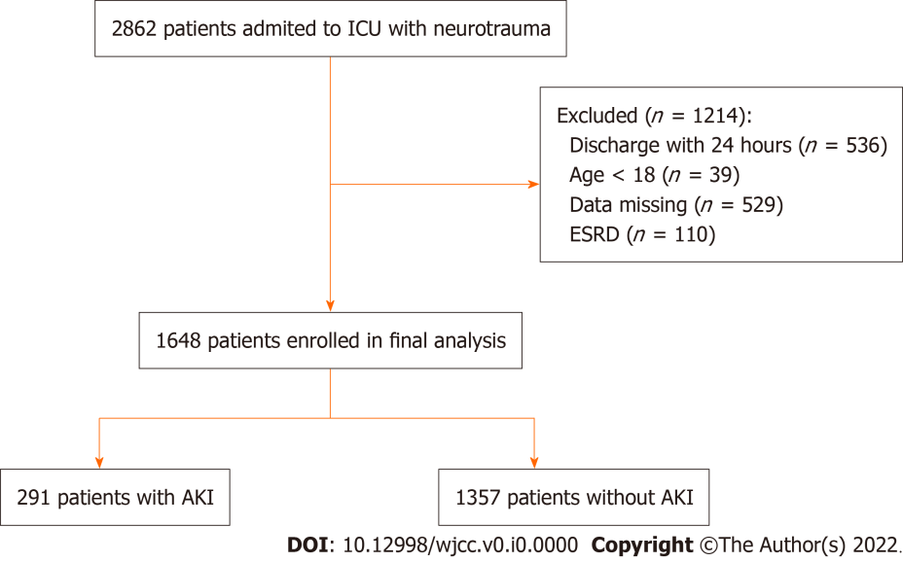
Figure 1 Flow chart of the study. ICU: Intensive care unit; ESRD: End-stage renal disease; AKI: Acute Kidney Injury.
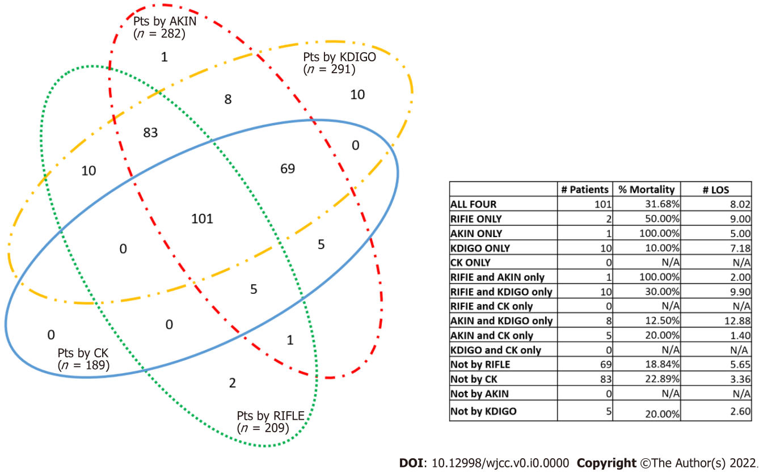
Figure 2 Definition overlap and in-hospital mortality of patients diagnosed by Creatinine kinetics, “Risk, Injury, Failure, Loss of kidney function, and End-stage kidney disease”, Acute Kidney Injury Network, and Kidney Disease Improving Global Outcomes. Each number in the figure represents the number of patients correctly identified with acute kidney injury by the different definitions represented by the colored circles. For example, 101 patients are included in all four circles, meaning that they have been correctly classified by all four definitions, while 83 patients were correctly identified by “Risk, Injury, Failure, Loss of kidney function, and End-stage kidney disease” (RIFLE), Acute Kidney Injury Network (AKIN), and Kidney Disease Improving Global Outcomes (KDIGO). KDIGO was shown in yellow; AKIN in red; RIFLE in green; and Creatinine kinetics in blue. LOS: Length of stay (day); CK: Creatinine kinetics; RIFLE: Risk, Injury, Failure, Loss of kidney function, and End-stage kidney disease; AKIN: Acute Kidney Injury Network; KDIGO: Kidney Disease Improving Global Outcomes.

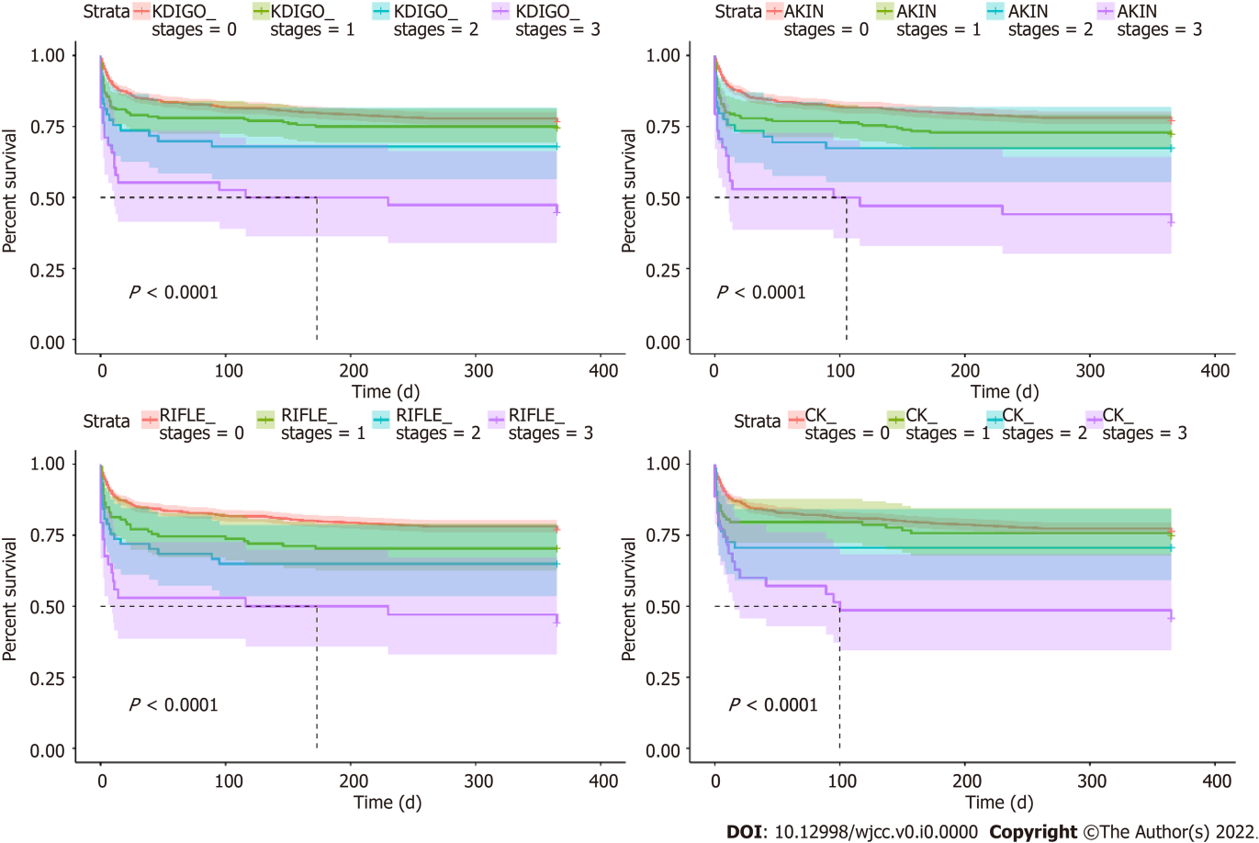
Figure 3 In-hospital mortality of patients diagnosed by Creatinine kinetics, “Risk, Injury, Failure, Loss of kidney function, and End-stage kidney disease”, Acute Kidney Injury Network, and Kidney Disease Improving Global Outcomes. CK: Creatinine kinetics; RIFLE: Risk, Injury, Failure, Loss of kidney function, and End-stage kidney disease; AKIN: Acute Kidney Injury Network; KDIGO: Kidney Disease Improving Global Outcomes. P values < 0.05 were considered statistically significant.

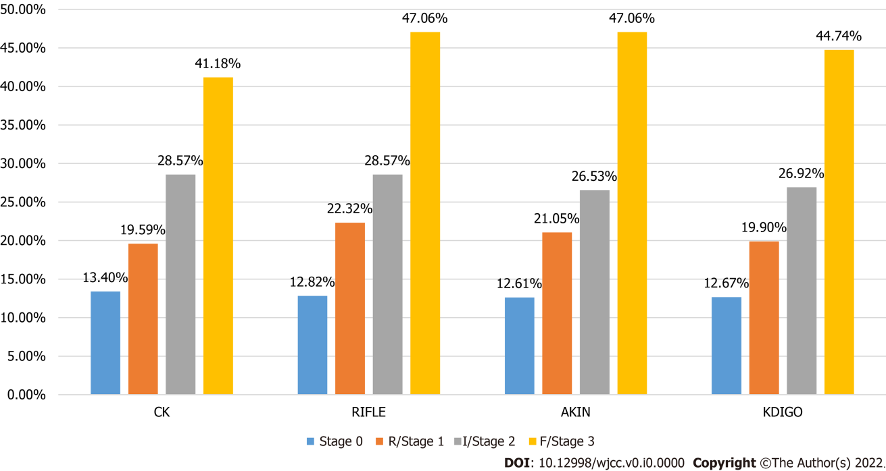
Figure 4 Percentage of in-hospital mortality for each stage of Acute kidney injury diagnosed by Risk, Injury, Failure, Loss of kidney function, and End-stage kidney disease, Acute kidney injury network, Creatinine kinetics, and Kidney Disease Improving Global Outcomes. Stage 0 is considered no AKI. Stage 1 is at risk. Stage 2 is injury. Stage 3 is failure. AKI: Acute Kidney Injury; KDIGO: Kidney Disease Improving Global Outcomes; AKIN: Acute Kidney Injury Network; RIFLE: Risk, Injury, Failure, Loss of kidney function, and End-stage kidney disease; CK: Creatinine kinetics.

Table 1 Patient characteristics according to the Kidney Disease Improving Global Outcomes criteria (propensity score matching)
Characteristics | Total patients  (n = 582) | Non-AKI  (n = 291) | AKI (n = 291) | P value
Ethnicity |  |  |  | 0.195
White | 415 (71.3) | 206 (70.8) | 209 (71.8)
Hispanic/Latino | 8 (1.4) | 7 (2.4) | 1 (0.3)
African American | 22 (3.8) | 13 (4.5) | 9 (3.1)
Asian | 3 (0.5) | 2 (0.7) | 1 (0.3)
Other/unknown | 134 (23.0) | 63 (21.7) | 71 (24.4)
Age (yr) | 55.3 ± 23.9 | 54.7 ± 24.7 | 55.8 ± 23.1 | 0.595
Sex |  |  |  | 0.925
Female | 152 (26.1) | 75 (25.8) | 77 (26.5)
Male | 430 (73.9) | 216 (74.2) | 214 (73.5)
Elixhauser score | 8.1 ± 11.5 | 7.4 ± 10.9 | 8.7 ± 12.1 | 0.187
SAPS II | 34.8 ± 14.8 | 33.1 ± 13.4 | 36.6 ± 15.9 | 0.004
SOFA | 4.4 ± 2.9 | 4.0 ± 2.7 | 4.8 ± 3.1 | 0.001
GCS | 12.8 ± 3.2 | 12.8 ± 3.2 | 12.9 ± 3.3 | 0.778
Craniotomy | 84 (14.4) | 42 (14.4) | 42 (14.4) | > 0.99
Peak SCr (µmol/L) | 1.46 ± 0.72 | 1.22 ± 0.34 | 1.70 ± 0.90 | < 0.001
SCr at admission (µmol/L) | 1.19 ± 0.46 | 1.08 ± 0.27 | 1.29 ± 0.57 | < 0.001
Use of antiplatelet drugs | 40 (6.87) | 16 (5.50) | 24 (8.25) | 0.251
Use of anticoagulants | 13 (2.2) | 5 (1.7) | 8 (2.8) | 0.575
Use of vancomycin | 178 (30.6) | 80 (27.5) | 98 (33.7) | 0.126
Use of ARB/ACE-I | 34 (5.8) | 19 (6.5) | 15 (5.2) | 0.596
Use of aminoglycosides | 39 (6.7) | 16 (5.5) | 23 (7.9) | 0.320
Transfusion (mL) | 553 ± 1589 | 400 ± 1077 | 645 ± 1967 | 0.063
Red blood cell (mL) | 276 ± 1109 | 174 ± 623 | 377 ± 1433 | 0.027
Plasma (mL) | 232 ± 690 | 214 ± 646 | 250 ± 733 | 0.526
Shock | 177 (30.4) | 73 (25.1) | 104 (35.7) | 0.007
UO (mL) | 0.68 ± 0.60 | 0.70 ± 0.44 | 0.67 ± 0.73 | 0.468
Data are shown as n (%) or mean ± SD. P values < 0.05 were considered statistically significant. KDIGO: Kidney Disease Improving Global Outcomes; PSM: Propensity score matching; AKI: Acute kidney injury; SAPS II: Simplified acute physiology score; SOFA: Sequential organ failure assessment; GCS: Glasgow coma scale; Scr: Serum creatinine; ARB: Angiotensin receptor blocker; ACE-I: Angiotensin-converting enzyme inhibitor; UO: Urine output.

Table 2 Patient characteristics by Kidney Disease Improving Global Outcomes stage before propensity score matching
Characteristics | Total patients (n = 1648) | Non-AKI (n = 1357) | AKI (n = 291) | P value
Ethnicity |  |  |  | 0.070
White | 1220 (74.0) | 1011 (74.5) | 209 (71.8)
Hispanic/Latino | 20 (1.2) | 19 (1.4) | 1 (0.3)
African American | 55 (3.3) | 46 (3.4) | 9 (3.1)
Asian | 23 (1.4) | 22 (1.6) | 1 (0.3)
Other/unknown | 330 (20.0) | 259 (18.8) | 71 (28.4)
Age (yr) | 58.5 ± 22.5 | 59.0 ± 22.4 | 55.8 ± 22.1 | 0.025
Sex |  |  |  | 0.001
Female | 603 (36.6) | 526 (38.8) | 77 (26.5)
Male | 1045 (63.4) | 831 (61.2) | 214 (73.5)
Elixhauser score | 6.4 ± 10.2 | 5.9 ± 9.6 | 8.7 ± 12.1 | < 0.001
SAPS II | 31.9 ± 13.0 | 30.9 ± 12.0 | 36.6 ± 15.9 | < 0.001
SOFA | 3.3 ± 2.5 | 2.9 ± 2.2 | 4.8 ± 3.1 | < 0.001
GCS | 13.1 ± 2.9 | 13.1 ± 2.8 | 12.9 ± 3.3 | 0.096
Craniotomy | 344 (20.9) | 302 (22.3) | 42 (14.4) | 0.020
Peak SCr (µmol/L) | 1.09 ± 0.53 | 0.96 ± 0.27 | 1.70 ± 0.90 | < 0.001
SCr at admission (µmol/L) | 0.95 ± 0.36 | 0.88 ± 0.23 | 1.29 ± 0.57 | < 0.001
Use of antiplatelet drugs | 138 (8.4) | 114 (8.4) | 24 (8.3) | 0.932
Use of anticoagulants | 31 (1.9) | 23 (1.7) | 8 (2.8) | 0.235
Use of vancomycin | 408 (24.8) | 310 (22.8) | 98 (33.7) | < 0.001
Use of ARB/ACE-I | 84 (5.1) | 69 (5.1) | 15 (5.2) | 0.961
Use of aminoglycosides | 80 (4.9) | 57 (4.2) | 23 (7.9) | 0.008
Transfusion (mL) | 309 ± 1082 | 237 ± 752 | 645 ± 1967 | 0.001
Red blood cell (mL) | 141 ± 710 | 93 ± 398 | 377 ± 1433 | 0.001
Plasma (mL) | 158 ± 596 | 138 ± 560 | 250 ± 733 | 0.004
Shock | 460 (27.9) | 356 (26.2) | 104 (35.7) | < 0.001
UO (mL) | 0.80 ± 1.06 | 0.83 ± 1.12 | 0.67 ± 0.73 | 0.016
Data are shown as n (%) or mean ± SD. P values < 0.05 were considered statistically significant. KDIGO: Kidney Disease Improving Global Outcomes; PSM: Propensity score matching; AKI: Acute kidney injury; SAPS II: Simplified acute physiology score; SOFA: Sequential organ failure assessment; GCS: Glasgow coma scale; Scr: Serum creatinine; ARB: Angiotensin receptor blocker; ACE-I: Angiotensin-converting enzyme inhibitor; UO: Urine output.

Table 3 Patient characteristics by Kidney Disease Improving Global Outcomes stage
Characteristics | Stage 1 (n = 200) | Stage 2 (n = 53) | Stage 3 (n = 38) | P value
Ethnicity |  |  |  | 0.512
White | 141 (70.5) | 39 (73.6) | 29 (76.3)
Hispanic/Latino | 1 (0.5) | 0 | 0
African American | 5 (2.5) | 3 (5.7) | 1 (2.6)
Asian | 1 (0.5) | 0 | 0
Other/unknown | 52 (26.0) | 11 (20.8) | 8 (21.1)
Age (yr) | 53.4 ± 23.1 | 64.6 ± 20.4 | 55.8 ± 23.9 | 0.001
Sex |  |  |  | < 0.001
Female | 42 (21.0) | 23 (43.4) | 12 (31.6)
Male | 158 (79.0) | 30 (56.6) | 26 (68.4)
Elixhauser score | 8.2 ± 12.5 | 8.9 ± 9.9 | 11.1 ± 12.9 | < 0.001
SAPS II | 35.1 ± 16.0 | 39.2 ± 12.8 | 40.6 ± 18.1 | < 0.001
SOFA | 4.6 ± 2.9 | 4.6 ± 2.9 | 6.3 ± 4.0 | < 0.001
GCS | 12.9 ± 3.3 | 12.9 ± 3.2 | 12.7 ± 3.8 | 0.582
Craniotomy | 28 (14.0) | 7 (13.2) | 7 (18.4) | 0.025
Max creatinine (µmol/L) | 1.49 ± 0.44 | 1.70 ± 1.03 | 2.81 ± 1.54 | < 0.001
Creatinine at admission (µmol/L) | 1.24 ± 0.34 | 1.22 ± 0.57 | 1.67 ± 1.14 | < 0.001
Use of antiplatelet drugs | 94 (9.8) | 20 (13.2) | 10 (13.0) | 0.890
Use of anticoagulant | 21 (2.2) | 8 (5.3) | 5 (6.49) | 0.281
Use of vancomycin | 74 (37.0) | 14 (26.4) | 10 (26.32) | < 0.001
Use of ARB/ACE-I | 9 (4.5) | 5 (9.4) | 1 (2.63) | 0.443
Use of aminoglycosides | 14 (7.0) | 5 (9.4) | 4 (10.53) | 0.040
Transfusion (mL) | 537 ± 1081 | 500 ± 1210 | 1412 ± 4613 | < 0.001
Red blood cell (mL) | 291 ± 692 | 274 ± 920 | 974 ± 3451 | < 0.001
Plasma (mL) | 231 ± 666 | 213 ± 606 | 400 ± 1133 | 0.010
Shock | 460 (26.9) | 356 (26.2) | 104 (35.74) | 0.004
UO (mL) | 0.70 ± 0.80 | 0.62 ± 0.47 | 0.53 ± 0.58 | 0.080
Data are shown as n (%) or mean ± SD. P values < 0.05 were considered statistically significant. KDIGO: Kidney Disease Improving Global Outcomes; PSM: Propensity score matching; AKI: Acute kidney injury; SAPS II: Simplified acute physiology score; SOFA: Sequential organ failure assessment; GCS: Glasgow coma scale; Scr: Serum creatinine; ARB: Angiotensin receptor blocker; ACE-I: Angiotensin-converting enzyme inhibitor; UO: Urine output.

Table 4 Stages of acute kidney injury according to each classification
Stages, n (%) | KDIGO | AKIN | RIFLE | CK | P value
Stage 0 | 1357 (82.3) | 1365 (82.9) | 1439 (87.3) | 1458 (88.5) | 0.967
Stage 1 | 200 (12.1) | 199 (12.1) | 118 (7.2) | 103 (6.3) | 0.370
Stage 2 | 53 (3.2) | 49 (3.0) | 57 (3.5) | 51 (3.1) | 0.998
Stage 3 | 38 (2.3) | 34 (2.1) | 34 (2.1) | 35 (2.1) | > 0.99
Stage 0 is considered as no-acute kidney injury. Data are shown as n (%) or mean ± SD. P values < 0.05 were considered statistically significant. KDIGO: Kidney Disease Improving Global Outcomes; AKIN: Acute Kidney Injury Network; RIFLE: Risk, Injury, Failure, Loss of kidney function, and End-stage kidney disease; CK: Creatinine kinetics.

Table 5 Overlap of classification systems
KDIGO definition | Compared criteria | AKI Stage by RIFLE, AKIN, or CK
 |  | Stage 0, n (%) | R/Stage1, n (%) | I/Stage 2, n (%) | F/Stage 3, n (%)
Stage 0 | RIFLE | 1348 (99.3) | 9 (0.1) | 0 | 0
Stage 1 |  | 126 (63.0) | 72 (36.0) | 2 (1.0) | 0
Stage 2 |  | 31 (58.5) | 2 (3.8) | 19 (35.9) | 1 (1.9)
Stage 3 |  | 14 (36.8) | 2 (5.3) | 4 (10.5) | 18 (47.4)
Stage 0 | AKIN | 1344 (99.1) | 12 (0.9) | 0 | 0
Stage 1 |  | 17 (8.5) | 183 (91.5) | 0 | 0
Stage 2 |  | 2 (3.8) | 3 (5.7) | 48 (90.6) | 0
Stage 3 |  | 2 (5.3) | 1 (2.6) | 1 (2.6) | 34 (89.5)
Stage 0 | CK | 1346 (99.3) | 5 (0.4) | 2 (0.2) | 3 (0.2)
Stage 1 |  | 66 (33.0) | 89 (44.5) | 40 (20.0) | 5 (2.5)
Stage 2 |  | 31 (58.5) | 3 (5.7) | 6 (11.3) | 13 (24.5)
Stage 3 |  | 15 (39.5) | 6 (15.8) | 3 (7.9) | 14 (36.8)
Stage 0 is considered no Acute Kidney Injury. Stage 1 is at risk. Stage 2 is injury. Stage 3 is failure. KDIGO: Kidney Disease Improving Global Outcomes; AKIN: Acute Kidney Injury Network; RIFLE: Risk, Injury, Failure, Loss of kidney function, and End-stage kidney disease; CK: Creatinine kinetics.

Table 6 Prognosis-related indicators in patients
Indicators | Non-AKI | AKI |  |  | P value
 | Stage 0  n = 291 | Stage 1  n = 200 | Stage 2  n = 53 | Stage 3  n = 38
Ventilation (h) | 105.5 ± 132.4 | 135.4 ± 149.8 | 138.7 ± 206.7 | 149.1 ± 207.1 | 0.029
ICU duration (d) | 4.7 ± 5.8 | 6.5 ± 7.4 | 5.6 ± 9.1 | 6.3 ± 9.2 | 0.001
Hospitalization (d) | 10.8 ± 11.0 | 13.9 ± 14.6 | 12.6 ± 13.1 | 12.4 ± 10.2 | 0.008
Hospital mortality | 185 (12.9) | 38 (19.0) | 14 (26.4) | 17 (44.7) | 0.001
30-d mortality | 202 (14.9) | 42 (21.0) | 14 (26.4) | 17 (44.7) | < 0.001
1-yr mortality | 316 (23.3) | 51 (25.5) | 17 (32.1) | 21 (55.3) | < 0.001
Data are shown as n (%) or mean ± SD. P values < 0.05 were considered statistically significant. Acute kidney injury and its stage were diagnosed by the Kidney Disease Improving Global Outcomes criteria. AKI: Acute kidney injury; ICU: Intensive care unit.

Table 7 Association between in-hospital mortality and the acute kidney injury stages in diagnosed by Creatinine kinetics, “Risk, Injury, Failure, Loss of kidney function, and End-stage kidney disease”, Acute Kidney Injury Network, and Kidney Disease Improving Global Outcomes
Variables |  | Univariable analysis |  | Multivariable analysis
 |  | Odds ratio (95%CI) | P value | Odds ratio (95%CI) | P value
KDIGO | Stage 1 | 1.64 (1.11-2.41) | 0.013 | 0.70 (0.27-1.83) | 0.635
 | Stage 2 | 2.51 (1.33-4.71) | 0.004 | 0.15 (0.00-4.76) | 0.242
 | Stage 3 | 5.65 (2.92-10.93) | < 0.001 | 0.10 (0.00-7.83) | 0.705
RIFLE | Stage 1 | 1.86 (1.16, 2.96) | 0.010 | 0.97 (0.39-2.43) | 0.879
 | Stage 2 | 2.70 (1.48-4.90) | 0.001 | 3.26 (0.18-59.43) | 0.166
 | Stage 3 | 6.14 (3.08-12.25) | < 0.001 | 1.90 (0.07-49.94) | 0.466
AKIN | Stage 1 | 1.77 (1.21-2.59) | 0.004 | 1.32 (0.39-4.40) | 0.933
 | Stage 2 | 2.54 (1.32-4.88) | 0.005 | 3.23 (0.33-31.98) | 0.552
 | Stage 3 | 6.25 (3.13-12.49) | < 0.001 | 16.88 (0.74-349.18) | 0.403
CK | Stage 1 | 1.49 (0.89-2.51) | 0.132 | 1.34 (0.44-4.83) | 0.500
 | Stage 2 | 2.49 (1.32-4.70) | 0.005 | 1.07 (0.35-3.25) | 0.579
 | Stage 3 | 4.40 (2.20-8.79) | < 0.001 | 0.72 (0.17-2.98) | 0.615
ORs are adjusted for ethnicity, age, sex, Elixhauser score, simplified acute physiology score, SOFA, Glasgow Coma Scale, craniotomy, max creatinine, creatinine at admission, use of antiplatelet drugs, anticoagulant, vancomycin, angiotensin receptor blocker/angiotensin-converting enzyme inhibitor and aminoglycosides, transfusion, red blood cell, plasma and shock. P values < 0.05 were considered statistically significant. KDIGO: Kidney Disease Improving Global Outcomes; AKIN: Acute Kidney Injury Network; RIFLE: Risk, Injury, Failure, Loss of kidney function, and End-stage kidney disease; CK: Creatinine kinetics; CI: Confidence interval.

