Name of journal: World Journal of Gastroenterology
ESPS Manuscript No: 6626
Columns: TOPIC HIGHLIGHTS

WJG 20th Anniversary Special Issues (9): Hepatitis B virus

Prospects for inhibiting the post-transcriptional regulation of gene expression in hepatitis B virus

Chen A et al. HBV post-transcriptional regulation

Augustine Chen, Nattanan Panjaworayan T-Thienprasert, Chris M Brown

Augustine Chen, Centre for Translational Cancer Research, Department of Biochemistry, University of Otago, 710 Cumberland St, Dunedin 9054, New Zealand

Nattanan Panjaworayan T-Thienprasert, Department of Biochemistry, Faculty of Science, Kasetsart University, Ladyaow Chatuchak, Bangkok 10900, Thailand

Chris M Brown, Department of Biochemistry and Webster Centre for Infectious diseases, University of Otago, 710 Cumberland St, Dunedin 9054, New Zealand

Author contributions: All authors contributed equally to writing this review.

Supported by Thailand Research Fund and the Commission on Higher Education Fund grant (to Nattanan Panjaworayan T-Thienprasert), No. MRG5680051; and NZ Health Research Council Grant 05/195 (to Augustine Chen and Chris M Brown)

Correspondence to: Chris M Brown, PhD, Department of Biochemistry and Webster Centre for Infectious diseases, University of Otago, 710 Cumberland St, Dunedin 9054, New Zealand. chris.brown@otago.ac.nz

Telephone: +64-3-479 5201 Fax: +64-3-479 7866
Received: October 25, 2013 Revised: January 19, 2014
Accepted: April 8, 2014

Abstract
There is a continuing need for novel antivirals to treat hepatitis B virus (HBV) infection, as it remains a major health problem worldwide. Ideally new classes of antivirals would target multiple steps in the viral lifecycle. In this review, we consider the steps in which HBV RNAs are processed, exported from the nucleus and translated. These are often overlooked steps in the HBV life-cycle. HBV, like retroviruses, incorporates a number of unusual steps in these processes, which use a combination of viral and host cellular machinery. Some of these unusual steps deserve a closer scrutiny. They may provide alternative targets to existing antiviral therapies, which are associated with increasing drug resistance. The RNA post-transcriptional regulatory element (PRE) identified 20 years ago promotes nucleocytoplasmic export of all unspliced HBV RNAs. There is evidence that inhibition of this step is part of the antiviral action of interferon. Similarly, the structured RNA epsilon element situated at the 5’ end of the polycistronic HBV pregenomic RNA also performs key roles during HBV replication. The pregenomic RNA, which is the template for translation of both the viral core and polymerase proteins, is also encapsidated and used in replication. This complex process, regulated at the epsilon element, also presents an attractive antiviral target. These RNA elements that mediate and regulate gene expression are highly conserved and could be targeted using novel strategies employing RNAi, miRNAs, aptamers. Such approaches targeting these functionally constrained genomic regions should avoid escape mutations. Therefore understanding these regulatory elements, along with providing potential targets, may also facilitate the development of other new classes of antiviral drugs.

© 2014 Baishideng Publishing Group Co., Limited. All rights reserved.

Key words: Hepatitis B virus; Translational control; Antiviral; Nuclear export; Post-transcriptional control; Nucleocytoplasmic export

Core tip: This review presents an outline of what is known about post-transcriptional regulation of gene expression in hepatitis B virus, a virus that infects over 200 million people worldwide. These steps may be targeted by novel antivirals, or be considered when characterising new antivirals derived from screening natural or synthetic products.

Chen A, Panjaworayan T-Thienprasert N, Brown CM. Prospects for inhibiting the post-transcriptional regulation of gene expression in hepatitis B virus.
Available from:
DOI:

INTRODUCTION
Hepatitis B virus (HBV) infection is a major global health problem that continues to cause about 1 million deaths per year worldwide. Despite there being an effective vaccine, it is estimated that more than 240 million people remain chronically infected with HBV^{[1]}. Current treatments targeting HBV proteins have been associated with increasing drug resistance^{[2-4]}. Therefore, novel and effective antiviral treatments are urgently needed to reduce morbidity and mortality associated with acute and chronic infection^{[2-4]}. In order to facilitate the development of new antiviral drugs, a better understanding of the viral lifecycle is essential^{[5]}. Novel drugs targeting other distinct viral pathways could become part of a combination treatment, or be utilised when resistance arises^{[6]}.
In the processing and translation of RNAs, the HBV has adopted several unique or unusual features. These provide potential drug targets, and fascinating insights into the possibilities of viral manipulation of human cells^{[7,8]}. As this review forms part of a special issue on HBV, it will focus on current knowledge of the less well-understood aspects of post-transcriptional regulation in HBV. It includes RNA splicing and processing, nuclear export, and translational control events, in addition to identifying potential antiviral targets at these post-transcriptional steps, particularly at the sites of specific RNA-RNA or RNA-protein interactions.

HBV lifecycle: sites of regulation and potential intervention
HBV has an unique replication lifecycle in that it has both a DNA phase in which protein-DNA interactions are important, and an RNA phase in which RNAs must be translated or encapsidated. Remarkably, the virus has resourcefully adapted ways to perform all these functions despite having a small genome of 3.2 kb. The transcription and translation of HBV is shown in the schematic in Figure 1. The circular HBV genome consists of four major overlapping reading frames (C, P, S and X)
HBV, like retroviruses, engages unusual steps to produce its proteins. This includes mechanisms that avoid splicing, that export unspliced RNAs, and also the translation of the core and polymerase proteins from a polycistronic mRNA. For Human immunodeficiency virus (HIV), some of these unusual features involve ribosomal frameshifting, protein-RNA interactions between Rev-Rev Response Element (RRE) and Tat-TAR and have been well studied^{[9-12]}. However, compared to retroviruses some of these steps are still much less well understood in HBV.

HBV RNA pregenome and mRNAs

The five major primary HBV RNAs are transcribed by cellular RNA polymerase II (Figure 1). These transcripts are capped and polyadenylated in the nucleus of hepatocytes. They each have different transcription start sites but have a common unusual polyadenylation site^{[13]}, and all contain the post-transcriptional regulatory element (PRE)^{[8]}. The common non-canonical polyadenylation signal (TATAAA) is unusual in that it is bypassed in producing genome length RNAs then functions at the second pass. It also acts as a TATA box for transcription^{[14]}. The precore RNA (PcRNA) is the longest of two genome length HBV RNAs. This transcript encodes the precore (PC) protein which is translated from the first initiation codon in the mRNA, in a typical eukaryotic “Kozak” context. The PC initiation codon is present only in this pcRNA transcript, producing a fusion protein containing a signal peptide, targeting it for secretion^{[15]}. The eventual cleavage of the carboxy and amino termini of the PC precursor protein gives rise to the soluble secreted protein HBeAg. The core (C) protein is translated from the C initiation codon of the pregenomic (pgRNA), another genome length transcript, which also encodes the polymerase (P) which is in a different and partially overlapping frame^{[5,15,16]}. The C protein is encoded by the same ORF as the PC but is 19 amino acids shorter, lacking the signal peptide.
The P protein is translated from the polycistronic pgRNA at an internal initiation codon that is preceded by multiple upstream AUG codons (uAUGs) using a complex mechanism discussed in detail in a later section^{[15,17-20]}. The P protein is essential for viral DNA replication with key roles in encapsidation, reverse transcription and RNA degradation^{[5]}. Interestingly, the C initiation codon is not the first in the pgRNA. It is preceded by another initiation codon for a short open reading frame, named C0 (“C zero”) by Chen et al^{[15]} 2005. Interestingly there are also short upstream open reading frames (uORFs) within the pgRNA of the related DHBV^{[21]}. Such uORFs have a role in many other viral and cellular genes translation^{[22]}.
The other transcripts include the preS1, preS2, S and X mRNA that are translated to produce their corresponding primary polypeptide products using the conventional translation mechanism. The three co-terminal S proteins encode 'surface' structural components of the virions, The X protein is a transcriptional transactivator, but may play other roles in the viral lifecycle.

Nuclear export of HBV RNA
The regulation of RNA export is a tightly controlled process in human cells and it has been shown to be coupled with RNA splicing. The link between RNA splicing and RNA nuclear export is a quality control step allowing for only fully spliced mRNAs to exit the nucleus, thereby preventing the formation of aberrant proteins^{[23-25]}. However, this model creates an interesting paradox for nucleocytoplasmic transport of HBV viral RNAs, which are partly spliced or unspliced^{[26]}. Therefore, viruses must evolve to encode elements within their RNA and employ mechanisms that can exploit the host nuclear export machinery to efficiently export their unspliced or intronless mRNAs^{[27]}. Furthermore viruses have adopted means to interfere with cellular mRNA export, or protein export, particularly of antiviral effectors e.g. those induced by interferon^{[28,29]} in order to improve the export of their transcripts. Nevertheless, these processes may remain inefficient, as reflected by the poor export of HBV transcripts and lack of serological marker production (e.g. HBsAg), contributing to the lack of detection in “occult” HBV infection^{[30]}.
An export element for HBV mRNAs was first proposed twenty years ago and named the HBV post-transcriptional regulatory element (HBV PRE)^{[31]}. It was shown to have the capacity to partially substitute for the nuclear export element of HIV-1 (Rev responsive element, RRE) in a chloramphenicol acetyltransferase (CAT) reporter construct (pDM138), whose expression is entirely dependent on the RRE and Rev protein. Therefore, Huang and Liang^{[31]} (1993) proposed that the HBV PRE could have a similar function to the RRE by inhibiting splicing and facilitating nuclear export. Subsequent studies have since uncovered in greater detail the functional core elements and its nuclear export pathway^{[8,32,33]} reviewed by Sommer and Heise^{[8]} (2008). A summary of current models for nuclear export of HBV is shown in Figure 2. The indicated steps and the exact roles of some proteins involved remain unclear.
The HBV PRE (nucleotide 1151-1684) is approximately 500 bases in length and is located within the 3′ ends of all HBV mRNAs. Computational analysis demonstrated that the HBV PRE is a highly conserved element among HBV genotypes and contains conserved secondary structures namely the HBV SLα (nucleotide 1292-1321) and HBV SLβ1 (nucleotide 1417-1458)^{[7,8,34,35]}. Despite the possibility that HBV PRE may function through these structured elements, no one has yet reported any cellular factors that bind to these two stem-loops. Interestingly, a subsection of this element known as HBV PRE fragment III (nucleotide 1485-1584)^{[36]} was found to strongly bind two cellular proteins, GAPDH and PTB in in vitro systems^{[37]}. Furthermore, Huang et al^{[36]} (1996) reported that six copies of this HBV PRE fragment III could increase the level of cytoplasmic S transcript in the same manner as the full length HBV PRE. The activation of cytoplasmic expression by HBV PRE was also observed with other unspliced transcripts such as the CAT reporter gene of the HIV-1 based plasmid (pDM138)^{[38]}, β- globin^{[39]} and c-myc^{[31]} Importantly, this function of HBV PRE was only observed when it is in the correct orientation^{[40]}. Interestingly, HBV PRE confers no effect on very stable intronless transcripts such as codon optimized luciferase (luc+) transcript^{[41]}. Taken together, these results demonstrated that HBV PRE serves as a crucial nuclear export element for intronless transcripts^{[8]}.
Given that HBV PRE can function in the absence of viral proteins, HBV PRE is likely to act through a different nuclear export pathway to RRE. This proposal is supported by findings from antibiotic sensitivity assays whereby an inhibitor of leucine-rich NES-dependent export (CRM1-Rev interaction), leptomycin B strongly blocked the nuclear export of RRE mediated mRNA export, but not the HBV PRE export pathway^{[42]}. These observations suggest that the nuclear export of HBV PRE proceeds via a CRM1 independent pathway and does not require viral trans-acting factors for its function. Therefore, it was hypothesized to respond in a similar way to the constitutive transport element CTE, an RNA cis-acting export element found in the 3′ UTR of simple retroviruses, Manson-Pfizer monkey virus (MPMV) and simian retrovirus type 1 (SRV-1)^{[43]}. The CTE is 120 nucleotides in length and forms a stem-loop structure that binds to the NXF protein family member TAP/NXF1^{[44]}. CTE interacts directly with TAP/NXF1, which then delivers the CTE-containing transcript to the nuclear pore for export to the cytoplasm. TAP/NXF1 is a non-importinβ family transporter reporter, which plays a crucial role in nuclear export of spliced cellular mRNAs but does not require RanGTP. However, the mutant of Ran-binding protein 1 (RanBP1) is found to block export mediated by HBV PRE and RRE, but not CTE^{[42]} indicating a distinct pathway. In silico analysis revealed that there is no RNA sequence similarity between the CTE and HBV PRE. These data also suggest that HBV PRE does not contain the binding site for TAP/NXF1, and did not directly interact with the TAP/NXF1protein^{[45]}. These results suggest, HBV PRE is likely to utilize a distinct nuclear export pathway different to that of RRE-Rev or CTE-TAP. In addition, Zang et al. 2001 indicated that PTB is important for the nuclear export activity of HBV PRE because mutations of PTB binding sites on HBV PRE fragment III within a reporter construct drastically decreased its expression^{[37]}. Moreover, cells that stably overexpressed PTB could significantly increase expression of reporter protein in the presence of HBV PRE. This was further supported by the finding that myeloid differentiation primary response protein 88 (MyD88) could inhibit PTB and the nuclear export of pre-S/S RNAs via a PRE dependent mechanism^{[46]}.
Although studies have confirmed the function of HBV PRE as nuclear export element of HBV pre-S/S RNAs^{[37,46]} it has been shown not to promote nuclear export of the full length pgRNA^{[8,47]}. The HBV PRE also contains a cis-acting splicing regulatory element (SRE-1) (nucleotide 1252-1348), required for splicing of pgRNA. SRE-1 has been shown to functionally substitute for a retroviral bidirectional exonic splicing enhancer (ESE) in a heterologous ESE-dependent reporter^{[8,47]}. Therefore, part of the HBV PRE also appears to be involved in regulating the splicing of pgRNA.

Recently, four nuclear export signals (NES) have been reported at the C-terminus of the HBV core protein (HBc or C)^{[32]}. This is not surprising considering the HBV core protein shuttles in infected cells, and must therefore be transported across the nuclear envelope. These NES are arginine rich. By using heterokaryon analysis, Li et al^{[32]} (2010) demonstrated that these NES could mediate transport between nuclei. Moreover, co-immunoprecipitation revealed that the core NES interacts directly with a cellular nuclear export factor TAP/NXF1. The authors speculate that the core protein binds to HBV RNAs, particularly the pgRNA, and exports them (Figure 2 iii). The core protein may provide the long sought after adapter between the pgRNA and TAP/NXF1.
Several studies have suggested it may be possible to target nucleocytoplasmic RNA export or RNA processing. Firstly the abundant RNA binding protein hLa binds within the PRE SRE-1 and may be involved in stabilising RNAs (Figure 2)^{[8,48]}. An inhibitor of hLa protein, or RNAi targeted against hLa, were shown to have anti-HBV activities^{[49,50]}. In addition, the MxA protein induced as part of the antiviral action of interferon also inhibits nucleocytoplasmic export of HBV RNAs^{[51]}. Similarly, targeting viral specific steps in the nucleocytoplasmic transport of viral proteins has been investigated for several viruses^{[52]}.

Translation of HBV RNA
Following export the HBV RNA is translated by host ribosomes (Figure 1). Most of the HBV proteins are translated via a typical cellular ribosome scanning mechanism (Figure 3), before undergoing further processing or modification. This is exemplified by the synthesis of the S family of proteins. However, HBV, like many viruses with a compact genome also produces polycistronic mRNAs. As a result, these viruses tend to adopt alternative mechanisms to translate the multiple proteins encoded by the different reading frames within such mRNAs^{[53]}. Some of these examples are outlined in Figure 3. The HBV pgRNA is an example which employs variations to the host’s typical scanning translation mechanism. The pgRNA transcript encodes four partially overlapping major open reading frames (ORFs) and contains multiple AUG codons^{[17,18]} (Figure 4). Since the core and polymerase genes are both translated from the pgRNA, the question that arises is, how is the polymerase coding region translated? It is preceded by four “upstream” AUGs (uAUGs) and the core coding region. Furthermore, no specific transcript for the P protein has been identified in infected cells^{[18,19]}. A variety of mechanisms were postulated in which the internal polymerase reading frame could be translated, notably utilization of the frameshifting mechanism used by HIV, shunting used by DHBV and CaMV, or the internal ribosome entry site (IRES) mechanism used by HCV (Figure 3).
Since the polymerase gene in hepadnaviruses is known to be homologous to the retroviral pol gene, it was suggested perhaps the P protein could be synthesised using the translational frameshifting mechanism used by retroviruses to generate a core-polymerase fusion. Although truncated core-polymerase fusions were detected in some tumours, this was found to be attributed to integrated rearranged viral DNA genomes^{[56]}. Furthermore, no core-polymerase fusion protein was detected in HBV infected cells. Later translation studies conducted have also verified that the P protein is not synthesised as a fusion protein^{[57]}.
Another proposed model was shunting, utilized by the distantly related DHBV to synthesize its P protein Figure 3^{[58]}. However, this model was considered unlikely as there are marked differences between the pgRNA of DHBV and HBV. The DHBV pgRNA leader is longer (900 nts) and more structured with 13 uAUGs preceding the P gene whereas the shorter HBV pgRNA leader (495 nts) has only 4 to 5 uAUGs and a less structured leader. Several independent HBV studies have also shown that the P protein is unlikely to be translated from an IRES mechanism as another genome-length transcript but slightly longer, the pcRNA was not used to translate the P protein^{[17,59]}. All these postulated translation models were tested and eventually excluded for HBV P protein synthesis^{[17-20,60]}.
Further careful and exacting experiments subsequently resulted in the proposal of a complex model. This involves leaky scanning and termination-reinitiation and is consistent with all current experimental data (Figure 4A)^{[17,59]}. However, the omission of a short and highly conserved uORF (C0 ORF) from earlier studies required a revision of the model proposed.
In the revised model incorporating the C0 ORF, translation from the suboptimal C0 AUG would effectively allow those ribosomes to bypass the optimal C AUG codon^{[15]}. However, most of the ribosomes would leaky scan past the suboptimal C0 AUG context to initiate at downstream C AUG and translates the C gene (Figure 4A). Ribosomes which leaky scan past the C AUG codon would then be available to initiate at C1, J and C2 AUG codons. Those ribosomes which initiate at the C1 and C2 AUG codons would translate a truncated C ORF. The ribosomes which translate the C ORF are unable to 'backscan' after termination and initiate at the P AUG codon due to the distance of overlap^{[53]}. (B) Ribosomes which translate the C0 ORF and terminate in an appropriate context^{[61]}, could then re-engage in scanning and reinitiate at downstream J and P AUG codons, to translate J and P proteins at a lower level. (C) Translation of J ORF, would facilitate reinitiation at P and at the same time preventing initiation at C2 AUG codon, consistent with earlier studies^{[17]}. Overall C0 would play an inhibitory role being the first ORF within the pgRNA as it decrease the availability of scanning ribosomes to C, J, C2 and P as is observed experimentally^{[15]}.
Neither the J nor C0 peptides have been observed as free peptides, although C0 can be detected as a reporter fusion protein. It was further demonstrated that a synthetic C0 peptide was unstable in cell lysates (Chen et al^{[15]} unpublished). It is likely that they are unstable peptides and could take on the role of uORFs rather than protein. Nevertheless, some uORF peptides have been shown to confer function^{[22,62-64]} and there is still an untested possibility that both the C0 and J could be functional peptides.

Sequence specific antivirals targeting conserved regions of the HBV RNA

Several classes of sequence specific antivirals have been proposed to target specific sequences in the HBV DNA or RNA. These include siRNA^{[65]}, shRNA^{[65,66]}, miRNA like^{[67-69]}, PNA^{[70]}, ribozymes^{[71]} and SELEX selected RNA aptamers^{[72]}. There has been an increasing interest in the development of RNAi based inhibitors using miRNA or siRNA based vectors, reviewed in^{[69,73]}. There is some evidence that endogenous cellular miRNAs could target HBV RNAs and their enhancement may also provide an antiviral effect^{[74-76]}. Significant hurdles that are being overcome include delivery of RNA based drugs, off-target effects, and mutation of the target sites^{[73,77-79]}. One strategy to target multiple HBV genotypes and avoid mutation(s) when utilizing RNA-based drugs is to target conserved regions of the genome. These include parts of the PRE and the epsilon, which are not only very conserved but also quite structured. Surprisingly, the targeting of structured parts of the HBV RNA e.g. the epsilon (ε) or stem loops in the PRE have been effective^{[77]}. Large numbers of RNAi candidates have been screened and their effects determined experimentally^{[66,79]}. Some of the current candidates target conserved regions of the HBV genome involved in the post-transcriptional processes described here^{[77]}.

Prospective targets within the ε-P protein complex
The 5' end of the pgRNA which includes the  structure and the C0 ORF is involved in critical steps of the HBV lifecycle. The RNA sequence within this region is highly conserved across all HBV genotypes and must function both as an RNA element and be translated^{[21,80,81]}. This region of the RNA and its interactions present a unique target for antivirals. We speculate on some of these below. The steps which could be targeted using molecular drugs are summarized below and in Figure 5.
There are several other ways in which the ε-P protein interaction could be targeted. The conserved ε sequence required for P protein binding, the main sequence determinants of the internal bulge (specifically its first and second nucleotides) and sequences surrounding the bulge (upper part of the lower stem and the unpaired base at the upper stem as well as the lower part of the upper stem^{[82]}). These sequences could be targets for AS-OGs, ribozymes and RNA aptamers. This could disrupt initiation of replication, encapsidation as well as expression of C0, which may in turn disrupt polymerase expression.
Hammerhead ribozymes^{[83]} which preferentially cleave after an AUG or CUG triplet could be used to target several specific regions within this complex. First, the CUG sequences at the bulge, the triloop as well as upper part of the stem loop sequence, and also the C0 AUG or C AUG codons. Importantly both the C0 and C AUG triplets are in close proximity and are involved in the base-pairing required for the  lower stem-loop. Successful cleavage of these sequences especially around the C and C0 AUG codons would impact significantly on C0 and C translation and disrupt the ε secondary structure required for HBV encapsidation and initiation of RNA replication.
Additionally, the usage of ε-specific RNA aptamers^{[72]} would also have the potential to interfere with scanning ribosomes and P protein binding, inhibiting protein expression and encapsidation or priming. Alternatively, targeting the HBV P protein at various crucial domains using aptamers would potentially have a similar effect. Although the entire P protein is required for pgRNA packaging^{[84]} regions mapped to less than 400 residues of the TP domain and the N-terminal portion of the RT domain are sufficient for specific ε binding^{[80,82]}. The TP domain required for priming activity has also been mapped to residues 20 to 199 similar to that required for ε binding (residues 42 to 196). Aptamers could then be used to target these regions of overlap within the TP domain responsible for protein priming and ε binding. Since the priming mechanism differs from any cellular priming it presents an excellent site, which specifically targets HBV with the potential to inhibit or stall the initiation of replication. A successful aptamers association to the TP would mean that the pgRNA-P protein interaction could be impaired in addition to the inability to proceed in reverse transcription, aborting viral encapsidation or causing the formation of defective viral particles devoid of DNA genome.

The encapsidation process that centres on the ε structure would present a good target as it facilitates not only the initiation of replication but also the subsequent packaging process. Additionally, it also has the potential to regulate or repress essential replicative proteins (C and P) protein expression by disrupting C0 translation at the ε region. The potential to disrupt multiple steps at one site would make it a very effective target to halt viral replication, unlike nucleos(t)ides analogs which target a single step (DNA replication) rendering them more susceptible to resistance.

Potential novel approaches to HBV treatment, using new classes of drugs from natural products
Plant-based remedies and traditional medicine continue to play essential roles in health care, especially for people residing in developing countries. These natural products can also be a valuable resource for the novel discovery of lead anti-viral drugs^{[85]}.
Some of these nature-derived antivirals have been shown to target regulatory steps in the viral lifecycle, and indeed several studies using plant extracts have demonstrated potent anti-HBV activities^{[85]}. For example, curcumin extracted from Curcuma longa Linn was shown to inhibit HBV gene expression and replication. This was shown to act via down-regulation of metabolic regulator PGC-1α^{[86]}. PGC-1α is a co-activator of transcription of gluconeogenesis genes^{[87]} and likely co-activates the transcription of HBV through the nuclear receptor HNF4α^{[88]} and the forkhead transcription factor FOXO1^{[89]}. Similarly, hydroalcoholic extracts from leaf of Cratoxylum formosum (Jack) Dyer specifically reduce the level of HBV cccDNA in transfected HepG2 cells^{[90]} and active compounds, including magnolol and 9-β-xylopyranosyl-isolariciresinol extracted from stem bark of Streblus asper exhibit anti-HBV activities in HBV transfected cells^{[91]}. The precise sites of action of these novel agents are not known.
The current natural products are not immediately useful as drugs in most cases^{[85]}. However, they may be further developed as potent drugs through chemical modification or serve as novel pharmacophores for a drug design, or identify novel viral targets for treatment.

Conclusion
In this review we have outlined the current knowledge of post-transcriptional regulation of gene expression in the HBV lifecycle. We have also speculated on the idea that compounds from natural products with unknown molecular targets might target these types of steps. However, there is currently not enough evidence as to how they act, or to support the clinical use of these substances^{[85]}.
The review has emphasized where HBV post-transcriptional processes differ from the host machinery as these are potential sites of new antivirals. However, the potential of antivirals to target these steps has received little attention. New compounds might target these steps directly either through the conserved sites in the viral RNAs or via the host and viral proteins that interact with them.

References
1 Ott JJ, Stevens GA, Groeger J, Wiersma ST. Global epidemiology of hepatitis B virus infection: new estimates of age-specific HBsAg seroprevalence and endemicity. Vaccine 2012; 30: 2212-2219 [PMID: 22273662 DOI: 10.1016/j.vaccine.2011.12.116]
2 Tujios SR, Lee WM. Update in the management of chronic hepatitis B. Curr Opin Gastroenterol 2013; 29: 250-256 [PMID: 23519135 DOI: 10.1097/MOG.0b013e32835ff1e9]
3 Zoulim F, Locarnini S. Management of treatment failure in chronic hepatitis B. J Hepatol 2012; 56 Suppl 1: S112-S122 [PMID: 22300461 DOI: 10.1016/S0168-8278(12)60012-9]
4 Song ZL, Cui YJ, Zheng WP, Teng DH, Zheng H. Diagnostic and therapeutic progress of multi-drug resistance with anti-HBV nucleos(t)ide analogues. World J Gastroenterol 2012; 18: 7149-7157 [PMID: 23326119 DOI: 10.3748/wjg.v18.i48.7149]
5 Lucifora J, Zoulim F. The life cycle of hepatitis B virus and antiviral targets. Future Virology 2011; 6: 599–614 [DOI 10.2217/Fvl.11.29]
6 Zoulim F. Are novel combination therapies needed for chronic hepatitis B? Antiviral Res 2012; 96: 256-259 [PMID: 22999818 DOI: 10.1016/j.antiviral.2012.09.006]
7 Panjaworayan N, Roessner SK, Firth AE, Brown CM. HBVRegDB: annotation, comparison, detection and visualization of regulatory elements in hepatitis B virus sequences. Virol J 2007; 4: 136 [PMID: 18086305 DOI: 10.1186/1743-422X-4-136]
8 Sommer G, Heise T. Posttranscriptional control of HBV gene expression. Front Biosci 2008; 13: 5533-5547 [PMID: 18508603 DOI: 3097]
9 Chamanian M, Purzycka KJ, Wille PT, Ha JS, McDonald D, Gao Y, Le Grice SF, Arts EJ. A cis-acting element in retroviral genomic RNA links Gag-Pol ribosomal frameshifting to selective viral RNA encapsidation. Cell Host Microbe 2013; 13: 181-192 [PMID: 23414758 DOI: 10.1016/j.chom.2013.01.007]
10 Brakier-Gingras L, Charbonneau J, Butcher SE. Targeting frameshifting in the human immunodeficiency virus. Expert Opin Ther Targets 2012; 16: 249-258 [PMID: 22404160 DOI: 10.1517/14728222.2012.665879]
11 Lusvarghi S, Sztuba-Solinska J, Purzycka KJ, Pauly GT, Rausch JW, Grice SF. The HIV-2 Rev-response element: determining secondary structure and defining folding intermediates. Nucleic Acids Res 2013; 41: 6637-6649 [PMID: 23640333 DOI: 10.1093/nar/gkt353]
12 Hamasaki T, Okamoto M, Baba M. Identification of novel inhibitors of human immunodeficiency virus type 1 replication by in silico screening targeting cyclin T1/Tat interaction. Antimicrob Agents Chemother 2013; 57: 1323-1331 [PMID: 23274668 DOI: 10.1128/AAC.01711-12]
13 Lee HJ, Lee J, Shin MK, Ryu WS. Polyadenylation is dispensable for encapsidation and reverse transcription of hepatitis B viral pregenomic RNA. Mol Cells 2008; 25: 545-552 [PMID: 18460902]
14 Paran N, Ori A, Haviv I, Shaul Y. A composite polyadenylation signal with TATA box function. Mol Cell Biol 2000; 20: 834-841 [PMID: 10629040]
15 Chen A, Kao YF, Brown CM. Translation of the first upstream ORF in the hepatitis B virus pregenomic RNA modulates translation at the core and polymerase initiation codons. Nucleic Acids Res 2005; 33: 1169-1181 [PMID: 15731337 DOI: 10.1093/nar/gki251]
16 Firth AE, Brown CM. Detecting overlapping coding sequences in virus genomes. BMC Bioinformatics 2006; 7: 75 [PMID: 16483358]
17 Fouillot N, Tlouzeau S, Rossignol JM, Jean-Jean O. Translation of the hepatitis B virus P gene by ribosomal scanning as an alternative to internal initiation. J Virol 1993; 67: 4886-4895 [PMID: 7687304]
18 Hwang WL, Su TS. Translational regulation of hepatitis B virus polymerase gene by termination-reinitiation of an upstream minicistron in a length-dependent manner. J Gen Virol 1998; 79 (Pt 9): 2181-2189 [PMID: 9747727]
19 Lin CG, Lo SJ. Evidence for involvement of a ribosomal leaky scanning mechanism in the translation of the hepatitis B virus pol gene from the viral pregenome RNA. Virology 1992; 188: 342-352 [PMID: 1566578]
20 Chang LJ, Ganem D, Varmus HE. Mechanism of translation of the hepadnaviral polymerase (P) gene. Proc Natl Acad Sci USA 1990; 87: 5158-5162 [PMID: 1695011]
21 Chen A, Brown C. Distinct families of cis-acting RNA replication elements epsilon from hepatitis B viruses. RNA Biol 2012; 9: 130-136 [PMID: 22418844 DOI: 10.4161/rna.18649]
22 Somers J, Pöyry T, Willis AE. A perspective on mammalian upstream open reading frame function. Int J Biochem Cell Biol 2013; 45: 1690-1700 [PMID: 23624144 DOI: 10.1016/j.biocel.2013.04.020]
23 Wagner E, Lykke-Andersen J. mRNA surveillance: the perfect persist. J Cell Sci 2002; 115: 3033-3038 [PMID: 12118059]
24 Kervestin S, Jacobson A. NMD: a multifaceted response to premature translational termination. Nat Rev Mol Cell Biol 2012; 13: 700-712 [PMID: 23072888 DOI: 10.1038/nrm3454]
25 Palacios IM. Nonsense-mediated mRNA decay: from mechanistic insights to impacts on human health. Brief Funct Genomics 2013; 12: 25-36 [PMID: 23148322 DOI: 10.1093/bfgp/els051]
26 Natalizio BJ, Wente SR. Postage for the messenger: designating routes for nuclear mRNA export. Trends Cell Biol 2013; 23: 365-373 [PMID: 23583578 DOI: 10.1016/j.tcb.2013.03.006]
27 York A, Fodor E. Biogenesis, assembly, and export of viral messenger ribonucleoproteins in the influenza A virus infected cell. RNA Biol 2013; 10: 1274-1282 [PMID: 23807439 DOI: 10.4161/rna.25356]
28 Kuss SK, Mata MA, Zhang L, Fontoura BM. Nuclear imprisonment: viral strategies to arrest host mRNA nuclear export. Viruses 2013; 5: 1824-1849 [PMID: 23872491 DOI: 10.3390/v5071824]
29 Chen J, Wu M, Zhang X, Zhang W, Zhang Z, Chen L, He J, Zheng Y, Chen C, Wang F, Hu Y, Zhou X, Wang C, Xu Y, Lu M, Yuan Z. Hepatitis B virus polymerase impairs interferon-α-induced STA T activation through inhibition of importin-α5 and protein kinase C-δ. Hepatology 2013; 57: 470-482 [PMID: 22996189 DOI: 10.1002/hep.26064]
30 Allain JP, Cox L. Challenges in hepatitis B detection among blood donors. Curr Opin Hematol 2011; 18: 461-466 [PMID: 21912252 DOI: 10.1097/MOH.0b013e32834bac10]
31 Huang J, Liang TJ. A novel hepatitis B virus (HBV) genetic element with Rev response element-like properties that is essential for expression of HBV gene products. Mol Cell Biol 1993; 13: 7476-7486 [PMID: 8246965]
32 Li HC, Huang EY, Su PY, Wu SY, Yang CC, Lin YS, Chang WC, Shih C. Nuclear export and import of human hepatitis B virus capsid protein and particles. PLoS Pathog 2010; 6: e1001162 [PMID: 21060813 DOI: 10.1371/journal.ppat.1001162]
33 Huang C, Xie MH, Liu W, Yang B, Yang F, Huang J, Huang J, Wu Q, Fu XD, Zhang Y. A structured RNA in hepatitis B virus post-transcriptional regulatory element represses alternative splicing in a sequence-independent and position-dependent manner. FEBS J 2011; 278: 1533-1546 [PMID: 21371260 DOI: 10.1111/j.1742-4658.2011.08077.x]
34 Smith GJ, Donello JE, Luck R, Steger G, Hope TJ. The hepatitis B virus post-transcriptional regulatory element contains two conserved RNA stem-loops which are required for function. Nucleic Acids Res 1998; 26: 4818-4827 [PMID: 9776740 DOI: 10.1093/Nar/26.21.4818]
35 Schwalbe M, Ohlenschläger O, Marchanka A, Ramachandran R, Häfner S, Heise T, Görlach M. Solution structure of stem-loop alpha of the hepatitis B virus post-transcriptional regulatory element. Nucleic Acids Res 2008; 36: 1681-1689 [PMID: 18263618 DOI: gkn006]
36 Huang ZM, Zang WQ, Yen TS. Cellular proteins that bind to the hepatitis B virus posttranscriptional regulatory element. Virology 1996; 217: 573-581 [PMID: 8610449 DOI: 10.1006/viro.1996.0152]
37 Zang WQ, Li B, Huang PY, Lai MM, Yen TS. Role of polypyrimidine tract binding protein in the function of the hepatitis B virus posttranscriptional regulatory element. J Virol 2001; 75: 10779-10786 [PMID: 11602719 DOI: 10.1128/JVI.75.22.10779-10786.2001]
38 Huang ZM, Yen TS. Hepatitis B virus RNA element that facilitates accumulation of surface gene transcripts in the cytoplasm. J Virol 1994; 68: 3193-3199 [PMID: 8151782]
39 Lu S, Cullen BR. Analysis of the stimulatory effect of splicing on mRNA production and utilization in mammalian cells. RNA 2003; 9: 618-630 [PMID: 12702820]
40 Huang ZM, Yen TS. Role of the hepatitis B virus posttranscriptional regulatory element in export of intronless transcripts. Mol Cell Biol 1995; 15: 3864-3869 [PMID: 7791793]
41 Panjaworayan N, Payungporn S, Poovorawan Y, Brown CM. Identification of an effective siRNA target site and functional regulatory elements, within the hepatitis B virus posttranscriptional regulatory element. Virol J 2010; 7: 216 [PMID: 20822550 DOI: 10.1186/1743-422X-7-216]
42 Zang WQ, Yen TS. Distinct export pathway utilized by the hepatitis B virus posttranscriptional regulatory element. Virology 1999; 259: 299-304 [PMID: 10388654 DOI: 10.1006/viro.1999.9777]
43 Nakamura RL, Landt SG, Mai E, Nejim J, Chen L, Frankel AD. A cell-based method for screening RNA-protein interactions: identification of constitutive transport element-interacting proteins. PLoS One 2012; 7: e48194 [PMID: 23133567 DOI: 10.1371/journal.pone.0048194]
44 Grüter P, Tabernero C, von Kobbe C, Schmitt C, Saavedra C, Bachi A, Wilm M, Felber BK, Izaurralde E. TAP, the human homolog of Mex67p, mediates CTE-dependent RNA export from the nucleus. Mol Cell 1998; 1: 649-659 [PMID: 9660949 DOI: S1097-2765(00)80065-9]
45 Tang H, Xu Y, Wong-Staal F. Identification and purification of cellular proteins that specifically interact with the RNA constitutive transport elements from retrovirus D. Virology 1997; 228: 333-339 [PMID: 9123840 DOI: 10.1006/viro.1996.8407]
46 Li J, Lin S, Chen Q, Peng L, Zhai J, Liu Y, Yuan Z. Inhibition of hepatitis B virus replication by MyD88 involves accelerated degradation of pregenomic RNA and nuclear retention of pre-S/S RNAs. J Virol 2010; 84: 6387-6399 [PMID: 20410269 DOI: 10.1128/JVI.00236-10]
47 Heise T, Sommer G, Reumann K, Meyer I, Will H, Schaal H. The hepatitis B virus PRE contains a splicing regulatory element. Nucleic Acids Res 2006; 34: 353-363 [PMID: 16410615 DOI: 10.1093/nar/gkj440]
48 Tang J, Zhang ZH, Huang M, Heise T, Zhang J, Liu GL. Phosphorylation of human La protein at Ser 366 by casein kinase II contributes to hepatitis B virus replication and expression in vitro. J Viral Hepat 2013; 20: 24-33 [PMID: 23231081 DOI: 10.1111/j.1365-2893.2012.01636.x]
49 Tang J, Huang ZM, Chen YY, Zhang ZH, Liu GL, Zhang J. A novel inhibitor of human La protein with anti-HBV activity discovered by structure-based virtual screening and in vitro evaluation. PLoS One 2012; 7: e36363 [PMID: 22558448 DOI: 10.1371/journal.pone.0036363]
50 Ni Q, Chen Z, Yao HP, Yang ZG, Liu KZ, Wu LL. Inhibition of human La protein by RNA interference downregulates hepatitis B virus mRNA in 2.2.15 cells. World J Gastroenterol 2004; 10: 2050-2054 [PMID: 15237432]
51 Gordien E, Rosmorduc O, Peltekian C, Garreau F, Bréchot C, Kremsdorf D. Inhibition of hepatitis B virus replication by the interferon-inducible MxA protein. J Virol 2001; 75: 2684-2691 [PMID: 11222692 DOI: 10.1128/JVI.75.6.2684-2691.2001]
52 Fulcher AJ, Jans DA. Regulation of nucleocytoplasmic trafficking of viral proteins: an integral role in pathogenesis? Biochim Biophys Acta 2011; 1813: 2176-2190 [PMID: 21530593 DOI: 10.1016/j.bbamcr.2011.03.019]
53 Firth AE, Brierley I. Non-canonical translation in RNA viruses. J Gen Virol 2012; 93: 1385-1409 [PMID: 22535777 DOI: 10.1099/vir.0.042499-0]
54 Jackson RJ, Hellen CU, Pestova TV. Termination and post-termination events in eukaryotic translation. Adv Protein Chem Struct Biol 2012; 86: 45-93 [PMID: 22243581 DOI: 10.1016/B978-0-12-386497-0.00002-5]
55 Hohn T, Rothnie H. Plant pararetroviruses: replication and expression. Curr Opin Virol 2013; 3: 621-628 [PMID: 24063990 DOI: 10.1016/j.coviro.2013.08.013]
56 Will H, Salfeld J, Pfaff E, Manso C, Theilmann L, Schaler H. Putative reverse transcriptase intermediates of human hepatitis B virus in primary liver carcinomas. Science 1986; 231: 594-596 [PMID: 2418501]
57 Schlicht HJ, Radziwill G, Schaller H. Synthesis and encapsidation of duck hepatitis B virus reverse transcriptase do not require formation of core-polymerase fusion proteins. Cell 1989; 56: 85-92 [PMID: 2463093]
58 Sen N, Cao F, Tavis JE. Translation of duck hepatitis B virus reverse transcriptase by ribosomal shunting. J Virol 2004; 78: 11751-11757 [PMID: 15479816 DOI: 10.1128/JVI.78.21.11751-11757.2004]
59 Hwang WL, Su TS. The encapsidation signal of hepatitis B virus facilitates preC AUG recognition resulting in inefficient translation of the downstream genes. J Gen Virol 1999; 80 (Pt 7): 1769-1776 [PMID: 10423146]
60 Ou JH, Bao H, Shih C, Tahara SM. Preferred translation of human hepatitis B virus polymerase from core protein- but not from precore protein-specific transcript. J Virol 1990; 64: 4578-4581 [PMID: 2384923]
61 Jacobs GH, Chen A, Stevens SG, Stockwell PA, Black MA, Tate WP, Brown CM. Transterm: a database to aid the analysis of regulatory sequences in mRNAs. Nucleic Acids Res 2009; 37: D72-D76 [PMID: 18984623 DOI: gkn763]
62 Powell ML, Brown TD, Brierley I. Translational termination-re-initiation in viral systems. Biochem Soc Trans 2008; 36: 717-722 [PMID: 18631147 DOI: 10.1042/BST0360717]
63 Wethmar K, Smink JJ, Leutz A. Upstream open reading frames: molecular switches in (patho)physiology. Bioessays 2010; 32: 885-893 [PMID: 20726009 DOI: 10.1002/bies.201000037]
64 Barbosa C, Peixeiro I, Romão L. Gene expression regulation by upstream open reading frames and human disease. PLoS Genet 2013; 9: e1003529 [PMID: 23950723 DOI: 10.1371/journal.pgen.1003529]
65 Chen CC, Chang CM, Sun CP, Yu CP, Wu PY, Jeng KS, Hu CP, Chen PJ, Wu JC, Shih CH, Gershwin ME, Tao MH. Use of RNA interference to modulate liver adenoma development in a murine model transgenic for hepatitis B virus. Gene Ther 2012; 19: 25-33 [PMID: 21562593 DOI: 10.1038/gt.2011.60]
66 Sun D, Rösler C, Kidd-Ljunggren K, Nassal M. Quantitative assessment of the antiviral potencies of 21 shRNA vectors targeting conserved, including structured, hepatitis B virus sites. J Hepatol 2010; 52: 817-826 [PMID: 20400195 DOI: 10.1016/j.jhep.2009.10.038]
67 Kumar M, Follenzi A, Garforth S, Gupta S. Control of HBV replication by antiviral microRNAs transferred by lentiviral vectors for potential cell and gene therapy approaches. Antivir Ther 2012; 17: 519-528 [PMID: 22300804 DOI: 10.3851/IMP2014]
68 Pu C, Wang L, Miao X, Zhang Y, Jiang C, Liu W, Sun W, Gao Q. Optimized tandem amiRNA mediates stronger inhibitory effects on hepatitis B virus infection. J Gastrointestin Liver Dis 2011; 20: 271-278 [PMID: 21961095]
69 Arbuthnot P. MicroRNA-like antivirals. Biochim Biophys Acta 2011; 1809: 746-755 [PMID: 21616187 DOI: 10.1016/j.bbagrm.2011.05.006]
70 El-Zayat WA, El-Sayed WA, Abdel-Rahman AA. Anti-hepatitis B virus activity of new pyrimidine and adenine peptide nucleic acid analogues. Z Naturforsch C 2009; 64: 6-10 [PMID: 19323259]
71 Wang CX, Lu YQ, Qi P, Chen LH, Han JX. Efficient inhibition of hepatitis B virus replication by hepatitis delta virus ribozymes delivered by targeting retrovirus. Virol J 2010; 7: 61 [PMID: 20236514 DOI: 10.1186/1743-422X-7-61]
72 Feng H, Beck J, Nassal M, Hu KH. A SELEX-screened aptamer of human hepatitis B virus RNA encapsidation signal suppresses viral replication. PLoS One 2011; 6: e27862 [PMID: 22125633 DOI: 10.1371/journal.pone.0027862]
73 McCaffrey AP. RNA interference inhibitors of hepatitis B virus. Ann N Y Acad Sci 2009; 1175: 15-23 [PMID: 19796073 DOI: 10.1111/j.1749-6632.2009.04974.x]
74 Wei YF, Cui GY, Ye P, Chen JN, Diao HY. MicroRNAs may solve the mystery of chronic hepatitis B virus infection. World J Gastroenterol 2013; 19: 4867-4876 [PMID: 23946591 DOI: 10.3748/wjg.v19.i30.4867]
75 Wu FL, Jin WB, Li JH, Guo AG. Targets for human encoded microRNAs in HBV genes. Virus Genes 2011; 42: 157-161 [PMID: 21113793 DOI: 10.1007/s11262-010-0555-7]
76 Zhang GL, Li YX, Zheng SQ, Liu M, Li X, Tang H. Suppression of hepatitis B virus replication by microRNA-199a-3p and microRNA-210. Antiviral Res 2010; 88: 169-175 [PMID: 20728471 DOI: 10.1016/j.antiviral.2010.08.008]
77 Panjaworayan N, Brown CM. Effects of HBV Genetic Variability on RNAi Strategies. Hepat Res Treat 2011; 2011: 367908 [PMID: 21760994 DOI: 10.1155/2011/367908]
78 Chen Y, Cheng G, Mahato RI. RNAi for treating hepatitis B viral infection. Pharm Res 2008; 25: 72-86 [PMID: 18074201 DOI: 10.1007/s11095-007-9504-0]
79 Wooddell CI, Rozema DB, Hossbach M, John M, Hamilton HL, Chu Q, Hegge JO, Klein JJ, Wakefield DH, Oropeza CE, Deckert J, Roehl I, Jahn-Hofmann K, Hadwiger P, Vornlocher HP, McLachlan A, Lewis DL. Hepatocyte-targeted RNAi therapeutics for the treatment of chronic hepatitis B virus infection. Mol Ther 2013; 21: 973-985 [PMID: 23439496 DOI: 10.1038/mt.2013.31]
80 Jones SA, Boregowda R, Spratt TE, Hu J. In vitro epsilon RNA-dependent protein priming activity of human hepatitis B virus polymerase. J Virol 2012; 86: 5134-5150 [PMID: 22379076 DOI: 10.1128/JVI.07137-11]
81 Feng H, Chen P, Zhao F, Nassal M, Hu K. Evidence for multiple distinct interactions between hepatitis B virus P protein and its cognate RNA encapsidation signal during initiation of reverse transcription. PLoS One 2013; 8: e72798 [PMID: 23977352 DOI: 10.1371/journal.pone.0072798]
82 Hu K, Beck J, Nassal M. SELEX-derived aptamers of the duck hepatitis B virus RNA encapsidation signal distinguish critical and non-critical residues for productive initiation of reverse transcription. Nucleic Acids Res 2004; 32: 4377-4389 [PMID: 15314208 DOI: 10.1093/nar/gkh772]
83 Weinberg MS, Ely A, Passman M, Mufamadi SM, Arbuthnot P. Effective anti-hepatitis B virus hammerhead ribozymes derived from multimeric precursors. Oligonucleotides 2007; 17: 104-112 [PMID: 17461767 DOI: 10.1089/oli.2006.0049]
84 Nassal M. Hepatitis B viruses: reverse transcription a different way. Virus Res 2008; 134: 235-249 [PMID: 18339439]
85 Qiu LP, Chen KP. Anti-HBV agents derived from botanical origin. Fitoterapia 2013; 84: 140-157 [PMID: 23164603 DOI: 10.1016/j.fitote.2012.11.003]
86 Rechtman MM, Har-Noy O, Bar-Yishay I, Fishman S, Adamovich Y, Shaul Y, Halpern Z, Shlomai A. Curcumin inhibits hepatitis B virus via down-regulation of the metabolic coactivator PGC-1alpha. FEBS Lett 2010; 584: 2485-2490 [PMID: 20434445 DOI: 10.1016/j.febslet.2010.04.067]
87 Yoon JC, Puigserver P, Chen G, Donovan J, Wu Z, Rhee J, Adelmant G, Stafford J, Kahn CR, Granner DK, Newgard CB, Spiegelman BM. Control of hepatic gluconeogenesis through the transcriptional coactivator PGC-1. Nature 2001; 413: 131-138 [PMID: 11557972 DOI: 10.1038/35093050]
88 Shlomai A, Paran N, Shaul Y. PGC-1alpha controls hepatitis B virus through nutritional signals. Proc Natl Acad Sci USA 2006; 103: 16003-16008 [PMID: 17043229 DOI: 10.1073/pnas.0607837103]
89 Bar-Yishay I, Shaul Y, Shlomai A. Hepatocyte metabolic signalling pathways and regulation of hepatitis B virus expression. Liver Int 2011; 31: 282-290 [PMID: 21281428 DOI: 10.1111/j.1478-3231.2010.02423.x]
90 Waiyaput W, Payungporn S, Issara-Amphorn J, Panjaworayan NT. Inhibitory effects of crude extracts from some edible Thai plants against replication of hepatitis B virus and human liver cancer cells. BMC Complement Altern Med 2012; 12: 246 [PMID: 23216691 DOI: 10.1186/1472-6882-12-246]
91 Li J, Meng AP, Guan XL, Li J, Wu Q, Deng SP, Su XJ, Yang RY. Anti-hepatitis B virus lignans from the root of Streblus asper. Bioorg Med Chem Lett 2013; 23: 2238-2244 [PMID: 23434030 DOI: 10.1016/j.bmcl.2013.01.046]

P-Reviewers: Ponziani FR, Ahmed Said ZN S-Editor: Ma YJ L-Editor: E-Editor:

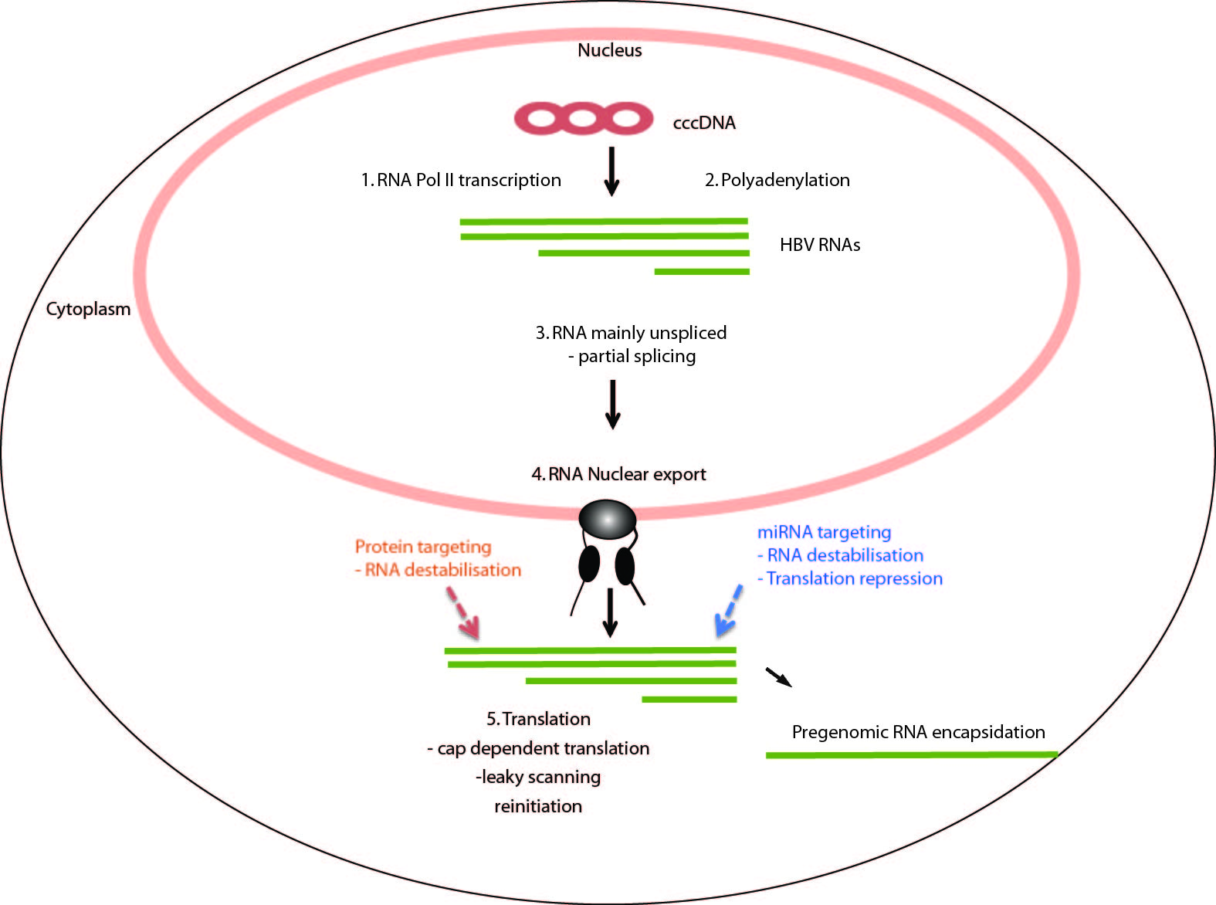

Figure 1 overview of the steps of post-transcriptional processing and translation of hepatitis B virus RNAs. The circular hepatitis B virus (HBV) genome is represented as the closed circular DNA (cccDNA). It encodes four large overlapping open reading frames encoding the core (C), surface (S), polymerase (P) and X proteins. It is transcribed into four main transcripts (HBV RNAs) with common polyadenylation sites and 3' ends. Sites in which the virus uses processes that differ from the host are indicated and reviewed in the text (1) Transcription at specific viral promoters; (2) Non-canonical polyadenylation; (3) Partial splicing; (4) Nuclear export; and (5) Translation by leaky scanning and reinitiation.

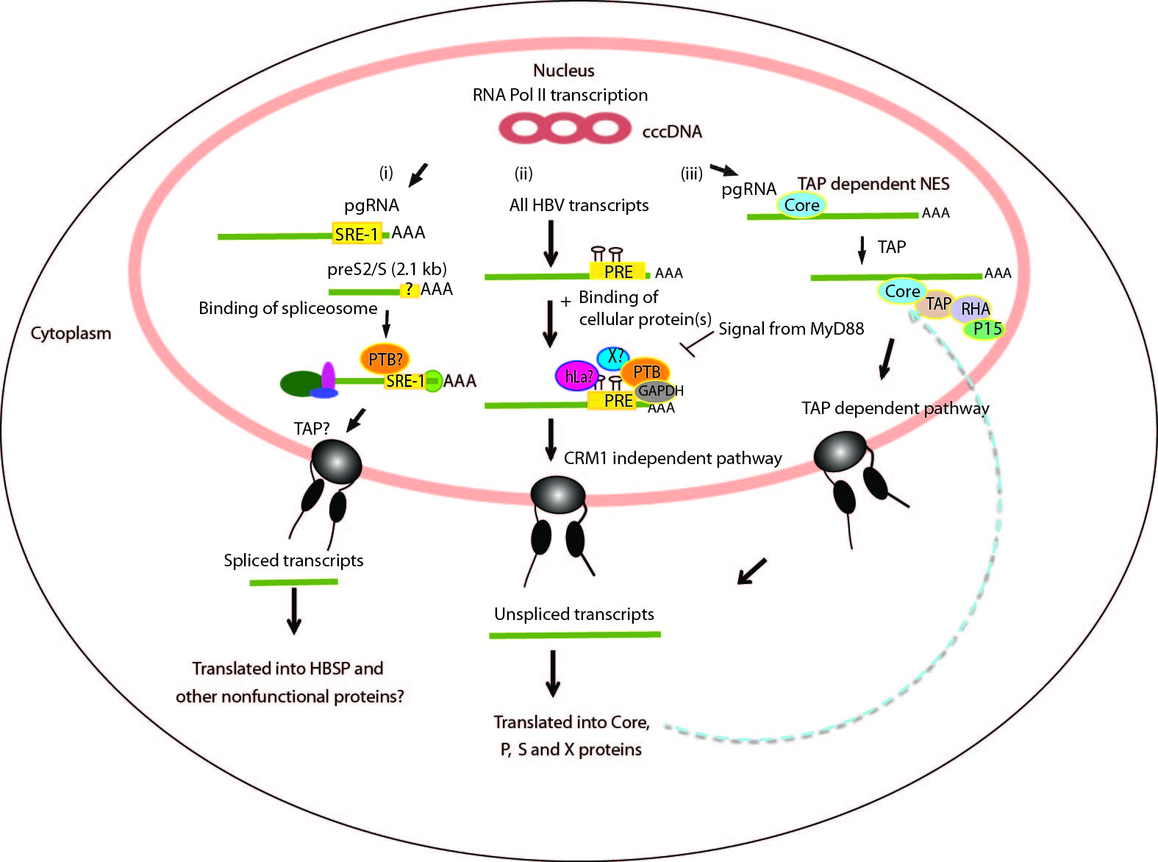
Figure 2 Nuclear export of hepatitis B virus mRNAs. (i) Nuclear export for aberrant spliced hepatitis B virus (HBV) transcripts. In this pathway, HBV post-transcriptional regulatory element (PRE) enhances over-splicing of the pgRNA and perhaps also the S transcripts. The spliced RNAs are then possibly exported out via a TAP pathway. These spliced HBV transcripts are translated into apparently non-functional proteins such as HBSP; (ii) Nuclear export of major HBV unspliced and intronless transcripts e.g. the preS/S and X transcripts. For this pathway, HBV PRE plays roles in inhibiting splicing as well as mediating the nuclear export of the unspliced transcripts. The exact mechanism of this nuclear export pathway is unknown, but may involve binding of cellular proteins (PTB, GAPDH, hLa) near to conserved secondary structures of HBV PRE; and (iii) TAP dependent NES pathway of the pgRNA transcript. The core protein binds the pgRNA facilitating its export though the TAP/NFX1 pathway.
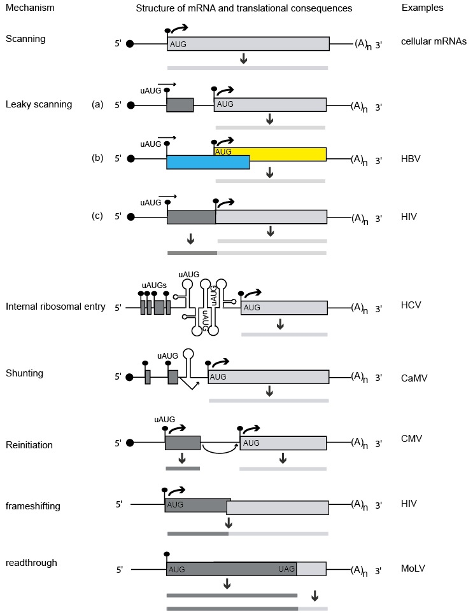
Figure 3 Alternative translation initiation mechanisms used by viruses and cellular mRNAs in eukaryotic cells. The line with a filled circle represents a capped and polyadenylated mRNA with a 5′ UTR and open reading frame. The filled circle represents the cap, filled rectangle denotes an open reading frames, (A)n represents the polyA tail and the curved arrowhead denotes translation initiation. Various strategies for initiating protein synthesis on each mRNA and for decoding its information are outlined. The most common strategy used for cellular mRNAs is the scanning model. Other unconventional translational strategies employed by eukaryotes and exploited by infecting viruses included internal ribosomal entry, shunting, leaky scanning, reinitiation^{[54]}, frameshifting and readthrough^{[53]}. Human immunodeficiency virus and CaMV are related to hepatitis B virus^{[55]}.

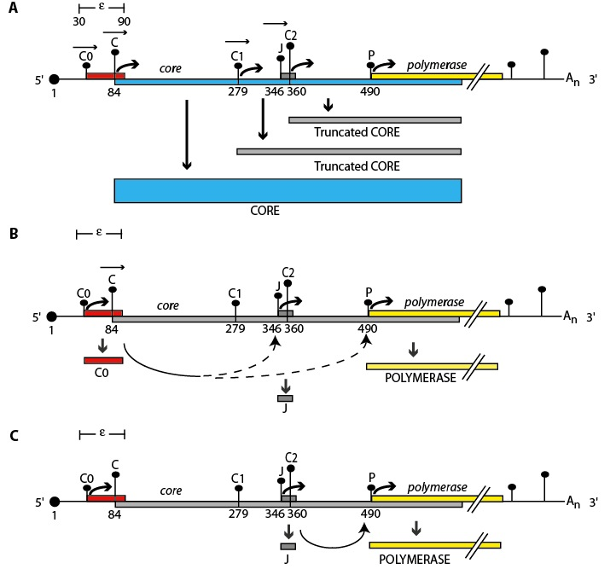
Figure 4 Proposed model for P protein synthesis. A schematic representation of a pgRNA transcript and its coding regions. The pgRNA transcript encodes the core (blue) and polymerase (yellow) genes. The pgRNA transcript start site is numbered 1. The pgRNA contains the ε structure and a repeated sequence of 117 bases in both its 5′ and 3′ ends. Vertical bars with dots represent the initiation codons within the pgRNA labelled C0, C, C1, J, C2 and P. The height of each bar represents the match to the "ideal" initiation context (Kozak’s consensus)^{[15]}. Filled boxes represent ORFs encoded by each initiation codon, (A)n denotes the polyA tail and the black dot at the 5′ end denotes the cap structure. The proposed model for P protein synthesis extends a scanning model. A: Leaky scanning. Ribosomes would scan from the capped 5′ end of the pgRNA, ribosomes would predominantly scan past C0 (in a poor initiation context) and initiate at the C AUG codon (which has an optimal initiation context) synthesising the core. However, some ribosomes may continue to leaky scan (represented by horizontal arrowheads) past the C AUG initiating at distal AUGs (e.g. making truncated core proteins from C1 or C2); B: role of C0. The C0 initiation codon is the first in the pgRNA, some ribosomes would initiate here, when they terminate they could re-initiate at P or J (represented by lower curved arrows). Those that initiate at P would translate the polymerase; C: role of J. Ribosomes which bypass C and C1 AUG codons by leaky scanning would then initiate translation at the J AUG codon (optimal initiation context), translating the short J ORF effectively bypassing the C2 AUG codon. Ribosomes which translated the J ORF may then reinitiate at the P AUG codon, translating the polymerase (curved arrow).

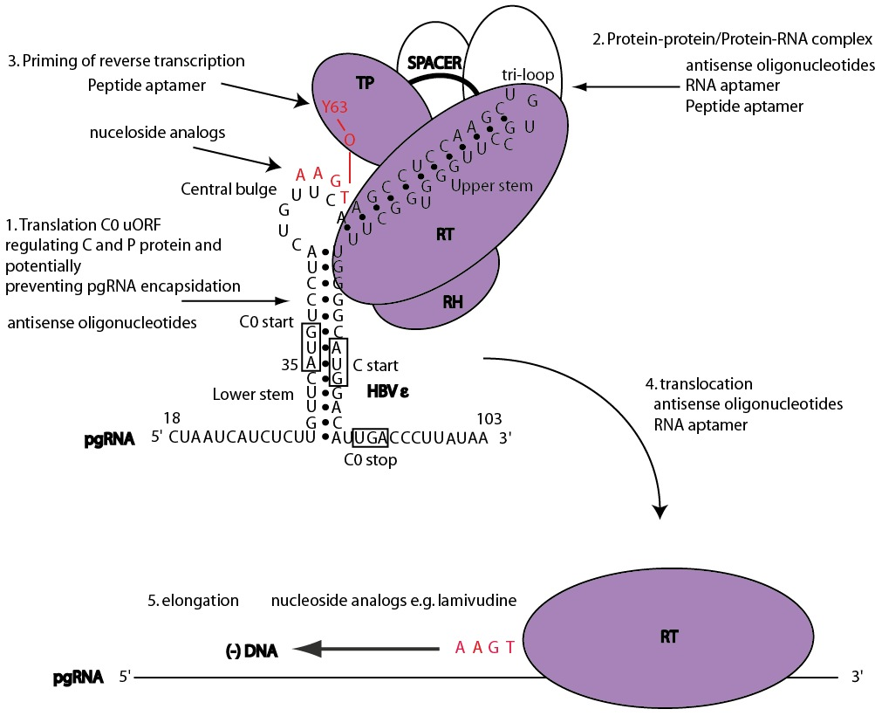
Figure 5 schematic model for the initiation of reverse transcription in hepatitis B virus with stages targetable by existing drugs, as well as potential targets for antiviral compounds. These may serve as a basis to design new strategies combining drugs with different mechanisms of action. Domains of the P protein are abbreviated as follows: terminal protein (TP), RNase H domain (RH), reverse transcriptase domain (RT). Open circles represent cellular chaperones. The initiation of reverse transcription to generate a dsDNA genome involves the pgRNA which is also the template for C and P protein translation. In this model, the C0 ORF which spans the ε structure is also translated (albeit weakly) and could potentially discriminate the selection of pgRNA required for encapsidation and translation (step 1). Secondly, the hepatitis B virus (HBV) P protein would then interact with cellular chaperones (heat shock proteins), the ε structure and gain enzymatic activity (step 2). Next, the reverse transcription step is primed by the formation of covalent bond between conserved tyrosine of the TP domain and the first nt of the minus-strand DNA followed by additions of three more nucleotides, GAA in a template dependent manner (step 3). Following an arrest in the viral DNA synthesis, a strand transfer occurs and the complex of P protein and short DNA primer is translocated to the 3′ end of the template DR1 (step 4). Then, elongation of the minus-strand DNA continues (step 5). Currently, the triphosphate forms of nucleoside analogs have shown inhibitory effects on the priming reaction (targeting step 3) or interfere with viral minus-strand DNA elongation (targeting step 5).

