Name of Journal: World Journal of Experimental Medicine
Manuscript NO: 87143
Manuscript Type: LETTER TO THE EDITOR

Research on nanosciences involvement in pharmaceutical education should be reinforced

Huang ZW et al. Boost nanoscience involvement in pharmaceutical education

Zheng-Wei Huang, Ye-Qi Huang

Zheng-Wei Huang, Ye-Qi Huang, College of Pharmacy, Jinan University, Guangzhou 510006, Guangdong Province, China

Author contributions: Huang Z designed the study and wrote the letter; Huang Y polished the language and prepared the artwork

Supported by National Natural Science Foundation of China, No. 82104070.

Corresponding author: Zheng-Wei Huang, PhD, Assistant Professor, Associate Professor, College of Pharmacy, Jinan University, No. 855 East Xingye Dadao, Panyu District, Guangzhou 510006, Guangdong Province, China. huangzhengw@jnu.edu.cn

Received: July 26, 2023
Revised: September 14, 2023
Accepted: October 8, 2023
Published online:

Abstract
Inclusion of nanoscience in pharmaceutical education should be reinforced, in order to match the demand of current pharmaceutical talent cultivation.

Key Words: Nanosciences; Pharmaceutical education; Talent cultivation; Reformation

Huang Z, Huang Y. Research on nanosciences involvement in pharmaceutical education should be reinforced. World J Exp Med 2023; In press

Core Tip: Nanosciences have currently boosted the development of various disciplines, including pharmaceutical sciences. Theoretically, nanosciences should be involved in pharmaceutical education, in order to cultivate pharmaceutical talents familiar with nanosciences. However, the current courses on nanoscience are insufficient in pharmaceutical curricula, and only a few studies on this topic are documented in databases. It seems that this field is rarely exploited. We therefore urge investigators and educators to perform more studies, and include nanosciences in pharmaceutical education.

TO THE EDITOR
Since the 1990s, nanoscience has gained rapid momentum in research and development. Although nanotoxicology is a rising concern worldwide^{[1]}, and the ethical issues (so-called “nanoethics”)^{[2]} and the ecological risks^{[3]} of nanotechnology have been identified, the application of nanomaterials and nanotechnologies is still a focus.
Consequently, various nanomaterials and nanotechnologies have been developed and introduced into different fields, including the chemical, biological, environmental, medical, and pharmaceutical sciences. In the chemistry field, it is possible to apply nanotechnologies to various chemical compounds, including polymers, to modify their structure and function. In a recent study, metal-organic framework based nano-adsorbents have made a number of noteworthy advances in anti-chemical warfare reagents^{[4]}. In the biology field, one of the most acclaimed achievements in nanotechnology in molecular biology is identification of the vaccination mechanism for coronavirus disease 2019 (COVID-19) using nanoscale vector systems^{[5]}. In the environment field, nanotechnology is utilized not only to enhance the environment but also to produce renewable sources of energy. A paradigmatic example is the employment of nanofluids in solar cells which can produce electricity at a competitive cost^{[6]}. In the medical field, the successful application of nanomedicine has helped to develop enhanced versions of diagnostics, treatment, prevention, and proactive healthcare measures^{[7]}. Recent research has shown that the controllability of nanorobots has advanced, allowing for efficient remodeling of dense tumor stromal microenvironments to enable deep tumor penetration^{[8]}.
As pharmaceutical researchers, the authors of this paper consider that nanoscience is deeply involved in the field of pharmaceutical sciences. The following are several key examples. (1) Pharmaceutical chemistry: one-component new chemical entity nanomedicines are synthesized to enhance therapeutic efficacy^{[9]}; (2) Pharmacology: nanovesicles can be used as analytical tools to investigate cellular signaling pathways^{[10]}; (3) Pharmaceutics: nanoparticles are effective carriers for drug loading and delivery^{[11]}; (4) Pharmaceutical analysis: nanotechnologies can facilitate the separation, identification, and quantification of drug molecules^{[12]}. This information is schematically illustrated in Figure 1.
As nanoscience has become an ever more integral part in pharmaceutical sciences, individuals with pharmaceutical interests (i.e., pharmaceutical scientists, pharmacists, staff in the pharmaceutical industry, and governors in drug administration) should master the relevant knowledge and skills regarding nanoscience. Pharmaceutical education is the fundamental and vital approach for cultivating pharmaceutical talent; hence, pharmaceutical curricula should involve imparting knowledge and skills on nanoscience. However, for several pharmaceutical education systems worldwide, the core courses in pharmaceutical curricula remain focused on the subdisciplines of pharmaceutical sciences (such as pharmaceutical chemistry, pharmacology, pharmaceutics, and pharmaceutical analysis^{[13]} and fundamental chemistry (such as inorganic, organic, and physical chemistry and biochemistry^{[14]}, and courses focused on nanoscience are insufficient or even absent. The reasons for this may include the following: Nanotechnology is a cutting-edge research field; its novelty may present some challenges to the faculty. Even in a nanoscience or nanotechnology training program, some teachers show a preference for teaching more familiar courses so that they can apply the knowledge into the classroom in a timely manner^{[15]}. It is documented that low self-confidence, associated with a lack of knowledge on the new content, sometimes hinders the acceptance and the willingness to use it in the classroom^{[16]}. Another aspect is that the study of basic theoretical subjects is still generally considered necessary in pharmacy education. Some people therefore reject the educational importance of nanoscience, believing that there is no room for a new science curriculum like that^{[17]}.
Moreover, not only are current courses lacking in coverage of nanoscience, retrospective/progressive/prospective studies on the inclusion of nanoscience in pharmaceutical education are also in their infancy. The authors consulted six databases associated with Web of Science (Web of Science Core Collection, Chinese Science Citation Database, KCI-Korean Journal Database, Medline, ProQuest Dissertations & Theses Citation Index, and SciELO Citation Index) using various search sets (Table 1) on July 13, 2023. Documents published between 1965 and 2023 were searched, and all document types and languages were included. Duplicate and irrelevant publications were manually excluded. However, according to the results of the literature survey, only eight documents were retrieved, which was surprisingly low. For comparison, the number of documents on pharmaceutical education and nanoscience were 50537 and 2985487, respectively. These results are shown in a Venn diagram in Figure 2. From the authors' perspective, characterized by interdisciplinarity, nanoscience is a deeply interconnected discipline, encompassing diverse areas of modern science and technology. When taking nanoscience into the classroom, it has been confronted with the dilemma of whether it should be taught as a new or a subsidiary discipline. Accordingly, the intricate nature of nanoscience may be the possible reason that has resulted in a scarcity of research exploring its intersection with a specialized field such as pharmacy education.
Overall, the current scenario is that insufficient attention has been paid to the inclusion of nanoscience into pharmaceutical education. Consequently, the cultivation of pharmaceutical talents mastering the required knowledge and skills of nanoscience cannot be guaranteed. With the continuous development of nanoscience, its inclusion in pharmaceutical science will become more comprehensive in the future. It is worth noting that the market for nanomedicines for disease management has great potential. The global market for nanomedicine was estimated at $53 billion in 2009. It is expected to grow by 13.5% to reach $100 billion in recent years^{[18]}. These data demonstrate global interest in the nanoscience field. Therapeutic formulations utilizing nanotechnology hold potential for improving clinical outcome. Engineered nanomaterials are rapidly evolving in drug development, and offer promise in overcoming biological barriers and achieving precise drug delivery for precision medicine^{[19]}. In addition, the potential of nanotechnology in pharmacy will be further expanded with efforts to combine nanomaterials with some established formulations. Recent studies have pointed out that the combined properties of hydrogels and nanoparticles in smart nanogels can improve drug loading capacity, drug stability, target delivery and therapeutic efficacy^{[20]}. Considering these factors, it is foreseeable that nanotechnology will become more widely and tightly integrated into pharmaceuticals in the future. Thus, correspondingly, continued efforts are required to promote the inclusion of nanoscience in pharmaceutical education.
To achieve this aim, the authors propose three suggestions:
Firstly, colleges and universities should establish scientific foundations for the educational reformation of nanoscience courses; the role of foundations in support of the education process is essential. A positive example to be studied is the National Science Foundation (NSF). The NSF is charged with funding basic research programs to maximize the advancement of science in the United States through the development of scientific information. In the National Nanotechnology Initiative, NSF assumed responsibility for funding basic research and education in nanoscience and nanotechnology, leading to a healthy growth of nanotechnology in the United States^{[21]}. Referring to the operation and supporting model of NSF, sufficient attention from colleges and universities should be given to the investment of adequate funding to meet the development of nanoscience in pharmacy education.
Secondly, faculties must initiate changes to their curricular systems and add nanoscience courses. In the post-pandemic era, the rate of change in healthcare has rapidly accelerated. Consequently, healthcare professionals must dedicate themselves to lifelong learning through continuing education and professional development programs, including those associated with nanoscience^{[22]}. For instance, teachers should learn about the applications of nanotechnology in COVID-19 treatment, and pass this knowledge to the students in the classroom. Through these efforts, students can gain scientific and technological literacy, which has a significant impact on curriculum design^{15]}. It can also serve as an effective means of bridging the gap between workforce needs and cutting-edge fields^{[23]}.
Lastly, journals, such as the World Journal of Experimental Medicine, should encourage the submission of relevant studies as a publishing platform. Currently, the evaluation of papers by impact factor is still the dominant approach used by journals. However, this single-factor approach has led to much discussion about its update or revolution^{[24]}, and the actual implication of papers for the real world should be reconsidered. As a publishing platform, considering and encouraging papers based on multiple factors may be a positive guide for the conduct of research focusing on a rare field (the very scenario of nanoscience education in pharmacy). The authors envision that the degree of inclusion of nanoscience in pharmaceutical education can be increased in the near future.
In summary, nanoscience is rapidly evolving in a number of disciplines and fields. It has been widely used in the fields of chemistry, biology, environment, medicine, and pharmacy, and has attracted much attention. Especially in the field of pharmacy, nanoscience and nanotechnology have played a significant role. However, at present, the coverage of nanoscience in pharmaceutical courses and educational studies is lacking, which is detrimental to the cultivation of talents in this field. The gaps in this area should be further addressed by all groups. We propose three suggestions to boost the inclusion of nanoscience in pharmacy education, viz. (1) Colleges and universities should establish scientific foundations for the educational reformation of nanoscience courses; (2) faculties must initiate changes to their curricular systems and add nanoscience courses; and (3) journals should encourage the submission of relevant studies as a publishing platform. Similar to the situation in pharmacy education, clinical medicine training should also include more courses on nanotechnology, and we will be conducting in-depth research on this topic in the future.

REFERENCES
1 Jamil B, Javed R, Qazi AS, Syed MA. Nanomaterials: Toxicity, Risk Managment and Public Perception. In: Rai M, Biswas JK, editors. Nanomaterials: Ecotoxicity, Safety, and Public Perception. Cham: Springer International Publishing; 2018: 283-304 [DOI: 10.1007/978-3-030-05144-0_14]
2 Mohanta D, Ahmaruzzaman M. Addressing Nanotoxicity: Green Nanotechnology for a Sustainable Future. In: Hussain CM, editor. The ELSI Handbook of Nanotechnology: Risk, Safety, ELSI and Commercialization. Scrivener Publishing LLC, 2020: 103-116 [DOI: 10.1002/9781119592990.ch6]
3 Zafar H, Javed R, Zia M. Nanotoxicity assessment in plants: an updated overview. Environ Sci Pollut Res Int 2023; 30: 93323-93344 [PMID: 37544947 DOI: 10.1007/s11356-023-29150-z]
4 Song Y, Peng C, Iqbal Z, Sirkar KK, Peterson GW, Mahle JJ, Buchanan JH. Graphene Oxide and Metal-Organic Framework-Based Breathable Barrier Membranes for Toxic Vapors. ACS Appl Mater Interfaces 2022; 14: 31321-31331 [PMID: 35771504 DOI: 10.1021/acsami.2c07989]
5 Kisby T, Yilmazer A, Kostarelos K. Reasons for success and lessons learnt from nanoscale vaccines against COVID-19. Nat Nanotechnol 2021; 16: 843-850 [PMID: 34381200 DOI: 10.1038/s41565-021-00946-9]
6 Hussein AKJR, Reviews SE. Applications of nanotechnology to improve the performance of solar collectors – Recent advances and overview. Renew Sustain Energy Rev 2016; 62: 767-792 [DOI: 10.1016/j.rser.2016.04.050]
7 Sandow J. Drug Discovery and Evaluation: Methods in Clinical Pharmacology: Drug Discovery and Evaluation: Methods in Clinical Pharmacology; 2011
8 Yan M, Chen Q, Liu T, Li X, Pei P, Zhou L, Zhou S, Zhang R, Liang K, Dong J, Wei X, Wang J, Terasaki O, Chen P, Gu Z, Jiang L, Kong B. Site-selective superassembly of biomimetic nanorobots enabling deep penetration into tumor with stiff stroma. Nat Commun 2023; 14: 4628 [PMID: 37532754 DOI: 10.1038/s41467-023-40300-2]
9 Ma Z, Li J, Lin K, Ramachandran M, Zhang D, Showalter M, De Souza C, Lindstrom A, Solano LN, Jia B, Urayama S, Duan Y, Fiehn O, Lin TY, Li M, Li Y. Author Correction: Pharmacophore hybridisation and nanoscale assembly to discover self-delivering lysosomotropic new-chemical entities for cancer therapy. Nat Commun 2021; 12: 2013 [PMID: 33767181 DOI: 10.1038/s41467-021-22419-2]
10 Kadry MO, Abdel Megeed RM. Ubiquitous toxicity of Mercuric Chloride in target tissues and organs: Impact of Ubidecarenone and liposomal-Ubidecarenone STAT 5A/ PTEN /PI3K/AKT signaling pathways. J Trace Elem Med Biol 2022; 74: 127058 [PMID: 35952450 DOI: 10.1016/j.jtemb.2022.127058]
11 Nel J, Elkhoury K, Velot É, Bianchi A, Acherar S, Francius G, Tamayol A, Grandemange S, Arab-Tehrany E. Functionalized liposomes for targeted breast cancer drug delivery. Bioact Mater 2023; 24: 401-437 [PMID: 36632508 DOI: 10.1016/j.bioactmat.2022.12.027]
12 Wang YF, Pan MM, Yu X, Xu L. The Recent Advances of Fluorescent Sensors Based on Molecularly Imprinted Fluorescent Nanoparticles for Pharmaceutical Analysis. Curr Med Sci 2020; 40: 407-421 [PMID: 32681246 DOI: 10.1007/s11596-020-2195-z]
13 Zheng H, Hu BJ, Sun Q, Cao J, Liu FM. Applying a Chemical Structure Teaching Method in the Pharmaceutical Analysis Curriculum to Improve Student Engagement and Learning. J Chem Educ 2020; 97: 421-426 [DOI: 10.1021/acs.jchemed.9b00551]
14 Ali RM, Idoudi S, Abdulrahman N, Mraiche F. Biotechnology content in pharmacy curricula: Focus on Arab Countries. Curr Pharm Teach Learn 2023; 15: 654-660 [PMID: 37481456 DOI: 10.1016/j.cptl.2023.07.001]
15 Spyrtou A, Manou L, Peikos G. Educational Significance of Nanoscience–Nanotechnology: Primary School Teachers’ and Students’ Voices after a Training Program. Educ Sci (Basel) 2021; 11: 724 [DOI: 10.3390/educsci11110724]
16 Bitan-Friedlander N, Dreyfus A, Milgrom Z. Types of “teachers in training”: the reactions of primary school science teachers when confronted with the task of implementing an innovation. Teach Teach Educ 2004; 20: 607-619 [DOI: 10.1016/j.tate.2004.06.007]
17 Healy N. Why Nano Education? J Nano Educ 2009; 1: 6-7 [DOI: 10.1166/jne.2009.004]
18 Mittal D, Ali A, Md S, Baboota S, Sahni JK, Ali J. Insights into direct nose to brain delivery: current status and future perspective. Drug Deliv 2014; 21: 75-86 [PMID: 24102636 DOI: 10.3109/10717544.2013.838713]
19 Mitchell MJ, Billingsley MM, Haley RM, Wechsler ME, Peppas NA, Langer R. Engineering precision nanoparticles for drug delivery. Nat Rev Drug Discov 2021; 20: 101-124 [PMID: 33277608 DOI: 10.1038/s41573-020-0090-8]
20 Bhaladhare S, Bhattacharjee S. Chemical, physical, and biological stimuli-responsive nanogels for biomedical applications (mechanisms, concepts, and advancements): A review. Int J Biol Macromol 2023; 226: 535-553 [PMID: 36521697 DOI: 10.1016/j.ijbiomac.2022.12.076]
21 Lukishova S, Bigelow N. Undergraduate program in nanoscience and nanoengineering: five years after the National Science Foundation grant including two pandemic years. Optical Engineering 2022; 61: 081810 [DOI: 10.1117/1.oe.61.8.081810]
22 Lok P, Beyene K, Awaisu A, Woods D, Kheir N. Microcredentials training in pharmacy practice and education: an exploratory study of its viability and pharmacists' professional needs. BMC Med Educ 2022; 22: 332 [PMID: 35488266 DOI: 10.1186/s12909-022-03341-7]
23 Hart D. Closing the Nanotechnology Workforce Gap [Nano Safety and Education]. IEEE Nanotechnology Magazine 2012; 6: 27-28 [DOI: 10.1109/MNANO.2012.2192656]
24 Rousseau R. Updating the journal impact factor or total overhaul? Scientometrics 2012; 92: 413-417 [DOI: 10.1007/s11192-012-0649-1]

Footnotes
Conflict-of-interest statement: All the authors declare that they have no conflict of interest.

Open-Access: This article is an open-access article that was selected by an in-house editor and fully peer-reviewed by external reviewers. It is distributed in accordance with the Creative Commons Attribution NonCommercial (CC BY-NC 4.0) license, which permits others to distribute, remix, adapt, build upon this work non-commercially, and license their derivative works on different terms, provided the original work is properly cited and the use is non-commercial. See: https://creativecommons.org/Licenses/by-nc/4.0/

Provenance and peer review: Invited article; Externally peer reviewed.
Peer-review model: Single blind

Peer-review started: July 26, 2023
First decision: August 31, 2023
Article in press:

Specialty type: Nanoscience and nanotechnology
Country/Territory of origin: China
Peer-review report’s scientific quality classification
Grade A (Excellent): A
Grade B (Very good): B
Grade C (Good): C
Grade D (Fair): 0
Grade E (Poor): 0

P-Reviewer: Ataei-Pirkooh A, Iran; Bugaj AM, Poland; Emran TB, Bangladesh S-Editor: Liu JH L-Editor: Webster JR P-Editor:
Figure Legends
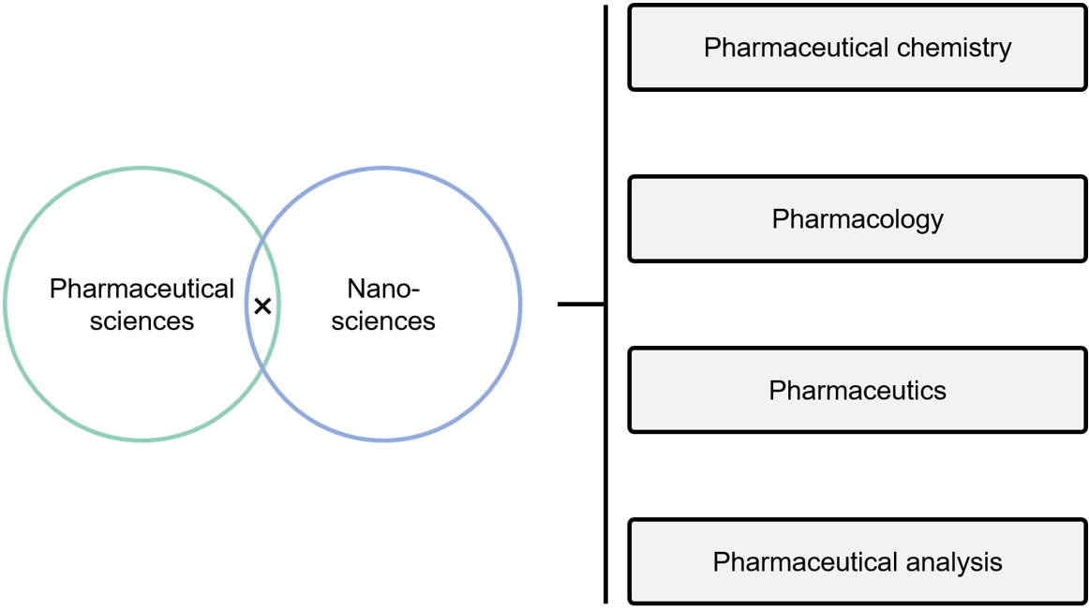
Figure 1 Main applications of nanoscience and nanotechnology in pharmaceutical sciences.
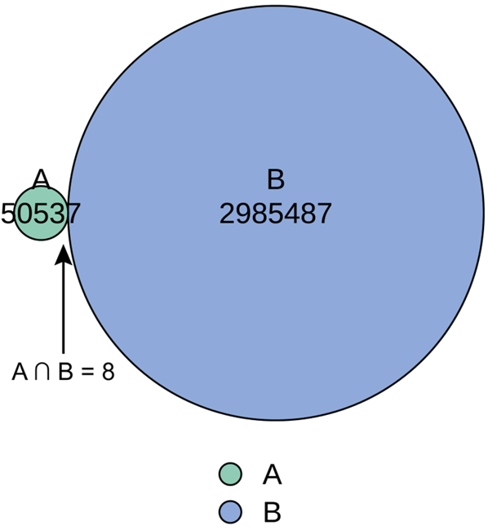
Figure 2 Euler Venn diagram showing the intersection of the publications on pharmaceutical education (A) and nanoscience (B).
Table 1 Search sets for literature retrieval
Step | Search set | Interpretation
#1 | TS = pharmacy educat¹, TS = pharmaceutical educat¹, TS = pharmacy train¹, TS = pharmaceutical train¹, TS = pharmacy curricul¹, TS = pharmaceutical curricul¹ | Pharmaceutical education as the topic
#2 | TS = nano¹ | Nano-related terms as the topic
#3 | #1 AND #2 | Intersection of #1 and #2
¹Is an infinite truncator, which allows the term to be infinitely expanded.

