Name of Journal: World Journal of Clinical Cases
Manuscript NO: 78102
Manuscript Type: EDITORIAL

Evolution of World Journal of Clinical Cases over the past 5 years

Muthu S. Evolution of World J Clinical Cases

Sathish Muthu

Sathish Muthu, Department of Orthopaedics, Government Medical College, Dindigul 624001, Tamil Nadu, India

Sathish Muthu, Orthopaedic Research Group, Coimbatore 641045, Tamil Nadu, India

Sathish Muthu, Department of Biotechnology, Sharda University, New Delhi 201310, Uttar Pradesh, India

Author contributions: Muthu S contributed to conceptualization, methodology, formal analysis and investigation, original draft preparation, manuscript review and editing, resources, and supervision.

Corresponding author: Sathish Muthu, DNB, MS, Assistant Professor, Research Associate, Department of Orthopaedics, Government Medical College, Dindigul 624001, Tamil Nadu, India. drsathishmuthu@gmail.com

Received: June 7, 2022
Revised: June 27, 2022
Accepted: July 20, 2022
Published online:

Abstract
Analysis of the articles published in any journal is necessary to ascertain the performance of the journal in the academia. The author made a scientometric analysis of the articles published in the World Journal of Clinical Cases in the past 5 years and present the data to the readers.

Key Words: World Journal of Clinical Cases; Scientific journal; Research publication; Keywords; Scientometrics; Trend analysis

Muthu S. Evolution of World Journal of Clinical Cases over the past 5 years. World J Clin Cases 2022; In press

Core Tip: We analysed the articles published in the World Journal of Clinical Cases to illustrate the journal performance in the past 5 years. The author demonstrated that the journal has been growing with time with appropriate publication standards as per the COPE guidelines. The journal has a wide spectrum of published articles covering various domains of medicine to meet the aims and scope of the journal.

INTRODUCTION
The World Journal of Clinical Cases started out publishing high-quality peer-reviewed articles since 2013^{[1]}. In this letter I would like to present a short summary of the performance of the journal in the past 5 years. A scientometric analysis was performed using the metadata of the articles published in the journal and indexed in Web of Science and Reference Citation Analysis^{[2]} database over the past 5 years (2017-2021). Visualisation of the data was made using CiteSpace software^{[3]}.

Publication volume
The journal published 2792 articles between 2017 and 2021. The journal experienced three times growth in the number of publications with 12 issues in 2017 covering 452 pages in Volume 5 to 36 issues in 2021 covering 11508 pages in Volume 9. Similarly, the number of published articles rose from 71 in 2017 to 1296 in 2021 as shown in Figure 1.

Institutional network
Of the 2792 analysed articles, the top contributors were from Zhejiang University (143), Capital Medical University (129), China Medical University (99), Sichuan University (91), and Jilin University (82).

Country network
The People’s Republic of China contributed to 71% (1982) of the total publications in the past 5 years, followed by South Korea (160), United States (127), Japan (111), and Italy (74).

Cited references
In order to analyse the self-citation policy, analysis was made on the journals of the cited references from the included publications in the past 5 years. A total of 731 journals were cited in the 31774 references analysed. The top cited journals were New England Journal of Medicine (622), Lancet (538), World Journal of Gastroenterology (518), Medicine (460), and PLOS One (416). This proves that the journal was adherent to the self-citation policy with only 122 self-citations, which account for 0.3% of the total references analysed.

Keyword cluster analysis
On analysing the keywords of the included articles, clustering of the keywords was made to represent the subject of the included articles. The top clusters in the included articles were #0 case report, #1 colorectal cancer, #2 inflammatory bowel disease, #3 hepatocellular carcinoma, #4 neoadjuvant chemoradiotherapy, and #5 coronavirus disease. Network of the included clusters is represented in Figure 2.

Publication trend analysis
On analysing the timeline of the keywords among the top clusters we noted that the recent publication trends revolved around the research domains like oncology, chemoradiotherapy, and coronavirus disease as shown in Figure 3.

Citation Analysis
The 2792 articles published in past 5 years accumulated a total citation count of 5285 (as of June 6, 2022). Average citation per article was 1.89. Based on the articles published in the past 5 years, the H-index of the journal was 22 (as of June 6, 2022). The article by Ren et al^{[4]} titled “Fear can be more harmful than the severe acute respiratory syndrome coronavirus 2 in controlling the coronavirus disease 2019 epidemic” is the most cited article of the journal with 134 citations (as of June 6, 2022). The rate of publication and the citation frequency are given in Figure 4. The journal demonstrates a Journal Impact Factor of 1.534 based on Journal Citation Reports 2022 and Journal Article Influence Index of 1.89^{[2]} ranking 135 among 172 journals in the category of Medicine, General and Internal^{[5]}.

CONCLUSION
We demonstrated that the journal has been growing with time with appropriate publication standards as per the COPE guidelines^{[6]}. The journal has a wide spectrum of published articles covering various domains of medicine to meet the aims and scope of the journal.

REFERENCES
1 Yoshida S. What is the purpose of launching the World Journal of Clinical Cases? World J Clin Cases 2013; 1: 1-3 [PMID: 24303452 DOI: 10.12998/wjcc.v1.i1.1]
2 Reference Citation Analysis - Baishideng Publishing Group. Available from: https://www.referencecitationanalysis.com/
3 Chen C. CiteSpace: A Practical Guide for Mapping Scientific Literature.
4 Ren SY, Gao RD, Chen YL. Fear can be more harmful than the severe acute respiratory syndrome coronavirus 2 in controlling the corona virus disease 2019 epidemic. World J Clin Cases 2020; 8: 652-657 [PMID: 32149049 DOI: 10.12998/wjcc.v8.i4.652]
5 2022 Journal Impact Factor, Journal Citation Reports (Clarivate, 2022) Available from: https://clarivate.com/webofsciencegroup/solutions/journal-citation-reports/
6 COPE: Committee on Publication Ethics. COPE: Committee on Publication Ethics. Available from: https://publicationethics.org/

Footnotes
Conflict-of-interest statement: The author is an editorial board member of the World Journal of Clinical Cases.

Open-Access: This article is an open-access article that was selected by an in-house editor and fully peer-reviewed by external reviewers. It is distributed in accordance with the Creative Commons Attribution NonCommercial (CC BY-NC 4.0) license, which permits others to distribute, remix, adapt, build upon this work non-commercially, and license their derivative works on different terms, provided the original work is properly cited and the use is non-commercial. See: https://creativecommons.org/Licenses/by-nc/4.0/

Provenance and peer review: Invited article; Externally peer reviewed.
Peer-review model: Single blind

Peer-review started: June 7, 2022
First decision: June 27, 2022
Article in press:

Specialty type: Scientific journal
Country/Territory of origin: India
Peer-review report’s scientific quality classification
Grade A (Excellent): A
Grade B (Very good): B
Grade C (Good): 0
Grade D (Fair): 0
Grade E (Poor): 0

P-Reviewer: Wu CC, Taiwan; Tan X, China S-Editor: Liu JH L-Editor: Wang TQ P-Editor:
Figure Legends
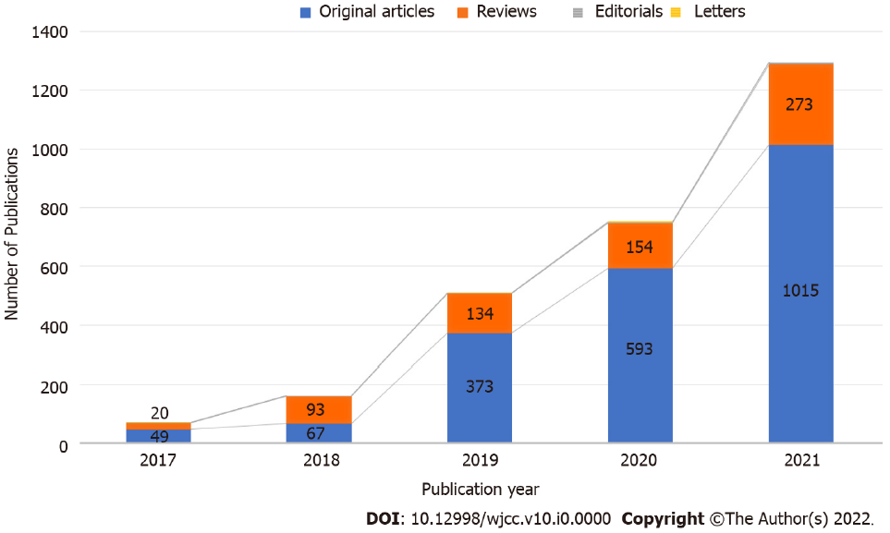
Figure 1 Trend of growth in the number of publications in the past 5 years.
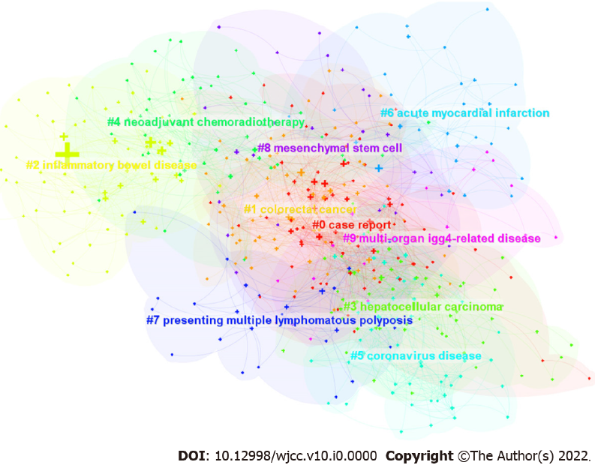
Figure 2 Network map of keyword clusters of the publication in the past 5 years.
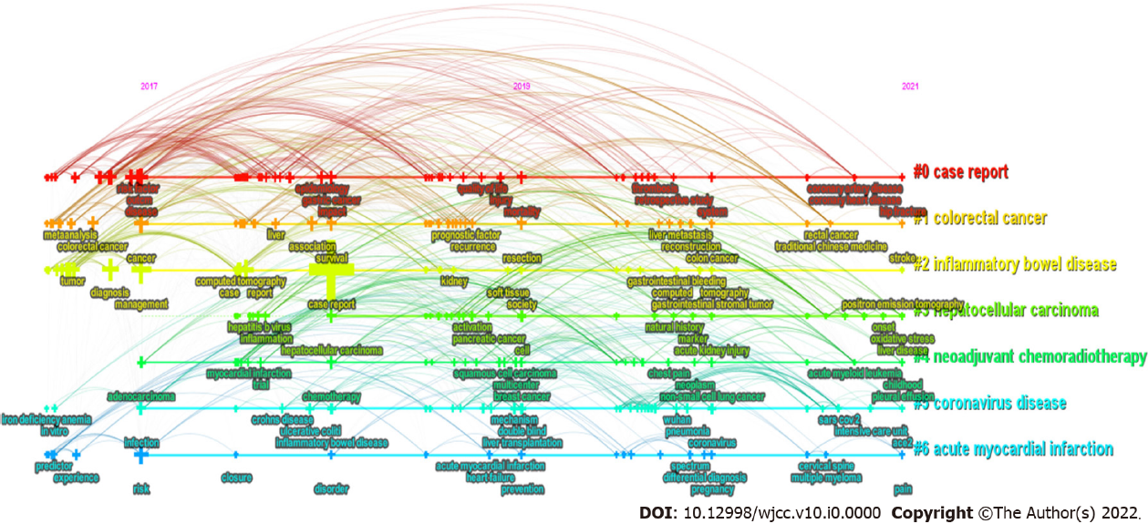
Figure 3 Timeline analysis of research publication trend.
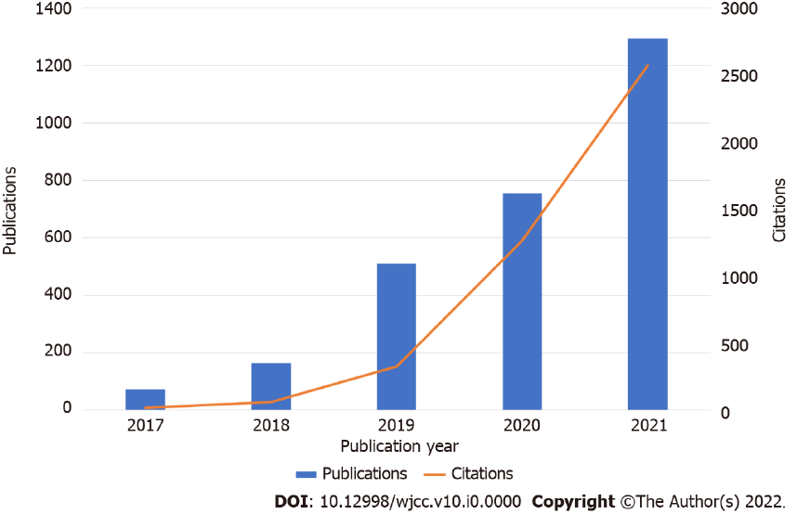
Figure 4 Relationship between annual publications and citations.

