Name of Journal: World Journal of Gastrointestinal Endoscopy
Manuscript NO: 85431
Manuscript Type: CASE REPORT

Hybrid laparo-endoscopic access: New approach to surgical treatment for giant fibrovascular polyp of esophagus: A case report and review of literature

Dzhantukhanova S et al. Treatment for giant fibrovascular polyp

Seda Dzhantukhanova, Lyudmila Grigori Avetisyan, Amina Badakhova, Yury Starkov, Andrey Glotov

Seda Dzhantukhanova, Department of Surgical Endoscopic, The Vishnevsky National Medical Research Center of Surgery, Moscow 115093, Russia

Lyudmila Grigori Avetisyan, Faculty of General Medicine, Yerevan State Medical University, Yerevan 0025, Armenia

Amina Badakhova, Yury Starkov, Department of Surgical Endoscopic, The Vishnevsky National Medical Research Center of Surgery, Ministry of Health of Russia, Moscow 115093, Russia

Andrey Glotov, Department of Morphologist, The Vishnevsky National Medical Research Center of Surgery, Ministry of Health of Russia, Moscow 115093, Russia

Author contributions: Dzhantukhanova SV and Starkov YG contributed equally to this work; Dzhantukhanova SV, Starkov YG - concept and design of the study, editing, approval of the final version of the article; Badakhova AB, Avetisyan L - concept and design of the study, writing text, editing; Glotov AV - contributed new reagents and analytic tools.

Corresponding author: Amina Badakhova, MD, Doctor, Surgeon, Department of Surgical Endoscopic, The Vishnevsky National Medical Research Center of Surgery, Ministry of Health of Russia, Bolshaya Serpukhovskaya, 27, Moscow 115093, Russia. badakhovaamina@mail.ru

Received: May 10, 2023
Revised: August 3, 2023
Accepted: September 22, 2023
Published online: November 16, 2023

Abstract
BACKGROUND
Fibrovascular polyps are rare type of esophageal submucosal neoplasms. They are highly vascularized and can cause difficulty swallowing and even fatal complications such as uncontrolled bleeding and death caused by asphyxiation in case of tumor migration to oropharynx. In the article we describe a novel hybrid technique to surgical treatment – an endoscopic submucosal dissection with laparoscopic removal of the tumor.

CASE SUMMARY
The patient with a giant fibrovascular esophageal polyp presented with cough, discomfort in the throat, difficulty swallowing, and an episode of tumor migration into oropharynx. The patient was investigated with several imaging studies and was diagnosed with a giant highly vascularized esophageal fibrovascular polyp. The follow-up period of eight months accompanied with no complications.

CONCLUSION
This method has been shown to have comparable rates of recurrence and a low risk of complications.

Key Words: Esophagus; Fibrovascular polyp; Benign esophageal tumor; Endoscopic resection; Minimal invasive surgery; Case report

©The Author(s) 2023. Published by Baishideng Publishing Group Inc. All rights reserved.

Citation: Dzhantukhanova S, Avetisyan LG, Badakhova A, Starkov Y, Glotov A. Hybrid laparo-endoscopic access: New approach to surgical treatment for giant fibrovascular polyp of esophagus: A case report and review of literature. World J Gastrointest Endosc 2023; 15(11): 666-675
URL: https://www.wjgnet.com/1948-5190/full/v15/i11/666.htm
DOI: https://dx.doi.org/10.4253/wjge.v15.i11.666

Core Tip: In our case the patient was investigated with several imaging studies and was diagnosed with a giant highly vascularized esophageal fibrovascular polyp. It is crucial to consider the size and vascularization of fibrovascular polyps when assume endoscopic removal as a treatment option and to carefully plan the surgical technique to avoid difficulties or discomfort during the procedure. However, there is an alternative approach to traditional surgical removal known as the endoscopic approach that can be both safe and effective for treating giant fibrovascular polyps in the esophagus. Therefore, the aim of our study is to demonstrate demonstrate a novel hybrid technique to surgical treatment – an endoscopic submucosal dissection with laparoscopic removal of the tumor.

INTRODUCTION
Fibrovascular polyp (FVP) are rare (approximately 0.03% of esophageal tumors), benign, richly vascularized tumors of the esophagus or hypopharynx^{[1]}. The etiology of this disease has yet to be well-known. Esophageal fibrovascular polyps arise from the submucosal layer of the esophagus and usually are covered with normal mucosa, mostly appearing from the esophagus's upper third. Also, the lesions can be attached to the inferior aspect of the cricopharyngeal muscle and often have a stalk. Histologically the polyp contains loose or dense fibrous tissue, adipose tissue, and vascular structures^{[2]}.
In the early stages, FVP are clinically asymptomatic. The clinical symptoms correlate with the size of the tumor. The most common complaints are dysphagia, chest discomfort, and foreign body sensation^{[2]}. There can also present other symptoms, such as odynophagia, dyspnea, coughing, neck pain, respiratory distress, and gastrointestinal bleeding^{[3]}.The most common complications that can cause even fatal exits are fatal bleeding and airway obstruction due to the aspiration of a tumor.
Even though in the modern world of the 21st century there are a lot of technologies and facilitating methods of diagnosis and treatment, the difficulties are still relevant. Furthermore, depending on the size of the polyp, there can be either endoscopic or surgical resection^{[4]}.

CASE PRESENTATION
Chief complaints
A 70-year-old female presented to the endoscopic surgical department of the A. V. Vishnevsky National Medical Research Center of Surgery in October 2022.
On admission, the patient complained of cough, dysphagia, discomfort in the throat, and the presence of large soft mass in the esophagus with episodes of its migration into oropharynx. The patient was examined.

History of present illness
During the last 5 years, a tumor was discovered during the examination and an episode of tumor migration into oropharynx.

History of past illness
The patient has consistently maintained a state of general well-being throughout her life, without encountering notable medical complications. Nevertheless, the patient mentioned that she has experienced persistent elevation of blood pressure, for which she received a diagnosis of stage 1 arterial hypertension (measuring between 140-145 mm Hg). In an effort to regulate her blood pressure levels, perindopril and indapamide in combination (marketed as Noliprel) were prescribed for her.
No allergies, recent infections, or harmful habits (such as smoking, alcohol consumption, or drug use) were reported. There is no family or personal history of genetic hypertension/cardiovascular issues; the elevated pressure seems to be linked to lifestyle factors. Apart from the prescribed anti hypertensives, the patient did not mention the use of any concurrent medications or supplements.

Personal and family history
The patient is married and has two daughters. No significant family medical history of diseases or conditions pronounced.

Physical examination
The Patient observed without any signs of visible immediate discomfort. Upon admission, the vital signs were measured: blood pressure at 140/80 mmHg, heart rate at 72 bpm, temperature at 98.6°F (37°C), and oxygen saturation at 98%. A thorough examination of all organ systems was done, and no abnormalities were found.
During the palpation the abdomen was non-tender, without masses, and both the liver and spleen were non-palpable below the rib cage. No palpable lymph nodes were found in cervical, axillary, or inguinal areas. Patient reported no discomfort during palpation.

Laboratory examinations
The blood count and coagulation assessment results revealed that all measured parameters resided comfortably within established normative reference intervals. The concentration of Albumin manifested at 3.73 g/dL, alanine transaminase at 8 g/dL, and Aspartate transaminase at 26 g/dL, as shown in Table 1.

Imaging examinations
The upper gastrointestinal (GI) endoscopy showed a base of non-epithelial tumor right behind the upper esophageal sphincter (UES). Tumor continues distally throughout the esophagus, freely locating and occupying almost the entire space of esophageal lumen. The neoplasm was a 25 cm in length and 4-5 cm width in the distal part, covered by a normal mucosa of squamous esophageal epithelium. Also, there was significant dilation of the esophagus due to a large size of the tumor, maximum up to 6 cm in middle and lower thirds. The tumor had a complex configuration, the distal part of the tumor splits into two parts and it reaches the stomach cardia. On retroflexion the distal part of non-epithelial neoplasm is visible in the gastric lumen, size of the diaphragmatic crura is up to 5 cm with sliding of cardia and fungus above diaphragm during examination - signs of sliding hiatal cardiofundal hernia (Figure 1A and B).
For identification of tumor features, type of growth and localization related to layers of the esophageal walls, an endoscopic ultrasound (EUS) was done. An ultrasound scanning showed heterogeneous hypo-echoic neoplasm with a smooth, clear-contoured, irregular cylindrical shape. The base of the tumor is located right behind the UES and originates from the submucosal layer of the esophagus (3rd echo-layer), type 1 according to the classification of non-epithelial tumors of the gastrointestinal tract^{[5]}. The doppler color mode showed a hypervascular zone at the base of the tumor with multiple large feeding vessels, up to 4-5 mm in diameter, extending along the wall of the esophagus for 8-10 cm. Paragastric lymphatic nodes are not enlarged (Figure 2A and B). EUS imaging, most likely, corresponded to a FVP of the esophagus.
Computed tomography (CT) with intravenous contrast enhancement revealed an expansion of the esophagus up to 5-6 cm in the distal part, a hypervascular neoplasm in the lumen of the esophagus extending throughout the entire length from UES to the gastric cardia with a maximum diameter of up to 6 cm (Figure 3A and B).

FINAL DIAGNOSIS
Fibrovascular polyp with foci of highly differentiated liposarcoma, tumor tissue at the sight of endoscopic dissection is not determined, R0, М 8850/3; Grade 1.

TREATMENT
Hybrid laparo-endoscopic access - endoscopic submucosal dissection with laparoscopic removal of the tumor.

The course of intervention
Before to start an endoscopic submucosal dissection (ESD) first step of the procedure was creating a lifting by injection of Gelofusine solution dyed with indigo carmine into submucosal layer. Thereafter, using an endoscopic knife, a dissection of the mucosa and submucosal layer was performed immediately behind UES in horizontal plane (Figure 4А). In order to achieve a stable position of the endoscope in the submucosal layer, a transparent dissection cap was installed on the distal end of the endoscope according to the standard ESD technique. Next, the steps of dissection in the submucosal layer were performed up to 11 cm distally until the tumor was completely cut off at the base. For the dissection of the submucosal layer an endoscopic knife was used. For the coagulation of large feeding vessels in the submucosal layer a coagrasper was used. Using high frequent electro generator, the larger vessels of the submucosal layer were coagulated using <Soft coagulation> mode and the smaller vessels using <Spray coagulation> mode (Figure 4B-D). On the control endoscopic view the area of ESD was 1.5 cm × 2.5 cm × 11 cm in size.
The expected challenges of surgical intervention for esophageal FVP are the technical difficulties of adequate endoscope positioning, instrumental manipulations, and exposure of the surgical field because of anatomically limited space of UES, which corresponds to area of tumor base. One more challenge is the transoral extraction of the tumor with a high risk of stuck of the tumor in a small space of UES and oropharynx due to the large size of the tumor especially in the distal part. That is why we decided to implement an innovative technique - a hybrid laparo-endoscopic approach. After complete excision of the tumor by ESD technique at the base, the neoplasm was brought down into the stomach and removed through a laparoscopic gastrotomy (Figure 5А and B). The detection of the neoplasm did not entail complications, since the patient was also diagnosed with a hernia of the esophageal opening of the diaphragm, characterized by a distance between its size of 5 cm (Figure 5C and D). Next, a standard technique for hiatal hernia repair was performed - diaphragm cruroraphy with Nissen fundoplication (pictures from the operation).

OUTCOME AND FOLLOW-UP
The duration of the operation was 3 h and 50 min. There were no intraoperative and postoperative complications. At the follow-up X-Ray examination done on the 3rd day after surgery, swallowing was not disturbed when taking a contrast, the esophagus was free to pass a contrast agent, no exit of the contrast beyond the walls of the esophagus was registered; no signs of pneumothorax and hydrothorax were revealed. The patient was discharged on the 7th postoperative day. The removed specimen represents a tumor of an irregular elongated shape splitting into two parts at the distal end, 25 cm × 4 cm × 5 cm in size, with a smooth surface covered by intact mucosa (Figure 6). On section, the tumor is represented by vascularized adipose tissue with foci of fibrosis. Morphology study showed fragments of tumor represented by adipose tissue, separated by wide fields of sclerotic fibrous tissue with numerous vessels and cells of the inflammatory infiltrate. Among the fibrous tissue there are unilocular and different-sized adipocytes and hyperchromic cells with angular nuclei (Figure 7A and B). Morphology report: fibrovascular polyp with foci of highly differentiated liposarcoma, tumor tissue at the sight of endoscopic dissection is not determined, R0, М 8850/3; Grade 1 (Figure7A and B).
The follow-up endoscopic examination 3 mo after surgery showed no residual fragments of the tumor, no narrowing and pathological changes of the mucosa at the area of endoscopic dissection (Figure 8A and B). The fundoplication cuff is well closed, located below the diaphragmatic crura, no gastroesophageal reflux was noted by the patient. The follow-up period up to date is 6 mo. At the moment, the patient has no complaints.

DISCUSSION
The giant FVP of the esophagus are benign non-epithelial tumors that originate from submucosal layer, covered with normal esophageal mucosa. Usually they appear from the esophagus's upper third at the level of upper esophageal sphincter. Previously the tumor was known as pedunculated lipoma, myxofibroma, and fibroma^{[6]}. FVP are rare tumors, that are composed of around 0.03% esophageal tumors and less than 2% esophageal benign tumors^{[1,7,8]}.
There have been fewer than 100 reported cases so far, with most cases occurring in males aged between their late sixties and early nineties^{[9]}. The risk of malignancy is extremely low.
The term ‘fibrovascular polyp’ is collecting the esophageal neoplasms, such as fibroma, fibrolipoma, lipoma, or fibromyxoma, according to World Health Organization classification^{[10]}. Different terms for this type of tumor appeared because the polyps can be composed of various tissues, such blood vessels, muscles, fat, and fibrous tissue.
The etiology of giant fibrovascular polyps is debated. One theory suggests that the lack of muscular support at the pharyngoesophageal junction causes elongation of tissue due to peristalsis traction and swallowing^{[11]}. Another theory, supported by a cytogenetic study, proposes that giant fibrovascular polyps is a neoplastic process with chromosomal changes indicating instability^{[12]}. Retrospective analysis of cases previously labeled as giant fibrovascular polyp of the esophagus lipoma, or liposarcoma revealed murine double minute 2 amplification in all cases, suggesting that most large polypoid fat-containing masses in the esophagus are actually liposarcoma^{[13]}.
The size of the tumor can vary from a few centimeters up to large sizes (the widest reported size was 25 cm), which can cause serious complications such as asphyxia as a result of obstruction of the aero-digestive crossroads, dysphagia associated with the tumor’s complete occupation of the lumen of the esophagus. Usually, symptoms are not presented in the early stages due to a small size of the tumor, and the risk of previous complications is mainly presented for tumors above 8 cm^{[14]}. Other clinical symptoms that can alert to this disease are foreign body sensation, coughing, dyspnea, chest discomfort, neck pain, and odynophagia^{[3]}.
Diagnosis of fibrovascular polyps is not easy and often requires a combination of patient`s symptoms, history, invasive and non-invasive methods of diagnosis. Among non-invasive methods of diagnosis, barium swallow can show a dilated esophagus and long, smooth filling defects in the lumen of the upper esophagus^{[14]}. However, the sensitivity of this method is not high. CT scans and magnetic resonance imaging are still regarded as the most reliable method to identify the characteristics and origin of a mass. A CT scan of the cervicothoracic region provides important information about a mass, including its characteristics, location in relation to surrounding organs and tissues, and blood supply. This information is crucial in deciding the best approach for clinical treatment^{[15]}. In addition to regular CT scan, positron emission tomography (PET)-CT can also be used to identify, which can help to identify abnormal F-fluoroxy-d-glucose values in various parts of the polyp, which aided in distinguishing between benign and malignant lesions. As a result, PET-CT can be recommended for certain diagnostically challenging cases^{[15]}.
Sometimes esophageal polyps are not correctly identified during diagnosis. Around 25% of esophagoscopy may result in misdiagnosis due to the microscopic appear of the polyp^{[16]}.
GI endoscopy and EUS play a crucial role in identifying and differentiating between various forms of esophageal fibrovascular polyps. EUS enables real-time ultrasound scanning to gather information about the polyp's origin, echogenicity, and blood supply^{[17]}. Some studies showed that fine Doppler can be unsuccessful in showing vascularization due to the mobile characteristic of fibrovascular polyp. In such cases EUS with contrast enhancement could be helpful. Using EUS with a contrast Sonovue®, tissue microcirculation was highlighted inside the entire head of the polyp, leading to better appreciate the risk of bleeding related to its resection. Sonovue®, as enhancement contrast agent, confirmed its efficacy in identifying microvascularization and improving characterization of a submucosal tumor of the upper digestive tract^{[6]}. On endoscopy, fibrovascular polyps are usually seen as a large intraluminal mass that can be freely moved through the lumen of the esophagus and covered by regular mucosa. However, on occasion, these polyps may go unnoticed if they are covered by normal mucosa or they may be misidentified as cancerous tumors because their pedicles are not easily visible^{[18]}.
The accepted approach to address fibrovascular polyps is through surgical excision^{[19]}.
This method not only alleviates symptoms but also eliminates the possibility of choking. It can be performed through various approaches, including transoral, transthoracic, transcervical, and endoscopic resection^{[9,20-24]}. Cockbain et al^{[25]} presented a study on the open technique treatment of four patients with epidural field potentials, recommending it for polyps more prominent than 10 cm due to its advantages. However, there were difficulties with polyp removal, but there were no recurrences during long-term follow-up. Quijano et al^{[26]} believe the open technique is best for treating recurrent polyps. The review analyzed 31 patients who underwent transluminal resection, with 15 cases undergoing transoral resection using instruments such as the Weerda laryngoscope and the Weerda diverticuloscope^{[19]}. According to Iván et al^{[27]}, transoral resection is a safe approach for giant fibrovascular polyps if specific criteria are met. In one of the reported case series, a combined endoscopic/transoral approach was used to extract the polyp through the oral cavity gradually, and an endo-Gia stapler was used for the stalk section^{[19]}.
The neoplasms usually are pedunculated and does not contain deep muscular layers of esophagus which is one of the benefits for minimal invasive surgery^{[10]}. The stag beetle knife can be beneficial in removing large polyps along with their stalks, as it can grab, evaluate, extract, and cauterize specific tissues^{[28]}.
Endoscopic resection is a minimally invasive option, but the procedure can be challenging, particularly for larger polyps with a broad pedicle measuring > 8 cm, which may have a higher risk of bleeding. New and more flexible endoscopic guides have made the approach more feasible^{[29]}. The most commonly used technical device is the Endoloop, which is used to trap the polyp stalk and section it with an electrosurgical snare, after which the polyp can be removed by transoral or gastrotomic passway^{[19]}. However, the difficulty of exposing the lesion and the risk of uncontrollable bleeding is higher with endoscopic resection, especially for larger polyps. In choosing the appropriate treatment method, surgeons must consider the size, location, and characteristics polyp's size, as well as the patient's overall health status. If a lesion has only one pedicle, it can be eliminated by endoscopic resection by ligating and electrocoagulating the pedicle^{[30]}.
However, endoscopic follow-up examination, typically once every three years, is strongly recommended, as the risk of recurrence is high (up to 50% reported in the literature)^{[25]}.
Overall, the treatment and management of fibrovascular polyps require a multidisciplinary approach involving a team of specialists, including gastroenterologists, thoracic surgeons, and endoscopists, to ensure optimal outcomes for the patient.

CONCLUSION
It is crucial to consider the size and vascularization of fibrovascular polyps when assume endoscopic removal as a treatment option and to carefully plan the surgical technique to avoid difficulties or discomfort during the procedure. However, there is an alternative approach to traditional surgical removal known as the new laparo-endoscopic approach that can be both safe and effective for treating giant fibrovascular polyps in the esophagus.

REFERENCES
1 Plachta A. Benign tumors of the esophagus. Review of literature and report of 99 cases. Am J Gastroenterol 1962; 38: 639-652 [PMID: 13943914]
2 Khamaysi I, Asbeh YA. Endoscopic resection of giant esophageal fibrovascular polyp. Turk J Gastroenterol 2020; 31: 276-278 [PMID: 32343242 DOI: 10.5152/tjg.2020.19237]
3 Caceres M, Steeb G, Wilks SM, Garrett HE Jr. Large pedunculated polyps originating in the esophagus and hypopharynx. Ann Thorac Surg 2006; 81: 393-396 [PMID: 16368421 DOI: 10.1016/j.athoracsur.2005.05.106]
4 I H, Kim JS, Shim YM. Giant fibrovascular polyp of the hypopharynx: surgical treatment with the biappoach. J Korean Med Sci 2006; 21: 749-751 [PMID: 16891825 DOI: 10.3346/jkms.2006.21.4.749]
5 Dzhantukhanova S, Starkov Y, Solodinina E, Zamolodchikov R. The smart approach to surgical treatment of submucosal tumors based on preoperative EUS-typing. Ann Laparosc Endosc Surg 2019 [DOI: 10.21037/ales.2019.06.08]
6 Williet N, Kassir R, Casteillo F, Yvorel V, Habougit C, Roblin X, Phelip JM. First Characterization with Ultrasound Contrast Agent of a Fibrovascular Polyp Before Its Endoscopic Resection: A Case Report (with Videos). Clin Endosc 2019; 52: 186-190 [PMID: 30300986 DOI: 10.5946/ce.2018.083]
7 Jose P, Scott N, Sarela AI. Two-stage removal of giant fibrovascular polyp of the oesophagus. BMJ Case Rep 2010; 2010 [PMID: 22791489 DOI: 10.1136/bcr.05.2010.3011]
8 Levine MS, Buck JL, Pantongrag-Brown L, Buetow PC, Hallman JR, Sobin LH. Fibrovascular polyps of the esophagus: clinical, radiographic, and pathologic findings in 16 patients. AJR Am J Roentgenol 1996; 166: 781-787 [PMID: 8610549 DOI: 10.2214/ajr.166.4.8610549]
9 Paik HC, Han JW, Jung EK, Bae KM, Lee YH. Fibrovascular polyp of the esophagus in infant. Yonsei Med J 2001; 42: 264-266 [PMID: 11371118 DOI: 10.3349/ymj.2001.42.2.264]
10 Watanabe H, Jass JR, Sobin LH. Histological typing of oesophageal and gastric tumours, in: Collaboration With Pathologists in 8 Countries (World Health Organization. International Histological Classification of Tumours), 2nd ed., Springer, Berlin, 1998 [DOI: 10.1007/978-3-642-83920-7_2]
11 Pinto A, Abastado B, Cattan P. An esophageal tumor unlike others: The fibrovascular polyp. J Visc Surg 2019; 156: 271-273 [PMID: 30581157 DOI: 10.1016/j.jviscsurg.2018.11.009]
12 Yu Z, Bane BL, Lee JY, Pitha JV, Peyton M, Houck J, Li S. Cytogenetic and comparative genomic hybridization studies of an esophageal giant fibrovascular polyp: a case report. Hum Pathol 2012; 43: 293-298 [PMID: 21835434 DOI: 10.1016/j.humpath.2011.04.022]
13 Graham RP, Yasir S, Fritchie KJ, Reid MD, Greipp PT, Folpe AL. Polypoid fibroadipose tumors of the esophagus: 'giant fibrovascular polyp' or liposarcoma? A clinicopathological and molecular cytogenetic study of 13 cases. Mod Pathol 2018; 31: 337-342 [PMID: 28984298 DOI: 10.1038/modpathol.2017.140]
14 Blacha MM, Sloots CE, Van Munster IP, Wobbes T. Dysphagia caused by a fibrovascular polyp: a case report. Cases J 2008; 1: 334 [PMID: 19019249 DOI: 10.1186/1757-1626-1-334]
15 Wang J, Han DM, Ni X, Ma LJ, Ye JY, Xiao Y. Fibrovascular polyp of the hypopharynx and esophagus. Chin Med J (Engl) 2011; 124: 3182-3184 [PMID: 22040577]
16 Dindo D, Demartines N, Clavien PA. Classification of surgical complications: a new proposal with evaluation in a cohort of 6336 patients and results of a survey. Ann Surg 2004; 240: 205-213 [PMID: 15273542 DOI: 10.1097/01.sla.0000133083.54934.ae]
17 Costa PM, Marques A, Távora, Oliveira E, Diaz M. Inflammatory fibroid polyp of the esophagus. Dis Esophagus 2000; 13: 75-79 [PMID: 11005337 DOI: 10.1046/j.1442-2050.2000.00086.x]
18 Yannopoulos P, Manes K. Giant fibrovascular polyp of the esophagus - imaging techniques can localize, preoperatively, the origin of the stalk and designate the way of surgical approach: a case report. Cases J 2009; 2: 6854 [PMID: 19829872 DOI: 10.4076/1757-1626-2-6854]
19 Ferri V, Vicente E, Quijano Y, Duran H, Diaz E, Fabra I, Malave L, Ruiz P, Isernia R, Caruso R. Giant fibrovascular polyps of the esophagus. Trans oral versus surgical approach. Case report and systematic literature review. Int J Surg Case Rep 2022; 97: 107412 [PMID: 35917607 DOI: 10.1016/j.ijscr.2022.107412]
20 Chourmouzi D, Drevelegas A. Giant fibrovascular polyp of the oesophagus: a case report and review of the literature. J Med Case Rep 2008; 2: 337 [PMID: 18957112 DOI: 10.1186/1752-1947-2-337]
21 Lee SY, Chan WH, Sivanandan R, Lim DT, Wong WK. Recurrent giant fibrovascular polyp of the esophagus. World J Gastroenterol 2009; 15: 3697-3700 [PMID: 19653354 DOI: 10.3748/wjg.15.3697]
22 Dutta R, Kumar A, Handa KK, Dinda AK. Large pedunculated fibrovascular polyp of oesophagus in a young woman. Interact Cardiovasc Thorac Surg 2009; 9: 352-353 [PMID: 19457898 DOI: 10.1510/icvts.2009.207696]
23 Lorenzo D, Gonzalez JM, Barthet M. Endoscopic resection of a giant esophageal fibrovascular polyp. Endoscopy 2016; 48 Suppl 1 UCTN: E69-E70 [PMID: 26890548 DOI: 10.1055/s-0042-101857]
24 Murino A, Eisendrath P, Blero D, Ibrahim M, Neuhaus H, Devière J. A giant fibrovascular esophageal polyp endoscopically resected using 2 gastroscopes simultaneously (with videos). Gastrointest Endosc 2014; 79: 834-835 [PMID: 24556047 DOI: 10.1016/j.gie.2014.01.001]
25 Cockbain AJ, England R, Dexter SPL, Sarela AI. Surveillance Is Important After Surgical Excision of Giant Fibrovascular Polyps of the Esophagus. Ann Thorac Surg 2017; 104: e341-e343 [PMID: 28935332 DOI: 10.1016/j.athoracsur.2017.05.049]
26 Quijano Y, Ferri V, Duran H, Diaz E, Fabra I, Malave L, Ruiz P, de Nobili G, Caruso R, Vicente E. Recurrent giant fibrovascualr oesophageal polyp: Benefits and pitfalls of a multimodal approach. Int J Surg Case Rep 2021; 83: 105935 [PMID: 34023549 DOI: 10.1016/j.ijscr.2021.105935]
27 Iván L, Paczona R, Szentpáli K, Jóri J. Peroral endoscopic removal: as a minimally invasive long-term surgical treatment of a regurgitated giant polisegmented fibrovascular polyp of the esophagus. Eur Arch Otorhinolaryngol 2009; 266: 1031-1034 [PMID: 18688632 DOI: 10.1007/s00405-008-0766-x]
28 Yamazaki K, Yoshida Y, Maruta A, Shimizu M, Kushima R. Endoscopic resection of a giant fibrovascular esophageal polyp by use of a scissor-type knife. VideoGIE 2019; 4: 451-453 [PMID: 31709327 DOI: 10.1016/j.vgie.2019.06.004]
29 Park JS, Bang BW, Shin J, Kwon KS, Kim HG, Shin YW, Choi SJ. A Case of Esophageal Fibrovascular Polyp That Induced Asphyxia during Sleep. Clin Endosc 2014; 47: 101-103 [PMID: 24570890 DOI: 10.5946/ce.2014.47.1.101]
30 Goenka AH, Sharma S, Ramachandran V, Chattopadhyay TK, Ray R. Giant fibrovascular polyp of the esophagus: report of a case. Surg Today 2011; 41: 120-124 [PMID: 21191703 DOI: 10.1007/s00595-009-4212-5]

Footnotes
Informed consent statement: All study participants, or their legal guardian, provided informed written consent prior to study enrollment.

Conflict-of-interest statement: Author(s) certify that there is no conflict of interest related to the manuscript. If any potential conflict-of-interest exists, author(s) certify that it is fully disclosed.

CARE Checklist (2016) statement: The authors have read the CARE Checklist (2016), and the manuscript was prepared and revised according to the CARE Checklist (2016).

Open-Access: This article is an open-access article that was selected by an in-house editor and fully peer-reviewed by external reviewers. It is distributed in accordance with the Creative Commons Attribution NonCommercial (CC BY-NC 4.0) license, which permits others to distribute, remix, adapt, build upon this work non-commercially, and license their derivative works on different terms, provided the original work is properly cited and the use is non-commercial. See: https://creativecommons.org/Licenses/by-nc/4.0/

Provenance and peer review: Unsolicited article; Externally peer reviewed.
Peer-review model: Single blind

Peer-review started: May 10, 2023
First decision: July 4, 2023
Article in press: September 22, 2023

Specialty type: Surgery
Country/Territory of origin: Russia
Peer-review report’s scientific quality classification
Grade A (Excellent): 0
Grade B (Very good): B
Grade C (Good): C
Grade D (Fair): 0
Grade E (Poor): 0

P-Reviewer: Kanetaka K, Japan; Zhang J, China S-Editor: Liu JH L-Editor: A P-Editor: Cai YX
Figure Legends
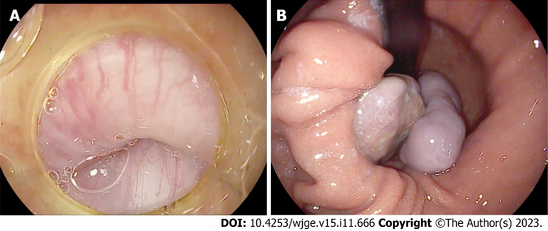
Figure 1 Esophagogastroduodenoscopy. A: Right behind the upper esophageal sphincter is visualizing the base of a non-epithelial tumor, which continues distally throughout the esophagus, freely locating and occupying almost the entire space of the esophageal lumen; B: On retroflection, the distal part of the non-epithelial neoplasm splits into two parts, visible in the gastric lumen. Diastases of the diaphragmatic crura is up to 5-6 cm with sliding of cardia and fungus above the diaphragm during examination - signs of sliding hiatal cardiofundal hernia.

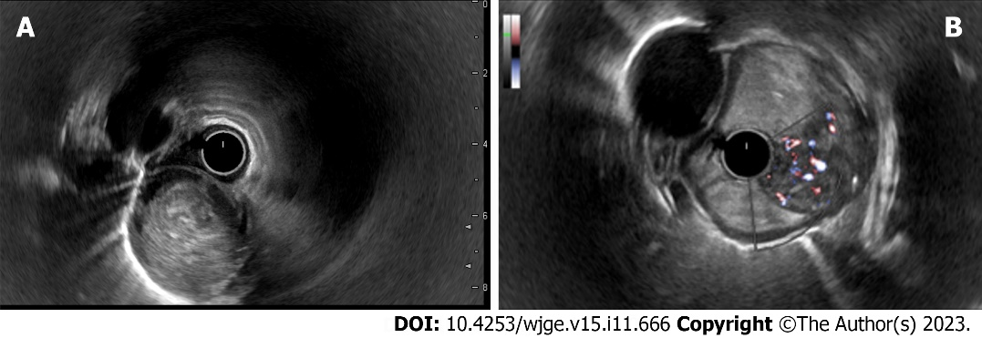
Figure 2 Endosonography of the esophagus. A: A heterogeneous hypoechoic mass with a smooth and clear borders, cylindrically shaped, originating from submucosal layer (3rd echo layer); B: A doppler color mode shows a hypervascular zone at the base of the tumor with multiple large feeding vessels, up to 4-5 mm in diameter, extending along the wall of the esophagus.
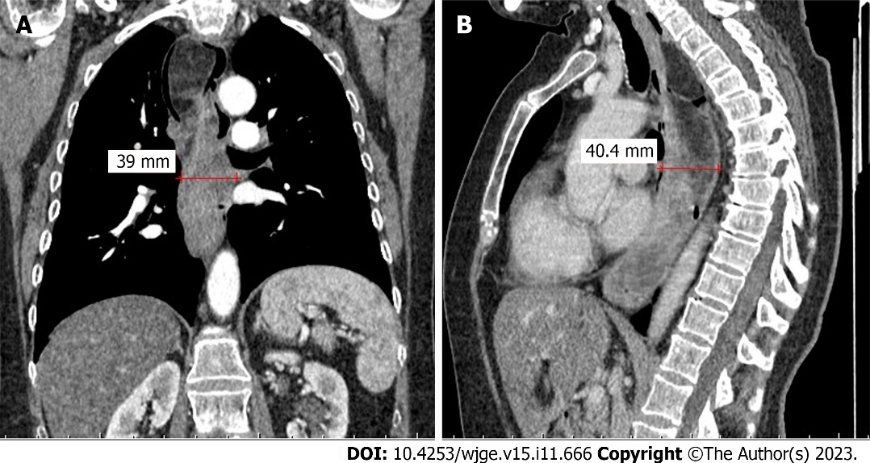
Figure 3 Chest computed tomography scan. A: Coronal plane; B: Sagittal plane. Computed tomography with intravenous contrast enhancement revealed an expansion of the esophagus up to 5-6 cm in the distal part, a hypervascular neoplasm in the lumen of the esophagus extending throughout the entire esophageal length from upper esophageal sphincter to the gastric cardia with the maximum diameter of the tumor up to 6 cm.
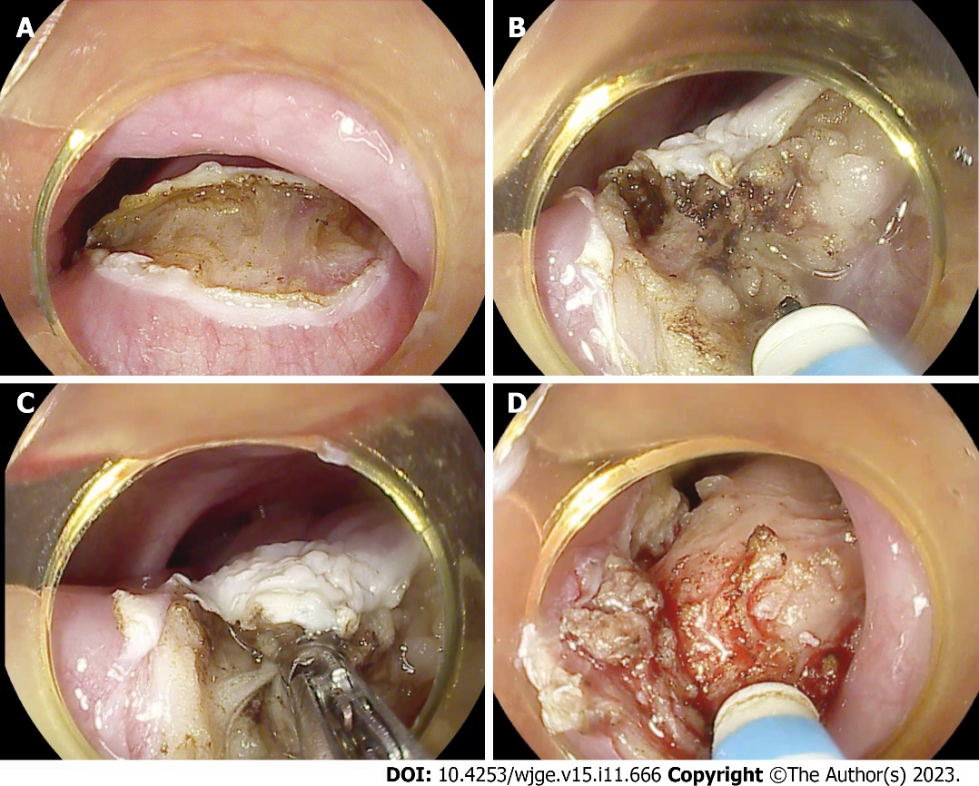
Figure 4 Endoscopic steps of the surgery. A: Dissection of the mucosal and submucosal layers behind UES at the base of the tumor; B: Endoscopic submucosal dissection using endoscopic needle-knife; C: Coagulation of large feeding vessels in the submucosal layer using the coagrasper; D: The tumor is almost fully mobilized from the esophageal wall at its base.

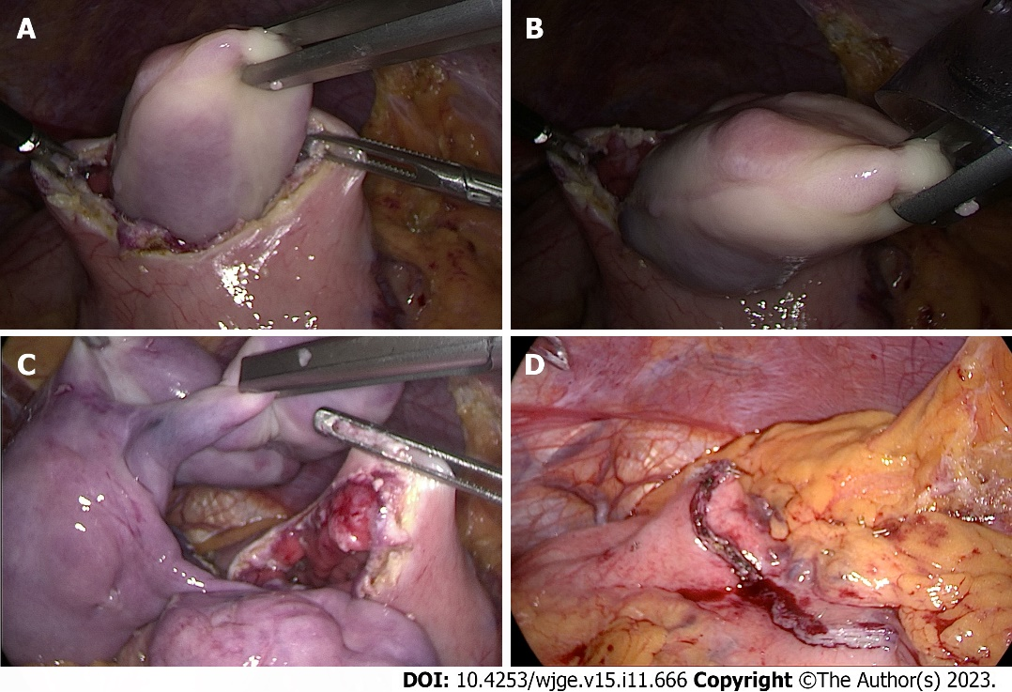
Figure 5 Laparoscopic steps of the surgery. A: Using a laparoscopic grasper, the tumor is captured through a gastrotomy on the anterior wall of the gastric body; B: Removal of the tumor from the gastric body after it was completely brought down from the esophagus; C: The complete extraction of the tumor from the stomach into abdominal cavity; D: Gastrotomy closure with laparoscopic EndoGIA stapler suture.

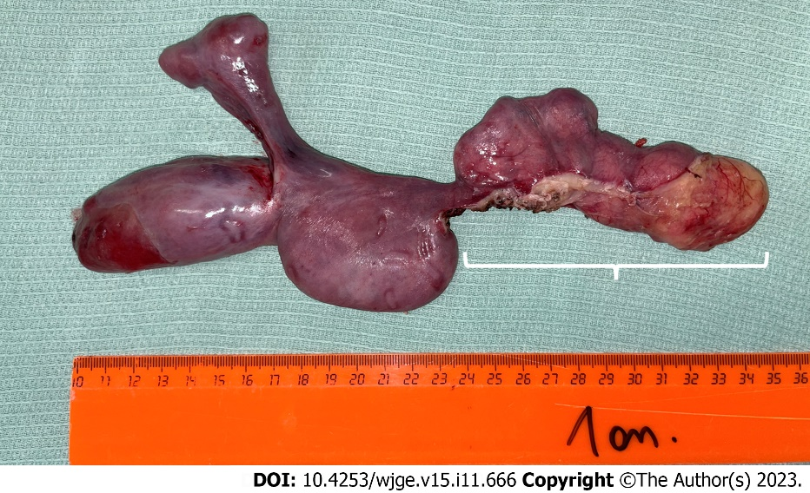
Figure 6 Specimen. The removed specimen represents a tumor of an irregular elongated shape splitting into two parts at the distal end, 25 cm × 4 cm × 6 cm in size, with a smooth surface covered by intact mucosa. The area of endoscopic submucosal dissection at the tumor's base is 11 centimeters long (marked with square bracket).
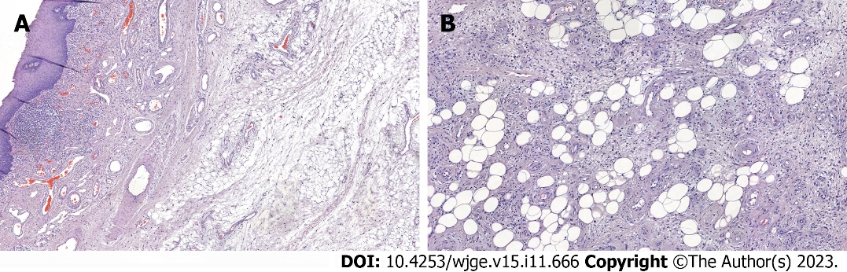
Figure 7 Morphology. A and B: The tumor is represented by adipose tissue, separated by wide fields of sclerotic fibrous tissue with numerous vessels and cells of the inflammatory infiltrate. The adipocytes are uninuclear and different-sized. Among the fibrous tissue there are hyperchromic cells with angular nuclei. Morphology report: fibrovascular polyp with foci of highly differentiated liposarcoma, tumor tissue at the sight of endoscopic dissection is not determined, R0, М 8850/3; Grade 1.
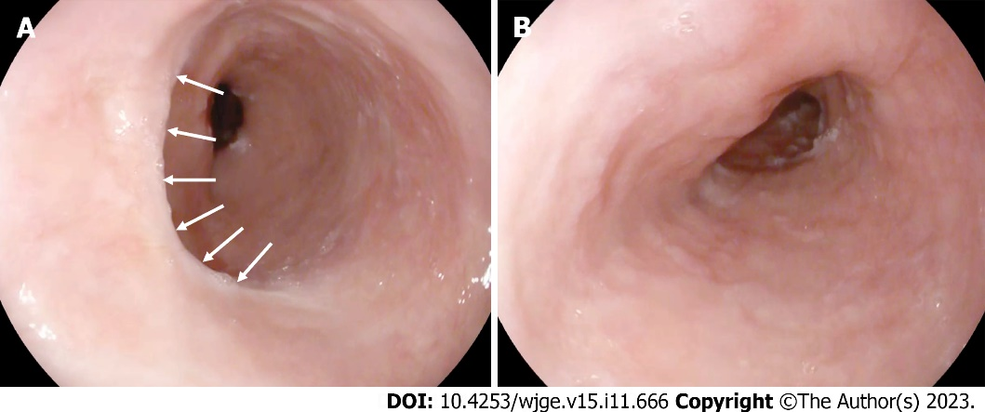
Figure 8 Follow-up esophagoscopy three months after surgery. A: A white linear scar is observed in the submucosasl layer behind the upper esophageal sphincter, where endoscopic dissection was previously performed (marked with white arrows). There are no residual tumor fragments and no signs of narrowing of the lumen at the sight of dissection; B: No alterations in the esophageal lumen along its entire length.

Table 1 The blood count and coagulation assessment results revealed that all measured parameters resided comfortably within established normative reference intervals
AST | 26 | 0-40 U/L
ALT | 8 | 0-41 U/L
Albumin | 3.73 | 3.5-5.5 g/dL
Urea | 25.2 | 16.6-48.5 mg/dL
Creatinine | 0.42 | < 1.2 mg/dL
Sodium | 140 | 136-145 mmol/L
Potassium | 4.61 | 3.5-5 mmol/L
Chloride | 104 | 98-106 mmol/L
Calcium | 7.9 | 7.6-11 mg/dL
Procalcitonin | 0.26 | < 0.5 ng/mL
Blood culture | Sterile | Sterile
ALT: Alanine transaminase; AST: Aspartate transaminase.

Published by Baishideng Publishing Group Inc
7041 Koll Center Parkway, Suite 160, Pleasanton, CA 94566, USA
Telephone: +1-925-3991568
E-mail: bpgoffice@wjgnet.com
Help Desk: https://www.f6publishing.com/helpdesk
https://www.wjgnet.com

© 2023 Baishideng Publishing Group Inc. All rights reserved.

