Name of Journal: World Journal of Clinical Cases
Manuscript NO: 78851
Manuscript Type: CASE REPORT

Benign paroxysmal positional vertigo with congenital nystagmus: A case report

Li GF et al. BPPV with congenital nystagmus

Gui-Fang Li, Yue-Tang Wang, Xin-Ge Lu, Man Liu, Chao-Bing Liu, Chun-Hua Wang

Gui-Fang Li, Department of Otolaryngology, Hebei Provincial Eye Hospital, Hebei Provincial Key Laboratory of Ophthalmology, Hebei Provincial Eye Institute, Xingtai 054001, Hebei Province, China

Yue-Tang Wang, Xin-Ge Lu, Man Liu, Chao-Bing Liu, Chun-Hua Wang, Department of Ophthalmology, Hebei Provincial Eye Hospital, Hebei Provincial Key Laboratory of Ophthalmology, Hebei Provincial Eye Institute, Xingtai 054001, Hebei Province, China

Author contributions: Liu M and Liu CB were the otolaryngologists for the patient; Li GF and Wang CH analyzed the case, reviewed the literature, and contributed to drafting the manuscript; Wang YT and Lu XG were responsible for manual reduction; and all authors gave their approval for the submission of the final version of the manuscript.

Corresponding author: Gui-Fang Li, MPhil, Chief Physician, Department of Otolaryngology, Hebei Provincial Eye Hospital, Hebei Provincial Key Laboratory of Ophthalmology, Hebei Provincial Eye Institute, No. 399 Quanbei East Street, Xingtai 054001, Hebei Province, China. lifang9922@163.com

Received: July 20, 2022
Revised: August 15, 2022
Accepted: September 22, 2022
Published online: November 6, 2022

Abstract
BACKGROUND
Benign paroxysmal positional vertigo (BPPV) is a form of temporary vertigo induced by moving the head to a specific position. It is a self-limited, peripheral, vestibular disease and can be divided into primary and secondary forms. Congenital nystagmus (CN), an involuntary, rhythmic, binocular-symmetry, conjugated eye movement, is found at birth or within 3 mo of birth. According to the pathogenesis, CN can be divided into sensory-defect nystagmus and motor-defect nystagmus. The coexistence of BPPV and CN is rarely seen in the clinic.

CASE SUMMARY
A 62-year-old woman presented to our clinic complaining of a 15-d history of recurrent positional vertigo. The vertigo lasting less than 1 min occurred when she turned over, sometimes accompanied by nausea and vomiting. Both the patient and her father had CN. Her spontaneous nystagmus was horizontal to right; however, the gaze test revealed variable horizontal nystagmus with the same degree when the eyes moved. The patient’s Dix-Hallpike test was normal, except for persistent nystagmus, and the roll test showed severe variable horizontal nystagmus, which lasted for about 20 s in the same direction as her head movement to the right and left, although the right-side nystagmus was stronger than the left-side. Since these symptoms were accompanied by nausea, she was diagnosed with BPPV with CN and treated by manual reduction.

CONCLUSION
Though rare, if BPPV with CN is correctly identified and diagnosed, reduction treatment is comparably effective to other vertigo types.

Key Words: Congenital; Nystagmus; Benign paroxysmal positional vertigo; Case report

©The Author(s) 2022. Published by Baishideng Publishing Group Inc. All rights reserved.

Citation: Li GF, Wang YT, Lu XG, Liu M, Liu CB, Wang CH. Benign paroxysmal positional vertigo with congenital nystagmus: A case report. World J Clin Cases 2022; 10(31): 11625-11629
URL: https://www.wjgnet.com/2307-8960/full/v10/i31/11625.htm
DOI: https://dx.doi.org/10.12998/wjcc.v10.i31.11625

Core Tip: Benign paroxysmal positional vertigo (BPPV) is defined as a disorder of the inner ear characterized by repeated episodes of positional vertigo. Congenital nystagmus (CN), an involuntary, rhythmic, binocular-symmetry, conjugated eye movement, is found at birth or within 3 mo of birth. BPPV with CN is rarely seen in the clinic. CN should be distinguished from other pathologic nystagmus types. BPPV can be accurately determined through postural nystagmus. We report the characteristics of BPPV with CN, further explaining how to identify nystagmus.

INTRODUCTION
Benign paroxysmal positional vertigo (BPPV) is defined as a disorder of the inner ear characterized by repeated episodes of positional vertigo^{[1]}. BPPV is among the common diseases that cause aural vertigo, and 24.1% of patients with dizziness or vertigo are diagnosed with BPPV^{[2]}. Spontaneous nystagmus refers to a continuous, involuntary, and rhythmic movement of the eyeball in the absence of inducing factors and is divided into congenital nystagmus (CN) and acquired nystagmus. The latter is a type of nystagmus commonly seen in the clinic. CN is an ocular motor disorder in which patients are afflicted by periodic involuntary ocular oscillations affecting both eyes^{[3,4]}. It develops during the first 3 to 6 mo of a patient’s life and has a prevalence of 14 per 10000 people in the United Kingdom^{[5]}. The etiology of CN is largely unknown, but we know that most patients have lifelong nystagmus, although it can gradually relieve with age in some patients. Some BPPV patients present with spontaneous nystagmus, but BPPV with CN is rare: To date, we have not seen such cases reported. In this report, we present the case of a BPPV patient with CN and her nystagmus findings.

CASE PRESENTATION
Chief complaints
A 62-year-old woman presented at our clinic, complaining of positional vertigo that had recurred for 15 d.

History of present illness
Fifteen days previously, the patient’s symptoms had begun with severe dizziness when she rose, which recurred when she rolled over or lied down. She sometimes experienced nausea and vomiting at the onset of these symptoms.

History of past illness
The patient was physically healthy in the past.

Personal and family history
Both the patient and her father had a history of CN.

Physical examination
The patient’s physical examination revealed no abnormal findings.

Laboratory examinations
The patient did not undergo laboratory examinations.

Imaging examinations
The patient did not undergo imaging examinations.

FINAL DIAGNOSIS
The patient was ultimately diagnosed with BPPV with CN.

TREATMENT
The patient was prescribed a barbecue roll maneuver to treat her right, lateral, semicircular canal BPPV of geotropic type. This treatment required her to lie down with the affected ear facing downward. Then, she rolled over to the opposite side for 90 degrees until she returned to the original position. Her vertigo symptoms disappeared after the therapy.

OUTCOME AND FOLLOW-UP
The patient’s follow-up comprised three telephone appointments at 1 wk, 1 mo, and 6 mo after treatment. She was asymptomatic, without any recurrence of vertigo.

DISCUSSION
BPPV is generally categorized as posterior semicircular canal, anterior semicircular canal, and horizontal semicircular canal types. Of these categories, posterior semicircular canal BPPV is the most common (affecting 80%-90% of patients), followed by horizontal semicircular canal BPPV (10%-20%), while anterior semicircular canal BPPV is rare (3%)^{[6,7]}. The Dix-Hallpike maneuver is considered the gold standard test to diagnose posterior canal BPPV, and the supine roll test is considered the gold standard for diagnosing horizontal semicircular canal BPPV^{[8]}. Upbeat-torsional nystagmus is provoked by vertical semicircular canal BPPV.
The pathogenesis of BPPV remains unclear; however, risk factors include age, mental stress, osteoporosis, insomnia, and hypertension^{[9,10]}. Currently, the following two theories are widely accepted. First, canalithiasis suggests that when the head is moved relative to gravity, otoliths residing on the macula utriculi migrate into the semicircular canal and are displaced relative to the semicircular canal wall because of gravity, causing endolymph flow and resulting in the deviation of the cupula terminalis and, in turn, corresponding signs and symptoms. When the otolith moves due to gravity to the lowest point in the semicircular canal lumen, the endolymph stops, the cupula terminalis returns to its original position, and signs and symptoms disappear.
Second, eupulolithiasis suggests that the detached otoliths on the macula utriculi adhere to the cupula terminalis, changing the density of the latter relative to the endolymph and making it sensitive to gravity, resulting in the corresponding symptoms and signs^{[11]}. CN usually occurs at birth or within 3 mo of birth. Although this nystagmus persists throughout most patients’ lives, some patients’ symptoms gradually relieve with age. CN is divided into two categories. The first is congenital motor defect nystagmus, in which eye movement includes fast and slow phases. The second is congenital sensory defect nystagmus, also known as “pendular nystagmus”, in which the eye moves at one speed. CN is clinically rare, with an incidence of about 0.005%-0.286%^{[3]}. To our knowledge, BPPV with CN has not been previously reported.
In the United States, according to statistics, about 5.6 million patients clinically complain of dizziness per year, and 17%-42% of patients with vertigo are diagnosed with BPPV^{[12-14]}. BPPV treatment can be categorized as canalith repositioning maneuvers or vestibular rehabilitation^{[1]}. Diagnosis of horizontal semicircular canal BPPV relies on the supine roll test. During examinations, clinicians should observe whether the direction of the nystagmus is geotropic or apogeotropic and which side of the nystagmus is stronger to enable identification of the patient’s affected side. In our case, the Dix-Hallpike test showed the signs of horizontal nystagmus without vertigo and geotropic nystagmus, which was stronger on her right side during the roll test (Figure 1). Unlike other patients with BPPV, she exhibited persistent horizontal nystagmus on the right side after intense nystagmus lasting more than 10 s, which was accompanied by vertigo. The lasting nystagmus is suggestive of CN, which is similar to that observed in patients with spontaneous nystagmus but absent in BPPV patients without spontaneous nystagmus. Spontaneous nystagmus is very common clinically among patients with vertigo.
The following aspects should be used to distinguish CN from other central and peripheral spontaneous forms of nystagmus. The first and most important is a patient’s medical history. Nystagmus is always present during CN; someone in the patient’s family will have CN because of the heritability of the disease, while other types of spontaneous nystagmus only appear at the onset of the disease. Second, the direction of peripheral nystagmus is constant, while that of CN is variable. The test can be conducted with Frenzel glasses to observe the nystagmus accurately. The direction of the nystagmus will be seen to remain the same in the peripheral nystagmus; however, the direction of the nystagmus is consistent with the eye movement in central nystagmus and variable nyatagmus in CN (Figure 2). Third, a CN patient usually experiences horizontal nystagmus of variable intensity, while other pathologic central nystagmus types may entail vertical and horizontal nystagmus with generally persistent intensity.

CONCLUSION
CN is rare in the clinic. If individuals experience spontaneous nystagmus with constant intensity and variable direction, a careful medical history should be taken to eliminate CN, which may influence the diagnosis. The treatment for BPPV with CN is the same as that for BPPV. In the case reported here, the patient was diagnosed with BPPV with CN, and the result was good.

REFERENCES
1 Bhattacharyya N, Gubbels SP, Schwartz SR, Edlow JA, El-Kashlan H, Fife T, Holmberg JM, Mahoney K, Hollingsworth DB, Roberts R, Seidman MD, Steiner RW, Do BT, Voelker CC, Waguespack RW, Corrigan MD. Clinical Practice Guideline: Benign Paroxysmal Positional Vertigo (Update). Otolaryngol Head Neck Surg 2017; 156: S1-S47 [PMID: 28248609 DOI: 10.1177/0194599816689667]
2 Kim HJ, Lee JO, Choi JY, Kim JS. Etiologic distribution of dizziness and vertigo in a referral-based dizziness clinic in South Korea. J Neurol 2020; 267: 2252-2259 [PMID: 32300888 DOI: 10.1007/s00415-020-09831-2]
3 Casteels I, Harris CM, Shawkat F, Taylor D. Nystagmus in infancy. Br J Ophthalmol 1992; 76: 434-437 [PMID: 1627515 DOI: 10.1136/bjo.76.7.434]
4 Abadi RV, Bjerre A. Motor and sensory characteristics of infantile nystagmus. Br J Ophthalmol 2002; 86: 1152-1160 [PMID: 12234898 DOI: 10.1136/bjo.86.10.1152]
5 Proudlock FA, Gottlob I. Nystagmus in childhood. In: Hoyt C, Taylor D. Pediatric Ophthalmology and Strabismus, 4th ed. Philadelphia: Saunders, 2013: 922-932
6 Kim JS, Zee DS. Clinical practice. Benign paroxysmal positional vertigo. N Engl J Med 2014; 370: 1138-1147 [PMID: 24645946 DOI: 10.1056/NEJMcp1309481]
7 Hornibrook J. Benign Paroxysmal Positional Vertigo (BPPV): History, Pathophysiology, Office Treatment and Future Directions. Int J Otolaryngol 2011; 2011: 835671 [PMID: 21808648 DOI: 10.1155/2011/835671]
8 Fife TD, Iverson DJ, Lempert T, Furman JM, Baloh RW, Tusa RJ, Hain TC, Herdman S, Morrow MJ, Gronseth GS; Quality Standards Subcommittee, American Academy of Neurology. Practice parameter: therapies for benign paroxysmal positional vertigo (an evidence-based review): report of the Quality Standards Subcommittee of the American Academy of Neurology. Neurology 2008; 70: 2067-2074 [PMID: 18505980 DOI: 10.1212/01.wnl.0000313378.77444.ac]
9 Byun H, Chung JH, Lee SH, Park CW, Kim EM, Kim I. Increased risk of benign paroxysmal positional vertigo in osteoporosis: a nationwide population-based cohort study. Sci Rep 2019; 9: 3469 [PMID: 30837524 DOI: 10.1038/s41598-019-39830-x]
10 Chen J, Zhang S, Cui K, Liu C. Risk factors for benign paroxysmal positional vertigo recurrence: a systematic review and meta-analysis. J Neurol 2021; 268: 4117-4127 [PMID: 32839838 DOI: 10.1007/s00415-020-10175-0]
11 Editorial Board of Chinese Journal of Otorhinolaryngology Head and Neck Surgery, Chinese Medical Association of Otorhinolaryngology Head and Neck Surgery. Clinical Guidelines: Benign Paroxysmal Positional Vertigo. Chin J Otorhinolaryngol Head Neck Surg 2017; 52: 173-177
12 Schappert SM. National Ambulatory Medical Care Survey: 1989 summary. Vital Health Stat 13 1992: 1-80 [PMID: 1376543]
13 Katsarkas A. Benign paroxysmal positional vertigo (BPPV): idiopathic versus post-traumatic. Acta Otolaryngol 1999; 119: 745-749 [PMID: 10687929 DOI: 10.1080/00016489950180360]
14 Hanley K, O'Dowd T, Considine N. A systematic review of vertigo in primary care. Br J Gen Pract 2001; 51: 666-671 [PMID: 11510399]

Footnotes
Informed consent statement: Informed written consent was obtained from the patient for publication of this report and any accompanying images.

Conflict-of-interest statement: All the authors report no relevant conflicts of interest for this article.

CARE Checklist (2016) statement: The authors have read the CARE Checklist (2016), and the manuscript was prepared and revised according to the CARE Checklist (2016).

Open-Access: This article is an open-access article that was selected by an in-house editor and fully peer-reviewed by external reviewers. It is distributed in accordance with the Creative Commons Attribution NonCommercial (CC BY-NC 4.0) license, which permits others to distribute, remix, adapt, build upon this work non-commercially, and license their derivative works on different terms, provided the original work is properly cited and the use is non-commercial. See: https://creativecommons.org/Licenses/by-nc/4.0/

Provenance and peer review: Unsolicited article; Externally peer reviewed
Peer-review model: Single blind

Peer-review started: July 20, 2022
First decision: August 4, 2022
Article in press: September 22, 2022

Specialty type: Medicine, research and experimental
Country/Territory of origin: China
Peer-review report’s scientific quality classification
Grade A (Excellent): 0
Grade B (Very good): B
Grade C (Good): C, C
Grade D (Fair): 0
Grade E (Poor): 0

P-Reviewer: Bhandari A, United States; Faraji N, Iran S-Editor: Wang JJ L-Editor: Wang TQ P-Editor: Wang JJ

Figure Legends
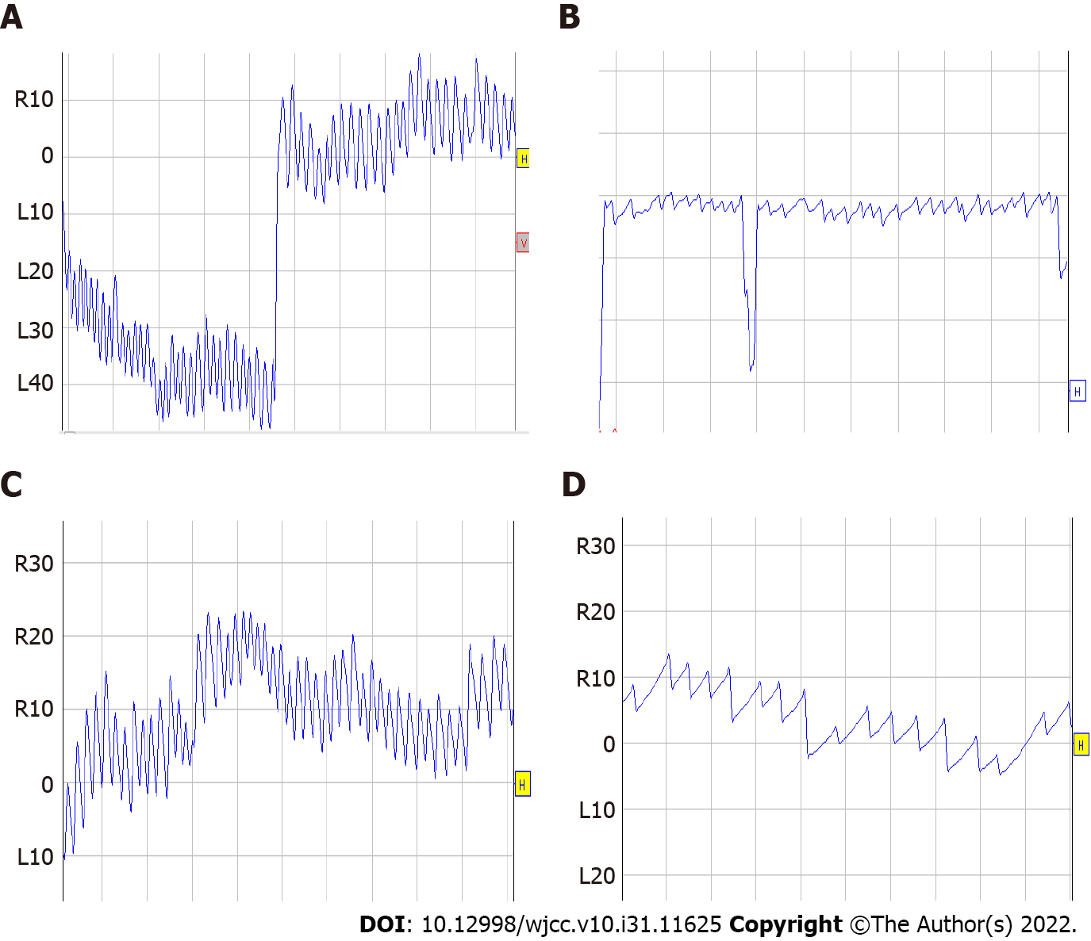
Figure 1 Nystagmus in the roll test. A and B: When the head was to the right, intensive nystagmus occurred between 13 s and 32 s with dizziness and nausea; the highest slow phase velocity (SPV) was 162°/s and then weakened gradually to 8°/s, and vertigo disappeared; C and D: When the head was to the left, the intensive nystagmus occurred between 9 s and 30 s with dizziness; the highest SPV was 62°/s and then weakened gradually to 9°/s, and vertigo disappeared.
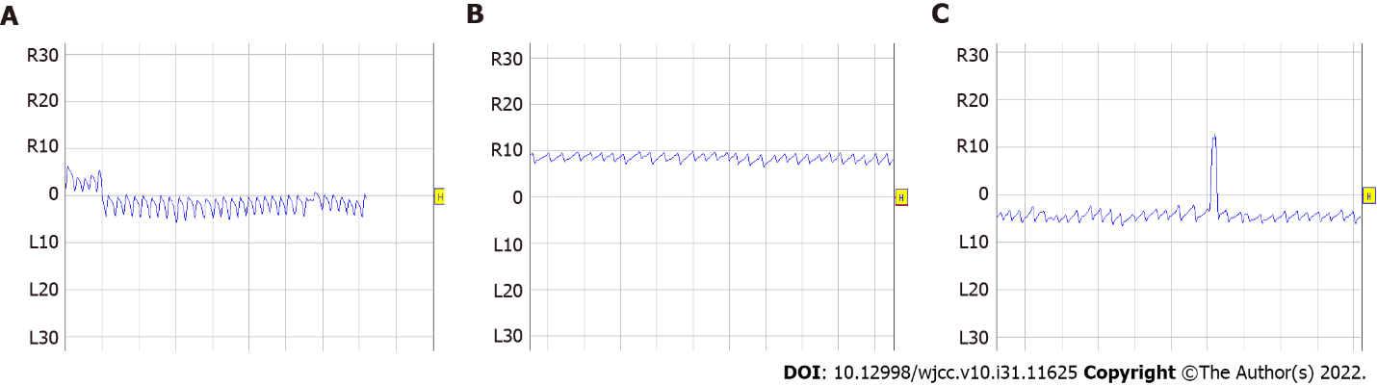
Figure 2 Spontaneous nystagmus and nystagmus in the gaze test. A: The intensity of spontaneous nystagmus was 20°/s, and it was constant; B: When the eyes moved to right, the direction of nystagmus changed to left, and the slow phase velocity (SPV) of nystagmus was 7°/s; C: When the eyes moved to left, the nystagmus was still to the left, and the SPV of nystagmus was 8°/s.

Published by Baishideng Publishing Group Inc
7041 Koll Center Parkway, Suite 160, Pleasanton, CA 94566, USA
Telephone: +1-925-3991568
E-mail: bpgoffice@wjgnet.com
Help Desk: https://www.f6publishing.com/helpdesk
https://www.wjgnet.com

© 2022 Baishideng Publishing Group Inc. All rights reserved.

