Name of Journal: World Journal of Gastrointestinal Surgery
Manuscript NO: 79397
Manuscript Type: CASE REPORT

Malignant transformation of perianal tailgut cyst: A case report

Fang Y et al. Canceration of perianal tailgut cyst

Yuan Fang, Yong Zhu, Wei-Zhen Liu, Xia-Qing Zhang, Yu Zhang, Kang Wang

Yuan Fang, Yong Zhu, Wei-Zhen Liu, Xia-Qing Zhang, Yu Zhang, Colorectal Surgery Center, Nanjing Hospital of Chinese Medicine Affiliated to Nanjing University of Chinese Medicine, Nanjing 210022, Jiangsu Province, China

Kang Wang, Department of Pathology, Nanjing Hospital of Chinese Medicine Affiliated to Nanjing University of Chinese Medicine, Nanjing 210022, Jiangsu Province, China

Author contributions: Fang Y contributed to data curation and writing of the original draft; Liu WZ, Zhang XQ, and Zhang Y contributed to data curation; Zhang Y contributed to manuscript review and editing; Wang K contributed to evaluation of the histopathology; all authors have read and approved the final manuscript.

Corresponding author: Yong Zhu, MD, Doctor, Colorectal Surgery Center, Nanjing Hospital of Chinese Medicine Affiliated to Nanjing University of Chinese Medicine, No. 157 Daming Road, Nanjing 210022, Jiangsu Province, China. zhuyong839@sina.com

Received: August 19, 2022
Revised: September 17, 2022
Accepted: October 25, 2022
Published online:
ABSTRACT
BACKGROUND
Tailgut cyst is a congenital enterogenous cyst that rarely undergoes malignant transformation. Its clinical manifestations mainly correlate to the mass effect caused by the development of cysts and the infections that originate from these. Furthermore, the complete resection of this cyst is curative. We report our diagnostic and treatment experience with one case of malignant transformation of a perianal tailgut cyst, which was initially misdiagnosed as perianal abscess.

CASE SUMMARY
A 72-year-old woman visited our institution with complaints of a refractory nonhealing lesion on the right hip, which repeatedly broke and suppurated for > 70 years, and aggravated in 4 mo. The patient was given a diagnosis of refractory perianal abscess with repeated incision and drainage procedures. Computed tomography of the pelvic cavity revealed a giant perianal cyst. Subsequent biopsy revealed a tumor with moderate-to-severe glandular epithelial dysplasia, and suggested that this was derived from the developmental cysts in the posterior rectal space. After further clarifying the nature and extent of the tumor by magnetic resonance imaging, total cystic resection was performed. Postoperative histopathological examination confirmed the malignancy, dictating the investigators to add postoperative chemotherapy to the treatment regimen.

CONCLUSION
The malignant transformation of perianal tailgut cysts is uncommon, and should be differentiated from perianal abscess. Complete surgical removal is curative, and postoperative pathology may determine the necessity of additional postoperative chemotherapy or radiotherapy, which may be beneficial for preventing local recurrence and metastasis.

Key Words: Tailgut cyst; Perianal cyst; Perianal abscess; Adenocarcinoma; Chemotherapy; Case report

Fang Y, Zhu Y, Liu WZ, Zhang XQ, Zhang Y, Wang K. Malignant transformation of perianal tailgut cyst: A case report. World J Gastrointest Surg 2022; In press

Core tip: We report our diagnostic and treatment experience of a unique case of malignant transformation of perianal tailgut cyst. Since perianal tailgut cysts are difficult to differentiate from other perianal diseases, the reported case was initially misdiagnosed as perianal abscess with repeated incision and drainage procedures. The patient underwent complete resection and received salvage chemotherapy for 3 mo after surgery.

INTRODUCTION
Tailgut cysts are developmental congenital enterogenous cysts that mostly occur in the retrorectal or presacral space^{[1]}. The clinical features include the mass effect caused by the development of cysts, and the infection that originates from these^{[2]}. Magnetic resonance imaging (MRI) can reveal the typical cyst appearance, which is crucial for distinguishing the cyst from perianal abscess. Complete resection of the cyst is curative and clinically preferred^{[3]}. Postoperative histopathological analysis is routinely performed to pathologically confirm the diagnosis and mainly rule out the chance of malignancy. Clinically, this entity is not complicated in its diagnosis and treatment. We report a case of malignant transformation after the perianal tailgut cyst was misdiagnosed as perianal abscess, in which total resection was performed and postoperative chemotherapy was added.

CASE PRESENTATION
Chief complaints
A 72-year-old woman was transferred to our hospital with complaints of a tumor on the right hip, which repeatedly broke and suppurated for > 70 years, and aggravated in 4 mo.

History of present illness
The patient was born with a 5 mm × 5 mm mass under the right hip, which covered the skin. Perianal distending pain and discomfort were experienced by the patient with the gradual increase of the tumor. At a local hospital, the patient was diagnosed with perianal abscess as a result of its fluctuating feature. During the incision and drainage procedures, copious brownish pus was repeatedly drained from the mass. In particular, during the past 4 mo, the mass progressively become larger, with multiple ulcers on its surface, cauliflower-like objects at its base, and jelly-like liquid inside.

History of past illness
The patient had a history of hypertension, and her daily blood pressure was maintained at approximately 120/60 mmHg with regular oral medication.

Personal and family history
The patient denied any family history of malignancy.

Physical examination
The physical examination did not unveil any significant finding, except for the 5 cm ulcerative mass under the right hip.

Laboratory examinations
The patient had a slightly elevated carbohydrate antigen 7-24 of 23.04 U/mL, but no abnormalities were detected in other blood and urine analyses.

Imaging examinations
Computed tomography (CT) revealed a multilocular cystic soft tissue mass in the right hip, which extended into the sacrococcygeal region, with an enhanced edge and a size of 6.0 cm × 5.8 cm × 9.5 cm (Figure 1A and 1B). In order to establish a diagnosis, biopsy was performed on the cystic mass. The results revealed a tumor with moderate-to-severe glandular epithelial dysplasia, and suggested the origin of developmental cysts in the posterior rectal space (Figure 2A). After the patient was transferred to our hospital, intestinal lesions were further excluded by proctoscopy. Endorectal ultrasonography further revealed multiple hypoechoic areas (diameter: 1.0–2.5 cm), with clear boundaries in the sacrococcygeal region, and uneven echo areas in the right hip with unclear boundaries (Figure 1C and 1D). MRI revealed an abnormal hypointense T1 and hyperintense T2 signal shadow in irregular quasicircular lesion, and diffusion-weighted imaging (DWI) revealed a size of 107 mm in the sagittal position with wall enhancement (Figure 1E–1H).

MULTIDISCIPLINARY EXPERT CONSULTATION
Through the discussion of the multidisciplinary team, enterogenous cyst with malignant transformation was suggested as the preliminary diagnosis. The patient underwent a transperineal operation, during which the tailgut cyst was identified to extend into the posterior rectal space, and reach the sacral vertebrae at the 4th–5th levels above the tip of the coccyx. Since the sacrococcyx fascia was considered to be the origin of the cyst and attached to the coccyx, part of this was resected to expose the surgical field. After radically resecting the cystic lesion with the surrounding tissues without injuring the posterior rectal wall, endorectal ultrasonography was performed to confirm that no cystic remnants were present, and a free-flap procedure to reconstruct the extensive resection site was performed by cooperating with the plastic surgery team (Figure 3). The operation lasted for ~270 min, with an unexpected intraoperative blood loss of > 600 mL. The patient was hospitalized for 36 d for postoperative recovery.
Postoperatively, pathological examination revealed a diagnosis of malignant transformation of the perianal tailgut cyst, and this was identified as mucinous adenocarcinoma, with a size of 6.5 cm × 4.0 cm × 6.0 cm, without local infiltration (Figure 2B). Histologically, tumorous cells were found 0.2 cm away from the resection margin, confirming pathological R0 resection. Further immunohistological examinations were paneled, as follows: MLH1 (+), MSH2 (+), MSH6 (+), PMS2 (+), P53S100 (−), CD34 (−), D2-40 (−), Ki-67 (70%), CDH-17 (+), CDX-2 (+), CK7 (+), CK20 (+), and SATB-2 (+).

FINAL DIAGNOSIS
Pathologically, the patient was given a final diagnosis of malignant transformation of the perianal tailgut cyst.

TREATMENT
Three months after surgery, MRI revealed a small cyst under the right levator ani (Figure 1I), and carbohydrate antigen 7-24 decreased to normal. According to the postoperative pathology, oral salvage chemotherapy with capecitabine 1000 mg, twice daily, for eight cycles, was added, and MRI was recommend every 3 mo to monitor the change in size of the cyst.

OUTCOME AND FOLLOW-UP
After the third cycle of chemotherapy with capecitabin, the patient did not have any special complaints or discomfort.

DISCUSSION
As a rare congenital disease, tailgut cyst originates from the tailgut and neurenteric canal^{[4]}, and most likely occurs in the retrorectal or presacral space^{[1]}. Clinically, this disease is more commonly observed in middle-aged women with the presentation of a mass lesion, with or without infection^{[2]}. Malignancy infrequently occurs in presacral tailgut cysts, at a rate of < 8%, and when this occurs, it may most likely be adenocarcinoma or carcinoid^{[3]}. For the present case, the patient presented with an infected and inflammatory mass, with the dissemination of cells from the cyst wall as the result of repeated incision, and this might have been the main cause of the local recurrence that contributed to the malignant transformation^{[5]}.
The present case emphasizes the differentiation of a perianal tailgut cyst from a perianal abscess. For perianal abscess in the retrorectal space, when it shows incomplete healing because of the discharge of residual pus, when no anal fistula is found, or when this recurs multiple times after repeated surgical treatment, tailgut cyst should be suspected and completely resected for further pathological diagnosis. Biopsy specimens often contain only the inflamed fibrous tissue without the epithelia, or one type of epithelium, which may not consequently support any diagnosis^{[6]}; therefore, biopsy of the cystic lesion is not recommended.
Pathohistologically, the cyst may be filled with brown and jelly-like fluid from the wall of the tailgut cyst^{[6]}, which may be partially or completely covered with intestinal epithelium, and contain columnar cells, squamous cells, and transitional cells with mucus secretion function^{[2]}, while the smooth muscle fibers in the cyst wall are disorganized without the nerve plexus^{[7]}. The canceration of caudal cysts is mostly focal, allowing for a thorough postoperative histopathological analysis of the resected specimen, to confirm the diagnosis and rule out malignant tumors. Unlike perianal abscesses, tailgut cysts have a multilocular nature, which demands preoperative endorectal ultrasonography, or pelvic MRI or CT^{[8]}. MRI can reveal the typical cyst appearance as low attenuation on T1 and high-attenuation on T2, and DWI can allow for the tailgut cyst to be distinguished from a perianal abscess^{[9]}. Although the importance of MRI in the diagnosis of tailgut cysts has been emphasized, endorectal ultrasonography is more convenient and accessible than MRI, especially in operations for complete cyst resection^{[10]}.
For the risk of malignant transformation of a cyst, surgical resection is the first choice of treatment for tailgut cysts^{[3]}, and the surgical approach should be selected according to the location of the cyst as shown in the imaging studies. The incidence of canceration of the tailgut cyst remains low, although there is still a risk of local recurrence and distant metastasis. At present, three cases of local recurrence and two of distant metastasis have been reported^{[11-14]}. Among these cases (Table 1), a patient with pseudomyxoma peritonei benefited from chemotherapy. After 3 mo, MRI revealed a small cyst under the right levator ani, which might be correlated with local implantation of cyst wall cells caused by partial rupture of the cyst wall during surgery. Since the preoperative carbohydrate antigen 724 was also slightly elevated, with a Ki-67 index of 70%, oral capecitabine as salvage chemotherapy was given to the patient, who refused to undergo reoperation for the small lesion. Close follow-up with MRI was recommended. A previous study recommended postoperative adjuvant radiotherapy for patients with canceration of tailgut cysts and remnant lesions for incomplete lesion resection, to achieve good outcomes, with or without chemotherapy^{[15]}.

CONCLUSION
Perianal caudal cysts are difficult to differentiate from other perianal diseases, especially perianal abscesses. Multidisciplinary treatment should be undertaken because of the risk of cancerization of the cyst.

REFERENCES
1 Sung MT, Ko SF, Niu CK, Hsieh CS, Huang HY. Perirenal tailgut cyst (cystic hamartoma). J Pediatr Surg 2003; 38: 1404-1406 [PMID: 14523832 DOI: 10.1016/s0022-3468(03)00408-1]
2 Dahan H, Arrivé L, Wendum D, Docou le Pointe H, Djouhri H, Tubiana JM. Retrorectal developmental cysts in adults: clinical and radiologic-histopathologic review, differential diagnosis, and treatment. Radiographics 2001; 21: 575-584 [PMID: 11353107 DOI: 10.1148/radiographics.21.3.g01ma13575]
3 Broccard SP, Colibaseanu DT, Behm KT, Mishra N, Davis P, Maimone KL, Mathis KL, Stocchi L, Dozois EJ, Merchea A. Risk of malignancy and outcomes of surgically resected presacral tailgut cysts: A current review of the Mayo Clinic experience. Colorectal Dis 2022; 24: 422-427 [PMID: 34941020 DOI: 10.1111/codi.16030]
4 Hjermstad BM, Helwig EB. Tailgut cysts. Report of 53 cases. Am J Clin Pathol 1988; 89: 139-147 [PMID: 3277378 DOI: 10.1093/ajcp/89.2.139]
5 Zhao XR, Gao C, Zhang Y, Yu YH. The Malignant Transformation of Retrorectal Cystic Hamartomas With Blood Irregular Antibodies Positive: A Case Report. Medicine (Baltimore) 2015; 94: e2253 [PMID: 26656372 DOI: 10.1097/MD.0000000000002253]
6 Prasad AR, Amin MB, Randolph TL, Lee CS, Ma CK. Retrorectal cystic hamartoma: report of 5 cases with malignancy arising in 2. Arch Pathol Lab Med 2000; 124: 725-729 [PMID: 10782156 DOI: 10.5858/2000-124-0725-RCH]
7 Hufkens AS, Cools P, Leyman P. Tailgut cyst: report of three cases and review of the literature. Acta Chir Belg 2019; 119: 110-117 [PMID: 30776969 DOI: 10.1080/00015458.2017.1353758]
8 Li Z, Lu M. Presacral Tumor: Insights From a Decade's Experience of This Rare and Diverse Disease. Front Oncol 2021; 11: 639028 [PMID: 33796466 DOI: 10.3389/fonc.2021.639028]
9 Shetty AS, Loch R, Yoo N, Mellnick V, Fowler K, Narra V. Imaging of tailgut cysts. Abdom Imaging 2015; 40: 2783-2795 [PMID: 26017036 DOI: 10.1007/s00261-015-0463-3]
10 Visscher AP, Felt-Bersma RJ. Endoanal ultrasound in perianal fistulae and abscesses. Ultrasound Q 2015; 31: 130-137 [PMID: 25364961 DOI: 10.1097/RUQ.0000000000000124]
11 Liessi G, Cesari S, Pavanello M, Butini R. Tailgut cysts: CT and MR findings. Abdom Imaging 1995; 20: 256-258 [PMID: 7620420 DOI: 10.1007/BF00200409]
12 Erdrich J, Schaberg KB, Khodadoust MS, Zhou L, Shelton AA, Visser BC, Ford JM, Alizadeh AA, Quake SR, Kunz PL, Beausang JF. Surgical and molecular characterization of primary and metastatic disease in a neuroendocrine tumor arising in a tailgut cyst. Cold Spring Harb Mol Case Stud 2018; 4 [PMID: 30087100 DOI: 10.1101/mcs.a003004]
13 Zappa L, Godwin TA, Sugarbaker PH. Tailgut cyst, an unusual cause of pseudomyxoma peritonei. Tumori 2009; 95: 514-517 [PMID: 19856666]
14 Maruyama A, Murabayashi K, Hayashi M, Nakano H, Isaji S, Uehara S, Kusuda T, Miyahara S, Kondo A, Nakano H, Yabana T. Adenocarcinoma arising in a tailgut cyst: report of a case. Surg Today 1998; 28: 1319-1322 [PMID: 9872560 DOI: 10.1007/bf02482826]
15 Martins P, Canotilho R, Peyroteo M, Afonso M, Moreira A, de Sousa A. Tailgut cyst adenocarcinoma. Autops Case Rep 2020; 10: e2019115 [PMID: 32039057 DOI: 10.4322/acr.2019.115]

Footnotes
Informed consent statement: Informed written consent was obtained from the patient and her family for publication of this report and any accompanying images.

Conflict-of-interest statement: All the authors report no relevant conflicts of interest for this article.

CARE Checklist (2016) statement: The authors have read the CARE Checklist (2016), and the manuscript was prepared and revised according to the CARE Checklist (2016).

Open-Access: This article is an open-access article that was selected by an in-house editor and fully peer-reviewed by external reviewers. It is distributed in accordance with the Creative Commons Attribution NonCommercial (CC BY-NC 4.0) license, which permits others to distribute, remix, adapt, build upon this work non-commercially, and license their derivative works on different terms, provided the original work is properly cited and the use is non-commercial. See: https://creativecommons.org/Licenses/by-nc/4.0/

Provenance and peer review: Unsolicited article; Externally peer reviewed.

Peer-review model: Single blind

Peer-review started: August 19, 2022
First decision: September 4, 2022
Article in press:

Specialty type: Gastroenterology and hepatology
Country/Territory of origin: China
Peer-review report’s scientific quality classification
Grade A (Excellent): 0
Grade B (Very good): B, B
Grade C (Good): C, C, C
Grade D (Fair): D
Grade E (Poor): 0

P-Reviewer: Jiang Y, China; Piltcher-da-Silva R, Brazil; Tajiri K, Japan; Tangsuwanaruk T, Thailand; Tsujinaka S, Japan; S-Editor: Liu GL L-Editor: Kerr C P-Editor: Liu GL
Figure Legends
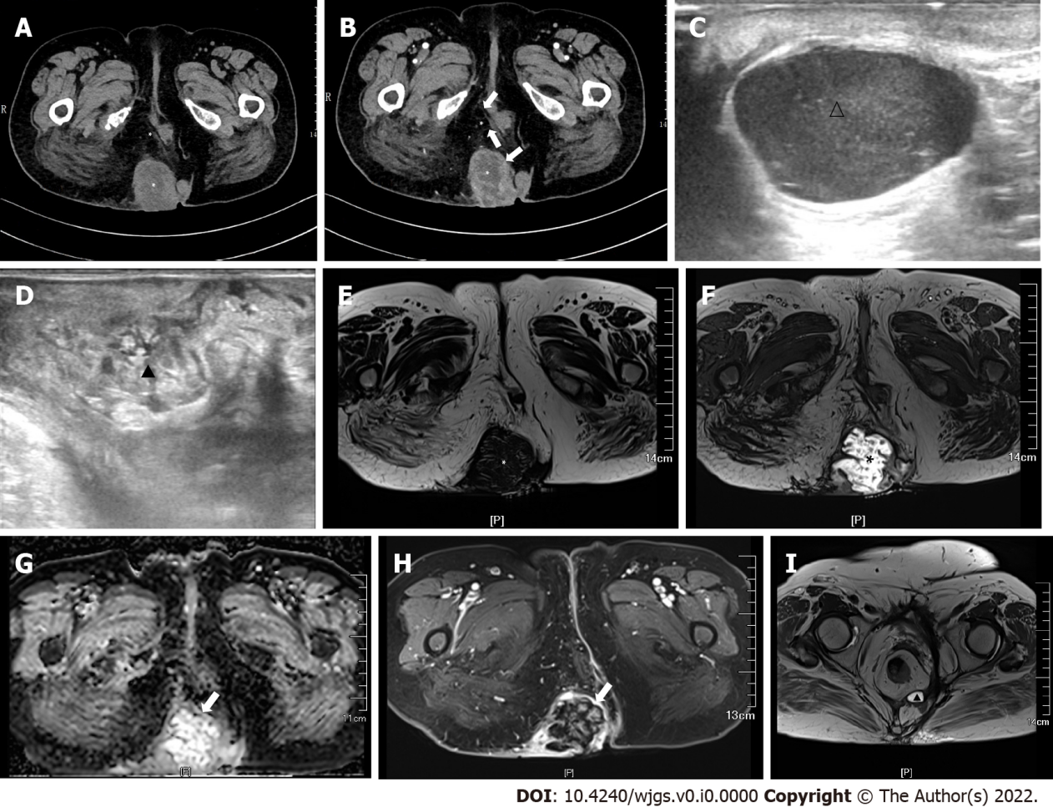
Figure 1 Computed tomography and magnetic resonance imaging. A: A soft tissue mass and cystic density shadow were observed in the right hip and sacrococcygeal region (*), and the largest range was approximately 6.0 cm × 5.8 cm × 9.5 cm; B: The cyst was uneven, and the edge and septal of the focus were enhanced (↑); C and D: Multiple hypoechoic areas with a clear boundary (1.0–2.5 cm) were observed in the sacral region (△) (C), and uneven echo areas in the right hip (▲) (D); E and F: The lesion had low-attenuation on T1 (*) (E) and high-attenuation on T2 (*) (F); G: Diffusion weighted image (↑). The longest diameter of the sagittal position was approximately 107 mm; H: The edge of the lesion was obviously enhanced (↑); I: Magnetic resonance imaging (T2) revealed a small cyst (▲) under the right levator ani.
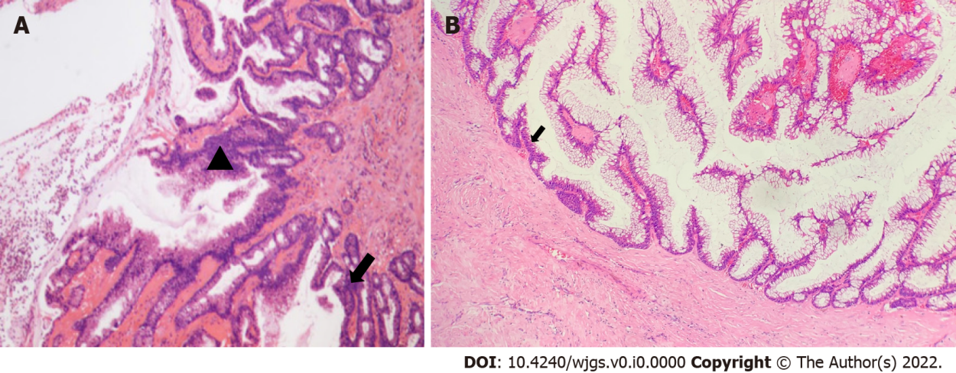
Figure 2 Histopathological analysis. A: Moderate (▲)-to-severe (↑) dysplasia of the glandular epithelium; B: The columnar epithelial lining of the cyst wall had a large amount of mucus secretion, some of the epithelium had moderate dysplasia, and deranged smooth muscle bundles could be observed in the cyst wall (↑).
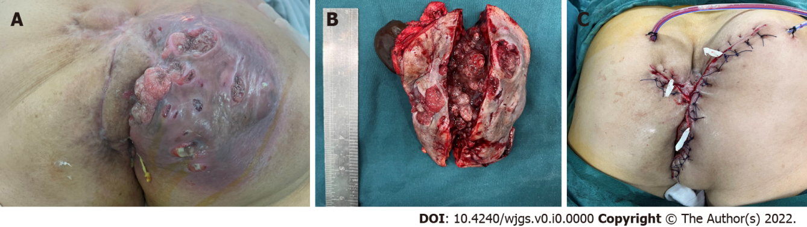
Figure 3 Macroscopic examination. A: A 13 cm × 12 cm lesion was found on the right hip, with obvious fluctuation, reddish skin on the surface, multiple ruptures, jelly-like fluid outflow, and cauliflower-like objects attached to the base; B: Gross examination of the specimen revealed brown and jelly-like fluid in the cyst; C: The orthopedists assisted with the free skin flap, and closed the incision.
Table 1 Characteristics of patients with perianal tailgut cyst who accepted chemotherapy therapy
Refs | Gender | Age (yr) | Pathology | Cause of chemotherapy | Scheme | Follow-up
Maruyama et al^{[14]}, 1998 | Female | 66 | Moderately differentiated adenocarcinoma | Elevated carcinoembryonic antigen level | Oral tegafur, 200 mg daily | 3.2 yr
Zappa et al^{[13]}, 2009 | Female | 37 | Mucinous adenocarcinoma | Resection was complete, but not en bloc | Intraperitoneal mitomycin C and doxorubicin plus systemic 5-fluorouracil and leucovorin | 3.0 yr
Zhao et al^{[5]}, 2015 | Female | 44 | Moderately differentiated adenocarcinoma | Elevated carcinoembryonic antigen level | Intracapsular tumor necrosis factor and raltitrexed plus systemic oxaliplatin 3 cycles (130 mg/m²) | 9.0 wk

