Name of Journal: World Journal of Gastroenterology
Manuscript NO: 88286
Manuscript Type: SCIENTOMETRICS

Research status and hotspots of autoimmune gastritis: A bibliometric analysis

Yu YF et al. Research status and hotspots of AIG

Yun-Feng Yu, Ke-Ke Tong, Xue-Li Shangguan, Xin-Yu Yang, Jing-Yi Wu, Gang Hu, Rong Yu, Chuan-Chuan Tan

Yun-Feng Yu, Xue-Li Shangguan, Gang Hu, Rong Yu, Chuan-Chuan Tan, The First Hospital, Hunan University of Chinese Medicine, Changsha 410007, Hunan Province, China

Ke-Ke Tong, The Hospital of Hunan University of Traditional Chinese Medicine, Hunan University of Traditional Chinese Medicine, Changde 415213, Hunan Province, China

Xin-Yu Yang, College of Chinese Medicine, Hunan University of Chinese Medicine, Changsha 410208, Hunan Province, China

Jing-Yi Wu, The Third Hospital, Zhejiang Chinese Medical University, Hangzhou 310005, Zhejiang Province, China

Co-first authors: Yun-Feng Yu and Ke-Ke Tong.

Author contributions: Yu YF conceived and designed the study; Yu YF and Tong KK participated in data processing and statistical analysis; Yu YF, Tong KK, Wu JY, and Shangguan XL drafted the manuscript; Shangguan XL, Yang XY, Hu G, Tan CC, and Wu JY contributed to data analysis and interpretation; Yu YF, Tong KK, Yang XY, Yu R, and Tan CC supervised the review of the study; All authors seriously revised and approved the final manuscript. Yu YF and Tong KK contributed equally to this work as co-first authors. The reasons for designating Yu YF and Tong KK as co-first authors are threefold. First, the research was performed as a collaborative effort, and the designation of co-first authorship accurately reflects the distribution of responsibilities and burdens associated with the time and effort required to complete the study and the resultant paper. This also ensures effective communication and management of post-submission matters, ultimately enhancing the paper’s quality and reliability. Second, the overall research team encompassed authors with a variety of expertise and skills from different fields, and the designation of co-first authors best reflects this diversity. Third, Yu YF and Tong KK contributed efforts of equal substance throughout the research process. The choice of these researchers as co-first authors acknowledges and respects this equal contribution, while recognizing the spirit of teamwork and collaboration of this study. In summary, we believe that designating Yu YF and Tong KK as co-first authors of is fitting for our manuscript as it accurately reflects our team’s collaborative spirit, equal contributions, and diversity.

Supported by National Natural Science Foundation of China, NO. U21A20411.

Corresponding author: Chuan-Chuan Tan, Doctor, The First Hospital, Hunan University of Chinese Medicine, No.95 Shaoshan Middle Road, Yuhua District, Changsha 410007, Hunan Province, China. cchuan16@hotmail.com

Received: September 20, 2023
Revised: October 18, 2023
Accepted: October 30, 2023
Published online: November 14, 2023

Abstract
BACKGROUND
As an emerging potential risk factor for gastric cancer, autoimmune gastritis (AIG) has garnered increasing attention from researchers.

AIM
To analyze the research overview and popular topics in the field of AIG using bibliometrics.

METHODS
Relevant publications on AIG in the Web of Science Core Collection were collated, and data visualization and analysis of the number of publications, countries, institutions, journals, authors, keywords, and citations were performed using software such as VOSviewer, CiteSpace, and Scimago Graphic.

RESULTS
In total, 316 relevant articles were included in the analysis. From 2015 to 2022, the number of publications increased annually. The countries, institutions, authors, and journals with the highest number of publications in this field were Italy, Monash University, Toh BH, and Internal Medicine. The main keywords used in this field of research were pathogenesis, Helicobacter pylori, autoantibody, parietal cell antibody, atrophic gastritis, classification, diagnosis, autoimmune disease, risk, cancer, gastric cancer, vitamin B12 deficiency, and pernicious anemia. The following directions may be popular for future research: (1) The role of Helicobacter pylori in the pathogenesis of AIG; (2) diagnostic criteria for AIG and reference values for serum antibodies; (3) comorbidity mechanisms between AIG and other autoimmune diseases; (4) specific risks of AIG complicating gastric and other cancers; and (5) the role of vitamin B12 supplementation in patients with early-stage AIG.

CONCLUSION
This bibliometric analysis reported on popular topics and emerging trends in AIG, with diagnosis and prognosis being research hotspots in this field.

Key Words: Autoimmune gastritis; Autoimmune diseases; Bibliometric; CiteSpace; VOSviewer; Helicobacter pylori

©The Author(s) 2023. Published by Baishideng Publishing Group Inc. All rights reserved.

Citation: Yu YF, Tong KK, Shangguan XL, Yang XY, Wu JY, Hu G, Yu R, Tan CC. Research status and hotspots of autoimmune gastritis: A bibliometric analysis. World J Gastroenterol 2023; 29(42): 5781-5799
URL: https://www.wjgnet.com/1007-9327/full/v29/i42/5781.htm
DOI: https://dx.doi.org/10.3748/wjg.v29.i42.5781

Core Tip: The pathogenesis, diagnostic criteria and prognosis of autoimmune gastritis (AIG) have been controversial. This study is expected to provide valuable insights for AIG. It uses bibliometrics to scrutinize factors such as publication years, countries, institutions, authors, journals, and keywords, while also revealing key areas for future research: (1) The role of Helicobacter pylori in the pathogenesis of AIG; (2) diagnostic criteria for AIG and reference values for serum antibodies; (3) comorbidity mechanisms between AIG and other autoimmune diseases; (4) specific risks of AIG complicating gastric and other cancers; and (5) the role of vitamin B12 supplementation in patients with early-stage AIG.
INTRODUCTION
Autoimmune gastritis (AIG) is a chronic inflammatory disease characterized by the destruction of gastric parietal cells, loss of intrinsic factors, and atrophy of the gastric mucosa^{[1]}. Epidemiological investigations indicate that the prevalence of AIG ranges from 0.1% to 2% in the general population, and it can be as high as 2%-3% in females and those older than 60 years of age^{[2]}. The pathogenesis of AIG has not been fully elucidated, and current theories suggest that CD4+ T lymphocytes target the H+/K+- ATPase of parietal cells, stimulating plasma cells to secrete autoantibodies, which may constitute the main pathogenesis^{[3]}. The autoantibodies secreted by plasma cells mainly include parietal cell antibodies (PCA) and intrinsic factor antibodies (IFA)^{[4]}; the former plays a pivotal role in parietal cell destruction and glandular atrophy^{[5]}, while the latter is an internal mechanism that triggers vitamin B12 deficiency and pernicious anemia^{[6]}. Due to the nonspecific clinical symptoms of AIG, its diagnosis primarily relies on digestive endoscopy, histopathological manifestations, and serum antibodies^{[7]}. Although recently published “Diagnostic criteria and endoscopic and histological findings of autoimmune gastritis in Japan” offer guidance for the clinical diagnosis of AIG^{[8]}, ongoing controversy remains regarding the diagnostic criteria for AIG among different countries, and as yet, there are no uniform diagnostic criteria. Research progress has provided increasing evidence in recent years that AIG may be a preneoplastic disease, which increases the patient’s risk of developing gastric cancer and neuroendocrine tumors^{[9]}. Furthermore, AIG is often comorbid with other autoimmune diseases, and it has been reported that approximately 53% of patients with AIG suffer from autoimmune thyroid disease^{[10]}. Moreover, AIG may be a risk factor for other autoimmune diseases^{[11]}. There are ongoing controversies surrounding the pathogenesis, diagnostic criteria, and prognosis of AIG, which may characterize future research in this field.
Bibliometrics is an emerging method of literature analysis that can quantitatively and qualitatively analyze articles in related fields^{[12]} and summarize various characteristics of the included literature, such as countries, institutions, journals, authors, citation rates, and keywords, thereby revealing popular research topics and trends in related fields that have been widely applied across multiple fields^{[13-15]}. In recent years, research in the field of AIG has progressed rapidly, with an increasing number of scholars focusing on the pathogenesis, diagnosis, and prognosis of AIG; however, there are no bibliometric studies related to AIG. Therefore, this study uses bibliometric analysis to explore the current research status and popular topics of AIG to provide directions for future research.

MATERIALS AND METHODS
Data sources and search strategy
The Web of Science Core Collection (WoSCC) was chosen as the data source for this study because of its coverage, citation analysis, journal quality, standardized data, and interdisciplinary research^{[16,17]}. The proposed search formula was “translational science = Autoimmune gastritis OR Autoimmune atrophic gastritis”. The search was conducted until May 2023, the restricted language was English, and the types of studies included were articles and review articles.

Data collection and analysis
Yu YF and Tong KK screened the documents and excluded non-journal papers, papers not written in English, and those that were not relevant to the research topic. The remaining documents were exported in “plain text file” and “delimited file” formats. Disagreements were resolved by Yang XY.
The data were imported into Microsoft Excel 2021 to construct a bibliometric database. VOSviewer 1.6.19, CiteSpace 6.2.2, Pajek 5.16, and Scimago Graphica 1.0.34 were used for the bibliometric analysis of the research data, which included the countries, institutions, authors, journals, references, and keywords of the selected literature. Bibliometric indicators such as average citations per item (ACI), H-index, centrality, and sum of times cited (SOTC) were used for data analysis^{[18,19]}. The ACI metric was used to measure the academic impact of a researcher, organization, or scholarly journal, with higher values indicating a greater academic impact. The H-index is the highest number of papers that received at least one citation. A higher H-index indicates greater influence. Centrality is an important metric used to identify the relative importance of a node within a network. The SOTC summed all citations of a set of papers, providing a holistic view of the overall impact, with a higher value indicating greater academic influence.

RESULTS
The trend of publication output
We searched a total of 1014 articles and ultimately included 316 articles after screening (Figure 1). As shown in Figure 2, the study of AIG commenced in 1969, and 53.48% of the total research articles were published in the last decade. The number of articles published each year after 2018 has consistently increased compared to the previous year, with the number of articles published in 2019 being 1.31 times that in 2018, the number of articles published in 2020 being 1.35 times that in 2019, and the number of articles published in 2021 being 1.17 times that in 2020. In 2022, there were 39 articles, which was 1.44 times that in 2021. For 2023, our data cover only the first five months; thus, a year-to-year comparison is not yet available.

Analysis of country/region distribution
Thirty countries published studies on AIG. Italy had the highest number of publications, accounting for 22.15% of the total, followed by Japan (21.52%), the United States (18.67%), and Australia (15.19%); the remaining countries contributed 5.7% or less (Table 1).
To visualize the collaboration among countries/regions, this study employed Scimago Graphica 1.0.34, in which a larger node area corresponds to a larger number of publications from that country or region. Nodes with a redder color represent a larger number of collaborative publications between that country/region and other countries/regions, whereas a thicker connecting line between nodes indicates closer collaboration between the two countries/regions, as shown in Figure 3. Among these, the United States had the highest number of collaborative publications with other nations. Italy and the United States exhibited the closest cooperation, followed by Italy and the Netherlands. In terms of the H-index, Italy led the way with an H-index of 25, followed by Australia (H-index = 22) and the United States (H-index = 19). Regarding ACI, Sweden (ACI = 57.3) took the lead, followed by the Netherlands (ACI = 50.63) and Australia (ACI = 33.52).

Analysis of institution distribution
A total of 409 institutions conducted research on AIG. The institution with the highest number of publications was Monash University in Australia, with 38 articles, which is twice as many as the second-ranked University of Pavia (n = 19). Kyoto University in Japan ranked third with 17 publications. Half of the top 10 institutions were based in Italy, while the remaining institutions were from Australia (n = 2), Japan (n = 2), and Turkey (n = 1), as shown in Table 2.
Institutional co-occurrence analysis illustrates the collaborative relationships among organizations, as demonstrated in Figure 4. The size of the node indicates the volume of publications, and the color intensity of the node represents the level of collaboration with other institutions. Among the top 10 institutions, Monash University had the highest number of collaborative publications with other organizations, indicating a strong cooperative relationship.

Analysis of authors and authors’ collaborations
A total of 1428 authors participated in AIG-related research, with an average of 4.5 authors per paper. Notably, the top four authors with the highest number of publications were from Australia. Among them, Toh had the highest publication volume, with 31 articles published, followed by Vandriel (n = 25), Gleeson (n = 23), and Alderuccio (n = 19). Among the top 10 authors, three were from Italy, two were from Turkey, and one was from Japan. In terms of the ACI, Gleeson topped the list with a score of 41.96, closely followed by Toh (ACI = 41.35) and Lenti (ACI = 34.17), as shown in Table 3.
Author co-occurrence networks, as illustrated in Figure 5, provide insight into the collaborative relationships between authors. Larger nodes signify more publications, node colors represent different countries, and connecting lines denote collaborative relationships between individual authors. In terms of collaborative relationships, four large working groups consisting of 10 or more authors were observed. Among the top 10 authors by publication volume, Australian authors tended to collaborate more frequently with their domestic counterparts, whereas Italian authors exhibited higher degrees of international collaboration.

Analysis of journal distribution
Table 4 lists the top 20 journals that have published the highest number of articles in the field of AIG. The journal with the highest number of articles published is “Internal Medicine” with 11 relevant articles, followed by “Gastroenterology” (n = 10). The journal with the highest impact factor (IF) is “Gastroenterology” with an IF of 33.883, followed by “Autoimmunity Reviews” (IF = 17.390), while the IF of all other journals is below 10. In terms of journal partition, two of the top three journals belong to the Q4 region, and one is in the Q1 region. Among the top 20 journals, 13 fall within Q1 and Q2 regions, while the remaining seven are in Q3 and Q4 regions.

Analysis of popular topics and frontiers
The keywords included in the literature were statistically analyzed using CiteSpace, and the top 20 keywords in terms of frequency are listed in Table 5. Apart from the subject and free words related to AIG, keywords such as “pernicious anemia”, “Helicobacter pylori”, “classification”, “diagnosis”, “Helicobacter pylori infection”, “autoantibody”, and “cancer” have a high frequency. Among them, “Helicobacter pylori”, “Helicobacter pylori infection” and “autoantibody” are related to the pathogenesis of AIG, while “classification” and “diagnosis” are linked to its clinical diagnosis. “Pernicious anemia”, “cancer”, and “vitamin B12 deficiency” are associated with AIG prognosis, indicating that researchers in this field should pay close attention to its pathogenesis, diagnosis, and prognosis.
Burst detection of keywords can indicate current popular research topics and trends in a field, as shown in Figure 6. The red bars represent the start, end, and duration of citation bursts. “Follow up” is the earliest keyword to appear, with a burst strength of 2.8 and a duration of 4 years, indicating that it is a topic of close attention in the early stage. “Prevalence” has the longest duration, appearing in 2015 and continuing for seven years, and is a topic that researchers continue to focus on. Excluding the subject and free words of AIG, “pathogenesis” is the keyword with the highest burst intensity, indicating that pathogenesis is a topic of great concern for researchers. “Risk”, “vitamin B12 deficiency”, “atrophic gastritis”, and “gastric cancer” are the keywords that have remained in the burst to the present, and they are currently popular topics that researchers are still focusing on.
CiteSpace clusters the keywords and presents them in a timeline view; Figure 7 shows the clustering results for the first 11 clusters. The differently colored horizontal lines represent the clusters formed by the keywords, the nodes on the horizontal lines represent the keywords, and the positions of the nodes represent the year in which the documents containing the keywords first appeared. “Atrophic body gastritis” was the largest keyword cluster, followed by “Helicobacter pylori”. “Vitamin B12 deficiency” appeared the latest, while “vaccine candidates” and “expression” appeared later, and the remaining keyword clusters appeared early. Over time, nodes for “Helicobacter pylori”, “parietal cell antibody”, and “autoimmune disease” continue to exist and increase, signifying that they remain popular topics for future research in this field.

Analysis of cited references and reference burst
Table 6 lists the top 20 cited articles in the field. “Reappraisal of nature and significance of chronic atrophic gastritis” authored by Strickland and Mackay^{[20]} in 1973 was the earliest published article and has been cited 505 times. It was the first AIG-related article to be recognized and cited by many researchers. The most cited article is “Classification and grading of gastritis - The updated Sydney System”, published by Dixon et al^{[21]} in 1996, with a citation frequency of 4036. This count is significantly higher than other articles, indicating that the concepts and grading involved in the article are widely recognized by the academic community. These highly cited articles were predominantly concentrated within the 20-year period from 1990 to 2010, with only three highly cited articles published in the last decade. Among the top 20 cited articles, only Toh published two articles, while the remainder were authored by different researchers.
Reference burst detection can be used to identify specific works or authors that have received significant attention during a specific period, as shown in Figure 8. The red bars represent the start, end, and duration of citation bursts. Burst detection reveals that the article “Autoimmune gastritis” by Lenti et al^{[22]} in 2020 has the highest burst intensity, indicating that the results have received focused attention from researchers. Additionally, the articles “Multicenter study of autoimmune gastritis in Japan: clinical and endoscopic characteristics” by Terao et al^{[23]} in 2020, “Natural history of autoimmune atrophic gastritis: a prospective, single centre, long-term experience” by Miceli et al^{[2]} in 2019, and “Prevalence of autoimmune gastritis in individuals undergoing medical checkups in Japan” by Notsu et al^{[24]} in 2019 have bursts that have continued to the present, indicating that they remain popular topics in the field.

Analysis of co-cited references
Over the last two decades, 6625 co-cited references on AIG have been published. Table 7 shows the top 20 cocited references, all of which were co-cited at least 33 times. “Classification and grading of gastritis. The updated Sydney System” by Dixon et al^{[21]} published in 1996, is the most co-cited reference, with 78 co-citations. This count is significantly higher than that of other articles, indicating that the concepts and grading involved in the article are widely recognized by the academic community.
We chose references with 15 or more co-citations to construct a co-citation network graph, as shown in Figure 9. The size of the nodes was proportional to the number of co-citations. The lines between nodes represent co-citation relationships, and the thickness and number of connections between nodes indicate the strength of the links between citations. “Dixon et al^{[21]}, 1996, Am J Surg Pathol” and “Strickland and Mackay^{[20]}, 1973, Am J Dig Dis”, as well as “Dixon et al^{[21]}, 1996, Am J Surg Pathol” and “Toh et al^{[25]} 1997, New Engl J Med” show a strong association, suggesting that they are universally recognized and relevant studies in the AIG field.

DISCUSSION
General information
With the growing awareness of AIG, an increasing number of doctors are focusing on this often-overlooked and undiagnosed disease. The pathogenesis, diagnosis, and treatment of AIG are gradually becoming popular research topics across multiple disciplines^{[26]}. This study aims to utilize bibliometric analysis to examine the major countries, institutions, journals, authors, etc., that have studied the AIG field and explore the popular research topics and trends in this field.
Research on AIG originated in the mid-20th century, and its publication volume grew slowly in the early years. However, since 2018, there has been explosive growth in terms of publications. Approximately 40% of the articles were published in 2018 or after, and the number of articles issued annually has shown a growing trend. In the 1960s, with the widespread use of gastroscopy and the discovery of PCA and IFA, AIG emerged as a special disease characterized by gastritis caused by autoimmune mechanisms^{[27,28]}. In 1973, Strickland and Mackay^{[20]} proposed categorizing gastritis into type A and type B based on whether serum PCA was positive. They pointed out that type A gastritis is associated with an autoimmune response characterized by highly restrictive atrophy of the body and fundus of the stomach^{[20]}. Since then, AIG and type A gastritis have become synonymous. In the 1990s, the Sydney System proposed by the World Congress of Gastroenterology categorized atrophic gastritis into two types: Predominantly gastric body gastritis associated with autoimmunity, known as AIG, and multifocal gastritis associated with environmental factors^{[21]}. In the 20 years that followed, research progress on AIG was relatively modest because researchers’ understanding of AIG was mostly inseparable from pernicious anemia and Helicobacter pylori infection. The harmful effects of Helicobacter pylori were further elaborated by the Kyoto Global Consensus in 2015^{[29]}. As the rate of Helicobacter pylori eradication increases, an increasing number of patients with AIG are being clinically diagnosed, leading people to realize that AIG is an underestimated disease. Since 2018, an increasing number of researchers have focused on AIG, resulting in an explosive surge in publications, with the annual number of articles reaching 39 in 2022.
Analyzing the countries/regions contributing to published articles helps us understand the influence and contributions of each country/region in the field. Italy ranked the highest in publication volume, with 70 articles, accounting for 22.15% of the total. In terms of influence, Italy also holds the highest H-index, while the Netherlands has the highest ACI. In terms of cooperative relationships between countries, Italy engages in close cooperation with the United States and the Netherlands. These results show that Italy is an indispensable and important country in this field of research, not only contributing significantly to the research progress of AIG but also playing a crucial role in international collaboration. Among the top 10 countries in terms of publication volume, Italy, Germany, Sweden, the Netherlands, and Finland are all European countries, suggesting that research on AIG is more popular in the European region, which may be related to the high prevalence of pernicious anemia among Europeans^{[30]}. Pernicious anemia is the result of a deficiency in internal factors caused by the autoimmune mechanism of AIG^{[31]}, and its diagnosis relies on atrophy of the gastric acid gland mucosa. This makes AIG research in European countries both necessary and urgent. It is worth noting that Japan, ranked second in publication volume, has an average citation rate of only 14.65, whereas China, which is also an Asian country, has a much lower H-index and publication volume than European and American countries. This suggests a large gap between the international influence of Asian countries in the field of AIG and that of European and American countries. From a collaborative perspective, there is a lack of collaboration between Japan and China, which could be detrimental to the long-term development of academia. The disease characteristics of the Chinese and Japanese populations may be similar because they are both of Asian descent, indicating that strengthening the collaboration between the two countries in this field would be meaningful.
The institution with the highest number of publications was Monash University in Australia, with 38 articles, twice the number of second-ranking institutions. Monash University collaborates closely with the University of Melbourne within the same country and with a number of institutions abroad, indicating that Monash University has conducted in-depth research in this field and can promote progress in this field internationally. Half of the top 10 institutions by volume are from Italy, which shows that there is a strong interest in AIG among Italian researchers; however, these institutions lack close collaboration among themselves. Thus, they should focus on exchanges with domestic institutions to enhance their breadth and depth of cooperation. Similarly, Kyoto University in Japan, which ranks third in publication volume, has collaborations with institutions from various countries but lacks collaboration with the second-ranking domestic institution, which is detrimental to research on AIG in Japan as well as to the long-term development of both institutions. It is advisable for Kyoto University to deepen collaboration with domestic institutions and, at the same time, strengthen ties with institutions in other Asian countries, such as China, to increase its international influence while increasing the output of its achievements. It is worth noting that the United States, which ranks third in publication volume, lacks an institution in the top 10 rankings, suggesting that while there might be numerous American institutions engaged in research on AIG, there is a lack of leading institutions with high output in the field. Research institutions in the US should provide stronger support to establish leading institutions that can guide research efforts, thereby fostering coordinated collaboration among various institutions.
The four authors with the highest number of publications were from Australia. Toh and Alderuccio are from Monash University, while Vandriel and Gleeson are from the University of Melbourne. Their research focuses on cell biology, immunology, pathology, and gastroenterology. Toh, Vanriel, and Gleeson are a team, and Toh and Alderuccio work closely together; their research focuses on exploring the pathogenesis of AIG in mouse models. They conducted a series of studies on BALB/c mice induced by neonatal thymectomy and found that the autoimmune response to AIG is caused by TH1-type CD4 T cells recognizing the β-subunit of the gastric H+/K+ ATPase^{[32]} and indicates that Fas is necessary for the development of gastric mucosal cell damage in AIG^{[33]}. These authors’ articles rank among the top in terms of quantity and quality, and they collaborate closely with each other, jointly promoting research in the field of AIG pathogenesis in Australia. However, Australia has fewer authors engaged in this field, and it is hoped that more Australian scholars will engage in AIG research in the future. Among the top 10 authors, there are also three from Italy: Miceli from Fondazione IRCCS Policlinico San Matteo and Di Sabatino and Lenti from the University of Pavia. They also constitute a tightly collaborating team, primarily engaging in laboratory serology studies and clinical research related to AIG and focusing on controversial aspects of AIG, such as its relationship with Helicobacter pylori^{[34]}, its course^{[2]}, and its potential risk factors^{[35,36]}. In terms of cooperation, they not only closely cooperate with domestic scholars but also actively cooperate with foreign researchers, which enriches their clinical trial data, thus promoting the development of AIG clinical research. It is anticipated that more multicenter clinical trials will be conducted in the future to provide an inexhaustible impetus for further advancement in AIG research. The two authors from Turkey, Soykan and Kalkan, predominantly study complications and laboratory serology in relation to AIG^{[37,38]}, and their achievements are primarily found in cooperation with each other, while they lack of collaboration with the outside world. Haruma from Japan promoted endoscopic research on AIG^{[23,39]} and identified endoscopic clues for early AIG by accumulating cases^{[40]}. Overall, AIG research has been conducted in various ways, but each country focuses on different directions, and academic exchanges should be strengthened in the future to provide a better environment for the development of this field.
In analyzing the publication journals, the journal with the highest IF is Gastroenterology (IF=33.883, Q1), which has published a total of 10 articles in the field of AIG. Articles published before 2002 mainly focused on foundational research on AIG pathogenesis^{[3,41]}, whereas in recent years, the tendency has been to publish high-quality clinical studies^{[42]}. This shift indicates that the AIG research trend is evolving from basic research to clinical investigation, with an increasing number of researchers attempting to explore the pathogenesis, clinical diagnosis, and treatment of AIG through clinical studies. The journal with the largest number of published articles is Internal Medicine (IF=1.282, Q4), which mainly publishes case reports related to AIG, and most of the topics are related to digestive endoscopy. This suggests that the journal has a strong interest in case reports of endoscopic manifestations of AIG and that the accumulation and summary of these case reports play an important role in promoting clinical research on AIG. The top 10 journals in terms of publication volume mostly belong to the Q1 and Q2 regions, indicating that AIG research is still influential in the relevant disciplines in this field.

Popular topics and frontiers
To gain a clearer understanding of the research focal points in the realm of AIG, we reviewed primary literature pertaining to popular topics implicated in frequency, burst, and temporal clustering analyses. Subsequently, we distilled from these pivotal keywords the current quintet of popular research topics in the domain of AIG: (1) The role of Helicobacter pylori in AIG pathogenesis (keywords: Helicobacter pylori, Helicobacter pylori infection): The role of Helicobacter pylori infection in AIG pathogenesis is the current focal point of investigation. Most scholars posit that Helicobacter pylori is implicated in the onset of AIG, possibly due to antigen mimicry or cross-reactivity^{[43]}. Amedei et al^{[44]} reported that in genetically susceptible individuals, Helicobacter pylori infection can activate cross-reactive gastric T cells, thereby inducing gastric autoimmunity through molecular mimicry. Faller et al^{[45]} have detected PCA and anti-PCA in Helicobacter pylori-infected gastritis, suggesting some similarities between the pathogenic mechanisms of Helicobacter pylori-infected gastritis and AIG. However, the ongoing discourse regarding whether Helicobacter pylori infection exerts a positive or negative influence on the progression of AIG remains unclear. Kotera et al^{[46]} reported a case of AIG in which gastric mucosal atrophy showed improvement after Helicobacter pylori eradication; however, the underlying reasons for this change remain unexplained. Conversely, the literature has documented cases of AIG progression after Helicobacter pylori eradication, suggesting that Helicobacter pylori infection may inhibit AIG activity^{[47]}. In summary, the role of Helicobacter pylori in AIG remains a subject of ongoing debate and should be a focal theme for future research; (2) Diagnostic criteria for AIG and reference values of serum antibodies (keywords: autoantibody, parietal cell antibody): AIG diagnosis currently lacks a universally accepted standard. The most recent diagnostic criteria, published in 2023 by Kamada et al^{[8]} in “Diagnostic criteria and endoscopic and histological findings of autoimmune gastritis in Japan”, have set the diagnostic criteria for AIG as the fulfillment of endoscopic and/or histological manifestations that meet specific criteria, alongside positive findings for PCA and/or IFA^{[8]}. Given that early-stage AIG lacks distinct endoscopic manifestations, its diagnosis requires the fulfillment of histological criteria and the presence of autoantibodies. Autoantibodies such as PCA and IFA, which represent diagnostic markers for AIG, hold significant value. However, the absence of autoantibodies does not definitively exclude the possibility of AIG. This is attributed to the fact that PCA titers tend to gradually decline from early- to late-stage AIG, and late-stage patients may exhibit PCA negativity due to the depletion of antigens resulting from parietal cell loss^{[48]}. Furthermore, evidence suggests an age-related correlation, with PCA negativity being more common among older adult AIG patients^{[49]}. Notably, recent research by Kriķe et al^{[50]} suggests that PCA and PGI/II constitute the optimal combination for AIG detection, while the diagnostic value of IFA is limited. In summary, the academic community currently lacks consensus regarding AIG diagnostic standards, and the specificity and sensitivity of autoantibodies, such as PCA and IFA, in AIG diagnosis remains a subject of debate. These findings provide avenues for future research and potential breakthroughs; (3) Comorbidity mechanisms between AIG and other autoimmune diseases (keyword: Autoimmune disease): As an autoimmune disease, AIG often coexists with other autoimmune diseases. When AIG is combined with other autoimmune afflictions and results in deficiencies in various endocrine organs, it is termed autoimmune multiglandular syndrome^{[51]}. Thyroid disorders are the most common comorbidities in patients with AIG, affecting approximately 53% of AIG cases^{[10]}. Known autoimmune disorders that commonly coincide with AIG include type 1 diabetes, rheumatoid arthritis, primary Sjögren’s syndrome, inflammatory bowel disease, vitiligo, chronic cheilitis, myasthenia gravis, Addison’s disease, etc^{[11,52]}. Although the current evidence suggests a connection between AIG and other autoimmune disorders, the mechanisms underlying their comorbidity are yet to be elucidated. The shared comorbidity mechanisms of AIG and other autoimmune diseases may be a focal point for future research; (4) Specific risks of AIG complicating gastric and other cancers (keywords: Risk, gastric cancer, cancer): Gastric carcinoma and neuroendocrine tumors represent the most severe known complications and latent risks of AIG^{[53]}. The damaged parietal cells are supplanted by tissues undergoing pseudopyloric and intestinal metaplasia, thus fostering the metamorphosis into gastric cancer^{[54]}. This destruction of parietal cells leads to a reduction in gastric acid secretion, thereby triggering negative feedback regulation in the gastric antrum, resulting in increased levels of gastrin in the bloodstream^{[55]}. Gastrin has the potential to stimulate the proliferation of enterochromaffin-like cells in the intestines, culminating in the development of neuroendocrine tumors^{[55]}. The OLGA/OLGIM systems indicate a heightened risk of gastric cancer in patients with AIG at stages III-IV, which is primarily associated with concomitant Helicobacter pylori infection^{[56]}. Notably, a recent long-term clinical observation suggested that AIG did not elevate the risk of gastric cancer when compared to the general population, suggesting that the previously reported increased risk may be attributed to undetected concurrent Helicobacter pylori infection^{[57]}. Nevertheless, Waldum^{[58]} contends that the design of this clinical observation lacked rationality and posited that the role of Helicobacter pylori infection in augmenting gastric cancer risk among AIG patients remains to be substantiated. In summary, AIG may augment the risk of neuroendocrine tumors, yet its impact on gastric cancer risk remains a subject of contention. The precise risk of AIG complicating gastric cancer and other malignancies warrants further investigation. In summary, AIG leads to an increased risk of neuroendocrine tumors; however, its effect on the risk of gastric cancer remains controversial. The specific risk of AIG being complicated by gastric and other cancers is an interesting area of research; and (5) Potential role of vitamin B12 supplementation in patients with early-stage AIG (keywords: Vitamin B12 deficiency, pernicious anemia): In early investigations, pernicious anemia was regarded as a complex ailment encompassing serology, gastroenterology, and immunology^{[30]}. During AIG, the destruction of parietal cells and the formation of IFA jointly lead to a decline in intrinsic factor levels, consequently hindering the absorption of vitamin B12 and ultimately leading to pernicious anemia. Notably, clinical observations by Hershko and others^{[59]} revealed that iron-deficiency anemia, rather than megaloblastic anemia, was the most common type of anemia in patients with AIG. They suggested that this anemia occurred before the onset of pernicious anemia caused by prolonged vitamin B12 deficiency, with its etiology linked to parietal cell destruction, leading to gastric acid deficiency. Furthermore, multicenter studies have indicated that mild hematological alterations and deficiencies in trace nutrients, such as iron and vitamins, appear before overt anemia^{[60]}. These indications suggest that iron and vitamin B12 supplementation might be advantageous for patients before the diagnosis of iron-deficiency anemia or pernicious anemia, although there is insufficient evidence to support this inference. In summary, because pernicious anemia rarely occurs in the early stages of AIG, the need for early vitamin B12 and iron supplementation is debatable and is a research topic of interest for future studies in the field of AIG.

Limitations
Although we rigorously adhered to bibliometric research methods, our study has limitations. First, to ensure the quality of this study, we exclusively obtained data from the WoSCC database. This decision may have led to an incomplete search for articles. Second, our study was limited to English-language publications, and abstract-only papers were excluded. This may have reduced the comprehensiveness of the research findings. Third, as WoSCC was continuously updated, the citation counts and H-index of the included articles continuously evolves, introducing inevitable temporal limitations to this study.

CONCLUSION
To the best of our knowledge, this is the first comprehensive quantitative bibliometric analysis of AIG. It scrutinized factors such as publication year, country, institution, author, journal, and keywords while also clarifying key areas for future research: (1) The role of Helicobacter pylori in AIG pathogenesis; (2) diagnostic criteria for AIG and the significance of serum antibodies; (3) comorbidity mechanisms of AIG and other autoimmune diseases; (4) specific risks of AIG complicated by gastric cancer and other malignancies; and (5) the potential role of vitamin B12 supplementation in patients with early-stage AIG. This study is expected to provide valuable insight for further AIG research.

ARTICLE HIGHLIGHTS
Research background
Autoimmune gastritis (AIG) is a distinctive type of chronic atrophic gastritis that is considered a potential risk factor for some tumors. Increasing numbers of researchers are focusing on the pathogenesis, diagnosis, and prognosis of AIG.

Research motivation
Bibliometrics is one of the most commonly used methods to evaluate the research status in a field. To date, there are no bibliometric studies related to AIG. Bibliometric analysis provide a more comprehensive overview of the research status and research hotspots in AIG.

Research objectives
This study aims to provide a comprehensive understanding of the knowledge structure and research hotspots of AIG and to offer new ideas and directions for its research.

Research methods
Data for this study were sourced from the Web of Science Core Collection. The proposed search formula was “translational science = Autoimmune gastritis OR Autoimmune atrophic gastritis”. The search was conducted until May 2023, the restricted language was English, and the type of studies included were articles and review articles.

Research results
In total, 316 relevant articles were included. From 2015 to 2022, the number of publications increased annually. The countries, institutions, authors, and journals with the highest number of publications in this field were Italy, Monash University, Toh BH, and Internal Medicine. The main keywords usd in this field of research were pathogenesis, Helicobacter pylori, autoantibody, parietal cell antibody, atrophic gastritis, classification, diagnosis, autoimmune disease, risk, cancer, gastric cancer, vitamin B12 deficiency, and pernicious anemia.

Research conclusions
This was the first bibliometric analysis related to AIG, highlighting hot topics and emerging trends in the field, and offering new ideas to further scientific research and clinical applications.

Research perspectives
The following directions may be popular for future research: (1) The role of Helicobacter pylori in the pathogenesis of AIG; (2) diagnostic criteria for AIG and the reference value of serum antibodies; (3) comorbidity mechanisms between AIG and other autoimmune diseases; (4) specific risks of AIG complicating gastric and other cancers; and (5) the role of vitamin B12 supplementation in patients with early-stage AIG.

REFERENCES
1 Kulnigg-Dabsch S. Autoimmune gastritis. Wien Med Wochenschr 2016; 166: 424-430 [PMID: 27671008 DOI: 10.1007/s10354-016-0515-5]
2 Miceli E, Vanoli A, Lenti MV, Klersy C, Di Stefano M, Luinetti O, Caccia Dominioni C, Pisati M, Staiani M, Gentile A, Capuano F, Arpa G, Paulli M, Corazza GR, Di Sabatino A. Natural history of autoimmune atrophic gastritis: a prospective, single centre, long-term experience. Aliment Pharmacol Ther 2019; 50: 1172-1180 [PMID: 31621927 DOI: 10.1111/apt.15540]
3 Martinelli TM, van Driel IR, Alderuccio F, Gleeson PA, Toh BH. Analysis of mononuclear cell infiltrate and cytokine production in murine autoimmune gastritis. Gastroenterology 1996; 110: 1791-1802 [PMID: 8964405 DOI: 10.1053/gast.1996.v110.pm8964405]
4 Rustgi SD, Bijlani P, Shah SC. Autoimmune gastritis, with or without pernicious anemia: epidemiology, risk factors, and clinical management. Therap Adv Gastroenterol 2021; 14: 17562848211038771 [PMID: 34484423 DOI: 10.1177/17562848211038771]
5 Minalyan A, Benhammou JN, Artashesyan A, Lewis MS, Pisegna JR. Autoimmune atrophic gastritis: current perspectives. Clin Exp Gastroenterol 2017; 10: 19-27 [PMID: 28223833 DOI: 10.2147/CEG.S109123]
6 Miura T, Matsuda M, Yanbe H, Sugiyama S. Two cases of autoimmune progesterone dermatitis. Immunohistochemical and serological studies. Acta Derm Venereol 1989; 69: 308-310 [PMID: 2568048 DOI: 10.1016/j.rce.2014.12.013]
7 Toh BH. Diagnosis and classification of autoimmune gastritis. Autoimmun Rev 2014; 13: 459-462 [PMID: 24424193 DOI: 10.1016/j.autrev.2014.01.048]
8 Kamada T, Watanabe H, Furuta T, Terao S, Maruyama Y, Kawachi H, Kushima R, Chiba T, Haruma K. Diagnostic criteria and endoscopic and histological findings of autoimmune gastritis in Japan. J Gastroenterol 2023; 58: 185-195 [PMID: 36855000 DOI: 10.1007/s00535-022-01954-9]
9 Bizzaro N, Antico A, Villalta D. Autoimmunity and Gastric Cancer. Int J Mol Sci 2018; 19 [PMID: 29373557 DOI: 10.3390/ijms19020377]
10 Lahner E, Centanni M, Agnello G, Gargano L, Vannella L, Iannoni C, Delle Fave G, Annibale B. Occurrence and risk factors for autoimmune thyroid disease in patients with atrophic body gastritis. Am J Med 2008; 121: 136-141 [PMID: 18261502 DOI: 10.1016/j.amjmed.2007.09.025]
11 Rodriguez-Castro KI, Franceschi M, Miraglia C, Russo M, Nouvenne A, Leandro G, Meschi T, De' Angelis GL, Di Mario F. Autoimmune diseases in autoimmune atrophic gastritis. Acta Biomed 2018; 89: 100-103 [PMID: 30561426 DOI: 10.23750/abm.v89i8-S.7919]
12 Wu F, Gao J, Kang J, Wang X, Niu Q, Liu J, Zhang L. Knowledge Mapping of Exosomes in Autoimmune Diseases: A Bibliometric Analysis (2002-2021). Front Immunol 2022; 13: 939433 [PMID: 35935932 DOI: 10.3389/fimmu.2022.939433]
13 Wei N, Xu Y, Li Y, Shi J, Zhang X, You Y, Sun Q, Zhai H, Hu Y. A bibliometric analysis of T cell and atherosclerosis. Front Immunol 2022; 13: 948314 [PMID: 36311729 DOI: 10.3389/fimmu.2022.948314]
14 Thompson DF, Walker CK. A descriptive and historical review of bibliometrics with applications to medical sciences. Pharmacotherapy 2015; 35: 551-559 [PMID: 25940769 DOI: 10.1002/phar.1586]
15 Ninkov A, Frank JR, Maggio LA. Bibliometrics: Methods for studying academic publishing. Perspect Med Educ 2022; 11: 173-176 [PMID: 34914027 DOI: 10.1007/s40037-021-00695-4]
16 Cheng K, Guo Q, Shen Z, Yang W, Wang Y, Sun Z, Wu H. Bibliometric Analysis of Global Research on Cancer Photodynamic Therapy: Focus on Nano-Related Research. Front Pharmacol 2022; 13: 927219 [PMID: 35784740 DOI: 10.3389/fphar.2022.927219]
17 Cheng K, Zhang H, Guo Q, Zhai P, Zhou Y, Yang W, Wang Y, Lu Y, Shen Z, Wu H. Emerging trends and research foci of oncolytic virotherapy for central nervous system tumors: A bibliometric study. Front Immunol 2022; 13: 975695 [PMID: 36148235 DOI: 10.3389/fimmu.2022.975695]
18 Wu Z, Cheng K, Shen Z, Lu Y, Wang H, Wang G, Wang Y, Yang W, Sun Z, Guo Q, Wu H. Mapping knowledge landscapes and emerging trends of sonodynamic therapy: A bibliometric and visualized study. Front Pharmacol 2022; 13: 1048211 [PMID: 36699067 DOI: 10.3389/fphar.2022.1048211]
19 Wu H, Cheng K, Tong L, Wang Y, Yang W, Sun Z. Knowledge structure and emerging trends on osteonecrosis of the femoral head: a bibliometric and visualized study. J Orthop Surg Res 2022; 17: 194 [PMID: 35346273 DOI: 10.1186/s13018-022-03068-7]
20 Strickland RG, Mackay IR. A reappraisal of the nature and significance of chronic atrophic gastritis. Am J Dig Dis 1973; 18: 426-440 [PMID: 4573514 DOI: 10.1007/BF01071995]
21 Dixon MF, Genta RM, Yardley JH, Correa P. Classification and grading of gastritis. The updated Sydney System. International Workshop on the Histopathology of Gastritis, Houston 1994. Am J Surg Pathol 1996; 20: 1161-1181 [PMID: 8827022 DOI: 10.1097/00000478-199610000-00001]
22 Lenti MV, Rugge M, Lahner E, Miceli E, Toh BH, Genta RM, De Block C, Hershko C, Di Sabatino A. Autoimmune gastritis. Nat Rev Dis Primers 2020; 6: 56 [PMID: 32647173 DOI: 10.1038/s41572-020-0187-8]
23 Terao S, Suzuki S, Yaita H, Kurahara K, Shunto J, Furuta T, Maruyama Y, Ito M, Kamada T, Aoki R, Inoue K, Manabe N, Haruma K. Multicenter study of autoimmune gastritis in Japan: Clinical and endoscopic characteristics. Dig Endosc 2020; 32: 364-372 [PMID: 31368581 DOI: 10.1111/den.13500]
24 Notsu T, Adachi K, Mishiro T, Fujihara H, Toda T, Takaki S, Kinoshita Y. Prevalence of Autoimmune Gastritis in Individuals Undergoing Medical Checkups in Japan. Intern Med 2019; 58: 1817-1823 [PMID: 30918182 DOI: 10.2169/internalmedicine.2292-18]
25 Toh BH, van Driel IR, Gleeson PA. Pernicious anemia. N Engl J Med 1997; 337: 1441-1448 [PMID: 9358143 DOI: 10.1056/NEJM199711133372007]
26 Valdes-Socin H, Leclercq P, Polus M, Rohmer V, Beckers A, Louis E. Chronic autoimmune gastritis: a multidisciplinary management. Rev Med Liege 2019; 74: 598-605 [PMID: 31729849]
27 Mackay IR. Autoimmune serological studies in chronic gastritis and pernicious anaemia. Gut 1964; 5: 23-26 [PMID: 14127504 DOI: 10.1136/gut.5.1.23]
28 Adams JF, Glen AI, Kennedy EH, Mackenzie IL, Morrow JM, Anderson JR, Gray KG, Middleton DG. The histological and secretory changes in the stomach in patients with autoimmunity to gastric parietal cells. Lancet 1964; 1: 401-403 [PMID: 14092953 DOI: 10.1016/s0140-6736(64)92785-0]
29 Sugano K, Tack J, Kuipers EJ, Graham DY, El-Omar EM, Miura S, Haruma K, Asaka M, Uemura N, Malfertheiner P; faculty members of Kyoto Global Consensus Conference. Kyoto global consensus report on Helicobacter pylori gastritis. Gut 2015; 64: 1353-1367 [PMID: 26187502 DOI: 10.1136/gutjnl-2015-309252]
30 Bizzaro N, Antico A. Diagnosis and classification of pernicious anemia. Autoimmun Rev 2014; 13: 565-568 [PMID: 24424200 DOI: 10.1016/j.autrev.2014.01.042]
31 Lahner E, Annibale B. Pernicious anemia: new insights from a gastroenterological point of view. World J Gastroenterol 2009; 15: 5121-5128 [PMID: 19891010 DOI: 10.3748/wjg.15.5121]
32 De Silva HD, Gleeson PA, Toh BH, Van Driel IR, Carbone FR. Identification of a gastritogenic epitope of the H/K ATPase beta-subunit. Immunology 1999; 96: 145-151 [PMID: 10233689 DOI: 10.1046/j.1365-2567.1999.00669.x]
33 Marshall AC, Alderuccio F, Toh BH. Fas/CD95 is required for gastric mucosal damage in autoimmune gastritis. Gastroenterology 2002; 123: 780-789 [PMID: 12198704 DOI: 10.1053/gast.2002.35383]
34 De Re V, Repetto O, De Zorzi M, Casarotto M, Tedeschi M, Giuffrida P, Lenti MV, Magris R, Miolo G, Mazzon C, Zanette G, Alessandrini L, Canzonieri V, Caggiari L, Zanussi S, Steffan A, Di Sabatino A, Cannizzaro R. Polymorphism in Toll-Like Receptors and Helicobacter Pylori Motility in Autoimmune Atrophic Gastritis and Gastric Cancer. Cancers (Basel) 2019; 11 [PMID: 31083432 DOI: 10.3390/cancers11050648]
35 Lenti MV, Miceli E, Vanoli A, Klersy C, Corazza GR, Di Sabatino A. Time course and risk factors of evolution from potential to overt autoimmune gastritis. Dig Liver Dis 2022; 54: 642-644 [PMID: 34732311 DOI: 10.1016/j.dld.2021.10.001]
36 Lenti MV, Vanoli A, Miceli E, Arpa G, Di Stefano M, Soriano S, Capuano F, Gentile A, Aronico N, Coppola L, Pasini A, Luinetti O, Mauro A, Paulli M, Klersy C, Corazza GR, Di Sabatino A. Increase of Deep Intraepithelial Lymphocytes in the Oxyntic Mucosa of Patients With Potential and Overt Autoimmune Gastritis. Front Immunol 2022; 13: 866167 [PMID: 35603187 DOI: 10.3389/fimmu.2022.866167]
37 Soykan I, Yakut M, Keskin O, Bektaş M. Clinical profiles, endoscopic and laboratory features and associated factors in patients with autoimmune gastritis. Digestion 2012; 86: 20-26 [PMID: 22710370 DOI: 10.1159/000338295]
38 Kalkan Ç, Soykan İ. Utility of a laboratory score in the prediction of altered autonomic nervous system function in autoimmune gastritis. Turk J Gastroenterol 2018; 29: 32-35 [PMID: 29391305 DOI: 10.5152/tjg.2018.17295]
39 Kamada T, Maruyama Y, Monobe Y, Haruma K. Endoscopic features and clinical importance of autoimmune gastritis. Dig Endosc 2022; 34: 700-713 [PMID: 34674318 DOI: 10.1111/den.14175]
40 Kotera T, Oe K, Kushima R, Haruma K. Multiple Pseudopolyps Presenting as Reddish Nodules Are a Characteristic Endoscopic Finding in Patients with Early-stage Autoimmune Gastritis. Intern Med 2020; 59: 2995-3000 [PMID: 32759583 DOI: 10.2169/internalmedicine.4637-20]
41 Jones CM, Callaghan JM, Gleeson PA, Mori Y, Masuda T, Toh BH. The parietal cell autoantigens recognized in neonatal thymectomy-induced murine gastritis are the alpha and beta subunits of the gastric proton pump [corrected]. Gastroenterology 1991; 101: 287-294 [PMID: 1648525 DOI: 10.1016/0016-5085(91)90002-3]
42 Butt J, Lehtinen M, Öhman H, Waterboer T, Epplein M. Association of Helicobacter pylori and Autoimmune Gastritis With Stomach Cancer in a Cohort of Young Finnish Women. Gastroenterology 2022; 163: 305-307.e4 [PMID: 35301012 DOI: 10.1053/j.gastro.2022.03.012]
43 D'Elios MM, Appelmelk BJ, Amedei A, Bergman MP, Del Prete G. Gastric autoimmunity: the role of Helicobacter pylori and molecular mimicry. Trends Mol Med 2004; 10: 316-323 [PMID: 15242679 DOI: 10.1016/j.molmed.2004.06.001]
44 Amedei A, Bergman MP, Appelmelk BJ, Azzurri A, Benagiano M, Tamburini C, van der Zee R, Telford JL, Vandenbroucke-Grauls CM, D'Elios MM, Del Prete G. Molecular mimicry between Helicobacter pylori antigens and H+, K+ --adenosine triphosphatase in human gastric autoimmunity. J Exp Med 2003; 198: 1147-1156 [PMID: 14568977 DOI: 10.1084/jem.20030530]
45 Faller G, Steininger H, Eck M, Hensen J, Hann EG, Kirchner T. Antigastric autoantibodies in Helicobacter pylori gastritis: prevalence, in-situ binding sites and clues for clinical relevance. Virchows Arch 1996; 427: 483-486 [PMID: 8624577 DOI: 10.1007/BF00199508]
46 Kotera T, Nishimi Y, Kushima R, Haruma K. Regression of Autoimmune Gastritis after Eradication of Helicobacter pylori. Case Rep Gastroenterol 2023; 17: 34-40 [PMID: 36742095 DOI: 10.1159/000528388]
47 Ihara T, Ihara N, Kushima R, Haruma K. Rapid Progression of Autoimmune Gastritis after Helicobacter pylori Eradication Therapy. Intern Med 2023; 62: 1603-1609 [PMID: 36261377 DOI: 10.2169/internalmedicine.0533-22]
48 Nishizawa T, Watanabe H, Yoshida S, Toyoshima A, Kataoka Y, Kanazawa T, Yoshizawa N, Ebinuma H, Suzuki H, Toyoshima O. Decreased anti-parietal cell antibody titer in the advanced phase of autoimmune gastritis. Scand J Gastroenterol 2022; 57: 143-148 [PMID: 34693845 DOI: 10.1080/00365521.2021.1994642]
49 Conti L, Lenti MV, Di Sabatino A, Miceli E, Galli G, Cazzato M, Falangone F, Annibale B, Lahner E. Seronegative autoimmune atrophic gastritis is more common in elderly patients. Dig Liver Dis 2020; 52: 1310-1314 [PMID: 32487505 DOI: 10.1016/j.dld.2020.04.015]
50 Kriķe P, Shums Z, Poļaka I, Kikuste I, Vanags A, Tolmanis I, Isajevs S, Liepniece-Karele I, Santare D, Tzivian L, Rudzīte D, Song M, Camargo MC, Norman GL, Leja M. The Diagnostic Value of Anti-Parietal Cell and Intrinsic Factor Antibodies, Pepsinogens, and Gastrin-17 in Corpus-Restricted Atrophic Gastritis. Diagnostics (Basel) 2022; 12 [PMID: 36428844 DOI: 10.3390/diagnostics12112784]
51 Rojas-Villarraga A, Amaya-Amaya J, Rodriguez-Rodriguez A, Mantilla RD, Anaya JM. Introducing polyautoimmunity: secondary autoimmune diseases no longer exist. Autoimmune Dis 2012; 2012: 254319 [PMID: 22454759 DOI: 10.1155/2012/254319]
52 De Block CE, De Leeuw IH, Van Gaal LF. Autoimmune gastritis in type 1 diabetes: a clinically oriented review. J Clin Endocrinol Metab 2008; 93: 363-371 [PMID: 18029461 DOI: 10.1210/jc.2007-2134]
53 Pachuashvili NV, Nagornaya DP, Tertychnyi AS. Metachronous tumors of the stomach in a patient with autoimmune gastritis. Arkh Patol 2023; 85: 57-61 [PMID: 36785963 DOI: 10.17116/patol20238501157]
54 Nguyen TL, Khurana SS, Bellone CJ, Capoccia BJ, Sagartz JE, Kesman RA Jr, Mills JC, DiPaolo RJ. Autoimmune gastritis mediated by CD4+ T cells promotes the development of gastric cancer. Cancer Res 2013; 73: 2117-2126 [PMID: 23378345 DOI: 10.1158/0008-5472.CAN-12-3957]
55 Burkitt MD, Pritchard DM. Review article: Pathogenesis and management of gastric carcinoid tumours. Aliment Pharmacol Ther 2006; 24: 1305-1320 [PMID: 17059512 DOI: 10.1111/j.1365-2036.2006.03130.x]
56 Rugge M, Fassan M, Pizzi M, Zorzetto V, Maddalo G, Realdon S, De Bernard M, Betterle C, Cappellesso R, Pennelli G, de Boni M, Farinati F. Autoimmune gastritis: histology phenotype and OLGA staging. Aliment Pharmacol Ther 2012; 35: 1460-1466 [PMID: 22519568 DOI: 10.1111/j.1365-2036.2012.05101.x]
57 Rugge M, Bricca L, Guzzinati S, Sacchi D, Pizzi M, Savarino E, Farinati F, Zorzi M, Fassan M, Dei Tos AP, Malfertheiner P, Genta RM, Graham DY. Autoimmune gastritis: long-term natural history in naïve Helicobacter pylori-negative patients. Gut 2023; 72: 30-38 [PMID: 35772926 DOI: 10.1136/gutjnl-2022-327827]
58 Waldum HL. Conclusion that autoimmune gastritis does not predispose to gastric cancer is unproven. Gut 2023 [PMID: 36693711 DOI: 10.1136/gutjnl-2022-329323]
59 Hershko C, Ronson A, Souroujon M, Maschler I, Heyd J, Patz J. Variable hematologic presentation of autoimmune gastritis: age-related progression from iron deficiency to cobalamin depletion. Blood 2006; 107: 1673-1679 [PMID: 16239424 DOI: 10.1182/blood-2005-09-3534]
60 Lenti MV, Lahner E, Bergamaschi G, Miceli E, Conti L, Massironi S, Cococcia S, Zilli A, Caprioli F, Vecchi M, Maiero S, Cannizzaro R, Corazza GR, Annibale B, Di Sabatino A. Cell Blood Count Alterations and Patterns of Anaemia in Autoimmune Atrophic Gastritis at Diagnosis: A Multicentre Study. J Clin Med 2019; 8 [PMID: 31731715 DOI: 10.3390/jcm8111992]

Footnotes
Conflict-of-interest statement: Dr. Tan has nothing to disclose.

PRISMA 2009 Checklist statement: The authors have read the PRISMA 2009 Checklist, and the manuscript was prepared and revised according to the PRISMA 2009 Checklist.

Open-Access: This article is an open-access article that was selected by an in-house editor and fully peer-reviewed by external reviewers. It is distributed in accordance with the Creative Commons Attribution NonCommercial (CC BY-NC 4.0) license, which permits others to distribute, remix, adapt, build upon this work non-commercially, and license their derivative works on different terms, provided the original work is properly cited and the use is non-commercial. See: https://creativecommons.org/Licenses/by-nc/4.0/

Provenance and peer review: Unsolicited article; Externally peer reviewed.

Peer-review model: Single blind

Peer-review started: September 20, 2023
First decision: October 7, 2023
Article in press: October 30, 2023

Specialty type: Gastroenterology and hepatology
Country/Territory of origin: China
Peer-review report’s scientific quality classification
Grade A (Excellent): 0
Grade B (Very good): B
Grade C (Good): C
Grade D (Fair): 0
Grade E (Poor): 0

P-Reviewer: Haruma K, Japan; Wu H, United States S-Editor: Lin C L-Editor: A P-Editor: Yuan YY

Figure Legends
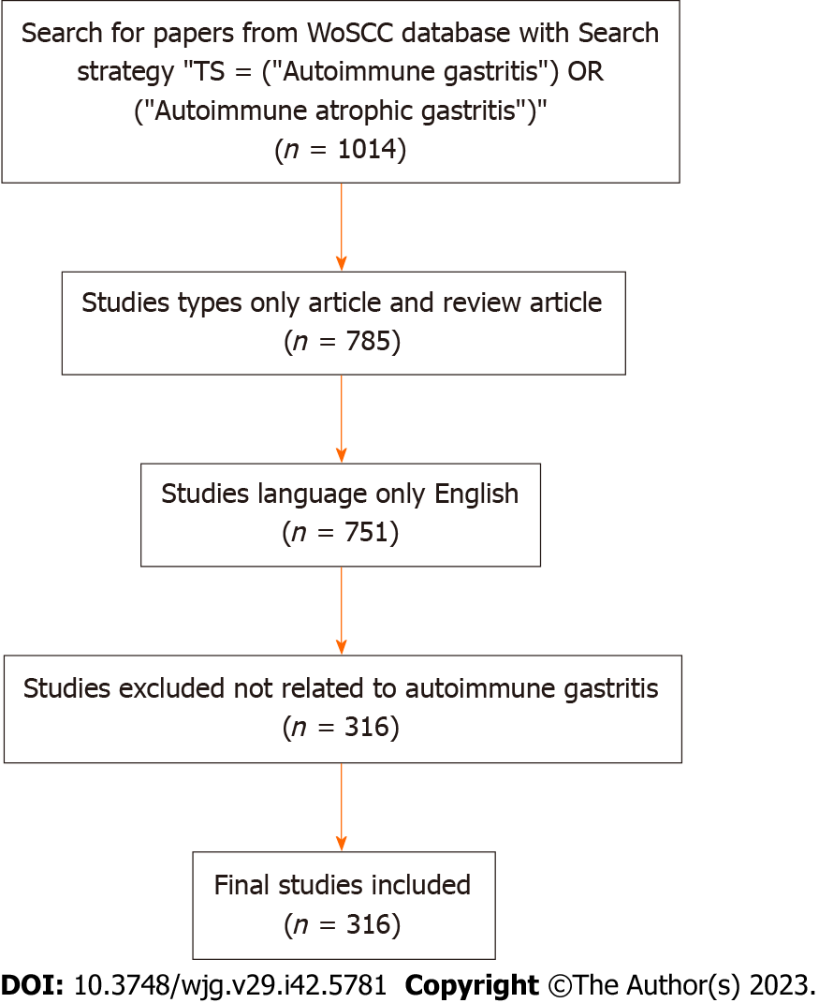
Figure 1 Flow diagram of the included papers. TS: Translational science; WoSCC: Web of Science Core Collection.
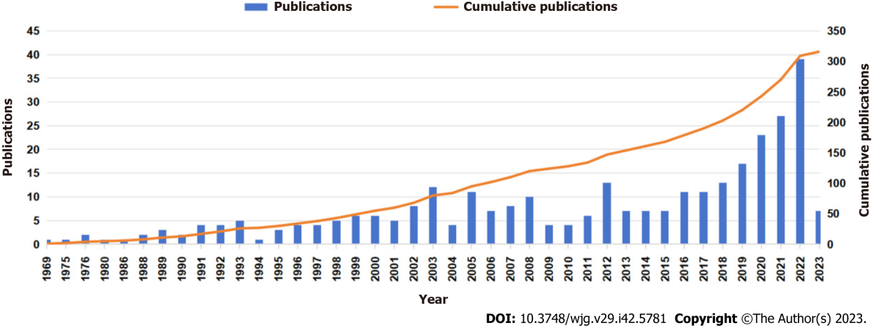
Figure 2 Trends of the related annual publications.
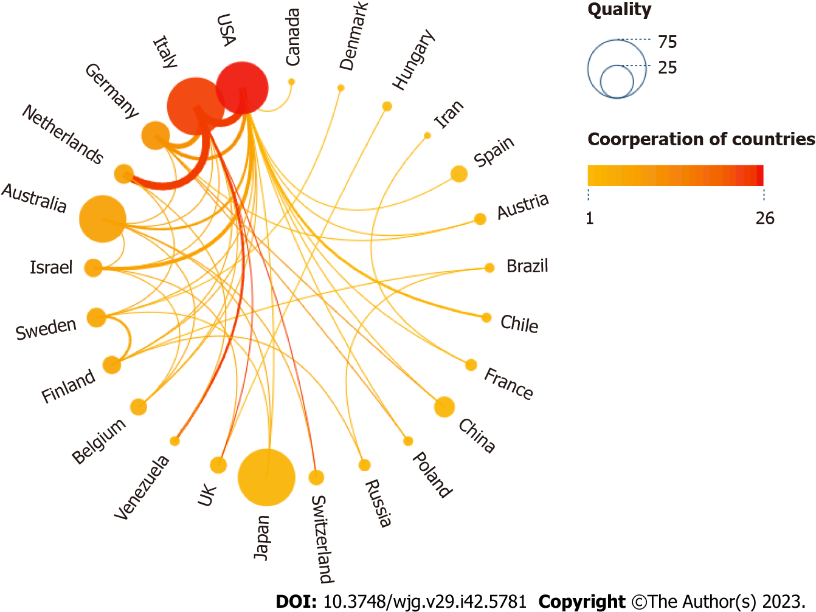
Figure 3 Scimago Graphic collaboration visualization map of country/region. In this visual map, each node is a country, and the links between countries represent cooperative relations. The size of each node is proportional to the total number of publications. The red nodes indicate that there are more cooperative publications between the country/region and other countries/regions, while the thicker connecting lines between the nodes indicate that the cooperation between the two countries/regions is closer.
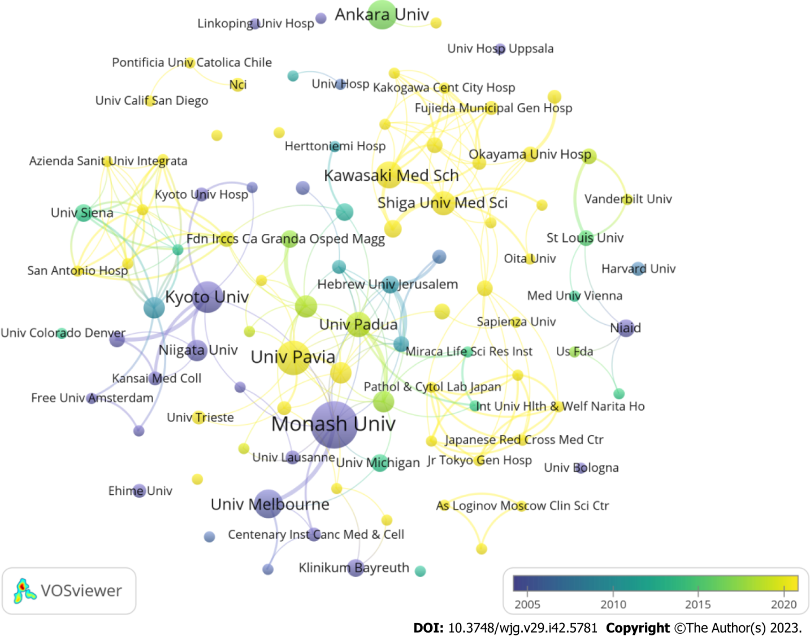
Figure 4 Scimago Graphic collaboration visualization map of institutions. In this network visualization map, each node is an institution. The size of the node indicates the volume of publications, and the color intensity of the node represents the level of collaboration with other institutions. The node color reflects the corresponding average appearing year according to the color gradient in the lower right corner.
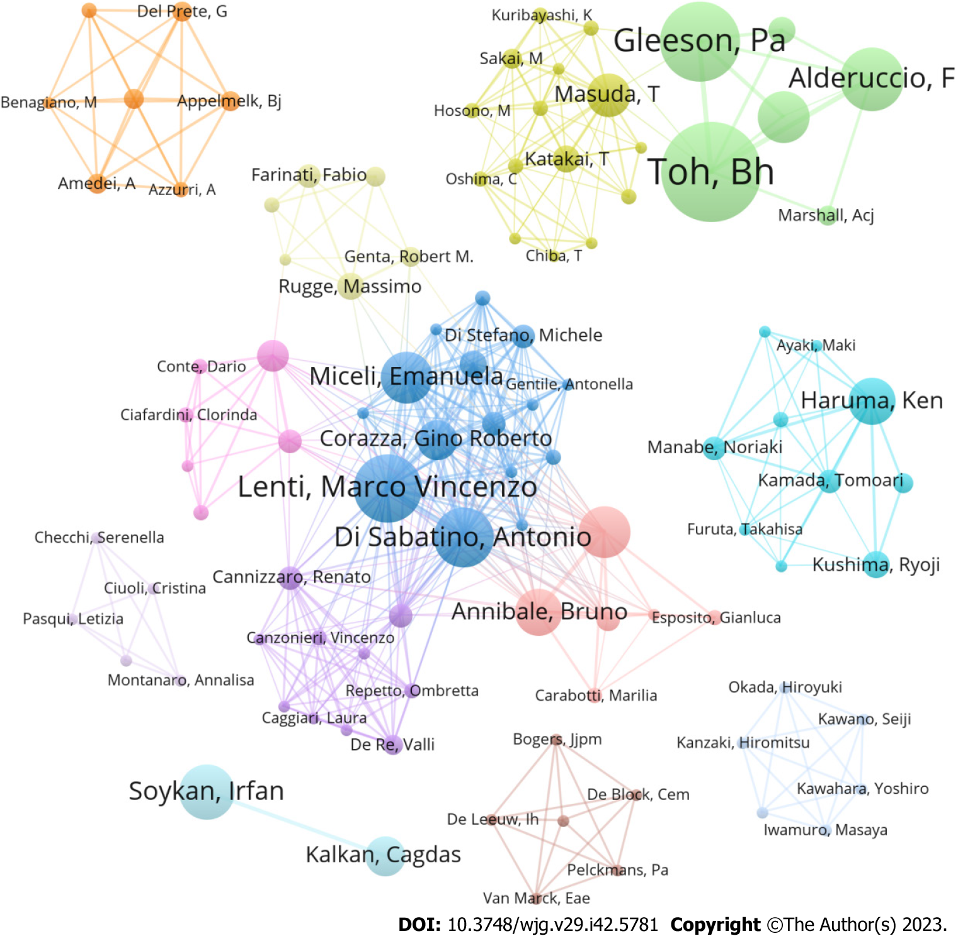
Figure 5 Analysis of author collaborations. In this network visualization map, each node is an author, and the links between the authors represent the cooperative relationship. The size of each node is proportional to the total number of publications, the colors of nodes represent different countries, and the connecting lines represent the cooperative relationship between individual authors.
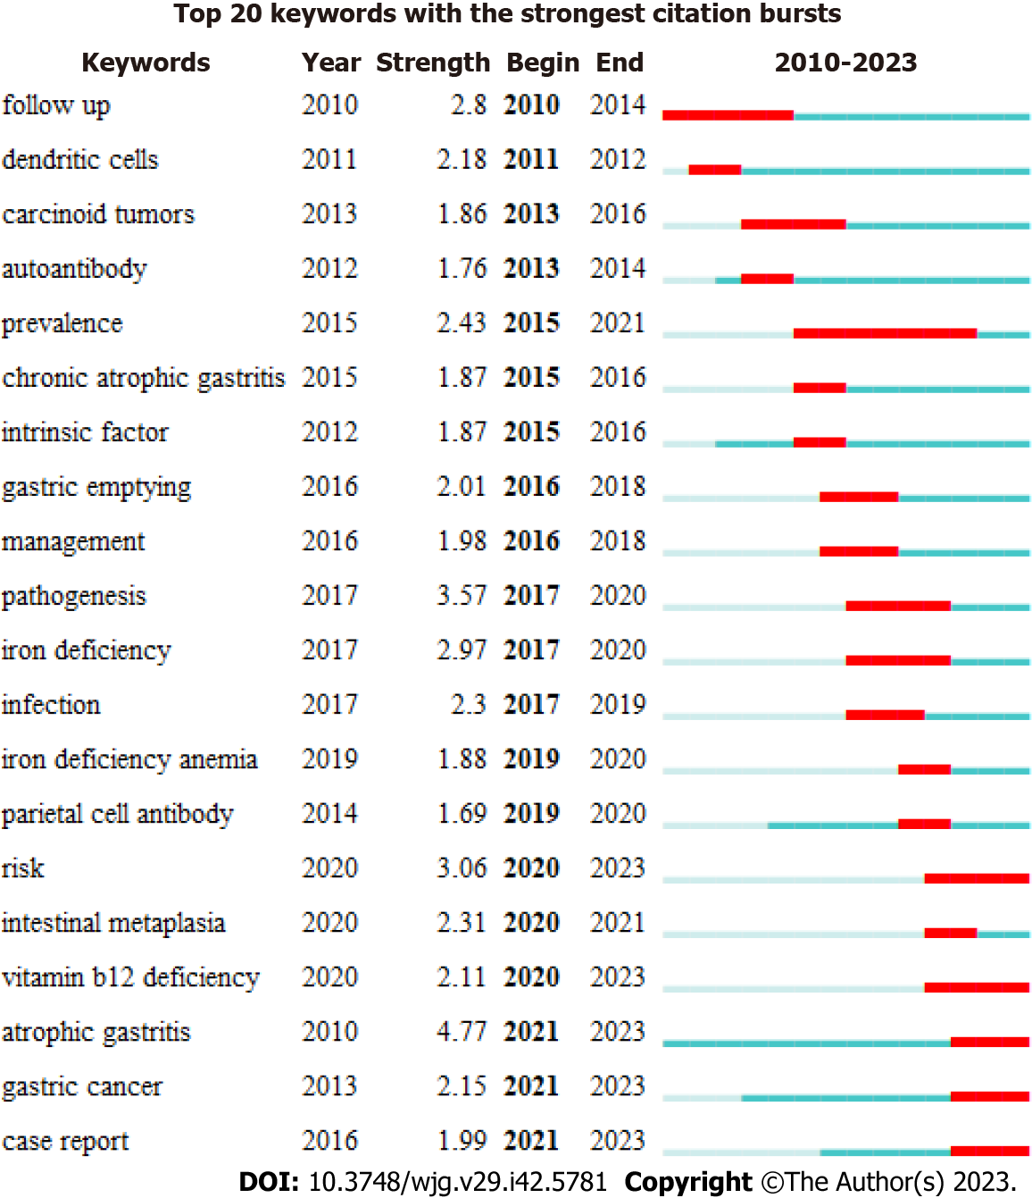
Figure 6 Top 20 keywords with the strongest keyword bursts. The red bars represent the starting and ending, and the duration of citation bursts.
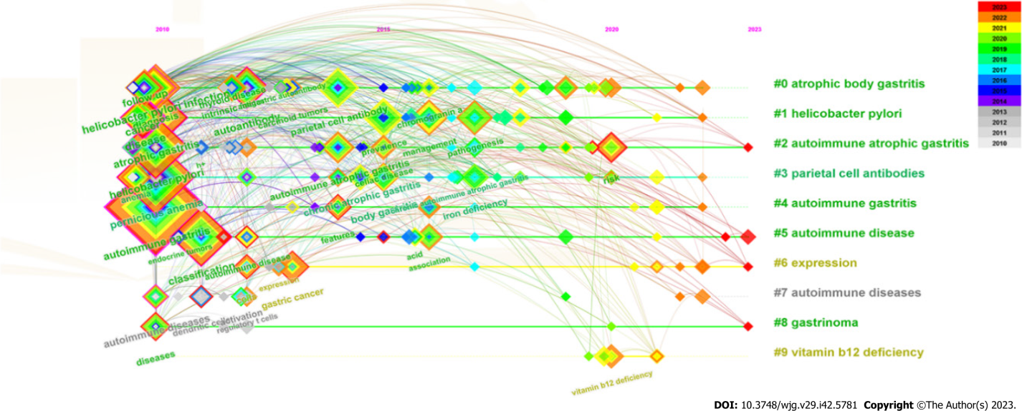
Figure 7 CiteSpace visualization timeline view of keywords clustering analysis. The different colored horizontal lines represent the clusters formed by the keywords, the nodes on the horizontal lines represent the keywords, and the position of the nodes represents the year in which the documents containing the keywords first appeared.
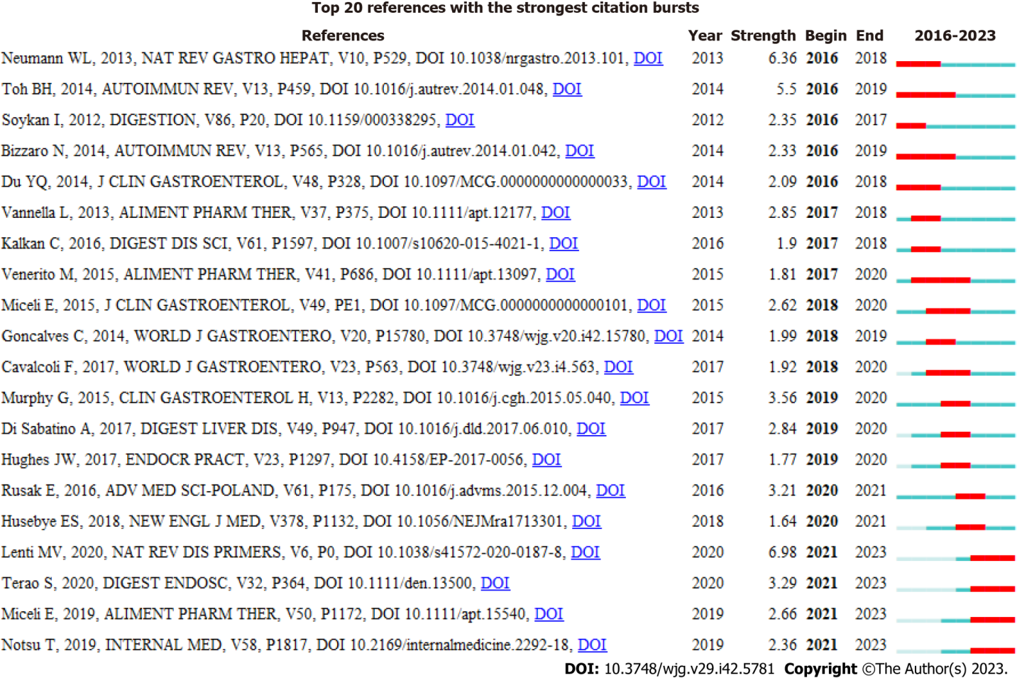
Figure 8 Top 20 references with the strongest citation bursts. The red bars represent the starting and ending, and the duration of citation bursts.
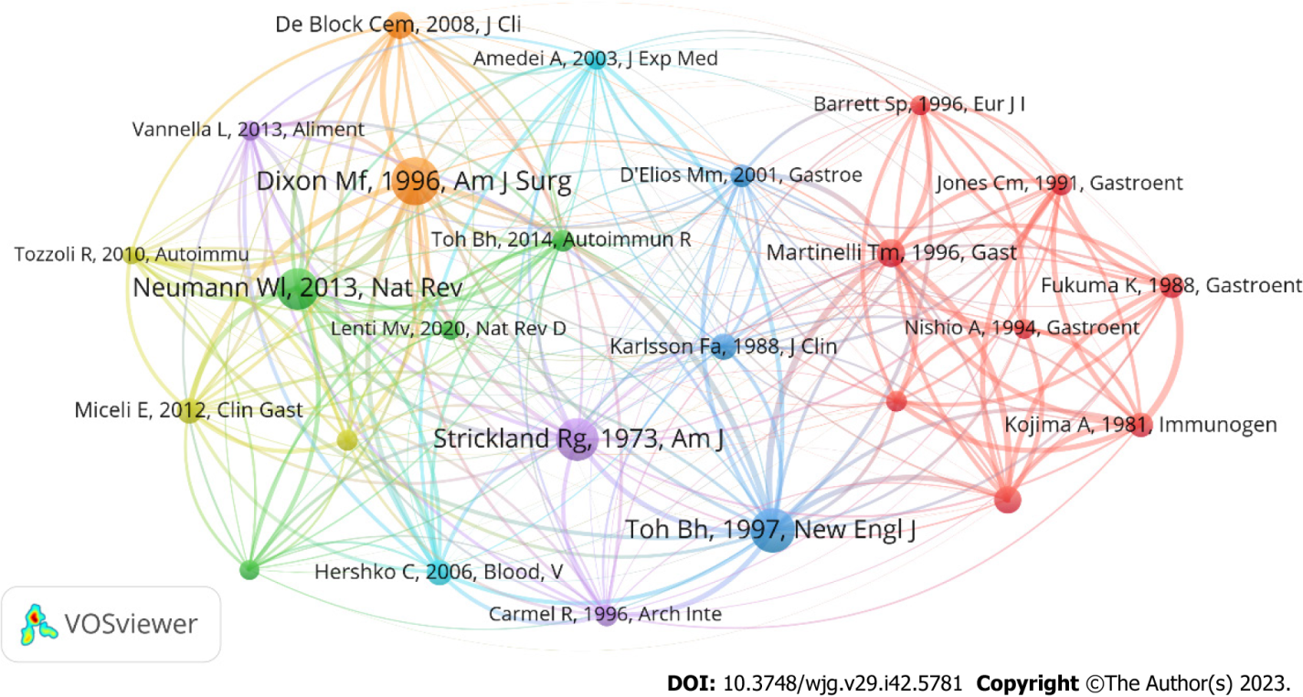
Figure 9 CiteSpace visualization cluster view of co-cited references. In this visual map, each node represents a co-cited reference, and the size of the nodes is proportional to the number of co-citations, and the lines between nodes represent co-citation relationships. The thickness and number of connections between nodes indicate the strength of the links between co-citations.
Table 1 Top 10 productive countries
Rank | Country | Quantity | Proportion (%) | ACI | H-index | Centrality
1 | Italy | 70 | 22.15 | 29.16 | 25 | 0.49
2 | Japan | 68 | 21.52 | 14.65 | 16 | 0.03
3 | United States | 59 | 18.67 | 26.32 | 19 | 0.80
4 | Australia | 48 | 15.19 | 33.52 | 22 | 0.04
5 | Germany | 18 | 5.70 | 18.5 | 11 | 0.06
6 | Turkey | 16 | 5.06 | 6.44 | 6 | 0.00
7 | Sweden | 10 | 3.16 | 57.3 | 9 | 0.01
8 | China | 9 | 2.85 | 1.78 | 2 | 0.00
9 | Netherlands | 8 | 2.53 | 50.63 | 6 | 0.00
10 | Finland | 7 | 2.22 | 11.57 | 5 | 0.29
ACI: Average citations per item.
Table 2 Top 10 productive institutions
Rank | Institution | Country | Quantity | SOTC | ACI | H-index
1 | Monash University | Australia | 38 | 1413 | 37.18 | 20
2 | University of Pavia | Italy | 19 | 433 | 22.79 | 10
3 | Kyoto of University | Japan | 17 | 593 | 34.88 | 12
4 | Ankala University | Turkey | 14 | 95 | 6.79 | 6
5 | Sapienza University Rome | Italy | 14 | 284 | 20.29 | 9
6 | University of Melbourne | Australia | 14 | 367 | 26.21 | 11
7 | Irccs Fondazione San Matteo | Italy | 13 | 375 | 28.85 | 7
8 | University of Padua | Italy | 12 | 467 | 38.92 | 8
9 | Azienda Ospedaliera Sant Andrea | Italy | 11 | 192 | 17.45 | 7
10 | Kawasaki Medical School | Japan | 11 | 92 | 8.36 | 6
SOTC: Sum of times cited; ACI: Average citations per item.
Table 3 Top 10 authors
Rank | Author | Country | Institution | Quantity | ACI | H-index
1 | Toh BH | Australia | Monash University | 31 | 41.35 | 19
2 | Vandriel IR | Australia | University of Melbourne | 25 | 33.88 | 17
3 | Gleeson PA | Australia | University of Melbourne | 23 | 41.96 | 16
4 | Alderuccio F | Australia | Monash University | 19 | 33.89 | 12
5 | Miceli E | Italy | Irccss S Matteo Hosp Fdn | 14 | 24.07 | 8
6 | Soykan I | Turkey | Ankara University | 14 | 6.79 | 6
7 | Di Sabatino A | Italy | University of Pavia | 13 | 11.62 | 6
8 | Haruma K | Japan | Kawasaki Medical School | 12 | 7.83 | 6
9 | Lenti MV | Italy | University of Pavia | 12 | 34.17 | 10
10 | Kalkan C | Turkey | City Hospital Ankara | 10 | 6.1 | 4
ACI: Average citations per item.
Table 4 Top 20 journals
Rank | Journal | Quantity | ACI | IF (2022) | JCR
1 | Internal Medicine | 11 | 6.73 | 1.282 | Q4
2 | Gastroenterology | 10 | 39.6 | 33.883 | Q1
3 | Autoimmunity | 9 | 21.33 | 2.957 | Q4
4 | Journal of Immunology | 9 | 44.11 | 5.426 | Q2
5 | World Journal of Gastroenterology | 8 | 29.25 | 5.374 | Q2
6 | Digestive and Liver Disease | 7 | 11.29 | 5.165 | Q2
7 | Frontiers in Immunology | 7 | 1.57 | 8.786 | Q1
8 | International Reviews of Immunology | 7 | 17.43 | 5.078 | Q2
9 | Alimentary Pharmacology & Therapeutics | 6 | 35.5 | 9.524 | Q1
10 | Clinical and Experimental Immunology | 6 | 22.83 | 5.732 | Q2
11 | Digestion | 6 | 17.33 | 3.672 | Q3
12 | Autoimmunity Reviews | 5 | 58 | 17.390 | Q1
13 | Clinical Journal of Gastroenterology | 5 | 2.8 | 0 | Q3
14 | Journal of Gastroenterology | 5 | 6.6 | 6.772 | Q2
15 | Scandinavian Journal of Gastroenterology | 5 | 18.4 | 3.027 | Q4
16 | American Journal of Physiology-Gastrointestinal and Liver Physiology | 4 | 28.75 | 4.871 | Q1/Q2
17 | Archives of Pathology & Laboratory Medicine | 4 | 14.25 | 5.686 | Q1/Q2
18 | BMC Gastroenterology | 4 | 14.5 | 2.847 | Q4
19 | Digestive Diseases and Sciences | 4 | 8 | 3.487 | Q3
20 | European Journal of Immunology | 4 | 41.25 | 6.688 | Q2
IF: Impact factor; JCR: Journal citation reports; ACI: Average citations per item.
Table 5 Top 20 Keywords
Rank | Keywords | Count | Centrality
1 | Autoimmune gastritis | 96 | 0.25
2 | Pernicious anemia | 64 | 0.12
3 | Atrophic gastritis | 46 | 0.12
4 | Helicobacter pylori | 44 | 0.14
5 | Classification | 40 | 0.16
6 | Diagnosis | 29 | 0.07
7 | Helicobacter pylori infection | 27 | 0.18
8 | Disease | 26 | 0.26
9 | Autoantibody | 21 | 0.10
10 | Cancer | 21 | 0.13
11 | Prevalence | 20 | 0.04
12 | Parietal cell antibody | 20 | 0.03
13 | Follow up | 16 | 0.08
14 | Atrophic body gastritis | 15 | 0.06
15 | Pathogenesis | 15 | 0.03
16 | Management | 15 | 0.03
17 | Risk | 12 | 0.04
18 | Autoimmune atrophic gastritis | 11 | 0.08
19 | Gastric cancer | 11 | 0.07
20 | Body gastritis | 10 | 0.08
Table 6 Top 20 cited references
Rank | Title | Journal | Author | Year | Citation
1 | Classification and grading of gastritis - The updated Sydney System | American Journal of Surgical Pathology | Dixon M | 1996 | 4036
2 | Autoimmune disease as a consequence of developmental abnormality of a T cell subpopulation | Journal of Experimental Medicine | Asano M | 1996 | 1067
3 | Prevalence of undiagnosed pernicious anemia in the elderly | Archives of Internal Medicine | Carmel R | 1996 | 798
4 | Reappraisal of nature and significance of chronic atrophic gastritis | American Journal of Digestive Diseases | Strickland RG | 1973 | 505
5 | Mechanisms of disease: Pernicious anemia | New England Journal of Medicine | Toh BH | 1997 | 381
6 | Genetic susceptibility to post-thymectomy autoimmune-diseases in mice | Immunogenetics | Kojima A | 1981 | 244
7 | Autoimmune atrophic gastritis-pathogenesis, pathology and management | Nature Reviews Gastroenterology & Hepatology | Neumann WL | 2013 | 198
8 | Major parietal-cell antigen in autoimmune gastritis with pernicious-anemia is the acid-producing H+,K+-adenosine triphosphatase of the stomach | Journal of Clinical Investigation | Karlsson FA | 1988 | 183
9 | Molecular mimicry between Helicobacter pylori antigens and H+,K+-adenosine triphosphatase in human gastric autoimmunity | Journal of Experimental Medicine | Amedei A | 2003 | 180
10 | Variable hematologic presentation of autoimmune gastritis: age-related progression from iron deficiency to cobalamin depletion | Blood | Hershko C | 2006 | 157
11 | An autoimmune-disease with multiple molecular targets abrogated by the transgenic expression of a single autoantigen in the thymus | Journal of Experimental Medicine | Alderuccio F | 1993 | 148
12 | Autoimmune gastritis in type 1 diabetes: A clinically oriented review | Journal of Clinical Endocrinology & Metabolism | De Block C | 2008 | 121
13 | H+, K+-ATPase (proton pump) is the target autoantigen of Th1-type cytotoxic T cells in autoimmune gastritis | Gastroenterology | D'elios MM | 2001 | 109
14 | Systematic review: gastric cancer incidence in pernicious anaemia | Alimentary Pharmacology & Therapeutics | Vannella L | 2013 | 109
15 | Reassessment of Intrinsic Factor and Parietal Cell Autoantibodies in Atrophic Gastritis With Respect to Cobalamin Deficiency | American Journal of Gastroenterology | Lahner E | 2009 | 95
16 | The parietal-cell autoantibodies recognized in neonatal thymectomy-induced murine gastritis are the alpha-subunit and beta-subunit of the gastric proton pump | Gastroenterology | Jones CM | 1991 | 92
17 | Immunological and clinical-studies on murine experimental autoimmune gastritis induced by neonatal thymectomy | Gastroenterology | Fukuma K | 1988 | 85
18 | Diagnosis and classification of autoimmune gastritis | Autoimmunity Reviews | Toh BH | 2014 | 83
19 | Analysis of mononuclear cell infiltrate and cytokine production in murine autoimmune gastritis | Gastroenterology | Martinelli TM | 1996 | 75
20 | Common Features of Patients with Autoimmune Atrophic Gastritis | Clinical Gastroenterology and Hepatology | Miceli E | 2012 | 73
Table 7 Top 10 co-cited references
Rank | Title | Journal | Author | Year | Citation
1 | Classification and grading of gastritis - The updated Sydney System | American Journal of Surgical Pathology | Dixon MF | 1996 | 78
2 | Mechanisms of disease: Pernicious anemia | New England Journal of Medicine | Toh BH | 1997 | 71
3 | Reappraisal of Nature And Significance of Chronic Atrophic Gastritis | American Journal of Digestive Diseases | Strickland RG | 1973 | 69
4 | Autoimmune Atrophic Gastritis-Pathogenesis, Pathology and Management | Nature Reviews Gastroenterology & Hepatology | Neumann WL | 2013 | 67
5 | Analysis of Mononuclear Cell Infiltrate and Cytokine Production in Murine Autoimmune Gastritis | Gastroenterology | Martinelli TM | 1996 | 46
6 | An Autoimmune-Disease with Multiple Molecular Targets Abrogated by the Transgenic Expression of A Single Autoantigen In the Thymus | Journal of Experimental Medicine | Alderuccio F | 1993 | 44
7 | Autoimmune Gastritis in Type 1 Diabetes: A Clinically Oriented Review | Journal of Clinical Endocrinology & Metabolism | De Block CEM | 2008 | 44
8 | Major Parietal-Cell Antigen In Autoimmune Gastritis With Pernicious-Anemia is The Acid-Producing H+,K+-Adenosine Triphosphatase of The Stomach | Journal of Clinical Investigation | Karlsson Fa | 1988 | 42
9 | Variable Hematologic Presentation of Autoimmune Gastritis: Age-Related Progression From Iron Deficiency To Cobalamin Depletion | Blood | Hershko C | 2006 | 41
10 | Common Features of Patients With Autoimmune Atrophic Gastritis | Clinical Gastroenterology and Hepatology | Miceli E | 2012 | 41
11 | Immunologic and clinical studies on murine experimental autoimmune gastritis induced by neonatal thymectomy | Gastroenterology | Fukuma K | 1988 | 40
12 | Genetic susceptibility to post-thymectomy autoimmune diseases in mice | Immunogenetics | Kojima A | 1981 | 40
13 | H(+),K(+)-atpase (proton pump) is the target autoantigen of Th1-type cytotoxic T cells in autoimmune gastritis | Gastroenterology | D'Elios Mm | 2001 | 37
14 | Prevalence of undiagnosed pernicious anemia in the elderly | Arch Intern Med | Carmel R | 1996 | 36
15 | The parietal cell autoantigens recognized in neonatal thymectomy-induced murine gastritis are the alpha and beta subunits of the gastric proton pump [corrected] | Gastroenterology | Jones Cm | 1991 | 36
16 | Diagnosis and classification of autoimmune gastritis | Autoimmun Rev | Toh Bh | 2014 | 36
17 | Autoimmune disease as a consequence of developmental abnormality of a T cell subpopulation | J Exp Med | Asano M | 1996 | 34
18 | Reassessment of intrinsic factor and parietal cell autoantibodies in atrophic gastritis with respect to cobalamin deficiency | Am J Gastroenterol | Lahner E | 2009 | 34
19 | Molecular mimicry between Helicobacter pylori antigens and H+, K+ --adenosine triphosphatase in human gastric autoimmunity | J Exp Med | Amedei A | 2003 | 33
20 | Autoimmune gastritis: Pathologist’s viewpoint | World J Gastroentero | Coati I | 2015 | 33

Published by Baishideng Publishing Group Inc
7041 Koll Center Parkway, Suite 160, Pleasanton, CA 94566, USA
Telephone: +1-925-3991568
E-mail: bpgoffice@wjgnet.com
Help Desk: https://www.f6publishing.com/helpdesk
https://www.wjgnet.com

© 2023 Baishideng Publishing Group Inc. All rights reserved.

