Name of Journal: World Journal of Gastroenterology
Manuscript NO: 67551
Manuscript Type: MINIREVIEWS

Therapeutic endoscopy for the treatment of post-bariatric surgery complications

Larsen M et al. Therapeutic endoscopy for post-bariatric surgery complications

Michael Larsen, Richard Kozarek

Michael Larsen, Richard Kozarek, Digestive Disease Institute, Virginia Mason Medical Center, Seattle, WA 98101, United States

Author contributions: Larsen M reviewed the literature and prepared the manuscript; Kozarek R contributed to and revised the manuscript; all authors approved the final manuscript.

Corresponding author: Michael Larsen, MD, Doctor, Digestive Disease Institute, Virginia Mason Medical Center, 1100 Ninth Avenue, Seattle, WA 98101, United States. michael.larsen@virginiamason.org

Received: April 27, 2021
Revised: July 8, 2021
Accepted: December 31, 2021
Published online:

Abstract
Obesity rates continue to climb worldwide. Obesity often contributes to other comorbidities such as type 2 diabetes, hypertension, heart disease and is a known risk factor for many malignancies. Bariatric surgeries are by far the most invasive treatment options available but are often the most effective and can result in profound, durable weight loss with improvement in or resolution of weight associated comorbidities. Currently performed bariatric surgeries include Roux-en-Y gastric bypass, sleeve gastrectomy, and laparoscopic gastric banding. These surgeries are associated with significant weight loss, but also with significant rates of major complications. The complexity of these patients and surgical anatomies makes management of these complications by a multidisciplinary team critical for optimal outcomes. Minimally invasive treatments for complications are typically preferred because of the high risk associated with repeat operations. Endoscopy plays a large role in both the diagnosis and the management of complications. Endoscopy can provide therapeutic interventions for many bariatric surgical complications including anastomotic strictures, anastomotic leaks, choledocholithiasis, sleeve stenosis, weight regain, and eroded bands. Endoscopists should be familiar with the various surgical anatomies as well as the various therapeutic options available. This review article serves to delineate the current role of endoscopy in the management of complications after bariatric surgery.

Key words: Therapeutic endoscopy; Bariatric surgery; Complications; Weight regain; Sleeve stenosis; Sleeve leak

Larsen M, Kozarek R. Therapeutic endoscopy for the treatment of post-bariatric surgery complications. World J Gastroenterol 2021; In press

Core Tip: Bariatric surgery is the most effective treatment for morbid obesity. While surgical techniques have improved, complications after these surgeries remain common. Multidisciplinary management of these complications is important given their complexity. Therapeutic endoscopy provides a minimally invasive option for treatment of complications. This review article serves to delineate the current role of therapeutic endoscopy in the management of complications after bariatric surgery.

INTRODUCTION
Obesity rates have grown dramatically both in wealthy nations and the developing world; resulting in a worldwide global health problem. According to the WHO, in 2016, 1.9 billion people worldwide were affected by this disease^{[1]}. Obesity often contributes to other comorbidities such as type 2 diabetes, hypertension, heart disease and is a known risk factor for many malignancies^{[2]}. Obesity can dramatically affect a patient’s quality of life and significantly reduces life expectancy.
Many treatments for obesity exist including dieting, exercise, weight loss medications, endoscopic bariatric therapies, and bariatric surgery^{[3]}. However, treatment is difficult as most therapies result in, at most, moderate weight loss and once the therapy is withdrawn, significant weight recidivism occurs^{[4]}. Bariatric surgeries are by far the most invasive treatment options available but are often the most effective and can result in profound, durable weight loss with improvement in or resolution of weight associated comorbidities^{[5]}. For this reason, 256000 people underwent bariatric surgery in the United States in 2019, and 696191 underwent surgery worldwide in 2018^{[6,7]}. While bariatric surgery is very effective, it does represent a major operation often being performed in high-risk individuals with multiple comorbidities. While surgical techniques have improved, and these surgeries have become safer over time, they remain associated with significant complications. About 9%-12% of patients undergoing bariatric surgery will experience 1 or more adverse events in the first five years after surgery^{[8]}. While most complications will be minor, they can also be life threatening or associated with significant morbidity. These are often very complex patients such that adverse events are best managed by a multidisciplinary bariatric team which can include bariatric surgeons, endocrinologists, interventional radiologists, dieticians, and gastroenterologists. Minimally invasive, endoscopic or percutaneous treatments are preferred as reoperation is associated with significant additional risk. This review will focus on the large subset of adverse events after bariatric surgery that can be managed through endoscopic techniques (Table 1).

BARIATRIC SURGERY
Effective endoscopic treatment of post-bariatric surgery complications requires a detailed understanding of the gastrointestinal anatomy created by the particular surgical procedure. Currently the most performed surgical procedures are the sleeve gastrectomy and the laparoscopic Roux-en-Y gastric bypass (RYGB). Less commonly performed surgeries include laparoscopic adjustable gastric banding (LAGB) and the duodenal switch. Gastroenterologists will also still encounter patients with complications after vertical banded gastroplasty though this procedure is no longer performed.

RYGB
Despite the fact that it has lost some degree of popularity secondary to the rise of the sleeve gastrectomy, Roux-en-Y gastric bypass remains a commonly chosen bariatric surgery because of its excellent efficacy. Originally an open surgical procedure, gastric bypass is now done nearly exclusively laparoscopically. This minimally invasive approach combined with improved surgical techniques have led to decreased morbidity. This surgery involves partitioning a small gastric pouch from the proximal stomach and the creation of a Roux limb which diverts most absorption to the distal small bowel. Weight loss occurs secondary to the restrictive effect of the small gastric pouch, malabsorptive effects, and complex hormonal changes that occur as a result of the bypass. Hormonal changes are likely responsible for the profound effect this surgery has not just on the treatment of obesity but also for diabetes^{[9]}. Surgical anatomies are not uniform and highly operator dependent. Details such as the size of the gastric pouch, diameter of the gastrojejunostomy, length of the Roux limb, and length of the pancreatobiliary limb will vary significantly by surgeon.
Complications of this surgery can manifest at any point after surgery with GI bleeding and leaks typically presenting early while vitamin deficiencies may take years to manifest. Possible adverse events related to this surgery include marginal ulceration, anastomotic strictures, gastrogastric fistulas, anastomotic leaks, choledocholithiasis, dumping syndrome, metabolic abnormalities, vitamin deficiencies, or chronic abdominal pain among others.

Anastomotic strictures
Stricturing at the gastrojejunal anastomosis is a common adverse event after RYGB which can occur as early as the first few weeks post-operatively or many years after the surgery. In some surgical series, the frequency of strictures is in the 20%-30% range^{[10]}. The exact etiology of these strictures has not been completely elucidated-ulceration, ischemia, and minor anastomotic leaks as well as foreign body reactions to staples or suture are likely contributors. Surgical technique likely contributes as it has been shown that operations involving circular staplers are more likely to stricture^{[11]}.
Patients with anastomotic strictures typically present with nausea and vomiting symptoms or in the early post-operative period will report inability to advance their diet beyond liquids. Some stricture patients will describe dysphagia while others may endorse significant post-prandial abdominal pain. Symptoms of gastrojejunal stricturing are often very similar to those of marginal ulceration and differentiating between these 2 adverse events prior to endoscopic evaluation can be very difficult. Tight strictures can be diagnosed using a radiologic upper GI series, but more subtle narrowing can be missed as liquid will continue to pass through to the jejunum. Some patients with strictures will have inadvertent weight gain as they will compensate for the stricture by sticking to a high calorie liquid diet.
All patients with symptoms that are suggestive of a possible anastomotic stricture should undergo an upper endoscopy for diagnosis and treatment. Normal anastomotic diameter should be between 10 mm and 15 mm, therefore a stricture can be diagnosed in any patient in which the standard upper endoscope cannot pass easily through the anastomosis into the jejunum. Treatment for the stricture can then be performed immediately after diagnosis through endoscopic through-the-scope balloon dilation. Fluoroscopy can often be helpful to ensure the correct positioning of the balloon and to avoid trauma to the thin jejunum. Therapy should be aimed at dilating the stricture to achieve a luminal diameter of 10-15 mm. Dilation should be gradual and often requires more than 1 dilation session-particularly in patients with very tight strictures. Care should be taken to avoid over dilating the anastomosis as this is associated with an increased risk of complications and can result in the patient experiencing a decreased sense of restriction and ultimately result in weight gain. Overall, endoscopic balloon dilation is safe, with very few complications and is effective for most patients^{[12,13]} (Figure 1).
Multiple options are available for the treatment of refractory strictures. Increasing balloon diameter combined with intralesional steroid injection can be effective. Our group will typically utilize Triamcinolone 10 mg/mL with 1-2 mL injected in a 4- quadrant fashion. An additional technique which can be added is incisional ablation of the stricture with radial cuts with a needle knife prior to dilation therapy. For patients who continue to be refractory, these strictures can be treated with endoscopic stenting. While treatment with esophageal stents in gastric bypass patients is typically poorly tolerated secondary to associated side-effects (pain, nausea, vomiting, reflux) and frequent stent migration, treatment with new lumen apposing metal stents (LAMS) is well tolerated and effective^{[14,15]}. Our group has had good success with the 10 mm × 15 mm LAMS but in patients whose strictures continue to recur, the 20 mm stent may also be effective. Truly refractory strictures which require a surgical revision are very rare and usually represent narrowing secondary to twisting/torsion of the post-anastomotic jejunum rather than true fibrotic strictures of the anastomosis.

Gastrogastric fistula
A gastrogastric fistula is a communication between the gastric pouch and the gastric remnant. In the traditional open RYGB surgery this was a common occurrence seen in up to 30% of patients. However, in laparoscopic patients this is a much less frequently seen complication secondary to changes in surgical technique^{[16]}. In open surgeries the gastric pouch was partitioned using a staple line but was not completely separated from the defunctionalized stomach as is done in laparoscopic RYGB. While the exact etiology of these fistulas is not known, anastomotic leaks, ulceration, ischemia, and erosions of foreign bodies are thought to contribute^{[17-19]}. The presenting symptoms of gastrogastric fistula patients are highly variable and can range from being completely asymptomatic to refractory or perforating marginal ulcers. Weight regain is a common occurrence with these fistulas as they can allow a significant amount of food to pass into the gastric remnant which functionally reverses the effects of the surgery. Gastric acid can pass through the fistula from the gastric remnant to the pouch and result in gastroesophageal reflux disease, abdominal pain, marginal ulcers, and anastomotic strictures.
Gastrogastric fistulas can be diagnosed via upper endoscopy, upper GI series, or sometimes via computed tomography (CT) scan. While the radiological tests can be helpful one must be careful not to overinterpret the presence of contrast in the gastric remnant as contrast can often reflux up the pancreatobiliary limb. Endoscopic diagnosis is particularly helpful as it provides the most accurate measure of the size of the fistula which is important in determining treatment.
Patients with symptoms of GERD or other consequences of gastric acid passage through the gastrogastric fistula can often be treated with therapy with proton pump inhibitors or other antacids alone. Indications for closure of a gastrogastric fistula include refractory symptoms or significant weight regain.
Endoscopic therapy is most effective for smaller fistulas-particularly those that are smaller than 1 cm in diameter. Unfortunately, even these smaller fistulas have high rates of reopening after endoscopic closure^{[20]}. The most studied endoscopic therapy is endoscopic suturing which results in a very high initial closure rate, but long-term efficacy may be as low as 20%^{[21]}. The over-the-scope-clip (OTSC) is another option for fistula closure though it has been less studied for this indication^{[22]}. In our experience these clips can be effective for small fistulas and can be used to reinforce an endoscopic suturing closure. One concern about using this device is that the large clip can interfere with surgical revision if that becomes necessary secondary to failure of closure. However, endoscopists now have access to a device specifically designed to help remove these large clips which can be done prior to a surgical closure^{[23]}. Patients with persistent symptoms despite medical therapy, with large fistulas or those that are refractory to endoscopic closure should be evaluated by a bariatric surgeon for surgical revision.

Anastomotic leaks
Anastomotic leaks can be the most severe and debilitating complications after bariatric surgery and are seen most commonly after sleeve gastrectomy (discussed in sleeve gastrectomy section) but can also be seen typically as a very early complication after RYGB^{[24]}. RYGB involves the creation of multiple different surgical anastomoses, and leaks can occur at any of these sites including the gastric pouch, gastrojejunostomy, blind limb of jejunum, jejunojejunostomy, and the gastric remnant. Leak patients will typically present with abdominal pain, fevers, and potentially sepsis and clinical instability^{[25]}. The initial treatment for all leak patients involves antibiotics, fluid resuscitation, and NPO status^{[26]}. Patients who are clinically unstable will typically need to be taken to the operating room for a wash-out and attempted surgical closure. In more stable patients cross-sectional imaging should be obtained in order to evaluate the location of the leak.
Patients with leaks originating from the gastric pouch or gastrojejunostomy can be treated successfully with endoscopic therapy using covered endoluminal stents^{[27,28]}. The majority of published research on this treatment involves the use of self-expandable metal esophageal stents which can be fully covered or partially covered with plastic. Unfortunately, these stents are poorly tolerated by patients but can typically be removed in 6 to 8 wk with a leak resolution rate of 87.8%^{[29]}. For leaks at the gastrojejunostomy, the much shorter, dumbbell shaped LAMS stents can be used and are significantly better tolerated, but currently experience with this technique is limited.
Another option for treatment of leaks is internal drainage, which involves the placement of double pigtail stents through the opening of the leak into the associated abscess cavity^{[30]}. This drainage allows the leak to heal around the stents similar to what occurs in drainage of pancreatic fluid collections. The stents are then exchanged every 6 wk until resolution of the abscess cavity and leak are seen. This technique is much better tolerated than esophageal stents and has the benefit of being able to be performed at leak sites throughout the RYGB anatomy-even those that require an enteroscope to reach. Other options for treating leaks include endoscopic suturing, endoscopic clipping, eVAC therapy (transnasal wound vac with endosponge), as well as over-the-scope clips^{[31]}. However, the published data for their use remains very limited.

Choledocholithiasis
The development of cholelithiasis is common after bariatric surgery and particularly so after RYGB. Up to 36% of patients will have gallbladder stones 6 months after surgery, and a large portion of those patients have gallstone-related symptoms^{[32]}. Rapid weight loss is believed to increase the cholesterol saturation of bile, and anatomic changes occurring during the surgery may affect gallbladder emptying, both of which promote
stone formation. Studies have shown that 2%-7% of symptomatic patients will have choledocholithiasis which is best treated by endoscopic retrograde cholangiopancreatography (ERCP), a procedure that is technically very challenging for post RYGB patients as the major papilla cannot be reached with a standard duodenoscope^{[33]}. Currently there are 3 endoscopic options for performing ERCP in the RYGB patient-overtube-assisted enteroscopy ERCP, lap-assisted transgastric ERCP, or an endoscopic ultrasound-directed transgastric ERCP (EDGE).
Enteroscopy ERCP can be performed with a single- or double-balloon enteroscope, or spirus assisted, or in patients with short Roux limbs, with a colonoscope. Published data suggest a 70% efficacy rate of this technique^{[34]}. Limitations are primarily related to the lack of appropriate length and size of devices and lack of elevator on the scope. Long Roux limbs or pancreatobiliary limbs can also affect the likelihood of success. Use of a clear cap on the end of the enteroscope can improve visualization and positioning of the scope in the descending duodenum.
Laparoscopic-assisted ERCP requires taking the patient to the operating room where a surgeon will create a gastrostomy in order to facilitate percutaneous passage of a standard duodenoscope into the second portion of the duodenum^{[35]}. This access allows the endoscopist the ability to perform ERCP with standard devices and techniques. This technique has been shown to be effective with a technical success rate of 97.9%, but adverse event rates are higher (19%) than that seen with overtube-assisted ERCP (6.5%)^{[36]}. For patients who need multiple ERCPs a gastrostomy tube can be left in place to provide an access tract, however repeat ERCP can be challenging as the duodenoscope will not pass easily through a standard gastrostomy tube tract.
EDGE is a new and still somewhat controversial technique for performing ERCP which involves the creation of a gastrogastric fistula with EUS-guided deployment of an Axios (Boston Scientific, Marlborough, MA) LAMS^{[37]} (Figure 2). The first step in this process is to identify the gastric remnant from the gastric pouch with a linear EUS scope. A 19-gauge needle is then advanced into the gastric remnant and used to infuse water into the gastric remnant to distend it. If not already in the left lateral position, moving the patient onto their left side can facilitate keeping this fluid in the gastric remnant. Once the gastric remnant is distended with fluid a LAMS can be deployed in a similar fashion to draining a pancreatic pseudocyst. As the gastric remnant is typically separated from the gastric remnant the stent does cross the serosa of the gastric pouch and the gastric remnant such that if the stent migrates a perforation will occur. Therefore, this procedure is done most safely if the stent is deployed and then 2-3 wk is allowed for a tract to form along the stent prior to passing the duodenoscope through to perform ERCP^{[38]}. For those patients that cannot wait for their ERCP, the stent should be sutured or clipped in place, and the stent should not be removed immediately after the procedure. Once the LAMS stent is in place a duodenoscope can pass through it and then achieve standard positioning for ERCP. If repeat ERCPs are needed the stent can be left in place, but plans should be made to remove the stent as soon as possible to reduce the risk of a persistent gastrogastric fistula. Data on this technique is limited, though a retrospective multicenter review of 178 patients demonstrated a technical success of 98% and only 4 patients with adverse events^{[39]}. It remains controversial because of the risk of persistent gastrogastric fistula which was 10% in this review.
ERCP for patients after RYGB is challenging and should involve a multidisciplinary team. Bariatric surgery consult should be considered prior to embarking on any of the 3 potential endoscopic treatment options. Balloon-assisted ERCP is our first line therapy for most ERCP indications, but a plan should be in place prior to the procedure as to what second-line option will be utilized in the event that this is not successful. If EDGE is planned after failed balloon-assisted ERCP, then water can be pumped quickly into the gastric remnant through the enteroscope prior to exchanging for the linear EUS scope, and the LAMS is deployed to create the gastrogastric fistula as part of the same procedure.

Weight regain
Patients who undergo Roux-en-Y gastric bypass typically experience a profound weight loss in the first 6 mo after surgery. While the rate of weight loss will slow after this initial period, significant weight loss will continue for the first 12-15 mo after which patients will typically hit a weight loss plateau with expected total weight loss of roughly 30% total weight or 60% excess weight loss. It is common for patients to gain back a small amount (10%) of this significant weight loss over the subsequent 1-2 years. However, about 18%-30% of RYGB patients will suffer from significant “weight regain”-a term which generally denotes regaining more than 50% of the initial weight loss^{[40-42]}. This kind of weight gain can be devastating emotionally for these patients who have undertaken significant surgery only to see their health gains eliminated.
The etiology of weight regain after RYGB is often multifactorial and can involve dietary, hormonal, and behavioral factors but also often involves anatomic changes to the RYGB anatomy. Gastrogastric fistulas can contribute significantly to weight gain and their management was discussed earlier in this review. Dilation of the gastric pouch and/or dilation of the gastrojejunostomy are other anatomic changes that have been shown to be associated with weight gain in RYGB patients^{[43]}. Presumably these changes result in weight gain by removing the sense of restriction or satiety that these patients are used to experiencing after eating. A dilated gastrojejunostomy will allow food to empty the gastric pouch very quickly after eating. These patients will often describe an initial sense of fullness after eating which passes very quickly, resulting in frequent hunger and resultant increase in caloric intake. While a gastrogastric fistula can be diagnosed by upper GI series these anatomical changes are typically best evaluated by endoscopy as an upper GI series cannot measure the size of the gastrojejunostomy.
Surgical revisions for alterations in gastric bypass anatomy are associated with very high rates of adverse events - making minimally invasive endoscopic treatments better options. The most studied endoscopic treatment for a dilated gastrojejunostomy is to narrow the stoma diameter using endoscopic suturing (Figure 3). This has been done with multiple different suturing platforms and has been shown to be effective for weight loss in a sham controlled randomized controlled trial^{[44]}. Data with the newer Overstitch (Apollo Endosurery, Austin Tx) device which allows full thickness suturing demonstrates that this device is the most effective^{[45]}. Argon plasma coagulation (APC) treatment to the 2 cm of tissue on the gastric side of the gastrojejunostomy to expose the submucosa is typically performed prior to suturing. Multiple different suturing patterns
have been used with some published data suggesting that a circumferential running stitch pattern provides a more robust weight loss than interrupted suture patterns^{[46]}. The goal of suturing is typically to reduce the diameter of the gastrojejunostomy to 8 to 10 mm. When this is achieved, patients will typically stop regaining weight and data from the largest published study (n = 331) demonstrates weight loss of 8.5% ± 8.5% at 1 year.
Long-term follow-up has also shown persistent effect of the intervention with patients losing 8.8% ± 12.5% total weight at 5 years^{[47]}. For those patients who are not able to undergo endoscopic suturing there are other endoscopic options to narrow the gastrojejunostomy though data on these alternate methods at this point is limited. Investigators have shown that placement of an OTSC at 1 edge of the gastrojejunostomy or 2 clips at opposite sides of the gastrojejunostomy can be effective at narrowing the stoma diameter^{[48]}. Alternatively, serial sessions of treatment with APC alone to the rim of the gastrojejunostomy without any suturing can be effective^{[49]}. In this technique the APC is applied with some degree of contact with the mucosa in order to achieve a deeper penetration of the thermal effect. This technique is less effective for gastrojejunostomies with a diameter greater than 30 mm. One case series also described the use of serial sessions of radiofrequency ablation to the edges of the gastrojejunostomy with 18.8% excess weight loss at 12 mo^{[50]}. Serial sessions with injection of the sclerosant sodium morrhuate has also been shown to be effective, but unfortunately this product is no longer available for purchase for medical usages.

SLEEVE GASTRECTOMY
The creation of a gastric sleeve was initially just 1 part of the more complex and rarely performed duodenal switch operation. However, since becoming a stand-alone surgery, sleeve gastrectomy has gained popularity over the past 2 decades and is now the most commonly performed bariatric surgery in the U.S. Sleeve gastrectomy now accounts for greater than 50% of all bariatric surgery^{[51]}.
The creation of the gastric sleeve involves the surgical excision of a large portion of the greater curve of the stomach. The surgeon then closes the resulting defect with a long staple line. The resulting anatomy is a narrow tubular stomach. The surgery is thought to induce weight loss in multiple different ways. Resection of the greater curve of the stomach results in the removal of the majority of the ghrelin-producing cells which results in decreased hunger^{[52]}. Additionally, the resultant tubular sleeve has much less capacity than a normal stomach and results in greater satiety after eating. Interestingly, the sleeve gastrectomy is thought to result in quicker gastric emptying which results in weight loss through various hormonal effects. Overall, the weight loss seen with this surgery is significant and can be similar to that seen with Roux-en-Y gastric bypass^{[53]}.
While typically considered a more straight-forward surgery than RYGB, complications occur with similar frequency with the sleeve gastrectomy^{[54]}. Common complications which can occur and be treated with therapeutic endoscopy include staple line leaks as well as the development of a stenosis of the gastric sleeve.

Sleeve gastrectomy staple line leak
As discussed above with regard to leaks after RYGB, surgical leaks can occur at any surgical anastomosis. Leaks can be a devastating complication which can take a very long time and multiple endoscopic procedures to heal. The creation of a gastric sleeve results in a very long staple line anastomosis which extends from the antrum of the stomach up to the GE junction. Leaks are seen in up to 5% of sleeve gastrectomy patients and can occur anywhere along the staple line^{[55]}. However, most leaks occur near the top of this staple line at the angle of His which is particularly susceptible to leaks because this area has a very thin gastric wall, often experiences relative ischemia secondary to surgical ligation of the short gastric arteries, has relative dysmotility, and is an area of increased intragastric pressure. Downstream obstructions such as a concomitant sleeve stenosis often contribute to the development of leaks and need to be addressed as part of treatment^{[56]}. Sleeve leaks typically present in the early post-operative period, but chronic leaks can present at any point-sometimes even many years after their surgery.
Leak patients’ clinical presentation typically varies based on the timing of their leak. Patients with acute leaks (< 7 d after surgery) typically present with signs of sepsis and are often hemodynamically unstable and require urgent operative intervention with abdominal wash-out and placement of abdominal drains. Patients with subacute or chronic leaks are typically less acutely ill and present with signs and symptoms including abdominal pain, fever, and tachycardia. Prompt evaluation is needed to reduce associated complications^{[57]}. Diagnosis of a sleeve leak is typically made by a combination of CT scan and upper GI series. If a leak is suspected but not confirmed on upper GI series, then endoscopy with direct visualization can typically secure a diagnosis. Initial leak treatment involves initiation of broad-spectrum antibiotics, IV fluid resuscitation, NPO status, and surgical consultation.
While some leak patients will require re-operation, the majority can be treated with various endoscopic techniques. Unfortunately, this often involves a prolonged treatment course which can involve long hospital stays and significant impacts to quality of life. Many patients will require multiple different modalities of endoscopic treatment to achieve resolution of the leak^{[58]}. Available endoscopic treatment options include covered esophageal stents, internal drainage, OTSC, endoscopic suturing, eVAC endosponge therapy, and endoscopic septotomy. Many patients will also require supplemental enteral nutrition delivered through a jejunostomy tube during their treatment.
The most commonly used endoscopic treatment for sleeve gastrectomy leaks is the use of covered self-expandable metal stents (CSEMS) (Figure 4). These stents treat sleeve leaks through 2 mechanisms-the stent both covers the leak orifice and treats the distal gastric stenosis and reshapes the stomach. Stents used can include both fully covered and partially covered stents. Our group utilizes more partially covered stents for this purpose because they result in decreased stent migration and can result in a more effective seal at the top of the stent as tissue grows into the partially covered portion of the stent. The downside to using partially covered stents is the increased difficulty of removing these stents once the leak has healed. In order to achieve successful removal of a partially covered stent one must place an overlapping fully covered stent within the stent. The expansile pressure from the second stent results in tissue necrosis of tissue ingrowth of the first stent and allows removal of both stents about 1 week after placement^{[59]}. A recent systematic review and meta-analysis demonstrated that the use of CSEMS for treatment of sleeve leaks was effective in 72.8% of cases^{[60]}. Unfortunately, use of these stents is associated with poor patient tolerance with symptoms of chest pain, gerd, nausea and vomiting, and frequent stent migration when fully covered stents are used. Because of the associated side effects of these stents, patients can rarely maintain adequate nutrition via PO intake, and therefore we typically place an endoscopic jejunal feeding tube at the initiation of treatment to provide supplemental enteral nutrition to promote leak healing. Multiple techniques have been tried to prevent stent migration including using hemoclips, over-the-scope-clips, and endoscopic suturing to attempt to secure the proximal aspect of the stent to the esophagus. However, migration can still occur despite these measures and was seen in 15.9% of patients in a large meta-analysis^{[61]}.
Internal drainage using transgastric double pigtail stents is a more recently described technique for treating sleeve gastrectomy leaks^{[30]}. This involves the drainage of the associated abscess cavity with transgastric plastic stents (Figure 5). If the leak opening is large enough prior to stenting, the endoscope can be passed through the leak and used to lavage and debride the associated cavity prior to stenting. If there is a stenosis of the distal sleeve, then this should be combined with dilation of the sleeve as well. The stents are then exchanged every 6 wk until the cavity and leak have resolved through healing by secondary intention. Retrospective studies have shown improved decreased morbidity and mortality, and improved technical success when compared with the use of CSEMS. The largest published study included 67 sleeve leak patients and demonstrated a 72.8% clinical success rate and a mean of 3.18 endoscopic procedures^{[30]}.
In our experience, this technique is very well tolerated by patients, and PO intake can be started early which obviates the need for PEJ tube, and the internal drainage avoids the need for percutaneous drainage. This method of endoscopic treatment has become our primary method for treatment of sub-acute leaks, and some data has demonstrated effectiveness in acute leaks as well.
Other treatment options for leak closure include devices which attempt to directly close the leak orifice, including the use of through the scope clips, OTSC, and endoscopic suturing. Data on the use of these techniques in sleeve leaks is limited though retrospective case series, have shown that OTSCs and endoscopic suturing can be effective in some leak patients^{[62]}. In our experience the typical location of sleeve leaks at the proximal end of the staple line makes access for suturing or clipping challenging. Furthermore, the leak site tissue is generally of poor quality secondary to associated infection and relative ischemia such that clips and sutures may initially appear to close the defect-only to have it re-open at a later time (similar to what occurs during attempts at operative repair). Use of these closure devices should be limited to very small holes and those that are easily accessed endoscopically.
A novel treatment for gastrointestinal leaks is the use of endoscopic vacuum therapy (EVT) which involves the placement of a wound vac sponge attached to a naso- gastric tube into or adjacent to the leak. Continuous suction from a wound-vac device is then applied through the NG tube. The sponge induces the formation of granulation tissue while the suction removes fluid, pus, and any associated necrotic debris in order to induce leak healing. This treatment requires placement of a new sponge every 3-7 d, resulting in multiple endoscopic procedures. While the sponge is in place the patient cannot have any PO intake, therefore typically a PEJ tube should be placed for enteral nutrition. Several small retrospective case series have demonstrated the efficacy of this treatment for sleeve gastrectomy leaks. One single center series evaluated 9 patients who all had resolution of their leak after a mean of 50 d of treatment^{[63]}. Another series demonstrated leak resolution in 7 of 8 patients, and a third series of 3 patients demonstrated resolution in all 3 cases with a mean treatment time of 72 d^{[64]}. While EVT appears to be an effective treatment it is significantly uncomfortable for the patient and typically requires many endoscopies for sponge exchanges resulting in this primarily being a therapy for refractory or very large leaks not amenable to other therapies.

Sleeve stenosis
Stenosis of the gastric sleeve occurs in up to 4% of patients and typically occurs at the level of the incisura^{[65]}. Patients typically present with symptoms of nausea and vomiting when advancing their diet beyond liquids. Other patients can present with symptoms of refractory gastroesophageal reflux. The diagnosis can often be made through upper GI series which will typically demonstrate an area of significant narrowing at the level of the incisura within the gastric sleeve. The diagnosis can also be made during upper endoscopy, but the endoscopist must be familiar with the condition - the narrowing is not typically a true mucosal stricture that prevents scope passage but rather an area of relative narrowing often with significant angulation requiring scope manipulation to get through. Contributing factors to the development of the stenosis include forming the sleeve around a small bougie, over-sewing the staple line, and inadvertent rotation of the sleeve during stapling can result in a twisted and narrowed sleeve^{[66]}.
Endoscopic treatment of sleeve stenosis involves the use of balloon dilation of the stricture. Dilation can be started at 20 mm with a radial expanding balloon. However, if dilation with the 20 mm balloon does not have much apparent effect on the stenosis then dilation can immediately proceed to pneumatic dilation with a 30 mm achalasia balloon under fluoroscopic guidance (Figure 6). Inflation to the 20 PSI maximum inflation pressure may not be possible during the first session. The patient can then return every 2 wk for repeat dilations with gradually increased inflation pressures and balloon sizes until the 40 mm balloon is used. The addition of dilating the pylorus up to 20 mm can also be helpful in improving symptoms. Dilations can be stopped once the patient is symptomatically improved. Efficacy of this dilation regimen was shown to be 76% effective in a large meta-analysis^{[67]}. Complications of this treatment include bleeding or perforation and occur in about 6 % of patients^{[68]}. Patients who fail endoscopic dilation will require either surgical seromyotomy or conversion to RYGB.

LAGB
At the beginning of the century the LAGB was the most popular bariatric surgery in the United States. However, the use of this device has dramatically reduced secondary to poor efficacy and high numbers of complications, and it now represents less than 10% of bariatric surgeries performed nationwide. Many patients still have these bands in place and will continue to have adverse events needing endoscopic therapy. LAGB surgery involves the placement of a silicone band around the cardia of the stomach which creates a small proximal pouch to create a feeling of satiety after eating small amounts of food. The band is attached to a port that is placed in the subcutaneous tissue of the abdomen via a thin piece of tubing. The port can be used to inflate or deflate the band with saline to adjust the restrictive effect of the device. Common adverse events that occur with the LAGB include the development of GERD, esophageal dilation, port infection, band slippage and band erosion.

Band erosion
Placement of LAGB can be complicated by erosion of part of or the entire band into the gastric lumen. This can occur in the early post-operative period or many years later. Erosion of the band is thought to occur secondary to an inflammatory reaction between the band and the gastric wall. Precipitating factors include perforations at the time of surgery, bands placed too tightly around the stomach, bands that are sutured to the stomach and port infections^{[69]}. Symptoms vary from patients being completely asymptomatic to the development of GERD, nausea and vomiting, or signs of infection^{[70]}. Bands that have a significant portion visibly eroded into the gastric lumen can be removed endoscopically. If the band buckle is visible the likelihood of successful removal is greater. If the band appears to be insufficiently migrated, then placement of a covered esophageal stent for 2 wk can be considered to promote additional migration of the band^{[71]}. Prior to endoscopic removal the subcutaneous port must be removed surgically- if necessary, this can be done simultaneously in the endoscopy suite.
The technique for endoscopic removal of the LAGB involves the use of the emergency mechanical lithotripter typically used for ERCP^{[72]} (Figure 7). Initially the scope is passed through the center of the band, and a wire is placed into the distal stomach. The scope is then withdrawn, leaving the wire in place, and then re-introduced alongside the wire. The scope must be driven into the distal stomach without going through the center of the band, and the end of the wire is then grasped with a snare and pulled out through the mouth forming a loop around the band. The sheath of the mechanical lithotripter is then advanced over 2 ends of the wire up to the band. We use a combination of endoscopic and fluoroscopic imaging to ensure that only the band is trapped in the wire to avoid significant tissue trauma. The lithotripter is then cranked until it pulls the wire through the band to transect it. The lithotripter is then removed, and the scope is re-advanced into the stomach. If visible, the cut side with the buckle is grasped and used to pull the band out through the mouth^{[72]}. The body forms a capsule around the band which prevents a perforation from occurring after removal. Adhesions can occur between the band and adjacent structures which prevent successful endoscopic removal. Bands that cannot be removed successfully endoscopically do need surgical removal.

CONCLUSION
The prevalence of obesity continues to rise around the globe, resulting in 1 of the most significant health problems affecting the world. Bariatric surgery rates will continue to climb in order to combat this disease. Despite improved surgical techniques, complications after these major surgeries are not uncommon. Post bariatric surgery patients are complex, and these complications are best managed with a multidisciplinary team with experience in this field. The endoscopic armamentarium continues to expand and helps serve as a minimally invasive treatment option for many patients with post- bariatric surgery complications.

REFERENCES
1 World Health Organization. Obesity and Overweight Fact Sheet [Internet]. 2020. Available from: http://www.who.int/
2 Katzmarzyk PT, Reeder BA, Elliott S, Joffres MR, Pahwa P, Raine KD, Kirkland SA, Paradis G. Body mass index and risk of cardiovascular disease, cancer and all-cause mortality. Can J Public Health 2012; 103: 147-151 [PMID: 22530540 DOI: 10.1007/BF03404221]
3 Thompson WG, Cook DA, Clark MM, Bardia A, Levine JA. Treatment of obesity. Mayo Clin Proc 2007; 82: 93-101; quiz 101-2 [PMID: 17285790 DOI: 10.4065/82.1.93]
4 Maclean PS, Bergouignan A, Cornier MA, Jackman MR. Biology's response to dieting: the impetus for weight regain. Am J Physiol Regul Integr Comp Physiol 2011; 301: R581-R600 [PMID: 21677272 DOI: 10.1152/ajpregu.00755.2010]
5 Shubeck S, Dimick JB, Telem DA. Long-term Outcomes Following Bariatric Surgery. JAMA 2018; 319: 302-303 [PMID: 29340664 DOI: 10.1001/jama.2017.20521]
6 ASMBS. Estimate of Bariatric Surgery Numbers, 2011-2019. Available from: https://asmbs.org/resources/estimate-of-bariatric-surgery-numbers
7 Angrisani L, Santonicola A, Iovino P, Ramos A, Shikora S, Kow L. Bariatric Surgery Survey 2018: Similarities and Disparities Among the 5 IFSO Chapters. Obes Surg 2021; 31: 1937-1948 [PMID: 33432483 DOI: 10.1007/s11695-020-05207-7]
8 Courcoulas A, Coley RY, Clark JM, McBride CL, Cirelli E, McTigue K, Arterburn D, Coleman KJ, Wellman R, Anau J, Toh S, Janning CD, Cook AJ, Williams N, Sturtevant JL, Horgan C, Tavakkoli A; PCORnet Bariatric Study Collaborative. Interventions and Operations 5 Years After Bariatric Surgery in a Cohort From the US National Patient-Centered Clinical Research Network Bariatric Study. JAMA Surg 2020; 155: 194-204 [PMID: 31940024 DOI: 10.1001/jamasurg.2019.5470]
9 Bradley D, Magkos F, Klein S. Effects of bariatric surgery on glucose homeostasis and type 2 diabetes. Gastroenterology 2012; 143: 897-912 [PMID: 22885332 DOI: 10.1053/j.gastro.2012.07.114]
10 Nguyen NT, Stevens CM, Wolfe BM. Incidence and outcome of anastomotic stricture after laparoscopic gastric bypass. J Gastrointest Surg 2003; 7: 997-1003; discussion 1003 [PMID: 14675709 DOI: 10.1016/j.gassur.2003.09.016]
11 Giordano S, Salminen P, Biancari F, Victorzon M. Linear stapler technique may be safer than circular in gastrojejunal anastomosis for laparoscopic Roux-en-Y gastric bypass: a meta-analysis of comparative studies. Obes Surg 2011; 21: 1958-1964 [PMID: 21909866 DOI: 10.1007/s11695-011-0520-0]
12 Peifer KJ, Shiels AJ, Azar R, Rivera RE, Eagon JC, Jonnalagadda S. Successful endoscopic management of gastrojejunal anastomotic strictures after Roux-en-Y gastric bypass. Gastrointest Endosc 2007; 66: 248-252 [PMID: 17451700 DOI: 10.1016/j.gie.2006.10.012]
13 Go MR, Muscarella P 2nd, Needleman BJ, Cook CH, Melvin WS. Endoscopic management of stomal stenosis after Roux-en-Y gastric bypass. Surg Endosc 2004; 18: 56-59 [PMID: 14625732 DOI: 10.1007/s00464-003-8919-x]
14 Irani S, Jalaj S, Ross A, Larsen M, Grimm IS, Baron TH. Use of a lumen-apposing metal stent to treat GI strictures (with videos). Gastrointest Endosc 2017; 85: 1285-1289 [PMID: 27633158 DOI: 10.1016/j.gie.2016.08.028]
15 Uchima H, Abu-Suboh M, Mata A, Cruz M, Espinos J. Lumen-apposing metal stent for the treatment of refractory gastrojejunal anastomotic stricture after laparoscopic gastric bypass. Gastrointest Endosc 2016; 83: 251 [PMID: 26255145 DOI: 10.1016/j.gie.2015.07.008]
16 Yao DC, Stellato TA, Schuster MM, Graf KN, Hallowell PT. Gastrogastric fistula following Roux-en-Y bypass is attributed to both surgical technique and experience. Am J Surg 2010; 199: 382-5; discussion 385-6 [PMID: 20226915 DOI: 10.1016/j.amjsurg.2009.09.017]
17 Tucker ON, Szomstein S, Rosenthal RJ. Surgical management of gastro-gastric fistula after divided laparoscopic Roux-en-Y gastric bypass for morbid obesity. J Gastrointest Surg 2007; 11: 1673-1679 [PMID: 17912592 DOI: 10.1007/s11605-007-0341-6]
18 Pauli EM, Beshir H, Mathew A. Gastrogastric fistulae following gastric bypass surgery-clinical recognition and treatment. Curr Gastroenterol Rep 2014; 16: 405 [PMID: 25113040 DOI: 10.1007/s11894-014-0405-1]
19 Stanczyk M, Deveney CW, Traxler SA, McConnell DB, Jobe BA, O'Rourke RW. Gastro-gastric fistula in the era of divided Roux-en-Y gastric bypass: strategies for prevention, diagnosis, and management. Obes Surg 2006; 16: 359-364 [PMID: 16545169 DOI: 10.1381/096089206776116426]
20 Fernandez-Esparrach G, Lautz DB, Thompson CC. Endoscopic repair of gastrogastric fistula after Roux-en-Y gastric bypass: a less-invasive approach. Surg Obes Relat Dis 2010; 6: 282-288 [PMID: 20510291 DOI: 10.1016/j.soard.2010.02.036]
21 Mukewar S, Kumar N, Catalano M, Thompson C, Abidi W, Harmsen W, Enders F, Gostout C. Safety and efficacy of fistula closure by endoscopic suturing: a multi-center study. Endoscopy 2016; 48: 1023-1028 [PMID: 27576179 DOI: 10.1055/s-0042-114036]
22 Niland B, Brock A. Over-the-scope clip for endoscopic closure of gastrogastric fistulae. Surg Obes Relat Dis 2017; 13: 15-20 [PMID: 27693362 DOI: 10.1016/j.soard.2016.08.005]
23 Flicker MS, Lautz DB, Thompson CC. Endoscopic management of gastrogastric fistulae does not increase complications at bariatric revision surgery. J Gastrointest Surg 2011; 15: 1736-1742 [PMID: 21479671 DOI: 10.1007/s11605-011-1503-0]
24 Gonzalez R, Nelson LG, Gallagher SF, Murr MM. Anastomotic leaks after laparoscopic gastric bypass. Obes Surg 2004; 14: 1299-1307 [PMID: 15603642 DOI: 10.1381/0960892042583978]
25 Mickevicius A, Sufi P, Heath D. Factors predicting the occurrence of a gastrojejunal anastomosis leak following gastric bypass. Wideochir Inne Tech Maloinwazyjne 2014; 9: 436-440 [PMID: 25337170 DOI: 10.5114/wiitm.2014.44142]
26 Almahmeed T, Gonzalez R, Nelson LG, Haines K, Gallagher SF, Murr MM. Morbidity of anastomotic leaks in patients undergoing Roux-en-Y gastric bypass. Arch Surg 2007; 142: 954-957 [PMID: 17938308 DOI: 10.1001/archsurg.142.10.954]
27 Eisendrath P, Cremer M, Himpens J, Cadière GB, Le Moine O, Devière J. Endotherapy including temporary stenting of fistulas of the upper gastrointestinal tract after laparoscopic bariatric surgery. Endoscopy 2007; 39: 625-630 [PMID: 17611917 DOI: 10.1055/s-2007-]
28 Salinas A, Baptista A, Santiago E, Antor M, Salinas H. Self-expandable metal stents to treat gastric leaks. Surg Obes Relat Dis 2006; 2: 570-572 [PMID: 17015217 DOI: 10.1016/j.soard.2006.08.007]
29 Puli SR, Spofford IS, Thompson CC. Use of self-expandable stents in the treatment of bariatric surgery leaks: a systematic review and meta-analysis. Gastrointest Endosc 2012; 75: 287-293 [PMID: 22047699 DOI: 10.1016/j.gie.2011.09.010]
30 Donatelli G, Dumont JL, Cereatti F, Ferretti S, Vergeau BM, Tuszynski T, Pourcher G, Tranchart H, Mariani P, Meduri A, Catheline JM, Dagher I, Fiocca F, Marmuse JP, Meduri B. Treatment of Leaks Following Sleeve Gastrectomy by Endoscopic Internal Drainage (EID). Obes Surg 2015; 25: 1293-1301 [PMID: 25913755 DOI: 10.1007/s11695-015-1675-x]
31 Ritter LA, Wang AY, Sauer BG, Kleiner DE. Healing of complicated gastric leaks in bariatric patients using endoscopic clips. JSLS 2013; 17: 481-483 [PMID: 24018092 DOI: 10.4293/108680813X13693422521999]
32 Shiffman ML, Sugerman HJ, Kellum JM, Brewer WH, Moore EW. Gallstone formation after rapid weight loss: a prospective study in patients undergoing gastric bypass surgery for treatment of morbid obesity. Am J Gastroenterol 1991; 86: 1000-1005 [PMID: 1858735]
33 Miranda da Rocha LC, Ayub Pérez OA, Arantes V. Endoscopic management of bariatric surgery complications: what the gastroenterologist should know. Rev Gastroenterol Mex 2016; 81: 35-47 [PMID: 26552500 DOI: 10.1016/j.rgmx.2015.06.012]
34 Skinner M, Popa D, Neumann H, Wilcox CM, Mönkemüller K. ERCP with the overtube-assisted enteroscopy technique: a systematic review. Endoscopy 2014; 46: 560-572 [PMID: 24839188 DOI: 10.1055/s-0034-1365698]
35 Schreiner MA, Chang L, Gluck M, Irani S, Gan SI, Brandabur JJ, Thirlby R, Moonka R, Kozarek RA, Ross AS. Laparoscopy-assisted versus balloon enteroscopy-assisted ERCP in bariatric post-Roux-en-Y gastric bypass patients. Gastrointest Endosc 2012; 75: 748-756 [PMID: 22301340 DOI: 10.1016/j.gie.2011.11.019]
36 Ayoub F, Brar TS, Banerjee D, Abbas AM, Wang Y, Yang D, Draganov PV. Laparoscopy-assisted versus enteroscopy-assisted endoscopic retrograde cholangiopancreatography (ERCP) in Roux-en-Y gastric bypass: a meta-analysis. Endosc Int Open 2020; 8: E423-E436 [PMID: 32118116 DOI: 10.1055/a-1070-9132]
37 Kedia P, Kumta NA, Widmer J, Sundararajan S, Cerefice M, Gaidhane M, Sharaiha R, Kahaleh M. Endoscopic ultrasound-directed transgastric ERCP (EDGE) for Roux-en-Y anatomy: a novel technique. Endoscopy 2015; 47: 159-163 [PMID: 25575353 DOI: 10.1055/s-0034-1390771]
38 Dhindsa BS, Dhaliwal A, Mohan BP, Mashiana HS, Girotra M, Singh S, Ohning G, Bhat I, Adler DG. EDGE in Roux-en-Y gastric bypass: How does it compare to laparoscopy-assisted and balloon enteroscopy ERCP: a systematic review and meta-analysis. Endosc Int Open 2020; 8: E163-E171 [PMID: 32010749 DOI: 10.1055/a-1067-4411]
39 Runge TM, Chiang AL, Kowalski TE, James TW, Baron TH, Nieto J, Diehl DL, Krafft MR, Nasr JY, Kumar V, Khara HS, Irani S, Patel A, Law RJ, Loren DE, Schlachterman A, Hsueh W, Confer BD, Stevens TK, Chahal P, Al-Haddad MA, Mir FF, Pleskow DK, Huggett MT, Paranandi B, Trindade AJ, Brewer-Gutierrez OI, Ichkhanian Y, Dbouk M, Kumbhari V, Khashab MA. Endoscopic ultrasound-directed transgastric ERCP (EDGE): a retrospective multicenter study. Endoscopy 2021; 53: 611-618 [PMID: 32882722 DOI: 10.1055/a-1254-3942]
40 Magro DO, Geloneze B, Delfini R, Pareja BC, Callejas F, Pareja JC. Long-term weight regain after gastric bypass: a 5-year prospective study. Obes Surg 2008; 18: 648-651 [PMID: 18392907 DOI: 10.1007/s11695-007-9265-1]
41 Monaco-Ferreira DV, Leandro-Merhi VA. Weight Regain 10 Years After Roux-en-Y Gastric Bypass. Obes Surg 2017; 27: 1137-1144 [PMID: 27798793 DOI: 10.1007/s11695-016-2426-3]
42 Christou NV, Look D, Maclean LD. Weight gain after short- and long-limb gastric bypass in patients followed for longer than 10 years. Ann Surg 2006; 244: 734-740 [PMID: 17060766 DOI: 10.1097/01.sla.0000217592.04061.d5]
43 Abu Dayyeh BK, Lautz DB, Thompson CC. Gastrojejunal stoma diameter predicts weight regain after Roux-en-Y gastric bypass. Clin Gastroenterol Hepatol 2011; 9: 228-233 [PMID: 21092760 DOI: 10.1016/j.cgh.2010.11.004]
44 Thompson CC, Chand B, Chen YK, DeMarco DC, Miller L, Schweitzer M, Rothstein RI, Lautz DB, Slattery J, Ryan MB, Brethauer S, Schauer P, Mitchell MC, Starpoli A, Haber GB, Catalano MF, Edmundowicz S, Fagnant AM, Kaplan LM, Roslin MS. Endoscopic suturing for transoral outlet reduction increases weight loss after Roux-en-Y gastric bypass surgery. Gastroenterology 2013; 145: 129-137.e3 [PMID: 23567348 DOI: 10.1053/j.gastro.2013.04.002]
45 Jirapinyo P, Kröner PT, Thompson CC. Purse-string transoral outlet reduction (TORe) is effective at inducing weight loss and improvement in metabolic comorbidities after Roux-en-Y gastric bypass. Endoscopy 2018; 50: 371-377 [PMID: 29253919 DOI: 10.1055/s-0043-122380]
46 Schulman AR, Kumar N, Thompson CC. Transoral outlet reduction: a comparison of purse-string with interrupted stitch technique. Gastrointest Endosc 2018; 87: 1222-1228 [PMID: 29108984 DOI: 10.1016/j.gie.2017.10.034]
47 Jirapinyo P, Kumar N, AlSamman MA, Thompson CC. Five-year outcomes of transoral outlet reduction for the treatment of weight regain after Roux-en-Y gastric bypass. Gastrointest Endosc 2020; 91: 1067-1073 [PMID: 31816315 DOI: 10.1016/j.gie.2019.11.044]
48 Heylen AM, Jacobs A, Lybeer M, Prosst RL. The OTSC®-clip in revisional endoscopy against weight gain after bariatric gastric bypass surgery. Obes Surg 2011; 21: 1629-1633 [PMID: 20814761 DOI: 10.1007/s11695-010-0253-5]
49 Baretta GA, Alhinho HC, Matias JE, Marchesini JB, de Lima JH, Empinotti C, Campos JM. Argon plasma coagulation of gastrojejunal anastomosis for weight regain after gastric bypass. Obes Surg 2015; 25: 72-79 [PMID: 25005812 DOI: 10.1007/s11695-014-1363-2]
50 Abrams JA, Komanduri S, Shaheen NJ, Wang Z, Rothstein RI. Radiofrequency ablation for the treatment of weight regain after Roux-en-Y gastric bypass surgery. Gastrointest Endosc 2018; 87: 275-279.e2 [PMID: 28713063 DOI: 10.1016/j.gie.2017.06.030]
51 Ozsoy Z, Demir E. Which Bariatric Procedure Is the Most Popular in the World? A Bibliometric Comparison. Obes Surg 2018; 28: 2339-2352 [PMID: 29512038 DOI: 10.1007/s11695-018-3163-6]
52 Peterli R, Steinert RE, Woelnerhanssen B, Peters T, Christoffel-Courtin C, Gass M, Kern B, von Fluee M, Beglinger C. Metabolic and hormonal changes after laparoscopic Roux-en-Y gastric bypass and sleeve gastrectomy: a randomized, prospective trial. Obes Surg 2012; 22: 740-748 [PMID: 22354457 DOI: 10.1007/s11695-012-0622-3]
53 Salminen P, Helmiö M, Ovaska J, Juuti A, Leivonen M, Peromaa-Haavisto P, Hurme S, Soinio M, Nuutila P, Victorzon M. Effect of Laparoscopic Sleeve Gastrectomy vs Laparoscopic Roux-en-Y Gastric Bypass on Weight Loss at 5 Years Among Patients With Morbid Obesity: The SLEEVEPASS Randomized Clinical Trial. JAMA 2018; 319: 241-254 [PMID: 29340676 DOI: 10.1001/jama.2017.20313]
54 Oor JE, Roks DJ, Ünlü Ç, Hazebroek EJ. Laparoscopic sleeve gastrectomy and gastroesophageal reflux disease: a systematic review and meta-analysis. Am J Surg 2016; 211: 250-267 [PMID: 26341463 DOI: 10.1016/j.amjsurg.2015.05.031]
55 Burgos AM, Braghetto I, Csendes A, Maluenda F, Korn O, Yarmuch J, Gutierrez L. Gastric leak after laparoscopic-sleeve gastrectomy for obesity. Obes Surg 2009; 19: 1672-1677 [PMID: 19506979 DOI: 10.1007/s11695-009-9884-9]
56 Cai JX, Schweitzer MA, Kumbhari V. Endoscopic Management of Bariatric Surgery Complications. Surg Laparosc Endosc Percutan Tech 2016; 26: 93-101 [PMID: 26766313 DOI: 10.1097/SLE.0000000000000230]
57 Rosenthal RJ; International Sleeve Gastrectomy Expert Panel, Diaz AA, Arvidsson D, Baker RS, Basso N, Bellanger D, Boza C, El Mourad H, France M, Gagner M, Galvao-Neto M, Higa KD, Himpens J, Hutchinson CM, Jacobs M, Jorgensen JO, Jossart G, Lakdawala M, Nguyen NT, Nocca D, Prager G, Pomp A, Ramos AC, Rosenthal RJ, Shah S, Vix M, Wittgrove A, Zundel N. International Sleeve Gastrectomy Expert Panel Consensus Statement: best practice guidelines based on experience of >12,000 cases. Surg Obes Relat Dis 2012; 8: 8-19 [PMID: 22248433 DOI: 10.1016/j.soard.2011.10.019]
58 Rodrigues-Pinto E, Pereira P, Sousa-Pinto B, Shehab H, Pinho R, Larsen MC, Irani S, Kozarek RA, Capogreco A, Repici A, Shemmeri E, Louie BE, Rogalski P, Baniukiewicz A, Dabrowski A, Correia de Sousa J, Barrias S, Ichkhanian Y, Kumbhari V, Khashab MA, Bowers N, Schulman AR, Macedo G. Retrospective multicenter study on endoscopic treatment of upper GI postsurgical leaks. Gastrointest Endosc 2021; 93: 1283-1299.e2 [PMID: 33075368 DOI: 10.1016/j.gie.2020.10.015]
59 Hirdes MM, Siersema PD, Houben MH, Weusten BL, Vleggaar FP. Stent-in-stent technique for removal of embedded esophageal self-expanding metal stents. Am J Gastroenterol 2011; 106: 286-293 [PMID: 20940709 DOI: 10.1038/ajg.2010.394]
60 Okazaki O, Bernardo WM, Brunaldi VO, Junior CCC, Minata MK, de Moura DTH, de Souza TF, Campos JM, Santo MA, de Moura EGH. Efficacy and Safety of Stents in the Treatment of Fistula After Bariatric Surgery: a Systematic Review and Meta-analysis. Obes Surg 2018; 28: 1788-1796 [PMID: 29654447 DOI: 10.1007/s11695-018-3236-6]
61 Law R, Prabhu A, Fujii-Lau L, Shannon C, Singh S. Stent migration following endoscopic suture fixation of esophageal self-expandable metal stents: a systematic review and meta-analysis. Surg Endosc 2018; 32: 675-681 [PMID: 28726147 DOI: 10.1007/s00464-017-5720-9]
62 Shoar S, Poliakin L, Khorgami Z, Rubenstein R, El-Matbouly M, Levin JL, Saber AA. Efficacy and Safety of the Over-the-Scope Clip (OTSC) System in the Management of Leak and Fistula After Laparoscopic Sleeve Gastrectomy: a Systematic Review. Obes Surg 2017; 27: 2410-2418 [PMID: 28353180 DOI: 10.1007/s11695-017-2651-4]
63 Leeds SG, Burdick JS. Management of gastric leaks after sleeve gastrectomy with endoluminal vacuum (E-Vac) therapy. Surg Obes Relat Dis 2016; 12: 1278-1285 [PMID: 27178614 DOI: 10.1016/j.soard.2016.01.017]
64 Archid R, Wichmann D, Klingert W, Nadiradze G, Hönes F, Archid N, Othman AE, Ahmad SJS, Königsrainer A, Lange J. Endoscopic Vacuum Therapy for Staple Line Leaks after Sleeve Gastrectomy. Obes Surg 2020; 30: 1310-1315 [PMID: 31792702 DOI: 10.1007/s11695-019-04269-6]
65 Lalor PF, Tucker ON, Szomstein S, Rosenthal RJ. Complications after laparoscopic sleeve gastrectomy. Surg Obes Relat Dis 2008; 4: 33-38 [PMID: 17981515 DOI: 10.1016/j.soard.2007.08.015]
66 Schulman AR, Thompson CC. Complications of Bariatric Surgery: What You Can Expect to See in Your GI Practice. Am J Gastroenterol 2017; 112: 1640-1655 [PMID: 28809386 DOI: 10.1038/ajg.2017.241]
67 Chang SH, Popov VB, Thompson CC. Endoscopic balloon dilation for treatment of sleeve gastrectomy stenosis: a systematic review and meta-analysis. Gastrointest Endosc 2020; 91: 989-1002.e4 [PMID: 31785274 DOI: 10.1016/j.gie.2019.11.034]
68 Donatelli G, Dumont JL, Pourcher G, Tranchart H, Tuszynski T, Dagher I, Catheline JM, Chiche R, Marmuse JP, Dritsas S, Vergeau BM, Meduri B. Pneumatic dilation for functional helix stenosis after sleeve gastrectomy: long-term follow-up (with videos). Surg Obes Relat Dis 2017; 13: 943-950 [PMID: 27955962 DOI: 10.1016/j.soard.2016.09.023]
69 Lattuada E, Zappa MA, Mozzi E, Fichera G, Granelli P, De Ruberto F, Antonini I, Radaelli S, Roviaro G. Band erosion following gastric banding: how to treat it. Obes Surg 2007; 17: 329-333 [PMID: 17546840 DOI: 10.1007/s11695-007-9060-z]
70 Abu-Abeid S, Keidar A, Gavert N, Blanc A, Szold A. The clinical spectrum of band erosion following laparoscopic adjustable silicone gastric banding for morbid obesity. Surg Endosc 2003; 17: 861-863 [PMID: 12618932 DOI: 10.1007/s00464-002-9195-x]
71 Wilson TD, Miller N, Brown N, Snyder BE, Wilson EB. Stent induced gastric wall erosion and endoscopic retrieval of nonadjustable gastric band: a new technique. Surg Endosc 2013; 27: 1617-1621 [PMID: 23233012 DOI: 10.1007/s00464-012-2638-0]
72 Robinson TJ, Soriano C, Larsen M, Mallipeddi MK, Hunter JA, Chang L. Endoscopic removal of eroded laparoscopic adjustable gastric bands: a preferred approach. Surg Obes Relat Dis 2020; 16: 1030-1034 [PMID: 32540149 DOI: 10.1016/j.soard.2020.04.034]

Footnotes
Conflict-of-interest statement: The authors declare that they have no conflicts of interest.

Open-Access: This article is an open-access article that was selected by an in-house editor and fully peer-reviewed by external reviewers. It is distributed in accordance with the Creative Commons Attribution NonCommercial (CC BY-NC 4.0) license, which permits others to distribute, remix, adapt, build upon this work non-commercially, and license their derivative works on different terms, provided the original work is properly cited and the use is non-commercial. See: http://creativecommons.org/Licenses/by-nc/4.0/

Provenance and peer review: Invited article; Externally peer reviewed.
Peer-review model: Single blind

Peer-review started: April 27, 2021
First decision: June 13, 2021
Article in press:

Specialty type: Gastroenterology and hepatology
Country/Territory of origin: United States
Peer-review report’s scientific quality classification
Grade A (Excellent): 0
Grade B (Very good): 0
Grade C (Good): C
Grade D (Fair): 0
Grade E (Poor): 0

P-Reviewer: Iovino P S-Editor: Wu YXJ L-Editor: A P-Editor: Wu YXJ

Figure Legends
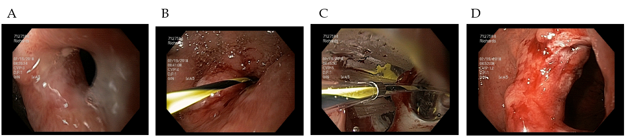
Figure 1 Anastomotic stricture dilation. A: Tight stricture of gastrojejunostomy; B: Wire placement through stenosis; C: Balloon dilation; D: Stricture appearance after dilation.

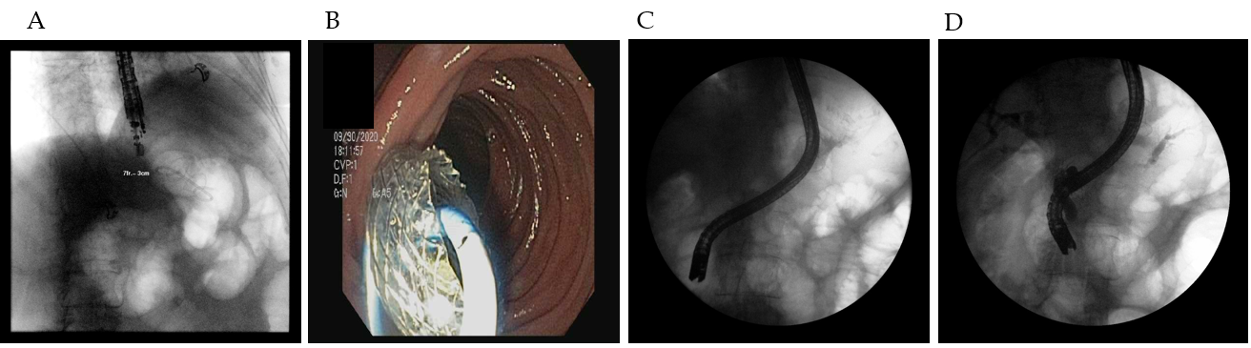
Figure 2 Endoscopic ultrasonography-directed transgastric endoscopic retrograde cholangiopancreatography. A: Endoscopic ultrasonography placement of lumen apposing metal stents (LAMS) gastrogastric fistula; B: Endoscopic view of LAMS; C: Duodenoscope passing through LAMS for endoscopic retrograde cholangiopancreatography; D: Successful cholangiogram and pancreatogram.

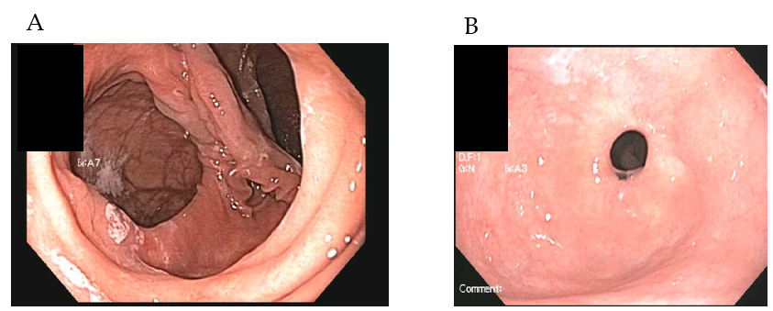
Figure 3 Dilated gastrojejunostomy treated with endoscopic suturing. A: Dilated gastrojejunostomy; B: Gastrojejunostomy several months after suturing for stoma reduction.

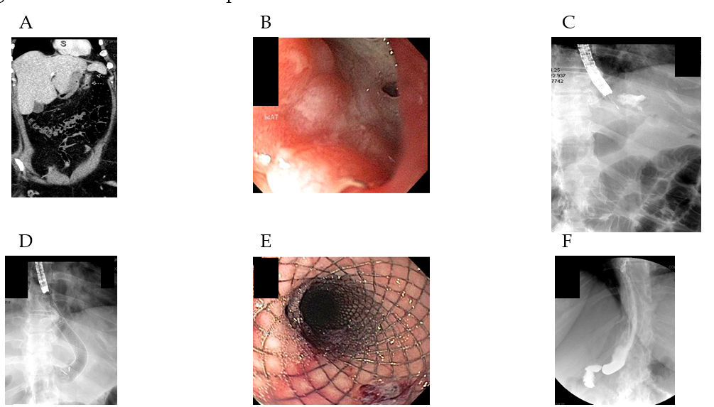
Figure 4 Sleeve leak treated with covered esophageal stent. Computed tomography (CT) imaging demonstrating sleeve leak; B: Endoscopic appearance of leak site; C: Contrast injection to confirm leak site; D: Placement of covered self-expandable metal stents; E: Endoscopic appearance of stent; F: Subsequent upper gastrointestinal series showing no residual leak after stent placement.

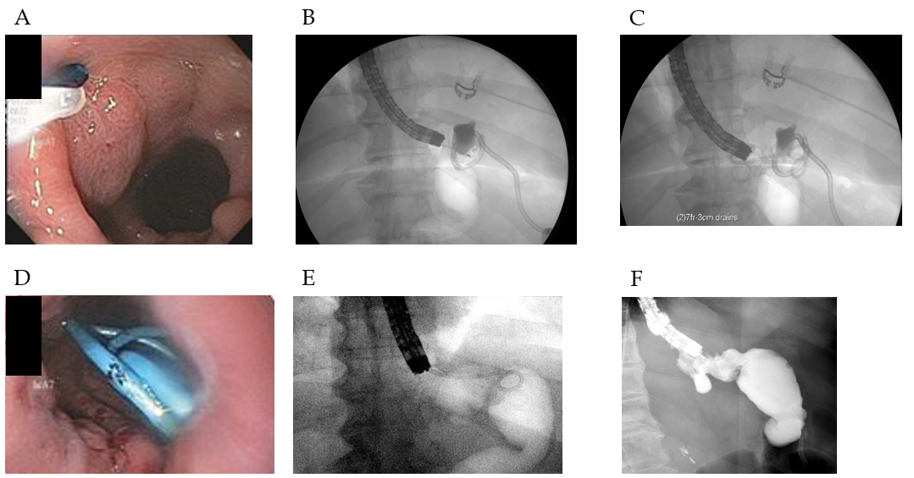
Figure 5 Sleeve gastrectomy leak treated with internal drainage. A: Endoscopic appearance of leak site; B: Contrast injection to confirm leak site; C: Placement of transgastric double pigtail stents; D: Endoscopic appearance of stents; E: Repeat endoscopy for stent removal; F: Contrast injection after stent removal confirming no residual leak.

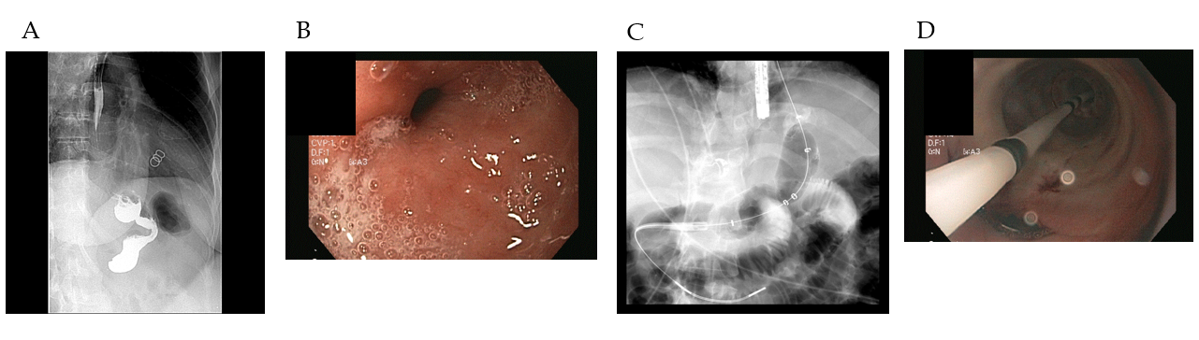
Figure 6 Sleeve stenosis treated with balloon dilation. A: Upper gastrointestinal series demonstrating stenosis at the level of the incisura; B: Endoscopic appearance of the stenosis; C: Pneumatic balloon dilation of stricture; D: Endoscopic appearance of balloon dilation.

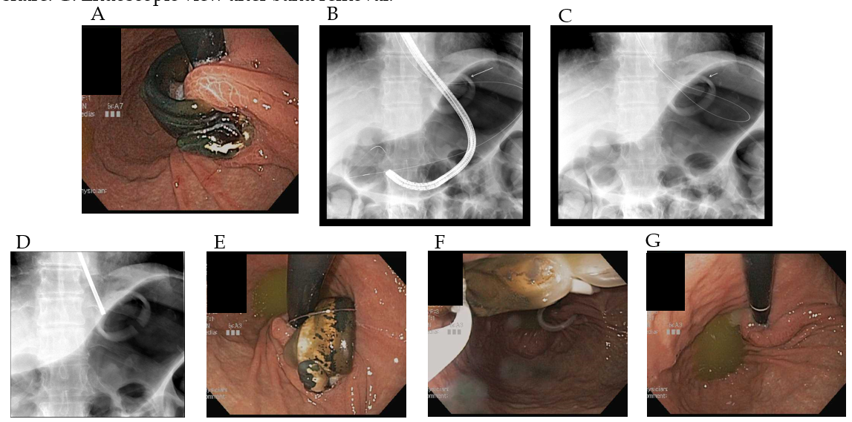
Figure 7 Eroded lap band removed endoscopically. A: Eroded lap band; B: Endoscope passage through the band with distal deployment of wire; C: Wire looped around band; D: Fluoroscopic view of cut lapband; E: Endoscopic view of cut lap band; F: Cut band grasped by snare; G: Endoscopic view after band removal.

Table 1 Endoscopic management of bariatric complications
Surgery | Complication | Diagnosis | Management options
RYGB | Gastrojejunal anastomotic stricture | Upper GI series;  Endoscopy | Endoscopic balloon dilation;  Steroid injection;  Needle knife radial incisions;  Lumen-opposing metal stent
 | Gastrogastric fistula | Upper GI series;  Endoscopy | Endoscopic suturing;  OTSC
 | Anastomotic leaks | CT imaging;  Upper GI series;  Endoscopy | CSEMS;  Internal drainage with pigtail stents;  OTSC;  Endosponge therapy;  Endoscopic suturing
 | Choledocholithiasis | MRCP;  CT imaging;  Ultrasound | Overtube-assisted ERCP;  Laparoscopic-assisted ERCP;  EDGE
 | Weight regain | EGD-Dilated gastrojejunostomy | Stoma reduction:  Endoscopic suturing;  OTSC;  Serial APC treatments;  Radiofrequency ablation
Sleeve gastrectomy | Staple line leak | CT imaging;  Upper GI series;  Endoscopy | CSEMS;  Internal drainage with pigtail stents;  OTSC;  Endosponge therapy;  Endoscopic suturing
 | Sleeve stenosis | Upper GI series;  Endoscopy | Radial expanding balloon dilation;  Pneumatic balloon dilation
LAGB | Band migration | CT imaging;  Endoscopy | Mechanical lithotripter band cutting
RYGB: Roux-en-Y gastric bypass; CSEMS: Covered self-expandable metallic stent; OTSC: Over-the-scope-clip; EDGE: Endoscopic ultrasound-directed transgastric endoscopic retrograde cholangiopancreatography; APC: Argon plasma coagulation; LAGB: Laparoscopic adjustable gastric band.

