Name of Journal: World Journal of Gastrointestinal Oncology
Manuscript NO: 68183
Manuscript Type: ORIGINAL ARTICLE

Prospective Study
Intertwined leukocyte balances in tumours and peripheral blood as robust predictors of right and left colorectal cancer survival

Cantero-Cid R et al. Leukocyte balances and colorectal cancer survival

Ramón Cantero-Cid, Karla Marina Montalbán-Hernández, Jenny Guevara, Alejandro Pascual-Iglesias, Elisa Pulido, José Carlos Casalvilla, Cristóbal Marcano, Cristina Barragán Serrano, Jaime Valentín, Gloria Cristina Bonel-Pérez, José Avendaño-Ortiz, Verónica Terrón, Roberto Lozano-Rodríguez, Alejandro Martín-Quirós, Elvira Marín, Eva Pena, Laura Guerra-Pastrián, Eduardo López-Collazo, Luis Augusto Aguirre

Ramón Cantero-Cid, Karla Marina Montalbán-Hernández, Alejandro Pascual-Iglesias, Elisa Pulido, José Carlos Casalvilla, Jaime Valentín, Gloria Cristina Bonel-Pérez, José Avendaño-Ortiz, Verónica Terrón, Roberto Lozano-Rodríguez, Elvira Marín, Eduardo López-Collazo, Luis Augusto Aguirre, Tumor Immunology Laboratory, The Innate Immune Response Group, Hospital La Paz Institute for Health Research (IdiPAZ), Madrid 28046, Spain

Jenny Guevara, Cristóbal Marcano, Cristina Barragán Serrano, Digestive Surgery Service, La Paz University Hospital, Madrid 28046, Spain

Alejandro Martín-Quirós, Emergency Department and Emergent Pathology Research Group, Hospital La Paz Institute for Health Research (IdiPAZ), Madrid 28046, Spain

Eva Pena, Laura Guerra-Pastrián, Pathologic Anatomy Service, Hospital La Paz, Madrid 28046, Spain

Author contributions: Cantero-Cid R and Montalbán-Hernández KM contributed equally to the manuscript; Cantero-Cid R participated in the design of the study and performed patient recruitment, surgery, and sample collection; Montalbán-Hernández KM performed sample collection, assisted with sample analysis, and performed image analysis; Pulido E performed sample analysis and assisted with image analysis; Pascual-Iglesias A performed statistical analysis; Casalvilla JC assisted with sample analysis and with image analysis; Valentín J assisted with sample analysis and with image analysis; Bonel-Pérez GC assisted with sample analysis and with image analysis; Avendaño-Ortiz J assisted with sample analysis; Terrón V assisted with sample analysis; Lozano-Rodríguez R assisted with sample analysis; Martín-Quirós A participated in patient recruitment; Marín E performed sample analysis; Guevara J participated in patient recruitment, surgery, sample collection, and assisted with data analysis; Marcano C participated in patient recruitment, surgery, sample collection, and assisted with data analysis; Barragán C participated in patient recruitment, surgery, and sample collection; Pena E was involved with sample collection and assisted with anatomo-pathological analyses; Guerra-Pastrián L was involved with sample collection and performed anatomo-pathological analyses; López-Collazo E participated in the design and oversight of the study and drafted the manuscript; Aguirre LA designed and supervised the study, assisted with data analysis, and drafted the manuscript; all authors read and approved the final manuscript.

Supported by the Foundation for the Hospital La Paz Institute for Health Research, No. PI698; Fundación Familia Alonso; Fundación Antolín Garcíarena and the European Union’s Horizon 2020 research and innovation program under the Marie Sklodowaska-Curie-’laCaixa’, No. 713673.

Corresponding author: Luis Augusto Aguirre, PhD, Senior Researcher, Tumor Immunology Laboratory, The Innate Immune Response Group, Hospital La Paz Institute for Health Research (IdiPAZ), Paseo de la Castellana, 261, Madrid 28046, Spain. luis.augusto.aguirre@idipaz.es

Received: May 16, 2021
Revised: August 7, 2021
Accepted: November 30, 2021
Published online:

Abstract
BACKGROUND
Colorectal cancer (CRC) accounts for 9.4% of overall cancer deaths, ranking second after lung cancer. Despite the large number of factors tested to predict their outcome, most patients with similar variables show big differences in survival. Moreover, right-sided CRC (RCRC) and left-sided CRC (LCRC) patients exhibit large differences in outcome after surgical intervention as assessed by preoperative blood leukocyte status. We hypothesised that stronger indexes than circulating (blood) leukocyte ratios to predict RCRC and LCRC patient outcomes will result from combining both circulating and infiltrated (tumour/peritumour fixed tissues) concentrations of leukocytes.

AIM
To seek variables involving leukocyte balances in peripheral blood and tumour tissues and to predict the outcome of CRC patients.

METHODS
Sixty-five patients diagnosed with colon adenocarcinoma by the Digestive Surgery Service of the La Paz University Hospital (Madrid, Spain) were enrolled in this study: 43 with RCRC and 22 with LCRC. Patients were followed-up from January 2017 to March 2021 to record overall survival (OS) and recurrence-free survival (RFS) after surgical interventions. Leukocyte concentrations in peripheral blood were determined by routine laboratory protocols. Paraffin-fixed samples of tumour and peritumoural tissues were assessed for leukocyte concentrations by immunohistochemical detection of CD4, CD8, and CD14 marker expression. Ratios of leukocyte concentration in blood and tissues were calculated and evaluated for their predictor values for OS and RFS with Spearman correlations and Cox univariate and multivariate proportional hazards regression, followed by the calculation of the receiver-operating characteristic and area under the curve (AUC) and the determination of Youden’s optimal cutoff values for those variables that significantly correlated with either RCRC or LCRC patient outcomes. RCRC patients from the cohort were randomly assigned to modelling and validation sets, and clinician-friendly nomograms were developed to predict OS and RFS from the respective significant indexes. The accuracy of the model was evaluated using calibration and validation plots.

RESULTS
The relationship of leukocyte ratios in blood and peritumour resulted in six robust predictors of worse OS in RCRC: CD8⁺ lymphocyte content in peritumour (CD8_{pt}, AUC = 0.585, cutoff < 8.250, P = 0.0077); total lymphocyte content in peritumour (CD4CD8_{pt}, AUC = 0.550, cutoff < 10.160, P = 0.0188); lymphocyte-to-monocyte ratio in peritumour (LMR_{pt}, AUC = 0.807, cutoff < 3.185, P = 0.0028); CD8⁺ LMR in peritumour (CD8MR_{pt}, AUC = 0.757, cutoff < 1.650, P = 0.0007); the ratio of blood LMR to LMR in peritumour (LMR_{b}/LMR_{pt}, AUC = 0.672, cutoff > 0.985, P = 0.0244); and the ratio of blood LMR to CD8⁺ LMR in peritumour (LMR_{b}/CD8MR_{pt}, AUC = 0.601, cutoff > 1.485, P = 0.0101). In addition, three robust predictors of worse RFS in RCRC were found: LMR_{pt} (AUC = 0.737, cutoff < 3.185, P = 0.0046); LMR_{b}/LMR_{pt} (AUC = 0.678, cutoff > 0.985, P = 0.0155) and LMR_{b}/CD8MR_{pt} (AUC = 0.615, cutoff > 1.485, P = 0.0141). Furthermore, the ratio of blood LMR to CD4⁺ LMR in peritumour (LMR_{b}/CD4MR_{pt}, AUC = 0.786, cutoff > 10.570, P = 0.0416) was found to robustly predict poorer OS in LCRC patients. The nomograms showed moderate accuracy in predicting OS and RFS in RCRC patients, with concordance index of 0.600 and 0.605, respectively.

CONCLUSION
Easily obtainable variables at preoperative consultation, defining the status of leukocyte balances between peripheral blood and peritumoural tissues, are robust predictors for OS and RFS of both RCRC and LCRC patients.

Key Words: Left colorectal cancer; Leukocyte ratios; Prognostic variables; Recurrence-free survival; Right colorectal cancer; Overall survival

Cantero-Cid R, Montalbán-Hernández KM, Guevara J, Pascual-Iglesias A, Pulido E, Casalvilla JC, Marcano C, Serrano CB, Valentín J, Bonel-Pérez GC, Avendaño-Ortiz J, Terrón V, Lozano-Rodríguez R, Martín-Quirós A, Marín E, Pena E, Guerra-Pastrián L, López-Collazo E, Aguirre LA. Intertwined leukocyte balances in tumours and peripheral blood as robust predictors of right and left colorectal cancer survival. World J Gastrointest Oncol 2021; In press

Core Tip: This was a prospective study involving 65 patients with colorectal cancer, seeking to find robust predictors of survival after surgical intervention amongst the leukocyte balances in peripheral blood, tumour, and peritumoural tissues. A number of these variables are shown to predict overall survival and recurrence-free survival in both RCRC and LCRC patients, thus allowing the improvement of pre- and postoperative patient treatments.

INTRODUCTION
Despite the great medical and scientific achievements attained over the last decades in the fields of cancer understanding, early detection, and care, cancer continues to be a majorly threatening disease worldwide. Amongst the many pathologies gathered under this term, colorectal cancer (CRC) accounts for 9.4% of overall cancer deaths, ranking second just after lung cancer^{[1]}. CRC treatments vary depending on tumour location and stage of diagnosis; standard colectomy (along with lymphadenectomy) without adjuvant therapy is the usual treatment in early stages I and II, while most patients in advanced stages III and IV follow with chemo- and/or radiotherapy to reduce the risk of recurrence^{[2]}. However, a large proportion of these patients present with (synchronous; 15%-25%) or will develop (metachronous; 40%-75%) metastases, mainly in the liver^{[3]}, which constitutes the major cause of deaths^{[4]}. Therefore, a 5-year relative survival rate is reduced from 90% in early-stage detection to 12% in advanced cases^{[2]}. Thus, finding robust markers before surgery to predict patient outcomes constitutes a safe strategy in order to stratify those groups with a high risk of recurrence and design personalised pre- and postoperative therapies.
A wide variety of factors, mainly based on clinical and pathological features, have been tested as prognostic markers for CRC development, such as: weight loss, haemoglobin levels, TNM staging and tumour differentiation, mismatch-repair proficiency, lymph node involvement, or response to (neo-) adjuvant therapies^{[5-7]}. Moreover, since a clear distinction between the behaviour of right-sided CRC (RCRC) and left-sided CRC (LCRC) patients is well established, much effort has been put into categorising putative prognostic markers according to their respective characteristics, though still with controversial results^{[8]}.
Currently, an increasing number of research and clinical trials are supporting evidence of the influence of the systemic inflammatory response in cancer progression^{[5]}. A measure of this response has been assessed by combining the number of peripheral circulating leukocytes: lymphocyte-to-monocyte ratio (LMR), neutrophil-to-lymphocytes ratio (NLR), and platelet-to-lymphocyte ratio (PLR). These analyses have shown interesting prognostic associations in several cancer types including urothelial, nasopharyngeal, osteosarcoma, lung carcinomas^{[9-12]}, and CRC^{[13-16]}. Nevertheless, few studies have been directed towards the prognostic value of intertwined relationships across circulating and tumour-infiltrated populations of leucocytes on solid tumour progression^{[17-19]}.
Herein, we aimed to delve deep into the prognostic value of leukocyte distribution ratios, in both blood and tumour tissues, for CRC patient outcomes after surgery. We hypothesised that stronger indexes than circulating (blood) leukocyte ratios to predict patient outcome will result from combining both circulating and infiltrated (tumour/peritumoural tissues) concentrations of leukocytes. We show six robust predictors for RCRC overall survival (CD8_{pt}, CD4CD8_{pt}, LMR_{pt}, CD8MR_{pt}, LMR_{b}/LMR_{pt}, LMR_{b}/CD8MR_{pt}), three for RCRC recurrence-free survival (LMR_{pt}, CD8MR_{pt}, LMR_{b}/LMR_{pt}, LMR_{b}/CD8MR_{pt}), and another one for LCRC overall survival (LMR_{b}/CD4MR_{pt}), all these being based on the ratios between blood and peritumoural tissue concentration of lymphocytes and monocytes. Moreover, we highlight the importance of these variables in designing ad hoc surgical strategies, due to the ease with which surgeons can build a protocol by taking samples of peripheral blood and peritumoural tissue during a preoperative colonoscopy.

MATERIALS AND METHODS
Patient selection
Sixty-five patients diagnosed with colon adenocarcinoma, with no records of previous neo-adjuvant therapy, were recruited at the Digestive Surgery Service of La Paz University Hospital (Madrid, Spain) from January 2017 to September 2019. They were surgically treated according to each patient’s condition for right (caecum, ascending, or transverse colon) or left (descending or sigmoid colon) hemicolectomies followed by anastomosis, with partial hepatectomy if synchronous metastasis was present. Patients’ clinical records were followed-up until March 2021. Overall survival (OS) was then defined as the length of time since surgery until exitus or the end of the study, whilst recurrence-free survival (RFS) was considered the interval from surgery until relapse, either from disease-free or (synchronous/metachronous) metastases-free statuses. All patients signed written consent, in accordance with the ethical guidelines of the 1975 Declaration of Helsinki and the Ethics Committee for Clinical Research of La Paz University Hospital (PI-1958), for further uses of blood samples and surgically resected organs for research purposes.

Exclusion criteria
Only patients with adenomas or rectum adenocarcinoma were excluded from the study.

Blood tests
Venous blood samples were collected in 10 mL EDTA-tubes in the hospital room, 24 h prior to surgery and routinely tested for white blood cell, lymphocyte (L), monocyte (M), neutrophil (N) and platelet (P) counts at the Central Laboratory (CORE) of the La Paz University Hospital. Preoperative blood LMR (LMR_{b}), NLR (NLR_{b}), and PLR (PLR_{b}) were then calculated for each patient by dividing the absolute counts of the respective populations in the peripheral blood (Table 1).

Tissue preparation
Samples from the middle part (avoiding both the epicentre and the edge) of the tumours, 5 cm-adjacent peritumoural (non-neoplastic), and liver (in case of synchronous metastases) tissues were taken at the time of surgery, upon in situ evaluation of morphological characteristics by pathologists. Histological types and grades were based on microscopic features. Microsatellite stability analyses were performed as previously described^{[20]}.
Organ samples were washed with PBS solution containing 56 μg/mL gentamicin (Braun, Melsungen, Germany; 636159), 2.5 μg/mL fungizome/anphotericin-B (Gibco, Amarillo, TX, United States; 15290-018), and 1% penicillin/streptomycin (Sigma-Aldrich, Saint Louis, MO, United States; P4333-100mL) and gently shaken for 30 min at room temperature. Then they were fixed in 4% paraformaldehyde for 16 h, washed with PBS for 24 h, and paraffin-embedded by standard procedures.
Tissue microarrays (TMA) recipient paraffin-blocks (24 mm × 2.0 mm) were prepared with a TMA builder kit (Histopathology Ltd., Baranya, 7632, Hungary; 20010.2) and filled with properly matched samples of previous patients’ blocks, following manufacturer’s protocol.

Immunohistochemistry and image analysis
Thin sections (5 μm thick) of TMAs were cut with a Leica (RM2255) ultrathin-microtome and allowed to completely adhere to slides for 30 min at 60°C, before staining with commercially available antibodies against assessed surface markers was performed by standardised protocols (see Supplementary Table 1 for a complete list of primary and secondary antibodies used). Briefly, sections were deparaffinised with xylene, rehydrated through graded (100% to 70%) ethanol, and blocked for endogenous peroxidase by immersion in 97% methanol. Next, sections were immersed in heated sodium citrate buffer (10 mmol/L, pH 6.0) for antigenicity recovery and then incubated in unspecific-binding blocking solution [TBS solution containing 1% BSA, 1% Triton X-100 (Thermo Scientific; Waltham, MA, United States, 85111) and 2.5% horse serum (Gibco; Amarillo, TX, United States, 26050088)]. Primary antibodies were then added at recommended dilutions and incubated overnight at 4°C in a humid chamber. After washing slides with TBS, matched HRP-secondary antibodies were added and incubated for 1 h at room temperature. Then, DAB chromogen (DAB substrate kit, Cell Marque; Rocklin, CA, United States, 1-957D-30) was added for a few seconds until colour change and gently washed with TBS and distilled water. Finally, sections were counterstained by immersion in haematoxylin, dehydrated through graded (70% to 100%) ethanol, and mounted with DPX medium (Sigma-Aldrich; Saint louis, MO, United States, 06522).
An average of four photographs per sample (in order to cover the whole field for each sample on the TMA sections) were taken with an Olympus BX-41 microscope and blind-analysed by two independent observers with ImageJ (v1.52p), for the calculus of the relative areas to each antibody corresponding surface marker expression (CD4, CD8, and CD14). For a detailed description of the image processing see Supplementary Figure 1A. A percentage of the total tissue area (A) for the three surface markers, in each patient’s tumour and peritumour samples, was reported as the mean of all their relative areas per field.
Total tumour and peritumour LMRs (respectively, LMR_{t} and LMR_{pt}) were calculated by dividing the sum of the areas for CD4 and CD8 by the area for CD14, e.g., LMR_{t}=(A(CD4_{t})+A(CD8_{t}))/A(CD14_{t}). Individual subpopulation ratios were also analysed for both tumour and peritumour samples (CD4MR_{t}, CD8MR_{t} and CD4MR_{pt}, CD8MR_{pt}, respectively), e.g., CD4MR_{t}=A(CD4_{t})/A(CD14_{t}). Then, blood-to-tissue ratios for all previous tumour and peritumour subpopulation ratios (LMR_{b}/LMR_{t}, LMR_{b}/CD4MR_{t}, LMR_{b}/CD8MR_{t} and LMR_{b}/LMR_{pt}, LMR_{b}/CD4MR_{pt}, LMR_{b}/CD8MR_{pt}, respectively) were also reported for each patient.

Nomogram construction and validation
All RCRC patients from the cohort were randomly divided into training (60%) and validation (40%) sets to establish and validate the clinician-friendly nomograms. For each nomogram to predict the probability of OS or RFS, the six or the three respectively significant predictive factors found early were used to formulate the nomograms with several R packages. The discriminatory ability of the nomogram was assessed by calculating the Harrell’s concordance index (C-index).

Statistical analysis
Data are represented as mean ± standard deviation. Student’s t test was used for pairwise comparisons. Mann-Whitney U analysis was applied for equal standard deviations, otherwise Welch’s correction was used. The distribution of the variables was assessed by a nonparametric test. Spearman r correlations were used to evaluate the association between the variables and ratios with the OS and RFS observed in our patients. Survival and population ratio relationships were analysed using Cox proportional hazard ratios; statistically significant variables in univariate analysis were further evaluated with the Cox multivariate step-by-step backward method to identify those with independent prognostic value. The Kaplan-Meier method was used to calculate the differences in OS and RFS rates for RCRC and LCRC over time (months), and significance was compared using the log-rank (Mantel-Cox) test; median time (months) survival proportions and P accuracy were reported. We calculated the receiver-operating characteristic (ROC) curve and the area under the curve (AUC) to determine whether the different variables and ratios could be used to predict OS and RFS in our cohort. We indicated the sensitivity, the specificity, the positive and negative predictive values, and 95% confidence interval for AUC and P accuracy. Optimal cutoff values, as determined with Youden’s index, Harrell’s C-index, and P accuracy, were calculated with R software. P values of 0.05 or less were considered indicative of statistical significance, and all these were two-sided. All statistics were performed in either Prism 6.0 (GraphPad, San Diego, CA, United States) or SPSS version 23 (IBM, NY, United States) software.

RESULTS
Cohort baseline characteristics
The cohort included in this study was exclusively recruited by one team of surgeons, from their assigned patients for surgically treated disorders of the digestive tract, thus only a fraction is constituted of the whole figure of CRC patients attended at La Paz University Hospital during the period of recruitment. Detailed clinicopathological characterisation of patients is shown in Table 1.
A total of 65 patients with a mean age of 73.5 years, of whom 43 (66.1%) presented with RCRC and 22 (33.8%) with LCRC, were finally enrolled. Of these, 29 (44.6%) were women and 36 (55.4%) were men. With the exception of one case, all had been programmed for surgery without an emergency condition. Forty-eight (73.8%) were hemicolectomised by minimally invasive laparoscopic procedure. They ranged from stages 0 to IV, based on TNM classification; 28 (43.1%) were presenting metastasis (either synchronous or metachronous at the time of surgery), and 30 (46.1%) received adjuvant therapy after surgery. Fifty-six (86.1%) of the tumours were found proficient for the mismatch-repair machinery at the histological level.

Patient progression follow-up
The survival analysis, with a median follow-up of 26 mo, showed no differences for OS between RCRC and LCRC patients (Figure 1A) but a trend towards poorer outcome for the latter (74.5% vs 40.8%, P = 0.1875). However, in the analysis of RFS (Figure 1B), we observed significantly better outcomes for RCRC compared to LCRC patients (60.4% vs 19.1%, P = 0.0036).

Leukocyte counts and ratios
We found no differences (Table 1) in total leukocyte counts nor in individual populations of circulating lymphocytes, monocytes, neutrophils, or platelets between RCRC and LCRC patient peripheral blood. However, though all mean counts for both groups were within the normal physiological ranges, RCRC patients showed a trend towards low circulating lymphocytes. Thus, their LMR_{b} was lower (P = 0.0462) than LCRC patients (Figure 2A). Neither NLR_{b} nor PLR_{b} showed differences between RCRC and LCRC patients (Figure 2B and C).
Tissues from 54 out of the total 65 patients included in the study, 34 from RCRC patients (63%) and 20 from LCRC patients (37%), could be assessed for leukocyte infiltration analyses. This fact was mainly due to the morphological characteristics of 11 tumours, which made it impossible to separate pieces for research purposes without affecting the global diagnostics by pathologists.
Figure 3 shows the staining pattern for CD4, CD8, and CD14 cells in tumour and peritumour samples from two representative patients of LCRC and RCRC. The distribution of total (CD4⁺ plus CD8⁺) lymphocytes, CD4⁺ lymphocytes, CD8⁺ lymphocytes, and CD14⁺ monocytes, in all analysed tissues, is shown in Supplementary Figure 2. Higher total lymphocyte content in tumours than peritumours from LCRC patients (13.06 ± 2.123 vs 7.57 ± 1.794, P = 0.0095) seemed due to the proportional increase of CD8⁺ lymphocytes (11.19 ± 2.158 vs 5.13 ± 1.757, P = 0.0020), as we detected no differences amongst infiltrated CD4⁺ lymphocytes in these tissues. No differences were found for lymphocyte infiltration in right tumours with respect to right peritumoural tissues. Moreover, infiltrated-leukocyte content in right tumours showed no differences to right peritumours.
The analysis of resulting ratios for lymphocyte and monocyte counts in tumour (t) and peritumoural (pt) tissues showed a higher LMR_{t} with respect to LMR_{pt} (4.128 ± 1.363 vs 2.022 ± 0.3432, P = 0.0023) beside higher CD8MR_{t} than CD8MR_{pt} (4.121 ± 1.374 vs 1.218 ± 0.3297, P = 0.0001) in LCRC patients (Figure 2D-F). No differences were detected for these ratios amongst RCRC respective tissues. Consequently, the analysis of blood-to-tissue ratios (Figure 2G-I) showed LCRC patients exhibited lower LMR_{b}/LMR_{t} than LMR_{b}/LMR_{pt} (2.104 ± 0.601 vs 2.900 ± 0.5061, P = 0.0282) as well as lower LMR_{b}/CD8MR_{t} than LMR_{b}/CD8MR_{pt} (3.381 ± 1.083 vs 5.898 ± 1.138, P = 0.0033). There were no differences in these ratios for RCRC respective tissues.

Association of leukocyte balance and patient’s outcome
In order to assess the degree to which leukocyte balance (i.e. both the concentration and ratios of leukocytes for blood, tumour, and peritumours described above) was associated with RCRC and LCRC patient OS and RFS, we first conducted a Spearman correlation analysis (Table 2). We found that for RCRC LMR_{b} (r = -0.3039, P = 0.0476), LMR_{pt} (r = -0.4301, P = 0.0111), and CD8MR_{pt} (r =-0.3596, P=0.0367) were negatively correlated with OS; LMR_{t} (r = -0.4775, P = 0.0043), LMR_{pt} (r = -0.3846, P = 0.0247), and CD8MRt (r = -0.4422, P = 0.0088) negatively correlated, but LMR_{b}/LMR_{t} (r = 0.3621, P = 0.0363) positively correlated with RFS. LMR_{b}/CD8MR_{t} (r = 0.3364, P = 0.0517) also showed a trend towards being positively correlated. For LCRC, CD14_{pt} (r = 0.5677, P = 0.009) and LMR_{b}/CD4MR_{pt} (r = 0.4541, P=0.0443) positively correlated, but CD4MR_{pt} (r = -0.473, P = 0.0352) negatively correlated with OS, whilst both CD14_{pt} (r = 0.6018, P = 0.005) and CD8MR_{t} (r = 0.4779, P = 0.331) positively correlated with RFS, and CD4CD8_{pt} (r = 0.4425, P = 0.0507) also showed a trend towards being positively correlated.
Next, the effect of these variables on survival was assessed by Cox proportional hazards regression. For OS (Table 3), the univariate analysis revealed that besides previously found LMR_{b} (P = 0.043), LMR_{pt} (P = 0.024), and CD8MR_{pt} (P = 0.031) in RCRC patients, NLR_{b} (P = 0.038) also significantly correlated with OS; LMR_{b}/CD4MR_{pt} (P = 0.026) was also confirmed to be significantly correlated with OS of LCRC patients. After adjusting for confounding variables through the multivariate analysis, NLR_{b} (P = 0.038), CD8MR_{pt} (P = 0.011), and LMR_{b}/CD8MR_{pt} (P = 0.016) resulted in a significant association with OS of RCRC patients; CD8_{pt} (P = 0.058) also showed a trend towards being associated.
Regarding RFS (Table 4), the univariate analysis showed that in addition to previously found LMR_{t} (P = 0.021) and LMR_{b}/LMR_{t} (P = 0.040) in RCRC, LMR_{b}/CD8MR_{t} (P = 0.025) also significantly correlated with RFS, and CD8MR_{t} (P = 0.052) showed a trend towards being associated. In addition to previously found CD14_{pt} (P = 0.010), NLR_{b} (P = 0.020) and PLR_{b} (P = 0.018) were also significantly correlated with RFS in LCRC patients. After the multivariate analysis, several variables emerged as independent prognostic factors for RFS in RCRC patients: NLR_{b} (P = 0.039), PLR_{b} (P = 0.037), CD14_{t} (P = 0.026), LMR_{pt} (P = 0.014), LMR_{b}/LMR_{pt} (P = 0.042), and LMR_{b}/CD8MR_{t} (P = 0.006). In LCRC patients, NLR_{b} (P = 0.009), CD8_{pt} (P = 0.020), CD4CD8_{t} (P = 0.039), and CD8MR_{t} (P = 0.019) were found, together with a trend observed for CD4CD8_{pt} (P = 0.053).

Survival prognostic value of the studied variables and ratios
Taking into account all previous correlations, we then calculated the optimal cutoff values by ROC analyses for those variables significantly correlated with OS or RFS, using respectively cancer-specific death or relapse as the endpoints for both RCRC (Figures 4 and 6) and LCRC (Figure 5) patients after surgical intervention.
Regarding OS, ROC curve analysis of CD8_{pt} (Figure 4A; AUC = 0.585, 95%CI: 0.376-0.793, P = 0.496) identified the optimal cutoff point at 8.250, which entails significantly worse outcomes for RCRC patients ranking below this (Figure 4B; 100% vs 48.2%, P = 0.0077). CD4CD8_{pt} analysis (Figure 4C; AUC = 0.550, 95%CI: 0.334-0.766, P = 0.686) identified 10.16 as the optimal cutoff, with worse outcomes for RCRC patients ranking below this (Figure 4D; 92.3% vs 49.1%, P = 0.0188). LMR_{pt} analysis (Figure 4E; AUC = 0.807, 95%CI: 0.641-0.973, P = 0.013) identified 3.185 as the optimal cutoff, with worse outcomes for RCRC patients ranking below this (Figure 4F; 100% vs 42.7%, P = 0.0028). CD8MR_{pt} analysis (Figure 4G; AUC = 0.757, 95%CI: 0.600-0.914, P = 0.039) identified 1.650 as the optimal cutoff, with worse outcomes for RCRC patients ranking below this (Figure 4H; 100% vs 35.7%, P = 0.0007). LMR_{b}/LMR_{pt} analysis (Figure 4I; AUC = 0.672, 95%CI: 0.479-0.865, P = 0.166) identified 0.985 as the optimal cutoff, with worse outcomes for RCRC patients ranking above this (Figure 4J; 91.6% vs 52.0%, P = 0.0244). LMR_{b}/CD8MR_{pt} analysis (Figure 4K; AUC = 0.601, 95%CI: 0.419-0.782, P = 0.418) identified 1.485 as the optimal cutoff, with worse outcomes for RCRC patients ranking above this (Figure 4L; 100% vs 50.9%, P = 0.0101). Finally, LMR_{b}/CD4MR_{pt} analysis (Figure 5A; AUC = 0.786, 95%CI: 0.564-1.000, P = 0.048) identified 10.57 as the optimal cutoff, with worse outcomes for LCRC patients ranking above this (Figure 5B; 66.6% vs 18.7%, P = 0.0416). In addition, ROC curve analyses (Supplementary Figure 3) of CD4CD8_{t}, PLR_{b}, CD4CD8_{pt}, and CD8MR_{t}, though they showed significant AUC (0.524, 0.619, 0.726 and 0.571, respectively), rendered optimal cutoff values with no significant differences for LCRC survival.
With respect to RFS, ROC curve analysis of LMR_{pt} (Figure 6A; AUC = 0.737, 95%CI: 0.554-0.920, P = 0.027) identified 3.185 as the optimal cutoff, with worse outcomes for RCRC patients ranking below this (Figure 6B; 92.3% vs 32.5%, P = 0.0046). LMR_{b}/LMR_{pt} analysis (Figure 6C; AUC = 0.678, 95%CI: 0.499-0.857, P = 0.098) identified 0.985 as the optimal cutoff, with worse outcomes for RCRC patients ranking above this (Figure 6D; 84.4% vs 40.6%, P = 0.0155). LMR_{b}/CD8MR_{pt} analysis (Figure 6E; AUC = 0.615, 95%CI: 0.427-0.802, P = 0.286) identified 1.485 as the optimal cutoff, with worse outcomes for RCRC patients ranking above this (Figure 6F; 91.7% vs 40.7%, P = 0.0141). The ROC analyses in RCRC patients of CD8MR_{pt}, CD8_{pt}, and CD4CD8_{pt} (Supplementary Figure 4), though they showed significant AUC (0.672, 0.528 and 0.506, respectively) did not render optimal cutoff values that significantly prognosticated the RCRC patient RFS. Similarly, ROC analyses of CD4CD8_{t}, PLR_{b}, CD4CD8_{pt}, CD8MR_{t}, and LMR_{b}/CD4MR_{pt} (Supplementary Figure 5) with significant AUC (0.656, 0.635, 0.760, 0.781 and 0.563, respectively) did not provide optimal cutoff values with significant prognostication in LCRC patient RFS.

Nomograms modelling and validation
In order to avoid conflicts in handling the different values of the predictive indexes for RCRC patients, clinician-friendly nomograms were developed for both OS (Figure 7A) and RFS (Figure 7B) of these patients. The six significant predictive variables found for OS and the three found for RFS were used to construct the respective nomograms, with data from the training set of RCRC patients. The calibration of these nomograms revealed C-indexes of 0.600 (95%CI: 0.561-0.639) and 0.605 (95%CI: 0.579-0.631), respectively (Supplementary Figure 6A-B). Moreover, the reliability of the nomograms was evaluated with the validation set of RCRC patients, showing a moderate accuracy, with C-indexes of 0.500 (95%CI: 0.475-0.525) and 0.570 (95%CI: 0.541-0.599) for OS and RFS, respectively (Supplementary Figure 6C-D).

DISCUSSION
The segment of the large intestine proximal to the splenic flexure, i.e. the right colon (comprising caecum, ascending colon, and proximal two-thirds of the transverse colon), derives from the embryonic midgut; whereas the left colon (comprising the distal third part of the transverse colon and descending and sigmoid colon) derives from the embryonic hindgut^{[21]}. Distinct embryologic origin of right and left sides of the colon markedly determines important physiological differences, mainly: cell motility, vasculature, lymphatic drainage, extrinsic innervation, development of the endocrine components, and the expression and patterns of epigenetic marks of crucial molecular factors for cell development^{[21,22]}.
Since seminal contributions by Bufill et al^{[23]}, an increasing number of studies have supported the hypothesis that these differences in origin may explain why RCRC and LCRC constitute two distinct clinical entities, which arise through different pathogenetic mechanisms^{[22,24,25]}. Thus, differential aspects such as incidence, presentation, microbiome composition, genetic burden, or immunogenicity could be explained on these grounds^{[26-31]}. In a large study with more than 17000 CRC patients, Benedix et al^{[32]} showed that RCRC represents a more distinct tumour entity than LCRC, mainly because of its higher incidence in women and older people, poor differentiation, locally advanced carcinomas, a distinct pattern of metastatic spread, and worse outcome.
Likewise, survival after surgical intervention to remove the tumour should constitute a prominent feature to differentiate both pathologies. In this line, controversial results arise throughout the literature. Thereby, some studies support RCRC patients having poorer overall and disease-free survival rates^{[8]}, whilst others call attention to the stage of the disease, with better rates for RCRC being limited to stage II and better rates for LCRC being limited to stage III^{[33]}. In our cohort, perhaps due to the stage’s heterogeneity of the patients, both OS and RFS were found side-dependent, with better outcomes in RCRC patients, reinforcing the idea that prognostic markers for the two pathologies should be studied separately.
A number of studies have stressed the importance of the systemic inflammatory response in CRC development and the search for variables involving its components as a valuable tool to drive prognosis^{[15,34]}. Important prognostic records have been obtained in several research works^{[16,35]}, which avail the use of blood leukocyte ratios as predictors in CRC progression after surgery. However, some studies have highlighted inherent failures to these analyses. Thus, Zhang et al^{[36]} warn against the impact of the use of distinct factors, within different studies, to adjust possible confounders for multivariate hazard ratio determination, which can make the latter at risk of bias and heterogeneity, in turn making LMR fail to reach significance in survival. Likewise, sample size, race heterogeneity, and most of all the pre/postoperative dynamic changes in circulating leukocyte population can dramatically affect the observable effects of these variables in the multivariate models for survival progression^{[37]}. In our correlative analyses, though all preoperative blood leukocyte ratios significantly rose at different stages, in the end we were unable to establish a predictor value for any of them, neither for RCRC nor for LCRC survival, perhaps due to a conjunction of previously discussed handicaps. Nonetheless, we do not discard the possibility for them to emerge as good predictors in the putative case those handicaps could be solved, thus improving the multivariate analyses.
Notably, we report tissue leukocyte ratios, both alone and combined with preoperative blood LMR_{b}, as six variables with a strong predictor value for RCRC overall survival (CD8_{pt}, CD4CD8_{pt}, LMR_{pt}, CD8MR_{pt}, LMR_{b}/LMR_{pt}, LMR_{b}/CD8MR_{pt}), three variables for recurrence-free survival (LMR_{pt}, CD8MR_{pt}, LMR_{b}/LMR_{pt}, LMR_{b}/CD8MR_{pt}), and another robust variable to predict LCRC overall survival (LMR_{b}/CD4MR_{pt}). In addition, to avoid conflicts when interpreting the different survival predictors of RCRC, physician-friendly nomograms are proposed for both OS and RFS. Albeit much effort has been made in describing and associating the leukocyte content of tumour tissues with CRC survival^{[38]}, most studies have been performed on disaggregated tumour and peritumour samples, and only a few of them have attempted to measure leukocyte expression in fixed samples of these tissues to associate them with circulating ratios^{[19]} or to correlate them with patient survival^{[18,39]}. Hence, this could be the first study in which leukocyte measures in both blood and fixed tissues are put together into predictor indexes for CRC survival.
It is worth noting that, in addition to the well-established predictor value of blood leukocyte ratios, the 10 indexes involve leukocyte concentrations in peritumoural zones of the bowel but not in the tumour mass. A peritumour constitutes an easily obtainable tissue during a preoperative exploration of the patient (this could be the colonoscopy), which might be safely biopsied without affecting the tumour environment in an adenoma-like surgical extraction protocol. Therefore, on a routine basis, surgeons might access both preoperative peripheral blood parameters as well as non-neoplastic peritumoural tissue (without disturbing the tumour itself) and make use of the described ratios and nomograms to predict the patient’s outcome after surgery. Thus, ad hoc surgical strategies can be designed to allow physicians to continue with surgery as programmed or delay the intervention until better scores are achieved after personalised treatments to correct the leukocyte levels in the patient.
Altogether, these indexes could be implemented in the first line of prognosis, making it easier to predict the outcome of patients after surgery depending on the tumour location and leukocyte distribution in both peripheral blood and biopsies of the peritumoural region.

Limitations
Our study is mainly limited by the cohort size. It might be expected that the extension of these variables to a greater cohort would reinforce our conclusions or even make foregoing unobserved interactions surface.

CONCLUSION
Herein we present important remarks on the value of combining circulating leukocyte ratios and tissue infiltrated leukocyte ratios on the sustaining of valuable prognosis tools for physicians in order to stratify patients regarding their putative outcome. In the era of personalised medicine, such indexes will provide benefits to improving both resources and well-being of CRC patients after surgery.

ARTICLE HIGHLIGHTS
Research background
Colorectal cancer (CRC) points to 9.4% of cancer deaths worldwide, ranking second after lung cancer. Despite the wide variety of factors tested to predict their outcome, most patients with similar variables show big differences in survival. Moreover, right-sided CRC (RCRC) and left-sided CRC (LCRC) patients exhibit large differences in outcome after surgical intervention as assessed by preoperative blood leukocyte ratios [today, the most extended parameters used to assess a patient’s overall survival (OS) and recurrence-free survival (RFS) after surgery]. However, few efforts have been made to link tumour infiltrated leukocyte ratios to patient outcomes.

Research motivation
To determine whether both RCRC and LCRC patient outcomes could be accurately predicted based on the counting of infiltrated leukocytes in tumour and peritumoural tissues.

Research objectives
The aim of this study was to find stronger indexes than circulating (blood) leukocyte ratios to predict RCRC and LCRC patient outcomes.

Research methods
A prospective study was performed with CRC patients who had undergone surgical intervention to resect the tumours. Leukocyte concentrations in peripheral blood, tumour, and non-neoplastic peritumoural tissues were determined. Ratios of these parameters were evaluated as predictors for OS and RFS using Spearman correlations, Cox univariate and multivariate proportional hazards regression followed by the calculation of the receiver-operating characteristic and area under the curve (AUC) and the determination of Youden’s optimal cutoff values for those variables that significantly correlated with either RCRC or LCRC patient outcomes. Clinician-friendly nomograms were developed to predict OS and RFS from the prediction indexes. The accuracy of the model was evaluated using calibration and validation analyses.

Research results
We obtained six robust predictors of worse OS in RCRC: CD8⁺ lymphocyte content in peritumour (CD8_{pt}, AUC = 0.585, cutoff < 8.250, P = 0.0077), total lymphocyte content in peritumour (CD4CD8_{pt}, AUC = 0.550, cutoff < 10.160, P = 0.0188), lymphocyte-to-monocyte ratio in peritumour (LMR_{pt}, AUC = 0.807, cutoff < 3.185, P = 0.0028), CD8⁺ LMR in peritumour (CD8MR_{pt}, AUC = 0.757, cutoff < 1.650, P = 0.0007), the ratio of blood LMR to LMR in peritumour (LMR_{b}/LMR_{pt}, AUC = 0.672, cutoff > 0.985, P = 0.0244), and the ratio of blood LMR to CD8⁺ LMR in peritumour (LMR_{b}/CD8MR_{pt}, AUC = 0.601, cutoff > 1.485, P = 0.0101). In addition, three robust predictors of worse RFS in RCRC were found: LMR_{pt} (AUC = 0.737, cutoff < 3.185, P = 0.0046), LMR_{b}/LMR_{pt} (AUC = 0.678, cutoff > 0.985, P = 0.0155), and LMR_{b}/CD8MR_{pt} (AUC = 0.615, cutoff > 1.485, P = 0.0141). Furthermore, the ratio of blood LMR to CD4⁺ LMR in peritumour (LMR_{b}/CD4MR_{pt}, AUC = 0.786, cutoff > 10.570, P = 0.0416) was found to robustly predict poorer OS in LCRC patients. The developed nomograms to predict OS and RFS of RCRC patients showed C-indexes of 0.600 (95% confidence interval: 0.561-0.639) and 0.605 (95% confidence interval: 0.579-0.631), respectively.

Research conclusions
Easily obtainable variables at preoperative consultation, defining the status of leukocyte balances between peripheral blood and peritumoural tissue, have been shown to render indexes that accurately predict OS and RFS of CRC patients after surgical ablation of the tumours.

Research perspectives
We hope these indexes could be implemented in the first line of prognosis, making it easier to predict the outcome of patients after surgery depending on the tumour location and leukocyte distribution in both peripheral blood and biopsies of the peritumoural region.

ACKNOWLEDGEMENTS
We thank Dr. María Teresa Vallejo-Cremades and Onys Camps-Ortega from the Service of Image and Immunohistochemistry of IdiPAZ for helpful assistance, and Dr. Jair A. Tenorio for software support.

REFERENCES
1 Sung H, Ferlay J, Siegel RL, Laversanne M, Soerjomataram I, Jemal A, Bray F. Global Cancer Statistics 2020: GLOBOCAN Estimates of Incidence and Mortality Worldwide for 36 Cancers in 185 Countries. CA Cancer J Clin 2021; 71: 209-249 [PMID: 33538338 DOI: 10.3322/caac.21660]
2 Miller KD, Nogueira L, Mariotto AB, Rowland JH, Yabroff KR, Alfano CM, Jemal A, Kramer JL, Siegel RL. Cancer treatment and survivorship statistics, 2019. CA Cancer J Clin 2019; 69: 363-385 [PMID: 31184787 DOI: 10.3322/caac.21565]
3 Augestad KM, Merok MA, Ignatovic D. Tailored Treatment of Colorectal Cancer: Surgical, Molecular, and Genetic Considerations. Clin Med Insights Oncol 2017; 11: 1179554917690766 [PMID: 28469509 DOI: 10.1177/1179554917690766]
4 Forster S, Radpour R. Molecular Immunotherapy: Promising Approach to Treat Metastatic Colorectal Cancer by Targeting Resistant Cancer Cells or Cancer Stem Cells. Front Oncol 2020; 10: 569017 [PMID: 33240813 DOI: 10.3389/fonc.2020.569017]
5 Tan D, Fu Y, Tong W, Li F. Prognostic significance of lymphocyte to monocyte ratio in colorectal cancer: A meta-analysis. Int J Surg 2018; 55: 128-138 [PMID: 29807167 DOI: 10.1016/j.ijsu.2018.05.030]
6 Mao Y, Chen D, Duan S, Zhao Y, Wu C, Zhu F, Chen C, Chen Y. Prognostic impact of pretreatment lymphocyte-to-monocyte ratio in advanced epithelial cancers: a meta-analysis. Cancer Cell Int 2018; 18: 201 [PMID: 30534002 DOI: 10.1186/s12935-018-0698-5]
7 Peng J, Li H, Ou Q, Lin J, Wu X, Lu Z, Yuan Y, Wan D, Fang Y, Pan Z. Preoperative lymphocyte-to-monocyte ratio represents a superior predictor compared with neutrophil-to-lymphocyte and platelet-to-lymphocyte ratios for colorectal liver-only metastases survival. Onco Targets Ther 2017; 10: 3789-3799 [PMID: 28794643 DOI: 10.2147/OTT.S140872]
8 Guo D, Li X, Xie A, Cao Q, Zhang J, Zhang F, Li W, Chen J. Differences in oncological outcomes and inflammatory biomarkers between right-sided and left-sided stage I-III colorectal adenocarcinoma. J Clin Lab Anal 2020; 34: e23132 [PMID: 31755593 DOI: 10.1002/jcla.23132]
9 Altan M, Haberal HB, Akdoğan B, Özen H. A critical prognostic analysis of neutrophil-lymphocyte ratio for patients undergoing nephroureterectomy due to upper urinary tract urothelial carcinoma. Int J Clin Oncol 2017; 22: 964-971 [PMID: 28600686 DOI: 10.1007/s10147-017-1150-x]
10 Lu A, Li H, Zheng Y, Tang M, Li J, Wu H, Zhong W, Gao J, Ou N, Cai Y. Prognostic Significance of Neutrophil to Lymphocyte Ratio, Lymphocyte to Monocyte Ratio, and Platelet to Lymphocyte Ratio in Patients with Nasopharyngeal Carcinoma. Biomed Res Int 2017; 2017: 3047802 [PMID: 28321405 DOI: 10.1155/2017/3047802]
11 Liu B, Huang Y, Sun Y, Zhang J, Yao Y, Shen Z, Xiang D, He A. Prognostic value of inflammation-based scores in patients with osteosarcoma. Sci Rep 2016; 6: 39862 [PMID: 28008988 DOI: 10.1038/srep39862]
12 Biswas T, Kang KH, Gawdi R, Bajor D, Machtay M, Jindal C, Efird JT. Using the Systemic Immune-Inflammation Index (SII) as a Mid-Treatment Marker for Survival among Patients with Stage-III Locally Advanced Non-Small Cell Lung Cancer (NSCLC). Int J Environ Res Public Health 2020; 17 [PMID: 33143164 DOI: 10.3390/ijerph17217995]
13 Ying HQ, Liao YC, Sun F, Peng HX, Cheng XX. The Role of Cancer-Elicited Inflammatory Biomarkers in Predicting Early Recurrence Within Stage II-III Colorectal Cancer Patients After Curable Resection. J Inflamm Res 2021; 14: 115-129 [PMID: 33500648 DOI: 10.2147/JIR.S285129]
14 Dell'Aquila E, Cremolini C, Zeppola T, Lonardi S, Bergamo F, Masi G, Stellato M, Marmorino F, Schirripa M, Urbano F, Ronzoni M, Tomasello G, Zaniboni A, Racca P, Buonadonna A, Allegrini G, Fea E, Di Donato S, Chiara S, Tonini G, Tomcikova D, Boni L, Falcone A, Santini D. Prognostic and predictive role of neutrophil/lymphocytes ratio in metastatic colorectal cancer: a retrospective analysis of the TRIBE study by GONO. Ann Oncol 2018; 29: 924-930 [PMID: 29324972 DOI: 10.1093/annonc/mdy004]
15 Clarke SJ, Burge M, Feeney K, Gibbs P, Jones K, Marx G, Molloy MP, Price T, Reece WHH, Segelov E, Tebbutt NC. The prognostic role of inflammatory markers in patients with metastatic colorectal cancer treated with bevacizumab: A translational study [ASCENT]. PLoS One 2020; 15: e0229900 [PMID: 32142532 DOI: 10.1371/journal.pone.0229900]
16 Ying HQ, Deng QW, He BS, Pan YQ, Wang F, Sun HL, Chen J, Liu X, Wang SK. The prognostic value of preoperative NLR, d-NLR, PLR and LMR for predicting clinical outcome in surgical colorectal cancer patients. Med Oncol 2014; 31: 305 [PMID: 25355641 DOI: 10.1007/s12032-014-0305-0]
17 Wu Y, Ye S, Goswami S, Pei X, Xiang L, Zhang X, Yang H. Clinical significance of peripheral blood and tumor tissue lymphocyte subsets in cervical cancer patients. BMC Cancer 2020; 20: 173 [PMID: 32131750 DOI: 10.1186/s12885-020-6633-x]
18 Hamada T, Ishizaki H, Haruyama Y, Hamada R, Yano K, Kondo K, Kataoka H, Nanashima A. Neutrophil-to-Lymphocyte Ratio and Intratumoral CD45RO-Positive T Cells as Predictive Factors for Longer Survival of Patients with Colorectal Liver Metastasis after Hepatectomy. Tohoku J Exp Med 2020; 251: 303-311 [PMID: 32779620 DOI: 10.1620/tjem.251.303]
19 Guo G, Wang Y, Zhou Y, Quan Q, Zhang Y, Wang H, Zhang B, Xia L. Immune cell concentrations among the primary tumor microenvironment in colorectal cancer patients predicted by clinicopathologic characteristics and blood indexes. J Immunother Cancer 2019; 7: 179 [PMID: 31300050 DOI: 10.1186/s40425-019-0656-3]
20 Cantero-Cid R, Casas-Martin J, Hernández-Jiménez E, Cubillos-Zapata C, Varela-Serrano A, Avendaño-Ortiz J, Casarrubios M, Montalbán-Hernández K, Villacañas-Gil I, Guerra-Pastrián L, Peinado B, Marcano C, Aguirre LA, López-Collazo E. PD-L1/PD-1 crosstalk in colorectal cancer: are we targeting the right cells? BMC Cancer 2018; 18: 945 [PMID: 30285662 DOI: 10.1186/s12885-018-4853-0]
21 Wilson DJ, Bordoni B. Embryology, Bowel. Treasure Island (FL): StatPearls, 2021. Available from: https://www.ncbi.nlm.nih.gov/pubmed/31424831/
22 Kostouros A, Koliarakis I, Natsis K, Spandidos DA, Tsatsakis A, Tsiaoussis J. Large intestine embryogenesis: Molecular pathways and related disorders (Review). Int J Mol Med 2020; 46: 27-57 [PMID: 32319546 DOI: 10.3892/ijmm.2020.4583]
23 Bufill JA. Colorectal cancer: evidence for distinct genetic categories based on proximal or distal tumor location. Ann Intern Med 1990; 113: 779-788 [PMID: 2240880 DOI: 10.7326/0003-4819-113-10-779]
24 Kwak HD, Ju JK. Immunological Differences Between Right-Sided and Left-Sided Colorectal Cancers: A Comparison of Embryologic Midgut and Hindgut. Ann Coloproctol 2019; 35: 342-346 [PMID: 31937074 DOI: 10.3393/ac.2019.03.17.1]
25 Lee GH, Malietzis G, Askari A, Bernardo D, Al-Hassi HO, Clark SK. Is right-sided colon cancer different to left-sided colorectal cancer? - a systematic review. Eur J Surg Oncol 2015; 41: 300-308 [PMID: 25468456 DOI: 10.1016/j.ejso.2014.11.001]
26 Álvaro E, Cano JM, García JL, Brandáriz L, Olmedillas-López S, Arriba M, Rueda D, Rodríguez Y, Cañete Á, Arribas J, Inglada-Pérez L, Pérez J, Gómez C, García-Arranz M, García-Olmo D, Goel A, Urioste M, González-Sarmiento R, Perea J. Clinical and Molecular Comparative Study of Colorectal Cancer Based on Age-of-onset and Tumor Location: Two Main Criteria for Subclassifying Colorectal Cancer. Int J Mol Sci 2019; 20 [PMID: 30813366 DOI: 10.3390/ijms20040968]
27 Baek SK. Laterality: Right-Sided and Left-Sided Colon Cancer. Ann Coloproctol 2017; 33: 205-206 [PMID: 29354601 DOI: 10.3393/ac.2017.33.6.205]
28 Baran B, Mert Ozupek N, Yerli Tetik N, Acar E, Bekcioglu O, Baskin Y. Difference Between Left-Sided and Right-Sided Colorectal Cancer: A Focused Review of Literature. Gastroenterology Res 2018; 11: 264-273 [PMID: 30116425 DOI: 10.14740/gr1062w]
29 Ghidini M, Petrelli F, Tomasello G. Right Versus Left Colon Cancer: Resectable and Metastatic Disease. Curr Treat Options Oncol 2018; 19: 31 [PMID: 29796712 DOI: 10.1007/s11864-018-0544-y]
30 Jung MK, Shin US, Ki YJ, Kim YB, Moon SM, Sung SJ. Is the Location of the Tumor Another Prognostic Factor for Patients With Colon Cancer? Ann Coloproctol 2017; 33: 210-218 [PMID: 29354603 DOI: 10.3393/ac.2017.33.6.210]
31 Stintzing S, Tejpar S, Gibbs P, Thiebach L, Lenz HJ. Understanding the role of primary tumour localisation in colorectal cancer treatment and outcomes. Eur J Cancer 2017; 84: 69-80 [PMID: 28787661 DOI: 10.1016/j.ejca.2017.07.016]
32 Benedix F, Kube R, Meyer F, Schmidt U, Gastinger I, Lippert H; Colon/Rectum Carcinomas (Primary Tumor) Study Group. Comparison of 17,641 patients with right- and left-sided colon cancer: differences in epidemiology, perioperative course, histology, and survival. Dis Colon Rectum 2010; 53: 57-64 [PMID: 20010352 DOI: 10.1007/DCR.0b013e3181c703a4]
33 Huang ZS, Wu JW, Li Y, Lin YH, Li XY. Effect of sidedness on survival among patients with early-stage colon cancer: a SEER-based propensity score matching analysis. World J Surg Oncol 2021; 19: 127 [PMID: 33874958 DOI: 10.1186/s12957-021-02240-3]
34 Patel M, McSorley ST, Park JH, Roxburgh CSD, Edwards J, Horgan PG, McMillan DC. The relationship between right-sided tumour location, tumour microenvironment, systemic inflammation, adjuvant therapy and survival in patients undergoing surgery for colon and rectal cancer. Br J Cancer 2018; 118: 705-712 [PMID: 29337962 DOI: 10.1038/bjc.2017.441]
35 Guo G, Chen X, He W, Wang H, Wang Y, Hu P, Rong Y, Fan L, Xia L. Establishment of inflammation biomarkers-based nomograms to predict prognosis of advanced colorectal cancer patients based on real world data. PLoS One 2018; 13: e0208547 [PMID: 30513126 DOI: 10.1371/journal.pone.0208547]
36 Zhang J, Chen L, Zhou R, Sun H, Liao Y, Liao W. Pretreatment Lymphocyte Monocyte Ratio Predicts Long-Term Outcomes in Patients with Digestive System Tumor: A Meta-Analysis. Gastroenterol Res Pract 2016; 2016: 9801063 [PMID: 27594882 DOI: 10.1155/2016/9801063]
37 Li Z, Zhao R, Cui Y, Zhou Y, Wu X. The dynamic change of neutrophil to lymphocyte ratio can predict clinical outcome in stage I-III colon cancer. Sci Rep 2018; 8: 9453 [PMID: 29930287 DOI: 10.1038/s41598-018-27896-y]
38 Idos GE, Kwok J, Bonthala N, Kysh L, Gruber SB, Qu C. The Prognostic Implications of Tumor Infiltrating Lymphocytes in Colorectal Cancer: A Systematic Review and Meta-Analysis. Sci Rep 2020; 10: 3360 [PMID: 32099066 DOI: 10.1038/s41598-020-60255-4]
39 Forssell J, Oberg A, Henriksson ML, Stenling R, Jung A, Palmqvist R. High macrophage infiltration along the tumor front correlates with improved survival in colon cancer. Clin Cancer Res 2007; 13: 1472-1479 [PMID: 17332291 DOI: 10.1158/1078-0432.CCR-06-2073]

Footnotes
Institutional review board statement: This study was reviewed and approved by the Ethics Committee for Clinical Research of the La Paz University Hospital (Madrid, Spain). Access number: PI-1958.

Informed consent statement: All study participants, or their legal guardian, provided written consent prior to study enrolment.

Conflict-of-interest statement: The authors of this manuscript have no conflicts of interest to disclose.

Data sharing statement: There is no additional data available.

Open-Access: This article is an open-access article that was selected by an in-house editor and fully peer-reviewed by external reviewers. It is distributed in accordance with the Creative Commons Attribution NonCommercial (CC BY-NC 4.0) license, which permits others to distribute, remix, adapt, build upon this work non-commercially, and license their derivative works on different terms, provided the original work is properly cited and the use is non-commercial. See: https://creativecommons.org/Licenses/by-nc/4.0/

Provenance and peer review: Invited article; Externally peer reviewed.
Peer-review model: Single blind

Peer-review started: May 16, 2021
First decision: June 16, 2021
Article in press:

Specialty type: Oncology
Country/Territory of origin: Spain
Peer-review report’s scientific quality classification
Grade A (Excellent): 0
Grade B (Very good): B
Grade C (Good): C
Grade D (Fair): D
Grade E (Poor): 0

P-Reviewer: Wu ZQ, Xie Q, Zeng YY S-Editor: Chang KL L-Editor: Filipodia P-Editor:

Figure Legends
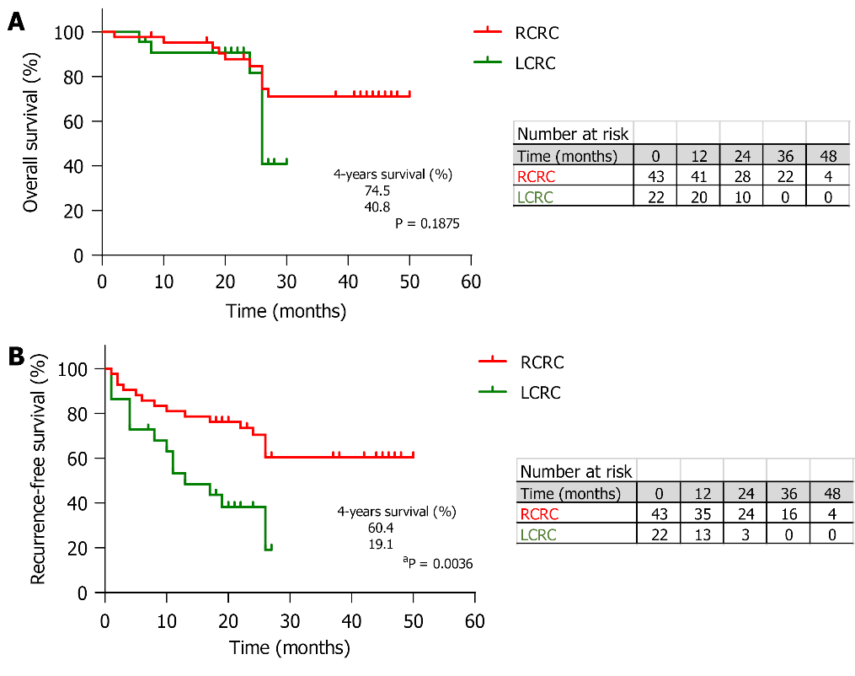
Figure 1 Survival rates of colorectal cancer patients. A, B: Kaplan-Meier curves for 4-year overall survival (A) and 4-year recurrence-free survival (B) observed in the cohort for both right-sided colorectal cancer (CRC) (orange) and left-sided CRC (green) patients. Survival proportions at 26 mo after surgery (median follow-up) of right-sided CRC and left-sided CRC patients are shown (^{b}P < 0.01, log-rank test). Number of cases at risk are tabled for both overall survival and recurrence-free survival. RCRC: Right-sided colorectal cancer; LCRC: Left-sided colorectal cancer.

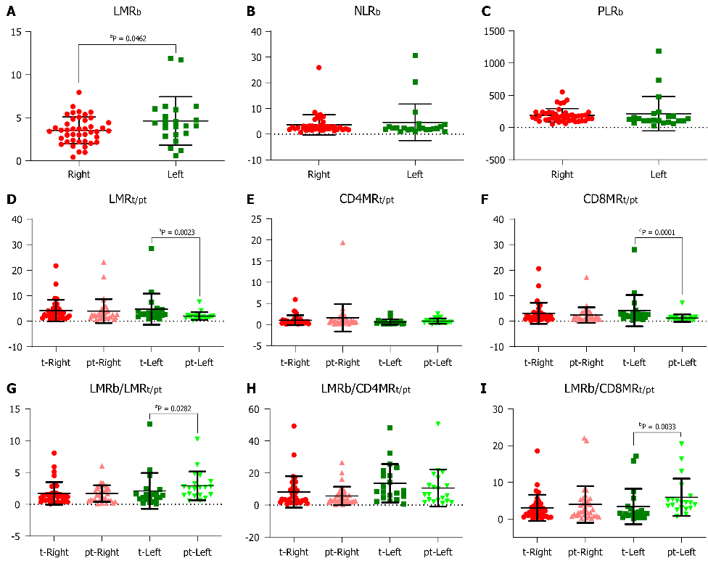
Figure 2 Leukocyte ratios in peripheral blood and tissues from colorectal cancer patients. A-C: Blood circulating leukocytes in right-sided colorectal cancer (CRC) patients (orange, n = 43) and left-sided CRC patients (green, n = 22) represented as lymphocyte-to-monocyte ratio (LMR)_{blood (b)} (A), neutrophil-to-lymphocyte ratio (B), and platelet-to-lymphocyte ratio (C) (ªP < 0.05, unpaired t test, data are mean ± standard deviation); D-F: Tissue-infiltrated leukocytes in right-sided CRC tumours (tumour [t], orange, n = 34) and peritumours (peritumour [pt], light red, n = 34) and left-sided CRC tumours (t, green, n = 20) and peritumours (pt, light green, n = 20), represented as LMR_{t/pt} (D), CD4⁺-lymphocyte-to-monocyte ratio (CD4MR)_{t/pt} (E), and CD8⁺-lymphocyte-to-monocyte ratio (CD8MR)_{t/pt} (F) (ªP < 0.05, ^{b}P < 0.01, unpaired Mann-Whitney U test, data are mean ± standard deviation); G-I: Blood-to-tissue leukocyte ratios for right-sided CRC tumours (t, orange, n = 34) and peritumours (pt, light red, n = 34) and left-sided CRC tumours (t, green, n = 20) and peritumours (pt, light green, n = 20) represented as LMR_{b}/LMR_{t/pt} (G), LMR_{b}/CD4MR_{t/pt} (H), and LMR_{b}/CD8MR_{t/pt} (I) (ªP < 0.05, ^{b}P < 0.01, unpaired Mann-Whitney U test, data are mean ± standard deviation). PLR: Platelet-to-lymphocyte ratio.

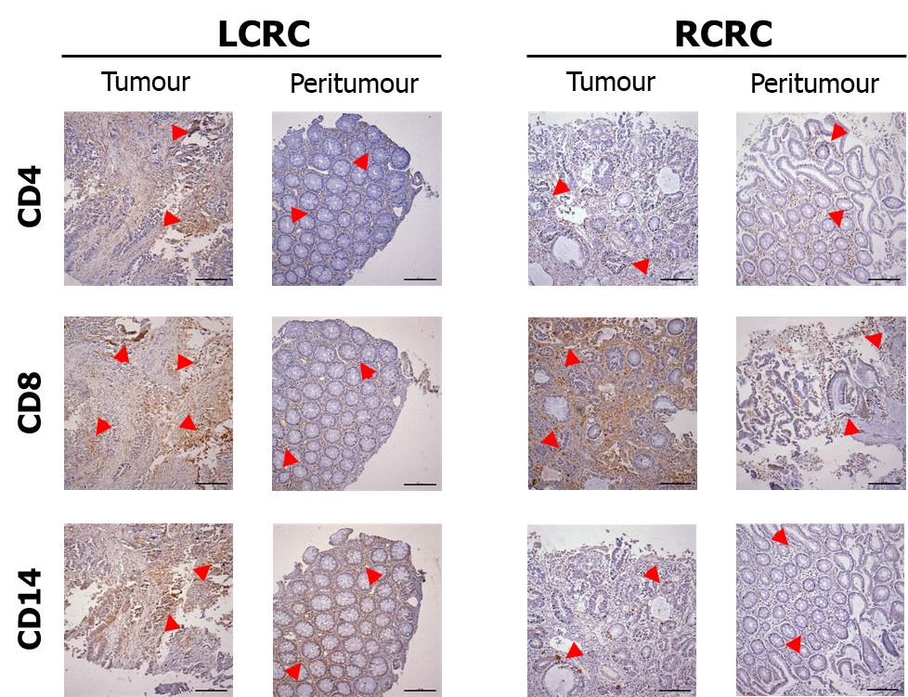
Figure 3 Leukocyte infiltration in tissues from right-sided colorectal cancer and left-sided colorectal cancer patients. Representative immunohistochemical images (× 100, scale bar = 200 μm) of CD4⁺ lymphocytes, CD8⁺ lymphocytes and CD14⁺ monocytes in tumour and peritumour samples, from one left-sided colorectal cancer (LCRC) patient (left panel) and one right-sided colorectal cancer (RCRC) patient (right panel). Arrows show rich-marker zones in each sample.

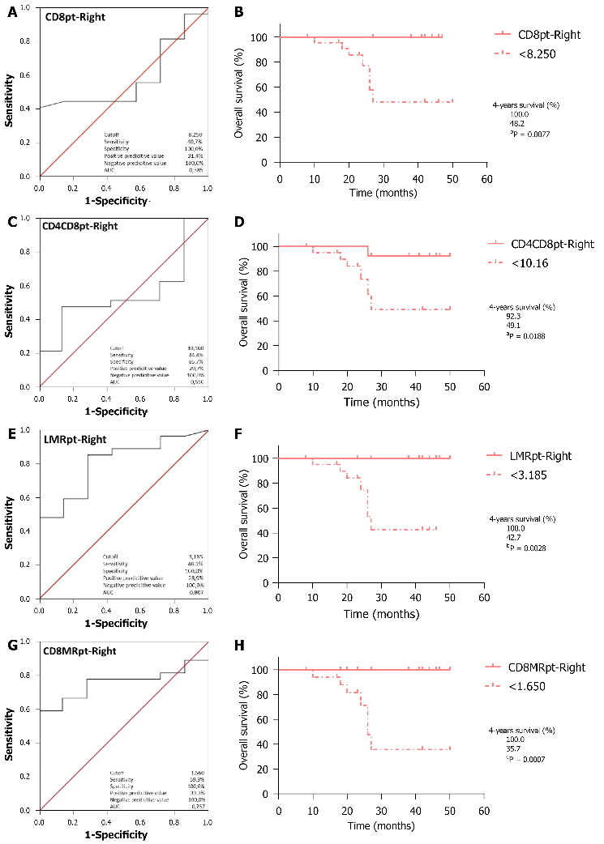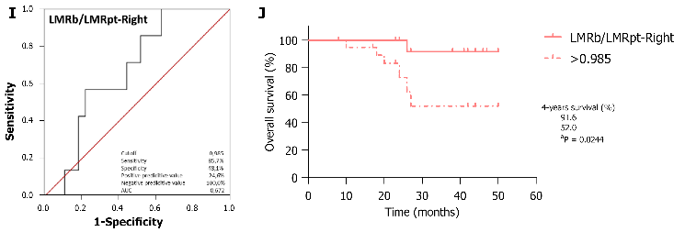
Figure 4 Receiver operating curve analyses for overall survival and Kaplan-Meier curves for optimal cutoff values in right-sided colorectal cancer patients for significant predictors. A-B: CD8⁺-lymphocyte (CD8)_{peritumour} _{(pt)}, worse below 8.25; C-D: CD4⁺ plus CD8⁺-lymphocyte (CD4CD8)_{pt} worse below 10.16; E-F: Lymphocyte-to-monocyte ratio (LMR)_{pt} worse below 3.185; G-H: CD8⁺-lymphocyte-to-monocyte ratio (CD8MR)_{pt} worse below 1.65; I-J: LMR_{b}/LMR_{pt} worse above 0.985; K-L: LMR_{blood (b)}/ CD8⁺-lymphocyte-to-monocyte ratio_{pt} worse above 1.485; survival proportions at 26 mo after surgery (median follow-up) are shown (ªP < 0.05, ^{b}P < 0.01, log-rank test).

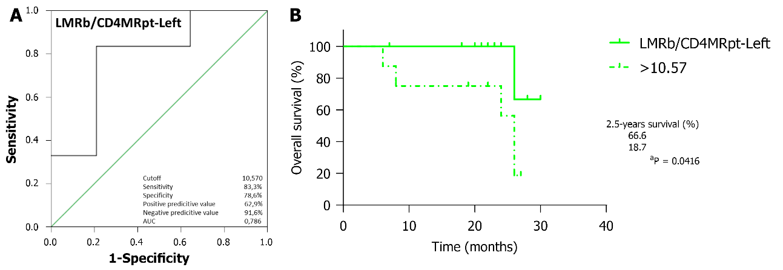
Figure 5 Receiver operating curve analysis for overall survival (A) and Kaplan-Meier curve (B) for optimal cutoff value in left-sided colorectal cancer patients for the significant predictor blood lymphocyte-to-monocyte ratio/peritumour CD4⁺-lymphocyte-to-monocyte ratio. Worse above 10.57; survival proportions at 26 mo after surgery (median follow-up) are shown (ªP < 0.05, log-rank test). b: Blood; CD4MR: CD4⁺-lymphocyte-to-monocyte ratio; LMR: Lymphocyte-to-monocyte ratio; pt: Peritumour.

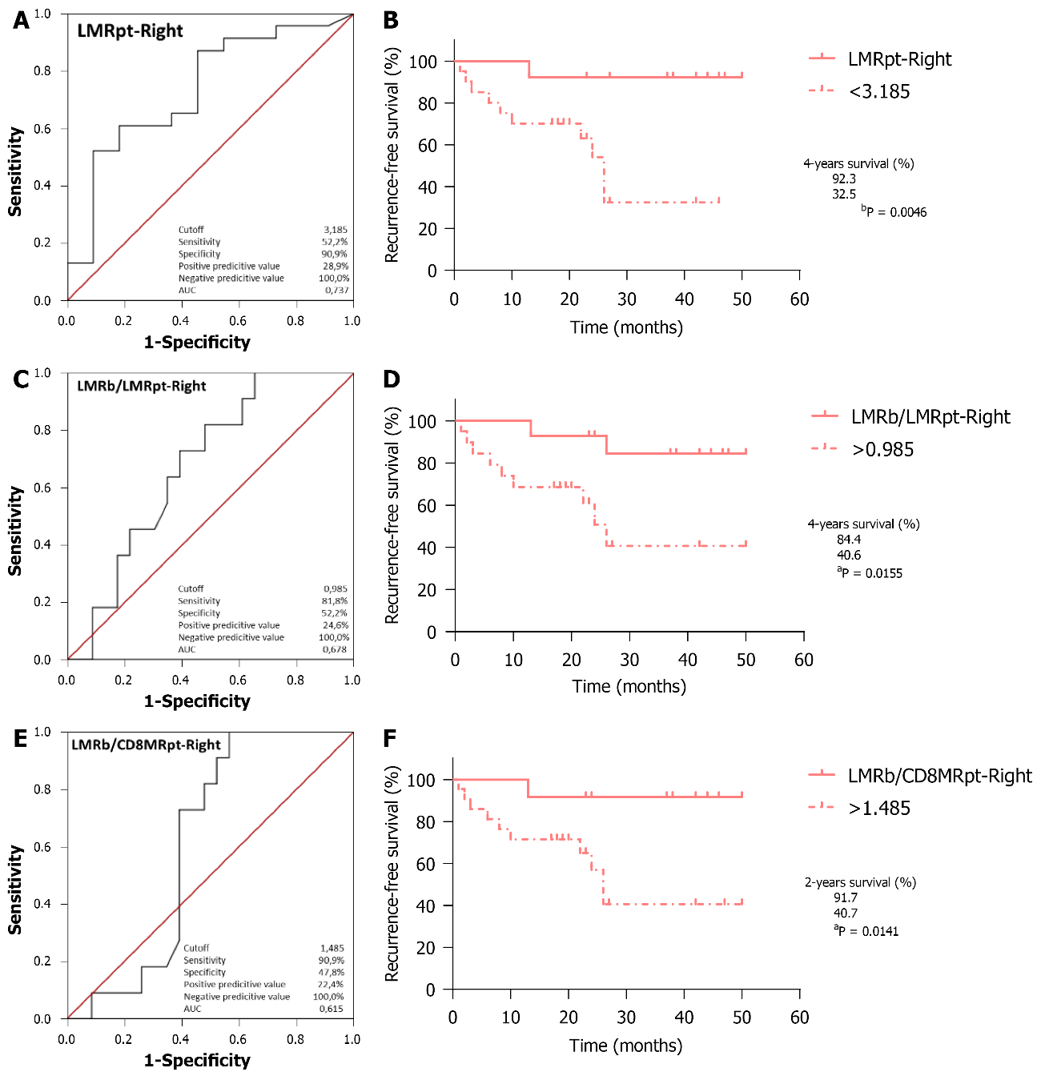
Figure 6 Receiver operating curve analyses for recurrence-free survival and Kaplan-Meier curves for optimal cutoff values in right-sided colorectal cancer patients for significant predictors. A-B: Peritumour lymphocyte-to-monocyte ratio (LMR) worse below 3.185; C-D: Blood (b) LMR/peritumour (pt) LMR worse above 0.985; E-F: Blood LMR/peritumour CD8⁺-lymphocyte-to-monocyte ratio (CD8MR) worse above 1.485; survival proportions at 26 mo after surgery (median follow-up) are shown (ªP < 0.05, ^{b}P < 0.01, log-rank test).

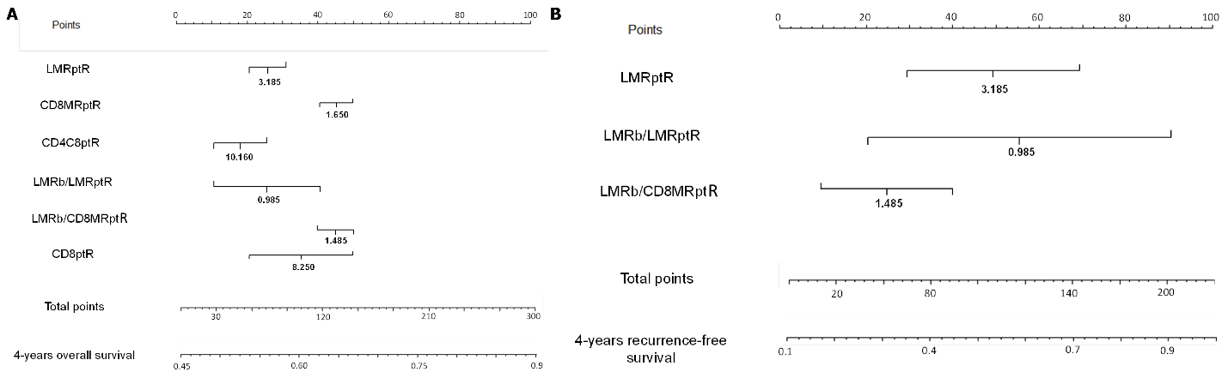
Figure 7 Nomograms for predicting overall survival and recurrence-free survival after surgical intervention of right-sided colorectal cancer patients. A: The 4-year probability of overall survival was estimated by summing the scores of peritumour (pt) lymphocyte-to-monocyte ratio (LMR), CD8⁺-lymphocyte (CD8)⁺-lymphocyte-to-monocyte ratio (CD8MR)_{pt}, CD4⁺ plus CD8⁺-lymphocyte (CD4CD8)_{pt}, blood (b) LMR/LMR_{pt}, LMR_{b}/CD8MR _{pt}, and CD8_{pt}; B: The 4-year probability of recurrence-free survival was estimated by summing the scores of LMR_{pt}, LMR_{b}/LMR_{pt}, and LMR_{b}/CD8⁺-lymphocyte-to-monocyte ratio_{pt}. For each graph, locate the patient’s values for each variable at one of the extremes of its corresponding axis, taking into account the correct position with respect to the optimal cutoff that is indicated; values higher than the cutoff go to the upper end and values lower than the cutoff go to the lower end. Then, draw a line straight upwards to the “Points” axis to determine the score associated to each variable. Add up all the scores, locate this sum in the “Total points” axis and draw a line straight down to the lowest axes of “4-year overall survival” or “4-year recurrence-free survival” to find the predictive probability of the patient for overall survival or recurrence-free survival outcome, respectively.

Table 1 Baseline characteristics of patients included in this study
Characteristics |  | Frequency | %
All patients (n = 65)
Age (yr) ± SD |  | 73.54 ± 9.51
(range) |  | (52-92)
Gender
Female |  | 29 | 44.62
Male |  | 36 | 55.38
Tumour localisation
Right colorectal cancer |  | 43 | 66.15
Caecum |  | 13 | 30.23
Ascending colon |  | 23 | 53.49
Transverse colon |  | 7 | 16.28
Left colorectal cancer |  | 22 | 33.85
Descending colon |  | 11 | 50.00
Sigma |  | 11 | 50.00
Emergency surgery
Yes |  | 1 | 1.54
No |  | 64 | 98.46
Surgical procedure
Laparoscopic hemicolectomy |  | 48 | 73.85
Open hemicolectomy |  | 17 | 26.15
Development at surgery
Non-metastasised |  | 37 | 56.92
Metastases |  | 28 | 43.08
Liver synchronous |  | 13 | 46.43
Liver metachronous |  | 8 | 28.57
Other organs |  | 13 | 46.43
MMR status
pMMR |  | 56 | 86.15
dMMR |  | 5 | 7.69
unknown |  | 4 | 6.15
TNM stage
0 |  | 3 | 4.62
I |  | 7 | 10.77
IIA |  | 21 | 32.31
IIB |  | 5 | 7.69
IIIA |  | 2 | 3.08
IIIB |  | 8 | 12.31
IIIC |  | 5 | 7.69
IV |  | 1 | 1.54
IVA |  | 10 | 15.38
IVB |  | 3 | 4.62
Adjuvant chemotherapy
Yes |  | 30 | 46.15
No |  | 35 | 53.85
Blood leukocytes counting (× 10³/μL), (normal range) | RCRC | LCRC | P value
White blood cells count (3.6-10.5) | 7.41 (3.52-16.2) | 8.19 (4.83-15.8) | 0.271
Lymphocytes (1.1-4.5) | 1.77 (0.46-4.46) | 2.04 (0.32-4.87) | 0.235
Monocytes (0.1-0.9) | 0.54 (0.20-1.26) | 0.50 (0.22-1.11) | 0.493
Neutrophils (1.5-7.7) | 4.86 (1.76-15.3) | 5.34 (2.96-13.0) | 0.480
Platelets (150-370) | 275.65 (101.0-602.0) | 272.41 (142.0-725.0) | 0.910
LMR_{b} | 3.54 (0.42-7.96) | 4.64 (0.58-11.88) | 0.046
NLR_{b} | 3.65 (0.69-25.93) | 4.61 (0.93-30.66) | 0.481
PLR_{b} | 188.58 (52.24-551.22) | 213.93 (29.16-1187.50) | 0.585
TNM: Tumour-nodes-metastasis classification; MMR: DNA mismatch repair; pMMR: Proficient MMR; dMMR: Deficient MMR; LMR: Lymphocyte-to-monocyte ratio; NLR: Neutrophil-to-lymphocytes ratio; PLR: Platelet-to-lymphocyte ratio; RCRC: Right-sided colorectal cancer; LCRC: Left-sided colorectal cancer; SD: Standard deviation; b: Blood.

Table 2 Association of leukocytes counts and ratios with overall and recurrence-free survival
Index | Total patients | 4-year OS |  |  |  | 4-year RFS
 | n (%) | Spearman r | 95% CI | P |  | Spearman r | 95% CI | P
LMR_{b}
Right | 43 (66.2) | -0.3039 | -0.5601 to 0.005346 | 0.0476 | < 0.05 | -0.1946 | -0.4748 to 0.1214 | 0.211 | ns
Left | 22 (33.8) | 0.1615 | -0.2914 to 0.5553 | 0.4727 | ns | -0.07447 | -0.4912 to 0.3700 | 0.7419 | ns
NLR_{b}
Right | 43 (66.2) | 0.2262 | -0.08868 to 0.5000 | 0.1446 | ns | 0.1062 | -0.2094 to 0.4017 | 0.498 | ns
Left | 22 (33.8) | -0.06922 | -0.4872 to 0.3746 | 0.7595 | ns | 0.1192 | -0.3305 to 0.5247 | 0.5974 | ns
PLR_{b}
Right | 43 (66.2) | 0.2307 | -0.08405 to 0.5035 | 0.1367 | ns | 0.06684 | -0.2470 to 0.3680 | 0.6702 | ns
Left | 22 (33.8) | 0.1615 | -0.2914 to 0.5553 | 0.4727 | ns | 0.1192 | -0.3305 to 0.5247 | 0.5974 | ns
CD4_{t}
Right | 34 (63.0) | -0.05561 | -0.3954 to 0.2976 | 0.7548 | ns | 0.05447 | -0.2986 to 0.3944 | 0.7596 | ns
Left | 20 (37.0) | 0.01892 | -0.4387 to 0.4687 | 0.9369 | ns | -0.0354 | -0.4815 to 0.4253 | 0.8822 | ns
CD4_{pt}
Right | 34 (63.0) | 0.03708 | -0.3144 to 0.3796 | 0.8351 | ns | 0.07371 | -0.2809 to 0.4106 | 0.6787 | ns
Left | 20 (37.0) | -0.142 | -0.5597 to 0.3334 | 0.5505 | ns | 0.3276 | -0.1483 to 0.6803 | 0.1586 | ns
CD8_{t}
Right | 34 (63.0) | -0.08526 | -0.4202 to 0.2702 | 0.6316 | ns | -0.2083 | -0.1958 to 0.6531 | 0.2372 | ns
Left | 20 (37.0) | 0.03784 | -0.4233 to 0.4834 | 0.8741 | ns | 0.2832 | -0.3863 to 0.3074 | 0.2263 | ns
CD8_{pt}
Right | 34 (63.0) | -0.1186 | -0.4476 to 0.2386 | 0.504 | ns | -0.04486 | -0.3863 to 0.3074 | 0.8011 | ns
Left | 20 (37.0) | 0.3406 | -0.1340 to 0.6881 | 0.1417 | ns | 0.3186 | -0.1581 to 0.6749 | 0.171 | ns
CD4CD8_{t}
Right | 34 (63.0) | -0.1372 | -0.4626 to 0.2208 | 0.4392 | ns | -0.1955 | -0.5084 to 0.1630 | 0.268 | ns
Left | 20 (37.0) | 0.03784 | -0.4233 to 0.4834 | 0.8741 | ns | 0.2655 | -0.2142 to 0.6420 | 0.2579 | ns
CD4CD8_{pt}
Right | 34 (63.0) | -0.07044 | -0.4079 to 0.2839 | 0.6922 | ns | -0.009612 | -0.3559 to 0.3389 | 0.957 | ns
Left | 20 (37.0) | 0.3595 | -0.1127 to 0.6993 | 0.1195 | ns | 0.4425 | -0.01421 to 0.7464 | 0.0507 | ns
CD14_{t}
Right | 34 (63.0) | 0.1891 | -0.1695 to 0.5034 | 0.2842 | ns | 0.2467 | -0.1102 to 0.5472 | 0.1595 | ns
Left | 20 (37.0) | 0.05677 | -0.4076 to 0.4978 | 0.8121 | ns | -0.1239 | -0.5470 to 0.3496 | 0.6028 | ns
CD14_{pt}
Right | 34 (63.0) | 0.3003 | -0.05262 to 0.5865 | 0.0844 | ns | 0.2596 | -0.09658 to 0.5568 | 0.1382 | ns
Left | 20 (37.0) | 0.5677 | 0.1533 to 0.8122 | 0.009 | < 0.01 | 0.6018 | 0.2035 to 0.8292 | 0.005 | < 0.01
LMR_{t}
Right | 34 (63.0) | -0.2929 | -0.5812 to 0.06070 | 0.0927 | ns | -0.4775 | -0.7075 to -0.1559 | 0.0043 | < 0.01
Left | 20 (37.0) | 0.07569 | -0.3916 to 0.5119 | 0.7511 | ns | 0.4425 | -0.01421 to 0.7464 | 0.0507 | ns
LMR_{pt}
Right | 34 (63.0) | -0.4301 | -0.6764 to -0.09719 | 0.0111 | < 0.05 | -0.3846 | -0.6457 to -0.04285 | 0.0247 | < 0.05
Left | 20 (37.0) | 0 | -0.4538 to 0.4538 | > 0.9999 | ns | -0.0354 | -0.4815 to 0.4253 | 0.8822 | ns
CD4MRt
Right | 34 (63.0) | -0.2781 | -0.5704 to 0.07674 | 0.1113 | ns | -0.3173 | -0.5987 to 0.03388 | 0.0675 | ns
Left | 20 (37.0) | 0.04736 | -0.4154 to 0.4907 | 0.8428 | ns | 0.1949 | -0.2841 to 0.5960 | 0.4102 | ns
CD4MRpt
Right | 34 (63.0) | -0.2781 | -0.5704 to 0.07670 | 0.1112 | ns | -0.2596 | -0.5568 to 0.09650 | 0.1381 | ns
Left | 20 (37.0) | -0.473 | -0.7631 to -0.02445 | 0.0352 |  | -0.0885 | -0.5214 to 0.3806 | 0.7106 | ns
CD8MRt
Right | 34 (63.0) | -0.2039 | -0.5149 to 0.1545 | 0.2474 | ns | -0.4422 | -0.6845 to -0.1120 | 0.0088 | < 0.01
Left | 20 (37.0) | 0.1135 | -0.3588 to 0.5396 | 0.6337 | ns | 0.4779 | 0.03071 to 0.7657 | 0.0331 | < 0.05
CD8MRpt
Right | 34 (63.0) | -0.3596 | -0.6285 to -0.01393 | 0.0367 | < 0.05 | -0.2788 | -0.5709 to 0.07601 | 0.1104 | ns
Left | 20 (37.0) | 0.1893 | -0.2894 to 0.5923 | 0.4241 | ns | -0.03541 | -0.4815 to 0.4253 | 0.8822 | ns
LMR_{b}/LMRt
Right | 34 (63.0) | 0.1075 | -0.2492 to 0.4386 | 0.545 | ns | 0.3621 | 0.01678 to 0.6302 | 0.0353 | < 0.05
Left | 20 (37.0) | -0.05677 | -0.4978 to 0.4076 | 0.8121 | ns | -0.4248 | -0.7366 to 0.03599 | 0.0619 | ns
LMR_{b}/LMRpt
Right | 34 (63.0) | 0.241 | -0.1162 to 0.5430 | 0.1698 | ns | 0.2884 | -0.06561 to 0.5779 | 0.0981 | ns
Left | 20 (37.0) | 0.1325 | -0.3420 to 0.5531 | 0.5778 | ns | -0.0531 | -0.4950 to 0.4106 | 0.8241 | ns
LMR_{b}/CD4MR_{t}
Right | 34 (63.0) | 0.1372 | -0.2208 to 0.4626 | 0.4392 | ns | 0.2467 | -0.1101 to 0.5473 | 0.1595 | ns
Left | 20 (37.0) | -0.09461 | -0.5259 to 0.3754 | 0.6915 | ns | -0.177 | -0.5839 to 0.3010 | 0.4554 | ns
LMR_{b}/CD4MR_{pt}
Right | 34 (63.0) | 0.1446 | -0.2136 to 0.4685 | 0.4146 | ns | 0.189 | -0.1695 to 0.5034 | 0.2843 | ns
Left | 20 (37.0) | 0.4541 | 0.0003499 to 0.7528 | 0.0443 | < 0.05 | 0.1062 | -0.3653 to 0.5343 | 0.6559 | ns
LMR_{b}/CD8MR_{t}
Right | 34 (63.0) | 0.04078 | -0.3111 to 0.3828 | 0.8189 | ns | 0.3364 | -0.01245 to 0.6123 | 0.0517 | ns
Left | 20 (37.0) | -0.03784 | -0.4834 to 0.4233 | 0.8741 | ns | -0.4071 | -0.7267 to 0.05735 | 0.0748 | ns
LMR_{b}/CD8MR_{pt}
Right | 34 (63.0) | 0.1409 | -0.2172 to 0.4655 | 0.4267 | ns | 0.1859 | -0.1727 to 0.5009 | 0.2926 | ns
Left | 20 (37.0) | -0.1703 | -0.5794 to 0.3073 | 0.4729 | ns | -0.1416 | -0.5595 to 0.3337 | 0.5515 | ns
OS: Overall survival; RFS: Recurrence-free survival; LMR: Lymphocyte-to-monocyte ratio; NLR: Neutrophil-to-lymphocytes ratio; PLR: Platelet-to-lymphocyte ratio; b: Blood; t: Tumour; pt: Peritumour; CD4MR: CD4⁺-lymphocyte-to-monocyte ratio; CD8MR: CD8⁺-lymphocyte-to-monocyte ratio; CI: Confidence interval; ns: Not significant.

Table 3 Univariate and multivariate analyses for prognostic variables of overall survival after surgical interventions of right-sided colorectal cancer and left-sided colorectal cancer
 | Total patients | Univariate analysis |  |  |  |  | Multivariate analysis
 | n (%) | HR | 95% CI |  | P |  | HR | 95% CI |  | P
Variables |  |  | Low | High |  |  |  | Low | High
LMR_{b}
Right | 34 (63.0) | 0.565 | 0.325 | 0.982 | 0.043 | < 0.05 | 0.133 | 0.000 | 71.041 | 0.529
Left | 20 (37.0) | 1.141 | 0.867 | 1.502 | 0.346 |  | 1.141 | 0.867 | 1.502 | 0.346
NLR_{b}
Right | 34 (63.0) | 1.416 | 1.019 | 1.967 | 0.038 | < 0.05 | 1.416 | 1.019 | 1.967 | 0.038 | < 0.05
Left | 20 (37.0) | 1.043 | 0.944 | 1.152 | 0.410 |  | 1.126 | 0.987 | 1.284 | 0.078
PLR_{b}
Right | 34 (63.0) | 1.005 | 1.000 | 1.011 | 0.064 |  | 0.989 | 0.719 | 1.361 | 0.946
Left | 20 (37.0) | 1.001 | 0.999 | 1.004 | 0.292 |  | 0.997 | 0.937 | 1.060 | 0.912
CD4_{t}
Right | 34 (63.0) | 0.923 | 0.638 | 1.334 | 0.670
Left | 20 (37.0) | 0.843 | 0.493 | 1.439 | 0.531
CD4_{pt}
Right | 34 (63.0) | 0.959 | 0.817 | 1.124 | 0.604
Left | 20 (37.0) | 0.813 | 0.454 | 1.456 | 0.487
CD8_{t}
Right | 34 (63.0) | 0.995 | 0.897 | 1.105 | 0.931 |  | 1.032 | 0.913 | 1.167 | 0.611
Left | 20 (37.0) | 0.954 | 0.860 | 1.057 | 0.364
CD8_{pt}
Right | 34 (63.0) | 0.792 | 0.617 | 1.016 | 0.066 |  | 0.800 | 0.636 | 1.007 | 0.058
Left | 20 (37.0) | 1.018 | 0.957 | 1.083 | 0.570 |  | 1.033 | 0.962 | 1.110 | 0.372
CD4CD8_{t}
Right | 34 (63.0) | 0.987 | 0.892 | 1.093 | 0.806
Left | 20 (37.0) | 0.937 | 0.833 | 1.054 | 0.277
CD4CD8_{pt}
Right | 34 (63.0) | 0.891 | 0.761 | 1.043 | 0.150 |  | 1.073 | 0.821 | 1.401 | 0.606
Left | 20 (37.0) | 1.015 | 0.953 | 1.082 | 0.641
CD14_{t}
Right | 34 (63.0) | 1.048 | 0.845 | 1.300 | 0.670 |  | 1.077 | 0.836 | 1.388 | 0.565
Left | 20 (37.0) | 0.979 | 0.703 | 1.362 | 0.898
CD14_{pt}
Right | 34 (63.0) | 1.113 | 0.889 | 1.394 | 0.351 |  | 1.342 | 0.987 | 1.826 | 0.060
Left | 20 (37.0) | 1.053 | 0.723 | 1.533 | 0.788 |  | 0.700 | 0.381 | 1.286 | 0.250
LMR_{t}
Right | 34 (63.0) | 0.635 | 0.365 | 1.103 | 0.107
Left | 20 (37.0) | 1.000 | 0.908 | 1.101 | 0.997 |  | 0.976 | 0.555 | 1.716 | 0.933
LMR_{pt}
Right | 34 (63.0) | 0.416 | 0.194 | 0.889 | 0.024 | < 0.05
Left | 20 (37.0) | 1.030 | 0.712 | 1.490 | 0.876 |  | 0.031 | 0.000 | 4.228 | 0.166
CD4MR_{t}
Right | 34 (63.0) | 0.270 | 0.039 | 1.850 | 0.182
Left | 20 (37.0) | 0.759 | 0.146 | 3.954 | 0.743
CD4MR_{pt}
Right | 34 (63.0) | 0.431 | 0.112 | 1.660 | 0.221
Left | 20 (37.0) | 0.135 | 0.004 | 4.148 | 0.252
CD8MR_{t}
Right | 34 (63.0) | 0.712 | 0.364 | 1.394 | 0.321
Left | 20 (37.0) | 1.001 | 0.910 | 1.100 | 0.986
CD8MR_{pt}
Right | 34 (63.0) | 0.223 | 0.057 | 0.872 | 0.031 | < 0.05 | 0.024 | 0.001 | 0.430 | 0.011 | < 0.05
Left | 20 (37.0) | 1.078 | 0.775 | 1.500 | 0.654
LMR_{b}/LMR_{t}
Right | 34 (63.0) | 0.957 | 0.603 | 1.519 | 0.853
Left | 20 (37.0) | 1.163 | 0.935 | 1.446 | 0.175
LMR_{b}/LMR_{pt}
Right | 34 (63.0) | 1.253 | 0.824 | 1.907 | 0.292
Left | 20 (37.0) | 1.196 | 0.845 | 1.695 | 0.313
LMR_{b}/CD4MR_{t}
Right | 34 (63.0) | 1.009 | 0.950 | 1.073 | 0.767 |  | 1.282 | 0.931 | 1.765 | 0.128
Left | 20 (37.0) | 1.027 | 0.961 | 1.099 | 0.428
LMR_{b}/CD4MR_{pt}
Right | 34 (63.0) | 1.028 | 0.926 | 1.142 | 0.600 |  | 1.291 | 0.447 | 3.728 | 0.636
Left | 20 (37.0) | 1.097 | 1.011 | 1.190 | 0.026 | < 0.05 | 0.991 | 0.420 | 2.341 | 0.984
LMR_{b}/CD8MR_{t}
Right | 34 (63.0) | 0.973 | 0.747 | 1.269 | 0.842
Left | 20 (37.0) | 1.103 | 0.940 | 1.294 | 0.229 |  | 1.971 | 0.258 | 15.069 | 0.513
LMR_{b}/CD8MR_{pt}
Right | 34 (63.0) | 1.053 | 0.880 | 1.260 | 0.572 |  | 0.484 | 0.268 | 0.873 | 0.016 | < 0.05
Left | 20 (37.0) | 1.026 | 0.834 | 1.262 | 0.812 |  | 0.952 | 0.009 | 96.530 | 0.983
LMR: Lymphocyte-to-monocyte ratio; NLR: Neutrophil-to-lymphocytes ratio; PLR: Platelet-to-lymphocyte ratio; HR: Hazard ratio; CI: Confidence interval; b: Blood; t: Tumour; pt: Peritumour; CD4MR: CD4⁺-lymphocyte-to-monocyte ratio; CD8MR: CD8⁺-lymphocyte-to-monocyte ratio.

Table 4 Univariate and multivariate analyses for prognostic variables of recurrence-free survival after surgical interventions of right-sided colorectal cancer and left-sided colorectal cancer
 | Total patients | Univariate analysis |  |  |  |  | Multivariate analysis
 | n (%) | HR | 95% CI |  | P |  | HR | 95% CI |  | P
Variables |  |  | Low | High |  |  |  | Low | High
LMR_{b}
Right | 34 (63.0) | 0.865 | 0.593 | 1.262 | 0.453
Left | 20 (37.0) | 0.977 | 0.770 | 1.239 | 0.848 |  | 0.156 | 0.001 | 24.118 | 0.470
NLR_{b}
Right | 34 (63.0) | 1.135 | 0.841 | 1.532 | 0.407 |  | 2.760 | 1.050 | 7.254 | 0.039 | < 0.05
Left | 20 (37.0) | 1.094 | 1.094 | 1.180 | 0.020 | < 0.05 | 1.156 | 1.038 | 1.288 | 0.009 | < 0.01
PLR_{b}
Right | 34 (63.0) | 1.001 | 0.996 | 1.007 | 0.596 |  | 0.978 | 0.958 | 0.999 | 0.037 | < 0.05
Left | 20 (37.0) | 1.002 | 1.000 | 1.004 | 0.018 | < 0.05 | 0.987 | 0.954 | 1.022 | 0.468
CD4_{t}
Right | 34 (63.0) | 1.010 | 0.864 | 1.181 | 0.902 |  | 0.802 | 0.457 | 1.407 | 0.441
Left | 20 (37.0) | 0.981 | 0.617 | 1.559 | 0.934
CD4_{pt}
Right | 34 (63.0) | 0.963 | 0.851 | 1.091 | 0.556 |  | 1.486 | 0.124 | 17.828 | 0.755
Left | 20 (37.0) | 1.120 | 0.795 | 1.577 | 0.516
CD8_{t}
Right | 34 (63.0) | 0.962 | 0.872 | 1.062 | 0.446 |  | 1.821 | 0.451 | 7.347 | 0.400
Left | 20 (37.0) | 1.032 | 0.971 | 1.097 | 0.310
CD8_{pt}
Right | 34 (63.0) | 0.906 | 0.780 | 1.053 | 0.199 |  | 1.117 | 0.848 | 1.472 | 0.431
Left | 20 (37.0) | 1.050 | 0.988 | 1.115 | 0.116 |  | 1.098 | 1.015 | 1.189 | 0.020 | < 0.05
CD4CD8_{t}
Right | 34 (63.0) | 0.972 | 0.893 | 1.058 | 0.515
Left | 20 (37.0) | 1.033 | 0.970 | 1.100 | 0.307 |  | 0.436 | 0.198 | 0.960 | 0.039 | < 0.05
CD4CD8_{pt}
Right | 34 (63.0) | 0.944 | 0.857 | 1.041 | 0.248
Left | 20 (37.0) | 1.052 | 0.992 | 1.117 | 0.093 |  | 0.008 | 0.000 | 1.071 | 0.053
CD14_{t}
Right | 34 (63.0) | 1.123 | 0.949 | 1.329 | 0.178 |  | 1.467 | 1.048 | 2.054 | 0.026 | < 0.05
Left | 20 (37.0) | 0.918 | 0.713 | 1.180 | 0.502
CD14_{pt}
Right | 34 (63.0) | 1.075 | 0.891 | 1.297 | 0.449 |  | 1.790 | 0.592 | 5.406 | 0.302
Left | 20 (37.0) | 1.472 | 1.095 | 1.978 | 0.010 | < 0.05
LMR_{t}
Right | 34 (63.0) | 0.555 | 0.337 | 0.915 | 0.021 | < 0.05 | 0.641 | 0.213 | 1.926 | 0.428
Left | 20 (37.0) | 1.084 | 0.999 | 1.176 | 0.052 |  | 0.165 | 0.003 | 9.203 | 0.380
LMR_{pt}
Right | 34 (63.0) | 0.691 | 0.458 | 1.042 | 0.078 |  | 0.312 | 0.123 | 0.793 | 0.014 | < 0.05
Left | 20 (37.0) | 1.066 | 0.688 | 1.653 | 0.775
CD4MR_{t}
Right | 34 (63.0) | 0.588 | 0.220 | 1.572 | 0.290 |  | 0.876 | 0.382 | 2.010 | 0.756
Left | 20 (37.0) | 0.950 | 0.381 | 2.370 | 0.912
CD4MR_{pt}
Right | 34 (63.0) | 0.734 | 0.327 | 1.648 | 0.454 |  | 7.229 | 0.515 | 101.544 | 0.142
Left | 20 (37.0) | 0.583 | 0.199 | 1.709 | 0.325
CD8MR_{t}
Right | 34 (63.0) | 0.497 | 0.246 | 1.005 | 0.052
Left | 20 (37.0) | 1.083 | 0.999 | 1.174 | 0.052 |  | 1.123 | 1.020 | 1.238 | 0.019 | < 0.05
CD8MR_{pt}
Right | 34 (63.0) | 0.584 | 0.333 | 1.023 | 0.060
Left | 20 (37.0) | 1.191 | 0.815 | 1.741 | 0.365 |  | 0.293 | 0.026 | 3.345 | 0.323
LMRb/LMR_{t}
Right | 34 (63.0) | 1.311 | 1.013 | 1.697 | 0.040 | < 0.05
Left | 20 (37.0) | 0.958 | 0.730 | 1.258 | 0.760
LMRb/LMR_{pt}
Right | 34 (63.0) | 1.248 | 0.887 | 1.756 | 0.203 |  | 0.404 | 0.169 | 0.969 | 0.042 | < 0.05
Left | 20 (37.0) | 1.030 | 0.787 | 1.347 | 0.830 |  | 1.132 | 0.859 | 1.493 | 0.378
LMRb/CD4MR_{t}
Right | 34 (63.0) | 1.012 | 0.965 | 1.060 | 0.632 |  | 1.056 | 0.973 | 1.146 | 0.192
Left | 20 (37.0) | 0.991 | 0.937 | 1.048 | 0.742
LMRb/CD4MR_{pt}
Right | 34 (63.0) | 1.031 | 0.948 | 1.121 | 0.479 |  | 1.393 | 0.875 | 2.220 | 0.163
Left | 20 (37.0) | 1.023 | 0.969 | 1.079 | 0.412 |  | 0.925 | 0.847 | 1.011 | 0.087
LMRb/CD8MR_{t}
Right | 34 (63.0) | 1.146 | 1.017 | 1.292 | 0.025 | < 0.05 | 1.301 | 1.078 | 1.571 | 0.006 | < 0.01
Left | 20 (37.0) | 0.941 | 0.775 | 1.143 | 0.542 |  | 1.036 | 0.591 | 1.816 | 0.903
LMRb/CD8MR_{pt}
Right | 34 (63.0) | 1.022 | 0.894 | 1.169 | 0.746 |  | 1.390 | 0.304 | 6.350 | 0.671
Left | 20 (37.0) | 0.968 | 0.844 | 1.109 | 0.638 |  | 0.847 | 0.576 | 1.244 | 0.397
LMR: Lymphocyte-to-monocyte ratio; NLR: Neutrophil-to-lymphocytes ratio; PLR: Platelet-to-lymphocyte ratio; HR: Hazard ratio; CI: Confidence interval; b: Blood; t: Tumour; pt: Peritumour; CD4MR: CD4⁺-lymphocyte-to-monocyte ratio; CD8MR: CD8⁺-lymphocyte-to-monocyte ratio.

