Name of Journal: World Journal of Stem Cells
Manuscript NO: 85624
Manuscript Type: META-ANALYSIS

Up-to-date meta-analysis of long-term evaluations of mesenchymal stem cell therapy for complex perianal fistula

Cheng F et al. Local MSC therapy for complex perianal fistula

Fang Cheng, Huang Zhong, Zhong Huang, Zhi Li

Fang Cheng, Division of Gastroenterology, Zigong First People’s Hospital, Zigong 643000, Sichuan Province, China

Fang Cheng, Huang Zhong, Zhong Huang, Zhi Li, Department of Gastroenterology, Zigong First People’s Hospital, Zigong 643000, Sichuan Province, China

Author contributions: Cheng F and Zhong H developed a search strategy for each database and collected the citations; Hong Z and Li Z performed the assessment of study quality and risk of bias, the data extraction and statistical analysis; Cheng F was major contributors in writing the manuscript; and all authors read and approved the final manuscript.

Corresponding author: Fang Cheng, Doctor, Division of Gastroenterology, Zigong First People’s Hospital, No. 42 Shangyihao Road, Zigong 643000, Sichuan Province, China. 1072893878@qq.com

Received: May 7, 2023
Revised: June 21, 2023
Accepted: July 19, 2023
Published online: August 26, 2023

Abstract
BACKGROUND
Local mesenchymal stem cell (MSC) therapy for complex perianal fistulas (PFs) has shown considerable promise. But, the long-term safety and efficacy of MSC therapy in complex PFs remain unknown.

AIM
To explore the long-term effectiveness and safety of local MSC therapy for complex PFs.

METHODS
Sources included the PubMed, EMBASE, and Cochrane Library databases. A standard meta-analysis was performed using RevMan 5.3.

RESULTS
After screening, 6 studies met the inclusion criteria. MSC therapy was associated with an improved long-term healing rate (HR) compared with the control condition [odds ratio (OR) = 2.13; 95% confidence interval (95%CI): 1.34 to 3.38; P = 0.001]. Compared with fibrin glue (FG) therapy alone, MSC plus FG therapy was associated with an improved long-term HR (OR = 2.30; 95%CI: 1.21 to 4.36; P = 0.01). When magnetic resonance imaging was used to evaluate fistula healing, MSC therapy was found to achieve a higher long-term HR than the control treatment (OR = 2.79; 95%CI: 1.37 to 5.67; P = 0.005). There were no significant differences in long-term safety (OR = 0.77; 95%CI: 0.27 to 2.24; P = 0.64).

CONCLUSION
Our study indicated that local MSC therapy promotes long-term and sustained healing of complex PFs and that this method is safe.

Key Words: Complex perianal fistula; Mesenchymal stem cells; Long-term evaluation; Meta-analysis

©The Author(s) 2023. Published by Baishideng Publishing Group Inc. All rights reserved.

Citation: Cheng F, Zhong H, Huang Z, Li Z. Up-to-date meta-analysis of long-term evaluations of mesenchymal stem cell therapy for complex perianal fistula. World J Stem Cells 2023; 15(8): 866-875
URL: https://www.wjgnet.com/1948-0210/full/v15/i8/866.htm
DOI: https://dx.doi.org/10.4252/wjsc.v15.i8.866

Core Tip: The long-term safety and efficacy of mesenchymal stem cell (MSC) therapy for complex perianal fistulas (PFs) remain unknown. So, we explored the long-term effectiveness and safety of local MSC therapy for complex PFs. We found that MSC treatment is a safe and effective method that can significantly improve the long-term healing of complex PFs, and this method confers no risk of MSC-related adverse events.

INTRODUCTION
A perianal fistula (PF) is an epithelialized tract that connects the luminal surface of the anal canal or rectum with the perianal or perineal skin. It affects approximately 2 in 10000 people and represents a difficult therapeutic challenge and a source of physical and psychological morbidity with a long-term risk of proctectomy^{[1]}. The most severe form is complex PF, which is difficult to manage, as it has a high rate of recurrence and may cause sphincter damage and fecal incontinence. Complex PF is defined as cases with more muscle involvement or anterior fistulas in female patients, as well as recurrent fistulas, suprasphincteric fistulas, extrasphincteric fistulas, horseshoe fistulas, fistulas associated with irritable bowel disease, transsphincteric fistulas that involve greater than 30% of the external sphincter and fistulas associated with preexisting fecal incontinence, inflammatory bowel disease, radiation, malignancy, or chronic diarrhea. PFs are also a probable consequence of Crohn’s disease (CD) since as many as 26% of CD patients eventually develop a PF within 20 years after diagnosis^{[2,3]}. Complex PFs in patients with CD have a high recurrence rate and cause a vast range of complications that significantly reduce quality of life (QoL)^{[4]}. In addition, there is a risk of developing a neoplasm in the PF area related to the complexity and perianal disease duration^{[5]}. The results of one study showed that complex PFs may lead to anal cancer in approximately 28% of patients within 20 years after diagnosis^{[6]}. Complex PF is a chronic, recurrent immune-mediated disease with a variety of treatment options. Its exact pathogenesis is unknown. The key long-term therapeutic goals for the treatment of complex PF are to: (1) Resolve fistula discharge; (2) achieve fistula healing; (3) prevent fistula recurrence; (4) maintain fecal continence; (5) avoid long-term diversion (protectomy with stoma), and hence; and (6) improve and maintain QoL for patients. Although current treatments for PFs include a range of medical and surgical options, managing this condition is difficult. Patients with complex PFs tend to have poor treatment outcomes or experience frequent relapses, and most interventions are ineffective in providing long-term healing^{[7-10]}. Immunomodulators can have serious side effects. Additionally, there is a risk of opportunistic infection associated with the use of biological treatments. In more severe cases of complex PF, fecal incontinence can occur, furthering morbidity. Complex PF is often not permanently cured by surgery, leading to multiple procedures and complications such as fecal incontinence. Therefore, there is a need for an effective therapy that provides long-term healing of complex PFs without the risk of fecal incontinence.
In recent years, local injection of mesenchymal stem cells (MSCs) has shown notable promising results in the treatment of PFs^{[11]}. MSCs are a heterogeneous subset of stromal stem cells. They can be isolated from a wide variety of tissues and expanded in vitro to obtain large quantities. MSCs are characterized by multilineage differentiation and powerful immunomodulatory effects and are able to mitigate inflammatory states. Complex PF is thought to arise from an epithelial defect, which may be caused by ongoing inflammation. Current treatments cannot maintain long-term healing of the disease. Possible alternative treatments include cell therapy, especially MSC therapy. Local administration is the most performed approach to deliver MSCs. After being delivered directly to fistula tracts, MSCs induce peripheral tolerance and migrate to injured tissues, where they can inhibit the release of proinflammatory cytokines and promote the survival of damaged cells. Consequently, MSCs are capable of repairing damaged tissues and promoting tissue healing, which can lead to long-term fistula healing, significantly improving patients’ quality of life. An increasing number of studies have indicated that local MSC therapy is safe and efficacious for complex PFs. In 2020, to evaluate whether local MSC therapy for complex PFs is effective and safe, we conducted a meta-analysis. That study, with a follow-up of 8 wk to 2 years, showed that local MSC therapy for complex PFs was safe and feasible. However, the efficacy and safety evaluation period of the study was short and middle term^{[12]}. Therefore, the long-term efficacy of MSC therapy is unclear. To date, an increasing number of studies have aimed to perform long-term evaluations of MSC therapy for PFs. Thus, based on a previous study^{[12]}, this study aimed to explore the long-term effectiveness and safety of MSC therapy for complex PFs (48 wk to 4 years of follow-up after MSC therapy).

MATERIALS AND METHODS
Data source and search strategies
This meta-analysis followed the Preferred Reporting Items for Systematic Reviews and Meta-Analyses (PRISMA) guidelines^{[13]}. In August 2022, a search was performed in the PubMed, EMBASE and Cochrane Library databases for clinical studies written in English regarding local MSC treatment in patients with complex PFs. The following search terms were used: “Mesenchymal stem cell’’, “mesenchymal stromal cell”, “complex perianal fistula”, “perianal fistula”, “complex perianal Crohn’s disease”, “Crohn’s perianal fistula”, “perianal Crohn’s disease”, “Crohn’s disease”, “perianal fistulizing Crohn’s disease”, “cryptoglandular perianal fistula”, and “long-term”. We also checked the reference lists of the screened full-text studies to identify other potentially eligible trials.

Study selection
Two authors independently assessed studies for inclusion by screening titles and abstracts. The inclusion criteria were: (1) Studies of human subjects; (2) randomized clinical trials (RCTs) and retrospective studies or cohort studies of patients with complex PFs treated with local injection(s) of autologous or allogeneic MSCs from any source; (3) local injection of MSCs or MSCs combined with fibrin glue (FG) for complex PFs; and (4) assessment of the efficacy and/or safety of MSC therapy at least 48 wk after treatment.

Data extraction and quality assessment
A customized data extraction form was used by two authors to extract data. These authors extracted study data features including: (1) Study characteristics (first author, publication year); (2) MSC origin; (3) definition of fistula healing [clinical and/or magnetic resonance imaging (MRI)]; (4) study outcomes; (5) dosage and modalities of intervention administration; (6) adverse events (AEs); and (7) concomitant treatment (anti-TNF). Table 1 lists the basic characteristics of the 6 identified studies. Quality assessment was performed using Review Manager (version 5.3) according to the recommendations from the Cochrane Collaboration. The bias risk assessment tool recommended by Cochrane was used to assess the quality of all enrolled studies. Each item of studies was judged as having a high, low or unclear risk of bias.

Statistical analysis
Based on the included studies, odds ratios (ORs) and corresponding 95% confidence intervals (95%CIs) were calculated to compare the MSC groups and control groups. Heterogeneity was quantified using the I² statistic. If the I² value was ≤ 50%, heterogeneity was considered low, and we employed a fixed-effect model. If the I² value was > 50%, heterogeneity was considered high, and we employed a random-effect model. All statistical analyses were performed using Review Manager (version 5.3). A value of P < 0.05 was considered statistically significant.

RESULTS
Literature search and quality assessment
The literature search process is illustrated in Figure 1. Using this search strategy, we identified 462 references related to local MSC treatment for complex PF, of which 358 duplicate articles were removed. After reading the titles and abstracts, we identified 20 articles for full-text review. Ultimately, after all criteria were applied, 6 articles were included in the meta-analysis^{[14-19]}. A summary of the risk of bias in the included articles is presented in Figure 2.

Long-term efficacy of MSCs in complex PF (48 wk to 4 years of follow-up after MSC therapy)
Our meta-analysis included 6 studies that assessed the long-term efficacy of post-MSC treatment. The pooled analysis showed that MSC therapy was associated with an improved long-term healing rate (HR) compared with the control condition (OR = 2.13; 95%CI: 1.34 to 3.38; P = 0.001) (Figure 3). The benefit was sustained for at least 48 wk of follow-up after MSC therapy.

Long-term efficacy of MSCs for complex PF (MSCs + FG vs FG alone)
Cell therapy strategies using MSCs carried in FG have shown promising results in regenerative medicine. FG is a natural polymer involved in the coagulation process. In regenerative medicine, FG can be used as a delivery system for drugs, biomolecules, growth factors and cells. FG also provides a temporary structure that favors angiogenesis, extracellular matrix deposition and cell-matrix interactions and it also FG maintains the local and paracrine functions of MSCs, providing tissue regeneration through less invasive clinical procedures. The biological properties of FG as a growth environment for MSCs have been reported in several studies^{[20]}. Now, local FG combined with MSCs therapy is still a relatively new treatment and has not yet gained popularity. So, the need for the local FG combined with MSCs therapy remains unknown. In our meta-analysis, three studies were included that reported local FG combined with MSCs therapy for PF^{[14,15,17]}, with low heterogeneity between the studies (I² = 0%). In a fixed-effects model, MSCs plus FG had more long-term efficacy for fistula healing than FG alone (OR = 2.30; 95%CI: 1.21 to 4.36; P = 0.01) (Figure 4). So, we think local FG combined with MSCs therapy have synergistic effect on PF.

MRI as the standard for evaluating fistula healing
In our meta-analysis, MRI was used to evaluate fistula healing in 3 studies. The pooled analysis showed that MSC therapy was associated with improved long-term HR (OR = 2.79; 95%CI: 1.37 to 5.67; P = 0.005) (Figure 5).

Long-term safety
Only two studies^{[16,19]} in this review assessed the long-term safety of MSC treatment for complex PF. The pooled results demonstrated that MSC treatment did not increase the risk of any long-term adverse or serious AEs (OR = 0.77; 95%CI: 0.27 to 2.24; P = 0.64) (Figure 6). No serious AEs related to MSC therapy were found.

DISCUSSION
During the past decade, cell therapy-based treatments have been developed to manage several digestive tract diseases, including PF^{[21,22]}. Previous research has shown that MSCs have a variety of mechanisms that promote wound healing. These cells also lack substantial immunogenicity and are thus suitable for use across human leukocyte antigen (HLA) barriers^{[23,24]}. An increasing number of studies have shown that MSC therapy is a safe and efficacious option for the short-term closure of PFs. However, maintaining continuous long-term fistula closure is also very important. A recurrent fistula is considered more difficult to treat surgically than the original fistula. Recently, an increasing number of studies have aimed to perform long-term follow-up of patients undergoing MSC administration to treat complex PFs. However, there has been no meta-analysis to comprehensively evaluate the long-term effectiveness and safety of MSC treatment. Therefore, this study aimed to find a treatment to maintain long-term PF healing and to provide a basis for clinical application.
To our knowledge, this is the first meta-analysis to evaluate the long-term safety and efficacy of local MSC therapy for complex PFs. Findings from our study show that MSC therapy promotes sustained healing of complex PFs and that this therapy alone or combined with FG treatment can promote the long-term healing of complex PFs (OR = 2.13; 95%CI: 1.34 to 3.38; P = 0.001). The benefit over the control was sustained for at least 48 wk after local injection of MSCs. In our study, the timepoint for the assessment of fistula healing fluctuated greatly (48 wk-4 years), and all included studies showed good long-term healing of fistulas post-MSC treatment. Therefore, we believe that fistula healing persisted after MSC treatment. Barnhoorn et al^{[17]} also reported that in addition to high fistula closure rates, MSC-treated patients had a higher QoL after therapy than at baseline. Some studies have also shown that in patients receiving MSC transplantation, the PF closure rate is significantly higher and the time to closure significantly shorter than that with anti-TNF drugs and fistulotomy, and MSC transplantation yields a decreased frequency of recurrence of the disease^{[25-27]}. Therefore, these data confirm that MSC therapy promotes the long-term healing of complex PFs and significantly improves the QoL of patients. In the future, in evaluating MSC therapy for PF, it might be useful to consider work productivity and lifestyle restrictions.
Cell therapy strategies using MSCs carried in FG have shown promising results in regenerative medicine. MSCs have angiogenic, anti-apoptotic and immunomodulatory properties. FG provides a temporary structure that favors angiogenesis, extracellular matrix deposition and cell-matrix interactions. Additionally, FG maintains the local and paracrine functions of MSCs, providing tissue regeneration through less invasive clinical procedures^{[28]}. The use of FG has been found to be uniformly safe, with minimal adverse effects, an early return to normal activity, and no negative impact on continence. One study showed that FG had a short-term effectiveness in the treatment of PF. At week 8 of the study, more than one-third of patients had healed fistulas, and half showed clinical improvement. Most of the patients in clinical remission at week 8 maintained clinical remission at week 16^{[29]}. There was also a study indicating that FG was effective over the long term for the treatment of PF, and nearly 2 years after the use of FG to treat PF, over half of the patients showed clinical signs of remission^{[30]}. Therefore, in association with MSCs, the use of FG has shown promising results in the field of regenerative medicine^{[31]}. However, there is a lack of long-term success data on the combination of FG and other treatments for complex PF. In our study, MSCs plus FG had more long-term efficacy for fistula healing than FG alone (OR = 2.30; 95%CI: 1.21 to 4.36; P = 0.01). Therefore, we believe that the stimulation of the cellular adhesion and growth action of FG and the differentiation ability of MSCs may have a synergistic effect on the healing of fistulas. In our study, all patients received cleaning surgery before MSC treatment. Deep curettage had a positive effect on fistula closure in both groups (MSC recipients and controls). However, Garcia-Arranz et al^{[16]} observed an increased number of long-term recurrences among control participants. Therefore, we speculate that the inflammatory focus persists, explaining why “deep curettage” may not provide a lasting resolution. In this scenario, MSCs and their anti-inflammatory and immunomodulatory effects can promote long-term healing.
Questions persist regarding the safety of MSC treatment for PF. Although MSC therapy has not raised any major safety concerns thus far in clinical trials, it is important to evaluate the safety of cell therapy in the long term. Our study provides evidence that MSC therapy has a good long-term safety profile as a treatment for complex PF (OR = 0.77; 95%CI: 0.27 to 2.24; P = 0.64). In our study, the surgical management was fistula tract curettage and internal opening closure before MSC therapy. Notably, this is a minimally invasive surgery (involving perioperative antibiotic use, anesthesia, antisepsis, internal fistula orifice location, de-epithelization of the fistula tract, cleaning of the cavities and fistula tracts, closure of the internal opening, stem cell handling and resuspension, and cell injection) and does not produce fecal incontinence^{[32]}. In contrast, anti-TNF therapies used for the treatment of PFs are associated with an increased risk of opportunistic infections, and surgical procedures often result in fecal incontinence. Tumorigenicity and ectopic tissue formation are the main concerns with the use of MSCs, and the risk of these SAEs is especially high during long-term MSC treatment. To date, MSCs have not been reported to cause tumors. Nevertheless, neoplasm development may become apparent only after longer follow-up periods. In another study conducted by our group, no neoplasm development was reported over the longest follow-up period of approximately 4 years^{[17]}. To further confirm that neoplasms are not a concern with MSC treatment, biopsies taken from the fistula region were examined in that study. However, publication of these results is still pending, and we can continue the follow-up. While MSCs have not been shown to cause tumors in existing studies, long-term follow-up should be carried out to investigate the risk of cancer development. In the future, more long-term safety data are needed to fully assess the safety aspects of local MSC treatment.
Studies included in our meta-analysis used variable definitions of fistula healing. We believe that defining a healed fistula as complete re-epithelialization of external openings is not objective or accurate, as it does not account for the inside of the entire fistula. To evaluate the efficacy of MSC treatment, we should use more accurate methods for evaluating the inside of the entire fistula. MRI is the reference standard and cornerstone of fistula imaging. It demonstrates high sensitivity and specificity for the number and location of fistula tracts, detecting complexities frequently missed on clinical examination alone^{[33]}. Therefore, MRI plays a crucial role in the evaluation, detection and follow-up of complex PFs^{[34]}. In our meta-analysis, 3 RCTs based fistula healing on a combination of clinical examination and MRI imaging. The results showed that the MSC group had a higher HR than the control group (OR = 2.79; 95%CI: 1.37 to 5.67; P = 0.005). The absence of MRI examinations in some of the included studies at the end of the long-term follow-up is a limitation of this meta-analysis. In the future, if possible, blood should be drawn for standard measurements, and serum should be used to comprehensively evaluate the long-term healing of MSC therapy.
In this study, we aimed to evaluate the long-term efficacy and safety of MSC therapy through a meta-analysis. However, there are some unresolved questions. In the current clinical research, there are two ways to inject stem cells: (1) Systemic (mainly intravenous) injection; and (2) local injection. In our study, all patients received local MSC treatment. We speculate that for localized digestive tract diseases, local application and delivery seems more logical because side effects can be minimized and the cells are kept in direct contact with the at-risk tissue. Therefore, local MSC therapy seems to be a more promising treatment approach for further research. In our study, all eligible patients received a fixed dose of MSCs (one-time local injection or a second dose). Unfortunately, not all of the studies have compared various doses of MSCs or the benefit of repeat injections after the initial treatment. Most patients in our study received two doses of MSCs. Some studies have indicated a relationship between cell dose—or even the number of doses and efficacy^{[35,36]}. In addition, all eligible patients with complex PFs may have branches with multiple tracks involving an extensive area that cannot always be adequately treated with a fixed dose of cells. Perhaps the cell dosage is related to the length of the fistula tracts and cavities. Due to the limitations of studies, it is difficult to provide recommendations on the optimal dose. In future research, we should pay attention to these unresolved questions (such as MSC origin, dosage and modality of intervention) to ensure that PF patients receive optimal treatment.
Our meta-analysis is the first to evaluate the long-term efficacy and safety of MSCs for PF treatment. Inevitably, this article has some limitations: (1) The studies used MSCs of different origins (adipose tissue and bone marrow from autologous as well as allogeneic sources); (2) some included studies defined the healed fistula as re-epithelialization of the external opening of the fistula. This may cause our results to be overestimated; (3) all patients underwent surgical procedures such as deep curettage. This may be beneficial to the short-term clinical remission of the fistulas. However, whether deep curettage will benefit long-term healing remains uncertain; (4) the follow-up period of the included studies varied significantly. Indeed, some of the studies lacked long-term follow-up data. In the future, we need more patients to enter the extended follow-up period so that the long-term safety and efficacy of MSCs can be assessed; (5) the number of included studies and the sample size were limited, and extrapolation of the meta-analysis results was limited to some extent. So, our study was limited by its multiple centers and heterogeneity in the study inclusion criteria, mesenchymal stem cell origin, dose and frequency of delivery, and definition and time point of fistula healing. In the future, more patients must be evaluated in long-term follow-ups to optimize the efficacy and safety of MSCs for PF treatment.

CONCLUSION
In summary, MSC treatment is a safe and effective method that can significantly improve the long-term healing of complex PFs, and this method confers no risk of MSC-related AEs.

ARTICLE HIGHLIGHTS
Research background
An increasing number of studies have indicated that local mesenchymal stem cell (MSC) therapy is safe and efficacious for complex perianal fistulas (PFs). But, the long-term efficacy of MSC therapy is unclear. To date, an increasing number of studies have aimed to perform long-term evaluations of MSC therapy for PFs.

Research motivation
Local MSC therapy for PFs has shown considerable promise. But, the long-term safety and efficacy of MSC therapy in complex PFs is unknown.

Research objectives
To explore the long-term effectiveness and safety of MSC therapy for complex PFs.

Research methods
PubMed, EMBASE and Cochrane Library databases were searched that reported the long-term evaluation of local MSC therapy for complex PFs. The effectiveness and safety data analysis were conducted using RevMan5.3.

Research results
After screening, 6 studies met the inclusion criteria. MSC therapy was associated with an improved long-term healing rate (HR) compared with the control condition [odds ratio (OR) = 2.13; 95% confidence interval (95%CI): 1.34 to 3.38; P = 0.001]. Compared with fibrin glue (FG) therapy alone, MSC plus FG therapy was associated with an improved long-term HR (OR = 2.30; 95%CI: 1.21 to 4.36; P = 0.01). When magnetic resonance imaging was used to evaluate fistula healing, MSC therapy was found to achieve a higher long-term HR than the control treatment (OR = 2.79; 95%CI: 1.37 to 5.67; P = 0.005). There were no significant differences in long-term safety (OR = 0.77; 95%CI: 0.27 to 2.24; P = 0.64).

Research conclusions
Our study indicated that local MSC therapy promotes long-term and sustained healing of complex PFs and that this method is safe.

Research perspectives
In complex PFs treatment, local MSC therapy should be paid more attention to. Considering that this small number may not be enough to represent the whole complex PFs population, In the future, to improve on the quality of research, future studies should be carefully designed and reported.

ACKNOWLEDGEMENTS
We appreciate the contributions of all the doctors, coworkers, and friends involved in this study and thank the editors and reviewers for their help with this manuscript.

REFERENCES
1 Zanotti C, Martinez-Puente C, Pascual I, Pascual M, Herreros D, García-Olmo D. An assessment of the incidence of fistula-in-ano in four countries of the European Union. Int J Colorectal Dis 2007; 22: 1459-1462 [PMID: 17554546 DOI: 10.1007/s00384-007-0334-7]
2 Bubbers EJ, Cologne KG. Management of Complex Anal Fistulas. Clin Colon Rectal Surg 2016; 29: 43-49 [PMID: 26929751 DOI: 10.1055/s-0035-1570392]
3 Park SH, Aniwan S, Scott Harmsen W, Tremaine WJ, Lightner AL, Faubion WA, Loftus EV. Update on the Natural Course of Fistulizing Perianal Crohn's Disease in a Population-Based Cohort. Inflamm Bowel Dis 2019; 25: 1054-1060 [PMID: 30346531 DOI: 10.1093/ibd/izy329]
4 Mahadev S, Young JM, Selby W, Solomon MJ. Quality of life in perianal Crohn's disease: what do patients consider important? Dis Colon Rectum 2011; 54: 579-585 [PMID: 21471759 DOI: 10.1007/DCR.0b013e3182099d9e]
5 Panés J, Rimola J. Perianal fistulizing Crohn's disease: pathogenesis, diagnosis and therapy. Nat Rev Gastroenterol Hepatol 2017; 14: 652-664 [PMID: 28790453 DOI: 10.1038/nrgastro.2017.104]
6 Eglinton TW, Barclay ML, Gearry RB, Frizelle FA. The spectrum of perianal Crohn's disease in a population-based cohort. Dis Colon Rectum 2012; 55: 773-777 [PMID: 22706129 DOI: 10.1097/DCR.0b013e31825228b0]
7 Kotze PG, Shen B, Lightner A, Yamamoto T, Spinelli A, Ghosh S, Panaccione R. Modern management of perianal fistulas in Crohn's disease: future directions. Gut 2018; 67: 1181-1194 [PMID: 29331943 DOI: 10.1136/gutjnl-2017-314918]
8 Aguilera-Castro L, Ferre-Aracil C, Garcia-Garcia-de-Paredes A, Rodriguez-de-Santiago E, Lopez-Sanroman A. Management of complex perianal Crohn's disease. Ann Gastroenterol 2017; 30: 33-44 [PMID: 28042236 DOI: 10.20524/aog.2016.0099]
9 Panes J, Reinisch W, Rupniewska E, Khan S, Forns J, Khalid JM, Bojic D, Patel H. Burden and outcomes for complex perianal fistulas in Crohn's disease: Systematic review. World J Gastroenterol 2018; 24: 4821-4834 [PMID: 30479468 DOI: 10.3748/wjg.v24.i42.4821]
10 Pedersen KE, Lightner AL. Managing Complex Perianal Fistulizing Disease. J Laparoendosc Adv Surg Tech A 2021; 31: 890-897 [PMID: 34314631 DOI: 10.1089/lap.2021.0285]
11 Sheikholeslami A, Fazaeli H, Kalhor N, Khoshandam M, Eshagh Hoseini SJ, Sheykhhasan M. Use of Mesenchymal Stem Cells in Crohn's Disease and Perianal Fistulas: A Narrative Review. Curr Stem Cell Res Ther 2023; 18: 76-92 [PMID: 34530720 DOI: 10.2174/1574888X16666210916145717]
12 Cheng F, Huang Z, Li Z. Efficacy and Safety of Mesenchymal Stem Cells in Treatment of Complex Perianal Fistulas: A Meta-Analysis. Stem Cells Int 2020; 2020: 8816737 [PMID: 33299423 DOI: 10.1155/2020/8816737]
13 Moher D, Liberati A, Tetzlaff J, Altman DG; PRISMA Group. Preferred reporting items for systematic reviews and meta-analyses: the PRISMA statement. PLoS Med 2009; 6: e1000097 [PMID: 19621072 DOI: 10.1371/journal.pmed.1000097]
14 Guadalajara H, Herreros D, De-La-Quintana P, Trebol J, Garcia-Arranz M, Garcia-Olmo D. Long-term follow-up of patients undergoing adipose-derived adult stem cell administration to treat complex perianal fistulas. Int J Colorectal Dis 2012; 27: 595-600 [PMID: 22065114 DOI: 10.1007/s00384-011-1350-1]
15 Herreros MD, Garcia-Arranz M, Guadalajara H, De-La-Quintana P, Garcia-Olmo D; FATT Collaborative Group. Autologous expanded adipose-derived stem cells for the treatment of complex cryptoglandular perianal fistulas: a phase III randomized clinical trial (FATT 1: fistula Advanced Therapy Trial 1) and long-term evaluation. Dis Colon Rectum 2012; 55: 762-772 [PMID: 22706128 DOI: 10.1097/DCR.0b013e318255364a]
16 Garcia-Arranz M, Garcia-Olmo D, Herreros MD, Gracia-Solana J, Guadalajara H, de la Portilla F, Baixauli J, Garcia-Garcia J, Ramirez JM, Sanchez-Guijo F, Prosper F; FISPAC Collaborative Group. Autologous adipose-derived stem cells for the treatment of complex cryptoglandular perianal fistula: A randomized clinical trial with long-term follow-up. Stem Cells Transl Med 2020; 9: 295-301 [PMID: 31886629 DOI: 10.1002/sctm.19-0271]
17 Barnhoorn MC, Wasser MNJM, Roelofs H, Maljaars PWJ, Molendijk I, Bonsing BA, Oosten LEM, Dijkstra G, van der Woude CJ, Roelen DL, Zwaginga JJ, Verspaget HW, Fibbe WE, Hommes DW, Peeters KCMJ, van der Meulen-de Jong AE. Long-term Evaluation of Allogeneic Bone Marrow-derived Mesenchymal Stromal Cell Therapy for Crohn's Disease Perianal Fistulas. J Crohns Colitis 2020; 14: 64-70 [PMID: 31197361 DOI: 10.1093/ecco-jcc/jjz116]
18 Panés J, Bouma G, Ferrante M, Kucharzik T, Nachury M, de la Portilla de Juan F, Reinisch W, Selvaggi F, Tschmelitsch J, Brett NR, Ladouceur M, Binek M, Hantsbarger G, Campbell-Hill S, Karki C, Buskens C. INSPECT: A Retrospective Study to Evaluate Long-term Effectiveness and Safety of Darvadstrocel in Patients With Perianal Fistulizing Crohn's Disease Treated in the ADMIRE-CD Trial. Inflamm Bowel Dis 2022; 28: 1737-1745 [PMID: 35099555 DOI: 10.1093/ibd/izab361]
19 Garcia-Olmo D, Gilaberte I, Binek M, D Hoore AJL, Lindner D, Selvaggi F, Spinelli A, Panés J. Follow-up Study to Evaluate the Long-term Safety and Efficacy of Darvadstrocel (Mesenchymal Stem Cell Treatment) in Patients With Perianal Fistulizing Crohn's Disease: ADMIRE-CD Phase 3 Randomized Controlled Trial. Dis Colon Rectum 2022; 65: 713-720 [PMID: 34890373 DOI: 10.1097/DCR.0000000000002325]
20 Süloğlu AK, Karacaoğlu E, Bilgic HA, Selmanoğlu G, Koçkaya EA, Karaaslan C. Osteogenic differentiation of adipose tissue-derived mesenchymal stem cells on fibrin glue- or fibronectin-coated Ceraform®. J Biomater Appl 2019; 34: 375-385 [PMID: 31165664 DOI: 10.1177/0885328219853421]
21 Trebol Lopez J, Georgiev Hristov T, García-Arranz M, García-Olmo D. Stem cell therapy for digestive tract diseases: current state and future perspectives. Stem Cells Dev 2011; 20: 1113-1129 [PMID: 21187000 DOI: 10.1089/scd.2010.0277]
22 García-Olmo D, García-Arranz M, García LG, Cuellar ES, Blanco IF, Prianes LA, Montes JA, Pinto FL, Marcos DH, García-Sancho L. Autologous stem cell transplantation for treatment of rectovaginal fistula in perianal Crohn's disease: a new cell-based therapy. Int J Colorectal Dis 2003; 18: 451-454 [PMID: 12756590 DOI: 10.1007/s00384-003-0490-3]
23 Spaggiari GM, Abdelrazik H, Becchetti F, Moretta L. MSCs inhibit monocyte-derived DC maturation and function by selectively interfering with the generation of immature DCs: central role of MSC-derived prostaglandin E2. Blood 2009; 113: 6576-6583 [PMID: 19398717 DOI: 10.1182/blood-2009-02-203943]
24 Melief SM, Schrama E, Brugman MH, Tiemessen MM, Hoogduijn MJ, Fibbe WE, Roelofs H. Multipotent stromal cells induce human regulatory T cells through a novel pathway involving skewing of monocytes toward anti-inflammatory macrophages. Stem Cells 2013; 31: 1980-1991 [PMID: 23712682 DOI: 10.1002/stem.1432]
25 Park MY, Yoon YS, Lee JL, Park SH, Ye BD, Yang SK, Yu CS. Comparative perianal fistula closure rates following autologous adipose tissue-derived stem cell transplantation or treatment with anti-tumor necrosis factor agents after seton placement in patients with Crohn's disease: a retrospective observational study. Stem Cell Res Ther 2021; 12: 401 [PMID: 34256838 DOI: 10.1186/s13287-021-02484-6]
26 Knyazev OV, Fadeeva NA, Kagramanova AV, Belyakov NI, Orlova NV, Lishchinskaya AA, Konoplyannikov AG, Parfenov AI. Stem Cell Therapy for Perianal Crohn's Disease. Ter Arkh 2018; 90: 60-66 [PMID: 30701858 DOI: 10.26442/terarkh201890360-66]
27 Park MY, Yoon YS, Kim HE, Lee JL, Park IJ, Lim SB, Yu CS, Kim JC. Surgical options for perianal fistula in patients with Crohn's disease: A comparison of seton placement, fistulotomy, and stem cell therapy. Asian J Surg 2021; 44: 1383-1388 [PMID: 33966965 DOI: 10.1016/j.asjsur.2021.03.013]
28 Ortiz AC, Fideles SOM, Pomini KT, Reis CHB, Bueno CRS, Pereira ESBM, Rossi JO, Novais PC, Pilon JPG, Rosa Junior GM, Buchaim DV, Buchaim RL. Effects of Therapy with Fibrin Glue combined with Mesenchymal Stem Cells (MSCs) on Bone Regeneration: A Systematic Review. Cells 2021; 10 [PMID: 34571972 DOI: 10.3390/cells10092323]
29 Grimaud JC, Munoz-Bongrand N, Siproudhis L, Abramowitz L, Sénéjoux A, Vitton V, Gambiez L, Flourié B, Hébuterne X, Louis E, Coffin B, De Parades V, Savoye G, Soulé JC, Bouhnik Y, Colombel JF, Contou JF, François Y, Mary JY, Lémann M; Groupe d'Etude Thérapeutique des Affections Inflammatoires du Tube Digestif. Fibrin glue is effective healing perianal fistulas in patients with Crohn's disease. Gastroenterology 2010; 138: 2275-2281, 2281.e1 [PMID: 20178792 DOI: 10.1053/j.gastro.2010.02.013]
30 Vitton V, Gasmi M, Barthet M, Desjeux A, Orsoni P, Grimaud JC. Long-term healing of Crohn's anal fistulas with fibrin glue injection. Aliment Pharmacol Ther 2005; 21: 1453-1457 [PMID: 15948812 DOI: 10.1111/j.1365-2036.2005.02456.x]
31 Ravari H, Hamidi-Almadari D, Salimifar M, Bonakdaran S, Parizadeh MR, Koliakos G. Treatment of non-healing wounds with autologous bone marrow cells, platelets, fibrin glue and collagen matrix. Cytotherapy 2011; 13: 705-711 [PMID: 21284564 DOI: 10.3109/14653249.2011.553594]
32 Georgiev-Hristov T, Guadalajara H, Herreros MD, Lightner AL, Dozois EJ, García-Arranz M, García-Olmo D. A Step-By-Step Surgical Protocol for the Treatment of Perianal Fistula with Adipose-Derived Mesenchymal Stem Cells. J Gastrointest Surg 2018; 22: 2003-2012 [PMID: 30066070 DOI: 10.1007/s11605-018-3895-6]
33 Williams G, Williams A, Tozer P, Phillips R, Ahmad A, Jayne D, Maxwell-Armstrong C. The treatment of anal fistula: second ACPGBI Position Statement - 2018. Colorectal Dis 2018; 20 Suppl 3: 5-31 [PMID: 30178915 DOI: 10.1111/codi.14054]
34 Thipphavong S, Costa AF, Ali HA, Wang DC, Brar MS, Jhaveri KS. Structured reporting of MRI for perianal fistula. Abdom Radiol (NY) 2019; 44: 1295-1305 [PMID: 30474723 DOI: 10.1007/s00261-018-1839-y]
35 Skific M, Golemovic M, Crkvenac-Gornik K, Vrhovac R, Golubic Cepulic B. Comparative Analysis of Biological and Functional Properties of Bone Marrow Mesenchymal Stromal Cells Expanded in Media with Different Platelet Lysate Content. Cells Tissues Organs 2018; 205: 226-239 [PMID: 30223277 DOI: 10.1159/000492581]
36 Lightner AL, Wang Z, Zubair AC, Dozois EJ. A Systematic Review and Meta-analysis of Mesenchymal Stem Cell Injections for the Treatment of Perianal Crohn's Disease: Progress Made and Future Directions. Dis Colon Rectum 2018; 61: 629-640 [PMID: 29578916 DOI: 10.1097/DCR.0000000000001093]

Footnotes
Conflict-of-interest statement: All the authors report no relevant conflicts of interest for this article.

PRISMA 2009 Checklist statement: The authors have read the PRISMA 2009 Checklist, and the manuscript was prepared and revised according to the PRISMA 2009 Checklist.

Open-Access: This article is an open-access article that was selected by an in-house editor and fully peer-reviewed by external reviewers. It is distributed in accordance with the Creative Commons Attribution NonCommercial (CC BY-NC 4.0) license, which permits others to distribute, remix, adapt, build upon this work non-commercially, and license their derivative works on different terms, provided the original work is properly cited and the use is non-commercial. See: https://creativecommons.org/Licenses/by-nc/4.0/

Provenance and peer review: Unsolicited article; Externally peer reviewed.
Peer-review model: Single blind

Peer-review started: May 7, 2023
First decision: June 9, 2023
Article in press: July 19, 2023

Specialty type: Cell biology
Country/Territory of origin: China
Peer-review report’s scientific quality classification
Grade A (Excellent): A
Grade B (Very good): 0
Grade C (Good): C, C
Grade D (Fair): 0
Grade E (Poor): 0

P-Reviewer: Salaga M, Poland; Trebol J, Spain; Li SC, United States S-Editor: Chen YL L-Editor: A P-Editor: Xu ZH

Figure Legends
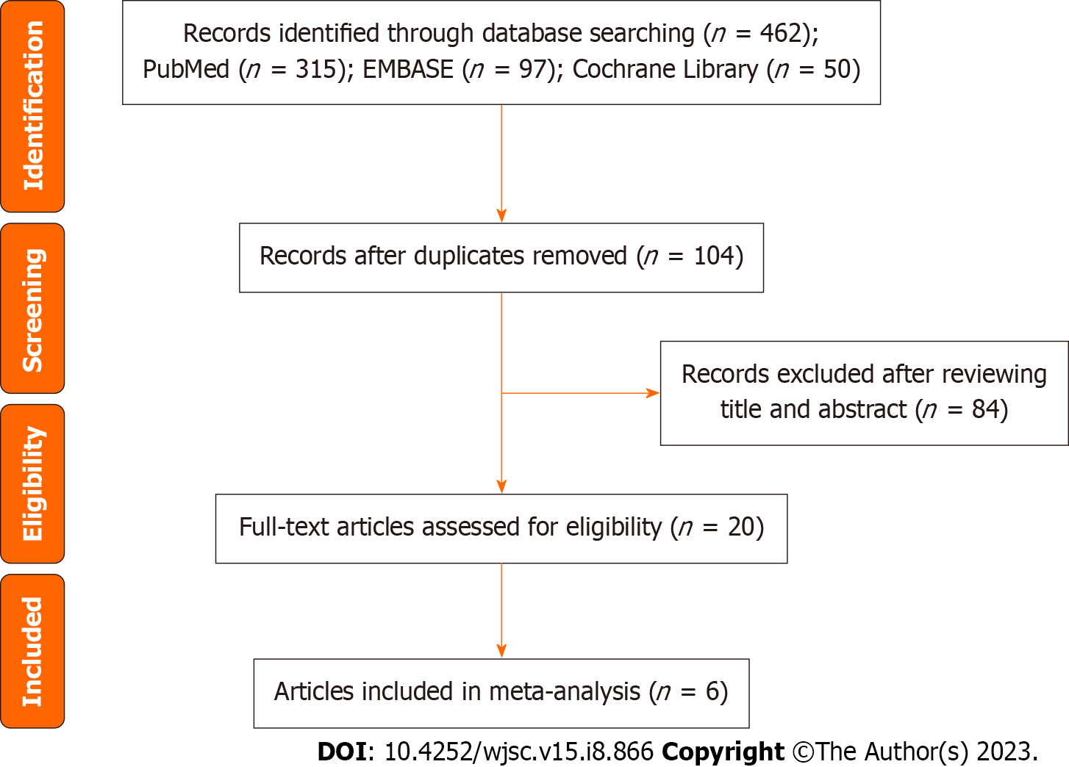Figure 1 Study selection process.
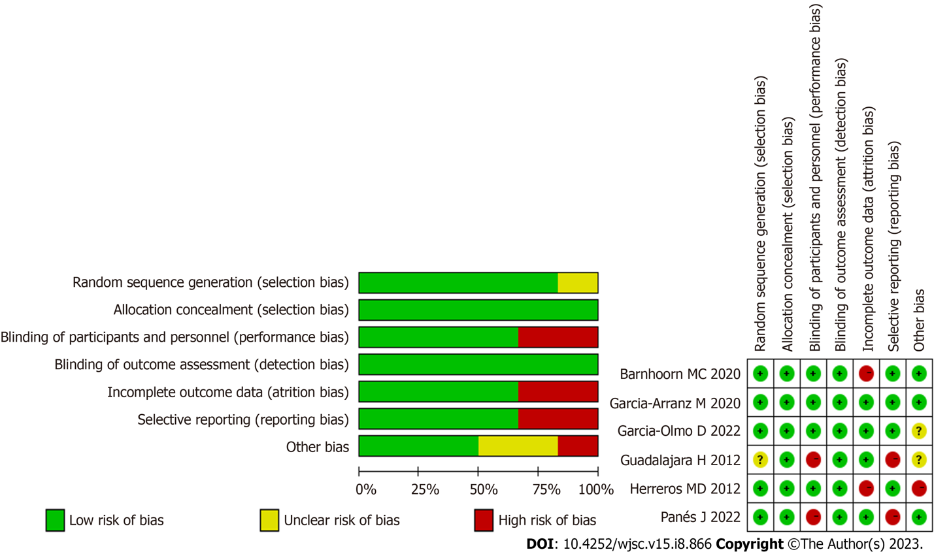
Figure 2 Risk of bias of the articles included in the meta-analysis.
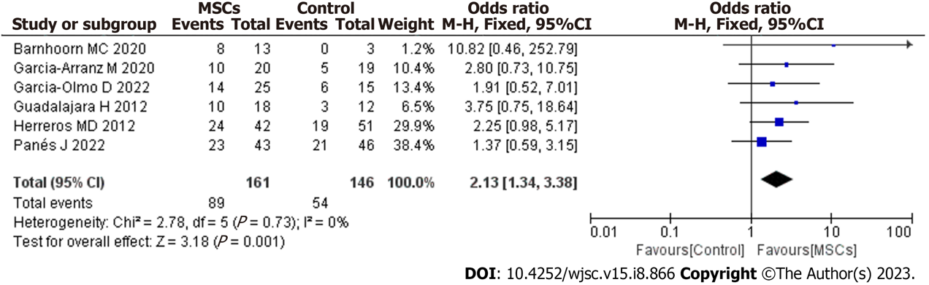
Figure 3 Forest plot showing the long-term effectiveness of mesenchymal stem cells for treating complex perianal fistula. MSCs: Mesenchymal stem cells; CI: Confidence interval.

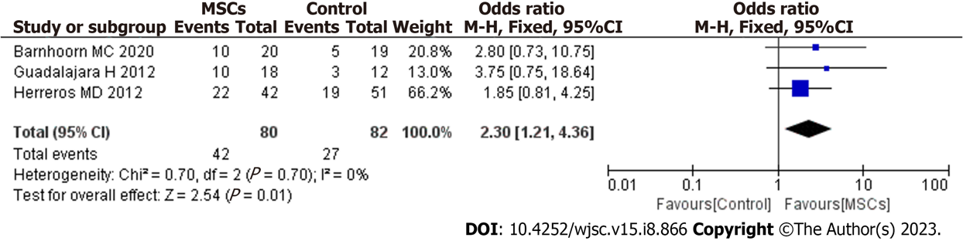
Figure 4 Differences in long-term effectiveness between mesenchymal stem cells plus fibrin glue and fibrin glue groups from meta-analysis. MSCs: Mesenchymal stem cells; CI: Confidence interval.

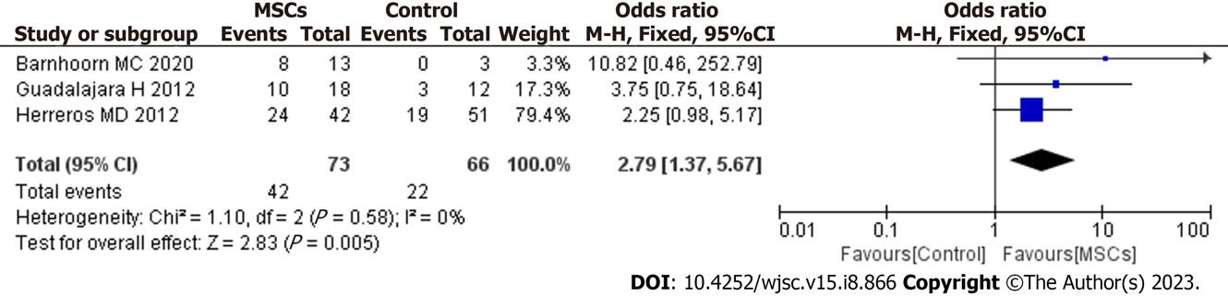
Figure 5 Forest plot showing the long-term effectiveness of mesenchymal stem cells for treating complex perianal fistula when magnetic resonance imaging is considered the standard for evaluating fistula healing. MSCs: Mesenchymal stem cells; CI: Confidence interval.

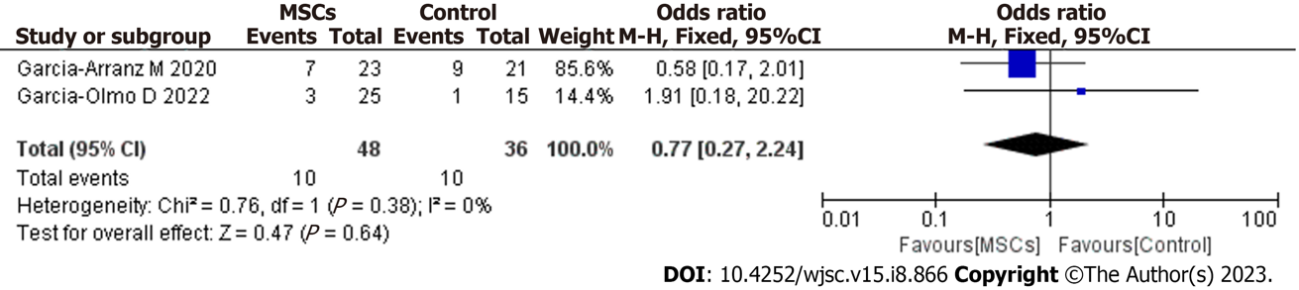
Figure 6 Pooled odds ratio of long-term safety. MSCs: Mesenchymal stem cells; CI: Confidence interval.

Table 1 Studies of local mesenchymal stem cells in complex perianal fistulas
Ref. | Cell type and source | Outcome assessment | Study outcomes | Intervention (mean) | AEs | Concurrent use of anti-TNF
Guadalajara et al^{[14]}, 2012 | Autologous, ASCs | Re-epithelialization + MRI | 10/18 for MSCs + FG; 3/12 for FG at 1 yr | First: 2 × 10⁷ MSCs; second: 4 × 10⁷ MSCs | / | Yes
Herreros et al^{[15]}, 2012 | Autologous, ASCs | Re-epithelialization +MRI | 24/42 for MSCs; 22/42 for MSCs + FG; 19/51 for FG at 48 wk | First: 2 × 10⁷ MSCs; second: 4 × 10⁷ MSCs | / | Yes
Garcia-Arranz et al^{[16]}, 2020 | Autologous, ASCs | Re-epithelialization | 10/20 for MSCs + FG; 5/19 for FG at 2 yr | First: 10 × 10⁷ MSCs; second: 10 × 10⁷ MSCs | 7/23 for MSCs + FG vs 9/21 for FG | Yes
Barnhoorn et al^{[17]}, 2020 | Allogeneic, BMSCs | MRI | 8/13 for MSCs; 0/3 for placebo group at 4 yr | A: 1 × 10⁷ MSCs; B: 3 × 10⁷ MSCs; C: 9 × 10⁷ MSCs | / | /
Panés et al^{[18]}, 2022 | Allogeneic, ASCs | Re-epithelialization | 23/43 for MSC; 21/46 for saline solution at 156 wk | 12 × 10⁷ MSCs | / | Yes
Garcia-Olmo et al^{[19]}, 2022 | Allogeneic, ASCs | Re-epithelialization | 14/25 for MSCs; 6/15 for saline solution at 104 wk | 12 × 10⁷ MSCs | 3/25 for MSCs vs 1/15 for placebo | Yes
AEs: Adverse events; MSCs: Mesenchymal stem cells; ASCs: Adipose-derived mesenchymal stromal cells; BMSCs: Bone marrow-derived mesenchymal stromal cells; FG: Fibrin glue; MRI: Magnetic resonance imaging.

Published by Baishideng Publishing Group Inc
7041 Koll Center Parkway, Suite 160, Pleasanton, CA 94566, USA
Telephone: +1-925-3991568
E-mail: bpgoffice@wjgnet.com
Help Desk: https://www.f6publishing.com/helpdesk
https://www.wjgnet.com

© 2023 Baishideng Publishing Group Inc. All rights reserved.

