Name of Journal: World Journal of Cardiology
Manuscript NO: 62633
Manuscript Type: EDITORIAL

New Year's greeting and overview of World Journal of Cardiology in 2021

Ma YJ et al. New Year’s greeting and overview of WJC in 2021

Ya-Juan Ma, Ramdas G Pai

Ya-Juan Ma, Editorial Office, Baishideng Publishing Group Inc, Pleasanton, CA 94566, United States

Ramdas G Pai, University of California Riverside School of Medicine, St Bernardines Medical Center, Riverside, CA 92507, United States

Author contributions: Ma YJ drafted the editorial; Pai RG reviewed and revised the editorial.

Corresponding author: Ya-Juan Ma, MSc, Director, Editorial Office, Baishideng Publishing Group Inc, 7041 Koll Center Parkway, Suite 160, Pleasanton, CA 94566, United States. y.j.ma@wjgnet.com

Received: January 14, 2021
Revised: February 6, 2021
Accepted: February 19, 2021
Published online:

Abstract
On behalf of the Editorial Office of World Journal of Cardiology (WJC), we extend our sincere gratitude to our authors, readers, Editorial Board members, and peer reviewers, thanking each and every one for their contributions to WJC in 2020 and with wishes for a Happy New Year. It was the collective support of all authors, Editorial Board members, peer reviewers and staff of the Editorial Office that allowed the Baishideng Publishing Group Inc. to carry out successfully the complete peer review, editing and publishing processes for WJC in 2020. We have now analyzed the metric data of WJC's manuscripts that were submitted and published in 2020, the peer review of manuscripts in 2020, the invited manuscripts for 2021 and the Editorial Board members’ composition and activities. As a global academic journal in cardiology, the findings from such will facilitate greater productivity and more efficient collaborative efforts to raise the academic rank of WJC in 2021. We enthusiastically anticipate WJC’s contributions to promote further cardiology research sharing and exchange in 2021.

Key Words: World Journal of Cardiology; Baishideng; Editorial Board Members; cardiology; New Year's message; academic rank

Ma YJ, Pai RG. New Year's greeting and overview of World Journal of Cardiology in 2021. World J Cardiol 2021; In press

Core Tip: With the support of all authors, Editorial Board members, peer reviewers and staff of the Editorial Office, Baishideng Publishing Group Inc. successfully carried out the complete peer review, editing and publishing processes for World Journal of Cardiology (WJC) in 2020. We are sincerely grateful for their contributions to and support of the WJC in 2020 and appreciate their continuous endeavors that will promote our productivity and raise the academic rank of WJC in 2021.

INTRODUCTION
The World Journal of Cardiology (WJC) launched on December 31, 2009 and remains a high-quality, online, open-access, single-blind peer-reviewed journal published by the Baishideng Publishing Group^{[1]}. All articles published in WJC are high-quality, basic and clinical, influential research articles by established academic authors as well as new researchers. The paramount objective of WJC is to showcase and promote distinguished research in the field of cardiology in order to help advance development of this field.
To date, WJC has 123 Editorial Board members^{[2]} hailing from countries across the globe. WJC has published 638 articles, which have been cited 1071 times. The WJC is now abstracted and indexed in Emerging Sources Citation Index (Web of Science), PubMed and PubMed Central. It was through the continuous support, dedication and encouragement of all authors, subscribers and readers, along with an excellent team effort by our Editorial Board members and staff of the Editorial Office, that the WJC was able to advance so appreciably in 2020.

Development of WJC in 2020
We received a total of 103 manuscripts in 2020, of which 26 (25.24%) were rejected, 11 (10.68%) were withdrawn, eight (7.77%) were under review and 58 (56.31%) were published online by the Production Department. The 58 published manuscripts included 28 (48.28%) invited manuscripts and 30 (51.72%) unsolicited manuscripts. The main columns represented by the published manuscripts were original articles and reviews (Figure 1). The authors of the published manuscripts were from 17 countries and regions, with the most being from the United States (Figure 2).
In 2020, WJC sent out 3145 invitations to peer reviewers and its Editorial Board members to conduct peer review of submitted manuscripts. These invitations yielded 487 acceptances (15.48%), 311 declines (9.89%) and 2347 non-responses (74.63%). Among those who accepted the invitation, 176 (36.24%) submitted the peer review report on time, 425 (63.86%) failed to submit the peer review report on time and four have not submitted the peer review report yet.
As of December 31, 2020, WJC had received a total of 163 proposals for titles of invited manuscripts for submission and review in 2021. These include 96 (58.90%) review articles, 47 (28.83%) original articles, eight (4.91%) editorials, and 12 (7.36%) ‘other’ types. Among them, 19 (11.66%) articles have already been submitted online, and 144 (88.34%) will be submitted in the future.
The editorial Board members of WJC^{[2]} represent 123 experts from 30 countries and regions, with the greatest number from Italy (21.50%) (Figure 3). Among them, 49 (39.84%) submitted their peer review reports on time, and 20 (33.3%) failed to submit their peer review reports on time.
As of January 14, 2021, the number of total visits to the WJC homepage was about 1219647, of which 21.7% of those visits were from the United States, 17.2% from China and 9.7% from United Kingdom. The number of total downloads of WJC articles was about 477708, of which 37% of those visits were from the United States, 19.9% from China, and 15% from Germany (Figure 4). according to data from the Web of Science, which WJC published 66 articles in 2018-2019, the yielded total cites in 2020 was 188 times.
As editors of WJC ourselves, we strive to work with the journal’s Editorial Office staff to make the manuscript submission process as simple as possible and ensure an efficient communication with the authors to provide our support and answer their questions. In order to maximize readers’ access to the latest research results, thereby promoting development of the field of cardiology, we have invited all Editorial Board members to conduct Article Quality Tracking-Peer-Review and published their comments after article publication. In order to advance the publishing efficiency and quality of WJC, Baishideng Publishing Group developed an automated manuscript editor system for manuscript revision and submission as well as an artificially intelligent program to generate a PDF version of the manuscript. Finally, to enable more peers to read, share and cite authors’ published research results and to help enhance their global academic influence and reputations, thereby also promoting the overall development of the field of cardiology, we have begun the routine of sending published articles via email to many highly influential experts, in a topically-accurate manner.

CONCLUSION
In 2020, with the great support of all our authors, readers, Editorial Board members, independent expert referees and staff of the editorial office, we successfully published 12 issues of WJC. in order to raise the academic rank of WJC in 2021, we will rely on the continuous support and submissions from our established and new authors and the dedicated efforts and expertise of our invited reviewers, many of whom also serve on our Editorial Board. we will invite more scientists in the field of cardiology to join the WJC Editorial Board, more active scientists to conduct peer review for WJC manuscripts and more scientists to contribute high-quality original and review manuscripts to WJC. By publishing more high-quality articles, the WJC will be able to make more substantive contributions to the development of basic medical and clinical research in the field of cardiology.
We remain open to any suggestions that could improve WJC’s operation and publication. if you have any questions or suggestions on WJC, please feel free to contact us at y.j.ma@wjgnet.com.
Once again, on behalf of the Editorial Office of WJC, we wish you and your families the best for the New Year.

REFERENCES
1 Baishideng Publishing Group Inc. World Journal of Cardiology home page. Available form: https://www.wjgnet.com/1949-8462/index.htm
2 Baishideng Publishing Group Inc. The Editorial Board Members of World Journal of Cardiology. Available form: https://www.wjgnet.com/1949-8462/editorialboard.htm
Footnotes
Conflict-of-interest statement: All authors have no conflict of interest.

Open-Access: This article is an open-access article that was selected by an in-house editor and fully peer-reviewed by external reviewers. It is distributed in accordance with the Creative Commons Attribution NonCommercial (CC BY-NC 4.0) license, which permits others to distribute, remix, adapt, build upon this work non-commercially, and license their derivative works on different terms, provided the original work is properly cited and the use is non-commercial. See: http://creativecommons.org/Licenses/by-nc/4.0/

Manuscript source: Invited manuscript

Peer-review started: January 14, 2021
First decision: January 29, 2021
Article in press:

Specialty type: Cardiac and Cardiovascular Systems
Country/Territory of origin: United States
Peer-review report’s scientific quality classification
Grade A (Excellent): A
Grade B (Very good): B
Grade C (Good): 0
Grade D (Fair): 0
Grade E (Poor): 0

P-Reviewer: Sandow SL, Turner NA S-Editor: Wang JL L-Editor: Filipodia P-Editor:

Figure Legends
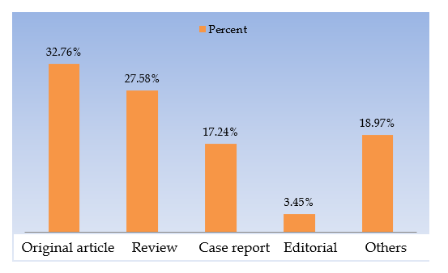
Figure 1 Column type distribution of manuscripts published in World Journal of Cardiology in 2020.

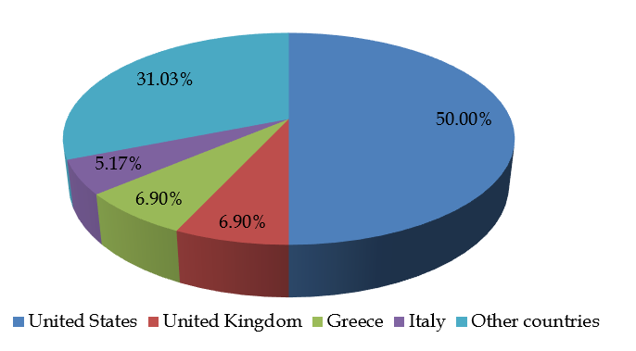
Figure 2 distribution of authors’ countries for the manuscripts published in World Journal of Cardiology in 2020.

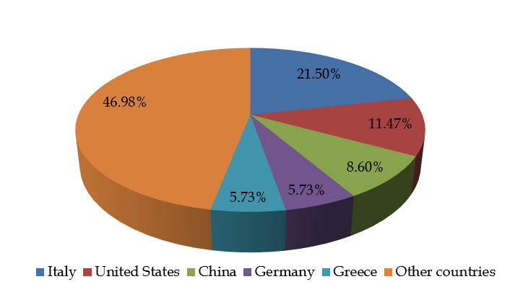
Figure 3 Distribution of Editorial Board members’ countries for World Journal of Cardiology.

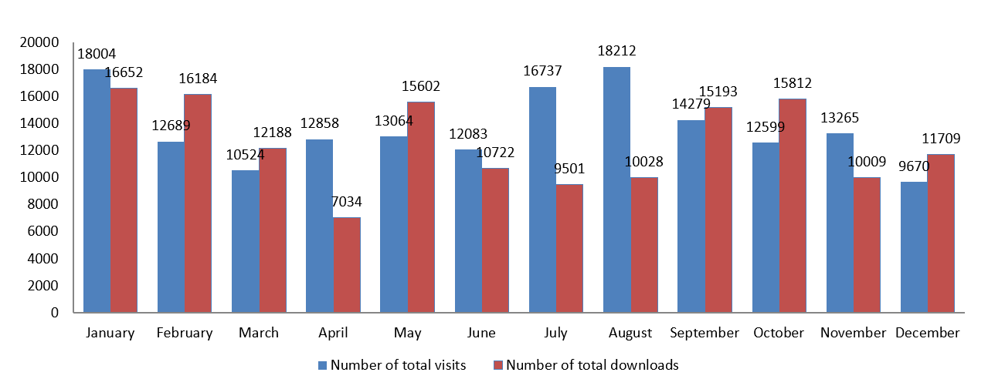
Figure 4 Number of total visits to the World Journal of Cardiology homepage and number of total downloads to the World Journal of Cardiology articles in 2020.

