Name of Journal: World Journal of Clinical Oncology
Manuscript NO: 67355
Manuscript Type: CASE REPORT

Gastric myeloid sarcoma: A case report

Rioja P et al. Gastric myeloid sarcoma: A case report

Patricia Rioja, Jackeline Macetas, Jorge Luna-Abanto, Indira Tirado-Hurtado, Daniel J Enriquez

Patricia Rioja, Jackeline Macetas, Department of Oncology Medicine, Instituto Nacional de Enfermedades Neoplásicas, Lima 15000, Peru

Jorge Luna-Abanto, Department of Surgical Oncology, Instituto Nacional de Enfermedades Neoplásicas, Lima 15000, Peru

Indira Tirado-Hurtado, Universidad Privada San Juan Bautista, Filial Chincha 11702, Peru

Daniel J Enriquez, Universidad Privada San Juan Bautista, Lima 15000, Peru

Author contributions: Rioja P, Macetas J and Enriquez DJ participated in the clinical management of the patient, the conception of the case report, and writing; Tirado-Hurtado I and Luna-Abanto J participated with the writing and critical review of the manuscript.

Corresponding author: Jorge Luna-Abanto, MD, Surgical Oncologist, Department of Oncological Surgery, Instituto Nacional de Enfermedades Neoplásicas, Av. Angamos Este 2520, Lima 15000, Peru. jorgelunaabanto@gmail.com

Received: April 21, 2021
Revised: July 26, 2021
Accepted: September 19, 2021
Published online: October 24, 2021

Abstract
BACKGROUND
Myeloid sarcoma (MS) is a rare hematologic malignancy defined as an extramedullary tumor of immature granulocytic cells. It can occur as primary or de novo and be associated with myelodysplasia or myeloproliferative neoplasms. The most frequent locations are the skin, lymph nodes and bones. The case of a patient with a diagnosis of primary granulocytic de novo gastric MS is reported.

CASE SUMMARY
A 19-year-old female patient with MS, whose abdominal computed tomography showed a bulky tumor of 16.5 cm in the gastric chamber with infiltration in the retroperitoneal, pancreatic and bile duct region; the histological study showed gastric mucosa diffusely infiltrated by mononucleated cells and the immunohistochemistry expressed myeloperoxidase. After receiving induction chemotherapy based on the 3 + 7 regimen (daunorubicin/cytarabine), the patient developed severe hematological toxicity and neutropenic typhlitis which required a prolonged medical treatment. She presented a rapid disease progression. Although she received supportive treatment, the patient died.

CONCLUSION
Gastric primary de novo MS is a rare and aggressive course neoplasm, fostering knowledge is very important to decide its management and to promote more approaches focused on understanding this pathology and its particularities in our population.

Key Words: Myeloid sarcoma; Granulocytic sarcoma; Stomach; Chemotherapy; Peru; Case report

©The Author(s) 2021. Published by Baishideng Publishing Group Inc. All rights reserved.

Citation: Rioja P, Macetas J, Luna-Abanto J, Tirado-Hurtado I, Enriquez DJ. Gastric myeloid sarcoma: A case report. World J Clin Oncol 2021; 12(10): 960-965
URL: https://www.wjgnet.com/2218-4333/full/v12/i10/960.htm
DOI: https://dx.doi.org/10.5306/wjco.v12.i10.960

Core Tip: This case report describes a gastric primary de novo myeloid sarcoma (MS) which is a very rare hematological neoplasm with poor prognosis in a young and symptomatic patient. After receiving chemotherapy, she presented severe toxicity (neutropenic typhlitis) and rapid disease progression. This case highlights the importance of detecting gastric primary MS as a rare form of extramedullary myeloid leukemia presentation. Moreover, management of gastric primary MS could lead to interventions to avoid deterioration of gastrointestinal system during treatment. There is limited information of management and outcomes regarding gastric primary MS. Furthermore, there is very limited data about de novo MS in Peruvian patients.
INTRODUCTION
Myeloid sarcoma (MS) is defined as a myeloblast tumor produced in an anatomical place different from the bone marrow that destroys the original architecture of the local tissue. These tumors are also known as granulocytic sarcomas, chloromas or extramedullary myeloid tumors^{[1,2]}. MS occurs more frequently in males and young individuals; its location is variable, and cerebral, mammary, testicular, gastrointestinal involvement has been reported, among other visceral organs, and it appears more frequently in the skin, lymph nodes and bones^{[3]}.
MS occurrence is frequently associated with acute myeloid leukemia (AML), affecting between 2.5% and 9% of patients. When the disease is detected without clinical signs of leukemia and in association with a negative bone marrow biopsy, it is classified as de novo MS^{[2]}, the incidence of which is 2 cases per million adults^{[2,4]}. Gastrointestinal presentation is uncommon and shows nonspecific symptoms related to the effect of tumor mass^{[3,5]}.

CASE PRESENTATION
Chief complaints
The patient was a 19-year-old female without a relevant history.

History of present illness
The patient was admitted to the hospital with nausea, vomiting and early satiety of 5 mo of evolution associated with an episode of hematemesis.

Physical examination
The patient showed low body weight, a regular general condition, distended abdomen, ascites, and a poorly defined bulky mass located in the upper hemiabdomen.

Laboratory examinations
Laboratory tests at admission revealed moderate anemia (Hb: 9 g/dL), hypoalbuminemia (albumin: 2.5 g/dL), grade 4 hyperbilirubinemia (total bilirubin: 2.5 mg/dL, indirect bilirubin: 1.8 g/dL), grade 2 hypertransaminasemia (aspartate aminotransferase: 90 IU/L, alanine aminotransferase: 100 IU/L), and elevated alkaline phosphatase (360 IU/L).

Imaging examinations
Abdominal computed tomography showed a bulky tumor of 16.5 cm in the gastric chamber, which infiltrated the retroperitoneal, pancreatic and bile duct regions, with dilation of the latter. In addition, peritoneal thickening, free fluid, splenomegaly and bilateral hydronephrosis were observed (Figure 1). Upper digestive endoscopy was reported at the level of the infiltrated gastric mucosal body with decreased contractility, thickened gastric folds, and infiltration of the duodenal bulb throughout its length. The colonoscopy showed no lesions.

Pathology
The histological study showed gastric mucosa diffusely infiltrated by mononucleated cells, which were intermediate in size with eosinophilic cytoplasm and blast-like nuclei (Figure 2). Immunohistochemistry indicated that these cells expressed myeloperoxidase (MPO) (+), CD117 (+) CD34 (+), CD20 (-), CD3 (-), CD68 (-), CD38 (-), CD30 (-), DTT (-), and Ki67: 80% (Figure 3). Bone marrow analysis by cytomorphology and flow cytometry was negative for infiltration by myeloid blasts. The bone marrow karyotype was 46 XX, and it was not possible to demonstrate the presence of the AML1-ETO, CBFB-MYH11, NPM1 mut A, and FLT3-ITD genes or mutations in exons 8 and 17 of the c-kit gene in bone marrow and the primary tumor.

FINAL DIAGNOSIS
This case final diagnosis is primary gastric de novo granulocytic MS.

TREATMENT
The patient began induction treatment based on the 3 + 7 regimen (daunorubicin 60 mg/m² for 3 d + citarabine 200 mg/m² for 7 d). She developed severe hematological toxicity and neutropenic typhlitis requiring antibiotic and antifungal coverage, parenteral nutritional support and a prolonged stay.

OUTCOME AND FOLLOW-UP
In the reassessment of the disease 30 d after treatment, the patient reached a partial response. A second cycle of 3 + 7 regimen treatment was scheduled, and regular tolerance and rapid disease progression were observed, thus she received supportive treatment; however, the patient died.

DISCUSSION
The case of a 19-year-old woman with a final diagnosis of gastric granulocytic type MS is presented. The symptoms were similar to those reported in other cases of gastric MS, which was conditioned by the extensive intra-abdominal involvement of the neoplasm (Figure 1)^{[2,6,7]}. The differential histopathological diagnosis was based on morphological and immunohistochemical characteristics, which included non-Hodgkin lymphoma, Burkitt lymphoma, diffuse large B-cell lymphoma, lymphoblastic lymphoma, and Ewing's sarcoma, among others^{[3,8]}. The present case had a blast type histology. Classically, MS expresses myeloid markers such as CD13, CD33 and MPO, but these markers are not present in all cases. For example, the expression of MPO, one of the most frequent markers, has been reported to be between 83.6% and 64.1% in different series^{[9]}. On the other hand, the expression of CD68, a marker related to lymphocyte lineage and lysosome leakage, was positive in our patient; its presence has been reported in up to 100% of patients with MS^{[8]}. Other markers, such as CD33, CD13 and related to line B, are less consistent in these patients^{[4,8,9]}. It can be distinguished from other round cell neoplasms, such as Ewing sarcoma or neuroendocrine tumors, with specific markers, such as CD99-specific neuronal enolase and CD99, respectively. It has been reported that the anomaly of the nucleus binding factor (translocation between chromosomes 8 and 21) is the most frequent in patients with de novo MS; this has been reported in 38% of cases in an North American study^{[8]}. In contrast, translocation 8; 21 was only found in 3% of patients in an Italian series^{[9]}. This translocation was not found in the present case, and there is probably a different frequency of it in our population.
Due to the rarity of MS, there are no prospective studies that guide its management^{[3,4,8,10]}, with induction therapy and postadmission therapy for AML being the only current alternatives to treatment. The prognosis of these patients is poor, and a 12-month survival has been reported for patients with MS without treatment and progression within 1 year to leukemia^{[3]}. However, retrospective series such as that of Pileri et al^{[4]} and Kawamoto et al^{[9]} report that systemic treatment, including daunorubicin and cytarabine, offers longer progression-free survival than local treatments (surgery and radiotherapy). In addition, promising results have been achieved with hematopoietic progenitor (TPH) transplantation; Movassaghian et al^{[10]} reported a median OS of 16.7 mo in a retrospective series of 22 patients with allogeneic post-PHT MS. However, despite this, the majority of the patients had disease progression in less than 6 mo^{[5,7]}.

CONCLUSION
In conclusion, gastric primary de novo MS is a rare neoplasm with an aggressive course. The differential diagnosis depends on the histological and immunohistochemical characteristics. Chemotherapy is the standard treatment, and important results have been reported with bone marrow transplantation. However, further collaborative studies are necessary to understand this pathology and its particularities in our population.

REFERENCES
1 Klco JM, Welch JS, Nguyen TT, Hurley MY, Kreisel FH, Hassan A, Lind AC, Frater JL. State of the art in myeloid sarcoma. Int J Lab Hematol 2011; 33: 555-565 [PMID: 21883967 DOI: 10.1111/j.1751-553X.2011.01361.x]
2 Huang XL, Tao J, Li JZ, Chen XL, Chen JN, Shao CK, Wu B. Gastric myeloid sarcoma without acute myeloblastic leukemia. World J Gastroenterol 2015; 21: 2242-2248 [PMID: 25717265 DOI: 10.3748/wjg.v21.i7.2242]
3 Almond LM, Charalampakis M, Ford SJ, Gourevitch D, Desai A. Myeloid Sarcoma: Presentation, Diagnosis, and Treatment. Clin Lymphoma Myeloma Leuk 2017; 17: 263-267 [PMID: 28342811 DOI: 10.1016/j.clml.2017.02.027]
4 Pileri SA, Ascani S, Cox MC, Campidelli C, Bacci F, Piccioli M, Piccaluga PP, Agostinelli C, Asioli S, Novero D, Bisceglia M, Ponzoni M, Gentile A, Rinaldi P, Franco V, Vincelli D, Pileri A Jr, Gasbarra R, Falini B, Zinzani PL, Baccarani M. Myeloid sarcoma: clinico-pathologic, phenotypic and cytogenetic analysis of 92 adult patients. Leukemia 2007; 21: 340-350 [PMID: 17170724 DOI: 10.1038/sj.leu.2404491]
5 Ravulapati S, Siegel C, Dara A, Lionberger JM. Myeloid sarcoma without circulating leukemia mimicking gastrointestinal malignancy and lymphoma. Hematol Rep 2018; 10: 7040 [PMID: 30046410 DOI: 10.4081/hr.2018.7040]
6 Bhat I. A Chloroma at the Gastric Cardia. Am J Gastroenterol 2016; 111: 1226 [PMID: 27580768 DOI: 10.1038/ajg.2016.128]
7 Yu T, Xu G, Xu X, Yang J, Ding L. Myeloid sarcoma derived from the gastrointestinal tract: A case report and review of the literature. Oncol Lett 2016; 11: 4155-4159 [PMID: 27313759 DOI: 10.3892/ol.2016.4517]
8 Vachhani P, Bose P. Isolated gastric myeloid sarcoma: a case report and review of the literature. Case Rep Hematol 2014; 2014: 541807 [PMID: 25105036 DOI: 10.1155/2014/541807]
9 Kawamoto K, Miyoshi H, Yoshida N, Takizawa J, Sone H, Ohshima K. Clinicopathological, Cytogenetic, and Prognostic Analysis of 131 Myeloid Sarcoma Patients. Am J Surg Pathol 2016; 40: 1473-1483 [PMID: 27631510 DOI: 10.1097/PAS.0000000000000727]
10 Movassaghian M, Brunner AM, Blonquist TM, Sadrzadeh H, Bhatia A, Perry AM, Attar EC, Amrein PC, Ballen KK, Neuberg DS, Fathi AT. Presentation and outcomes among patients with isolated myeloid sarcoma: a Surveillance, Epidemiology, and End Results database analysis. Leuk Lymphoma 2015; 56: 1698-1703 [PMID: 25213180 DOI: 10.3109/10428194.2014.963080]

Footnotes
Informed consent statement: Informed written consent was obtained from the patient for publication of this manuscript, also the accompanying images.

Conflict-of-interest statement: The authors declare that they have no conflict of interest.

CARE Checklist (2016) statement: The authors have read the CARE Checklist (2016), and the manuscript was prepared and revised according to the CARE Checklist (2016).

Open-Access: This article is an open-access article that was selected by an in-house editor and fully peer-reviewed by external reviewers. It is distributed in accordance with the Creative Commons Attribution NonCommercial (CC BY-NC 4.0) license, which permits others to distribute, remix, adapt, build upon this work non-commercially, and license their derivative works on different terms, provided the original work is properly cited and the use is non-commercial. See: http://creativecommons.org/Licenses/by-nc/4.0/

Manuscript source: Unsolicited manuscript

Peer-review started: April 21, 2021
First decision: July 16, 2021
Article in press: September 19, 2021

Specialty type: Oncology
Country/Territory of origin: Peru
Peer-review report’s scientific quality classification
Grade A (Excellent): 0
Grade B (Very good): 0
Grade C (Good): C
Grade D (Fair): 0
Grade E (Poor): 0

P-Reviewer: Gupta S S-Editor: Gao CC L-Editor: A P-Editor: Wu RR

Figure Legends
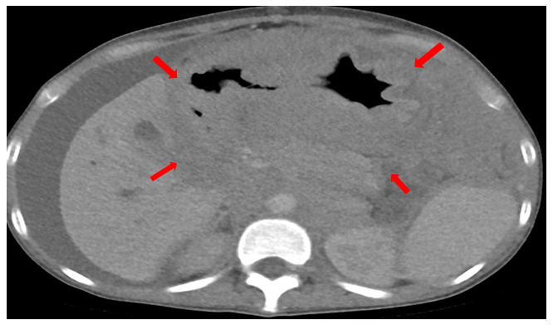
Figure 1 Abdominal computed tomography scan used a part of diagnosis. Computed tomography scan showing extensive intra-abdominal bulky tumor of 16.5 cm at diagnosis with the presence of ascitis.
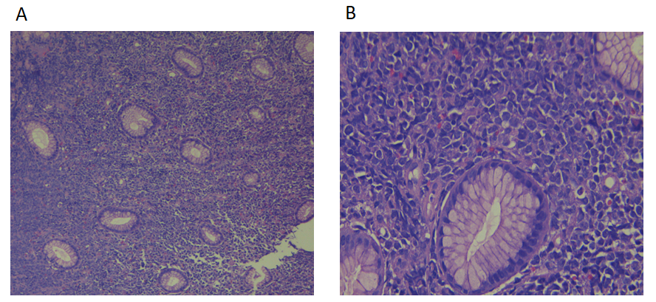
Figure 2 Hematoxylin-eosin staining of gastric myeloid sarcoma. A: There is mucosa with diffuse infiltration of monomorphic medium cells (× 10 magnification); B: At higher magnification (× 40 magnification) the cells show eosinophilic cytoplasm and nucleus with fine chromatin (blast).
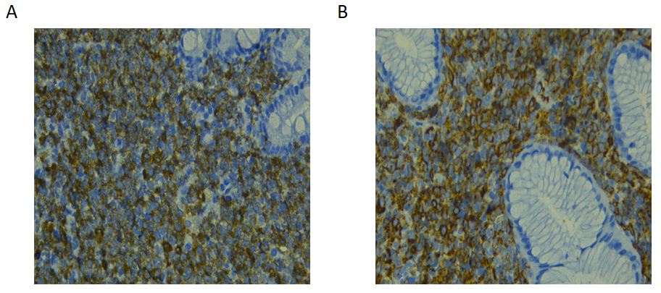
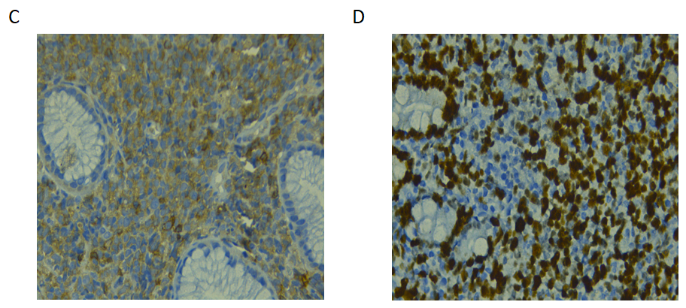
Figure 3 Immunohistochemistry. A: Positive staining for myeloperoxidase (× 40 magnification); B: Positive staining for CD34 (× 40 magnification); C: Positive staining for CD117 (× 40 magnification); D: Strong staining for Ki-67 (proliferation index), around 80% (× 40 magnification).

Published by Baishideng Publishing Group Inc
7041 Koll Center Parkway, Suite 160, Pleasanton, CA 94566, USA
Telephone: +1-925-3991568
E-mail: bpgoffice@wjgnet.com
Help Desk: https://www.f6publishing.com/helpdesk
https://www.wjgnet.com

© 2021 Baishideng Publishing Group Inc. All rights reserved.

