Name of Journal: World Journal of Gastrointestinal Surgery
ESPS Manuscript NO: 21297
Manuscript Type: Review

Gallstone ileus, clinical presentation, diagnostic and treatment approach

Nuño-Guzmán CM et al. Gallstone ileus

Carlos M Nuño-Guzmán, María Eugenia Marín-Contreras, Mauricio Figueroa-Sánchez, Jorge L Corona

Carlos M Nuño-Guzmán, Department of General Surgery, Hospital Civil de Guadalajara “Fray Antonio Alcalde”, Guadalajara CP 44280, Jalisco, México

Carlos M Nuño-Guzmán, Department of General Surgery, Unidad Médica de Alta Especialidad, Hospital de Especialidades del Centro Médico Nacional de Occidente, Instituto Mexicano del Seguro Social, Guadalajara CP 44340, Jalisco, México

María Eugenia Marín-Contreras, Department of Gastrointestinal Endoscopy, Unidad Médica de Alta Especialidad, Hospital de Especialidades del Centro Médico Nacional de Occidente, Instituto Mexicano del Seguro Social, Guadalajara CP 44340, Jalisco, México

Mauricio Figueroa-Sánchez, Jorge L Corona, Department of Radiology, Hospital Civil de Guadalajara “Fray Antonio Alcalde”, Guadalajara CP 44280, Jalisco, México

Author contributions: Nuño-Guzmán CM and Marín-Contreras ME contributed to the conception and design of the paper, the writing of the paper and the final revision; Nuño-Guzmán CM, Marín-Contreras ME, Figueroa-Sánchez M and Corona JL contributed to the literature search, the writing of the paper and the final revision of the paper.

Conflict-of-interest statement: There are no disclosures.

Open-Access: This article is an open-access article which was selected by an in-house editor and fully peer-reviewed by external reviewers. It is distributed in accordance with the Creative Commons Attribution Non Commercial (CC BY-NC 4.0) license, which permits others to distribute, remix, adapt, build upon this work non-commercially, and license their derivative works on different terms, provided the original work is properly cited and the use is non-commercial. See: http://creativecommons.org/licenses/by-nc/4.0/

Correspondence to: Carlos M Nuño-Guzmán, MD, MSc, Department of General Surgery, Hospital Civil de Guadalajara “Fray Antonio Alcalde”, Calle Hospital No. 278, Sector Hidalgo, Guadalajara CP 44280, Jalisco, México. carlosnunoguzman@hotmail.com
Telephone: +52-33-39424400
Fax: +52-33-36690229

Received: July 4, 2015
Peer-review started: July 9, 2015
First decision: September 22, 2015
Revised: November 11, 2015
Accepted: December 7, 2015
Article in press:
Published online:

Abstract
Gallstone ileus is a mechanical intestinal obstruction due to gallstone impaction within the gastrointestinal tract. Less than 1% of cases of intestinal obstruction are derived from this etiology. The symptoms and signs of gallstone ileus are mostly nonspecific. This entity has been observed with a higher frequency among the elderly, the majority of which have concomitant medical illness. Cardiovascular, pulmonary, and metabolic diseases should be considered as they may affect the prognosis. Surgical relief of gastrointestinal obstruction remains the mainstay of operative treatment. The current surgical procedures are: (1) simple enterolithotomy; (2) enterolithotomy, cholecystectomy and fistula closure (one-stage procedure); and (3) enterolithotomy with cholecystectomy performed later (two-stage procedure). Bowel resection is necessary in certain cases after enterolithotomy is performed. Large prospective laparoscopic and endoscopic trials are expected.

Key words: Gallstone ileus; Intestinal obstruction; Bouveret’s syndrome; Laparoscopic surgery; Endoscopic treatment

© The Author(s) 2015. Published by Baishideng Publishing Group Inc. All rights reserved.

Core tip: A review of the symptoms and signs of gallstone ileus is presented. The findings, advantages and limitations of the different diagnostic modalities such as plain abdominal radiographs, upper gastrointestinal series, ultrasound, computed tomography, magnetic resonance and endoscopy are reviewed. The different surgical options are discussed. Laparoscopic and endoscopic procedures are widely reviewed. Current data on morbidity and mortality are included.

Nuño-Guzmán CM, Marín-Contreras ME, Figueroa-Sánchez M, Corona JL. Gallstone ileus, clinical presentation, diagnostic and treatment approach. World J Gastrointest Surg 2015; In press

Gallstone ileus is an infrequent complication of cholelithiasis and is defined as a mechanical intestinal obstruction due to impaction of one or more gallstones within the gastrointestinal tract. The term “ileus” is a misnomer, since the obstruction is a true mechanical phenomenon^{[1]}. Gallstone gastrointestinal obstruction would be an appropriate term.

BACKGROUND
In 1654, Thomas Bartholin^{[2]} described a cholecystointestinal fistula with a gallstone within the gastrointestinal tract in a necropsy study. In 1890, Ludwig Georg Courvoisier^{[3]} published the first series of 131 cases of gallstone ileus cases, with a mortality rate of 44%. In 1896, Leon August Hoffman Bouveret^{[4]} described a syndrome of gastric outlet obstruction caused by an impacted gallstone in the duodenal bulb after its migration through a cholecysto- or choledochoduodenal fistula. This was the first preoperative diagnosis of the currently known Bouveret´s syndrome.

EPIDEMIOLOGY
Gallstone ileus has shown a constant incidence of 30-35 cases/1000000 admissions over a 45-year period^{[5]}. This entity develops in 0.3%-0.5% of patients with cholelithiasis^{[6]}. It constitutes the etiologic factor in less than 5% of cases of intestinal obstruction, but up to one quarter of nonstrangulated small bowel obstructions in elderly patients^{[7]}. In a nationwide study at the United States from 2004 to 2009, only 0.095% of mechanical bowel obstruction cases were caused by a gallstone^{[8]}. Gallstone ileus has been observed with a higher frequency among the elderly^{[1]}. Halabi et al^{[8]}, recently reported an age range from 60 to 84 years in American patients. A Japanese literature review reported a 13 years old case as their youngest patient, while a Mexican series included a 99 years old patient^{[9,10]}. Accordingly to the predominance of female patients in gallstone disease, the majority of gallstone ileus patients correspond to the female gender, with variable percentages from 72%-90%^{[11,12]}.

PATHOPHYSIOLOGY
Gallstone ileus is frequently preceded by an initial episode of acute cholecystitis. The inflammation in the gallbladder and surrounding structures leads to adhesion formation. The inflammation and pressure effect of the offending gallstone causes erosion through the gallbladder wall, leading to fistula formation between the gallbladder and the adjacent and adhered portion of the gastrointestinal tract, with further gallstone passage^{[13,14]}. Less commonly, a gallstone may enter the duodenum through the common bile duct and through a dilated papila of Vater^{[15]}.
The most frequent fistula occurs between the gallbladder and the duodenum, due to their proximity^{[11,16,17]}. The stomach, small bowel and the transverse portion of the colon may also be involved^{[1,13,14]} (Table 1). This process might be part of the natural history of Mirizzi syndrome^{[18]}. Once the gallbladder is free of calculi, it may become a blind sinus tract and contract down to a small fibrous remnant^{[19]}.
In 1981, Halter et al^{[20]} reported a case of gallstone ileus after endoscopic retrograde cholangiopancreatography (ERCP) and endoscopic sphincteromy (ES) and unsuccessful gallstone extraction. Three days later, the patient presented abdominal pain and vomiting. At laparotomy, a 3.5 cm gallstone was removed from the jejunum. To our knowledge, 13 cases of gallstone ileus have been reported after ERCP and ES. This adverse event may occur late after the endoscopic procedure, and should be considered in the differential diagnosis, especially in cases of delayed presentation^{[21,22]}.
Spillage of gallstones during laparoscopic cholecystectomy is not infrequent. Although most of gallstones lost in a previous biliary surgery and lying free in the abdominal cavity are silent, they can cause an intraabdominal abscess and might ulcerate the intestinal wall and gain entrance to the bowel lumen and cause gallstone ileus^{[23-26]}.
Once within the duodenal, intestinal or gastric lumen, the gallstone usually proceeds distally and may pass spontaneously through the rectum, or it may become impacted and cause obstruction. Less commonly if the gallstone is in the stomach, proximal migration can occur and the gallstone may be vomited^{[14]}. The size of the gallstone, the site of fistula formation and bowel lumen will determine whether an impaction will occur. The majority of gallstones smaller than 2 to 2.5 cm may pass spontaneously through a normal gastrointestinal tract and will be excreted uneventfully in the stools^{[1,13,14]}. Clavien et al^{[6]} reported an obstructing gallstones size range from 2 to 5 cm. Nakao et al^{[11]} found that impacted gallstones ranged in size from 2-10 cm, with a mean of 4.3 cm. Gallstones larger than 5 cm are even more likely to become impacted, although spontaneous passage of gallstones as large as 5 cm has occurred^{[1,14,17]}. The largest gallstone causing intestinal obstruction measured 17.7 cm in its largest diameter and was removed from the transverse colon^{[14]}. Multiple stones have been reported in 3%-40% of cases^{[6]}.
The site of impaction can be almost in any portion of the gastrointestinal tract. If the gallstone enters the duodenum, the most common intestinal obstruction will be the terminal ileum and the ileocecal valve because of their relatively narrow lumen and potentially less active peristalsis. Less frequently, the gallstone may be impacted in the proximal ileum or in the jejunum, especially if the gallstone is large enough. Less common locations include the stomach and the duodenum (Bouveret’s syndrome), and the colon^{[1,7,13,14,17]}. The size of the gallstone, a gallbladder inflammatory process compromising the duodenum and a cholecysto-duodenal fistula may cause a gallstone to become impacted in the duodenum^{[27]} (Table 2).
The presence of diverticula, neoplasms, or intestinal strictures such as secondary to Crohn’s disease, decrease the lumen size and may cause the gallstone to impact at the narrowing site^{[1,13,19]}. Gallstone ileus has been reported at sites of anastomosis after partial gastrectomy and Billroth II reconstruction and after biliointestinal bypass in two cases^{[28,29]}.
Isquemia may develop at the site of gallstone impaction, due to the pressure generated against the bowel wall and the proximal distention. Necrosis and perforation followed by peritonitis may occur^{[13]}.

CLINICAL MANIFESTATIONS
The presentation of gallstone ileus may be preceded by a history of prior biliary symptoms, with rates between 27%-80% of patients^{[6,7,10,12,16,30]}. Acute cholecystitis may be present in 10%-30% of the patients at the time of bowel obstruction. Jaundice has been found in only 15% of patients or less. Biliary symptoms may be absent in up to one third of cases^{[1,6,13,17,25,31]}.
Gallstone ileus may be manifested as acute, intermittent or chronic episodes of gastrointestinal obstruction. Nausea, vomiting, crampy abdominal pain and variable distension are commonly present^{[1,9,13,17,25,32]}. The intermittent nature of pain and vomiting of proximal gastrointestinal material, later becoming dark and feculent is due to the “tumbling“ gallstone advancement^{[12,15]}. Therefore, there may be intermittent partial or complete intestinal obstruction, with temporary advancement of the gallstone and relief of symptoms, until the gallstone either passes through the gastrointestinal tract or it definitively becomes impacted and complete intestinal obstruction ensues^{[13,17]}. The character of the vomitus is dependent on the obstruction location. When the gallstone is in the stomach or upper small intestine, the vomitus is mainly gastric content, becoming feculent when the ileum is obstructed.
Particularly, Bouveret’s syndrome presents with signs and symptoms of gastric outlet obstruction. Nausea and vomiting have been reported in 86% of cases, while abdominal pain or discomfort is referred in 71%. If the gallstone is not fully obstructing the lumen, the presentation will be of partial obstruction. Recent weight loss, anorexia, early satiety and constipation may be referred. Bouveret’s syndrome has also been reported to be preceded by or manifest as upper gastrointestinal bleeding, secondary to duodenal erosion caused by the offending gallstone, with hematemesis and melena, in 15% and 7%, respectively^{[17,27,33]}.
Physical examination may be nonspecific. The patients are often acutely ill, with signs of dehydration, abdominal distension and tenderness with high-pitched bowel sounds and obstructive jaundice. Fever, toxicity and physical signs of peritonitis may be noted if perforation of the intestinal wall takes place. The exam may be completely normal if no obstruction is present at the moment^{[1,13,14,27]}.

DIAGNOSIS
The symptoms and signs of gallstone ileus are mostly nonspecific^{[9,16,32]}. The intermittency of symptoms could also interfere with a correct diagnosis, if clinical manifestations at the moment correspond to a partial obstruction or distal migration of the gallstone. The “tumbling phenomenon” may be the cause why the patient does not seek medical attention or admittance is postponed. Patients usually present 4 to 8 d after the beginning of symptoms and diagnosis is usually made 3 to 8 d after the onset of symptoms^{[1,32]}. Cooperman et al^{[34]} found an average period of 7 d from the onset of symptoms until the hospitalization, and 3.7 d of hospitalization elapsed until surgical intervention. Periods of several months of symptoms before seeking hospital attention has been reported^{[30]}. A correct preoperative diagnosis has been reported in 30%-75% of the cases^{[6,12,30,35-37]}. A high index of suspicion will be helpful, particularly in a female elderly patient with intestinal obstruction and previous gallstone disease; Bouveret’s syndrome may be suspected in a patient with gastric outlet obstruction.

Plain abdominal radiograph
Plain abdominal radiographs are of major importance in establishing the diagnosis. In 1941, Rigler et al^{[38]} described four radiographic signs in gallstone ileus: (1) partial or complete intestinal obstruction; (2) pneumobilia or contrast material in the biliary tree; (3) an aberrant gallstone; and (4) change of the position of such gallstone on serial films. The presence of two of the three first signs, has been considered pathognomonic and has been found in 20%-50% of cases^{[1,25]}. Although pathognomonic, reports of Rigler’s triad range from 0%-87%^{[30]}. A careful inspection for pneumobilia should be performed, since it is present in most patients with gallstone ileus, but sometimes it is identified only in retrospective observation^{[25]}. Pneumobilia may occur secondary to prior surgical or endoscopic biliary interventions. Therefore, the clinical presentation should be considered when evaluating this radiologic sign^{[1]}. In 1978, Balthazar and Spechter^{[39]} described a fifth sign, which consist of two air fluid levels in the right upper quadrant on abdominal radiograph. The medial air fluid level corresponds to the duodenum and the lateral to the gallbladder. These authors found that this sign was present in 24% of patients at the time of admission. In Bouveret’s syndrome, a dilated stomach is expected to be seen on plain abdominal radiograph, due to the gastric outlet obstruction^{[40]}. Cappell and Davis^{[33]}, in a review of 64 cases of Bouveret´s syndrome, found as relatively common findings pneumobilia (39%), calcified right upper quadrant mass or gallstone (38%), gastric distension (23%) and dilated bowel loops (14%) (Figure 1).

Upper gastrointestinal series
An upper gastrointestinal series may help to identify the biliary enteric fistula and the level of obstruction^{[1]}. A secondary sign that may be useful is the identification of oral contrast material within the gallbladder^{[41]}. Cappell and Davis, in a review of Bouveret’s syndrome, upper gastrointestinal series included cholecystoduodenal fistula or pneumobilia (45%), a filling defect or mass in the duodenum (44%), cholecystoduodenal fistula (38%), gastric outlet or pyloric obstruction (27%), distended or dilated stomach (27%), gallstone in duodenum (21%), and duodenal obstruction (12%)^{[33]}.

Abdominal ultrasound
When diagnosis is still doubtful, an abdominal ultrasound (US) will be indicated for gallbladder stones, fistula and impacted gallstone visualization. It may also confirm the presence of choledocholithiasis^{[1,42]}. The use of US in combination with abdominal films to increase the sensitivity of diagnosis has been advocated. US is more sensitive at detecting pneumobilia and ectopic gallstones. The combination of abdominal films and US has increased the sensitivity of diagnosis of gallstone ileus to 74%^{[43]}. The most frequent findings in Bouveret’s syndrome are gallstone in or near the gallbladder (53%), pneumobilia or cholecystoduodenal fistula (45%), gallstone in duodenum (25%), dilated or distended stomach (15%), and a contracted gallbladder (13%)^{[33]} (Figure 2).

Computed tomography
Computed tomography (CT) is considered superior to plain abdominal films or US in the diagnosis of gallstone ileus cases, with a sensitivity of up to 93%^{[44]}. The frequency of Rigler’s triad detection is higher under CT examination. In a retrospective study by Lassandro et al^{[45]}, Rigler’s triad was observed in 77.8% of cases by means of CT, compared to 14.8% with radiographs and 11.1% with US. Bowel loops dilatation was seen in 92.6% of cases, pneumobilia in 88.9%, ectopic gallstone in 81.5%, air-fluid levels in 37%, and the bilio-digestive fistula in 14.8%. Yu et al^{[44]} performed a prospective study where 165 patients with acute small bowel obstruction were evaluated for gallstone ileus, with retrospective identification of three diagnostic criteria: (1) small bowel obstruction; (2) ectopic gallstone, either rim-calcified or total-calcified; and (3) abnormal gallbladder with complete air collection, presence of air-fluid level, or fluid accumulation with irregular wall. Overall sensitivity, specificity and accuracy were 93%, 100%, and 99%, respectively. Rigler’s triad was detected only in 36% of cases. These tomographic diagnostic criteria need further prospective validation. Current CT scanners may describe the location of the fistula, offending gallstones and gastrointestinal obstruction with better precision, and helping in therapeutic decisions^{[46]}.
In Bouveret’s syndrome, major findings on CT scan are obstruction due to a gastro-duodenal mass or lesion, pericholecystic inflammatory changes extending into the duodenum, gas in the gallbladder, pneumobilia or cholecysto-duodenal fistula, filling defects corresponding to one or more gallstones, thickened gallbladder wall, and a contracted gallbladder^{[17,27]}.
CT scan may allow detection of a rim or totally calcified ectopic gallstone without oral contrast administration. This may be done even with non-enhanced CT. Identification of a rim-calcified gallstone may be more difficult with contrast-enhanced CT, compared to total calcified gallstones. Less calcified gallstones could be missed^{[44]}. Contrast-enhanced CT allows detection of edema and ischemia of the affected gastrointestinal tract site^{[44,47]}. Given the relevance of possible bowel ischemia, contrast-enhanced CT is of particular importance in management decision making (Figure 3).

Magnetic resonance cholangiopancreatography
Magnetic resonance cholangiopancreatography (MRCP) may be useful in selected cases where diagnosis is not clear after CT. A potential drawback of CT is that 15%-25% of gallstones appear as isoattenuating relative to bile or fluid. Pickhardt et al^{[48]} described the use of MRCP for diagnosis of Bouveret’s syndrome with isoattenuating gallstones. MRCP may be useful in these cases, due to the possibility to delineate fluid from gallstones, which appear as signal voids against the high-signal fluid. This is also a potential advantage in patients unable to tolerate oral contrast material. If sufficient fluid is present in the cholecystoenteric fistula it could also be depicted. Therefore, MRCP may be particularly useful to confirm the gallstone ileus diagnosis in selected cases^{[40]}. Magnetic resonance for gastrointestinal obstruction evaluation is also a potential diagnostic option (Figure 4).

Esophagogastroduodenoscopy
In a review of 81 cases of Bouveret’s syndrome in whom esophagogastroduodenoscopy (EGD) was performed, the gastroduodenal obstruction was revealed in all of them, but gallstone visualization was possible only in 56 (69%). Among those 56 cases, such gallstones were observed in the duodenal bulb in 51.8%, postbulbar duodenum in 28.6%, pylorus or prepylorus in 17.9%, and in one case the location was not reported. In 31% of cases the gallstone was not recognized because it was deeply embedded within the mucosa. When the gallstone is not visualized, the diagnosis should be strongly suspected when the observed mass is hard, convex, smooth, nonfriable, and nonfleshy, which are all characteristic of a gallstone and may improve the sensitivity of EGD. For such cases, US and CT are the preferred noninvasive diagnostic tests to confirm the endoscopic diagnosis, delineate the gastroduodenal anatomy, and demonstrate a cholecystoduodenal fistula^{[33]} (Figure 5).

TREATMENT
The main therapeutic goal is relief of intestinal obstruction by extraction of the offending gallstone. Fluid and electrolyte imbalances and metabolic derangements due to intestinal obstruction, delayed presentation and pre-existing co-morbidities are common, and require management prior to surgical intervention^{[1,19,23,32]}.
There is no consensus on the indicated surgical procedure. The current surgical procedures are: (1) simple enterolithotomy; (2) enterolithotomy, cholecystectomy and fistula closure (one-stage procedure); and (3) enterolithotomy with cholecystectomy performed later (two-stage procedure). Bowel resection is necessary in certain cases after enterolithotomy is performed.
Enterolithotomy has been the most commonly surgical procedure performed. Through an exploratory laparotomy, the site of gastrointestinal obstruction is localized. A longitudinal incision is made on the antimesenteric border proximal to the site of gallstone impaction^{[5,6,23]}. When possible, through gentle manipulation the gallstone is brought proximally to a non-edematous segment of bowel. Most of the times, this is not possible due to the grade of impaction of the gallstone. The enterotomy is performed over the gallstone and it is extracted. Careful closure of the enterotomy is needed to avoid narrowing of the intestinal lumen and a transverse closure is recommended. Bowel resection is sometimes necessary, particularly in the presence of ischemia, perforation or an underlying stenosis^{[6,23]}. Manual propulsion of the gallstone through the ileocecal valve should be reserved for highly selected situations because of danger of mucosal injury and bowel perforation^{[5,6,23]}. Similarly, attempts to crush the gallstone in situ can damage the bowel wall and should be avoided^{[23]}. Multiple gallstones can generally be extracted through a single incision by clearing the gut and moving smaller gallstones towards bigger ones (Figure 6). In cases of sigmoid obstruction, transanal delivery is rarely possible. Sigmoid resection removing the gallstone and the underlying stenosis has been recommended^{[6]}.
The main long-standing controversy in the management of gallstone ileus is whether biliary surgery should be carried out at the same time as the relief of obstruction of the bowel (one-stage procedure), performed later (two-stage procedure) or not at all.
In 1922, Pybus successfully extracted an obstructing gallstone from the ileum, closed the duodenal fistula and drained the gallbladder after removing two additional gallstones from it. In 1929, Holz extracted a gallstone from the sigmoid and after removing a second gallstone that was impacted in the duodenum; he closed a cholecystoduodenal fistula and removed the gallbladder. The author recommended this procedure for patients in satisfactory general condition. In 1957, Welch performed a successful one-stage surgery in a patient who was well prepared after recurrent gallstone intestinal obstruction. The authors suggested the feasibility of the operation under optimal conditions. In 1965, Berliner and Burson^{[49]} reported three cases managed in a similar manner, and mentioned that when the patient is adequately hydrated with serum electrolytes restored and the procedure does not represent a prohibitive operative risk, a one-stage procedure should be considered. In 1966, Warshaw and Bartlett^{[12]} reported a series of 20 patients, where enterolithotomy was combined with cholecystectomy and fistula closure in two cases, with cholecystostomy and closure of the fistula in one, and delayed cholecystectomy and closure of the fistula in two. There was no operative mortality. The authors recommend that the one-stage procedure should be considered in selected cases.
Cholecystoenteric fistula closure after the extrusion process has been reported, but if the cystic duct is permanently occluded and any part of the gallbladder mucosa remains viable, it probably remains patent^{[15]}. The risk of gallstone ileus recurrence is higher than previously reported. The commonly quoted recurrence incidence is 2%-5%, but up to 8% recurrence after enterolithotomy alone has been reported as well; half of these new onset events will present in the following 30 days^{[50]}. It must be considered that recurrence rates of 17%-33% have been reported^{[6,51]}.
The possibility of recurrent cholecystitis and acute cholangitis has been highlighted^{[6,49]}. Warshaw and Bartlett reported recurrent symptoms or complications in 6 of 18 patients with unrepaired cholecystoenteric fistulas or retained gallbladders^{[12]}. Acute cholangitis has been reported in 11% of patients with cholecystoduodenal fistula and 60% with cholecystocolonic fistula^{[6,34]}. With a one-stage procedure, further gallstone-related events are prevented^{[12]}.
A long-term potential complication of biliary enteric fistula could be gallbladder cancer. Bossart et al^{[52]} found a 15% incidence of gallbladder cancer in 57 patients undergoing surgery for such fistulas, compared to 0.8% among all patients having cholecystectomy.
On the other hand, simple enterolithotomy has long been associated with a lower mortality^{[7]}. As Ravikumar and Williams^{[53]} observed, this study included patients from 70 published series spanning 40 years, with widely differing lengths of follow-up and evolving surgical techniques during this time period. Consideration should be taken of the fact that the severity of each case has influence on the outcome of any particular surgical procedure, and that mortality is not an absolute consequence of the surgical procedure itself. In the report by Clavien et al^{[6]}, when patients were comparable in terms of age, concomitant diseases and APACHE II score, operative mortality and morbidity rates were not significantly different.
In 2003, Doko et al^{[54]} reported a 30 patient series with morbidity of 27.3% in patients undergoing enterolithotomy alone and 61.1% for a one-stage procedure. Mortality was 9% following enterolithotomy and 10.5% after a one-stage procedure. American Society of Anesthesiologists (ASA) scores were similar between the two groups but operating times were significantly longer for the one-stage procedure. Urgent fistula repair was significantly associated with postoperative complications. The authors concluded that enterolithotomy is the procedure of choice, with a one-stage procedure reserved for patients with acute cholecystitis, gallbladder gangrene or residual gallstones^{[6]}.
In 2004, Tan et al^{[55]} reported a retrospective study of 19 patients treated by emergency surgery for gallstone ileus. The authors had no preference for either surgical procedure. Enterolithotomy alone was performed in 7 patients and enterolithotomy with cholecystectomy and fistula closure in 12 patients. In the first group, more patients had significant co-morbidity as identified by poorer ASA status (six patients were ASA III and IV), poorer pre-operative status, and four patients were hypotensive in the pre-operative phase. All 12 patients in the one-stage procedure group were ASA I and II and none were hypotensive in the pre-operative phase. Operative time was significantly shorter in the enterolithotomy group (70 min vs 178 min). There were no significant differences in morbidity and there was no mortality in either group.
In 2008, Riaz et al^{[56]} reported their retrospective experience with 10 patients diagnosed with gallstone ileus. The choice of the surgical procedure was largely determined by the clinical condition of the patient. Five patients underwent enterolithotomy alone (group 1), while the remaining five patients underwent cholecystectomy and fistula repair (group 2). In group 1, all patients were hypertensive and diabetic. All patients were hemodinamically-unstable, with metabolic acidosis and pre-renal azotemia. The ASA score was III or above in all patients. In group 2, only two patients were hypertensive and all were hemodynamically-stable at presentation with an ASA score of II. There was no operative mortality in both groups.
Many patients with gallstone ileus are elderly, with comorbidities, in poor general condition and have a delayed diagnosis, leading to dehydration, shock, sepsis or peritonitis. Relief of gastrointestinal obstruction by simple enterolithotomy is the safest procedure for these patients^{[30,31]}.
At laparotomy, examination and careful palpation of the entire bowel, gallbladder and extrahepatic bile duct is recommended, in order to exclude gallstones, bile leakage, abscess or necrosis^{[1,12,19,57]}. Cholecystectomy and fistula repair reduce the need for reintervention and the incidence of complications related to fistula persistence, including recurrent ileus, cholecystitis or cholangitis, but it is justified only in selected adequately stabilized patients in good general condition, such as good cardiorespiratory and metabolic reserve, who are able to withstand a more prolonged operation, unless it has been clearly demonstrated that no gallstones remain in the gallbladder^{[6,31,36,58]}.
Proponents of enterolithotomy alone argue that fistula closure is time consuming and technically demanding. Spontaneous fistula closure can occur when the gallbladder is gallstone-free and the cystic duct remains patent. Some authors have found no risk of cancer when fistula is not managed^{[1,6,8]}.
According to different authors, enterolithotomy alone is the best option for most patients with gallstone ileus. The one-stage procedure should be offered only to highly selected patients with absolute indications for biliary surgery at the time of presentation and who have been adequately reanimated^{[7,11,16,31,36,53]}.
The persistence or appearance of gallstone-related or gastrointestinal symptoms will prompt the need for evaluation. US and contrast gastrointestinal radiology may detect cholelithiasis and fistula persistence in patients who have been treated by enterolithotomy alone^{[6,12]}. Demonstration of gallstones, the appearance of symptoms, or a persistent cholecystoenteric fistula indicates the need for cholecystectomy, closure of the fistula, and common duct exploration^{[12]}. It has been emphasized that delayed cholecystectomy as a second procedure is clearly justified only in cases of symptom persistence^{[7,31]}. The two-stage procedure with scheduled follow-up biliary surgery is not common. Subsequent cholecystectomy and fistula closure are recommended to be performed 4 to 6 weeks later^{[7,16,32,55]}. A mortality rate of 2.94% has been reported in this group of patients^{[8]}.

Laparoscopy
In 1993, Montgomery^{[59]} reported two cases of mechanical intestinal obstruction, which were diagnosed laparoscopically and gallstone ileus was found. In both cases, the affected ileum segment was brought out of the abdominal cavity though a small incision, and through enterotomy the gallstone was removed. Both patients were discharged and only one presented a wound infection, which was successfully treated. In 1994, Franklin et al^{[60]} reported a case of laparoscopically treated along with cholecystectomy and repair of a cholecystoduodenal fistula.
In 2003, El-Dhuwaib and Ammori^{[61]} reported a case of gallstone ileus that underwent an emergency laparoscopic enterolithotomy. During follow-up, a cholecystoduodenal fistula and bile duct stones were detected. An elective laparoscopic cholecystectomy with fistula repair, concomitant bile duct exploration, choledocolithotomy and primary bile duct closure were successfully performed. In 2007, Moberg and Montgomery^{[62]} reported a series of 32 patients with gallstone ileus operated laparoscopically in 19 cases with two conversions, and by open surgery in 13 cases. There was no mortality. In 2013, Yang et al^{[63]} reported a case of Bouveret’s syndrome, which was successfully treated by laparoscopic by duodenolithotomy and subtotal cholecystectomy. In 2014, Watanabe et al^{[64]} reported a case of gallstone ileus due to a 4 cm gallstone in the jejunum with presence of pneumobilia. Through single-incision laparoscopic surgery, enterolithotomy was performed. Cholecystoduodenal fistula closure was demonstrated 4 mo after the surgery. The patient had an uneventful postoperative course.
Although experience in minimally invasive surgical treatment of gallstone ileus is still developing, adequate management in low risk patients has allowed successful results. Dilated and edematous bowel represents a more challenging scenario. According to a recent report, laparoscopy is used only in 10% of surgically managed gallstone ileus cases, with a high conversion rate (53.03%) to laparotomy^{[8]}. Early recovery and a low mortality are expected from laparoscopic procedures^{[65]}.

Endoscopy
Gallstones causing gastroduodenal or colonic obstruction may be amenable to endoscopic detection and in certain instances to endoscopic extraction. In 1976, Stempfle and Diamantopoulos^{[66]} reported a case of cholecystogastric fistula with passage of a gallstone to the stomach leading to massive hemorrhage of gastric mucosa. The gallstone was removed endoscopically and the imminent obstruction could be eliminated. Mucosal bleeding was managed with conservative method. Endoscopic visualization of radiologically detected gallstones in the duodenum has been reported, leading to definitive surgical treatment^{[67]}.
In 1981, Finn and Bienia^{[68]} reported a case of 73-year-old female with gallstone ileus which was diagnosed endoscopically and found 2 gallstones in the duodenal bulb. A cholecystoduodenal fistula was also demonstrated. Immediate surgery was performed. The role of colonoscopy in large bowel obstruction by a gallstone has been reported. In 1989, a report by Patel et al^{[69]} showed the technical difficulty after multiple attempts for gallstone extraction and further surgical extraction, but diagnosis was established. In 1990, Roberts et al^{[70]} reported the removal of a gallstone obstructing the sigmoid colon by means of colonoscopy. In 1985, Bedogni et al^{[71]} reported a successful gallstone extraction in a case of pyloroduodenal obstruction. The initial success rate of endoscopic management was less than 10%^{[72]}. After endoscopic mechanical lithotripsy (EML), electrohydraulic lithotripsy (EHL), extracorporeal shockwave lithotripsy (ESWL) and endoscopic laser lithotripsy (ELL) have been used alone or in combination for gallstone endoscopic management.
In 1991, Moriai et al^{[73]} reported the combined use of EHL and EML for the treatment of a patient with two 3-cm gallstones in the stomach. The smaller fragments were removed orally. EHL of a gallstone causing gallstone ileus was first reported by Bourke et^{[74]} in 1997. In 2007, Huebner et al^{[75]} reported two cases managed with EHL alone. This method has the risk of bleeding and perforation due to surrounding tissue damage. In 1997, ESWL was reported by Dumonceau et al^{[76]} who treated two patients with Bouveret’s syndrome. Al fragments were removed orally, except for one that was left in the stomach of the first patient and caused recurrent ileus. ESWL may need repeated sessions followed by endoscopy. Obesity and distended bowel interposition may be limitations^{[77]}.
The use of Holmium: YAG laser lithotripsy has been reported. An attempt to fragment and retrieve a duodenal gallstone causing Bouveret’s syndrome resulted in small bowel obstruction secondary to a fragment. The patient required surgical enterolithotomy^{[78]}. In 2005, Goldstein et al^{[79]} reported a case of a 94-year-old patient with two gallstones in the duodenum, which could not be retrieved beyond the upper esophageal sphincter using a Roth net. A holmium: yttrium-aluminum-garnet (Holmium: YAG) laser was used for gallstone fragmentation, with subsequent successful removal^{[79]}. The main advantage of ELL is the precise targeting of the offending gallstone, with reduced risk of surrounding tissue injury^{[80]}.
One of the potential limitations for endoscopic management of a gallstone is a location out of endoscopic reach. In 1999, Lübbers et al^{[81]} reported the case of a 91-year-old female patient who was unfit for surgery and after location of the gallstone in the upper jejunum, was managed by EML. In 2010, Heinzow et al^{[82]} reported the case of an 81-year-old female patient who suffered from gallstone ileus of the ileum. Peroral single-balloon enteroscopy allowed the successful endoscopic removal of the obstructing gallstone. Single and double balloon enteroscopy constitutes a recent means of endoscopically directed therapy.
A colonic location of an obstructing gallstone may be endoscopically managed in selected patients. In 2010, Zielinski et al^{[83]} reported a case of endoscopic EHL of a 4.1 cm gallstone in the sigmoid colon. A gallstone impacted at the ileocecal valve was successfully managed by Shin et al^{[84]} using EHL by means of colonoscopy in a patient with liver cirrhosis (Child-Pugh class B). The fragments were retrieved with snare and forceps.
These non-operative endoscopic methods and endoscopic should be considered in elderly and high risk patients^{[6]}. A potential complication of endoscopic treatment is the possibility of distal impaction of gallstone fragments^{[17]}.

MORBIDITY
Previously, the most common postoperative complication has been wound infection. In 1961, Raiford^{[15]} observed a 75% global rate of wound infection. Localized peritonitis, respiratory complications, phlebitis, recurrent obstruction due to residual gallstones and cholangitis were also observed. In more recent series, the global rate of postoperative complications has been reported in the range of 45%-63%^{[6,30,31,36,55]}. Wound infection continues to be the most common complication, with rates of 27% and 42.5%, as reported by Clavien et al^{[6]} and Rodríguez-Hermosa et al^{[30]} respectively. Several authors have reported no significant differences of postoperative complications between those patients treated by enterolithotomy or enterolithotomy, cholecystectomy and fistula closure^{[6,31,36,55]}. Martínez-Ramos et al^{[36]} found a 100% complication rate among patients requiring intestinal resection. Global immediate complications were greater when the diagnosis was made during the surgical procedure than when it was made prior to surgery. If relapsing gallstones ileus is not considered, less common postoperative complications have been wound dehiscence, cardiopulmonary and vascular complications, sepsis, intestinal and biliary fistulas, and urinary tract infections^{[6,31,55]}.
Currently, the most common postoperative complication is acute renal failure, which was seen in 30.45% of patients, followed by urinary tract infection (13.79%), ileus (12.42%), anastomotic leak, intraabdominal abscess, enteric fistula (12.27%), and wound infection (7.73%)^{[8]}.

MORTALITY
Gallstone ileus is predominantly a geriatric disease, and as many as 80%-90% of patients have concomitant medical illnesses. Hypertension, diabetes, congestive heart failure, chronic pulmonary disease and anemia are the most common comorbidities^{[8]}. These associated conditions need to be considered, as they may affect the results of treatment^{[1]}.
Mortality rates were reported as high as 44% at the late 1800’s, while in the first half of the twentieth century these rates maintained between 40%-50%^{[3,19]}. In the 1990’s, considerable reductions in mortality were observed to 15%-18%, to current rates of less than 7%^{[7,8]}. Specifically, simple enterolithotomy has long been associated with an 11.7% mortality compared to 16.9% for the one-stage procedure (enterolithotomy plus cholecystectomy and fistula closure)^{[7]}.
As described by Kirchmayr^{[85]}, four main reasons might be responsible for the high number of lethal courses. First of all gallstone ileus is a disease of the elderly. Second, concomitant diseases, such as cardiorespiratory diseases and/or diabetes mellitus are frequent. Third, because of uncommon symptoms diagnosis is difficult and a mean delay of 4 d from the beginning of symptoms to hospital admission is reported. Fourth, postoperative recovery is also hampered; age-related complications such as pneumonia or cardiac failure are more frequent than surgery associated complications.
In the study by Halabi et al^{[8]} of 3268 gallstone ileus cases who underwent surgical management, an overall mortality rate of 6.67% was observed. The authors noted that fistula closure, performed during the initial procedure, was independently associated with a higher mortality rate than enterolithotomy alone. When bowel resection was indicated, it was also associated with a higher mortality rate than enterolithotomy alone. When analyzing by surgical procedures, the mortality rates were 4.94% for the enterolithotomy alone group, 7.25% for the enterolithotomy plus cholecystectomy and fistula closure group, 12.87% for the bowel resection group, and 7.46% for the bowel resection and fistula closure group. However, if consideration is made of the fact that bowel resection is not exactly an option but a requirement due to the bowel segment conditions instead, the mortality for those patients undergoing enterolithotomy alone or bowel resection is actually 6.53%.
In summary, gallstone ileus or gallstone gastrointestinal obstruction represents less than 1% of gastrointestinal obstruction cases, with a higher frequency among the elderly. Computed tomography has proven to be the most accurate diagnostic modality, but diagnostic criteria validation is required. Surgical relief of obstruction is the cornerstone of treatment. Given the high incidence of comorbidities in these patients, a good judgement in selecting the surgical procedure is required. Enterolithotomy remains the mainstay of operative treatment. A one-stage cholecystectomy and repair of fistula is justified only in selected patients in good general condition and adequately stabilized preoperatively. Specific criteria for a one-stage procedure remain to be established. A two-stage surgery is an option for patients with persistent symptomatology after enterolithotomy surgery. Large prospective studies of laparoscopic and endoscopic-guided procedures are expected.
REFERENCES
1 Abou-Saif A, Al-Kawas FH. Complications of gallstone disease: Mirizzi syndrome, cholecystocholedochal fistula, and gallstone ileus. Am J Gastroenterol 2002; 97: 249-254 [PMID: 11866258 DOI: 10.1111/j.1572-0241.2002.05451.x]
2 Martin F. Intestinal obstruction due to gall-stones: with report of three successful cases. Ann Surg 1912; 55: 725-743 [PMID: 17862839 DOI: 10.1097/00000658-191205000-00005]
3 Courvoisier LG. Casuistisch-statistische Beitrage zur Pathologic und Chirurgie der gallenwege. XII Leipzig, FCW Vogel, 1890
4 Bouveret L. Stenose du pylore adherent a la vesicule calculeuse. Rev Med (Paris) 1896; 16: 1-16
5 Kurtz RJ, Heimann TM, Beck AR, Kurtz AB. Patterns of treatment of gallstone ileus over a 45-year period. Am J Gastroenterol 1985; 80: 95-98 [PMID: 3970007]
6 Clavien PA, Richon J, Burgan S, Rohner A. Gallstone ileus. Br J Surg 1990; 77: 737-742 [PMID: 2200556 DOI: 10.1002/bjs.1800770707]
7 Reisner RM, Cohen JR. Gallstone ileus: a review of 1001 reported cases. Am Surg 1994; 60: 441-446 [PMID: 8198337]
8 Halabi WJ, Kang CY, Ketana N, Lafaro KJ, Nguyen VQ, Stamos MJ, Imagawa DK, Demirjian AN. Surgery for gallstone ileus: a nationwide comparison of trends and outcomes. Ann Surg 2014; 259: 329-335 [PMID: 23295322 DOI: 10.1097/SLA.0b013e31827eefed]
9 Kasahara Y, Umemura H, Shiraha S, Kuyama T, Sakata K, Kubota H. Gallstone ileus. Review of 112 patients in the Japanese literature. Am J Surg 1980; 140: 437-440 [PMID: 7425220 DOI: 10.1016/0002-9610(80)90185-3]
10 Mondragón Sánchez A, Berrones Stringel G, Tort Martínez A, Soberanes Fernández C, Domínguez Camacho L, Mondragón Sánchez R. [Surgical management of gallstone ileus: fourteen year experience]. Rev Gastroenterol Mex 2005; 70: 44-49 [PMID: 16170962]
11 Nakao A, Okamoto Y, Sunami M, Fujita T, Tsuji T. The oldest patient with gallstone ileus: report of a case and review of 176 cases in Japan. Kurume Med J 2008; 55: 29-33 [PMID: 18981682 DOI: 10.2739/kurumemedj.55.29]
12 Warshaw AL, Bartlett MK. Choice of operation for gallstone intestinal obstruction. Ann Surg 1966; 164: 1051-1055 [PMID: 5926241 DOI: 10.1097/00000658-196612000-00015]
13 Fox PF. Planning the operation for cholecystoenteric fistula with gallstone ileus. Surg Clin North Am 1970; 50: 93-102 [PMID: 5412582]
14 VanLandingham SB, Broders CW. Gallstone ileus. Surg Clin North Am 1982; 62: 241-247 [PMID: 7071691]
15 Raiford TS. Intestinal obstruction due to gallstones. (Gallstone ileus). Ann Surg 1961; 153: 830-838 [PMID: 13739168 DOI: 10.1097/00000658-196106000-00003]
16 Ayantunde AA, Agrawal A. Gallstone ileus: diagnosis and management. World J Surg 2007; 31: 1292-1297 [PMID: 17436117 DOI: 10.1007/s00268-007-9011-9]
17 Masannat Y, Masannat Y, Shatnawei A. Gallstone ileus: a review. Mt Sinai J Med 2006; 73: 1132-1134 [PMID: 17285212]
18 Beltran MA, Csendes A. Mirizzi syndrome and gallstone ileus: an unusual presentation of gallstone disease. J Gastrointest Surg 2005; 9: 686-689 [PMID: 15862264 DOI: 10.1016/j.gassur.2004.09.058]
19 Rogers FA, Carter R. Gallstone intestinal obstruction. Calif Med 1958; 88: 140-143 [PMID: 13500219]
20 Chavalitdhamrong D, Donepudi S, Pu L, Draganov PV. Uncommon and rarely reported adverse events of endoscopic retrograde cholangiopancreatography. Dig Endosc 2014; 26: 15-22 [PMID: 24118211 DOI: 10.1111/den.12178]
21 Halter F, Bangerter U, Gigon JP, Pusterla C. Gallstone ileus after endoscopic sphincterotomy. Endoscopy 1981; 13: 88-89 [PMID: 7227334 DOI: 10.1055/s-2007-1021655]
22 Yamauchi Y, Wakui N, Asai Y, Dan N, Takeda Y, Ueki N, Otsuka T, Oba N, Nisinakagawa S, Kojima T. Gallstone Ileus following Endoscopic Stone Extraction. Case Rep Gastrointest Med 2014; 2014: 271571 [PMID: 25328725 DOI: 10.1155/2014/271571]
23 Deckoff SL. Gallstone ileus; a report of 12 cases. Ann Surg 1955; 142: 52-65 [PMID: 14388611 DOI: 10.1097/00000658-195507000-00007]
24 Habib E, Elhadad A. Digestive complications of gallstones lost during laparoscopic cholecystectomy. HPB (Oxford) 2003; 5: 118-122 [PMID: 18332969 DOI: 10.1080/13651820310016463]
25 Luu MB, Deziel DJ. Unusual complications of gallstones. Surg Clin North Am 2014; 94: 377-394 [PMID: 24679427 DOI: 10.1016/j.suc.2014.01.002]
26 Zehetner J, Shamiyeh A, Wayand W. Lost gallstones in laparoscopic cholecystectomy: all possible complications. Am J Surg 2007; 193: 73-78 [PMID: 17188092 DOI: 10.1016/j.amjsurg.2006.05.015]
27 Koulaouzidis A, Moschos J. Bouveret's syndrome. Narrative review. Ann Hepatol 2007; 6: 89-91 [PMID: 17519830]
28 Dias AR, Lopes RI. Biliary stone causing afferent loop syndrome and pancreatitis. World J Gastroenterol 2006; 12: 6229-6231 [PMID: 17036402 DOI: 10.3748/wjg.v12.i38.6229]
29 Micheletto G, Danelli P, Morandi A, Panizzo V, Montorsi M. Gallstone ileus after biliointestinal bypass: report of two cases. J Gastrointest Surg 2013; 17: 2162-2165 [PMID: 23897084 DOI: 10.1007/s11605-013-2290-6]
30 Rodríguez Hermosa JI, Codina Cazador A, Gironès Vilà J, Roig García J, Figa Francesch M, Acero Fernández D. [Gallstone Ileus: results of analysis of a series of 40 patients]. Gastroenterol Hepatol 2001; 24: 489-494 [PMID: 11730617 DOI: 10.1016/S0210-5705(01)70220-8]
31 Rodríguez-Sanjuán JC, Casado F, Fernández MJ, Morales DJ, Naranjo A. Cholecystectomy and fistula closure versus enterolithotomy alone in gallstone ileus. Br J Surg 1997; 84: 634-637 [PMID: 9171749 DOI: 10.1002/bjs.1800840514]
32 Zaliekas J, Munson JL. Complications of gallstones: the Mirizzi syndrome, gallstone ileus, gallstone pancreatitis, complications of "lost" gallstones. Surg Clin North Am 2008; 88: 1345-168, x [PMID: 18992599 DOI: 10.1016/j.suc.2008.07.011]
33 Cappell MS, Davis M. Characterization of Bouveret's syndrome: a comprehensive review of 128 cases. Am J Gastroenterol 2006; 101: 2139-2146 [PMID: 16817848 DOI: 10.1111/j.1572-0241.2006.00645.x]
34 Cooperman AM, Dickson ER, ReMine WH. Changing concepts in the surgical treatment of gallstone ileus: a review of 15 cases with emphasis on diagnosis and treatment. Ann Surg 1968; 167: 377-383 [PMID: 5644101]
35 de Alencastro MC, Cardoso KT, Mendes CA, Boteon YL, de Carvalho RB, Fraga GP. Acute intestinal obstruction due to gallstone ileus. Rev Col Bras Cir 2013; 40: 275-280 [PMID: 24173476 DOI: 10.1590/S0100-69912013000400004]
36 Martínez Ramos D, Daroca José JM, Escrig Sos J, Paiva Coronel G, Alcalde Sánchez M, Salvador Sanchís JL. Gallstone ileus: management options and results on a series of 40 patients. Rev Esp Enferm Dig 2009; 101: 117-20, 121-4 [PMID: 19335047 DOI: 10.4321/s1130-01082009000200005]
37 Yakan S, Engin O, Tekeli T, Calik B, Deneçli AG, Coker A, Harman M. Gallstone ileus as an unexpected complication of cholelithiasis: diagnostic difficulties and treatment. Ulus Travma Acil Cerrahi Derg 2010; 16: 344-348 [PMID: 20849052]
38 Rigler LG, Borman CN, Noble JF. Gallstone obstruction: pathogenesis and roentgen manifestations. JAMA 1941; 117: 1753-1759 [DOI: 10.1001/jama.1941.02820470001001]
39 Balthazar EJ, Schechter LS. Air in gallbladder: a frequent finding in gallstone ileus. AJR Am J Roentgenol 1978; 131: 219-222 [PMID: 97997]
40 Liew V, Layani L, Speakman D. Bouveret's syndrome in Melbourne. ANZ J Surg 2002; 72: 161-163 [PMID: 12074073 DOI: 10.1046/j.1445-2197.2002.02319.x]
41 Brennan GB, Rosenberg RD, Arora S. Bouveret syndrome. Radiographics 2004; 24: 1171-1175 [PMID: 15256636 DOI: 10.1148/rg.244035222]
42 Lasson A, Lorén I, Nilsson A, Nirhov N, Nilsson P. Ultrasonography in gallstone ileus: a diagnostic challenge. Eur J Surg 1995; 161: 259-263 [PMID: 7612768]
43 Ripollés T, Miguel-Dasit A, Errando J, Morote V, Gómez-Abril SA, Richart J. Gallstone ileus: increased diagnostic sensitivity by combining plain film and ultrasound. Abdom Imaging 2001; 26: 401-405 [PMID: 11441553 DOI: 10.1007/s002610000190]
44 Yu CY, Lin CC, Shyu RY, Hsieh CB, Wu HS, Tyan YS, Hwang JI, Liou CH, Chang WC, Chen CY. Value of CT in the diagnosis and management of gallstone ileus. World J Gastroenterol 2005; 11: 2142-2147 [PMID: 15810081 DOI: 10.3748/wjg.v11.i14.2142]
45 Lassandro F, Gagliardi N, Scuderi M, Pinto A, Gatta G, Mazzeo R. Gallstone ileus analysis of radiological findings in 27 patients. Eur J Radiol 2004; 50: 23-29 [PMID: 15093232 DOI: 10.1016/j.ejrad.2003.11.011]
46 Lassandro F, Romano S, Ragozzino A, Rossi G, Valente T, Ferrara I, Romano L, Grassi R. Role of helical CT in diagnosis of gallstone ileus and related conditions. AJR Am J Roentgenol 2005; 185: 1159-1165 [PMID: 16247126 DOI: 10.2214/AJR.04.1371]
47 Balthazar EJ. George W. Holmes Lecture. CT of small-bowel obstruction. AJR Am J Roentgenol 1994; 162: 255-261 [PMID: 8310906 DOI: 10.2214/ajr.162.2.8310906]
48 Pickhardt PJ, Friedland JA, Hruza DS, Fisher AJ. Case report. CT, MR cholangiopancreatography, and endoscopy findings in Bouveret's syndrome. AJR Am J Roentgenol 2003; 180: 1033-1035 [PMID: 12646450 DOI: 10.2214/ajr.180.4.1801033]
49 Berliner SD, Burson LC. One-stage repair for cholecyst-duodenal fistula and gallstone ileus. Arch Surg 1965; 90: 313-316 [PMID: 14232966 DOI: 10.1001/archsurg.1965.01320080137028]
50 Doogue MP, Choong CK, Frizelle FA. Recurrent gallstone ileus: underestimated. Aust N Z J Surg 1998; 68: 755-756 [PMID: 9814734 DOI: 10.1111/j.1445-2197.1998.tb04669.x]
51 Kirkland KC, Croce EJ. Gallstone intestinal obstruction. A review of the literature and presentation of 12 cases, including 3 recurrences. JAMA 1961; 176: 494-497 [PMID: 13756258 DOI: 10.1001/jama.1961.03040190016005]
52 Bossart PA, Patterson AH, Zintel HA. Carcinoma of the gallbladder. A report of seventy-six cases. Am J Surg 1962; 103: 366-369 [PMID: 13871613]
53 Ravikumar R, Williams JG. The operative management of gallstone ileus. Ann R Coll Surg Engl 2010; 92: 279-281 [PMID: 20501012 DOI: 10.1308/003588410X12664192076377]
54 Doko M, Zovak M, Kopljar M, Glavan E, Ljubicic N, Hochstädter H. Comparison of surgical treatments of gallstone ileus: preliminary report. World J Surg 2003; 27: 400-404 [PMID: 12658481 DOI: 10.1007/s00268-002-6569-0]
55 Tan YM, Wong WK, Ooi LL. A comparison of two surgical strategies for the emergency treatment of gallstone ileus. Singapore Med J 2004; 45: 69-72 [PMID: 14985844]
56 Riaz N, Khan MR, Tayeb M. Gallstone ileus: retrospective review of a single centre's experience using two surgical procedures. Singapore Med J 2008; 49: 624-626 [PMID: 18756345]
57 Fiddian RV. Gall-stone ileus. Recurrences and multiple stones. Postgrad Med J 1959; 35: 673-676 [PMID: 13822643]
58 Nuño-Guzmán CM, Arróniz-Jáuregui J, Moreno-Pérez PA, Chávez-Solís EA, Esparza-Arias N, Hernández-González CI. Gallstone ileus: One-stage surgery in a patient with intermittent obstruction. World J Gastrointest Surg 2010; 2: 172-176 [PMID: 21160869 DOI: 10.4240/wjgs.v2.i5.172]
59 Montgomery A. Laparoscope-guided enterolithotomy for gallstone ileus. Surg Laparosc Endosc 1993; 3: 310-314 [PMID: 8269250]
60 Franklin ME, Dorman JP, Schuessler WW. Laparoscopic treatment of gallstone ileus: a case report and review of the literature. J Laparoendosc Surg 1994; 4: 265-272 [PMID: 7949386 DOI: 10.1089/lps.1994.4.265]
61 El-Dhuwaib Y, Ammori BJ. Staged and complete laparoscopic management of cholelithiasis in a patient with gallstone ileus and bile duct calculi. Surg Endosc 2003; 17: 988-989 [PMID: 12632139 DOI: 10.1007/s00464-002-4275-5]
62 Moberg AC, Montgomery A. Laparoscopically assisted or open enterolithotomy for gallstone ileus. Br J Surg 2007; 94: 53-57 [PMID: 17058318 DOI: 10.1002/bjs.5537]
63 Yang D, Wang Z, Duan ZJ, Jin S. Laparoscopic treatment of an upper gastrointestinal obstruction due to Bouveret's syndrome. World J Gastroenterol 2013; 19: 6943-6946 [PMID: 24187475 DOI: 10.3748/wjg.v19.i40.6943]
64 Watanabe Y, Takemoto J, Miyatake E, Kawata J, Ohzono K, Suzuki H, Inoue M, Ishimitsu T, Yoshida J, Shinohara M, Nakahara C. Single-incision laparoscopic surgery for gallstone ileus: An alternative surgical procedure. Int J Surg Case Rep 2014; 5: 365-369 [PMID: 24858981 DOI: 10.1016/j.ijscr.2014.04.024]
65 Bircan HY, Koc B, Ozcelik U, Kemik O, Demirag A. Laparoscopic treatment of gallstone ileus. Clin Med Insights Case Rep 2014; 7: 75-77 [PMID: 25187746 DOI: 10.4137/CCRep.S16512]
66 Stempfle B, Diamantopoulos G. [Spontaneous cholecysto-gastric fistula with massive gastrointestinal bleeding. Endoscopic diagnosis and concrement extraction]. Fortschr Med 1976; 94: 444-447 [PMID: 1085741]
67 Tauris P. Gallstone ileus revealed by endoscopy. Endoscopy 1977; 9: 104-106 [PMID: 891480 DOI: 10.1055/s-0028-1098500]
68 Finn H, Bienia M. [Determination of gallstone ileus using emergency gastroscopy]. Z Gesamte Inn Med 1981; 36: 85-87 [PMID: 7222856]
69 Patel SA, Engel JJ, Fine MS. Role of colonoscopy in gallstone ileus: --a case report. Endoscopy 1989; 21: 291-292 [PMID: 2612433 DOI: 10.1055/s-2007-1012973]
70 Roberts SR, Chang C, Chapman T, Koontz PG, Early GL. Colonoscopic removal of a gallstone obstructing the sigmoid colon. J Tenn Med Assoc 1990; 83: 18-19 [PMID: 2294333]
71 Bedogni G, Contini S, Meinero M, Pedrazzoli C, Piccinini GC. Pyloroduodenal obstruction due to a biliary stone (Bouveret's syndrome) managed by endoscopic extraction. Gastrointest Endosc 1985; 31: 36-38 [PMID: 3979766 DOI: 10.1016/S0016-5107(85)71965-7]
72 Lowe AS, Stephenson S, Kay CL, May J. Duodenal obstruction by gallstones (Bouveret's syndrome): a review of the literature. Endoscopy 2005; 37: 82-87 [PMID: 15657864 DOI: 10.1055/s-2004-826100]
73 Moriai T, Hasegawa T, Fuzita M, Kimura A, Tani T, Makino I. Successful removal of massive intragastric gallstones by endoscopic electrohydraulic lithotripsy and mechanical lithotripsy. Am J Gastroenterol 1991; 86: 627-629 [PMID: 2028958]
74 Bourke MJ, Schneider DM, Haber GB. Electrohydraulic lithotripsy of a gallstone causing gallstone ileus. Gastrointest Endosc 1997; 45: 521-523 [PMID: 9199914 DOI: 10.1016/S0016-5107(97)70186-X]
75 Huebner ES, DuBois S, Lee SD, Saunders MD. Successful endoscopic treatment of Bouveret's syndrome with intracorporeal electrohydraulic lithotripsy. Gastrointest Endosc 2007; 66: 183-184; discussion 184 [PMID: 17521642 DOI: 10.1016/j.gie.2007.01.024]
76 Dumonceau JM, Delhaye M, Devière J, Baize M, Cremer M. Endoscopic treatment of gastric outlet obstruction caused by a gallstone (Bouveret's syndrome) after extracorporeal shock-wave lithotripsy. Endoscopy 1997; 29: 319-321 [PMID: 9255539 DOI: 10.1055/s-2007-1004197]
77 Gemmel C, Weickert U, Eickhoff A, Schilling D, Riemann JF. Successful treatment of gallstone ileus (Bouveret's syndrome) by using extracorporal shock wave lithotripsy and argon plasma coagulation. Gastrointest Endosc 2007; 65: 173-175 [PMID: 17137860 DOI: 10.1016/j.gie.2006.05.025]
78 Alsolaiman MM, Reitz C, Nawras AT, Rodgers JB, Maliakkal BJ. Bouveret's syndrome complicated by distal gallstone ileus after laser lithotropsy using Holmium: YAG laser. BMC Gastroenterol 2002; 2: 15 [PMID: 12086587 DOI: 10.1186/1471-230X-2-15]
79 Goldstein EB, Savel RH, Pachter HL, Cohen J, Shamamian P. Successful treatment of Bouveret syndrome using holmium: YAG laser lithotripsy. Am Surg 2005; 71: 882-885 [PMID: 16468542]
80 Sethi S, Kochar R, Kothari S, Thosani N, Banerjee S. Good Vibrations: Successful Endoscopic Electrohydraulic Lithotripsy for Bouveret's Syndrome. Dig Dis Sci 2015; 60: 2264-2266 [PMID: 25381652 DOI: 10.1007/s10620-014-3424-8]
81 Lübbers H, Mahlke R, Lankisch PG. Gallstone ileus: endoscopic removal of a gallstone obstructing the upper jejunum. J Intern Med 1999; 246: 593-597 [PMID: 10620104 DOI: 10.1046/j.1365-2796.1999.00597.x]
82 Heinzow HS, Meister T, Wessling J, Domschke W, Ullerich H. Ileal gallstone obstruction: Single-balloon enteroscopic removal. World J Gastrointest Endosc 2010; 2: 321-324 [PMID: 21160765 DOI: 10.4253/wjge.v2.i9.321]
83 Zielinski MD, Ferreira LE, Baron TH. Successful endoscopic treatment of colonic gallstone ileus using electrohydraulic lithotripsy. World J Gastroenterol 2010; 16: 1533-1536 [PMID: 20333797 DOI: 10.3748/wjg.v16.i12.1533]
84 Shin KH, Kim DU, Choi MG, Kim WJ, Ryu DY, Lee BE, Kim GH, Song GA. [A case of gallstone ileus treated with electrohydraulic lithotripsy guided by colonoscopy]. Korean J Gastroenterol 2011; 57: 125-128 [PMID: 21350324 DOI: 10.4166/kjg.2011.57.2.125]
85 Kirchmayr W, Mühlmann G, Zitt M, Bodner J, Weiss H, Klaus A. Gallstone ileus: rare and still controversial. ANZ J Surg 2005; 75: 234-238 [PMID: 15839973 DOI: 10.1111/j.1445-2197.2005.03368.x]

P-Reviewer: Mirnezami AH, Surlin V S-Editor: Ji FF L-Editor: E-Editor:

Table 1 Frequency of biliary-enteric fistulas in patients with gallstone ileus
Fistula type | Range (%)
Cholecystoduodenal | 32.5-96.5
Cholecystogastric | 0-13.3
Cholecystojejunal | 0-2.5
Cholecystoileal | 0-2.5
Cholecystocolic | 0-10.9
Choledochoduodenal | 0-13.4
Undetermined | 0-65

Data expressed in percentage ranges, according to Ref. [6,10,11,16,25,30,34,36,55].

Table 2 Site of gastrointestinal obstruction in patients with gallstone ileus
Site | Range (%)
Duodenum | 0-10.5
Stomach | 0-20
Jejunum | 0-50
Jejunum/proximal ileum | 0-50
Ileum | 0-89.5
Colon | 0-8.1
Undetermined | 0-25

Data expressed in percentage ranges, according to Ref. [6,7,10-12,16,19,25,30,34,36,55].

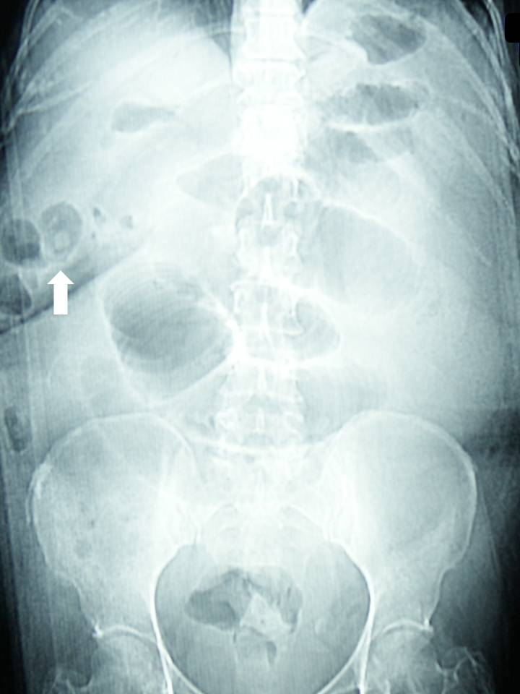
Figure 1 Plain abdominal radiograph showing dilated small bowel loops and a high density endoluminal image suggestive of a gallstone (arrow). No pneumobilia is visualized.

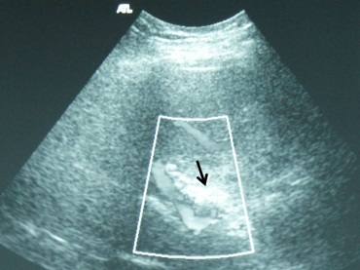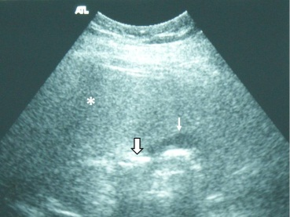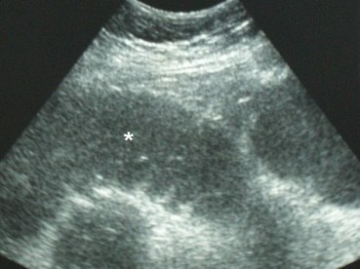
Figure 2 Ultrasound findings in a patient with gallstone ileus. A: Hyperechoic images without acoustic shadow in a non-dilated common bile duct, suggestive of air in the bile duct (arrow). Right portal vein was identified by Doppler US; B: US showing hyperechoic images without acoustic shadow in a collapsed gallbladder (arrow) and duodenum, suggestive of endoluminal air (thin arrow). Liver parenchyma (asterisk); C: Fluid-filled dilated proximal jejunum bowel loop (asterisk). US: Ultrasound.

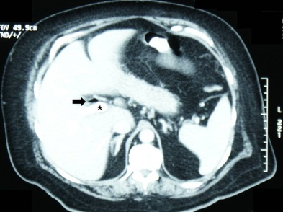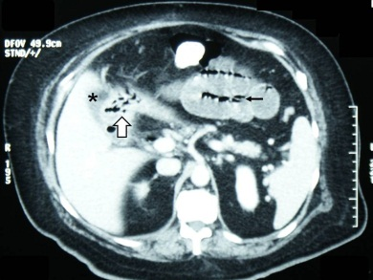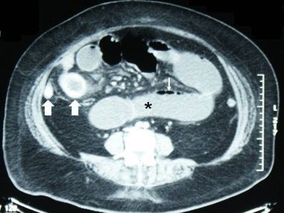
Figure 3 Contrast-enhanced computed tomography findings in a patient with gallstone ileus. A: Portal phase IV-contrast enhanced computed tomography section reveals air in the hepatic duct (arrow), anterior to a permeable right portal vein (asterisk); B: Communication between a non-distended gallbladder (asterisk) and the duodenum (arrow), where presence of air is observed. Fluid-filled dilated jejunum loops and intestinal pneumatosis are seen (thin black arrow); C: Endoluminal round-shaped calcium-density images (arrows), and dilated small bowel loops (asterisk) with pneumatosis (thin arrow).

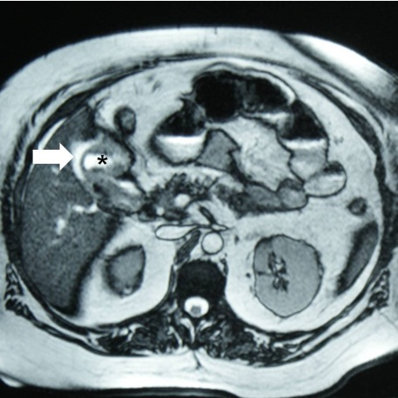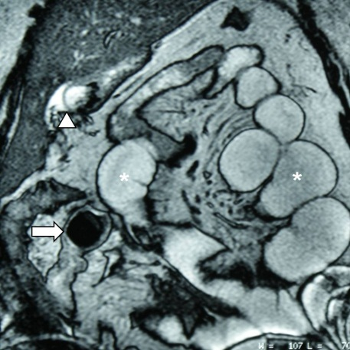
Figure 4 Magnetic resonance cholangiopancreatography findings in a patient with gallstone ileus. A: On T2-MRI, a hyperintense image is identified in the gallbladder bed (arrow), with communication with the duodenal second portion (asterisk), suggestive of a cholecystoduodenal fistula; B: MRI coronal reconstruction showed dilated small bowel loops with endoluminal air (asterisks) and a signal-void round-shaped image, suggestive of a gallstone (arrow). Gallbladder communication with duodenum is observed (arrowhead). MRI: Magnetic resonance imaging.

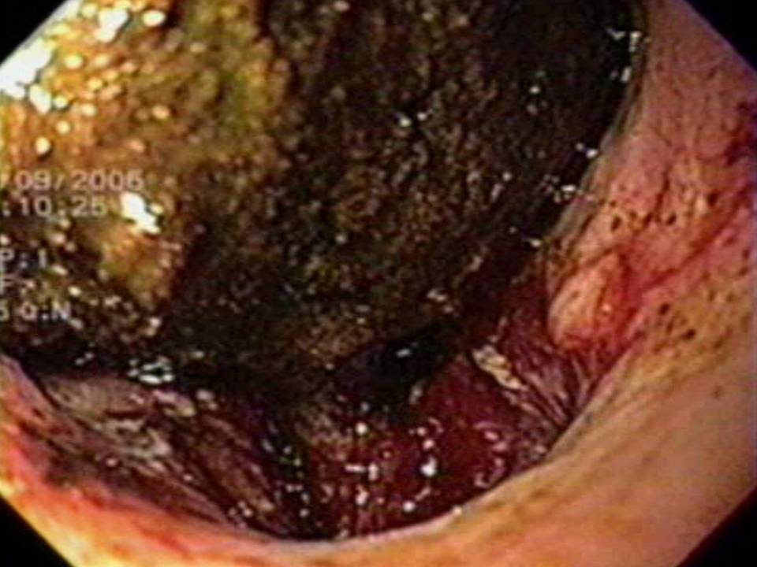
Figure 5 Esophagogastroduodenoscopy in a patient with Bouveret’s syndrome revealed a gallstone in the duodenal bulb and the fistulous sinus. Courtesy of Gabriela Quintero-Tejeda, MD, Department of Gastrointestinal Endoscopy, Unidad Médica de Alta Especialidad, Hospital de Especialidades del Centro Médico Nacional de Occidente, Instituto Mexicano del Seguro Social.

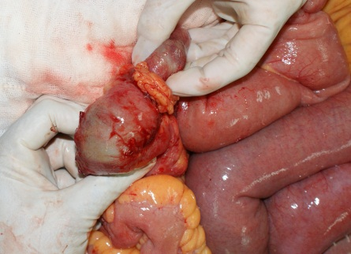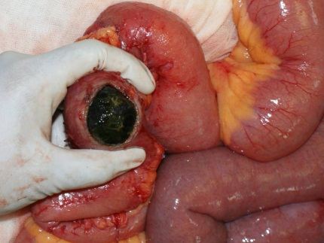
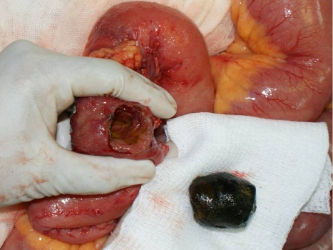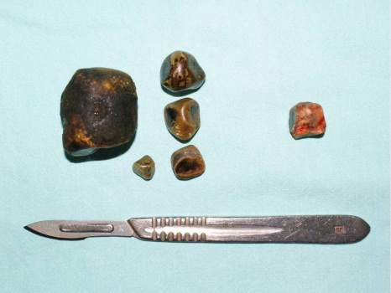
Figure 6 Surgical findings in a patient with gallstone ileus. A: An impacted gallstone was found in distal jejunum. A smaller gallstone proximal to the impacted one is observed; B: Enterotomy over the site of the impacted gallstone; C: Intestinal wall compromise due to gallstone impaction can be observed; D: The offending gallstone, plus four of smaller dimensions found in proximal jejunum. An obstructing gallstone was found and extracted from the common bile duct in the same patient (gallstone on the right).

