Name of journal: World Journal of Gastroenterology
ESPS Manuscript NO: 680

Efficacy of cap-assisted endoscopy for routine examining the ampulla of Vater

Cap-assisted endoscopy and ampulla of Vater

Young Rak Choi, M.D., Joung-Ho Han, M.D., Young Shim Cho, M.D., Hye-suk Han, M.D., Hee Bok Chae, M.D., Seon Mee Park, M.D., Sei Jin Youn, M.D.

Department of Internal Medicine, College of Medicine, Chungbuk National University, Cheongju, Korea

Author contributions: Choi YR and Han JH designed, conceptualized the study and performed the procedures; Youn SJ, Park SM provided clinical advice, and assessed the results from the picture archiving and communication system images and video recordings; Han HS, Cho YS, Chae HB were involved in final editing and writing of the manuscript.

Correspondence to: Joung-Ho Han, M.D., Department of Internal Medicine, Chungbuk National University College of Medicine, 410 SungBong-Ro Heungdeok-Gu, Cheongju-Si ChungBuk, Republic of Korea. joungho@cbnu.ac.kr
Telephone: +82-43-269-6802 Fax: +82-43-273-3252

Received: Revised: Accepted:
Published online:

Abstract
AIM: To determine the efficacy of a cap-assisted endoscopy to completely visualize the AV in patients failed by conventional endoscopy.

METHODS: A prospective study was conducted on 120 patients >20 years of age who visited the Health Promotion Center of Chungbuk National University Hospital for conscious sedation EGD as a screening test from July to October, 2011. First, forward-viewing endoscopy was performed with reasonable effort using a push and pull method. We considered complete visualization of the AV when we could observe the entire AV including the orifice clearly, and reported the observation as complete or incomplete (partial or not found at all). Second, in cases of complete failure of the observation, an additional AV examination was conducted by attaching a short cap (D-201-10704, Olympus Medical Systems, Tokyo, Japan) to the tip of a forward-viewing endoscope. Third, if the second method failed, we replaced the short cap with a long cap (MH-593, Olympus Medical Systems) and performed a re-examination of the AV.
RESULTS: Conventional endoscopy achieved complete visualization of the AV in 97 of the 120 patients (80.8%) but was not achieved in 23 patients (19.2%). Age (mean ± standard deviation [SD]) and gender (male [%]) were not significantly different between the complete observation and the incomplete observation groups. Additional short CAE was performed in patients in whom we could not completely visualize the AV. This group included 13 patients (10.9%) with partial observation of the AV and 10 (8.3%) in which the AV was not found. Short CAE permitted a complete observation of the AV in 21 of the 23 patients (91.3%). Patients in whom visualization of the AV failed with short CAE had satisfactory outcomes by replacing the short cap with a long cap. The additional time for cap-assisted endoscopy took an average of 141 ± 88 seconds (mean ± SD). There were no complications and no significant mucosal trauma.
CONCLUSIONS: CAE is safe to use as a salvage method to achieve complete visualization of the AV when a regular esophagogastroduodenoscopy examination fails.

Key words: Ampulla of Vater; Conventional endoscopy; Cap-assisted endoscopy; Screening test; complete observation

INTRODUCTION
It is recommended to visualize the second portion of the duodenum including the ampulla of Vater (AV) during a standard esophagogastroduodenoscopy (EGD) procedure^{[1-2]}. Adequate visualization of the AV is important for early detection of periampullary or pancreaticobiliary diseases ^{[3-4]}.
EGD textbooks and guidelines have emphasized complete visualization of the AV^{[1-2]}, but at the same time indicated that complete visualization of the AV is difficult due to the anatomical characteristics of the second portion of the duodenum, including the tangential angle, the periampullary diverticulum, and loop formation in the scope^{[5]}. Thus, a side-viewing endoscope has been recommended for complete visualization of the AV in patients with a suspected AV lesion or in whom the AV cannot be observed completely. However, a side-viewing endoscope is not always available in an ordinary endoscopy suite^{[6]}. So clinicians should refer the patient for side-viewing endoscopy. In the case of Korea, 4.2 million EGDs being performed as a screening test per year. Among them, 84% were performed in clinics that not equipped with side-viewing endoscope^{[6]}. And, although tertiary referral center were equipped with side-viewing endoscope, the Health Promotion Center for screening test were separated from Hospital Endoscopy Center for inpatient. So many endoscopists for screening test are not familiar with side-viewing endoscope for ERCP. Therefore an additional examination using a side-viewing endoscope is expensive, time-consuming and difficult.
Cap-assisted endoscopy (CAE) has been used widely to facilitate detection of polyps^{[7-10]}, improve the success rate of cecal intubation^{[11-12]}, and to facilitate inspection of lesions situated in blind areas of the colon^{[13-15]}. We have found that the complete visualization rate of the AV in patients who are referred for incomplete visualization of the AV can be improved by attaching a transparent cap. Therefore, we conducted a prospective observational study to investigate the complete visualization rate of the AV during routine EGD and to evaluate the efficacy and safety of endoscopic examination using a transparent cap to completely visualize the AV in patients in whom this procedure failed with a conventional endoscope.

MATERIALS AND METHODS
Patients
A prospective study was conducted on 120 patients > 20 years of age who visited the Health Promotion Center of Chungbuk National University Hospital for conscious sedation EGD as a screening test from July to October, 2011. The following patients were excluded from the study: (1) those with poor general condition who had an American Society of Anesthesiology classification ≥ 3, (2) those who received previous upper gastrointestinal tract surgery or endoscopic retrograde cholangiopancreatography (ERCP), and (3) patients with severe comorbidities. All patients provided written informed consent to participate in the study. This study was reviewed and approved by the Institutional Review Board of Chungbuk National University Hospital (D-2011-06-006).

Procedure
All examinations were conducted with the patient lying on their left side, and midazolam was administered as a sedative and pain medication. Approximately 30–40 mg of propofol was also administered depending on patient weight^{[16]}. Additional administration of propofol was used when deemed necessary, according to procedure time. Heart rate and oxygen saturation were checked in real time. Demographic data, procedure time, visualization of the AV, and complications were recorded. All examinations were carried out with a forward-viewing endoscope (GIF 230; Olympus Optical Co, Ltd, Tokyo, Japan) by a well-qualified endoscopist (JH Han), who has conducted more than 1,500 EGDs including 400 ERCPs annually. Two types of transparent caps were used: disposable distal attachments; “soft and short” cap (D-201-10704, outer diameter: 11.35 mm, length from distal end of endoscope: 4 mm. Olympus Medical Systems) and a ‘hard and long’ cap (MH-593, outer diameter: 12.9 mm, length from distal end of endoscope: 11 mm; Olympus Medical Systems) (Figure 1).
First, forward-viewing endoscopy was performed with reasonable effort using a push and pull method. We considered complete visualization of the AV when we could observe the entire AV including the orifice clearly, and reported the observation as complete or incomplete (partial or not found at all). Second, in cases of complete failure of the observation, an additional AV examination was conducted by attaching a short cap to the tip of a forward-viewing endoscope. Third, if the second method failed, we replaced the short cap with a long cap and performed a re-examination of the AV.
Statistical analysis
Descriptive statistical analyses were performed using the SPSS software, version 12.0 (SPSS Inc, Chicago, IL, United States), and frequency, percentage, mean, and range were used for descriptive analyses. A P value < 0.05 was considered statistically significant.
RESULTS
Patients’ characteristics and outcomes of conventional endoscopy
A total of 181 patients were examined, 61 were excluded. 120 patients were enrolled and agreed to participate in the study by signing an informed consent (Figure 2). Conventional endoscopy achieved complete visualization of the AV in 97 of the 120 patients (80.8%) but was not achieved in 23 patients (19.2%)(Figure 3). The reasons for failure to visualize the ampulla were large fold in 16 patients, and diverticulum in 7 patients. Age (mean ± SD) and gender (male [%]) were not significantly different between the complete observation and the incomplete observation groups. (55.3 ± 12.6 years, 59 [60.8%]; 55.2 ± 16.2 years, 12 [52.2%]), respectively.

Outcomes of CAE
Additional short CAE was performed in patients in whom we could not completely visualize the AV. This group included 13 patients (10.8%) with partial observation of the AV and 10 (8.4%) in which the AV was not found. Short CAE permitted a complete observation of the AV in 21 of the 23 patients (91.3%).
In cases of an incomplete visualization due to folded mucous membranes, complete observation of the orifice areas was achieved by uncovering the fold with a short cap (Figure 4A, B, video 1). Due to a too close proximity of the endoscope tip to the superior ampulla lesion, the short cap provided a proper distance and the ability to straighten the mucosal fold by pressing the area surrounding the lesion (Figure 4C, D). The cap made it easier to access the AV at the edge of the diverticulum by directing the force vector along the tip of the endoscope (Figure 4E, F, video 2). Patients in whom visualization of the AV failed with short CAE had satisfactory outcomes by replacing the short cap with a long cap; one AV was observed only partially due to the deep location of the AV in the large diverticulum, whereas the other was not found due to a loop in the scope (Figure 4G, H). The time for CAE was 141 ± 88 seconds (mean ± standard deviation). No complications or significant mucosal trauma occurred. In one case of suspected abnormal lesions, an additional side-viewing endoscopy with biopsy revealed a tubular adenoma, so an endoscopic ampullectomy was performed.
DISCUSSION
The transparent cap was first proposed in 1990 by Inoue to improve the accessibility of the forward-viewing endoscope ^{[17]}. Since then, transparent CAE has been used widely as a method to increase the success rate of the procedure ^{[18-19]}. For example, CAE improves cecal intubation times and polyp detection rates during colonoscopy^{[9,11]}, it achieves higher success rates of afferent loop intubation and bile-duct cannulation in patients with a Billroth II gastrectomy^{[20-22]}, and it possible to clip a lesion too tangential to be clipped by routine endoscopy^{[23-27]}.
Although there is a growing need to identify CAE as an effective approach to visualize the AV, no studies have investigated the AV observation rate during routine EGD or the efficacy of CAE for AV observation. Although small studies (preliminary data of Jorge et al^{[28]}. describing the feasibility of visualizing the AV by attaching a long cap from a variceal band ligation set to a conventional endoscope) have been conducted, almost all cases (19 of 20) required emergency endoscopic hemostasis treatment, were not for screening test. That study reported conventional endoscopy permitted an inadequate observation of the AV in all cases (20 of 20), which is questionable, although they reported that observations of the AV using CAE were effective.
Although our cases had a wide variation in procedure duration, complete visualization of the AV was possible in up to 100% by attaching a cap to the tip of a conventional endoscope. The additional time for this procedure was short (average, 141 s). Moreover, the AV could be visualized completely in almost all patients using short CAE. Although a long cap has been used widely, the long cap is hard and difficult to pass over the larynx and pylorus, so it is easy to damage the mucosa, whereas the short cap is soft, safer, and relatively simple and easy to handle.
The transparent cap made the following multiple mechanisms possible. (1) The transparent cap provided a proper distance between the AV and the tip of the endoscope, which may prevent sticking of the endoscope to the duodenal lumen. (2) The cap allowed efficient manipulation of a tangentially placed AV to a more square approach. (3) The cap made it easier to access hidden areas by straightening the mucosal folds by pressing the surrounding lesion areas, and (4) the cap reduced loop formation by “hooking” the tip of the endoscope in the second portion of the duodenum and directing the force vector of the endoscope tip^{[29-33]}. Moreover, the long cap improved all of these functions; thus, it allowed an approach to a deeply AV located deepin the diverticulum^{[34-36]}.
This study had some limitations. First, data collection was limited to screening tests in a healthy population that visited the Health Promotion Center; these patients can have a lower disease prevalence or anatomical variations in the AV than those in the general population. Thus, the success rate of CAE may be different in the general population. Second, because EGD was performed by one ERCP expert, the results cannot be generalized to a conventional endoscopist with less experience visualizing the AV.
In conclusion, CAE was an effective salvage technique when regular EGD was ineffective for visualizing the AV properly. CAE can increase the diagnostic accuracy of a forward-viewing endoscope and decrease the need for side-viewing endoscopy.

Acknowledgments
This study was supported by a grant from the National R & D Program for Cancer Control, Ministry for Health and Welfare, Republic of Korea (A100054 and 1120330). This study was presented as an Abstract at Digestive Disease Week, 7–10 May 2011, Chicago, IL, USA.
COMMENTS
Background
Adequate visualization of the AV is important for early detection of periampullary or pancreaticobiliary diseases. But visualization of the AV with a forward-viewing endoscope is difficult due to the anatomical characteristics of the second portion of the duodenum. Thus, a side-viewing endoscope has been recommended for complete visualization of the AV. However, a side-viewing endoscope is not always available in an ordinary endoscopy suite.

Research frontiers
Cap-assisted endoscopy (CAE) has been used widely to facilitate detection of polyps, improve the success rate of cecal intubation, and to facilitate inspection of lesions situated in blind areas of the colon. We have found that the complete visualization rate of the AV in patients who are referred for incomplete visualization of the AV can be improved by attaching a transparent cap.
Innovations and breakthrough
Although there is a growing need to identify CAE as an effective approach to visualize the AV, no studies have investigated the AV observation rate during routine EGD or the efficacy of CAE for AV observation. This is the first study to determine the efficacy and safety of an endoscopic examination using a transparent cap to completely visualize the AV in patients failed by conventional endoscopy.

Applications
CAE can increase the diagnostic accuracy of a forward-viewing endoscope and decrease the need for side-view endoscopy. This study may represent a future strategy for effective endoscopic examination as a screening test.
Terminology
Endoscopic caps are commonly used for both diagnosis and therapy during endoscopy. Transparent caps are attached to the distal end of the endoscope. Currently, many different sized caps are available. Cap assisted endoscopic mucosal resection (EMRC) is the most common application of endoscopic caps. The appropriate selection of an endoscopic cap based on indication and location of the lesion is important for procedural success.

Peer review
The authors examined the efficacy of a cap-assisted endoscopy to completely visualize the AV in patients failed by conventional endoscopy. It revealed that CAE can increase the diagnostic accuracy of a forward-viewing endoscope and decrease the need for side-view endoscopy. The result are interesting and promising for endoscopic examination as a screening test.
REFERENCES
- Block B, Schachschal G, Schmidt H. Endoscopy of the upper GI tract. Thieme 2004; 52-59.
- Canard JM, Letard JC, Palazzo L, Penman I, Lennon AM. Gastrointestinal endoscopy in practice. Elsevier 2011; 84-100.
- Fischer HP, Zhou H. Pathogenesis of carcinoma of the papilla of Vater. J Hepatobiliary Pancreat Surg 2004;11(5):301–309. [PMID: 15549428]
- Ende A, Zopf Y, Konturek P, Naegel A, Hahn EG, Matthes K, Maiss J. Strategies for training in diagnostic upper endoscopy: a prospective, randomized trial. Gastrointest Endosc 2012;75:254-260. [PMID 22153875 DOI:10.1016/j.gie.2011.07.063]
- Yap CK, Ng HS. Cap-fitted gastroscopy improves visualization and targeting of lesions. Gastrointest Endosc 2001;53:93-95. [PMID 11154499 DOI:10.1067/mge.2001.110453]
- Han JH. Safe endoscopic retrograde cholangiopancreatography in community hospital. Korean J Gastrointest Endosc 2011;43 Suppl 2 :182-187
- Sumiyama K, Rajan E. Endoscopic Caps. Tech Gastrointest Endosc 2006; 8:28-32.
- Urita Y, Nishino M, Ariki H, Ozaki M, Naruki Y, Otsuka S. A transparent hood simplifies magnifying observation of the colonic mucosa by colonoscopy. Gastrointest Endosc 1997;46:170-172 [PMID: 9283870]
- Ng SC, Tsoi KK, Hirai HW, Lee YT, Wu JC, Sung JJ, Chan FK, Lau JY. The efficacy of cap-assisted colonoscopy in polyp detection and cecal intubation: a meta-analysis of randomized controlled trials. Am J Gastroenterol. 2012;107(8):1165-1173. [PMID: 22664471 DOI: 10.1038/ajg.2012.135]
- Tada M, Inoue H, Yabata E, Okabe S, Endo M. Feasibility of the transparent cap-fitted colonoscope for screening and mucosal resection. Dis Colon Rectum 1997; 40: 618-621 [PMID: 9152195]
- Kim HH, Park SJ, Park MI, Moon W, Kim SE. Transparent-cap-fitted colonoscopy shows higher performance with cecal intubation time in difficult cases. World J Gastroentero. 2012;18(16):1953-1958 [PMID: 22563177 DOI:10.3748/wjg.v18.i16.1953]
- Lee MS, Shim CS, Kim YT, Hong SJ, Kim JO, Cho JY, Lee JS. Efficacy of Total Colonoscopy with a Transparent Cap. Korean J Gastrointest Endosc. 2000;20(4):262-266.
- Hewett DG, Rex DK. Cap-fitted colonoscopy: a randomized, tandem colonoscopy study of adenoma miss rates. Gastrointest Endosc. 2010;72:775–781 [PMID: 20579648 DOI:10.1016/j.gie.2010.04.030]
- Park SY, Kim HS, Yoon KW, Cho SB, Lee WS, Park CH, Joo YE, Choi SK, Rew JS. Usefulness of cap-assisted colonoscopy during colonoscopic EMR: a randomized, controlled trial. Gastrointest Endosc. 2011;74:869–875 [PMID: 21824612]
- Kondo S, Yamaji Y, Watabe H, Yamada A, Sugimoto T, Ohta M, Ogura K, Okamoto M, Yoshida H, Kawabe T, Omata M. A randomized controlled trial evaluating the usefulness of a transparent hood attached to the tip of the colonoscope. Am J Gastroenterol 2007; 102: 75-81 [PMID: 17100978
DOI:10.1111/j.1572-0241.2006.00897]
- Kwon JS, Kim ES, Cho KB, Park KS, Park WY, Lee JE, Kim TY, Jang BK, Chung WJ, Hwang JS. Incidence of propofol injection pain and effect of lidocaine pretreatment during upper gastrointestinal endoscopy. Dig Dis Sci 2012;57(5):1291-1297 [PMID 22160549 DOI:10.1007/s10620-011-1992-4]
- Inoue H, Endo M, Takeshita K, Yoshino K, Muraoka Y, Yoneshima H. A new simplified technique of endoscopic esophageal mucosal resection using a cap-fitted panendoscope (EMRC). Surg Endosc 1992;6:264-265 [PMID: 1465738 DOI: 10.1007/BF02498820]
- Dafnis GM. Technical considerations and patient comfort in total colonoscopy with and without a transparent cap: initial experiences from a pilot study. Endoscopy. 2000;32:381–384. [PMID:10817176 DOI: 10.1055/s-2000-637]
- Lee YT, Lai LH, Hui AJ, Wong VW, Ching JY, Wong GL, Wu JC, Chan HL, Leung WK, Lau JY, Sung JJ, Chan FK. Efficacy of cap-assisted colonoscopy in comparison with regular colonoscopy:
a randomized controlled trial. Am J Gastroenterol 2009; 104: 41-46 [PMID: 19098847
DOI:10.1038/ajg.2008.56]
- Park CH, Lee WS, Joo YE, Kim HS, Choi SK, Rew JS. Cap-assisted ERCP in patients with a Billroth II gastrectomy. Gastrointest Endosc 2007; 66:612-615. [PMID 17725957 DOI:10.1016/j.gie.2007.04.024]
- Mehdizadeh S, Sadda M, Lo SK. Mucosectomy-Cap Assisted Ampullectomy (MCAA) is an effective technique in removing residual tissue after snare ampullectomy. Gastrointest Endosc 2006;63:242. [DOI: 10.1016/j.gie.2006.03.630]
- Matsuzaki K, Nagao S, Kawaguchi A, Miyazaki J, Yoshida Y, Kitagawa Y, Nakajima H, Kato S, Hokari R, Tsuzuki Y, Itoh K, Niwa H, Miura S. Newly designed soft prelooped cap for endoscopic mucosal resection of gastric lesions. Gastrointest Endosc 2003;57:242-246 [PMID: 12556795]
- Leal-Salazar JA, Gonzalez-Gonzalez JA, Garza-Galindo AA, Maldonado-Garza HJ, Flores Rendón AR, Mar Ruiz MA. Use of a gastroscope armed with a transparent cap in the treatment of bleeding after endoscopic sphincterotomy. Endoscopy. 2009;41 Suppl 2:E91 [PMID 19370530 DOI: 10.1055/s-0028-1119730]
- Lee TH, Bang BW, Jeong JI, Kim HG, Jeong S, Park SM, Lee DH, Park SH, Kim SJ. Primary endoscopic approximation suture under cap-assisted endoscopy of an ERCP-induced duodenal perforation. World J Gastroenterol 2010;16: 2305-10. [PMID 20458771 DOI: 10.3748/wjg.v16.i18.2305]
- Koo HS, Kim YS, Kim GI, Yang JK, Kim SM, Cheon SY, Sun JH, Kim SM. A Case of Transparent Cap-fitted Endoscopic Hemoclipping on a Bleeding Dieulafoy’s Lesion in the Ampulla of Vater. Korean J Gastrointest Endosc 2010;40:45-48.
- Kim JI, Kim SS, Park S, Han J, Kim JK, Han SW, Choi KY, Chung IS, Chung KW, Sun HS. Endoscopic hemoclipping using a transparent cap in technically difficult cases. Endoscopy 2003;35:659-662 [PMID 12929060 DOI: 10.1055/s-2003-41512]
- Warneke RM, Walser E, Faruqi S, Jafri S, Bhutani MS, Raju GS. Cap-assisted endoclip placement for recurrent ulcer hemorrhage after repeatedly unsuccessful endoscopic treatment and angiographic embolization: case report. Gastrointest Endosc 2004;60:309-312. [PMID 15278071 DOI: 10.1016/S0016-5107(04)01681-5]
- Leal-Salazar JA, Rendon RF, Garza AA, Maldonado HJ, Gonzalez JA. Cap-fitted frontal view gastroscopy allows for adequate examination of the ampulla of vater. Gastrointest Endosc 2009;69:AB377-378.
- Tee HP, Corte C, Al-Ghamdi H, Prakoso E, Darke J, Chettiar R, Rahman W, Davison S, Griffin SP, Selby WS, Kaffes AJ. Prospective randomized controlled trial evaluating cap-assisted colonoscopy vs. standard colonoscopy. World J Gastroenterol 2010;21:3905-3910. [PMID 20712051 DOI: 10.3748/wjg.v16.i31.3905]
- Heinrich HS, Weber A, Bauerfein P. Successful removal of a papillary adenoma by using the cap technique. Gastrointest Endosc 2010;72:220-221. [PMID 20417506 DOI: 10.1016/j.gie.2009.11.011]
- Jeon SM, Lee JH, Hong SP, Kim TI, Kim WH, Cheon JH. Feasibility of salvage endoscopic mucosal resection by using a cap for remnant rectal carcinoids after primary EMR. Gastrointest Endosc 2011;73:1009-14.[ PMID 21316666 DOI:10.1016/j.gie.2010.12.029 ]
- Trecca A, Gaj F, Gagliardi G. Our experience with endoscopic repair of large colonoscopic perforations and review of the literature. Tech Coloproctol 2008;12:315–322. [PMID 19018468 DOI: 10.1007/s10151-008-0442-6]
- Horiuchi A, Nakayama Y, Kajiyama M, Kato N, Ichise Y, Tanaka N. Benefits and Limitations of Cap-Fitted Colonoscopy in Screening Colonoscopy. Dig Dis Sci 2012 [Epub ahead of print] [PMID: 23053884]
- Westwood DA, Alexakis N, Connor SJ. Transparent cap-assisted colonoscopy versus standard adult colonoscopy: a systematic review and meta-analysis. Dis Colon Rectum. 2012;55(2):218-225. [PMID: 22228167 DOI:10.1097/DCR.0b013e31823461ef]
- Lee YT, Hui AJ, Wong VW, Hung LC, Sung JJ. Improved colonoscopy success rate with a distally attached mucosectomy cap. Endoscopy 2006; 38: 739-742 [PMID: 16673307 DOI:10.1055/s-2006-925238]
- Matsushita M, Hajiro K, Okazaki K, Takakuwa H, Tominaga M. Efficacy of total colonoscopy with a transparent cap in comparison with colonoscopy without the cap. Endoscopy 1998; 30: 444-447 [PMID: 9693890]
Figure 1 Endoscopic transparent cap. A: Short transparent cap (Olympus distal attachment D-201-10704, outer diameter: 11.35 mm, length from distal end of endoscope: 4 mm; Olympus Tokyo, Japan), B: Long transparent cap (Olympus distal attachment MH-593, outer diameter: 12.9 mm, length from distal end of endoscope: 11 mm; Olympus), C: Short cap attached to the tip of a forward-viewing endoscope, D: Long cap attached to the tip of a forward-viewing endoscope.

Figure 2 Flow diagram of patient enrollment and examinations. In total, 120 patients were examined by forward-viewing endoscopy. In cases when complete observations of the AV were unsuccessful, an additional examination for the AV was conducted by short CAE. If that examination was unsuccessful, the short cap was replaced with a long cap, and a re-examination was performed. AV, ampulla of Vater; CAE, cap-assisted endoscopy

Figure 3 Outcomes of conventional endoscopy. A: Complete observation of the AV, including the orifice, by forward-viewing endoscopy, B: Partial observation of the AV with a folded mucous membrane by forward-viewing endoscopy. C: The AV was not found during forward-viewing endoscopy. AV, ampulla of Vater

Figure 4 Incomplete observation of the AV by conventional endoscopy and outcomes of cap-assisted endoscopy. A: Incomplete observation of the AV by forward-viewing endoscopy due to a folded mucous membrane, C: Incomplete observation of the AV due to the close proximity of the endoscope tip to a superior ampulla lesion E: Incomplete observations of the AV on the edge of diverticulum. B, D, F: Complete observation of the AV, including the orifice, by short cap-assisted endoscopy (A→B, C→D, E→F), G: Incomplete observation of the AV by short cap-assisted endoscopy due to a loop in the scope, H: Complete observation of the AV by long cap-assisted endoscopy (G→H). AV: ampulla of Vater.

Video 1 A case of complete observation of the AV by CAE. In cases where incomplete visualization was due to a covering fold by the forward-viewing endoscope, complete observation of the hidden areas was achieved by uncovering the mucosal fold and membrane wrinkles using a short cap-assisted endoscope.

Video 2 A case of complete observation of the AV by CAE. In cases of incomplete observation of the edge of the diverticulum by forward-viewing endoscopy, a cap-assisted endoscope provided complete visualization of the ampulla of Vater.
Figure 1.
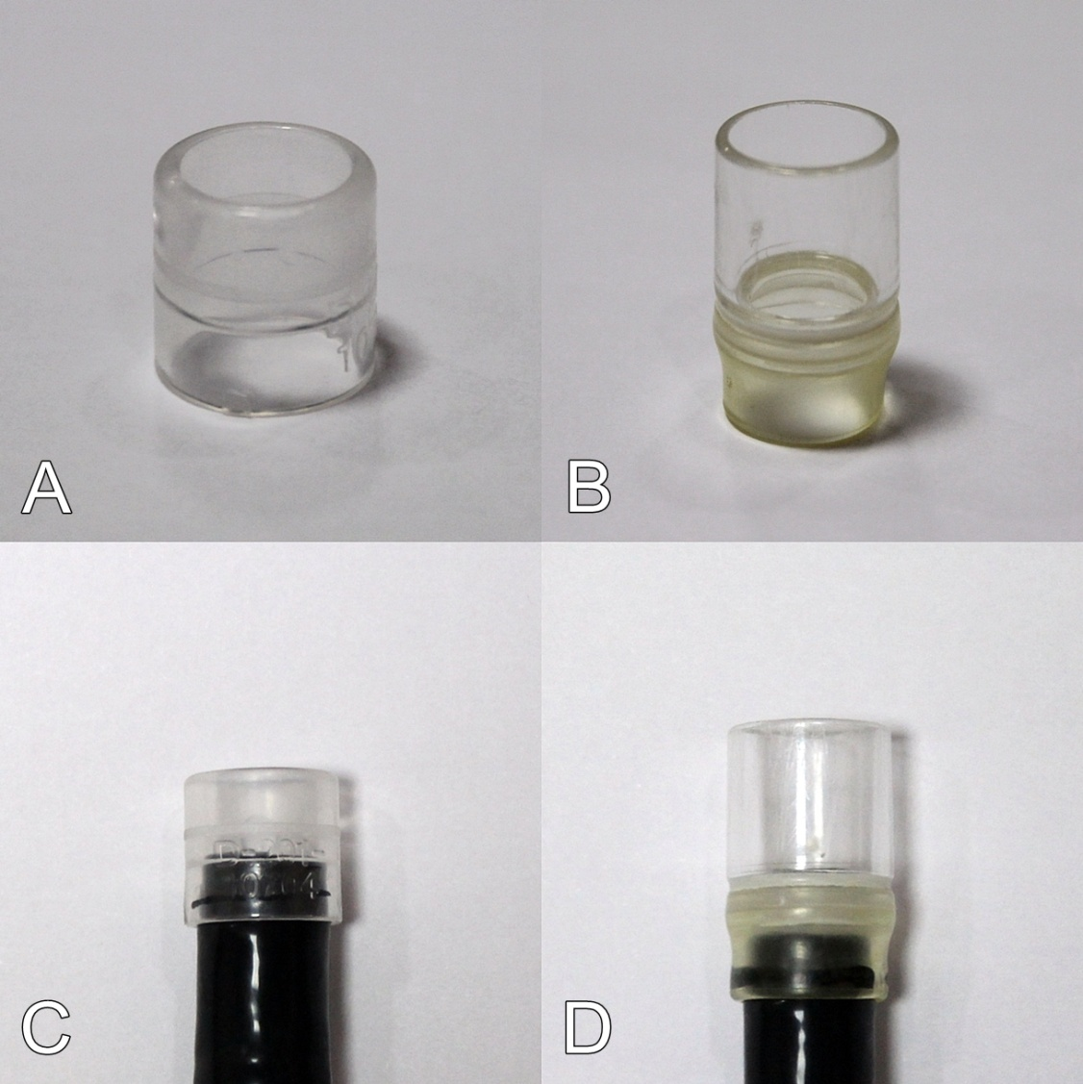

Figure 2.
120 patients that visited for conscious sedation endoscopy as a screening test were enrolled

Examination with the forward-viewing endoscopy
-
Incomplete observation of the AV (n=23, 19.2%)
-Partial observation (n=13, 10.8%)
-Not found at all (n=10, 8.4%)
Complete observation of the AV
(n = 97, 80.8%)

Examination with the short cap-assisted endoscopy

Incomplete observation of the AV
-Partial observation (n=1, 4.35%)
-Not found at all (n=1, 4.35%)

Complete observation of the AV
(n = 21, 91.3%)

Examination with the long cap-assisted endoscopy

Complete observation of the AV
(n = 2, 100%)

Figure 3.
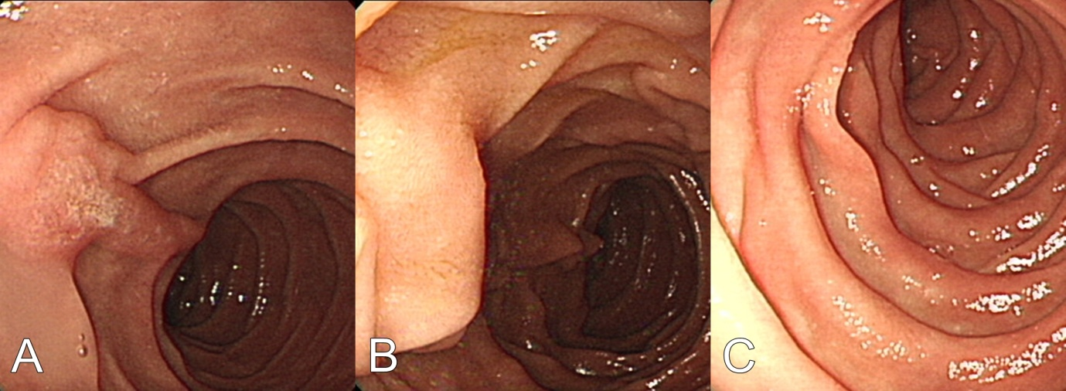

Figure 4.
