Name of Journal: World Journal of Nephrology
ESPS Manuscript NO: 22286
Manuscript Type: MINIREVIEWS

Central blood pressure and chronic kidney diseases

Ohno Y et al. Pathophysiology of cardio-renal syndrome

Yoichi Ohno, Yoshihiko Kanno, Tsuneo Takenaka

Yoichi Ohno, Department of Nephrology, Saitama Medical University, Saitama 350-0495, Japan

Yoshihiko Kanno, Department of Nephrology, Tokyo Medical University, Tokyo 160-0023, Japan

Tsuneo Takenaka, Department of Medicine, International University of Health and Welfare, Clinical Research Center, Sanno Hospital, Tokyo 107-0052, Japan

Author contributions: All authors equally contributed to this paper with conception and design of the study, acquisition and analysis of the data, drafting and critical revision and editing, and final approval of the final version.

Conflict-of-interest statement: No potential conflicts of interest. No financial support.

Open-Access: This article is an open-access article which was selected by an in-house editor and fully peer-reviewed by external reviewers. It is distributed in accordance with the Creative Commons Attribution Non Commercial (CC BY-NC 4.0) license, which permits others to distribute, remix, adapt, build upon this work non-commercially, and license their derivative works on different terms, provided the original work is properly cited and the use is non-commercial. See: http://creativecommons.org/licenses/by-nc/4.0/

Correspondence to: Tsuneo Takenaka, MD, PhD, Department of Medicine, International University of Health and Welfare, Clinical Research Center, Sanno Hospital, 8-10-16 Akasaka Minato, Tokyo 107-0052, Japan. takenaka@iuhw.ac.jp
Telephone: 81-3-34023151
Fax: 81-3-34043652

Received: August 30, 2015
Peer-review started: August 31, 2015
First decision: October 27, 2015
Revised: November 17, 2015
Accepted: December 13, 2015
Article in press:
Published online:

Abstract
In this review, we focused on the relationship between central blood pressure and chronic kidney diseases. Wave reflection is a major mechanism that determines central blood pressure in patients with chronic kidney disease. Recent medical technology advances have enabled non-invasive central blood pressure measurements. Clinical trials have demonstrated that compared with brachial blood pressure, central blood pressure is a stronger risk factor for cardiovascular and renal diseases. Chronic kidney disease is characterized by a diminished renal autoregulatory ability, an augmented direct transmission of systemic blood pressure to glomeruli, and an increase in proteinuria. Any elevation in central blood pressure accelerates chronic kidney disease progression. In the kidney, interstitial inflammation induces oxidative stress to handle proteinuria. Oxidative stress facilitates atherogenesis, increases arterial stiffness and central blood pressure, and worsens the cardiovascular prognosis in patients with chronic kidney disease. A vicious cycle exists between chronic kidney disease and central blood pressure. To stop this cycle, vasodilator antihypertensive drugs and statins can reduce central blood pressure and oxidative stress. Even in early-stage chronic kidney disease, mineral and bone disorders may develop. Mineral and bone disorder promotes oxidative stress, arteriosclerosis, and elevated central blood pressure in patients with chronic kidney disease. Early intervention or prevention seems necessary to maintain vascular health in patients with chronic kidney disease.

Key words: Atherosclerosis; Mineral and bone disorder; Oxidative stress; Proteinuria; Renal autoregulation

© The Author(s) 2015. Published by Baishideng Publishing Group Inc. All rights reserved.

Core tip: Wave reflection is a major mechanism that determines central blood pressure in chronic kidney disease (CKD). Diminished renal autoregulatory ability characterizes CKD, allowing an increase in proteinuria. Thus, any elevations of central blood pressure accelerate the progression of CKD. The kidney produces oxidative stress compounds due to proteinuria handling and secondary interstitial inflammation. Oxidative stress facilitates atherogenesis, increases arterial stiffness and central blood pressure. Furthermore, even in early stages of CKD, mineral and bone disorder (MBD) is developed. CKD-MBD facilitates to induce oxidative stress and elevation of central blood pressure. To keep vascular health in CKD, early intervention or prevention seems mandatory.

Ohno Y, Kanno Y, Takenaka T. Central blood pressure and chronic kidney diseases. World J Nephrol 2015; In press

INTRODUCTION
Blood pressure is the product of the cardiac output and total peripheral vascular resistance. In turn, cardiac output is the product of the stroke volume and heart rate. The diastolic and mean blood pressures remain similar along the systemic arterial tree^{[1]}. Therefore, the aortic and brachial mean blood pressures are comparable^{[1]}. However, systolic blood pressure differs significantly between the central and peripheral arteries, even within a single cardiac beat. Specifically, the central systolic blood pressure is lower than the brachial systolic blood pressure, which itself is lower than the systolic blood pressure at the dorsal foot artery. At any given site within the arterial tree, the systolic blood pressure increases as the distance from the heart increases^{[2]}.

CENTRAL HEMODYNAMIC MECHANISMS
How does a single heart stroke cause variations in blood pressure from the aorta to the peripheral arteries? Two mechanisms have been proposed (Figure 1): wave reflection, and amplification^{[2]}. Wave reflection occurs at all levels of the arterial tree^{[3]}. Reflection occurs in areas where the arterial caliber is decreasing, or at areas where a single artery divides into two or three branches. Each wave reflection causes a backward wave in arterial system. If all backward waves could be integrated, the single wave would ascend approximately from the aortic bifurcation. Backward and forward waves yield summation effects, resulting in augmented systolic blood pressure. As shown in Figure 2, the augmentation index (AI) is defined as the augmented pressure/forwarding pulse pressure. The summation effects are affected by many factors^{[4]}, including the degree of wave reflection, heart rate, height, and pulse wave velocity (PWV). The reflection magnitude is modulated by the stroke volume and arterial stiffness. A greater stroke volume enlarges the reflection. Increased arterial stiffness, such as that in elderly individuals, also increases reflection. A short height and fast PWV also allow the backward wave to reach the ascending aorta during systole, resulting in a very high central systolic blood pressure and significant stress on the left ventricle^{[5,6]}. Normally, the backward wave arrives at the ascending aorta in diastole, facilitating coronary perfusion. A slower heart rate lengthens the ejection period and allows the backward wave to reach the ascending aorta at late systole. Thus, the early arrival of a large reflection wave at the ascending aorta increases both the central systolic blood pressure and cardiovascular risk.
Pressure amplification is a physiological phenomenon that is evident in young people with supple, flexible, elastic arteries^{[2]}. In such individuals, the arterial wall flexes like a whip with each heart stroke. We will attempt the difficult process of explaining pressure amplification without a mathematical analysis. During the systolic phase, the pulse wave arrives at the aorta and proceeds at the speed of the PWV. The PWV speed is well known to increase along with systolic blood pressure. One can divide the forwarding pulse into three parts: initial, middle, and last. In the initial part, blood travels from the heart to the aorta, which is very soft and becomes distended. Accordingly, the PWV is slow in the initial part and functionally increases the aortic root stiffness with a small increase in blood pressure. During the middle part, the forwarding pulse emerges from the heart. As the aortic root stiffness is higher in the middle part than in the initial part, the PWV also increases. Consequently, some of the middle part catches up with the initial part, leading to a moderate amplification of systolic pressure. Finally, the last part enters the aorta at the fastest PWV, further amplifying the systolic blood pressure. Closure of the aortic valve ends this escalation of systolic pressure. Importantly, this pressure amplification continues along the length of the aorta as the pulse wave travels. Thus, in young people, the central systolic blood pressure remains low, compared with the brachial systolic blood pressure^{[7]}.
Indeed, isolated systolic hypertension is a cardiovascular (CV) risk in elderly patients, not in young subjects^{[7]}. The above description may explain why pressure amplification is a major cause of isolated systolic hypertension in young individuals, whereas wave reflection causes central systolic blood pressure elevation in the elderly. The Framingham Study focused attention toward pulse pressure as the best measure of cardiovascular risk, at least in older subjects^{[7]}. Since pulse pressure is a surrogate measure of arterial stiffness, such data indicate that arterial stiffness is a key determinant of cardiovascular risk in older subjects. Although there is a debate, the data from Framingham study suggest that diastolic pressure remains the best predictor of coronary heart disease risk in younger subjects. As chronic kidney disease (CKD) is rather common in elderly populations whose artery is stiff due to the remodeling^{[2,5,6]}, wave reflection, rather than pressure amplification, determines the central blood pressure in this patient population.

CENTRAL BLOOD PRESSURE MEASUREMENT METHODS
The central systolic blood pressure places a direct burden on the left ventricle and is a better predictor of cardiovascular prognosis than the brachial blood pressure. Central blood pressure correlates better with real blood pressure for heart and great vessels than brachial blood pressure. A lower central blood pressure is associated with a better CV outcome, regardless of brachial blood pressure. Until recently, intravascular catheterization was only the method to measure central blood pressure efficiently. This method is direct and accurate, and therefore remains the gold standard for central blood pressure assessment. However, it is so invasive that only selected patients can undergo such an evaluation. Recent progress in medical technologies has enabled non-invasive assessments of central blood pressure.
Currently, two devices that provide consistent central blood pressure readings are available on the market^{[8]}. First, Kelly et al^{[9]} performed invasive simultaneous measurements of both the brachial and aortic pulse waveforms and used a Fourier analysis to generate a generalized transfer function. This transfer function allows the estimation of an aortic waveform from a brachial waveform. The transfer function was later used to develop a device that uses a tonometer to access the radial pulse waveform and estimate an aortic pulse waveform (Figure 3). This device is able to calculate the aortic blood pressure through calibration with indirect brachial blood pressure measurements obtained via the cuff method. Second, Takazawa et al^{[10]} independently developed a new device to access the central blood pressure. The authors invasively measured the aortic blood pressure during cardiac catheterization, while simultaneously indirectly measuring both the radial pulse waveform and brachial blood pressure. They found that the second peak of radial pulse waveform correlated with the aortic waveform peak, thus enabling an indirect estimation of the aortic systolic blood pressure without using the generalized transfer function (Figure 4).
Notably, cuff measurements of brachial blood pressure via oscillometric methods have such large errors that invasive measurements of the brachial blood pressure are approximately 10 mmHg higher than non-invasive measurements^{[8]}. Both devices have been described as calibrating the central blood pressure through the indirect measurement of brachial blood pressure. Thus, invasive measurement yields central blood pressure values approximately 10 mmHg higher than device-assisted indirect central blood pressure values. Although we are very familiar with the indirect measurement of brachial blood pressure, great cautions are required when discussing the accuracy of the method to assess the exact blood pressure.

INCREASED CENTRAL BLOOD PRESSURE IS AN IMPORTANT CARDIOVASCULAR RISK
Recent clinical studies have shown that the increase in central blood pressure is a stronger cardiovascular risk than the brachial blood pressure. Williams et al. divided a cohort of enrolled hypertensive Anglo-Saxon and Scandinavian patients into two groups: those treated with calcium channel blocker-based medications, and treated with beta-blocker-based regimens^{[11]}. During the follow-up period, both groups exhibited similar brachial blood pressure control. However, fewer cardiovascular events occurred in patients receiving calcium channel blocker-based therapy. Importantly, the central blood pressure was significantly lower in those treated with calcium channel blockers than in those treated with beta-blockers (Figure 5). The authors also demonstrated that central blood pressure contributed to the number of total cardiovascular events and the development of renal impairment, suggesting that a correct central blood pressure measurement is a more accurate parameter than brachial blood pressure in preventing cardiovascular and renal events. Roman et al. performed a population-based longitudinal study of prevalent and incident cardiovascular disease in 3502 American Indians; 319 of these subjects suffered fatal and non-fatal cardiovascular events during a 5-year follow-up^{[12]}. The authors concluded that the measurement of central blood pressure more strongly predicts cardiovascular events than does brachial blood pressure. However, Townsend et al. enrolled 2606 patients with CKD patients and observed the incidence of hospitalization for new-onset heart failure over a 3.5-year period^{[13]}. These authors concluded that a fast aortic PWV, but not a high central blood pressure, predicted heart failure. It is difficult to distinguish heart failure from fluid retention in patients with CKD partly due to vascular remodeling including calcification. In contrast, our previous study indicated that AI predicted cardiovascular events in hemodialysis patients^{[14]}. Collectively, these data suggest that the blood pressure in the ascending aorta is a significant cardiovascular risk for the development of atherosclerotic cardiovascular diseases.
What about abdominal aortic blood pressure, to which the kidney is exposed? The backward wave travels for a shorter distance and meets the forwarding wave sooner in the aorta at the renal artery level, compared to the ascending aorta. Thus, the backward wave augments the forwarding wave in mid-systole, leading to greater summation effects^{[5]}. The pressure amplification at this level is also greater than in the ascending aorta because the forwarding wave travels a longer distance. Collectively, the renal arterial pressure should fall between the aortic root and brachial blood pressures. Indeed, Hope et al. examined blood pressure profiles along the aorta during cardiac catheterization in patients with an average age of 65 years, and reported that the aortic systolic pressure was approximately 10 mmHg higher at the level of the kidney than in the ascending aorta^{[15]}.

CENTRAL BLOOD PRESSURE AS A CAUSE OF CHRONIC KIDNEY DISEASE
When exposed to high blood pressure, the arteries and arterioles constrict and increase their vascular resistance to buffer the direct transmission of systemic pressure to capillary beds in the terminal organs, in a process called autoregulatory or myogenic vasoconstriction^{[16]}. In addition to myogenic constriction, tubuloglomerular feedback (TGF) affects renal autoregulation^{[17]}. TGF is the mechanism specific for the kidney to maintain glomerular filtration rate constant. Elevations of blood pressure temporally increase both glomerular capillary pressure and filtration rate. This elicits an increase in tubular flow that reaches macula densa. Then, the reabsorption by macula densa is increased. Macula densa cells release the mediator to constrict afferent arteriole, thereby returning both glomerular capillary pressure and filtration rate to the baseline. Many studies have repeatedly demonstrated that the dysregulation of these autoregulatory responses in CKD^{[18]}. Nephritic patients commonly exhibit mesangial changes, which damage the effectiveness of TGF^{[19]}. In nephrosclerosis, afferent arteriolar changes such as hyalinosis (benign nephrosclerosis) and fibrinoid necrosis (malignant nephrosclerosis) preclude the normal autoregulatory behavior of the afferent arteriole^{[20]}. In diabetes, hyperglycemia facilitates the re-uptake of NaCl through sodium-glucose co-transporters at the proximal tubules. NaCl delivery to the macula densa is reduced in diabetes, thereby reducing the TGF^{[21]}. CKD is characterized by the diminished TGF, activating renin-angiotensin system, causing secondary hyperaldosteronism, volume expansion and hypertension. Consequently, in patients with CKD, systemic blood pressure is transmitted rather directly to the glomeruli, partly because of inadequate renal autoregulatory adjustments. Thus, glomerular hyperfiltration and hypertension are commonly observed in this patient population.
Proteinuria is a clinical marker of glomerular hypertension^{[21]}. We performed clinical studies to determine the role of central hemodynamics in CKD progression. As the aortic blood pressures at the renal artery and aortic root differ, we focused on central hemodynamic parameters such as AI and the time for reflection (TR), rather than the central blood pressure itself. TR indicates the time required for the reflection pressure to arrive at the ascending aorta (Figure 2). As discussed above, an inappropriate activation of renin angiotensin system is common in CKD. Our previous data indicated that AI correlated positively with proteinuria in 99 non-diabetic patients with CKD^{[5]}. Among 44 patients with angiotensin inhibition, a higher basal AI led to a greater annual decrease in creatinine clearance (Figure 6), suggesting that in addition to angiotensin, AI is a risk factor for the progression of non-diabetic CKDs. We further performed an observational study of 42 non-diabetic patients with CKD^{[22]}. A multivariate regression analysis revealed a correlation between annual increases in serum creatinine and the TR, suggesting that the TR predicts the progression of renal dysfunction in patients with CKD. Finally, we performed a randomized controlled trial of 59 hypertensive CKD patients to assess the long-term effects of calcium antagonists on AI^{[23]}. All patients received an angiotensin receptor blocker and amlodipine or azelnidipine. Compared to amlodipine, azelnidipine reduced proteinuria and AI to a greater extent. Consequently, these data support the notion that any reductions in the abdominal aortic blood pressure would decrease proteinuria, thus slowing the progression of CKD.
Recent findings indicate an increase in blood pressure variability causes kidney damage^{[24]}. Blood pressure exhibits beat-to-beat, day-to-day, and visit-to-visit variations. Renal autoregulatory adjustments occur with some delay following changes in blood pressure^{[16,17]}. The myogenic mechanism requires a few second to initiate, and the TGF requires a slightly longer time to complete its final adjustment. If the blood pressure suddenly decreases, the low blood pressure must perfuse the kidney, which exhibits high vascular resistance due to the remaining autoregulatory vasoconstriction; this situation presumably leads to renal ischemia. If the blood pressure increases abruptly, this high systemic blood pressure is transmitted to the glomeruli rather directly before an adequate autoregulatory increase in renal vascular resistance can occur. Thus, marked blood pressure variability may induce ischemia-reperfusion type renal damage^{[25]}. Of interest, a high aortic pulse pressure was found to correlate with an increase in beat-to-beat blood pressure variability^{[26]}. Collectively, central hemodynamic abnormality hastens the progression of CKD presumably by causing renal ischemia in addition to glomerular hypertension.

INCREASED CENTRAL BLOOD PRESSURE AS A CONSEQUENCE OF CHRONIC KIDNEY DISEASE
The glomeruli continuously leak proteins into the ultrafiltrate^{[27]}. These filtered proteins are largely taken up by proximal tubular cells and handled in in one of two ways. Under physiological conditions, the glomerulus leaks a small amount of proteins that are absorbed by proximal tubular cells and subjected to acid hydrolysis. Under pathological conditions, such as proteinuric CKD, each glomerulus leaks a large amount of proteins. Because the capacity of the proximal tubules to hydrolyze proteins is limited, oxidative degradation begins to break down the absorbed proteins, thus triggering an atherogenic chain reaction. Reactive oxidative species (ROS) diffuse into the peritubular capillary and oxidize circulating molecules such as low-density lipoprotein cholesterol (LDL-C). Oxidized LDL-C consequently induces inflammation in the arterial wall to initiate an atheroma^{[28]}. Subsequently, these atheromas become focal points for de novo oxidative stress and promote progression to systemic atherosclerosis. In addition to generating oxidative stress, the proximal tubular cells secrete various chemokines that recruit inflammatory cells into the renal interstitium. In turn, interstitial inflammation accelerates oxidative stress. Non-proteinuric CKDs, such as hydronephrosis, cystic kidney disease, and ischemia-reperfusion, also increase oxidative stress^{[25]}. Cystic expansion or increased intra-tubular pressure causes tubular cell damage and can induce apoptosis or necrosis. In a manner similar to that observed in proteinuric CKDs, inflammatory cells accumulate in the renal interstitium to remove the debris and replace it with fibrotic material. Epithelial-mesenchymal transition may contribute to fibrosis process. Interstitial inflammation also triggers an atherogenic chain reaction in non-proteinuric CKDs.
Atherosclerosis is characterized by arterial stiffness, for which PWV is a good index. The carotid–femoral (cf) PWV has been used in many studies. We previously conducted an observational study of 102 hypertensive patients with CKD^{[29]}. These patients were divided into two groups according to the use or non-use of an angiotensin converting enzyme inhibitor or angiotensin receptor blocker and observed for 4 years. The heart–femoral (hf) PWV was measured repeatedly. Compared with cfPWV, which measures arterial stiffness below the aortic arch, hfPWV assesses arterial stiffness across the total aorta and iliac artery. Brachial blood pressure was similarly controlled in both groups. However, although gradual hfPWV elevation was observed in the group without angiotensin inhibition, this value remained unchanged in the patients under angiotensin inhibition. As expected from the lack of a progressive increase in PWV^{[30]}, angiotensin inhibition reduced both cardiovascular and renal deaths. In addition, PWV correlated positively with AI in patients with CKD^{[22]}. In other words, a rapid PWV indicates a high AI and central blood pressure. Maintenance of the central blood pressure within a normal range is a mandatory step in maintaining renal blood flow and glomerular filtration without inducing oxidative stress. It would be advantageous to slow the progression of renal dysfunction in CKD. From these results, we propose a working hypothesis in which a vicious cycle exists between CKD and increased central blood pressure (Figure 7).
Mineral and bone disorders (MBDs) also underlie the development of cardiovascular diseases in CKD^{[31]}. Notably, MBDs are initiated at an early stage of CKD. For example, renal klotho expression is already reduced at CKD stage 2. This situation induces an increase in FGF23 expression. In CKD stage 3, a decreased calcitriol level and secondary hyperparathyroidism are common observations. In CKD stage 4–5, hyperphosphatemia and hypocalcemia become evident. FGF23 increases ROS production in vascular smooth muscle cells and induces cardiac hypertrophy^{[32,33]}. In vascular smooth muscle cells, the excessive uptake of phosphate through Pit1 induces the expression of osteocyte-specific genes, thus changing the cellular phenotype from vascular to bone^{[34]}. Arterial calcification is a significant cardiovascular risk, especially in patients with advanced CKD^{[35]}. Aortic root calcification is common in this population. Lam et al. demonstrated that aortic root remodeling is a significant cardiovascular risk^{[36]}. We performed a cross-sectional study to characterize the central hemodynamics in 1392 CKD patients. As shown in Figure 8, the AI was lower in stage 5 than in stage 1^{[37]}. Because of the marked increase in aortic root stiffness, the forwarding wave cannot adequately stretch the aortic root; subsequently, the forwarding pressure increases to the extent that the reflection pressure contributes slightly to the peak aortic pressure, thus reducing the AI. Collectively, our results provide functional evidence that aortic root stiffness is markedly increased in stage 5 CKD, which would account for the high cardiovascular risk faced by advanced CKD patients. In addition, our data indicated that diastolic blood pressures were lower in CKD stages 3-5 were lower than stage 1. Under physiological conditions, aorta stores approximately half of the stroke volume during systole. The pooled blood keeps the organ well perfused during diastole. Increased aortic stiffness not only decreases this storage capacity and thus reduces coronary perfusion, but also elicits central high blood pressure and resultant left ventricular hypertrophy^{[38,39]}. Thus, increased aortic stiffness exacerbates myocardial ischemia, worsening cardiovascular prognosis.

POSSIBLE THERAPIES FOR CENTRAL HIGH BLOOD PRESSURE IN CKD
Most patients with CKD manifest hypertension, and the selection of antihypertensive agents might determine their central blood pressure^{[40]}. Vasodilating antihypertensive agents, including calcium channel blockers, angiotensin receptor blockers, converting enzyme inhibitors, and alpha-adrenergic blockers, preferentially reduce the central blood pressure rather than the brachial blood pressure (Figure 9). Aliskiren was not available in the market when this study was performed. In contrast, non-vasodilating antihypertensive medications, such as diuretics and beta-adrenergic blockers, similarly reduce the central and brachial blood pressures. Thus, the administration of vasodilator antihypertensive agents to hypertensive patients with CKD more efficiently lowers the central blood pressure, compared with non-vasodilator antihypertensive medications, thereby ameliorating proteinuria and preventing the development of atherosclerotic cardiovascular diseases. In this regard, patients whose blood pressure had not reached goal values, despite treatment with an angiotensin receptor blocker, were evaluated in a retrospective study^{[41]}. Patients treated with additional calcium channel blockers or additional diuretics were compared. Both calcium channel blocker and diuretic treatment considerably reduced the brachial blood pressure. However, although both agents reduced the AI, calcium channel blockers yielded greater improvements in this parameter. Compared with those using diuretics, patients using calcium channel blockers exhibited a greater decrease in protein excretion. Interestingly, decreases in proteinuria correlated with reductions in AI. Similarly, Bakris et al^{[42]} demonstrated that combined treatment with converting enzyme inhibitors and calcium channel blockers provided better renal protection than combined treatment with both converting enzyme inhibitors and diuretics. Although angiotensin receptor blockers, converting enzyme inhibitors, and direct renin inhibitors have been established as first-line antihypertensive drugs for proteinuric patients with CKD^{[43]}, calcium channel blockers appears more suitable than diuretics for second-line antihypertensive treatment. In addition, calcium channel blockers flatten intra-individual variations in blood pressure^{[44]}. Therefore, calcium channel blockers appear to retard the progression of hypertensive non-proteinuric CKD by preventing additional ischemia-reperfusion renal damage.
Endothelial cells secrete nitric oxide in response to shear stress, thus relaxing the arteries^{[45]}. Alternatively, oxidative stress reduces the bioavailability of nitric oxide, which elicits vasoconstriction and arterial remodeling^{[46]}. Clinically, flow-mediated vasodilation (FMD) can be used to assess endothelial function^{[47]}. Blood flow stimulates the endothelium to release vasodilators such as nitric oxide, and the effects of the vasodilators can be assessed by monitoring arterial diameter with ultrasound device. We enrolled 36 CKD patients with dyslipidemia to evaluate the effects of statin on FMD^{[27]}. Although FMD is was reduced in patients with CKD, this parameter correlated inversely with the magnitude of proteinuria. Furthermore, atorvastatin treatment improved both FMD, as well as LDL-C levels. In addition, our previous data suggest that combined treatment with statins and angiotensin inhibitors attenuated the progressive increases in PWV observed in hemodialysis patients^{[48]}. Statins exert pleiotrophic actions, including immunomodulation, anti-inflammation, and oxidative stress reduction^{[49]}. Statins also inhibit both podocyte injury and protein re-uptake by proximal tubules (Figure 10)^{[27]}. As discussed, oxidative stress is a mediator of atherosclerosis development in CKD. In patients with CKD, the judicious use of statins might help to end the vicious cycle between the progression of renal dysfunction and central high blood pressure.
A recent study demonstrated that when compared with calcium carbonate treatment, sevelamer hydrochloride treatment for the control of hyperphosphatemia slowed coronary artery calcification and suppressed advanced glycation end products (AGEs) in hemodialysis patients^{[50]}. Similarly, our previous data indicated that switching from calcium carbonate to sevelamer hydrochloride reduced LDL-C levels and attenuated progressive increases in PWV in hemodialysis patients^{[51]}. Another vicious cycle appears to link oxidative stress and AGEs^{[52]}. AGEs induce ROS in vascular cells, leading to ongoing AGE formation and atherogenesis. Therefore, a blockade of ROS or AGE formation might interrupt this vicious cycle. In contrast to the inverse association between 25-hydroxyvitamin D and hypertension risk, 1,25-dihydroxyvitamin D was positively associated with risk of hypertension^{[53]}. Thus, careful supplementation of vitamin D is mandatory for CKD patients. These observations suggest that an appropriate treatment for hyperphosphatemia would cut this vicious cycle and arrest further increases in arterial stiffness (especially aortic root stiffness) and central hemodynamic deteriorations in patients with stage 5 CKD.

CONCLUSION
It is not possible to determine the exact central blood pressure from brachial blood pressure. However, central blood pressure is a stronger predictor of cardiovascular and renal diseases, compared with brachial blood pressure, and should therefore be used to guide antihypertensive therapy. In CKD patients, the arteries, including the aorta, become stiff even at early stages of disease^{[54]}. As the proportions of elderly citizens are increasing within populations, the prevalence of CKD might also increase. For these patients, central blood pressure measurements and subsequent therapeutic interventions could improve their renal and cardiovascular prognoses. However, even Western medicine remains far from meeting this goal. We hope that this review will enlighten all individuals with an interest in medical care, including medical staff members, nephrologists and cardiologists, to the details of this issue.

ACKNOWLEDGEMENTS
All authors have no conflicts of interest to declare. We thank Ms. Mami Dogi for technical assistance in acquiring the data, and appreciate Ms. Sachiko Nakazato for secretary help during preparation of the manuscript.
REFERENCES
1 Takenaka T, Kikuta T, Watanabe Y, Inoue T, Takane H, Ohno Y, Suzuki H. Validation of carotid blood pressure assessment by tonometry. J Hypertens 2012; 30: 429-32; author reply 432 [PMID: 22236973 DOI: 10.1097/HJH.0b013e32834c7af9]
2 Nichols WW, O'Rourke M, Vlachopoulos C. McDonald's blood flow in arteries. Theoretical, Experimental and Clinical Principles 6th ed. Auckland: Arnold, 2011: 54–113, 201–222, 284–292, 347–401
3 Sharman JE, Davies JE, Jenkins C, Marwick TH. Augmentation index, left ventricular contractility, and wave reflection. Hypertension 2009; 54: 1099-1105 [PMID: 19720955 DOI: 10.1161/HYPERTENSIONAHA.109.133066]
4 Wilkinson IB, MacCallum H, Flint L, Cockcroft JR, Newby DE, Webb DJ. The influence of heart rate on augmentation index and central arterial pressure in humans. J Physiol 2000; 525 Pt 1: 263-270 [PMID: 10811742 DOI: 10.1111/j.1469-7793.2000.t01-1-00263.x]
5 Takenaka T, Mimura T, Kanno Y, Suzuki H. Qualification of arterial stiffness as a risk factor to the progression of chronic kidney diseases. Am J Nephrol 2005; 25: 417-424 [PMID: 16110203 DOI: 10.1159/000087605]
6 London G, Guerin A, Pannier B, Marchais S, Benetos A, Safar M. Increased systolic pressure in chronic uremia. Role of arterial wave reflections. Hypertension 1992; 20: 10-19 [PMID: 1618545 DOI: 10.1161/01.HYP.20.1.10]
7 Wilkinson IB, Franklin SS, Hall IR, Tyrrell S, Cockcroft JR. Pressure amplification explains why pulse pressure is unrelated to risk in young subjects. Hypertension 2001; 38: 1461-1466 [PMID: 11751736 DOI: 10.1161/hy1201.097723]
8 Herbert A, Cruickshank JK, Laurent S, Boutouyrie P. Establishing reference values for central blood pressure and its amplification in a general healthy population and according to cardiovascular risk factors. Eur Heart J 2014; 35: 3122-3133 [PMID: 25112663 DOI: 10.1093/eurheartj/ehu293]
9 Karamanoglu M, O'Rourke MF, Avolio AP, Kelly RP. An analysis of the relationship between central aortic and peripheral upper limb pressure waves in man. Eur Heart J 1993; 14: 160-167 [PMID: 8449191 DOI: 10.1093/eurheartj/14.2.160]
10 Takazawa K, Kobayashi H, Shindo N, Tanaka N, Yamashina A. Relationship between radial and central arterial pulse wave and evaluation of central aortic pressure using the radial arterial pulse wave. Hypertens Res 2007; 30: 219-228 [PMID: 17510503 DOI: 10.1291/hypres.30.219]
11 Williams B, Lacy PS, Thom SM, Cruickshank K, Stanton A, Collier D, Hughes AD, Thurston H, O'Rourke M. Differential impact of blood pressure-lowering drugs on central aortic pressure and clinical outcomes: principal results of the Conduit Artery Function Evaluation (CAFE) study. Circulation 2006; 113: 1213-1225 [PMID: 16476843 DOI: 10.1161/CIRCULATIONAHA.105.595496]
12 Roman MJ, Devereux RB, Kizer JR, Lee ET, Galloway JM, Ali T, Umans JG, Howard BV. Central pressure more strongly relates to vascular disease and outcome than does brachial pressure: the Strong Heart Study. Hypertension 2007; 50: 197-203 [PMID: 17485598 DOI: 10.1161/HYPERTENSIONAHA.107.089078]
13 Chirinos JA, Khan A, Bansal N, Dries DL, Feldman HI, Ford V, Anderson AH, Kallem R, Lash JP, Ojo A, Schreiber M, Sheridan A, Strelsin J, Teal V, Roy J, Pan Q, Go AS, Townsend RR. Arterial stiffness, central pressures, and incident hospitalized heart failure in the chronic renal insufficiency cohort study. Circ Heart Fail 2014; 7: 709-716 [PMID: 25059422 DOI: 10.1161/CIRCHEARTFAILURE.113.001041]
14 Takenaka T, Sato T, Hoshi H, Kato N, Sueyoshi K, Tsuda M, Watanabe Y, Takane H, Ohno Y, Suzuki H. Height constitutes an important predictor of mortality in end-stage renal disease. Cardiol Res Pract 2011; 2011: 242353 [PMID: 21113297 DOI: 10.4061/2011/242353]
15 Hope SA, Tay DB, Meredith IT, Cameron JD. Waveform dispersion, not reflection, may be the major determinant of aortic pressure wave morphology. Am J Physiol Heart Circ Physiol 2005; 289: H2497-H2502 [PMID: 16024572 DOI: 10.1152/ajpheart.00411.2005]
16 Loutzenhiser R, Bidani A, Chilton L. Renal myogenic response: kinetic attributes and physiological role. Circ Res 2002; 90: 1316-1324 [PMID: 12089070 DOI: 10.1161/01.RES.0000024262.11534.18]
17 Takenaka T, Harrison-Bernard LM, Inscho EW, Carmines PK, Navar LG. Autoregulation of afferent arteriolar blood flow in juxtamedullary nephrons. Am J Physiol 1994; 267: F879-F887 [PMID: 7977792]
18 Bidani AK, Griffin KA. Pathophysiology of hypertensive renal damage: implications for therapy. Hypertension 2004; 44: 595-601 [PMID: 15452024 DOI: 10.1161/01.HYP.0000145180.38707.84]
19 Takenaka T, Okada H, Kanno Y, Inoue T, Ryuzaki M, Nakamoto H, Kawachi H, Shimizu F, Suzuki H. Exogenous 5'-nucleotidase improves glomerular autoregulation in Thy-1 nephritic rats. Am J Physiol Renal Physiol 2006; 290: F844-F853 [PMID: 16189293 DOI: 10.1152/ajprenal.00112.2005]
20 Hida K, Wada J, Odawara M, Kunitomi M, Hayakawa N, Kashihara N, Makino H. Malignant hypertension with a rare complication of pulmonary alveolar hemorrhage. Am J Nephrol 2000; 20: 64-67 [PMID: 10644871 DOI: 10.1159/000013558]
21 Takenaka T, Inoue T, Ohno Y, Miyazaki T, Nishiyama A, Ishii N, Suzuki H. Elucidating mechanisms underlying altered renal autoregulation in diabetes. Am J Physiol Regul Integr Comp Physiol 2012; 303: R495-R504 [PMID: 22739351 DOI: 10.1152/ajpregu.00217.2012]
22 Takenaka T, Mimura T, Kikuta T, Kato N, Inoue T, Kanno Y, Ohno Y, Kobayashi T, Miyawaki Y, Suzuki H. Time for reflection predicts the progression of renal dysfunction in patients with nondiabetic chronic kidney disease. Clin Exp Hypertens 2009; 31: 220-230 [PMID: 19387898 DOI: 10.1080/10641960902822476]
23 Takenaka T, Seto T, Okayama M, Kojima E, Nodaira Y, Sueyoshi K, Kikuta T, Watanabe Y, Inoue T, Takane H, Ohno Y, Suzuki H. Long-term effects of calcium antagonists on augmentation index in hypertensive patients with chronic kidney disease: a randomized controlled study. Am J Nephrol 2012; 35: 416-423 [PMID: 22517217 DOI: 10.1159/000338132]
24 Yano Y, Fujimoto S, Kramer H, Sato Y, Konta T, Iseki K, Iseki C, Moriyama T, Yamagata K, Tsuruya K, Narita I, Kondo M, Kimura K, Asahi K, Kurahashi I, Ohashi Y, Watanabe T. Long-Term Blood Pressure Variability, New-Onset Diabetes Mellitus, and New-Onset Chronic Kidney Disease in the Japanese General Population. Hypertension 2015; 66: 30-36 [PMID: 25987664 DOI: 10.1161/HYPERTENSIONAHA.115.05472]
25 Ying Y, Kim J, Westphal SN, Long KE, Padanilam BJ. Targeted deletion of p53 in the proximal tubule prevents ischemic renal injury. J Am Soc Nephrol 2014; 25: 2707-2716 [PMID: 24854277 DOI: 10.1681/ASN.2013121270]
26 Webb AJ, Rothwell PM. Physiological correlates of beat-to-beat, ambulatory, and day-to-day home blood pressure variability after transient ischemic attack or minor stroke. Stroke 2014; 45: 533-538 [PMID: 24407950 DOI: 10.1161/STROKEAHA.113.003321]
27 Takenaka T, Takane H, Kikuta T, Watanabe Y, Suzuki H. Statin improves flow-mediated vasodilation in chronic kidney diseases. Int J Hypertens 2013; 2013: 876865 [PMID: 24396591 DOI: 10.1155/2013/876865]
28 Takenaka T, Takahashi K, Kobayashi T, Oshima E, Iwasaki S, Suzuki H. Oxidized low density lipoprotein (Ox-LDL) as a marker of atherosclerosis in hemodialysis (HD) patients. Clin Nephrol 2002; 58: 33-37 [PMID: 12141404]
29 Mimura T, Takenaka T, Kanno Y, Moriwaki K, Okada H, Suzuki H. Vascular compliance is secured under angiotensin inhibition in non-diabetic chronic kidney diseases. J Hum Hypertens 2008; 22: 38-47 [PMID: 17653243 DOI: 10.1038/sj.jhh.1002264]
30 O'Rourke MF, Safar ME. Relationship between aortic stiffening and microvascular disease in brain and kidney: cause and logic of therapy. Hypertension 2005; 46: 200-204 [PMID: 15911742 DOI: 10.1161/01.HYP.0000168052.00426.65]
31 Jia G, Aroor AR, Sowers JR. Arterial Stiffness: A Nexus between Cardiac and Renal Disease. Cardiorenal Med 2014; 4: 60-71 [PMID: 24847335 DOI: 10.1159/000360867]
32 Faul C, Amaral AP, Oskouei B, Hu MC, Sloan A, Isakova T, Gutiérrez OM, Aguillon-Prada R, Lincoln J, Hare JM, Mundel P, Morales A, Scialla J, Fischer M, Soliman EZ, Chen J, Go AS, Rosas SE, Nessel L, Townsend RR, Feldman HI, St John Sutton M, Ojo A, Gadegbeku C, Di Marco GS, Reuter S, Kentrup D, Tiemann K, Brand M, Hill JA, Moe OW, Kuro-O M, Kusek JW, Keane MG, Wolf M. FGF23 induces left ventricular hypertrophy. J Clin Invest 2011; 121: 4393-4408 [PMID: 21985788 DOI: 10.1172/JCI46122]
33 Six I, Okazaki H, Gross P, Cagnard J, Boudot C, Maizel J, Drueke TB, Massy ZA. Direct, acute effects of Klotho and FGF23 on vascular smooth muscle and endothelium. PLoS One 2014; 9: e93423 [PMID: 24695641 DOI: 10.1371/journal.pone.0093423]
34 Voelkl J, Alesutan I, Leibrock CB, Quintanilla-Martinez L, Kuhn V, Feger M, Mia S, Ahmed MS, Rosenblatt KP, Kuro-O M, Lang F. Spironolactone ameliorates PIT1-dependent vascular osteoinduction in klotho-hypomorphic mice. J Clin Invest 2013; 123: 812-822 [PMID: 23298834 DOI: 10.1172/JCI64093]
35 Ortiz A, Covic A, Fliser D, Fouque D, Goldsmith D, Kanbay M, Mallamaci F, Massy ZA, Rossignol P, Vanholder R, Wiecek A, Zoccali C, London GM. Epidemiology, contributors to, and clinical trials of mortality risk in chronic kidney failure. Lancet 2014; 383: 1831-1843 [PMID: 24856028 DOI: 10.1016/S0140-6736(14)60384-6]
36 Lam CS, Xanthakis V, Sullivan LM, Lieb W, Aragam J, Redfield MM, Mitchell GF, Benjamin EJ, Vasan RS. Aortic root remodeling over the adult life course: longitudinal data from the Framingham Heart Study. Circulation 2010; 122: 884-890 [PMID: 20713896 DOI: 10.1161/CIRCULATIONAHA.110.937839]
37 Kanno Y, Takenaka T, Watanabe Y, Inoue T, Takane H, Ohno Y, Hayashi M, Suzuki H. Paradoxical distribution of augmentation index level in chronic kidney diseases. Nephrol Rev 2012; 4: e19 [DOI: 10.4081/nr.2012.e19].
38 Tomiyama H, Yamashina A. Vascular Dysfunction: A Key Player in Chronic Cardio-renal Syndrome. Intern Med 2015; 54: 1465-1472 [PMID: 26073234 DOI: 10.2169/internalmedicine.54.4502]
39 Hashimoto J, Ito S. Aortic stiffness determines diastolic blood flow reversal in the descending thoracic aorta: potential implication for retrograde embolic stroke in hypertension. Hypertension 2013; 62: 542-549 [PMID: 23798349 DOI: 10.1161/HYPERTENSIONAHA.113.01318]
40 Miyashita H, Aizawa A, Hashimoto J, Hirooka Y, Imai Y, Kawano Y, Kohara K, Sunagawa K, Suzuki H, Tabara Y, Takazawa K, Takenaka T, Yasuda H, Shimada K. Cross-sectional characterization of all classes of antihypertensives in terms of central blood pressure in Japanese hypertensive patients. Am J Hypertens 2010; 23: 260-268 [PMID: 20044738 DOI: 10.1038/ajh.2009.255]
41 Takenaka T, Uchida K, Kojima E, Gen S, Nodaira Y, Hoshi H, Kato N, Takane H, Ohno Y, Suzuki H. Amlodipine and loop diuretics as the second anti-hypertensive medication for the treatment of hypertension with chronic kidney diseases. Clin Exp Hypertens 2011; 33: 210-215 [PMID: 21699446 DOI: 10.3109/10641963.2011.583965]
42 Bakris GL, Sarafidis PA, Weir MR, Dahlöf B, Pitt B, Jamerson K, Velazquez EJ, Staikos-Byrne L, Kelly RY, Shi V, Chiang YT, Weber MA. Renal outcomes with different fixed-dose combination therapies in patients with hypertension at high risk for cardiovascular events (ACCOMPLISH): a prespecified secondary analysis of a randomised controlled trial. Lancet 2010; 375: 1173-1181 [PMID: 20170948 DOI: 10.1016/S0140-6736(09)62100-0]
43 Takenaka T, Nobe K, Okayama M, Kojima E, Nodaira Y, Sueyoshi K, Hoshi H, Watanabe Y, Takane H, Suzuki H. Aliskiren reduces morning blood pressure in hypertensive patients with diabetic nephropathy. Clin Exp Hypertens 2012; 34: 243-248 [PMID: 22559034 DOI: 10.3109/10641963.2012.681080]
44 Rothwell PM, Howard SC, Dolan E, O'Brien E, Dobson JE, Dahlöf B, Poulter NR, Sever PS. Effects of beta blockers and calcium-channel blockers on within-individual variability in blood pressure and risk of stroke. Lancet Neurol 2010; 9: 469-480 [PMID: 20227347 DOI: 10.1016/S1474-4422(10)70066-1]
45 Griffith TM, Edwards DH, Lewis MJ, Newby AC, Henderson AH. The nature of endothelium-derived vascular relaxant factor. Nature 1984; 308: 645-647 [PMID: 6424031]
46 Vanhoutte PM. How We Learned to Say NO. Arterioscler Thromb Vasc Biol 2009; 29: 1156-1160 [PMID: 19605779 DOI: 10.1161/ATVBAHA.109.190215]
47 Thorne S, Mullen MJ, Clarkson P, Donald AE, Deanfield JE. Early endothelial dysfunction in adults at risk from atherosclerosis: different responses to L-arginine. J Am Coll Cardiol 1998; 32: 110-116 [PMID: 9669257 DOI: 10.1016/S0735-1097(98)00211-3]
48 Takenaka T, Kobayashi K, Suzuki H. Pulse wave velocity as an indicator of arteriosclerosis in hemodialysis patients. Atherosclerosis 2004; 176: 405-409 [PMID: 15380466 DOI: 10.1016/j.atherosclerosis.2004.05.024]
49 Davignon J. Beneficial cardiovascular pleiotropic effects of statins. Circulation 2004; 109: III39-III43 [PMID: 15198965 DOI: 10.1161/01.CIR.0000131517.20177.5a]
50 Kakuta T, Tanaka R, Hyodo T, Suzuki H, Kanai G, Nagaoka M, Takahashi H, Hirawa N, Oogushi Y, Miyata T, Kobayashi H, Fukagawa M, Saito A. Effect of sevelamer and calcium-based phosphate binders on coronary artery calcification and accumulation of circulating advanced glycation end products in hemodialysis patients. Am J Kidney Dis 2011; 57: 422-431 [PMID: 21239096 DOI: 10.1053/j.ajkd.2010.10.055]
51 Takenaka T, Suzuki H. New strategy to attenuate pulse wave velocity in haemodialysis patients. Nephrol Dial Transplant 2005; 20: 811-816 [PMID: 15772266 DOI: 10.1093/ndt/gfh656]
52 Schleicher E, Friess U. Oxidative stress, AGE, and atherosclerosis. Kidney Int Suppl 2007; : S17-S26 [PMID: 17653206 DOI: 10.1038/sj.ki.5002382]
53 van Ballegooijen AJ, Gansevoort RT, Lambers-Heerspink HJ, de Zeeuw D, Visser M, Brouwer IA, Kema IP, de Borst MH, Bakker SJ, Joosten MM. Plasma 1,25-Dihydroxyvitamin D and the Risk of Developing Hypertension: The Prevention of Renal and Vascular End-Stage Disease Study. Hypertension 2015; 66: 563-570 [PMID: 26195480 DOI: 10.1161/HYPERTENSIONAHA.115.05837]
54 Wang MC, Tsai WC, Chen JY, Huang JJ. Stepwise increase in arterial stiffness corresponding with the stages of chronic kidney disease. Am J Kidney Dis 2005; 45: 494-501 [PMID: 15754271 DOI: 10.1053/j.ajkd.2004.11.011]

P-Reviewer: Trimarchi H S-Editor: Qi Y L-Editor: E-Editor:

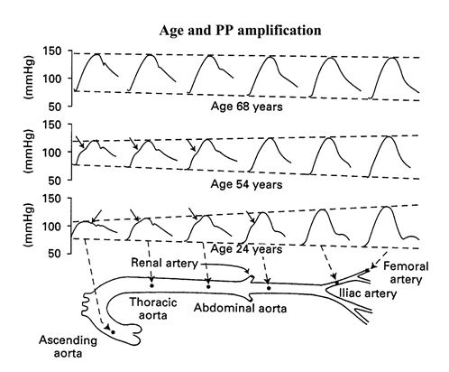
Figure 1 Representative pulse waveforms along the aorta in young, middle-aged and elderly persons. In younger subjects (age: 24 yr), the rate of propagation is relatively low in arterial vessels, which become progressively narrower and less distensible. Because of the summation of the forward and the backward wave at each point of the arterial tree, peak systolic blood pressure (SBP) increases markedly from central to peripheral arteries, while end-diastolic blood pressure (DBP) tends to be reduced and mean arterial pressure (MAP) remains unchanged. In older subjects (age: 68 yr), because of the more rapid propagation of pressure wave with resulting changes in wave reflections, the amplification of PP disappears, making that central and peripheral BP become identical. At 54 yr of age, the situation is intermediate between younger and older subjects^{[2]}.
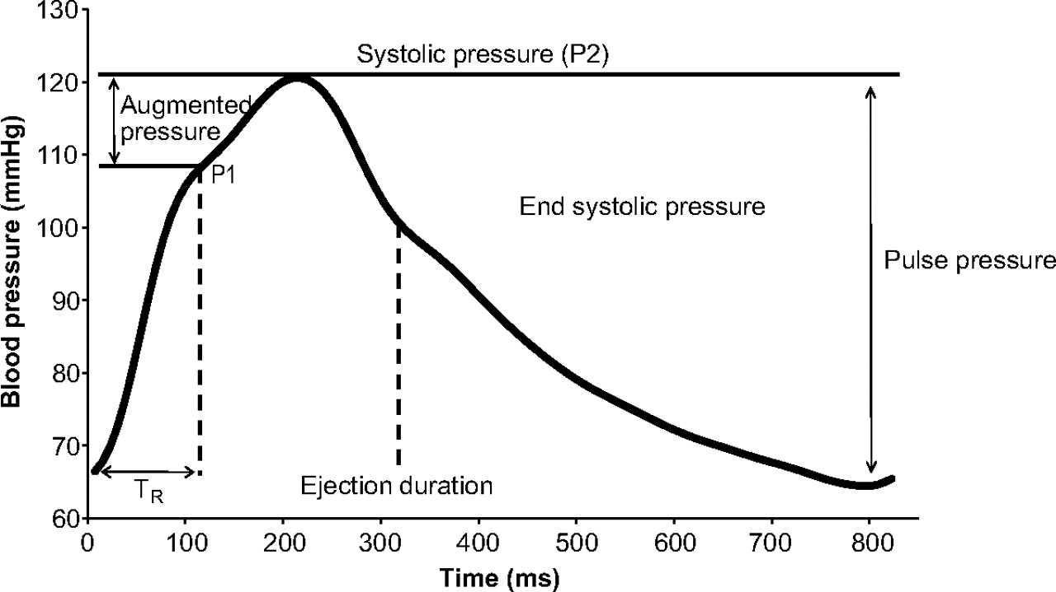
Figure 2 Example central pressure waveform. TR indicates timing of the reflected pressure wave; P1 and P2 represent the first and second systolic peaks, respectively^{[3]}. Augmentation index is defined as augmented pressure/forwarding pulse pressure (P1).
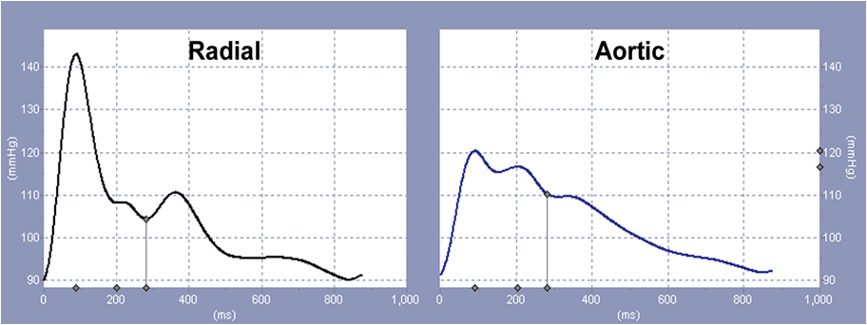
Figure 3 Estimation of central pulse waveform. Radial tonometry detects radial pulse waveform with high systolic blood pressure over 140 mmHg (left panel). Using this radial waveform, generalized transfer function calculates aortic pulse waveform (right panel). Please note that aortic systolic blood pressure is 120 mmHg (http://hogimed.fr/?q=sphyg%20p1).
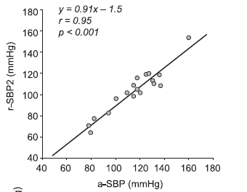
Figure 4 Relationship between radial second peak of systolic blood pressure (r-SBP2) and aortic systolic blood pressure. There is a strong positive relation between two^{[10]}. r-SBP2: Radial second peak of systolic blood pressure; a-SBP: Aortic systolic blood pressure.
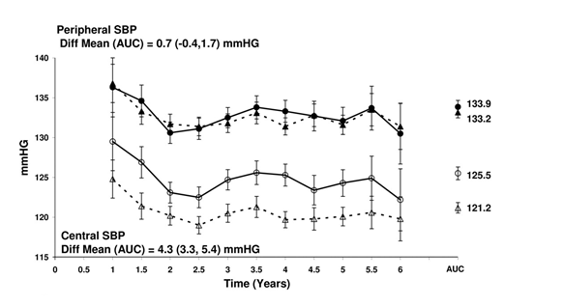
Figure 5 Principal results of ASCOT-CAFÉ study. Brachial blood pressure was similar between the patients treated with beta-blocker-based medication (close circles) and calcium channel blocker-based treatment (closed triangles). However, central blood pressure was higher in the former (open circles) than the latter group (open triangles)^{[11]}.
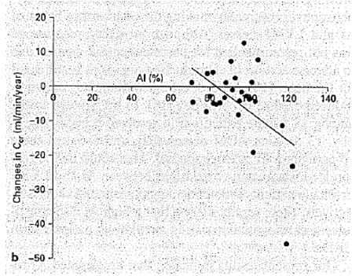
Figure 6 Relationship between annual changes in creatinine clearance and augmentation index. There is an inverse relation between two^{[5]}.
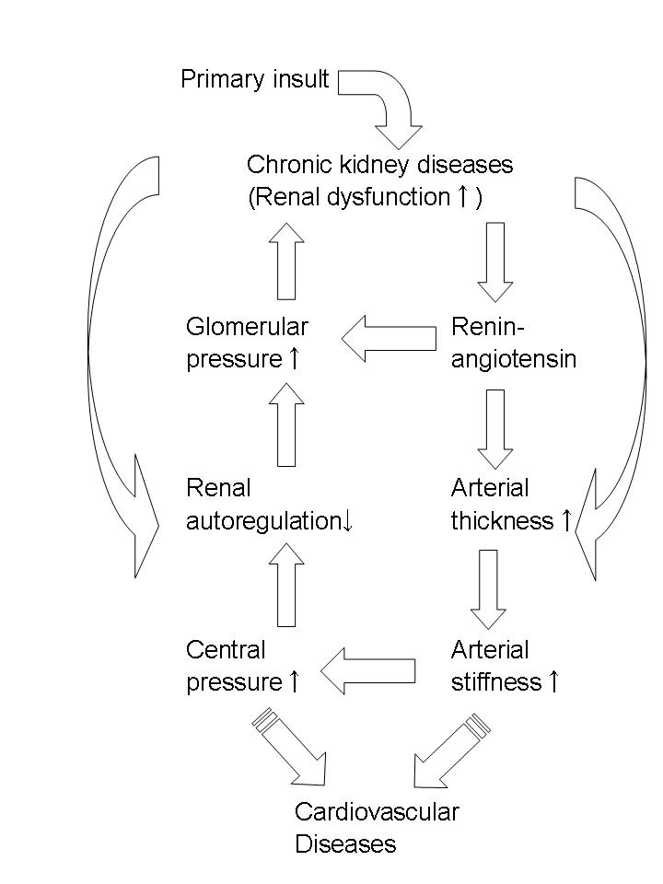
Figure 7 Working hypothesis underlying cardiovascular disease and chronic kidney disease. Lowering central blood pressure could cut vicious cycle between CVD and CKD^{[29]}.
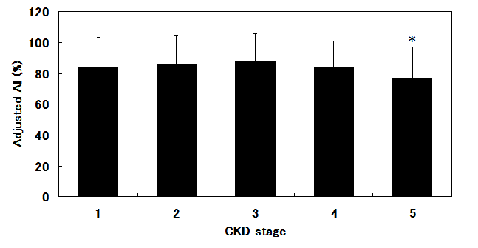
Figure 8 Comparison of augmentation index among all chronic kidney disease stages. AI was adjusted with confounding factors including age, blood pressure, pulse rate, and vasodilator antihypertensive drugs. * indicated significant difference from stage 1^{[37]}.
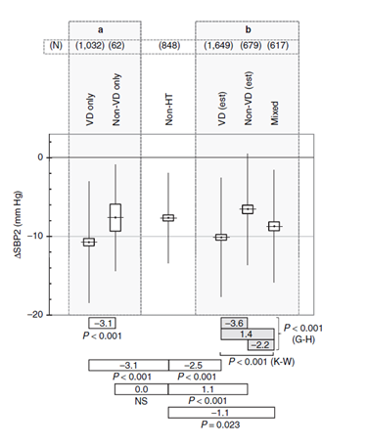
Figure 9 Disparate effects of antihypertensive drugs on central blood pressure. Differences between brachial systolic blood pressure and central systolic blood pressure (△SBP2) were compared between vasodilator (VD) and non-vasosilator (non-VD) antihypertensive medications. △SBP2 was adjusted by age, gender, height, BMI, diastolic blood pressure and use of nitrate. The comparison between actual VD and non-VD only regimen was shown in left panel (A). Right panel (B) depicted comparisons among VD(est), non-VD(est) and Mixed combination of VD and non-VD. “(est)” indicated including data derived from mixed combination, for which the effects of VD and non-VD alone on △SBP2 were estimated. Non-hypertensive population (non-HT) was used as physiological reference for △SBP2. VD antihypertensive drugs included angiotensin receptor blocker, calcium channel blocker, converting enzyme inhibitor and alpha-blocker. Non-VD group includes beta-blocker and diuretics. Mann-Whitney U test was used to compare the means, unless otherwise specified. K-W and G-H described Kruskal-Wallis and Games-Howell multiple comparison test^{[40]}.
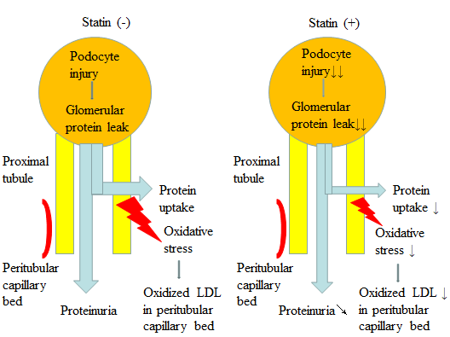
Figure 10 Multiple actions of statin on chronic kidney diseases: Statin decreases proximal tubular uptake of protein leaked from glomeruli, reducing oxidative stress. Statin also improve podocyte injury, reducing glomerular protein leak^{[27]}.

