Name of Journal: World Journal of Gastrointestinal Oncology
Manuscript NO: 74658
Manuscript Type: ORIGINAL ARTICLE

Retrospective Cohort Study
Increased 5-hydroxymethylcytosine is a favorable prognostic factor of Helicobacter pylori-negative gastric cancer patients

Fu YL et al. 5-hydroxymethylcytosine and gastric cancer

Ying-Li Fu, Yan-Hua Wu, Dong-Hui Cao, Zhi-Fang Jia, Ao Shen, Jing Jiang, Xue-Yuan Cao

Ying-Li Fu, Yan-Hua Wu, Dong-Hui Cao, Zhi-Fang Jia, Jing Jiang, Division of Clinical Research, The First Hospital of Jilin University, Changchun 130000, Jilin Province, China

Ao Shen, Xue-Yuan Cao, Department of Gastric and Colorectal Surgery, The First Hospital of Jilin University, Changchun 130000, Jilin Province, China

Author contributions: Cao XY conceived and designed the study; Fu YL and Wu YH conducted data analysis and drafted the manuscript, and they contributed equally to this work; Cao DH, Jia ZF and Shen A collected data and biospecimens on gastric cancer patients; Jiang J measured the level of 5-hmC; All authors approved the final version for submission.

Supported by National Natural Science Foundation of China, No. 81874279; Scientific and Technological Development program of Jilin Province, No. 20190201093JC and No. 20200201326JC; Jilin Province Department of Finance, No. JLSWSRCZX2020-010; and Youth Development Fund from First Hospital of Jilin University, No. JDYY11202021.

Corresponding author: Xue-Yuan Cao, PhD, Professor, Research Scientist, Department of Gastric and Colorectal Surgery, The First Hospital of Jilin University, Xinmin Street, Changchun 130000, Jilin Province, China. jd3d2ub@jlu.edu.cn

Received: January 11, 2022
Revised: March 18, 2022
Accepted: May 28, 2022
Published online: July 15, 2022

Abstract
BACKGROUND
Most gastric cancer (GC) patients are diagnosed at middle or late stage because the symptoms in early stage are obscure, which causes higher mortality rates of GC. Helicobacter pylori (H. pylori) was identified as a class I carcinogen and leads to aberrant DNA methylation/hydroxymethylation. 5-hydroxymethylcytosine (5-hmC) plays complex roles in gene regulation of tumorigenesis and can be considered as an activating epigenetic mark of hydroxymethylation.

AIM
To explore the association between 5-hmC levels and the progression and prognosis of GC patients with or without H. pylori infection.

METHODS
A retrospective cohort study was conducted to estimate the predicted value of 5-hmC level in the progression and prognosis of GC patients with different H. pylori infection status. A total of 144 GC patients were recruited.

RESULTS
The levels of 5-hmC were significantly decreased in tumor tissues (0.076 ± 0.048) compared with the matched control tissues (0.110 ± 0.057, P = 0.001). A high level of 5-hmC was an independent significant favorable predictor of overall survival in GC patients (hazard ratio = 0.61, 95% confidence interval: 0.38-0.98, P = 0.040), the H. pylori-negative GC subgroup (hazard ratio = 0.30, 95% confidence interval: 0.13-0.68, P = 0.004) and the GC patients with TNM stage Ⅰ or Ⅱ (hazard ratio = 0.32, 95% confidence interval: 0.13-0.77, P = 0.011).

CONCLUSION
Increased 5-hmC is a favorable prognostic factor in GC, especially for H. pylori-negative subgroups.

Key Words: 5-hydroxymethylation; 5-hydroxymethylcytosine; Helicobacter pylori; Gastric cancer; Prognosis

©The Author(s) 2022. Published by Baishideng Publishing Group Inc. All rights reserved.

Citation: Fu YL, Wu YH, Cao DH, Jia ZF, Shen A, Jiang J, Cao XY. Increased 5-hydroxymethylcytosine is a favorable prognostic factor of Helicobacter pylori-negative gastric cancer patients. World J Gastrointest Oncol 2022; 14(7): 1295-1306
URL: https://www.wjgnet.com/1948-5204/full/v14/i7/1295.htm
DOI: https://dx.doi.org/10.4251/wjgo.v14.i7.1295

Core Tip: Helicobacter pylori (H. pylori) was identified as a class I carcinogen and leads to aberrant DNA methylation/hydroxymethylation. 5-hydroxymethylcytosine plays complex roles in the gene regulation of tumorigenesis and is considered an activating epigenetic mark of hydroxymethylation. We conducted a retrospective cohort study to estimate the predictive value of 5-hydroxymethylcytosine levels in the progression and prognosis of gastric cancer patients with different H. pylori infection statuses. The results indicated that increasing 5-hydroxymethylcytosine is a favorable prognostic factor in gastric cancer patients who were not infected with H. pylori, but no associations were observed in H. pylori-positive gastric cancer patients.

INTRODUCTION
Gastric cancer (GC) is a serious disease with over 1 million estimated new cases annually around the world, and it is the fifth most diagnosed malignancy worldwide^{[1]}. Due to the symptoms in early stage being obscure, most GC patients are diagnosed at middle or late stage, which causes higher mortality rates, and accounted for 769000 deaths globally in 2020^{[1]}.
Recent comprehensive analyses showed that many GC-related pathways are more frequently altered by aberrant DNA methylation than by mutations^{[2]}, and the degree of accumulation of aberrant DNA methylation is highly correlated with GC risk^{[3,4]}.
Helicobacter pylori (H. pylori) was identified as a class I carcinogen leading to gastric adenocarcinoma by the World Health Organization^{[5]}. H. pylori-induced chronic inflammation plays a direct role in the induction of aberrant DNA methylation. The methylation level in an H. pylori-positive group was 2.5-34.1 times higher than a negative group. H. pylori eradication leads to a decrease in DNA methylation levels^{[6,7]}.
A promising method to reverse the progression of GC is effective demethylation treatment. The passive demethylation agents (5-azacytidine/decitabine), which relies on DNA methyltransferase, are not effective in the treatment of solid tumors and have serious side effects. A newly proposed classical active demethylation process involves oxidizing 5-methylcytosine to 5-hydroxymethylcytosine (5-hmC) and further downstream products by the ten-eleven translocation (TET) family. The median product, 5-hmC, is considered an activating epigenetic marker, and it plays complex roles in gene regulation of tumorigenesis^{[8-10]}. Significant reductions in 5-hmC levels have been found in hematological malignancies, such as breast cancer, colon cancer, prostate cancer and melanoma. A few small size studies analyzed the association between 5-hmC levels and GC, but the evidence is still lacking^{[11,12]}, especially for the H. pylori-induced GC.
In the current study, we explored the level of 5-hmC and H. pylori infection in a relatively large scale GC patient cohort to assess the association between 5-hmC level and the malignant progression of the tumor and the overall survival of GC patients with different H. pylori infection status.

MATERIALS AND METHODS
Ethics statement
This study was approved by the Institutional Review Board of the First Hospital of Jilin University. All participants provided written informed consent prior to joining the study.

Study population
A total of 158 patients with histologically diagnosed GC who underwent radical gastrectomy at the Department of Gastric and Colorectal Surgery in the First Hospital of Jilin University (Changchun, China) during 2007 to 2017 were recruited in this cohort study. For each patient, 5 mL of peripheral blood before surgery and 0.5 cm³ of tumor tissue were collected. Among the patients, 38 specimens of 0.5 cm³ adjacent tissue were collected during the operation. All patients did not undergo chemotherapy or radiotherapy before surgery. Demographic information (sex, age) and principal clinical pathological information (histological grade, TNM stage, tumor size, neural invasion, vascular invasion, etc.) were collected. The tumor histological grade was evaluated by the World Health Organization criteria. TNM stages were classified according to the 8th edition of the TNM staging system of the Union for International Cancer Control/American Joint Committee on Cancer (2017). Patients with the following conditions were excluded from this study: (1) patients with distant metastasis or a positive surgical margin; (2) patients who died due to complications of the surgical procedure during the perioperative period; and (3) patients who were lost at the first time of interview.

Follow-up
Follow-up for all patients was implemented at 3 mo, 6 mo, 12 mo and annually afterwards until death or the end of the follow-up. Information on general status and postoperative chemotherapy were collected during each follow-up. If the patients had died, the date of death and potential cause were recorded. The duration from the date of surgery to the date of death or the last successful interview date was defined as the survival time. If the patient was lost to follow-up, survival time was defined as the duration from the date of surgery to the date of the last successful interview.

5-hmC quantification and test for H. pylori infection
The genomic DNA from primary tumors and paired noncancerous mucosa tissues were extracted using a QIAamp DNA Mini Kit (Qiagen, Hilden, Germany) according to the manufacturer’s instructions. The 5-hmC content of genomic DNA was determined with a Quest 5-hmC DNA enzyme-linked immunosorbent assay (ELISA) Kit (Zymo Research, Irvine, CA, United States) according to the manufacturer’s instructions. Assays were performed using 4 μg/mL anti-5-hmC polyclonal antibodies, loading 200 ng of DNA per well. Absorbance at 405 nm was evaluated using a SynergyH1 microplate reader and Gen5 software (BioTek, Winooski, VT, United States). The amount of 5-hmC was calculated as a percentage based on a standard curve generated using kit controls and the median value was used as the cutoff of 5-hmC level category. Values above the median value were considered to be the 5-hmC high group (≥ 0.106%), and those below the median value were considered the 5-hmC low group (< 0.106%).
A commercial ELISA kit for H. pylori immunoglobulin G (Biohit, Helsinki, Finland) was used to detect the serum H. pylori immunoglobulin G antibodies. The antibody titers were quantified by optical density readings according to the manufacturer’s protocol, and titers higher than the threshold value of 30 EIU were considered as positive for H. pylori infection.

Statistical analysis
Continuous variables that followed a normal distribution were shown as the mean ± standard deviation. Independent samples were compared by two-sample t-test, and matched-paired samples were compared by paired t-test. Categorical variables were presented as frequencies with percentages and were compared with the χ² test or Fisher’s exact test when appropriate.
Survival curves within each stratification of variables were plotted by the Kaplan-Meier method and compared by log-rank test. The forward stepwise multivariate Cox proportional hazard model was used to evaluate the prognostic role of clinical characteristics and 5-hmC level. Hazard ratios (HRs) with their 95% confidence intervals (Cis) were calculated. All analyses were conducted with the SPSS program (version 21.0; IBM Corp., Armonk, NY, United States) or GraphPad Prism 5.0 (La Jolla, CA, United States). A two-tailed P value < 0.05 indicated statistical significance.

RESULTS
In the present study, 144 GC patients were involved for the final prognostic analysis and were followed up until August 2021. The median survival time was 73.59 mo. During the follow-up period, 75 (52.1%) patients died, 68 (47.2%) patients remained alive, and 1 (0.7%) patient was lost to follow-up (Figure 1).
Among the 38 paired tissues, the 5-hmC levels were significantly reduced in tumor tissues (0.076 ± 0.048) compared with the matched control tissues (0.110 ± 0.057, P = 0.001) (Figure 2A).
Among the 144 subjects, there were 99 (68.7%) males, and the median age was 62.82 (range 39–90) years old. The mean 5-hmC level of the 144 GC patients was 0.104 ± 0.062. We investigated possible correlations between 5-hmC levels and general demographic characteristics/routine clinicopathological parameters in the GC patients. The TNM stages (P = 0.012), neural invasion (P = 0.008), age (P = 0.008) and H. pylori infection (P = 0.049) were associated with 5-hmC level. Details were shown in Table 1.
For the 144 GC patients, the results of H. pylori infection examination showed that 89 (61.8%) subjects were positive and 55 (38.2%) subjects were negative. We compared the 5-hmC level between H. pylori-positive infection and H. pylori-negative infection groups. It showed that the 5-hmC level was reduced in the H. pylori-positive group, but the P value was at the boundary of significance (P = 0.067, Figure 2B).
We further investigated the association between 5-hmC level and characteristics stratified by H. pylori infection status. We found that 5-hmC levels were higher in patients aged more than 60 years (P = 0.009), with neural invasion positive (P = 0.002), with low histological grade (P = 0.042) or with later TNM stage (P = 0.012) in the H. pylori-positive subset, but no significant associations were observed in the H. pylori-negative subset except sex (Table 2).
Overall survival analyses were performed in total patients and patient stratification by H. pylori infection status or TNM stage. The results of the Kaplan-Meier analysis showed that the 5-hmC level was not associated with overall survival in total patients or H. pylori-negative or positive groups (log rank P values were 0.406, 0.094 and 0.763, respectively, Figure 3A-C). Furthermore, the 5hmC high level was associated with longer overall survival time compared with the 5hmC low group in the TNM stage Ⅰ and Ⅱ subgroup, and log rank test showed the survival curves were significantly different (log rank P = 0.037, Figure 3D), but the association was not significant in the TNM stage Ⅲ subgroup (log rank P = 0.547, Figure 3E).
In the full patient set, 5-hmC high level was a significant favorable predictor of overall survival in multivariate Cox regression analysis (HR = 0.61, 95%CI: 0.38-0.98, P = 0.040) after adjustment for tumor size, histological grade and TNM stage (Table 3).
Multivariate Cox regression analysis for overall survival was also performed in GC patients stratified by H. pylori infection status or TNM stage. In the H. pylori-negative GC subgroup, increased 5-hmC level was a favorable prognostic factor in the multivariate Cox regression analysis (HR = 0.30, 95%CI: 0.13-0.68, P = 0.004) (Table 4), which indicated that higher 5-hmC level was an independent significant protective factor of overall survival time in patients without H. pylori infection. However, within the H. pylori-positive group, we did not observe any significant association between 5-hmC level and GC patient prognosis.
Among patients with TNM stage I or II, increased 5-hmC level was associated with favorable prognosis after adjustment for sex in the multivariate Cox regression analysis (HR = 0.32, 95%CI: 0.13-0.77, P = 0.011). However, no significant association was observed between 5-hmC level and the prognosis in patients with TNM stage Ⅲ (Table 5).

DISCUSSION
Long-time H. pylori infection leads to chronic inflammation and further aberrant DNA methylation, which plays an important role in tumorigenesis of GC. The global prevalence of H. pylori reported by a meta-analysis across individual countries varied from 18.9% to 87.7%, and the prevalence in China was 55.8% (95%CI: 51.8%-59.9%)^{[13]}. Among our 144 GC patients, 89 (61.8%) patients were defined as H. pylori-positive by ELISA. The infection rate was slightly higher than the prevalence in the general Chinese population but was similar to the previously reported prevalence in GC patients^{[14,15]}, indicating that our study cohort was representative.
DNA methylation/hydroxymethylation is one of the most widely studied epigenetic modifications and has been shown to play significant roles in tumorigenesis and prognosis^{[16]}. Previous studies have shown that aberrant DNA methylation is a common event and a strong candidate mechanism for early nongenetic alterations in GC^{[17]}. Nevertheless, the reports of DNA hydroxymethylation and GC are limited to several small studies.
We estimated the 5-hmC level with an absolutely quantitative method ELISA, which is more objective than the semi-quantitative evaluation system of immunohistochemistry. The results showed that the 5-hmC level was downregulated in GC tissues compared with matched control tissues, which revealed that it was associated with the occurrence of GC and is consistent with previous reports^{[18]}. Although some evidence has emerged about the potential progression and prognostic implications of 5-hmC level in GC^{[12]}, very few studies have evaluated the association stratified by H. pylori infection status. The present study was performed on a well-characterized cohort to simultaneously evaluate the level of 5-hmC in GC patients and subsets stratified by H. pylori infection to assess the association between 5-hmC levels and the susceptibility or prognosis of GC in order to provide more evidence for the effect of H. pylori-infection DNA hydroxymethylation on GC.
The 5-hmC level was slightly decreased in the H. pylori-positive subset compared to the H. pylori-negative group in our study. It is hypothesized that H. pylori infection affects TET1 expression in normal gastric epithelial cells and reduces the genome hydroxymethylation level^{[19]}. Interestingly, higher global 5-hmC levels were associated with GC progression in the H. pylori-positive subset. A similar phenomenon was reported that the 5-hmC level in ERG- prostate cancer patients was lower than ERG+ patients, but a higher 5hmC level was associated with tumor progression in ERG- prostate cancer patients^{[20]}. This could be explained by cells responding to hypoxia inducing a transcriptional program regulated by the TET family. Hypoxia together with reactive oxygen species increase global 5-hmC levels by transcriptional activation of TET1^{[21,22]}. H. pylori infection induced the expression of hypoxia-inducible factor^{[23]}, which is required for hypoxic induction of TET1 and global increase of 5-hmC. The proliferation rate of H. pylori under aerobic conditions was 3-fold higher than under microaerophilic conditions, and the bacterial growth was more dependent on carbon dioxide than on oxygen^{[24]}.
This interesting phenomenon and potential mechanism suggested to us that the 5-hmC level changed due to H. pylori infection and was not simply one direction but complicated. Therefore, it was essential to assess the association between 5-hmC and the prognosis of GC patients in negative or positive H. pylori infection. Our results first showed that reduced 5-hmC was associated with poor prognosis in all GC patients, which was consistent with previous studies^{[11,12]}. Furthermore, in H. pylori-negative GC patients, the 5-hmC level was a significant predictor of prognosis, independent of routine clinicopathological factors. But in contrast, 5-hmC had no prediction value of prognosis in H. pylori-positive GC patients. These results highlight the importance of H. pylori stratification in GC biomarker studies. Similarly to our results, the study conducted in prostate cancer patients also showed that the prognostic predictor value of 5-hmC was discrepant in ERG- and ERG+ prostate cancer patients^{[20]}. Together with our results, it supports potential prognostic implications of 5-hmC as cancer subtype-specific.
In this study, the association between 5-hmC level and the prognosis of GC patients was not significant in the Kaplan-Meier analysis, which could not be adjusted for potential confounders. However, it showed significant association in the multivariate Cox regression after the confounders such as TNM stage were adjusted. This indicated that the clinical characteristics such as TNM stage (which is strongly associated with the prognosis of GC patients) confused the relationship between 5-hmC level and the prognosis. This conclusion was further supported by the Cox regression results of TNM stage stratified analysis.
Several limitations should be mentioned of the present study. First, our study was based at a single center. The prognostic value of 5-hmC in H. pylori-negative but not positive GC patients’ needs to be validated in larger and multicenter GC patient cohorts. Another limitation of our study is the lack of data of 5-methylcytosine and enzymes related to 5-hmC regulation for our sample set. Thus, we have not investigated the correlation between them, which should be investigated in future studies.

CONCLUSION
5-hmC level was a significant predictor of the prognosis of GC patients without H. pylori infection, independent of routine clinicopathological factors.

ARTICLE HIGHLIGHTS
Research background
Most gastric cancer (GC) patients are diagnosed at middle or late stage because the symptoms in early stage are obscure, which causes higher mortality rates of GC. Analyses show that aberrant DNA methylation is highly correlated with GC risk. Helicobacter pylori (H. pylori) was identified as a class I carcinogen leading to gastric adenocarcinoma, and H. pylori-induced chronic inflammation plays a direct role in the induction of aberrant DNA methylation. The median demethylation product 5-hydroxymethylcytosine (5-hmC) is considered as an activating epigenetic marker, and it plays complex roles in gene regulation of tumorigenesis.

Research motivation
A few small studies analyzed the association between 5-hmC levels and GC, but the evidence is lacking, especially for H. pylori-induced GC.

Research objectives
Exploring the association between 5-hmC level and the progression and prognosis of GC patients with or without H. pylori infection.

Research methods
This was a retrospective cohort study to estimate the predicted value of 5-hmC level in the progression and prognosis of GC patients with different H. pylori infection status.

Research results
A high level of 5-hmC was an independent significant favorable predictor of overall survival in the entire GC patient cohort (hazard ratio = 0.61, 95% confidence interval: 0.38-0.98, P = 0.040), the H. pylori-negative GC subgroup (hazard ratio = 0.30, 95% confidence interval: 0.13-0.68, P = 0.004) and GC patients with early TNM stage (hazard ratio = 0.32, 95% confidence interval: 0.13-0.77, P = 0.011).

Research conclusions
5-hmC level was a significant predictor of the prognosis of GC patients without H. pylori infection.

Research perspectives
A large-scale GC patient cohort to assess the association between the level of 5-hmC and the prognosis of GC patients, especially for different H. pylori infection status, should be conducted.

ACKNOWLEDGEMENTS
We are grateful to all sample donors and the research assistants who helped with sample collection.

REFERENCES
1 Sung H, Ferlay J, Siegel RL, Laversanne M, Soerjomataram I, Jemal A, Bray F. Global Cancer Statistics 2020: GLOBOCAN Estimates of Incidence and Mortality Worldwide for 36 Cancers in 185 Countries. CA Cancer J Clin 2021; 71: 209-249 [PMID: 33538338 DOI: 10.3322/caac.21660]
2 Wang K, Yuen ST, Xu J, Lee SP, Yan HH, Shi ST, Siu HC, Deng S, Chu KM, Law S, Chan KH, Chan AS, Tsui WY, Ho SL, Chan AK, Man JL, Foglizzo V, Ng MK, Chan AS, Ching YP, Cheng GH, Xie T, Fernandez J, Li VS, Clevers H, Rejto PA, Mao M, Leung SY. Whole-genome sequencing and comprehensive molecular profiling identify new driver mutations in gastric cancer. Nat Genet 2014; 46: 573-582 [PMID: 24816253 DOI: 10.1038/ng.2983]
3 Nakajima T, Maekita T, Oda I, Gotoda T, Yamamoto S, Umemura S, Ichinose M, Sugimura T, Ushijima T, Saito D. Higher methylation levels in gastric mucosae significantly correlate with higher risk of gastric cancers. Cancer Epidemiol Biomarkers Prev 2006; 15: 2317-2321 [PMID: 17119066 DOI: 10.1158/1055-9965.epi-06-0436]
4 Maekita T, Nakazawa K, Mihara M, Nakajima T, Yanaoka K, Iguchi M, Arii K, Kaneda A, Tsukamoto T, Tatematsu M, Tamura G, Saito D, Sugimura T, Ichinose M, Ushijima T. High levels of aberrant DNA methylation in Helicobacter pylori-infected gastric mucosae and its possible association with gastric cancer risk. Clin Cancer Res 2006; 12: 989-995 [PMID: 16467114 DOI: 10.1158/1078-0432.ccr-05-2096]
5 Parsonnet J, Friedman GD, Vandersteen DP, Chang Y, Vogelman JH, Orentreich N, Sibley RK. Helicobacter pylori infection and the risk of gastric carcinoma. N Engl J Med 1991; 325: 1127-1131 [PMID: 1891020 DOI: 10.1056/nejm199110173251603]
6 Shimazu T, Asada K, Charvat H, Kusano C, Otake Y, Kakugawa Y, Watanabe H, Gotoda T, Ushijima T, Tsugane S. Association of gastric cancer risk factors with DNA methylation levels in gastric mucosa of healthy Japanese: a cross-sectional study. Carcinogenesis 2015; 36: 1291-1298 [PMID: 26354778 DOI: 10.1093/carcin/bgv125]
7 Nakajima T, Enomoto S, Yamashita S, Ando T, Nakanishi Y, Nakazawa K, Oda I, Gotoda T, Ushijima T. Persistence of a component of DNA methylation in gastric mucosae after Helicobacter pylori eradication. J Gastroenterol 2010; 45: 37-44 [PMID: 19821005 DOI: 10.1007/s00535-009-0142-7]
8 Song CX, Yi C, He C. Mapping recently identified nucleotide variants in the genome and transcriptome. Nat Biotechnol 2012; 30: 1107-1116 [PMID: 23138310 DOI: 10.1038/nbt.2398]
9 Mellén M, Ayata P, Dewell S, Kriaucionis S, Heintz N. MeCP2 binds to 5hmC enriched within active genes and accessible chromatin in the nervous system. Cell 2012; 151: 1417-1430 [PMID: 23260135 DOI: 10.1016/j.cell.2012.11.022]
10 Thomson JP, Lempiäinen H, Hackett JA, Nestor CE, Müller A, Bolognani F, Oakeley EJ, Schübeler D, Terranova R, Reinhardt D, Moggs JG, Meehan RR. Non-genotoxic carcinogen exposure induces defined changes in the 5-hydroxymethylome. Genome Biol 2012; 13: R93 [PMID: 23034186 DOI: 10.1186/gb-2012-13-10-r93]
11 Park JL, Kim HJ, Seo EH, Kwon OH, Lim B, Kim M, Kim SY, Song KS, Kang GH, Kim HJ, Choi BY, Kim YS. Decrease of 5hmC in gastric cancers is associated with TET1 silencing due to with DNA methylation and bivalent histone marks at TET1 CpG island 3'-shore. Oncotarget 2015; 6: 37647-37662 [PMID: 26462176 DOI: 10.18632/oncotarget.6069]
12 Yang Q, Wu K, Ji M, Jin W, He N, Shi B, Hou P. Decreased 5-hydroxymethylcytosine (5-hmC) is an independent poor prognostic factor in gastric cancer patients. J Biomed Nanotechnol 2013; 9: 1607-1616 [PMID: 23980508 DOI: 10.1166/jbn.2013.1713]
13 Hooi JKY, Lai WY, Ng WK, Suen MMY, Underwood FE, Tanyingoh D, Malfertheiner P, Graham DY, Wong VWS, Wu JCY, Chan FKL, Sung JJY, Kaplan GG, Ng SC. Global Prevalence of Helicobacter pylori Infection: Systematic Review and Meta-Analysis. Gastroenterology 2017; 153: 420-429 [PMID: 28456631 DOI: 10.1053/j.gastro.2017.04.022]
14 Alipour M. Molecular Mechanism of Helicobacter pylori-Induced Gastric Cancer. J Gastrointest Cancer 2021; 52: 23-30 [PMID: 32926335 DOI: 10.1007/s12029-020-00518-5]
15 Elzouki AN, Buhjab SI, Alkialani A, Habel S, Sasco AJ. Gastric cancer and Helicobacter pylori infection in the eastern Libya: a descriptive epidemiological study. Arab J Gastroenterol 2012; 13: 85-88 [PMID: 22980598 DOI: 10.1016/j.ajg.2012.06.002]
16 Flavahan WA, Gaskell E, Bernstein BE. Epigenetic plasticity and the hallmarks of cancer. Science 2017; 357 [PMID: 28729483 DOI: 10.1126/science.aal2380]
17 Do C, Shearer A, Suzuki M, Terry MB, Gelernter J, Greally JM, Tycko B. Genetic-epigenetic interactions in cis: a major focus in the post-GWAS era. Genome Biol 2017; 18: 120 [PMID: 28629478 DOI: 10.1186/s13059-017-1250-y]
18 Liu H, Xu T, Cheng Y, Jin MH, Chang MY, Shu Q, Allen EG, Jin P, Wang X. Altered 5-Hydroxymethylcytosine Landscape in Primary Gastric Adenocarcinoma. DNA Cell Biol 2019; 38: 1460-1469 [PMID: 31657619 DOI: 10.1089/dna.2019.4965]
19 Zhao R, Liu Z, Xu W, Song L, Ren H, Ou Y, Liu Y, Wang S. Helicobacter pylori infection leads to KLF4 inactivation in gastric cancer through a TET1-mediated DNA methylation mechanism. Cancer Med 2020; 9: 2551-2563 [PMID: 32017451 DOI: 10.1002/cam4.2892]
20 Strand SH, Hoyer S, Lynnerup AS, Haldrup C, Storebjerg TM, Borre M, Orntoft TF, Sorensen KD. High levels of 5-hydroxymethylcytosine (5hmC) is an adverse predictor of biochemical recurrence after prostatectomy in ERG-negative prostate cancer. Clin Epigenetics 2015; 7: 111 [PMID: 26478752 DOI: 10.1186/s13148-015-0146-5]
21 Mariani CJ, Vasanthakumar A, Madzo J, Yesilkanal A, Bhagat T, Yu Y, Bhattacharyya S, Wenger RH, Cohn SL, Nanduri J, Verma A, Prabhakar NR, Godley LA. TET1-mediated hydroxymethylation facilitates hypoxic gene induction in neuroblastoma. Cell Rep 2014; 7: 1343-1352 [PMID: 24835990 DOI: 10.1016/j.celrep.2014.04.040]
22 Tsai YP, Chen HF, Chen SY, Cheng WC, Wang HW, Shen ZJ, Song C, Teng SC, He C, Wu KJ. TET1 regulates hypoxia-induced epithelial-mesenchymal transition by acting as a co-activator. Genome Biol 2014; 15: 513 [PMID: 25517638 DOI: 10.1186/s13059-014-0513-0]
23 Valenzuela-Valderrama M, Cerda-Opazo P, Backert S, González MF, Carrasco-Véliz N, Jorquera-Cordero C, Wehinger S, Canales J, Bravo D, Quest AFG. The Helicobacter pylori Urease Virulence Factor Is Required for the Induction of Hypoxia-Induced Factor-1α in Gastric Cells. Cancers (Basel) 2019; 11 [PMID: 31185594 DOI: 10.3390/cancers11060799]
24 Abass A, Okano T, Boonyaleka K, Kinoshita-Daitoku R, Yamaoka S, Ashida H, Suzuki T. Effect of low oxygen concentration on activation of inflammation by Helicobacter pylori. Biochem Biophys Res Commun 2021; 560: 179-185 [PMID: 34000467 DOI: 10.1016/j.bbrc.2021.04.123]

Footnotes
Institutional review board statement: This study was approved by the First Hospital of Jilin University Institutional Review Board (Approval No.2021-493).

Informed consent statement: Patients were not required to give informed consent to the study because the analysis used anonymous clinical data that were obtained after each patient agreed to treatment by written consent.

Conflict-of-interest statement: All authors declared no competing financial interests.

Data sharing statement: Technical appendix, statistical code, and dataset available from the corresponding author at email jd3d2ub@jlu.edu.cn.

STROBE statement: The authors have read the STROBE Statement—checklist of items, and the manuscript was prepared and revised according to the STROBE Statement—checklist of items.

Open-Access: This article is an open-access article that was selected by an in-house editor and fully peer-reviewed by external reviewers. It is distributed in accordance with the Creative Commons Attribution NonCommercial (CC BY-NC 4.0) license, which permits others to distribute, remix, adapt, build upon this work non-commercially, and license their derivative works on different terms, provided the original work is properly cited and the use is non-commercial. See: https://creativecommons.org/Licenses/by-nc/4.0/

Provenance and peer review: Unsolicited article; Externally peer reviewed.
Peer-review model: Single blind

Peer-review started: January 11, 2022
First decision: March 13, 2022
Article in press: May 28, 2022

Specialty type: Gastroenterology and hepatology
Country/Territory of origin: China
Peer-review report’s scientific quality classification
Grade A (Excellent): A
Grade B (Very good): B
Grade C (Good): 0
Grade D (Fair): 0
Grade E (Poor): 0

P-Reviewer: Jeong SH, South Korea; Kirkik D, Turkey A-Editor: Zhu JQ, China S-Editor: Ma YJ L-Editor: Filipodia P-Editor: Ma YJ

Figure Legends
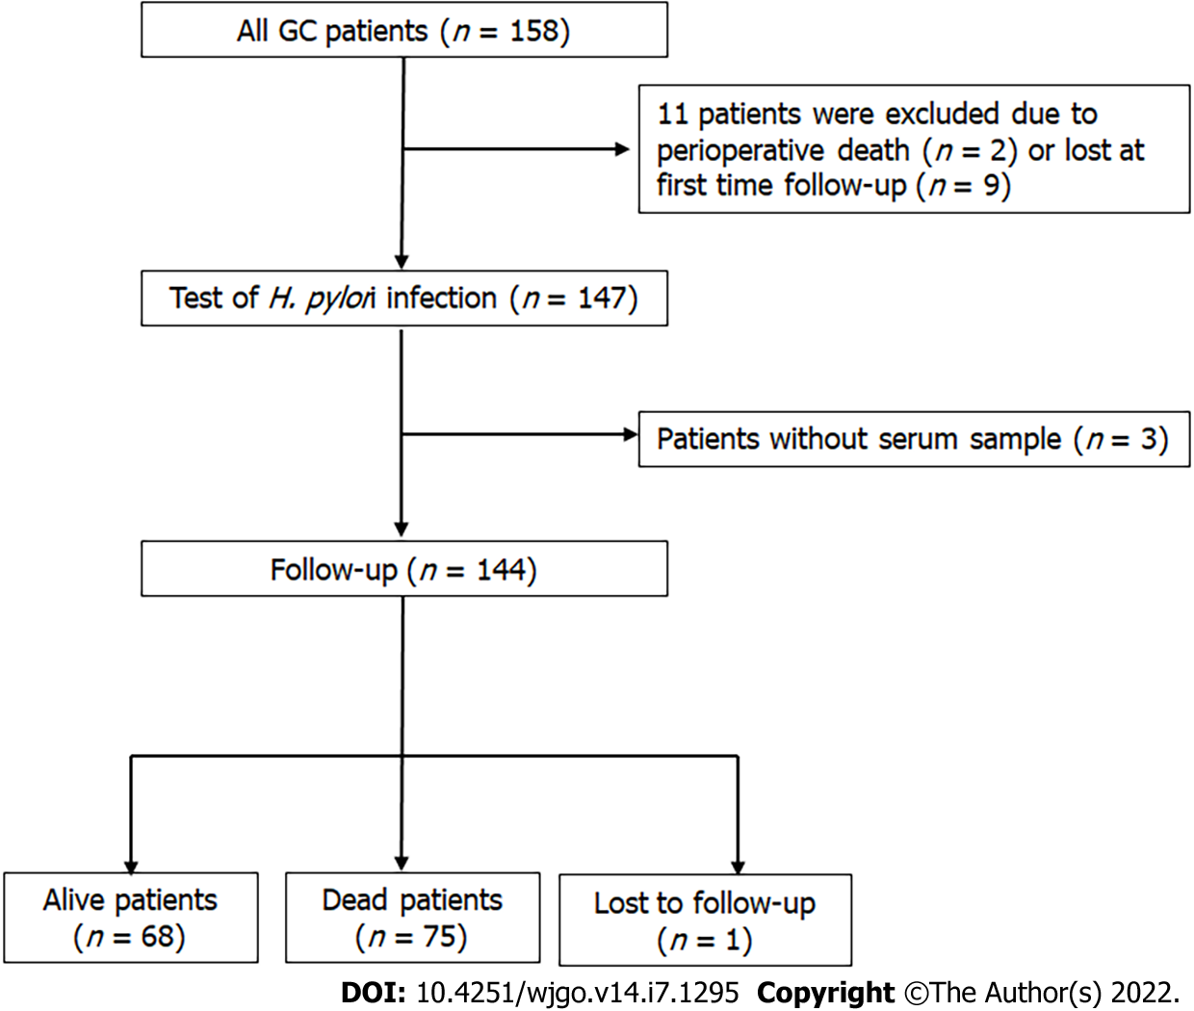
Figure 1 Flow chart of the subjects enrolled. GC: gastric cancer; H. pylori: Helicobacter pylori.

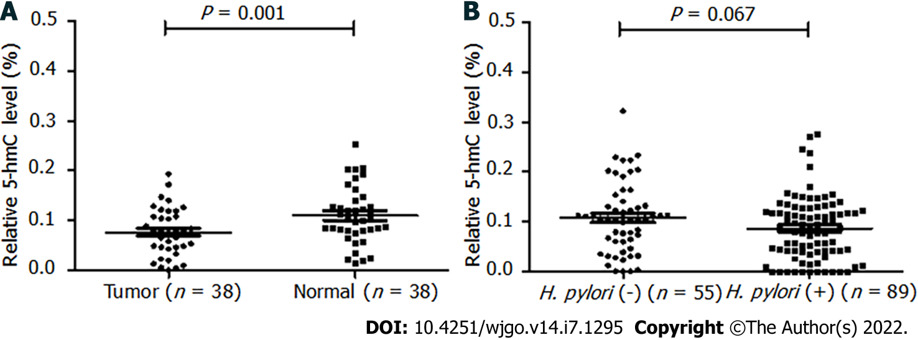
Figure 2 5-hydroxymethylcytosine level measurement compared between tumor vs control tissues and Helicobacter pylori-negative vs positive subgroups. A: tumor vs control tissues; B: Helicobacter pylori -negative vs positive subgroups. 5-hmC: 5-hydroxymethylcytosine.

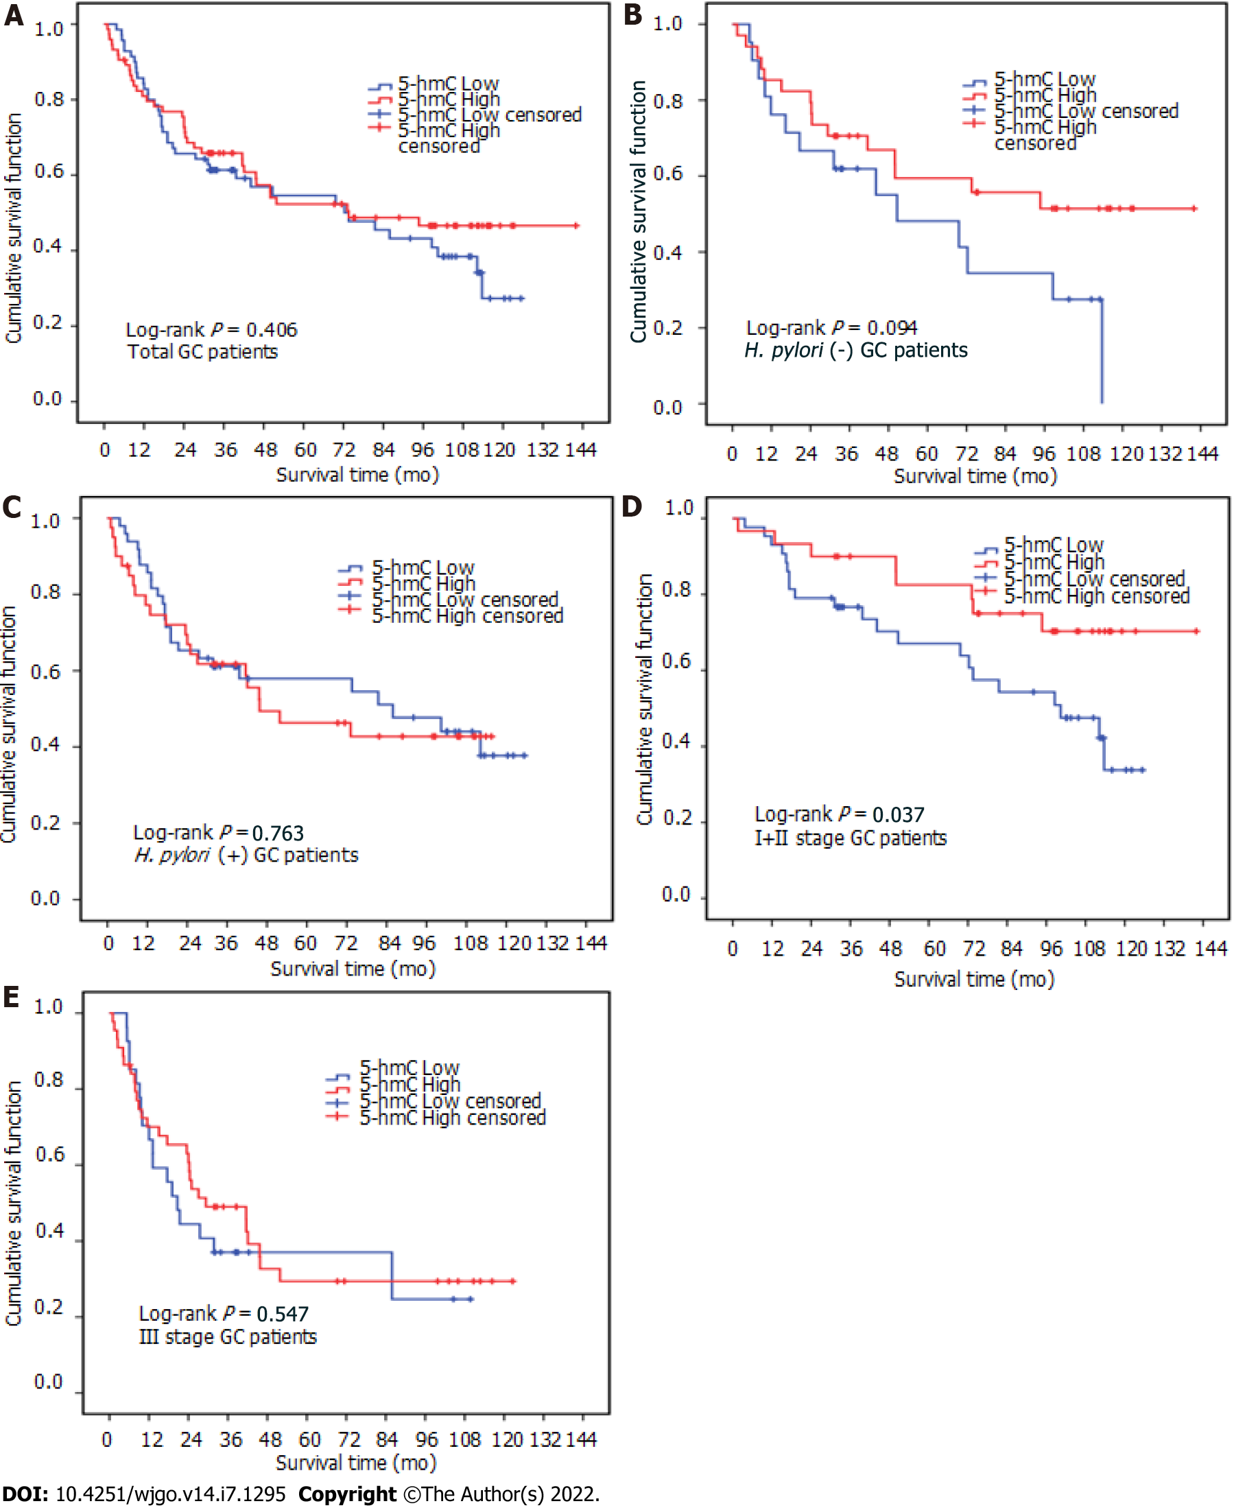
Figure 3 Kaplan–Meier estimates of overall survival in gastric cancer patients. A: total gastric cancer (GC) patients; B: GC patients with negative Helicobacter pylori (H. pylori) infection; C: GC patients with positive H. pylori infection; D: GC patients with Ⅰ or Ⅱ TNM stage; E: GC patients with Ⅲ TNM stage. 5-hmC: 5-hydroxymethylation.
Table 1 5-hydroxymethylcytosine levels between different characteristics, n = 144
Characteristics | Total, n (%) | 5-hmC low, n (%) | 5-hmC high, n (%) | P value
Sex
Male | 45 (31.3) | 17 (24.3) | 28 (37.8) | 0.079
Female | 99 (68.7) | 53 (75.7) | 46 (62.2)
Age in yr
< 60 | 56 (38.9) | 35 (50.0) | 21 (28.4) | 0.008
≥ 60 | 88 (61.1) | 35 (50.0) | 53 (71.6)
Histological grade
Low | 106 (73.6) | 47 (67.1) | 59 (79.7) | 0.087
High | 38 (26.4) | 23 (32.9) | 15 (20.3)
WHO Classification
Tubular adenocarcinoma | 115 (79.9) | 55 (78.6) | 60 (81.1) | 0.707
Others | 29 (20.1) | 15 (21.4) | 14 (18.9)
Tumor size in cm
< 5 | 62 (43.1) | 32 (45.7) | 30 (40.5) | 0.531
≥ 5 | 82 (56.9) | 38 (54.3) | 44 (59.5)
Vascular invasion
Negative | 39 (27.1) | 23 (32.9) | 16 (21.6) | 0.129
Positive | 105 (72.9) | 47 (67.1) | 58 (78.4)
Neural invasion
Negative | 64 (44.4) | 39 (55.7) | 25 (33.8) | 0.008
Positive | 80 (55.6) | 31 (44.3) | 49 (66.2)
Depth of invasion
T1/T2 | 54 (37.5) | 30 (42.9) | 24 (32.4) | 0.197
T3/T4 | 90 (62.5) | 40 (57.1) | 50 (67.6)
Lymph metastasis
N0 | 41 (28.5) | 24 (34.3) | 17 (23.0) | 0.133
N1/N2/N3 | 103 (71.5) | 46 (65.7) | 57 (77.0)
TNM stage
Ⅰ + Ⅱ | 73 (50.7) | 43 (61.4) | 30 (40.5) | 0.012
Ⅲ | 71 (49.3) | 27 (38.6) | 44 (59.5)
Chemotherapy
No | 75 (52.1) | 33 (47.1) | 42 (56.8) | 0.248
Yes | 69 (47.9) | 37 (52.9) | 32 (43.2)
H. pylori
Negative | 55 (38.2) | 21 (30.0) | 34 (45.9) | 0.049
Positive | 89 (61.8) | 49 (70.0) | 40 (54.1)
5-hmC: 5-hydroxymethylcytosine; H. pylori: Helicobacter pylori; WHO: World Health Organization.

Table 2 5-hydroxymethylcytosine level stratified by different characteristics according to Helicobacter pylori infection condition
Characteristics | H. pylori (-), n = 55 |  | H. pylori (+), n = 89
 | 5-hmC high, n (%) | p value | 5-hmC high, n (%) | P value
Sex
Male | 18 (50.0) | 0.013 | 28 (44.4) | 0.883
Female | 16 (84.2) |  | 12 (46.2)
Age in yr
< 60 | 10 (55.6) | 0.505 | 11 (28.9) | 0.009
≥ 60 | 24 (64.9) |  | 29 (56.9)
Histological grade
High | 10 (55.6) | 0.505 | 5 (25.0) | 0.042
Low | 24 (64.9) |  | 35 (50.7)
WHO classification
Tubular adenocarcinoma | 31 (60.8) | 1¹ | 29 (45.3) | 0.911
Others | 3 (75.0) |  | 11 (44.0)
Tumor size in cm
< 5 | 13 (61.9) | 0.992 | 17 (41.5) | 0.542
≥ 5 | 21 (61.8) |  | 23 (47.9)
Vascular invasion
Negative | 10 (52.6) | 0.308 | 6 (30.0) | 0.127
Positive | 24 (66.7) |  | 34 (49.3)
Neural invasion
Negative | 16 (57.1) | 0.467 | 9 (25.0) | 0.002
Positive | 18 (66.7) |  | 31 (58.5)
Depth of invasion
T1/T2 | 12 (50.0) | 0.112 | 12 (40.0) | 0.504
T3/T4 | 22 (71.0) |  | 28 (47.5)
Lymph metastasis
N0 | 9 (50.0) | 0.208 | 8 (34.8) | 0.255
N1/N2/N3 | 25 (67.6) |  | 32 (48.5)
TNM stage
Ⅰ + Ⅱ | 17 (54.8) | 0.226 | 13 (31.0) | 0.012
Ⅲ | 17 (70.8) |  | 27 (57.4)
Chemotherapy
No | 19 (61.3) | 0.927 | 23 (52.3) | 0.169
Yes | 15 (62.5) |  | 17 (37.8)
¹P value of Fisher’ exact test. 5-hmC: 5-hydroxymethylcytosine; H. pylori: Helicobacter pylori; WHO: World Health Organization.

Table 3 Multivariate analyses of risk factors affecting overall survival in total patients, n = 144
Characteristics |  | HR (95%CI) | P value
Tumor size in cm | < 5 | 1 | 0.027
 | ≥ 5 | 1.78 (1.07-2.95)
Histological grade | High | 1 | 0.011
 | Low | 2.25 (1.21-4.18)
TNM stage | Ⅰ + Ⅱ | 1 | < 0.001
 | Ⅲ | 2.84 (1.72-4.70)
5-hmC | Low | 1 | 0.040
 | High | 0.61 (0.38-0.98)
5-hmC: 5-hydroxymethylcytosine; CI: Confidence interval; HR: Hazard ratio.

Table 4 Multivariate analysis of risk factors affecting overall survival in the Helicobacter pylori-negative subgroup, n = 55
Characteristics |  | HR (95%CI) | P value
Neural invasion | Negative | 1 | < 0.001
 | Positive | 5.45 (2.28-13.07)
Tumor size in cm | < 5 | 1 | 0.031
 | ≥ 5 | 2.63 (1.09-6.32)
5-hmC | Low | 1 | 0.004
 | High | 0.30 (0.13-0.68)
5-hmC: 5-hydroxymethylcytosine; CI: Confidence interval; HR: Hazard ratio.

Table 5 Multivariate analyses of risk factors affecting overall survival in the TNM stage I + II subgroup, n = 73
Characteristics |  | HR (95%CI) | P value
Sex | Female | 1 | 0.047
 | Male | 0.43 (0.19-0.99)
5-hmC | Low | 1 | 0.011
 | High | 0.32 (0.13-0.77)
5-hmC: 5-hydroxymethylcytosine; CI: Confidence interval; HR: Hazard ratio.

Published by Baishideng Publishing Group Inc
7041 Koll Center Parkway, Suite 160, Pleasanton, CA 94566, USA
Telephone: +1-925-3991568
E-mail: bpgoffice@wjgnet.com
Help Desk: https://www.f6publishing.com/helpdesk
https://www.wjgnet.com

© 2022 Baishideng Publishing Group Inc. All rights reserved.

