Name of Journal: World Journal of Clinical Cases
Manuscript NO: 83527
Manuscript Type: CASE REPORT

Malignant melanoma of the prostate: Primary or metastasis? A case report

Zhao H et al. Malignant melanoma of the prostate

Hong Zhao, Chun Liu, Bin Li, Jian-Ming Guo

Hong Zhao, Department of Urology, Shanghai Xu-Hui Central Hospital, Shanghai 200001, China

Chun Liu, Department of Radiology, Shanghai Xu-Hui Central Hospital, Shanghai 200001, China

Bin Li, Department of Pathology, Shanghai Xu-Hui Central Hospital, Shanghai 200001, China

Jian-Ming Guo, Department of Urology, Zhongshan Hospital, Fudan University, Shanghai 200001, China

Author contributions: Zhao H contributed to study protocol and manuscript writing; Liu C contributed to the manuscript writing; Li B contributed to data collection; Guo JM contributed to project development; Zhao H and Liu C contributed equally to this work; All authors have read and approved the final version to be submitted.

Corresponding author: Jian-Ming Guo, MD, PhD, Academic Editor, Doctor, Department of Urology, Zhongshan Hospital, Fudan University, No. 180 Fenglin Road, Shanghai 200001, China. drguojm@126.com

Received: April 5, 2023
Revised: May 24, 2023
Accepted: August 3, 2023
Published online:

Abstract
BACKGROUND
Malignant melanoma of the prostate is rare. Twenty-five studies describing 45 cases have been reported. Prostate melanoma is characterized by an insidious onset and poor prognosis. The prognosis and treatment vary according to primary or secondary melanoma.

CASE SUMMARY
A 75-year-old man attended the hospital due to low back pain of 2 mo duration. He denied a history of trauma or abnormal urinary symptoms. Digital rectal examination showed indentation in the left lobe of the prostate, 1 cm in diameter. His prostate-specific antigen was 5.6 ng/mL and ¹⁸F-fluorodeoxyglucose positron emission tomography computed tomography (¹⁸F-FDG-PET/CT) showed focal glucose metabolism in the left lobe. Imaging showed bone metastases to T12 and bilateral ribs. Transperineal prostate biopsy was done and three tissue specimens on the left side showed prostate adenocarcinoma (Gleason score 3+3=6), but the specimen on the right side showed malignant melanoma. The patient underwent T12 tumor resection and pathology findings indicated metastatic malignant melanoma. The patient underwent gastroscopy and colonoscopy, and gastroscopy revealed multiple mucosal black spots in the gastric body and fundus. The patient was diagnosed with secondary malignant prostate melanoma and primary gastric disease.

CONCLUSION
Diagnosis of primary prostate melanoma requires caution and ¹⁸F-FDG-PET/CT may result in false-negative detection of melanoma.

Key Words: Melanoma; Prostate; Primary; Metastases; Diagnosis; Case report

Zhao H, Liu C, Li B, Guo JM. Malignant melanoma of the prostate: Primary or metastasis? A case report. World J Clin Cases 2023; In press

Core Tip: Malignant melanoma of the prostate is rare. To date, 25 studies describing 45 cases have been reported. There is a significant difference in prognosis between primary and secondary cases. We report a case of secondary malignant prostate melanoma with primary gastric disease. We also review the literature on 10 cases of primary prostate melanoma, and found that most cases did not receive sufficient tests and ¹⁸F-fluorodeoxyglucose positron emission tomography computed tomography (¹⁸F-FDG-PET/CT) was false-negative. We conclude that caution should be used in the diagnosis of primary prostate melanoma, and ¹⁸F-FDG-PET/CT may result in false-negative detection of melanoma.

INTRODUCTION
Malignant melanoma, derived from melanocytes, mainly occurs in the skin, but can also be seen in the mucosa and internal organs, accounting for approximately 3% of all tumors^{[1]}. Melanoma of the genitourinary tract is a rare disease, representing < 1% of all melanomas in men^{[2]}. The majority develop from the penis and distal urethra, and melanoma of the prostate is even rarer; most are of prostatic urothelial origin or secondary to metastatic disease^{[3]}, and only 10 cases of primary melanoma of the prostate^{[4-13]} and several cases of metastasis^{[14-17]} have been reported in the English-language literature.

CASE PRESENTATION
Chief complaints
A 75-year-old man attended the hospital due to low back pain of 2 mo duration.

History of present illness
The patient had no history of trauma, tumor, and skin melanoma, and no recent weight loss. He also had no urinary symptoms.

History of past illness
The patient had a free previous medical history.

Personal and family history
The patient denied family history of melanoma.

Physical examination
Digital rectal examination showed an indentation in the left lobe of the prostate, which was 1 cm in diameter.

Laboratory examinations
Laboratory tests showed an abnormal level of prostate-specific antigen (PSA), which was 5.6 ng/mL, and free PSA/total PSA was 13.19%. His hemoglobin was 114 g/L and lactate dehydrogenase was 376 U/L. Other biochemical tests were within the reference range.

Imaging examinations
Lumbar magnetic resonance imaging (MRI) showed multiple abnormal signals in the bone, indicating possible metastatic tumors, and compressed bone in thoracic (T12) vertebrae (Figure 1), with a high T1 signal and a low T2 signal. Bone single photon emission computed tomography showed T12 compression of whole body bone, with a concentration of radioactivity in bilateral ribs, and bone metastases were considered (Figure 2).
Positron emission tomography (PET)/computed tomography (CT) showed benign prostate hyperplasia, focal glucose metabolism in the left lobe, a malignant tumor waiting to be excreted, and puncture biopsy was recommended. Extensive bone lesions in the whole body were considered large metastases, and multiple small lymph nodes in the retroperitoneal and left pelvic wall required close follow-up (Figure 3).

Further diagnostic work-up
The patient underwent a transperineal prostate biopsy. Six tissue specimens were obtained. Three on the left side showed prostate adenocarcinoma (Gleason score 3+3=6), grade 1 (Figure 4A), and one on the right side showed small foci of melanocytes in the proliferative prostate tissue (Figure 4B). Immunohistochemical results were as follows: S100⁺, Ki-67⁺ 10%, CD68⁻, SOX10⁺, Melan A⁺, P40⁻, and HMB45⁺ (Figure 4C).
The patient underwent gastroscopy and colonoscopy, and gastroscopy revealed multiple mucosal black spots in the body and fundus of the stomach (Figure 5A). A mucosal biopsy showed acute chronic nonatrophic gastritis in the antrum. Alcian Blue–Periodic Acid–Schiff in the gastric body suggested malignant melanoma. Immunohistochemical results were as follows: tumor cells S100⁺, HMB45⁺, AE1/AE3⁻, p53⁺, Ki-67⁺ 3%, CD68⁻, SOX10⁺, and Melan A⁺ (Figure 5B).
The patient underwent T12 tumor resection, spinal canal decompression and vertebroplasty. Black lesions were found on the thoracic vertebrae and lumbar appendages. Pathology findings indicated metastatic malignant melanocytoma.

FINAL DIAGNOSIS
This patient was diagnosed with primary prostate adenocarcinoma, gastric melanoma with bone metastases, and prostate metastases.

TREATMENT
Following bone surgery (T12 tumor resection, spinal canal decompression and vertebroplasty), the patient received dacarbazine + cisplatin chemotherapy and (Rh-endostatin) targeted therapy for four courses.

OUTCOME AND FOLLOW-UP
The patient died within 11 mo.

DISCUSSION
Melanoma is a malignant tumor arising from pigment-containing cells, known as melanocytes, which are mainly located in cutaneous tissue. Prostate malignant melanoma may be primary or secondary^{[2]}, and a total of 46 cases have been reported to date including our patient. The median age of the patients was 61 years ranging from 29 to 84 years^{[1]}.
The most common presentation is obstructive lower urinary tract symptoms. Diagnosis needs histological analysis during transurethral resection of the prostate or core-biopsy material. When a diagnosis of prostate melanoma is made, it is important to distinguish between primary and secondary lesions, so it is important to look for melanoma lesions in other sites.
Our patient had primary gastric malignant melanoma with multiple metastases to the prostate and bone. In this case, ¹⁸F-FDG-PET/CT showed high glucose metabolism on the left side of the prostate. The final pathological findings confirmed that it was prostate carcinoma. Melanoma has the lowest glucose metabolism of all malignant tumors. The lesions in the right prostate, gastric mucosa and ribs were not observed by ¹⁸F-FDG-PET/CT. ¹⁸F-FDG-PET/CT may result in a false-negative diagnosis. Teoh et al^{[18]} and colleagues found that glutamine metabolism was more specific than deoxyribose metabolism both in melanoma and prostate cancer. In 2017, the United States Food and Drug Administration approved ¹⁸F-FDG-PET/CT for imaging of recurrent prostate cancer. Fluciclovine also has the potential ability to selectively image T-cell modulation in the tumor microenvironment. Thus, ¹⁸F-FDG-PET/CT may perform better than ¹⁸F-FDG-PET/CT in the detection of prostate melanoma.
MRI manifestations of bone metastases from prostate carcinoma are generally T1 signal hypointensity and T2 hyperintensity. MR images in our patient were characterized by T1 enhancement and T2 attenuation, which can be used to differentiate between melanoma and prostate carcinoma of bone metastasis.
Following MRI, PET/CT and prostate biopsy, our patient underwent gastroenteroscopy, which revealed the primary lesion in the stomach. In the 10 cases of primary prostate melanoma reviewed in the present study (Table 1), it was found that there was a lack of thorough examination in most cases. Only three cases underwent endoscopy of the gastrointestinal tract and two received ¹⁸F-FDG-PET/CT. The prognosis in these patients also varied, ranging from 1 to 84 mo^{[1-14]}. We suggest that some patients diagnosed with primary prostate melanoma may have metastatic lesions at the time of diagnosis.
In the only systematic review presented to date on all cases of prostate melanoma, Caputo et al^{[14]} summarized 45 cases both in English and non-English literature. The median age of patients was 61 years and only 10 primary prostatic cases have been reported so far. Caputo’s team found that patients with prostatic metastases from melanoma had a dismal prognosis with a median survival of 3 mo (range 7 d to 6 mo). The prognosis of primary prostatic melanoma was not as bad as expected. Of the seven available cases with at least 1 year of follow-up, two survived for > 5 years, while the remaining five died after an average of 1 year.
It is important to distinguish between primary and secondary melanoma. Radical surgery followed by adjuvant chemo-/immunotherapy represents the most reasonable therapeutic strategy. For patients with primary disease, a more aggressive approach may provide better benefits.

CONCLUSION
Malignant melanoma of the prostate is rare. There have been 46 cases reported including our patient. There is a significant difference in the prognosis between primary and secondary cases^{[14]} (3 mo vs 12 mo). The diagnosis of primary prostate melanoma has important implications for treatment. For accurate diagnosis, physical examination of the body skin surface, CT of the whole body, and endoscopy including the urinary tract and gastrointestinal tract should be conducted. ¹⁸F-FDG-PET may result in false-negative findings in the detection of melanoma both in the prostate and gastric mucosa.

REFERENCES
1 Humphrey PA, Moch H, Cubilla AL, Ulbright TM, Reuter VE. The 2016 WHO Classification of Tumours of the Urinary System and Male Genital Organs-Part B: Prostate and Bladder Tumours. Eur Urol 2016; 70: 106-119 [PMID: 26996659 DOI: 10.1016/j.eururo.2016.02.028]
2 Sánchez-Ortiz R, Huang SF, Tamboli P, Prieto VG, Hester G, Pettaway CA. Melanoma of the penis, scrotum and male urethra: a 40-year single institution experience. J Urol 2005; 173: 1958-1965 [PMID: 15879790 DOI: 10.1097/01.ju.0000159207.91737.53]
3 Paner GP, Aron M, Hansel DE, Amin MB. Non-epithelial neoplasms of the prostate. Histopathology 2012; 60: 166-186 [PMID: 22212085 DOI: 10.1111/j.1365-2559.2011.04020.x]
4 Berry NE, Reese L. Malignant melanoma which had its first clinical manifestations in the prostate gland. J Urol 1953; 69: 286-290 [PMID: 13023825 DOI: 10.1016/S0022-5347(17)68061-3]
5 Hübler J, Pajor L, Kincses I. [Primary malignant melanoma of the prostate]. Acta Chir Acad Sci Hung 1980; 21: 239-243 [PMID: 7324720]
6 Wang CJ. Followup of primary malignant melanoma of the prostate. J Urol 2001; 166: 214 [PMID: 11435865]
7 Wong J, Wise GJ, Clark B. Malignant melanoma of the prostate: a case report. Can J Urol 2008; 15: 4027-4029 [PMID: 18405456]
8 Wong JA, Bell DG. Primary malignant melanoma of the prostate: case report and review of the literature. Can J Urol 2006; 13: 3053-3056 [PMID: 16672119]
9 Doublali M, Chouaib A, Khallouk A, Tazi MF, El Fassi MJ, Farih MH, Elfatmi H, Bendahou M, Benlemlih A, Lamarti O. Primary malignant melanoma of prostate. Urol Ann 2010; 2: 76-77 [PMID: 20882159 DOI: 10.4103/0974-7796.65105]
10 Ma L, Liu W, Sun F. Primary malignant melanoma of the prostate. Int J Urol 2010; 17: 94-95 [PMID: 20377830 DOI: 10.1111/j.1442-2042.2009.02418.x]
11 Tosev G, Kuru TH, Huber J, Freier G, Bergmann F, Hassel JC, Pahernik SA, Hohenfellner M, Hadaschik BA. Primary melanoma of the prostate: case report and review of the literature. BMC Urol 2015; 15: 68 [PMID: 26169921 DOI: 10.1186/s12894-015-0052-3]
12 Li R, Zhang M, Duplisea JJ, Troncoso P, Ward JF. Detection and Treatment of Primary Prostatic Melanoma. Urology 2019; 123: 16-19 [PMID: 30195014 DOI: 10.1016/j.urology.2018.08.035]
13 Parmar K, Khanna A, Singh SK, Sharma M. A rare cause of acute urinary retention- Primary malignant melanoma of prostate. Asian J Urol 2019; 6: 380-382 [PMID: 31768327 DOI: 10.1016/j.ajur.2019.01.003]
14 Caputo A, Addesso M, Zeppa P, D'Antonio A. Malignant melanoma of the prostate gland: A systematic review. Pathol Res Pract 2021; 226: 153594 [PMID: 34481214 DOI: 10.1016/j.prp.2021.153594]
15 Sella A, Ro JY. Renal cell cancer: best recipient of tumor-to-tumor metastasis. Urology 1987; 30: 35-38 [PMID: 3603907 DOI: 10.1016/0090-4295(87)90568-1]
16 Grignon DJ, Ro JY, Ayala AG. Malignant melanoma with metastasis to adenocarcinoma of the prostate. Cancer 1989; 63: 196-198 [PMID: 2910417 DOI: 10.1002/1097-0142(19890101)63:1<196::aid-cncr2820630131>3.0.co;2-o]
17 Snow H, Hazell S, Francis N, Mohammed K, O'Neill S, Davies E, Mansfield D, Messiou C, Hujairi N, Nicol D, Harrington K, Smith M. Prostate-specific membrane antigen expression in melanoma metastases. J Cutan Pathol 2020; 47: 1115-1122 [PMID: 32529651 DOI: 10.1111/cup.13774]
18 Teoh EJ, Tsakok MT, Bradley KM, Hyde K, Subesinghe M, Gleeson FV. Recurrent Malignant Melanoma Detected on 18F-Fluciclovine PET/CT Imaging for Prostate Cancer. Clin Nucl Med 2017; 42: 803-804 [PMID: 28806256 DOI: 10.1097/RLU.0000000000001789]

Footnotes
Informed consent statement: The patient has provided informed consent.

Conflict-of-interest statement: The authors declare that there are no financial and personal relationships with other people or organizations that could inappropriately influence our work. There is no professional or other personal interest of any nature in any product, service and/or company that could be construed as influencing the position presented in, or the review of this manuscript.

CARE Checklist (2016) statement: The authors have read the CARE Checklist (2016), and the manuscript was prepared and revised according to the CARE Checklist (2016).

Open-Access: This article is an open-access article that was selected by an in-house editor and fully peer-reviewed by external reviewers. It is distributed in accordance with the Creative Commons Attribution NonCommercial (CC BY-NC 4.0) license, which permits others to distribute, remix, adapt, build upon this work non-commercially, and license their derivative works on different terms, provided the original work is properly cited and the use is non-commercial. See: https://creativecommons.org/Licenses/by-nc/4.0/

Provenance and peer review: Unsolicited article; Externally peer reviewed.

Peer-review model: Single blind

Peer-review started: April 5, 2023
First decision: May 15, 2023
Article in press:

Specialty type: Medicine, research and experimental
Country/Territory of origin: China
Peer-review report’s scientific quality classification
Grade A (Excellent): A
Grade B (Very good): 0
Grade C (Good): C, C, C
Grade D (Fair): 0
Grade E (Poor): 0

P-Reviewer: Bagheri-Mohammadi S, Iran; Sahin TT, Turkey; Sarier M, Turkey S-Editor: Fan JR L-Editor: Kerr C P-Editor:

Figure Legends
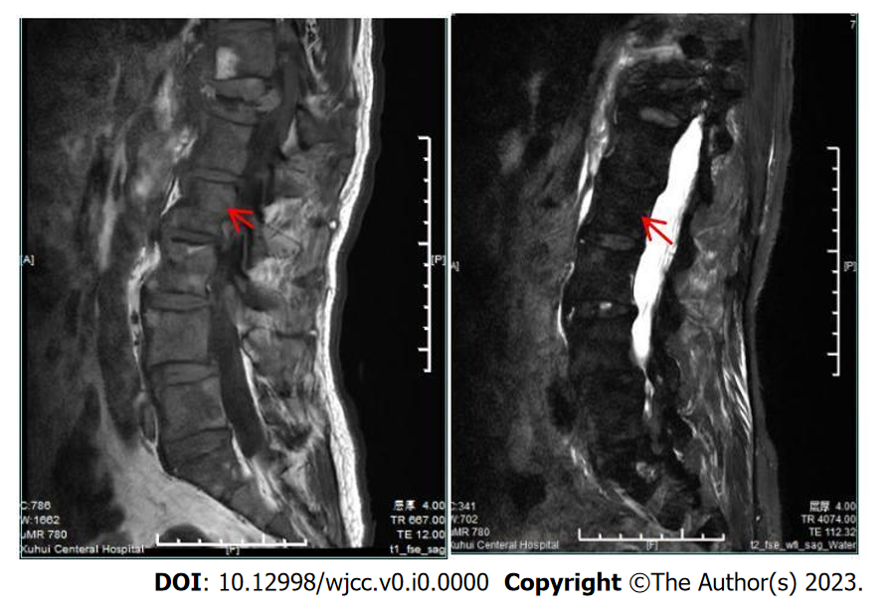
Figure 1 Compressed bone of thoracic 12 vertebrae showing a high T1 signal and low T2 signal.
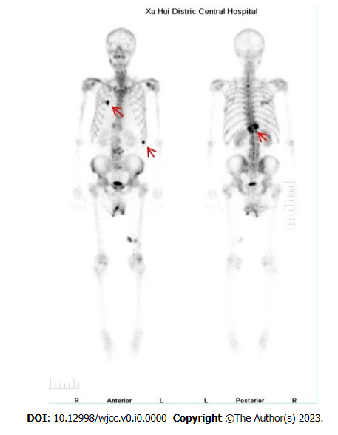
Figure 2 Bone single photon emission tomography/computed tomography showing T12 compression of the whole body bone, and the concentration of radioactivity in bilateral ribs, thus bone metastasis was considered.
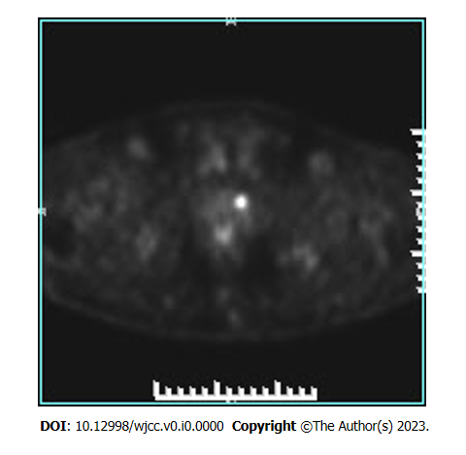
Figure 3 ¹⁸F-fluorodeoxyglucose positron emission tomography/computed tomography showing focal glucose metabolism in the left lobe of the prostate, and a malignant tumor waiting to be excreted.
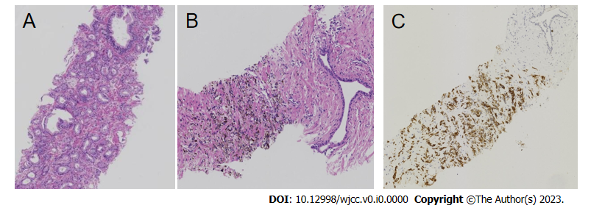
Figure 4 Histopathology. A: Prostate adenocarcinoma [Hematoxylin and eosin (HE), original magnification, 25 ×]; B: Small foci of melanocytes in the proliferative prostate tissue (HE, original magnification, 25 ×); C: Immunohistochemical results: HMB45⁺ (HE, original magnification, 25 ×).
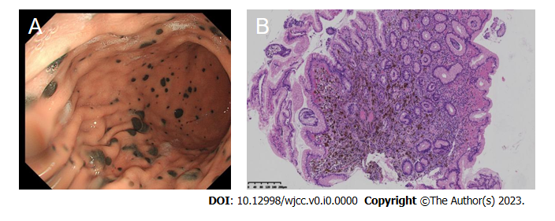
Figure 5 Gastroscopy findings. A: Multiple mucosal black spots in the body and fundus of the stomach; B: Microscopic small foci of melanocytes in the gastric mucosa (hematoxylin–eosin, original magnification, 25 ×).

Table 1 Clinicopathological characteristics of the 10 primary prostatic melanomas included in the present review
Ref. | Age | History disease | Symptoms | Other test | Treatment | Stage | Time to recurrence | Metastases | Secondly treatment | OS
Berry and Reese^{[4]}, 1953 | 38 | No | Luts | n/m | Cystoprostatectomy | n/m | 7 mo | n/m | n/m | 36 mo
Hübler et al^{[5]}, 1980 | n/f | n/f | n/f | n/f | n/f | n/f | n/f | n/f | n/f | n/f
Wang^{[6]}, 2001 | 61 | n/m | BPH | (1) Physical examination of the whole body skin surface, oral cavity, and mucosa and optic fundus; (2) CT and MRI of the brain, abdo_x005f men and pelvic cavity; and (3) endoscopy of gastrointestinal tract | TURP | T1N0Mo | n/m | n/m | No | 84 mo
Wong and Bell^{[8]}, 2006 | 71 | n/f | Urinary retention | n/f | TURP | n/f | n/f | n/f | n/f | 5 mo
Wong et al^{[7]}, 2008 | n/f | n/f | n/f | n/f | n/f | n/f | n/f | n/f | n/f | n/f
Doublali et al^{[9]}, 2010 | 75 | n/m | Urinary tract obstruction. Urethroscopy had revealed black discoloration of the prostate | (1) Physical examination of body skin surface, mucosa; (2) CT of brain, abdomen and pelvis; and (3) colonoscopy and gastroscopy | TURP | n/m | n/m | n/m | No | 1 mo
Ma et al^{[10]}, 2010 | 29 | n/m | Disuria Digital rectal examination and Transrectal Ultrasound of a mass | Pelvic CT scan with contrast | Radical prostatectomy | T2N0M0 | n/m | n/m | n/m | 3 mo
Tosev et al^{[11]}, 2015 | 37 | Hodgkin’s disease | Hematuria and urinary retention. In-house cystoscopy showed an asymmetric prostate enlargement with purple discoloration Prostate biopsy | (1) Skin of the body; (2) colonoscopy and gastroscopy; (3) CT of chest and abdomen; and (4) pelvic MRI | Open retropubic radical prostatectomy with extended lymph-node dissection | n/m | 4 mo | Lung | Dacarbazine, ipilimumab, nivolumab | 16 mo
Li et al^{[12]}, 2019 | 42 | No | Hematuria Accepy PVP. Intraoperatively, a dark lesion was noted in the patient’s prostatic urethra | (1) CT of the chest, abdomen, and pelvis; (2) brain MRI; (3) bone scan; and (4) ¹⁸F-FDG PET/CT scan | RRP and PLND | T2N1M0 | 3 mo | Lesion along the right iliac artery, pulmonary nodule | Biochemotherapy for 6 cycles dacarbazine, vinblastine, cisplatin, IL2 | 84 mo
Parmar et al^{[13]}, 2019 | 65 | No | Acute urinary retention | (1) Physical examination of whole body skin surface, oral cavity and anal mucosa; and (2) PET-CT | TURP, Dacarbazine, Chemotherapy | n/m | 3 mo | n/m | n/m | n/m
n/f: Full text not found; n/m: Not mentioned; no: None; LUTS: Lower urinary tract symptoms; TURP: Transurethral resection of the prostate; PVP: Photoselective vaporization of the prostate; RRP: Radical retropubic prostatectomy; PLND: Pelvic lymph node dissection; MRI: Magnetic resonance imaging; ¹⁸F-FDG PET/CT: 18F-fluorodeoxyglucose positron emission tomography computed tomography; IL: Interleukin.

