Name of Journal: World Journal of Gastrointestinal Surgery

ESPS Manuscript NO: 22899

Manuscript Type: Original Article

Prospective Study
PERFACT procedure to treat supralevator fistula-in-ano-a novel single stage sphincter sparing procedure

Pankaj Garg

Garg P. PERFACT procedure in supralevator fistula-in-ano

Pankaj Garg, Colorectal Surgery Division, Indus Super Specialty Hospital, Mohali, Punjab 160055, India

Pankaj Garg, Garg Fistula Research Institute, Panchkula, Haryana 134113, India

Author contributions: Garg P conceived the idea, designed the study, did acquisition of data, did the analysis of data, drafted the manuscript, revised the manuscript, and submitted the manuscript.

Institutional review board statement: The study was reviewed and approved by the Indus Hospital Ethical Committee.

Clinical trial registration statement: Not applicable.

Informed consent statement: All study participants, or their legal guardian, provided informed written consent prior to study enrollment.

Conflict-of-interest statement: The author has not received any fees for serving as a speaker or as a position [such as consultant and/or an advisory board member] which could have a conflict of interest with this study. The author has not received research funding from any organization or individual. The author is not an employee of an organization, or owns stocks and/or shares in name of an organization which has potential conflict of interest with the study.

Data sharing statement: Technical appendix, statistical code, and dataset available from the corresponding author at drgargpankaj@yahoo.com. No consent was not obtained but the presented data are anonymized and risk of identification is low.

Open-Access: This article is an open-access article which was selected by an in-house editor and fully peer-reviewed by external reviewers. It is distributed in accordance with the Creative Commons Attribution Non Commercial (CC BY-NC 4.0) license, which permits others to distribute, remix, adapt, build upon this work non-commercially, and license their derivative works on different terms, provided the original work is properly cited and the use is non-commercial. See: http://creativecommons.org/licenses/by-nc/4.0/

Correspondence to: Dr. Pankaj Garg, MBBS, MS, FIAGES, Chief Colorectal Surgeon, Garg Fistula Research Institute, 1042, Sector-15, Panchkula, Haryana 134113, India. drgargpankaj@yahoo.com
Telephone: +91-950-1011000
Fax: +91-172-2594556

Received: September 30, 2015
Peer-review started: October 1, 2015
First decision: November 13, 2015
Revised: November 22, 2015
Accepted: January 21, 2016

Article in press:
Published online:

Abstract
AIM: To prospectively perform the PERFACT procedure in supralevator anal fistula/abscess.

METHODS: Magnetic resonance imaging was done preoperatively in all the patients. PERFACT (proximal cauterization around the internal opening, emptying regularly of fistula tracts and curettage of tracts) was done in all the patients with supralevator fistula or abscess. All types of anal fistula and/or abscess with supralevator extension whether intersphincteric or transsphincteric were included in the study. The internal opening along with the adjacent mucosa was electrocauterized. The resulting wound was left open to heal by secondary intention so as to heal (close) the internal opening by granulation tissue. The supralevator tract/abscess was drained and thoroughly curetted. It was regularly cleaned and kept empty in the postoperative period. The primary outcome parameter was complete fistula healing. The secondary outcome parameters were return to work and change in incontinence scores (Vaizey’s objective scoring system) assessed preoperatively and at 3 mo after the operation.

RESULTS: Seventeen patients were prospectively enrolled and followed for median of 13 mo (range 5-21 mo). Mean age was 41.1 ± 13.4 years, M/F-15/2. Fourteen (82.4%) had recurrent, eight (47.1%) had associated abscess, fourteen (82.4%) had multiple tracts and five (29.4%) had horseshoe fistulae. Supralevator extension was intersphincteric in 4 and transsphincteric in 13 patients. Two patients were excluded. 11/15(73.3%) were cured and 26.7% (4/15) had a recurrence. Two patients with recurrence were reoperated with the same procedure and one got cured. Thus the overall healing rate was 80% (12/15). All the patients could resume normal work within 48 h of operation. There was no deterioration in incontinence scores (Vaizey’s objective scoring system). This is the largest series of supralevator fistula-in-ano published till date.

CONCLUSION: PERFACT procedure is an effective single step sphincter saving procedure to treat supralevator fistula-in-ano with minimal risk to incontinence.

Key words: Anal fistula; Complex; Simple; Horseshoe; Abscess; Supralevator; Tracts

© The Author(s) 2016. Published by Baishideng Publishing Group Inc. All rights reserved.

Core tip: Supralevator fistula-in-ano and abscess are quite difficult to treat. There is no good treatment available for this dreaded disease as the risk of incontinence is quite high in operating such fistula. PERFACT (proximal cauterization around the internal opening, emptying regularly of fistula tracts and curettage of tracts) was done in seventeen patients of supralevator fistula-in-ano. The overall healing rate was 80% (12/15). All the patients could resume normal work within 48 h of operation and there was no deterioration in incontinence scores. This is the largest series of treatment of supralevator fistula-in-ano published till date.

Garg P. PERFACT procedure to treat supralevator fistula-in-ano-a novel single stage sphincter sparing procedure. World J Gastrointest Surg 2016; In press

INTRODUCTION
Supralevator abscess (SLA) constitute up to 9 % of all the cryptoglandular abscesses^{[1-3]}. These are difficult to treat as there is no satisfactory treatment procedure available which can manage these fistulas with high success rate with minimal risk of incontinence. Conventionally adequate drainage followed by either a primary fistulotomy or a two-stage fistulotomy using a seton fistula-in-ano was recommended^{[3]}. There had been great enthusiasm for ligation of intersphincteric tract (LIFT) and even Biolift procedures but of late, the results were disappointing^{[4]}.
Electrocauterization of area around the internal opening can successfully close the internal opening of a fistula-in-ano^{[5]}. This step along with curettage of the tracts and emptying regularly of fistula tracts (PERFACT procedure) has been shown to be effective in effective in treating complex anal fistulas^{[5]}. The efficacy of this procedure to manage supralevator fistula-in-ano (SLF) was assessed in this study.

MATERIALS AND METHODS
This was a prospective analysis of all the consecutive patients of cryptoglandular SLF and SLA treated between 2012 to 2014 at the referral colorectal unit of the hospital. The clearance (approval) was taken from the institutional ethics committee. Informed consent was taken from all the patients.

Inclusion creteria
All types of anal fistula and/or abscess with supralevator extension whether intersphincteric or transsphincteric.

Exclusion creteria
Patients who couldn’t follow post operative schedule and protocol.
Vaizey objective incontinence scoring was done preoperatively and at 3 mo after the operation^{[6]}. On a scale of 0-24, a score 0 implied perfect continence and a score of 24 meant total incontinence.
A pre-operative magnetic resonance imaging (MRI) scan was done in every case to accurately map the fistula tracts. A schematic diagram- Coronal and Transverse sections was made based on the MRI (Figures 1-3).

Principle/ concept
Intraoperatively, the procedure had two steps: (1) Electrocauterization around the internal opening-The superficial layer (mucosa) around the internal opening was electrocauterized to create a fresh wound (Figures 2 and 4). The resulting wound was encouraged to heal by secondary intention (granulation tissue). The aim was to permanently close (heal) the internal opening. If there was an additional supralevator opening in the rectum, the same procedure was done for that opening as well; and (2) Curettage of tracts- All the tracts were thoroughly curetted and debrided of their lining with a curette. The transsphincteric supralevator tract/abscess was drained and curetted through the ischiorectal fossa through the external opening (Figure 2). The intersphincteric supralevator tract/abscess was curetted through the external opening already present or through a small new incision in the intersphincteric groove (Figure 2). Once the intersphincteric space was opened up, a blunt curette was introduced through the incision into this space. The curette was advanced towards the supralevator tract/collection taking guidance from the MRI scan. A finger was kept in the rectum to prevent inadvertent injury to the rectal wall.

Post-operative management
Emptying regularly of fistula tracts: The curetted tracts were kept clean and empty of any serous fluid so as to ensure that the tracts healed (closed) by granulation tissue. Keeping all the tracts clean was required for 4 to 8 wk (occasionally longer) till all the tracts healed fully. The cleaning was usually done twice a day.
To ensure proper cleaning of the tracts, the following steps (one or multiple depending upon the requirement and fistula characteristics) were done during the operation. (1) The external opening was widened and the scarred puckered skin (if present) was excised. The aim was to make the external opening bigger than 1 cm x 1 cm (Figures 4 and 5). This facilitated cleaning of the tracts for a longer duration; (2) Small tube (red rubber, nasograstic or plastic) were put in the outer part of the tract to prevent premature closure of the outer part of the tract (Figure 5)^{[7]}. The tube was removed before every dressing and then inserted back after the dressing. No need was felt to secure the tube with a suture as the tract used to hold the tube in place and the tube didn’t usually come out while walking. The cleaning was done with a swab mounted on an artery forceps^{[7]}. The schematic diagram (Figures 1-3) provided guidance regarding the direction and the depth of the tracts. The tube size and diameter was gradually decreased as the deeper portion of the tracts healed. The insertion was stopped only after it was ensured that the deeper (including the supralevator) part of the tract had completely healed. The healing was assessed by narrowing of the tracts and non negotiation of the swab in the upper part of the tract. Post operative MRI was done in affording patients to assess the healing (Figure 1); and (3) In case of long multiple tracts or horseshoe tracts, multiple holes were made along the tract (Figure 5) so that all parts of the tract could be cleaned with ease.

Intra-operative procedure
A saddle block (spinal anesthesia) or general anesthesia was given. The patient was positioned in a lithotomy or a prone jack-knife position. The internal opening was localized. This was facilitated by injecting saline or povidone iodine through the external opening.
Proximal superficial cauterization (Figures 2 and 4) was carried out with electrocautery around the internal opening, cauterizing only the mucosa and superficial part of the internal sphincter. The crypt glands, the internal opening and the tissue around it were cauterized. This usually resulted in an oval cauterized area, approximately 1 cm (wide) and 2 cm (long), with internal opening at the centre of the wound (Figures 2 and 4). After cauterization, the wound was left as such and no attempt was made to close the wound or the internal opening with any suture, stapler, glue or plug.
After this, the tracts were curetted in accordance with the MRI diagram and the tract lining was scrapped out as much as possible with a blunt curette (Figure 2). While doing so, a finger was kept in the rectum so as to ensure that the curette didn’t accidentally perforate the rectum.
The patient was discharged on the operation day (if done under short general anesthesia) or the first postoperative day (if done under saddle or spinal anesthesia). Antibiotics (Ciprofloxacin-500 mg and Oridazole-500 mg) were prescribed twice a day for five days. The patient was instructed to resume all his/her normal activities on the same day. The patient was encouraged to walk briskly for five kilometers every day. This helped in keeping the tracts empty.
The cleaning process of the curetted tracts was done by a cotton swab mounted on an artery forceps^{[7]}. The tube was removed before every dressing and then inserted back after the dressing (Figure 5). No povidone iodine, hydrogen peroxide or any liquid was injected in the tract during the cleaning process as this would have prevented the internal opening from closing. The cleaning was done by a trained nurse, a medical attendant or a relative. In our setting, teaching a relative was an economical and easier and hence a preferred option.
The cleaning process was done two to four times a day. For the first 10 day, the patient was called to the outpatient clinic for supervised cleaning once or twice a day depending upon the complexity of the fistula. After this, the patient could do the cleaning process at home. The cleaning process was not painful, though uncomfortable at times. No sedation was required for this. The cure was defined as complete cessation of purulent or serous discharge and complete healing of all the tracts. Persistence of even one of the tracts was considered a failure.
The statistical methods of this study were reviewed by Pankaj Garg MBBS, MS, Chief Colorectal Surgeon at Garg Fistula Research Institute, Panchkula, India.

RESULTS
Seventeen patients were prospectively enrolled and followed for median-13 months (3-21 months). Mean age: 41.1 ± 13.4 years, M/F-15/2. Fourteen (82.4%) had recurrent, eight (47.1%) had associated abscess, fourteen (82.4%) had multiple tracts and five (29.4%) had horseshoe fistulae.
The supralevator extension was intersphincteric in four (23.5%) (Figure 1) and transsphincteric in thirteen (76.5%) patients (Figure 3) (Table 1). All fistula were Type 3 (suprasphincteric fistula) according to Park’s classification^{[8]} and Type 5 as per James classification^{[9]}. Two patients were excluded from the analysis (they couldn’t follow postoperative protocol). Out of 15 patients, 11/15 (73.3%) were cured (Figures 1 and 3) and four patients (26.7%) had a failure of treatment. All the recurred patients had transsphincteric supralevator extension (Table 1). Two patients with recurrence were reoperated with the same procedure and one got cured. Thus the overall healing rate was 80% (12/15). The tracts especially the supralevator tract didn’t heal in the patients in whom the treatment failed. All the patients were discharged within 24 h of the procedure and could resume normal work in 48 h. There was no deterioration in incontinence scores at 3 mo after the operation.

DISCUSSION
The study describes a novel simple method to treat supralevator fistula with satisfactory cure rate (80%) and minimal risk to incontinence. The morbidity was also minimal as there was no cutting of sphincter muscle and the wound was quite small. Therefore all the patients could resume their normal work within 48 h of the operation. As per our literature search, this is the largest series to be published on supralevator fistula.
MRI played a pivotal role in the diagnosis of supralevator extension. Endoanal ultrasound (EUS) and MRI are recommended for recurrent or suspected supralevator anal fistula^{[10-12]}. Though both these modalities are quite sensitive in detecting perianal fistulas, the specificity of MRI is better than EUS^{[13]}. Since ours is a referral center for anorectal fistulas, we get MRI done in all our patients of perianal fistulas. The supralevator extension was unsuspected incidental finding in thirteen (76.5%) of our patients. Twelve (92.3%) of these 13 patients had recurrent anal fistula and 11 (84.6%) had multiple tracts. These findings reaffirm the suggestion that MRI should be done in all patients with recurrent and complex anal fistula^{[11-13]}. MRI is perhaps the best method to assess supralevator abscess and fistula as it provides images in all three planes (axial, sagittal and coronal). The coronal view enables positioning of the abscess and the tract with respect to levator plate and clearly shows supralevator extension in most patients (Figures 1 and 3)^{[14]}. MRI is also a good modality to assess the resolution of disease process. The photographs of preoperative MRI and postoperative MRI showing resolution of the supralevator disease process is shown in Figure 1. The postoperative MRI of all the patients could not be done due to cost constraints.
Though the route of drainage of supralevator anal abscess (SLA) has been described in the past^{[2,3]} but there is no effective method available for definite treatment of the supralevator fistula (SLF). The standard practice is to drain a SLA abscess through the rectum when SLA spread upwards from an intersphincteric abscess^{[15,16]}. This is to avoid an iatrogenic suprasphincteric fistula if the drainage is incorrectly performed through the ischiorectal fossa. On the other hand, if a SLA is secondary to an upward extension of an ischiorectal abscess, the drainage should be performed through the ischiorectal fossa to avoid an iatrogenic extrasphincteric fistula^{[2,3,8,15,17,18]}. Subsequent management is opening the intersphincteric space through the rectum by dividing the internal anal sphincter (IAS) or by staged seton procedure.
Both the internal as well as external anal sphincters play an important role in maintaining continence^{[19-21]}. Cutting seton when used in high transsphincteric anal fistula can affect continence in upto 60% of patients^{[19]}. On the other hand, completely sparing the external anal sphincter (EAS) but dividing the IAS to open the intersphincteric space through the rectum in intersphincteric fistulas also lead to continence deficits in upto 50% of patients^{[20]}. Therefore, both IAS and EAS play a significant role in continence preservation^{[20,21]}. A recent multicentric study reported a long term incidence of major incontinence (Vaizey score > 6) in 26.8% patients undergoing fistulotomy in low perianal fistulas^{[22]}. This further emphasizes the need to move towards sphincter saving procedures to treat anal fistula.
PERFACT procedure is perhaps the first method described to treat supralevator fistula which didn’t involve dividing either internal or external anal sphincter. Therefore, the continence scores didn’t show any deterioration in any of the patients postoperatively. Secondly, unlike the conventional methods^{[15]}, this procedure aimed to cure supralevator abscess and fistula in a single step. This made it less morbid and quite cost effective as it prevented the cost of second admission and reoperation.
The concept behind this procedure was very simple. It aimed to close the internal opening by proximal superficial cauterization in the anal canal (Figure 2 and 4). In the postoperative period, it was ensured that the wound healed by secondary intention so that the internal opening was sealed by granulation tissue. The closure of internal opening by natural means (granulation tissue) might be a good alternative to other methods of closure y primary intention like plug, suture, flap, stapler or a clip^{[23-25]}.
In PEFACT procedure, the internal opening is not widened. If internal opening is widened, then there would be some chance of stool passing through the internal opening. In this procedure, only the mucosa (superficial layer) all around the internal opening is electrocauterized so as to create a fresh raw wound which heals with granulation tissue. The internal and external sphincters are not cut. Due to this, the internal opening is not widened as compared to pre-operative status.
The second step was curettage of the tracts. This ensured that the infected epithelium was removed and the freshened raw wound in the tracts led to the generation of the granulation tissue which facilitated the closure of the tracts. However, the serous discharge of the granulation tissue needed to be thoroughly cleaned/ removed from the tracts on regular basis. Otherwise the stagnant discharge would get infected leading to a collection. The latter would not only lead to the rapid reepithelialization of the tracts but the collected fluid could also flow into internal opening thereby preventing its closure.
At times, the tracts were curved and branching. Preoperative MRI, which was done in all the cases, helped to accurately localize the tracts. Once this was done, it helped to curette the tracts (primary tract as well as the branching secondary tracts). For this purpose, the curettes of different sizes and lengths were kept handy. Cleaning the curved tracts usually didn’t pose much problem as the tracts were usually flexible and adapted to the shape of the curette.
The postoperative management was quite significant. It aimed to keep the tracts clean and empty. Any inadequacy in this care was detrimental to the final outcome.
The cauterization of the internal opening alone has been tried earlier without much success^{[5]}. The reason of the success of the same step in PERFACT procedure needs explanation. Undoubtedly, the internal opening is the prime culprit in a fistula-in-ano as it allows ingress of the bacteria from the anal canal into the fistula tracts. However, once the tracts are formed and get lined by the infected epithelium, then it’s a mutually propagating situation. The patent internal opening keeps the tracts infected and the infected collection in the tracts keep the internal opening patent. Therefore isolated attempt to close the internal opening would fail until it is accompanied by meticulous cleaning, emptying and healing of all the associated tracts. This perhaps explains the need for regular tract cleaning in the post operative period.
PERFACT procedure can also be done effectively in fistula cases where internal opening cannot be localized accurately during the operation. The possible reasons of failure to identify the internal opening are twofold. First, it could be due to temporary closure of the internal opening due to debris. Second reason could be the closure of the collapsible fistula tract (which passes through the sphincter complex) due to external pressure of the sphincter muscle. As per published literature, this can happen in up to 15-20% of cases. In the earlier published series of PERFACT procedure, internal opening could not be found in 15.7% (8/44) cases^{[5]}. Still this procedure was successful in 87.5% (7/8) ^{[5]}. The MRI was done preoperatively in every case. This helps to fairly localize the position of the tracts in the majority of cases and give a reasonable idea where the tract is coursing towards the rectum. This information along with the examination findings during the operation (induration of the sphincter in the region of internal opening) helped to determine the most likely location of the internal opening. At that place, the superficial cauterization was done. This was a safe step to do as it created only a superficial wound with no injury/damage to either of the sphincters.
The concept behind this procedure was undoubtedly simple but to achieve good results in complex anal fistulas, it required detailed analysis of the MRI scan, careful planning and mapping of the tracts (preoperatively), meticulous curettage and cleaning of all the tracts (intraoperatively), and disciplined post operative care (postoperatively).
As discussed, the main benefit of this procedure was its ability to treat supralevator abscess/fistula in a single sitting with minimal risk to incontinence. The morbidity was also minimal as there was no extensive tissue cutting was done. Apart from a small superficial wound in the anal canal, external opening was slightly widened (Figures 4 and 5). The cauterized anal wound was also small (usually about 2 cm long and 1 cm wide) (Figure 4). Due to these small wounds, the patients had little pain and they were able to resume all their normal daily activities from the first postoperative day. The patients were encouraged to walk briskly 4-5 km from the first postoperative day as it facilitated in keeping the tracts empty. Secondly as both the sphincters were completely spared, the negative impact on the incontinence was minimal.
The tube (mushroom catheter) has been used for drainage of the perianal abscesses, both ischiorectal abscesses^{[26]} and supralevator abscesses^{[15]}. However, a tube has perhaps not been used in the way described in this study (to keep the outer part of the fistula tract patent). In the present procedure, a tube in the outer portion of the fistula helped in several ways (Figure 5). First, it prevented the outer portion of the fistula tract from closing prematurely^{[7]}. The tube was put till the upper and inner portion of the fistula had not completely healed. Premature closure of the outer part of the tract especially the skin would risk accumulation of fluid which could prevent healing of the upper part^{[7]}. Second, unlike a loose draining seton, nothing (no seton or thread) is needed to be passed through the internal opening in this technique^{[7]}. This helped in achieving the closure of the internal opening which would not have been possible if instead a draining seton had been used. Third, to drain supralevator extension (with no rectal opening), a draining seton could not be used whereas a tube could be used for adequate regular drainage.
The results in intersphincteric supralevator extension (100%-4/4) (Figure 1) were better than extrasphincteric supralevator extension (72.7%- 8/11) (Figure 3). The reason for this could be that the intersphincteric space was a collapsible space. Once the abscess was adequately drained (or the fistula tract adequately curetted) and the internal opening healed by cauterization, the intersphincteric space had the tendency to collapse (close) (Figure 1). This however would not happen after simple drainage or curettage of the supralevator tract as there would be persistent ingress of bacteria from the internal opening.
It was observed in this series that supralevator component usually developed some time after the development of infralevator anal fistula. If the infralevator anal fistula was intersphincteric, then it extended upwards in the intersphincteric plane (Figure 2). If infralevator anal fistula was transsphincteric, even in these cases, the supralevator extension was in the intersphincteric plane (Figure 2). Thus the supralevator extension was always in the intersphincteric plane. Since supralevator rectal opening was not present in all fistula-in-ano patients with supralevator extension, it indicated that supralevator rectal opening developed late and was not as important in the pathophysiology of supralevator fistula-in-ano. Mucosal papilla (granulation tissue overgrowth) was also observed at the site of supralevator rectal opening in four patients. Such overgrowth of granulation tissue usually occurs at the point of exudation of purulent discharge. These points indicated that the supralevator rectal opening developed as a result of bursting of supralevator intersphincteric abscess/collection into the rectum and this opening mainly acted as a point of drainage for the abscess/fistula. The primary source of ingress of bacteria was perhaps the opening at the dentate line. Another point in favor of this concept is that the intramural pressure during defecation in anal canal (hence at dentate line) is quite high whereas the intramural pressure in rectum is comparatively low as it is a storage organ. This high pressure in anal canal “forces” bacteria into the opening at the dentate line which perhaps is responsible for persistence and propagation of fistula and in few cases, development of supralevator abscess. A small proportion of these cases then progress to develop supralevator rectal opening as well. Further data is needed to substantiate these observations. Unfortunately, too little data is available on supralevator anal fistula due to rarity of this disease and the difficulty in management it poses.
Other advantages of this procedure were that the operating time was less (20-30 min), the procedure was easy to perform and reproduce and the operation didn’t require any expensive gadget as in VAAFT or anal fistula plug^{[23, 25, 27]}.
PERFACT procedure is quite different from VAAFT. In VAAFT, the internal opening is closed by a stapler or by suturing whereas in PERFACT, the mucosa (superficial layer) all around the internal opening is electrocauterized so as to create a fresh raw wound which heals with granulation tissue. The aim is to close the internal opening by secondary intention whereas in VAAFT, the aim is to close the internal opening by primary intention. Closure of tissues by primary intention put tissues under tension which increases the risk of failure. That could perhaps be the reason that PERFACT procedure seems more effective than VAAFT especially in complex and supralevator fistulas.
This was a prospective cohort study with no control group. Undoubtedly, a control group would have added value to the study. However the comparative study was not feasible as the prevalence of supralevator fistula is quite low. Secondly, no other procedure in the literature has been shown to be effective in supralevator fistula especially the transsphincteric supralevator fistulas. Therefore, a comparative study couldn’t be planned.
To conclude, PERFACT procedure (proximal cauterization of the internal opening, emptying regularly of tracts and curettage of the tracts) is an effective single step sphincter saving procedure to treat supralevator anal fistula. It is associated with little morbidity and minimal risk to incontinence. Long term studies with large number of patients are required to substantiate the results.

COMMENTS
Background
Supralevator fistula-in-ano and abscess are quite difficult to treat. There is no good treatment available for this dreaded disease till date. The reason is that the risk of incontinence is quite high in operating such fistula.

Research frontiers
Supralevator fistula-in-ano are extremely difficult to treat. Conventionally, drainage of abscess followed by either a primary fistulotomy or a two-stage fistulotomy using a seton were done. But these were associated with high incontinence rates. There has been great enthusiasm for ligation of intersphincteric tract and even Biolift procedures but the results have been disappointing.

Innovations and breakthroughs
This is the largest study of treatment of supralevator fistula-in-ano to be published. PERFACT (proximal cauterization around the internal opening, emptying regularly of fistula tracts and curettage of tracts) is a minimally invasive treatment in which the risk of sphincter damage is very low. This procedure was done in seventeen patients of supralevator fistula-in-ano. The overall healing rate was 80% (12/15). All the patients could resume normal work within 48 h of operation and there was no deterioration in incontinence scores.

Applications
PERFACT procedure is simple novel procedure with many distinct advantages. As there is no satisfactory treatment available for supralevator fistula, this procedure provides a ray of hope to treat this dreaded disease.

Peer-review
This is a very nice study on PERFACT procedure. PERFACT procedure allows treating supralevator fistula without dividing either internal or external anal sphincter. Therefore, the continence scores didn’t show any deterioration in any of the patients postoperatively and this procedure aimed to cure supralevator abscess and fistula in a single step.

REFERENCES
1 Read DR, Abcarian H. A prospective survey of 474 patients with anorectal abscess. Dis Colon Rectum 1979; 22: 566-568 [PMID: 527452 DOI: 10.1007/BF02587008]
2 Ramanujam PS, Prasad ML, Abcarian H, Tan AB. Perianal abscesses and fistulas. A study of 1023 patients. Dis Colon Rectum 1984; 27: 593-597 [PMID: 6468199 DOI: 10.1007/BF02553848]
3 Prasad ML, Read DR, Abcarian H. Supralevator abscess: diagnosis and treatment. Dis Colon Rectum 1981; 24: 456-461 [PMID: 7273983 DOI: 10.1007/BF02626783]
4 Wallin UG, Mellgren AF, Madoff RD, Goldberg SM. Does ligation of the intersphincteric fistula tract raise the bar in fistula surgery? Dis Colon Rectum 2012; 55: 1173-1178 [PMID: 23044679 DOI: 10.1097/DCR.0b013e318266edf3]
5 Garg P, Garg M. PERFACT procedure: a new concept to treat highly complex anal fistula. World J Gastroenterol 2015; 21: 4020-4029 [PMID: 25852290 DOI: 10.3748/wjg.v21.i13.4020]
6 Vaizey CJ, Carapeti E, Cahill JA, Kamm MA. Prospective comparison of faecal incontinence grading systems. Gut 1999; 44: 77-80 [PMID: 9862829 DOI: 10.1136/gut.44.1.77]
7 Garg P. Tube in tract technique: a simple alternative to a loose draining seton in the management of complex fistula-in-ano: video vignette. Colorectal Dis 2015; [Epub ahead of print] [PMID: 26452075 DOI: 10.1111/codi.13143]
8 Parks AG, Gordon PH, Hardcastle JD. A classification of fistula-in-ano. Br J Surg 1976; 63: 1-12 [PMID: 1267867 DOI: 10.1002/bjs.1800630102]
9 Morris J, Spencer JA, Ambrose NS. MR imaging classification of perianal fistulas and its implications for patient management. Radiographics 2000; 20: 623-35; discussion 635-7 [PMID: 10835116]
10 Ommer A, Herold A, Berg E, Fürst A, Sailer M, Schiedeck T. German S3 guideline: anal abscess. Int J Colorectal Dis 2012; 27: 831-837 [PMID: 22362468 DOI: 10.1007/s00384-012-1430-x]
11 Steele SR, Kumar R, Feingold DL, Rafferty JL, Buie WD. Practice parameters for the management of perianal abscess and fistula-in-ano. Dis Colon Rectum 2011; 54: 1465-1474 [PMID: 22067173 DOI: 10.1097/DCR.0b013e31823122b3]
12 Beets-Tan RG, Beets GL, van der Hoop AG, Kessels AG, Vliegen RF, Baeten CG, van Engelshoven JM. Preoperative MR imaging of anal fistulas: Does it really help the surgeon? Radiology 2001; 218: 75-84 [PMID: 11152782 DOI: 10.1148/radiology.218.1.r01dc0575]
13 Siddiqui MR, Ashrafian H, Tozer P, Daulatzai N, Burling D, Hart A, Athanasiou T, Phillips RK. A diagnostic accuracy meta-analysis of endoanal ultrasound and MRI for perianal fistula assessment. Dis Colon Rectum 2012; 55: 576-585 [PMID: 22513437 DOI: 10.1097/DCR.0b013e318249d26c]
14 Halligan S, Stoker J. Imaging of fistula in ano. Radiology 2006; 239: 18-33 [PMID: 16567481 DOI: 10.1148/radiol.2391041043]
15 Garcia-Granero A, Granero-Castro P, Frasson M, Flor-Lorente B, Carreño O, Espí A, Puchades I, Garcia-Granero E. Management of cryptoglandular supralevator abscesses in the magnetic resonance imaging era: a case series. Int J Colorectal Dis 2014; 29: 1557-1564 [PMID: 25339133 DOI: 10.1007/s00384-014-2028-2]
16 García-Granero A, Granero-Castro P, Frasson M, Flor-Lorente B, Carreño O, Garcia-Granero E. The use of an endostapler in the treatment of supralevator abscess of intersphincteric origin. Colorectal Dis 2014; 16: O335-O338 [PMID: 24853735 DOI: 10.1111/codi.12670]
17 Hanley PH. Reflections on anorectal abscess fistula: 1984. Dis Colon Rectum 1985; 28: 528-533 [PMID: 3893948 DOI: 10.1007/BF02554105]
18 Rickard MJ. Anal abscesses and fistulas. ANZ J Surg 2005; 75: 64-72 [PMID: 15740520 DOI: 10.1111/j.1445-2197.2005.03280.x]
19 Isbister WH, Al Sanea N. The cutting seton: an experience at King Faisal Specialist Hospital. Dis Colon Rectum 2001; 44: 722-727 [PMID: 11357036 DOI: 10.1007/BF02234574]
20 Lunniss PJ, Kamm MA, Phillips RK. Factors affecting continence after surgery for anal fistula. Br J Surg 1994; 81: 1382-1385 [PMID: 7953425 DOI: 10.1002/bjs.1800810947]
21 Thomson JP, Ross AH. Can the external anal sphincter be preserved in the treatment of trans-sphincteric fistula-in-ano? Int J Colorectal Dis 1989; 4: 247-250 [PMID: 2614223 DOI: 10.1007/BF01644991]
22 Göttgens KW, Janssen PT, Heemskerk J, van Dielen FM, Konsten JL, Lettinga T, Hoofwijk AG, Belgers HJ, Stassen LP, Breukink SO. Long-term outcome of low perianal fistulas treated by fistulotomy: a multicenter study. Int J Colorectal Dis 2015; 30: 213-219 [PMID: 25421101 DOI: 10.1007/s00384-014-2072-y]
23 Schwandner O. Video-assisted anal fistula treatment (VAAFT) combined with advancement flap repair in Crohn's disease. Tech Coloproctol 2013; 17: 221-225 [PMID: 23179892 DOI: 10.1007/s10151-012-0921-7]
24 Prosst RL, Joos AK, Ehni W, Bussen D, Herold A. Prospective pilot study of anorectal fistula closure with the OTSC Proctology. Colorectal Dis 2015; 17: 81-86 [PMID: 25175824 DOI: 10.1111/codi.12762]
25 Garg P, Song J, Bhatia A, Kalia H, Menon GR. The efficacy of anal fistula plug in fistula-in-ano: a systematic review. Colorectal Dis 2010; 12: 965-970 [PMID: 19438881 DOI: 10.1111/j.1463-1318.2009.01933.x]
26 Beck DE, Fazio VW, Lavery IC, Jagelman DG, Weakley FL. Catheter drainage of ischiorectal abscesses. South Med J 1988; 81: 444-446 [PMID: 3358166 DOI: 10.1097/00007611-198804000-00008]
27 Garg P. To determine the efficacy of anal fistula plug in the treatment of high fistula-in-ano: an initial experience. Colorectal Dis 2009; 11: 588-591 [PMID: 18637937 DOI: 10.1111/j.1463-1318.2008.01632.x]

P-Reviewer: Attaallah W, Brusciano L, Lara FJP, Milone M, Santoro GA
S-Editor: Wang JL L-Editor: E-Editor:

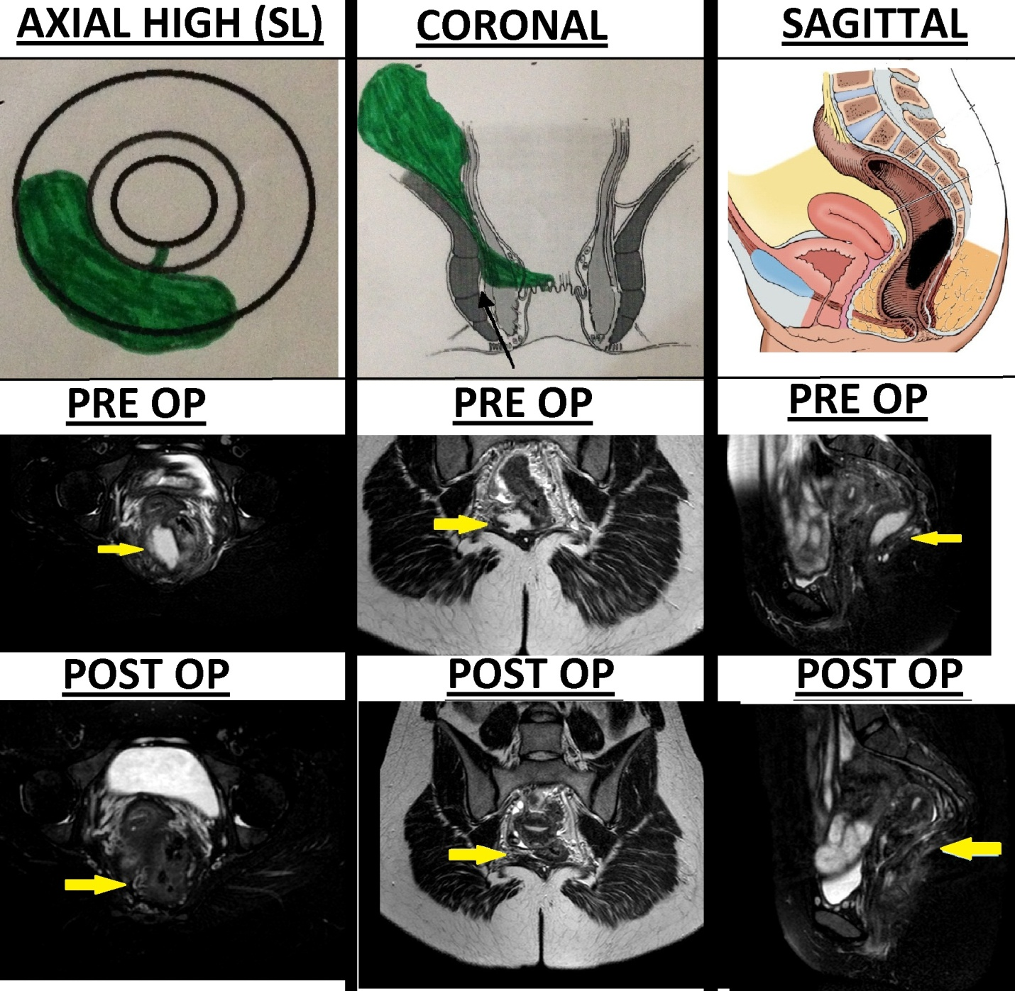
Figure 1 Intersphincteric supralevator abscess and fistula. A 25 years old female with supralevator collection from 5 to 9 o’clock. Post operation MRI images after 6 weeks (bottom row) show complete disease resolution. SL: Supralevator).

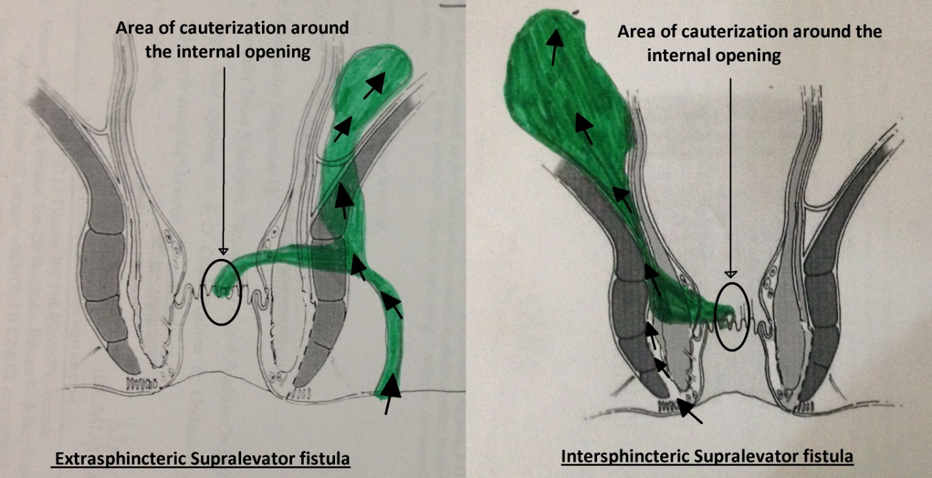

Figure 2 Approach to curette the supralevator fistula. Left: Extrasphincteric; Right: Intersphincteric.

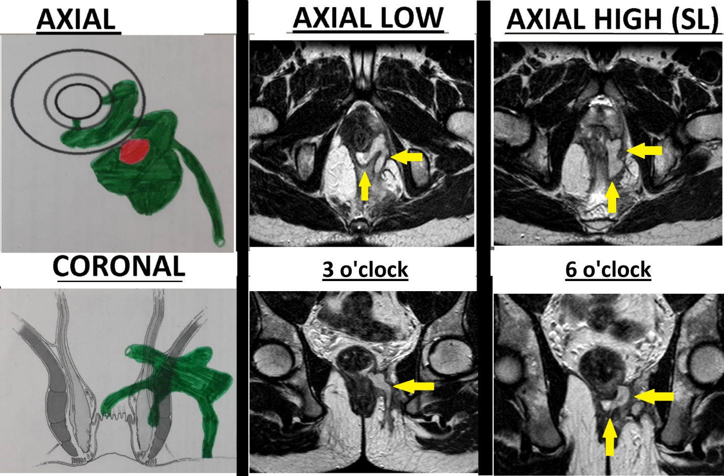
Figure 3 Transsphincteric supralevator fistula. A 22 years old male patient with infralevator posterior fistula opening at 6 o’clock and supralevator opening at 3 o’clock. Upper row: Axial; Lower row: Coronal.

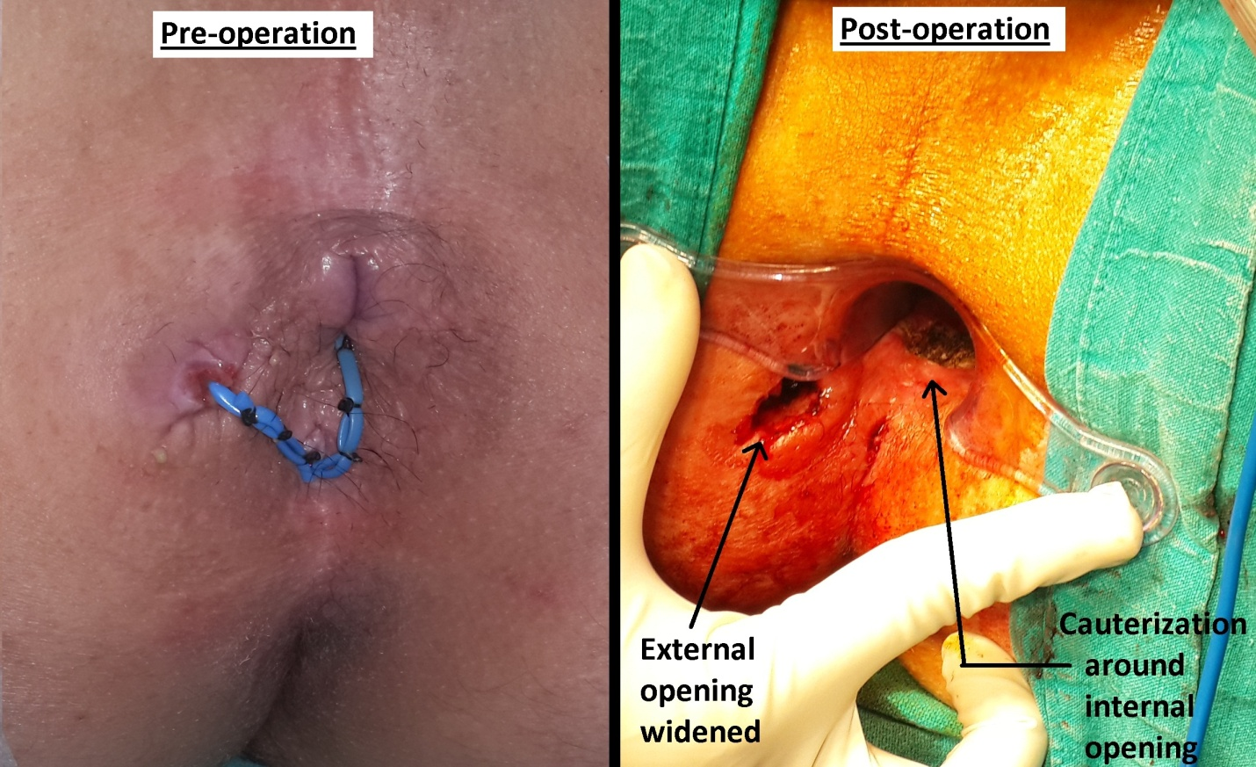

Figure 4 Cauterization around the internal opening and widening of external opening. Loose draining seton (blue color) can be seen in the pre-operation (left) photograph which was inserted during the previous operation by another surgeon 3 months before PERFACT procedure was done. Left: Pre-operation; Right: Post operation.

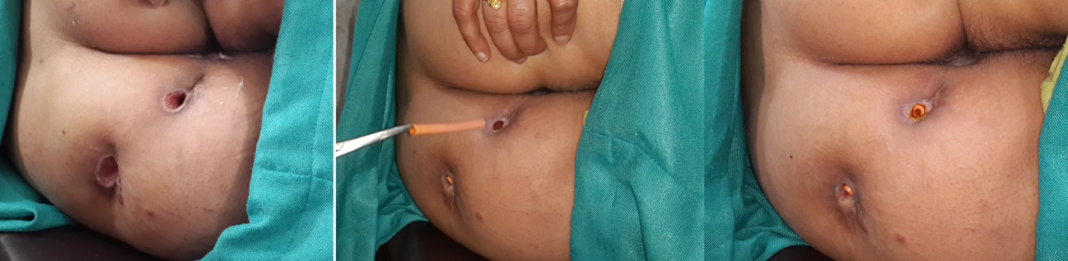

Figure 5 Widened external opening in a patient with multiple tracts (left), removal of tube to clean tracts in the office (middle), and reinserted tubes in the tracts after the cleaning process (right).

Table 1 Patient parameters, fistula characteristics and outcome
Case | Age (yr) | Sex | Previous operations | Site | Abscess | Horseshoe | Multiple  tracts | Outcome
1 | 62 | M | 2 | TS | N | N | N | Healed
2 | 45 | M | 1 | TS | Y | Y | Y | Recurred, Healed after reoperation
3 | 45 | M | 1 | TS | N | N | Y | Healed
4 | 49 | M | 2 | TS | N | N | Y | Not healed
5 | 59 | M | 1 | TS | N | N | Y | Didn’t follow protocol/ lost to follow up
6 | 48 | M | 1 | TS | Y | Y | Y | Healed
7 | 36 | M | 2 | IS | Y | Y | Y | Healed
8 | 26 | M | 0 | TS | Y | N | Y | Didn’t follow protocol/ lost to follow up
9 | 22 | F | 3 | TS | Y | N | Y | Not healed, Recurred after second operation
10 | 32 | M | 1 | IS | N | Y | Y | Healed
11 | 55 | M | 5 | IS | N | N | N | Healed
12 | 25 | F | 0 | IS | Y | N | N | Healed
13 | 59 | M | 1 | TS | N | N | Y | Healed
14 | 22 | M | 1 | TS | Y | N | Y | Healed
15 | 34 | M | 2 | TS | Y | N | Y | Healed
16 | 34 | M | 1 | TS | N | N | Y | Not healed
17 | 45 | M | 0 | TS | N | Y | Y | Healed
Total | 41.1 ± 13.4 | M-15/F-2 | Recurrent -14 | TS-13  IS-4 | 8 | 5 | 14 | Healed-11 (73.3%)  Not – 4  Excluded-2
TS: Transsphincteric (in ischiorectal fossa); IS: Intrasphincteric.

