Name of Journal: World Journal of Orthopedics
Manuscript NO: 62390
Manuscript Type: CASE REPORT

Rare shear-type fracture of the talar head in a thirteen-year-old child - Is this a transitional fracture: A case report and review of the literature

Monestier L et al. Shear-type fracture of the talar head: Is this a transitional fracture?

Luca Monestier, Giacomo Riva, Luca Faoro, Michele Francesco Surace

Luca Monestier, Giacomo Riva, Orthopedic and Trauma Unit, ASST Sette Laghi, Varese 21100, Italy

Luca Faoro, Residency Program in Orthopedics and Trauma, University of Insubria, Varese 21100, Italy

Michele Francesco Surace, Department of Biotechnology and Life Sciences, University of Insubria, Varese 21020, Italy

Author contributions: Monestier L and Faoro L were the patient’s surgeons; Monestier L, Riva G, Faoro L reviewed the literature and contributed to manuscript drafting; Monestier L analyzed the imaging findings; Surace MF, Monestier L and Riva G were responsible for revision of the manuscript for important intellectual content; all authors issued final approval for the version to be submitted.

Corresponding author: Luca Monestier, MD, Doctor, Surgeon, Orthopedic and Trauma Unit, ASST Sette Laghi, via L. Borri 57, Varese 21100, Italy. dottlucamonestier@outlook.it

Received: January 12, 2021
Revised: January 29, 2021
Accepted: March 18, 2021
Published online: May 18, 2021

Abstract
BACKGROUND
Talar fractures are exceedingly rare in childhood. There are very few studies on the clinical aspects, the long-term outcomes and the appropriate treatment of these fractures in pediatric patients. The mechanism of trauma consists of the application of a sudden dorsiflexion force on a fully plantar-flexed foot. Traumatic mechanism, symptoms and imaging of injuries of the talar head are similar to transitional fractures that are normally described at the distal epiphysis of the tibia: the so-called transitional fracture is defined as an epiphyseal injury when the growth plate has already started to close.

CASE SUMMARY
A thirteen-year-old girl reported a high-energy trauma to her right foot, due to falling from her horse. X-rays at the Emergency Department were negative. Because of persistent pain, the patient was assessed by an orthopedic surgeon after two weeks and computed tomography scans revealed a misdiagnosed displaced shear-type fracture of the talar head. Hence, surgical open reduction and fixation with two headless screws was performed. The girl was assessed regularly, and plain films at follow-up revealed complete healing of the fracture. Within six months after surgery, the patient returned to pre-injury sport activities reporting no complications.

CONCLUSION
Injuries of the talar head in childhood should be considered as transitional fractures. Open reduction with internal fixation aims to reduce malalignment and osteoarthritis. Computed tomography scans are recommended in these cases.

Key Words: Head; Talus; Transitional fracture; Child; Surgical treatment; Case report
©The Author(s) 2021. Published by Baishideng Publishing Group Inc. All rights reserved.

Monestier L, Riva G, Faoro L, Surace MF. Rare shear-type fracture of the talar head in a thirteen-year-old child - Is this a transitional fracture: A case report and review of the literature. World J Orthop 2021; 12(5): 329-337 URL: https://www.wjgnet.com/2218-5836/full/v12/i5/329.htm DOI: https://dx.doi.org/10.5312/wjo.v12.i5.329

Core Tip: Fractures of the talar head in childhood must be judged as transitional fractures. These injuries, typically occurring at the distal tibia, are defined as an epiphyseal injury when the growth plate has already started to close. This crucial aspect should be considered by orthopedic surgeons: surgical treatment is preferred in order to reduce malalignment and osteoarthritis.

INTRODUCTION
Talar fractures are exceedingly rare in childhood, with an estimated incidence of 0.01%-0.08% among all pediatric fractures^{[1-6]}. This rarity is due to skeletal immaturity making the bone more resistant to bending and torsional forces without subsequent fracture^{[2,4,5,7-9]}.
In the talus, the neck is usually involved, followed by the body and the head: the latter is protected by ligaments and capsule of the talar-navicular joint^{[4,10]}. Talar fractures are often related to high-energy trauma (high-altitude fall, sport injuries, car accidents)^{[8,11,12]}. The mechanism of trauma generally consists of the application of a sudden dorsiflexion force on a fully plantar-flexed foot: compressive forces through the talar head result in compression of the talar head against the anterior tibial edge^{[11]}. Participation in high-impact sports may increase the incidence of talus fractures in children^{[12]}.
Despite the improvements in surgical procedures, complications of these fractures are extremely frequent: osteonecrosis, post-traumatic osteoarthritis and foot deformity are the most common^{[3,8,11,13]}. In the past, fracture displacement and delayed surgery were considered the main risk factors; thus, immediate open reduction with internal fixation (ORIF) was recommended^{[14,15]}. However, the most recent literature has shown that there is no significant correlation between time of surgery and development of osteonecrosis or osteoarthritis^{[16,17]}.
Relatively little is known about talar injuries in childhood, as there are only a small number of studies in the literature. Due to their rarity, there are very few studies on the clinical aspects, the long-term outcomes, and the appropriate treatment in pediatric patients^{[18]}.
Here we report the rare case of a shear-type fracture of the talar head in a female adolescent, initially misdiagnosed in the emergency room.

CASE PRESENTATION
Chief complaints
A 13-year-old female came to the Emergency Department (ASST Settelaghi-Fondazione Macchi, Varese, VA, Italy) with a possible dislocation of the right ankle after a fall from her horse.

Physical examination
At clinical examination, an antero-medial tenderness of the foot, local pain and inability to bear weight on right foot were observed.

Laboratory examinations
Laboratory examinations were normal.

Imaging examinations
A trauma X-ray series was performed, with no evidence of fractures (Figure 1).

FINAL DIAGNOSIS
Shear-type fracture of the talar head.

TREATMENT
The patient was released from the hospital without evaluation by an orthopedic surgeon and was prescribed rest, no weight-bearing for a week, non-steroidal anti-inflammatory drugs and ice.
As local pain and inability to weight-bear was protracted with no further trauma, the patient came to our Trauma Unit after fifteen days. Pain at palpation and minimal swelling were found in her right foot. Hence, the orthopedic surgeon requested a computed tomography (CT) scan which revealed a displaced shear-type fracture of the talar head (Figure 2). This fracture was described as type-2, as defined by Canale et al^{[19]}.
It was decided to perform ORIF due to displacement and involvement of the articular surface. Surgery was performed two days later (seventeen day after trauma).
Open reduction was performed through an anteromedial approach and the fracture was fixed using two divergent BSS headless screws (Medartis AG, Basel, Switzerland), favoring compression and avoiding rotation of the fragment (Figure 3).
Postoperatively, the ankle was protected by a below-knee cast and no weight-bearing was allowed. Enoxaparin was prescribed for thromboprophylaxis. Pulsed electromagnetic field therapy was indicated for 4-6 h per day (IGEA Clinical Biophysics, Carpi, Italy).

OUTCOME AND FOLLOW-UP
At one-month follow-up, we found no local edema or wound complications, and the patient had minimal pain [(numeric rating scale) NRS = 2]. Plain films revealed initial healing of the fracture (Figure 4). The cast was substituted with a removable air-cushioned ankle orthosis (Bauerfiend© AirLoc) to avoid foot pronation and supination. We believe it was crucial to protect the cartilaginous surface of the talar head. Weight-bearing was not permitted. A rehabilitation protocol was begun with active/passive dorsiflexion and plantarflexion. At six weeks, foot pronation and supination exercises were introduced, as weight off proprioception and exercises in the pool.
At two months follow-up, range of motion was restored without pain (NRS = 0), 50% partial weight-bearing was indicated for two weeks, and then complete weight-bearing as tolerated. A rehabilitation protocol was deployed (Figure 5). Running and atraumatic sport activities were reintroduced at three months.
At six months, the young patient practiced every sport, and specifically horse riding, without any complications (NRS = 0). Range of motion was completely restored, and the patient showed no postoperative foot deformities or neurovascular deficits. Plain films revealed healing of the fracture with no osteonecrosis or osteoarthritis (Figure 6).

DISCUSSION
Talar fractures are exceedingly rare in childhood with an estimated incidence of 0.01%-0.08%^{[1-6]}. This rarity is due to skeletal immaturity making the bone more resistant to forces without subsequent fracture ^{[2,4,5,7-9]}.
When comparing children (< 12 years) and adolescents (> 12 years), Ebler reported a higher incidence of talar fractures in the latter, probably due to skeletal development: in younger children, the immature portion of the talus shows more resistance to bending or compressive forces^{[11]}. The severity of these fractures has been demonstrated to be greater in older patients^{[6,12]}.
Talar fractures are often related to high-energy trauma (high-altitude falls, sport injuries, car accidents). First described by Anderson in 1919, the mechanism of trauma generally consists of the application of a sudden dorsiflexion resulting in compression of the talar head against the anterior edge of the tibia^{[18]}. This theory was successively confirmed^{[8,11,12]}.
The rarity of these fractures in childhood and the difficulty in their diagnosis on plain films often result in misdiagnosis. Our patient was diagnosed after two weeks only because a CT scan was requested due to protracted pain and inability to walk. Hence, we emphasize the importance not only of a careful clinical assessment of the foot and ankle at the Emergency Department, but also of a meticulous examination of the medical history of the patient and of the trauma mechanism. In the case of a pediatric patient with high energy trauma, despite no recognizable fractures on plain films, CT or magnetic resonance imaging (MRI) scans are strongly suggested.
CT scanning has several advantages over MRI: CT is useful for precisely analyzing the degree of injury, specifically articular involvement, and to plan accurate surgical treatment^{[20]}. CT permits rapid acquisition of scans, optimal visual resolution and three dimensional-acquired images. Moreover, sedation and anesthesia are not required. Conversely, MRI eliminates the exposure to radiation in pediatric patients. This issue should not be underestimated as compared to adults, children show more sensitivity of tissues to ionizing radiation and their longer lifetime allows the development of several tumors. For this reason, in the last decades several studies evaluated the effects of exposure to radiation in children, introducing the notion of “as low as reasonably achievable” dose^{[21-25]}. The use of low-dose CT or ultra-low-dose CT, digital acquisition of images and more accurate protective devices have significantly reduced the exposure of pediatric patients to ionizing radiation: with regard to fractures, ultra-low-dose CT has been demonstrated to expose patients to lower doses than plain films^{[24]}. Hence, we strongly believe that a CT scan at the Emergency Department is necessary in the case of high energy trauma involving children. Our statement regarding the necessity of CT scans in pediatric ankle fractures is supported by the literature^{[26-29]}.
With regard to the pediatric population, ossification of the talus and the mechanism pattern, an important question emerges: could these injuries be transitional fractures?
Talus development is based on endochondral ossification. The ossific nuclei of the talus compares to the neck during the 26th-28th gestational week. In newborns, up to 24% of the talus consists of bony tissue^{[30,31]}. Frisch described two periosteal collars: the first forms the roof of the sinus tarsi; the second is situated at the top of the ossification center and is covered by a layer of fibrocartilage-like tissue, a layer of dense connective tissue and the synovial membrane of the tibiotalar joint^{[30]}. Complete talar maturity occurs during adolescence (12-22 years). However, because the talus has no epiphysis, it is difficult to determine the maturity of the talus; hence, its development is usually defined by the closure of metatarsals (14-21 years)^{[32]}.
The so-called transitional fracture is defined as an epiphyseal injury when the growth plate has already started to close (Figure 7 shows closure of the distal tibial physis). The most involved site is the distal tibia: transitional fracture occurs because of the combination of relative weakness of not yet mineralized epiphyseal areas and the great resistance of mature bone, stabilized by tibiotalar ligaments. The distal epiphysis of the tibia is prone to fracture as it shows a uniform and eccentric closure pattern of the growth plate^{[33]}.
Could the fracture of the talar head/neck edge be considered a transitional fracture? Presumably, yes. The mechanism could be compared to that which occurs at the distal tibia. As described above, the enchondral ossification of the talus concludes in adolescence. The weakness of unfused talar areas on the one hand, the increased stability of the already mineralized parts and the strength of the talonavicular joint on the other hand, tend to facilitate fracture at this site when a torsional or compressive force is applied to the foot.
The treatment is conservative for nondisplaced transitional fractures. The tolerance limit is a fracture displacement greater than 2 mm and/or a joint step^{[33]}. The purpose of surgical treatment is anatomical joint reconstruction. Several authors disputed whether an open reduction or percutaneous closed reduction is required^{[33-35]}.
With regard to the distal tibia, Schneidmueller et al^{[33]} suggested ORIF should be performed as capsule incision ensures the evacuation of hemarthrosis reducing intraarticular pressure, and permits a direct view of the fracture. Fixation is performed with cannulated screws^{[33]}.
The treatment of a transitional fracture aims to reduce complications, physeal malalignment, growth disturbances and post-traumatic osteoarthritis. However, closure of the physeal plate is not sufficient in adolescents to cause significant growth-related problems and ORIF is indicated mostly to reduce articular malalignment leading to osteoarthritis.
These principles can all be applied to fractures of the talar head.
In the present case, we decided to perform ORIF using two headless screws. A displaced shear-type fracture of the talar head could result in midfoot deformity and osteoarthritis of the talonavicular joint. Open reduction was necessary as we performed surgery on the seventeenth day after the trauma. At follow-up, no signs or symptoms were observed in our young patient.
Talar fractures in pediatric patients must be treated similar to those in adults^{[5,36]}. Nondisplaced fractures of the talus can be treated non-operatively by using cast immobilization, while displaced fractures require operative intervention^{[5,11]}. Godoy-Santos et al^{[8]} and Rammelt et al^{[20]} highlighted the limitations of the talar spontaneous remodeling capacity during growth; thus, these authors indicated ORIF for all displaced fractures^{[8,20]}. If a few attempts of closed reduction appear unsuccessful, open reduction should be performed^{[8]}.
Kruppa et al^{[6]} demonstrated worse injuries with high rates of complications (nonunion, osteonecrosis, osteoarthritis, deformities) and disabilities in adolescents: in general, older children and adolescents were more likely to benefit from surgical treatment^{[6]}.
The purpose of treatment is to reduce the rate of complications: osteonecrosis, osteoarthritis and foot deformities are the most frequent and dangerous^{[3,5,8,11-13]}. With regard to the talar head specifically, unreduced fractures may result in post-traumatic arthritis and three-dimensional deformities: the foot function can be severely restricted by the medial column displacement and subluxation in the talonavicular joint^{[8,13]}. Hence, immediate ORIF was traditionally considered crucial^{[14,15]}. Nonetheless, the most recent literature has shown that there is no significant correlation between time of surgery and development of osteonecrosis or osteoarthritis^{[16,17]}.

CONCLUSION
Talar head fractures represent severe injuries, including in the pediatric population. Open reduction and internal fixation are necessary in the case of displacement. Injuries of the talar head in children and adolescents should be considered as transitional fractures; hence, the treatment aims to reduce malalignment and osteoarthritis. Due to the frequent misdiagnosis of these fractures, CT scans are recommended in children describing high energy trauma.

REFERENCES
1 Beaty JH, Kasser JR. Rockwood and Green’s Fractures in Children. Lippincott Williams & Wilkins, 2006: 1136-1138
2 Letts RM, Gibeault D. Fractures of the neck of the talus in children. Foot Ankle 1980; 1: 74-77 [PMID: 7274901 DOI: 10.1177/107110078000100203]
3 Jensen I, Wester JU, Rasmussen F, Lindequist S, Schantz K. Prognosis of fracture of the talus in children. 21 (7-34)-year follow-up of 14 cases. Acta Orthop Scand 1994; 65: 398-400 [PMID: 7976283 DOI: 10.3109/17453679408995478]
4 Thermann H, Schratt HE, Hüfner T, Tscherne H. [Fractures of the pediatric foot]. Unfallchirurg 1998; 101: 2-11 [PMID: 9522665 DOI: 10.1007/s001130050225]
5 Yazdi H, Ramezan Shirazi M. An unusual presentation of talus fracture in a child: a case report. Foot Ankle Surg 2010; 16: e57-e60 [PMID: 20655001 DOI: 10.1016/j.fas.2010.03.005]
6 Kruppa C, Snoap T, Sietsema DL, Schildhauer TA, Dudda M, Jones CB. Is the Midterm Progress of Pediatric and Adolescent Talus Fractures Stratified by Age? J Foot Ankle Surg 2018; 57: 471-477 [PMID: 29506948 DOI: 10.1053/j.jfas.2017.10.031]
7 Sferopoulos NK. Talus fractures in children. ARC J Res Sport Med 2017; 2: 21-26
8 Godoy-Santos AL, Albuquerque DM, Diniz-Fernandes T, Rammelt S. Fracture of the talar neck associated with a compression fracture of the calcaneocuboid joint in a 5-year-old child: a case report. Arch Orthop Trauma Surg 2013; 133: 1267-1271 [PMID: 23784318 DOI: 10.1007/s00402-013-1791-9]
9 Mayr J, Peicha G, Grechenig W, Hammerl R, Weiglein A, Sorantin E. Fractures and dislocations of the foot in children. Clin Podiatr Med Surg 2006; 23: 167-189, ix [PMID: 16598914 DOI: 10.1016/j.cpm.2005.10.011]
10 Bykov Y. Fractures of the talus. Clin Podiatr Med Surg 2014; 31: 509-521 [PMID: 25281512 DOI: 10.1016/j.cpm.2014.06.004]
11 Eberl R, Singer G, Schalamon J, Hausbrandt P, Hoellwarth ME. Fractures of the talus--differences between children and adolescents. J Trauma 2010; 68: 126-130 [PMID: 20065767 DOI: 10.1097/TA.0b013e3181a74667]
12 Smith JT, Curtis TA, Spencer S, Kasser JR, Mahan ST. Complications of talus fractures in children. J Pediatr Orthop 2010; 30: 779-784 [PMID: 21102201 DOI: 10.1097/BPO.0b013e3181f73e6e]
13 Zwipp H, Ranft T. [Malunited juvenile fractures in the foot region]. Orthopade 1991; 20: 374-380 [PMID: 1684652]
14 Kızılay YO, Aytan O. Low-Energy Hawkins Type III Talar Neck Fracture-Dislocation With Neurovascular and Tendon Entrapment in a Pediatric Patient. J Foot Ankle Surg 2017; 56: 1288-1291 [PMID: 28778631 DOI: 10.1053/j.jfas.2017.05.007]
15 García-Rey E, Sanz-Hospital FJ, Galdrán FJ, Cano-Egea JM, Alcázar LFL. Talar neck fractures: results and complications by type. Foot Ankle Surg 2002; 8: 203-208 [DOI: 10.1046/j.1460-9584.2002.00305.x]
16 Schulze W, Richter J, Russe O, Ingelfinger P, Muhr G. Surgical treatment of talus fractures: a retrospective study of 80 cases followed for 1-15 years. Acta Orthop Scand 2002; 73: 344-351 [PMID: 12143985 DOI: 10.1080/000164702320155374]
17 Vallier HA, Nork SE, Barei DP, Benirschke SK, Sangeorzan BJ. Talar neck fractures: results and outcomes. J Bone Joint Surg Am 2004; 86: 1616-1624 [PMID: 15292407]
18 Anderson HG. Medical and Surgical Aspects of Aviation. 1919, Henry Frowde Oxford University Press [DOI: 10.1097/00000441-192001000-00019]
19 Canale ST, Kelly FB Jr. Fractures of the neck of the talus. Long-term evaluation of seventy-one cases. J Bone Joint Surg Am 1978; 60: 143-156 [PMID: 417084]
20 Rammelt S, Schneiders W, Fitze G, Zwipp H. [Foot and ankle fractures in children]. Orthopade 2013; 42: 45-54 [PMID: 23306525 DOI: 10.1007/s00132-012-1993-9]
21 Kern M, Tucker A, Rogers K, Kruse RW. CT Utilization for Pediatric Orthopedic Trauma. Del Med J 2015; 87: 366-369 [PMID: 26852433]
22 Frush DP. Justification and optimization of CT in children: how are we performing? Pediatr Radiol 2011; 41 Suppl 2: 467-471 [PMID: 21847724 DOI: 10.1007/s00247-011-2097-0]
23 Almohiy H. Paediatric computed tomography radiation dose: A review of the global dilemma. World J Radiol 2014; 6: 1-6 [PMID: 24578786 DOI: 10.4329/wjr.v6.i1.1]
24 Moritz JD, Hoffmann B, Sehr DH, Eggerking J, Keil K, Caliebe A, Dischinger J, Heller M, Bolte H. [Pediatric fracture diagnosis--ultra-low-dose CT with an effective dose equal to that of radiographs]. Rofo 2012; 184: 1026-1033 [PMID: 22872600 DOI: 10.1055/s-0032-1313060]
25 Goske MJ, Strauss KJ, Westra SJ, Frush DP. The Image Gently ALARA CT summit on new CT technologies for children. Pediatr Radiol 2014; 44 Suppl 3: 403 [PMID: 25304694 DOI: 10.1007/s00247-014-3076-z]
26 Nenopoulos A, Beslikas T, Gigis I, Sayegh F, Christoforidis I, Hatzokos I. The role of CT in diagnosis and treatment of distal tibial fractures with intra-articular involvement in children. Injury 2015; 46: 2177-2180 [PMID: 26250713 DOI: 10.1016/j.injury.2015.07.017]
27 Lemburg SP, Lilienthal E, Heyer CM. Growth plate fractures of the distal tibia: is CT imaging necessary? Arch Orthop Trauma Surg 2010; 130: 1411-1417 [PMID: 20563820 DOI: 10.1007/s00402-010-1140-1]
28 Olgun ZD, Maestre S. Management of Pediatric Ankle Fractures. Curr Rev Musculoskelet Med 2018; 11: 475-484 [PMID: 29987644 DOI: 10.1007/s12178-018-9510-3]
29 Eismann EA, Stephan ZA, Mehlman CT, Denning J, Mehlman T, Parikh SN, Tamai J, Zbojniewicz A. Pediatric Triplane Ankle Fractures: Impact of Radiographs and Computed Tomography on Fracture Classification and Treatment Planning. J Bone Joint Surg Am 2015; 97: 995-1002 [PMID: 26085533 DOI: 10.2106/JBJS.N.01208]
30 Fritsch H, Schmitt O, Eggers R. The ossification centre of the talus. Ann Anat 1996; 178: 455-459 [PMID: 8931858 DOI: 10.1016/S0940-9602(96)80140-3]
31 Howard CB, Benson MK. The ossific nuclei and the cartilage anlage of the talus and calcaneum. J Bone Joint Surg Br 1992; 74: 620-623 [PMID: 1624527 DOI: 10.1302/0301-620X.74B4.1624527]
32 Herring JA. Growth and Development. In: Herring JA. Tachdjian’s Pediatric Orthopaedics, 4th Edition. Saunders, 2008
33 Schneidmueller D, von Rüden C, Friederichs J, Bühren V. [Transitional fractures: Epiphyseal injuries in adolescence]. Unfallchirurg 2016; 119: 517-526 [PMID: 27240851 DOI: 10.1007/s00113-016-0186-0]
34 Spiegel PG, Mast JW, Cooperman DR, Laros GS. Triplane fractures of the distal tibial epiphysis. Clin Orthop Relat Res 1984: 74-89 [PMID: 6467731]
35 Crawford AH. Triplane and Tillaux fractures: is a 2 mm residual gap acceptable? J Pediatr Orthop 2012; 32 Suppl 1: S69-S73 [PMID: 22588107 DOI: 10.1097/BPO.0b013e31824b25a1]
36 Draijer F, Havemann D, Bielstein D. [Injury analysis of pediatric talus fractures]. Unfallchirurg 1995; 98: 130-132 [PMID: 7754399]

Footnotes
Informed consent statement: The informed consent statement has been correctly acquired. The file was previously sent to the reviewer.

Conflict-of-interest statement: Each author certifies that he has no commercial associations (e.g., consultancies, stock ownership, equity interest, patent/licensing arrangements, etc.) that might pose a conflict of interest in connection with the submitted article.

CARE Checklist (2016) statement: The CARE checklist (2016) statement has been correctly completed. The file was previously sent to the reviewer.

Open-Access: This article is an open-access article that was selected by an in-house editor and fully peer-reviewed by external reviewers. It is distributed in accordance with the Creative Commons Attribution NonCommercial (CC BY-NC 4.0) license, which permits others to distribute, remix, adapt, build upon this work non-commercially, and license their derivative works on different terms, provided the original work is properly cited and the use is non-commercial. See: http://creativecommons.org/Licenses/by-nc/4.0/

Manuscript source: Invited manuscript

Peer-review started: January 12, 2021
First decision: January 24, 2021
Article in press: March 18, 2021

Specialty type: Orthopedics
Country/Territory of origin: Italy
Peer-review report’s scientific quality classification
Grade A (Excellent): 0
Grade B (Very good): 0
Grade C (Good): C
Grade D (Fair): 0
Grade E (Poor): 0

P-Reviewer: Rabbi Q S-Editor: Zhang L L-Editor: Webster JR P-Editor: Xing YX

Figure Legends
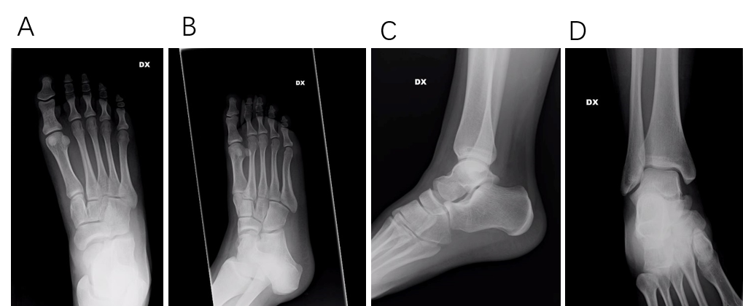
Figure 1 X-rays of the patient at the emergency department. A: The foot was investigated by A-P view; B: Oblique view; C: Ankle on lateral view; and D: A-P view.
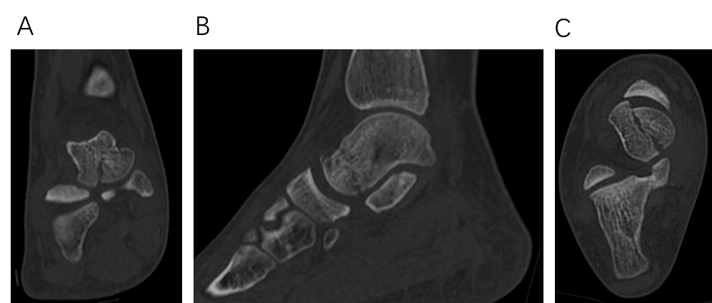
Figure 2 Pre-operative computed tomography images of the shear-type fracture. A: Coronal, B: Sagittal; and C: Axial view are shown.
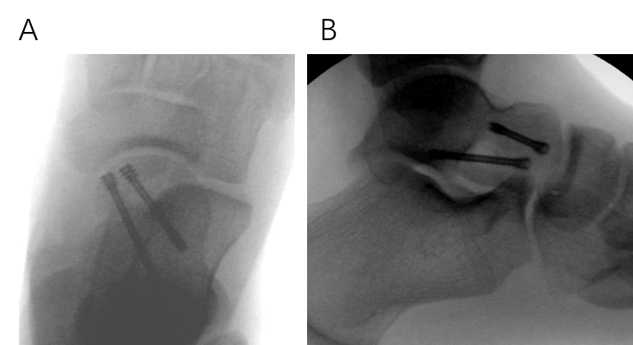
Figure 3 Intraoperative X-rays. Two headless screws were used for fixation. A: Anteroposterior view; B: Lateral view.
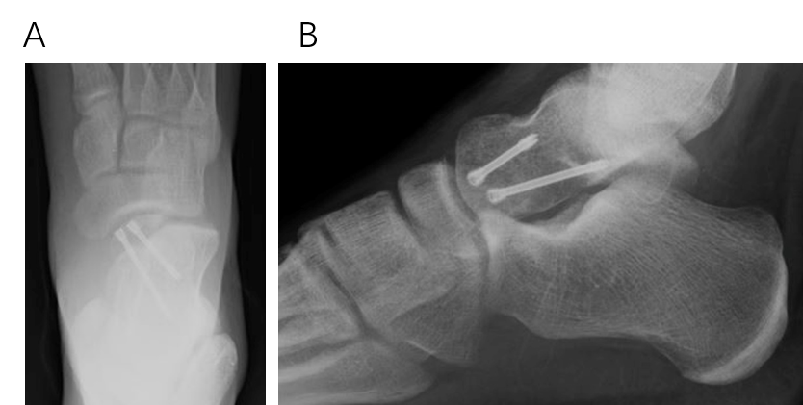
Figure 4 Plain films at one-month postoperative follow-up: the fracture is healing. A: Anteroposterior view; B: Lateral view.
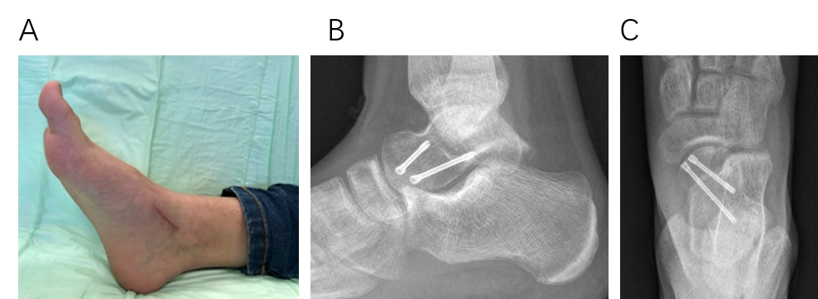
Figure 5 Follow-up at two months: the foot is shrunken and the surgical wound healed. Plain films revealed a healed fracture. A: Clinical assessment; B: Lateral view; and C: Anteroposterior view.
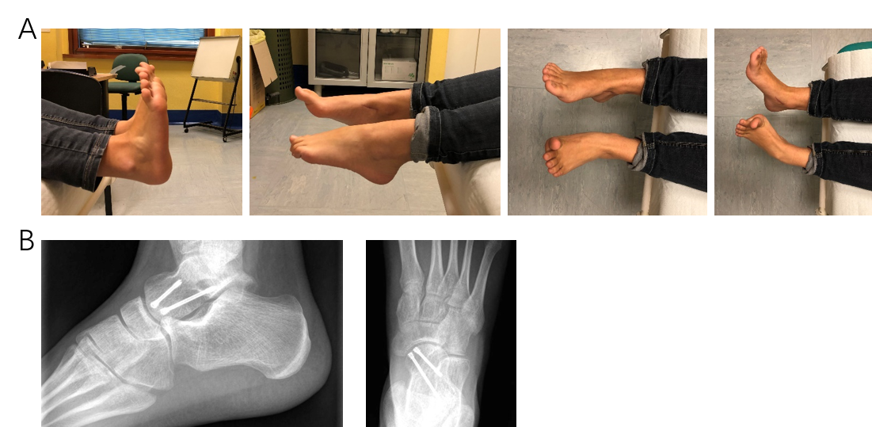
Figure 6 Follow-up at six months: complete range of motion was restored. A: Clinical assessment; and B: Fracture healed without osteonecrosis or osteoarthritis.
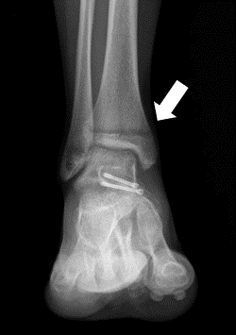
Figure 7 Postoperative plain film: The orange arrow shows that the physis of the distal tibia has started to close.

Published by Baishideng Publishing Group Inc
7041 Koll Center Parkway, Suite 160, Pleasanton, CA 94566, USA
Telephone: +1-925-3991568
E-mail: bpgoffice@wjgnet.com
Help Desk: https://www.f6publishing.com/helpdesk
https://www.wjgnet.com

© 2021 Baishideng Publishing Group Inc. All rights reserved.

