Name of Journal: World Journal of Clinical Cases
Manuscript NO: 77866
Manuscript Type: CASE REPORT

Rectal cancer combined with abdominal tuberculosis: A case report

Liu PG et al. Abdominal tuberculosis mimicking abdominal metastasis

Pei-Gen Liu, Xiang-Fan Chen, Pan-Feng Feng

Pei-Gen Liu, Department of General Surgery, Central Hospital of Panzhihua City, Panzhihua 617000, Sichuan Province, China

Xiang-Fan Chen, Pan-Feng Feng, Department of Pharmacy, Affiliated Hospital 2 of Nantong University, Nantong 226000, Jiangsu Province, China

Author contributions: Liu PG performed the operation; Chen XF designed the research study; Feng PF analyzed the data and wrote the manuscript; all authors have read and approved the final manuscript.

Corresponding author: Pan-Feng Feng, PhD, Surgical Oncologist, Department of Pharmacy, Affiliated Hospital 2 of Nantong University, No. 6 Haierxiang North Road, Nantong 226001, Jiangsu Province, China. 929083891@qq.com

Received: May 26, 2022
Revised: June 29, 2022
Accepted: September 19, 2022
Published online: November 6, 2022

Abstract
BACKGROUND
It is very rare to suffer from colorectal adenocarcinoma and abdominal tuberculosis simultaneously. Even in a country such as China, where tuberculosis is still endemic, its diagnosis and treatment are challenging. This article describes in detail a case of rectal cancer complicated by abdominal tuberculosis and its pathological features.

CASE SUMMARY
We outline the case of a 71-year-old female who was admitted with intermittent blood in the stool over the past year. The patient was diagnosed with low rectal cancer and received neoadjuvant therapy. The patient then returned to the hospital for surgery, but diffusely distributed nodules were found during laparoscopic exploration. The diagnosis of rectal cancer with extensive metastasis was considered during the operation. There was no opportunity for radical surgery. Thus, nodules were taken for pathological examination, and the abdomen was closed. The histopathological diagnosis was tuberculous granuloma, and the patient was treated with standardized anti-tuberculosis drugs in a specialized hospital. Later, the patient again came to our hospital and underwent abdominoperineal resection. She was discharged 10 d after the operation in good clinical condition.

CONCLUSION
We aim to emphasize the importance of preoperative and postoperative pathological examination in diagnosis and treatment.

Key Words: Abdominal tuberculosis; Rectal cancer; Extrapulmonary tuberculosis; Peritoneal nodules; Case report

©The Author(s) 2022. Published by Baishideng Publishing Group Inc. All rights reserved.

Citation: Liu PG, Chen XF, Feng PF. Rectal cancer combined with abdominal tuberculosis: A case report. World J Clin Cases 2022; 10(31): 11523-11528
URL: https://www.wjgnet.com/2307-8960/full/v10/i31/11523.htm
DOI: https://dx.doi.org/10.12998/wjcc.v10.i31.11523

Core Tip: We report a relatively rare case of rectal adenocarcinoma combined with abdominal tuberculosis. The difficulty is that it is easily misdiagnosed as rectal cancer with extensive abdominal and pelvic metastasis, thus delaying treatment. Therefore, the pathological examination of abdominal and pelvic nodules during and after surgery is very important in diagnosis and treatment.

INTRODUCTION
Tuberculosis is a chronic infectious disease that is caused by Mycobacterium tuberculosis invading the human body. According to the global tuberculosis report released by the World Health Organization in 2019, tuberculosis is an infectious disease with the highest mortality rate in the world, causing 1.5 million deaths in 2018. The incidence of tuberculosis in China ranks third in the world, and China is one of 22 countries with a high burden of tuberculosis^{[1,2]}. Abdominal tuberculosis is a form of extrapulmonary tuberculosis, and it accounts for approximately 1%-5% of the total number of tuberculosis cases^{[3]}. The clinical manifestations are mostly nonspecific symptoms^{[4]}. The common diseased organs of abdominal tuberculosis are the colon, peritoneum and mesentery^{[5]}, and peritoneal biopsy is the gold standard for diagnosis. It is very rare to suffer from colorectal cancer and abdominal tuberculosis at the same time, and only 5 cases have been reported in the English literature published in the past 20 years^{[6-10]}. We report a case of rectal adenocarcinoma combined with abdominal tuberculosis and emphasize the key role of the pathological examination of abdominal and pelvic nodules on intraoperative and postoperative diagnosis and treatment.

CASE PRESENTATION
Chief complaints
A 71-year-old female patient reported changes in stool characteristics with intermittent blood in the stool over the past year without obvious cause.

History of present illness
The patient was diagnosed with low rectal cancer and received neoadjuvant therapy in our hospital several months ago. The long-course chemoradiotherapy included a total radiotherapy dose of 50.4 Gray unit (Gy) and a daily dose of 1.8 Gy, combined with capecitabine [625-825 mg/(m²· time), peros, twice/day, (day 1 - day 7) × 5 wk].

History of past illness
The patient had no underlying disease and no history of living in foci of infection or endemic areas.

Personal and family history
She had no personal or family history of other disease.

Physical examination
The patient’s abdomen was soft without tenderness, rebound pain and abdominal mass. During the digital rectal examination, a 3 cm × 2 cm tumor was touched on the anterior wall of the rectum 4 cm from the anal margin. Her blood pressure was 113/54 mmHg and pulse rate was 94 bpm.

Laboratory examinations
The tumor-related biological indicators carcinoembryonic antigen was 2.30 ng/mL and carbohydrate antigen (CA) 199 was 28.4 U/mL, which were within the normal range. The value of CA242 was 35.20 U/mL, which was slightly high.

Imaging examinations
Magnetic resonance imaging (MRI) examination showed that the lesion was located below the peritoneal reentry, about 0.7 cm from the dentate line and about 3.3 cm from the anal margin (Figure 1). Chest computed tomography (CT) showed no obvious abnormalities.

FINAL DIAGNOSIS
During the first operation, laparoscopic exploration revealed pelvic floor effusion, as well as diffuse gray-white nodules on the surface of the abdominal pelvic cavity, greater omentum, and the intestinal wall. The largest nodule was approximately 0.3 cm in diameter (Figure 2). Histopathological examination showed that the nodule tissue submitted for examination was a granulomatous nodule, and Tb-polymerase chain reaction (PCR) (+) found a fragment of Mycobacterium tuberculosis (Figure 3).

TREATMENT
The patient received standardized anti-tuberculosis treatment (isoniazid, rifampicin, ethambutol) for three months in a specialist hospital. She then returned to our hospital to undergo abdominoperineal resection.

OUTCOME AND FOLLOW-UP
During the operation, there was no obvious effusion and lymphadenectasis in the abdominal cavity. Postoperative pathology showed moderately differentiated rectal adenocarcinoma. A large number of peritoneal nodules were necrotic, and the surrounding tissues were granulomas. In addition, no cancer was found. After the operation, the patient was in stable condition and was discharged from the hospital ten days later. Her clinical condition has been good since then.

DISCUSSION
Tuberculosis is still a global health problem. It has caused high morbidity and mortality in developing countries and has shown an upwards trend each year in the western world^{[11]}. The definition of abdominal tuberculosis refers to tuberculosis infection involving the abdomen, such as the peritoneum, mesentery, abdominal lymph nodes, gastrointestinal tract, liver and gallbladder and other substantial organs^{[12]}. According to reports, the ileo-colic junction is the most common site of abdominal tuberculosis^{[13]}, and the peritoneum and abdominal lymph nodes are the most common sites of involvement in children^{[14]}. Abdominal tuberculosis is a relatively rare type of tuberculosis. The clinical symptoms are nonspecific, ranging from acute symptoms, such as perforation and obstruction, to chronic symptoms, such as abdominal pain, bloating, fatigue, diarrhea, and weight loss^{[15]}. The initial symptoms can be confusing, especially in the context of a history of cancer or elevated tumor indicators. If the patient is not treated in time, the delay in the diagnosis of abdominal tuberculosis is associated with high morbidity and mortality^{[16,17]}. Currently, there is no reliable tool to diagnose abdominal tuberculosis. Chest X-ray is a routine and simple imaging test, but it has been reported that only 15%-56% of patients with abdominal tuberculosis have chest X-ray evidence of pulmonary tuberculosis^{[18]}. In the era of laparoscopy, the diagnosis rate of histopathological examination by peritoneal biopsy is 85%-100%^{[19]}. In addition, PCR detection of tissue is also an effective tool that has a high degree of specificity and sensitivity^{[20]}.
This is a relatively rare case. The patient was diagnosed with rectal adenocarcinoma on admission to our hospital. The ulcerative mass was 4 cm from the anal margin. MRI showed that the tumor stage was cT3-4NxM0. Neoadjuvant therapy was performed according to treatment guidelines. However, during the first laparoscopic exploration, a small amount of yellow effusion was found in the pelvic cavity, and grey-white nodules were diffusely distributed on the surface of the abdominal pelvic cavity, omentum, and intestinal wall. We hypothesized that the patient had rectal cancer with extensive abdominal and pelvic metastasis, and there was no chance of radical surgery. Therefore, the peritoneum, mesenteric and greater omentum nodules were removed and sent for paraffin pathology. As the patient's rectal disease was not obstructed, colostomy was not performed temporarily. Moreover, the patient had no chest CT abnormalities, so the possibility of tuberculosis was not considered.
However, it was surprising that histopathological examination revealed granulomatous tissue nodules, suggesting tuberculosis. At this time, further inspection was needed to clarify its nature to formulate the next treatment plan. If it was determined to be rectal cancer with abdominal tuberculosis, it should be reviewed after regular anti-tuberculosis treatment, and then rectal cancer surgery should be performed according to the situation. If rectal cancer surgery can be completed, the patient's prognosis will be greatly improved. If it is suggested that it is a metastatic nodule, chemotherapy is recommended, but the prognosis is very poor. Fragments of Mycobacterium tuberculosis were found by Tb-PCR. Therefore, the patient was clearly diagnosed with abdominal tuberculosis and rectal adenocarcinoma.
After three months of standardized anti-tuberculosis treatment in a specialist hospital, the patient was ready for surgery. As the patient was in the locally advanced stage of low rectal cancer, was older, had poor cardiac function, and had tuberculosis, sphincter-preserving surgery was not performed. Instead, a radical resection of the abdominal perineum combined with rectal cancer excision was performed. The patient recovered well after the operation.
Histopathological examination is still the gold standard for the diagnosis of abdominal tuberculosis^{[21]}, but there are certain difficulties in obtaining suitable tissue materials in clinical practice, which brings certain difficulties to our comprehensive diagnosis. Clinically, the understanding of abdominal tuberculosis should be strengthened, and the awareness and ability of differential diagnosis should be enhanced. The pathological examination of abdominal and pelvic nodules during and after the operation is very important in the diagnosis and treatment of the disease.

CONCLUSION
Pathological examination during and after surgery is very important in the diagnosis and treatment of complex diseases.

REFERENCES
1 Hernandez-Andrade E. Re: Childhood cognitive development after fetal growth restriction. E. Llurba, A. A. Baschat, O. M. Turan, J. Harding and L. M. McCowan. Ultrasound obstet gynecol 2013; 41: 383-389. Ultrasound Obstet Gynecol 2013; 41: 364-365 [PMID: 23616349 DOI: 10.1002/uog.12452]
2 Floyd K, Glaziou P, Zumla A, Raviglione M. The global tuberculosis epidemic and progress in care, prevention, and research: an overview in year 3 of the End TB era. Lancet Respir Med 2018; 6: 299-314 [PMID: 29595511 DOI: 10.1016/S2213-2600(18)30057-2]
3 Cho JK, Choi YM, Lee SS, Park HK, Cha RR, Kim WS, Kim JJ, Lee JM, Kim HJ, Ha CY, Kim HJ, Kim TH, Jung WT, Lee OJ. Clinical features and outcomes of abdominal tuberculosis in southeastern Korea: 12 years of experience. BMC Infect Dis 2018; 18: 699 [PMID: 30587154 DOI: 10.1186/s12879-018-3635-2]
4 Lata Verma M, Tripathi V, Singh U, Agarwal P, Sachan R, Lata Sankwar P. Peritoneal tuberculosis with benign ovarian tumor. Indian J Tuberc 2019; 66: 499-501 [PMID: 31813439 DOI: 10.1016/j.ijtb.2018.12.001]
5 Debi U, Ravisankar V, Prasad KK, Sinha SK, Sharma AK. Abdominal tuberculosis of the gastrointestinal tract: revisited. World J Gastroenterol 2014; 20: 14831-14840 [PMID: 25356043 DOI: 10.3748/wjg.v20.i40.14831]
6 Roh WS, Lee S, Park JH, Kang J. Abdominal Sarcoidosis Mimicking Peritoneal Carcinomatosis. Ann Coloproctol 2018; 34: 101-105 [PMID: 29742855 DOI: 10.3393/ac.2018.01.29]
7 Buch K, Christiansen EG, Skau AM. [Simultaneous intestinal tuberculosis and adenocarcinoma]. Ugeskr Laeger 2017; 179 [PMID: 28869010 DOI: 10.1007/bf02612496]
8 Choi YJ, Kim HG, Choi YA, Joo WC, Son DW, Kim CH, Shin YW, Kim YS. [A case of pseudomembranous colitis associated with rifampicin therapy in a patient with rectal cancer and gastrointestinal tuberculosis]. Korean J Gastroenterol 2009; 53: 53-56 [PMID: 19158472 DOI: 10.1159/000323753]
9 Fahlbusch T, Künzli B, Schlottmann R, Tannapfel A, Uhl W, Braumann C. Tuberculosis Mimicking Disseminated Peritoneal Carcinomatosis of a Sigmoid Carcinoma. J Gastrointest Surg 2019; 23: 877-878 [PMID: 29736664 DOI: 10.1007/s11605-018-3800-3]
10 Demetriou GA, Nair MS, Navaratnam R. Concurrent caecal and transverse colonic tuberculosis masqueratingsynchironous colonic carcinima. BMJ Case Rep 2013: bcr2013009379 [DOI: 10.1136/bcr-2013-009379]
11 Pattanayak S, Behuria S. Is abdominal tuberculosis a surgical problem? Ann R Coll Surg Engl 2015; 97: 414-419 [PMID: 26274741 DOI: 10.1308/rcsann.2015.0010]
12 Rathi P,Gambhire P. Abdominal Tuberculosis. J Assoc Physicians India 2016; 64: 38-47 [DOI: 10.4103/jacp.jacp_47_20]
13 Gill P, Coatsworth NR, Gundara JS, Hugh TJ, Samra JS. Tuberculosis: experience in a low endemic area Australian tertiary hospital. World J Surg 2013; 37: 984-990 [PMID: 23397169 DOI: 10.1007/s00268-013-1935-7]
14 Sartoris G, Seddon JA, Rabie H, Nel ED, Schaaf HS. Abdominal Tuberculosis in Children: Challenges, Uncertainty, and Confusion. J Pediatric Infect Dis Soc 2020; 9: 218-227 [PMID: 31909804 DOI: 10.1093/jpids/piz093]
15 Chen CH, Yang CC, Yeh YH, Yang JC, Chou DA. Pancreatic tuberculosis with obstructive jaundice--a case report. Am J Gastroenterol 1999; 94: 2534-2536 [PMID: 10484020 DOI: 10.1111/j.1572-0241.1999.01389.x]
16 Yeh HF, Chiu TF, Chen JC, Ng CJ. Tuberculous peritonitis: analysis of 211 cases in Taiwan. Dig Liver Dis 2012; 44: 111-117 [PMID: 21944948 DOI: 10.1016/j.dld.2011.08.020]
17 Chow KM, Chow VC, Szeto CC. Indication for peritoneal biopsy in tuberculous peritonitis. Am J Surg 2003; 185: 567-573 [PMID: 12781888 DOI: 10.1016/s0002-9610(03)00079-5]
18 Hassan I, Brilakis ES, Thompson RL, Que FG. Surgical management of abdominal tuberculosis. J Gastrointest Surg 2002; 6: 862-867 [PMID: 12504225 DOI: 10.1016/s1091-255x(02)00063-x]
19 Rath T, Atreya R, Geißdörfer W, Lang R, Nägel A, Neurath MF. A Severe Case of Tuberculosis Radiologically and Endoscopically Mimicking Colorectal Cancer with Peritoneal Carcinomatosis. Case Rep Gastrointest Med 2017; 2017: 6206951 [PMID: 29109875 DOI: 10.1155/2017/6206951]
20 Lazarus AA,Thilagar B. Abdominal tuberculosis. Dis Mon 2007; 53: 32-38 [DOI: 10.1016/j.disamonth.2006.10.004]
21 Ahmad R, Changeez M, Khan JS, Qureshi U, Tariq M, Malik S, Ahmad SH, Shafique MS. Diagnostic Accuracy of Peritoneal Fluid GeneXpert in the Diagnosis of Intestinal Tuberculosis, Keeping Histopathology as the Gold Standard. Cureus 2018; 10: e3451 [PMID: 30564530 DOI: 10.7759/cureus.3451]

Footnotes
Informed consent statement: A written informed consent was obtained from the patient for publication of this case report.

Conflict-of-interest statement: The authors have nothing to disclose.

CARE Checklist (2016) statement: The authors have read the CARE Checklist (2016), and the manuscript was prepared and revised according to the CARE Checklist (2016).

Open-Access: This article is an open-access article that was selected by an in-house editor and fully peer-reviewed by external reviewers. It is distributed in accordance with the Creative Commons Attribution NonCommercial (CC BY-NC 4.0) license, which permits others to distribute, remix, adapt, build upon this work non-commercially, and license their derivative works on different terms, provided the original work is properly cited and the use is non-commercial. See: https://creativecommons.org/Licenses/by-nc/4.0/

Provenance and peer review: Unsolicited article; Externally peer reviewed.
Peer-review model: Single blind

Peer-review started: May 26, 2022
First decision: June 27, 2022
Article in press: September 19, 2022

Specialty type: Oncology
Country/Territory of origin: China
Peer-review report’s scientific quality classification
Grade A (Excellent): 0
Grade B (Very good): B
Grade C (Good): C
Grade D (Fair): 0
Grade E (Poor): 0

P-Reviewer: Elfeki H, Egypt; Poullis A, United Kingdom S-Editor: Wang DM L-Editor: Webster JR P-Editor: Wang DM
Figure Legends
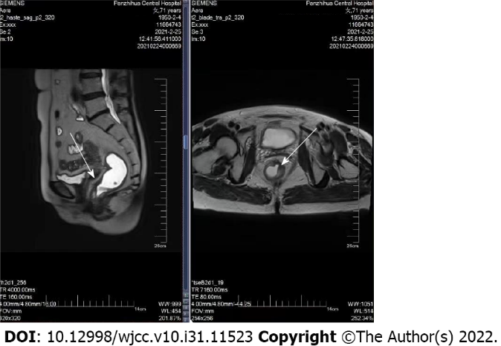
Figure 1 Rectal magnetic resonance imaging shows the area of lesion (white arrow). There was no specific abdominal ascites and no mesenteric lymph node enlargement.

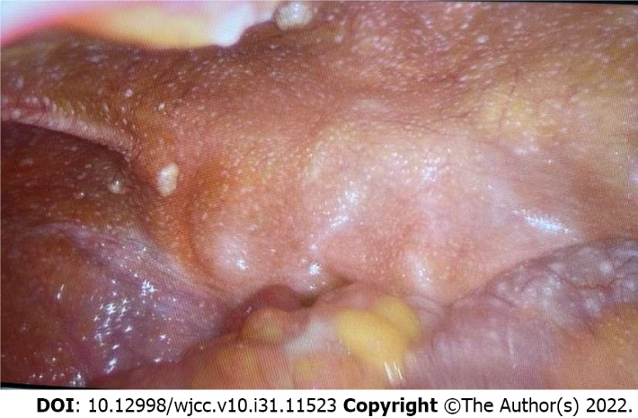
Figure 2 Disseminated peritoneal nodules detected during laparoscopy. Representative biopsies were taken.

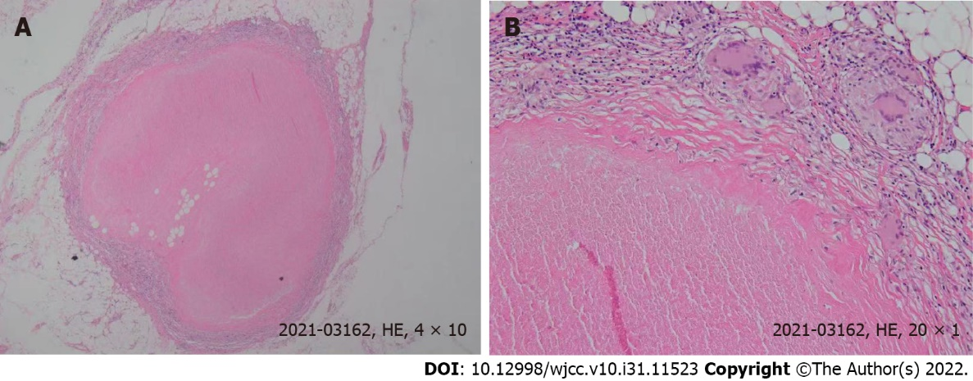
Figure 3 Pathologic findings. A: Histopathological image of a biopsy, taken from the greater omentum, showing granulomas (hematoxylin and eosin stain, magnification 40 ×); B: Histopathological image of granulomas (hematoxylin and eosin stain, magnification 200 ×). HE: Hematoxylin and eosin.

Published by Baishideng Publishing Group Inc
7041 Koll Center Parkway, Suite 160, Pleasanton, CA 94566, USA
Telephone: +1-925-3991568
E-mail: bpgoffice@wjgnet.com
Help Desk: https://www.f6publishing.com/helpdesk
https://www.wjgnet.com

© 2022 Baishideng Publishing Group Inc. All rights reserved.

