Name of Journal: World Journal of Clinical Cases
Manuscript NO: 57998
Manuscript Type: ORIGINAL ARTICLE

Clinical Trials Study
Biliary stent combined with iodine-125 seed strand implantation in malignant obstructive jaundice

Wang HW et al. Biliary stent and ¹²⁵I seed strand

Hui-Wen Wang, Xiao-Jing Li, Shi-Jie Li, Jun-Rong Lu, Dong-Feng He

Hui-Wen Wang, Xiao-Jing Li, Shi-Jie Li, Jun-Rong Lu, Dong-Feng He, Department of Interventional, Harbin Medical University Cancer Hospital, Harbin 150081, Heilongjiang Province, China

Author contributions: Wang HW and Li XJ drafted the manuscript and analyzed all the data; He DF performed the surgeries and acquired data; Li SJ and Lu JR assisted in all surgeries and data collection; He DF designed and supervised the study, analyzed all the data, and revised the manuscript.

Corresponding author: Dong-Feng He, PhD, Research Scientist, Surgical Oncologist, Department of Interventional, Harbin Medical University Cancer Hospital, No. 150 Haping street, Nangang District, Harbin 150081, Heilongjiang Province, China. 13644578588@139.com

Received: November 3, 2020
Revised: November 23, 2020
Accepted: December 10, 2020
Published online: February 6, 2021

Abstract
BACKGROUND
Malignant obstructive jaundice is mainly caused by cholangiocarcinoma. Only a few patients are indicated for surgical resection, and the 3-year survival rate is < 50%. For patients who are not eligible for surgery, biliary stent placement can relieve biliary obstruction and improve liver function and quality of life. However, restenosis after biliary stents has a poor prognosis and is a clinical challenge. Biliary stent combined with iodine-125 (¹²⁵I) seed implantation can prolong stent patency and improve survival.

AIM
To evaluate the safety and efficacy of biliary stent combined with ¹²⁵I seed strand implantation in malignant obstructive jaundice.

METHODS
We enrolled 67 patients between January 2016 and June 2018 with malignant obstructive jaundice and randomized them into a biliary stent combined with ¹²⁵I seed strand treatment (combined) group (n = 32) and biliary stent (control) group (n = 35). All patients underwent enhanced computed tomography and magnetic resonance imaging and were tested for biochemical and cancer markers. Twelve patients underwent pathological examination before surgery. All patients were followed up by telephone or clinical visit. Postoperative liver function improvement, postoperative complications, stent patency time, and survival time were compared between the two groups. Prognostic risk factors were evaluated.

RESULTS
Technical success was achieved in all patients in both groups. Postoperative liver function improved significantly in all patients (total bilirubin, direct bilirubin, alanine aminotransferase, and aspartate aminotransferase decreased significantly in all patients, the P values were less than 0.05). There was no significant difference in preoperative or postoperative indexes between the two groups for changes in total bilirubin (P = 0.147), direct bilirubin (P = 0.448), alanine aminotransferase (P = 0.120), and aspartate aminotransferase (P = 0.387) between the two groups. The median stent patency time of the combined group was 9.0 ± 1.4 mo [95% confidence interval (CI): 6.3-11.8 mo], which was significantly longer than the that of the control group (6.0 ± 0.3 mo, 95%CI: 5.5-6.5 mo, P = 0.000). The median survival time of the combined group was 11.0 ± 1.4 mo (95%CI: 8.2-13.7 mo), which was significantly longer than that of the control group (7.0 ± 0.3 mo, 95%CI: 6.4-7.6 mo, P = 0.000). Location of obstruction and number of stents were independent risk factors affecting prognosis.

CONCLUSION
Biliary stent combined with ¹²⁵I seed strand implantation is safe and effective in malignant obstructive jaundice and improves stent patency time and median survival time.

Key Words: Biliary stent; ¹²⁵I; Obstructive jaundice; Malignant tumor; Clinical research; Surgery

©The Author(s) 2021. Published by Baishideng Publishing Group Inc. All rights reserved.

Wang HW, Li XJ, Li SJ, Lu JR, He DF. Biliary stent combined with iodine-125 seed strand implantation in malignant obstructive jaundice. World J Clin Cases 2021; 9(4): 801-811 URL: https://www.wjgnet.com/2307-8960/full/v9/i4/801.htm DOI: https://dx.doi.org/10.12998/wjcc.v9.i4.801

Core Tip: For patients who are unable to undergo surgery, biliary stent placement can relieve biliary obstruction and prolong survival. However, previous studies relieved stenosis caused by an existing tumor lesion by placing an iodine-125 seed in the middle of the stent while ignoring both ends. Both ends of the stent can be reobstructed. We observed that extending the iodine-125 seed strand along the length of the stent produced a safe and effective result in malignant obstructive jaundice.

INTRODUCTION
Malignant obstructive jaundice is caused by cholangiocarcinoma or peribiliary malignant tumor invasion and compression; onset of symptoms is generally insidious with only 10%-20% of patients indicated for surgical resection. The 3-year survival rate is < 50%^{[1,2]}. For patients who are not indicated for or unwilling to undergo surgery, biliary stent placement can relieve biliary obstruction, improve liver function and quality of life, and prolong survival^{[3-5]}. However, restenosis after a biliary stent may significantly worsen prognosis and remains a clinical challenge. The main causes of restenosis include tumor growth, cholestatic accumulation, and granulation tissue hyperplasia. In recent years, reports of biliary stents combined with iodine-125 (¹²⁵I) seed implantation seemed to prolong stent patency time and improved patient survival^{[6-8]}. However, most attempts to relieve stenosis caused by tumors utilized a technique of placing the ¹²⁵I seed in the middle of the stent while ignoring both ends. Because of overgrowth of the tumor and fibrous granulation tissue hyperplasia caused by frictional stimulation between the two ends of the stent and the bile duct wall, both ends of the stent can be reobstructed^{[9,10]}. Therefore, measures to prevent reobstruction may provide a greater benefit to patients. In this study, we evaluated extending the ¹²⁵I seed strand across the entire length of the stent.

MATERIALS AND METHODS
Ethical permission
This study was approved by the Medical Ethics Review Committee of Harbin Medical University Cancer Hospital and registered for the Chinese clinical trial (Registration Number: ChiCTR2000030878).

Inclusion and exclusion criteria
This was a single center, randomized, controlled study. The inclusion criteria were as follows: (1) Age 18-80 years; (2) Eastern Cooperative Oncology Group score ≤ 2 points; (3) Obstructive jaundice caused by pathologically or clinically diagnosed malignant tumor, and patient not indicated or unwilling to undergo surgery; (4) No severe cardiovascular and cerebrovascular diseases; (5) No severe coagulation abnormalities; and (6) Willing to participate in this study and give signed informed consent. The exclusion criteria were as follows: (1) Suspicion of benign biliary stricture; and (2) Patients with reobstruction after biliary stenting or drainage.

Patient characteristics
Based on previous reports, the median survival time after traditional biliary stent implantation is 3-8 mo^{[6,11-13]}. We assumed median survival time of 3 mo in the control group and 8 mo in the combined group. The α value was 0.05 (unilateral test), the power was 0.9, and we needed 30 cases in each group for the sample size.
Between January 2016 and June 2018, 67 patients with malignant obstructive jaundice were treated in our center. All patients underwent enhanced computed tomography and magnetic resonance imaging and were tested for biochemical and cancer markers. Twelve patients underwent pathological examination before surgery. All patients were diagnosed with malignant obstructive jaundice. Envelopes were randomly assigned to the simple stent (control) group and the biliary stent combined with ¹²⁵I seed strand treatment (combined) group according to a 1:1 ratio. There were 35 patients in the control group and 32 in the combined group (one patient in the combined group was transferred to the control group for economic reasons). There were 35 patients with pancreatic cancer (21 in the control group and 14 in the combined group); 19 patients with gallbladder cancer and cholangiocarcinoma (8 in the control group and 11 in the combined group); and 13 patients with lymph node metastasis from digestive malignant tumors (6 in the control group and 7 in the combined group). The statistician was blinded to group assignment. The general clinical characteristics of the two groups of patients are shown in Table 1. The differences between the two groups were not significant.

Stent and ¹²⁵I seed
¹²⁵I seeds were produced by Beijing Science and Technology Biotechnology Co. Ltd. (Beijing, China). Dimensions: length = 4.5 mm, diameter = 0.8 mm, effective radiation radius of 15-20 mm, half-life of 59.43 d, energy of 27.4 keV for X rays and 35.5 keV for R rays. The stent was a biliary stent produced by Nanjing Minitron Co. Ltd. (Nanjing, China) with a diameter of 10 mm and length of 40-80 mm.

Procedures
Under the guidance of ultrasound and digital subtraction angiography, an 18G needle was used to puncture the intrahepatic dilated bile duct. A guide wire was introduced in place of the puncture needle core, and the puncture needle sheath was pulled out. An 8F long arterial sheath was introduced through the guide wire, and two guide wires were introduced through the long arterial sheath after withdrawing the core of the arterial sheath. After removing the arterial sheath, the stent conveyor was placed along one of the guide wires. A customized ¹²⁵I seed strand was placed along an 8F long arterial sheath that was introduced along the other guide wire (Figure 1A-F). The ¹²⁵I seeds were placed in a 4F plastic tube via a seed gun, and both ends were heated and then clamped shut (Figure 1G). The number of ¹²⁵I seeds was calculated by: N = L/4.5 + 2 (L = stent length). Only simple stents were placed in the control group. After successful stenting and ¹²⁵I seed strand implantation, an external drainage tube was placed through the guide wire. After 2 mo, imaging examination was performed to confirm that the stent was unobstructed before the drainage tube was removed.

Follow-up
All patients were followed up by telephone or clinical visit. Telephone follow-up was performed every 2 mo to document the patient’s status. If a patient had new jaundice or a significant increase in total bilirubin, abdominal enhanced computed tomography or magnetic resonance imaging was recommended to determine stent obstruction. Follow-up continued until a patient died or the end of the study. The overall survival period was calculated from the time the stent was placed to when the patient died or the end of the study. The stent patency time was from stent placement to stent blockage or the end of the study.

Statistical analysis
The c² test was used to compare the numerical data. Continuous variables were expressed as mean ± standard deviation, and changes in the laboratory tests in the same group were evaluated by paired t test. Comparison of changes in preoperative and postoperative indexes in both groups was performed by independent t test. Survival was calculated using the Kaplan-Meier method, and factors affecting prognosis were analyzed using a Cox regression model. P < 0.05 indicated that the difference was significant. Statistical analysis was performed using SPSS version 17.0.

RESULTS
Technical success rate, liver function relief, and complications
Both groups of patients were successfully implanted with biliary stents or ¹²⁵I seed strand, and the technical success rate was 100%. Liver function was significantly improved in both groups 5 d after surgery (total bilirubin, direct bilirubin, alanine aminotransferase, and aspartate aminotransferase decreased significantly in all patients; the P values were less than 0.05). There was no significant difference in preoperative or postoperative indexes between the two groups for changes in total bilirubin (P = 0.147), direct bilirubin (P = 0.448), alanine aminotransferase (P = 0.120), and aspartate aminotransferase (P = 0.387) (Table 2). No serious complications occurred in either group.

Stent patency time
The mean and median stent patency times for the combined group were 9.5 ± 0.6 mo [95% confidence interval (CI): 8.3-10.7 mo] and 9.0 ± 1.4 mo (95%CI: 6.3-11.8 mo), respectively. For the control group, they were 5.8 ± 0.2 mo (95%CI: 5.4-6.3 mo) and 6.0 ± 0.3 mo (95%CI: 5.5-6.5 mo), respectively. There was a significant difference between the two groups (P = 0.000) (Figure 2A). By the end of the study, 18 patients in the combined group had stent occlusion, of whom four had percutaneous transhepatic cholangial drainage, and 19 patients in the control group had stent occlusion, of whom seven had percutaneous transhepatic cholangial drainage.

Survival time
The median survival time for the combined group was 11.0 ± 1.4 mo (95%CI: 8.3-13.8 mo). For the control group, it was 7.0 ± 0.3 mo (95%CI: 6.4-7.6 mo). There was a significant difference between the groups (P = 0.000) (Figure 2B).

Risk factors affecting prognosis of survival
Univariate and multivariate analysis showed that the type of obstruction and the number of stents were independent risk factors that affected the prognosis for survival. Patients with low biliary obstruction and a single stent had a better prognosis (P values were 0.015 and 0.035, respectively; hazard ratios were 2.060 and 3.489, respectively) (Table 3).

DISCUSSION
To treat unresectable malignant obstructive jaundice, the first task is to remove biliary blockage, improve liver function, and relieve symptoms to prepare for further radiotherapy, chemotherapy, or other treatments. Biliary stent placement has become the preferred treatment method^{[3-5,14]}. However, after stent placement due to tumor overgrowth, tissue-reactive hyperplasia, and biliary formation, stent restenosis significantly affects the survival of patients^{[15-18]}. Therefore, prevention of restenosis after stenting has been a hot topic for clinical research and investigation in recent years and has included the study of covered and drug-eluting stents. Covered stents are prone to displacement, and stent displacement tends to increase the incidence of cholecystitis and pancreatitis. These two approaches have not achieved satisfactory clinical outcomes^{[19-21]}.
¹²⁵I seeds are new micro-low-dose-rate particle sources developed in recent years with an effective irradiation radius of 15-20 mm, half-life of 59.43 d, and energy of 27.4 keV for X rays and 35.5keV for R rays. Low dose rate and continuous irradiation lead to high dose within the target, resulting in a strong targeted killing effect on tumor cells by destroying DNA double strands of tumor cells and reducing their ability to proliferate without significantly affecting surrounding normal tissues. Because of these advantages, ¹²⁵I seed implantation has achieved good results in the treatment of various solid malignancies in recent years.
Chen et al^{[22]} first implanted ¹²⁵I seeds into porcine bile duct. They demonstrated that ¹²⁵I seeds were safe and did not cause serious damage to the bile duct. There are also reports that biliary stents combined with ¹²⁵I seed strands for patients with malignant obstructive jaundice. Due to the killing effect of ¹²⁵I seeds on tumor tissues, they can increase stent patency time and prolong survival^{[6,8,11,12,23]}. Some researchers placed the ¹²⁵I seed strands into biliary stenosis through an external drainage tube and then removed the drainage tube and ¹²⁵I seed strands 2 mo later. This approach also improved the stent patency time and survival of patients compared with traditional stents^{[6,8,11,12,23]}, but the drainage tube was unstable due to respiratory movement and other daily activities and affected quality of life. Because the drainage tube and ¹²⁵I seed strands were removed after 2 mo, the ¹²⁵I seed strands had a shorter duration of action, which inevitably affected treatment efficacy.
Subsequently, Zhu et al^{[6]} developed a biliary stent carrying ¹²⁵I seeds and placed the biliary stent into 12 patients with malignant obstructive jaundice. They showed that radioactive particle stents were superior to traditional bare stents. However, because the stent was divided into a jacket and an inner stent carrying particles, the inner diameter of the stent for drainage was reduced, and the narrowing of the stent inevitably affected bile drainage and stent patency time^{[15,24]}. Additionally, other researchers inserted the ¹²⁵I seed strands between the stent and bile duct wall, and the stent patency time and patient survival also improved^{[25]}. The ¹²⁵I seed strands are fixed and stable, and the quality of life can be significantly improved without carrying an external drainage tube for a long time. We also used this approach with a satisfactory outcome and quality of life was significantly improved. However, all of the aforementioned studies focused on the stenosis caused by existing tumors and placed ¹²⁵I seeds in the middle of the stent, ignoring both ends of the stent.
Tumor growth will occur along the outside of the stent, causing obstruction at both ends of the stent as reported previously^{[9]}. Guo et al^{[26,27]} found that after esophageal stent implantation, both ends were prone to reocclusion in animal experiments and clinical practice. Pathological examination revealed that the obstruction was mainly caused by overgrown tumor tissue and hyperplastic granulation tissue. After biliary stenting, granulation tissue hyperplasia may also occur with local frictional stimulation between both ends of the stent and the biliary tract^{[10]}. These factors can cause reobstruction at both ends of the stent. ¹²⁵I seeds destroy double-stranded DNA of tumor cells and stop tumor proliferation. Additionally, it has been found that radioactive stents increase the activity of the caspase-3 gene through γ rays, promoting canine bile duct smooth muscle cell apoptosis, and therefore inhibiting canine bile duct stenosis in animal experiments^{[28]}.
Based on the inhibitory effect of ¹²⁵I seeds on tumor and granulation tissues, we extended the coverage of ¹²⁵I seed strands to both ends of the biliary stent to prevent reobstruction at either end. Our results showed that the survival time of the combined group reached 11.0 ± 1.4 mo, which is longer than that from the Zhu et al^{[6]} study (median survival time 7.4 mo). The stent patency time reached 9.0 ± 1.4 mo, which was significantly better than that reported by Zhu et al^{[6]} (stent patency time and median survival time of 194 d)^{[13]}. A few factors may have contributed to the improved outcomes in our study. Firstly, the extended ¹²⁵I seed strand played a role in preventing obstruction at both ends of the stent. Secondly, the diameter of our stent was 10 mm. Some studies have shown that the larger the diameter of the stent, the longer the restenosis time appears to be^{[15]}. Thirdly, if there was biliary tract infection, we performed conventional percutaneous transhepatic cholangial drainage before biliary stent placement to reduce biliary edema and control infection. When the biliary stent was implanted, the catheter was first used to drain the accumulated viscous bile, and normal saline was used to wash out the remaining bile.
The stent was placed after bile drainage, which seemed to prolong stent patency time, presumably because thick bile can rapidly cause reobstruction of the stent^{[15,24]}. Our study also found that the type of obstruction and number of stents were independent risk factors that affected prognosis. The higher the location of the obstruction, the more and thinner the bile duct branches would be. Because left and right hepatic ducts are disconnected, bilateral stents are required. One stent can only resolve one obstruction. If there are more than two biliary obstructions, then the stents cannot resolve all the obstructions. Therefore, multibranch biliary obstruction has a generally poor bilirubin declining effect, which directly affects liver function and prognosis.
There were some limitations to our study. First, the sample size was small, and a multicenter study with a large sample size is needed. Second, due to the lack of advanced measuring instruments, accurate metrological data could not be obtained.

CONCLUSION
In conclusion, biliary stent combined with ¹²⁵I seed strand implantation is safe and effective for treatment of malignant obstructive jaundice. The present study suggests that it could improve stent patency and median survival.

ARTICLE HIGHLIGHTS
Research background
Biliary stent placement can relieve biliary obstruction and improve liver function and quality of life. However, restenosis after biliary stents has a poor prognosis and is a clinical challenge.

Research motivation
In order to solve the problem of biliary stent restenosis, we should seek a better method for clinical treatment.

Research objectives
To evaluate the safety and efficacy of biliary stent combined with iodine-125 seed strand implantation in malignant obstructive jaundice.

Research methods
Sixty-seven patients were randomly divided into the biliary stent with iodine-125 group (combined group) and the biliary stent group (control group). The stent patency time and total survival time were compared between the two groups.

Research results
The present study suggests that biliary stent combined with iodine-125 seed strands could improve stent patency and median survival.

Research conclusions
Biliary stent combined with ¹²⁵I seed strand implantation is safe and effective for the treatment of malignant obstructive jaundice.

Research perspectives
A multicenter study with a large sample size is needed. Accurate metrological data is needed.

REFERENCES
1 Skipworth JR, Olde Damink SW, Imber C, Bridgewater J, Pereira SP, Malagó M. Review article: surgical, neo-adjuvant and adjuvant management strategies in biliary tract cancer. Aliment Pharmacol Ther 2011; 34: 1063-1078 [PMID: 21933219 DOI: 10.1111/j.1365-2036.2011.04851.x]
2 Jemal A, Siegel R, Ward E, Hao Y, Xu J, Thun MJ. Cancer statistics, 2009. CA Cancer J Clin 2009; 59: 225-249 [PMID: 19474385 DOI: 10.3322/caac.20006]
3 Crosara Teixeira M, Mak MP, Marques DF, Capareli F, Carnevale FC, Moreira AM, Ribeiro U Jr, Cecconello I, Hoff PM. Percutaneous transhepatic biliary drainage in patients with advanced solid malignancies: prognostic factors and clinical outcomes. J Gastrointest Cancer 2013; 44: 398-403 [PMID: 23760941 DOI: 10.1007/s12029-013-9509-3]
4 Tsuyuguchi T, Takada T, Miyazaki M, Miyakawa S, Tsukada K, Nagino M, Kondo S, Furuse J, Saito H, Suyama M, Kimura F, Yoshitomi H, Nozawa S, Yoshida M, Wada K, Amano H, Miura F; Japanese Association of Biliary Surgery; Japanese Society of Hepato-Biliary-Pancreatic Surgery; Japan Society of Clinical Oncology. Stenting and interventional radiology for obstructive jaundice in patients with unresectable biliary tract carcinomas. J Hepatobiliary Pancreat Surg 2008; 15: 69-73 [PMID: 18274846 DOI: 10.1007/s00534-007-1282-x]
5 Meller MT, Arts GR, Dean JR. Outcomes in percutaneous stenting of non-hepato-biliary/pancreatic malignant jaundice. Eur J Cancer Care (Engl) 2010; 19: 664-668 [PMID: 19708950 DOI: 10.1111/j.1365-2354.2009.01120.x]
6 Zhu HD, Guo JH, Zhu GY, He SC, Fang W, Deng G, Qin YL, Li GZ, Coldwell DM, Teng GJ. A novel biliary stent loaded with (125)I seeds in patients with malignant biliary obstruction: preliminary results versus a conventional biliary stent. J Hepatol 2012; 56: 1104-1111 [PMID: 22266605 DOI: 10.1016/j.jhep.2011.12.018]
7 Li S, He X, Dang L, Xu F, Fang J, Li F, Wang W. Efficacy of ¹²⁵I Versus Non-¹²⁵I Combined with Transcatheter Arterial Chemoembolization for the Treatment of Unresectable Hepatocellular Carcinoma with Obstructive Jaundice. Dig Dis Sci 2018; 63: 321-328 [PMID: 29305738 DOI: 10.1007/s10620-017-4899-x]
8 Chen W, Fang XM, Wang X, Sudarshan SKP, Hu XY, Chen HW. Preliminary clinical application of integrated 125I seeds stents in the therapy of malignant lower biliary tract obstruction. J Xray Sci Technol 2018; 26: 865-875 [PMID: 30040791 DOI: 10.3233/XST-180403]
9 Lee SJ, Kim MD, Lee MS, Kim IJ, Park SI, Won JY, Lee DY. Comparison of the efficacy of covered versus uncovered metallic stents in treating inoperable malignant common bile duct obstruction: a randomized trial. J Vasc Interv Radiol 2014; 25: 1912-1920 [PMID: 25085230 DOI: 10.1016/j.jvir.2014.05.021]
10 Hausegger KA, Kleinert R, Lammer J, Klein GE, Flückiger F. Malignant biliary obstruction: histologic findings after treatment with self-expandable stents. Radiology 1992; 185: 461-464 [PMID: 1410354 DOI: 10.1148/radiology.185.2.1410354]
11 Yang M, Yan Z, Luo J, Liu Q, Zhang W, Ma J, Zhang Z, Yu T, Zhao Q, Liu L. A pilot study of intraluminal brachytherapy using ¹²⁵I seed strand for locally advanced pancreatic ductal adenocarcinoma with obstructive jaundice. Brachytherapy 2016; 15: 859-864 [PMID: 27364870 DOI: 10.1016/j.brachy.2016.05.004]
12 Jiao D, Wu G, Ren J, Han X. Study of self-expandable metallic stent placement intraluminal ¹²⁵I seed strands brachytherapy of malignant biliary obstruction. Surg Endosc 2017; 31: 4996-5005 [PMID: 28643064 DOI: 10.1007/s00464-017-5481-5]
13 Zhou WZ, Fu YM, Yang ZQ, Shi HB, Liu S, Xia JG, Zhou CG. Study of Percutaneous Stent Placement with Iodine-125 Seed Strand for Malignant Biliary Obstruction. Cardiovasc Intervent Radiol 2019; 42: 268-275 [PMID: 30506169 DOI: 10.1007/s00270-018-2117-7]
14 van Delden OM, Laméris JS. Percutaneous drainage and stenting for palliation of malignant bile duct obstruction. Eur Radiol 2008; 18: 448-456 [PMID: 17960388 DOI: 10.1007/s00330-007-0796-6]
15 Guo Y, Liu Y, Lu Z, Shi X, Zou D, Wang D, Liu F, Jin Z, Li Z. Obstructive component analysis of radioactive stents and common plastic stents in the bile duct. Eur J Gastroenterol Hepatol 2014; 26: 795-802 [PMID: 24901823 DOI: 10.1097/MEG.0000000000000120]
16 Kida M, Miyazawa S, Iwai T, Ikeda H, Takezawa M, Kikuchi H, Watanabe M, Imaizumi H, Koizumi W. Recent advances of biliary stent management. Korean J Radiol 2012; 13 Suppl 1: S62-S66 [PMID: 22563289 DOI: 10.3348/kjr.2012.13.S1.S62]
17 Steel AW, Postgate AJ, Khorsandi S, Nicholls J, Jiao L, Vlavianos P, Habib N, Westaby D. Endoscopically applied radiofrequency ablation appears to be safe in the treatment of malignant biliary obstruction. Gastrointest Endosc 2011; 73: 149-153 [PMID: 21184881 DOI: 10.1016/j.gie.2010.09.031]
18 Kim HS, Lee DK, Kim HG, Park JJ, Park SH, Kim JH, Yoo BM, Roe IH, Moon YS, Myung SJ. Features of malignant biliary obstruction affecting the patency of metallic stents: a multicenter study. Gastrointest Endosc 2002; 55: 359-365 [PMID: 11868009 DOI: 10.1067/mge.2002.121603]
19 Isayama H, Komatsu Y, Tsujino T, Sasahira N, Hirano K, Toda N, Nakai Y, Yamamoto N, Tada M, Yoshida H, Shiratori Y, Kawabe T, Omata M. A prospective randomised study of "covered" versus "uncovered" diamond stents for the management of distal malignant biliary obstruction. Gut 2004; 53: 729-734 [PMID: 15082593 DOI: 10.1136/gut.2003.018945]
20 Song TJ, Lee SS, Yun SC, Park DH, Seo DW, Lee SK, Kim MH. Paclitaxel-eluting covered metal stents versus covered metal stents for distal malignant biliary obstruction: a prospective comparative pilot study. Gastrointest Endosc 2011; 73: 727-733 [PMID: 21288514 DOI: 10.1016/j.gie.2010.11.048]
21 Yoon WJ, Lee JK, Lee KH, Lee WJ, Ryu JK, Kim YT, Yoon YB. A comparison of covered and uncovered Wallstents for the management of distal malignant biliary obstruction. Gastrointest Endosc 2006; 63: 996-1000 [PMID: 16733115 DOI: 10.1016/j.gie.2005.11.054]
22 Chen Y, Wang XL, Yan ZP, Wang JH, Cheng JM, Gong GQ, Li GP. Damage to pig bile duct caused by intraluminal brachytherapy using a (125)I ribbon. Acta Radiol 2013; 54: 272-277 [PMID: 23446746 DOI: 10.1258/ar.2012.120214]
23 Hasimu A, Gu JP, Ji WZ, Zhang HX, Zhu DW, Ren WX. Comparative Study of Percutaneous Transhepatic Biliary Stent Placement with or without Iodine-125 Seeds for Treating Patients with Malignant Biliary Obstruction. J Vasc Interv Radiol 2017; 28: 583-593 [PMID: 28162906 DOI: 10.1016/j.jvir.2016.11.038]
24 Rey JF, Maupetit P, Greff M. Experimental study of biliary endoprosthesis efficiency. Endoscopy 1985; 17: 145-148 [PMID: 2410246 DOI: 10.1055/s-2007-1018485]
25 Ma J, Luo J, Gu J, Liu Q, Liu L, Zhang W, Zhang Z, Yan Z. Malignant obstructive jaundice treated with intraluminal placement of Iodine-125 seed strands and metal stents: An analysis of long-term outcomes and prognostic features. Brachytherapy 2018; 17: 689-695 [PMID: 29748084 DOI: 10.1016/j.brachy.2018.04.001]
26 Guo JH, Teng GJ, Zhu GY, He SC, Deng G, He J. Self-expandable stent loaded with 125I seeds: feasibility and safety in a rabbit model. Eur J Radiol 2007; 61: 356-361 [PMID: 17085003 DOI: 10.1016/j.ejrad.2006.10.003]
27 Guo JH, Teng GJ, Zhu GY, He SC, Fang W, Deng G, Li GZ. Self-expandable esophageal stent loaded with 125I seeds: initial experience in patients with advanced esophageal cancer. Radiology 2008; 247: 574-581 [PMID: 18349316 DOI: 10.1148/radiol.2472070999]
28 He GJ, Yu FQ, Wu R, Gao QY, Xu SH, Gao H, Jiang WG, Jiang T, Dai XW. 103Pd-induced apoptosis of proliferative smooth muscle cells in bile ducts of dogs: significance and effects on related genes. Hepatobiliary Pancreat Dis Int 2007; 6: 521-526 [PMID: 17897918]

Footnotes
Institutional review board statement: The study was reviewed and approved by the Medical Ethics Review Committee of Harbin Medical University Cancer Hospital.

Clinical trial registration statement: This registration policy applies to prospective, randomized, controlled trials only.

Informed consent statement: All study participants, or their legal guardian, provided informed written consent prior to study enrollment.

Conflict-of-interest statement: The authors declare no competing interests.

CONSORT 2010 Statement: The authors have read the CONSORT 2010 Statement, and the manuscript was prepared and revised according to the CONSORT 2010 Statement.

Open-Access: This article is an open-access article that was selected by an in-house editor and fully peer-reviewed by external reviewers. It is distributed in accordance with the Creative Commons Attribution NonCommercial (CC BY-NC 4.0) license, which permits others to distribute, remix, adapt, build upon this work non-commercially, and license their derivative works on different terms, provided the original work is properly cited and the use is non-commercial. See: http://creativecommons.org/Licenses/by-nc/4.0/

Manuscript source: Unsolicited manuscript

Peer-review started: November 3, 2020
First decision: November 20, 2020
Article in press: December 10, 2020

Specialty type: Medicine, research and experimental
Country/Territory of origin: China
Peer-review report’s scientific quality classification
Grade A (Excellent): A
Grade B (Very good): B, B
Grade C (Good): 0
Grade D (Fair): 0
Grade E (Poor): 0

P-Reviewer: Faloppi L, Otto G, Raisch K S-Editor: Fan JR L-Editor: Filipodia P-Editor: Yuan YY
Figure Legends
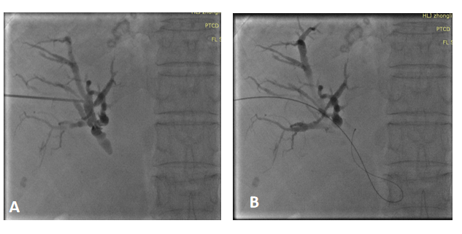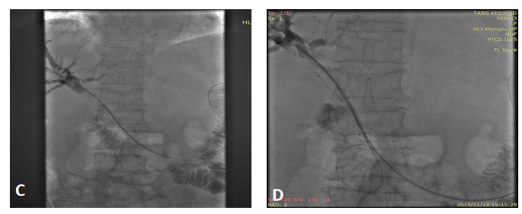
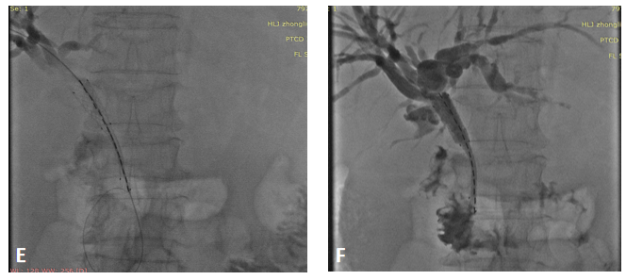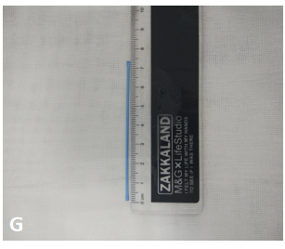
Figure 1 Guidance by ultrasound and digital subtraction angiography. A: The dilated bile duct was punctured with an 18G cannula puncture needle; B: A guide wire was introduced through the puncture needle sheath; C: Two guide wires were introduced through the 8F catheter; D: One guide wire was introduced into the stent conveyor, and the other into the 8F catheter, ready to push the iodine-125 (¹²⁵I) seed strands; E: Successful placement of stent and ¹²⁵I seed strands; F: External drainage tube angiography showing the unobstructed stent; G: ¹²⁵I seeds were placed into 4F plastic tubes to make ¹²⁵I seed strands.
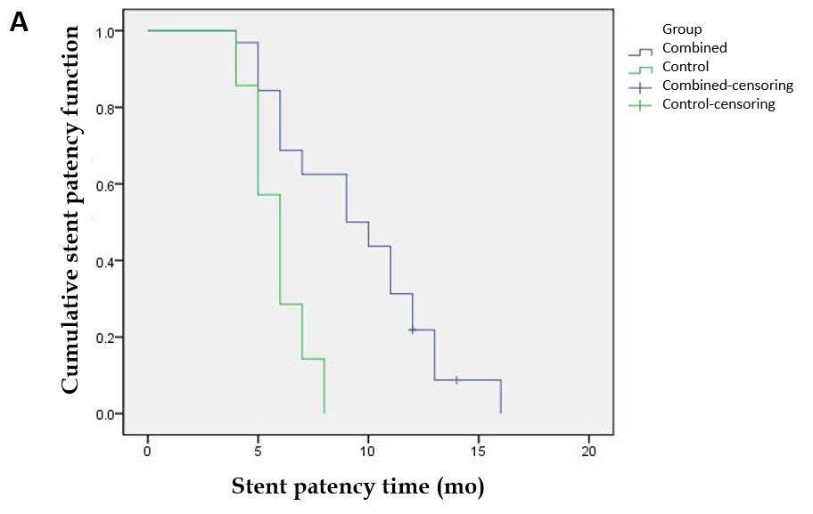
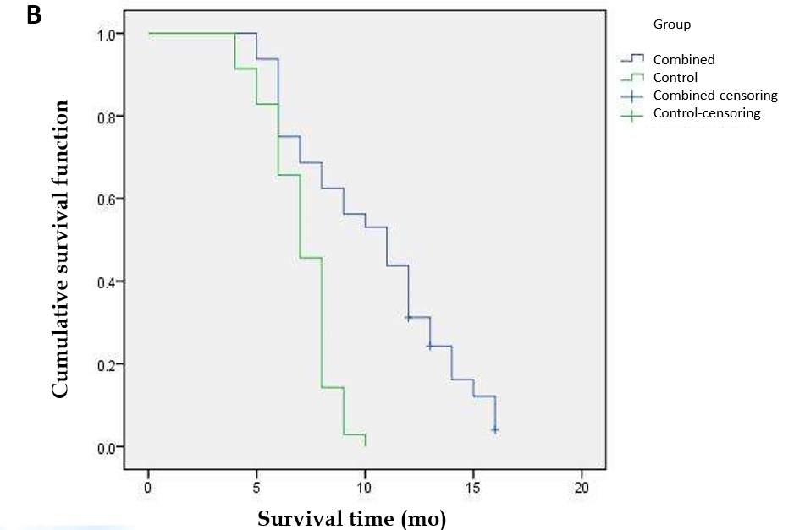
Figure 2 Median stent patency times and survival time for the combined group. A: The survival curve showed that the median stent patency time in the combined group was 9.000 ± 1.414 mo (95% confidence interval (CI): 6.228-11.772 mo), the control group was 6.000 ± 0.267 mo (95%CI: 5.476-6.524 mo), and there was a significant difference (P = 0.000); B: The survival curve showed that the median survival time of the combined group was 11.000 ± 1.403 mo (95%CI: 8.250-13.750 mo), the control group was 7.000 ± 0.327 mo (95%CI: 6.358-7.642 mo), and there was a significant difference between the two groups (P = 0.000).
Table 1 Comparison of baseline clinical characteristics between the two groups
 | Combined | Control | χ² /t | P value
Age in yr | 63.25 ± 9.92 | 63.46 ± 10.43 | -0.083¹ | 0.934
Sex
Male | 16 | 15 | 0.343 | 0.558
Female | 16 | 20
ECOG score
< 2 | 20 | 25 | 0.604 | 0.437
2 | 12 | 10
Child grade
B | 25 | 26 | 0.136 | 0.713
C | 7 | 9
Type of obstruction¹
High | 16 | 16 | 0.123 | 0.726
Low | 16 | 19
Obstruction length (cm) | 3.22 ± 1.04 | 3.26 ± 0.98 | -0.156² | 0.877
Number of stents
Unilateral | 30 | 32 |  | 1.000³
Bilateral | 2 | 3
Tumor type
Pancreatic cancer | 14 | 21 | 1.820 | 0.403
Bile duct and gallbladder cancer | 11 | 8
Gastrointestinal cancer metastasis | 7 | 6
Combined infusion chemotherapy
Yes | 13 | 14 | 0.003 | 0.958
No | 19 | 21
¹Above the junction of the cystic duct and common hepatic duct is called high obstruction, below the junction is called low obstruction; ²t value, using independent sample t test; ³Using Fisher’s exact probability method. ECOG: Eastern Cooperative Oncology Group.

Table 2 Comparison of preoperative and postoperative changes in the two groups of patients
 | Combined | Control | P value
Total bilirubin, μmoL/L |  |  | 0.147
Before | 358.98 ± 134.05 | 347.86 ± 131.73
After | 180.08 ± 110.94 | 199.43 ± 113.88
P value | 0.000 | 0.000
Direct bilirubin, μmoL/L |  |  | 0.448
Before | 196.02 ± 74.90 | 194.76 ± 73.52
After | 97.89 ± 67.33 | 108.97 ± 66.91
P value | 0.000 | 0.000
ALT, U/L |  |  | 0.120
Before | 209.82 ± 148.62 | 209.65 ± 152.53
After | 80.73 ± 54.18 | 95.41 ± 68.73
P value | 0.000 | 0.000
AST, U/L |  |  | 0.387
Before | 195.46 ± 154.29 | 193.51 ± 136.76
After | 61.97 ± 47.25 | 80.71 ± 67.98
P value | 0.000 | 0.000
ALT: Alanine aminotransferase; AST: Aspartate aminotransferase.

Table 3 Univariate and multivariate analysis of overall survival
 | Univariate analysis |  |  | Multivariate analysis
 | HR | 95%CI | P value | HR | 95%CI | P value
ECOG score, < 2/2 | 1.569 | (0.931-2.646) | 0.091
Child rating, B/C | 0.901 | (0.504-1.610) | 0.724
Type of obstruction, low/high | 2.395 | (1.412-4.062) | 0.001 | 2.060 | (1.153-3.678) | 0.015
Obstruction length in cm | 1.188 | (0.904-1.560) | 0.216
Number of stents, unilateral/bilateral | 6.129 | (2.310-16.262) | 0.000 | 3.489 | (1.094-11.126) | 0.035
Tumor type¹, pancreatic cancer/biliary cancer/gastrointestinal metastatic cancer | 1.192 | (0.665-2.135) | 0.555
 | 0.532 | (0.269-1.053) | 0.070
Combined perfusion, yes/no | 0.766 | (0.465-1.264) | 0.297
¹A dummy variable with pancreatic cancer set as a control, biliary cancer and gastrointestinal metastatic cancer are compared with pancreatic cancer. CI: Confidence interval; ECOG: Eastern Cooperative Oncology Group; HR: Hazard ratio.

Published by Baishideng Publishing Group Inc
7041 Koll Center Parkway, Suite 160, Pleasanton, CA 94566, USA
Telephone: +1-925-3991568
E-mail: bpgoffice@wjgnet.com
Help Desk: https://www.f6publishing.com/helpdesk
https://www.wjgnet.com

© 2021 Baishideng Publishing Group Inc. All rights reserved.

