Name of Journal: World Journal of Clinical Cases
Manuscript NO: 73556
Manuscript Type: CASE REPORT

Imaging-based diagnosis for extraskeletal Ewing sarcoma in pediatrics: A case report

Chen ZH et al. Preoperative imaging of EES for pediatrics

Zhi-Hui Chen, He-Qing Guo, Jing-Jing Chen, Ying Zhang, Li Zhao

Zhi-Hui Chen, Medical Ultrasound, Affiliated Lishui Hospital of Zhejiang University, The Fifth Affiliated Hospital of Wenzhou Medical University, The Central Hospital of Zhejiang Lishui, Lishui 323000, Zhejiang Province, China

He-Qing Guo, Medical Ultrasound, Women and Children Hospital of Shaoxing, Shaoxing 312000, Zhejiang Province, China

Jing-Jing Chen, Electrocardiogram Room, Cixi integrated Traditional Chinese and Western Medicine Medical, Health Group Cixi Hospital of Traditional Chinese Medicine, Cixi 315300, Zhejiang Province, China

Ying Zhang, Medical Ultrasound, Ningbo Medical Center Lihuili Hospital, Ningbo 315040, Zhejiang Province, China

Li Zhao, Department of Radiology, Shaoxing People's Hospital, Shaoxing 312000, Zhejiang Province, China

Author contributions: Zhao L designed the research; Chen ZH wrote the paper; Guo HQ, Chen JJ and Zhang Y provided and analyzed the images; all authors have read and approved the final version of the manuscript.

Corresponding author: Li Zhao, MD, Deputy Director, Department of Radiology, Shaoxing People's Hospital, No. 568 Zhongxin North Street, Shaoxing, Shaoxing 312000, Zhejiang Province, China. 269972605@qq.com

Received: November 27, 2021
Revised: January 24, 2021
Accepted: May 16, 2022
Published online:

Abstract
BACKGROUND
Extraskeletal Ewing sarcoma (EES) is a member of the Ewing sarcoma family of tumors which is pathologically known as a small, round, blue cell tumor involving bone and soft tissue. The prevalence of EES is only 15%-25% of all Ewing sarcoma and EES often occurs in patients aged from 20-mo-old to 30-years-old resulting in an unfavorable prognosis.

CASE SUMMARY
The present case report described a 7-year-old patient with a palpable EES mass of 33 mm × 27 mm × 28 mm in the deep neck with symptoms of persistent dyspnea over the past 5 mo. After laboratory examinations, abnormal physiological and biochemical indicators were not found. Ultrasound images presented the mass to be complex, solid and fluid-filled with circumscribed margins and posterior acoustic enhancement. The mass also presented with partial internal vascularity. The contrast-enhanced magnetic resonance imaging scan illustrated the outstanding enhancement with fast perfusion mode in the early arterial phase.

CONCLUSION
Our study suggested that a quick-growing mass in the pediatric patient is possibly a malignant tumor whether the mass has well-defined margins or not.

Key Words: Extraskeletal Ewing sarcoma; Pediatric imaging; Head and neck; Contract-enhanced MRI; Ultrasound; Case report

Chen ZH, Guo HQ, Chen JJ, Zhang Y, Zhao L. Imaging-based diagnosis for extraskeletal Ewing sarcoma in pediatrics: A case report. World J Clin Cases 2022; In press

Core Tip: The depth, growth rate and solitary location are valuable indicators for the pre-operative diagnosis of Extraskeletal Ewing sarcoma (EES). Meanwhile, the serpentine-like vascularity was present inside EES, accompanied by the outstanding enhancement with fast perfusion mode in the early arterial phase on the contrast-enhanced magnetic resonance imaging. Multimodal imaging is helpful for clarifying the tumor stage and follow-up.

INTRODUCTION
In modern medicine, the Ewing sarcoma family of tumors is composed of Ewing sarcoma, extraskeletal Ewing sarcoma (EES), primitive neuroectodermal tumor and Askin tumor^{[1,2]}. EES is the extraskeletal-originated tumors found in soft tissue with or without the involvement of bone which is mainly located in the trunk and lower limbs^{[1]}. It was firstly reported as a paravertebral soft-tissue mass in a child whose pathological presentation was "round cell"^{[3]}. The prevalence of EES is 15%-20% of all Ewing sarcoma^{[4]}. Although it is a rare disease, 85% of the patients are young people aged from 20-mo-old to 30-years-old and is associated with a genetic translocation of t (11; 22) (q12; q24)^{[4]}. To date, EES is still an uncommon disease with little research and leads to an unfavorable prognosis of low survival and high recurrence. Moreover, difficulties remain in the pre-operative diagnosis of EES, even when pathological confirmation has been made^{[5]}.

CASE PRESENTATION
Chief complaints
A 7-year-old girl with a palpable mass in the right neck and symptoms of persistent dyspnea for the past 5 mo.

History of present illness
The patient had no fever, headache, trauma or skin redness. Her only symptoms were periodic episodes of dyspnea and nocturnal obstruction.

History of past illness
The patient has a history of bronchitis which was diagnosed in the local outpatient setting. The subsequent symptomatic treatment of bronchitis was almost ineffectual. The patient had no history of diabetes, heart disease, alcohol consumption or smoking.

Personal and family history
The patient and family denied that they have histories of cancer, contagion or genetic disease.

Physical examination
The physical examination showed no abnormalities.

Laboratory examinations
The physiological and biochemical values obtained from laboratory tests were normal.

Imaging examinations
She was preliminarily examined by laryngoscopy, sonography and magnetic resonance imaging (MRI). For the protection of the thyroid, the patient was not subjected to X-ray and Computer tomography (CT) scans.
The greyscale and Doppler imaging were performed by a conventional ultrasound machine equipped with an L12-5 Linear array transducer (Philips healthcare, Bothell, WA, the United States, with L12-5 Linear array transducer) in the initial evaluation. According to the longitudinal section and transection of greyscale images, the soft-tissue mass was measured to be 33 mm × 27 mm × 28 mm, which was located above the right thyroid and inner side of the carotid (Figure 1A and B). It was found that the soft-tissue mass consisted of both hypoechoic solid-component and anechoic fluid, and it appeared as an alveolate mass with circumscribed margins and posterior acoustic enhancement. The Doppler images also suggested that some internal vascularity was present in the soft-tissue mass whereas vascular calcification was not detectable (Figure 1C).
The well-defined mass measured 35 mm × 33 mm leading to an airway stenosis and was demonstrated in the right laryngeal and piriform recess by 3.0T MRI (Discovery MR 750; GE Medical Systems, Milwaukee, WI, the United States) afterward, which was heterogeneous equisignal, like that in skeletal muscle, on T1 -weighted images (Figure 2A), and high signal intensity on T2 -weighted images (Figure 2B, 2D, and 2F). The contrast-enhanced MRI (gadolinium diethylenetriamine pentetic acid, Magnevist, Bayer Schering Pharma, Berlin, Germany) illustrated the outstanding enhancement with fast perfusion mode in the early arterial phase (Figure 2C, 2E, and 2G). Meanwhile, several lymph nodes nearby were revealed as well.

FINAL DIAGNOSIS
The diagnosis was Extraskeletal Ewing sarcoma.

TREATMENT
The patient was subjected to the resection of the soft-tissue mass and airway remodeling. It was observed that the dark red mass tissue obtained from the patient was absolutely enveloped in the well-defined capsule showing a pliable but stiff tactile impression (Figure 3A and B), which was quite similar to the characteristics of neurilemmoma.

OUTCOME AND FOLLOW-UP
The mass tissue was diagnosed as Extraskeletal Ewing sarcoma according to the pathological examination (Figure 4). The patient was followed up every 3 mo and each follow-up examination included a medical history, a physical examination, comprehensive biochemical tests, CT and a routine blood examination with no signs of recurrence or metastasis detected.

DISCUSSION
According to the pre-operative sonography, the lesion presented to be a complex cystic and solid tumor that was enveloped within a well-defined capsule and was located in the deep neck. Meanwhile, the serpentine-like vascularity was found to be present inside the soft-tissue mass, accompanied by the outstanding enhancement with fast perfusion mode in the early arterial phase on the contrast-enhanced MRI. The soft-tissue mass might be misdiagnosed as the following diseases. The first one is dysplastic diseases, such as thyroglossal duct cyst, branchial cleft cyst and cystic lymphangioma. Although dysplastic diseases commonly occur in the pediatric patient, neither the quick growth of the tumor nor the increased inner blood flow support its likelihood of dysplastic diseases. The second one is benign tumors with fluid components, such as Warthin’s tumor and neurilemmoma. However, the two types of benign tumors have well-defined margins, and they commonly occur in adults. The third one is malignant tumors with hemorrhage or necrosis, such as metastatic lymph nodes, lymphoma and some soft-tissue sarcoma. However, the lesion of this case was unlikely to be the metastatic lymph nodes because the primary tumors were absent in ambient tissue. The fourth one is infectious diseases, such as abscess, tuberculosis and parasitic disease. However, it was not reasonable to confirm the lesion of this case was a type of infectious disease because there was no supportive evidence.
The depth, growth rate and solitary location are important and valuable indicators for identifying whether a lesion is an EES lesion or not^{[6]}. Previous studies have indicated that EES are commonly located in the paravertebral region (approximately 32%), lower extremities (approximately 26%), chest wall (approximately 18%), retroperitoneum, pelvis and hip (approximately 11%) and upper extremities (approximately 3%)^{[6-10]}. Hypoechoic mass with or without anechoic areas was frequently reported on sonography^{[11]}, in which the increased internal blood flow maybe closely associated with Doppler images. In the case of CT diagnosis, the imaging characteristics of EES was quite similar (similarity approximately 87%) to the muscle^{[11]}, and therefore leaving mass effect as seldom an indicator on the image. The same problem was also present in the diagnosis of an EES lesion by MRI. Similar to skeletal muscle, 91% of EES patients show heterogeneous signal intensity on T1-weighted images and almost 100% of patients show a high signal intensity on T2-weighted images. In the case of an MRI diagnosis, the observation of serpentine high-flow vascularity was commonly considered to be the characteristic sign of EES while sometimes it also could be observed in hemangioendothelioma and other vascular lesions^{[8]}. The best indicator, a direct invasion of bone usually happens in the terminal stage, is that MRI can help in clinical staging and follow-up for EES recurrence^{[12]}. Despite the benign-like appearance, sometimes nonspecific imaging features of large, deep in soft-tissue and well-defined may aid the EES diagnosis^{[6,8,13,14]}.
In general, surgical resection is well accepted as a first-line therapy for EES patients^{[15-18]}. After resection, some patients should be managed with radiation therapy (RT) or chemotherapy as neoadjuvant therapy for prolonging survival rate^{[17,18]}. With the development of modern medicine, the early diagnosis by multiple imaging technique as well as complete resection could largely improve the prognosis of EES^{[19]}. It was reported that the overall survival (OS) rates of EES patients in 5 years increased from 28% to 61% between 1970 and 1999, and the 5-year OS reaches to above 70% by now^{[17,20,21]}, despite the recurrence rate of EES is still quite high^{[17]}. A previous study with 42 EES cases has indicated that the unfavorable prognosis of EES is closely associated with the pelvic tumors, incomplete resections and the presence of metastatic lesions^{[20]}. This study also demonstrated that EES patients could largely benefit from a wide surgical resection with negative microscopic margins and adjuvant local RT. Another study has suggested that the patients’ age below 16 yo and wide surgical resection with negative margins are independent indicators for the prognosis of EES, whereas no statistical significance could be found in tumor size, location, stage, and doses of RT^{[21]}.

CONCLUSION
In summary, the depth, growth rate and solitary location are valuable indicators for the pre-operative diagnosis of EES. The masses with well-defined margins in young patients also has the possibility of being malignant tumors. Multimodal imaging is helpful for determining the tumor stages and follow-up. In addition, more investigations should be carried out for young EES patients with a poor prognosis.

REFERENCES
1 Murphey MD, Senchak LT, Mambalam PK, Logie CI, Klassen-Fischer MK, Kransdorf MJ. From the radiologic pathology archives: ewing sarcoma family of tumors: radiologic-pathologic correlation. Radiographics 2013; 33: 803-831 [PMID: 23674776 DOI: 10.1148/rg.333135005]
2 Durer S, Shaikh H. Ewing Sarcoma. StatPearls. Treasure Island (FL): StatPearls Publishing Copyright © 2021, StatPearls Publishing LLC., 2021.
3 Tefft M, Vawter GF, Mitus A. Paravertebral "round cell" tumors in children. Radiology 1969; 92: 1501-1509 [PMID: 5799839 DOI: 10.1148/92.7.1501]
4 Javery O, Krajewski K, O'Regan K, Kis B, Giardino A, Jagannathan J, Ramaiya NH. A to Z of extraskeletal Ewing sarcoma family of tumors in adults: imaging features of primary disease, metastatic patterns, and treatment responses. AJR Am J Roentgenol 2011; 197: W1015-W1022 [PMID: 22109315 DOI: 10.2214/AJR.11.6667]
5 Cheng Y, Yang L, Zhang N, Chen GS, Li J, Liu YF, Zhou CJ. Extraskeletal Ewing's Sarcoma with CD7 Positivity and T-cell Receptor/Immunoglobulin Rearrangement Masquerading as T-lymphoblastic Lymphoma. Fetal Pediatr Pathol 2020: 1-6 [PMID: 33213248 DOI: 10.1080/15513815.2020.1845885]
6 Angervall L, Enzinger FM. Extraskeletal neoplasm resembling Ewing's sarcoma. Cancer 1975; 36: 240-251 [PMID: 1203852 DOI: 10.1002/1097-0142(197507)36:1<240::aid-cncr2820360127>3.0.co;2-h]
7 Soule EH, Newton W Jr, Moon TE, Tefft M. Extraskeletal Ewing's sarcoma: a preliminary review of 26 cases encountered in the Intergroup Rhabdomyosarcoma Study. Cancer 1978; 42: 259-264 [PMID: 667797 DOI: 10.1002/1097-0142(197807)42:1<259::aid-cncr2820420140>3.0.co;2-r]
8 Kennedy JG, Eustace S, Caulfield R, Fennelly DJ, Hurson B, O'Rourke KS. Extraskeletal Ewing's sarcoma: a case report and review of the literature. Spine (Phila Pa 1976) 2000; 25: 1996-1999 [PMID: 10908947 DOI: 10.1097/00007632-200008010-00022 ]
9 Rose JS, Hermann G, Mendelson DS, Ambinder EP. Extraskeletal Ewing sarcoma with computed tomography correlation. Skeletal Radiol 1983; 9: 234-237 [PMID: 6867772 DOI: 10.1007/BF00354123]
10 Harimaya K, Oda Y, Matsuda S, Tanaka K, Chuman H, Iwamoto Y. Primitive neuroectodermal tumor and extraskeletal Ewing sarcoma arising primarily around the spinal column: report of four cases and a review of the literature. Spine (Phila Pa 1976) 2003; 28: E408-E412 [PMID: 14520055 DOI: 10.1097/01.BRS.0000085099.47800.DF]
11 O'Keeffe F, Lorigan JG, Wallace S. Radiological features of extraskeletal Ewing sarcoma. Br J Radiol 1990; 63: 456-460 [PMID: 2379070 DOI: 10.1259/0007-1285-63-750-456]
12 Hopp AC, Nguyen BD. Gastrointestinal: Multi-modality imaging of extraskeletal Ewing sarcoma of the stomach. J Gastroenterol Hepatol 2019; 34: 1273 [PMID: 30912185 DOI: 10.1111/jgh.14638]
13 Spaulding SL, Xing MH, Seo GT, Matloob A, Khorsandi AS, Urken ML. Extraskeletal Ewing sarcoma of the buccal space. Clin Imaging 2021; 73: 108-110 [PMID: 33360836 DOI: 10.1016/j.clinimag.2020.12.004]
14 Gazula S, Rani VL, Jonathan GT, Kumar NN. Extraskeletal Ewing's Sarcoma Masquerading as Infantile Benign Neck Mass. J Indian Assoc Pediatr Surg 2019; 24: 209-211 [PMID: 31258273 DOI: 10.4103/jiaps.JIAPS_98_18]
15 Mangual D, Bisbal-Matos LA, Jiménez-Lee R, Vélez R, Noy M. Extraskeletal presentation of Ewing's Sarcoma. P R Health Sci J 2018; 37: 55-57 [PMID: 29547686]
16 Cantu C, Bressler E, Dermawan J, Paral K. Extraskeletal Ewing Sarcoma of the Jejunum: A Case Report. Perm J 2019; 23 [PMID: 31314729 DOI: 10.7812/TPP/18-255]
17 Salah S, Abuhijla F, Ismail T, Yaser S, Sultan I, Halalsheh H, Shehadeh A, Abdelal S, Almousa A, Jaber O, Abu-Hijlih R. Outcomes of extraskeletal vs. skeletal Ewing sarcoma patients treated with standard chemotherapy protocol. Clin Transl Oncol 2020; 22: 878-883 [PMID: 31429039 DOI: 10.1007/s12094-019-02202-y]
18 Gulsen S, Vicdan H. Primary Extraskeletal Ewing Sarcoma of the Parotid Gland. Ear Nose Throat J 2021; 100: 147-149 [PMID: 31547700 DOI: 10.1177/0145561319876922]
19 Ottóffy G, Komáromy H. Extraskeletal, intradural, non-metastatic Ewing's sarcoma. Case report. Ideggyogy Sz 2020; 73: 286-288 [PMID: 32750246 DOI: 10.18071/isz.73.0268]
20 Rud NP, Reiman HM, Pritchard DJ, Frassica FJ, Smithson WA. Extraosseous Ewing's sarcoma. A study of 42 cases. Cancer 1989; 64: 1548-1553 [PMID: 2776115 DOI: 10.1002/1097-0142(19891001)64:7<1548::aid-cncr2820640733>3.0.co;2-w]
21 Ahmad R, Mayol BR, Davis M, Rougraff BT. Extraskeletal Ewing's sarcoma. Cancer 1999; 85: 725-731 [PMID: 10091746]

Footnotes
Informed consent statement: Informed consent statement was waived.

Conflict-of-interest statement: The authors declare that they have no conflicts of interest.

CARE Checklist (2016) statement: The authors have read the CARE Checklist (2016) and the manuscript was prepared and revised according to the CARE Checklist (2016).

Open-Access: This article is an open-access article that was selected by an in-house editor and fully peer-reviewed by external reviewers. It is distributed in accordance with the Creative Commons Attribution NonCommercial (CC BY-NC 4.0) license, which permits others to distribute, remix, adapt, build upon this work non-commercially, and license their derivative works on different terms, provided the original work is properly cited and the use is non-commercial. See: https://creativecommons.org/Licenses/by-nc/4.0/

Provenance and peer review: Unsolicited article; Externally peer reviewed.
Peer-review model: Single blind

Peer-review started: November 27, 2021
First decision: January 12, 2022
Article in press:

Specialty type: Radiology, nuclear medicine and medical imaging
Country/Territory of origin: China
Peer-review report’s scientific quality classification
Grade A (Excellent): 0
Grade B (Very good): 0
Grade C (Good): C, C
Grade D (Fair): 0
Grade E (Poor): 0

P-Reviewer: Bhardwaj R, India; Naganuma H, Japan A-Editor: Lin FY S-Editor: Xing YX L-Editor: Filipodia P-Editor: Xing YX
Figure Legends
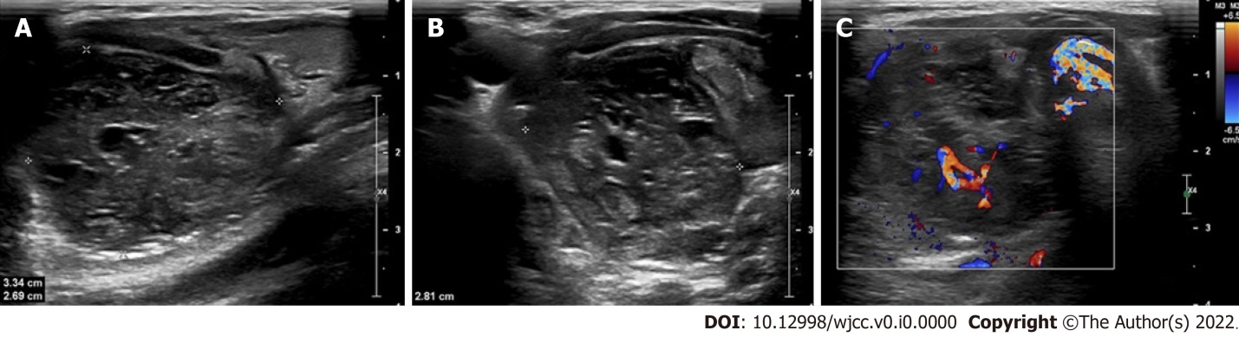
Figure 1 Sonography of the soft tissue mass in the neck. A and B: At the grey scale images, a soft tissue mass consisted of hypoechoic and anechoic was found in the right neck with the measurement of 33 mm × 27 mm × 28 mm on the longitudinal section and transection; C: Internal vascularity was present on Doppler images.
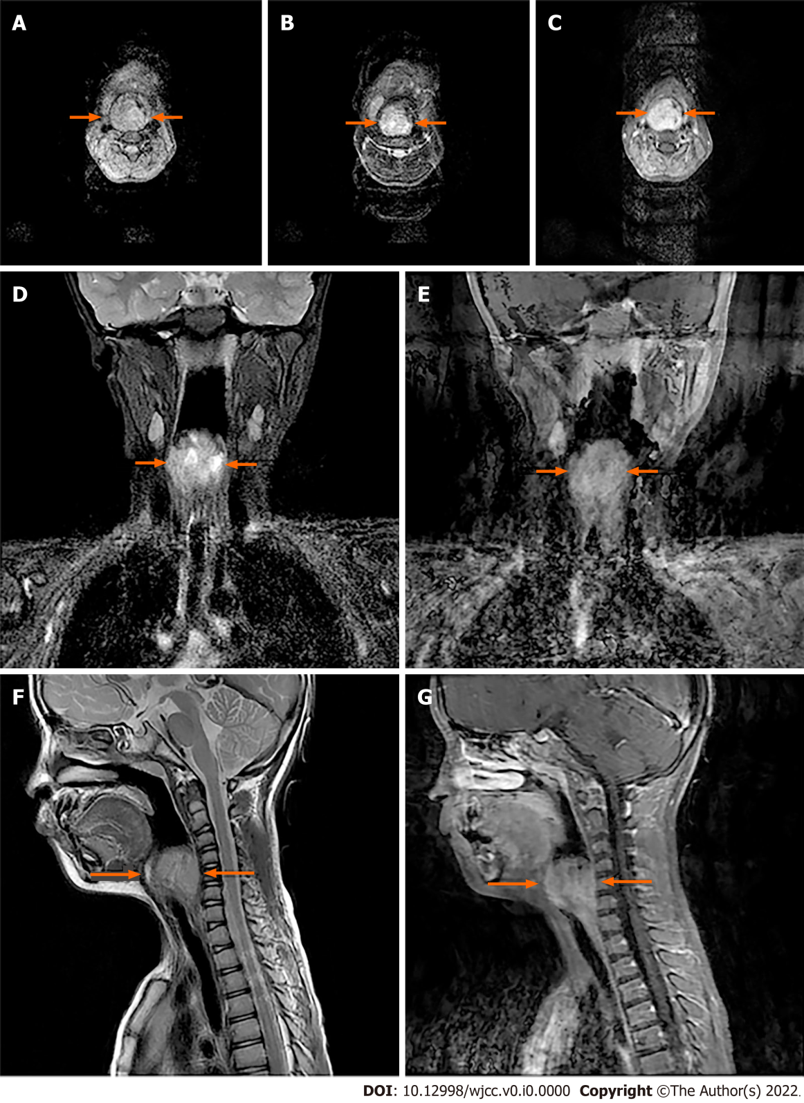
Figure 2 The soft tissue mass was indicated on the transverse plane, coronal plane and sagittal plane from 3.0 T magnetic resonance imaging scan. A: A well-defined lesion located in the right laryngeal and piriform recess present as heterogeneous equisignal intensity on T1 -weighted image; B, D and F: High signal intensity on T2 -weighted images; C, E and G: Moreover, the contrast enhanced MRI scan displayed the prominent and heterogeneous contrast enhancement with fast perfusion mode in the early arterial phase on T1+C images.
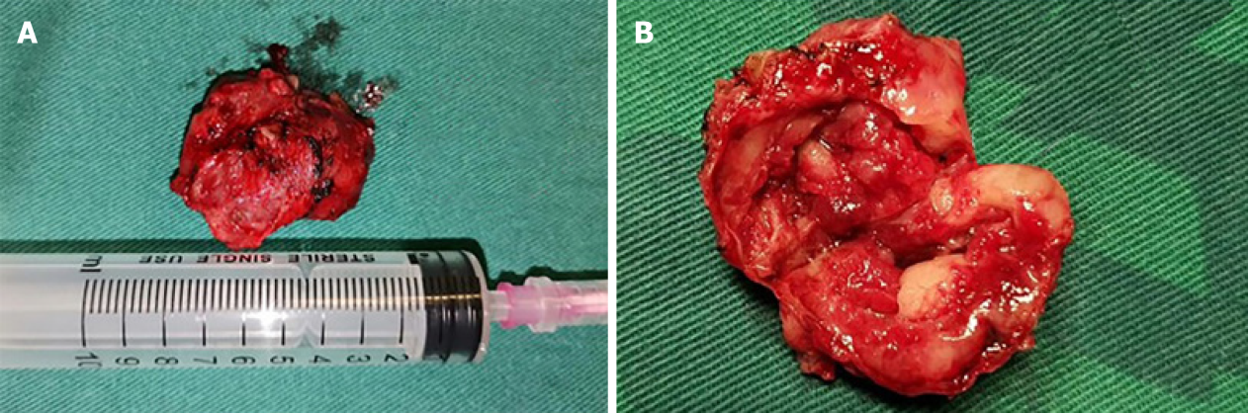
Figure 3 Pathological gross images of the lesion. A: The dark red mass was completely enveloped in well-defined capsule; B: It was elucidated to be multilocular cystic when split.
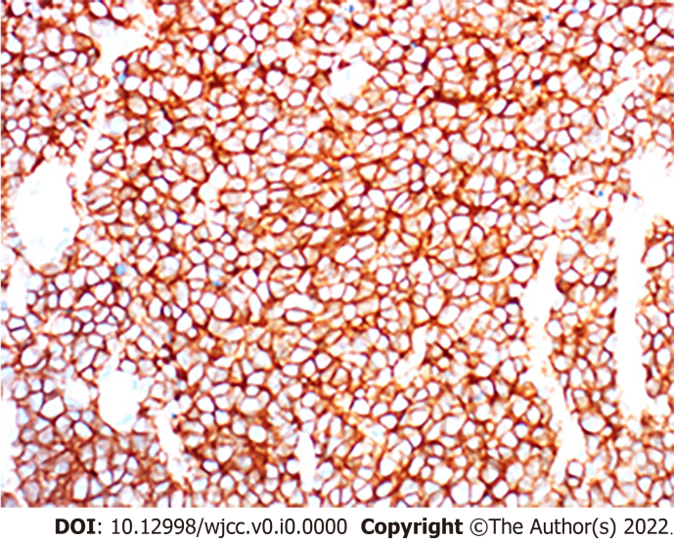
Figure 4 Histologic specimen (immunohistochemical stain, immunohistochemistry; original magnification, × 400) confirmed a diagnosis of the extraskeletal Ewing sarcoma, with the small round blue-stained cells observed. Immunochemical histological findings: NSE(+), NF(-), INI-1(+++), TTF-1(-), CK20(-), TDT(-), Wilms tumor(-), Bcl-2(+++), Ki-67(+), CD34(-), CD99(+++), Vimentin(+++), Syn(+).

