Name of Journal: World Journal of Gastroenterology
Manuscript NO: 86784
Manuscript Type: ORIGINAL ARTICLE

Retrospective Study
Impressive recompensation in transjugular intrahepatic portosystemic shunt-treated individuals with complications of decompensated cirrhosis based on Baveno VII criteria

Gao L et al. Impressive recompensation in TIPS-treated individuals

Long Gao, Man-Biao Li, Jin-Yu Li, Yang Liu, Chao Ren, Dui-Ping Feng

Long Gao, Jin-Yu Li, Dui-Ping Feng, Department of Oncological and Vascular Intervention, First Hospital of Shanxi Medical University, Taiyuan 030001, Shanxi Province, China

Long Gao, Jin-Yu Li, Dui-Ping Feng, Shanxi Provincial Clinical Research Center for Interventional Medicine, First Hospital of Shanxi Medical University, Taiyuan 030001, Shanxi Province, China

Man-Biao Li, Yang Liu, Chao Ren, College of Medical Imaging, Shanxi Medical University, Taiyuan 030001, Shanxi Province, China

Author contributions: Gao L, Li MB, and Li JY contributed equally to this manuscript; Gao L, Li MB, Li JY and Feng DP contributed to study conception and design; Li MB, Liu Y, and Ren C contributed to data acquisition; Li MB, Gao L, Li JY, and Feng DP contributed to analysis and interpretation of data; Gao L, Li MB, Li JY, and Feng DP contributed to manuscript writing, critical revision of the manuscript, and statistical analysis; All authors vouch for the veracity and completeness of the data and analyses presented, the final version of the manuscript has been reviewed and approved by all authors.

Supported by Natural Science Foundation of China, No. 82200650; Key Research and Development (R and D) Projects of Shanxi Province, No. 202102130501014; Shanxi Provincial Clinical Research Center for Interventional Medicine, No. 202204010501004; Natural Science Foundation of Shanxi Province, No. 202203021211021; Natural Science Foundation of Shanxi Province, No. 202203021212046; Natural Science Foundation of Shanxi Province, No. 20210302123258.

Corresponding author: Dui-Ping Feng, MD, Chief Doctor, Department of Oncological and Vascular Intervention, First Hospital of Shanxi Medical University, No. 85 Jiefang South Road, Yingze District, Taiyuan 030001, Shanxi Province, China. fengdp@sxmu.edu.cn

Received: July 7, 2023
Revised: August 15, 2023
Accepted: September 20, 2023
Published online:

Abstract
BACKGROUND
Transjugular intrahepatic portosystemic shunt (TIPS) is the standard second-line treatment option for individuals with complications of decompensated cirrhosis, such as variceal bleeding and refractory ascites.

AIM
To investigate whether recompensation existed in TIPS-treated patients with decompensated cirrhosis according to Baveno VII criteria.

METHODS
This retrospective analysis was performed on 64 patients who received TIPS for variceal bleeding or refractory ascites. The definition of recompensation referred to Baveno VII criteria and previous study. Clinical events, laboratory tests, and radiological examinations were regularly conducted during a preset follow-up period. The recompensation ratio in this cohort was calculated. Beyond that, univariate and multivariate regression models were conducted to identify the predictors of recompensation.

RESULTS
Of the 64 patients with a 12-mo follow-up, 20 (31%) achieved recompensation. Age [odds ratio (OR): 1.124; 95% confidence interval (CI): 1.034-1.222] and post-TIPS portal pressure gradient < 12 mmHg (OR: 0.119; 95% CI: 0.024-0.584) were identified as independent predictors of recompensation in patients with decompensated cirrhosis after TIPS.

CONCLUSION
The present study demonstrated that nearly one-third of the TIPS-treated patients achieved recompensation within this cohort. According to our findings, recompensation is more likely to be achieved in younger patients. In addition, postoperative portal pressure gradient reduction below 12 mmHg contributes to the occurrence of recompensation.

Key Words: Liver cirrhosis; Cirrhosis recompensation; Complications; Portal hypertension; Transjugular intrahepatic portosystemic shunt; Predictors

Gao L, Li MB, Li JY, Liu Y, Ren C, Feng DP. Impressive recompensation in transjugular intrahepatic portosystemic shunt-treated individuals with complications of decompensated cirrhosis based on Baveno VII criteria. World J Gastroenterol 2023; In press

Core Tip: Decompensated cirrhosis with complications of portal hypertension is often considered the end-stage of cirrhosis, with little chance of improvement. Despite this, recent studies have put forward the concept of recompensation. However, it remains unknown whether transjugular intrahepatic portosystemic shunts (TIPS) can achieve recompensation. Herein, we demonstrated that almost one-third of patients treated with TIPS achieved recompensation. Therefore, TIPS should be given greater priority in the treatment of decompensated cirrhosis with complications of portal hypertension, and prospective studies are necessary. In summary, the role of TIPS in achieving recompensation warrants further examination.

INTRODUCTION
Liver cirrhosis ranks as the 14th most common cause of adult deaths worldwide, causing 1.03 million deaths annually. Most cirrhotic complications and subsequent deaths result from portal hypertension rather than hepatocyte failure^{[1]}. Serious health threats, such as variceal bleeding and refractory ascites, are common complications of portal hypertension, and they create a significant burden on healthcare economics^{[2-4]}. Unlike liver fibrosis, cirrhosis has been considered an end-stage disease with limited chances of improvement in clinical practice. The therapeutic goals for cirrhosis are typically focused on symptom relief and avoiding liver transplantation, if possible^{[5]}.
However, recent studies have introduced the concept of recompensation, although there is currently no agreement on its definition^{[6]}. The Baveno VII consensus proposed criteria for recompensation, but specific cutoff values for stable improvement of liver function have not yet been established^{[7]}. More recently, Wang et al^{[8]} validated the Baveno VII criteria for recompensation in entecavir-treated individuals with hepatitis B-related decompensated cirrhosis and proposed laboratory criteria to define recompensation. Nevertheless, it is still unclear whether this threshold can be applied to other treatments.
Transjugular intrahepatic portosystemic shunts (TIPS) is an effective treatment for cirrhosis patients who experience variceal bleeding or refractory ascites^{[9]}. In cases of variceal bleeding, TIPS is typically used as a salvage therapy after the failure of standard medication combined with endoscopic therapy, with the goal of preventing rebleeding^{[10]}. Studies have shown that early implantation of TIPS is recommended to improve survival in patients with acute variceal bleeding and high risk of early rebleeding who fulfill any of the following criteria: Child-Pugh class C < 14 points or Child-Pugh class B > 7 with active bleeding at initial endoscopy or hepatic venous pressure gradient > 20 mmHg at the time of hemorrhage^{[11-13]}.
For patients with refractory ascites, TIPS has been shown to effectively clear ascites, leading to nutritional improvement and even normalization of renal function^{[14]}. In a prospective randomized trial involving 62 patients with cirrhosis and recurrent ascites, TIPS was found to increase the proportion of patients who survived transplantation-free for 1 year compared to patients who underwent repeated large-volume paracenteses and albumin (ALB) infusion. This supports TIPS as a first-line intervention in this scenario^{[15]}. Despite these advantages, the role of TIPS in the treatment of portal hypertension complications in cirrhosis remains secondary, and it is often considered only as a bridge to liver transplantation. Additionally, it is still unknown whether TIPS can further achieve recompensation.
Based on the above analysis, we hypothesized that TIPS can aid in recompensation to some extent based on Baveno VII criteria for recompensation^{[7]} and the laboratory threshold from Wang et al^{[8]}. To verify our assumption, we retrospectively collected relative data and outcomes of TIPS-treated patients over a 12-mo follow-up.

MATERIALS AND METHODS
Study population
This single-center, retrospective, single-arm study was conducted at the First Hospital of Shanxi Medical University between April 2019 and August 2022, which complied with the ethical guidelines of the 2013 Declaration of Helsinki and was approved by the ethics committee of the First Hospital of Shanxi Medical University (approval No. K-K231). Prior to enrolling the subjects, all participants or their legal guardian gave written informed consent.
The inclusion criteria were as follows: (1) 18-75 years of age; (2) receipt of etiological treatment before or immediately after enrollment; (3) meeting of clinical, biochemical, hematological, radiological, or histological diagnostic criteria for cirrhosis; (4) fulfillment of indication for TIPS; and (5) agreement to be treated with TIPS for variceal bleeding or refractory ascites. The exclusion criteria were as follows: (1) Concomitant hepatocellular carcinoma or other malignancies; (2) previous history of hepatic encephalopathy (HE), hepatorenal syndrome, or hepatopulmonary syndrome; (3) prothrombin time > 20 s or international normalized ratio (INR) > 2.0; (4) creatinine > 3 mg/dL; (5) comorbidity of any malignancy (excluding cured); (6) previous history of heart, lung, kidney, brain, blood, or other vital organ dysfunction; and (7) Other scenarios that did not meet the inclusion criteria.

TIPS procedure and follow-up
All TIPS procedures were performed by three interventional radiologists with more than 10 years of TIPS experience. No participant had active variceal bleeding at the time of the procedure. The TIPS procedure was performed under local anesthesia as previously described^{[10,16,17]}. The portosystemic pressure gradient (PPG) values were recorded before and after stent placement. In all patients, 8-mm expanded e-polytetrafluoroethylene-covered stent grafts (VIATORR; W.L. Gore and Associates, Inc, Newark, NJ, United States) were used. The varices were embolized with coils (Interlock; Boston Scientific, Marlborough, MA, United States) and N-butyl cyanoacrylate (B. Braun Melsungen AG, Melsungen, Germany), mixed with iodine oil (Guerbet, Villepinte, France) at a 1:2 ratio.
At baseline (1-7 d prior to TIPS), the patient’s demographics, clinical features, biochemical and radiological findings, and other related data were collected. After that, all patients were re-examined at 3-d, 1-mo, 3-mo, and 6-mo postoperative, and then every 6 mo thereafter. At each time point, data from laboratory tests, radiological examinations, and reports of clinical events were collected via outpatient follow-up or inpatient follow-up if necessary.

Etiological treatment
Besides TIPS treatment, all patients received necessary medication or lifestyle interventions for treating their respective causes according to the Guidelines of the European Association for the Study of the Liver study on chronic hepatitis B^{[18]}, hepatitis C^{[19]}, alcoholic liver disease^{[20]}, nonalcoholic fatty liver disease^{[21]}, autoimmune liver disease^{[22]}, and cholestatic liver disease^{[23]}. These interventions were aimed at achieving the removal/suppression of the primary cause of cirrhosis.

Definition of recompensation and research endpoints
Based on the Baveno VII consensus^{[7]} and a previous report^{[8]}, the definition of recompensation in this study fulfilled three items: (1) Removal of etiology of cirrhosis; (2) regression of ascites or resolution of ascites (off diuretics) and encephalopathy (off lactulose/rifaximin), and absence of recurrent variceal bleeding (for at least 12 mo); and (3) stable improvement of liver function tests, such as model for end-stage liver disease (MELD) score < 10 and/or liver function tests within Child-Pugh A [ALB > 35 g/L, INR < 1.50, and total bilirubin (TBIL) < 34 μmol/L].
The primary endpoint was the clinical occurrence of recompensation in TIPS-treated patients according to the above criteria. The secondary endpoints were changes in Child-Pugh scores, MELD scores, abdominal ultrasound parameters, PPG values, and the predictors of recompensation.

Abdominal ultrasound measurement methods
The ultrasound measurement procedures were performed by the same observer with more than 10 years of experience in ultrasound examinations. All patients were examined after an overnight fast. Operations were performed in strict accordance with standards using a convex array probe (Resona 6W; Mindray, Mahwah, NJ, United States) or a LFP5-1U probe (Resona 6W; Mindray) for real-time grey-scale imaging and measurement and sound touch quantification (STQ)^{[24]}. The portal vein diameter and peak ﬂow velocity were measured approximately 1-2 cm in front of the branches emanating from the portal vein trunk. The formula for calculating spleen volume was: (Maximum length × maximum width × maximum thickness × 0.52)^{[25]}. Severity of ascites were measured as: Grade 1 (mild), < 3 cm depth of ascites; grade 2 (moderate), 3-10 cm; and grade 3 (severe), ≥ 10 cm ^{[26]}. All measurements were repeated three times and averaged.

Statistical analysis
All analyses were conducted using SPSS statistical software (version 26.0; IBM Corp., Armonk, NY, United States) and GraphPad Prism (version 8.0). Sankey diagram was performed on the Tutools platform (https://www.cloudtutu.com). Before analysis, normality tests or P-P plots were used to check the normality of the variables. Continuous variables were expressed as mean ± SD or median interquartile range (IQR), while categorical variables were expressed as frequency (proportion). Comparison of two groups for quantitative variables was performed with a Student’s t-test or with the Mann-Whitney U test. Categorical variables for comparison of two groups was performed with a χ² test or Fisher’s exact test. Differences in biochemistry, ultrasound parameters, MELD scores, and Child-Pugh scores were compared at each time point using paired samples t-test/independent samples t-test or repeated measures analysis of variance. Sankey plots were generated to represent the change in Child-Pugh scores from baseline to month 12 of treatment. A univariate logistic regression analysis was used to investigate the factors of recompensation. Covariates with a P value less than 0.1 were further included in the multivariate logistic analysis with stepwise method (likelihood ratio) to test the association. In all cases, bilateral P values < 0.05 were considered statistically significant.

RESULTS
Baseline characteristics of the enrolled patients
Eligibility screening of 163 patients undergoing TIPS for cirrhotic decompensated events was retrospective conducted. After excluding 93 patients for various reasons, 70 patients were enrolled. We further excluded 6 patients with new hepatic malignancies. For the remaining 64 patients, data were collected (Figure 1).
The baseline characteristics of the patients are shown in Table 1. The mean age was 56 ± 13 years, of which 53% (34/64) were male. The mean alanine aminotransferase (ALT) level was 19 (IQR 16-27) IU/L, with 4.7% (3/64) having elevated ALT (> 40 IU/L). Prior to TIPS insertion, the median PPG was 25.50 (IQR 22.00-28.25) mmHg. The median Child-Pugh score was 7.50 (IQR 6.00-8.25), and the mean MELD score was 10.60 ± 4.13. All patients were successfully stented, and the mean PPG for the entire cohort decreased to 14.21 ± 4.59 mmHg postoperatively.

Follow-up of major laboratory test parameters and Child-Pugh and MELD scores after TIPS
Liver function tests changed significantly after TIPS (Figure 2, Supplementary Table 1). ALT increased significantly in the 12th month [from a median of 19 (IQR 16-27) IU/L to 30 (IQR 20-36) IU/L, P < 0.001] (Figure 2A). Similarly, aspartate aminotransferase level also increased significantly from baseline in the 12th month (P < 0.001) (Figure 2B). ALB levels were not different from baseline levels (P = 0.060) (Figure 2C). TBIL level continued to rise from baseline levels and reached a maximum in the 3rd postoperative month (P < 0.001). Then, the TBIL level decreased to level similar to baseline (Figure 2D). Creatinine continued to decrease postoperatively [baseline 67.18 ± 16.20 μmol/L vs 44.47 (IQR 40.08- 48.58) μmol/L in the 12th month, P < 0.001] (Figure 2E). Platelet level increased significantly from baseline in the 12th month (P < 0.001) (Figure 2F). The INR increased to a maximum in the 6th postoperative month (P < 0.001) and then returned to baseline levels (Figure 2G). Child-Pugh scores increased on the 3rd postoperative day then decreased in the 12th postoperative month (P < 0.001) (Figure 2H). MELD scores remained high from baseline for 6 mo (P < 0.001) and then decreased to baseline levels in the 12th postoperative month (Figure 2I).

Follow-up of abdominal ultrasound after TIPS
As shown in Supplementary Table 2, portal vein blood flow velocity was faster than at baseline (P < 0.001) and reached a maximum flow velocity of 33.69 ± 12.37 cm/s in the 6th postoperative month, accompanied by a maximum portal vein inner diameter of 1.45 ± 0.42 cm (P < 0.001) in the 6th postoperative month (Figure 3A and B). Liver STQ and spleen STQ decreased from baseline in the 12th postoperative month (P < 0.001) (Figure 3C and D). Spleen length decreased by 10.8% in the 6th postoperative month (P < 0.001) (Figure 3E). Similarly, spleen volume shrank to 75% of baseline in the 3rd postoperative month (P = 0.035) (Figure 3F).

Baseline and on-treatment characteristics in patients with and without recompensation
According to whether recompensation had occurred, the patients were divided into a recompensated group (n = 20) or a no recompensation group (n = 44). The baseline characteristics of the two groups are presented in Supplementary Table 3. The difference in Child-Pugh scores between the two groups at baseline was not statistically significant [6.5 (IQR 6.0-8.0) vs 8.0 (IQR 6.0-9.0), P = 0.174]. The patients without recompensation had higher MELD scores than patients with recompensation (11.41 ± 4.04 vs 8.81 ± 3.85, P = 0.019). In addition, the patients without recompensation tended to have higher TBIL, portal vein velocity, spleen length, spleen volume, and post-TIPS PPG, although they were not statistically different (P > 0.05).
There was a more profound improvement in Child-Pugh and MELD scores from the 6th postoperative month to the 12th postoperative month in the patients with recompensation compared to the patients without recompensation (Figure 4A and B). We plotted Sankey plots to represent the change in Child-Pugh scores from baseline to the 12th postoperative month, and the results showed significantly more favorable outcomes in the group with recompensation (Figure 4C-E). Although there was no statistical difference between the two groups at baseline, the proportion of patients with Child-Pugh A increased significantly over time in the recompensation group (Figure 4D).

Univariate and multivariate logistic analyses of predictors for recompensation
All baseline data were first analyzed using the univariate logistic regression model, which revealed no statistical differences between the two groups in terms of etiology and sex (Supplementary Table 4). Only age and post-TIPS PPG < 12 mmHg were significant (P < 0.05) and included in the multivariate regression model (Figure 5A). In the multivariate analysis, age [odds ratio (OR): 1.124; 95% confidence interval (CI): 1.034-1.222] and post-TIPS PPG < 12 mmHg (OR: 0.119; 95% CI: 0.024-0.584) were independent predictors of recompensation after TIPS (Figure 5B).

Characteristics in patients with or without new-onset HE
In general, 19 patients had HE within 12 mo and no patients had variceal bleeding. The baseline characteristics of those 19 patients with new-onset HE and 45 patients without new-onset HE are shown in Supplementary Table 5. Compared with patients without new-onset HE, patients with new-onset HE had higher age (53 ± 11 years vs 64 ± 13 years, P = 0.002) and pre-TIPS PPG [27.00 (IQR 25.50-29.50) mmHg vs 23.00 (IQR 21.00-26.25) mmHg, P = 0.031].

DISCUSSION
It is unknown whether the TIPS procedure is able to achieve recompensation. Our present study showed 31% of patients (n = 20/64) achieved recompensation after TIPS. Beyond that, we found that age and post-TIPS PPG < 12 mmHg were independent predictors of recompensation (Figure 5). Therefore, we suggest that TIPS should be given more priority for treatment of decompensated cirrhosis with complications of portal hypertension in the above scenarios. To the best of our knowledge, this is the first study to examine recompensation after TIPS based on the Baveno VII definition of recompensation^{[7]} and recent research^{[8]}.
Baveno VII proposed criteria to define recompensation, including the elimination or control of the underlying cause, absence of recurrent events for at least 12 mo, and stable improvement in liver function tests. However, the detailed criteria for stable improvement of liver function tests were still absent. Fortunately, a recent study validated the Baveno VII definition of recompensation and precisely defined the cutoff values for stable improvement of liver function tests, which require a MELD score < 10 and/or a liver function test in the Child-Pugh A range (ALB > 35 g/L, INR < 1.50, and TBIL < 34 μmol/L).
We chose the above criteria to conduct our current study for several reasons. First, it was easier to draw credible conclusions from mostly similar etiology and demographic backgrounds. Second, the nature of multicenter prospective clinical research determined the high evidence-based value. Third, the explanations of threshold setting (such as using INR instead of prothrombin time) was logical and acceptable.
TIPS is regarded as the bridge before liver transplantation and remains the second-line option either for gastrointestinal hemorrhage or refractory ascites^{[10,16]}, mainly attributed to the larger trauma of TIPS and postoperative HE^{[27,28]}. However, since a previous milestone study reported that early use of TIPS in patients with cirrhosis and variceal bleeding at high risk for treatment failure was associated with significant reductions in treatment failure and in mortality^{[13]}, more and more studies have confirmed that TIPS provides significant survival benefits over traditional first-line treatment (i.e. endoscopic therapy or medication) in selected patients^{[29-31]}. Lv et al^{[11]} revealed that early TIPS could improve transplantation-free survival in selected patients with advanced cirrhosis and acute variceal bleeding compared to standard first-line treatment with no significant difference in adverse events. Furthermore, Wang et al^{[32]} showed that TIPS with 8-mm covered stents achieved similar shunt function to 10-mm covered stents and halved the risk of spontaneous overt HE and reduced hepatic impairment.
In addition, a more recent meta-analysis of data from 1327 patients with cirrhosis reconfirmed that preemptive TIPS increased the proportion who survived for 1 year compared with drugs plus endoscopy in both subgroups separately^{[30]}. Nevertheless, none of these studies clarified the detailed mechanism for the survival benefits associated with TIPS, such as cirrhosis recompensation.
Our current study indicated that nearly one-third of patients achieved recompensation after TIPS during the 12-mo follow-up, which was impressive and encouraging for TIPS practitioners. As previous research confirmed, the stiffness of the liver and spleen had a good correlation with hepatic vein pressure gradient, which served as the gold standard for assessing severity of portal hypertension. However, in our cohort, we were unable to draw the same conclusion. Although the stiffness of the liver and spleen decreased 12 mo after TIPS compared to baseline (Figure 3C and D), it did not show statistical significance in predicting recompensation in univariate and multivariate logistic regression analysis (Supplementary Table 4). This may be due to the fact that the patients included in our study had not responded to repeated medical treatment, indicating that their cirrhosis was more severe and could not be easily reversed^{[5]}.
Previous research had shown that low MELD score and high platelet levels at admission predicted delisting after improvement^{[33]}. Accordingly, we originally believed that the MELD score could predict recompensation, and it did show statistical significance in univariate analysis. However, surprisingly, there was no statistical significance in multivariate analysis for MELD score to predict recompensation (Figure 5). This finding highlights the possible impact that a small sample size can have on studies and the importance of replicative investigations with large sample sizes for validation. Additionally, we found that older patients were more likely to develop new-onset HE (Supplementary Table 5), which was consistent with previous research^{[2,34]}.
To examine possible causes, we further compared relevant characteristics of patients with or without new-onset HE and found that the preoperative PPG of the former was significantly higher than that of the latter (Supplementary Table 5). This may be attributed to the fact that higher PPG predicted poorer liver function and therefore greater susceptibility to HE. Although preoperative PPG itself cannot predict the risk of HE, it can still be considered as a risk factor for early onset HE after TIPS, as evidenced by other studies^{[17,34]}.
While it had been documented that addressing the underlying causes can lead to cirrhosis recompensation, the severity of decompensation in the cirrhosis patients involved in these studies was reported to be mild^{[8,35]}. However, in our study, the enrolled patients had already met the indications for TIPS, indicating an already advanced stage of liver cirrhosis in these individuals. Consequently, relying solely on etiological treatment proved woefully insufficient in suppressing the recurrence of life-threatening portal hypertension complications, not to mention facilitating cirrhosis recompensation. Given this context, we firmly believed that in our study, the pivotal factor driving liver cirrhosis recompensation was the reversal of portal hypertension achieved through TIPS, rather than the sole emphasis on etiological treatment.
There are several rational explanations for postoperative recompensation after TIPS. First, since predisposition for decompensation in cirrhosis was mainly due to the progress of portal hypertension, radically reduced portal pressure after TIPS was a prerequisite for recompensation^{[36]}. Second, TIPS increased the cardiac output and thereby the effective blood volume, which further improved perfusion of vital organs, especially that of the kidneys and liver^{[37]}. Finally, portal hypertension is highly correlated with systemic inflammation. As a result, the reduction of portal vein pressure can in turn reduce systemic inflammation to some extent, especially the inflammation of hepatic sinuses^{[33]}. In this regard, the reversal of abnormal intestinal flora, attributed to intestinal congestion of portal hypertension, also led to an improvement in systemic and logical inflammation^{[34]}. In addition, the improvement in nutritional status after TIPS, especially in sarcopenia, was beneficial to recompensation and further reduced the risk of death^{[2]}.
Our study had certain limitations. First, the nature of retrospective research determined that the level of evidence-based medical evidence for our present work was not high enough. Second, the relatively small sample size limited the credibility of this study. Third, this work was performed in our single-center, which inevitably leads to selection bias. In addition, the etiology of cirrhosis in the enrolled patients was not entirely hepatitis B. Consequently, the laboratory criteria we selected to define recompensation may not be entirely accurate. Last but not the least, this study did not incorporate a control group for ethical and practical considerations, since etiological treatment such as antiviral therapy or alcohol abstinence had become the standard of care. In other words, once a patient met the indications for TIPS, it would have been both ethically and clinically inappropriate to administer treatment focused solely on either the underlying causes or TIPS in isolation.

CONCLUSION
For the first time, our study demonstrated that nearly one-third of individuals achieved recompensation after TIPS according to the Baveno VII definition of recompensation and previous research. Preoperative PPG < 12 mmHg and age were demonstrated as independent predictors of recompensation. Additional prospective trials are warranted to further validate our findings.

ARTICLE HIGHLIGHTS
Research background
Decompensated cirrhosis with complications of portal hypertension is often considered the end-stage of cirrhosis, with little chance of improvement. Despite this, recent studies have put forward the concept of recompensation.

Research motivation
Transjugular intrahepatic portosystemic shunts (TIPS) are the standard second-line treatment option for individuals with complications of decompensated cirrhosis, such as variceal bleeding and refractory ascites. However, it remains unknown whether TIPS can achieve recompensation.

Research objectives
Herein, we investigated whether recompensation existed in TIPS-treated patients with decompensated cirrhosis according to the Baveno VII criteria.

Research methods
This retrospective analysis was performed on 64 patients who received TIPS for variceal bleeding or refractory ascites. The definition of recompensation referred to the Baveno VII criteria and a previous study. Clinical events, laboratory tests, and radiological examinations were regularly conducted during the follow-up period. The recompensation ratio in this cohort was calculated. Beyond that, univariate and multivariate regression models were conducted to identify the predictors of recompensation.

Research results
In this present cohort, nearly one-third of the TIPS-treated patients achieved recompensation. TIPS-treated patients will benefit from recompensation if portosystemic pressure gradient (PPG) drops below 12 mmHg. Age is recommended as the observation index of recompensation. PPG and age were identified as the independent predictors of recompensation in TIPS-treated patients with decompensated cirrhosis.

Research conclusions
Therefore, TIPS should be given greater priority in the treatment of decompensated cirrhosis with complications of portal hypertension, and prospective studies are necessary.

Research perspectives
In summary, the role of TIPS in achieving recompensation warrants further examination.

REFERENCES
1 Tsochatzis EA, Bosch J, Burroughs AK. Liver cirrhosis. Lancet 2014; 383: 1749-1761 [PMID: 24480518 DOI: 10.1016/S0140-6736(14)60121-5]
2 Engelmann C, Clària J, Szabo G, Bosch J, Bernardi M. Pathophysiology of decompensated cirrhosis: Portal hypertension, circulatory dysfunction, inflammation, metabolism and mitochondrial dysfunction. J Hepatol 2021; 75 Suppl 1: S49-S66 [PMID: 34039492 DOI: 10.1016/j.jhep.2021.01.002]
3 Magaz M, Baiges A, Hernández-Gea V. Precision medicine in variceal bleeding: Are we there yet? J Hepatol 2020; 72: 774-784 [PMID: 31981725 DOI: 10.1016/j.jhep.2020.01.008]
4 Mezzano G, Juanola A, Cardenas A, Mezey E, Hamilton JP, Pose E, Graupera I, Ginès P, Solà E, Hernaez R. Global burden of disease: acute-on-chronic liver failure, a systematic review and meta-analysis. Gut 2022; 71: 148-155 [PMID: 33436495 DOI: 10.1136/gutjnl-2020-322161]
5 Rudler M, Savier E, Alioua I, Sultanik P, Thabut D. TIPS and liver transplantation should always be discussed together. J Hepatol 2021; 75: 1000-1001 [PMID: 34051330 DOI: 10.1016/j.jhep.2021.05.012]
6 Reiberger T, Hofer BS. The Baveno VII concept of cirrhosis recompensation. Dig Liver Dis 2023; 55: 431-441 [PMID: 36646527 DOI: 10.1016/j.dld.2022.12.014]
7 de Franchis R, Bosch J, Garcia-Tsao G, Reiberger T, Ripoll C; Baveno VII Faculty. Baveno VII - Renewing consensus in portal hypertension. J Hepatol 2022; 76: 959-974 [PMID: 35120736 DOI: 10.1016/j.jhep.2021.12.022]
8 Wang Q, Zhao H, Deng Y, Zheng H, Xiang H, Nan Y, Hu J, Meng Q, Xu X, Fang J, Xu J, Wang X, You H, Pan CQ, Xie W, Jia J. Validation of Baveno VII criteria for recompensation in entecavir-treated patients with hepatitis B-related decompensated cirrhosis. J Hepatol 2022; 77: 1564-1572 [PMID: 36038017 DOI: 10.1016/j.jhep.2022.07.037]
9 Rössle M. TIPS: 25 years later. J Hepatol 2013; 59: 1081-1093 [PMID: 23811307 DOI: 10.1016/j.jhep.2013.06.014]
10 Tripathi D, Stanley AJ, Hayes PC, Travis S, Armstrong MJ, Tsochatzis EA, Rowe IA, Roslund N, Ireland H, Lomax M, Leithead JA, Mehrzad H, Aspinall RJ, McDonagh J, Patch D. Transjugular intrahepatic portosystemic stent-shunt in the management of portal hypertension. Gut 2020; 69: 1173-1192 [PMID: 32114503 DOI: 10.1136/gutjnl-2019-320221]
11 Lv Y, Yang Z, Liu L, Li K, He C, Wang Z, Bai W, Guo W, Yu T, Yuan X, Zhang H, Xie H, Yao L, Wang J, Li T, Wang Q, Chen H, Wang E, Xia D, Luo B, Li X, Yuan J, Han N, Zhu Y, Niu J, Cai H, Xia J, Yin Z, Wu K, Fan D, Han G; AVB-TIPS Study Group. Early TIPS with covered stents versus standard treatment for acute variceal bleeding in patients with advanced cirrhosis: a randomised controlled trial. Lancet Gastroenterol Hepatol 2019; 4: 587-598 [PMID: 31153882 DOI: 10.1016/S2468-1253(19)30090-1]
12 Liu J, Shi Q, Xiao S, Zhou C, Zhou B, Yuan F, Zheng C, Lin S, Qian K, Feng G, Xiong B. Using transjugular intrahepatic portosystemic shunt as the first-line therapy in secondary prophylaxis of variceal hemorrhage. J Gastroenterol Hepatol 2020; 35: 278-283 [PMID: 31222830 DOI: 10.1111/jgh.14761]
13 García-Pagán JC, Caca K, Bureau C, Laleman W, Appenrodt B, Luca A, Abraldes JG, Nevens F, Vinel JP, Mössner J, Bosch J; Early TIPS (Transjugular Intrahepatic Portosystemic Shunt) Cooperative Study Group. Early use of TIPS in patients with cirrhosis and variceal bleeding. N Engl J Med 2010; 362: 2370-2379 [PMID: 20573925 DOI: 10.1056/NEJMoa0910102]
14 Adebayo D, Neong SF, Wong F. Refractory Ascites in Liver Cirrhosis. Am J Gastroenterol 2019; 114: 40-47 [PMID: 29973706 DOI: 10.1038/s41395-018-0185-6]
15 Bureau C, Thabut D, Oberti F, Dharancy S, Carbonell N, Bouvier A, Mathurin P, Otal P, Cabarrou P, Péron JM, Vinel JP. Transjugular Intrahepatic Portosystemic Shunts With Covered Stents Increase Transplant-Free Survival of Patients With Cirrhosis and Recurrent Ascites. Gastroenterology 2017; 152: 157-163 [PMID: 27663604 DOI: 10.1053/j.gastro.2016.09.016]
16 Lv Y, Fan D, Han G. Transjugular intrahepatic portosystemic shunt for portal hypertension: 30 years experience from China. Liver Int 2023; 43: 18-33 [PMID: 35593016 DOI: 10.1111/liv.15313]
17 Liu J, Ma J, Zhou C, Yang C, Huang S, Shi Q, Xiong B. Potential Benefits of Underdilation of 8-mm Covered Stent in Transjugular Intrahepatic Portosystemic Shunt Creation. Clin Transl Gastroenterol 2021; 12: e00376 [PMID: 34140457 DOI: 10.14309/ctg.0000000000000376]
18 European Association for the Study of the Liver. Electronic address: easloffice@easloffice.eu; European Association for the Study of the Liver. EASL 2017 Clinical Practice Guidelines on the management of hepatitis B virus infection. J Hepatol 2017; 67: 370-398 [PMID: 28427875 DOI: 10.1016/j.jhep.2017.03.021]
19 European Association for Study of Liver. EASL Clinical Practice Guidelines: management of hepatitis C virus infection. J Hepatol 2014; 60: 392-420 [PMID: 24331294 DOI: 10.1016/j.jhep.2013.11.003]
20 European Association for the Study of the Liver. Electronic address: easloffice@easloffice.eu; European Association for the Study of the Liver. EASL Clinical Practice Guidelines: Management of alcohol-related liver disease. J Hepatol 2018; 69: 154-181 [PMID: 29628280 DOI: 10.1016/j.jhep.2018.03.018]
21 European Association for the Study of the Liver (EASL); European Association for the Study of Diabetes (EASD); European Association for the Study of Obesity (EASO). EASL-EASD-EASO Clinical Practice Guidelines for the management of non-alcoholic fatty liver disease. Diabetologia 2016; 59: 1121-1140 [PMID: 27053230 DOI: 10.1007/s00125-016-3902-y]
22 European Association for the Study of the Liver. EASL Clinical Practice Guidelines: Autoimmune hepatitis. J Hepatol 2015; 63: 971-1004 [PMID: 26341719 DOI: 10.1016/j.jhep.2015.06.030]
23 European Association for the Study of the Liver. EASL Clinical Practice Guidelines: management of cholestatic liver diseases. J Hepatol 2009; 51: 237-267 [PMID: 19501929 DOI: 10.1016/j.jhep.2009.04.009]
24 Zhu H, Guo H, Yin X, Yang J, Yin Q, Xiao J, Wang Y, Zhang M, Han H, Zhuge Y, Zhang F. Spleen Stiffness Predicts Survival after Transjugular Intrahepatic Portosystemic Shunt in Cirrhotic Patients. Biomed Res Int 2020; 2020: 3860390 [PMID: 33282945 DOI: 10.1155/2020/3860390]
25 Huang Y, Zheng Y, Zhang C, Zhong S. Ultrasound Assessment of the Relevance of Liver, Spleen, and Kidney Dimensions with Body Parameters in Adolescents. Comput Math Methods Med 2022; 2022: 9150803 [PMID: 35832132 DOI: 10.1155/2022/9150803]
26 Aithal GP, Palaniyappan N, China L, Härmälä S, Macken L, Ryan JM, Wilkes EA, Moore K, Leithead JA, Hayes PC, O'Brien AJ, Verma S. Guidelines on the management of ascites in cirrhosis. Gut 2021; 70: 9-29 [PMID: 33067334 DOI: 10.1136/gutjnl-2020-321790]
27 Lee HL, Lee SW. The role of transjugular intrahepatic portosystemic shunt in patients with portal hypertension: Advantages and pitfalls. Clin Mol Hepatol 2022; 28: 121-134 [PMID: 34571587 DOI: 10.3350/cmh.2021.0239]
28 Patel RK, Chandel K, Tripathy TP, Mukund A. Complications of transjugular intrahepatic portosystemic shunt (TIPS) in the era of the stent graft - What the interventionists need to know? Eur J Radiol 2021; 144: 109986 [PMID: 34619618 DOI: 10.1016/j.ejrad.2021.109986]
29 Kumar R, Kerbert AJC, Sheikh MF, Roth N, Calvao JAF, Mesquita MD, Barreira AI, Gurm HS, Ramsahye K, Mookerjee RP, Yu D, Davies NH, Mehta G, Agarwal B, Patch D, Jalan R. Determinants of mortality in patients with cirrhosis and uncontrolled variceal bleeding. J Hepatol 2021; 74: 66-79 [PMID: 32561318 DOI: 10.1016/j.jhep.2020.06.010]
30 Nicoară-Farcău O, Han G, Rudler M, Angrisani D, Monescillo A, Torres F, Casanovas G, Bosch J, Lv Y, Thabut D, Fan D, Hernández-Gea V, García-Pagán JC; Preemptive TIPS Individual Data Metanalysis, International Variceal Bleeding Study and Baveno Cooperation Study groups. Effects of Early Placement of Transjugular Portosystemic Shunts in Patients With High-Risk Acute Variceal Bleeding: a Meta-analysis of Individual Patient Data. Gastroenterology 2021; 160: 193-205.e10 [PMID: 32980344 DOI: 10.1053/j.gastro.2020.09.026]
31 Trebicka J, Gu W, Ibáñez-Samaniego L, Hernández-Gea V, Pitarch C, Garcia E, Procopet B, Giráldez Á, Amitrano L, Villanueva C, Thabut D, Silva-Junior G, Martinez J, Genescà J, Bureau C, Llop E, Laleman W, Palazon JM, Castellote J, Rodrigues S, Gluud L, Ferreira CN, Barcelo R, Cañete N, Rodríguez M, Ferlitsch A, Mundi JL, Gronbaek H, Hernández-Guerra M, Sassatelli R, Dell'Era A, Senzolo M, Abraldes JG, Romero-Gómez M, Zipprich A, Casas M, Masnou H, Primignani M, Weiss E, Catalina MV, Erasmus HP, Uschner FE, Schulz M, Brol MJ, Praktiknjo M, Chang J, Krag A, Nevens F, Calleja JL, Robic MA, Conejo I, Albillos A, Rudler M, Alvarado E, Guardascione MA, Tantau M, Bosch J, Torres F, Pavesi M, Garcia-Pagán JC, Jansen C, Bañares R; International Variceal Bleeding Observational Study Group and Baveno Cooperation. Rebleeding and mortality risk are increased by ACLF but reduced by pre-emptive TIPS. J Hepatol 2020; 73: 1082-1091 [PMID: 32339602 DOI: 10.1016/j.jhep.2020.04.024]
32 Wang Q, Lv Y, Bai M, Wang Z, Liu H, He C, Niu J, Guo W, Luo B, Yin Z, Bai W, Chen H, Wang E, Xia D, Li X, Yuan J, Han N, Cai H, Li T, Xie H, Xia J, Wang J, Zhang H, Wu K, Fan D, Han G. Eight millimetre covered TIPS does not compromise shunt function but reduces hepatic encephalopathy in preventing variceal rebleeding. J Hepatol 2017; 67: 508-516 [PMID: 28506905 DOI: 10.1016/j.jhep.2017.05.006]
33 Liu J, Ma J, Yang C, Chen M, Shi Q, Zhou C, Huang S, Chen Y, Wang Y, Li T, Xiong B. Sarcopenia in Patients with Cirrhosis after Transjugular Intrahepatic Portosystemic Shunt Placement. Radiology 2022; 303: 711-719 [PMID: 35289658 DOI: 10.1148/radiol.211172]
34 Trebicka J. Does Transjugular Intrahepatic Portosystemic Shunt Stent Differentially Improve Survival in a Subset of Cirrhotic Patients? Semin Liver Dis 2018; 38: 87-96 [PMID: 29471569 DOI: 10.1055/s-0038-1627457]
35 Hofer BS, Simbrunner B, Hartl L, Jachs M, Balcar L, Paternostro R, Schwabl P, Semmler G, Scheiner B, Trauner M, Mandorfer M, Reiberger T. Hepatic recompensation according to Baveno VII criteria is linked to a significant survival benefit in decompensated alcohol-related cirrhosis. Liver Int 2023 [PMID: 37469291 DOI: 10.1111/liv.15676]
36 Gracia-Sancho J, Marrone G, Fernández-Iglesias A. Hepatic microcirculation and mechanisms of portal hypertension. Nat Rev Gastroenterol Hepatol 2019; 16: 221-234 [PMID: 30568278 DOI: 10.1038/s41575-018-0097-3]
37 Gedgaudas R, Bajaj JS, Skieceviciene J, Varkalaite G, Jurkeviciute G, Gelman S, Valantiene I, Zykus R, Pranculis A, Bang C, Franke A, Schramm C, Kupcinskas J. Circulating microbiome in patients with portal hypertension. Gut Microbes 2022; 14: 2029674 [PMID: 35130114 DOI: 10.1080/19490976.2022.2029674]

Footnotes
Institutional review board statement: The study was reviewed and approved by the Ethics Committee of the First Hospital of Shanxi Medical University.

Informed consent statement: All study participants, or their legal guardian, provided informed written consent prior to study enrollment.

Conflict-of-interest statement: We have no financial relationships to disclose.

Data sharing statement: No additional data are available.

Open-Access: This article is an open-access article that was selected by an in-house editor and fully peer-reviewed by external reviewers. It is distributed in accordance with the Creative Commons Attribution NonCommercial (CC BY-NC 4.0) license, which permits others to distribute, remix, adapt, build upon this work non-commercially, and license their derivative works on different terms, provided the original work is properly cited and the use is non-commercial. See: https://creativecommons.org/Licenses/by-nc/4.0/

Provenance and peer review: Unsolicited article; Externally peer reviewed.

Peer-review model: Single blind

Peer-review started: July 7, 2023
First decision: August 8, 2023
Article in press:

Specialty type: Gastroenterology and hepatology
Country/Territory of origin: China
Peer-review report’s scientific quality classification
Grade A (Excellent): 0
Grade B (Very good): B
Grade C (Good): C
Grade D (Fair): D
Grade E (Poor): 0

P-Reviewer: Batta A, India; Karagiannakis DS, Greece S-Editor: Qu XL L-Editor: P-Editor:
Figure Legends
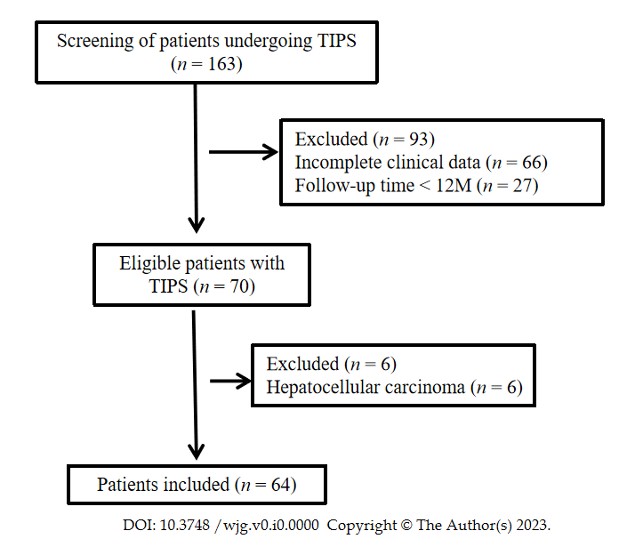
Figure 1 Flow chart of patient inclusion. TIPS: Transjugular intrahepatic portosystemic shunt.
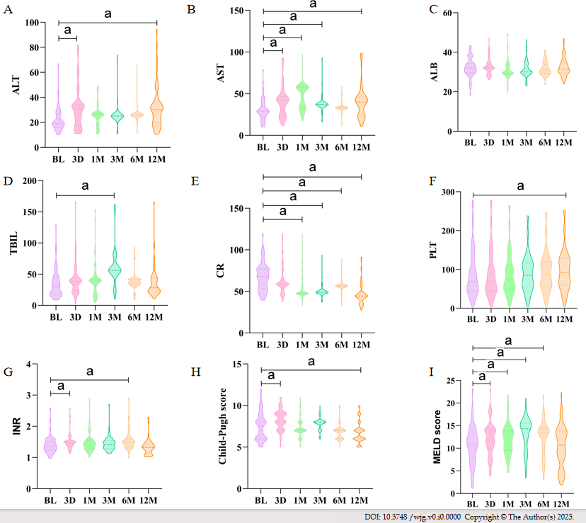
Figure 2 Dynamic changes of major laboratory test parameters and Child-Pugh/model for end-stage liver disease scores during the 12-mo follow-up. A: Alanine aminotransferase; B: Aspartate aminotransferase; C: Albumin; D: Total bilirubin; E: Creatinine; F: Platelets; G: International normalized ratio; H: Child-Pugh score; I: Model for end-stage liver disease score. ªP < 0.05. BL: Baseline; 3D: Postoperative day 3; 1M: One month postoperatively; 3M: Three months postoperatively; 6M: Six months postoperatively; 12M: Twelve months postoperatively; ALT: Alanine aminotransferase; AST: Aspartate aminotransferase; ALB: Albumin; TBIL: Total bilirubin; CR: Creatinine; PLT: Platelets; INR: International normalized ratio; MELD: Model for end-stage liver disease.
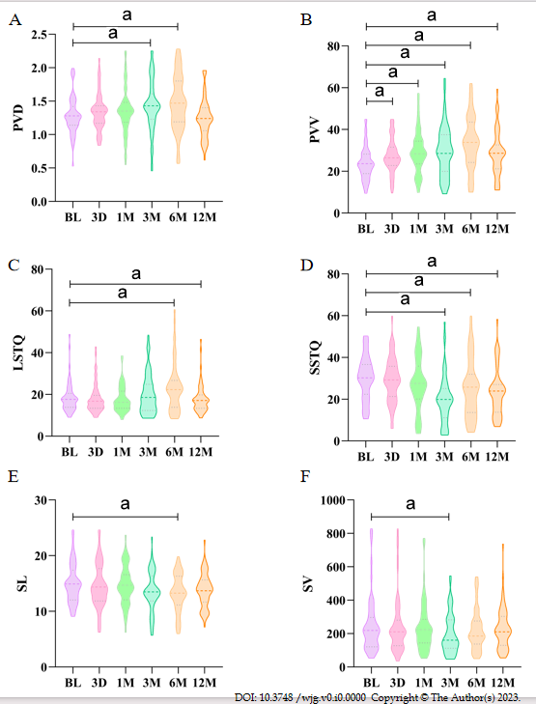
Figure 3 Dynamic changes in abdominal ultrasound measurement results during the 12-mo follow-up. A: Portal vein inner diameter; B: Portal vein velocity; C: Liver sound touch quantification; D: Spleen sound touch quantification; E: Spleen length; F: Spleen volume. ªP < 0.05. BL: Baseline; 3D: Postoperative day 3; 1M: One month postoperatively; 3M: Three months postoperatively; 6M: Six months postoperatively; 12M: Twelve months postoperatively; PVD: Portal vein inner diameter; PVV: Portal vein velocity; LSTQ: Liver sound touch quantification; SSTQ: Spleen sound touch quantification; SL: Spleen length; SV: Spleen volume.

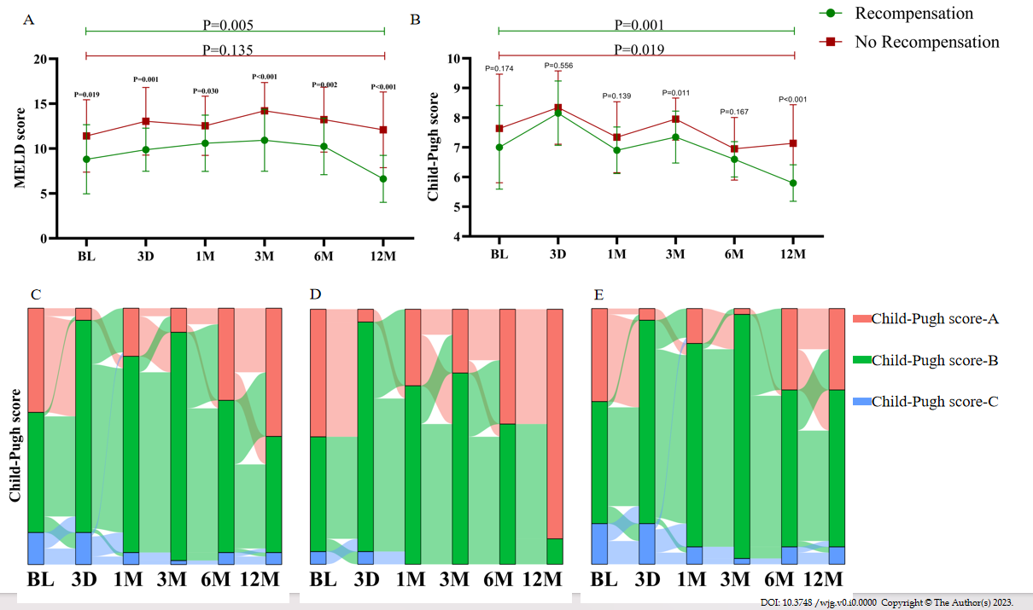
Figure 4 Dynamic changes of liver function classification in patients with and without recompensation during the 12-mo follow-up. A and B: Mean Child-Pugh/model for end-stage liver disease (MELD) scores at baseline (BL) and follow-up in patients with or without recompensation (bars represent standard error of the mean). The differences in Child-Pugh/MELD scores in these two groups at each time point were compared using the Student’s t-test. The difference in Child-Pugh/MELD scores between BL and 12 mo after transjugular intrahepatic portosystemic shunt was compared separately for each group. Sankey diagrams were used to show the major transfers or flows of patients. The colors of the columns represent patients with different Child-Pugh classifications, with red representing Child-Pugh A, green representing Child-Pugh B, and blue representing Child-Pugh C. The length of the column represents the proportion of patients. The thicker the line, the greater the number of patients involved; C: Entire cohort (n = 64); D: Patients with recompensation (n = 20); E: Patients without recompensation (n = 44). BL: Baseline; 3D: Postoperative day 3; 1M: One month postoperatively; 3M: Three months postoperatively; 6M: Six months postoperatively; 12M: Twelve months postoperatively.
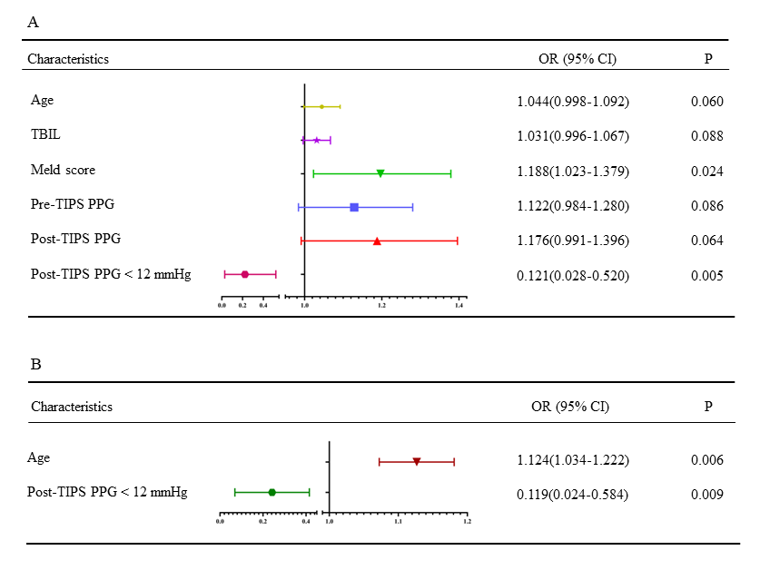
Figure 5 Univariate and multivariate logistic regression analysis identified independent predictors of recompensation after transjugular intrahepatic portosystemic shunt. A: Univariate logistic regression analysis; B: Multivariate logistic regression analysis. Age and post-transjugular intrahepatic portosystemic shunt portosystemic pressure gradient < 12 mmHg could be identified as independent predictors of recompensation. All parameters with a P value < 0.1 in the univariate analysis were included in the multivariate logistic regression analysis. CI: Confidence interval; TIPS: Transjugular intrahepatic portosystemic shunt; OR: Odds ratio; PPG: Portosystemic pressure gradient; TBIL: Total bilirubin.
Table 1 Baseline study population characteristics, n (%)
Variables | Value
Age in yr | 56 ± 13
Male sex | 34 (53.1)
Etiology
Viral | 32 (50.0)
Alcohol | 10 (15.6)
Other | 22 (34.4)
PLT as 10⁹/L | 68.5 (44.5, 114.8)
INR | 1.36 (1.23, 1.52)
ALT in IU/L | 19 (16, 27)
AST in IU/L | 29 (22, 35)
ALB in g/L | 32.28 ± 4.46
TBIL in μmol/L | 30.3 (18.2, 43.9)
MELD score | 10.60 ± 4.13
Child-Pugh score | 7.5 (6.0, 8.3)
PPG in mmHg
Pre-TIPS | 25.5 (22.0, 28.3)
Post-TIPS | 14.21 ± 4.59
Post-TIPS PPG < 12 mmHg | 15 (23.4)
PPG reduction by TIPS | 9 (7, 14)
Data are mean ± SD, n (%), or median (interquartile range). ALB: Albumin; ALT: Alanine aminotransferase; AST: Aspartate aminotransferase; INR: International normalized ratio; MELD: Model for end-stage liver disease; PLT: Platelets; PPG: Portosystemic pressure gradient; TBIL: Total bilirubin; TIPS: Transjugular intrahepatic portosystemic shunt.

