Name of Journal: World Journal of Cardiology
Manuscript NO: 74514
Manuscript Type: OPINION REVIEW

Metabolic and cardiovascular benefits with combination therapy of SGLT-2 inhibitors and GLP-1 receptor agonists in type 2 diabetes

Singh AK et al. GLP-1RA and SGLT-2I dual therapy in T2DM

Awadhesh Kumar Singh, Ritu Singh

Awadhesh Kumar Singh, Department of Diabetes and Endocrinology, G.D Hospital and Diabetes Institute, Kolkata 700013, India

Ritu Singh, Department of Reproductive Endocrinology, G.D Hospital and Diabetes Institute, Kolkata 700013, India

Author contributions: Singh AK made conception and design of the study and collected the data; Singh AK and Singh R did the statistical calculations, drafted the manuscript, and revised the manuscript critically; all authors read and approved the final manuscript.

Corresponding author: Awadhesh Kumar Singh, MBBS, MD, PhD, Consultant Physician-Scientist, Intermediate Editor, Senior Postdoctoral Fellow, Senior Researcher, Department of Diabetes and Endocrinology, G.D Hospital and Diabetes Institute, No. 3 Canal Street, Kolkata 700013, India. draksingh_2001@yahoo.com

Received: December 26, 2021
Revised: March 17, 2022
Accepted: May 21, 2022
Published online: June 26, 2022

Abstract
Both GLP-1 receptor agonists (GLP-1RA) and SGLT-2 inhibitors (SGLT-2I) are newer classes of anti-diabetic agents that lower HbA1c moderately and decrease body weight and systolic blood pressure (SBP) modestly. Combination therapy with GLP-1RA plus SGLT-2I have shown a greater reduction in HbA1c, body weight, and SBP compared to either agent alone without any significant increase in hypoglycemia or other side effects. Since several agents from each class of these drugs have shown an improvement in cardiovascular (CV) and renal outcomes in their respective cardiovascular outcome trials (CVOT), combination therapy is theoretically expected to have additional CV and renal benefits. In this comprehensive opinion review, we found HbA1c lowering with GLP-1RA plus SGLT-2I to be less than additive compared to the sum of HbA1c lowering with either agent alone, although body weight lowering was nearly additive and the SBP lowering was more than additive. Our additional meta-analysis of CV outcomes with GLP-1RA plus SGLT-2I combination therapy from the pooled data of five CVOT found a similar reduction in three-point major adverse cardiovascular events compared to GLP-1RA or SGLT-2I alone, against placebo. Interestingly, a greater benefit in reduction of heart failure hospitalization with GLP-1RA plus SGLT-2I combination therapy was noted in the pooled meta-analysis of two randomized controlled trials. Future adequately powered trials can confirm whether additional CV or renal benefit is truly exerted by GLP-1RA plus SGLT-2I combination therapy.

Key Words: GLP-1 receptor agonists; SGLT-2 inhibitors; Combination therapy, Metabolic outcomes; Cardiovascular outcomes; Renal outcomes

©The Author(s) 2022. Published by Baishideng Publishing Group Inc. All rights reserved.

Citation: Singh AK, Singh R. Metabolic and cardiovascular benefits with combination therapy of SGLT-2 inhibitors and GLP-1 receptor agonists in type 2 diabetes. World J Cardiol 2022; 14(6): 329-342
URL: https://www.wjgnet.com/1949-8462/full/v14/i6/329.htm
DOI: https://dx.doi.org/10.4330/wjc.v14.i6.329

Core Tip: GLP-1 receptor agonist (GLP-1RA) plus SGLT-2 inhibitor (SGLT-2I) dual therapy causes a greater reduction in HbA1c, body weight, and systolic blood pressure (SBP), compared to either agent alone with similar adverse events. However, lowering of HbA1c, body weight, and SBP with combination therapy appeared to be less, nearly equal, and more than additive, respectively, compared to the sum of either agent alone. Our meta-analysis from five cardiovascular outcome trials suggests a similar reduction in major adverse cardiovascular events with dual therapy compared to GLP-1RA or SGLT-2I alone, but an additional benefit in heart failure hospitalization is likely. Future trials are needed to confirm these findings.
INTRODUCTION
Type 2 diabetes mellitus (T2DM) has a complex nature of pathophysiology, and therefore, most patients will eventually require a combination of antidiabetic agents (ADD) with different mechanisms of action (MOA) to achieve optimal glycemic control. GLP-1 receptor agonists (GLP-1RA) are a newer class of ADD that lower plasma glucose both by enhancing insulin secretion and inhibiting glucagon secretion^{[1]}. SGLT-2 inhibitors (SGLT-2I) are another newer class of ADD that lower plasma glucose by promoting urinary glucose excretion through the kidney by inhibiting glucose reabsorption^{[2]}. Notably, both classes of these drugs have shown a favorable effect on body weight and blood pressure. Importantly, several recent cardiovascular (CV) outcome trials (CVOT) conducted with SGLT-2I or GLP-1RA have shown that certain agents within each class can reduce the incidence of CV events and mortality in people with T2DM^{[3,4]}. In this comprehensive opinion review, we attempt to answer three contemporary questions: (1) What is the rationale of this combination therapy in the management of T2DM; (2) What additional metabolic control can we achieve with this combination therapy; and (3) Do we get an additional CV and renal benefit by combining both classes of drug?

What is the rationale of this combination THERAPY in THE MANAGEMENT OF T2DM?
Since GLP-1RA and SGLT-2I work through different MOA in different organs, combination therapy with these agents is expected to have a complementary or perhaps synergistic effect on metabolic outcomes. Combination of GLP-1RA and SGLT-2I can potentially correct seven of the eight pathophysiologic defects (Ominous Octet) of T2DM^{[5]}. GLP-1RA lower plasma glucose concentration by augmenting insulin secretion and inhibiting glucagon secretion via β-cells and α-cells in the pancreas, respectively, in a glucose-dependent manner^{[1,6]}. SGLT-2I lower plasma glucose concentration by producing glucosuria, which in turn causes a compensatory and “paradoxical” increase in endogenous glucose production (EGP) accompanied by a significant increase in plasma glucagon as well as a significant decrease in the fasting plasma insulin concentration. Thus, SGLT-2I administration can lead to a marked increase in plasma glucagon-to-insulin ratio (GIR) by 50%-100%^{[7,8]}. This increase in EGP by SGLT-2I appears to counterbalance or offset nearly 40%-50% of the amount of glucose that is lost in the urine during glucosuria and, therefore, attenuates the overall decrease in HbA1c caused by the SGLT-2I class of drugs^{[7]}. Since increase in plasma GIR contributes to an increase in EGP caused by SGLT-2I (at least in part), any pharmacological agents that reverse this ratio and in turn prevent an increase in EGP would likely amplify the decrease in HbA1c by SGLT-2I^{[9,10]}. This led to the belief that the addition of GLP-1RA to SGLT-2I would stimulate insulin secretion and inhibit glucagon secretion and, thus, prevent an increase in plasma GIR and, therefore, is expected to mitigate any increase in EGP caused by SGLT-2I. This would allow amplification of plasma glucose lowering with SGLT-2I in combination with GLP-1RA. Indeed, a study (n = 36) that evaluated the acute effects of a single dose of liraglutide (GLP-1RA), canagliflozin (SGLT-2I), and combination of liraglutide plus canagliflozin on serum insulin, glucagon, and EGP found that acute administration of a single dose of liraglutide prevented the insulin decline and blocked the glucagon rise observed with canagliflozin, although it did not inhibit the increase in EGP^{[11]}. Similarly, a 16-wk trial (n = 45) that evaluated the chronic effect of liraglutide, canagliflozin, and liraglutide plus canagliflozin combination therapy on serum insulin, glucagon, and EGP, found that canagliflozin caused a significant 9% increase in EGP (P < 0.05) accompanied by a significant 50% increase (P < 0.05) in plasma GIR, while liraglutide inhibited EGP and reduced plasma glucagon concentration. Interestingly, EGP increased by a significant 15% (P < 0.05) in canagliflozin plus liraglutide combination arm, despite the fact that canagliflozin induced plasma glucagon concentration was blocked by liraglutide and no change in plasma insulin from the baseline was observed^{[12]}. These findings hint that factors other than insulin and glucagon may contribute to the stimulation of EGP with SGLT-2I induced glucosuria, and these include the contribution of renal gluconeogenesis, which is insensitive to plasma glucagon concentration^{[13]}.
Other logic of this combination therapy also stems from the fact that while SGLT-2I cause a significant reduction of body weight, chronic administration may lead to a plateau effect due to a compensatory increase in appetite that may partially offset weight reduction^{[14]}. Contrarily, GLP-1RA delays gastric emptying and is associated with appetite suppression; therefore, combination therapy may overcome SGLT-2I induced hyperphagia. Figure 1 summarizes the potential effect of combined SGTL-2I and GLP-1RA therapy. Importantly, early initiation of GLP-1RA and SGLT-2I in combination does not potentiate hypoglycemia and adverse events significantly and will allow a timely achievement of glycemic goals. Consequently, this combination has the potential of lowering the risks of diabetes-related morbidity and mortality in patients with T2DM, especially in the light of positive CV and renal outcomes with these agents as demonstrated in their respective CV and renal outcome trials^{[15]}.

What additional metabolic control can we achieve with this combination therapy?
Several short- and long-term randomized controlled trials (RCTs)^{[12,16-23]} and observational studies^{[24-30]} (ranging from 12-104 wk), and meta-analyses of RCTs^{[31-34]} have assessed the efficacy and safety of GLP-1RA and SGLT-2I combination therapy, either simultaneously or sequentially. All these studies have demonstrated a significantly greater benefit on metabolic outcomes (HbA1c, body weight, and systolic blood pressure) with combination therapy compared to either agent alone or placebo. Table 1 summarizes the results from both randomized and observational studies, while Table 2 summarizes the results of meta-analyses. Collectively, reduction in HbA1c, body weight, and SBP was significantly greater with GLP-1RA plus SGLT-2I combination therapy compared to the placebo or GLP-1RA or SGLT-2I alone. However, in these RCTs, HbA1c lowering with simultaneous combination therapy of GLP-1RA and SGLT-2I was found to be less than additive compared to the sum of HbA1c lowering with either agent. Notably, body weight lowering appeared to be nearly additive, while SBP lowering was more than additive with simultaneous GLP-1RA and SGLT-2I combination therapy when compared to the sum effect with either agent alone across the RCTs. Table 3 summarizes these findings from RCTs. From the safety perspective, no obvious increase in odds of severe hypoglycemia was noted with combination therapy compared to either agent alone. Similarly, no obvious increase in gastrointestinal (GI) side effect or genital tract infection (GTI) was observed with GLP-1RA and SGLT-2I combination therapy compared with GLP-1RA or SGLT-2I alone, respectively.
The less than additive effect on HbA1c is commonly observed with many combination treatments including SGLT-2I plus metformin or SGLT-2I plus DPP-4 inhibitors or SGLT-2I plus GLP-1RA. It may be partly due to the “floor effect”, as the efficacy of each individual agent depends on baseline HbA1c. When given in combination, one ADD would lower HbA1c more rapidly than the other due to the differential time to onset of action for each drug, thereby resulting in a smaller “effective baseline HbA1c” for the second ADD of combination therapy. Thus, the second ADD would then result in a smaller decline in HbA1c compared with its use in monotherapy, given the lower starting glycemic load. Second, it could be related to the MOA of the individual components. Third, despite a notable reduction in GIR and EGP with GLP-1RA alone, there was no decrease in EGP with combination therapy of GLP-1RA plus SGLT-2I, which can partly explain less than additive effect on HbA1c. Summarily, the overall effect on HbA1c with combination therapy depends upon multiple factors including onset of action and MOA of each drug and may not necessarily be synergistic despite having complimentary MOA. Another unique finding that has emerged about simultaneous GLP-1RA and SGLT-2I dual therapy compared to either therapy alone is weight reduction in short term vs long-term trials. In the longest conducted RCT (DURATION-8; 26-, 52- and 104-wk), ∆weight reduction with GLP-1RA plus SGLT-2I dual therapy (exenatide QW and dapagliflozin combination) and GLP1-RA therapy (exenatide QW) alone decreased over time when compared to ∆weight reduction at 28 wk^{[16-18]}. Contrarily, SGLT-2I (dapagliflozin) recipients alone achieved greater ∆weight reduction at 104 wk compared with ∆weight reduction at 28 wk. This hint to a time-dependent diminution in body weight lowering is attributed to GLP-1RA rather than the SGLT-2I and, therefore, this finding defies the logic of “plateau” effect on body weight reduction with long-term use of SGLT-2I. Lastly, it is unclear whether simultaneous initiation or sequential administration of GLP-1RA and SGLT-2I has any difference in metabolic outcome based on available evidence. This is because all available studies that have evaluated sequential administration were primarily placebo-controlled trials. To know the metabolic outcome difference between simultaneous vs sequential approach, one requires comparison of three-arm trials - arm with simultaneous GLP-1RA plus SGLT-2I combination vs arm with GLP-1RA initiation and subsequent addition of SGLT-2I vs arm with SGLT-2I initiation and subsequent addition of GLP-1RA.
Several other studies with combination therapy with GLP-1RA plus SGLT-2I are currently in progress that can further enlighten their synergistic metabolic effect as compared to either therapy alone. Dapagliflozin plus exenatide on central regulation of appetite in diabetes type 2 (DECREASE; NCT03361098) is a double-blind, 16-wk RCT (n = 65) investigating the separate and combined actions of GLP-1RA plus SGLT-2I on food intake, body weight, activity within the central satiety and reward circuits in response to food-related stimuli, and whether the combination can prevent the increased intake observed with SGLT2-I in obese T2DM^{[35]}. Effects of combined dapagliflozin and exenatide vs dapagliflozin and placebo on ectopic lipids in patients with uncontrolled type 2 diabetes mellitus (EXENDA, NCT003007329) is a triple-blind, 24-wk RCT (n = 34) investigating the effect of combination therapy vs SGLT-2I alone on hepatic lipid content (primary outcome) and myocardial and pancreatic lipid content (secondary outcome) as measured by magnetic resonance spectroscopy^{[36]}. Another randomized, controlled, double blind study is ongoing to assess mechanistic effects of combination therapy of dapagliflozin with exenatide QW vs dapagliflozin alone in obese (BMI > 30 kg/m²) patients with type 2 diabetes mellitus (RESILIENT; EudraCT 2015-005242-60). This study is evaluating the effect of exenatide QW plus dapagliflozin vs dapagliflozin alone compared with placebo on adjusted mean reduction in total body fat mass (as determined by dual-energy X-ray absorptiometry, DEXA) after 32 wk of treatment (n = 110)^{[37]}. A 6-wk (n = 17), open-label, randomized, cross-over study to evaluate the albuminuria lowering effect of dapagliflozin, exenatide, and their combination in patients with type 2 diabetes (DECADE, EudraCT 2017-004709-42) is also currently underway^{[38]}. Results from these studies of GLP-1RA plus SGLT-2I dual therapy would further add to our knowledge.

Do we get an additional CV and renal benefit by combining both CLASSES OF drugs?
The mechanism by which both SGLT-2I and GLP-1RA exert their CV benefit appears to be mostly independent of glucose lowering and likely to be complementary owing to their differential MOA and differential CV benefits. Available data from CVOT and renal outcome trials do hint that GLP-1RA primarily reduce the risk of atherosclerotic cardiovascular diseases (ASCVD) (ischemic stroke benefits being greater) with a modest effect on kidney function and minimal effect on heart failure, whereas SGLT-2I significantly reduced the risk of heart failure hospitalizations (HHF) and improved kidney function with a modest effect on ASCVD. Consequently, it is alluring to consider that combination therapy of SGLT-2I and GLP-1RA would achieve greater metabolic and cardio-renal benefits in patients with T2DM, compared with either class of drugs alone. This has gained further importance in the light of the latest American Diabetes Association and the European Association for the Study of Diabetes consensus report^{[39]} and the European Society of Cardiology guidelines^{[40]} that have put SGLT-2I, GLP-1RA, and their combination therapy much early in hierarchy in the presence of high CV risk, despite the lack of clarity on whether beneficial CV effects of individual GLP-1RA and SGLT-2I are retained, enhanced, or mitigated in combination therapy. To date, no dedicated randomized CVOT have yet evaluated the cardio-renal outcome with combination therapy of these two drug classes. A real-world propensity-matched study (n = 25168) using insurance claims databases from the United States has found addition of SGLT-2I to GLP-1RA therapy to be associated with lower rates of major adverse cardiovascular events (MACE) and HHF compared to initiation with sulfonylureas, in people with T2DM^{[41]}. Another 12-mo randomized blinded study (n = 160) reported a significant increase of global myocardial work index with GLP-1RA plus SGLT-2I combination therapy (17.4%) or GLP-1RA alone (12.7%) compared with insulin (3.1%) or SGLT-2I (2%). Similarly, a significantly (P < 0.05 for all comparisons) greater decline of pulse wave velocity (PWV), including central and brachial systolic blood pressure, was observed with GLP-1RA plus SGLT-2I combination therapy (PWV, 13%) or SGLT-2I (PWV, 10.1%) as compared with GLP-1RA (PWV, 8.6%) or insulin (PWV, 3.6%). The dual therapy of GLP-1RA plus SGLT-2I showed a significantly (P < 0.05) greater effect on all measured markers in patients with left ventricular ejection fraction < 55%^{[42]}. Summarily, GLP-1RA and SGLT-2I dual therapy showed a significantly better improvement of endothelial glycocalyx thickness (a marker of endothelial dysfunction) and myocardial work index and a larger reduction in arterial stiffness compared with insulin therapy despite a similar glucose reduction.
The study of combination therapy with GLP-1RA plus SGLT-2I in the recently conducted CVOT has been rare. The prevalence of baseline SGLT-2I use in GLP-1RA CVOT ranged from 0% to 5.3%, with the exception being AMPLITUDE-O study of efpeglenatide, where 15.2% (n = 618) were using SGLT-2I at the baseline^{[43-45]}. Likewise, the prevalence of baseline GLP-1RA use in SGLT-2I CVOT ranged from 2.5% to 4.4% (CANVAS, n = 407; DECLARE-TIMI, n = 750; VERTIS-CV, n = 277)^{[45-48]}. To understand the CV effect of GLP-1RA plus SGLT-2I combination therapy, we systematically reviewed the literature and pooled the data of the primary three-point MACE (3P-MACE) outcomes from five CVOT that reported the results against placebo^{[43,45-48]}. Figure 2 represents the search criteria and flow diagram according to PRISMA statements. Additionally, we also pooled the data of HHF and renal composite that were available for two RCTs - AMPLITUDE-O and DECLARE-TIMI^{[45,47]}. Table 4 summarizes the findings from five CVOT that reported the outcomes stratified on combination therapy users. Subsequently, a meta-analysis was conducted by applying the inverse variance-weighted averages of pooled logarithmic hazard ratio (HR) using a fixed-effects model with Comprehensive Meta-Analysis software Version 3, Biostat Inc., Englewood, NJ, United States. A two-sided P value of < 0.05 was considered statistically significant. Heterogeneity was measured using Higgins I² and Cochrane Q statistics and it was considered low (I² ≤ 25%) or moderate (> 25%-50%) or high (> 50%)^{[49]}. While we did not use Cochrane tool to assess the bias risk assessment considering the robust quality of trials included in this meta-analysis, publication bias for CV outcome was evaluated by applying funnel plot using the “trim and fill” adjustment, rank correlation test, and the Egger’s test. A sensitivity exclusion analysis was additionally performed to determine whether any subgroups included in this meta-analysis could have influenced the aggregate result or changed the heterogeneity significantly. Our meta-analysis of five CVOT (n = 40, 760) that reported the outcome with or without combination therapy, found a significant reduction in composite of 3P-MACE (hazard ratio [HR] = 0.90; 95% confidence interval [CI]: 0.85-0.96; P = 0.001), without any heterogeneity. This finding was similar regardless of baseline GLP-1RA or SGLT-2I use: GLP-1RA without SGLT-2I (1 RCT; n = 3458; HR = 0.74; 95%CI: 0.58-0.94; P = 0.02), SGLT-2I without GLP-1RA (3 RCT; n = 34106; HR = 0.92; 95%CI: 0.86-0.99; P = 0.02), and GLP-1RA plus SGLT-2I combination therapy (5 RCT; n = 3196; HR = 0.77; 95%CI: 0.59-1.01; P = 0.06), without any significant heterogeneity and interaction (P_{interaction} = 0.12) (Figure 3). Sensitivity analysis showed that no individual subgroup significantly affected the aggregate results or heterogeneity (Supplementary Table 1). No obvious publication bias was noted amongst the three subgroups, and Trim and Fill imputed point estimates were similar to the final results (Supplementary Figure 1). Our analysis suggests no incremental or attenuated 3P-MACE benefits with GLP-1RA plus SGLT-2I combination therapy, although that needs to be confirmed through large adequately powered clinical trials. Our findings are congruent to two recent network meta-analyses that did not report additional CV benefit with GLP-RA and SGLT-2I combination therapy^{[50,51]}.
Unlike 3P-MACE, a possible additive beneficial effect on heart failure and renal events with GLP-1RA and SGLT-2I combination therapy is very likely mechanistically because both drug classes have shown a consistent reduction in urinary protein excretion and rate of estimated glomerular filtration rate (eGFR) decline. Since both classes of drugs cause natriuresis (albeit by different mechanisms), a synergistic effect on HHF reduction is also mechanistically possible. Indeed, in a post hoc subgroup analysis of DECLARE-TIMI (n = 750) stratified by baseline GLP-1RA use, a greater benefit (P_{interaction} = 0.014) on HHF was noted in patients with baseline dapagliflozin plus GLP-1RA user (HR = 0.20; 95%CI: 0.07-0.60) compared to dapagliflozin alone (HR = 0.77; 95%CI: 0.64-0.92)^{[47]}. Similarly, a greater benefit (P_{interaction} = 0.03) on composite of CV death/HHF was also noted in DECLARE-TIMI in patients with baseline dapagliflozin plus GLP-1RA use (HR = 0.37; 95%CI: 0.18-0.78) compared with dapagliflozin alone (HR = 0.86; 95%CI: 0.75-0.98)^{[47]}. However, the benefit of dapagliflozin on renal endpoints in DECLARE-TIMI was similar (P_{interaction} = 0.49) amongst baseline dapagliflozin plus GLP-1RA users (HR = 0.36; 95%CI: 0.11-1.15) compared to dapagliflozin alone or GLP-1RA non-users (HR = 0.54; 95%CI: 0.43-0.67)^{[47]}. A post hoc analysis of the CANVAS program also noted a similar effect on the composite renal outcome in canagliflozin plus GLP-1RA users vs GLP-1RA non-users (P_{interaction} = 0.43)^{[46]}.
Similar trends were also noted in GLP-1RA CVOT although it was inconsistent. In an exploratory analysis of AMPLITUDE-O with GLP-1RA efpeglenatide (n = 618), a nonsignificant trend (P_{interection} = 0.35) of greater HHF reduction was observed in baseline efpeglenatide plus SGLT-2I users (HR = 0.23; 95%CI: 0.05-0.97) vs SGLT-2I non-users (HR = 0.70; 95%CI: 0.42-1.17)^{[45]}. Similarly, improvement in renal composite outcome in AMPLITUDE-O was insignificantly (P_{interection} = 0.38) greater in baseline efpeglenatide plus SGLT-2I users (HR = 0.52; 95%CI: 0.33-0.83) compared to SGLT-2 non-users (HR = 0.70; 95%CI: 0.59-0.83)^{[45]}. Notably, a propensity matched post hoc analysis (n = 1144) of EXSCEL reported a nominally significant reduction in all-cause mortality (adjusted HR = 0.38, 95%CI: 0.16-0.90) and CV death (adjusted HR = 0.17; 95%CI: 0.04-0.77) and improvement in estimated eGFR slope (adjusted HR = +1.94 mL/min; 95%CI: 0.94-2.94 mL/min/1.73 m²/year) with exenatide QW plus SGLT-2I combination therapy compared to the placebo^{[43]}. Importantly, exenatide QW plus SGLT-2I combination also demonstrated a nominally significant reduction in all-cause mortality (HR = 0.41; 95%CI: 0.17-0.95) and CV death (HR = 0.21; 95%CI: 0.05-0.93) and improved eGFR slope (HR = +2.38 mL/min; 95%CI: 1.40-3.35 mL/min/1.73 m²/year) as compared to exenatide QW alone in a propensity-matched analysis of 1150 participants^{[43]}.
Our meta-analysis from the pooled data of two RCTs that reported the outcomes of HHF and renal composite suggested a greater benefit (P_{interaction} = 0.02) on HHF outcomes with GLP-1RA plus SGLT-2I dual therapy (HR = 0.21; 95%CI: 0.08-0.50, P < 0.001) compared with GLP-1RA without SGLT-2I (HR = 0.70; 95%CI: 0.42-1.17; P = 0.17) and SGLT-2I without GLP-1RA (HR = 0.77; 95%CI: 0.64-0.92; P = 0.005) against placebo (Figure 4). No significant difference (P_{interection} = 0.11) was noted on the composite of renal outcome between the combination therapy (HR = 0.50; 95%CI: 0.32-0.76; P = 0.001), GLP-1RA without SGLT-2I (HR = 0.70; 95%CI: 0.59-0.83, P < 0.001), or SGLT-2I without GLP-1RA (HR = 0.54; 95%CI: 0.43-0.67; P < 0.001) against placebo (Figure 5). Collectively, these findings hint to a possible synergistic CV and renal effect of GLP-1RA plus SGLT-2I combination therapy. Nevertheless, some caution must be exercised while interpreting these findings in the light of following limitations: Exploratory, post hoc analysis with a small number of participants in each subgroup compounded by a very small number of events (9 events of HHF in AMPLITUDE-O and 14 events for renal outcome in DECLARE-TIMI in combination arm); uncategorized type of heart failure; results with wide confidence interval (imprecise point estimates); allocation bias; applying the aggregate trial-level results for the meta-analysis in the absence of individual patient data; inclusion of adjusted HR from propensity-matched analysis of EXSCEL; and no correction made for multiplicity in the subgroups analysis. Moreover, baseline GLP-1RA or SGLT-2I addition in SGLT-2I or GLP-1RA CVOT, respectively, may have been determined by the patient preference, cost, availability of treatment, and local guidelines, and thus, precludes true randomization. Future randomized trial PRECIDENTD (PREvention of CardIovascular and DiabEtic kidNey disease in Type 2 Diabetes), which has been planned to evaluate cardiovascular and renal outcomes with either SGLT-2I or GLP-1RA or both, in nearly 9000 T2DM having high CV risk, will further enlighten the effect of combination therapy^{[52]}.

CONCLUSION
GLP-1RA plus SGLT-2I combination therapy lower HbA1c, body weight, and SBP significantly greater than GLP-1RA or SGLT-2I therapy alone. While HbA1c lowering with this combination therapy is less than additive compared to the sum of HbA1c lowering with individual agents, body weight lowering seems to be nearly additive and SBP lowering is found to be more than additive. Importantly, combination therapy with GLP-1RA and SGLT-2I does not potentiate hypoglycemia, GI side effects, or GTI compared to either agent alone. While 3P-MACE risk reduction with GLP-1RA plus SGLT-2I combination therapy appears to be similar compared with either GLP-1RA or SGLT-2I alone, improvement in HHF and possibly renal outcomes could be likely additive. Future adequately powered large RCT are needed to confirm additional benefit of GLP-1RA plus SGLT-2I combination therapy on CV, renal, and mortality outcomes.

REFERENCES
1 Drucker DJ. The Cardiovascular Biology of Glucagon-like Peptide-1. Cell Metab 2016; 24: 15-30 [PMID: 27345422 DOI: 10.1016/j.cmet.2016.06.009]
2 Heerspink HJ, Perkins BA, Fitchett DH, Husain M, Cherney DZ. Sodium Glucose Cotransporter 2 Inhibitors in the Treatment of Diabetes Mellitus: Cardiovascular and Kidney Effects, Potential Mechanisms, and Clinical Applications. Circulation 2016; 134: 752-772 [PMID: 27470878 DOI: 10.1161/CIRCULATIONAHA.116.021887]
3 Kristensen SL, Rørth R, Jhund PS, Docherty KF, Sattar N, Preiss D, Køber L, Petrie MC, McMurray JJV. Cardiovascular, mortality, and kidney outcomes with GLP-1 receptor agonists in patients with type 2 diabetes: a systematic review and meta-analysis of cardiovascular outcome trials. Lancet Diabetes Endocrinol 2019; 7: 776-785 [PMID: 31422062 DOI: 10.1016/S2213-8587(19)30249-9]
4 Zelniker TA, Wiviott SD, Raz I, Im K, Goodrich EL, Furtado RHM, Bonaca MP, Mosenzon O, Kato ET, Cahn A, Bhatt DL, Leiter LA, McGuire DK, Wilding JPH, Sabatine MS. Comparison of the Effects of Glucagon-Like Peptide Receptor Agonists and Sodium-Glucose Cotransporter 2 Inhibitors for Prevention of Major Adverse Cardiovascular and Renal Outcomes in Type 2 Diabetes Mellitus. Circulation 2019; 139: 2022-2031 [PMID: 30786725 DOI: 10.1161/CIRCULATIONAHA.118.038868]
5 DeFronzo RA. Combination therapy with GLP-1 receptor agonist and SGLT2 inhibitor. Diabetes Obes Metab 2017; 19: 1353-1362 [PMID: 28432726 DOI: 10.1111/dom.12982]
6 Holst JJ. The physiology of glucagon-like peptide 1. Physiol Rev 2007; 87: 1409-1439 [PMID: 17928588 DOI: 10.1152/physrev.00034.2006]
7 Merovci A, Solis-Herrera C, Daniele G, Eldor R, Fiorentino TV, Tripathy D, Xiong J, Perez Z, Norton L, Abdul-Ghani MA, DeFronzo RA. Dapagliflozin improves muscle insulin sensitivity but enhances endogenous glucose production. J Clin Invest 2014; 124: 509-514 [PMID: 24463448 DOI: 10.1172/JCI70704]
8 Ferrannini E, Muscelli E, Frascerra S, Baldi S, Mari A, Heise T, Broedl UC, Woerle HJ. Metabolic response to sodium-glucose cotransporter 2 inhibition in type 2 diabetic patients. J Clin Invest 2014; 124: 499-508 [PMID: 24463454 DOI: 10.1172/JCI72227]
9 DeFronzo RA, Ferrannini E, Simonson DC. Fasting hyperglycemia in non-insulin-dependent diabetes mellitus: contributions of excessive hepatic glucose production and impaired tissue glucose uptake. Metabolism 1989; 38: 387-395 [PMID: 2657323 DOI: 10.1016/0026-0495(89)90129-7]
10 Cherrington AD. Banting Lecture 1997. Control of glucose uptake and release by the liver in vivo. Diabetes 1999; 48: 1198-1214 [PMID: 10331429 DOI: 10.2337/diabetes.48.5.1198]
11 Martinez R, Al-Jobori H, Ali AM, Adams J, Abdul-Ghani M, Triplitt C, DeFronzo RA, Cersosimo E. Endogenous Glucose Production and Hormonal Changes in Response to Canagliflozin and Liraglutide Combination Therapy. Diabetes 2018; 67: 1182-1189 [PMID: 29602791 DOI: 10.2337/db17-1278]
12 Ali AM, Martinez R, Al-Jobori H, Adams J, Triplitt C, DeFronzo R, Cersosimo E, Abdul-Ghani M. Combination Therapy With Canagliflozin Plus Liraglutide Exerts Additive Effect on Weight Loss, but Not on HbA_{1c}, in Patients With Type 2 Diabetes. Diabetes Care 2020; 43: 1234-1241 [PMID: 32220916 DOI: 10.2337/dc18-2460]
13 Martinez R, Al-Jobori H, Ali AM, Adams J, Abdul-Ghani M, Triplitt C, DeFronzo RA, Cersosimo E. Endogenous Glucose Production and Hormonal Changes in Response to Canagliflozin and Liraglutide Combination Therapy. Diabetes 2018; 67: 1182-1189 [PMID: 29602791 DOI: 10.2337/db17-1278]
14 Devenny JJ, Godonis HE, Harvey SJ, Rooney S, Cullen MJ, Pelleymounter MA. Weight loss induced by chronic dapagliflozin treatment is attenuated by compensatory hyperphagia in diet-induced obese (DIO) rats. Obesity (Silver Spring) 2012; 20: 1645-1652 [PMID: 22402735 DOI: 10.1038/oby.2012.59]
15 Reach G, Pechtner V, Gentilella R, Corcos A, Ceriello A. Clinical inertia and its impact on treatment intensification in people with type 2 diabetes mellitus. Diabetes Metab 2017; 43: 501-511 [PMID: 28754263 DOI: 10.1016/j.diabet.2017.06.003]
16 Frías JP, Guja C, Hardy E, Ahmed A, Dong F, Öhman P, Jabbour SA. Exenatide once weekly plus dapagliflozin once daily versus exenatide or dapagliflozin alone in patients with type 2 diabetes inadequately controlled with metformin monotherapy (DURATION-8): a 28 week, multicentre, double-blind, phase 3, randomised controlled trial. Lancet Diabetes Endocrinol 2016; 4: 1004-1016 [PMID: 27651331 DOI: 10.1016/S2213-8587(16)30267-4]
17 Jabbour SA, Frías JP, Hardy E, Ahmed A, Wang H, Öhman P, Guja C. Safety and Efficacy of Exenatide Once Weekly Plus Dapagliflozin Once Daily Versus Exenatide or Dapagliflozin Alone in Patients With Type 2 Diabetes Inadequately Controlled With Metformin Monotherapy: 52-Week Results of the DURATION-8 Randomized Controlled Trial. Diabetes Care 2018; 41: 2136-2146 [PMID: 30082326 DOI: 10.2337/dc18-0680]
18 Birnbaum Y, Bajaj M, Yang HC, Ye Y. Combined SGLT2 and DPP4 Inhibition Reduces the Activation of the Nlrp3/ASC Inflammasome and Attenuates the Development of Diabetic Nephropathy in Mice with Type 2 Diabetes. Cardiovasc Drugs Ther 2018; 32: 135-145 [PMID: 29508169 DOI: 10.1007/s10557-018-6778-x]
19 Ikonomidis I, Kalogeris A, Kostelli G, Andreou Y, Birba D, Thimis I, Andreadou I, Parissis J, Dimitriadis G, Kousathana F, Varoudi M, Triantafyllidi H, Dimitriadis G, Iliodromitis E, Lambadiari V. The combined treatment with glucagon like peptide-1 analogues and sodium-glucose co-transporter 2 causes a greater improvement of arterial stiffness than each treatment alone in type 2 diabetes. Eur Heart J 2018; 39: 2522 [DOI: 10.1093/eurheartj/ehy565.P2522]
20 Ludvik B, Frías JP, Tinahones FJ, Wainstein J, Jiang H, Robertson KE, García-Pérez LE, Woodward DB, Milicevic Z. Dulaglutide as add-on therapy to SGLT2 inhibitors in patients with inadequately controlled type 2 diabetes (AWARD-10): a 24-week, randomised, double-blind, placebo-controlled trial. Lancet Diabetes Endocrinol 2018; 6: 370-381 [PMID: 29483060 DOI: 10.1016/S2213-8587(18)30023-8]
21 Zinman B, Bhosekar V, Busch R, Holst I, Ludvik B, Thielke D, Thrasher J, Woo V, Philis-Tsimikas A. Semaglutide once weekly as add-on to SGLT-2 inhibitor therapy in type 2 diabetes (SUSTAIN 9): a randomised, placebo-controlled trial. Lancet Diabetes Endocrinol 2019; 7: 356-367 [PMID: 30833170 DOI: 10.1016/S2213-8587(19)30066-X]
22 Blonde L, Belousova L, Fainberg U, Garcia-Hernandez PA, Jain SM, Kaltoft MS, Mosenzon O, Nafach J, Palle MS, Rea R. Liraglutide as add-on to sodium-glucose co-transporter-2 inhibitors in patients with inadequately controlled type 2 diabetes: LIRA-ADD2SGLT2i, a 26-week, randomized, double-blind, placebo-controlled trial. Diabetes Obes Metab 2020; 22: 929-937 [PMID: 31984646 DOI: 10.1111/dom.13978]
23 Fulcher G, Matthews DR, Perkovic V, de Zeeuw D, Mahaffey KW, Mathieu C, Woo V, Wysham C, Capuano G, Desai M, Shaw W, Vercruysse F, Meininger G, Neal B; CANVAS trial collaborative group. Efficacy and safety of canagliflozin when used in conjunction with incretin-mimetic therapy in patients with type 2 diabetes. Diabetes Obes Metab 2016; 18: 82-91 [PMID: 26450639 DOI: 10.1111/dom.12589]
24 Saroka RM, Kane MP, Busch RS, Watsky J, Hamilton RA. SGLT-2 inhibitor therapy added to GLP-1 agonist therapy in the management of T2DM. Endocr Pract 2015; 21: 1315-1322 [PMID: 26307900 DOI: 10.4158/EP15877.OR]
25 Curtis L, Humayan MA, Walker J, Hampton K, Partridge H. Addition of SGLT2 inhibitor to GLP-1 agonist therapy in people with type 2 diabetes and suboptimal glycaemic control. Practical Diabetes 2016; 33: 129–132 [DOI: 10.1002/pdi.2018]
26 Deol H, Lekkakou L, Viswanath AK, Pappachan JM. Combination therapy with GLP-1 analogues and SGLT-2 inhibitors in the management of diabesity: the real world experience. Endocrine 2017; 55: 173-178 [PMID: 27696231 DOI: 10.1007/s12020-016-1125-0]
27 Harashima SI, Inagaki N, Kondo K, Maruyama N, Otsuka M, Kawaguchi Y, Watanabe Y. Efficacy and safety of canagliflozin as add-on therapy to a glucagon-like peptide-1 receptor agonist in Japanese patients with type 2 diabetes mellitus: A 52-week, open-label, phase IV study. Diabetes Obes Metab 2018; 20: 1770-1775 [PMID: 29473709 DOI: 10.1111/dom.13267]
28 Goncalves E, Bell DSH. Glucagon-like peptide-1 receptor agonists and sodium-glucose co-transporter-2 inhibitors: Sequential or simultaneous start? Diabetes Obes Metab 2017; 19: 909-911 [PMID: 28176440 DOI: 10.1111/dom.12897]
29 Goncalves E, Bell DSH. Combination Treatment of SGLT2 Inhibitors and GLP-1 Receptor Agonists: Symbiotic Effects on Metabolism and Cardiorenal Risk. Diabetes Ther 2018; 9: 919-926 [PMID: 29623594 DOI: 10.1007/s13300-018-0420-6]
30 Seino Y, Yabe D, Sasaki T, Fukatsu A, Imazeki H, Ochiai H, Sakai S. Sodium-glucose cotransporter-2 inhibitor luseogliflozin added to glucagon-like peptide 1 receptor agonist liraglutide improves glycemic control with bodyweight and fat mass reductions in Japanese patients with type 2 diabetes: A 52-week, open-label, single-arm study. J Diabetes Investig 2018; 9: 332-340 [PMID: 28502112 DOI: 10.1111/jdi.12694]
31 Zhou Y, Geng Z, Wang X, Huang Y, Shen L, Wang Y. Meta-analysis on the efficacy and safety of SGLT2 inhibitors and incretin based agents combination therapy vs. SGLT2i alone or add-on to metformin in type 2 diabetes. Diabetes Metab Res Rev 2020; 36: e3223 [PMID: 31642583 DOI: 10.1002/dmrr.3223]
32 Castellana M, Cignarelli A, Brescia F, Perrini S, Natalicchio A, Laviola L, Giorgino F. Efficacy and safety of GLP-1 receptor agonists as add-on to SGLT2 inhibitors in type 2 diabetes mellitus: A meta-analysis. Sci Rep 2019; 9: 19351 [PMID: 31852920 DOI: 10.1038/s41598-019-55524-w]
33 Patoulias D, Stavropoulos K, Imprialos K, Katsimardou A, Kalogirou MS, Koutsampasopoulos K, Zografou I, Papadopoulos C, Karagiannis A, Doumas M. Glycemic efficacy and safety of glucagon-like peptide-1 receptor agonist on top of sodium-glucose co-transporter-2 inhibitor treatment compared to sodium-glucose co-transporter-2 inhibitor alone: A systematic review and meta-analysis of randomized controlled trials. Diabetes Res Clin Pract 2019; 158: 107927 [PMID: 31733280 DOI: 10.1016/j.diabres.2019.107927]
34 Mantsiou C, Karagiannis T, Kakotrichi P, Malandris K, Avgerinos I, Liakos A, Tsapas A, Bekiari E. Glucagon-like peptide-1 receptor agonists and sodium-glucose co-transporter-2 inhibitors as combination therapy for type 2 diabetes: A systematic review and meta-analysis. Diabetes Obes Metab 2020; 22: 1857-1868 [PMID: 32476254 DOI: 10.1111/dom.14108]
35 DECREASE: Dapagliflozin Plus Exenatide on Central REgulation of Appetite in diabeteS typE 2. [accessed 2021 Dec 25]. In: ClinicalTrials.gov [Internet]. Bethesda (MD): U.S. National Library of Medicine. Available from: http://clinicaltrials.gov/show/ NCT03361098 ClinicalTrials.gov Identifier: NCT03361098
36 Effects of Combined Dapagliflozin and Exenatide Versus Dapagliflozin and Placebo on Ectopic Lipids in Patients With Uncontrolled Type 2 Diabetes Mellitus. [accessed 2021 Dec 25]. In: ClinicalTrials.gov [Internet]. Bethesda (MD): U.S. National Library of Medicine. Available from: http://clinicaltrials.gov/show/ NCT03007329 ClinicalTrials.gov Identifier: NCT03007329
37 Brown E, Wilton MM, Sprung VS, Harrold JA, Halford JCG, Stancak A, Burgess M, Howarth E, Umpleby AM, Kemp GJ, Wilding JP, Cuthbertson DJ. A randomised, controlled, double blind study to assess mechanistic effects of combination therapy of dapagliflozin with exenatide QW versus dapagliflozin alone in obese patients with type 2 diabetes mellitus (RESILIENT): study protocol. BMJ Open 2021; 11: e045663 [PMID: 34285005 DOI: 10.1136/bmjopen-2020-045663]
38 An open-label randomised cross-over study to evaluate the albuminuria lowering effect of dapagliflozin, exenatide and their combination in patients with type 2 diabetes. [accessed 2021 Dec 25]. In: EU Clinical Trials Register [Internet]. Available from: https://www.clinicaltrialsregister.eu/ctr-search/search?query=2017-004709-42 EudraCT Number: 2017-004709-42
39 Buse JB, Wexler DJ, Tsapas A, Rossing P, Mingrone G, Mathieu C, D'Alessio DA, Davies MJ. 2019 Update to: Management of Hyperglycemia in Type 2 Diabetes, 2018. A Consensus Report by the American Diabetes Association (ADA) and the European Association for the Study of Diabetes (EASD). Diabetes Care 2020; 43: 487-493 [PMID: 31857443 DOI: 10.2337/dci19-0066]
40 Cosentino F, Grant PJ, Aboyans V, Bailey CJ, Ceriello A, Delgado V, Federici M, Filippatos G, Grobbee DE, Hansen TB, Huikuri HV, Johansson I, Jüni P, Lettino M, Marx N, Mellbin LG, Östgren CJ, Rocca B, Roffi M, Sattar N, Seferović PM, Sousa-Uva M, Valensi P, Wheeler DC; ESC Scientific Document Group. 2019 ESC Guidelines on diabetes, pre-diabetes, and cardiovascular diseases developed in collaboration with the EASD. Eur Heart J 2020; 41: 255-323 [PMID: 31497854 DOI: 10.1093/eurheartj/ehz486]
41 Dave CV, Kim SC, Goldfine AB, Glynn RJ, Tong A, Patorno E. Risk of Cardiovascular Outcomes in Patients With Type 2 Diabetes After Addition of SGLT2 Inhibitors Versus Sulfonylureas to Baseline GLP-1RA Therapy. Circulation 2021; 143: 770-779 [PMID: 33302723 DOI: 10.1161/CIRCULATIONAHA.120.047965]
42 Ikonomidis I, Pavlidis G, Thymis J, Birba D, Kalogeris A, Kousathana F, Kountouri A, Balampanis K, Parissis J, Andreadou I, Katogiannis K, Dimitriadis G, Bamias A, Iliodromitis E, Lambadiari V. Effects of Glucagon-Like Peptide-1 Receptor Agonists, Sodium-Glucose Cotransporter-2 Inhibitors, and Their Combination on Endothelial Glycocalyx, Arterial Function, and Myocardial Work Index in Patients With Type 2 Diabetes Mellitus After 12-Month Treatment. J Am Heart Assoc 2020; 9: e015716 [PMID: 32326806 DOI: 10.1161/JAHA.119.015716]
43 Clegg LE, Penland RC, Bachina S, Boulton DW, Thuresson M, Heerspink HJL, Gustavson S, Sjöström CD, Ruggles JA, Hernandez AF, Buse JB, Mentz RJ, Holman RR. Effects of exenatide and open-label SGLT2 inhibitor treatment, given in parallel or sequentially, on mortality and cardiovascular and renal outcomes in type 2 diabetes: insights from the EXSCEL trial. Cardiovasc Diabetol 2019; 18: 138 [PMID: 31640705 DOI: 10.1186/s12933-019-0942-x]
44 Gerstein HC, Sattar N, Rosenstock J, Ramasundarahettige C, Pratley R, Lopes RD, Lam CSP, Khurmi NS, Heenan L, Del Prato S, Dyal L, Branch K; AMPLITUDE-O Trial Investigators. Cardiovascular and Renal Outcomes with Efpeglenatide in Type 2 Diabetes. N Engl J Med 2021; 385: 896-907 [PMID: 34215025 DOI: 10.1056/NEJMoa2108269]
45 Lam CSP, Ramasundarahettige C, Branch KRH, Sattar N, Rosenstock J, Pratley R, Del Prato S, Lopes RD, Niemoeller E, Khurmi NS, Baek S, Gerstein HC. Efpeglenatide and Clinical Outcomes With and Without Concomitant Sodium-Glucose Cotransporter-2 Inhibition Use in Type 2 Diabetes: Exploratory Analysis of the AMPLITUDE-O Trial. Circulation 2022; 145: 565-574 [PMID: 34775781 DOI: 10.1161/CIRCULATIONAHA.121.057934]
46 Arnott C, Neuen BL, Heerspink HJL, Figtree GA, Kosiborod M, Lam CS, Cannon CP, Rosenthal N, Shaw W, Mahaffey KW, Jardine MJ, Perkovic V, Neal B. The effects of combination canagliflozin and glucagon-like peptide-1 receptor agonist therapy on intermediate markers of cardiovascular risk in the CANVAS program. Int J Cardiol 2020; 318: 126-129 [PMID: 32569700 DOI: 10.1016/j.ijcard.2020.06.011]
47 Cahn A, Wiviott SD, Mosenzon O, Murphy SA, Goodrich EL, Yanuv I, Rozenberg A, Wilding JPH, Leiter LA, Bhatt DL, McGuire DK, Litwak L, Kooy A, Gause-Nilsson IAM, Fredriksson M, Langkilde AM, Sabatine MS, Raz I. Cardiorenal outcomes with dapagliflozin by baseline glucose-lowering agents: Post hoc analyses from DECLARE-TIMI 58. Diabetes Obes Metab 2021; 23: 29-38 [PMID: 32844557 DOI: 10.1111/dom.14179]
48 Cannon CP, Pratley R, Dagogo-Jack S, Mancuso J, Huyck S, Masiukiewicz U, Charbonnel B, Frederich R, Gallo S, Cosentino F, Shih WJ, Gantz I, Terra SG, Cherney DZI, McGuire DK; VERTIS CV Investigators. Cardiovascular Outcomes with Ertugliflozin in Type 2 Diabetes. N Engl J Med 2020; 383: 1425-1435 [PMID: 32966714 DOI: 10.1056/NEJMoa2004967]
49 Higgins JP, Thompson SG, Deeks JJ, Altman DG. Measuring inconsistency in meta-analyses. BMJ 2003; 327: 557-560 [PMID: 12958120 DOI: 10.1136/bmj.327.7414.557]
50 Tsapas A, Avgerinos I, Karagiannis T, Malandris K, Manolopoulos A, Andreadis P, Liakos A, Matthews DR, Bekiari E. Comparative Effectiveness of Glucose-Lowering Drugs for Type 2 Diabetes: A Systematic Review and Network Meta-analysis. Ann Intern Med 2020; 173: 278-286 [PMID: 32598218 DOI: 10.7326/M20-0864]
51 Palmer SC, Tendal B, Mustafa RA, Vandvik PO, Li S, Hao Q, Tunnicliffe D, Ruospo M, Natale P, Saglimbene V, Nicolucci A, Johnson DW, Tonelli M, Rossi MC, Badve SV, Cho Y, Nadeau-Fredette AC, Burke M, Faruque LI, Lloyd A, Ahmad N, Liu Y, Tiv S, Millard T, Gagliardi L, Kolanu N, Barmanray RD, McMorrow R, Raygoza Cortez AK, White H, Chen X, Zhou X, Liu J, Rodríguez AF, González-Colmenero AD, Wang Y, Li L, Sutanto S, Solis RC, Díaz González-Colmenero F, Rodriguez-Gutierrez R, Walsh M, Guyatt G, Strippoli GFM. Sodium-glucose cotransporter protein-2 (SGLT-2) inhibitors and glucagon-like peptide-1 (GLP-1) receptor agonists for type 2 diabetes: systematic review and network meta-analysis of randomised controlled trials. BMJ 2021; 372: m4573 [PMID: 33441402 DOI: 10.1136/bmj.m4573]
52 Precidentd (PREvention of CardIovascular and DiabEtic kidNey disease in Type 2 Diabetes). [accessed 2021 Dec 25]. In: Patient-Centered Outcoms Research Institute [Internet]. Available from: https://www.pcori.org/research-results/2021/precidentd-prevention-cardiovascular-and-diabetic-kidney-disease-type-2-diabetes

Footnotes
Conflict-of-interest statement: The authors declare no conflict interest for this article.

Open-Access: This article is an open-access article that was selected by an in-house editor and fully peer-reviewed by external reviewers. It is distributed in accordance with the Creative Commons Attribution NonCommercial (CC BY-NC 4.0) license, which permits others to distribute, remix, adapt, build upon this work non-commercially, and license their derivative works on different terms, provided the original work is properly cited and the use is non-commercial. See: https://creativecommons.org/Licenses/by-nc/4.0/

Provenance and peer review: Invited article; Externally peer reviewed.
Peer-review model: Single blind

Peer-review started: December 26, 2021
First decision: March 16, 2022
Article in press: May 21, 2022

Specialty type: Endocrinology and metabolism
Country/Territory of origin: India
Peer-review report’s scientific quality classification
Grade A (Excellent): 0
Grade B (Very good): B, B, B, B, B, B, B
Grade C (Good): C
Grade D (Fair): D
Grade E (Poor): 0

P-Reviewer: Bloomfield DA, United States; Kharlamov AN, Netherlands; Ong H, Malaysia; Ueda H, Japan; Ugo O, Italy; Wang T, China A-Editor: Yao QG, China S-Editor: Zhang H L-Editor: Wang TQ P-Editor: Zhang H

Figure Legends
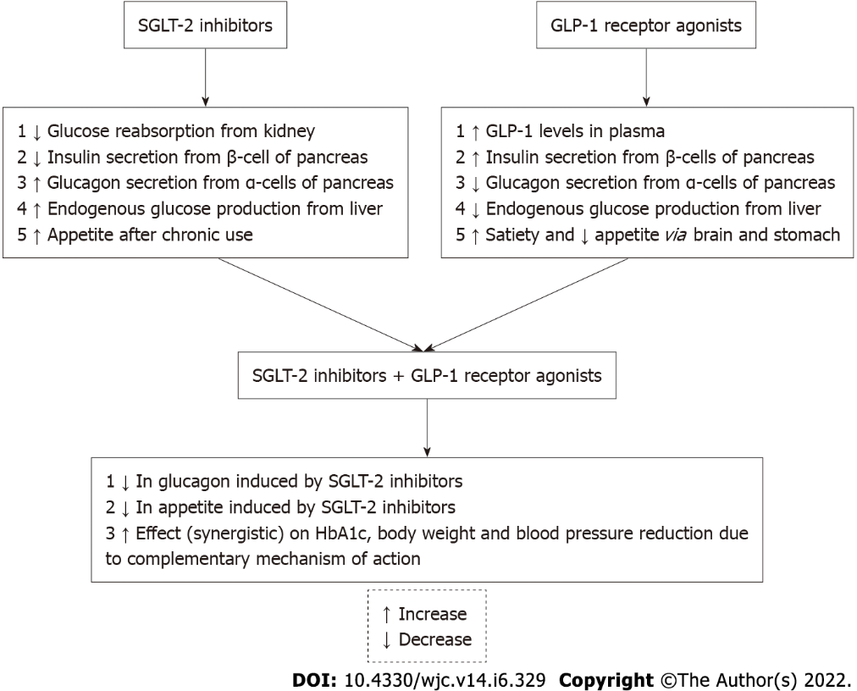
Figure 1 Complementary mechanism of action of SGLT-2 inhibitor and GLP-1 receptor agonist dual therapy.

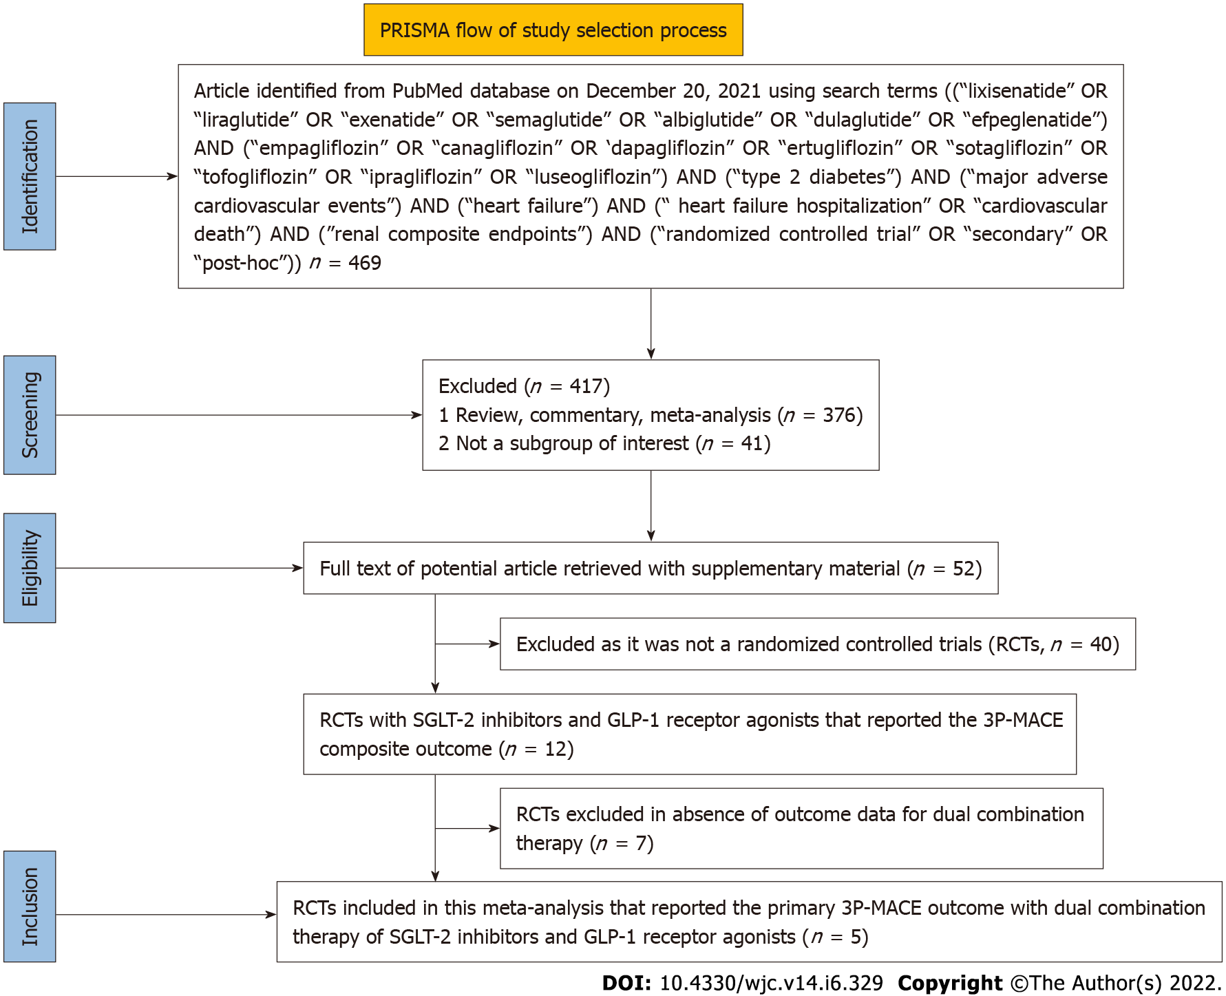
Figure 2 PRISMA flow diagram for randomized controlled trials chosen for meta-analysis.

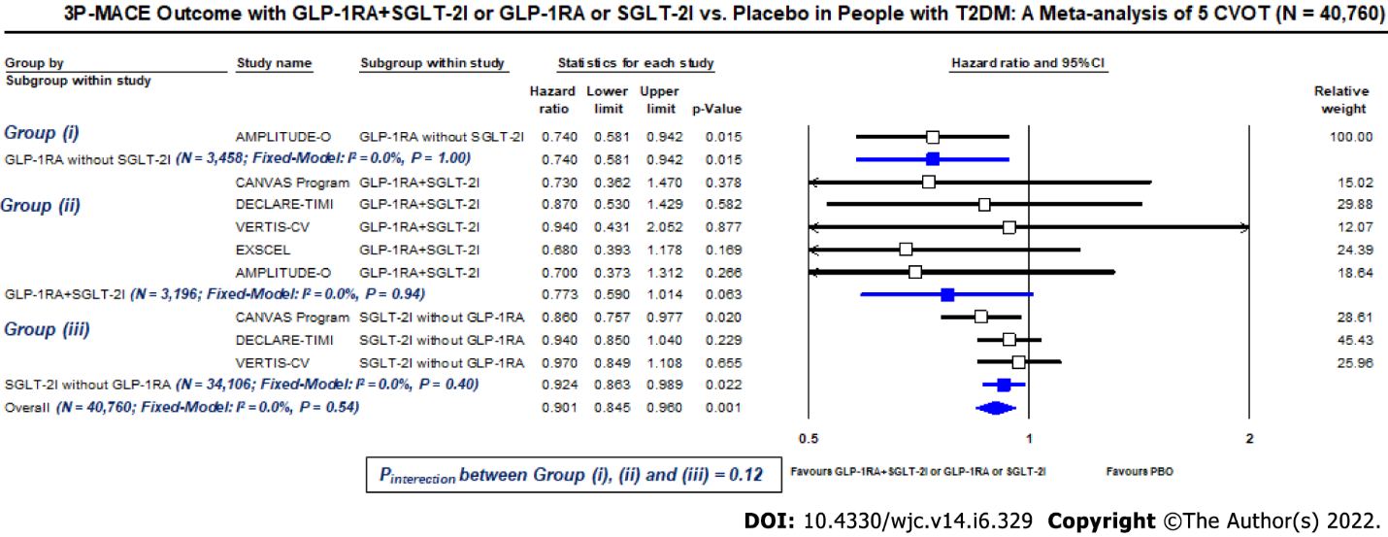
Figure 3 Three-point major adverse cardiovascular event outcome with GLP-1 receptor agonist plus SGLT-2 inhibitor dual therapy or GLP-1 receptor agonists or SGLT-2 inhibitors vs placebo: A meta-analysis of five cardiovascular outcome trials.

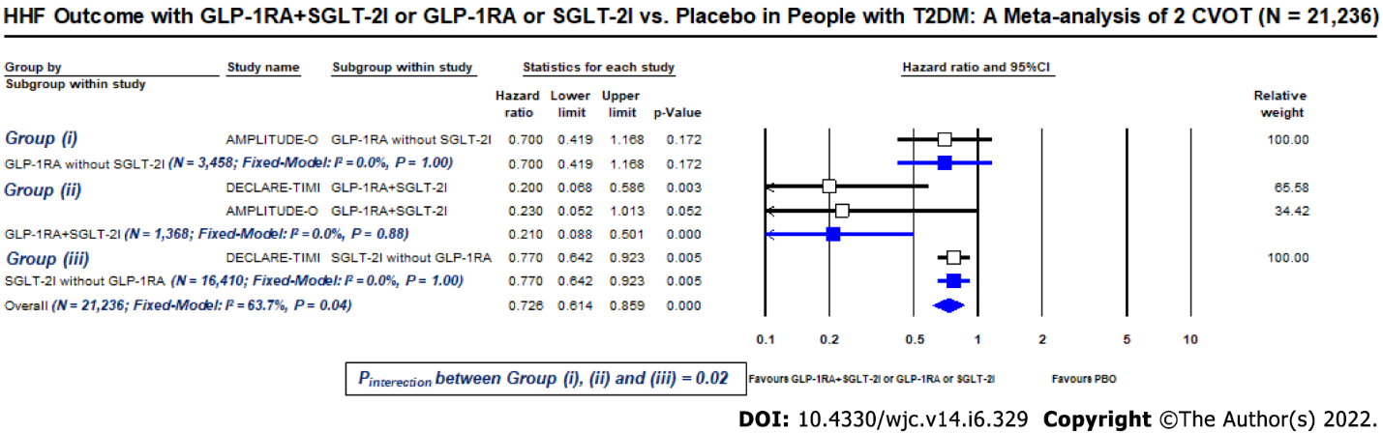
Figure 4 Heart failure hospitalization outcome with GLP-1 receptor agonist plus SGLT-2 inhibitor dual therapy or GLP-1 receptor agonists or SGLT-2 inhibitors vs placebo: A meta-analysis of two cardiovascular outcome trials.

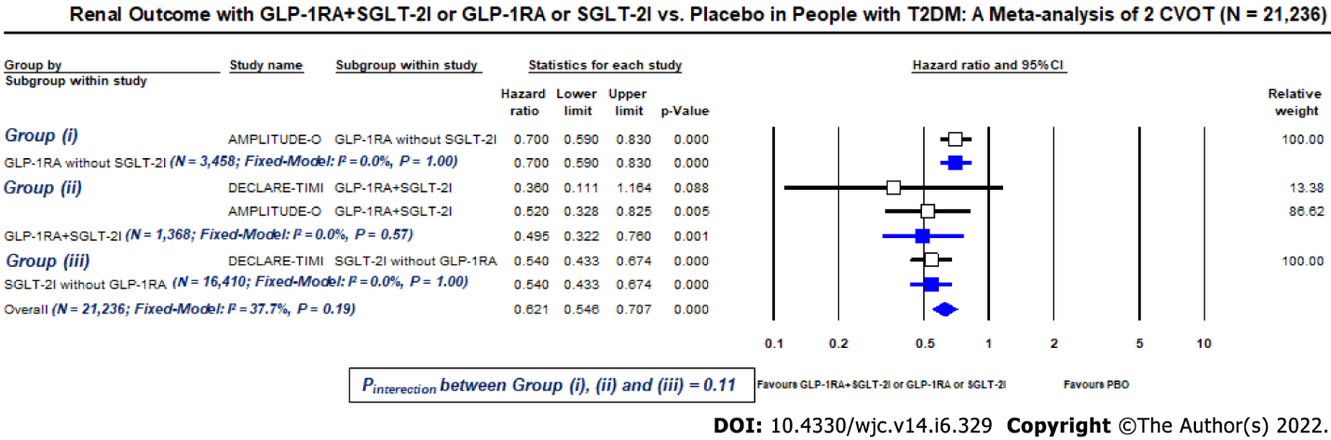
Figure 5 Renal outcome with GLP-1 receptor agonist plus SGLT-2 inhibitor dual therapy or GLP-1 receptor agonists or SGLT-2 inhibitors vs placebo: A meta-analysis of two cardiovascular outcome trials.

Table 1 Studies with GLP-1 receptor agonists plus SGLT-2 inhibitors vs SGLT-2 inhibitors or GLP-1 receptor agonists
Type of study | Ref. | Comparator agent | n | Duration |  | ∆HbA1c (%), (95%CI or mean ± SD) |  | ∆Weight (Kg), (95%CI) | ∆SBP (mmHg), (95%CI) | OR for severe Hypo’s (95%CI) | GI S/E | GTI
Simultaneous initiation of GLP-1RA plus SGLT-2I vs SGLT-2I
RCT, DB/ DURATION-8 | Frías et al^{[16]}, 2016 | EXE QW + DAPA vs DAPA | 695 | 28 wk |  | -0.6 (-0.8; -0.3) |  | -1.22 (-2.00; -0.44) | -2.4 (-4.5; -0.3) | 1.00 (0.02; 50.61) | EXENA + DAPA-16%; DAPA-12% | EXENA + DAPA- 4%; DAPA- 6%
RCT | Ikonomodis et al^{[19]}, 2018 | LIRA + EMPA vs EMPA | 40 | 12 wk |  | -0.70 (-2.55; 1.15) |  | NR | 0.00 (-5.70; 5.70) | NR | NR | NR
RCT, OL | Ali et al^{[12]}, 2020 | LIRA + CANA vs CANA | 45 | 16 wk |  | -0.78 (-1.52; -0.04) |  | -2.50 (-4.35; -0.65) | -8.90 (-16.19; -1.61) | 1.00 (0.02; 53.66) | NR | NR
Sequential addition of GLP-1RA to SGLT-2I vs SGLT-2I
RCT, DB/AWARD-10 | Ludvik et al^{[20]}, 2018 | DULA + SGLT-2I vs PBO + SGLT-2I | 424 | 24 wk |  | -0.73 (-0.88; -0.58) |  | -0.75 (-1.47; -0.03) | -2.45 (-4.78; -0.12) | 2.50 (0.06; 104.85) | DULA + SGLT-2I- 26.5%; PBO-17% | DULA + SGLT-2I- 0%; PBO-1%
RCT, DB/SUSTAIN-9 | Zinman et al^{[21]}, 2019 | SEMA + SGLT-2I vs PBO + SGLT-2I | 302 | 30 wk |  | -1.40 (-1.58; -1.22) |  | -3.80 (-4.67; -2.93) | -6.30 (-9.07; -3.53) | 9.27 (0.50; 173.02) | SEMA + SGLT-2I- 37.3%; PBO-13.2% | NR
RCT, DB/LIRA-ADD2SGLT2i | Blonde et al^{[22]}, 2020 | LIRA + SGLT-2I vs PBO + SGLT-2I | 303 | 26 wk |  | -0.68 (-0.89; -0.47) |  | -0.82 (-1.67; 0.03) | 1.40 (-1.65; 4.45) | 1.00 (0.02; 64.81) | LIRA + SGLT-2I- 26%¹; PBO-6.0%¹ | NR
Simultaneous initiation of SGLT-2I plus GLP-1RA vs GLP-1RA
RCT/DURATION-8 | Frías et al^{[16]}, 2016 | DAPA + EXE QW vs EXE QW | 695 | 28 wk |  | -0.4 (-0.6; -0.1) |  | -1.87 (-2.66; -1.08) | -2.9 (-5.0; -0.8) | 1.00 (0.02; 50.61) | EXENA + DAPA-16%; DAPA-15% | EXENA + DAPA-4%; EXENA-2%
RCT | Ikonomodis et al^{[19]}, 2018 | EMPA + LIRA vs LIRA | 40 | 12 wk |  | -0.20 (-2.16; 1.76) |  | NR | -1.00 (-6.57; 4.57) | NR | NR | NR
RCT | Ali et al^{[12]}, 2020 | CANA + LIRA vs LIRA | 45 | 16 wk |  | -0.23 (-1.18; 0.72) |  | -4.10 (-6.32; -1.88) | -9.00 (-18.49; 0.49) | 1.00 (0.02; 53.66) | NR | NR
Sequential addition of SGLT-2I to GLP-1RA vs GLP-1RA
RCT, DB/CANVAS | Fulcher et al^{[23]}, 2016 | CANA + GLP-1RA vs PBO + GLP-1RA | 95 | 18 wk |  | -1.03 (-1.34; -0.72) |  | -2.72 (-3.70; -1.74) | -8.05 (-14.13; -1.97) | 2.5 (0.05; 114.6) | NR | CANA + GLP-1RA-12.3%; PBO-5.3%
Non-randomized studies (all ∆ from baseline)
Simultaneous initiation of SGLT-2I plus GLP-1RA
Obs | Goncalves et al^{[28,29]}, 2017 | SGLT-2I with LIRA | 33 | 62 |  | -2.0 |  | -10.0 | -13.0 | NR | NR | NR
Sequential addition of SGLT-2I to GLP-1RA
Obs | Saroka et al^{[24]}, 2015 | CANA added to GLP-1RA | 75 (60 on insulin) |  | 10.7 mo (mean) |  | -0.39 ± 0.88 | -4.6 ± 4.3 | -4.0 ± 12 | NR | 1.3% | GTI: 8%
Retro, Obs | Curtis et al^{[25]}, 2016 | DAPA added to GLP-1RA | 14 (10 on insulin) |  | 48 wk |  | -4.4 (-5.7; -2.7) | -5.47 (-22.9; -5) | NR | NR | NR | NR
Retro, Obs | Deol et al^{[26]}, 2016 | SGLT-2I added to GLP-1RA | 37 (DAPA = 36, CANA = 1) |  | 3-6 mo 139 d (mean) |  | -1.05 (-1.41; -0.69) | -3.07 (-4.36; -1.78) | -1.16 (-6.01; 8.42) | NR | NR | NR
Non-R, OL, PMS | Harashima et al^{[27]}, 2017 | CANA added to LIRA | 71 |  | 52 wk |  | -0.7 (-0.89; -0.51) | -3.29 (-3.86; -2.72) | -7.9 (-10.7; -5.1) | 9.9% (mild) | NR | 7.1%
Obs | Goncalves et al^{[28,29]}, 2017 | SGLT-2I added to LIRA | 46 |  | 76 wk |  | -0.9 | -4.0 | -7.0 | NR | NR | NR
Non-R | Seino et al^{[30]}, 2018 | LUSEO added to LIRA | 76 |  | 52 wk |  | -0.68 (-0.87; -0.49) | -2.71 (-3.18; -2.23) | -7.1 (-10.4; -3.9) | 6.6% (mild) | 13.2% | 3.9%
¹Nausea. CANA: Canagliflozin; DAPA: Dapagliflozin; DB: Double blind; EMPA: Empagliflozin; EX QW: Exenatide once weekly; GI: Gastrointestinal; GLP-1RA: GLP-1 receptor agonists; GTI: Genital tract infections; Hypo’s: Hypoglycemia; LIRA: Liraglutide; LUSEO: Luseogliflozin; Non-R: Non-randomized; NR: Not reported/retrievable; Obs: Observational; OL: Open label; OR: Odds ratio; PBO: Placebo; PMS: Post marketing study; RCT: Randomized controlled trial; Retro: Retrospective; SBP: Systolic blood pressure; SGLT-2I: SGLT-2 inhibitors; S/E: Side effect; SEMA: Semaglutide.
Table 2 Meta-analysis of randomized controlled trials comparing GLP-1 receptor agonists + SGLT-2I vs SGLT-2I or GLP-1 receptor agonists
Ref. | Types of studies included, n | Comparator arm | N | ∆HbA1c (%), (95%CI) | ∆Weight (Kg), (95%CI) | ∆SBP (mmHg), (95%CI) | Adverse events (GI, GTI, Hypo’s) with SGLT-2I + GLP-1RA vs SGLT-2I
Zhou et al^{[31]}, 2019 | RCT, 3 | GLP-1RA + SGLT-2I vs SGLT-2I | 1421 | -0.80 (-1.14; -0.45) | -1.46 (-2.38; -0.54) | -2.88 (-4.52; -1.25) | Increased risk of GI S/E (RR: 1.68; 95%CI: 1.14-2.47) but similar GTI (RR: 0.82; 95%CI: 0.39-1.75) and hypo’s (RR: 2.10; 95%CI: 0.75-5.90) in combo arm
Castellana et al^{[32]}, 2019 | RCT, 4 | GLP-1RA + SGLT-2I vs SGLT-2I | 1610 | -0.74 (-1.15; -0.33) | -1.61 (-2.83; -0.38) | -3.32 (-4.96; -1.68) | Similar hypo’s (RR: 1.43; 95%CI: 0.46-4.52). GTI and GI S/E not reported
Patoulias et al^{[33]}, 2019 | RCT, 3 | GLP-1RA + SGLT-2I vs SGLT-2I | 1042 | -0.91 (-1.41; -0.42) | -1.95 (-3.83; -0.07) | -3.64 (-6.24; -1.03) | Increased risk of nausea (RR: 3.21; 95%CI: 1.36-7.54) and hypo’s (RR: 2.62; 95%CI: 1.15-5.96) in combo arm. GTI not reported
Mantsiou et al^{[34]}, 2020 | RCT, 7 | GLP-1RA + SGLT-2I vs SGLT-2I | 1913 | -0.85 (-1.19; -0.52) | -1.46 (-2.94; +0.03) | -2.66 (-5.26; -0.06) | No difference in severe hypo’s (OR: 2.39; 95%CI: 0.47-12.27). GTI and GI S/E not reported
 |  | GLP-1RA + SGLT-2I vs GLP-1RA |  | -0.61 (-1.09; -0.14) | -2.59 (-3.68; -1.51) | -4.13 (-7.28; -0.99) | No difference in severe hypo’s (OR: 1.38; 95%CI: 0.14-13.14). GTI and GI S/E not reported
GI: Gastrointestinal; GLP-1RA: GLP-1 receptor agonists; GTI: Genital tract infections; Hypo’s: Hypoglycemia; OR: Odds ratio; RR: Risk ratio; RCT: Randomized controlled trial; SBP: Systolic blood pressure; S/E: Side effect; SGLT-2I: SGLT-2 inhibitors.
Table 3 Effect of simultaneous application of GLP-1 receptor agonists + SGLT-2I therapy on HbA1c (%), body weight (Kg), and systolic blood pressure (mmHg) in randomized controlled trialx
Ref. | Parameters studied | Duration (wk) | (A) ∆GLP-1 RA | (B) ∆SGLT-2I | (C) ∆GLP-1 RA + SGLT-2I | (A + B) ∆Sum of GLP-1 RA and SGLT2i | Effect of (C) compared to (A + B)
Frías et al^{[16]}, 2016; Jabbour et al^{[17]}, 2018; Birnbaum et al^{[18]}, 2018 | HbA1c | 28 | -1.60 | -1.40 | -2.00 | -3.00 | Less than additive
 |  | 52 | -1.38 | -1.23 | -1.75 | -2.61 | Less than additive
 |  | 104 | -1.29 | -1.06 | -1.70 | -2.35 | Less than additive
Ikonomidis et al^{[19]}, 2018 | HbA1c | 12 | -1.30 | -0.80 | -1.50 | -2.10 | Less than additive
Ali et al^{[12]}, 2020 | HbA1c | 16 | -1.44 | -0.89 | -1.67 | -2.33 | Less than additive
Frías et al^{[16]}, 2016; Jabbour et al^{[17]}, 2018; Birnbaum et al^{[18]}, 2018 | Body weight | 28 | -1.56 | -2.22 | -3.55 | -3.78 | Nearly additive
 |  | 52 | -1.51 | -2.28 | -3.31 | -3.79 | Nearly additive
 |  | 104 | -0.80 | -3.00 | -2.50 | -3.80 | Less than additive
Ikonomidis et al^{[19]}, 2018 | Body weight | 12 | NR | NR | NR | NR | NR
Ali et al^{[12]}, 2020 | Body weight | 16 | -1.90 | -3.50 | -6.00 | -5.40 | More than additive
Frías et al^{[16]}, 2016; Jabbour et al^{[17]}, 2018; Birnbaum et al^{[18]}, 2018 | SBP | 28 | -1.20 | -1.80 | -4.30 | -3.00 | More than additive
 |  | 52 | -0.70 | -2.70 | -4.50 | -3.40 | More than additive
 |  | 104 | -0.10 | -1.10 | -3.10 | -1.20 | More than additive
Ikonomidis et al^{[19]}, 2018 | SBP | 12 | -3.00 | -4.00 | -4.00 | -7.00 | Less than additive
Ali et al^{[12]}, 2020 | SBP | 16 | -5.10 | -5.20 | -14.10 | -10.30 | More than additive
GLP-1RA: GLP-1 receptor agonists; HbA1c: Glycated haemoglobin; NR: Not reported; SBP: Systolic blood pressure; SGLT-2I: SGLT-2 inhibitors.
Table 4 Meta-data of three-point composite of major adverse cardiovascular events, heart failure hospitalization, and renal outcome in cardiovascular outcome trials of SGLT-2 inhibitors and GLP-1 receptor agonists
Trial eponym, drugs | Background GLP-1RA + SGLT-2I therapy; n | Active arm (n/N), % or rate-per 100-patient-yr¹ | Placebo arm (n/N), % or rate-per 100-patient-yr¹ | HR, (95%CI) | P value of interaction
3-point composite of major adverse cardiovascular events outcome
CANVAS^{[46]}, Canagliflozin | Yes; 407 | NR | NR | 0.73 (0.36-1.46) | 0.94
 | No; 9735 | NR | NR | 0.86 (0.76-0.98)
DECLARE-TIMI^{[47]}, Dapagliflozin | Yes; 750 | 31/397, 7.8% | 31/353, 8.8% | 0.87 (0.53-1.43) | 0.84
 | No; 16410 | 725/8185, 8.9% | 772/8225, 9.4% | 0.94 (0.85-1.04)
VERTIS-CV^{[48]}, Ertugliflozin | Yes; 277 | 21/192, 3.54¹ | 9/85, 3.79¹ | 0.94 (0.43-2.05) | NR
 | No; 7961 | 632/5301, 3.91¹ | 318/2660, 4.02¹ | 0.97 (0.85-1.11)
EXSCEL^{[43]}, Exenatide QW | Yes; 1144² | NR/572, 3.29¹ | NR/572, 4.81¹ | 0.68 (0.39-1.17) | NR
 | No | NR | NR | NR
AMPLITUDE-O^{[45]}, Efpeglenatide | Yes; 618 | 25/412, 6.1%, 3.4¹ | 17/206, 8.3%, 5.0¹ | 0.70 (0.37-1.30) | 0.68
 | No; 3458 | 164/2305, 7.1%, 4.0¹ | 108/1153, 9.4%, 5.4¹ | 0.74 (0.58-0.94)
Heart failure hospitalization outcome
DECLARE-TIMI^{[47]}, Dapagliflozin | Yes; 750 | 4/397, 1.0% | 18/353, 5.1% | 0.20 (0.07-0.60) | 0.01
 | No; 16410 | 208/8185, 2.5% | 268/8225, 3.3% | 0.77 (0.64-0.92)
AMPLITUDE-O^{[45]}, Efpeglenatide | Yes; 618 | 3/412, 0.7%; 0.4¹ | 6/206, 2.9%, 1.6¹ | 0.23 (0.05-0.97) | 0.35
 | No; 3458 | 37/2305, 1.6%, 0.9¹ | 25/1153, 2.2%, 1.2¹ | 0.70 (0.42-1.17)
Renal outcome
DECLARE-TIMI^{[47]}, Dapagliflozin³ | Yes; 750 | 4/397, 1.0% | 10/353, 2.8% | 0.36 (0.11-1.15) | 0.49
 | No; 16410 | 123/8185, 1.5% | 228/8225, 2.8% | 0.54 (0.43-0.67)
AMPLITUDE-O^{[45]}, Efpeglenatide⁴ | Yes; 618 | 37/412, 9.0%, 5.1¹ | 34/206, 16.5%, 10.0¹ | 0.52 (0.33-0.83) | 0.38
 | No; 3458 | 316/2305, 13.7%, 8.2¹ | 216/1153, 18.7%, 11.9¹ | 0.70 (0.59-0.83)
¹Rate-per 100-patient-yr.
²Open-label, propensity-matched.
³Renal composite outcome consist of sustained decrease of 40% or more in eGFR to less than 60 mL/min/1.73 m², new end-stage renal disease, or death from renal causes.
⁴Renal composite outcome consists of incident macroalbuminuria (UACR > 300 mg/g or 33.9 mg/mmol) plus ≥ 30% rise of UACR from baseline, a sustained ≥ 30 d decrease in eGFR by ≥ 40%, renal replacement therapy, and a sustained (≥ 30 d) eGFR < 15 mL/min/1.73 m².
3P-MACE: Three-point composite of major adverse cardiovascular events; CVOTs: Cardiovascular outcome trials; HHF: Heart failure hospitalization; GLP-1RA: Glucagon-like petide-1 receptor agonists; HR: Hazard ratio; n: Number of events; N: Total number of patients; NR: Not reported/retrievable; PBO: Placebo; SGLT-2I: Sodium glucose transporter-2 inhibitors.

Published by Baishideng Publishing Group Inc
7041 Koll Center Parkway, Suite 160, Pleasanton, CA 94566, USA
Telephone: +1-925-3991568
E-mail: bpgoffice@wjgnet.com
Help Desk: https://www.f6publishing.com/helpdesk
https://www.wjgnet.com

© 2022 Baishideng Publishing Group Inc. All rights reserved.

