Name of Journal: World Journal of Clinical Cases
Manuscript NO: 86703
Manuscript Type: META-ANALYSIS

Meta-analysis on the effectiveness of parent education for children with disabilities

Jang J et al. Meta-analysis of parental education

JongSik Jang, Geonwoo Kim, Hyewon Jeong, Narae Lee, Seri Oh

JongSik Jang, Department of Occupatioanl Therapy, Kangwon National University, Gangwon-do, Samcheok 25945, South Korea

Geonwoo Kim, Hyewon Jeong, Narae Lee, Seri Oh, Department of Occupational Therapy, Kangwon National University Graduate School, Gangwon-do, Samcheok 25949, South Korea

Author contributions: Jang J and Oh S wrote the paper; Jang J, Kim G, Jeong H, Lee N and Oh S edited and revised the manuscript.

Corresponding author: Seri Oh, MS, Lecturer, Department of Occupatioanl Therapy, Kangwon National University Graduate School, No. 346 Hwangjo-gil, Dogye-eup, Gangwon-do, Samcheok 25949, South Korea. dhtpfl247@naver.com

Received: July 3, 2023
Revised: August 24, 2023
Accepted: September 19, 2023
Published online: October 16, 2023

Abstract
BACKGROUND
Parents of children with disabilities often have difficulty understanding their child’s behavior and are unable to do it appropriately because they do not know what to do. The more we properly understand children with disabilities, the more positive the importance of parent education becomes in various aspects.

AIM
To demonstrate the effectiveness of parent education for children with disabilities in various aspects and present it as evidence that can be used clinically.

METHODS
For a meta-analysis on the effectiveness of parent education for children with disabilities, literature was collected from 2002 to 2022 using PubMed, Embase, Web of Science, Directory of Open Access Journals, and Europe PMC. Search terms were “disabled children,” “disabled children,” “parent education,” “parent training,” and “parent coaching.” The final searched literature included a total of 11 articles. To calculate the effect size, the mean, standard deviation, and sample size of the experimental and control groups were analyzed, and a meta-analysis was performed using RevMan version 5.4.1. To analyze statistical heterogeneity, a chi-square test was performed to evaluate the significance of Q statistics to indicate statistical heterogeneity.

RESULTS
The final literature totaled 11 articles, and a total of 4 items were analyzed. There were 5 studies on parental depression, the heterogeneity was 98%, and the effect size for parental depression was 0.35 [confidence interval (CI): 0.30-0.40], indicating a small but statistically significant effect size. There were 4 studies on parenting attitude, the heterogeneity was 100%, the effect size on parenting attitude was 0.41 (CI: 0.37-0.46), which was a medium effect size, and the P value showed a statistically significant score. Additionally, face-to-face parent education was found to have a larger effect size than non-face-to-face education. Regarding parent education methods, face-to-face parent education had a medium effect size [0.57 (CI: 0.52-0.61]), while non-face-to-face parent education had a small effect size [0.23 (CI: 0.18-0.28]).

CONCLUSION
Parental education has shown high effectiveness in child development, and it has proven to be even more effective when face-to-face parenting education is conducted. Accordingly, more effective and objective data was presented. Based on this study, it is believed that parent education research applying various diagnostic groups should continue to be conducted.

Key Words: Children; Children with disabilities; Education; Meta-analysis; Parents; Parent education

©The Author(s) 2023. Published by Baishideng Publishing Group Inc. All rights reserved.

Citation: Jang J, Kim G, Jeong H, Lee N, Oh S. Meta-analysis on the effectiveness of parent education for children with disabilities. World J Clin Cases 2023; 11(29): 7082-7090
URL: https://www.wjgnet.com/2307-8960/full/v11/i29/7082.htm
DOI: https://dx.doi.org/10.12998/wjcc.v11.i29.7082

Core Tip: Previous meta-analyses targeting the education of parents of children with disabilities have been limited to domestic papers or meta-analyses on parental depression and parenting attitude. Studies on the effectiveness of face-to-face versus non-face-to-face parental education is lacking. Our meta-analysis showed that parental education for parents of children with disabilities effectively enhanced parental attitude and diminished parental depression. We suggest effective educational methods and future research directions for parents of children with disabilities.

INTRODUCTION
Children with disabilities have delays in various areas, such as cognitive, verbal, and physical, and are often at a specific stage of development because of slow motor development and inexperience in physical coordination^{[1,2]}. Thus, it is difficult for children with disabilities to lead independent daily lives. Therefore, parents of children with disabilities must continue to (E1) care for them^{[3]}. Parents of children with disabilities experience excessive stress in managing their children’s behavior and needs, leading to changes in their overall family life^{[4,5]}. In addition, parents of these children feel a psychological burden and experience relational and emotional difficulties in daily life while raising a child with disabilities^{[6,7]}. Therefore, great effort is required from parents to acknowledge, nurture, and educate their children^{[7,8]}. However, parents often have difficulty understanding their children’s behavior and sometimes miss early education because they do not know how to cope with problems^{[8]}. Therefore, proper parental education is essential for families of children with disabilities to enable them to perform their roles and function in a healthy manner^{[9]}. The importance of parental education is growing in the sense that the more the parent of a disabled child understands the child correctly, the more effective the child’s education is^{[8]}.
Parental education for children with disabilities is essential for family support in special education; it is an activity that changes parents’ behavior, emotions, and thinking, helps improve family relationships, and provides parenting skills and knowledge^{[10]}. Parental education plays a role in correctly understanding the disability and developmental characteristics of children, and home guidance methods, behaviors, habits, thoughts, and methods related to childrearing^{[11]}. Education for parents of children with disabilities has various purposes, such as acquisition of skills and knowledge for raising their children, improvement of family relationships, and psychological and emotional support^{[12]}. Considering that the need for parental care decreases in children without disabilities as they develop, and that children with disabilities require continued parental care even after becoming adults, parents of children with disabilities should have access to support systems. Therefore, education is essential to strengthen the capacity of parents of children with disabilities^{[13]}.
Studies have demonstrated the effectiveness of parental education programs for children with disabilities^{[13-17]}. However, even though most studies examining these programs have proven their effectiveness, it is difficult to conclude a valid effect by analyzing the programs individually because of differences in the study populations, measurement tools, and program contents^{[18]}. Therefore, it is necessary to obtain scientific and objective results to establish the effectiveness of parental education for children with disabilities. Meta-analysis is an effective statistical method for deriving objective results^{[19]} and determining their clinical applicability by forming new knowledge through the integration of multiple studies and the synthesizing of results^{[20]}. Meta-analyses are more accurate and reliable than single-study results and can be of great help in clinical decisions regarding interventions^{[20]}. It is a statistical method used to draw new implications by classifying numerous research results implicitly rather than simply listing data; it can also reduce the risk of generalization^{[21]}.
Analyzing previous studies, we found a meta-analysis targeting parental education of children with disabilities, but it was limited to domestic papers or meta-analyses on parents’ depression and parenting attitudes, while the effectiveness of face-to-face vs non-face-to-face education is lacking^{[18,22,23]}. This meta-analysis assessed the effectiveness of parental education for children with disabilities.

MATERIALS AND METHODS
Study design
In this study, the participants, interventions, comparisons, outcomes, timing of outcome measurement, setting, study design method by the preferred reporting items for systematic reviews and meta-analyses was used to systematically review the literature.

Literature search strategy
PubMed, Embase, Web of Science, Directory of Open Access journals, and European PMC were used as databases and papers published between 2002 and 2022 were selected. The main search terms were “disabled children,” “handicapped children,” “parent education,” “parent training,” and “parent coaching.” Literature search, selection, and data extraction were conducted by two researchers according to the systematic literature review criteria, and discrepancies were resolved by a third reviewer. The intervention effects of the studies selected by the three researchers were analyzed using a meta-analysis.

Literature standards
Studies published between 2002 and 2022 and conducted within 20 years of randomized clinical trials on parents of children with disabilities were selected. The clinical trials conducted at this time were limited to those that applied parental education. Studies that did not meet the purpose of the study were removed by reviewing titles and abstracts, and those that presented values that could be compared before and after the test were selected.

Data analysis
Data coding: The studies selected according to the research topic were coded by author, publication year, intervention method, main result, sample size, etc., according to the research characteristics. Subsequently, to analyze the effect size, the mean and standard deviation and sample size were coded according to the evaluation purpose of the experimental and control groups.

Analysis method: After receiving an institutional review board exemption approval (KWNUIRB-2023-03-002) from the Bioethics Committee of Kangwon National University, we analyzed the general characteristics of the participants, characteristics of the interventions, and results of the 12 selected studies. In addition, the average and standard deviation of the experimental and control groups and the number of samples were analyzed to calculate the effect sizes, and a meta-analysis was conducted using RevMan version 5.4.1. To analyze statistical heterogeneity, a chi-square test was performed to assess the significance of the Q statistic, and a P value of less than 0.10 was considered indicative of statistical heterogeneity^{[24]}. The effect size shows the difference in the effectiveness of the experimental group compared to the control group, and publication bias refers to an error that occurs depending on the direction or nature of the research results^{[25]} (Figure 1).

RESULTS
Selection of studies for the analysis
A total of 8641 literatures collected from the database were selected according to the criteria for analysis by three doctoral students with more than three years of clinical experience and majors in occupational therapy. When the level of research evidence was analyzed, a meta-analysis was performed on the 12 studies that were finally selected as documents corresponding to the first stage with the highest level of evidence.

Meta-analysis of the effects of parental education
Twelve articles were included in the final analysis. First, when five articles on parental depression and four on parenting attitudes were analyzed to determine the effect of parental education, the literature on the effect on parental depression was the most common. A comparative analysis of ten studies on face-to-face parental education and four studies on non-face-to-face parental education showed that face-to-face parental education resulted in a higher effect size.

Effects of parental education on parents’ depression
Five studies of parental depression were included in the analysis (Figure 2)^{[3,26-28]}. Heterogeneity was 98%, and the effect size for parental depression was 0.35 [confidence interval (CI): 0.30-0.40], indicating a small but statistically significant effect size (Figure 2).

Effects of parental education on parenting attitudes
Four papers were published on the effects of parenting on parenting attitudes (Figure 3) ^{[3,14,26,29]}. Heterogeneity was 100%, the effect size for parenting attitude was 0.41 (CI: 0.37-0.46), indicating a medium effect size, and the P value showed a statistically significant score.

Meta-analysis of parental education methods
Regarding the parental education methods, face-to-face parental education had a medium effect size [0.57 (CI: 0.52-0.61)], whereas non-face-to-face parental education had a small effect size [0.23 (CI: 0.18-0.28)] (Figure 4 and 5)^{[3,14,16,26-33]}.

Publication convenience
As a result of analyzing publication convenience for this study, it was found that parental depression, parenting attitude, face-to-face parental education, and non-face-to-face parental education were symmetrical, and publication errors did not appear to be significant (Figure 6).

DISCUSSION
Parental education for children with disabilities is important for recognizing habits, behaviors, and thoughts related to the development and rearing of children with disabilities; improving family relationships; and ensuring emotional stability for parents. Therefore, this study conducted studies were analyzed to examine the effects of parental education.
First, when parental education was provided for parents of children with disabilities, both parenting attitudes (0.41) and parental depression (0.35) showed significant effects. The purpose of the parental education program is to understand the child's disability and developmental stage and to acquire direct parenting methods to influence the child’s behavior and attitude^{[14]}. Parental education was found to positively affect childrearing attitudes. Ultimately, parental education not only provides general knowledge and understanding of children’s development, but also acquires parenting knowledge suitable for social and temporal changes and correct attitudes as a parent. This seems to be because it helps obtain^{[34]}. This result is consistent with the existing thesis that parental education for parents raising children with disabilities shows positive results for parenting attitudes^{[35]}. It is believed that the reason for the effect on parental depression is that the parental education program provides an opportunity to control the parents’ psychological state through conversations with the leader so that the child has confidence and expectations for improvement^{[36]}. This suggests that parental education for children with disabilities needs to be actively implemented in clinical phenomena because it has a significant effect on both parenting attitudes and parental depression.
Second, regarding the effectiveness of the parental education method for children with disabilities, face-to-face parental education showed a medium effect size (0.57), whereas non-face-to-face parental education showed a small but significant effect size (0.23). Many factors are believed to induce learning immersion, including immediate real-time feedback and various interactions during the learning process. However, the reason for the greater effectiveness of face-to-face education is that both verbal and nonverbal communication is involved, increasing immersion. In addition, in face-to-face education, parents can communicate with educators in one space, expand their understanding through real-time questions and answers, and concentrate better^{[36,37]}. These results are consistent with those of previous studies showing that face-to-face education is more effective than non-face-to-face education^{[38,39]}. These data suggest the importance of actively conducting face-to-face education in future parental education programs.
This study had some limitations. Because all parental education studies were analyzed as one and detailed parental education methods were not analyzed, it seems necessary to conduct various meta-analyses by subdividing parental education studies. In addition, most studies used in the meta-analysis did not specify the exact diagnosis of children with disabilities; therefore, it was not possible to examine the effects of the parent education program on each diagnosis group. However, when this study was conducted on parental education for children with disabilities, and since the effectiveness of parental depression was analyzed separately, parenting attitude is considered significant in that clinicians who mediate and manage parents of children with disabilities can more effectively attempt education according to the intervention goals of parents of children with disabilities. Additionally, the results of the analysis of face-to-face and non-face-to-face parental education provide a basis for developing more effective education strategies. The results of this study provide information on effective educational methods for parents of children with disabilities and future research directions.

CONCLUSION
In this study, we searched the literature on parental education of children with disabilities and conducted a meta-analysis to provide clinicians with a clinical basis for intervention. A meta-analysis of 12 studies was conducted to analyze the effect size of parental education. The analysis showed that parental education was effective in improving parenting attitudes and depression, and it proved more effective when face-to-face parental education was conducted, suggesting more effective and objective data. Therefore, further research on parental education using various diagnostic groups should be conducted based on the effectiveness of parental education for children with disabilities shown in this study.

ARTICLE HIGHLIGHTS
Research background
Children with disabilities have delays in various areas, such as cognitive, verbal, and physical, and are often at a specific stage of development because of slow motor development and inexperience in physical coordination.

Research motivation
It is necessary to obtain scientific and objective results to establish the effectiveness of parental education for children with disabilities.

Research objectives
Meta-analysis of parents of children with disabilities is conducted to reveal the impact of parental education on children.

Research methods
Data from 2002 to 2022 were searched using Pubmed, Embase, Web of Science, Directory of Open Access Journals, and Europe PMC. The search terms were “disabled children,” “handicapped children,” “parent education,” “parent training,” and “parent coaching.” Twelve studies were eligible for inclusion in the meta-analysis. The average and standard deviation of the experimental and control groups and the number of samples were analyzed to calculate the effect sizes, and a meta-analysis was conducted using RevMan version 5.4.1. To analyze statistical heterogeneity, a chi-square test was performed to assess the significance of the Q statistic, and a P value of less than 0.10 was considered to indicate statistical heterogeneity.

Research results
A total of 20011 literatures collected from the database were selected according to the criteria for analysis. Twelve articles were included in the final analysis. Five studies of parental depression were included. Heterogeneity was 98%, and the effect size for parental depression was 0.35 [confidence interval (CI): 0.30-0.40], indicating a small but statistically significant effect size. Four papers were published on the effects of parenting on parenting attitudes. Heterogeneity was 100%, and the effect size for parenting attitude was 0.41 (CI: 0.37-0.46), indicating a medium effect size, with the P value showing a statistically significant score. As a result of a meta-analysis targeting parents of children with disabilities, both parenting attitude and parental depression showed significant effect sizes, and E1 face-to-face parental education had a larger effect size than non-face-to-face education. Regarding the parental education methods, face-to-face parental education had a medium effect size [0.57 (CI: 0.52-0.61)], whereas non-face-to-face parental education had a small effect size [0.23 (CI: 0.18-0.28)].

Research conclusions
Future studies based on the results of this study and revealing strong evidence would provide more useful guidelines for parents of children with disabilities.

Research perspectives
Based on the effectiveness of parental education for children with disabilities shown in this study, research on parental education using various diagnostic groups should be conducted in the future.

REFERENCES
1 Kim M. Comparison of Play Awareness, Play Development of Children, and Play Types of Children With Disabilities and Non-disabled Children. (Master's thesis). Dongshin University, Naju. 2021; Available from: http://www.riss.kr/link?id=T16059470
2 Best SJ. Cerebral Palsy. Teaching Individuals with Physical or Multiple Disabilities. 5th ed. Upper Saddle River: Prentice Hall 2005
3 Bjornstad G, Cuffe-Fuller B, Ukoumunne OC, Fredlund M, McDonald A, Wilkinson K, Lloyd J, Hawton A, Berry V, Tarrant M, Borek A, Fitzpatrick K, Gillett A, Rhodes S, Logan S, Morris C. Healthy Parent Carers: feasibility randomised controlled trial of a peer-led group-based health promotion intervention for parent carers of disabled children. Pilot Feasibility Stud 2021; 7: 144 [PMID: 34301334 DOI: 10.1186/s40814-021-00881-5]
4 Zablotsky B, Black LI, Maenner MJ, Schieve LA, Danielson ML, Bitsko RH, Blumberg SJ, Kogan MD, Boyle CA. Prevalence and Trends of Developmental Disabilities among Children in the United States: 2009-2017. Pediatrics 2019; 144 [PMID: 31558576 DOI: 10.1542/peds.2019-0811]
5 Wieland N, Green S, Ellingsen R, Baker BL. Parent-child problem solving in families of children with or without intellectual disability. J Intellect Disabil Res 2014; 58: 17-30 [PMID: 23336566 DOI: 10.1111/jir.12009]
6 Kim JS. The Study of Predictors for Suicidal Ideation among Mothers of Children with disability. (Doctor's thesis). Kangnam University, Yongin 2020; Available from: http://www.riss.kr/link?id=T16090467
7 Boström PK, Broberg M, Hwang P. Parents' descriptions and experiences of young children recently diagnosed with intellectual disability. Child Care Health Dev 2010; 36: 93-100 [PMID: 20015279 DOI: 10.1111/j.1365-2214.2009.01036.x]
8 Kim JY. The Effect of Parental Education Program on the Language Development and the Mother's Raising of Children with Language Development Disorder. (Master's thesis). Daegu University Gyeongbuk 2020; Available from: http://www.riss.kr/link?id=T15531863
9 Choi MS, Jeon IS. An Analysis of a Keyword Network of the Research Field on the Education for Parents of Children With Disabilities. J Spec Educ 2021; 55: 169-185 [DOI: 10.15861/kjse.2021.55.4.169]
10 Lee EK, Seok DI. The Development of Assessment and Evaluation System to Parent Education Program. J speech lang hear disord 2007; 16: 149-163 [DOI: 10.15724/jslhd.2007.16.1.009]
11 Kim GS. Current Development Status of the Parent Education Program and an Analysis of the Program. Journal of Parent Education 2017; 9: 273-292. Available from: https://www.dbpia.co.kr/journal/articleDetail?nodeId=NODE10798893
12 Jeon HI, Lee MH. The Current Situation and Needs of Parent Education Programs for Parents of Children with Disabilities. The Journal of the Korean Association on Developmental Disabilities 2014; 18: 1-23
13 Ruane A, Carr A. Systematic Review and Meta-analysis of Stepping Stones Triple P for Parents of Children with Disabilities. Fam Process 2019; 58: 232-246 [PMID: 29520764 DOI: 10.1111/famp.12352]
14 Hinton S, Sheffield J, Sanders MR, Sofronoff K. A randomized controlled trial of a telehealth parenting intervention: A mixed-disability trial. Res Dev Disabil 2017; 65: 74-85 [PMID: 28458049 DOI: 10.1016/j.ridd.2017.04.005]
15 Studts CR, Jacobs JA, Bush ML, Lowman J, Westgate PM, Creel LM. Behavioral Parent Training for Families With Young Deaf or Hard of Hearing Children Followed in Hearing Health Care. J Speech Lang Hear Res 2022; 65: 3646-3660 [PMID: 35985319 DOI: 10.1044/2022_JSLHR-22-00055]
16 Goli S, Noroozi M, Salehi M. Comparing the effect of two educational interventions on mothers' awareness, attitude, and self-efficacy regarding sexual health care of educable intellectually disabled adolescent girls: a cluster randomized control trial. Reprod Health 2021; 18: 54 [PMID: 33653361 DOI: 10.1186/s12978-021-01112-z]
17 Salehian MH, Sarvari S, Ghanati P. Comparison of happiness training based on Islamic concepts and Qigong exercises effectiveness on happiness of mothers with handicapped children. J psychopathol 2021; 3: 140-147 [DOI: 10.36148/2284-0249-426]
18 Lee MJ, Jang SY. A Meta-Analysis on the Effectiveness of Program for Parents of Students with Disabilities. Journal of Parent Education 2020; 21: 123-147 [DOI: 10.36431/JPE.12.3.6]
19 Borenstein M, Hedges LV, Higgins JP, Rothstein HR. Introduction to meta-analysis; 2th ed. John Wiley & Sons 2021
20 Brown SJ. Evidence-based nursing: The research-practice connection. 3th ed. Jones & Bartlett Publishers 2014
21 Rosenthal R, DiMatteo MR. Meta-analysis: recent developments in quantitative methods for literature reviews. Annu Rev Psychol 2001; 52: 59-82 Available from: https://doi.org/10.1146/annurev.psych.52.1.59
22 Ruane A, Carr A, Moffat V. A qualitative study of parents' and facilitators' experiences of Group Stepping Stones Triple P for parents of children with disabilities. Clin Child Psychol Psychiatry 2019; 24: 694-711 [PMID: 30400757 DOI: 10.1177/1359104518807265]
23 Tellegen CL, Sanders MR. Stepping Stones Triple P-Positive Parenting Program for children with disability: a systematic review and meta-analysis. Res Dev Disabil 2013; 34: 1556-1571 [PMID: 23475006 DOI: 10.1016/j.ridd.2013.01.022]
24 Rosenthal R, Rubin DB. Comparing effect sizes of independent studies. Psychol Bull 1982; 92: 500-504 [DOI: 10.1037/0033-2909.92.2.500]
25 Higgins JPT, Thomas J, Chandler J, Cumpston M, Li T, Page MJ, Welch VA. Cochrane handbook for systematic reviews of interventions; 2th ed. Chichester (UK): John Wiley & Sons 2019
26 Sofronoff K, Jahnel D, Sanders M. Stepping Stones Triple P seminars for parents of a child with a disability: A randomized controlled trial. Research in developmental disabilities 2011; 32: 2253-2262 [DOI: 10.1016/j.ridd.2011.07.046]
27 Yildirim G, Ertekin Pinar S, Ucuk S, Duran Aksoy O, Ersan E E. The effect of training given to parents with mentally disabled children on their life satisfaction self-stigma of seeking help depression and stress-coping styles. International Journal of Social Psychiatry 2020; 66: 279-291 [DOI: 10.1177/0020764020903750]
28 Burmaoglu G. Comparison of the effect of mindfulness based on stress reduction and dialectical behavior therapy on reducing depression in mothers with handicapped children in rehabilitation centers. Pakistan Journal of Medical & Health Sciences 2021; 15: 885-890
29 Roux G, Sofronoff K, Sanders M. ). A randomized controlled trial of group Stepping Stones Triple P: A mixed‐disability trial. Family process 2013; 52: 411-424 [DOI: 10.1111/famp.12016]
30 Bilgin S, Gozum S. Reducing burnout in mothers with an intellectually disabled child: an education programme. Journal of Advanced Nursing 2009; 65: 2552-2561 [DOI: 10.1111/j.1365-2648.2009.05163.x]
31 Burke M, Rossetti Z, Li C. The efficacy and impact of a special education legislative advocacy program among parents of children with disabilities. Journal of Autism and Developmental Disorders 2022; 52: 3271-3279 [DOI: 10.1007/s10803-021-05258-4]
32 ERCIŞ S. Comparison of the effect of Shoenaker's self-encouragement training and emotion regulation on resilience of mothers with disabilities children. Pakistan Journal of Medical & Health Sciences 2021; 15: 781-786
33 Moghimi M, Esmaeilpour N, Karimi Z, Zoladl M, Moghimi MA. Effectiveness of resilience teaching via short message service on stress of mothers of educable mentally retarded children. Iranian Journal of Psychiatry and Behavioral Sciences 2018; 12: 4 [DOI: 10.5812/ijpbs.59966]
34 Choe EJ. The Effects of Activity-Centered Parent Education based on Transactional Analysis: Mother’s Self Concept, Rearing Attitude, and Interaction with Their Child. (Doctor's thesis). Wonkwang University, Jeollabuk-do. 2019. Available from: 30. Park JT. Analysis of perceptions of face-to-face and non-face-to-face physical education classes of elementary school students, teachers, and parents in the COVID-19 situation. The Korean Journal of Elementary Physical Education 2022; 28: 105-117 [DOI: 10.26844/ksepe.2022.28.3.105]
35 Antonini TN, Raj SP, Oberjohn KS, Cassedy A, Makoroff KL, Fouladi M, Wade SL. A pilot randomized trial of an online parenting skills program for pediatric traumatic brain injury: improvements in parenting and child behavior. Behav Ther 2014; 45: 455-468 [PMID: 24912459 DOI: 10.1016/j.beth.2014.02.003]
36 Kim SB. The Effects of Parents-Education Program based on Literature-Therapy on Child-bearing Attitude, Parenting Stress and Depression of the Mother with ADHD Children. Journal of Special Education & Rehabilitation Science 2019; 58: 59-74 [DOI: 10.23944/Jsers.2019.06.58.2.4]
37 Yoon AS. <Cours en présentiel> vs. <cours non-présentiel>:une étude comparative des réussites scolaires avant et après le Covid-19 : Une analyse de cas dans les matières de <grammaire française> à l’université. Association culturelle franco coreenne 2022; 52: 179-210 [DOI: 10.18022/acfco.2022.52.1.007]
38 Park JT. Analysis of perceptions of face-to-face and non-face-to-face physical education classes of elementary school students, teachers, and parents in the COVID-19 situation. The Korean Journal of Elementary Physical Education 2022; 28: 105-117 Available from: https://www.earticle.net/Article/A419361
39 Shin AR, Shim HS. A Learning Satisfaction in face-to-face/non-face-to-face Educational Environments of New Dental Hygiene Students. The Journal of the Korea Contents Association 2021; 21: 804-813 [DOI: 10.5392/JKCA.2021.21.06.804]

Footnotes
Conflict-of-interest statement: All the authors declare that they have no conflict of interest.

PRISMA 2009 Checklist statement: The authors have read the PRISMA 2009 checklist and the manuscript has been prepared and revised according to the PRISMA 2009 checklist.

Open-Access: This article is an open-access article that was selected by an in-house editor and fully peer-reviewed by external reviewers. It is distributed in accordance with the Creative Commons Attribution NonCommercial (CC BY-NC 4.0) license, which permits others to distribute, remix, adapt, build upon this work non-commercially, and license their derivative works on different terms, provided the original work is properly cited and the use is non-commercial. See: https://creativecommons.org/Licenses/by-nc/4.0/

Provenance and peer review: Unsolicited article; Externally peer reviewed.
Peer-review model: Single blind

Peer-review started: July 3, 2023
First decision: August 10, 2023
Article in press: September 19, 2023

Specialty type: Medicine, research and experimental
Country/Territory of origin: South Korea
Peer-review report’s scientific quality classification
Grade A (Excellent): 0
Grade B (Very good): B
Grade C (Good): C
Grade D (Fair): 0
Grade E (Poor): 0

P-Reviewer: Liu XQ, China S-Editor: Qu XL L-Editor: A P-Editor: Cai YX

Figure Legends
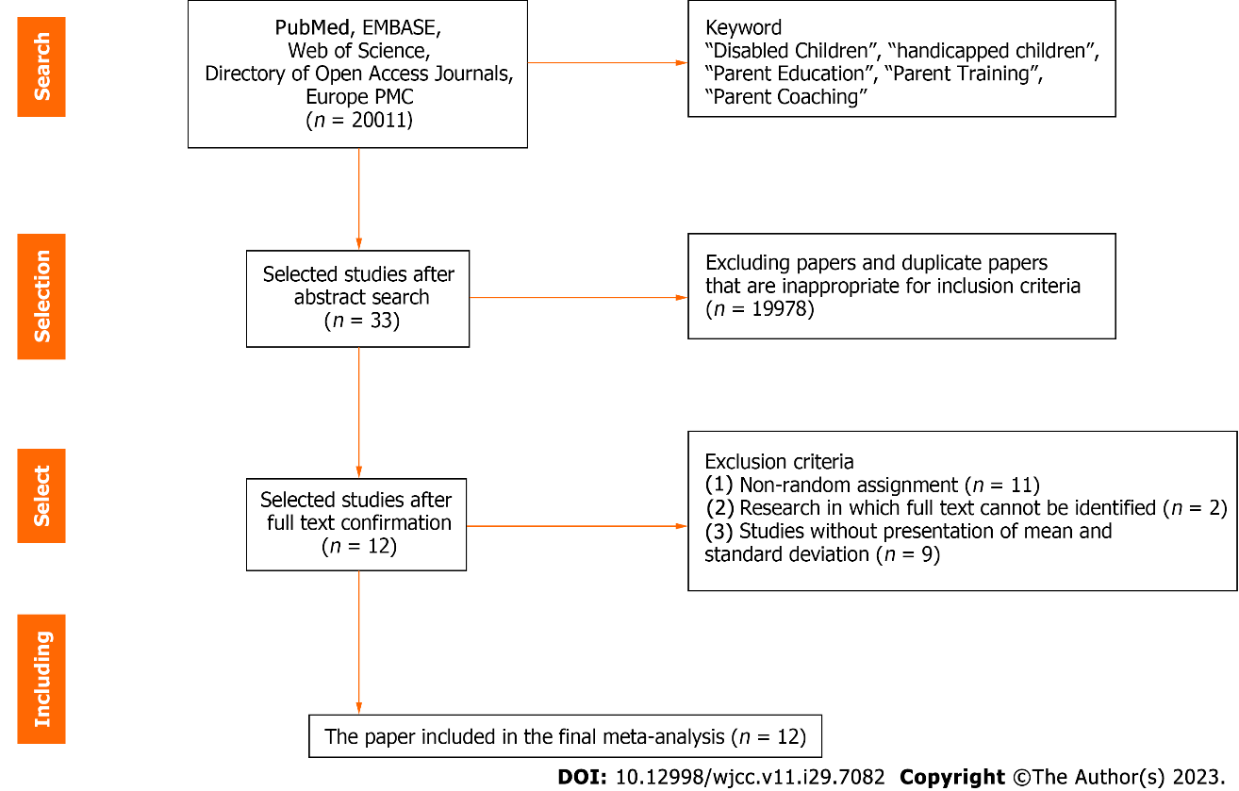
Figure 1 PRISMA flow diagram.

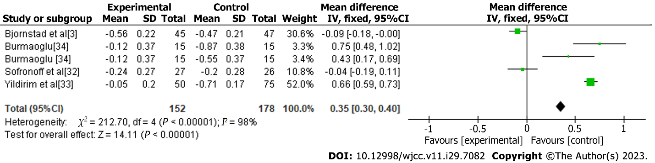
Figure 2 Effects of parent education on parents’ depression.

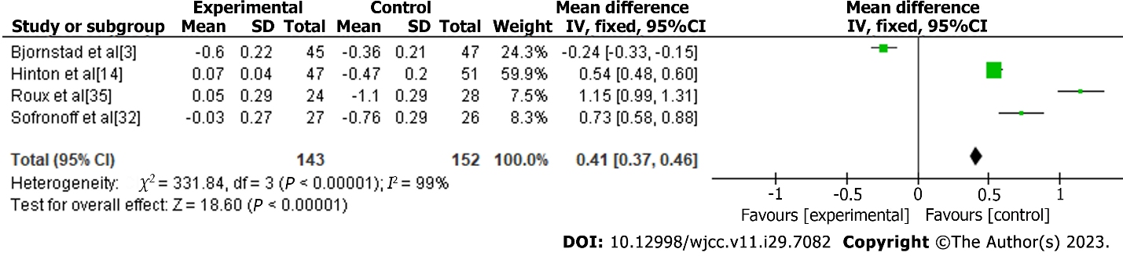
Figure 3 Effects of parent education on parenting attitudes.

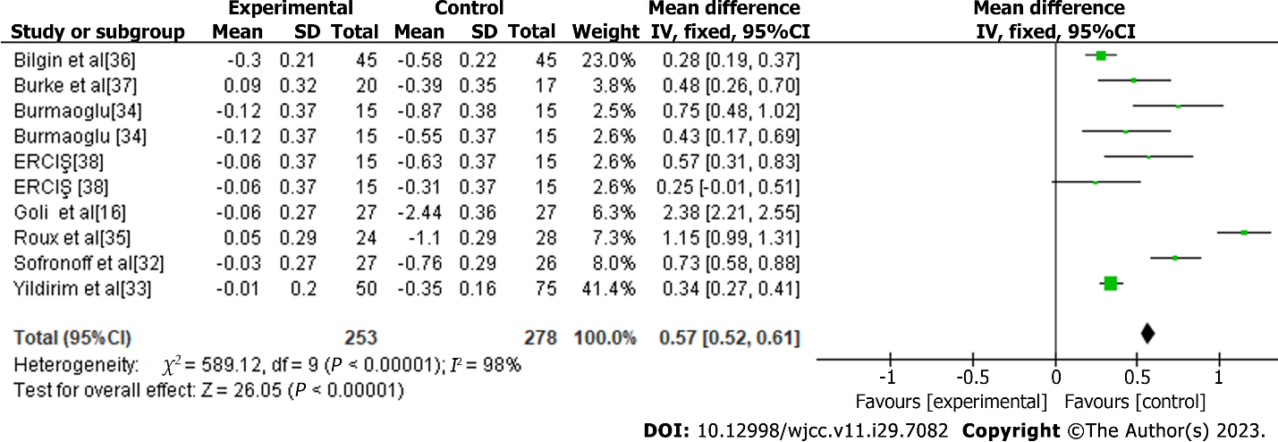
Figure 4 Meta-analysis of parent education methods (face-to-face).

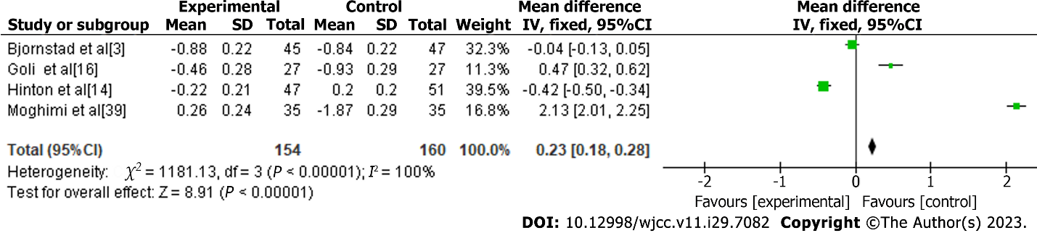
Figure 5 Meta-analysis of parent education methods (non-face-to-face).

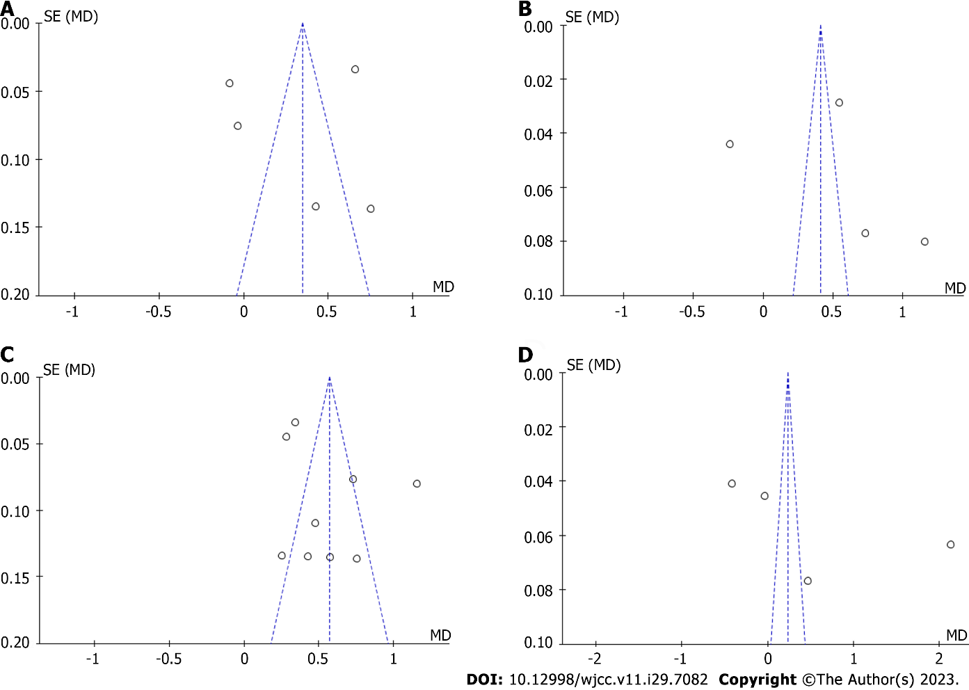
Figure 6 Publication convenience. A: Parents’ depression; B: Parenting attitudes; C: Parent education methods (face-to-face); D: Parent education methods(non-face-to-face).

Published by Baishideng Publishing Group Inc
7041 Koll Center Parkway, Suite 160, Pleasanton, CA 94566, USA
Telephone: +1-925-3991568
E-mail: bpgoffice@wjgnet.com
Help Desk: https://www.f6publishing.com/helpdesk
https://www.wjgnet.com

© 2023 Baishideng Publishing Group Inc. All rights reserved.

