Name of Journal: World Journal of Gastroenterology
Manuscript NO: 65248
Manuscript Type: SYSTEMATIC REVIEWS

Current guidelines for the management of celiac disease: A systematic review with comparative analysis

Raiteri A et al. Celiac disease guidelines

Alberto Raiteri, Alessandro Granito, Alice Giamperoli, Teresa Catenaro, Giulia Negrini, Francesco Tovoli

Alberto Raiteri, Alessandro Granito, Alice Giamperoli, Teresa Catenaro, Giulia Negrini, Francesco Tovoli, Division of Internal Medicine, Hepatobiliary and Immunoallergic Diseases, IRCCS Azienda Ospedaliero-Universitaria di Bologna, Bologna 40138, Italy

Author contributions: Raiteri A and Tovoli F designed the research; Granito A, and Catenaro T performed the research; Raiteri A, Giamperoli A and Negrini G analysed the data; Raiteri A and Tovoli F wrote the paper.

Corresponding author: Francesco Tovoli, MD, Assistant Professor, Research Fellow, Division of Internal Medicine, Hepatobiliary and Immunoallergic Diseases, IRCCS Azienda Ospedaliero-Universitaria di Bologna, via Albertoni 15, Bologna 40138, Italy. francesco.tovoli2@unibo.it

Received: March 2, 2021
Revised: August 8, 2021
Accepted: December 25, 2021
Published online: January 7, 2022

Abstract
BACKGROUND
Wheat and other gluten-containing grains are widely consumed, providing approximately 50% of the caloric intake in both industrialised and developing countries. The widespread diffusion of gluten-containing diets has rapidly led to a sharp increase in celiac disease prevalence. This condition was thought to be very rare outside Europe and relatively ignored by health professionals and the global media. However, in recent years, the discovery of important diagnostic and pathogenic milestones has led to the emergence of celiac disease (CD) from obscurity to global prominence. These modifications have prompted experts worldwide to identify effective strategies for the diagnosis and follow-up of CD. Different scientific societies, mainly from Europe and America, have proposed guidelines based on CD's most recent evidence.

AIM
To identify the most recent scientific guidelines on CD, aiming to find and critically analyse the main differences.

METHODS
We performed a database search on PubMed selecting papers published between January 2010 and January 2021 in the English language. PubMed was lastly accessed on 1 March 2021.

RESULTS
We distinguished guidelines from 7 different scientific societies whose reputation is worldwide recognized and representative of the clinical practice in different geographical regions. Differences were noted in the possibility of a no-biopsy diagnosis, HLA testing, follow-up protocols, and procedures.

CONCLUSION
We found a relatively high concordance between the guidelines for CD. Important modifications have occurred in the last years, especially about the possibility of a no-biopsy diagnosis in children. Other modifications are expected in the next future and will probably involve the extension of the non-invasive diagnosis to the adult population and the follow-up modalities.

Key Words: Celiac disease; Gluten; Gluten-free diet; Gluten sensitivity; Clinical guidelines; Non-invasive diagnosis; Histopathological findings; Serological markers; Genetics

©The Author(s) 2022. Published by Baishideng Publishing Group Inc. All rights reserved.

Citation: Raiteri A, Granito A, Giamperoli A, Catenaro T, Negrini G, Tovoli F. Current guidelines for the management of celiac disease: A systematic review with comparative analysis. World J Gastroenterol 2022; 28(1): 154-175
URL: https://www.wjgnet.com/1007-9327/full/v28/i1/154.htm
DOI: https://dx.doi.org/10.3748/wjg.v28.i1.154

Core Tip: Once considered a rare condition, celiac disease (CD) is becoming a significant health issue globally. An increasing number of studies have investigated this condition. International scientific societies have proposed guidelines for the management of CD to translate this evidence into clinical practice. In this review, we critically analyse both the converging and diverging points in the current clinical guidelines of CD, focusing on the diagnostic aspects and follow-up procedures.
INTRODUCTION
Celiac disease (CD) is an immune-mediated reaction to gluten characterised by an inflammatory injury to the small bowel in genetically predisposed subjects as a result of an inappropriate T cell-mediated immune response^{[1]}. The epidemiology of CD is well known, with an estimated worldwide prevalence of 0.6%-1% of the general population^{[2]}. However, CD remains largely underdiagnosed in developing countries and has a higher impact on children^{[3,4]}. Simultaneously, the misdiagnosis of CD is becoming an emergent problem worldwide^{[5]}.
An evidence-based approach is needed to optimise diagnostic accuracy to avoid life-threatening complications (including small bowel carcinoma and lymphoma)^{[6]} resulting from unrecognised CD on the one hand, and unnecessary cost burden and impact on the quality of life due to incorrect prescription of a life-long gluten-free diet (GFD) on the other hand.
Simultaneously, follow-up of patients with CD who are on a GFD is of critical importance to assess the responsiveness to the GFD, detect complicated CD, find associated autoimmune diseases, and identify metabolic alterations induced by the GFD^{[7]}.
Thus, an increasing number of scientific societies have proposed guidelines for diagnosing and managing CD. In our systematic review, we identified the most recent and significant national and international guidelines and compared their recommendations. We also underlined the most apparent differences among these guidelines to identify ‘hot topics’ on CD and possible future developments.

MATERIALS AND METHODS
The primary aim of this review was to identify the most recent national and international guidelines for CD by means of a systematic review and to compare their main recommendations.
We performed a database search on PubMed and selected papers published between January 2010 and January 2021 in the English language. PubMed was last accessed on 1 March 2021. The following keywords and terms were used: (1) Coeliac Diseaseor Celiac Disease; (2) Guideline; and (3) Management. The following string was used: (("coeliac disease"[All Fields] OR "celiac disease"[MeSH Terms] OR ("celiac"[All Fields] AND "disease"[All Fields]) OR "celiac disease"[All Fields] OR ("coeliac disease"[All Fields] OR "celiac disease"[MeSH Terms] OR ("celiac"[All Fields] AND "disease"[All Fields]) OR "celiac disease"[All Fields])) AND ("guideline"[Publication Type] OR "guidelines as topic"[MeSH Terms] OR "guideline"[All Fields] OR ("manage"[All Fields] OR "managed"[All Fields] OR "managements"[All Fields] OR "managements"[All Fields] OR "manager"[All Fields] OR "manager s"[All Fields] OR "managers"[All Fields] OR "manages"[All Fields] OR "managing"[All Fields] OR "management"[All Fields] OR "organization and administration"[MeSH Terms] OR ("organization"[All Fields] AND "administration"[All Fields]) OR "organization and administration"[All Fields] OR "management"[All Fields] OR "disease management"[MeSH Terms] OR ("disease"[All Fields] AND "management"[All Fields]) OR "disease management"[All Fields]))).
A total of 415 papers were identified with no duplicates, and, as a first step, no papers were excluded for other reasons (PRISMA flow diagram reported in Figure 1). However, twenty-one records were unavailable, leaving 396 papers for further evaluation. As a second step, we excluded papers that were not pertinent to any of the following criteria: (1) Clinical guidelines related to diagnosis and management of CD; and (2) Clinical guidelines published by governmental agencies and scientific associations. We included only the last version of the guidelines, excluding the previous updated versions.
According to the selection criteria, out of the 396 results of PubMed research assessed for eligibility, seven guidelines were finally included in this analysis. These guidelines strictly focus on the diagnosis and management of CD. These papers are presented in order of publication (newest to oldest): (1) European Society Paediatric Gastroenterology, Hepatology and Nutrition (ESPGHAN) 2020^{[8]}; (2) European Society for the Study of Coeliac Disease (ECD) 2019^{[9]}; (3) World Gastroenterology Organization (WGO) 2017^{[10]}; (4) Central Research Institute of Gastroenterology, Russia, 2016^{[11]}; (5) National Institute for Health and Care Excellence (NICE), 2015^{[12]}; (6) British Society of Gastroenterology (BSG), 2014^{[13]}; and (7) America College of Gastroenterology (ACG), 2013^{[14]}.
The recommendations provided by each selected guideline were systematically explored and classified into five categories: patients to be tested for CD, diagnostic tests (serology, duodenal biopsy, genetic test, no-biopsy diagnosis), potential/silent/seronegative CD, refractory/complicated CD, and follow-up. These categories represent the most discussed topics of CD.
The results are reported in different paragraphs, containing both a brief introduction to the specific topic (with references derived from the supporting evidence used by the guidelines and other relevant papers according to a narrative approach) and a comparative analysis of the guidelines’ recommendations (collected using a strictly systematic approach).

RESULTS
Clinical presentation and risk factors: who should be tested for CD?
CD is a diagnostic challenge as it may develop at any age (even in older adults) and with a polymorphic clinical presentation^{[15]}. The clinical spectrum of CD includes both symptomatic and silent forms revealed only by serological screening^{[16,17]}. CD-related symptoms can be both intestinal and extraintestinal, reflecting the systemic nature of the disease. These manifestations are classified as ‘classical’ and ‘non-classical’ according to the historical presentation of first described cases. Table 1 reports the main manifestations of CD according to their categorization^{[1,17-26]}.
Some guidelines draw specific attention to some extraintestinal symptoms (Figure 2). In particular, the ESsCD 2019 guidelines focus on oral-dental and neuropsychiatric manifestations^{[9]}. CD testing is advised in cases of dental enamel defects and recurrent oral aphthae. Special attention to neurological manifestations has also been drawn by the Russian Central Research Institute of Gastroenterology^{[11]}. These guidelines also focus on reproductive disorders, such as delayed sexual development, amenorrhea, infertility, and miscarriage^{[11]}.
Despite these premises, all the guidelines agree on testing for CD in children, adolescents, and adults showing classical and non-classical symptoms of CD^{[7-13]}. There is also a consensus on considering iron-deficiency anaemia and hypertransaminasemia as the most common laboratory abnormalities^{[8-14]}.
The high-risk group of patients did not change over time. These groups include first-degree relatives of patients with CD, patients with autoimmune conditions (such as type 1 diabetes mellitus and thyroid diseases) or genetic disorders such as IgA deficiency, Down syndrome, Turner syndrome, and Williams-Beuren syndrome^{[8-14]}.

Diagnosis
There is no ‘gold standard’ for the diagnosis of CD. Clinical features, serology, or histology alone cannot provide a definitive diagnosis. Instead, the final diagnosis of CD relies on a combination of these elements. All the guidelines agree on a sequential approach to diagnosis, consisting of serology as a first-line test in high-risk patients, followed by duodenal biopsy in cases of positive serology or persistent suspicion of malabsorption (Figure 3). A positive serology paired with evidence of duodenal villous atrophy indicate a definite CD diagnosis, whereas cases with discordant findings should undergo HLA testing. All the guidelines also agree that patients with discordance between serology, histology, and HLA DQ2/DQ8 positivity should be evaluated on a patient-by-patient basis in expert centres. The so-called ‘four-out-of-five rule’ has long been advocated as a standard of care^{[27]}. According to this rule, four of the following criteria are sufficient to establish CD diagnosis: (1) Typical signs and symptoms (diarrhoea and malabsorption), (2) Antibody positivity, (3) HLA-DQ2 or HLA-DQ8 positivity, (4) Intestinal damage (i.e., villous atrophy and minor lesions); and (5) Clinical response to GFD. This rule also helps physicians to identify various subtypes of CD, that is, non-classic CD (absence of point 1), seronegative CD (absence of point 2), potential CD (absence of point 4), and non-responsive CD (absence of point 5). However, the ‘four-out-of-five rule’ is yet to be recognised by any guideline.
We will report the guidelines’ detailed suggestions for obtaining key diagnostic elements from serology, histology, and genetic testing in the following paragraphs.

Serology
All diagnostic serological testing should be performed in patients on a gluten-containing diet^{[28]}. Serum immunoglobulin A(IgA) anti-tissue transglutaminase antibody (anti-tTG-IgA) is widely accepted as the most sensitive test for CD diagnosis, although it suffers from low specificity, especially at low titres^{[29-33]}. In contrast, IgA anti-endomysial antibodies (EMA-IgA) are nearly 100% specific for CD but are less sensitive, more expensive, and more operator-dependent than anti-tTG-IgA. Therefore, these characteristics make EMA-IgA an ideal second-line test^{[34]}. The diagnostic performance of both anti-tTG-IgA and EMA-IgA is limited in patients with concurrent IgA deficiency. Antibodies to deamidated gliadin peptides (DGP) of the IgG class are advantageous in this setting and for younger children^{[35,36]}. Even with the most recent advancements in CD serology, up to 2% of patients with CD have no circulating markers of gluten sensitivity, defining a condition of seronegative CD^{[37]}.
Currently, the guidelines are concordant and suggest anti-tTG-IgA as the initial serological test, complemented by a determination of total IgA levels to rule out concurrent IgA deficiency (Figure 4)^{[8-14]}. This initial approach was suggested for both children and adults. TheACG2013 guidelines suggest a combination of different IgA and IgG antibodies in children younger than two years of age (for instance, anti-tTG IgA and DGP-IgG)^{[14]}. This approach is still accepted only by the WGO2017 guidelines^{[10]}. The remaining guidelines advise against this strategy, as a combination of antibodies implies a higher sensitivity at the expense of a reduced specificity, often leading to the necessity of histological confirmation. This scenario represents an obstacle in the pursuit of a no-biopsy approach in children, for whom the anti-tTG-IgA + total IgA strategy fits better^{[8]}. Alternatively, DGP-IgG (together with anti-tTG-IgG) maintained the unanimous recommendation as the test of choice in patients with IgA deficiency^{[8-14]}.
Further, EMA-IgA is considered a confirmatory test, particularly when TG2 has a low titre, i.e., < 2x the upper normal limit (UNL)^{[9,10,12]}. A positive result is also required for a no-biopsy CD diagnosis in children with anti-tTG IgA > 10x^{[8]}. However, the use of paired anti-tTG and EMA-IgA as the first diagnostic test is not supported by any guideline.
Currently, all of the guidelines strongly discourage urine, stool, and saliva tests in clinical practice due to their low-performances^{[8-14]} and the consequent risk of initiating a GFD without a firm diagnosis, impacting the final diagnosis^{[13]}.

Biopsy
For a long time considered the ‘gold standard’ for diagnosing CD (ambiguously suggesting that other tests were of lesser importance), duodenal biopsies remain the mainstay of CD diagnosis, and all guidelines unanimously recognise this role. The presence of positive histology, however, was not considered CD-specific. Thus, clinical, and serological correlations are mandatory (Figure 5) ^{[8-14]}.
Duodenal biopsies should be obtained from all patients with suspected CD. In high-risk symptomatic patients, duodenal biopsies should be performed irrespective of serology results for CD^{[9,13,14]}. Some authors also suggested that duodenal biopsies should be considered in any individual undergoing endoscopy because of the relatively high prevalence of CD in the general population and its polymorphic presentation^{[13]}.
Histology samples should be collected from multiple sites, given the possible patchy distribution of CD lesions. Current evidence suggests collecting four biopsies from the second duodenal portion and two biopsies from the bulb^{[38]}. Biopsy sample orientation using cellulose acetate Millipore filters is of paramount importance to avoid artefacts, potentially leading to a false diagnosis of villous atrophy^{[39]}.
The histological findings are currently categorised according to the classification proposed by Marsh and subsequently modified by Oberhuber^{[40]}. Pathology findings are reported as Marsh-Oberhuber 0 (normal histology), 1, 2, or 3 (subdivided into 3a, 3b, and 3c).
An increase in intraepithelial lymphocytes (IELs) without villous atrophy defines Marsh 1 Lesion. In most cases, Marsh 1 Lesions (also called minimal lesions) are attributable to other causes, including lymphocytic colitis, bacterial and parasitic intestinal infections (especially Helicobacter pylori and Giardia lamblia), small intestinal bacterial overgrowth, Crohn’s disease, common variable immunodeficiency, and non-steroidal anti-inflammatory drugs^{[41]}. While a Marsh 1 Lesion is not considered sufficient to diagnose CD, the BSG 2014 guidelines state that minimal lesions combined with positive serology could represent a probable CD. A trial with a GFD could be considered to support the diagnosis of CD^{[13]}. When the increase in IELs is paired with hyperplasia of the duodenal crypts, the lesion is classified as Marsh 2. Conversely, increased IELs in combination with villous atrophy define the typical CD lesion (Marsh 3), subclassified as mild (3a), moderate (3b), or subtotal (3c)^{[40]}. Some authors proposed a simplified histopathological grading, reducing the possible grades from five to three, thus reducing the possible inter-operator variability in the histological interpretation^{[42]}. This simplified classification is yet to be adopted by the international guidelines, which currently recommend the Marsh-Oberhuber classification^{[8-14]}.
At present, there is no alternative to duodenal biopsy for examining mucosal damage^{[8-14]}. For instance, in children, video-capsule endoscopy (VCE) gives no indications^{[8]}, although in adults, VCE could support the diagnosis in cases of discordance between serology and biopsy^{[13]} or if the patient is unwilling or unable to undergo traditional endoscopy^{[14]}. VCE could also play a role in detecting CD complications (i.e., lymphoma, adenocarcinoma, ulcerative jejunitis)^{[9]} and in helping to differentiate extended diseases (e.g., CD vs. proximal Crohn’s disease)^{[11]}. Anti-actin IgA antibodies have been shown to be predictive of severe villous atrophy in CD patients at the time of diagnosis^{[43]}. Theoretically, they may also provide indirect information about villous recovery following the introduction of the GFD; however, data are still lacking in this setting. The available information about faecal and salivary microbiome, at present, is not sufficient to allow a reliable conclusion for the diagnosis of CD^{[44,45]}. Intestinal fatty-acid binding protein (I-FABP) are higher in dietary non-adherence and unintentional gluten intake and could be used as a sensible blood marker of mucosal damage^{[46,47]}. This exam was first mentioned in the ESsCD guidelines^{[9]}.
A repeated small intestinal biopsy, including biopsies from the jejunum, could be considered in adults with discordance between histopathology and anti-tTG-IgA results^{[13]}. In children, re-cutting biopsies and/or a second opinion from an experienced pathologist is preferred over endoscopic repetition^{[8]}.
In adults, a gluten challenge should be proposed for patients with uncertain CD diagnosis, who have been started on a GFD^{[9-14]}. In children, gluten challenge is discouraged before the age of 5 years and during puberty, and in general, it should be reserved for unusual cases^{[8]}.
Gluten challenge protocols are not homogeneous. A diet containing at least 10 g of gluten per day for 6-8 wk seems to be the most effective way to achieve disease relapse; however, the evidence is weak^{[28]}. In shorter protocols, a diet containing at least 3 g of gluten per day for at least 2 wk seems to be sufficient for most patients^{[10,13,14]}. Certainly, a shorter and lighter approach would fit better for highly symptomatic patients. A strategy for optimising the result would be to undergo a serology test after two weeks and, if negative, to extend the challenge to 8 wk^{[13]}.
After reintroducing gluten, physical symptoms should not be used for diagnosis in the absence of other supportive evidence^{[8,9,11-14]}. A diagnosis based only on the disappearance of symptoms on GFD and relapse during gluten re-introduction can be relevant in geographic areas where serology tests are not available, as the only way to confirm the diagnosis and treat the disease^{[10]}.

Human Leukocyte Antigen testing
The strong genetic component of CD is testified by its high familial recurrence and high disease concordance among monozygotic twins (75%-80%)^{[48]}. The presence of human leukocyte antigen (HLA) -DQ2/DQ8 is a pathogenic requisite for the development of the typical immune alterations found in CD. Simultaneously, HLA DQ2/DQ8 can be found in up to 30%-40% of the general population, so its specificity is remarkably poor^{[49]}. In contrast, the absence of HLA DQ2/DQ8 virtually excludes CD diagnosis^{[48,49]}. Restricting this observation to the sole HLA DQ2 alleles, a recent systematic review of the literature confirmed that only 5.06% of patients with CD were completely lacking the HLA-DQB1*02 allelic variant^{[50]}.
Consequently, all the guidelines advise against using HLA testing as a first-line tool for the diagnosis of CD (Figure 6)^{[8-14]}. They are also concordant in allocating this resource for: (1) Patients with uncertain diagnosis of CD, already on a GFD; (2) Patients with a flat intestinal mucosa but negative serology; and (3) In patients already on a GFD, serology and histology can be inconclusive. In this context, before embarking on a so-called ‘gluten-challenge’, it is advisable to verify the presence of HLA-DQ2/DQ8^{[8-14]}.
HLA tests would be useless for patients with positive serology before a gluten-challenge because virtually 100% of those patients would be positive. Therefore, HLA typing is no longer a criterion for the ‘no-biopsy’ approach of diagnosis in children with a TGA-IgA > 10x UNL^{[8]}. In patients with positive histology (i.e., villous atrophy, though occasionally detected on esophagogastroduodenoscopy), and negative or questionable serology, HLA testing can exclude the diagnosis of CD^{[9]}. In contrast, a positive result cannot confirm the diagnosis, which should be carefully evaluated on a patient-by-patient basis in expert centres.
The use of HLA typing in high-risk populations is controversial. HLA-DQ2/DQ8 can be found in more than 50% of first-degree relatives of patients with CD and in patients with other autoimmune or genetic disorders related to CD^{[14,49]}. Most guidelines suggest excluding HLA-DQ2/DQ8 in CD first-degree relatives and high-risk patients, even if asymptomatic, to avoid periodic monitoring^{[9,10,13,14]}. This strategy can be questioned in terms of resources and costs^{[10,11,14]}. Some authors hav esuggested screening high-risk patients only if they complain of gastrointestinal or extraintestinal symptoms or have laboratory abnormalities^{[11]}. In addition, a two-step genetic screening procedure starting with HLA-DQ β chains has been proposed^{[51]}. Thus, the choice of screening for symptomatic or asymptomatic first-degree relatives or high-risk patients, with or without a preliminary determination of HLA-type, remains debated, needing to take local resources and cost-benefit rates into account.

No-biopsy diagnosis
While most guidelines allow a no-biopsy diagnosis in children under strict conditions, endoscopy with duodenal biopsies is still mandatory to achieve a final diagnosis of CD in adults^{[9-14]}. As the only exception, the WGO guidelines allow a diagnosis based on serology and clinical response to the GFD (Figure 7) in developing countries where endoscopy may not possible or trained pathologists may not be available^{[10]}.
The ESPGHAN2012 guidelines endorsed the possibility of a no-biopsy approach in children for the first time. This possibility was limited to certain conditions, which included the presence of classic symptoms, with tTG-IgA > 10x UNL, EMA-IgA positivity, and presence of permissive HLA^{[8]}.
This approach was subsequently adopted by a plurality of international guidelines^{[9-12]}. Although, the ACG2013 and BSG 2014 guidelines did not include this approach^{[13,14]}.
The 2020 update of the ESPGHAN guidelines removed classic symptoms, EMA-IgA positivity, and HLA DQ-2 or DQ-8 as crucial criteria for a diagnosis not based on biopsy^{[7]}. However, EMA-IgA positivity is not discouraged^{[8,10]}. The increasing confidence in diagnosing CD without biopsy in children has increased so rapidly that many recent studies consider tTGA > 10x as a new possible cut-off to further reduce the need for biopsies^{[52]}.
CD diagnosis without a positive duodenal biopsy has always been discouraged in adults^{[9-14]}. This choice was not dictated by the reduced reliability of the serological tests in adults. In fact, large population studies concluded that tTG-IgA>10x could accurately predict villous atrophy^{[53]}. Rather, other considerations currently prevent the extension of paediatric criteria into the adult population. First, CD at onset can be associated with complications. In the case of primary or secondary resistance, or slow response to the GFD, the absence of baseline histology may make the diagnosis of complications difficult^{[9]}. Index histology may also predict the risk of future complications, such as lymphoma^{[54]}. Moreover, endoscopy may help diagnose other treatable disorders associated with CD, such as eosinophilic esophagitis, autoimmune gastritis, and lymphocytic gastritis^{[9]}.
Both complicated CD and possible differential diagnoses of CD are virtually absent in children. However, they represent a serious concern in adults, thus justifying different diagnostic algorithms according to the age of presentation of the first symptoms.

Potential, silent and seronegative CD
Potential CD is characterised by a positive serology for CD in the absence of mucosal damage at biopsy^{[1]}. As stated above, Marsh 1 Lesions (i.e., an increased IELs count) are not suggestive of an active CD but may increase the risk of developing villous atrophy^{[41]}.
It is widely accepted that symptomatic potential CD may benefit from a GFD, and a direct challenge would be run^{[8-14]}. In adult patients with both positive TGA-IgA and EMA-IgA CD is likely, and a GFD may be initiated irrespective of symptoms^{[9]}. A serological response after a period of approximately 12 mo confirms the diagnosis of CD^{[9]}. In EMA-IgA negativity, HLA-typing may exclude the diagnosis before embarking on follow-up^{[9]}. If a follow-up is started, potential CD patients should be retested after consuming a gluten-containing diet for 3-6 mo to confirm persistent seropositivity before referral for a new endoscopy (Figure 8)^{[9,10]}.
Silent CD is characterised by the presence of both positive serology and histology for CD in the absence of classical or non-classical symptoms^{[1]}. It is widely recommended to start a GFD in patients with silent CD because it is considered an active form of the disease^{[8-14]}.
Seronegative CD is characterised by the presence of active enteropathy and negative serology for CD, with no other causes, and with clinical and histological responses to a GFD^{[1,37]}. In these cases, other causes of enteropathy should be excluded before embarking on the direct challenge of a GFD^{[37,55]}. HLA-typing can also rule out the diagnosis of CD in seronegative enteropathies^{[9,14,37]}. Finally, the direct challenge of a GFD is advised only in patients with seronegative enteropathy, positive HLA typing with no other causes. A documented histological response after 1-3 years of GFD is needed to confirm the diagnosis^{[9,14,37]}. No major changes occurred over time in the management of seronegative CD^{[9,14]}.

Refractory and complicated CD
CD can be complicated by a persistent active form of the disease, independent of gluten intake, known as refractory CD (RCD)^{[1]}. Other rare complications of CD can be neoplastic. Primarily, enteropathy-associated T-cell lymphoma (EATL) is a rare T-cell lymphoma associated with untreated CD. EATL has an abysmal prognosis and can occur primarily at diagnosis or as an evolution of RCD type 2^{[56]}. Duodenal adenocarcinoma is possible, albeit less frequent in the CD population^{[57]}.
Refractory CD (RCD) is characterised by the persistence or recurrence of symptoms and signs of malabsorption, with documented villous atrophy, despite a strict GFD for more than 12 mo and in the absence of other causes^{[9-14]}. No major changes occurred in this definition over time (Figure 9).
RCD can be primary (refractory at the time of the first diagnosis), or secondary (occurring after a period of response to the GFD)^{[1]}. The first step in evaluating suspected RCD is to re-evaluate the initial diagnosis of CD by reviewing biopsies and serology tests obtained at the time of diagnosis^{[58]}. The most common cause of GFD failure is inadvertent gluten ingestion^{[59]}. Therefore, evaluation by an expert dietitian should always be included^{[9,10,13,14]}. Other associated or concomitant pathological conditions should be excluded before RCD diagnosis. These include lactose and fructose intolerance, small intestinal bacterial overgrowth, microscopic colitis, pancreatic insufficiency, and inflammatory bowel diseases^{[59,60]}. All guidelines recommend this strategy^{[9,10,13,14]}.
RCD is further classified into type 1 (RCD-1) and type 2 (RCD-2)^{[1]}. T-cell flow cytometry is the most reliable method for classifying RCDs. Aberrant T cells lose the normal surface markers CD3 and CD8 with preserved expression of intracytoplasmic CD3. In RCD-1, the percentage of aberrant T cells is below 20%, whereas in RCD-2, they represent more than 20% of the total IELs^{[58]}. RCD-2 can be considered a pre-lymphoma or low-grade lymphoma^{[54]}. T-cell receptor (TCR) g chain clonality analysis lacks sensitivity and specificity, and is of limited value in separating RCD-1 from RCD-2^{[54]}. TCR analysis has been formerly indicated as a criterion for differentiating RCD-1 from RCD-2^{[11,13,14]}. The latest ESsCD guidelines exclude TCR analysis in the RCD classification^{[9]}.
RCD-1 has an extremely high 5-year survival rate (> 90%)^{[54,59,60]}. In RCD-1, the first-line therapy should be ‘open-capsule’ budesonide (OCB), 3 mg, 3 times a day^{[61]}. Budesonide (open capsule or not) has been progressively accepted as the first-line therapy for RCD-1^{[9,11,13,14]}. In the ACG 2013 guidelines, systemic steroids are considered the first-line therapy for RCD-1^{[14]}. Second-line treatment for RCD-1 includes immunosuppressive drugs such as steroids (prednisone 0.5-1 mg/kg/day) and azathioprine (2-2.5 mg/kg/day)^{[60]}. Most guidelines agree with this strategy^{[9,11,12]}. Systemic steroids can also be considered as first-line treatment while waiting for a specialist’s advice^{[12]}. Infliximab may be the preferred biological therapy for second-line treatment of RCD-1^{[62]}. Evidence is still weak, and only one guideline includes infliximab as an RCD-1 treatment^{[9]}. Withdrawing of immunosuppressive therapy after 2-3 years of complete response may be considered^{[9,54]}.
RCD-2 is rarer than RCD-1, has a much higher mortality rate, and treatment is less well defined. Systemic steroids or open-capsule budesonide should be the first choice for milder presentations. In severe cases, cytoreductive therapies such as cladribine and fludarabine or autologous hematopoietic stem cell transplantation should be chosen^{[59,60]}. Guidelines are mostly aligned with this strategy^{[9,13,14]}. Some guidelines also report azathioprine, 6-mercaptopurine, methotrexate, cyclosporine, and anti-TNF antibodies as possible therapies, but the data are weaker^{[11,13,14]}. Not every guideline has raised the topic of RCD-2 treatment^{[10-14]}.
Transformation to enteropathy-associated T-cell lymphoma (EATL) is likely in RCD-2^{[59]}. VCE, positron-emission tomography (PET), and magnetic resonance (MR) enterography can be useful in cases of suspected progression to EATL to assess the extent of the disease^{[63]}. All guidelines advise the use of these tools in RCD-2 staging^{[9-14]}. Severe RCD-2 and EATL may require surgery, chemotherapy, or bone marrow transplantation^{[64]}. The former therapeutic strategies are mostly based on case reports, and only one guideline extensively discusses them^{[9]}.

Follow-up
Since CD is the only autoimmune disease with a known environmental trigger (i.e., gluten), a periodical assessment of compliance to a GFD is essential^{[65]}. Poor GFD compliance is not infrequent, and mucosal damage can persist despite negative serology and the absence of symptoms^{[66]}. Follow-up is also essential for evaluating possible complications^{[54]}. Osteoporosis and metabolic complications of GFD should also be evaluated during follow-up^{[67-69]}. Suggested follow-up schedules are based on the frequency of complications, risk of GFD non-compliance, and reported quality of life^{[70]}.
Therefore, there is universal agreement on the necessity of long-term monitoring of patients with CD to assess the compliance and responsiveness to the GFD and allow early detection of complicated CD (Figure 10)^{[8-14]}. Follow-up evaluations should be scheduled every 3-6 mo during the first year and then every 1-2 years^{[9-14]}. In children, follow-up should continue until they reach their final height^{[9-11,14]}, focusing on normal growth and development^{[9,10,14]}.
There is disagreement about who should oversee follow-up. While most guidelines show no preference between primary care physicians, specialists, or dietitians^{[9-11,13,14]}, the NICE 2015 guidelines suggest that dietitians with expertise in CD may be best suited to carry out an annual follow-up^{[12]}. However, on a general principle, all guidelines agree that newly diagnosed patients should be referred to a dietitian^{[9-14]}. Some guidelines suggest that nutritionist counselling should coincide with medical visits during follow-up^{[10,13]}. The inclusion of a dietitian assessment at diagnosis and during follow-up was supported by clinical data^{[71]}. Indeed, nutritional counselling could also help manage metabolic alterations, which frequently appear during the first years of the GFD^{[67]}.
All guidelines also provide information about the essential information that should be collected during follow-up evaluations. These evaluations should include a dietary interview, serology (TTG-IgA if normal IgA), and laboratory tests^{[9-14]}. Laboratory tests should evaluate the presence of micronutrients malabsorption, including complete blood count, iron status, folate, vitamin B12, calcium, phosphate, vitamin D, and should monitor associated autoimmune conditions (thyroid-stimulating hormone and serum glucose) and liver disorders (aspartate aminotransferase/alanine aminotransferase)^{[9-11,13,14]}. Normalisation of tTG-IgA levels do not predict full recovery of villous atrophy. In contrast, persistently positive serology 12 mo after GFD initiation is a strong indicator of gluten ingestion^{[72]}. All guidelines were aligned with the interpretation of tTG-IgA levels during follow-up^{[8-14]}.
The inability of serology alone to predict mucosal healing automatically leads to consider the opportunity of repeating duodenal biopsies after the start of the GFD. While the general agreement is that follow-up biopsies are not mandatory in asymptomatic patients on a GFD and without an increased risk of complications^{[9-14]}, the guidelines diverge regarding other points. Many guidelines consider it reasonable to repeat biopsy after 2 years of GFD to assess mucosal healing^{[9,11,14]}. Other guidelines suggest repeating biopsies only for persistent symptoms or serological abnormalities after 12 mo of GFD^{[10,12,13]}. A growing body of literature suggests that the risk of a complicated CD is higher in patients >40 years of age at the time of diagnosis or those with a classical presentation^{[54]}. Some guidelines agree that repeating biopsies should be of interest in these selected populations^{[13,14]}.
Some guidelines also provide suggestions for further examinations to be performed during follow-up. According to the ECD and Russian guidelines, bone densitometry should be offered to every patient at the time of diagnosis and should be repeated after 3 years if abnormal, or 5 years if normal^{[9,11]}. Other guidelines suggest performing bone densitometry only in patients with a high risk of osteoporosis or those older than 55 years^{[12,13]}.
While there is a general agreement in recommending a pneumococcal vaccine^{[8-10,12]}, the WGO2017 guidelines also recommend vaccinations against Haemophilus influenzae typeB, and Meningococcus, while other guidelines state that these vaccines have a less clear indication to be given to every patient with CD^{[9,11-13]}.
Mood disorders are another common problem in patients with dietary restrictions. Anxiety, depression, and fatigue may be associated with CD before and after diagnosis and can affect the quality of life^{[73]}. In this context, most guidelines agree on advising patients to join CD support groups and associations^{[9,10,12,13]}. Some of them also suggest that psychological support provided by a specialist may be offered^{[12,13]}.

Gluten-free diet
Gluten is a protein with high proline and glutamine content, primarily found in wheat. Rye and barley belong to the same tribe as wheat and are known to contain gluten. In contrast, oats are derived from a different tribe and do not contain pure gluten^{[1]}.
Uncontaminated oats are safe for almost all patients with CD, but a small percentage of patients may be sensitive to some oat cultivars^{[74]} and should be monitored^{[9,10,12-14]}. Some guidelines advise the initiation of a Gluten-free diet (GFD), excluding oats, and recently introduced them^{[10,13,14]}. The Russian guidelines (2016)are against oat consumption in patients with CD because of the high risk of contamination^{[11]}. Even if not stated, oat consumption would be safe in many countries, though it may be discouraged in developing countries where contamination could be widespread (Figure 11).
WHO guidelines on ‘Standard for Foods for Special Dietary Use for Persons Intolerant to Gluten’ state that foods labelled as ‘gluten free’ should contain ≤ 20 parts per million (ppm) of gluten^{[75]}.
Patients should be instructed to avoid contaminating their gluten-free food by using separate cooking utensils and cooking surfaces^{[9,10]}. At present, shared items can be safely used if thoroughly cleaned with soap and water between use^{[9,76]}.
The duration of breastfeeding and the timing of gluten introduction to the infant seem to have no impact on the risk of developing CD, even in those at high risk^{[77]}. Therefore, there are no strict indications for gluten introduction in infant diets^{[9]}. Formerly, it was advised to avoid either early or late gluten introduction in children at risk of CD^{[13]}.
Dermatitis herpetiformis (DH) is a bullous cutaneous disease triggered by gluten consumption like CD^{[1]}. DH and CD often coexist and share the same treatment, GFD^{[9,10,13,14]}. Interestingly, the ESsCD guidelines suggest that psoriasis could also benefit from GFD in the case of documented CD serology, even in the absence of mucosal damage^{[9]}.

DISCUSSION
Our comparative analysis of the currently adopted CD guidelines underlined differences in diagnostic aspects and the management of the follow-up. These differences mirror some relevant clinical points in both developing and developed countries.
First, the differences in the diagnostic process of CD are important. The possibility of a no-biopsy diagnosis has relevant repercussions in developing countries. Most guidelines are still cautious in this regard, with the WGO2017 guidelines being the only ones contemplating this possibility in geographical areas with a paucity of resources. As correctly underlined by these guidelines, some absolute recommendations may not be valid for developing countries where the availability of serology or endoscopy may be lacking^{[10]}. CD seems to have a non-negligible prevalence in Asia and sub-Saharan Africa^{[77,78]}. Especially in Russia and Central Asia, the prevalence of CD is very likely to be underestimated due to poor disease awareness among physicians and/or patients, limited access to diagnostic resources, inappropriate use or interpretation of the serological tests, absence of standardised diagnostic and endoscopic protocols, and insufficient expertise in histopathological interpretation^{[3]}. Specific guidelines are lacking in these geographical areas^{[79]}. In addition, the incidence of undiagnosed CD in children can be extremely high^{[80]}. Knowing the high mortality and disability related to untreated CD in childhood, it would be advisable to develop specific protocols for specific geographical areas.
The no-biopsy approach has been discouraged for a long time, especially in adults^{[13,14]}. In contrast, most recent guidelines have incorporated the ESPGHAN 2012 recommendations for a no-biopsy approach in children^{[9,10]}. The possibility of an outright extension of these criteria into the adult population still meets key obstacles. However, in an era during which the COVID-19 pandemic has caused a staggering drop in new CD diagnoses even in industrialised countries^{[81]}, ESPGHAN released the advice to lower the TGA-IgA threshold for diagnosing CD without biopsy^{[52]}. Moreover, retrospective data on a possible no-biopsy approach in adults are increasing^{[53]}. Prospective data will probably lead to the integration of such an approach to future guidelines over the next decade.
Second, the differences in follow-up recommendations reflect a relatively low interest in this topic in the past. Arguably, the search for more reliable diagnostic tools was the right priority in an era characterised by a severe under-diagnosis of CD. Nowadays, significant diagnostic delays can still occur in a minority of Central European children^{[82]}, with socioeconomically deprived children being more likely to be underdiagnosed despite improved and easily available serological testing^{[4]}.
Nonetheless, the current physicians’ awareness of CD has reached fairly high levels, and the case-detection strategy has significantly contributed to the increased number of diagnoses. Consequently, the correct management of follow-up is crucial. This topic is of special interest in developed countries, in which metabolic problems possibly caused by an unbalanced GFD are particularly prevalent. Uncontrolled weight gain, metabolic syndrome, and non-alcoholic fatty liver disease are epidemic in these countries and can also be facilitated by the GFD^{[67,69,83-85]}. In addition, quick detection of associated autoimmune conditions can prove highly beneficial, especially in autoimmune liver diseases^{[86]}. Finally, early detection of complicated CD requires particular attention, as both neoplastic and non-neoplastic complications may arise years after the diagnosis^{[6]}.

CONCLUSION
We found a relatively high concordance between CD guidelines. Important modifications have occurred in recent years, especially regarding the possibility of a no-biopsy diagnosis in children. Other modifications are expected in the future and will probably involve the extension of the non-invasive diagnosis to the adult population and the follow-up modalities.

ARTICLE HIGHLIGHTS
Research background
Celiac disease (CD) has risen from obscurity to global prominence in a few decades. These modifications have prompted experts from all over the world to identify effective strategies for the diagnosis and follow-up of CD. Different scientific societies, mainly from Europe and America regions, have proposed different guidelines.

Research motivation
CD guidelines are consistent when they deal key points in the diagnosis and follow-up of this condition. However, they differ in a number of other points.

Research objectives
To identify all of the existing guidelines across the globe and perform a comparative analysis to verify similarities and differences and, thus, discuss the most debated topics and the possible innovations in the next future.

Research methods
We searched PubMed for a complex string containing the terms “celiac disease”, “management”, and “guidelines”. The results were subsequently explored to identify the most recent versions of existing guidelines of governmental agencies and scientific societies. The recommendations provided by each selected guideline were systematically explored and classified under five categories: Patients to be tested for CD, diagnostic tests (serology, duodenal biopsy, genetic test, no-biopsy diagnosis), potential/silent/seronegative CD, refractory/complicated CD, follow-up.

Research results
We identified 7 different guidelines [European Society Paediatric Gastroenterology, Hepatology and Nutrition (ESPGHAN) 2020; European Society for the Study of Coeliac Disease (ECD) 2019; World Gastroenterology Organization (WGO) 2017; Central Research Institute of Gastroenterology, Russia, 2016; National Institute for Health and Care Excellence (NICE), 2015; British Society of Gastroenterology (BSG), 2014; and America College of Gastroenterology (ACG), 2013]. These guidelines were mostly concordant but differed under certain recommendation for no-biopsy diagnosis, refractory CD, and follow-up.

Research conclusions
We found a relatively high concordance between the guidelines for CD. Important modifications have occurred in the last years, especially about the possibility of a no-biopsy diagnosis in children.

Research perspectives
Modifications of the current guidelines are expected in the near future. These modification will probably regard the possibility of a no-biopsy diagnosis (especially in developing countries) and the modalities of follow-up.

REFERENCES
1 Ludvigsson JF, Leffler DA, Bai JC, Biagi F, Fasano A, Green PHR, Hadjivassiliou M, Kaukinen K, Kelly CP, Leonard JN, Lundin KEA, Murray JA, Sanders DS, Walker MM, Zingone F, Ciacci C. The Oslo definitions for coeliac disease and related terms. Gut 2013; 62: 43-52 [DOI: 10.1136/gutjnl-2011-301346]
2 Fasano A, Catassi C. Clinical practice. Celiac disease. N Engl J Med 2012; 367: 2419-2426 [PMID: 23252527 DOI: 10.1056/NEJMcp1113994]
3 Poddighe D, Abdukhakimova D. Celiac Disease in Asia beyond the Middle East and Indian subcontinent: Epidemiological burden and diagnostic barriers. World J Gastroenterol 2021; 27: 2251-2256 [PMID: 34040319 DOI: 10.3748/wjg.v27.i19.2251]
4 Whitburn J, Rao SR, Paul SP, Sandhu BK. Diagnosis of celiac disease is being missed in over 80% of children particularly in those from socioeconomically deprived backgrounds. Eur J Pediatr 2021; 180: 1941-1946 [PMID: 33569662 DOI: 10.1007/s00431-021-03974-8]
5 Ianiro G, Bibbò S, Bruno G, Ricci R, Arena V, Gasbarrini A, Cammarota G. Prior Misdiagnosis of Celiac Disease Is Common Among Patients Referred to a Tertiary Care Center: A Prospective Cohort Study. Clin Transl Gastroenterol 2016; 7: e139 [PMID: 26821194 DOI: 10.1038/ctg.2015.48]
6 Biagi F, Schiepatti A, Maiorano G, Fraternale G, Agazzi S, Zingone F, Ciacci C, Volta U, Caio G, Tortora R, Klersy C, Corazza GR. Risk of complications in coeliac patients depends on age at diagnosis and type of clinical presentation. Dig Liver Dis 2018; 50: 549-552 [PMID: 29277481 DOI: 10.1016/j.dld.2017.12.001]
7 D'Avino P, Serena G, Kenyon V, Fasano A. An updated overview on celiac disease: from immuno-pathogenesis and immuno-genetics to therapeutic implications. Expert Rev Clin Immunol 2021; 17: 269-284 [PMID: 33472447 DOI: 10.1080/1744666X.2021.1880320]
8 Husby S, Koletzko S, Korponay-Szabó I, Kurppa K, Mearin ML, Ribes-Koninckx C, Shamir R, Troncone R, Auricchio R, Castillejo G, Christensen R, Dolinsek J, Gillett P, Hróbjartsson A, Koltai T, Maki M, Nielsen SM, Popp A, Størdal K, Werkstetter K, Wessels M. European Society Paediatric Gastroenterology, Hepatology and Nutrition Guidelines for Diagnosing Coeliac Disease 2020. J Pediatr Gastroenterol Nutr 2020; 70: 141-156 [PMID: 31568151 DOI: 10.1097/MPG.0000000000002497]
9 Al-Toma A, Volta U, Auricchio R, Castillejo G, Sanders DS, Cellier C, Mulder CJ, Lundin KEA. European Society for the Study of Coeliac Disease (ESsCD) guideline for coeliac disease and other gluten-related disorders. United European Gastroenterol J 2019; 7: 583-613 [PMID: 31210940 DOI: 10.1177/2050640619844125]
10 Bai JC, Ciacci C. World Gastroenterology Organisation Global Guidelines: Celiac Disease February 2017. J Clin Gastroenterol 2017; 51: 755-768 [PMID: 28877080 DOI: 10.1097/MCG.0000000000000919]
11 Parfenov AI, Bykova SV, Sabel'nikova EA, Maev IV, Baranov AA, Bakulin IG, Krums LM, Bel'mer SV, Borovik TE, Zakharova IN, Dmitrieva YA, Roslavtseva EA, Kornienko EA, Khavkin AI, Potapov AS, Revnova MO, Mukhina YG, Shcherbakov PL, Fedorov ED, Belousova EA, Khalif IL, Khomeriki SG, Rotin DL, Vorob'eva NG, Pivnik AV, Gudkova RB, Chernin VV, Vokhmyanina NV, Pukhlikova TV, Degtyarev DA, Damulin IV, Mkrtumyan AM, Dzhulai GS, Tetruashvili NK, Baranovsky AY, Nazarenko LI, Kharitonov AG, Loranskaya ID, Saifutdinov RG, Livzan MA, Abramov DA, Osipenko MF, Oreshko LV, Tkachenko EI, Sitkin SI, Efremov LI. All-Russian Consensus on Diagnosis and Treatment of Celiac Disease in Children and Adults. Ter Arkh 2017; 89: 94-107 [PMID: 28378737 DOI: 10.17116/terarkh201789394-107]
12 Downey L, Houten R, Murch S, Longson D; Guideline Development Group. Recognition, assessment, and management of coeliac disease: summary of updated NICE guidance. BMJ 2015; 351: h4513 [PMID: 26333593 DOI: 10.1136/bmj.h4513]
13 Ludvigsson JF, Bai JC, Biagi F, Card TR, Ciacci C, Ciclitira PJ, Green PH, Hadjivassiliou M, Holdoway A, van Heel DA, Kaukinen K, Leffler DA, Leonard JN, Lundin KE, McGough N, Davidson M, Murray JA, Swift GL, Walker MM, Zingone F, Sanders DS; BSG Coeliac Disease Guidelines Development Group; British Society of Gastroenterology. Diagnosis and management of adult coeliac disease: guidelines from the British Society of Gastroenterology. Gut 2014; 63: 1210-1228 [PMID: 24917550 DOI: 10.1136/gutjnl-2013-306578]
14 Rubio-Tapia A, Hill ID, Kelly CP, Calderwood AH, Murray JA; American College of Gastroenterology. ACG clinical guidelines: diagnosis and management of celiac disease. Am J Gastroenterol 2013; 108: 656-676; quiz 677 [PMID: 23609613 DOI: 10.1038/ajg.2013.79]
15 Vilppula A, Kaukinen K, Luostarinen L, Krekelä I, Patrikainen H, Valve R, Mäki M, Collin P. Increasing prevalence and high incidence of celiac disease in elderly people: a population-based study. BMC Gastroenterol 2009; 9: 49 [PMID: 19558729 DOI: 10.1186/1471-230X-9-49]
16 Vivas S, Ruiz de Morales JM, Fernandez M, Hernando M, Herrero B, Casqueiro J, Gutierrez S. Age-related clinical, serological, and histopathological features of celiac disease. Am J Gastroenterol 2008; 103: 2360-2365; quiz 2366 [PMID: 18702652 DOI: 10.1111/j.1572-0241.2008.01977.x]
17 Fasano A. Celiac disease--how to handle a clinical chameleon. N Engl J Med 2003; 348: 2568-2570 [PMID: 12815143 DOI: 10.1056/NEJMe030050]
18 Baydoun A, Maakaron JE, Halawi H, Abou Rahal J, Taher AT. Hematological manifestations of celiac disease. Scand J Gastroenterol 2012; 47: 1401-1411 [PMID: 22861356 DOI: 10.3109/00365521.2012.706828]
19 Kamycheva E, Goto T, Camargo CA Jr. Celiac disease is associated with reduced bone mineral density and increased FRAX scores in the US National Health and Nutrition Examination Survey. Osteoporos Int 2017; 28: 781-790 [PMID: 27714440 DOI: 10.1007/s00198-016-3791-4]
20 Volta U, De Franceschi L, Lari F, Molinaro N, Zoli M, Bianchi FB. Coeliac disease hidden by cryptogenic hypertransaminasaemia. Lancet 1998; 352: 26-29 [PMID: 9800742 DOI: 10.1016/s0140-6736(97)11222-3]
21 Luostarinen L, Pirttilä T, Collin P. Coeliac disease presenting with neurological disorders. Eur Neurol 1999; 42: 132-135 [PMID: 10529537 DOI: 10.1159/000008086]
22 Schiepatti A, Sprio E, Sanders DS, Lovati E, Biagi F. Coeliac disease and obstetric and gynaecological disorders: where are we now? Eur J Gastroenterol Hepatol 2019; 31: 425-433 [PMID: 30676472 DOI: 10.1097/MEG.0000000000001361]
23 Agardh D, Lee HS, Kurppa K, Simell V, Aronsson CA, Jörneus O, Hummel M, Liu E, Koletzko S; TEDDY Study Group. Clinical features of celiac disease: a prospective birth cohort. Pediatrics 2015; 135: 627-634 [PMID: 25733751 DOI: 10.1542/peds.2014-3675]
24 Imanzadeh F, Sayyari AA, Yaghoobi M, Akbari MR, Shafagh H, Farsar AR. Celiac disease in children with diarrhea is more frequent than previously suspected. J Pediatr Gastroenterol Nutr 2005; 40: 309-311 [PMID: 15735484 DOI: 10.1097/01.mpg.0000154012.10420.08]
25 Reilly NR, Fasano A, Green PHR. Presentation of Celiac Disease. Gastrointest Endosc Clin N Am 2012; 22: 613-621 [DOI: 10.1016/j.giec.2012.07.008]
26 Leffler DA, Green PHR, Fasano A. Extraintestinal manifestations of coeliac disease. Nat Rev Gastroenterol Hepatol 2015; 12: 561-571 [DOI: 10.1038/nrgastro.2015.131]
27 Catassi C, Fasano A. Celiac disease diagnosis: simple rules are better than complicated algorithms. Am J Med 2010; 123: 691-693 [PMID: 20670718 DOI: 10.1016/j.amjmed.2010.02.019]
28 Hischenhuber C, Crevel R, Jarry B, Maki M, Moneret-Vautrin DA, Romano A, Troncone R, Ward R. Review article: safe amounts of gluten for patients with wheat allergy or coeliac disease. Aliment Pharmacol Ther 2006; 23: 559-575 [DOI: 10.1111/j.1365-2036.2006.02768.x]
29 Reeves GEM, Squance ML, Duggan AE, Murugasu RR, Wilson RJ, Wong RC, Gibson RA, Steele RH, Pollock WK. Diagnostic accuracy of coeliac serological tests: a prospective study. Eur J Gastroenterol Hepatol 2006; 18: 493-501 [DOI: 10.1097/00042737-200605000-00006]
30 Volta U, Fabbri A, Parisi C, Piscaglia M, Caio G, Tovoli F, Fiorini E. Old and new serological tests for celiac disease screening. Expert Rev Gastroenterol Hepatol 2010; 4: 31-35 [PMID: 20136587 DOI: 10.1586/egh.09.66]
31 Stern M; Working Group on Serologic Screening for Celiac Disease. Comparative evaluation of serologic tests for celiac disease: a European initiative toward standardization. J Pediatr Gastroenterol Nutr 2000; 31: 513-519 [PMID: 11144436 DOI: 10.1097/00005176-200011000-00012]
32 Sood A, Khurana MS, Mahajan R, Midha V, Puri S, Kaur A, Gupta N, Sharma S. Prevalence and clinical significance of IgA anti-tissue transglutaminase antibodies in patients with chronic liver disease. J Gastroenterol Hepatol 2017; 32: 446-450 [PMID: 27346589 DOI: 10.1111/jgh.13474]
33 Granito A, Muratori L, Muratori P, Petrolini N, Bianchi FB, Volta U. Antitransglutaminase antibodies and giardiasis. Am J Gastroenterol 2004; 99: 2505-2506 [PMID: 15571608 DOI: 10.1111/j.1572-0241.2004.41389_9.x]
34 Carroccio A, Vitale G, Di Prima L, Chifari N, Napoli S, La Russa C, Gulotta G, Averna MR, Montalto G, Mansueto S, Notarbartolo A. Comparison of anti-transglutaminase ELISAs and an anti-endomysial antibody assay in the diagnosis of celiac disease: a prospective study. Clin Chem 2002; 48: 1546-1550 [PMID: 12194932]
35 Korponay-Szabó IR, Dahlbom I, Laurila K, Koskinen S, Woolley N, Partanen J, Kovács JB, Mäki M, Hansson T. Elevation of IgG antibodies against tissue transglutaminase as a diagnostic tool for coeliac disease in selective IgA deficiency. Gut 2003; 52: 1567-1571 [PMID: 14570724 DOI: 10.1136/gut.52.11.1567]
36 Mozo L, Gómez J, Escanlar E, Bousoño C, Gutiérrez C. Diagnostic value of anti-deamidated gliadin peptide IgG antibodies for celiac disease in children and IgA-deficient patients. J Pediatr Gastroenterol Nutr 2012; 55: 50-55 [PMID: 22197936 DOI: 10.1097/MPG.0b013e31824703c7]
37 Leonard MM, Lebwohl B, Rubio-Tapia A, Biagi F. AGA Clinical Practice Update on the Evaluation and Management of Seronegative Enteropathies: Expert Review. Gastroenterology 2021; 160: 437-444 [PMID: 33010252 DOI: 10.1053/j.gastro.2020.08.061]
38 Pais WP, Duerksen DR, Pettigrew NM, Bernstein CN. How many duodenal biopsy specimens are required to make a diagnosis of celiac disease? Gastrointest Endosc 2008; 67: 1082-1087 [PMID: 18308317 DOI: 10.1016/j.gie.2007.10.015]
39 Corazza GR, Villanacci V. Coeliac disease. J Clin Pathol 2005; 58: 573-574 [PMID: 15917404 DOI: 10.1136/jcp.2004.023978]
40 Oberhuber G, Granditsch G, Vogelsang H. The histopathology of coeliac disease: time for a standardized report scheme for pathologists. Eur J Gastroenterol Hepatol 1999; 11: 1185-1194 [PMID: 10524652 DOI: 10.1097/00042737-199910000-00019]
41 Hammer ST, Greenson JK. The clinical significance of duodenal lymphocytosis with normal villus architecture. Arch Pathol Lab Med 2013; 137: 1216-1219 [PMID: 23991733 DOI: 10.5858/arpa.2013-0261-RA]
42 Corazza GR, Villanacci V, Zambelli C, Milione M, Luinetti O, Vindigni C, Chioda C, Albarello L, Bartolini D, Donato F. Comparison of the interobserver reproducibility with different histologic criteria used in celiac disease. Clin Gastroenterol Hepatol 2007; 5: 838-843 [PMID: 17544877 DOI: 10.1016/j.cgh.2007.03.019]
43 Granito A, Muratori P, Cassani F, Pappas G, Muratori L, Agostinelli D, Veronesi L, Bortolotti R, Petrolini N, Bianchi FB, Volta U. Anti-actin IgA antibodies in severe coeliac disease. Clin Exp Immunol 2004; 137: 386-392 [PMID: 15270857 DOI: 10.1111/j.1365-2249.2004.02541.x]
44 Poddighe D, Kushugulova A. Salivary Microbiome in Pediatric and Adult Celiac Disease. Front Cell Infect Microbiol 2021; 11: 625162 [PMID: 33680992 DOI: 10.3389/fcimb.2021.625162]
45 Abdukhakimova D, Dossybayeva K, Poddighe D. Fecal and Duodenal Microbiota in Pediatric Celiac Disease. Front Pediatr 2021; 9: 652208 [PMID: 33968854 DOI: 10.3389/fped.2021.652208]
46 Oldenburger IB, Wolters VM, Kardol-Hoefnagel T, Houwen RHJ, Otten HG. Serum intestinal fatty acid-binding protein in the noninvasive diagnosis of celiac disease. APMIS 2018; 126: 186-190 [PMID: 29383769 DOI: 10.1111/apm.12800]
47 Vreugdenhil AC, Wolters VM, Adriaanse MP, Van den Neucker AM, van Bijnen AA, Houwen R, Buurman WA. Additional value of serum I-FABP levels for evaluating celiac disease activity in children. Scand J Gastroenterol 2011; 46: 1435-1441 [PMID: 22029621 DOI: 10.3109/00365521.2011.627447]
48 Lundin KE, Wijmenga C. Coeliac disease and autoimmune disease-genetic overlap and screening. Nat Rev Gastroenterol Hepatol 2015; 12: 507-515 [PMID: 26303674 DOI: 10.1038/nrgastro.2015.136]
49 Megiorni F, Pizzuti A. HLA-DQA1 and HLA-DQB1 in Celiac disease predisposition: practical implications of the HLA molecular typing. J Biomed Sci 2012; 19: 88 [PMID: 23050549 DOI: 10.1186/1423-0127-19-88]
50 Poddighe D, Rebuffi C, De Silvestri A, Capittini C. Carrier frequency of HLA-DQB1*02 allele in patients affected with celiac disease: A systematic review assessing the potential rationale of a targeted allelic genotyping as a first-line screening. World J Gastroenterol 2020; 26: 1365-1381 [PMID: 32256023 DOI: 10.3748/wjg.v26.i12.1365]
51 De Silvestri A, Capittini C, Poddighe D, Valsecchi C, Marseglia G, Tagliacarne SC, Scotti V, Rebuffi C, Pasi A, Martinetti M, Tinelli C. HLA-DQ genetics in children with celiac disease: a meta-analysis suggesting a two-step genetic screening procedure starting with HLA-DQ β chains. Pediatr Res 2018; 83: 564-572 [PMID: 29244800 DOI: 10.1038/pr.2017.307]
52 Trovato CM, Montuori M, Cucchiara S, Oliva S. ESPGHAN 'biopsy-sparing' guidelines for celiac disease in children with low antitransglutaminase during COVID-19. Eur J Gastroenterol Hepatol 2020; 32: 1523-1526 [PMID: 32956181 DOI: 10.1097/MEG.0000000000001924]
53 Penny HA, Raju SA, Lau MS, Marks LJ, Baggus EM, Bai JC, Bassotti G, Bontkes HJ, Carroccio A, Danciu M, Derakhshan MH, Ensari A, Ganji A, Green PHR, Johnson MW, Ishaq S, Lebwohl B, Levene A, Maxim R, Mohaghegh Shalmani H, Rostami-Nejad M, Rowlands D, Spiridon IA, Srivastava A, Volta U, Villanacci V, Wild G, Cross SS, Rostami K, Sanders DS. Accuracy of a no-biopsy approach for the diagnosis of coeliac disease across different adult cohorts. Gut 2021; 70: 876-883 [PMID: 33139268 DOI: 10.1136/gutjnl-2020-320913]
54 Malamut G, Afchain P, Verkarre V, Lecomte T, Amiot A, Damotte D, Bouhnik Y, Colombel JF, Delchier JC, Allez M, Cosnes J, Lavergne-Slove A, Meresse B, Trinquart L, Macintyre E, Radford-Weiss I, Hermine O, Brousse N, Cerf-Bensussan N, Cellier C. Presentation and long-term follow-up of refractory celiac disease: comparison of type I with type II. Gastroenterology 2009; 136: 81-90 [PMID: 19014942 DOI: 10.1053/j.gastro.2008.09.069]
55 Schiepatti A, Biagi F, Fraternale G, Vattiato C, Balduzzi D, Agazzi S, Alpini C, Klersy C, Corazza GR. Short article: Mortality and differential diagnoses of villous atrophy without coeliac antibodies. Eur J Gastroenterol Hepatol 2017; 29: 572-576 [PMID: 28350748 DOI: 10.1097/MEG.0000000000000836]
56 Delabie J, Holte H, Vose JM, Ullrich F, Jaffe ES, Savage KJ, Connors JM, Rimsza L, Harris NL, Müller-Hermelink K, Rüdiger T, Coiffier B, Gascoyne RD, Berger F, Tobinai K, Au WY, Liang R, Montserrat E, Hochberg EP, Pileri S, Federico M, Nathwani B, Armitage JO, Weisenburger DD. Enteropathy-associated T-cell lymphoma: clinical and histological findings from the international peripheral T-cell lymphoma project. Blood 2011; 118: 148-155 [PMID: 21566094 DOI: 10.1182/blood-2011-02-335216]
57 Biagi F, Gobbi P, Marchese A, Borsotti E, Zingone F, Ciacci C, Volta U, Caio G, Carroccio A, Ambrosiano G, Mansueto P, Corazza GR. Low incidence but poor prognosis of complicated coeliac disease: a retrospective multicentre study. Dig Liver Dis 2014; 46: 227-230 [PMID: 24268568 DOI: 10.1016/j.dld.2013.10.010]
58 van Wanrooij RL, Schreurs MW, Bouma G, von Blomberg BM, Tack GJ, Verbeek WH, Mulder CJ. Accurate classification of RCD requires flow cytometry. Gut 2010; 59: 1732 [PMID: 20805314 DOI: 10.1136/gut.2010.223438]
59 Al-Toma A, Verbeek WH, Hadithi M, von Blomberg BM, Mulder CJ. Survival in refractory coeliac disease and enteropathy-associated T-cell lymphoma: retrospective evaluation of single-centre experience. Gut 2007; 56: 1373-1378 [PMID: 17470479 DOI: 10.1136/gut.2006.114512]
60 Rubio-Tapia A, Kelly DG, Lahr BD, Dogan A, Wu TT, Murray JA. Clinical staging and survival in refractory celiac disease: a single center experience. Gastroenterology 2009; 136: 99-107; quiz 352-353 [PMID: 18996383 DOI: 10.1053/j.gastro.2008.10.013]
61 Mukewar SS, Sharma A, Rubio-Tapia A, Wu TT, Jabri B, Murray JA. Open-Capsule Budesonide for Refractory Celiac Disease. Am J Gastroenterol 2017; 112: 959-967 [PMID: 28323276 DOI: 10.1038/ajg.2017.71]
62 Chaudhary R, Ghosh S. Infliximab in refractory coeliac disease. Eur J Gastroenterol Hepatol 2005; 17: 603-604 [PMID: 15879720 DOI: 10.1097/00042737-200506000-00002]
63 Daum S, Wahnschaffe U, Glasenapp R, Borchert M, Ullrich R, Zeitz M, Faiss S. Capsule endoscopy in refractory celiac disease. Endoscopy 2007; 39: 455-458 [PMID: 17516353 DOI: 10.1055/s-2007-966239]
64 Al-toma A, Visser OJ, van Roessel HM, von Blomberg BM, Verbeek WH, Scholten PE, Ossenkoppele GJ, Huijgens PC, Mulder CJ. Autologous hematopoietic stem cell transplantation in refractory celiac disease with aberrant T cells. Blood 2007; 109: 2243-2249 [PMID: 17068146 DOI: 10.1182/blood-2006-08-042820]
65 Pietzak MM. Follow-up of patients with celiac disease: achieving compliance with treatment. Gastroenterology 2005; 128: S135-S141 [PMID: 15825121 DOI: 10.1053/j.gastro.2005.02.025]
66 Ciacci C, Cirillo M, Cavallaro R, Mazzacca G. Long-term follow-up of celiac adults on gluten-free diet: prevalence and correlates of intestinal damage. Digestion 2002; 66: 178-185 [PMID: 12481164 DOI: 10.1159/000066757]
67 Tovoli F, Negrini G, Farì R, Guidetti E, Faggiano C, Napoli L, Bolondi L, Granito A. Increased risk of nonalcoholic fatty liver disease in patients with coeliac disease on a gluten-free diet: beyond traditional metabolic factors. Aliment Pharmacol Ther 2018; 48: 538-546 [PMID: 29984415 DOI: 10.1111/apt.14910]
68 Kemppainen T, Kröger H, Janatuinen E, Arnala I, Kosma VM, Pikkarainen P, Julkunen R, Jurvelin J, Alhava E, Uusitupa M. Osteoporosis in adult patients with celiac disease. Bone 1999; 24: 249-255 [PMID: 10071918 DOI: 10.1016/s8756-3282(98)00178-1]
69 Valletta E, Fornaro M, Cipolli M, Conte S, Bissolo F, Danchielli C. Celiac disease and obesity: need for nutritional follow-up after diagnosis. Eur J Clin Nutr 2010; 64: 1371-1372 [PMID: 20717130 DOI: 10.1038/ejcn.2010.161]
70 Hughey JJ, Ray BK, Lee AR, Voorhees KN, Kelly CP, Schuppan D. Self-reported dietary adherence, disease-specific symptoms, and quality of life are associated with healthcare provider follow-up in celiac disease. BMC Gastroenterol 2017; 17: 156 [PMID: 29228908 DOI: 10.1186/s12876-017-0713-7]
71 Johansson K, Malmberg Hård Af Segerstad E, Mårtensson H, Agardh D. Dietitian visits were a safe and cost-effective form of follow-up care for children with celiac disease. Acta Paediatr 2019; 108: 676-680 [PMID: 29782665 DOI: 10.1111/apa.14411]
72 van Wanrooij RL, Bouma G, Bontkes HJ, Neefjes-Borst A, van Grieken NC, von Blomberg BM, Mulder CJ. Outcome of Referrals for Non-Responsive Celiac Disease in a Tertiary Center: Low Incidence of Refractory Celiac Disease in the Netherlands. Clin Transl Gastroenterol 2017; 8: e218 [PMID: 28125074 DOI: 10.1038/ctg.2016.70]
73 Lee A, Newman JM. Celiac diet: its impact on quality of life. J Am Diet Assoc 2003; 103: 1533-1535 [PMID: 14576723 DOI: 10.1016/j.jada.2003.08.027]
74 Comino I, Moreno Mde L, Sousa C. Role of oats in celiac disease. World J Gastroenterol 2015; 21: 11825-11831 [PMID: 26557006 DOI: 10.3748/wjg.v21.i41.11825]
75 Standard for Foods for Special Dietary Use for Persons Intolerant to Gluten, CXS 118-1979, Adopted in 1979. [cited 22 February 2021]. Available from: http://www.fao.org/fao-who-codexalimentarius
76 Studerus D, Hampe EI, Fahrer D, Wilhelmi M, Vavricka SR. Cross-Contamination with Gluten by Using Kitchen Utensils: Fact or Fiction? J Food Prot 2018; 81: 1679-1684 [PMID: 30230372 DOI: 10.4315/0362-028X.JFP-17-383]
77 Aronsson CA, Lee H-S, Liu E, Uusitalo U, Hummel S, Yang J, Hummel M, Rewers M, She J-X, Simell O, Toppari J, Ziegler A-G, Krischer J, Virtanen SM, Norris JM, Agardh D, for the TEDDY STUDY GROUP. Age at Gluten Introduction and Risk of Celiac Disease. Pediatrics 2015; 135: 239-245 [DOI: 10.1542/peds.2014-1787]
78 Singh P, Arora A, Strand TA, Leffler DA, Catassi C, Green PH, Kelly CP, Ahuja V, Makharia GK. Global Prevalence of Celiac Disease: Systematic Review and Meta-analysis. Clin Gastroenterol Hepatol 2018; 16: 823-836.e2 [PMID: 29551598 DOI: 10.1016/j.cgh.2017.06.037]
79 Dhawan A, Agarwal A, Mulder CJ, Makharia GK. Celiac disease in the East and the West: Bridging the gaps between the guidelines and their implementation in daily practice is mandatory. Indian J Gastroenterol 2019; 38: 185-189 [PMID: 31313236 DOI: 10.1007/s12664-019-00970-7]
80 Biagi F, Raiteri A, Schiepatti A, Klersy C, Corazza GR. The Relationship Between Child Mortality Rates and Prevalence of Celiac Disease. J Pediatr Gastroenterol Nutr 2018; 66: 289-294 [PMID: 28753188 DOI: 10.1097/MPG.0000000000001696]
81 Valitutti F, Troncone R, Pisano P, Ciacci C; Campania Coeliac Disease Network. Where have all the other coeliacs gone in 2020? Road for a 2021 catch-up with missed diagnoses. Dig Liver Dis 2021; 53: 504-505 [PMID: 33541798 DOI: 10.1016/j.dld.2021.01.008]
82 Riznik P, De Leo L, Dolinsek J, Gyimesi J, Klemenak M, Koletzko B, Koletzko S, Korponay-Szabó IR, Krencnik T, Not T, Palcevski G, Sblattero D, Werkstetter KJ, Dolinsek J. Clinical Presentation in Children With Coeliac Disease in Central. Europe J Pediatr Gastroenterol Nutr 2021; 72: 546-551 [DOI: 10.1097/MPG.0000000000003015]
83 Reilly NR, Lebwohl B, Hultcrantz R, Green PH, Ludvigsson JF. Increased risk of non-alcoholic fatty liver disease after diagnosis of celiac disease. J Hepatol 2015; 62: 1405-1411 [PMID: 25617505 DOI: 10.1016/j.jhep.2015.01.013]
84 Reilly NR, Aguilar K, Hassid BG, Cheng J, Defelice AR, Kazlow P, Bhagat G, Green PH. Celiac disease in normal-weight and overweight children: clinical features and growth outcomes following a gluten-free diet. J Pediatr Gastroenterol Nutr 2011; 53: 528-531 [PMID: 21670710 DOI: 10.1097/MPG.0b013e3182276d5e]
85 Tortora R, Capone P, De Stefano G, Imperatore N, Gerbino N, Donetto S, Monaco V, Caporaso N, Rispo A. Metabolic syndrome in patients with coeliac disease on a gluten-free diet. Aliment Pharmacol Ther 2015; 41: 352-359 [PMID: 25581084 DOI: 10.1111/apt.13062]
86 Rubio-Tapia A, Murray JA. The Liver and Celiac Disease. Clin Liver Dis 2019; 23: 167-176 [PMID: 30947869 DOI: 10.1016/j.cld.2018.12.001]

Footnotes
Conflict-of-interest statement: The authors declare that they have no conflict of interest.

PRISMA 2009 Checklist statement: The authors have read the PRISMA 2009 Checklist, and the manuscript was prepared and revised according to the PRISMA 2009 Checklist.

Open-Access: This article is an open-access article that was selected by an in-house editor and fully peer-reviewed by external reviewers. It is distributed in accordance with the Creative Commons Attribution NonCommercial (CC BY-NC 4.0) license, which permits others to distribute, remix, adapt, build upon this work non-commercially, and license their derivative works on different terms, provided the original work is properly cited and the use is non-commercial. See: http://creativecommons.org/Licenses/by-nc/4.0/

Provenance and peer review: Invited article; Externally peer reviewed.
Peer-review model: Single blind

Peer-review started: March 2, 2021
First decision: July 14, 2021
Article in press: December 25, 2021

Specialty type: Gastroenterology and hepatology
Country/Territory of origin: Italy
Peer-review report’s scientific quality classification
Grade A (Excellent): 0
Grade B (Very good): B, B, B, B
Grade C (Good): C
Grade D (Fair): 0
Grade E (Poor): 0

P-Reviewer: Poddighe D, Sabelnikova EA, Sahin Y, Vasudevan A S-Editor: Wang LL L-Editor: A P-Editor: Wang LL

Figure Legends
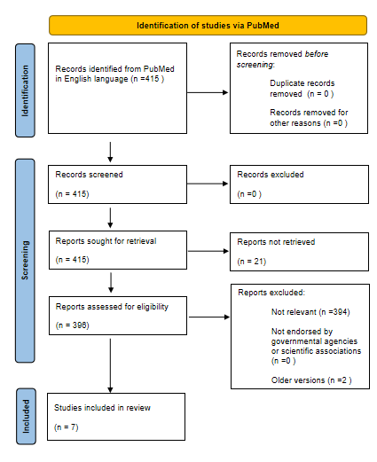
Figure 1 PRISMA flow diagram.
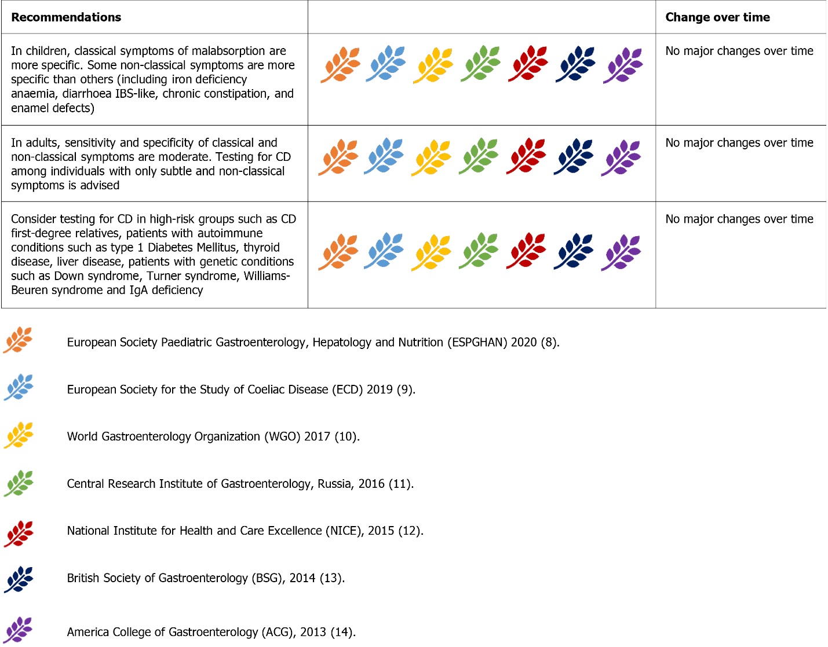
Figure 2 Recommendations about case finding.

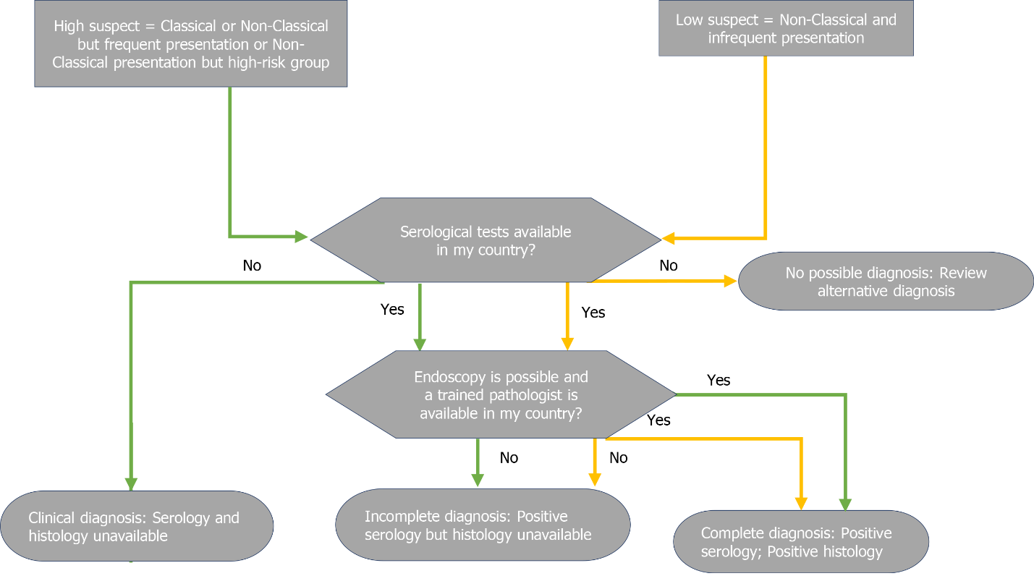
Figure 3 Worldwide adapted decision-making process for diagnosing celiac disease. Highly suspicious celiac disease (CD) comprises “classical presentation” (i.e., classical symptoms in children include failure to thrive, weight loss, growth failure, vomiting, chronic diarrhea, bloating, Iron-deficiency anemia, muscle wasting, oedema due to hypoproteinemia, irritability and unhappiness; in adults, classical symptoms include chronic diarrhea, weight loss, iron-deficiency anemia, malaise and fatigue, oedema due to hypoproteinemia, and osteoporosis), frequent “non-classical presentation” (i.e., iron deficiency and hypertransaminasemia) and “non-classical presentation” but high risk group (i.e., CD first-degree relatives, autoimmune conditions such as type 1 Diabetes Mellitus, and thyroid disease, genetic conditions such as IgA deficiency, Down syndrome, Turner syndrome and Williams-Beuren syndrome).
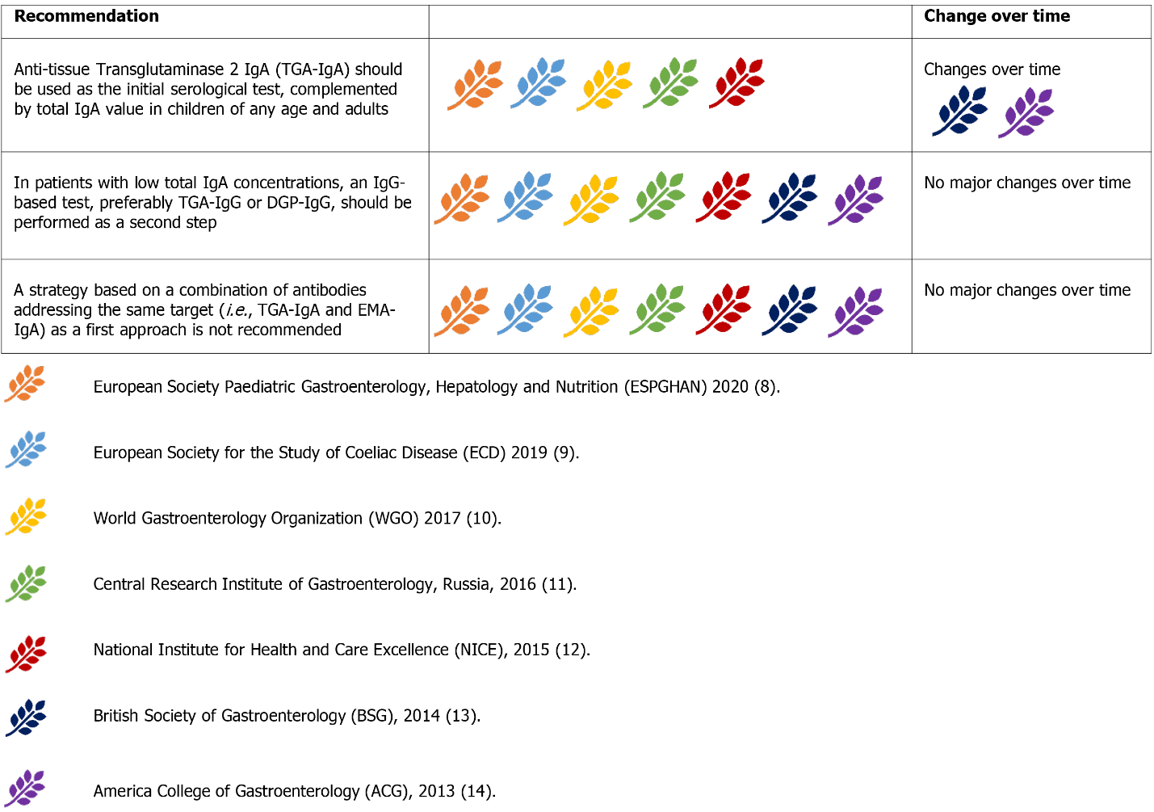
Figure 4 Recommendations about serology. IgA: Immunoglobulin A; IgG: Immunoglobulin G; DGP: Deamidated gliadin peptides; EMA: Anti-endomysium antibodies.
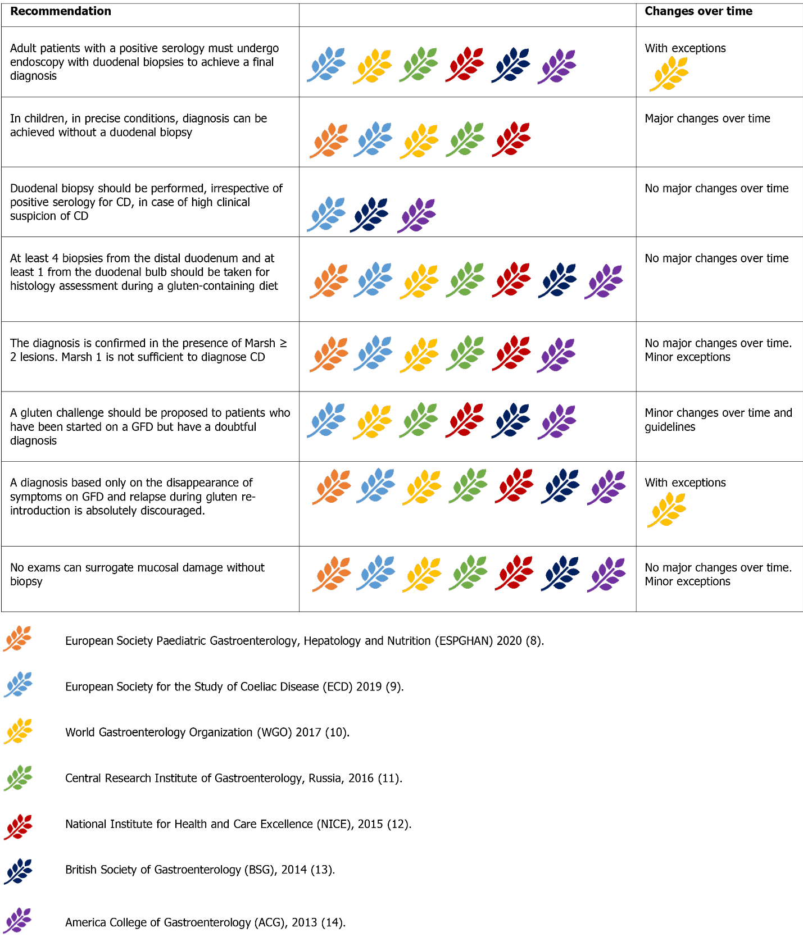
Figure 5 Recommendations about serology.
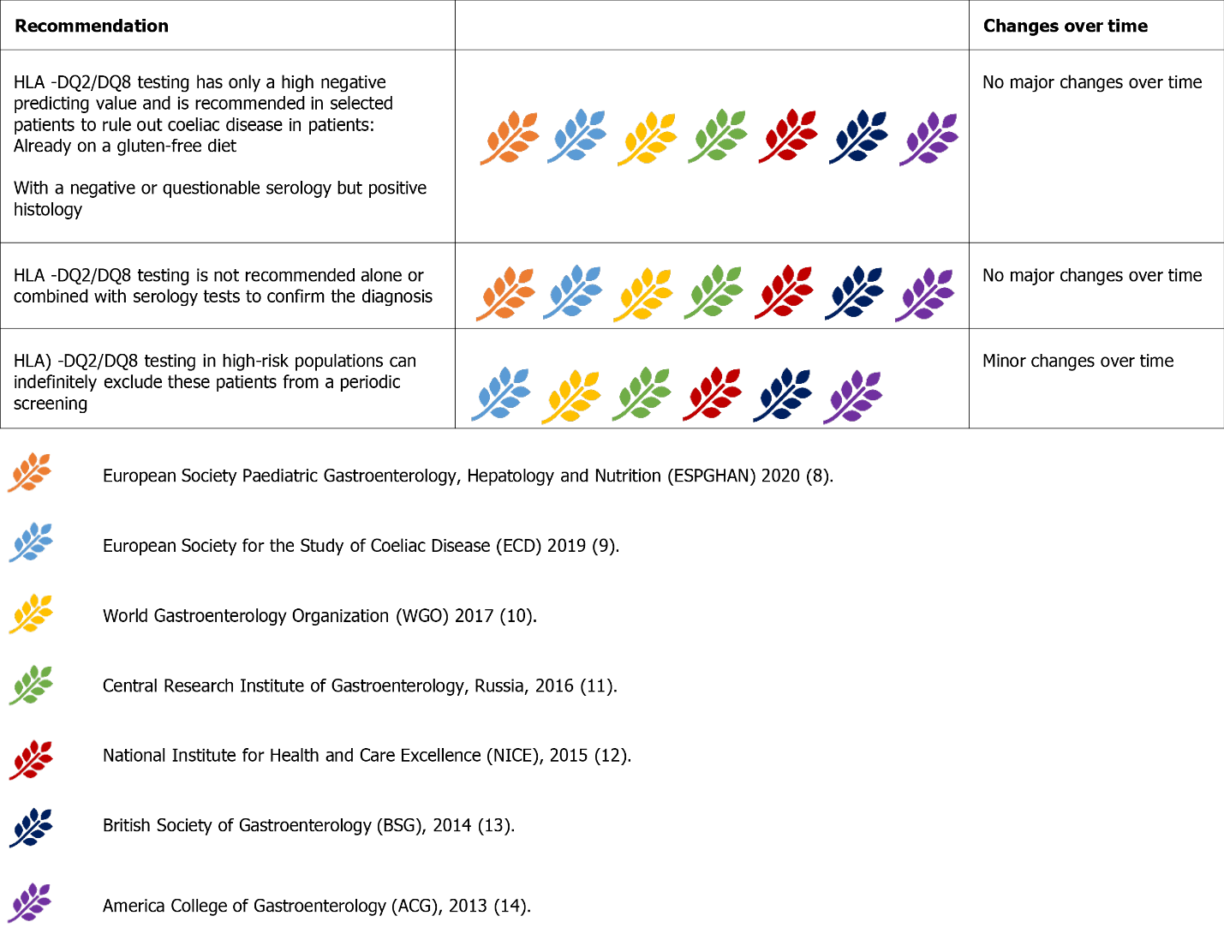
Figure 6 Recommendations about Human Leukocyte Antigen testing.
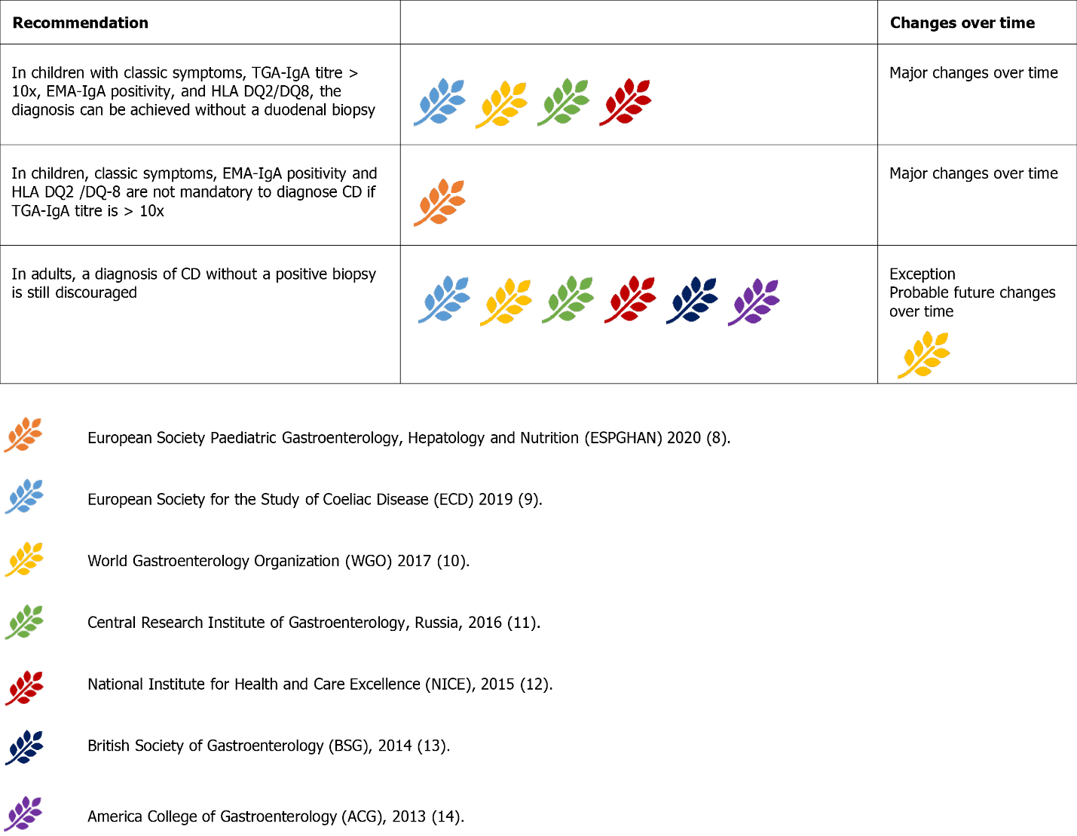
Figure 7 Recommendations about the possibility of a no-biopsy diagnosis. TGA: Anti-transglutaminase antibodies; IgA: Immunoglobulin A; EMA: Anti-endomysium antibodies; HLA: Human leukocytes antigen; CD: Celiac disease.
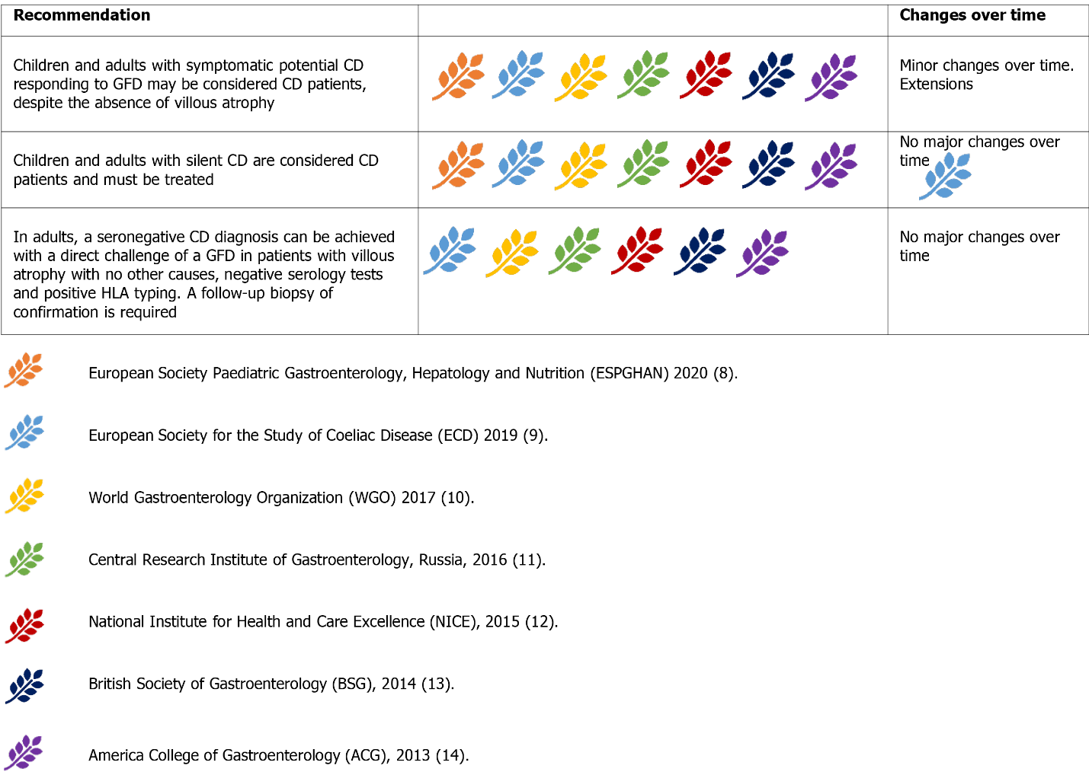
Figure 8 Recommendations about potential, silent, and seronegative celiac disease. GFD: Gluten-free diet; HLA: Human leukocytes antigen.
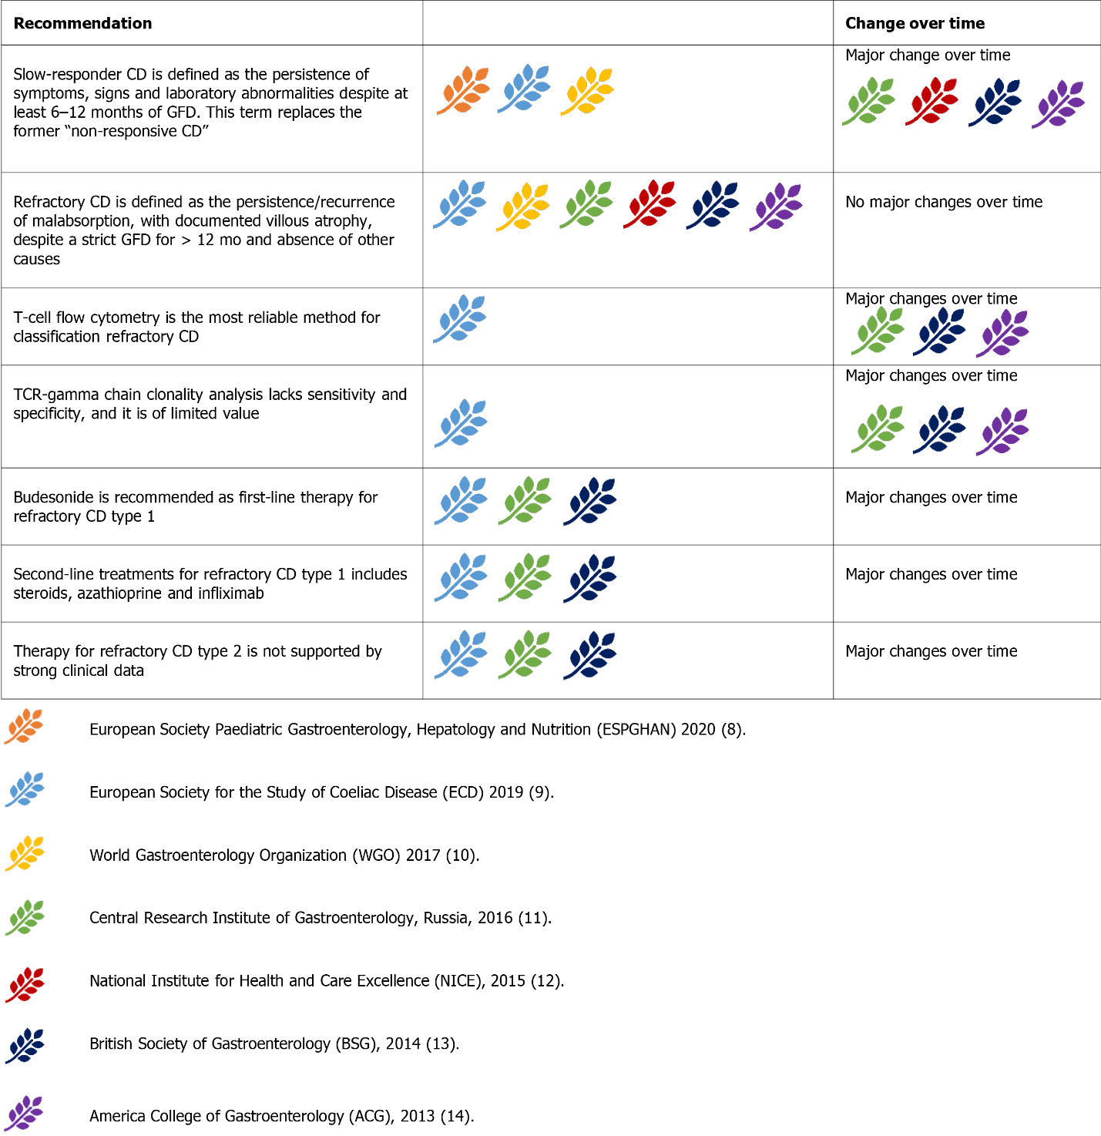
Figure 9 Recommendations about refractory and complicated celiac disease. GFD: Gluten-free diet; TCR: T-cell receptor.
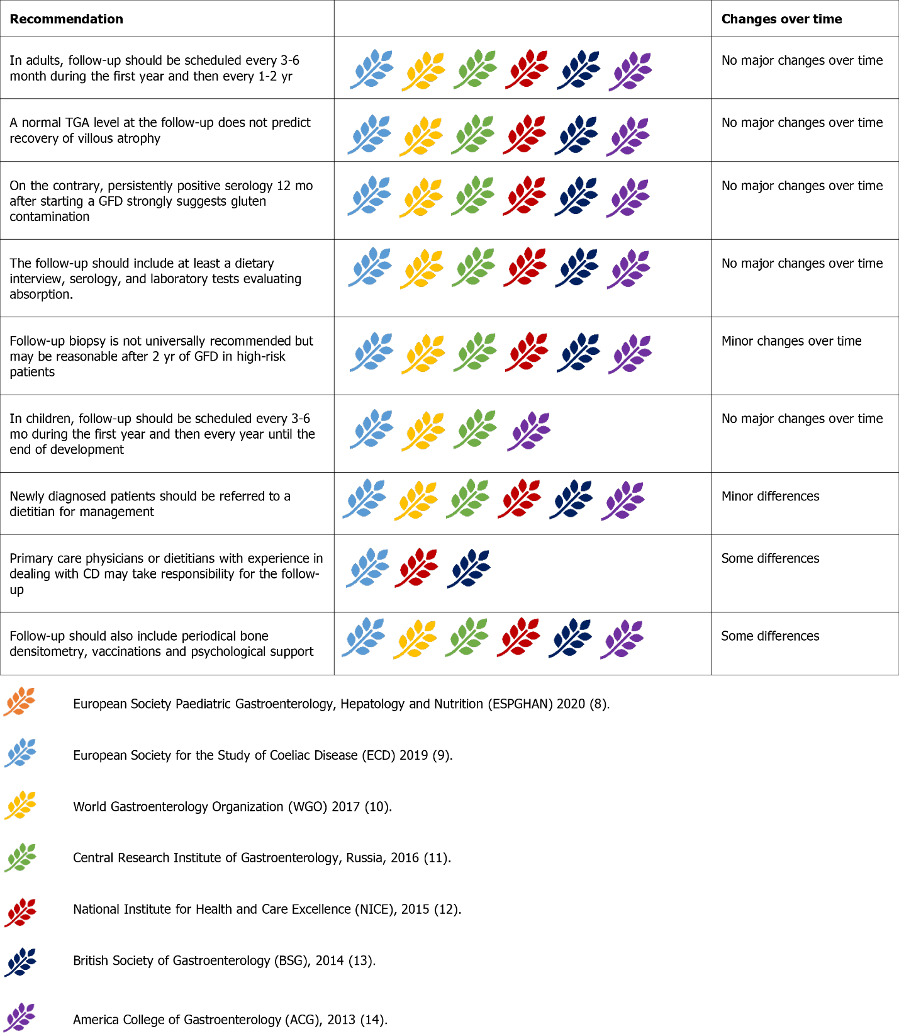
Figure 10 Recommendations about follow-up of celiac disease. TGA: Anti-transglutaminase antibodies; GFD: Gluten-free diet.
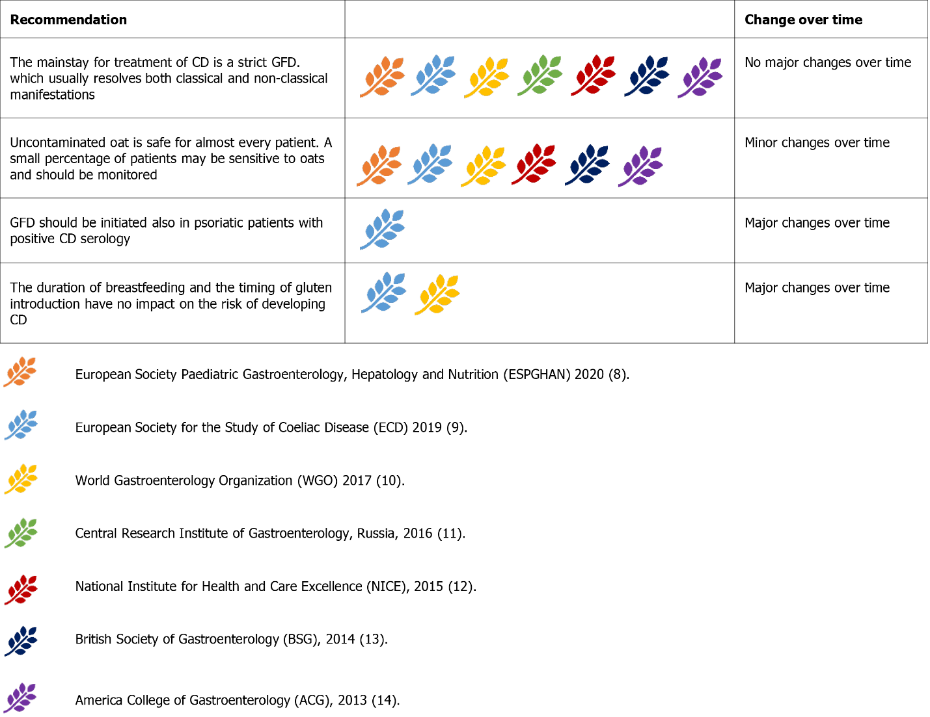
Figure 11 Recommendations about the gluten-free diet for celiac disease.
Table 1 Most frequent clinical manifestions of celiac disease
 | Intestinal | Extraintestinal
Classical | Diarroea | Iron deficiency anaemia
 | Failure to thrive | Muscle waisting
 | Weight loss | Oedema
 | Bloating
Non classical | Chronic abdominal pain | Short stature
 | Abdominal distension | Delayed puberty
 | Constipation | Amenorrhea
 | Vomiting | Irritability, unhappiness
 |  | Chronic fatigue
 |  | Epilepsy
 |  | Peripheral neuropathy
 |  | Joint/muscle pain
 |  | Elevated aminotransferases
 |  | Aphtous stomatitis
 |  | Recurrent miscarriages
 |  | Reduced bone mineral density

Published by Baishideng Publishing Group Inc
7041 Koll Center Parkway, Suite 160, Pleasanton, CA 94566, USA
Telephone: +1-925-3991568
E-mail: bpgoffice@wjgnet.com
Help Desk: https://www.f6publishing.com/helpdesk
https://www.wjgnet.com

© 2022 Baishideng Publishing Group Inc. All rights reserved.

