Name of Journal: World Journal of Gastroenterology
Manuscript NO: 73105
Manuscript Type: ORIGINAL ARTICLE

Basic Study
Long noncoding RNA negative regulator of antiviral response contributes to pancreatic ductal adenocarcinoma progression via targeting miR-299-3p

Wang HQ et al. NRAV promotes progression of pancreatic ductal adenocarcinoma

Hai-Quan Wang, Chun-Hua Qian, Zeng-Ya Guo, Pei-Ming Li, Zheng-Jun Qiu

Hai-Quan Wang, Zheng-Jun Qiu, Department of General Surgery, Shanghai General Hospital of Nanjing Medical University, Shanghai 200080, China

Hai-Quan Wang, Zeng-Ya Guo, Zheng-Jun Qiu, Pei-Ming Li, Department of General Surgery, Shanghai Jiao Tong University School of Medicine, Shanghai 200080, China

Chun-Hua Qian, Department of Endocrinology and Metabolism, Shanghai Tenth People’s Hospital, Shanghai 200072, China

Author contributions: Qiu ZJ and Wang HQ designed the experiments and revised the manuscript; Qian CH and Wang HQ performed most of the experiments; Li PM and Guo ZY analyzed the data; Wang HQ and Guo ZY wrote the manuscript; all authors discussed the results and reviewed the manuscript.

Supported by the National Natural Science Foundation of China, No. 81974372.

Corresponding author: Zheng-Jun Qiu, MD, Chief Doctor, Director, Surgeon, Department of General Surgery, Shanghai General Hospital of Nanjing Medical University, No. 100 Haining Road, Shanghai 200080, China. qiuzjdoctor@sina.com

Received: November 9, 2021
Revised: April 28, 2022
Accepted: September 1, 2022
Published online: September 21, 2022

Abstract
BACKGROUND
Pancreatic ductal cancer (PDAC) has high malignancy and poor prognosis. Long noncoding RNAs (lncRNAs) are associated with high levels of malignancy, including PDAC. However, the biological and clinical significance of negative regulator of antiviral response (NRAV) in PDAC is unclear.

AIM
To study the regulatory role of lncRNA NRAV in PDAC.

METHODS
GEPIA analyzed lncRNA NRAV and miRNA (miR-299-3p) expression levels in PDAC tissues and measured them in PDAC cells by quantitative measurements in real time. The specific role of NRAV and miR-299-3p in cell proliferation and transfer potential was evaluated by cell formation analysis, Cell Counting Kit-8 and Transwell analysis. The relationship between NRAV and miR-299-3p was studied by predictive bioinformatics, RNA immunoassay, and fluorescence enzyme analysis. In vivo experiments included transplantation of simulated tumor cells under naked mice.

RESULTS
The expression level of lncRNA NRAV was higher in both tumor tissues and cell lines of PDAC and was negatively associated with the clinical survival of PDAC patients. Functionally, overexpression of NRAV promoted cell proliferation and metastasis of PDAC cells, while knockdown of NRAV reversed these effects. Finally, NRAV was performed as a molecular sponge of miR-299-3p. Moreover, overexpression of miR-299-3p could reverse the promoting effects of NRAV on cell proliferation and metastasis of PDAC cells.

CONCLUSION
NRAV facilitates progression of PDAC as a molecular sponge of miR-299-3p and may be a potential molecular marker for diagnosis and treatment of PDAC.

Key Words: Long noncoding RNA; Negative regulator of antiviral response; miR-299-3p; Proliferation; Migration; Invasion; Pancreatic cancer

©The Author(s) 2022. Published by Baishideng Publishing Group Inc. All rights reserved.

Citation: Wang HQ, Qian CH, Guo ZY, Li PM, Qiu ZJ. Long noncoding RNA negative regulator of antiviral response contributes to pancreatic ductal adenocarcinoma progression via targeting miR-299-3p. World J Gastroenterol 2022; 28(35): 5141-5153
URL: https://www.wjgnet.com/1007-9327/full/v28/i35/5141.htm
DOI: https://dx.doi.org/10.3748/wjg.v28.i35.5141

Core Tip: In the present research, the expression level of long noncoding RNA negative regulator of antiviral response (NRAV) in pancreatic ductal adenocarcinoma (PDAC) was detected, and the clinicopathological relationship between NRAV and PDAC was demonstrated. Moreover, cell and animal tests were conducted to assess the concrete roles of NRAV in the progression of PDAC. Finally, the existence of potential specific molecular mechanisms that can provide new ideas for finding new molecular markers for the diagnosis and treatment of PDAC is demonstrated.

INTRODUCTION
As an extremely malignant tumor, pancreatic ductal adenocarcinoma (PDAC) has shown a rapidly increasing incidence rate in recent years worldwide^{[1]}. According to the latest cancer report in 2021, there are 495773 new cases reported globally every year and about 466003 people die of PDAC annually^{[2]}. Due to insufficient means of early diagnosis and effective treatment, the 5-year survival rate of PDAC patients is only about 8% and will drop to about 3% in patients with advanced PDAC^{[1]}. Therefore, it is urgent to establish a comprehensive pathological mechanism of PDAC and explore a more effective PDAC diagnosis and treatment center.
Long noncoding RNAs (lncRNAs) are new ncRNAs that are composed of > 200 nucleotides, accounting for the largest proportion of the entire human gene transcriptome^{[3,4]}. lncRNAs mainly regulate gene expression in a variety of ways, including chromatin remodeling and transcriptional and post-transcriptional processing, and participate in regulating a variety of biological processes^{[5,6]}. Recently, a large number of researches showed that lncRNAs are dysregulated in most tumors and function as key regulators in the process of tumor growth, metastasis, drug tolerance, and angiogenesis^{[7,8]}. The lncRNA negative regulator of antiviral response (NRAV) is a newly identified lncRNA and is mainly related to immunity^{[9]}. Xu et al^{[10]} found that NRAV is highly expressed in the cell system of hepatocytes and regulates the course of hepatocellular carcinoma. However, the statements and specific role of NRAV in PDAC are still unclear.
lncRNAs play an important regulatory role in the occurrence and development of various cancers and may be considered a potential molecular marker. Many studies have shown that RNA plays its biological function of competing with endogenous RNAs^{[11,12]}. Hsa-miR-299-3p plays an important role in the development of many cancers. Many studies describe the regulation of the relationship between miR-299-3p and lncRNAs^{[13,14]}. Many experts conducted in-depth research on the regulation of the relationship between the two and stated that miR-299-3p increased the volume and cellular system and prevented proliferation and metastasis of pancreatic cancer cells with exposure to Notch1^{[15]}. The relationship between NRAV and miR-299-3p in PDAC has not yet been investigated.
In this study, we tested the expression of NRAV in PDAC and studied its function, and found that NRAV and PDAC have obvious overlaps. The results of functional experiments showed that the level of NRAV expression was directly associated with cell proliferation and metastasis and was closely related to the growth of tumors in naked mice. In addition, we found that NRAV, as a molecular sponge of miR-299-3p, contributes to PDAC progression. Therefore, the results of this study may provide new insights into the role of NRAV in PDAC. It can be a biomarker for the diagnosis and treatment of PDAC.

MATERIALS AND METHODS
Cell lines
PDAC cell lines (PANC-1, AsPC-1, Mia Paca-2 and BxPC-3) and human immortalized normal pancreatic duct epithelial (HPDE) cells were obtained from the American Type Culture Collection (Manassas, VA, United States). The cell lines were cultured at an appropriate concentration in a specific environment in a moistened cell incubator with a CO₂ concentration of 5% at 37 °C. Percentage of 10 fetal serum and 1% penicillin–streptomycin were added to the culture medium, including RPMI-1640 and Dulbecco’s modified Eagle’s medium.

RNA isolation and quantitative real-time polymerase chain reaction
Total cellular RNA was extracted from cultured cells using Trizol reagent (Invitrogen, Carlsbad, CA, United States). For lncRNA, FastKing gDNA Dispeeling RT Supermix (TIANGEN, China) was selected for reverse transclncRNAn. The specific cDNAs of miRNAs were obtained with a specific kit (miDETECT A Track RT Reagent Kit; RiboBio, China). The quantitative real-time polymerase chain reaction (qRT-PCR) system wasABI 7300 PCR (Foster City, CA, United States). U6 and ACTB were respectively deemed as standardized internal controls of miRNA and lncRNA. The specific sequences of the primers were designed as follows. For NRAV, 5’-GGAGTTGATGCCTCCGAACA-3’ (forward) and 5’-ATGACCGGAGCTGAAAGGTG-3’ (reverse); for β-actin, 5’-TCCCTGGAGAAGAGCTACGA-3’ (forward) and 5’-AGCACTGTGTTGGCGTACAG-3’ (reverse); for miR-299-3p, 5’-ACACTCCAGCTGGGTATGTGGGATGGTAAAC-3’ (forward) and 5’-GTGCAGGGTCCGAGGT-3’ (reverse); and for U6, 5’-CTCGCTTCGGCAGCACA-3’ (forward) and 5’-AACGCTTCACGAATTTGCGT-3’ (reverse). The relative expression level of each gene was calculated with the 2^{−△△}Ct method.

Cell transfection
Lipofectamine 2000 kit (Invitrogen) was used to conduct cell transfection. Short hairpin RNAs (shRNAs) targeting NRAV were designed by Genepharma (Shanghai, China). The specific sequences targeting NRAV were designed as follows: For sh-NRAV #1, 5’-CACCTCATCCACAAGTAGGAC-3’; for sh-NRAV #2, 5’-TTGGAGCCAAGGACTGTACTG-3’; and negative control: 5’-TTCTCCGAACGTGTCACGT-3’. NRAV overexpression plasmid and shRNAs against NRAV were inserted into the pcDNA3.1 vector and pGpU6/GFP/Neo vector, respectively. The miR-299-3p mimic was purchased from RiboBio. qRT-PCR was performed to examine the transfection efficiency.

Cell Counting Kit-8 assay
A 96-well plate was selected, and 2000 tumor cells were cultured in each well. The cells were transfected with different vectors and allowed to stand for 48 h. Cell Counting Kit-8 (CCK-8) solution (10 μL; Mashiki, Japan) was added to each well, and incubated for 2 h. A microplate reader (Winooski, VT, United States) was used to check cell viability.

Colony formation assay
The specific PDAC cells transfected with different plasmids were inoculated into six-well plates and incubated at 37°C for 10 d. Tumor cells were fixed for 20 min in methanol after being washed with phosphate-buffered saline in triplicate. Cell colonies were stained and counted.

Transwell assay
In migration and invasion assays, PDAC cells were added to resuspension after setting a concentration of 10⁵ mL in a serum-free environment. Two hundred microliters of cell suspension was added to the upper layer of each Transwell chamber and 600 μL of complete media containing 10% fetal serum was added to the lower layer. To set up the invasion analysis phase, the Matrigel layer (BD Biosciences, United States) was first applied to the chamber membrane, and the cell suspension was placed on top of the transition chamber. A 24-h incubation was followed and the invasive cells were finally fixed and monitored and compared in five random fields.

Tumor xenograft experiments
All animal studies were approved by the Ethics Committee for Animal Studies at Shanghai 10th People’s Hospital. Specific PANC-1 cells (2 × 10⁶, 200/L) were transplanted subcutaneously to the right side of naked male mice aged 4 wk. The condition of the mice was monitored daily and the size of the tumor was measured every 5 d. Tumor volume was calculated according to tumor length and length formula volume = length through × wide²/2. Twenty days after inoculation, mice were killed and the entire tumor removed and weighed.

Immunohistochemical analysis
Mouse tumors were removed for immunohistochemical staining to visualize Ki-67 expression. Paraffin-embedded sections were prepared and wax removed in 100% xylene, followed by rehydration with various gradients of ethanol and distilled water. The fabric is dyed with a protractor for 1 h at room temperature and removed during washing with distilled water. Tissue sections were incubated for 20 min with secondary antibodies bound to horseradish peroxidase. To facilitate visualization, 3,3’-diaminobenzidine tetrahydrochloride Ki-67 was selected for positive staining.

Nuclear/cytoplasmic fractionation assay
The PARIS Kit (Life Technologies, United States) was used to isolate RNA from the nucleus and cytoplasm. qRT-PCR assays were conducted as described above.

RNA immunoprecipitation assay
RNA immunoprecipitation (RIP) assays were performed by EZ-Magna RNA Immunosuppression Kit (Millipore, United States). The cells were collected and resuspended in an immunodeposition buffer and kept on ice for 30 min. The cell suspension was incubated with a separate RIP buffer containing magnetic beads. Proteinase K was added to the bead state after buffering for further digestion of proteins. All RNA was extracted with Trizol and measured with qRT-PCR.

Dual-luciferase activity assay
According to a special combination of software for network prediction starbes 3.0 and NRAV miR-299-3p (http://starbase.sysu.edu.cn/ b). Other matters according to the V2 specification (enzyme, China), it is a rapid mutation reagent for NRAV, and supplementary DNA and mutant miR-299-3p are added to psicheck2 (US Promega) (NRAV wild and music) satellite. Paycheck-2 and miR-229-3p plasmid samples or miR-229-3p negative control were transferred to PDAC cells. After 48 h, the fluorescent enzyme activity of each well was examined by the Promega reporting system. The relative activity of luciferase is used for normalization.

Statistical analysis
Statistical analysis was performed using GraphPad Prisma 8.2 (LA Jolla, CA, United States) and SPSS 22.0 (IBM, Armonk, NY, United States). Student t test was used to compare the differences between the two groups and calculate the P value. P < 0.05 was statistically significant.

RESULTS
NRAV was significantly upregulated in PDAC and predicted poor prognosis
We used GEPIA to determine NRAV expression levels as an online bioinformatics tool for gene expression analysis based on the cancer genome database (TCGA)^{[16]}. NRAV expression of PDAC in tissues was significantly higher than that in nonmedical tissues (Figure 1A and B). The survival curve showed that the total life cycle (P = 0.034; Figure 1D) and disease-free life cycle (P = 0.046; Figure 1E) of PDAC patients were decreasing. The data of the TCGA database showed that the level of emotional expression was negatively correlated with the level of clinical pathology (Figure 1C). The level of NRAV expression in HPDE cells and four PDAC systems was tested. NRAV in the PDAC cell system was significantly higher than that in HPDE cells (Figure 1F). Based on these data, we believe that NRAV may be a potential carcinogen related to lncRNA.

Knockdown of NRAV inhibited proliferation, migration and invasion of PDAC cells
We studied the biological role of NRAV in the PDAC cell system. We used heterogeneous RNA transplantation to reduce NRAV expression in PANC-1 and AsPC-1 cells. qRT-PCR showed a significant decrease in expression after NRAV (Figure 2A). After showing the results of CCK-8 tests and colony formation, there was a significant reduction after removal of signs of proliferation and abscision of PANC-1 and AsPC-1 cells (Figure 2B and C). We performed Transwell analysis to test whether NRAV affected metastasis and damage to police cells. Similarly, after the removal of PANC-1 and AsPC-1 cells, migration and invasion rates slowed significantly (Figure 2D and E). Knockdown of NRAV inhibited proliferation, migration and invasion of PDAC cells.

Overexpression of NRAV promoted PDAC cell proliferation, migration and invasion
High expression of NRAV in BXPC-3 and Mia PaCa-2 cells used to display exogenous particles confirmed the effectiveness of the expression (Figure 3A). The CCK-8 test and the product reduction test showed that NRAV overexpression significantly supported proliferation and formation of PDAC cells (Figure 3B and C). Transwell analysis found that NRAV overexpression significantly increased displacement and invasion of Mia PaCa-2 and BXPC-3 cells (Figure 3D and E). Overall, the results showed that NRAV promotes proliferation, metastasis and invasion of PDAC cells.

NRAV ablation inhibited tumor growth in vivo
To further investigate whether NRAV supports tumor growth in vivo, PANC-1 cells were injected into naked mice treated with sh-NRAV and internal control cells. The tumor volume of the NRAV genotype was significantly lower than the negative control volume (Figure 4A and B). Similarly, the mass of the tumor in the NRAV group (Figure 4C) was significantly reduced compared to the control group. Ki-67 was analyzed for lignin content and immunochemical staining. Reduction of NRAV led to a significant reduction of Ki-67 and inhibition of tumor growth (Figure 4D and E). Overall, these findings suggest that NRAV does not inhibit tumor growth in vivo.

NRAV acted as a molecular sponge for miR-299-3p in PDAC
To study how NRAV plays a catalytic role in PDAC, we used the nuclear/cell separation method to determine the location of NRAV in PDAC. Spleen qi was mainly located in cells (Figure 5A), and it can exert its biological function as a competitive endogenous RNA^{[17,18]}. We used starbase V3.0 (http://starbase.sysu.edu.cn/) Interactive Bio information Analysis Software to identify potential miRNAs that may interact with genes. miR-299-3p was selected as the tempered target due to potential point complementarity (Figure 5B). Rip analysis confirms this point^{[19]}. As shown in Overexpression in PDAC cells resulted in significant enrichment of miR-299-3p on ago2 (Figure 5C). The miR-299-3p simulator significantly reduced the fluorescence activity of the wild-type NRAV group, while this change did not occur in the modified NRAV group (Figure 5D). qRT-PCR showed that expression of miR-299-3p in PDAC cells was significantly enhanced after removing the traits (Figure 5E). Spearman’s analysis showed that expression of NRAV and miR-299-3p in PDAC tissue was opposite (Figure 5F). Therefore, these results suggest that temper may play the role of molecular sponge miR-299-3p.

miR-299-3p reversed the effect of NRAV on PDAC cells
To validate whether NRAV affected proliferation and metastasis of PDAC cells through sponging miR-299-3p, specific miR-299-3p mimic or mimic NC vector was cotransfected into PDAC cells after overexpression of NRAV. Subsequently, we evaluated the cell proliferation, migration and invasion of PDAC cells. miR-299-3p mimic reversed the dramatic promotion by overexpression of NRAV on proliferation (Figure 6A and B). Similarly, miR-299-3p mimic inhibited the promoting effects of NRAV overexpression on migration and invasion of PDAC cells (Figure 6C and D). These results indicated that miR-299-3p mediated the promoting effects of NRAV on PDAC cell proliferation, migration and invasion.

DISCUSSION
An increasing number of studies have shown that lncRNAs play an important role in the development of various malignant tumors. Recent studies have shown that large amounts of lncRNAs are abnormally expressed in PDAC and participate in the tumor process^{[20,21]}. Guo et al^{[22]} found that under hypoxia, lncRNAs extract of PDAC UCA1 cells increased to promote angiogenesis. We used the TCGA database to identify NRAV in PDAC. We confirmed that the code of good conduct is a key element related to the program of action, and that significant progress has been made in the program of action. In addition, in PDAC patients, high levels of NRAV expression inhibit overall and disease-free survival. It is worth noting that NRAV may participate in PDAC progression.
The specific role of NRAV in oncology is not clear due to increased immunization. Recent studies have shown that NRAV expression is significantly increased in liver cancer and myeloma and can play a key role in the development of these two tumors^{[10,23]}. To verify the biological function of NRAV in PDAC, function loss and acquisition studies were carried out. The results of in vitro experiments showed that temper has a major contribution to the migration, invasion and reproduction of PDAC cells. In addition, ablation temperament significantly reduced the tumor of the nude mouse model overall, these results show that the NRAV plays an important role in promoting cancer and can be used as a new biometric index for diagnosis and prediction of diseases caused by PDAC.
To further study the potential mechanism of NRAV, nuclear/cell division experiments were carried out in PDAC, and NRAV was mainly in the cytoplasm. Further analysis of the rip report analysis showed that NRAV may play the role of miR-299-3p molecular sponge (Figure 7). In addition, the stimulation effect of NRAV on malignant tumors in PDAC cells was also proved in the rescue experiment. The role of NRAV in promoting progression of PDAC mainly depends on miR-299-3p.
At the beginning of the study, it was emphasized that the significant increase in lncRNA was negatively correlated with overall and disease-free survival in PDAC patients. In addition, it also plays a carcinogenic role by promoting the proliferation and metastasis of cells in the sponge world. Our research shows that NRAV/miR-299-3p play a key role in PDAC and can be used as potential biomarkers for PDAC diagnosis and treatment.
However, because no samples from patients with pancreatic cancer were collected, there was a lack of correlation analysis between temperament expression and PDAC clinicopathological features. In addition, it is also of great significance to study the significance of NRAV and miR-299-3p in PDAC organization.

CONCLUSION
NRAV can act as a molecular sponge of miR-299-3p and significantly promote the proliferation and metastasis of PDAC cells.

ARTICLE HIGHLIGHTS
Research background
Pancreatic ductal adenocarcinoma (PDAC) has high malignancy and poor prognosis. Long noncoding RNAs (lnRNAs) are recognized as crucial factors and associated with progression of PDAC. However, the specific biological role and practical clinical significance of lnRNAs and negative regulator of antiviral response (NRAV) in PDAC remain unclear.

Research motivation
Early and timely diagnosis and treatment of PDAC are still scarce. Therefore, it is a matter of urgency to comprehensively understand the pathogenesis of PDAC and explore more effective targets for its diagnosis and treatment.

Research objectives
To study the role of NRAV in the growth and metastasis of PDAC.

Research methods
Real-time polymerase chain reaction detected expression of NRAV and miR-299-3p in PDAC cells. The temperament correction and miR-299-3p in the process of cell proliferation, metastasis and invasion were verified by Cell Counting Kit-8, precipitation test, and Transwell assay. RNA and fluorescent enzyme immunoprecipitation test to test the interaction between NRAV and miR-299-3p. Verify the interaction between NRAV and miR-299-3p.

Research results
According to our data, NRAV in PDAC was significantly increased, which is related to the negative survival rate of PDAC patients. NRAV overexpression was conducive to the proliferation and metastasis of PDAC cells, and NRAV knockout reversed these effects. Finally, in terms of mechanism, NRAV acts as a miR-299-3p molecular sponge. Overexpression of miR-299-3p significantly changed the role of NRAV in the proliferation, metastasis and invasion of PDAC cells.

Research conclusions
NRAV promotes proliferation and metastasis of PDAC by playing the molecule sponge function of miR-299-3p.

Research perspectives
NRAV facilitated the progression of PDAC, which provides a potential biological marker for diagnosis and therapeutic target for PDAC.

REFERENCES
1 Siegel RL, Miller KD, Fuchs HE, Jemal A. Cancer Statistics, 2021. CA Cancer J Clin 2021; 71: 7-33 [PMID: 33433946 DOI: 10.3322/caac.21654]
2 Sung H, Ferlay J, Siegel RL, Laversanne M, Soerjomataram I, Jemal A, Bray F. Global Cancer Statistics 2020: GLOBOCAN Estimates of Incidence and Mortality Worldwide for 36 Cancers in 185 Countries. CA Cancer J Clin 2021; 71: 209-249 [PMID: 33538338 DOI: 10.3322/caac.21660]
3 Esteller M. Non-coding RNAs in human disease. Nat Rev Genet 2011; 12: 861-874 [PMID: 22094949 DOI: 10.1038/nrg3074]
4 Nagano T, Fraser P. No-nonsense functions for long noncoding RNAs. Cell 2011; 145: 178-181 [PMID: 21496640 DOI: 10.1016/j.cell.2011.03.014]
5 Guttman M, Rinn JL. Modular regulatory principles of large non-coding RNAs. Nature 2012; 482: 339-346 [PMID: 22337053 DOI: 10.1038/nature10887]
6 Yao RW, Wang Y, Chen LL. Cellular functions of long noncoding RNAs. Nat Cell Biol 2019; 21: 542-551 [PMID: 31048766 DOI: 10.1038/s41556-019-0311-8]
7 Bhan A, Soleimani M, Mandal SS. Long Noncoding RNA and Cancer: A New Paradigm. Cancer Res 2017; 77: 3965-3981 [PMID: 28701486 DOI: 10.1158/0008-5472.CAN-16-2634]
8 Arun G, Diermeier SD, Spector DL. Therapeutic Targeting of Long Non-Coding RNAs in Cancer. Trends Mol Med 2018; 24: 257-277 [PMID: 29449148 DOI: 10.1016/j.molmed.2018.01.001]
9 Ouyang J, Zhu X, Chen Y, Wei H, Chen Q, Chi X, Qi B, Zhang L, Zhao Y, Gao GF, Wang G, Chen JL. NRAV, a long noncoding RNA, modulates antiviral responses through suppression of interferon-stimulated gene transcription. Cell Host Microbe 2014; 16: 616-626 [PMID: 25525793 DOI: 10.1016/j.chom.2014.10.001]
10 Xu Q, Wang Y, Huang W. Identification of immune-related lncRNA signature for predicting immune checkpoint blockade and prognosis in hepatocellular carcinoma. Int Immunopharmacol 2021; 92: 107333 [PMID: 33486322 DOI: 10.1016/j.intimp.2020.107333]
11 Chan JJ, Tay Y. Noncoding RNA:RNA Regulatory Networks in Cancer. Int J Mol Sci 2018; 19 [PMID: 29702599 DOI: 10.3390/ijms19051310]
12 Chen W, Zhang K, Yang Y, Guo Z, Wang X, Teng B, Zhao Q, Huang C, Qiu Z. MEF2A-mediated lncRNA HCP5 Inhibits Gastric Cancer Progression via MiR-106b-5p/p21 Axis. Int J Biol Sci 2021; 17: 623-634 [PMID: 33613117 DOI: 10.7150/ijbs.55020]
13 Duan H, Li X, Chen Y, Wang Y, Li Z. LncRNA RHPN1-AS1 promoted cell proliferation, invasion and migration in cervical cancer via the modulation of miR-299-3p/FGF2 axis. Life Sci 2019; 239: 116856 [PMID: 31525429 DOI: 10.1016/j.lfs.2019.116856]
14 Bai N, Ma Y, Zhao J, Li B. Knockdown of lncRNA HCP5 Suppresses the Progression of Colorectal Cancer by miR-299-3p/PFN1/AKT Axis. Cancer Manag Res 2020; 12: 4747-4758 [PMID: 32606965 DOI: 10.2147/CMAR.S255866]
15 Xu K, Zhang L. Inhibition of TUG1/miRNA-299-3p Axis Represses Pancreatic Cancer Malignant Progression via Suppression of the Notch1 Pathway. Dig Dis Sci 2020; 65: 1748-1760 [PMID: 31655908 DOI: 10.1007/s10620-019-05911-0]
16 Tang Z, Li C, Kang B, Gao G, Li C, Zhang Z. GEPIA: a web server for cancer and normal gene expression profiling and interactive analyses. Nucleic Acids Res 2017; 45: W98-W102 [PMID: 28407145 DOI: 10.1093/nar/gkx247]
17 Salmena L, Poliseno L, Tay Y, Kats L, Pandolfi PP. A ceRNA hypothesis: the Rosetta Stone of a hidden RNA language? Cell 2011; 146: 353-358 [PMID: 21802130 DOI: 10.1016/j.cell.2011.07.014]
18 Batista PJ, Chang HY. Long noncoding RNAs: cellular address codes in development and disease. Cell 2013; 152: 1298-1307 [PMID: 23498938 DOI: 10.1016/j.cell.2013.02.012]
19 Gregory RI, Chendrimada TP, Cooch N, Shiekhattar R. Human RISC couples microRNA biogenesis and posttranscriptional gene silencing. Cell 2005; 123: 631-640 [PMID: 16271387 DOI: 10.1016/j.cell.2005.10.022]
20 Wang Y, Zhou L, Lu J, Jiang B, Liu C, Guo J, Xiao GG. Research progress on long non-coding RNAs and their roles as potential biomarkers for diagnosis and prognosis in pancreatic cancer. Cancer Cell Int 2020; 20: 457 [PMID: 32973402 DOI: 10.1186/s12935-020-01550-y]
21 Tasaki Y, Suzuki M, Katsushima K, Shinjo K, Iijima K, Murofushi Y, Naiki-Ito A, Hayashi K, Qiu C, Takahashi A, Tanaka Y, Kawaguchi T, Sugawara M, Kataoka T, Naito M, Miyata K, Kataoka K, Noda T, Gao W, Kataoka H, Takahashi S, Kimura K, Kondo Y. Cancer-Specific Targeting of Taurine-Upregulated Gene 1 Enhances the Effects of Chemotherapy in Pancreatic Cancer. Cancer Res 2021; 81: 1654-1666 [PMID: 33648930 DOI: 10.1158/0008-5472.CAN-20-3021]
22 Guo Z, Wang X, Yang Y, Chen W, Zhang K, Teng B, Huang C, Zhao Q, Qiu Z. Hypoxic Tumor-Derived Exosomal Long Noncoding RNA UCA1 Promotes Angiogenesis via miR-96-5p/AMOTL2 in Pancreatic Cancer. Mol Ther Nucleic Acids 2020; 22: 179-195 [PMID: 32942233 DOI: 10.1016/j.omtn.2020.08.021]
23 Maimaiti A, Jiang L, Wang X, Shi X, Pei Y, Hao Y, Paerhati H, Zibibula Y, Abudujielili A, Kasimu M. Identification and validation of an individualized prognostic signature of lower-grade glioma based on nine immune related long non-coding RNA. Clin Neurol Neurosurg 2021; 201: 106464 [PMID: 33454543 DOI: 10.1016/j.clineuro.2020.106464]

Footnotes
Institutional animal care and use committee statement: All procedures involving animals were reviewed and approved by the Institutional Animal Care and Use Committee of the Animal Ethics Committee of Shanghai General Hospital, No. SHDSYY-2020-T1663.

Conflict-of-interest statement: There are no conflicts of interest to report.

Data sharing statement: The authors are amenable to data sharing.

ARRIVE guidelines statement: The authors have read the ARRIVE Guidelines, and the manuscript was prepared and revised according to the ARRIVE Guidelines.

Open-Access: This article is an open-access article that was selected by an in-house editor and fully peer-reviewed by external reviewers. It is distributed in accordance with the Creative Commons Attribution NonCommercial (CC BY-NC 4.0) license, which permits others to distribute, remix, adapt, build upon this work non-commercially, and license their derivative works on different terms, provided the original work is properly cited and the use is non-commercial. See: https://creativecommons.org/Licenses/by-nc/4.0/

Provenance and peer review: Unsolicited article; Externally peer reviewed.
Peer-review model: Single blind

Peer-review started: November 9, 2021
First decision: April 16, 2022
Article in press: September 1, 2022

Specialty type: Medicine, research and experimental
Country/Territory of origin: China
Peer-review report’s scientific quality classification
Grade A (Excellent): 0
Grade B (Very good): B, B
Grade C (Good): C, C
Grade D (Fair): 0
Grade E (Poor): 0

P-Reviewer: Karamarkovic AR, Serbia; Nagaya M, Japan; Nakano H, Japan; Sheykhhasan M, Iran S-Editor: Chen YL L-Editor: Kerr C P-Editor: Cai YX
Figure Legends
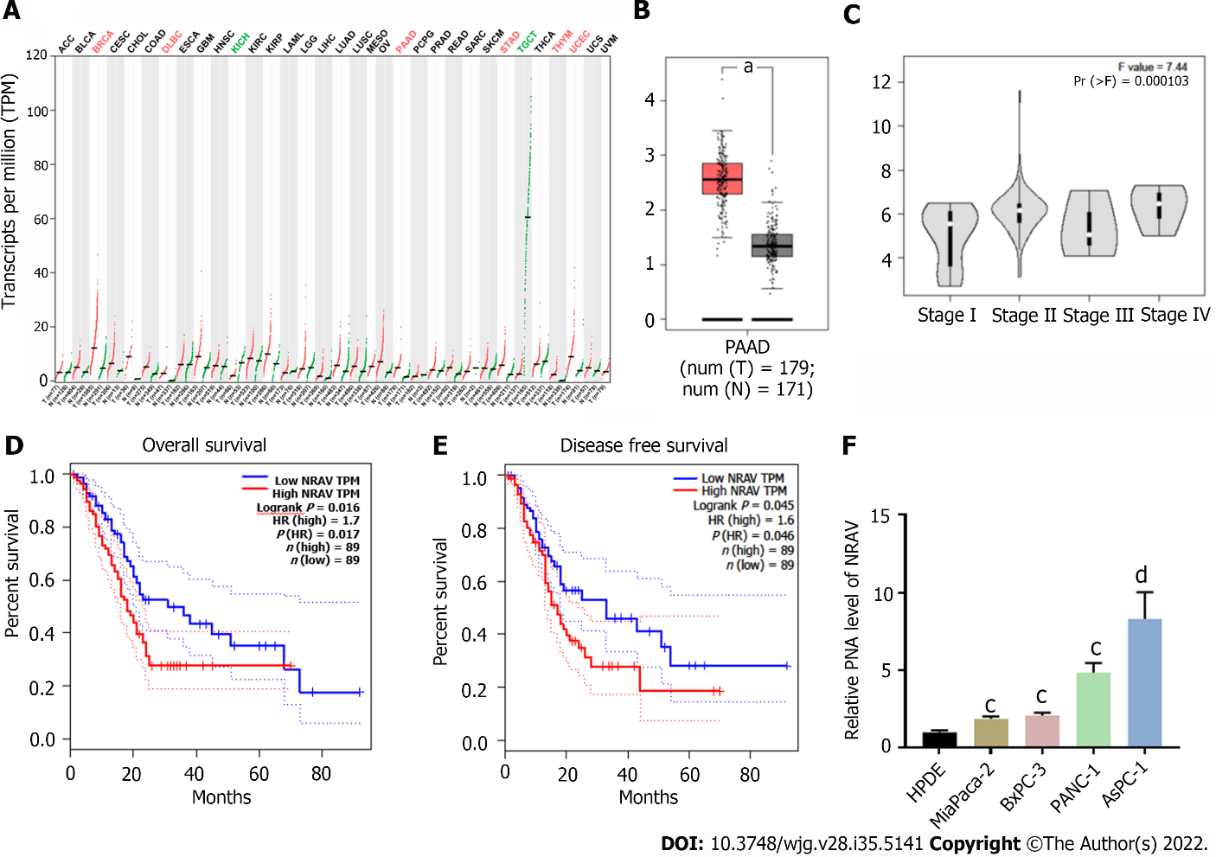
Figure 1 Relative expression of negative regulator of antiviral response in pancreatic cancer tissues and cells and its clinical significance. A: The negative regulator of antiviral response (NRAV) expression profile across all tumor samples and paired normal tissues; B: The NRAV expression of pancreatic adenocarcinoma in tissues was significantly higher than that in normal pancreas tissues; C: Expression of NRAV in patients divided by cancer stages using expression data from The Cancer Genome Atlas (TCGA) database; D: Overall survival analyzed by GEPIA based on the TCGA database; E: Disease-free survival analyzed by GEPIA based on the TCGA database; F: Quantitative real-time polymerase chain reaction analysis measured NRAV expression level in four pancreatic cancer and normal cell lines. ^{c}P < 0.001; ^{d}P < 0.0001. PAAD: Pancreatic adenocarcinoma; TPM: Transcripts per million; NRAV: Negative regulator of antiviral response; HR: Hazard ratio.
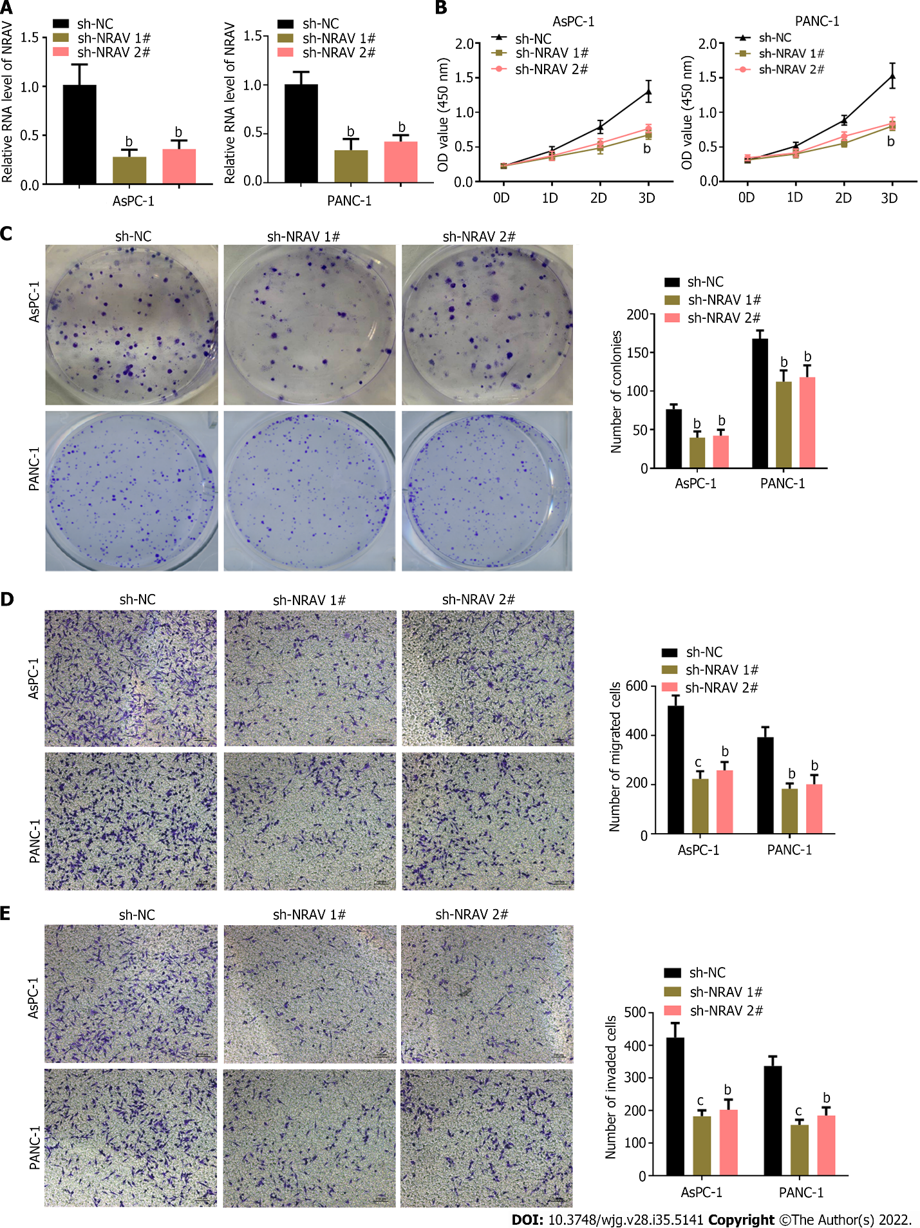
Figure 2 Knockdown of negative regulator of antiviral response inhibited proliferation, migration and invasion of pancreatic cancer cells. A: Quantitative real-time polymerase chain reaction analysis assessed expression of NRAV in PANC-1 and AsPC-1 cells transfected with shNC, shRNA #1 and shRNA #2 targeting negative regulator of antiviral response; B: Cell Counting Kit-8 analysis showed that compared with the NC group, NRAV gene knockout significantly reduced the proliferation of PANC-1 and AsPC-1 cells; C: The colony formation test showed that NRAV ablation inhibited the colony numbers of PANC-1 and AsPC-1 cells; D: Transwell assays were performed to measure migration of PANC-1 and AsPC-1 cells; E: Transwell assays were performed to measure invasion of PANC-1 and AsPC-1 cells. ^{b}P < 0.01; ^{c}P < 0.001. NRAV: Negative regulator of antiviral response; sh: Short hairpin; NC: Negative control.
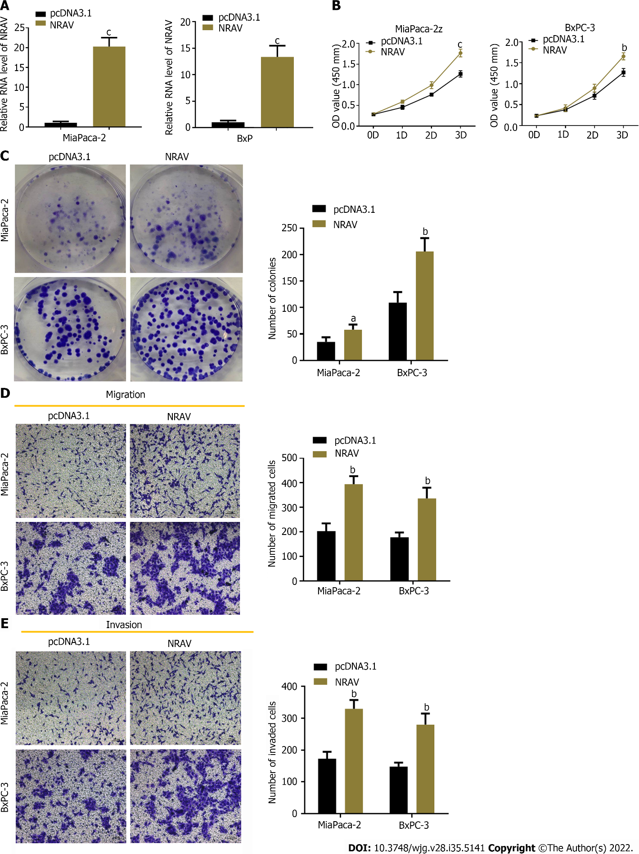
Figure 3 Overexpression of negative regulator of antiviral response promoted pancreatic cancer cell proliferation, migration and invasion. A: Quantitative real-time polymerase chain reaction measured negative regulator of antiviral response (NRAV) expression in Mia Paca-2 and BxPC-3 cells transfected with pcDNA3.1 empty vector or pcDNA3.1-NRAV; B: Cell Counting Kit-8 was performed to detect proliferation of Mia Paca-2 and BxPC-3 cells; C: Colony formation test showed that NRAV overexpression increased the number of clones of Mia-Paca-2 and BXPC-3 cells; D: Transwell assays were performed to measure migration of Mia Paca-2 and BxPC-3 cells; E: Transwell assays were performed to measure invasion of Mia Paca-2 and BxPC-3 cells. ªP < 0.05; ^{b}P < 0.01; ^{c}P < 0.001. NRAV: Negative regulator of antiviral response.
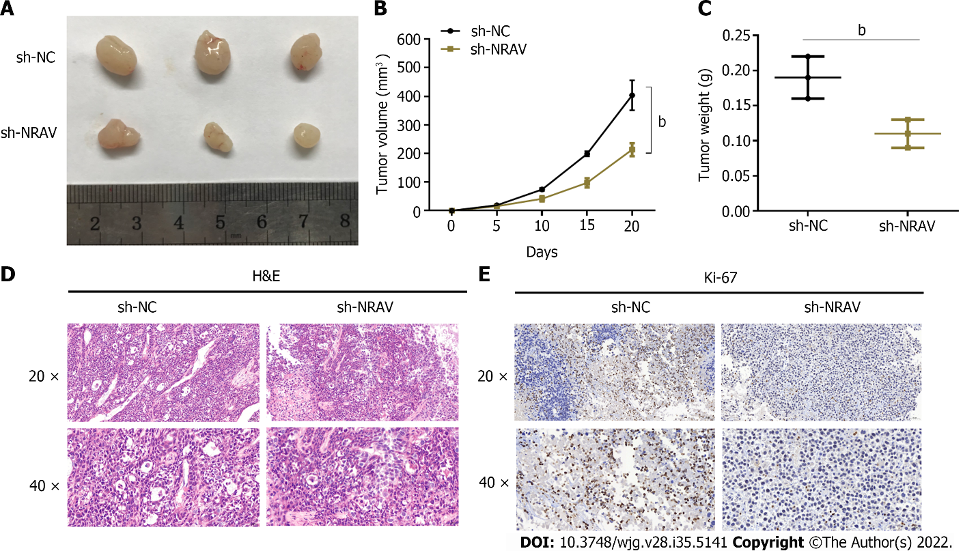
Figure 4 Negative regulator of antiviral response ablation inhibited tumor growth in a mouse xenograft models. A: Representative images of xenograft tumors after transfection with short hairpin NC or sh-negative regulator of antiviral response (NRAV); B: Tumor volume was measured; C: Tumor weight was measured; D: Representative images of hematoxylin and eosin staining for xenograft tumor tissue samples; E: Expression pattern of Ki-67 in the harvested tumor tissues was detected by immunohistochemical staining. ^{b}P < 0.01. sh: Short hairpin; NRAV: Negative regulator of antiviral response; NC: Negative control.
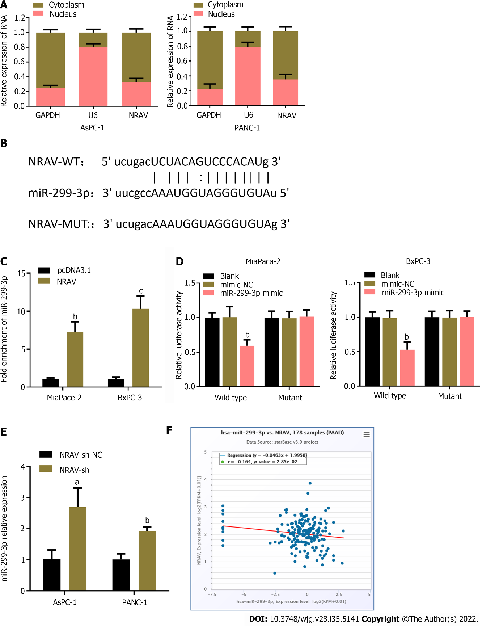
Figure 5 Negative regulator of antiviral response acted as a molecular sponge for miR-299-3p. A: Subcellular fractionation assay was used to determine the subcellular localization of NRAV; B: A complementary binding site of NRAV in miR-299-3p was predicted via starBase v3.0 online database; C: RNA immunoprecipitation assays were performed to validate whether NRAV could interact with miR-299-3p in MiaPaca-2 and BxPC-3 cells; D: Luciferase reporter assays were carried out to verify the direct binding of NRAV and miR-299-3p in MiaPaca-2 and BxPC-3 cells; E: Relative expression of miR-299-3p in AsPC-1 and PANC-1 cells following knockdown of NRAV; F: Spearman’s correlation analysis between NRAV and miR-299-3p expression in PAAD by the starBase v3.0 project. ªP < 0.05; ^{b}P < 0.01; ^{c}P < 0.001. NRAV: Negative regulator of antiviral response; MUT: Mutant; NC: Negative control; WT: Wild-type.
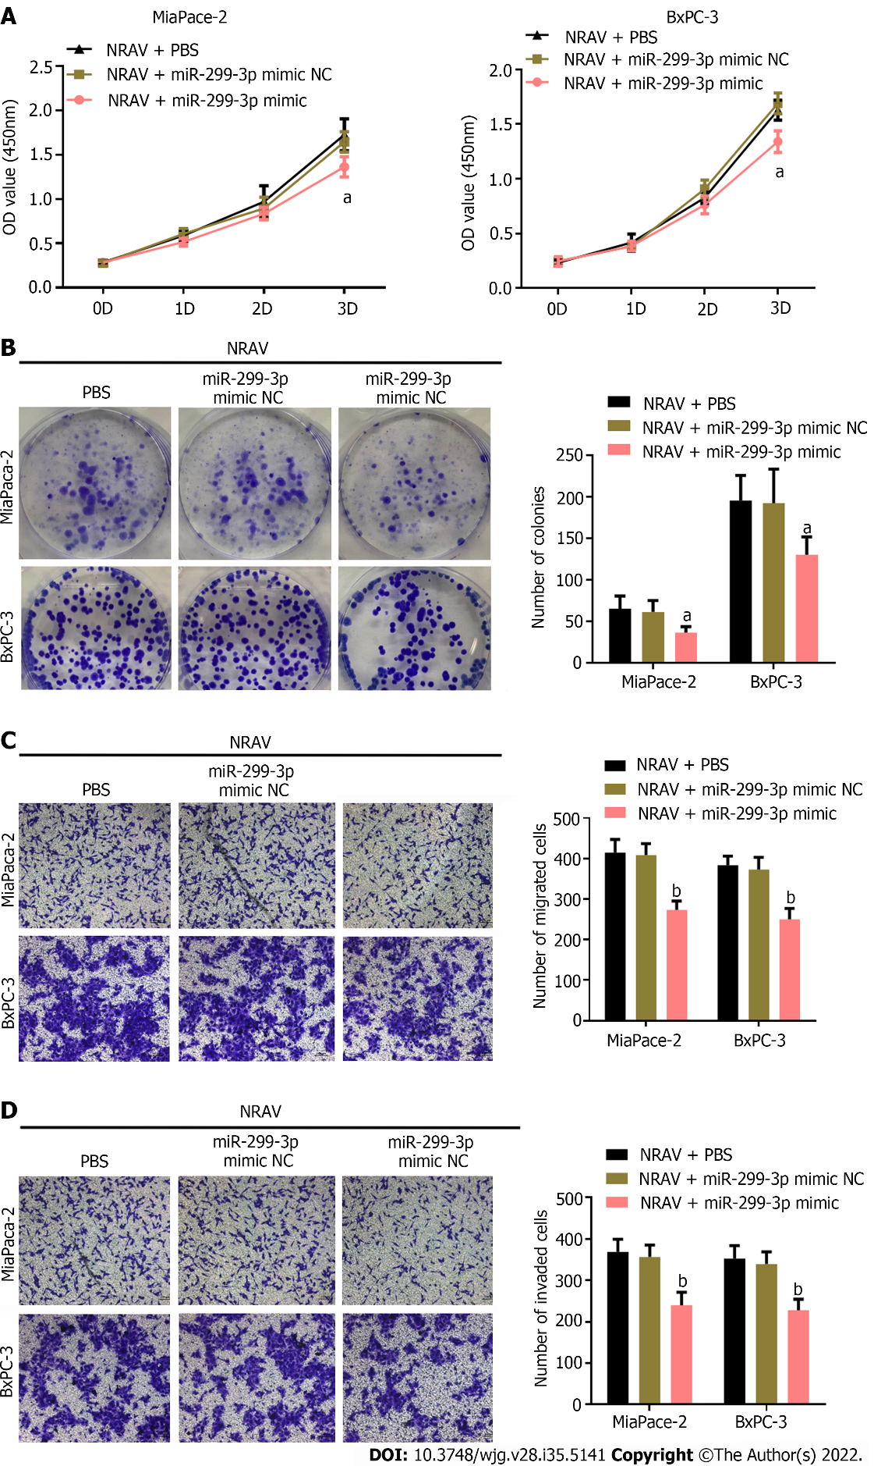
Figure 6 miR-299-3p reversed the effect of negative regulator of antiviral response on pancreatic cancer cells. A: Viability of MiaPaca-2 and BxPC-3 cells was determined following transfection with pcDNA3.1-NRAV and miR-299-3p mimic by Cell Counting Kit-8 assay; B: Proliferation of MiaPaca-2 and BxPC-3 cells was detected by colony formation assay; C: Transwell assays of cell migration was performed in MiaPaca-2 and BxPC-3 cells transfected with pcDNA3.1-NRAV and miR-299-3p mimic; D: Transwell assays of cell invasion were performed in MiaPaca-2 and BxPC-3 cells transfected with pcDNA3.1-NRAV and miR-299-3p mimic. ªP < 0.05; ^{b}P < 0.01. NRAV: Negative regulator of antiviral response; NC: Negative control; PBS: Phosphate-buffered saline.
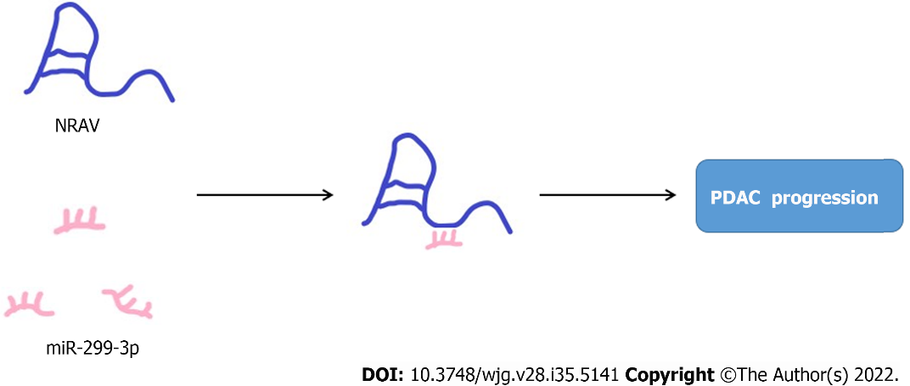
Figure 7 Negative regulator of antiviral response plays the role of miR-299-3p molecular sponge to promote the progress of pancreatic ductal cancer.

Published by Baishideng Publishing Group Inc
7041 Koll Center Parkway, Suite 160, Pleasanton, CA 94566, USA
Telephone: +1-925-3991568
E-mail: bpgoffice@wjgnet.com
Help Desk: https://www.f6publishing.com/helpdesk
https://www.wjgnet.com

© 2022 Baishideng Publishing Group Inc. All rights reserved.

