Name of Journal: World Journal of Gastrointestinal Oncology
ESPS Manuscript NO: 32695
Manuscript Type: Case Report

Goblet cell carcinoid of the appendix and mixed adenoneuroendocrine carcinoma: Report of three cases

Karaman H et al. Appendiceal neuroendocrine tumors

Hatice Karaman, Fatma Şenel, Mustafa Güreli, Turan Ekinci, Ömer Topuz

Hatice Karaman, Fatma Şenel, Mustafa Güreli, Turan Ekinci, Department of Pathology, Kayseri Education and Research Hospital, 38030 Kayseri, Turkey

Ömer Topuz, Department of Surgery, Kayseri Education and Research Hospital, 38030 Kayseri, Turkey

Author contributions: All authors contributed to the acquisition of data, writing, and revision of this manuscript.

Institutional review board statement: Kayseri Education and Research Hospital.

Informed consent statement: Patients were not required to give informed consent to the study because the analysis used anonymous clinical data.

Conflict-of-interest statement: We have no pertinent financial relationships to disclose

Open-Access: This article is an open-access article which was selected by an in-house editor and fully peer-reviewed by external reviewers. It is distributed in accordance with the Creative Commons Attribution Non Commercial (CC BY-NC 4.0) license, which permits others to distribute, remix, adapt, build upon this work non-commercially, and license their derivative works on different terms, provided the original work is properly cited and the use is non-commercial. See: http://creativecommons.org/licenses/by-nc/4.0/

Manuscript source: Invited manuscript

Correspondence to: Hatice Karaman, MD, PROF, Department of Pathology, Kayseri Education and Research Hospital, Alpaslan Mah, Emrah Cad, Beyoğlu Apt, 21/3, 38030 Kayseri, Turkey. htckaraman@yahoo.com
Telephone: +90-352-3368884
Fax: +90-352-3368884

Received: January 19, 2017
Peer-review started: January 23, 2017
First decision: February 17, 2017
Revised: March 15, 2017
Accepted: April 6, 2017
Article in press:
Published online:

Abstract
Neuroendocrine neoplasms are the most common epithelial tumors among appendix tumors. Appendix tumors that are completely or partially composed of neuroendocrine cells are divided into two categories: classic carcinoid tumors and goblet cell carcinoid tumors (GCCT). They are known to progress more aggressively than classic (neuro) endocrine tumors. In this study, three cases with acute appendicitis symptoms are presented, including their clinical and histopathological findings. Microscopic examination detected GCCT in two cases and mixed adenoneuroendocrine carcinoma in one case, in addition to acute appendicitis.

Key words: Appendix vermiformis; Mixed adenoneuroendocrine carcinoma; Goblet cell carcinoid tumors

© The Author(s) 2017. Published by Baishideng Publishing Group Inc. All rights reserved.

Core tip: Goblet cell carcinoid is a much more aggressive tumor than classic carcinoid, particularrly if the tumor shows transmural involvement or if it has extended to the cecum at the time of the operation. This paper presents three cases clinical and histopathological features. Two were diagnosed as goblet cell carcinoid tumor and one was diagnosed as mixed adenoneuroendocrine carcinoma.

Karaman H, Şenel F, Güreli M, Ekinci T, Topuz Ö. Goblet cell carcinoid of the appendix and mixed adenoneuroendocrine carcinoma: Report of three cases. World J Gastrointest Oncol 2017; In press

INTRODUCTION
Of appendix tumors, the most common epithelial tumors are neuroendocrine neoplasias^{[1]}. Appendix tumors composed completely or partially of neuroendocrine cells are divided into two categories: Classic carcinoid tumors and goblet cell carcinoid tumors (GCCT) and their variants. GCCT of the appendix are rare and constitute approximately 6% of appendix carcinoids^{[1,2]}. This kind of appendix tumor was first identified by Gagne in 1969^{[1,3]}. Goblet cell carcinoids originate from pluripotent intestinal stem cells that show both neuroendocrine and mucinous differentiation^{[3-5]}. Goblet cell carcinoid is known by various names such as adenocarcinoid, mucinous carcinoid, crypt cell carcinoid, and mucin-producingneuroendocrinetumor^{[3,6,7]}. According to the neuroendocrine neoplasm classification published by the World Health Organization (WHO) in 2010, GCCTs are in the neuroendocrine tumor group^{[8-10]}. They are known to progress more aggressively than classic (neuro)endocrine tumors^{[9,10]}.
In 2010, the WHO and the European Neuroendocrine Tumor Society (ENETS) divided the grade of neuroendocrine tumors (NET) into three groups based on the Ki-67 proliferation index and the number of mitoses. If there are less than two mitoses and a Ki-67 index of less than 3% in 10 HPF, it is called “NET, low grade (Grade 1)”. If there are 2-20 mitoses and a Ki-67 index of 3%-20%, it is called “NET, moderate-grade (Grade 2)”. If there are more than 20 mitoses with a Ki-67 index greater than 20%, it is classified as “neuroendocrine carcinoma, high grade (Grade 3)”^{[4,9]}. The most important prognostic factor is the stage of disease. Appendectomy and right hemicolectomy are the main modalities of treatment, followed by adjuvant chemotherapy in select cases.

CASE REPORT
This paper presents three cases clinical and histopathological features. Two were diagnosed as goblet cell carcinoid and one was diagnosed as mixed adenoneuroendocrine carcinoma.

Case 1
A 76-year-old male patient was admitted to the emergency room with abdominal pain and a fever. An appendectomy was performed with a pre-diagnosis of acute abdomen. The appendectomy material was submitted, which was 9 cm × 3 cm × 2 cm. There was a perforated area 2 cm in diameter. In section from the perforated area, tumour is composed of small, rounded nests of signet ring-like cells resembling normal intestinal goblet cells, except for the nuclear compression. The cells dispay mild-to-moderate atypia, low mitotic activity with a Ki 67 proliferation index < 20%, and infiltrated individually and in groups up to the subserosa and serosa by crossing the muscle layer from the mucosa on the appendix wall (Figure 1A). During the histochemical staining, mucicarmine and intra- and extra-cellular mucin deposition were identified in the tumor tissue (Figure 1B). Epithelial membrane antigen (Figure 2A), chromogranin-A (Figure 2B) and NSE (neuron-specific enolase) from the neuroendocrine markers, focal and CEA [monoclonal carcinoembryonic antigen (mCEA)], and wide spread immunoreaction were detected in the tumor cells via immunohistochemistry. Ten percent positive staining was obtained with a Ki 67 proliferation marker. There was no vascular and perineural invasion. Based on these findings, the diagnosis was goblet cell carcinoid and (pT3). Because of the tumor was potentially malignant right hemicolectomy were performed.

Case 2
A 71-year-old man patient was admitted to the hospital emergency room with abdominal pain associated nausea and vomiting. The patient was operated for acute appendicitis. During surgery, the appendix was observed to be hyperemic and edematous. No significant tumor structure was observed. The appendix was completely removed for examination. In the examination of microscopic sections from an area of 5 cm, mucosa, submucosa, muscle layer, and tumor tissue invading the subserosa were identified, which were completely covering the tissue, starting from the basal part of the appendix lamina propria crypts (Figure 3). No tumor was identified on the proximal end of the incision. The tumor was wide, eosinophilic, had granular cytoplasm, and was characterized by small uniform nests formed by eccentric nuclei goblet cells and microglandular development. Perineural invasion was monitored. PAS-Alcian Blue pH 2.5 (Figure 4) and intra and extra-cellular mucin deposition were detected in the tumor tissue. In the immunohistochemicalstudiestumor was positive with the epithelial markers CK-20 and monoclonal carcinoembriyonic antigen (mCEA) (Figure 5), and neuroendocrine cell component markersynaptophysin, chromogranin-A, CD56 and S100. With Ki-67, the proliferation index was 3%. There were acute appendicitis findings in the case as well.Overall the histological and immunohistochemical features were those of a goblet cell carcinoid tumor of the appendix tip with co-existing acute appendicitis. Because of the diffuse propagation of the tumor in an area of 5 cm on the appendix wall and themesoappendix and its potential to be malignant, a right hemicolectomy was performed.

Case 3
A 56-year-old man patient referred to the hospital with right lower quadrant pain.Physical examination revealed right lower quadrant abdominal tenderness and localized rebound tenderness. No palpable abdominal mass was present. In the emergency abdominal ultrasonography, the appendix diameter was 8.5 mm and markedly edematous. The neighboring mesenteric tissue was also edematous. Due to signs and symptoms typical of acute appendicitis, the patient underwent a simple appendectomy. Gross examination of the specimen showed the material measured 6 cm × 2 cm × 2 cm. The outer surface of the appendix was fibrinated in many areas. The area showing beige wall thickening was notablein macroscopic cross-section and measured 1.1 cm in diameter. In the surface of the cross-section, mucosa, submucosa, muscle layer, and tumor tissue infiltrated the subserosa were monitored, starting from the basal part of the appendix lamina propria crypts. No tumor was identified on the proximal end of the section. The tumor was significant cytologic atypia, wide, eosinophilic, had granular cytoplasm forming small nests and cords, and was characterized by small uniform nests with eccentric nuclei, signet-ring with micro glandular development, and cells in goblet cell appearance (Figure 6). No central lumen was observed in the tumor cell groups. In the serial sections, five mitoses were detected in 10 high-power fields (HPF) in the tumor. Perineural invasion was observed. PAS-Alcian Blue pH 2.5 and intra and extra-cellular mucin deposition were detected in the tumor tissue. In the immunohistochemical studies, mCEA, keratin 7, keratin 20, synaptophysin, chromogranin-A, CD56 and S100 from the common cytoplasmic and neuroendocrine markers, and strong focal positivity were detected in the tumor (Figure 7). With Ki-67, the proliferation index was 5%-10%. There were strong acute appendicitis findings in the case. Based on these findings, the case was diagnosed as “mixed adenoneuroendocrine carcinoma and acute appendicitis”. A right hemicolectomy was performed.
We considered these cases worth presenting, given their rarity, and for the opportunity to discuss malignancy criteria.

DISCUSSION
There are four types of appendix tumors: Epithelial tumors, mesenchymal tumors, lymphomas, and secondary tumors^{[1]}. Epithelial tumors are grouped categorized as premalignant lesions, carcinoma, neuroendocrine tumors^{[2]}. The most common epithelial tumors are neuroendocrine neoplasias. Appendix tumors that are completely or partially composed of neuroendocrine cells are divided into two different categories: Classic carcinoid tumors and GCCT, and their variants. Tumors showing both glandular and endocrine differentiation are called “amphicrine tumors”. The amphicrine tumor of the appendix is goblet cell carcinoid. In the WHO classification, this type of tumors that advance aggressively are called “mixed carcinoid adenocarcinoma” in the “mixed adenoneuroendocrine carcinoma” group, and “adenocarcinoma”, which develops on the goblet cell carcinoid^{[9]}. The goblet cell carcinoid is called adenocarcinoid of goblet cell type^{[11]}, mucinous carcinoid tumor^{[12]}, and microglandular carcinoma^{[13]}, as well as crypt cell carcinoma^{[14]}. Microscopically, it is characterized predominantly by submucosal growth. Extending into the muscle and serosa is common. However, the mucosa is typically preserved except tumor islets and obvious connections between crypt bases. The tumor itself is composed of small uniform goblet cell islets, which are generally arranged in the microglandular style and sometimes accompanied by extracellular mucus. The typical lesion consist of small uniform nests of goblet cells, often arranged in a microglandular fashion and sometimes accompanied by extracellular mucus^{[3]}.

Goblet cell carcinoids rare
GCCs usually occur in older patients, generally median age was 58 years (range 31-73) and no definite sex predominance^{[3]}. Clinical presentation followed two distinct patterns: Acute appendicitis or chronic symptoms associated with a pelvic mass. The pathogenesis is unclear however the tumor likely arises from pluripotent intestinal epithelial crypt base stem cells. Loss of Notch signaling may be the driver mutation with other successive downstream mutations likely favors them into progressing and behavior similar to poorly differentiated adenocarcinoma with minimal neuroendocrine differentiation^{[9,15,16]}.
Goblet cell carcinoid is a more aggressive tumor than classic carcinoid, if the tumor shows transmural involvement or if it has extended to the cecum at the time of the operation^{[3,11,13]}. In 2008, Tang et al^{[15]}, GCC patients are divided into three groups (A, B, C). Typical GCC (Group A); adenocarcinoma ex GCC, signet ring cell type (Group B); adenocarcinoma ex GCC, poorly differentiated carcinoma type (Group C). Typical GCC (Group A) was defined as well -defined goblet cells arrenged in cluster or in a cohesive linear pattern, with minimal cytologic atypia and architectural distortion of the appendical wall, and minimal to no desmoplasia. Adenocarcinoma ex GCC, signet ring cell type (Group B) was defined as goblet cells or signet ring cells arranged in irregular large clusters, with the lack of confluent sheets of cells in a discohesive single file or single cell infiltrating pattern with significant cytologic atypia, and desmoplasia and associated destruction of the appendiceal wall^{[15,16]}. Adenocarcinoma ex GCC, poorly differentiated carcinoma type (Group C) was defined with the least focal evidence of goblet cell morphology and a component (> 1 low power field or 1 mm²) that is not otherwise distinguishable from a poorly differentiated adenocarcinoma^{[15,16]}.
The tumor itself, as in our case study, is composed of small uniform goblet cell islets, which are generally arranged in the microglandular style and sometimes accompanied by extracellular mucus. The histochemical stainings, mucicarmine, and CEA stainings are always positive. There is generally CK20 in all cases and the focal style CK7 positivity in approximately 70% of the cases. In our case, in agreement with the literature, tumor cells were positive for CEA, CK7, CK20, and neuroendocrine markers.
Fifty percent of patients with these tumors, who are rarely seen, often go to hospitals in the 50s or 60s with abdominal pain and palpable masses^{[2]}. Others cases, like ours, were detected incidentally in the appendectomy specimens removed from the patients, who arrived at the hospital with acute abdominal pain and symptoms of acute appendicitis and were taken to surgery diagnosed with acute appendicitis^{[3,4,12,14-18]}. In addition to the characteristic histological appearance, as seen in our cases, they showed widespread invasion of the mesoappendix and perineural^{[19]}.
Adenocarcinoma developing on the goblet cell carcinoid ground constitutesa significant portion of mixed adenoneuroendocrine carcinoma. The adenocarcinoma component is in the form of signet ring cell carcinoma or poorly differentiated carcinoma. In these tumors, the goblet cell carcinoid tumor area should cover at least low-power fields (or 1 mm²) of the tumor. The signet ring cell type is composed of cells aligned in a single row or that form irregular groups with the appearance of a signet ring as well as goblet cell carcinoid areas^{[4]}. Our case was diagnosed as “mixed adenoneuroendocrine carcinoma diagnosis” because of the presence of the signet ring cell component developing from the goblet cell carcinoid.
In our case, the Ki-67 labeling index was 3%-10%. In the ENETS-2007 pathologic TNM staging, < 1 cm tumors are T1, ≤ 2 cm tumors with subserosa or mesoappendix invasion of less than 3 mm are T2, > 2 cm tumors with subserosa or mesoappendix invasion of > 3 mm are T3, and tumors with the peritoneum or other organ invasion are T4. GCCT are more aggressive than classical carcinoid tumors. Metastases have been documented in 8%-20% of the cases^{[11,13,15,16]}. There are liver, ovarian, and peritoneal metastases during the diagnosis in approximately 10% of patients. While five-year survival is between 50%-80% for the disease when limited to the appendix, it is less than 20% in the presence of distant metastases^{[16]}. In the literature, it is reported that an appendectomy should be sufficient for the treatment of tumors smaller than 1 cm that do not have no serious mesoappendix involvement and a low Ki-67 index^{[4,20-22]}.
The recommended treatment for goblet cell carcinoid, whether pure or combined, is a right hemicolectomy, especially if the tumor has spread beyond the appendix and/or shows a high mitoticcount. Although many authors suggest routine right hemicolectomy for goblet cell carcinoids, this recommendation has been questioned, and some auhors believe that appendectomy alone may be sufficient if the appendical margin is clear, there is no evidence of spread into the periappendiceal soft tissue, the mitotic count is no more than two mitoses per 10 HPF, and there are no features of mixed goblet cell carcinoid-adenocarcinoma^{[3,15,16]}. Both European and North American Neuroendocrine tumor societies guidelines recommend right hemicolectomy after appendectomy due to the high rate of metastases and its impact on prognosis. Our cases underwent a right hemicolectomy after the diagnosis of GCC and mixed adenoneuroendocrine carcinoma and have been made. As a result, because it is known that GCCT are more aggressive than classical carcinoid tumors but they do not show malignant behavior like adenocarcinomas, their histological identification is important.
Finally, GCCs are unique to the appendix. Appendiceal NETs asymptomatic. Carcinoid synrome is very uncommon. The symptoms resemble acute appendicitis. Since the diagnosis is usually established post appendectomy, appendectomy materials should be examined carefully. NET and adenocarcinomas developing on the goblet cell carcinoid should definitely be kept in mind in terms of malignancy. Grading and staging play an important role in treatment and prognosis.

COMMENTS
Case characteristics
Abdominal pain.

Clinical diagnosis
Acute abdomen.

Differential diagnosis
Appendiceal neoplasm.

Laboratory diagnosis
All labs were within normal limits.

Imaging diagnosis
Acute appendicitis.

Pathological diagnosis
Goblet cell carcinoid.

Treatment
Hemicolectomy mixed adenoneuroendocrine carcinoma.

Related reports
Grading and staging play an important role in treatment and prognosis.

Term explanation
GCCT: Goblet cell carcinoid tumors.

Experiences and lessons
Neuroendocrine tumors and adenocarcinomas developing on the goblet cell carcinoid should definitely be kept in mind in terms of malignancy.

Peer-review
The authors presented a rare pathology of appendix. The manuscript was well structured and written.

REFERENCES
1 Rosai J. Appendix. In: Rosai and Ackerman’s Surgical Pathology. 10th ed. Edinburgh, Elsevier, Mosby, China, 2011: 714
2 Gramlich J, Petras R. Vermiform appendix. In: Mills S, eds. Histology for Pathologists. Lippincot Williams, 2007: 648-657
3 Doyle LA, Odze RW. Inflammatory disorders of the appendix. In: Odze RD, Goldblum JR, eds. Surgical Pathology of the GI Tract, Liver, Biliary Tract and Pancreas, 2nd ed. Philadelphia, 2015: 512-529
4 Paşaoğlu E. Apendiksin Tümörleri. In: Doğusoy G, eds. Gastroenteroloji Patoloji. İzmir. O’tıp kitabevi ve Yayıncılık, 2015: 240-259
5 Mederos R, Danielpour P, Christopher M, Middendorf BA, Willis I, Minervini D, Vicentelli C. Goblet cell carcinoid tumors of the appendix: Report of two cases and a short review of the literature. Surgery Journal 2007; 2: 33-36
6 Haqqani MT, Williams G. Mucin producing carcinoid tumours of the vermiform appendix. J Clin Pathol 1977; 30: 473-480 [PMID: 864014 DOI: 10.1136/jcp.30.5.473]
7 Roy P, Chetty R. Goblet cell carcinoid tumors of the appendix: An overview. World J Gastrointest Oncol 2010; 2: 251-258 [PMID: 21160637 DOI: 10.4251/wjgo.v2.i6.251]
8 Klimstra DS, Modlin IR, Coppola D, Lloyd RV, Suster S. The pathologic classification of neuroendocrine tumors: a review of nomenclature, grading, and staging systems. Pancreas 2010; 39: 707-712 [PMID: 20664470 DOI: 10.1097/MPA.0b013e3181ec124e]
9 Bosman F, Carneiro F, Hruban R, Theise N, editors. WHO classification of tumours of the digestive system. Lyon: IARC Press, 2010
10 Schott M, Klöppel G, Raffel A, Saleh A, Knoefel WT, Scherbaum WA. Neuroendocrine neoplasms of the gastrointestinal tract. Dtsch Arztebl Int 2011; 108: 305-312 [PMID: 21629514 DOI: 10.3238/arztebl.2011.0305]
11 Warkel RL, Cooper PH, Helwig EB. Adenocarcinoid, a mucin-producing carcinoid tumor of the appendix: a study of 39 cases. Cancer 1978; 42: 2781-2793 [PMID: 728874 DOI: 10.1002/1097-0142(197812)42: 6<2781: : AID-CNCR2820420638>3.0.CO; 2-B]
12 Klein HZ. Mucinous carcinoid tumor of the vermiform appendix. Cancer 1974; 33: 770-777 [PMID: 4815580 DOI: 10.1002/1097-0142(197403)33: 3<770: : AID-CNCR2820330324>3.0.CO; 2-J]
13 Wolff M, Ahmed N. Epithelial neoplasms of the vermiform appendix (exclusive of carcinoid). I. Adenocarcinoma of the appendix. Cancer 1976; 37: 2493-2510 [PMID: 1260730]
14 Isaacson P. Crypt cell carcinoma of the appendix (so-called adenocarcinoid tumor). Am J Surg Pathol 1981; 5: 213-224 [PMID: 7235117 DOI: 10.1097/00000478-198104000-00001]
15 Tang LH, Shia J, Soslow RA, Dhall D, Wong WD, O'Reilly E, Qin J, Paty P, Weiser MR, Guillem J, Temple L, Sobin LH, Klimstra DS. Pathologic classification and clinical behavior of the spectrum of goblet cell carcinoid tumors of the appendix. Am J Surg Pathol 2008; 32: 1429-1443 [PMID: 18685490 DOI: 10.1097/PAS.0b013e31817f1816]
16 Shenoy S. Goblet cell carcinoids of the appendix: Tumor biology, mutations and management strategies. World J Gastrointest Surg 2016; 8: 660-669 [PMID: 27830037 DOI: 10.4240/wjgs.v8.i10.660]
17 Chetty R, Serra S. Lipid-rich and clear cell neuroendocrine tumors ("carcinoids") of the appendix: potential confusion with goblet cell carcinoid. Am J Surg Pathol 2010; 34: 401-404 [PMID: 20139759 DOI: 10.1097/PAS.0b013e3181ce9204]
18 Plöckinger U, Couvelard A, Falconi M, Sundin A, Salazar R, Christ E, de Herder WW, Gross D, Knapp WH, Knigge UP, Kulke MH, Pape UF. Consensus guidelines for the management of patients with digestive neuroendocrine tumours: well-differentiated tumour/carcinoma of the appendix and goblet cell carcinoma. Neuroendocrinology 2008; 87: 20-30 [PMID: 17934252 DOI: 10.1159/000109876]
19 Vilchez RT, Martin DP, Blanco CQ, Aragones AM, Liebana RF, Donoso FJM, Conejo EA. Goblet cell carcinoid of the appendix. A 52 years old male with acute appendicitis. Oncologia 2007; 30: 72-75 [DOI: 10.4321/S0378-48352007000200004]
20 Kahraman DS, Akin N. [Goblet cell carcinoid of the appendix: a case report]. Turk Patoloji Derg 2015; 31: 136-140 [PMID: 24638191 DOI: 10.5146/tjpath.2014.01233]
21 Pape UF, Perren A, Niederle B, Gross D, Gress T, Costa F, Arnold R, Denecke T, Plöckinger U, Salazar R, Grossman A. ENETS Consensus Guidelines for the management of patients with neuroendocrine neoplasms from the jejuno-ileum and the appendix including goblet cell carcinomas. Neuroendocrinology 2012; 95: 135-156 [PMID: 22262080 DOI: 10.1159/000335629]
22 Griniatsos J, Michail O. Appendiceal neuroendocrine tumors: Recent insights and clinical implications. World J Gastrointest Oncol 2010; 2: 192-196 [PMID: 21160597 DOI: 10.4251/wjgo.v2.i4.192]

P-Reviewer: Alkan A, Tanabe S S-Editor: Ji FF L-Editor: E-Editor:

Figure 1 Heamatoxylin and eosin stained sections showing the tumor itself is composed of small uniform tumor nests of goblet cells and signet ring cells, often arranged in a microglandular fashion and sometimes accompanied by extracellular mucus (A: H and E; × 200) and adenocarcinoid tumor of goblet cell type showing positivity intra- and extra-cellular mucin deposition (B: Mucicarmine; × 400). H and E: Heamatoxylin and eosin.

Figure 2 Tumor cells exhibit strong immunoreactivity forepithelial membrane antigen (A) and forneuroendocrine markers (B). A: EMA, IHC; × 200; B: Chromogranin-A, IHC; × 200.

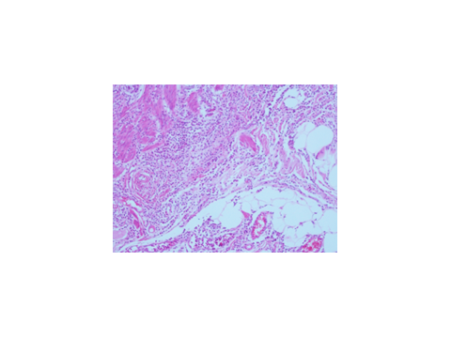
Figure 3 Adenocarcinoid tumor of goblet cell type tumor showing strong acute appendicitis findings (H and E; × 100).

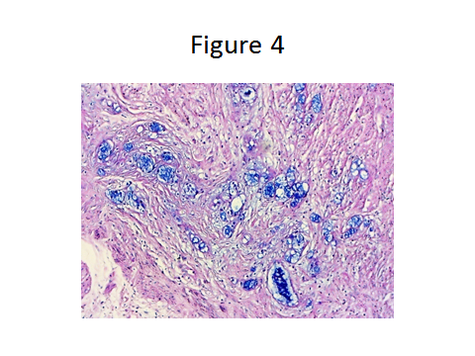
Figure 4 PAS-Alcian Blue pH 2.5 deposition were detected in the tumor tissue (PAS/AB; × 200).

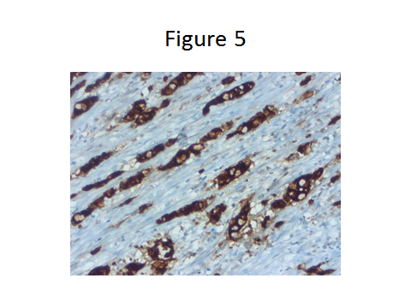
Figure 5 Adenocarcinoid tumor of goblet cell type showing positivity for immunoreactivity monoclonal carcinoembryonic antigen (IHC; × 200).

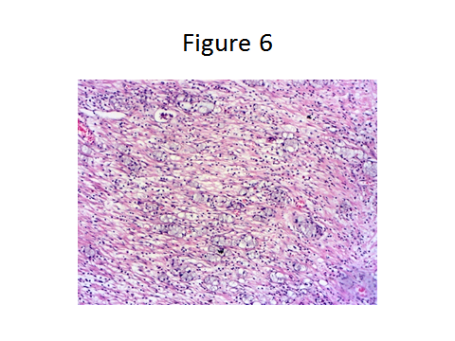
Figure 6 Heamatoxylin and eosin stained sections showing the tumor was wide, eosinophilic, had granular cytoplasm forming small nests and cords, and was characterized by small uniform nests with eccentric nuclei, signet-ring with micro glandular development and cells in goblet cell appearance (H and E; × 200).

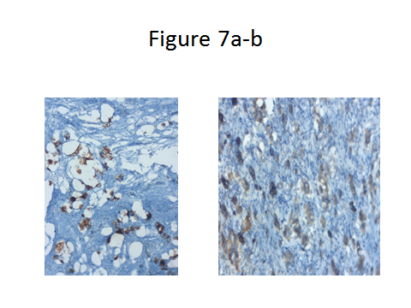
Figure 7 In the immunohistochemical studies neuroendocrine cell component markers, synaptophysin and chromogranin-A strong focal positivity were detected in the tumor (IHC; × 200).

