Name of Journal: World Journal of Hepatology
Manuscript NO: 77991
Manuscript Type: CASE REPORT

Primary hepatic leiomyosarcoma: A case report and literature review

Ahmed H et al. Primary hepatic leiomyosarcoma

Hassan Ahmed, Hassaan Bari, Umer Nisar Sheikh, Muhammad Irfan Basheer

Hassan Ahmed, Hassaan Bari, Department of Surgical Oncology, Shaukat Khanum Memorial Cancer Hospital and Research Centre, Lahore 54782, Pakistan

Umer Nisar Sheikh, Muhammad Irfan Basheer, Department of Pathology, Shaukat Khanum Memorial Cancer Hospital and Research Centre, Lahore 54782, Pakistan

Author contributions: Ahmed H and Bari H were the patient’s surgeons, reviewed the literature, and contributed to manuscript drafting; Sheikh UN and Basheer MI performed the histopathological analyses and interpretation; All authors issued final approval for the version submitted.

Corresponding author: Hassaan Bari, FCPS, MBBS, Surgeon, Department of Surgical Oncology, Shaukat Khanum Memorial Cancer Hospital and Research Centre, 7-A, Khayaban-e-Firdousi, Block R3, M A Johar Town, Lahore 54782, Pakistan. hassaanbari@skm.org.pk

Received: June 1, 2022
Revised: July 15, 2022
Accepted: September 13, 2022
Published online: September 27, 2022

Abstract
BACKGROUND
Primary hepatic leiomyosarcoma (PHL) is a rare tumor with a very low incidence of about 0.2%.

CASE SUMMARY
A 48-year-old diabetic, hypertensive, and morbidly obese female patient presented with a history of abdominal pain and weight loss for 2 mo. She had no history of fever, jaundice, or other liver disease(s). Clinical examination revealed a palpable mass in the epigastrium. Imaging evaluation with a contrast-enhanced computed tomography (CT) scan of the abdomen and pelvis revealed an ill-defined enhancing hyper vascular hepatic mass of 9.9 cm × 7.8 cm occupying the left hepatic lobe with evidence of central necrosis, compression effect on the left hepatic vein, and partial wash-out on delayed images. On further workup, the maximum standardized uptake value on positron emission computed tomography scan was 6.4, which was suggestive of malignancy. The remaining part of the liver was normal without any evidence of cirrhosis. Ultrasound-guided biopsy of the mass showed smooth muscle neoplasm suggestive of leiomyosarcoma. After optimization for co-morbidities, an extended left hepatectomy was planned in a multidisciplinary team meeting. On intraoperative ultrasound, the left hepatic lobe was entirely replaced by a large tumor extending to the caudate lobe with a compression effect on the middle and left hepatic veins. Final histopathology showed nodular and whorled white tumor comprised of spindled/fascicular cells with moderate to severe pleomorphism and focal necrosis. The mitotic index was greater than 20 mitoses per 10 high-power fields. The resection margins were free of tumor. Immunohistochemistry (IHC) depicted a desmin-positive/caldesmon-negative/discovered on gastrointestinal stromal tumor 1-negative/cluster of differentiation 117-negative profile, confirming the definitive diagnosis as PHL.

CONCLUSION
This case report highlights the rare malignant mesenchymal hepatic tumor. To confirm PHL diagnosis, one requires peculiar histopathological findings with ancillary IHC confirmation. Management options include adequate/complete surgical resection followed by chemotherapy and/or radiotherapy.

Key Words: Leiomyosarcoma; Immunohistochemistry; Hepatectomy; Surgical resection; Case Report

©The Author(s) 2022. Published by Baishideng Publishing Group Inc. All rights reserved.

Citation: Ahmed H, Bari H, Nisar Sheikh U, Basheer MI. Primary hepatic leiomyosarcoma: A case report and literature review. World J Hepatol 2022; 14(9): 1830-1839
URL: https://www.wjgnet.com/1948-5182/full/v14/i9/1830.htm
DOI: https://dx.doi.org/10.4254/wjh.v14.i9.1830

Core Tip: Primary hepatic leiomyosarcoma is an extremely rare tumor among all primary hepatic malignancies, with approximately 70 cases worldwide, including our case. The rare nature of the disease has precluded its underlying pathogenesis. Clinical manifestations are usually nonspecific, and tumors are generally asymptomatic until they significantly increase in size. They have a relatively poor prognosis and aggressive metastatic potential. The preferred type of treatment is surgical excision, which is sometimes combined with adjuvant chemotherapy and radiotherapy; however, little is known about their effectiveness because of the disease rarity. In-depth studies are needed to shed light on this uncommon clinical entity.

INTRODUCTION
Primary hepatic leiomyosarcoma (PHL) is a rare mesenchymal hepatic tumor whose clinical manifestations are often nonspecific and remain asymptomatic until there is a significant increase in tumor size causing a mass effect. This manuscript presents a case report of a 48-year-old woman with PHL.

CASE PRESENTATION
Chief complaints
A 48-year-old woman presented to the outpatient clinic with complaints of abdominal pain associated with weight loss.

History of present illness
The patient’s symptoms started 2 mo prior with recurrent episodes of abdominal pain without any specific aggravating or relieving factor(s).

History of past illness
She had no documented history of fever, jaundice, liver disease(s), blood transfusion, tattooing, or alcohol abuse.

Personal and family history
Her co-morbidities included diabetes, hypertension, and obesity. She had no family history of carcinoma.

Physical examination
On examination, there was a palpable mass in the epigastrium. The rest of the clinical examination was unremarkable, without any signs of disease elsewhere in the body.

Laboratory examinations
Complete blood count, serum biochemical profile, coagulation profile, and carbohydrate antigen 19-9 were normal. Viral serology was nonreactive.

Imaging examinations
An initial imaging evaluation with a contrast-enhanced computed tomography (CT) scan of the abdomen and pelvis showed an ill-defined heterogeneous contrast-enhancing and hyper vascular mass in the left lobe of the liver with extension up to the middle hepatic vein and compression effect on the left hepatic vein. The approximate measurement of the mass was 9.9 cm × 7.8 cm with central necrosis in the mass and partial wash-out on delayed images. The tumor encased the left portal vein branch at its point of bifurcation; however, the main portal vein and its right branch were not involved. No signs of hepatic cirrhosis were identified on imaging studies (Figure 1).
Positron emission tomography-CT (PET-CT) scan showed a maximum standardized uptake value (SUV) of the left hepatic mass of 6.4. The remaining liver had a standard baseline hepatic SUV (hepatic parenchymal baseline reference activity was up to 2.96 SUV).
No significant abnormality was seen above or below the diaphragm. In addition, the lungs, gastrointestinal (GI) tract, adrenal glands, kidneys, ovaries, and uterus did not show any evidence of primary disease or metastasis. No metastasis was found elsewhere in the body.
Ultrasound-guided biopsy was done, which showed cores of liver tissue with a proliferation of tumor cells having spindled-shaped nuclei with features of pleomorphism, up to 10 mitosis/10 high-power fields (HPFs), and necrosis. These findings suggested a spindle cell neoplasm raising a differential diagnosis of GI stromal tumor (GIST) and leiomyosarcoma. A panel of Immunohistochemical stains were applied that depicted a desmin-positive/caldesmon-negative/discovered on GIST1-negative (DOG1-)/cluster of differentiation 117-negative (CD117-) profile, thereby supporting the definitive diagnosis of PHL.

MULTIDISCIPLINARY EXPERT CONSULTATION
The case was discussed for management discussion in GI and hepatobiliary multidisciplinary team (MDT) meetings. According to MDT recommendations, surgical resection of the liver mass was planned, as there was no clinical and radiological evidence of metastatic disease or unknown primary disease elsewhere in the body.

FINAL DIAGNOSIS
The definitive preoperative diagnosis of the presented case was PHL in the absence of clinical and radiological evidence of metastatic disease or unknown primary disease elsewhere in the body.

TREATMENT
A formal extended left hepatectomy was performed. Staging laparoscopy was negative for metastasis, followed by a traditional laparotomy using a Mercedes Benz incision. The total operating time was 540 min with a blood loss of 300 milliliters.
Intraoperatively, the left lobe of the liver was involved by a large tumor extending inferiorly to the caudate lobe (left side only) and superiorly up to the middle hepatic vein (MHV). MHV and its branches were sacrificed. An en bloc resection was achieved with an intact capsule (Figure 2). Resection margins were confirmed to be free of the tumor with the help of intraoperative ultrasound. Enlarged hilar nodes (hepatic artery lymph node) and periportal lymph node were also removed separately. No distant metastasis or aortocaval nodes were found per operatively.

Final diagnosis and histopathology
Grossly, the left hepatectomy specimen measured 18 cm × 12.5 cm × 9.5 cm. Serial slicing of the specimen revealed a tumor (10.5 cm × 7.5 cm) with a nodular and whorled white appearance. The hepatic capsule was intact without any evident perforation. The microscopic evaluation revealed a cellular tumor with a fascicular array of tumor cells having spindle-shaped nuclei with a moderate-to-severe degree of cellular pleomorphism and more than 20 mitoses per 10 HPFs. Necrosis was focally seen. Lympho vascular invasion was not identified (Figures 3 and 4). All three regional lymph nodes (hepatic artery, periportal, and gallbladder neck) were negative for metastasis.

Immunohistochemical stain
Desmin (clone DE-R11, Ventana; Roche Diagnostics, Indianapolis, IN, USA), a marker of smooth muscle differentiation, was positive in tumor cells; and caldesmon (clone E-89; Cell Marque Co., Rocklin, CA, USA) was negative in tumor cells. In addition, CD117 (clone EP-10; Leica, Wetzlar, Germany) and DOG1 (clone SP31; Cell Marque) were also negative in tumor cells, ruling out the possibility of the closest differential diagnosis of GIST (Figure 5).

OUTCOME AND FOLLOW-UP
The postoperative recovery of the patient was uneventful. She was discharged on the 6th postoperative day. The patient remained asymptomatic until the follow-up visit after 6 mo. No short- or long-term postoperative complications were reported. CT and PET-CT scans were performed during this follow-up visit, which showed no evidence of recurrence and metastases. The patient was later presented in the MDT of Sarcoma, where it was decided to keep the patient under bi-annual surveillance, and no adjuvant treatment was recommended.

DISCUSSION
Sarcomas from the liver are rare, constituting only 1%-2% of all primary hepatic malignant tumors^{[1,2]}. Leiomyosarcoma accounts for 8%-10% of all hepatic sarcomas, whereas other hepatic sarcomas including angiosarcoma, fibrosarcoma, liposarcoma, embryonal sarcoma, malignant fibrous histiocytoma, carcinosarcoma, and epithelioid hemangioendothelioma collectively comprise nearly 70%-80% of hepatic sarcomas^{[3]}. Hepatic leiomyosarcomas are generally metastatic, arising from the GI tract, uterus, retroperitoneum, or lungs, requiring careful staging^{[2]}. To the best of our knowledge, only about 70 cases, including case series, have been published internationally, including our patient (Tables 1 and 2)^{[1]}.
Leiomyosarcoma potentially originates from the smooth muscle cells in the round ligament, intrahepatic blood vessels, and bile ducts. Tumors arising from intrahepatic veins have a worse prognosis because they tend to progress to Budd-Chiari syndrome. The differentiation between benign leiomyoma and low-grade leiomyosarcoma is based on mitotic figures per HPF, although variation occurs according to the site of origin^{[3,4]}.
There is no apparent sex predilection with an approximate male-to-female ratio of 1:1 in the literature review of cases reported to date including our patient. Age at the time of presentation is variably reported with a range of 5 mo to 86 years (mean age of 51.3 years)^{[5,6]}.
No specific pathological causes of PHL have been identified to date, although the literature review shows an association with multiple etiological factors, including immunosuppression due to acquired immunodeficiency syndrome. Epstein-Barr virus infection is reported in two cases and a previous history of immunosuppression postrenal transplant in 1 case. The other reported associations include hepatitis C virus infection, exposure to thorotrast, and previously treated Hodgkin’s lymphoma^{[7-11]}.
PHL usually pursues an indolent course being asymptomatic initially until they enlarge in size causing non-specific symptoms such as abdominal pain or discomfort, a palpable mass, fever, jaundice, anorexia, nausea or vomiting, and weight loss. The literature review revealed a single patient presenting as an emergency due to acute intraabdominal hemorrhage following tumor rupture. There is usually a single mass, although there are cases with multiple masses. Tumor size varies significantly ranging from 0.6 cm to 30 cm in the largest dimension (mean and median diameters of 10.3 cm and 9.1 cm, respectively). In our case, the tumor size was 10 cm in its largest dimension. The distribution of PHL within the liver segments and lobes also differs, with 2/3rd cases involving the right lobe and 1/3rd cases involving the left lobe. The case presented here involved the left lobe of the liver^{[6,11-16]}.
Histological examination usually shows intersecting bundles of spindle-shaped cells with hyperchromatic nuclei and mitotic figures. Immunohistochemistry shows positive results with smooth muscle actin, desmin, and vimentin, whereas cytokeratins, neuron-specific enolase, S-100 protein, α-fetoprotein, CD34, CD117, and DOG1 were not expressed.
Ultrasonography usually shows hypoechoic or heterogeneous echogenic mass. CT findings generally describe a hypodense and sometimes heterogeneous mass with inhomogeneous and often peripheral enhancement after intravenous contrast administration, which may show regions of cystic degeneration, demonstrated in our case^{[17]}. Ferrozzi et al^{[18]} reported that hemorrhagic necrosis, along with cystic degeneration and necrosis, are likely to be secondary to tumor growth. Magnetic resonance imaging characteristically displays homogeneous or heterogeneous hypointense T1-weighted images and hyperintense T2-weighted images^{[19]}. PET-CT scan SUV max can be correlated with the tumor size, tumor-node-metastasis staging, and histology subtype^{[20]}. In our case, the SUV max of the primary tumor was 6.4, with a baseline hepatic parenchymal SUV of 2.96.
Therapeutic options vary depending upon the tumor size and/or stage on initial presentation. Hepatic resection (wedge resection, segmentectomy, lobectomy, or extended hepatectomy with the intention of R0 resection) remains the only potentially curative surgical option for non-metastatic including our case. However, 4 patients with tumors confined within the liver had liver transplantation^{[14,21]}.
Some authors have also reported that adjuvant chemotherapy consisted of various drugs, including doxorubicin and ifosfamide, which help to attain prolonged survival after complete resection. In addition, three cases have been treated with radiotherapy as part of a combined adjuvant treatment along with chemotherapy^{[5,22-24]}.
Transarterial chemoembolization and transarterial infusion of epirubicin and carboplatin were also reported in individual cases as treatment modalities for PHL^{[25]}.
The median survival is 37.5 mo with a 5-year survival rate of about 40%; two large case series reported 67% disease-specific survival at 5 years after R0 resection. Matthaei et al^{[14]} in a case series, reported more than 10 years of survival after hepatectomy. Chi et al reported a median overall survival of 19 mo with 1-, 2-, and 5-year survival rates of 61.2%, 41.1%, and 14.5% respectively^{[26]}.
Age is another crucial predictive factor for prognosis, with patients below 50 years achieving better survival. Currently, no effective therapeutic options have been reported for unresectable PHL. Fujita et al^{[9]} reported a patient with metastatic leiomyosarcoma surviving 3 mo after diagnosis, who received only palliative and conservative therapy.

CONCLUSION
In conclusion, PHL is a rare malignant disease with often delayed presentation, relatively poor prognosis, and aggressive metastatic potential. The most preferred management options include surgical excision combined with chemotherapy and radiotherapy. However, very little is known about the efficacy of available therapeutic options because of the rarity of the disease. Therefore, in-depth studies are required to assess its causative, prognostic, and predictive parameters.

REFERENCES
1 Vella S, Cortis K, Pisani D, Pocock J, Aldrighetti L. Case of primary hepatic leiomyosarcoma successfully treated with laparoscopic right hepatectomy. BMJ Case Rep 2020; 13 [PMID: 32047090 DOI: 10.1136/bcr-2019-233567]
2 Cioffi U, Quattrone P, De Simone M, Bonavina L, Segalin A, Masini T, Montorsi M. Primary multiple epithelioid leiomyosarcoma of the liver. Hepatogastroenterology 1996; 43: 1603-1605 [PMID: 8975973]
3 Weitz J, Klimstra DS, Cymes K, Jarnagin WR, D'Angelica M, La Quaglia MP, Fong Y, Brennan MF, Blumgart LH, Dematteo RP. Management of primary liver sarcomas. Cancer 2007; 109: 1391-1396 [PMID: 17315167 DOI: 10.1002/cncr.22530]
4 Mitra S, Rathi S, Debi U, Dhiman RK, Das A. Primary Hepatic Leiomyosarcoma: Histopathologist's Perspective of a Rare Case. J Clin Exp Hepatol 2018; 8: 321-326 [PMID: 30302051 DOI: 10.1016/j.jceh.2018.04.015]
5 Tsai PS, Yeh TC, Shih SL. Primary hepatic leiomyosarcoma in a 5-mo-old female infant. Acta Radiol Short Rep 2013; 2: 2047981613498722 [PMID: 24349709 DOI: 10.1177/2047981613498722]
6 Maki HS, Hubert BC, Sajjad SM, Kirchner JP, Kuehner ME. Primary hepatic leiomyosarcoma. Arch Surg 1987; 122: 1193-1196 [PMID: 3310964 DOI: 10.1001/archsurg.1987.01400220103020]
7 Chelimilla H, Badipatla K, Ihimoyan A, Niazi M. A rare occurrence of primary hepatic leiomyosarcoma associated with epstein barr virus infection in an AIDS patient. Case Rep Gastrointest Med 2013; 2013: 691862 [PMID: 24024048 DOI: 10.1155/2013/691862]
8 Metta H, Corti M, Trione N, Masini D, Monestes J, Rizzolo M, Carballido M. Primary hepatic leiomyosarcoma--a rare neoplasm in an adult patient with AIDS: second case report and literature review. J Gastrointest Cancer 2014; 45 Suppl 1: 36-39 [DOI: 10.1007/s12029-013-9525-3]
9 Fujita H, Kiriyama M, Kawamura T, Ii T, Takegawa S, Dohba S, Kojima Y, Yoshimura M, Kobayashi A, Ozaki S, Watanabe K. Primary hepatic leiomyosarcoma in a woman after renal transplantation: report of a case. Surg Today 2002; 32: 446-449 [PMID: 12061699 DOI: 10.1007/s005950200073]
10 Tsuji M, Takenaka R, Kashihara T, Hadama T, Terada N, Mori H. Primary hepatic leiomyosarcoma in a patient with hepatitis C virus-related liver cirrhosis. Pathol Int 2000; 50: 41-47 [PMID: 10692176 DOI: 10.1046/j.1440-1827.2000.00999.x]
11 Giuliante F, Sarno G, Ardito F, Pierconti F. Primary hepatic leiomyosarcoma in a young man after Hodgkin's disease: diagnostic pitfalls and therapeutic challenge. Tumori 2009; 95: 374-377 [PMID: 19688980]
12 Jeong TY, Kim YS, Park KJ, Lee JS, Huh JG, Ryu SH, Lee JH, Moon JS. [A case of primary leiomyosarcoma of the liver presenting with acute bleeding]. Korean J Gastroenterol 2008; 51: 194-198 [PMID: 18451694]
13 Majumder S, Dedania B, Rezaizadeh H, Joyal T, Einstein M. Tumor rupture as the initial manifestation of primary hepatic leiomyosarcoma. Gastrointest Cancer Res 2014; 7: 33-34 [PMID: 24558513]
14 Matthaei H, Krieg A, Schmelzle M, Boelke E, Poremba C, Rogiers X, Knoefel WT, Peiper M. Long-term survival after surgery for primary hepatic sarcoma in adults. Arch Surg 2009; 144: 339-44; discussion 344 [PMID: 19380647 DOI: 10.1001/archsurg.2009.30]
15 Holloway H, Walsh CB, Thomas R, Fielding J. Primary hepatic leiomyosarcoma. J Clin Gastroenterol 1996; 23: 131-133 [PMID: 8877642 DOI: 10.1097/00004836-199609000-00014]
16 Lin YH, Lin CC, Concejero AM, Yong CC, Kuo FY, Wang CC. Surgical experience of adult primary hepatic sarcomas. World J Surg Oncol 2015; 13: 87 [PMID: 25880743 DOI: 10.1186/s12957-015-0489-6]
17 Yu RS, Chen Y, Jiang B, Wang LH, Xu XF. Primary hepatic sarcomas: CT findings. Eur Radiol 2008; 18: 2196-2205 [PMID: 18463872 DOI: 10.1007/s00330-008-0997-7]
18 Ferrozzi F, Bova D, Zangrandi A, Garlaschi G. Primary liver leiomyosarcoma: CT appearance. Abdom Imaging 1996; 21: 157-160 [PMID: 8661764 DOI: 10.1007/s002619900034]
19 Soyer P, Blanc F, Vissuzaine C, Marmuse JP, Menu Y. Primary leiomyosarcoma of the liver MR findings. Clin Imaging 1996; 20: 273-275 [PMID: 8959367 DOI: 10.1016/0899-7071(95)00043-7]
20 Yoh T, Seo S, Morino K, Fuji H, Ikeno Y, Ishii T, Taura K, Nakamoto Y, Higashi T, Kaido T, Uemoto S. Reappraisal of Prognostic Impact of Tumor SUVmax by ¹⁸F-FDG-PET/CT in Intrahepatic Cholangiocarcinoma. World J Surg 2019; 43: 1323-1331 [PMID: 30680501 DOI: 10.1007/s00268-019-04917-z]
21 Liang X, Xiao-Min S, Jiang-Ping X, Jie-Yu Y, Xiao-Jun Z, Zhi-Ren F, Guo-Shan D, Rui-Dong L. Liver transplantation for primary hepatic leiomyosarcoma: a case report and review of the literatures. Med Oncol 2010; 27: 1269-1272 [PMID: 19997990 DOI: 10.1007/s12032-009-9372-z]
22 Almogy G, Lieberman S, Gips M, Pappo O, Edden Y, Jurim O, Simon Slasky B, Uzieli B, Eid A. Clinical outcomes of surgical resections for primary liver sarcoma in adults: results from a single centre. Eur J Surg Oncol 2004; 30: 421-427 [PMID: 15063896 DOI: 10.1016/j.ejso.2004.01.004]
23 Shamseddine A, Faraj W, Mukherji D, El Majzoub N, Khalife M, Soubra A, Shamseddine A. Unusually young age distribution of primary hepatic leiomyosarcoma: case series and review of the adult literature. World J Surg Oncol 2010; 8: 56 [PMID: 20594305 DOI: 10.1186/1477-7819-8-56]
24 Feretis T, Kostakis ID, Damaskos C, Garmpis N, Mantas D, Nonni A, Kouraklis G, Dimitroulis D. Primary Hepatic Leiomyosarcoma: a Case Report and Review of the Literature. Acta Medica (Hradec Kralove) 2018; 61: 153-157 [PMID: 30664449 DOI: 10.14712/18059694.2018.135]
25 Zhu KL, Cai XJ. Primary hepatic leiomyosarcoma successfully treated by transcatheter arterial chemoembolization: A case report. World J Clin Cases 2019; 7: 525-531 [PMID: 30842965 DOI: 10.12998/wjcc.v7.i4.525]
26 Chi M, Dudek AZ, Wind KP. Primary hepatic leiomyosarcoma in adults: analysis of prognostic factors. Onkologie 2012; 35: 210-214 [PMID: 22488093 DOI: 10.1159/000337416]
27 O'Leary MR, Hill RB, Levine RA. Peritoneoscopic diagnosis of primary leiomyosarcoma of liver. Hum Pathol 1982; 13: 76-78 [PMID: 6210615 DOI: 10.1016/s0046-8177(82)80141-x]
28 Baur M, Pötzi R, Lochs H, Neuhold N, Walgram M, Gangl A. Primary leiomyosarcoma of the liver--a case report. Z Gastroenterol 1993; 31: 20-23 [PMID: 7680513]
29 Sato S, Hosoi K, Kagawa T. A primary leiomyosarcoma of the liver: an autopsy report. Elec J Pathol Histol 2000; 6: 8 [DOI: 10.1046/j.1440-1827.2000.01020.x]
30 Iordanidis F, Hytiroglou P, Drevelegas A, Kodonas F, Ioannidis I, Nenopoulou H, Papadimitriou CS. A 25-year-old man with a large hepatic tumor and multiple nodular lesions. Semin Liver Dis 2002; 22: 97-102 [PMID: 11928082 DOI: 10.1055/s-2002-23209]
31 Lee HJ, Lee JL, Choi WH. A case of primary myxoid leiomyosarcoma of the liver. Korean J Intern Med 2002; 17: 278-282 [PMID: 12647647 DOI: 10.3904/kjim.2002.17.4.278]
32 Shivathirthan N, Kita J, Iso Y, Hachiya H, Kyunghwa P, Sawada T, Kubota K. Primary hepatic leiomyosarcoma: Case report and literature review. World J Gastrointest Oncol 2011; 3: 148-152 [PMID: 22046492 DOI: 10.4251/wjgo.v3.i10.148]
33 Muranushi R, Hoshino K, Hagiwara K, Yamanaka T, Ishii N, Tsukagoshi M, Igarashi T, Tanaka H, Watanabe A, Kubo N, Araki K, Harimoto N, Ikota H, Shibuya K, Miyazaki M, Shirabe K. Hepatic pleomorphic leiomyosarcoma after surgery for gastric gastrointestinal stromal tumor: a case report. Surg Case Rep 2019; 5: 62 [PMID: 30993477 DOI: 10.1186/s40792-019-0622-9]
34 Watanabe K, Saito A, Wakabayashi H, Kawaguchi T, Suzuki T. Two autopsy cases of primary leiomyosarcoma of the liver. Superiority of muscle-specific actin immunoreactivity in diagnosis. Acta Pathol Jpn 1991; 41: 461-465 [PMID: 1950562 DOI: 10.1111/j.1440-1827.1991.tb03213.x]
35 Esposito F, Lim C, Baranes L, Salloum C, Feray C, Calderaro J, Azoulay D. Primary leiomyosarcoma of the liver: Two new cases and a systematic review. Ann Hepatobiliary Pancreat Surg 2020; 24: 63-67 [PMID: 32181431 DOI: 10.14701/ahbps.2020.24.1.63]
36 Yoshikawa K, Satake K, Kinoshita H, Umeyama K, Hojo K. Primary leiomyosarcoma of the liver. Clin Oncol 1977; 3: 197-202 [PMID: 326457]
37 Bloustein PA. Hepatic leiomyosarcoma: ultrastructural study and review of the differential diagnosis. Hum Pathol 1978; 9: 713-715 [PMID: 730153 DOI: 10.1016/s0046-8177(78)80054-9]

Footnotes
Informed consent statement: Informed written consent was obtained from the patient to publish this report and any accompanying images.

Conflict-of-interest statement: The authors have no conflicts of interest to declare.

CARE Checklist (2016) statement: The authors have read the CARE Checklist (2016), and the manuscript was prepared and revised according to the CARE Checklist (2016).

Open-Access: This article is an open-access article that was selected by an in-house editor and fully peer-reviewed by external reviewers. It is distributed in accordance with the Creative Commons Attribution NonCommercial (CC BY-NC 4.0) license, which permits others to distribute, remix, adapt, build upon this work non-commercially, and license their derivative works on different terms, provided the original work is properly cited and the use is non-commercial. See: https://creativecommons.org/Licenses/by-nc/4.0/

Provenance and peer review: Unsolicited article; Externally peer reviewed.
Peer-review model: Single blind

Peer-review started: June 1, 2022
First decision: June 23, 2022
Article in press: September 13, 2022

Specialty type: Gastroenterology and hepatology
Country/Territory of origin: Pakistan
Peer-review report’s scientific quality classification
Grade A (Excellent): A
Grade B (Very good): B
Grade C (Good): 0
Grade D (Fair): 0
Grade E (Poor): 0

P-Reviewer: Gao L, China; Wang P, China S-Editor: Wang LL L-Editor: Filipodia P-Editor: Wang LL

Figure Legends
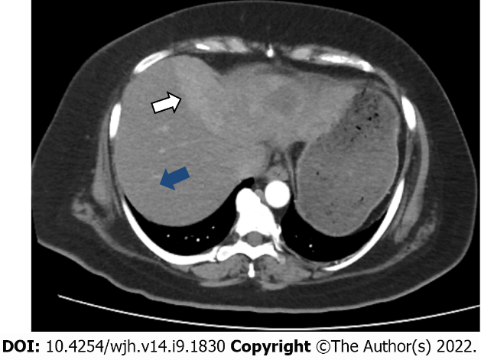
Figure 1 Contrast enhanced tomography scan image demonstrating a large enhancing heterogeneous mass in the left lobe of the liver (white arrow), surrounding normal the liver tissue (blue arrow).

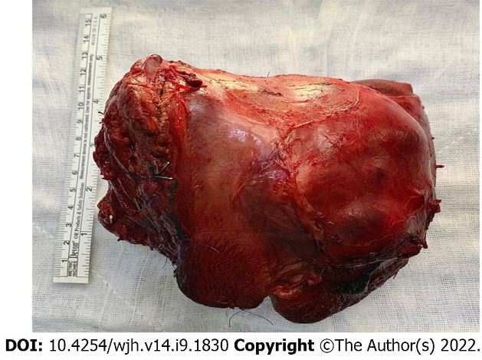
Figure 2 Resected specimen.

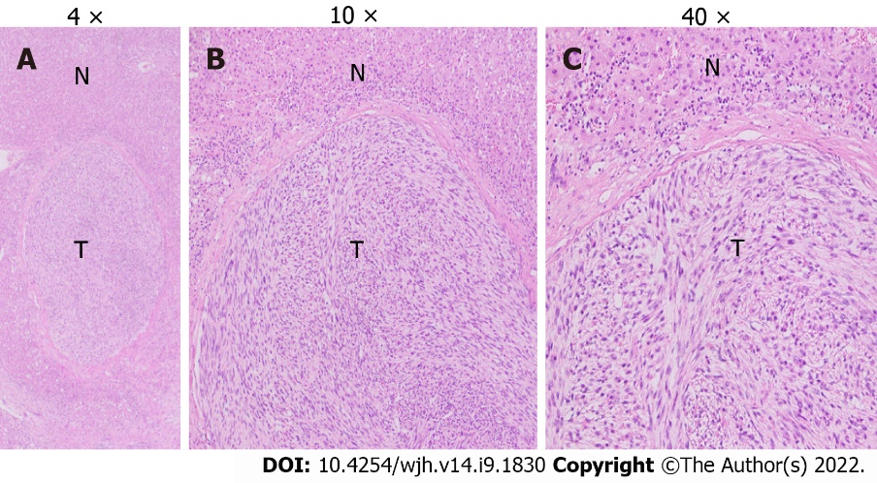
Figure 3 Leiomoyosarcoma, subsequent resection specimen. A: Original magnification: 4 ×, scale bar: 100 μm; B: The above figures show liver parenchyma with a central nodule/tumor fascicular array of cells having spindle-shaped nuclei, moderate degree nuclear atypia (original magnification: 10 ×; scale bar: 100 μm); C: Mitoses marked as T, and normal liver hepatocytes marked as N (original magnification: 40 ×; scale bar: 100 μm).

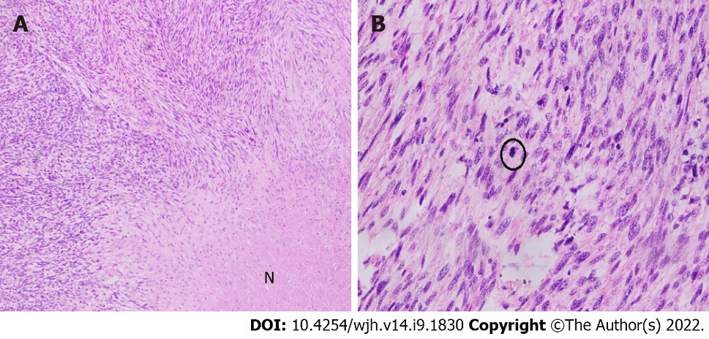
Figure 4 Hematoxylin and eosin stain of leiomoyosarcoma. A: Hematoxylin and eosin stain of leiomoyosarcoma, resected specimen, a section of the liver shows fascicular array of cells with spindle-shaped nuclei (Original magnification: 100 ×; scale bar: 100 μm); B: A moderate degree nuclear atypia, and mitoses (encircled) along with areas of necrosis marked as N (original magnification: 400 ×; scale bar: 100 μm).

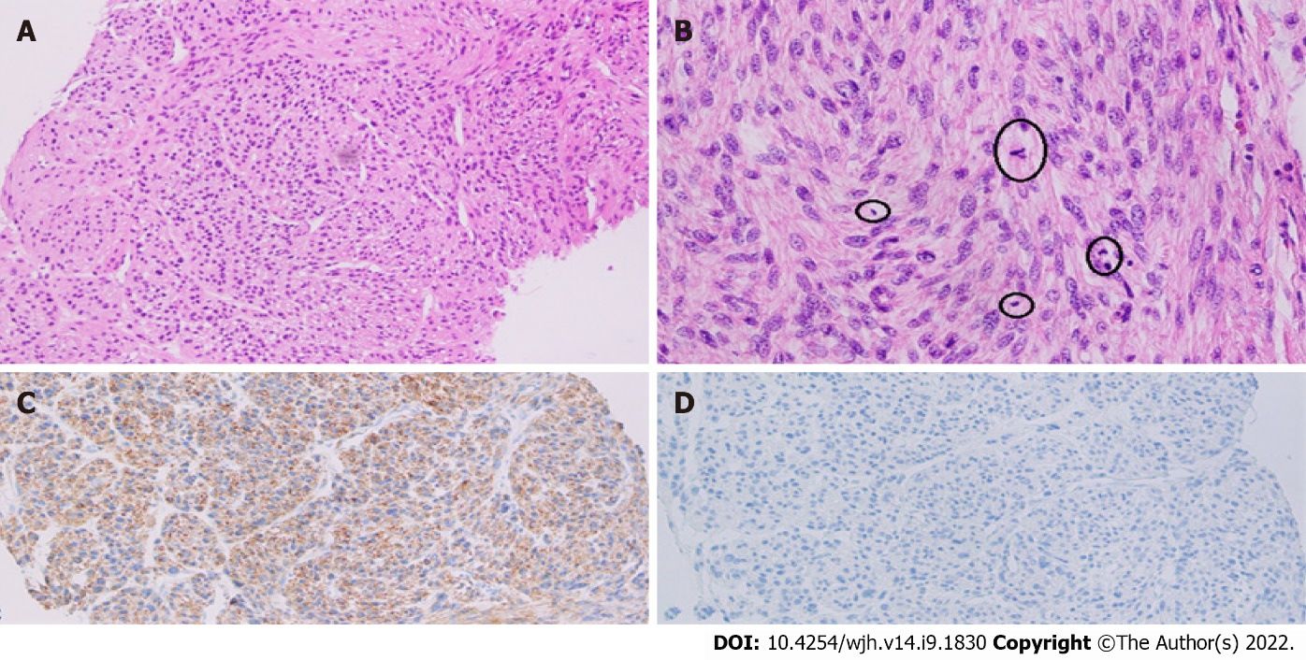
Figure 5 Fascicular array of cells with spindle-shaped nuclei. A: Moderate degree nuclear atypia (original magnification: 100 ×; scale bar: 100 μm); B: Mitoses (encircled) (original magnification: 100 ×; scale bar: 100 μm); C: Immunostaining of desmin highlighting spindle-shaped cells (original magnification: 100 ×; scale bar: 100 μm); D: Caldesmon-negative (original magnification: 100 ×; scale bar: 100 μm).

Table 1 Management outcomes of published case reports of primary hepatic leiomyosarcoma
Ref. | Patient age in yr | Sex | Risk factor/s | Management | Follow-up/ outcome
Jeong et al^{[12]}, 2008 | 49 | F |  | Wedge resection | Died at 18 mo
Cioffi et al^{[2]}, 1996 | 62 | M |  |  | Died at 20 mo
O'Leary et al^{[27]}, 1982 | 69 | M |  |  | Alive at 24 mo
Baur et al^{[28]}, 1993 | 69 | F |  | Surgery | Recurrence after 10 yr
Sato et al^{[29]}, 2000 | 62 | F |  |  | Diagnosis at autopsy
Iordanidis et al^{[30]} , 2002 | 25 | M |  | Surgery | Death at three mo
Lee et al^{[31]}, 2002 | 64 | F |  | Right lobectomy + wedge resection of the left lobe | No evidence of disease at 24 mo
Shivathirthan et al^{[32]}, 2011 | 78 | M |  | Chemotherapy, radiation | Death at 10 mo
Muranushi et al^{[33]}, 2019 | 62 | M | Gastric gist post resection | Left hepatectomy+ resection of 3 other lesions | No evidence of disease
Watanabe et al^{[34]}, 1991 | 62 | M |  | Lobectomy | No evidence of disease at 5 mo
Esposito et al^{[35]} ,2020 | 78 | M |  | Left hepatectomy | No evidence of disease at 18 mo
Yoshikawa et al^{[36]}, 1977 | 58 | F |  | Wedge resection | Death, 11th postoperative day
Bloustein^{[37]}, 1978 | 12 | F |  | Trisegmentectomy, chemotherapy | No evidence of disease at 6 yr
Maki et al^{[6]}, 1987 | 86 | F |  | Surgery | No evidence of disease at 5 mo
Holloway et al^{[15]}, 1996 | 63 | M |  | Conservative
Soyer et al^{[19]}, 1996 | 67 | F |  | Surgery
Tsuji et al^{[10]}, 2000 | 68 | M | Hepatitis c |  | Diagnosis at autopsy
Fujita et al^{[9]}, 2002 | 33 | F | Prior renal transplant | Right posterior segmentectomy | No evidence of disease at 24 mo
Giuliante et al^{[11]}, 2009 | 26 | M | Hodgkin's lymphoma | Right lobectomy + wedge resection of segment id | Death at 25 mo
Liang et al^{[21]}, 2009 | 44 | F |  | Liver transplant | Death at 34 mo
Shivathirthan et al^{[32]}, 2011 | 67 | M |  | Extended left hepatectomy + partial resection of segment 6 | No evidence of disease at 9 mo
Tsai et al^{[5]}, 2013 | Five mo | M |  | Chemotherapy + partial hepatectomy (segment vi) + adjuvant chemotherapy | No evidence of disease at 48 mo
Feretis et al^{[24]}, 2019 | 68 | F | Hepatitis b | Left hepatectomy+ cholecystectomy, chemotherapy, target therapy, redo surgery for recurrence | Recurrence at 18 mo 2nd recurrence at 21 mo died at 37 mo
Zhu et al^{[25]}, 2019 | 63 | M |  | Unresectable tumor TACE (2011) | No evidence of disease at 82 mo
Vella et al^{[1]}, 2020 | 77 | F |  | Right hepatectomy | No evidence of disease at 8 mo
F: Female; M: Male; TACE: Transcatheter arterial chemoembolization.

Table 2 Management outcomes of published case series of primary hepatic leiomyosarcoma
Ref. | Patient age in yr | Sex | Treatment | Follow up
Almogy et al^{[22]}, 2004 | 58 | F | Surgery + chemotherapy | Death at 4 mo
 | 63 | F | Surgery + chemotherapy | Death at 12 mo
Watanabe et al^{[34]}, 2008 | 63 | F |  | Diagnosis at autopsy
 | 49 | F |  | Diagnosis at autopsy
Matthaei et al^{[14]}, 2009 | 19 | F | Liver transplant | Death at 73 mo
 | 64 | F | Surgery | No evidence of disease 181 mo
 | 53 | F | Surgery | Death at 21 mo
 | 55 | M | Surgery | No evidence of disease at 133 mo
 | 51 | M | Liver transplant | No evidence of disease at 144 mo
 | 59 | M | Surgery | Death at 45 mo
 | 63 | F | Surgery | No evidence of disease at 133 mo
Shamseddine et al^{[23]}, 2010 | 25 | F | Right lobectomy | Death at 22 mo
 | 39 | M | Extended right lobectomy | Death at 19 d
 | 30 | M | Right lobectomy + chemotherapy | No evidence of disease at 12 mo
Esposito et al^{[35]} ,2020 | 78 | M | Left hepatectomy | No evidence of disease at 18 mo
 | 53 | M | Right extended hepatectomy | Lung metastasis at seven mo death at 14 mo
F: Female; M: Male.

Published by Baishideng Publishing Group Inc
7041 Koll Center Parkway, Suite 160, Pleasanton, CA 94566, USA
Telephone: +1-925-3991568
E-mail: bpgoffice@wjgnet.com
Help Desk: https://www.f6publishing.com/helpdesk
https://www.wjgnet.com

© 2022 Baishideng Publishing Group Inc. All rights reserved.

