Name of journal: World Journal of Gastroenterology
Manuscript NO: 34539
Manuscript Type: ORIGINAL ARTICLE

Observational Study
Establishment of a modified single antral section B-ultrasound method and its application value on enteral nutrition for critically ill patients

Liu Y et al. Enteral nutrition guided by modified B-ultrasound

Ying Liu, Ya-Kun Gao, Lei Yao, Li Li

Ying Liu, Ya-Kun Gao, Lei Yao, Li Li, Department of Ultrasound, Cangzhou Central Hospital, Cangzhou 061001, Hebei Province, China

Author contributions: Ying Liu contributed equally to this work; Ying Liu, Ya-KunGao, Lei Yao designed research; Ying Liu, Ya-KunGao, Lei Yao, Li Li performed research; Ya-KunGao, Lei Yao, Li Li contributed new reagents/analytic tools; Ying Liu, Ya-KunGao, Lei Yao, Li Li analyzed data; Ying Liu wrote the paper.

Supported by Cangzhou Science and Technology Project, No. 131302097.

Institutional review board statement: This study was reviewed and approved by Cangzhou Central Hospital Institutional Review Board.

Informed consent statement: All study participants, or their legal guardian, provided informed written consent prior to study enrolment.

Conflict-of-interest statement: We declare that there are no conflicts of interest to disclose.

Data sharing statement: No additional data are available.

Open-Access: This article is an open-access article which was selected by an in-house editor and fully peer-reviewed by external reviewers. It is distributed in accordance with the Creative Commons Attribution Non Commercial (CC BY-NC 4.0) license, which permits others to distribute, remix, adapt, build upon this work non-commercially, and license their derivative works on different terms, provided the original work is properly cited and the use is non-commercial. See: http://creativecommons.org/licenses/by-nc/4.0/

Manuscript source: Unsolicited Manuscript

Correspondence to: Ying Liu, MD, Attending Physician, Department of Ultrasound, Cangzhou Central Hospital, No. 201 Xinhua Road, Cangzhou 061001, Hebei Province, China. 13315703225@163.com
Telephone: +86-13315703225
Fax: +86-317-2075790

Received: May 3, 2017
Peer-review started: May 4, 2017
First decision: June 1, 2017
Revised: June 13, 2017
Accepted: June 18, 2017
Article in press:
Published online:

Abstract
AIM
To establish a modified single antral section B-ultrasound method to assess gastrointestinal motility in healthy people, and evaluate its application value on enteral nutrition for critically ill patients.

Methods
First, 30 healthy volunteers were selected. The modified single antral section B-ultrasound method and the traditional B-ultrasound method were applied to detect gastric function. The correlation between indices was analyzed by t-test and single-factor regression method. In addition, 64 critically ill patients were selected, and the modified single antral section B-ultrasound method and gastric juice withdrawal method were applied to guide the enteral nutrition implementation. Daily caloric value, the time required for complete enteral nutrition, ICU monitoring time, hospitalization time, as well as differences in serum prealbumin and albumin levels were recorded and compared between the two groups. At the same time, Kaplan-Meier survival curve was used to compare enteral nutrition complications between the two groups.

RESULTS
The comparative study of autologous healthy subjectsrevealed that there was a good correlation among gastric emptying time (GET), antral contraction frequency (ACF) and the antral motility index (MI) in the improved single antral section B-ultrasound method (r=0.57, 0.61 and 0.54). The study on critically ill patients also revealed that enteral nutrition achieved a better effect when guided by the modified single antral section B-ultrasound method, in which patients had less ICU monitoring time, shorter hospitalization time, and higher levels of serum prealbumin and albumin. In addition, the Kaplan-Meier survival curve also revealed that patients who underwent the improved B-ultrasound method had significantly less enteral nutrition complications, compared to the other group of patients (P = 0.031).

CONCLUSION
The modified single antral section B-ultrasound method and the traditional method can both provide a good real-time assessment of gastric function. The method that has a better effect in providing guidance for enteral nutrition can better provide nutritional support for critically ill patients, and contribute to the rehabilitation of patients.

Keywords: Gastric emptying; Real-time ultrasound; Critically ill patients; Enteral nutrition

©The Author(s) 2017. Published by Baishideng Publishing Group Inc. All rights reserved.

Core tip: In order to provide critically ill patientswithtimely postoperative enteral nutrition, a modified single antral section B-ultrasound method was established. The comparative study of autologous healthy subjects revealed that there was a good correlation among gastric emptying time, antral contraction frequency and the antral motility index between the modified and normal method. When guided by the modified method, the study on critically ill patients also revealed that enteral nutrition achieved a better effect in the aspects of patients' hospitalization conditions and the incidence of postoperative.

Liu Y, Gao YK, Yao L, Li L. Establishment of a modified single antral section B-ultrasound method and its application value on enteral nutrition for critically ill patients. World J Gastroenterol 2017; In press
INTRODUCTION
Critically ill patients with postoperative stress response and multiple system disorders will have increase the risk of infection and even death. Hence, timely postoperative enteral nutrition (EN) supportive treatment can significantly improve the prognosis of patients^{[1-6]}. However, severe patients are often accompanied by varying degrees of gastrointestinal motility disorders and other disorders. Therefore, an individualized EN program should be developed for the gastrointestinal function of patients^{[7-10]}. In clinical practice, medical staff often uses retractable gastric tubes to withdraw stomach residual fluid to assess the patient's gastric motility and guide EN. Due to the miniaturization and portability of B-ultrasound equipment, some medical units also use antral single section B-ultrasound on patient for real-time guidance of EN^{[11,12]}. However, there is a lack of actual operation for these two methods. On the one hand, gastric tube is too shallow when the measurement of the gastric residual volume is small. This causes the EN rate to be excessively high, which in turn cause bloating, reflux, as well as pneumonia and other complications. On the other hand, gastric tube retention is too deep when the measurement of the gastric residual volume is too large. This would easily lead to gastric mucosal injury during the operation. The antral single section B–ultrasound method requires severe patients to maintain the upper body position while drinking 500 mL of liquid. Severe patients often have difficulties tolerating such requirement^{[13,14]}. Therefore, in this study, the traditional B-ultrasound method was improved. Patients were placed in the semi-lying position to fill the gastric cavity with 300mL of ultrasound solution, followed by real-time monitoring of the patient's gastrointestinal motility. In this study, the traditional B-ultrasound method was improved, and was designed to reduce the stimulus of critically ill patients while obtaining accurate patient gastrointestinal function, with a view to providing individualized EN programs for critically ill patients.

MATERIAL AND METHODS
Inclusion and exclusion criteria
Inclusion criteria: (1) critically ill patients (52 cases) admitted in the ICU ward of our hospital from January 2014 to December 2015; (2) patients with an APACHE II score ≥ 8; and (3) patients in stable condition and in a stable recovery period.Exclusion criteria: (1) patients who underwent gastric resection; (2) patients with flatulence that could not be observed; and (3) patients who are not suitable to undergo gastrointestinal perfusion due to various reasons. At the same time, the hospital staff recruited 30 healthy subjects to evaluate the effect of the modified B ultrasound in detecting gastrointestinal function. This research was approved by the hospital Ethics Committee. All subjects provided a signed informed consent.

Evaluation of the effect of the modified B-ultrasound method in monitoring the gastrointestinal tract
Detection of gastric emptying using the B-ultrasound method: Gastric emptying detection using the B-ultrasound method: The SonoSite TITAN portable B-ultrasound machine (Bothell, WA, USA) was used for the timely detection of the gastrointestinal function changes in subjects. Detection indicators include :fasting antral area size (S fasting), the immediate antral maximum relaxation area after filling the stomach (S filling), 5-min changes in the antral diastolic area until the liquid dark area disappeared after filling the stomach, the disappearance time of the liquid dark areas in the stomach after filling (gastric emptying time, GET),5-minute antral contractions after filling, three consecutive an trial maximum relaxation and contraction areas (S_{relaxation}, S_{contraction}). Based on the above data, the following were calculated: antral area changes (ΔS) =S_{relaxation} – S_{contraction}; antral contraction frequency (ACF) = the number of antral contractions within five minutes after filling / 5; antral contraction amplitude (ACA) = ΔS / S_{relaxation}; antral motility index (MI) = ACF × ACA.

Research methods: Gastric function was detected in 30 healthy subjects using the self-control method. The subject fasted with water for eight hours. On the morning of the first day, the traditional B-ultrasound method was used to detect gastrointestinal function. That is, subjects were placed in the supine position, instructed to drink 500 mL of the B-ultrasound developer liquid for two minutes, and related gastrointestinal indicators were detected after filling the stomach cavity. On the morning of the 2nd day, the subjects fasted again with water for eight hours, were instructed to drink 300 mL of the B-ultrasound developer liquid within two minutes in a 45° half-lying position, and related gastrointestinal indicators detected after filling the stomach.

Comparison of the effects of the modified single antrial section B-ultrasound method and gastric acid withdrawal method in guiding enteral nutrition for critically ill patients
Detection of gastric function in critically ill patients using the gastric acid withdrawal method: The length from the hairline to the sternum of patients was used as the length of the indwelling gastric tube (the size was approximately 45-55 cm).At the same time, gastric remnants were measured by artificial aspiration every 50 h using a 50-mL syringe. According to American society for parenteral and enteral nutrition (ASPEN) guidelines on EN, combined with the actual situation in our hospital, the EN program was developed as follows: the target feeding amount for patients was set to 104.6-125.5 KJ (25 to 30 kcal)/(kg • d). The EN rate was controlled according to the patient’s MI, and the gastric function of patients was detected every one hour. If MI was < 0.4, EN rate was set to 20-30 mL/h; when 0.4 ≤ MI < 0.8, EN rate is set to 40-60 mL/h; when MI ≥ 0.8, infusion rate was ≥ 70 mL/h.
It has been considered that full EN can be achieved when the target feeding amount reaches > 80%. During the EN process, the tolerance of patients should be closely monitored. The incidence of adverse complications within 10 d after the initiation of EN was recorded (reflux, vomiting, diarrhea, abdominal distension, and new onset of pneumonia).

Research methods: According to the severity of the disease and disease selection of the 64 critically ill patients, these patients were divided into two groups (each group, n = 32), and the modified B-ultrasound method and gastric acid withdrawal method were respectively applied to monitor gastrointestinal function and guide the implementation of EN.
The following EN indicators of patients in the two groups were collected and recorded: EN start time and the time required to reach the maximum feeding rate, EN-related complications and the time of occurrence (including reflux, new onset of pneumonia, vomiting, diarrhea, abdominal distension, etc.), and changes inserum prealbumin and albumin before and after operation.

Statistical analysis
Analysis was performed using the SPSS 20.0 software package, normally distributed variables were expressed as mean ± SD, and non-normal distribution data are expressed as median (quartile). The gastric function data of the healthy subjects were analyzed using paired t-test and linear correlation analysis. The two groups of critically ill patients were compared using the two independent samples t-test. On this basis, Kaplan-Meier survival curves were used to further compare differences in the complications of EN in the two groups. P < 0.05 was considered statistically significant.

RESULTS
Evaluation of gastrointestinal effects using the modified B-ultrasound method
The antral section was gradually detected in the abdominal surface after the ultrasound imaging revealed the superior mesenteric vein, abdominal aorta and the left lobe of the liver. This test point was used as a marker of the antral section (Figure 1), and to detect related indicators. Gastric function indices were detected using the two types of B-ultrasound methods, as shown in Table 1. ACF, ACA, MI, GET and other indicators detected using the modified B-ultrasound method were significantly smaller than those detected using the traditional B-ultrasound method, and the differences were statistically significant (all, P < 0.05). At the same time, in the linear correlation analysis shown in Table 2, the ACF, ACA and GET results detected using the traditional and modified methods were highly correlated. However, ACA was poorly correlated.

Comparison of the effects of the modified single antral section B-ultrasound method and gastric acid withdrawal method in enteral nutrition
The effect of the two methods of guiding EN is shown in Table 3.Results revealed that the modified B-ultrasound method had a better effect on patients in guiding EN, and that the EN duration, EN compliance time, and daily average calorie value of these group of patients were higher than in the gastric juice withdrawal group; and the differences were statistically significant (all, P < 0.05). At the same time, prealbumin and albumin levels in patients also revealed similar results (Figures 2 and 3). Furthermore, prealbumin and albumin levels were higher in patients who used the modified B-ultrasound method for guiding EN in postoperative 3, 5 and 7 d; and the differences were also statistically significant (all, P < 0.05). The Kaplan-Meier survival curve was used to compare the incidence of EN complications in both groups. Results revealed that patients who used the modified B-ultrasound method for guiding EN had adverse complications (reflux, vomiting, diarrhea, abdominal distension, and new onset of pneumonia), but its incidence was significantly lower than the gastric juice withdrawal group; and the difference was statistically significant (P = 0.031).

DISCUSSION
Whether for patients or healthy people, adequate intake of nutrients is important for maintaining the normal functions of the body, and good nutrition helps to maintain cell metabolism, and in maintaining the normal structure of tissues and organs, and other functions^{[15-19]}. At present, usually through the intestine, parenteral nutrition provides patients with good nutritional support. The enteral nutrition approach has gained the attention of clinicians, because this approach is closer to the normal physiological conditions of the body’s intake of nutrients^{[20-25]}. However, for severe patients suffering from severe diseases, gastrointestinal function can be inhibited in varying degrees, and is mainly performed for gastric emptying disorders and enteral nutrition intolerance^{[26-33]}. Therefore, it is important to monitor the patient's stomach function in real time, in order to develop an individualized EN regimen for patient rehabilitation. In this study, for modified antral single section B-ultrasound method, and in the normal population, studies have shown that the modified B-ultrasound can also provide a good reflection of the gastric function. On this basis, its practical application in critically ill patients also suggests that the modified B-ultrasound for guiding the EN program can be well provided for patients with nutritional support, and this can also reduce the incidence of EN complications.

Evaluation of the effect of the modified B-ultrasound method in detecting the gastrointestinal tract
B-ultrasound has been widely used in various departments due to its simple, convenient, accurate and good repeatability features. In 1989, Marzioetal^{[14]} first proposed to use the antrum single section B-ultrasound measurement method for real-time monitoring of gastric emptying, in order to assess gastrointestinal function. However, this method requires that the patient to maintain an upright posture while drinking 500 mL liquid. Hence, this method cannot often be tolerated by critically ill patients due to stomach dysfunction and other reasons^{[14]}.Therefore, in this study, this method was improved. That is, patients were instructed to maintain a semi-recumbent position while drink 300 mL of the B-ultrasound developer solution to fill the antrum. Then, guided EN was performed after portable B-ultrasound equipment was used to detect relevant indicators of gastric function in patients. The differences and relevance of various gastric function indicators for the modified and traditional methods were investigated in a normal population using a self-controlled method to verify the reliability of the effect of the improved B-ultrasound method.
Stomach contents stimulate the power of gastric emptying, and the mechanical stimulation of the wall of the vagus nerve reflex increases stomach movement. In general, the rate of gastric emptying is proportional to the stomach contents^{[34-43]}. In the present study, differences in gastric wall nerve stimulation were caused by the different volumes of B-ultrasound-contrast liquid. The indicators (ACA, ACF, MI and GET) detected using the modified B-ultrasound method were significantly lesser than those obtained using the conventional method, and the differences were statistically significant. Since the rate of gastric emptying is regulated by nerves, body fluids and a variety of factors, ACA indicators derived by these two detection methods have a low correlation phenomenon. However, the rest of the important indicators (ACF, GET and MI) are highly correlation between these two methods. This suggests that the modified B-ultrasound method has the potential to enable the real-time detection of gastrointestinal function.

Comparison of the effect of using the modified single antral section B-ultrasound method and gastric acid withdrawal method for enteral nutrition
The self-controlled study of healthy people revealed that the modified B-ultrasound has a potential to detect gastrointestinal function. This study further investigated the difference effects of using the modified antral single section B-ultrasound method and gastric acid withdrawal method when guiding EN in critically ill patients.
The gastric acid withdrawal method is a method of guiding EN by detecting gastric residues, which has been widely used in most hospitals^{[44-51]}. However, a variety of factors including the length and location of the indwelling tube would result in the lack of accuracy of the test results, and some deficiencies often occur in the implementation of this method for guiding EN. If the indwelling tube is too shallow, this causes the amount of residual calorie measurement to be small; and this would increases EN speed, allowing bloating, reflux, new onset of pneumonia and other complications to easily occur. If the indwelling tube is too deep, it not only makes the gastric residual volume measurement value excessively large, but also causes gastric mucosal damage. Hence, there is an urgent need for a more effective method of detection for clinical applications.
When comparing the effects of the different methods of guiding EN, the average calorie intake of patients receiving EN was significantly higher when the modified B-ultrasound method was used, than when the traditional gastric acid withdrawal method was used. Furthermore, the time required to reach complete EN is also significantly lesser than the traditional gastric acid withdrawal method; and the differences were statistically significant. As a result, patients who used the modified B-ultrasound method obtained better nutritional support. Furthermore, the modified B-ultrasound method exhibited a significant advantage in reflecting the nutritional status of the body through the detection plasma prealbumin, albumin and other indicators in patients. That is, the recovery rate of prealbumin and albumin levels was higher in this group of patients within seven days after surgery, compared with the traditional gastric acid withdrawal group. According to a multicenter survey that involved 26 hospitals in Europe, the nutritional status of patients and hospital stay, complications and mortality were significantly negatively correlated. Hence, hospital stay and complications were reduced, while increasing the survival rate, in patients who received good nutritional support^{[52-55]}. In the present study, the Kaplan-Meier survival curve further revealed that the complications of patients with good nutritional support were significantly lesser than in the traditional gastric acid withdrawal group. Furthermore, ICU time and hospital stay in this group of patients were also significantly lesser than in the traditional group. The reason for this is that patients obtain a better recovery effect due to the support provided by the modified B-ultrasound method in guiding EN. In addition, the modified B-ultrasound method can more accurately assess the gastric function patients, and is conducive for doctors to accurately control the EN speed. This causes the incidence of vomiting, bloating, new onset of pneumonia and other complications to be significantly lower. These results show that the modified B-ultrasound method is a good method for guiding EN, which has promotional value.
However, since the B-ultrasound method is susceptible to stomach gas interference, B-ultrasound detection was not performed in three patients during the course of the study due to severe flatulence. Therefore, future studies should be further evaluate the types of disease suitable for B-ultrasound detection, in order to provide appropriate guidance for the doctor's targeted selection method.
In summary, the modified B-ultrasound method can reflect gastric function, and its effect on EN was better than in the traditional gastric juice withdrawal group, showing good clinical value.

comments
Background
The enteral nutrition (EN) is widely used widely in clinic for the reason that this approach is closer to the normal physiological conditions of the body’s intake of nutrients. However, for severe patients suffering from severe diseases, gastrointestinal function can be inhibited in varying degrees, and is mainly performed for gastric emptying disorders and EN intolerance. Therefore, it is important to monitor the patient's stomach function in real time, in order to develop an individualized EN regimen for patient rehabilitation.

Research frontiers
In clinical practice, medical staff often uses retractable gastric tubes to withdraw stomach residual fluid to assess the patient's gastric motility and guide EN. Due to the miniaturization and portability of B-ultrasound equipment, some medical units also use antral single section B-ultrasound on patient for real-time guidance of EN. Given the fact that these two methods both have some deficiencies such as lack of accuracy and high requirements of operation, more methods should be developed to provide crucially ill patients with enteral nutrition in real time.

Innovations and breakthroughs
In this study, a modified single antral section B-ultrasound method was established. The comparative study of autologous healthy subjects revealed that there was a good correlation among gastric emptying time, antral contraction frequency and the antral motility index between the modified and normal method. When guided by the modified method, the study on critically ill patients also revealed that enteral nutrition achieved a better effect in the aspects of patients' hospitalization conditions and the incidence of postoperative.

Applications
The modified method that has a better effect in providing guidance for enteral nutrition can better provide nutritional support for critically ill patients, and contribute to the rehabilitation of patients.

Peer- review
This an interesting study about the establishment of a modified single antral section B-ultrasound method and its application value on enteral nutrition for critically ill patients.

REFERENCES
1 Li B, Liu HY, Guo SH, Sun P, Gong FM, Jia BQ. Impact of early postoperative enteral nutrition on clinical outcomes in patients with gastric cancer. Genet Mol Res 2015; 14: 7136-7141 [PMID: 26125924 DOI: 10.4238/2015.June.29.7]
2 Li CH, Chen DP, Yang J. Enteral Nutritional Support in Patients with Head Injuries After Craniocerebral Surgery. Turk Neurosurg 2015; 25: 873-876 [PMID: 26617135 DOI: 10.5137/1019-5149.JTN.9503-13.1]
3 Moreno C, Deltenre P, Senterre C, Louvet A, Gustot T, Bastens B, Hittelet A, Piquet MA, Laleman W, Orlent H, Lasser L, Sersté T, Starkel P, De Koninck X, Negrin Dastis S, Delwaide J, Colle I, de Galocsy C, Francque S, Langlet P, Putzeys V, Reynaert H, Degré D, Trépo E. Intensive Enteral Nutrition Is Ineffective for Patients With Severe Alcoholic Hepatitis Treated With Corticosteroids. Gastroenterology 2016; 150: 903-10.e8 [PMID: 26764182 DOI: 10.1053/j.gastro.2015.12.038]
4 Takesue T, Takeuchi H, Ogura M, Fukuda K, Nakamura R, Takahashi T, Wada N, Kawakubo H, Kitagawa Y. A Prospective Randomized Trial of Enteral Nutrition After Thoracoscopic Esophagectomy for Esophageal Cancer. Ann Surg Oncol 2015; 22 Suppl 3: S802-S809 [PMID: 26219242 DOI: 10.1245/s10434-015-4767-x]
5 Yoon SR, Lee JH, Lee JH, Na GY, Lee KH, Lee YB, Jung GH, Kim OY. Low-FODMAP formula improves diarrhea and nutritional status in hospitalized patients receiving enteral nutrition: a randomized, multicenter, double-blind clinical trial. Nutr J 2015; 14: 116 [PMID: 26530312 DOI: 10.1186/s12937-015-0106-0]
6 Zheng T, Zhu X, Liang H, Huang H, Yang J, Wang S. Impact of early enteral nutrition on short term prognosis after acute stroke. J Clin Neurosci 2015; 22: 1473-1476 [PMID: 26183306 DOI: 10.1016/j.jocn.2015.03.028]
7 Adolph M, Eckart A, Eckart J. [Fructose vs. glucose in total parenteral nutrition in critically ill patients]. Anaesthesist 1995; 44: 770-781 [PMID: 8678268]
8 Awad S, Fearon KC, Macdonald IA, Lobo DN. A randomized cross-over study of the metabolic and hormonal responses following two preoperative conditioning drinks. Nutrition 2011; 27: 938-942 [PMID: 21126861 DOI: 10.1016/j.nut.2010.08.025]
9 Circeo LE, Reeves ST. Multicenter trial of prolonged infusions of rocuronium bromide in critically ill patients: effects of multiple organ failure. South Med J 2001; 94: 36-42 [PMID: 11213940]
10 Nguyen NQ, Fraser RJ, Chapman MJ, Bryant LK, Holloway RH, Vozzo R, Wishart J, Feinle-Bisset C, Horowitz M. Feed intolerance in critical illness is associated with increased basal and nutrient-stimulated plasma cholecystokinin concentrations. Crit Care Med 2007; 35: 82-88 [PMID: 17095943 DOI: 10.1097/01.CCM.0000250317.10791.6C]
11 Cucchiara S, Raia V, Minella R, Frezza T, De Vizia B, De Ritis G. Ultrasound measurement of gastric emptying time in patients with cystic fibrosis and effect of ranitidine on delayed gastric emptying. J Pediatr 1996; 128: 485-488 [PMID: 8618181]
12 Gentilcore D, Hausken T, Horowitz M, Jones KL. Measurements of gastric emptying of low- and high-nutrient liquids using 3D ultrasonography and scintigraphy in healthy subjects. Neurogastroenterol Motil 2006; 18: 1062-1068 [PMID: 17109689 DOI: 10.1111/j.1365-2982.2006.00830.x]
13 Kusunoki H, Haruma K, Manabe N, Imamura H, Kamada T, Shiotani A, Hata J, Sugioka H, Saito Y, Kato H, Tack J. Therapeutic efficacy of acotiamide in patients with functional dyspepsia based on enhanced postprandial gastric accommodation and emptying: randomized controlled study evaluation by real-time ultrasonography. Neurogastroenterol Motil 2012; 24: 540-545, e250-e251 [PMID: 22385472 DOI: 10.1111/j.1365-2982.2012.01897.x]
14 Marzio L, Giacobbe A, Conoscitore P, Facciorusso D, Frusciante V, Modoni S. Evaluation of the use of ultrasonography in the study of liquid gastric emptying. Am J Gastroenterol 1989; 84: 496-500 [PMID: 2655434]
15 Alsaffar AA. Sustainable diets: The interaction between food industry, nutrition, health and the environment. Food Sci Technol Int 2016; 22: 102-111 [PMID: 25680370 DOI: 10.1177/1082013215572029]
16 Hofman DL, van Buul VJ, Brouns FJ. Nutrition, Health, and Regulatory Aspects of Digestible Maltodextrins. Crit Rev Food Sci Nutr 2016; 56: 2091-2100 [PMID: 25674937 DOI: 10.1080/10408398.2014.940415]
17 Kang Y, Lee HS, Paik NJ, Kim WS, Yang M. Evaluation of enteral formulas for nutrition, health, and quality of life among stroke patients. Nutr Res Pract 2010; 4: 393-399 [PMID: 21103085 DOI: 10.4162/nrp.2010.4.5.393]
18 Kimokoti RW, Hamer DH. Nutrition, health, and aging in sub-Saharan Africa. Nutr Rev 2008; 66: 611-623 [PMID: 19019023 DOI: 10.1111/j.1753-4887.2008.00113.x]
19 Naberhuis JK, Bell JD, Goates S, Nuijten M. Global Publication Trends in Medical Nutrition Health Economics. Value Health 2015; 18: A553 [PMID: 26533108 DOI: 10.1016/j.jval.2015.09.1780]
20 Canarie MF, Barry S, Carroll CL, Hassinger A, Kandil S, Li S, Pinto M, Valentine SL, Faustino EV; Northeast Pediatric Critical Care Research Consortium. Risk Factors for Delayed Enteral Nutrition in Critically Ill Children. Pediatr Crit Care Med 2015; 16: e283-e289 [PMID: 26237658 DOI: 10.1097/PCC.0000000000000527]
21 Hegazi RA, DeWitt T. Enteral nutrition and immune modulation of acute pancreatitis. World J Gastroenterol 2014; 20: 16101-16105 [PMID: 25473161 DOI: 10.3748/wjg.v20.i43.16101]
22 Poropat G, Giljaca V, Hauser G, Štimac D. Enteral nutrition formulations for acute pancreatitis. Cochrane Database Syst Rev 2015; CD010605 [PMID: 25803695 DOI: 10.1002/14651858.CD010605.pub2]
23 Su YY, Gao DQ, Zeng XY, Sha RJ, Niu XY, Wang CQ, Zhou D, Jiang W, Cui F, Yang Y, Pan SY, Zhang X, Li LD, Gao L, Peng B, Zhong CL, Liu ZC, Li LH, Tan H, Lv PY. A survey of the enteral nutrition practices in patients with neurological disorders in the tertiary hospitals of China. Asia Pac J Clin Nutr 2016; 25: 521-528 [PMID: 27440686]
24 Weenen TC, Jentink A, Pronker ES, Commandeur HR, Claassen E, Boirie Y, Singer P. Patient needs and research priorities in the enteral nutrition market - a quantitative prioritization analysis. Clin Nutr 2014; 33: 793-801 [PMID: 24342258 DOI: 10.1016/j.clnu.2013.11.002]
25 Yip KF, Rai V, Wong KK. Evaluation of delivery of enteral nutrition in mechanically ventilated Malaysian ICU patients. BMC Anesthesiol 2014; 14: 127 [PMID: 25587238 DOI: 10.1186/1471-2253-14-127]
26 Chapman MJ, Fraser RJ, Matthews G, Russo A, Bellon M, Besanko LK, Jones KL, Butler R, Chatterton B, Horowitz M. Glucose absorption and gastric emptying in critical illness. Crit Care 2009; 13: R140 [PMID: 19712450 DOI: 10.1186/cc8021]
27 Elke G, Felbinger TW, Heyland DK. Gastric residual volume in critically ill patients: a dead marker or still alive? Nutr Clin Pract 2015; 30: 59-71 [PMID: 25524884 DOI: 10.1177/0884533614562841]
28 Friedman G, Flávia Couto CL, Becker M. Randomized study to compare nasojejunal with nasogastric nutrition in critically ill patients without prior evidence of altered gastric emptying. Indian J Crit Care Med 2015; 19: 71-75 [PMID: 25722547 DOI: 10.4103/0972-5229.151013]
29 Hamada SR, Garcon P, Ronot M, Kerever S, Paugam-Burtz C, Mantz J. Ultrasound assessment of gastric volume in critically ill patients. Intensive Care Med 2014; 40: 965-972 [PMID: 24841699 DOI: 10.1007/s00134-014-3320-x]
30 Kar P, Jones KL, Horowitz M, Chapman MJ, Deane AM. Measurement of gastric emptying in the critically ill. Clin Nutr 2015; 34: 557-564 [PMID: 25491245 DOI: 10.1016/j.clnu.2014.11.003]
31 Kar P, Plummer MP, Chapman MJ, Cousins CE, Lange K, Horowitz M, Jones KL, Deane AM. Energy-Dense Formulae May Slow Gastric Emptying in the Critically Ill. JPEN J Parenter Enteral Nutr 2016; 40: 1050-1056 [PMID: 26038421 DOI: 10.1177/0148607115588333]
32 Martinez EE, Pereira LM, Gura K, Stenquist N, Ariagno K, Nurko S, Mehta NM. Gastric Emptying in Critically Ill Children. JPEN J Parenter Enteral Nutr 2017; : 148607116686330 [PMID: 28061320 DOI: 10.1177/0148607116686330]
33 Nguyen NQ, Chapman MJ, Fraser RJ, Bryant LK, Burgstad C, Ching K, Bellon M, Holloway RH. The effects of sedation on gastric emptying and intra-gastric meal distribution in critical illness. Intensive Care Med 2008; 34: 454-460 [PMID: 18060542 DOI: 10.1007/s00134-007-0942-2]
34 Arzola C, Cubillos J, Perlas A, Downey K, Carvalho JC. Interrater reliability of qualitative ultrasound assessment of gastric content in the third trimester of pregnancy. Br J Anaesth 2014; 113: 1018-1023 [PMID: 25080428 DOI: 10.1093/bja/aeu257]
35 Bataille A, Rousset J, Marret E, Bonnet F. Ultrasonographic evaluation of gastric content during labour under epidural analgesia: a prospective cohort study. Br J Anaesth 2014; 112: 703-707 [PMID: 24401801 DOI: 10.1093/bja/aet435]
36 Coletta M, Gates FK, Marciani L, Shiwani H, Major G, Hoad CL, Chaddock G, Gowland PA, Spiller RC. Effect of bread gluten content on gastrointestinal function: a crossover MRI study on healthy humans. Br J Nutr 2016; 115: 55-61 [PMID: 26522233 DOI: 10.1017/S0007114515004183]
37 Cubillos J, Tse C, Chan VW, Perlas A. Bedside ultrasound assessment of gastric content: an observational study. Can J Anaesth 2012; 59: 416-423 [PMID: 22215523 DOI: 10.1007/s12630-011-9661-9]
38 Perlas A, Chan VW, Lupu CM, Mitsakakis N, Hanbidge A. Ultrasound assessment of gastric content and volume. Anesthesiology 2009; 111: 82-89 [PMID: 19512861 DOI: 10.1097/ALN.0b013e3181a97250]
39 Pinna W, Nieddu G, Moniello G, Cappai MG. Vegetable and animal food sorts found in the gastric content of Sardinian Wild Boar (Sus scrofa meridionalis). J Anim Physiol Anim Nutr (Berl) 2007; 91: 252-255 [PMID: 17516948 DOI: 10.1111/j.1439-0396.2007.00700.x]
40 Sakurai Y, Uchida M, Mimura F, Aiba J. [Ultrasound assessment of gastric content in cesarean delivery patients: an observational study]. Masui 2014; 63: 1097-1102 [PMID: 25693336]
41 Tian Y, Zhang L, Wang Y, Tang H. Age-related topographical metabolic signatures for the rat gastrointestinal contents. J Proteome Research 2012, 11: 1397-1411 [PMID: 22129435 DOI: 10.1021/pr2011507]
42 Van De Putte P, Perlas A. Ultrasound assessment of gastric content and volume. Br J Anaesth 2014; 113: 12-22 [PMID: 24893784 DOI: 10.1093/bja/aeu151]
43 Wahbeh G, Rubens D, Katz JR, Seidel K, Rampersad SE, Murray KF. Gastric contents in pediatric patients following bone marrow transplantation. Paediatr Anaesth 2010; 20: 660-665 [PMID: 20456059 DOI: 10.1111/j.1460-9592.2010.03319.x]
44 Ahmad S, Le V, Kaitha S, Morton J, Ali T. Nasogastric tube feedings and gastric residual volume: a regional survey. South Med J 2012; 105: 394-398 [PMID: 22864094 DOI: 10.1097/SMJ.0b013e31825d9bef]
45 Bartlett Ellis RJ, Fuehne J. Examination of accuracy in the assessment of gastric residual volume: a simulated, controlled study. JPEN J Parenter Enteral Nutr 2015; 39: 434-440 [PMID: 24562002 DOI: 10.1177/0148607114524230]
46 Chang WK, McClave SA, Hsieh CB, Chao YC. Gastric residual volume (GRV) and gastric contents measurement by refractometry. JPEN J Parenter Enteral Nutr 2007; 31: 63-68 [PMID: 17202443]
47 Kuppinger DD, Rittler P, Hartl WH, Rüttinger D. Use of gastric residual volume to guide enteral nutrition in critically ill patients: a brief systematic review of clinical studies. Nutrition 2013; 29: 1075-1079 [PMID: 23756283 DOI: 10.1016/j.nut.2013.01.025]
48 Li YQ, Zhao HL. [Gastric residual volume and the application of gastrointestinal prokinetic agents in critical patients]. Zhongguo Wei Zhong Bing Ji Jiu Yi Xue 2012; 24: 574-576 [PMID: 22938671]
49 Metheny NA, Schallom L, Oliver DA, Clouse RE. Gastric residual volume and aspiration in critically ill patients receiving gastric feedings. Am J Crit Care 2008; 17: 512-9; quiz 520 [PMID: 18978236]
50 Soroksky A, Lorber J, Klinowski E, Ilgayev E, Mizrachi A, Miller A, Ben Yehuda TM, Leonov Y. A simplified approach to the management of gastric residual volumes in critically ill mechanically ventilated patients: a pilot prospective cohort study. Isr Med Assoc J 2010; 12: 543-548 [PMID: 21287798]
51 Van Stappen J, Pigozzi C, Tepaske R, Van Regenmortel N, De Laet I, Schoonheydt K, Dits H, Severgnini P, Roberts DJ, Malbrain ML. Validation of a novel method for measuring intra-abdominal pressure and gastric residual volume in critically ill patients. Anaesthesiol Intensive Ther 2014; 46: 245-254 [PMID: 25293475 DOI: 10.5603/AIT.2014.0042]
52 Spapen H, De Waele E, De Waele E, Mattens S, Diltoer M, Gorp VV, Honoré PM. Calculating energy needs in critically ill patients: Sense or nonsense?. J Transl Int Med 2015 2: 150-153 [DOI: 10.4103/2224-4018.147737]
53 Hu W, Yu F. Economic evaluation of resonable nutrition support. J Transl Int Med 2015; 2: 3-6 [DOI: 10.4103/2224-4018.129496]
54 Allman RM, Goode PS, Burst N, Bartolucci AA, Thomas DR. Pressure ulcers, hospital complications, and disease severity: impact on hospital costs and length of stay. Adv Wound Care 1999; 12: 22-30 [PMID: 10326353]
55 Marín-Peñalver JJ, Martín-Timón I, Del Cañizo-Gómez FJ. Management of hospitalized type 2 diabetes mellitus patients. J Transl Int Med 2016; 4: 155-161 [PMID: 28191539 DOI: 10.1515/jtim-2016-0027]

P-Reviewer: McCarthy M, Provenzale D S-Editor: Wang JL
L-Editor: E-Editor:

Specialty type: Gastroenterology and hepatology
Country of origin: China
Peer-review report classification
Grade A (Excellent): 0
Grade B (Very good): B
Grade C (Good): C
Grade D (Fair): 0
Grade E (Poor): 0

Table 1 Comparison of the indices measured using the modified and traditional B-ultrasound methods
Index | Modified method ( n= 32) | Traditional method ( n= 32) | t | P
ACF | 2.39 ± 0.24 | 3.22 ± 0.32 | -10.580 | 0.000
ACA | 0.36 ± 0.04 | 0.69 ± 0.11 | -14.376 | 0.000
MI | 3.34 ± 0.25 | 4.37 ± 0.34 | -12.445 | 0.000
GET | 32.65 ± 4.46 | 60.44 ± 4.98 | -21.196 | 0.000
ACF: antral contraction frequency; ACA: antral contraction amplitude; MI: motility index; GET: enteral nutrition.

Table 2 Correlation analysis of indices measured using the modified and traditional methods
Index | Correlation coefficient | P-value | 95%CI
ACF | 0.613 | 0.003 | 0.21-0.74
ACA | 0.324 | 0.080 | -0.06-0.63
MI | 0.536 | 0.005 | 0.19-0.76
GET | 0.572 | 0.004 | 0.21-0.77
ACF: antral contraction frequency; ACA: antral contraction amplitude; MI: motility index; GET: enteral nutrition.

Table 3 Comparison of the implementation of enteral nutrition in the two groups of patients
Item | ICU time (d) | Hospitalization time (d) | Enteral nutrition standard time ( h) | Daily average calorie value (kcal/kg)
Modified B-ultrasound method (n=26) | 4.42 ± 1.92 | 13.35 ± 2.92 | 30.38 ± 9.42 | 28.73 ± 4.35
Gastric juice withdrawal method (n=26) | 5.31 ± 2.11 | 16.58 ± 5.95 | 36.63 ± 10.26 | 25.69 ± 3.74
t-value | -1.620 | -2.482 | -2.123 | 2.702
P-value | 0.111 | 0.016 | 0.039 | 0.009

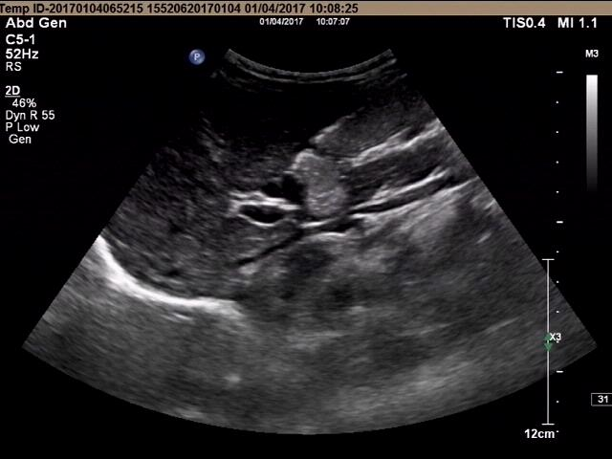
Figure 1 Single antral section image detected by ultrasound.

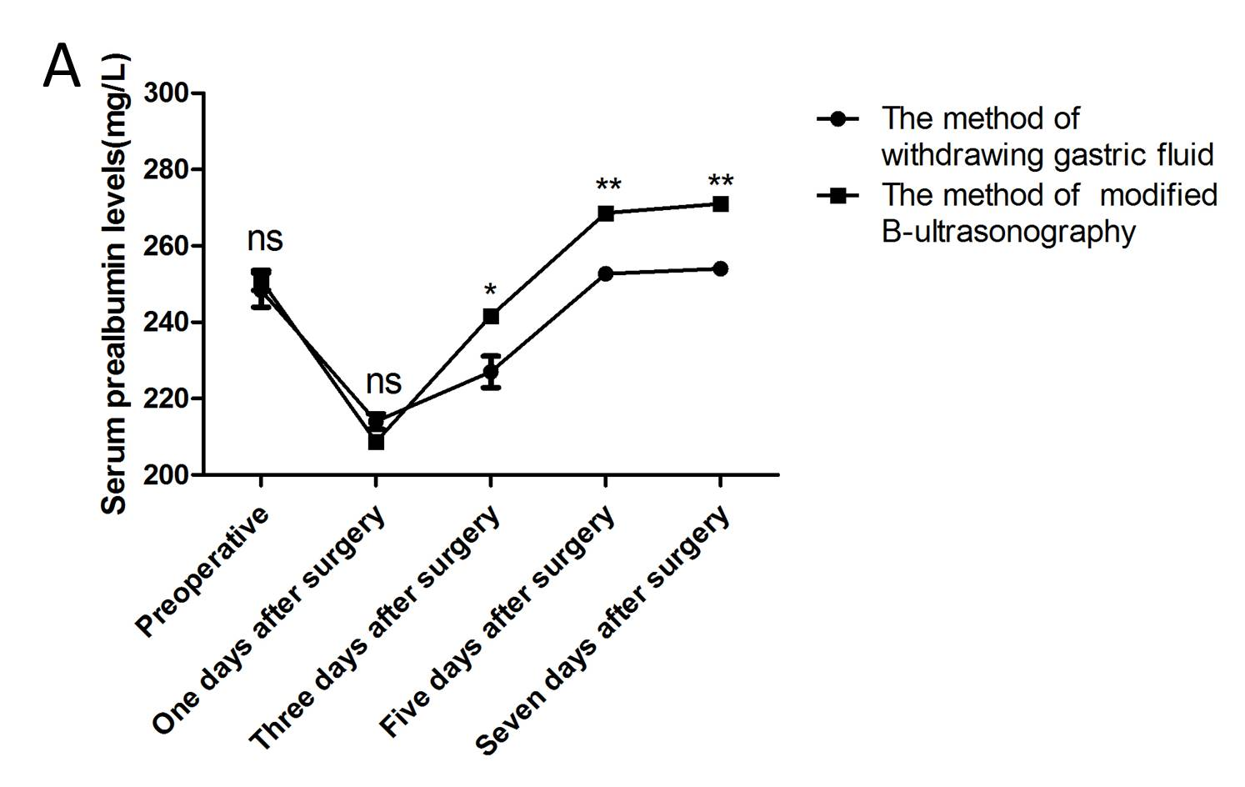

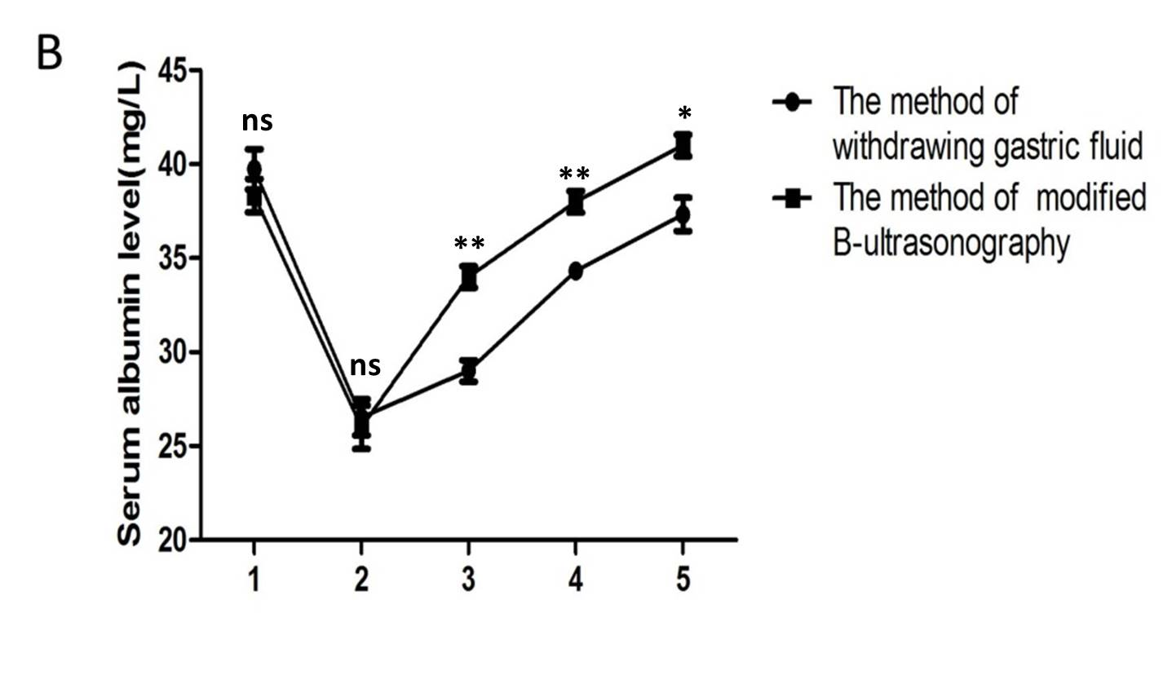
Figure 2 Comparison of prealbumin and albumin level changes between the two groups of patients. A: Changes in prealbumin levels; B: Changes in albumin levels. **P ＜ 0.01; *P ＜ 0.05.

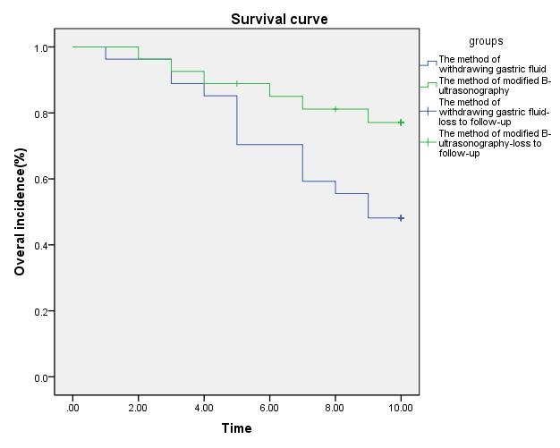
Figure 3 Comparison of complications between the two groups of patients.

