Supplementary Figure 1 Representative images of histological grading of colitis. Colonic inflammation was scored from Grade 0 as the mildest inflammation to Grade 5 as the most severe inflammation, as described in Materials and Methods.
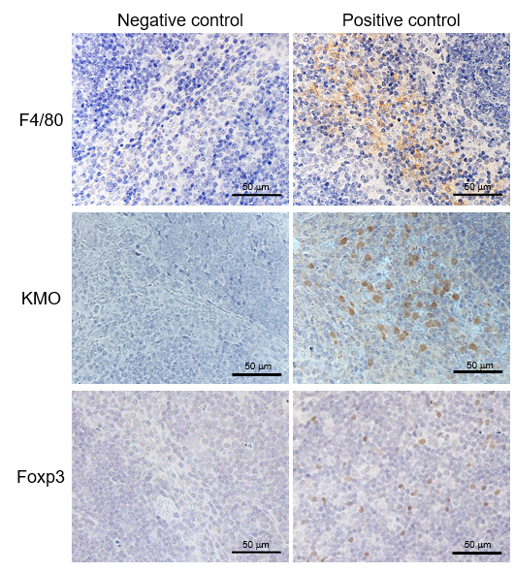
Supplementary Figure 2 Representative images of control staining of F4/80, KMO and Foxp3. Control staining of F4/80, KMO and Foxp3 by immunohistochemistry of spleen sections.
Supplementary Figure 3 Representative images of negative control staining of F4/80, CD19, CD11c, and anti-inflammatory cytokines. Representative images of negative control staining of F4/80, CD19, CD11c, KMO TGF-β, IL-10, and Foxp3. Immunofluorescent staining was used on colon sections.

Supplementary Figure 4 Changes in the ratio of colon to body weight in KMO^{+/+} mice and KMO^{−/−} mice. The ratios of colon to body weight were assessed on day 3 among the four groups (vehicle: KMO^{+/+}, n = 5; and KMO^{−/−}, n = 5; TNBS-treated: KMO^{+/+}, n = 6; and KMO^{−/−}, n = 5). The data are represented as mean ± SE. ªP < 0.05 vs TNBS-treated KMO^{+/+} mice group.

Supplementary Figure 5 Representative images of staining of F4/80, CD19, CD11c, and KMO in KMO^{−/−} mice. Expressions of F4/80, CD19 and CD11c, KMO, and DAPI (nuclei) in the colon of TNBS-treated mice were examined by immunofluorescence staining.

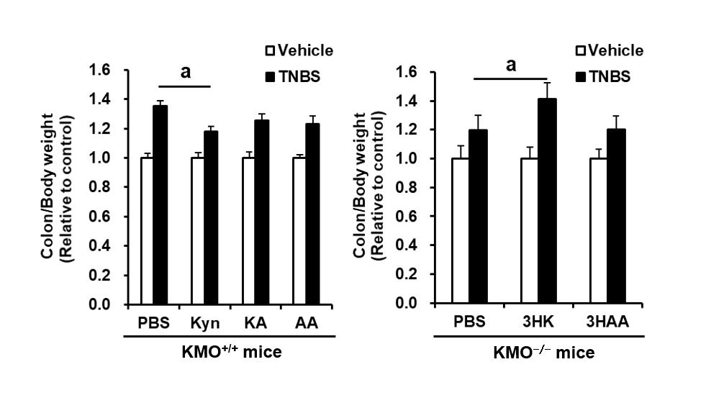
Supplementary Figure 6 Changes in the ratio of colon to body weight in KP metabolites-treated mice. The ratios of colon to body weight were assessed on day 3 of KP metabolites-treatment after TNBS injection. The data are represented as mean ± SE. ªP < 0.05 vs TNBS-treated PBS mice group.

Supplementary Figure 7 Representative images of H&E-staining in the colon of KP metabolites-treated mice. Representative images of H&E-staining in the colon from KP indicated mice 12 h after TNBS injection.

