Name of Journal: World Journal of Clinical Cases
Manuscript NO: 73934
Manuscript Type: CASE REPORT

Rare solitary splenic metastasis from a thymic carcinoma detected on fluorodeoxyglucose-positron emission tomography: A case report

Tsai YH et al. Rare splenic metastasis from a thymic carcinoma

Yueh-Hsun Tsai, Kuan-Hsun Lin, Tsai-Wang Huang

Yueh-Hsun Tsai, Department of Surgery, Tri-Service General Hospital, National Defense Medical Center, Taipei 114, Taiwan

Kuan-Hsun Lin, Tsai-Wang Huang, Division of Thoracic Surgery, Department of Surgery, Tri-Service General Hospital, National Defense Medical Center, Taipei 114, Taiwan

Author contributions: Tsai YH, Lin KH, and Huang TW were the patient’s surgeons; Tsai YH reviewed the literature and contributed to manuscript drafting; Lin KH analyzed and interpreted the imaging findings; Lin KH and Huang TW were responsible for the revision of the manuscript for important intellectual content; all authors issued final approval for the version to be submitted.

Corresponding author: Tsai-Wang Huang, Doctor, Division of Thoracic Surgery, Department of Surgery, Tri-Service General Hospital, National Defense Medical Center, No. 325 Section 2, Cheng-Gung Road, Nei-Hu, Taipei 114, Taiwan. chi-wang@yahoo.com.tw

Received: December 16, 2021
Revised: February 15, 2022
Accepted: March 26, 2022
Published online: May 26, 2022

Abstract
BACKGROUND
Thymic carcinoma is a rare, aggressive tumor arising from the thymus. In less than 7% of patients with thymic carcinoma, extrathoracic metastases occur in the extrathoracic lymph nodes, liver, and bone. Isolated splenic metastasis can occur but is very uncommon. To date, only 2 cases of splenic metastases from thymic carcinoma have been reported.

CASE SUMMARY
A 45-year-old man presented with chronic cough, dyspnea, persistent hoarseness and unintentional weight loss 17 kgs in 6 mo. Neck magnetic resonance imaging revealed a large, lobulated, soft-tissue mass measuring 5.4 cm × 6.6 cm × 3.8 cm which involved the left superior mediastinum and supraclavicular fossa. Chest computed tomography (CT) revealed a confluent and lobulated soft tissue mass encased the right brachiocephalic artery, right and left carotid arteries, and left subclavian artery in the mediastinum. A fluorodeoxyglucose-positron emission tomography was arranged for malignancy survey. The image revealed intense fluorodeoxyglucose avidity in a soft tissue lobulated mass occupying the superior mediastinum, over the cystic lesion in the spleen and in few enlarged nodules over the left supraclavicular fossa. CT-guided biopsy of the thymic mass and the ultrasound-guided biopsy of the splenic lesion were consistent with a thymic carcinoma with splenic metastasis. The patient was diagnosed of thymic carcinoma, cT2N2M1b, stage IVb.

CONCLUSION
A fluorodeoxyglucose (FDG)-positron emission tomography (PET) scan can provide a useful diagnostic value in conjunction with pathological result in evaluating tumor staging. Our case emphasizes the utility of FDG-PET for metastasis detection in thymic carcinoma.

Key Words: Thymic carcinoma; Splenic metastasis; Positron emission tomography; Extrathoracic metastases; Mediastinal tumor; Case report

©The Author(s) 2022. Published by Baishideng Publishing Group Inc. All rights reserved.

Citation: Tsai YH, Lin KH, Huang TW. Rare solitary splenic metastasis from a thymic carcinoma detected on fluorodeoxyglucose-positron emission tomography: A case report. World J Clin Cases 2022; 10(15): 5072-5076
URL: https://www.wjgnet.com/2307-8960/full/v10/i15/5072.htm
DOI: https://dx.doi.org/10.12998/wjcc.v10.i15.5072

Core Tip: Isolated splenic metastasis from thymic carcinoma is very rare. Nevertheless, splenic metastasis should be taken into consideration, although it is often asymptomatic. Our case emphasizes the utility of fluorodeoxyglucose -positron emission tomography for metastasis detection in thymic carcinoma.

INTRODUCTION
Thymic carcinoma is a rare, aggressive tumor arising from the thymus. The anterosuperior mediastinum is where most thymic carcinomas are found. In less than 7% patients, extrathoracic metastases are present in extrathoracic lymph nodes, the liver, and bones^{[1]}. Isolated splenic metastases are exceptionally rare. Patients with solitary splenic metastasis are often diagnosed without symptoms or raised tumor marker levels. This case study presents our experience with an unusual case of solitary splenic metastasis from a thymic carcinoma.

CASE PRESENTATION
Chief complaints
A 45-year-old man visited outpatient department presented with chronic cough, dyspnea and persistent hoarseness.

History of present illness
The patient started to have persistent cough with chest tightness since 10 mo ago. Unintentional weight loss for 17 kgs in 6 mo was also mentioned.

History of past illness
The patient denied any history of past illness.

Personal and family history
The patient denied any family history or allergic history to food or medicines.

Physical examination
No specific finding on physical examinations was identified.

Laboratory examinations
Routine blood test results were unremarkable, with normal levels of carcinoembryonic antigen, carbohydrate antigen 19-9 and squamous cell carcinoma antigen.

Imaging examinations
The chest X-ray did not show any significant abnormalities. No significant abnormal findings on the abdominal sonography. Abdomen computed tomography (CT) discovered a 3.8 cm cystic lesion with mild irregular wall in the spleen was noted, which regular follow up was suggested. The patient was transferred to otorhinolaryngology department owing to persistent hoarseness and left shoulder pain. He underwent microlaryngeal surgery after left sided vocal cord palsy with a protruding lesion on the postcricoid region was revealed by stroboscopy. Neck magnetic resonance imaging (MRI) and bone scan were arranged after surgery. A large, lobulated, soft-tissue mass measuring 5.4 cm × 6.6 cm × 3.8 cm which involved the left superior mediastinum and supraclavicular fossa was discovered accidentally on MRI. Chest CT (Figure 1) revealed a confluent and lobulated soft tissue mass encased the right brachiocephalic artery, right and left carotid arteries, and left subclavian artery in the mediastinum. With enlarged nodes (maximal size: 1.6 cm) in the left supraclavicular region. In addition, the chest CT scan disclosed a cystic mass in the spleen that increased from 3.8 cm to 5.1 cm in diameter in one month (Figure 1). A fluorodeoxyglucose (FDG)-positron emission tomography (PET) was arranged two months later for malignancy survey. The image revealed intense FDG-avidity in a soft tissue lobulated mass occupying the superior mediastinum (standard uptake value (SUV) max = 16.0, size > 9.0 cm), over the cystic lesion in the spleen (SUV max = 9.2, size = 6.1 cm) and in few enlarged nodules over the left supraclavicular fossa (SUV max. up to 17.5, size = 2.1 cm) (Figure 2).

Pathological examinations
The pathology result of the postcricoid lesion was benign. The CT-guided biopsy of the thymic mass was positive for cluster of differentiation 5, negative for thyroid transcription factor-1. Microscopically, Hematoxylin-Eosin staining of the thymic mass showed polygonal and spindle shaped tumor cells accompanied by giant cells with bizarre and multilobulated nuclei, suggesting poorly differentiated carcinoma of the mediastinum (Figure 3). The ultrasound-guided biopsy of the splenic lesion was made, which was consistent with a metastasis from the thymic carcinoma (Figure 3).

FINAL DIAGNOSIS
A thymic malignancy with regional nodal and splenic metastases, cT2N2M1b was suggested by the results of the PET scan. Correlated to the pathology results of thymic and splenic lesion, the patient was diagnosed of thymic carcinoma, cT2N2M1b, stage IVb according to eighth edition of TNM staging system.

TREATMENT
The patient underwent biopsies of the thymic and splenic masses. Nevertheless, the patient refused to take further treatment after the diagnosis of thymic carcinoma with solitary splenic metastasis was confirmed.

OUTCOME AND FOLLOW-UP
After two months of follow up at outpatient department. Unfortunately, we lost follow up of the patient after then.

DISCUSSION
Comparing with thymoma, thymic carcinoma is more aggressive. Survival rates for thymic carcinomas vary depending on the stage (stages I-II: 91%; stages III-IV: 31%) and resectability^{[2]}. Surgery is the gold standard treatment for early stage thymic carcinoma. Platinum-based chemotherapy is the standard choice for patients with locally invasive and metastatic disease^{[3]}. It is important to evaluate staging thoroughly to make proper therapeutic plan.
Isolated splenic metastasis from a thymic carcinoma is very rare. To date, only 2 cases have been reported^{[4,5]}. However, spleen biopsy was not performed in the case presented by Chen et al^{[5]}. Extrathoracic metastasis could also be neglected by abdomen sonography, which was operator dependent in the first study^{[4]}. In our study, pathological evidence and PET scan results completed a more definite diagnosis of thymic carcinoma with isolated splenic metastasis, cT2N2M1b, stage IVb.

CONCLUSION
It’s extremely rare to find isolated splenic metastasis in a patient with thymic carcinoma. Nevertheless, splenic metastasis should be taken into consideration, while splenic metastases are often asymptomatic. To help determine the appropriate management for thymic carcinoma, FDG-PET scan is suggested. FDG-PET scan can provide a useful diagnostic value in conjunction with pathological result in evaluating tumor staging. Our case emphasizes the utility of FDG-PET for metastasis detection in thymic carcinoma.

REFERENCES
1 Lewis JE, Wick MR, Scheithauer BW, Bernatz PE, Taylor WF. Thymoma. A clinicopathologic review. Cancer 1987; 60: 2727-2743 [PMID: 3677008 DOI: 10.1002/1097-0142(19871201)60:11<2727::aid-cncr2820601125>3.0.co;2-d]
2 Litvak AM, Woo K, Hayes S, Huang J, Rimner A, Sima CS, Moreira AL, Tsukazan M, Riely GJ. Clinical characteristics and outcomes for patients with thymic carcinoma: evaluation of Masaoka staging. J Thorac Oncol 2014; 9: 1810-1815 [PMID: 25393794 DOI: 10.1097/JTO.0000000000000363]
3 Yang Y, Fan XW, Wang HB, Xu Y, Li DD, Wu KL. Stage IVb thymic carcinoma: patients with lymph node metastases have better prognoses than those with hematogenous metastases. BMC Cancer 2017; 17: 217 [PMID: 28347273 DOI: 10.1186/s12885-017-3228-2]
4 Kao HW, Lin WC, Peng YJ, Chen CY. Unusual isolated splenic metastasis secondary to thymic carcinoma. Zhonghua Fangshexue Zazhi 2005: 4
5 Chen D, Meng X, Zhao Y, Wu S. Isolated splenic metastasis from a thymic carcinoma: A case report. Cancer Biol Ther 2016; 17: 911-914 [PMID: 27413995 DOI: 10.1080/15384047.2016.1210738]

Footnotes
Informed consent statement: All study participants provided informed written consent prior to study enrollment.

Conflict-of-interest statement: The authors declare that they have no conflict of interest to disclose.

CARE Checklist (2016) statement: We have completed the checklist to ensure that the manuscript meets the requirements of the CARE Checklist – 2016: Information for writing a case report.

Open-Access: This article is an open-access article that was selected by an in-house editor and fully peer-reviewed by external reviewers. It is distributed in accordance with the Creative Commons Attribution NonCommercial (CC BY-NC 4.0) license, which permits others to distribute, remix, adapt, build upon this work non-commercially, and license their derivative works on different terms, provided the original work is properly cited and the use is non-commercial. See: https://creativecommons.org/Licenses/by-nc/4.0/

Provenance and peer review: Unsolicited article; Externally peer reviewed.
Peer-review model: Single blind

Peer-review started: December 16, 2021
First decision: February 8, 2022
Article in press: March 26, 2022

Specialty type: Oncology
Country/Territory of origin: Taiwan
Peer-review report’s scientific quality classification
Grade A (Excellent): 0
Grade B (Very good): 0
Grade C (Good): C, C
Grade D (Fair): 0
Grade E (Poor): 0

P-Reviewer: Koizumi T, Japan; Liu YC, China S-Editor: Liu JH L-Editor: A P-Editor: Liu JH

Figure Legends
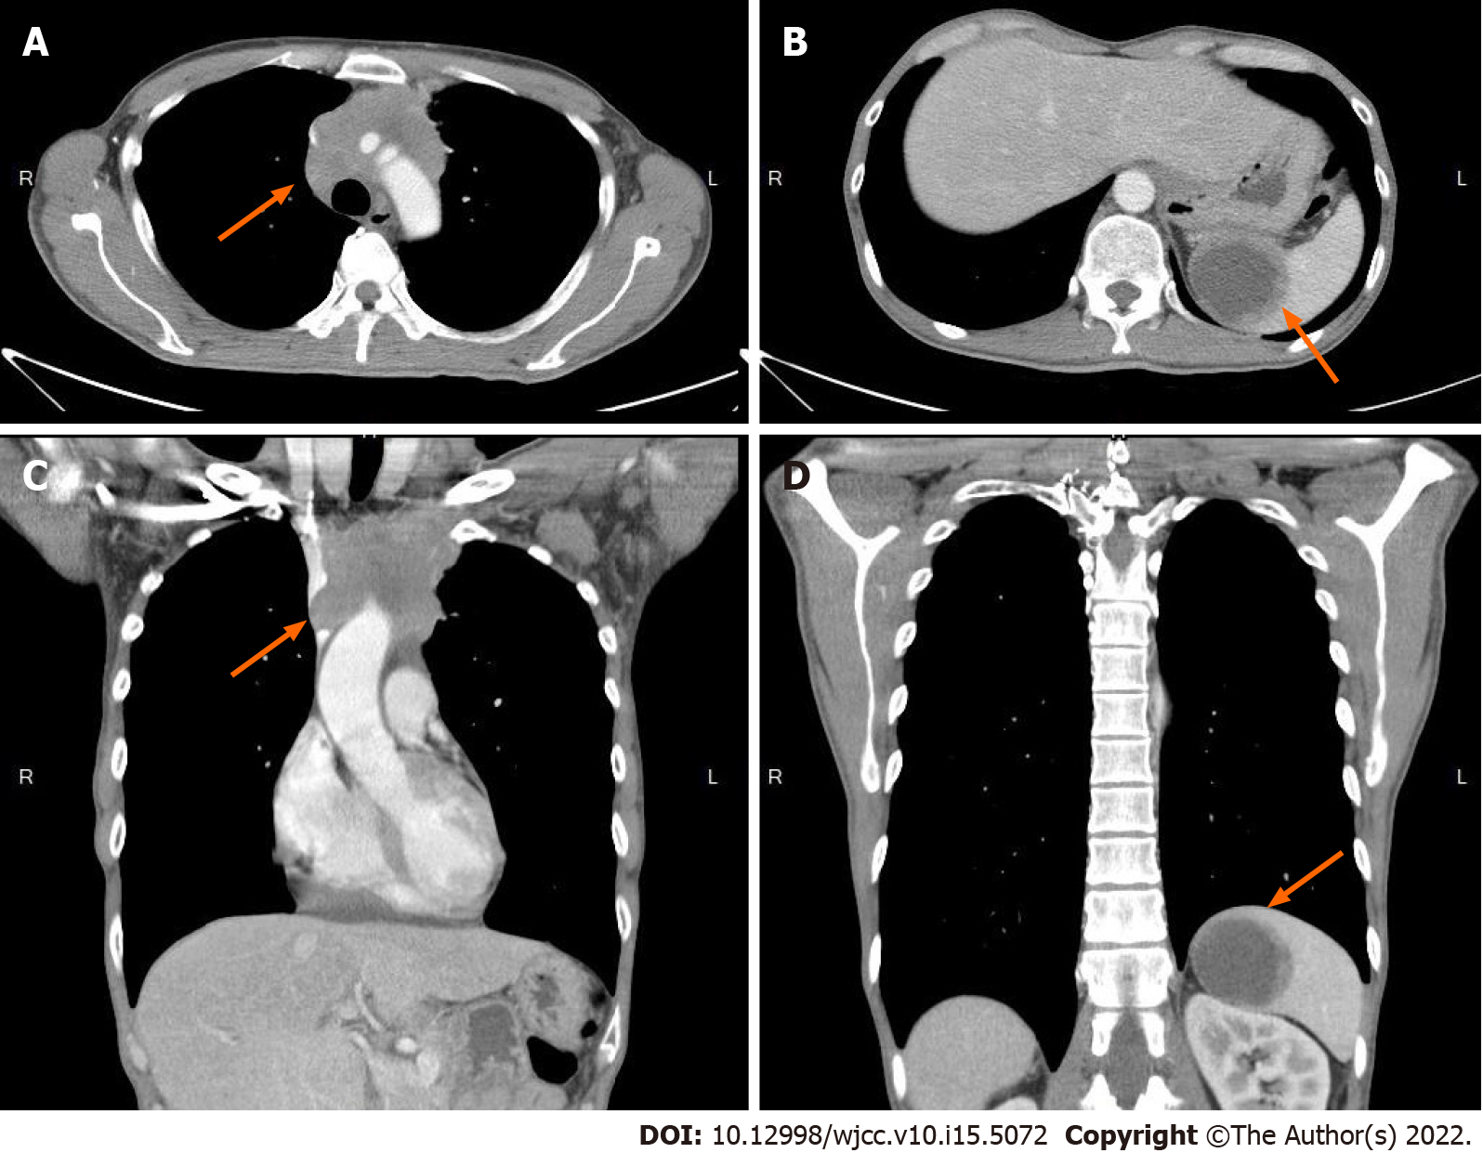
Figure 1 Computed tomography revealed mass over mediastinum and spleen. A and C: The mediastinum has a confluent and lobulated soft tissue mass (arrow), encasing the right brachiocephalic artery, right and left carotid arteries, and left subclavian artery and compressing the superior vena cava; B and D: There is one cystic mass (arrow), measuring approximately 5.1-cm in diameter, in the spleen.

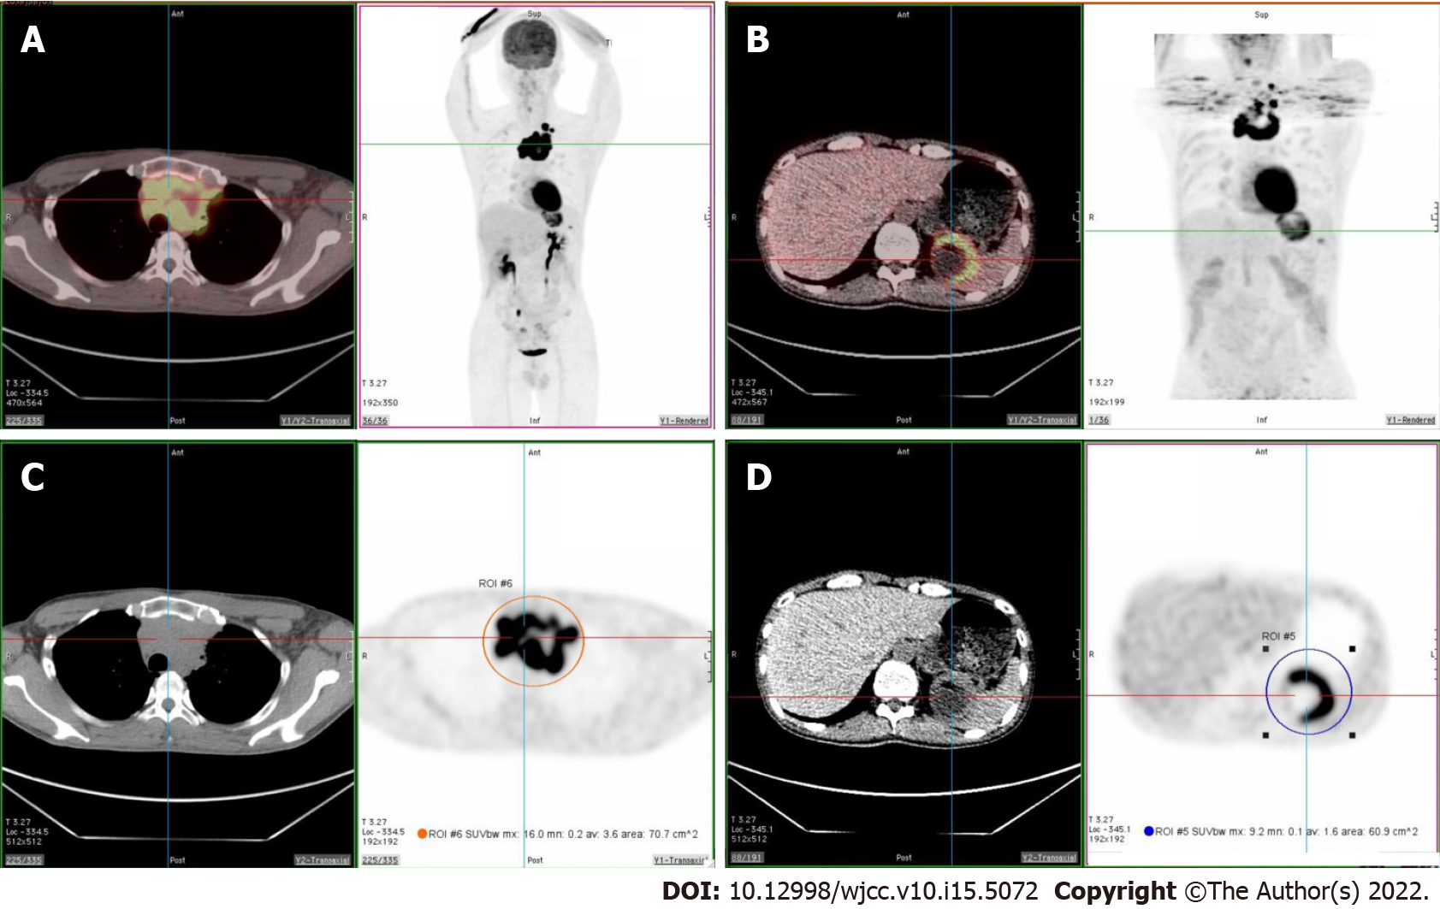
Figure 2 Fluorine-18 fluorodeoxyglucose positron emission tomography/computed tomography revealed increased fluorodeoxyglucose uptake over superior mediastinum and spleen. A and C: Intense fluorodeoxyglucose (FDG) avidity in a soft tissue lobulated mass occupying the superior mediastinum (SUVmax = 16.0, size > 9.0 cm); B and D: Intense FDG avidity over the cystic lesion in the spleen (SUVmax = 9.2, size = 6.1 cm).

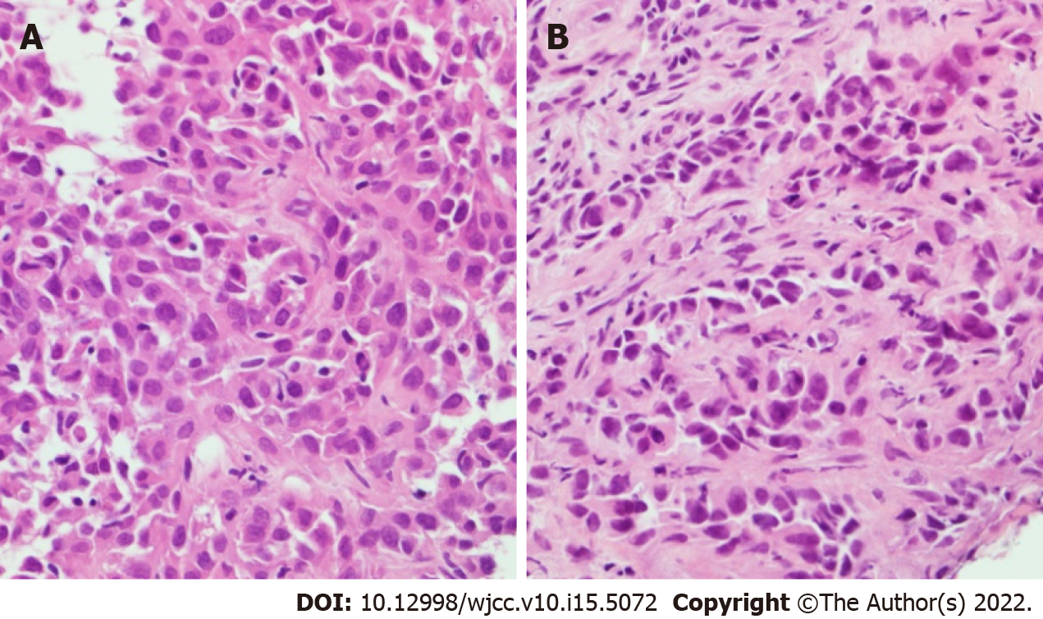
Figure 3 Pathology images. A: Hematoxylin-Eosin staining of the thymic mass showed polygonal and spindle shaped tumor cells accompanied by giant cells with bizarre and multilobulated nuclei; B: Hematoxylin-Eosin staining of the spleen tissue was compatible with poorly differentiated metastatic carcinoma.

Published by Baishideng Publishing Group Inc
7041 Koll Center Parkway, Suite 160, Pleasanton, CA 94566, USA
Telephone: +1-925-3991568
E-mail: bpgoffice@wjgnet.com
Help Desk: https://www.f6publishing.com/helpdesk
https://www.wjgnet.com

© 2022 Baishideng Publishing Group Inc. All rights reserved.

