Name of Journal: World Journal of Diabetes
Manuscript NO: 82020
Manuscript Type: ORIGINAL ARTICLE

Basic Study
Characterization of gut microbial and metabolite alterations in faeces of Goto Kakizaki rats using metagenomic and untargeted metabolomic approach

Zhao JD et al. Gut microbial and metabolite characterization of GK

Jin-Dong Zhao, Min Sun, Yan Li, Chan-Juan Yu, Ruo-Dong Cheng, Si-Hai Wang, Xue Du, Zhao-Hui Fang

Jin-Dong Zhao, Chan-Juan Yu, Ruo-Dong Cheng, Si-Hai Wang, Xue Du, Zhao-Hui Fang, Zhao-Hui Fang, Department of Endocrinology, The First Affiliated Hospital of Anhui University of Chinese Medicine, Hefei 230031, Anhui Province, China

Jin-Dong Zhao, Graduate School, Anhui University of Chinese Medicine, Hefei 230012, Anhui Province, China

Min Sun, School of Life Sciences, Anhui University, Hefei 230039, Anhui Province, China

Yan Li, Department of Infectious Disease, The First Affiliated Hospital of Anhui University of Chinese Medicine, Hefei 230031, Anhui Province, China

Author contributions: Zhao JD and Fang ZH participated in the design of the study and wrote the manuscript; Sun M, Li Y, Yu CJ, Cheng RD, Wang SH and Du X performed the experiment and helped complete the data analysis; The final version of the manuscript was reviewed and approved by all the authors.

Supported by the University Scientific Research Projects of Anhui, No. KJ2020A0401 and 2022AH050491; the open fund of Ministry of Education Key Laboratory of Glucolipid Metabolic Disorder, No. GYDKFXM01; Anhui University Collaborative Innovation Project, No. GXXT-2020-025; the National Natural Science Foundation of China, No. 82174153; the National Key Research and Development Program, No. 2018YFC1704202; the Anhui Provincial Quality Engineering Project of Universities, No. 2021jyxm0834; the Major and Difficult Diseases Project of Anhui Province, No. 2021zdynjb06; and the Clinical Research Project of Anhui University of Traditional Chinese Medicine, No. 2021yfylc01.

Corresponding author: Zhao-Hui Fang, PhD, Chief Doctor, Department of Endocrinology, The First Affiliated Hospital of Anhui University of Chinese Medicine, No. 117 Meishan Road, Hefei 230031, Anhui Province, China. fangzhaohui1111@163.com

Received: December 2, 2022
Revised: December 31, 2022
Accepted: February 7, 2023
Published online:

Abstract
BACKGROUND
In recent years, the incidence of type 2 diabetes (T2DM) has shown a rapid growth trend. Goto Kakizaki (GK) rats are a valuable model for the study of T2DM and share common glucose metabolism features with human T2DM patients. A series of studies indicate that T2DM is associated with the gut microbiota composition and gut metabolites. We aimed to systematically characterize the faecal gut microbes and metabolites of GK rats and analyse the relationship between glucose and insulin resistance.

AIM
To evaluate the gut microbial and metabolite alterations in GK rat faeces based on metagenomics and untargeted metabolomics.

METHODS
Ten GK rats (model group) and Wistar rats (control group) were observed for 10 wk. Indexes related to glucose, mainly including weight, fasting blood glucose (FBG) and insulin levels, homeostasis model assessment of insulin resistance (HOMA-IR) and homeostasis model assessment of β cell (HOMA-β) were assessed. The faecal gut microbiota was sequenced by metagenomics, and faecal metabolites were analysed by untargeted metabolomics. Multiple metabolic pathways were evaluated based on the differential metabolites identified, and the correlations between blood glucose and the gut microbiota and metabolites were analysed.

RESULTS
The model group displayed significant differences in weight, FBG, insulin, HOMA-IR and HOMA-β (P < 0.05, P < 0.01) and a shift in the gut microbiota structure compared with the control group. The results demonstrated significantly decreased abundances of Prevotella sp. CAG:604 and Lactobacillus murinus (P < 0.05) and a significantly increased abundance of Allobaculum stercoricanis (P < 0.01) in the model group. A correlation analysis indicated that FBG and HOMA-IR were positively correlated with Allobaculum stercoricanis and negatively correlated with Lactobacillus murinus. Orthogonal partial least squares discriminant analysis suggested that the faecal metabolic profiles differed between the model and control groups. Fourteen potential metabolic biomarkers, including glycochenodeoxycholic acid, uric acid, 13(S)-hydroxyoctadecadienoic acid (HODE), N-acetylaspartate, β-sitostenone, sphinganine, 4-pyridoxic acid, and linoleic acid, were identified. Moreover, FBG and HOMA-IR were positively correlated with glutathione, 13(S)-HODE, uric acid, 4-pyridoxic acid and allantoic acid and negatively correlated with 3-α, 7-α, chenodeoxycholic acid glycine conjugate and 26-trihydroxy-5-β-cholestane (P < 0.05, P < 0.01). Allobaculum stercoricanis was positively correlated with linoleic acid and sphinganine (P < 0.01), and 2-methyl-3-hydroxy-5-formylpyridine-4-carboxylate was negatively associated with Prevotella sp. CAG:604 (P < 0.01). The metabolic pathways showing the largest differences were arginine biosynthesis; primary bile acid biosynthesis; purine metabolism; linoleic acid metabolism; alanine, aspartate and glutamate metabolism; and nitrogen metabolism.

CONCLUSION
Metagenomics and untargeted metabolomics indicated that disordered compositions of gut microbes and metabolites may be common defects in GK rats.

Key Words: Type 2 diabetes mellitus; Gut microbial; Metabolites; Goto-Kakizaki rats; Metagenomic; Untargeted metabolomic

Zhao JD, Sun M, li Y, Yu CJ, Cheng RD, Wang SH, Du X, Fang ZH. Characterization of gut microbial and metabolite alterations in faeces of Goto Kakizaki rats using metagenomic and untargeted metabolomic approach. World J Diabetes 2023; In press

Core Tip: Studies suggested that the gut microbial and metabolites has an essential role in Goto Kakizaki rats. The results revealed evidence of a decrease in Prevotella sp. CAG:604 and Lactobacillus_murinus. Allobaculum_stercoricanis is increase. Fourteen potential metabolism biomarkers were glycochenodeoxycholic acid, uric acid, N-acetylaspartate, β-sitostenone, sphinganine, 4-pyridoxic acid, 13(S)-hydroxyoctadecadienoic acid, linoleic acid, etc.
INTRODUCTION
In recent years, the incidence of type 2 diabetes (T2DM) has shown a rapid growth trend in China, where its current prevalence is 12.8%^{[1]}. T2DM is a metabolic disorder whose major pathological hallmark is insulin resistance^{[2]}. Goto-Kakizaki (GK) noninsulin-dependent rats are a valuable animal model for studies of T2DM^{[3]}. At 4 wk of age, GK rats exhibit insulin resistance, basal hyperglycaemia development, increased hepatic glucose production, and impaired insulin secretion^{[4,5]}. GK rats share common features with human T2DM. Therefore, the results obtained using GK rats as the research subjects will be more similar to those of patients with T2DM than the results obtained in other systems and will thus provide more useful evidence for analysing the pathogenesis and treatment of T2DM.
The gut microbiota of the host constitutes a massive, complex microecosystem. Exploring the composition of the gut microbiota will improve our understanding of the relationship with the host as one of the key factors in host health or disease. Recent studies suggest that both humans and animal models of T2DM and its complications, including GK rats, exhibit dysbiosis of the gut microbiota and further indicate that this characteristic microbiota imbalance, which may involve decreased bacterial diversity, contributes to the development of T2DM^{[6-8]}. In addition, studies have shown that undesirable shifts in metagenomic- and microbiota-associated metabolite production may negatively impact glucose tolerance and insulin resistance^{[9]}.
Because the human dietary structure is complex and diverse, the changes in gut microbes and metabolites observed in different studies vary, even when the type and amount of diets administered to patients with T2DM (e.g., dietary fibre contents or low-carbohydrate diets) and nutritional advice are controlled^{[10-12]}. In this study, we selected a fixed diet with balanced nutrient proportions for rats to avoid deviations in the results due to dietary differences. In animal models of diabetes, streptozotocin or alloxan is usually selected as an agent for damaging pancreatic function. This type of model is more similar to type 1 diabetes. In the classification of diabetes, T2DM accounts for approximately 90% of cases. Therefore, the further exploration of gut microbes and metabolites in a T2DM model is desired. Moreover, a joint analysis of the gut microbiota and metabolite structure has not previously been conducted^{[13]}. Therefore, the faeces of GK rats were collected as the study object, and this study aimed to systematically characterize the faecal gut microbes and metabolites of GK rats using metagenomic and untargeted metabolomic approaches and to analyse the relationship between gut microbes and metabolites with glucose and insulin resistance.

MATERIALS AND METHODS
Experimental design
Ten male GK rats (aged 5-6 wk) were procured from Changzhou Cavens Model Animal Co., Ltd. (Changzhou, China; certificate No. 202145537), and ten male Wistar rats (aged 5-6 wk) were purchased from Sipeifu (Beijing) Biotechnology Co., Ltd. (Beijing, China; certificate No. 110324210106676238). The rats were acclimated in a controlled laboratory (25 ± 2 °C temperature, 60% ± 5% humidity) with free access to breeding feed and water. The Animal Committee of Anhui University of Chinese Medicine (Hefei, China; Approval AHUCM-rats-2021133) approved the experiments.
The rats were fed growth and reproduction feed during the 1-wk acclimatization period and were observed for 10 wk. The fasting blood glucose (FBG) was measured, and nine rats in the model group showed levels exceeding 11.1 mmol/L, whereas the FBG in the other rat was not as high. Additionally, one rat in the control group escaped due to poor management, and the analysis was thus performed using nine rats from each group. Body weight and FBG were measured every two weeks. FBG levels in blood sampled from the tail vein were measured with a glucose metre (ACCU-CHEK Performa, ROCHE, Basel, Switzerland) after food deprivation for 12 h overnight.

Sample collection
Eighteen rats were anaesthetized via the intraperitoneal administration of pentobarbital sodium (30 mg/kg, Merck, United States). Blood samples were collected in nonheparinized tubes and centrifuged to obtain serum. FBG, insulin, homeostasis model assessment of insulin resistance (HOMA-IR) and homeostasis model assessment of β cell (HOMA-β) were assessed. The faecal were placed in Eppendorf tubes. The serum and caecal contents were stored at -80 °C^{[14]}.

Faecal metagenomic analysis
Total DNA was extracted from 1 g of faeces using a kit (Omega Bio-Tek, Norcross, GA, United States). We determined the concentration, purity and quality of the DNA^{[15]}.
The extracted DNA (average length of 400 bp) was fragmented using a Covaris M220 ultrasonicator (Gene Company Limited, China). A paired-end library was constructed using NEXTFLEX Rapid DNA-Seq (Bioo Scientific, Austin, TX, United States). Sequencing was performed with an Illumina NovaSeq system (Illumina Inc., San Diego, CA, United States) using NovaSeq Reagent Kits according to the manufacturer’s instructions^{[16]}. The paired-end Illumina reads were trimmed of adaptors, and reads with a low quality (length < 50 bp, quality value < 20, containing N bases) were removed by fastp^{[17]}.
Metagenomic data were collected using MEGAHIT. Contigs with a length ≥ 300 bp were selected as the final assembly output and used for further gene annotation. Amino acid sequences from the predicted open reading frames with a length ≥ 100 bp were retrieved and translated from the NCBI database^{[18]}. The nonredundant gene catalogue was constructed using CD-HIT and aligned to high-quality reads using SOAP aligner.

Faecal metabolomic analysis
The supernatant was extracted from 200 mg of faeces and transferred to sample vials^{[19]}. Two microlitres of a sample was separated with an HSS T3 column and used for LC-MS/MS analysis. Mass spectrometric data were collected using a UHPLC-Q Exactive system (Thermo Fisher Scientific, Waltham, MA, United States) with an electrospray ionization source operating in positive- and negative-ion modes. Data acquisition was performed in data-dependent acquisition mode.
The raw LC‒MS/MS data were preprocessed using Progenesis QI (Waters Corporation, Milford, MA, United States) software. Internal standard peaks and false-positive peaks were removed from the data matrix, redundant signals were removed, and the peaks were pooled. In addition, the metabolites were searched and identified in the HMDB, KEGG and Metlin databases.
Metabolites detected in at least 80% of any set of samples were retained^{[20]}. After filtering, the metabolite response intensity of the mass spectrum peaks was normalized using the sum-normalization method. Moreover, variables with a relative standard deviation > 30% relative to the quality control samples were removed, and log10 Logarithmization was performed to obtain the final data matrix for subsequent analysis.

Statistical analysis
SPSS 23.0 (International Business Machines Corporation, NY, United States) and GraphPad Prism 9.0 (San Diego, CA, United States) software were used for statistical and graphical analyses with Student’s t tests and fold difference analysis. The heatmap data were normalized via the z score method [z = (x-μ)/σ] and graphically visualized using the pheatmap package.
Variance analysis was performed with the matrix file after data preprocessing. The R package ropls (Version 1.6.2) was used to perform orthogonal partial least squares discriminant analysis (OPLS-DA). The stability of the model was assessed by 7-cycle interactive validation. The significantly different metabolites were selected based on the variable importance in projection score (> 1) of OPLS-DA and the P value < 0.05 obtained by Student’s t test^{[21]}.
Differential metabolites were screened and mapped to their biochemical pathways through metabolic enrichment and pathway analysis based on the Kyoto Encyclopedia of Genes and Genomes (http://www. genome.jp/kegg/). These metabolites were classified according to their functions. Significantly enriched pathways were identified with MetaboAnalyst using degree centrality and Fisher’s exact test (https://www.metaboanalyst.ca/). The molecular weights of potential biomarkers were obtained from biochemical databases (https://www.genome.jp/kegg/compound/). The data were analysed on the Majorbio Cloud Platform (https://www.majorbio.com) and Personalbio Cloud Platform (https://www.genescloud.cn/).

RESULTS
Body weight
The initial body weights did not significantly differ between the groups (P > 0.05). In the final weeks of the experimental period, the model group had a significantly lower weight than the control group (P < 0.05; Figure 1A).

FBG and insulin resistance
The FBG levels significantly differed from weeks 0 to 11, and over this time period, the significant difference became increasingly pronounced (Figure 1B). The mean FBG of the model group exceeded 11.1 mmol/L at week 5 and was close to 16.7 mmol/L at week 11.
Starting from week 11, the fasting insulin level of the model group was significantly higher than that of the control group (Figure 1C). Additionally, HOMA-IR index of the model group was markedly higher than that of the control group from week 11 onward (Figure 1D). Moreover, the HOMA-β index of the model group was significantly lower than that of the control group (Figure 1E).

Community structure of the gut microbiota
In total, 4.15 × 10¹⁰ raw bases (bp) and 4.33 × 10⁸ raw reads were obtained. Subsequently, 1.59 × 10⁸ nonredundant genes were predicted from the reads after quality control and the removal of host sequences. In total, five domains, 14 kingdoms, 181 phylum, 316 classes, 551 orders, 940 families, 2764 genus and 12302 species were identified. At the domain level, the gut microbiota comprised bacteria, archaea, eukaryotes, viruses and unclassified. Bacteria accounted for more than 99.67% ± 0.05% of the organisms in both groups.
A principal coordinate analysis of the distance matrix showed that the first principal component (PC1) and the second principal components accounted for 13.87% and 10.59% of the observed variation, respectively (Figure 2A). The boxplots illustrate the distribution of different groups on the PC1 axis and reveal that the greatest difference existed between the control and model groups (Figure 2B).
At the phylum level, Firmicutes, Bacteroidetes, Actinobacteria, Spirochaetes, Proteobacteria and Candidatus Saccharibacteria were identified as the main phylum (Figure 3A). The relative abundances of Firmicutes and Bacteroidetes were 54.85% and 27.16% in the control group and 57.75% and 23.82% in the model group, respectively. Although no significant differences were detected, a greater abundance of Firmicutes and a lower abundance of Bacteroidetes were found in the model group than in the control group.
In addition to Allobaculum, which was the only genus showing a significant difference, Prevotella, Bacteroides, Dorea, Phascolarctobacterium, Faecalibacterium and Ruminococcus were enriched in the control group, and Collinsella, Clostridium, Blautia and Lactobacillus were the main components of the model group (Figure 3B). Among the 30 species with the highest abundance, 3 species showed significant differences between the control and model groups (P < 0.05). A higher abundance of Allobaculum stercoricanis and lower abundances of Prevotella sp. CAG:604 and Lactobacillus murinus were found in the model group compared with the control group (Figure 3C).
Based on the heatmap, we found that FBG and HOMA-IR were moderately positively correlated with Allobaculum stercoricanis and moderately negatively correlated with Lactobacillus murinus (P < 0.05, P < 0.01; Figure 4A).

Metabolomic analysis
The faecal metabolic profile data of the control and model groups were separated by an OPLS-DA model, which indicated that the positive- and negative-ion metabolic profiles of the samples differed between the two groups. The evaluation parameters of the OPLS-DA models from the positive- and negative-ion profiles showed values of Q₂ = -0.199 and Q₂ = -0.068, respectively, demonstrating good explanation and prediction with 200 × permutation testing. For the positive-ion profiles, the component 1 showed a value 14.00%, and the orthogonal component 1 showed a value of 30.70%. For the negative-ion profiles, the component 1 showed a value of 13.60%, and the orthogonal component 1 showed a value of 32.10% (Figure 5 A-D).
We identified 815 positive-ion and 678 negative-ion metabolites, and 596 metabolites were found in the KEGG compound database. The differential metabolites (included 145 positive- and 106 negative-ion metabolites or 180 upregulated and 71 downregulated metabolites) were filtered in volcano plots (Figure 6A). The most reasonable molecular formula was obtained from a search of the KEGG Compound database. According to the abovementioned principle, 14 potential metabolic biomarkers were identified in GK rats (Table 1).
Based on the heatmap, we found that FBG and HOMA-IR were positively correlated with 13(S)-hydroxyoctadecadienoic acid (HODE), glutathione, uric acid, 4-pyridoxic acid and allantoic acid and negatively associated with 3-α, 7-α, 26-trihydroxy-5-β-cholestane and chenodeoxycholic acid glycine conjugate (P < 0.05, P < 0.01; Figure 4B).
Based on the heatmap, we found that sphinganine and linoleic acid were positively correlated with Allobaculum stercoricanis (P < 0.01) and that 2-methyl-3-hydroxy-5-formylpyridine-4-carboxylate was negatively associated with Prevotella_sp._CAG:604 (P < 0.01; Figure 4C).
The KEGG compound IDs and compound names of endogenous metabolites were then introduced into the MetaboAnalyst 5.0 system for pathway and visual analyses. Based on the faecal biomarker data, the enriched pathways were found to include vitamin B6 metabolism; primary bile acid biosynthesis; arginine biosynthesis; purine metabolism; alanine, aspartate and glutamate metabolism; linoleic acid metabolism; and nitrogen metabolism. Among these pathways, six pathways were found to show differences (Figure 6B; Table 2). Figure 7 illustrates the key potential proteases of the metabolic pathways related to hyperglycaemia levels based on the KEGG database.

DISCUSSION
The aetiology and pathogenesis of T2DM are complex, and most experts believe that this disorder is a clinical syndrome caused by genetic and environmental factors. Because GK rats develop spontaneous diabetes and show insulin resistance, these rats constitute one of the best models for the study of T2DM. In clinical practice, we have found that some patients who suffer from T2DM do not consume a high-sugar and high-fat diet. Therefore, a high-sugar and high-fat diet was not selected in this study, which reduced the impacts of excess nutrition on glucose. Studies have shown that the glucose levels of 14- to 16-wk-old GK rats meet the diagnostic criteria for T2DM^{[3]}. In this study, at 14 wk, the GK rats appeared to drink water and urinate more than the control rats, and their hair colour turned yellow. Before 12 wk, the GK rats were heavier than the control Wistar rats. However, at 14 wk, the body weight of the GK rats was lower than that of the control group, and the FBG level exceeded 11.1 mmol/L. By the 16th week, the body weight was further reduced, and the glucose level was further increased, exceeding 16 mmol/L. Furthermore, the increase in glucose was related to the increase in HOMA-IR index and the decrease in HOMA-β index. This finding may be related to the observed decrease in the numbers of pancreatic β-cell islets, the irregular shape of islets, and the presence of amyloid degeneration. Some researchers believe that weight loss is related to a reduction in the Firmicutes/Bacteroidetes ratio, but this phenomenon is not observed universally^{[22,23]} and was not found in our research. Muñoz-Garach et al^{[24]} believe that weight loss is related to a reduction in the level of bile acid, and the results of the present study are consistent with this view.
A clear separation among the communities was observed between the control and model groups, which suggested that the gut microbiota shows substantial differences between the diabetes and nondiabetes groups. At the phylum level, Bacteroidetes and Firmicutes were dominant in GK and Wistar rats, with proportions greater than 80%. Although no significant differences were detected, a higher relative abundance of Firmicutes and a lower relative abundance of Bacteroidetes were found in the model group than in the control group. These findings may be related to the fact that the rats were fed breeding feed after weaning. These results may also be related to the shorter course of disease in the T2DM rats because the gut microbiota is seriously disturbed, and the development of characteristic hyperglycaemia lags behind.
At the species level, a higher abundance of Allobaculum stercoricanis and lower abundances of Prevotella sp. CAG:604 and Lactobacillus murinus were found in the model group compared with the control group. Allobaculum stercoricanis belongs to the Allobaculum genus (Firmicutes), for which a significant difference was found at the genus level. A previous study showed that Allobaculum presented a 10.95-fold increase in HF diabetic mice compared with ND-fed mice^{[25]}, and the corresponding increase found in this study was 2.75-fold. In a previous study, Allobaculum was identified as an important biomarker of metabolic disorders, particularly diabetes^{[26,27]}. This study also showed that Allobaculum stercoricanis was closely related to FBG, HOMA-IR index and a decrease in HOMA-β index. Different individual animals, even within the same species, show different feed conversion efficiencies. Animals with a high feed conversion efficiency show higher mRNA expression levels of insulin-like growth factor^{[28]}, which can further regulate glucose. The abundance of Prevotella sp. CAG:604 is related to the feed conversion efficiency^{[29]}. This study revealed a decrease in the abundance of Prevotella sp. CAG:604, which may be one of the reasons for the diabetic phenotype of GK rats, and a direct negative correlation was found between these factors. Prevotella_sp._CAG:604 could be considered a potential biomarker of diabetes. Lactobacillus murinus was decreased in GK rats, and this finding is consistent with the results reported by Cui et al^{[30]} and Yue et al^{[31]}. With increases in the abundance of Lactobacillus murinus, the glucose level and HOMA-IR index showed a downwards trend. Lactobacillus murinus is considered a beneficial gut microbe^{[32]}. In a previous study, a probiotic group whose members drank Lactobacillus casei strain milk showed a significant increase in the faecal count of Lactobacillus. The condition of patients with T2DM has also been controlled^{[33]}. We speculate that drinking milk containing Lactobacillus murinus may also control glucose levels.
The OPLS-DA model suggested that the positive- and negative-ion metabolic profiles differed between GK and Wistar rat faeces. Fourteen potential metabolic biomarkers were assigned to bile acids, benzenoids, amino acids, steroids, amines, pyridine carboxylic acids and derivatives, and fatty acids. The topological analysis of the metabolic pathways showed that the difference between GK and Wistar rats was mainly due to arginine biosynthesis; primary bile acid biosynthesis; alanine, aspartate and glutamate metabolism; purine metabolism; linoleic acid metabolism; and nitrogen metabolism. These results were consistent with those of previous studies^{[34,35]}. Metabolic pathway analysis showed that the differences were mainly due to amino acid metabolism, lipid metabolism, nucleotide metabolism, and energy metabolism. These pathways provide ideas for future research, and the results show that in addition to abnormal carbohydrate pathways, fat and protein are also metabolized in a disorderly manner leading to dysfunctions of the eyes, kidneys, blood vessels, and nerves, among other organs.
We observed marked decreases in the excretion of glycochenodeoxycholic acid and glycocholic acid in rat faeces, as reported by Sun et al^{[36]}. The levels of glycochenodeoxycholic acid are increased in the liver, blood and ileum^{[36-38]}. Lu et al^{[39]} showed that increased plasma glycochenodeoxycholic acid levels are associated with an increased risk of T2DM. The relationship among 3-α, 7-α, 26-trihydroxy-5-β-cholestane and T2DM has been less well studied; we found that 3-α, 7-α, 26-trihydroxy-5-β-cholestane was positively related to FBG and HOMA-IR, which may be a research topic that will be addressed in the future. Hyperuricaemia is particularly common in patients with T2DM^{[40]}. Some clinical studies have observed that ursodeoxycholic acid, as the representative drug regulating bile acid metabolism, exerts a certain effect on reducing glucose, glycosylated haemoglobin A1c, and weight and increasing GLP-1 secretion^{[41,42]}. Although ursodeoxycholic acid is not widely used in clinical practice, it may be used as a potential drug for the treatment of T2DM. In addition to excretion in the kidneys, uric acid can also be secreted into the intestine and metabolized by microorganisms^{[43]}. This interaction could potentially modulate serum uric acid levels^{[44]}. This study revealed an increase in the intestinal excretion of uric acid, indicating that uric acid in the body is likely to be a risk factor for T2DM and to aggravate this condition. In our study, we also found that uric acid was positively related to FBG and HOMA-IR.
In the presence of glutathione, a series of physiological reactions result in a low antioxidative defence capacity. β cells gradually die, and progression to T2DM occurs^{[45]}. This study showed that the glutathione level was increased in the GK group and was positively related to the FBG and HOMA-IR. Hyperglycaemia is a potential risk factor for the N-acetylaspartate network^{[46]}. The present study also identified this phenomenon. The N-acetylaspartate level was higher in GK rats. A high level of N-acetyl-L-glutamic acid may result in increased blood pressure^{[47]}. Uncontrolled blood pressure can significantly increase the risk of macroangiopathy in diabetes. The relationship of allantoic acid with diabetes has not been studied, but the present study revealed that allantoic acid was positively related to FBG and HOMA-IR. At baseline, a previous study showed that amino acids are upregulated in T2DM patients. The dysregulation of amino acid metabolism may occur earlier than glucose metabolism to T2DM^{[48]}. This finding suggests that patients with T2DM should not consume a diet with a high protein level.
We found that the concentration of sphinganine was increased in GK rats. Sphinganine is positively related to Lachnospiraceae bacteria, Allobaculum stercoricanis, and Lactobacillus johnsonii and is negatively related to Prevotella sp. CAG:604 and Phascolarctobacterium succinatutens. Studies have shown that when obese people lose weight, they exhibit an increase in the abundance of Phascolarctobacterium succinatutens^{[49]}. Weight loss is conducive to glucose control. Sphinganine is formed from ceramide and is a risk factor for β-cell dysfunction in T2DM^{[50]}. In this condition, insulin secretion was observed to be reduced, and the inhibition of ceramide metabolism was weakened. An increase in 13(S)-HODE is observed in individuals with nonalcoholic fatty liver disease^{[51]}. Because the common pathogenesis of nonalcoholic fatty liver and diabetes is insulin resistance, diabetes may also be accompanied by elevated levels of 13(S)-HODE, and our research confirms this hypothesis. 13(S)-HODE was found to be positively related to FBG and HOMA-IR, and Phascolarctobacterium succinatutens wasenriched in the model group.
We observed that the linoleic acid level was elevated in GK rats. Linoleic acid levels are markedly higher among populations with a higher prevalence of T2DM^{[52]}. Linoleic acid is positively related to Allobaculum stercoricanis and is negatively related to Prevotella sp. CAG:604. 4-Pyridoxic acid is a catabolite of vitamin B6 metabolism, and our study showed that 4-pyridoxic acid levels were increased in the model group and positively related to FBG and HOMA-IR. A higher level of vitamin B6 isassociated with a higher HOMA-IR values and T2DM^{[53]}. Furthermore, the risk of all-cause mortality in patients with T2DM is higher among those with 4-pyridoxic acid levels in the highest quartile^{[54]}. 2-Methyl-3-hydroxy-5-formylpyridine-4-carboxylate is also a catabolite of vitamin B6 metabolism, and a reduction in its content can help regulate glucose levels^{[55,56]}. This compound was found to be negatively related to Prevotella sp. CAG:604 and Dorea sp. CAG:317 and showed increased levels in the model group in this study. The results indicated that the glucose level was elevated in GK rats and that chenodeoxycholic acid glycine conjugate was negatively correlated with FBG and HOMA-IR, which was consistent with the results reported by Zhang et al^{[57]}.
Feng et al^{[58]} found that glutamine synthetase activity was significantly increased after the induction of diabetes by streptozotocin in rats. The serum levels of ornithine carbamoyltransferase are increased in KK-Ay diabetic mice^{[59]}. The liver is involved in glucose metabolism. In a state of hyperglycaemia, the liver is damaged to varying degrees, resulting in the abnormal expression of some proteases. Phosphoglucomutase is a key protease in carbohydrate metabolism^{[60]}. In particular, this protease is closely related to obesity. Endothelial cell function damage mostly occurs in T2DM and is related to argininosuccinate synthase and argininosuccinate lyase. In particular, TNF-α downregulates argininosuccinate synthase expression^{[61,62]}. The activity of amidophosphoribosyltransferase is higher in the kidneys of diabetic rats^{[63]}. The results indicate that amidophosphoribosyltransferase is related to the accretion of nucleic acids. A low level of aspartate aminotransferase is an independent risk factor of frail T2DM patients^{[64]}. Glycogen is synthesized in the liver, and changes in a series of liver enzymes affect the synthesis of glycogen. For example, aspartate 4-decarboxylase and alanine-glyoxylate transaminase were detected in this study. The occurrence of T2DM is related to many signalling pathways. Pyruvate, which is the end product of glycolysis, is transported into mitochondria and drives ATP production^{[65]}. This study showed that ATP imbalance was the main reason for insulin resistance and, thus, mainly affected IRS1 and AKT2 potential in the insulin resistance signalling pathway.
We identified different gut microbes and metabolites in GK rats, and the results provide new research directions related to faecal bacteria transplantation, supplementary metabolites, and drug screening, among other topics. This study also has some limitations, such as a lack of drug interventions for verification and a lack of long-term observations of the dynamic changes in gut microbes and metabolites. In future research, we will further improve the design scheme for studying metabolic disorders through the influence of nitrogen metabolism, arginine biosynthesis, primary bile acid biosynthesis, purine metabolism, alanine, aspartate and glutamate metabolism and insulin resistance, which can lead to the emergence of T2DM. In addition to the characteristics of hyperglycaemia, disordered fat and protein levels are also observed in patients with T2DM. T2DM is a clinical syndrome with multiple causes, and we thus believe that the treatment strategy for T2DM should be comprehensive and focus on glucose, lipids, protein, weight and other factors. This finding may provide ideas for the future management of patients with T2DM.

CONCLUSION
The present study revealed that disordered compositions of gut microbes and metabolites are putative common defects observed in GK rats by metagenomics and untargeted metabolomics. T2DM-related changes in gut microbes and metabolites may contribute to hyperglycaemia; however, further experiments are required to summarize the different stages of T2DM.

ARTICLE HIGHLIGHTS
Research background
Goto Kakizaki (GK) rats share common features with human type 2 diabetes (T2DM). Therefore, the gut microbiota and metabolite results obtained using GK rats will be more similar to those of patients with T2DM.

Research motivation
The gut microbiota and metabolites are critical in T2DM. Therefore, alterations in different gut microbiota and metabolites may provide useful evidence for analysing the pathogenesis and treatment of T2DM.

Research objectives
To investigate the alterations in different gut microbiota and metabolites in the faeces of T2DM rats.

Research methods
Systematic characterization of the faecal gut microbes and metabolites of GK rats using metagenomic and untargeted metabolomic approaches and analysis of the relationship between gut microbes and metabolites under conditions of glucose and insulin resistance.

Research results
The GK rats displayed significant differences in gut microbiota structure compared with the control group. The results demonstrated that the GK rats presented significantly decreased abundances of Prevotella sp. CAG:604 and Lactobacillus murinus (P < 0.05) and a significantly higher abundance of Allobaculum stercoricanis (P < 0.01). orthogonal partial least squares discriminant analysis suggested that the faecal metabolic profiles differed between the GK and control groups. Fourteen potential metabolic biomarkers, including glycochenodeoxycholic acid, uric acid, 13(S)-hydroxyoctadecadienoic acid, N-acetylaspartate, β-sitostenone, sphinganine, 4-pyridoxic acid, and linoleic acid, were identified. The metabolic pathways with the main differences were arginine biosynthesis; primary bile acid biosynthesis; purine metabolism; linoleic acid metabolism; alanine, aspartate and glutamate metabolism; and nitrogen metabolism.

Research conclusions
The present study revealed that disordered compositions of gut microbes and metabolites are putative common defects observed in GK rats by metagenomics and untargeted metabolomics.

Research perspectives
Gut microbes and metabolites play a key role in carbohydrate metabolic pathways. Therefore, the evaluation of the involvement of gut microbes and metabolite dynamic changes may be important in the future.

ACKNOWLEDGEMENTS
We thank Majorbio Li-Fen Huang and Ji-Long Feng (Majorbio Biotech Co., Ltd., Shanghai, China) for the excellent technical assistance.

REFERENCES
1 Li Y, Teng D, Shi X, Qin G, Qin Y, Quan H, Shi B, Sun H, Ba J, Chen B, Du J, He L, Lai X, Li Y, Chi H, Liao E, Liu C, Liu L, Tang X, Tong N, Wang G, Zhang JA, Wang Y, Xue Y, Yan L, Yang J, Yang L, Yao Y, Ye Z, Zhang Q, Zhang L, Zhu J, Zhu M, Ning G, Mu Y, Zhao J, Teng W, Shan Z. Prevalence of diabetes recorded in mainland China using 2018 diagnostic criteria from the American Diabetes Association: national cross sectional study. BMJ 2020; 369: m997 [PMID: 32345662 DOI: 10.1136/bmj.m997]
2 Kahn SE. The relative contributions of insulin resistance and beta-cell dysfunction to the pathophysiology of Type 2 diabetes. Diabetologia 2003; 46: 3-19 [PMID: 12637977 DOI: 10.1007/s00125-002-1009-0]
3 Nagao M, Esguerra JLS, Wendt A, Asai A, Sugihara H, Oikawa S, Eliasson L. Selectively Bred Diabetes Models: GK Rats, NSY Mice, and ON Mice. Methods Mol Biol2020; 2128: 25-54 [PMID: 32180184 DOI: 10.1007/978-1-0716-0385-7_3]
4 Zhang Q, Hong Z, Zhu J, Zeng C, Tang Z, Wang W, Huang H. Biliopancreatic Limb Length of Small Intestinal Bypass in Non-obese Goto-Kakizaki (GK) Rats Correlates with Gastrointestinal Hormones, Adipokines, and Improvement in Type 2 Diabetes. Obes Surg 2021; 31: 4419-4426 [PMID: 34312782 DOI: 10.1007/s11695-021-05604-6]
5 Portha B. Programmed disorders of beta-cell development and function as one cause for type 2 diabetes? The GK rat paradigm. Diabetes Metab Res Rev 2005; 21: 495-504 [PMID: 15926190 DOI: 10.1002/dmrr.566]
6 Scheithauer TPM, Rampanelli E, Nieuwdorp M, Vallance BA, Verchere CB, van Raalte DH, Herrema H. Gut Microbiota as a Trigger for Metabolic Inflammation in Obesity and Type 2 Diabetes. Front Immunol 2020; 11: 571731 [PMID: 33178196 DOI: 10.3389/fimmu.2020.571731]
7 Yang G, Wei J, Liu P, Zhang Q, Tian Y, Hou G, Meng L, Xin Y, Jiang X. Role of the gut microbiota in type 2 diabetes and related diseases. Metabolism 2021; 117: 154712 [PMID: 33497712 DOI: 10.1016/j.metabol.2021.154712]
8 Vangipurapu J, Fernandes Silva L, Kuulasmaa T, Smith U, Laakso M. Microbiota-Related Metabolites and the Risk of Type 2 Diabetes. Diabetes Care 2020; 43: 1319-1325 [PMID: 32295805 DOI: 10.2337/dc19-2533]
9 Iatcu CO, Steen A, Covasa M. Gut Microbiota and Complications of Type-2 Diabetes. Nutrients 2021; 14: 166 [PMID: 35011044 DOI: 10.3390/nu14010166]
10 Zhao L, Zhang F, Ding X, Wu G, Lam YY, Wang X, Fu H, Xue X, Lu C, Ma J, Yu L, Xu C, Ren Z, Xu Y, Xu S, Shen H, Zhu X, Shi Y, Shen Q, Dong W, Liu R, Ling Y, Zeng Y, Wang X, Zhang Q, Wang J, Wang L, Wu Y, Zeng B, Wei H, Zhang M, Peng Y, Zhang C. Gut bacteria selectively promoted by dietary fibers alleviate type 2 diabetes. Science 2018; 359: 1151-1156 [PMID: 29590046 DOI: 10.1126/science.aao5774]
11 Ren M, Zhang H, Qi J, Hu A, Jiang Q, Hou Y, Feng Q, Ojo O, Wang X. An Almond-Based Low Carbohydrate Diet Improves Depression and Glycometabolism in Patients with Type 2 Diabetes through Modulating Gut Microbiota and GLP-1: A Randomized Controlled Trial. Nutrients 2020; 12 [PMID: 33022991 DOI: 10.3390/nu12103036]
12 Palacios T, Vitetta L, Coulson S, Madigan CD, Denyer GS, Caterson ID. The effect of a novel probiotic on metabolic biomarkers in adults with prediabetes and recently diagnosed type 2 diabetes mellitus: study protocol for a randomized controlled trial. Trials 2017; 18: 7 [PMID: 28069054 DOI: 10.1186/s13063-016-1762-x]
13 Koh A, Bäckhed F. From Association to Causality: the Role of the Gut Microbiota and Its Functional Products on Host Metabolism. Mol Cell 2020; 78: 584-596 [PMID: 32234490 DOI: 10.1016/j.molcel.2020.03.005]
14 Zhao JD, Li Y, Sun M, Yu CJ, Li JY, Wang SH, Yang D, Guo CL, Du X, Zhang WJ, Cheng RD, Diao XC, Fang ZH. Effect of berberine on hyperglycaemia and gut microbiota composition in type 2 diabetic Goto-Kakizaki rats. World J Gastroenterol 2021; 27: 708-724 [PMID: 33716449 DOI: 10.3748/wjg.v27.i8.708]
15 Chen J, Li F, Zhao X, Wang Y, Zhang L, Yan L, Yu L. Change in composition and potential functional genes of microbial communities on carbonatite rinds with different weathering times. Front Microbiol 2022; 13: 1024672 [PMID: 36386643 DOI: 10.3389/fmicb.2022.1024672]
16 Hu R, Wang XP, Xu JS, Zhang YF, Pan YX, Su X. The mechanism of soil nitrogen transformation under different biocrusts to warming and reduced precipitation: From microbial functional genes to enzyme activity. Sci Total Environ 2020; 722: 137849 [PMID: 32179300 DOI: 10.1016/j.scitotenv.2020.137849]
17 Wang B, Song L, Li W, Hou L, Li J, Xu X, Sheng G. Distribution and migration of antibiotic resistance genes, as well as their correlation with microbial communities in swine farm and its surrounding environments. Environ Pollut 2023; 316: 120618 [PMID: 36368555 DOI: 10.1016/j.envpol.2022.120618]
18 Li F, Jiang L, Pan S, Jiang S, Fan Y, Jiang C, Gao C, Leng Y. Multi-omic Profiling Reveals that Intra-abdominal-Hypertension-Induced Intestinal Damage Can Be Prevented by Microbiome and Metabolic Modulations with 5-Hydroxyindoleacetic Acid as a Diagnostic Marker. mSystems 2022; 7: e0120421 [PMID: 35574681 DOI: 10.1128/msystems.01204-21]
19 Wang Z, Yu Y, Liao J, Hu W, Bian X, Wu J, Zhu YZ. S-Propargyl-Cysteine Remodels the Gut Microbiota to Alleviate Rheumatoid Arthritis by Regulating Bile Acid Metabolism. Front Cell Infect Microbiol 2021; 11: 670593 [PMID: 34422677 DOI: 10.3389/fcimb.2021.670593]
20 Kaleem MM, Nawaz MA, Ding X, Wen S, Shireen F, Cheng J, Bie Z. Comparative analysis of pumpkin rootstocks mediated impact on melon sensory fruit quality through integration of non-targeted metabolomics and sensory evaluation. Plant Physiol Biochem 2022; 192: 320-330 [PMID: 36302334 DOI: 10.1016/j.plaphy.2022.10.010]
21 Liu T, Wang D, Zhou X, Song J, Yang Z, Shi C, Li R, Zhang Y, Zhang J, Yan J, Zhu X, Li Y, Gong M, Wang C, Yuan C, Cui Y, Wu X. Study on the mechanism of American ginseng extract for treating type 2 diabetes mellitus based on metabolomics. Front Pharmacol 2022; 13: 960050 [PMID: 36120310 DOI: 10.3389/fphar.2022.960050]
22 Ley RE, Turnbaugh PJ, Klein S, Gordon JI. Microbial ecology: human gut microbes associated with obesity. Nature 2006; 444: 1022-1023 [PMID: 17183309 DOI: 10.1038/4441022a]
23 Schwiertz A, Taras D, Schäfer K, Beijer S, Bos NA, Donus C, Hardt PD. Microbiota and SCFA in lean and overweight healthy subjects. Obesity (Silver Spring) 2010; 18: 190-195 [PMID: 19498350 DOI: 10.1038/oby.2009.167]
24 Muñoz-Garach A, Diaz-Perdigones C, Tinahones FJ. Gut microbiota and type 2 diabetes mellitus. Endocrinol Nutr 2016; 63: 560-568 [PMID: 27633134 DOI: 10.1016/j.endonu.2016.07.008]
25 Jia L, Li D, Feng N, Shamoon M, Sun Z, Ding L, Zhang H, Chen W, Sun J, Chen YQ. Anti-diabetic Effects of Clostridium butyricum CGMCC0313.1 through Promoting the Growth of Gut Butyrate-producing Bacteria in Type 2 Diabetic Mice. Sci Rep 2017; 7: 7046 [PMID: 28765642 DOI: 10.1038/s41598-017-07335-0]
26 Nobel YR, Cox LM, Kirigin FF, Bokulich NA, Yamanishi S, Teitler I, Chung J, Sohn J, Barber CM, Goldfarb DS, Raju K, Abubucker S, Zhou Y, Ruiz VE, Li H, Mitreva M, Alekseyenko AV, Weinstock GM, Sodergren E, Blaser MJ. Metabolic and metagenomic outcomes from early-life pulsed antibiotic treatment. Nat Commun 2015; 6: 7486 [PMID: 26123276 DOI: 10.1038/ncomms8486]
27 Van Hul M, Geurts L, Plovier H, Druart C, Everard A, Ståhlman M, Rhimi M, Chira K, Teissedre PL, Delzenne NM, Maguin E, Guilbot A, Brochot A, Gérard P, Bäckhed F, Cani PD. Reduced obesity, diabetes, and steatosis upon cinnamon and grape pomace are associated with changes in gut microbiota and markers of gut barrier. Am J Physiol Endocrinol Metab 2018; 314: E334-E352 [PMID: 28874357 DOI: 10.1152/ajpendo.00107.2017]
28 He B, Li T, Wang W, Gao H, Bai Y, Zhang S, Zang J, Li D, Wang J. Metabolic characteristics and nutrient utilization in high-feed-efficiency pigs selected using different feed conversion ratio models. Sci China Life Sci 2019; 62: 959-970 [PMID: 30417245 DOI: 10.1007/s11427-018-9372-6]
29 Tan Z, Yang T, Wang Y, Xing K, Zhang F, Zhao X, Ao H, Chen S, Liu J, Wang C. Metagenomic Analysis of Cecal Microbiome Identified Microbiota and Functional Capacities Associated with Feed Efficiency in Landrace Finishing Pigs. Front Microbiol 2017; 8: 1546 [PMID: 28848539 DOI: 10.3389/fmicb.2017.01546]
30 Cui X, Chen J, Yang Y. Administration of selenomethionine in combination with serine benefits diabetes via gut microbiota. Front Microbiol 2022; 13: 1007814 [PMID: 36312938 DOI: 10.3389/fmicb.2022.1007814]
31 Yue S, Shan B, Peng C, Tan C, Wang Q, Gong J. Theabrownin-targeted regulation of intestinal microorganisms to improve glucose and lipid metabolism in Goto-Kakizaki rats. Food Funct 2022; 13: 1921-1940 [PMID: 35088787 DOI: 10.1039/d1fo03374c]
32 Goldstein EJ, Tyrrell KL, Citron DM. Lactobacillus species: taxonomic complexity and controversial susceptibilities. Clin Infect Dis 2015; 60 Suppl 2: S98-107 [PMID: 25922408 DOI: 10.1093/cid/civ072]
33 Sato J, Kanazawa A, Azuma K, Ikeda F, Goto H, Komiya K, Kanno R, Tamura Y, Asahara T, Takahashi T, Nomoto K, Yamashiro Y, Watada H. Probiotic reduces bacterial translocation in type 2 diabetes mellitus: A randomised controlled study. Sci Rep 2017; 7: 12115 [PMID: 28935921 DOI: 10.1038/s41598-017-12535-9]
34 Guo Q, Niu W, Li X, Guo H, Zhang N, Wang X, Wu L. Study on Hypoglycemic Effect of the Drug Pair of Astragalus Radix and Dioscoreae Rhizoma in T2DM Rats by Network Pharmacology and Metabonomics. Molecules 2019; 24 [PMID: 31717456 DOI: 10.3390/molecules24224050]
35 Ma Q, Li Y, Wang M, Tang Z, Wang T, Liu C, Wang C, Zhao B. Progress in Metabonomics of Type 2 Diabetes Mellitus. Molecules 2018; 23 [PMID: 30041493 DOI: 10.3390/molecules23071834]
36 Sun L, Pang Y, Wang X, Wu Q, Liu H, Liu B, Liu G, Ye M, Kong W, Jiang C. Ablation of gut microbiota alleviates obesity-induced hepatic steatosis and glucose intolerance by modulating bile acid metabolism in hamsters. Acta Pharm Sin B 2019; 9: 702-710 [PMID: 31384531 DOI: 10.1016/j.apsb.2019.02.004]
37 Mantovani A, Dalbeni A, Peserico D, Cattazzo F, Bevilacqua M, Salvagno GL, Lippi G, Targher G, Danese E, Fava C. Plasma Bile Acid Profile in Patients with and without Type 2 Diabetes. Metabolites 2021; 11 [PMID: 34357347 DOI: 10.3390/metabo11070453]
38 Osuna-Prieto FJ, Rubio-Lopez J, Di X, Yang W, Kohler I, Rensen PCN, Ruiz JR, Martinez-Tellez B. Plasma Levels of Bile Acids Are Related to Cardiometabolic Risk Factors in Young Adults. J Clin Endocrinol Metab 2022; 107: 715-723 [PMID: 34718617 DOI: 10.1210/clinem/dgab773]
39 Lu J, Wang S, Li M, Gao Z, Xu Y, Zhao X, Hu C, Zhang Y, Liu R, Hu R, Shi L, Zheng R, Du R, Su Q, Wang J, Chen Y, Yu X, Yan L, Wang T, Zhao Z, Wang X, Li Q, Qin G, Wan Q, Chen G, Xu M, Dai M, Zhang D, Tang X, Wang G, Shen F, Luo Z, Qin Y, Chen L, Huo Y, Li Q, Ye Z, Zhang Y, Liu C, Wang Y, Wu S, Yang T, Deng H, Li D, Lai S, Mu Y, Chen L, Zhao J, Xu G, Ning G, Bi Y, Wang W; 4C Study Group. Association of Serum Bile Acids Profile and Pathway Dysregulation With the Risk of Developing Diabetes Among Normoglycemic Chinese Adults: Findings From the 4C Study. Diabetes Care 2021; 44: 499-510 [PMID: 33355246 DOI: 10.2337/dc20-0884]
40 Katsiki N, Papanas N, Fonseca VA, Maltezos E, Mikhailidis DP. Uric acid and diabetes: Is there a link? Curr Pharm Des 2013; 19: 4930-4937 [PMID: 23278493 DOI: 10.2174/1381612811319270016]
41 Harrison SA, Gunn N, Neff GW, Kohli A, Liu L, Flyer A, Goldkind L, Di Bisceglie AM. A phase 2, proof of concept, randomised controlled trial of berberine ursodeoxycholate in patients with presumed non-alcoholic steatohepatitis and type 2 diabetes. Nat Commun 2021; 12: 5503 [PMID: 34535644 DOI: 10.1038/s41467-021-25701-5]
42 Shima KR, Ota T, Kato KI, Takeshita Y, Misu H, Kaneko S, Takamura T. Ursodeoxycholic acid potentiates dipeptidyl peptidase-4 inhibitor sitagliptin by enhancing glucagon-like peptide-1 secretion in patients with type 2 diabetes and chronic liver disease: a pilot randomized controlled and add-on study. BMJ Open Diabetes Res Care 2018; 6: e000469 [PMID: 29607050 DOI: 10.1136/bmjdrc-2017-000469]
43 Sorensen LB. Role of the intestinal tract in the elimination of uric acid. Arthritis Rheum 1965; 8: 694-706 [PMID: 5859543 DOI: 10.1002/art.1780080429]
44 Ichida K, Matsuo H, Takada T, Nakayama A, Murakami K, Shimizu T, Yamanashi Y, Kasuga H, Nakashima H, Nakamura T, Takada Y, Kawamura Y, Inoue H, Okada C, Utsumi Y, Ikebuchi Y, Ito K, Nakamura M, Shinohara Y, Hosoyamada M, Sakurai Y, Shinomiya N, Hosoya T, Suzuki H. Decreased extra-renal urate excretion is a common cause of hyperuricemia. Nat Commun 2012; 3: 764 [PMID: 22473008 DOI: 10.1038/ncomms1756]
45 Lenzen S. The mechanisms of alloxan- and streptozotocin-induced diabetes. Diabetologia 2008; 51: 216-226 [PMID: 18087688 DOI: 10.1007/s00125-007-0886-7]
46 Zyśk M, Pikul P, Kowalski R, Lewandowski K, Sakowicz-Burkiewicz M, Pawełczyk T. Neither Excessive Nitric Oxide Accumulation nor Acute Hyperglycemia Affects the N-Acetylaspartate Network in Wistar Rat Brain Cells. Int J Mol Sci 2020; 21 [PMID: 33198375 DOI: 10.3390/ijms21228541]
47 Mar Rodríguez M, Pérez D, Javier Chaves F, Esteve E, Marin-Garcia P, Xifra G, Vendrell J, Jové M, Pamplona R, Ricart W, Portero-Otin M, Chacón MR, Fernández Real JM. Obesity changes the human gut mycobiome. Sci Rep 2015; 5: 14600 [PMID: 26455903 DOI: 10.1038/srep14600]
48 Lai M, Liu Y, Ronnett GV, Wu A, Cox BJ, Dai FF, Röst HL, Gunderson EP, Wheeler MB. Amino acid and lipid metabolism in post-gestational diabetes and progression to type 2 diabetes: A metabolic profiling study. PLoS Med 2020; 17: e1003112 [PMID: 32433647 DOI: 10.1371/journal.pmed.1003112]
49 Cuevas-Sierra A, Romo-Hualde A, Aranaz P, Goni L, Cuervo M, Martínez JA, Milagro FI, Riezu-Boj JI. Diet- and sex-related changes of gut microbiota composition and functional profiles after 4 months of weight loss intervention. Eur J Nutr 2021; 60: 3279-3301 [PMID: 33591390 DOI: 10.1007/s00394-021-02508-0]
50 Górska M, Dobrzyń A, Baranowski M. Concentrations of sphingosine and sphinganine in plasma of patients with type 2 diabetes. Med Sci Monit 2005; 11: CR35-CR38 [PMID: 15614193]
51 Sun T, Zhang B, Ru QJ, Chen XM, Lv BD. Tocopheryl quinone improves non-alcoholic steatohepatitis (NASH) associated dysmetabolism of glucose and lipids by upregulating the expression of glucagon-like peptide 1 (GLP-1) via restoring the balance of intestinal flora in rats. Pharm Biol 2021; 59: 723-731 [PMID: 34139927 DOI: 10.1080/13880209.2021.1916542]
52 Henderson G, Crofts C, Schofield G. Linoleic acid and diabetes prevention. Lancet Diabetes Endocrinol 2018; 6: 12-13 [PMID: 29273163 DOI: 10.1016/S2213-8587(17)30404-7]
53 Spratlen MJ, Grau-Perez M, Umans JG, Yracheta J, Best LG, Francesconi K, Goessler W, Balakrishnan P, Cole SA, Gamble MV, Howard BV, Navas-Acien A. Arsenic, one carbon metabolism and diabetes-related outcomes in the Strong Heart Family Study. Environ Int 2018; 121: 728-740 [PMID: 30321848 DOI: 10.1016/j.envint.2018.09.048]
54 Zhang D, Li Y, Lang X, Zhang Y. Associations of Serum Vitamin B6 Status and Catabolism With All-Cause Mortality in Patients With T2DM. J Clin Endocrinol Metab2022; 107: 2822-2832 [PMID: 35907182 DOI: 10.1210/clinem/dgac429]
55 Gu X, Al Dubayee M, Alshahrani A, Masood A, Benabdelkamel H, Zahra M, Li L, Abdel Rahman AM, Aljada A. Distinctive Metabolomics Patterns Associated With Insulin Resistance and Type 2 Diabetes Mellitus. Front Mol Biosci 2020; 7: 609806 [PMID: 33381523 DOI: 10.3389/fmolb.2020.609806]
56 Liu Z, Li P, Zhao ZH, Zhang Y, Ma ZM, Wang SX. Vitamin B6 Prevents Endothelial Dysfunction, Insulin Resistance, and Hepatic Lipid Accumulation in Apoe (-/-) Mice Fed with High-Fat Diet. J Diabetes Res 2016; 2016: 1748065 [PMID: 26881239 DOI: 10.1155/2016/1748065]
57 Zhang J, Li H, Zhou H, Fang L, Xu J, Yan H, Chen S, Song Q, Zhang Y, Xu A, Fang Q, Ye Y, Jia W. Lowered fasting chenodeoxycholic acid correlated with the decrease of fibroblast growth factor 19 in Chinese subjects with impaired fasting glucose. Sci Rep 2017; 7: 6042 [PMID: 28729691 DOI: 10.1038/s41598-017-06252-6]
58 Feng B, Banner C, Max SR. Effect of diabetes on glutamine synthetase expression in rat skeletal muscles. Am J Physiol 1990; 258: E762-E766 [PMID: 1970710 DOI: 10.1152/ajpendo.1990.258.5.E762]
59 Murayama H, Ikemoto M, Hamaoki M. Serum ornithine carbamyltransferase reflects hepatic damage in diabetic obese mice. J Gastroenterol Hepatol 2010; 25: 413-419 [PMID: 19793175 DOI: 10.1111/j.1440-1746.2009.05969.x]
60 Gloria-Bottini F, Magrini A, Antonacci E, La Torre M, Di Renzo L, De Lorenzo A, Bergamaschi A, Bottini E. Phosphoglucomutase genetic polymorphism and body mass. Am J Med Sci 2007; 334: 421-425 [PMID: 18091362 DOI: 10.1097/MAJ.0b013e3180a5e934]
61 Goodwin BL, Pendleton LC, Levy MM, Solomonson LP, Eichler DC. Tumor necrosis factor-alpha reduces argininosuccinate synthase expression and nitric oxide production in aortic endothelial cells. Am J Physiol Heart Circ Physiol 2007; 293: H1115-H1121 [PMID: 17496212 DOI: 10.1152/ajpheart.01100.2006]
62 Oyadomari S, Gotoh T, Aoyagi K, Araki E, Shichiri M, Mori M. Coinduction of endothelial nitric oxide synthase and arginine recycling enzymes in aorta of diabetic rats. Nitric Oxide 2001; 5: 252-260 [PMID: 11384198 DOI: 10.1006/niox.2001.0344]
63 Beardsley SJ, Kunjara S, Sochor M, Greenbaum AL. Enzymes of the de novo and salvage pathways of purine synthesis in renal hypertrophy. Contrasting effects of early diabetes and unilateral nephrectomy. Enzyme 1988; 40: 231-237 [PMID: 3234321 DOI: 10.1159/000469168]
64 Yanagita I, Fujihara Y, Iwaya C, Kitajima Y, Tajima M, Honda M, Teruya Y, Asakawa H, Ito T, Eda T, Yamaguchi N, Kayashima Y, Yoshimoto M, Harada M, Yoshimoto S, Aida E, Yanase T, Nawata H, Muta K. Low serum albumin, aspartate aminotransferase, and body mass are risk factors for frailty in elderly people with diabetes-a cross-sectional study. BMC Geriatr 2020; 20: 200 [PMID: 32517659 DOI: 10.1186/s12877-020-01601-z]
65 Gray LR, Tompkins SC, Taylor EB. Regulation of pyruvate metabolism and human disease. Cell Mol Life Sci 2014; 71: 2577-2604 [PMID: 24363178 DOI: 10.1007/s00018-013-1539-2]

Footnotes
Institutional review board statement: All authors declare that Institutional Review Board approval was not applicable for this manuscript because the study does not involve human beings.

Institutional animal care and use committee statement: The experiments were approved by the Animal Ethics Committee of Anhui Chinese Medicine University (Hefei, China, No. ahucm-rats-2021133).

Conflict-of-interest statement: The authors declare that they have no conflicts of interest.

Data sharing statement: The data used to support the findings of this study are included within the article.

ARRIVE guidelines statement: The manuscript has been prepared and revised according to the ARRIVE guidelines.

Open-Access: This article is an open-access article that was selected by an in-house editor and fully peer-reviewed by external reviewers. It is distributed in accordance with the Creative Commons Attribution NonCommercial (CC BY-NC 4.0) license, which permits others to distribute, remix, adapt, build upon this work non-commercially, and license their derivative works on different terms, provided the original work is properly cited and the use is non-commercial. See: https://creativecommons.org/Licenses/by-nc/4.0/

Provenance and peer review: Unsolicited article; Externally peer reviewed.
Peer-review model: Single blind

Peer-review started: December 2, 2022
First decision: December 19, 2022
Article in press:

Specialty type: Endocrinology and metabolism
Country/Territory of origin: China
Peer-review report’s scientific quality classification
Grade A (Excellent): 0
Grade B (Very good): B
Grade C (Good): 0
Grade D (Fair): D
Grade E (Poor): 0

P-Reviewer: Kotlyarov S, Russia; Millman JF S-Editor: Zhang H L-Editor: A P-Editor:
Figure Legends
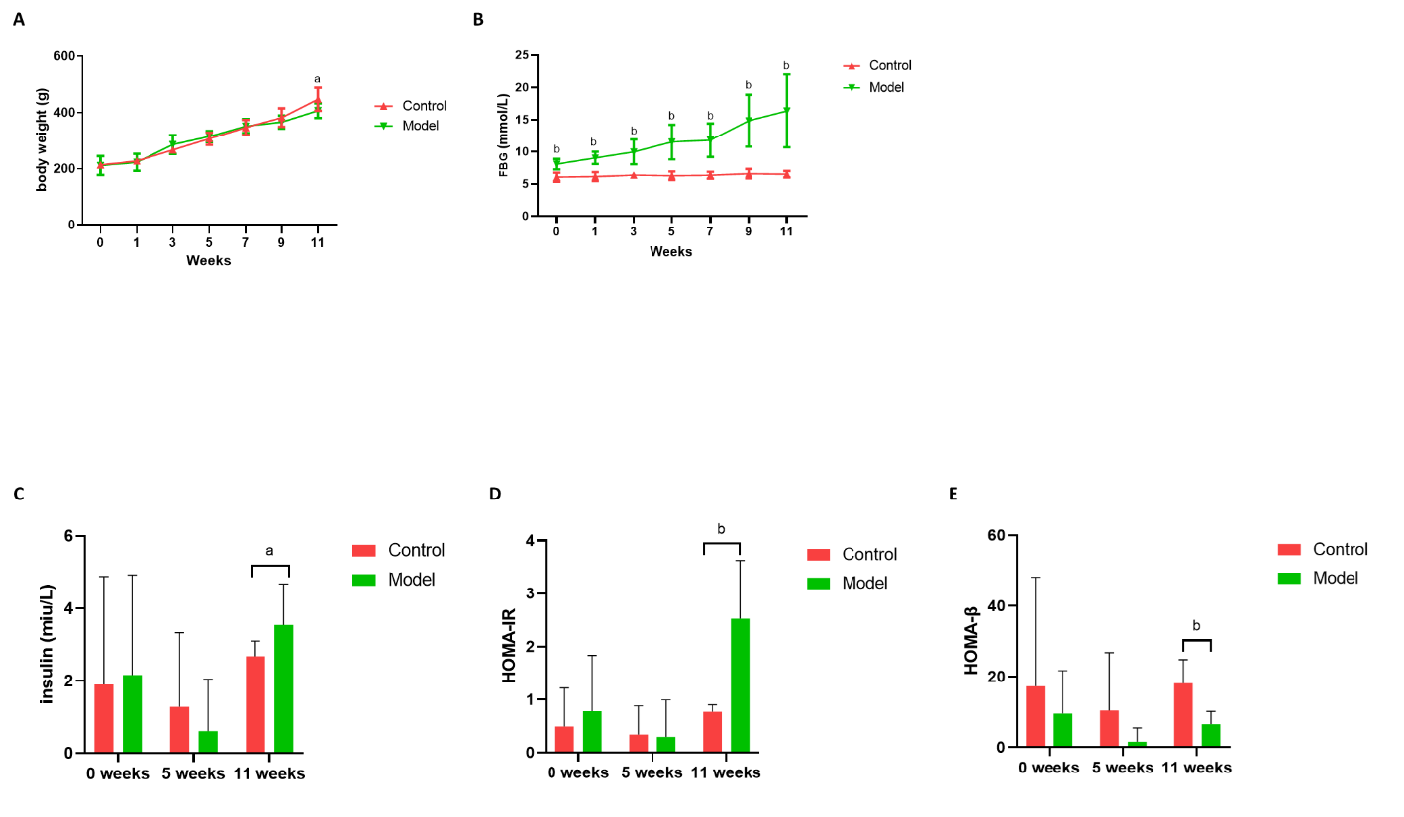
Figure 1 Comparison of body weight, fasting blood glucose and insulin resistance levels. A: Comparison of body weight; B: Comparison of fasting blood glucose levels; C: Comparison of insulin levels; D: Comparison of homeostasis model assessment of insulin resistance index; E: Comparison of homeostasis model assessment of β cell index. ªP < 0.05, ^{b}P < 0.01 vs the control group.
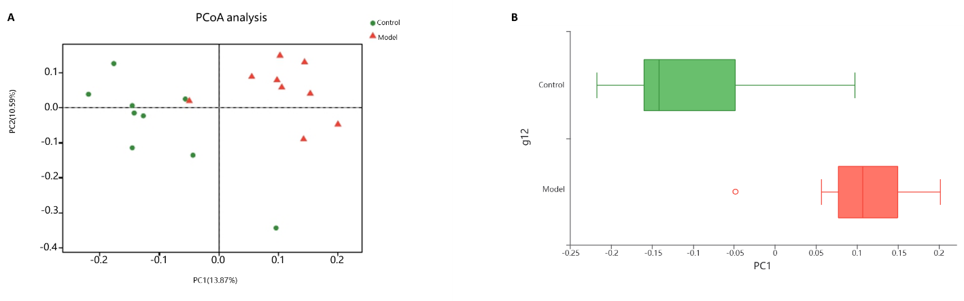
Figure 2 Comparison of the gut microbiota structure by principal coordinate analysis. A: Comparison of the gut microbiota structure by principal coordinate analysis; B: Distribution of different groups on the first principal component axis.
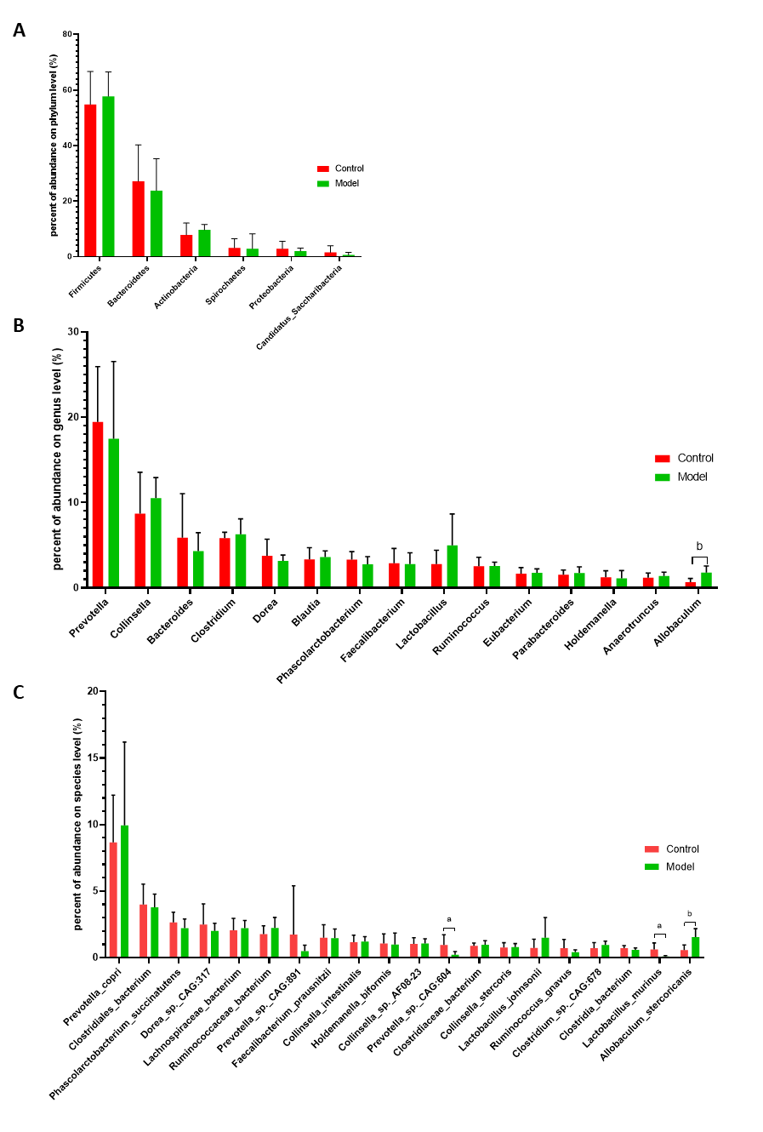
Figure 3 Comparison of the relative abundances of phylum, genus and species. A: Comparison of the relative abundances of phylum; B: Comparison of the relative abundances of genus; C: Comparison of the relative abundances of species. ªP < 0.05, ^{b}P < 0.01 vs the control group.
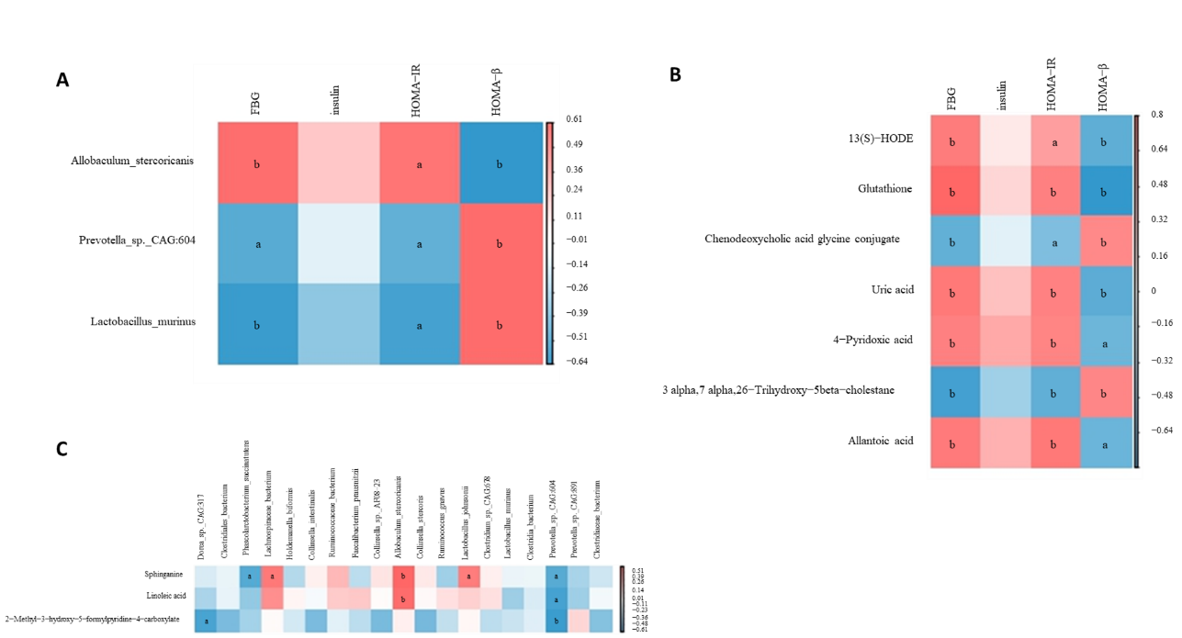
Figure 4 Correlation the relationship between glucose factors, gut microbiota at the species level and metabolites. A: Correlation between glucose factors and the gut microbiota at the species level; B: Correlation between glucose factors and metabolites; C: Correlation between metabolites and the gut microbiota at the species level. ªP < 0.05, ^{b}P < 0.01 vs the control group. The range of r values is noted.
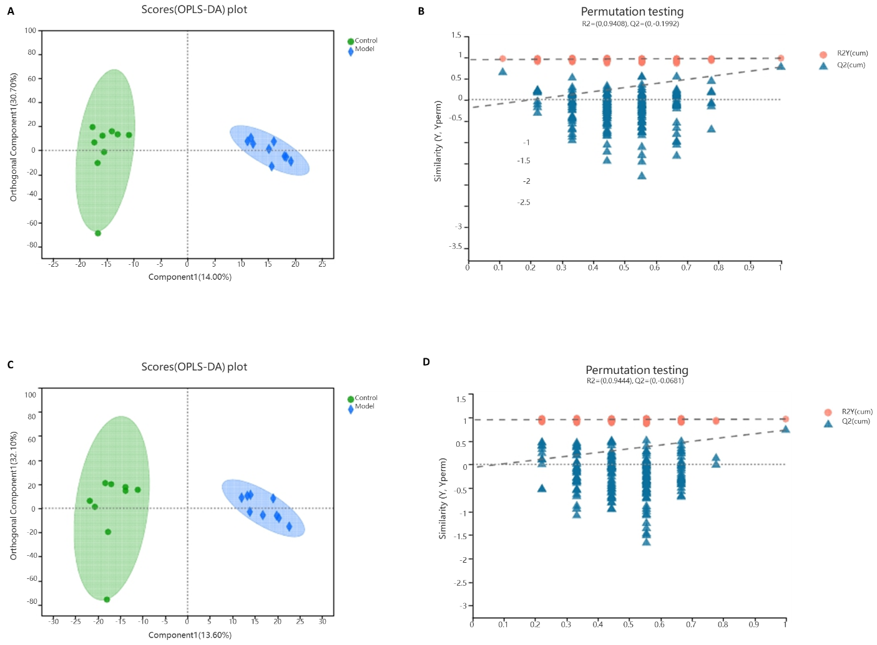
Figure 5 Comparison of the metabolite profiles by orthogonal partial least squares discriminant analysis and model validation. A: Comparison of the positive-ion metabolite profiles by orthogonal partial least squares discriminant analysis (OPLS-DA); B: Positive-ion metabolite profiles with OPLS-DA model validation; C: Comparison of the negative-ion metabolite profiles by OPLS-DA; D: Negative-ion metabolite profiles with OPLS-DA model validation.
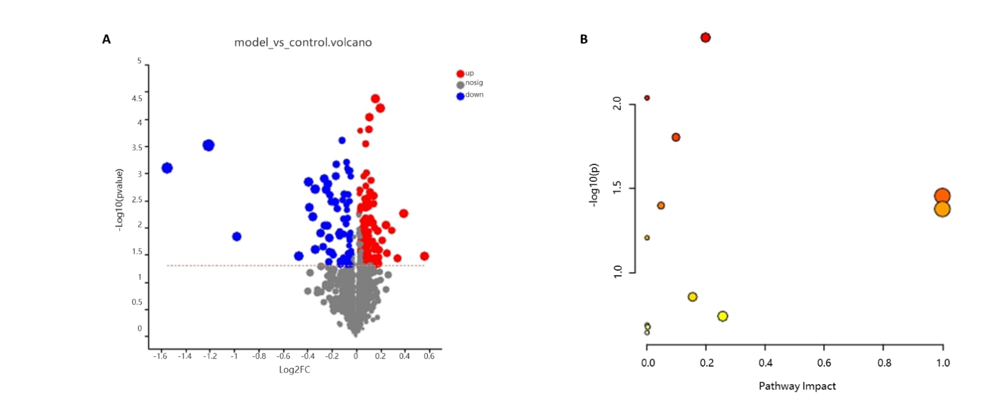
Figure 6 Differential metabolites and metabolic pathways. A: Volcano plot of the differential positive- and negative-ion metabolites; B: Metabolic pathways showing differential regulation in Goto Kakizaki rats.
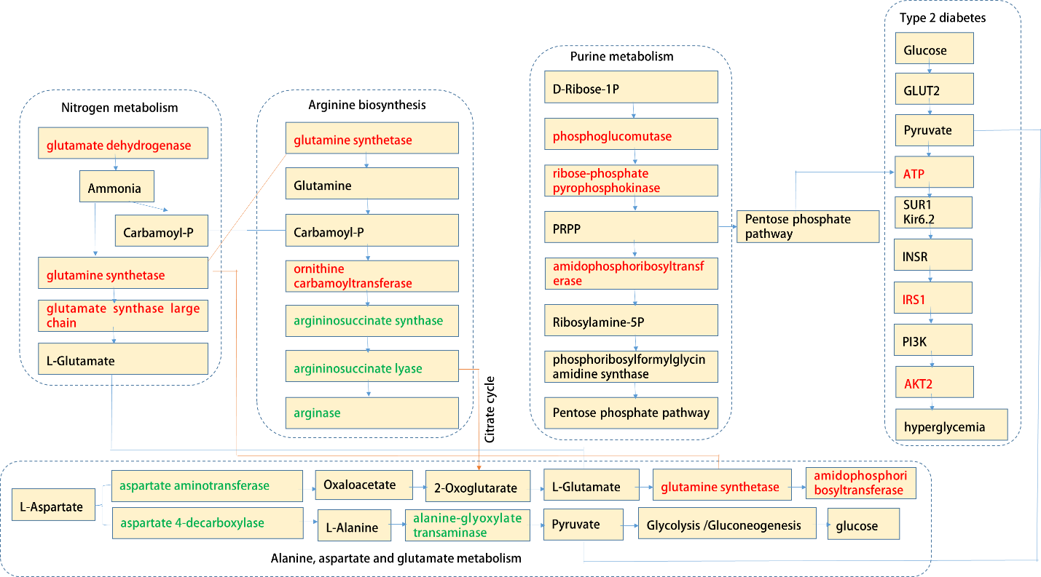
Figure 7 Potential targets of the metabolic pathways showing differential regulation in Goto Kakizaki rats. Compared with the control group, green and red represent decreased and increased levels, respectively.

Table 1 Potential metabolism biomarkers identified
Metabolite | Class | KEGG compound ID | Mass M/Z | Mode | Formula | Retention time (min) | Change trend (model/control)
Glycochenodeoxycholic acid | Bile acids | C05466 | 414.2993 | Pos | C26H43NO5 | 5.333 | Down
Uric acid | Benzenoids | C00366 | 169.0355 | Pos | C5H4N4O3 | 1.3882 | Up
Glutathione | Amino acids | C00051 | 371.1005 | Pos | C10H17N3O6S | 1.0579 | Up
Glycocholic acid | Bile acids | C01921 | 446.2898 | Neg | C26H43NO6 | 5.3482 | Down
Β-sitostenone | Steroid | C00014 | 413.3772 | Pos | C29H48O | 9.9336 | Up
Allantoic acid | Amino acids | C00499 | 175.0461 | Neg | C4H8N4O4 | 0.6403 | Up
N-acetylaspartate | Amino acids | C01042 | 174.0396 | Neg | C6H9NO5 | 1.1621 | Up
N-acetyl-l-glutamic acid | Amino acids | C00624 | 188.0553 | Neg | C7H11NO5 | 1.4766 | Up
Sphinganine | Amines | C00836 | 302.3045 | Pos | C18H39NO2 | 6.9062 | Up
4-pyridoxic acid | Pyridine carboxylic acids and derivatives | C00847 | 184.0604 | Pos | C8H9NO4 | 1.6417 | Up
2-methyl-3-hydroxy-5-formylpyridine-4-carboxylate | Pyridine carboxylic acids and derivatives | C06050 | 180.029 | Neg | C8H7NO4 | 2.2041 | Up
13(s)-HODE | Fatty acids | C14762 | 279.2311 | Pos | C18H32O3 | 7.4255 | Up
Linoleic acid | Linoleic acids and derivatives | C01595 | 281.2469 | Pos | C18H32O2 | 8.1846 | Up
3-α, 7-α, 26-trihydroxy-5-β-cholestane | Bile acids | C05444 | 419.3521 | Neg | C27H48O3 | 8.5577 | Down
Table 2 Metabolism pathway enrichment analysis
Pathway name | Match Status | P value | -log (p) | Impact | Pathway level
Arginine biosynthesis | 2/14 | 0.0055854 | 2.2529 | 0.19797 | Amino acid metabolism
Primary bile acid biosynthesis | 3/46 | 0.0056824 | 2.2455 | 0.05721 | Lipid metabolism
Purine metabolism | 3/65 | 0.014896 | 1.8269 | 0.0 | Nucleotide metabolism
Alanine, aspartate and glutamate metabolism | 2/28 | 0.021712 | 1.6633 | 0.09776 | Amino acid metabolism
Linoleic acid metabolism | 1/5 | 0.04129 | 1.3842 | 1.0 | Lipid metabolism
Nitrogen metabolism | 1/6 | 0.049357 | 1.3066 | 1.0 | Energy metabolism
Vitamin B6 metabolism | 1/9 | 0.073183 | 1.1356 | 0.0 | Metabolism of cofactors and vitamins
Glutathione metabolism | 1/28 | 0.21173 | 0.67421 | 0.25596 | Metabolism of other amino acids
Glyoxylate and dicarboxylate metabolism | 1/32 | 0.23835 | 0.62279 | 0.0 | Carbohydrate metabolism
Glycine, serine and threonine metabolism | 1/33 | 0.24487 | 0.61107 | 0.00245 | Amino acid metabolism
Biosynthesis of unsaturated fatty acids | 1/36 | 0.26413 | 0.57818 | 0.0 | Lipid metabolism

