**Name of Journal:** *World Journal of Gastrointestinal Oncology*

**Manuscript NO:** 56763

**Manuscript Type:** ORIGINAL ARTICLE

***Retrospective Study***

**Prognostic factors and therapeutic effects of different treatment modalities for colorectal cancer liver metastases**

Ma ZH *et al*. Prognostic factors and therapeutic effects for CRC liver metastases

Zuo-Hong Ma, Yong-Peng Wang, Wen-Heng Zheng, Ji Ma, Xue Bai, Yong Zhang, Yuan-He Wang, Da Chi, Xi-Bo Fu, Xiang-Dong Hua

**Zuo-Hong Ma, Yong-Peng Wang, Xue Bai, Yuan-He Wang, Da Chi, Xi-Bo Fu, Xiang-Dong Hua,** Department of Hepatopancreatobiliary Surgery, Cancer Hospital of China Medical University, Liaoning Cancer Hospital and Institute, Shenyang 110042, Liaoning Province, China

**Wen-Heng Zheng,** Department of Medical Imaging, Cancer Hospital of China Medical University, Liaoning Cancer Hospital and Institute, Shenyang 110042, Liaoning Province, China

**Ji Ma, Yong Zhang,** Department of Pathology, Cancer Hospital of China Medical University, Liaoning Cancer Hospital and Institute, Shenyang 110042, Liaoning Province, China

**Author contributions:** Ma ZH and Hua XD conceived this study and takes responsibility for the integrity of the data and the accuracy of the data analysis, including and especially any adverse effects; Wang YP, Zheng WH, Zhang Y, and Bai X improved the study design and contributed to the interpretation of results; Chi D and Fu XB performed data processing and statistical analysis; Ma ZH wrote the manuscript; Ma J and Wang YH revised the manuscript; and all authors read and approved the final manuscript.

**Corresponding author: Xiang-Dong Hua, MD, Chief Doctor, Surgeon,** Department of Hepatopancreatobiliary Surgery, Cancer Hospital of China Medical University, Liaoning Cancer Hospital and Institute, No. 44 Xiaoheyan Road, Shenyang 110042, Liaoning Province, China. [lnzl_hxd@163.com](mailto:lnzl_hxd@163.com)

**Received:** July 20, 2020

**Revised:** August 18, 2020

**Accepted:** September 14, 2020

**Published online:**

**Abstract**

BACKGROUND

Colorectal cancer (CRC) is one of the most common malignant tumors in China, and the liver is the most common metastatic site in patients with advanced CRC. Hepatectomy is the gold standard treatment for colorectal liver metastases. For patients who cannot undergo radical resection of liver metastases for various reasons, ablation therapy, interventional therapy, and systemic chemotherapy can be used to improve their quality of life and prolong their survival time.

AIM

To explore the prognostic factors and treatments of liver metastases of CRC.

METHODS

A retrospective analysis was conducted on 87 patients with liver metastases from CRC treated at the Liaoning Cancer Hospital and Institute between January 2005 and March 2011. According to different treatments, the patients were divided into the following four groups: Surgical resection group (36 patients); ablation group (23 patients); intervention group (15 patients); and drug group (13 patients). The clinicopathological data and postoperative survival of the four groups were analyzed. The Kaplan-Meier method was used for survival analysis, and the Cox proportional hazards regression model was used for multivariate analysis.

RESULTS

The median survival time of the 87 patients was 38.747 ± 3.062 mo, and the 1- and 3-year survival rates were 87.5% and 53.1%, respectively. The Cox proportional hazards model showed that the following factors were independent factors affecting prognosis: The degree of tumor differentiation, the number of metastases, the size of metastases, and whether the metastases are close to great vessels. The results of treatment factor analysis showed that the effect of surgical treatment was better than that of drugs, intervention, or ablation alone, and the median survival time was 48.83 ± 4.36 mo. The drug group had the worst prognosis, with a median survival time of only 13.5 ± 0.7 mo (*P* < 0.05). For patients with liver metastases of CRC near the great vessels, the median survival time (27.3 mo) of patients undergoing surgical resection was better than that of patients using other treatments (20.6 mo) (*P* < 0.05).

CONCLUSION

Patients with a low degree of primary tumor differentiation, multiple liver metastases (number of tumors > 4), and maximum diameter of liver metastases > 5 cm have a poor prognosis. Among drug therapy, intervention, ablation, and surgical treatment options, surgical treatment is the first choice for liver metastases. When liver metastases are close to great vessels, surgical treatment is significantly better than drug therapy, intervention, and ablation alone.

**Key Words:** Colorectal cancer; Liver metastasis; Prognostic factors; Ablation; Surgical resection; Retrospective study

Ma ZH, Wang YP, Zheng WH, Ma J, Bai X, Zhang Y, Wang YH, Chi D, Fu XB, Hua XD. Prognostic factors and therapeutic effects of different treatment modalities for colorectal cancer liver metastases. *World J Gastrointest Oncol* 2020; In press

**Core Tip:** Pathological data of patients with liver metastases from colorectal cancer were analyzed and the diameter, differentiation, and multiple lesions of liver metastases, were found to indicate a poor prognosis. The analysis of different treatment methods for patients with liver metastases from colorectal cancer proved that radical surgery is always the best option. For inoperable patients, personalized combination therapy is actively recommended.

**INTRODUCTION**

Colorectal cancer (CRC) is one of the most common malignant tumors in China, and its mortality has been increasing in recent years, ranking fourth in the incidence of malignant tumors, and the incidence increases with age[1,2]. The liver is the most common metastatic site in patients with advanced CRC. More than 50% of patients with CRC may develop colorectal liver metastases (CLMs), and approximately 20% of these patients have liver metastases at the initial diagnosis[3,4]. Hepatectomy is the gold standard treatment for CLM, with a 5-year overall survival rate of 58%[5,6]. However, 80% to 85% of patients with advanced CLM are still unable to achieve R0 resection[7-9]. For patients who cannot undergo radical resection of liver metastases for various reasons, ablation therapy, interventional therapy, and systemic chemotherapy can be used to improve their quality of life and prolong their survival time. In this study, we collected the data from 87 patients with CLM and compared their prognostic factors and treatments, with the hope of obtaining a more reasonable treatment plan and provide evidence for clinical treatment.

**MATERIALS AND METHODS**

***Clinical information***

The data of 103 patients with CLM treated at the Departments of Hepatobiliary Surgery, Colorectal Surgery and Intervention of the Liaoning Cancer Hospital and Institute between January 2005 and March 2011 were collected. Patients with incomplete follow-up were excluded; a total of 87 patients were included, including 61 males and 26 females. According to different treatments for liver metastases, the patients with CLM were divided into four groups: Surgical resection group (36 patients); ablation group (23 patients); intervention group (15 patients); and drug group (13 patients). The inclusion criteria were as follows: (1) Patients with a clear pathological diagnosis of CRC accompanied by liver metastasis; (2) patients who underwent radical surgery for the primary lesion (open or laparoscopic); (3) patients who agreed to receive different treatment plans, which were discussed by the multidisciplinary diagnosis and treatment (MDT) team; (4) patients who could be divided into two groups according to the distance between CLM and great vessels: Those near great vessels and those not near; (5) patients who received FOLFOX or CapeOx (XELOX) chemotherapy or other biological targeted therapy; and (6) patients whose interventional therapy was transcatheter arterial chemoembolization (TACE), and the chemotherapy drugs infused were calcium folinate and pentafluorouracil. The exclusion criteria were as follows: (1) Patients with communication difficulties; and (2) patients who did not cooperate with this study. This study was approved by the Ethics Committee of the hospital. The data are anonymous, and the requirement for informed consent was therefore waived.

***Selection of clinicopathological factors***

The following clinicopathological factors were selected for analysis: Sex, age, primary tumor size, primary tumor site, pathological type, degree of differentiation, carcinoembryonic antigen (CEA), cancer antigen (CA) 19-9, lymph node metastasis, distribution of CLMs, number of CLMs, proximity to great vessels, diameter of the largest CLM, postoperative chemotherapy cycle, *etc*. Among them, ≤ 1 cm was used to define whether the CLM is close to a great vessel. The great vessels include the intrahepatic portal vein trunk and secondary and tertiary branches, the left hepatic, right hepatic, and middle hepatic veins, and the vena cava.

***Evaluation indicators***

The following indicators were used to evaluate the short-term effects: Indicators of liver function tests; perioperative complications and adverse drug reactions during the treatment period; and physical evaluation (physical condition scores were rated according to the Eastern Cooperative Oncology Group score standard).

The following indicators were used to evaluate the long-term efficacy: Recurrent-free survival (RFS); tumor remission assessment (according to the Response Evaluation Criteria in Solid Tumours criteria).

***Follow-up***

Follow-up was performed by telephone and outpatient review. The follow-up deadline was January 1, 2015, and the median follow-up time was 20.8 mo. A total of 16 patients were lost to follow-up in this group, and the follow-up rate was 83.5%. The recorded survival time was from the time of surgery to the time of the last follow-up, death, or the deadline of follow-up (including loss to follow-up, death from other diseases, *etc*.).

***Statistical analysis***

SPSS 22.0 software was used for statistical analyses. Measurement data are expressed as the mean ± SD. The comparison between groups was analyzed by single factor analysis of variance. The unevenness of variance was measured by the Kruskal-Wallis test. Comparisons between groups were made using the *χ*2 test or continuous correction. Kaplan-Meier survival curves were used to indicate the RFS. The log-rank test was used for comparisons between the two groups. Significant single factors were incorporated into the Cox regression equation for multifactor analysis.

**RESULTS**

***Comparison of case data among the four groups***

In the comparison of clinicopathological data, there was no significant difference in the four groups of patients in terms of sex, primary tumor size, primary tumor location, pathological type, degree of differentiation, CEA, CA19-9, lymph node metastasis, and total chemotherapy time. More older patients were in the drug group and intervention group, but there was no significant difference. There were significant differences in the distribution of CLM, the diameter of the largest CLM, and the distance to great vessels (*P* < 0.05, Table 1).

***Comparison of complications***

None of the patients in the four groups died within 1 mo. The common symptoms were fever, pain in the liver area, and abnormal liver function. All patients recovered after symptomatic treatment. Of the 36 patients in the surgical resection group, four (11.1%) had postoperative complications, including two cases of postoperative liver wound bleeding, which were cured after symptomatic conservative treatment of hemostasis, and two cases of incision infection and dehiscence, which were cured by conservative treatment. None of the patients were treated by secondary surgery. There were no other definite complications or adverse reactions caused by drugs in the other three groups. Patients in the surgical resection group had abnormal liver function during the perioperative period, which improved after symptomatic liver protection treatment.

***Survival***

The median survival time of the 87 patients was 38.747 ± 3.062 mo, and the 1- and 3-year survival rates were 87.5% and 53.1%, respectively.

***Prognostic univariate and multivariate analyses***

**Univariate analysis:** The analysis of prognostic factors for the overall survival of patients with CLM showed that the following six factors were statistically significant for prognosis (*P* < 0.05): Degree of pathological differentiation, CEA, number of CLMs, diameter of maximum CLM, treatment of CLM, and proximity to great vessels or not (Table 2).

**Multivariate analysis:** The significant factors (*P* < 0.05) in the univariate prognostic analysis were incorporated into the multivariate Cox regression model, and the following results were obtained: The degree of tumor differentiation, the number of metastases, the size of metastases, and the proximity to great vessels were independent factors affecting the prognosis of CLM (*P* < 0.05, Table 3).

**Survival curve analysis:** Patients with a high degree of differentiation of the primary tumor had a better prognosis than those with a low degree of differentiation (*P* < 0.05, Figure 1A). Patients with the number of CLM ≤ 4 had better RFS than patients with the number of CLM > 4 (*P* < 0.05, Figure 1B). At the same time, the survival curves of the two groups of patients flattened after 2 years of diagnosis. The RFS of patients with a liver metastasis with a maximum diameter ≤ 5 cm was significantly better than that of patients with a diameter > 5 cm (*P* < 0.05, Figure 1C).

***Analysis of treatment factors***

An analysis was performed on the 87 patients. Among the patients, there were 13 patients in the drug group, 23 in the ablation group, 15 in the intervention group, and 36 in the surgical resection group. The results showed that patients who underwent surgical treatment had better RFS than patients who underwent interventional therapy, ablation therapy, or drug therapy. The median survival time in the surgical resection group was 48.83 ± 4.36 mo; the drug group had the worst prognosis, with a median survival time of only 13.5 ± 0.7 mo (Figure 2).

***Analysis of whether liver metastasis is close to great vessels***

A separate group comparison analysis was performed on whether the intrahepatic metastases were close to great vessels. The results showed that there were no significant differences in the general clinicopathological characteristics between the two groups, but there were differences in the treatments. Among patients with tumors close to great vessels, five chose surgical resection, ten chose interventional therapy, two chose ablation therapy, and only one selected drug therapy (Table 4).

According to our analysis of the 18 patients with CLM near great vessels, the median survival time (27.3 mo) of patients undergoing surgery was significantly better than that (20.6 mo) of patients receiving other treatments (*P* < 0.05, Figure 3).

**DISCUSSION**

The liver is a common site of hematogenous metastases in CRC. Approximately 30%-50% of patients with CRC develop simultaneous or metachronous CLM. Liver metastasis has become one of the leading causes of death in patients with CRC[10-15]. The MDT team conducted a comprehensive evaluation of patients with CLM, individually formulated treatment plans, carried out corresponding comprehensive treatments, and improved the 5-year survival rate[16]. Therefore, in order to establish more reasonable treatment plans, the clinical data of 87 patients with CLM who were treated by surgical resection, ablation, interventional therapy, and medicine alone were analyzed, their survival was followed, and prognostic factors and treatments were compared.

The results showed that there were no significant differences in sex, primary focus size, primary focus site, pathological type, degree of differentiation, CEA, CA19-9, lymph node metastasis, or total chemotherapy time in the four groups of patients, indicating that there was no special preference in the patient's general status. However, patients who chose drug therapy and interventional therapy were older. The reason may be related to the patient's comprehensive state and treatment expectations. Some patients and their families were unwilling to bear the risk of surgery and refuse to undergo surgical treatment. Many previous studies have shown that the lower the degree of differentiation of the primary tumor (mainly manifested by more aggressive and malignant phenotype), the worse the prognosis; the number of metastases (≤ 4) and the diameter of metastases (≤ 5 cm) are the main prognostic factors affecting the prognosis of patients with CLM[17-19]. This study also analyzed the degree of differentiation, the number of CLMs, and the maximum diameter of metastases and obtained similar results. In summary, the lower the degree of tumor differentiation, the greater the number of metastases, and the larger the diameter of the metastases, the heavier the tumor burden will be throughout the body, and the shorter the survival period. In addition, the distance between metastases and great vessels also affected the recurrent-free survival of patients. With ≤ 1 cm as the boundary, patients with metastases near great vessels had a worse prognosis than patients with metastases far from great vessels, which is related to the rich blood flow that may be beneficial to tumor invasion and metastasis.

The median survival time of patients with unresectable intrahepatic metastases is less than 12 mo[20]. For patients with resectable CLM, the 5-year survival rate of those who choose radical resection is between 38% and 58%[21,22], and the benefits are obvious. We found that the following three factors determined the possibility of radical resection: The distribution of CLMs, the diameter of the largest CLM, and the distance to great vessels. We temporarily defined patients with CLMs that could not be resected at one stage as potentially resectable patients. Some of the initially unresectable patients could be converted into resectable patients through local or systemic chemotherapy and other treatments[23-25]. Patients were treated by short-course radiotherapy and upfront chemotherapy, with delayed surgery[26,27]. Upfront systemic chemotherapy can reduce the size of primary lesion and metastasis, and the extent of surgery[28]. Compared with other treatments, the advantage of surgical resection is that it can remove all visible tumors in the liver and can reach R0 resection. Radical resection was achieved in all selected patients in this study (Figure 4). In addition, the widespread use of ultrasound in surgery can improve the rate of intraoperative exploration. For metastatic lesions not found before surgery, ultrasound can help to locate the lesion and provide a more reasonable surgical treatment in a timely manner to avoid residual tumors and improve the rate of R0 resection[29,30]. For all selected patients in this study, intraoperative ultrasound localization was used (Figures 5 and 6) to ensure R0 resection.

In addition to surgical resection for CLM, ablation, intervention, and chemotherapy alone (and/or a combination of targeted drugs) have been widely used clinically. In addition, new liver exploration and treatment methods are constantly emerging[31-37]. However, our study showed that the median survival time of patients who underwent surgical treatment was the longest, reaching 48.83 ± 4.36 mo, which was significantly better than that of intervention, ablation (Figure 7), and drug therapy. Therefore, the preferred treatment for patients with CLM is still surgery. Especially when the metastases are close to great vessels, surgical treatment has a greater benefit. Among the patients enrolled in this study, it is important to point out that of the 15 patients with CLM close to great vessels treated by ablation, eight had tumor recurrence *in situ* within 6 mo after surgery. The ablation effect of the metastasis near great vessels is not satisfactory. This may be due to the heat sink effect; that is, the blood vessels in the liver take away some of the heat from the thermal ablation zone, which will cause local cooling and prevent complete ablation[38,39]. Existing studies have suggested that ablation treatment can effectively treat CLM, especially when the metastasis is ≤ 3 cm; however, when the lesion is larger than 5 cm, it is difficult to achieve complete necrosis using ablation treatment. Complications may be more frequent when the lesion is located near the submental or portal or inferior vena cava[40-42]. In addition, incomplete tumor ablation still exists within a distance of 1 cm between the great vessels in the liver and the ablation electrode, which may have a significant impact on the local tumor recurrence rate[43]. Previous studies have shown that for some patients who are initially unresectable, surgery combined with ablation may be a safe and effective potential alternative after effective chemotherapy[44].

The efficacy of intervention alone for CLM is limited, and this study showed that the RFS of patients after intervention cannot be compared with that after surgical resection. The reason is that in addition to the hepatic arteries, the main source of blood supply for intrahepatic metastases in CLM patients is the portal vein. Because the portal vein branch of the blood supply to the liver tumor cannot be embolized, the treatment effect cannot be compared with the treatment effect for liver cancer dominated by a hepatic artery blood supply. However, most researchers believe that TACE treatment can significantly control tumor growth locally, shrink tumors, and increase the chance of surgical resection. At the same time, compared with simple drug therapy, during TACE treatment, the concentration of cytotoxic drugs in CLM is significantly increased and the systemic toxicity is small, which is more suitable for potentially resectable patients[45,46]. However, our experience suggests that after TACE treatment, CLMs will have different degrees of adhesion to the abdominal wall and diaphragm, which will increase the difficulty of surgical R0 resection and the incidence of postoperative complications. The reason for this may be the liver inflammation caused by liver tumors treated with TACE and the drug response caused by the high concentration of chemotherapy drug perfusion. Therefore, we believe that TACE treatment is relatively limited for CLM patients with potential surgical resection and is more suitable for the local treatment of tumors in unresectable patients. Nevertheless, some studies have shown that with a tumor diameter less than 3 cm, the long-term survival rate of patients treated with combined ablation is significantly better than that of patients treated with monotherapy, and the treatment effect is significantly improved compared with monotherapy[47,48].

In some other patients, drug therapy is often used when the above treatments cannot be performed for various reasons. Patients in the drug therapy group received XELOX chemotherapy or other biological targeted therapy, without any invasive treatment. Only one case was treated with chemotherapy combined with targeted therapy (bevacizumab). Since fewer patients are treated with targeted therapy, the prognosis of targeted therapy is not discussed. The results of our study showed that the median survival time with drug therapy was only 13.5 ± 0.7 mo, which is far inferior to that of surgical treatment. At present, the targeted therapeutic drugs for CLM mainly include monoclonal antibodies against EGFR and VEGF. At present, cetuximab and bevacizumab are commonly used in China. Most guidelines recommend the use of a fluorouracil-based chemotherapy combined with oxygenatin[49]. Other studies have also shown that the combination of intervention and systemic chemotherapy or targeted therapy is an effective treatment option that allows patients to be completely resected and have a good prognosis[50-52]. Therefore, for patients who cannot undergo radical resection, combined treatment seems more appropriate, but the actual condition and the patient's own wishes need to be considered[53].

**CONCLUSION**

In summary, in the treatment of patients with CLM, radical surgery is still the main method. However, the treatment should be carried out by a MDT team based on the actual condition of the patient, comprehensively identifying their adverse prognostic factors, correctly assessing the general state of the patient, and formulating the best treatment plan to ensure maximum benefit for the patient. The limitation of this study is that it was retrospective, and some index samples were small in the group comparison. Therefore, it is necessary to expand the sample size and provide evidence-based evidence for the treatment of CLM through multidisciplinary communication or further prospective research.

**ARTICLE HIGHLIGHTS**

***Research background***

Methods such as hepatectomy, ablation therapy, interventional therapy, and systemic chemotherapy improve the quality of life and prolong survival. Through the comparison of different prognostic factors and treatment plans, it is hoped that a more reasonable treatment plan will be obtained, which will provide evidence-based basis for clinical treatment.

***Research motivation***

This study analyzed the prognosis of different treatment methods, combining pathological characteristics and prognostic factors to formulate the most suitable treatment plan for patients.

***Research objective***

Through the comparison of prognostic factors and treatment rules, it is hoped that a more reasonable treatment plan will be obtained, which will provide evidence-based basis for clinical treatment.

***Research methods***

The clinicopathological data and postoperative survival of four groups of colorectal cancer patients with liver metastases (surgical resection group, ablation treatment group, interventional treatment group, and chemotherapy alone group) were retrospectively analyzed. The survival analysis was performed by the Kaplan-Meier method, and multivariate Cox proportional hazard regression model was used for analysis.

***Research results***

The Cox proportional hazards model showed that the following factors are independent factors affecting prognosis: The degree of tumor differentiation, the number of metastases, the size of metastases, and whether the metastases are close to great vessels. The effect of surgical treatment was better than that of drugs, intervention, or ablation alone.

***Research conclusions***

Patients with a low degree of primary tumor differentiation, multiple liver metastases (number of tumors > 4), and maximum diameter of liver metastases > 5 cm have a poor prognosis. Surgical treatment is the first choice for liver metastases, especially when liver metastases are close to great vessels.

***Research perspectives***

Radical surgery is the first choice for the treatment of patients with liver metastases from colorectal cancer. At the same time, multidisciplinary diagnosis and treatment should be discussed and combined with the actual situation to develop the most suitable treatment plan for the patient.

**ACKNOWLEDGEMENTS**

We thank all of the staff at the Department of Hepatopancreatobiliary Surgery, Department of Pathology, and Department of Medical Imaging of Cancer Hospital of China Medical University. We are grateful to all participants for their cooperation in the study.

**REFERENCES**

1 **Chen W**, Zheng R, Baade PD, Zhang S, Zeng H, Bray F, Jemal A, Yu XQ, He J. Cancer statistics in China, 2015. *CA Cancer J Clin* 2016; **66**: 115-132 [PMID: 26808342 DOI: 10.3322/caac.21338]

2 **Du LB**, Li HZ, Wang YQ, Zhu C, Zheng RS, Zhang SW, Chen WQ, He J. [Report of colorectal cancer incidence and mortality in China, 2013]. *Zhonghua Zhong Liu Za Zhi* 2017; **39**: 701-706 [PMID: 28926901 DOI: 10.3760/cma.j.issn.0253-3766.2017.09.012]

3 **Fiorentini G**, Sarti D, Aliberti C, Carandina R, Mambrini A, Guadagni S. Multidisciplinary approach of colorectal cancer liver metastases. *World J Clin Oncol* 2017; **8**: 190-202 [PMID: 28638789 DOI: 10.5306/wjco.v8.i3.190]

4 **Nanji S**, Mackillop WJ, Wei X, Booth CM. Simultaneous resection of primary colorectal cancer and synchronous liver metastases: a population-based study. *Can J Surg* 2017; **60**: 122-128 [PMID: 28234215 DOI: 10.1503/cjs.008516]

5 **Fonseca GM**, Herman P, Faraj SF, Kruger JAP, Coelho FF, Jeismann VB, Cecconello I, Alves VAF, Pawlik TM, de Mello ES. Pathological factors and prognosis of resected liver metastases of colorectal carcinoma: implications and proposal for a pathological reporting protocol. *Histopathology* 2018; **72**: 377-390 [PMID: 28858385 DOI: 10.1111/his.13378]

6 **Baba K**, Oshita A, Kohyama M, Inoue S, Kuroo Y, Yamaguchi T, Nakamura H, Sugiyama Y, Tazaki T, Sasaki M, Imamura Y, Daimaru Y, Ohdan H, Nakamitsu A. Successful treatment of conversion chemotherapy for initially unresectable synchronous colorectal liver metastasis. *World J Gastroenterol* 2015; **21**: 1982-1988 [PMID: 25684967 DOI: 10.3748/wjg.v21.i6.1982]

7 **Abdalla EK**. Resection of colorectal liver metastases. *J Gastrointest Surg* 2011; **15**: 416-419 [PMID: 21301986 DOI: 10.1007/s11605-011-1429-6]

8 **Poston GJ**, Figueras J, Giuliante F, Nuzzo G, Sobrero AF, Gigot JF, Nordlinger B, Adam R, Gruenberger T, Choti MA, Bilchik AJ, Van Cutsem EJ, Chiang JM, D'Angelica MI. Urgent need for a new staging system in advanced colorectal cancer. *J Clin Oncol* 2008; **26**: 4828-4833 [PMID: 18711170 DOI: 10.1200/JCO.2008.17.6453]

9 **Van Cutsem E**, Cervantes A, Adam R, Sobrero A, Van Krieken JH, Aderka D, Aranda Aguilar E, Bardelli A, Benson A, Bodoky G, Ciardiello F, D'Hoore A, Diaz-Rubio E, Douillard JY, Ducreux M, Falcone A, Grothey A, Gruenberger T, Haustermans K, Heinemann V, Hoff P, Köhne CH, Labianca R, Laurent-Puig P, Ma B, Maughan T, Muro K, Normanno N, Österlund P, Oyen WJ, Papamichael D, Pentheroudakis G, Pfeiffer P, Price TJ, Punt C, Ricke J, Roth A, Salazar R, Scheithauer W, Schmoll HJ, Tabernero J, Taïeb J, Tejpar S, Wasan H, Yoshino T, Zaanan A, Arnold D. ESMO consensus guidelines for the management of patients with metastatic colorectal cancer. *Ann Oncol* 2016; **27**: 1386-1422 [PMID: 27380959 DOI: 10.1093/annonc/mdw235]

10 **Kopetz S**, Chang GJ, Overman MJ, Eng C, Sargent DJ, Larson DW, Grothey A, Vauthey JN, Nagorney DM, McWilliams RR. Improved survival in metastatic colorectal cancer is associated with adoption of hepatic resection and improved chemotherapy. *J Clin Oncol* 2009; **27**: 3677-3683 [PMID: 19470929 DOI: 10.1200/JCO.2008.20.5278]

11 **Leung U**, Gönen M, Allen PJ, Kingham TP, DeMatteo RP, Jarnagin WR, D'Angelica MI. Colorectal Cancer Liver Metastases and Concurrent Extrahepatic Disease Treated With Resection. *Ann Surg* 2017; **265**: 158-165 [PMID: 28009741 DOI: 10.1097/SLA.0000000000001624]

12 **Clark ME**, Smith RR. Liver-directed therapies in metastatic colorectal cancer. *J Gastrointest Oncol* 2014; **5**: 374-387 [PMID: 25276410 DOI: 10.3978/j.issn.2078-6891.2014.064]

13 **Djiambou-Nganjeu H**. Hepatic Encephalopathy in Patients in Lviv (Ukraine). *J Transl Int Med* 2018; **6**: 146-151 [PMID: 30425951 DOI: 10.2478/jtim-2018-0021]

14 **Engstrand J**, Nilsson H, Strömberg C, Jonas E, Freedman J. Colorectal cancer liver metastases - a population-based study on incidence, management and survival. *BMC Cancer* 2018; **18**: 78 [PMID: 29334918 DOI: 10.1186/s12885-017-3925-x]

15 **Sak K**. A Hypothetical Approach on Gender Differences in Cancer Diagnosis. *J Transl Int Med* 2019; **7**: 90-92 [PMID: 31637178 DOI: 10.2478/jtim-2019-0020]

16 **Xu J**, Fan J, Qin X, Cai J, Gu J, Wang S, Wang X, Zhang S, Zhang Z; China CRLM Guideline Group. Chinese guidelines for the diagnosis and comprehensive treatment of colorectal liver metastases (version 2018). *J Cancer Res Clin Oncol* 2019; **145**: 725-736 [PMID: 30542791 DOI: 10.1007/s00432-018-2795-1]

17 **Wang Y**, Liu YF, Cheng Y, Yi DH, Li P, Song WQ, Fu DZ, Wang X. Prognosis of colorectal cancer with liver metastasis: value of a prognostic index. *Braz J Med Biol Res* 2010; **43**: 1116-1122 [PMID: 20945037 DOI: 10.1590/s0100-879x2010007500103]

18 **Kuo IM**, Huang SF, Chiang JM, Yeh CY, Chan KM, Chen JS, Yu MC. Clinical features and prognosis in hepatectomy for colorectal cancer with centrally located liver metastasis. *World J Surg Oncol* 2015; **13**: 92 [PMID: 25889950 DOI: 10.1186/s12957-015-0497-6]

19 **Scheele J**, Stang R, Altendorf-Hofmann A, Paul M. Resection of colorectal liver metastases. *World J Surg* 1995; **19**: 59-71 [PMID: 7740812 DOI: 10.1007/bf00316981]

20 **Ballantyne GH**, Quin J. Surgical treatment of liver metastases in patients with colorectal cancer. *Cancer* 1993; **71**: 4252-4266 [PMID: 8508388 DOI: 10.1002/1097-0142(19930615)71:12+<4252::aid-cncr2820711815>3.0.co;2-6]

21 **Spelt L**, Andersson B, Nilsson J, Andersson R. Prognostic models for outcome following liver resection for colorectal cancer metastases: A systematic review. *Eur J Surg Oncol* 2012; **38**: 16-24 [PMID: 22079259 DOI: 10.1016/j.ejso.2011.10.013]

22 **Stelzner S**, Radulova-Mauersberger O, Zschuppe E, Kittner T, Abolmaali N, Puffer E, Zimmer J, Witzigmann H. Prognosis in patients with synchronous colorectal cancer metastases after complete resection of the primary tumor and the metastases. *J Surg Oncol* 2019; **120**: 438-445 [PMID: 31168858 DOI: 10.1002/jso.25578]

23 **DʼAngelica MI**, Correa-Gallego C, Paty PB, Cercek A, Gewirtz AN, Chou JF, Capanu M, Kingham TP, Fong Y, DeMatteo RP, Allen PJ, Jarnagin WR, Kemeny N. Phase II trial of hepatic artery infusional and systemic chemotherapy for patients with unresectable hepatic metastases from colorectal cancer: conversion to resection and long-term outcomes. *Ann Surg* 2015; **261**: 353-360 [PMID: 24646562 DOI: 10.1097/SLA.0000000000000614]

24 **Xu F**, Tang B, Jin TQ, Dai CL. Current status of surgical treatment of colorectal liver metastases. *World J Clin Cases* 2018; **6**: 716-734 [PMID: 30510936 DOI: 10.12998/wjcc.v6.i14.716]

25 **Araujo RL**, Gönen M, Herman P. Chemotherapy for patients with colorectal liver metastases who underwent curative resection improves long-term outcomes: systematic review and meta-analysis. *Ann Surg Oncol* 2015; **22**: 3070-3078 [PMID: 25586244 DOI: 10.1245/s10434-014-4354-6]

26 **Niitsu H**, Hinoi T, Shimomura M, Egi H, Hattori M, Ishizaki Y, Adachi T, Saito Y, Miguchi M, Sawada H, Kochi M, Mukai S, Ohdan H. Up-front systemic chemotherapy is a feasible option compared to primary tumor resection followed by chemotherapy for colorectal cancer with unresectable synchronous metastases. *World J Surg Oncol* 2015; **13**: 162 [PMID: 25908502 DOI: 10.1186/s12957-015-0570-1]

27 **Kim KH**, Shin SJ, Cho MS, Ahn JB, Jung M, Kim TI, Park YS, Kim H, Kim NK, Koom WS. A phase II study of preoperative mFOLFOX6 with short-course radiotherapy in patients with locally advanced rectal cancer and liver-only metastasis. *Radiother Oncol* 2016; **118**: 369-374 [PMID: 26705682 DOI: 10.1016/j.radonc.2015.11.029]

28 **Naito A**, Kagawa Y, Kawai K, Takeno A, Takeda Y, Ohtsuka M, Suzuki Y, Imasato M, Fujie Y, Nakaba H, Akamatsu H, Murata K. Surgical Resection of Colorectal Cancer With Distant Metastases to Other than Liver or Lung. *In Vivo* 2019; **33**: 1605-1608 [PMID: 31471411 DOI: 10.21873/invivo.11643]

29 **Mazzoni G**, Napoli A, Mandetta S, Miccini M, Cassini D, Gregori M, Colace L, Tocchi A. Intra-operative ultrasound for detection of liver metastases from colorectal cancer. *Liver Int* 2008; **28**: 88-94 [PMID: 17971094 DOI: 10.1111/j.1478-3231.2007.01583.x]

30 **Walker TLJ**, Bamford R, Finch-Jones M. Intraoperative ultrasound for the colorectal surgeon: current trends and barriers. *ANZ J Surg* 2017; **87**: 671-676 [PMID: 28771975 DOI: 10.1111/ans.14124]

31 **Huang JY**. Role of EUS-guided liver biopsy in benign parenchymal disease (with video). *Endosc Ultrasound* 2018; **7**: 236-239 [PMID: 30117485 DOI: 10.4103/eus.eus_33_18]

32 **Lisotti A**, Serrani M, Caletti G, Fusaroli P. EUS liver assessment using contrast agents and elastography. *Endosc Ultrasound* 2018; **7**: 252-256 [PMID: 30117488 DOI: 10.4103/eus.eus_29_18]

33 **Chang KJ**, Samarasena JB, Iwashita T, Nakai Y, Lee JG. Endo-hepatology: a new paradigm. *Gastrointest Endosc Clin N Am* 2012; **22**: 379-385, xi [PMID: 22632959 DOI: 10.1016/j.giec.2012.04.010]

34 **Tsujino T**, Samarasena JB, Chang KJ. EUS anatomy of the liver segments. *Endosc Ultrasound* 2018; **7**: 246-251 [PMID: 30117487 DOI: 10.4103/eus.eus_34_18]

35 **Zachos I**, Zachou K, Dalekos GN, Tzortzis V. Management of Patients with Liver Cirrhosis and Invasive Bladder Cancer: A Case-series. *J Transl Int Med* 2019; **7**: 29-33 [PMID: 30997354 DOI: 10.2478/jtim-2019-0006]

36 **Samarasena J**, Chang KJ. Endo-hepatology: A new paradigm. *Endosc Ultrasound* 2018; **7**: 219-222 [PMID: 30117482 DOI: 10.4103/eus.eus_30_18]

37 **Bhatia V**, Dhir V. Radial EUS imaging of the liver: A pictorial guide. *Endosc Ultrasound* 2019; **8**: 76-81 [PMID: 31006705 DOI: 10.4103/eus.eus_17_19]

38 **Lehmann KS**, Poch FG, Rieder C, Schenk A, Stroux A, Frericks BB, Gemeinhardt O, Holmer C, Kreis ME, Ritz JP, Zurbuchen U. Minimal vascular flows cause strong heat sink effects in hepatic radiofrequency ablation ex vivo. *J Hepatobiliary Pancreat Sci* 2016; **23**: 508-516 [PMID: 27338856 DOI: 10.1002/jhbp.370]

39 **Pillai K**, Akhter J, Chua TC, Shehata M, Alzahrani N, Al-Alem I, Morris DL. Heat sink effect on tumor ablation characteristics as observed in monopolar radiofrequency, bipolar radiofrequency, and microwave, using ex vivo calf liver model. *Medicine (Baltimore)* 2015; **94**: e580 [PMID: 25738477 DOI: 10.1097/MD.0000000000000580]

40 **Lu DS**, Yu NC, Raman SS, Limanond P, Lassman C, Murray K, Tong MJ, Amado RG, Busuttil RW. Radiofrequency ablation of hepatocellular carcinoma: treatment success as defined by histologic examination of the explanted liver. *Radiology* 2005; **234**: 954-960 [PMID: 15681691 DOI: 10.1148/radiol.2343040153]

41 **Xu C**, Huang XE, Lv PH, Wang SX, Sun L, Wang FA. Radiofrequency Ablation in Treating Colorectal Cancer Patients with Liver Metastases. *Asian Pac J Cancer Prev* 2015; **16**: 8559-8561 [PMID: 26745116 DOI: 10.7314/apjcp.2015.16.18.8559]

42 **Babawale SN**, Jensen TM, Frøkjær JB. Long-term survival following radiofrequency ablation of colorectal liver metastases: A retrospective study. *World J Gastrointest Surg* 2015; **7**: 33-38 [PMID: 25848490 DOI: 10.4240/wjgs.v7.i3.33]

43 **Huang HW**. Influence of blood vessel on the thermal lesion formation during radiofrequency ablation for liver tumors. *Med Phys* 2013; **40**: 073303 [PMID: 23822457 DOI: 10.1118/1.4811135]

44 **Mima K**, Beppu T, Chikamoto A, Miyamoto Y, Nakagawa S, Kuroki H, Okabe H, Hayashi H, Sakamoto Y, Watanabe M, Kikuchi K, Baba H. Hepatic resection combined with radiofrequency ablation for initially unresectable colorectal liver metastases after effective chemotherapy is a safe procedure with a low incidence of local recurrence. *Int J Clin Oncol* 2013; **18**: 847-855 [PMID: 22940848 DOI: 10.1007/s10147-012-0471-z]

45 **Massmann A**, Rodt T, Marquardt S, Seidel R, Thomas K, Wacker F, Richter GM, Kauczor HU, Bücker A, Pereira PL, Sommer CM. Transarterial chemoembolization (TACE) for colorectal liver metastases--current status and critical review. *Langenbecks Arch Surg* 2015; **400**: 641-659 [PMID: 26088872 DOI: 10.1007/s00423-015-1308-9]

46 **Li J**, Zhang K, Gao Y, Xi H, Cui J, Liang W, Cai A, Wei B, Chen L. Evaluation of hepatectomy and palliative local treatments for gastric cancer patients with liver metastases: a propensity score matching analysis. *Oncotarget* 2017; **8**: 61861-61875 [PMID: 28977910 DOI: 10.18632/oncotarget.18709]

47 **Song MJ**, Bae SH, Lee JS, Lee SW, Song DS, You CR, Choi JY, Yoon SK. Combination transarterial chemoembolization and radiofrequency ablation therapy for early hepatocellular carcinoma. *Korean J Intern Med* 2016; **31**: 242-252 [PMID: 26874512 DOI: 10.3904/kjim.2015.112]

48 **Alexander ES**, Mick R, Nadolski GJ, Mondschein JI, Stavropoulos SW, Soulen MC. Combined chemoembolization and thermal ablation for the treatment of metastases to the liver. *Abdom Radiol (NY)* 2018; **43**: 2859-2867 [PMID: 29500644 DOI: 10.1007/s00261-018-1536-x]

49 **Saad AM**, Abdel-Rahman O. Initial systemic chemotherapeutic and targeted therapy strategies for the treatment of colorectal cancer patients with liver metastases. *Expert Opin Pharmacother* 2019; **20**: 1767-1775 [PMID: 31314604 DOI: 10.1080/14656566.2019.1642324]

50 **Beppu T**, Miyamoto Y, Sakamoto Y, Imai K, Nitta H, Hayashi H, Chikamoto A, Watanabe M, Ishiko T, Baba H. Chemotherapy and targeted therapy for patients with initially unresectable colorectal liver metastases, focusing on conversion hepatectomy and long-term survival. *Ann Surg Oncol* 2014; **21 Suppl 3**: S405-S413 [PMID: 24570379 DOI: 10.1245/s10434-014-3577-x]

51 **Rossi L**, Vakiarou F, Zoratto F, Bianchi L, Papa A, Basso E, Verrico M, Lo Russo G, Evangelista S, Rinaldi G, Perrone-Congedi F, Spinelli GP, Stati V, Caruso D, Prete A, Tomao S. Factors influencing choice of chemotherapy in metastatic colorectal cancer (mCRC). *Cancer Manag Res* 2013; **5**: 377-385 [PMID: 24399885 DOI: 10.2147/CMAR.S47986]

52 **Al Bandar MH**, Kim NK. Current status and future perspectives on treatment of liver metastasis in colorectal cancer (Review). *Oncol Rep* 2017; **37**: 2553-2564 [PMID: 28350137 DOI: 10.3892/or.2017.5531]

53 **Mohri J**, Katada C, Ueda M, Sugawara M, Yamashita K, Moriya H, Komori S, Hayakawa K, Koizumi W, Atsuda K. Predisposing Factors for Chemotherapy-induced Nephrotoxicity in Patients with Advanced Esophageal Cancer Who Received Combination Chemotherapy with Docetaxel, Cisplatin, and 5-fluorouracil. *J Transl Int Med* 2018; **6**: 32-37 [PMID: 29607302 DOI: 10.2478/jtim-2018-0007]

**Footnotes**

**Institutional review board statement:** The study was reviewed and approved by the Cancer Hospital of China Medical University, Liaoning Cancer Hospital and Institute (Approval No. 20200102).

**Informed consent statement:** Patients were not required to give informed consent to the study because the analysis used anonymous clinical data that were obtained after each patient agreed to treatment by written consent.

**Conflict-of-interest statement:** The authors declare that they have no conflict of interest.

**Data sharing statement:** No additional data are available.

**Open-Access:** This article is an open-access article that was selected by an in-house editor and fully peer-reviewed by external reviewers. It is distributed in accordance with the Creative Commons Attribution NonCommercial (CC BY-NC 4.0) license, which permits others to distribute, remix, adapt, build upon this work non-commercially, and license their derivative works on different terms, provided the original work is properly cited and the use is non-commercial. See: http://creativecommons.org/Licenses/by-nc/4.0/

**Manuscript source:** Unsolicited manuscript

**Peer-review started:** July 20, 2020

**First decision:** August 9, 2020

**Article in press:**

**Specialty type:** Gastroenterology and hepatology

**Country/Territory of origin:** China

**Peer-review report’s scientific quality classification**

Grade A (Excellent): A

Grade B (Very good): B, B

Grade C (Good): 0

Grade D (Fair): 0

Grade E (Poor): 0

**P-Reviewer:** Bouvier A, Jaggi M, Yuki S **S-Editor:** Wang JL **L-Editor:** Wang TQ **P-Editor:**

**Figure Legends**

**A**

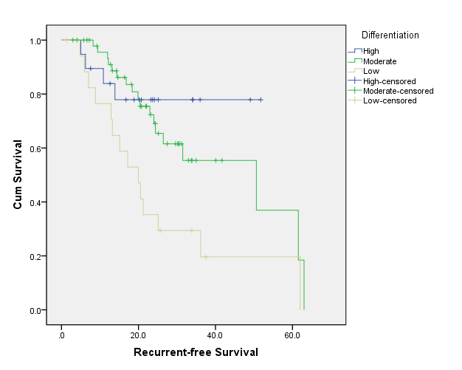

B

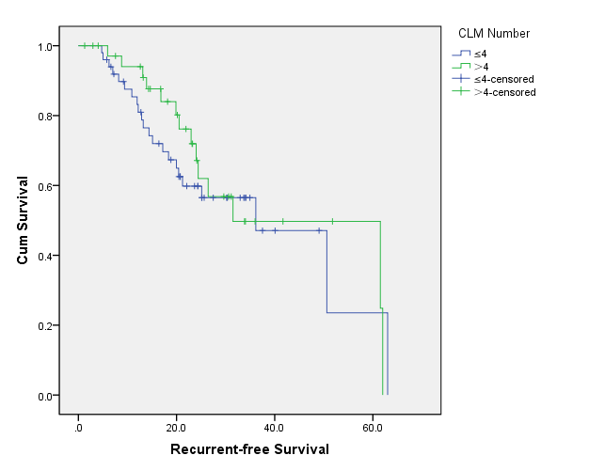

C

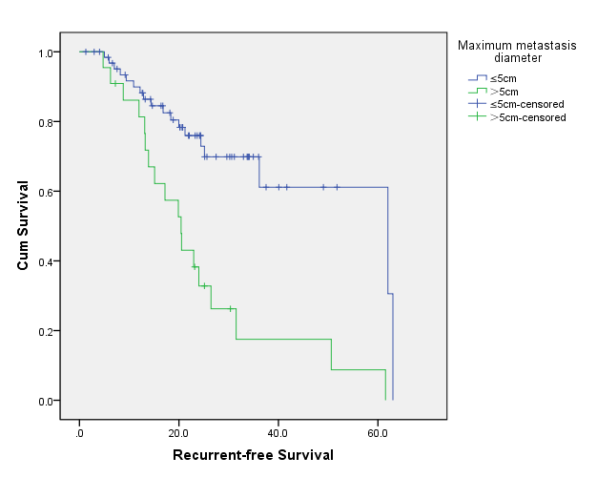

**Figure 1 Survival curves of patients.** A: Different differentiation degrees of the primary tumor; B: Colorectal liver metastases ≤ 4 and> 4; C: Colorectal liver metastases with a maximum metastasis diameter of ≤ 5 cm and > 5 cm. CLM: Colorectal liver metastases.

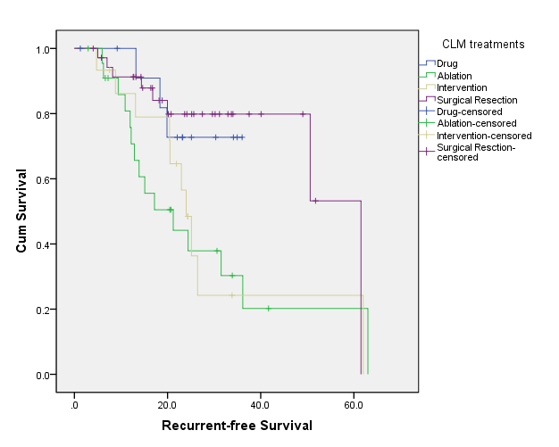

**Figure 2 Survival curves for different treatments.** CLM: Colorectal liver metastases.

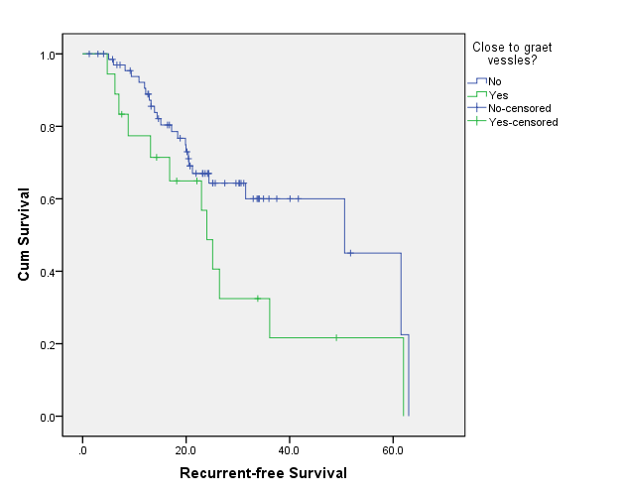

**Figure 3 Survival curves of colorectal liver metastases near or not near great vessels.**

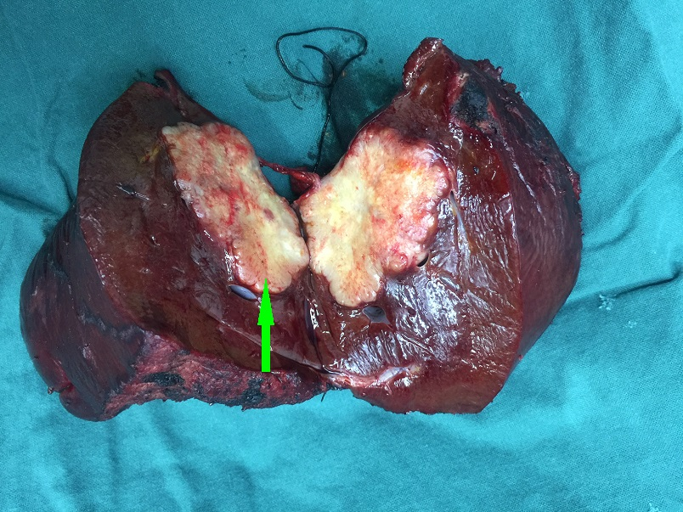

**Figure 4 Surgical resection of colorectal liver metastases. The arrow indicates metastases.**

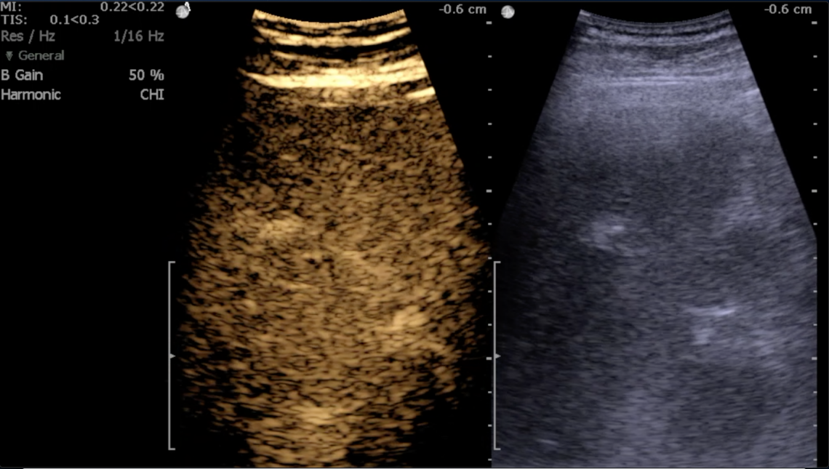

**Figure 5 Intraoperative ultrasound positioning.**

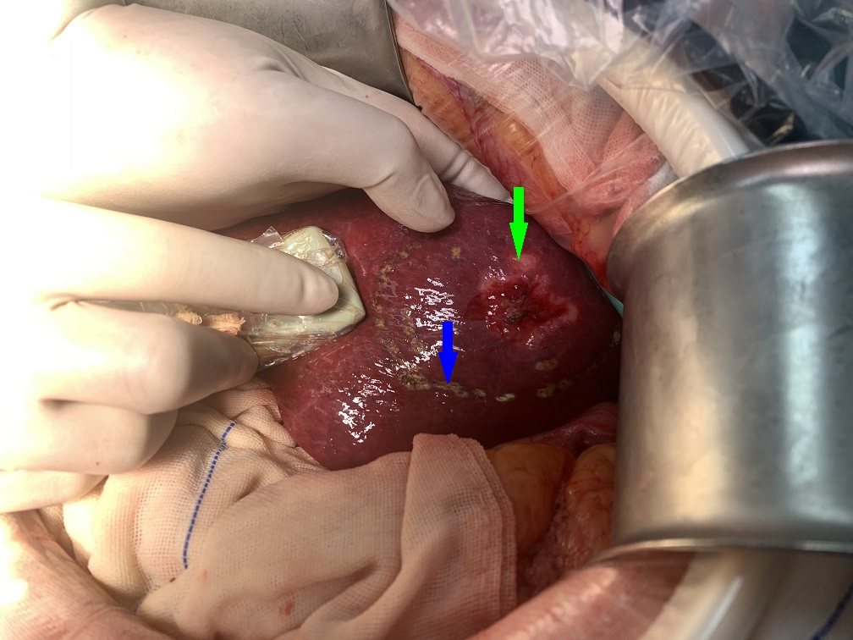

**Figure 6 Intraoperative ultrasound localization.** Green arrow represents colorectal liver metastases, and blue arrow represents electrosurgical markers after ultrasound localization.

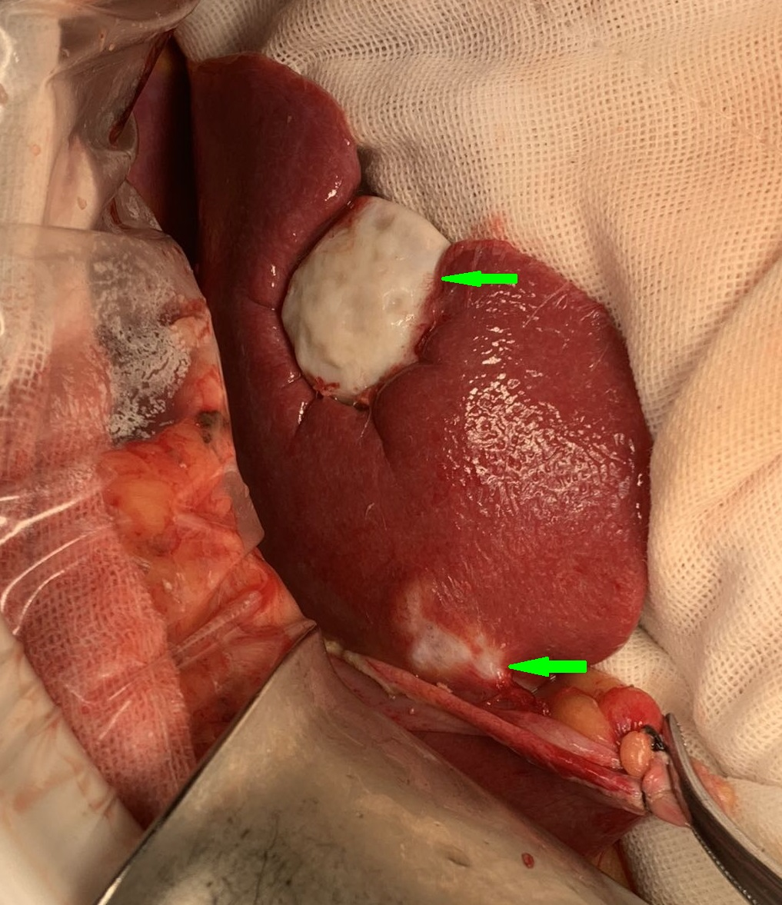

**Figure 7 Radiofrequency ablation.** Arrows indicate necrosis of colorectal liver metastases.

**Table 1 Comparison of clinicopathological data of the four groups of patients**

|  |  |  |  |  |  |  |
| --- | --- | --- | --- | --- | --- | --- |
|  | **Drug** | **Ablation** | **Intervention** | **Surgical resection** | **Statistical value** | ***P* value** |
| Gender |  |  |  |  | *χ*2 = 2.459 | 0.483 |
| Male | 8 | 19 | 10 | 24 |  |  |
| Female | 5 | 4 | 5 | 12 |  |  |
| Age (yr) | 62.77 ± 8.55 | 60.39 ± 9.33 | 63.13 ± 10.57 | 57.50 ± 12.52 | F = 1.337 | 0.268 |
| Primary tumor size (cm | 5.08 ± 2.17 | 4.35 ± 1.40 | 5.37 ± 2.72 | 5.10 ± 2.06 | F = 0.940 | 0.425 |
| Primary tumor site |  |  |  |  | *χ*2 = 11.729 | 0.068 |
| Right colon | 6 | 6 | 3 | 7 |  |  |
| Left colon | 5 | 4 | 3 | 16 |  |  |
| Rectum | 2 | 13 | 9 | 13 |  |  |
| Pathological type |  |  |  |  | *χ*2 = 3.032 | 0.387 |
| Non-MUC | 11 | 20 | 11 | 33 |  |  |
| MUC | 2 | 3 | 4 | 3 |  |  |
| Differentiation |  |  |  |  | *χ*2 = 7.807 | 0.253 |
| High | 4 | 4 | 1 | 10 |  |  |
| Moderate | 7 | 13 | 8 | 22 |  |  |
| Low | 2 | 6 | 6 | 4 |  |  |
| CEA (ng/mL) |  |  |  |  | *χ*2 = 2.950 | 0.339 |
| ≤ 15 | 11 | 13 | 10 | 24 |  |  |
| > 15 | 2 | 10 | 5 | 12 |  |  |
| CA19-9 (U/mL) |  |  |  |  | *χ*2 = 0.576 | 0.902 |
| ≤ 37 | 10 | 15 | 10 | 25 |  |  |
| > 37 | 3 | 8 | 5 | 11 |  |  |
| LMN |  |  |  |  | *χ*2 = 4.346 | 0.226 |
| No | 6 | 14 | 7 | 12 |  |  |
| Yes | 7 | 9 | 8 | 24 |  |  |
| CLM distribution |  |  |  |  | *χ*2 = 17.169 | 0.009 |
| Right lobe | 4 | 15 | 4 | 14 |  |  |
| Left lobe | 5 | 0 | 1 | 5 |  |  |
| Both lobes | 4 | 8 | 10 | 17 |  |
| CLM number |  |  |  |  | *χ*2 = 5.051 | 0.168 |
| ≤ 4 | 8 | 16 | 5 | 21 |  |  |
| > 4 | 5 | 7 | 10 | 15 |  |  |
| Proximity to great vessels |  |  |  |  | *χ*2 = 23.693 | 0.000 |
| No | 12 | 21 | 5 | 31 |  |  |
| Yes | 1 | 2 | 10 | 5 |  |  |
| Maximum CLM diameter (cm) | 4.96 ± 2.81 | 4.72 ± 1.74 | 5.03 ± 1.39 | 2.93 ± 1.11 | F = 9.627 | 0.000 |
| Total chemotherapy time |  |  |  |  | *χ*2 = 5.729 | 0.126 |
| < 6 mo | 13 | 18 | 14 | 27 |  |  |
| ≥ 6 mo | 0 | 5 | 1 | 9 |  |  |

MUC: Mucinous colorectal adenocarcinomas; CEA: Carcinoembryonic antigen; CA19-9: Cancer antigen 19-9; LMN: Lymph node metastases; CLM: Colorectal liver metastases.

**Table 2 Single factor analysis of prognosis of the patients**

|  |  |  |  |  |  |
| --- | --- | --- | --- | --- | --- |
| **Variable** | ***n*** | **Recurrent-free survival (%)** | | ***χ*2** | ***P* value** |
| **1 yr** | **3 yr** |
| Gender |  |  |  | 0.977 | 0.323 |
| Male | 61 | 91.4 | 55.9 |  |  |
| Female | 26 | 78.3 | 46.5 |  |  |
| Age (yr) |  |  |  | 0.509 | 0.475 |
| ≤ 60 | 50 | 82.7 | 49.6 |  |  |
| > 60 | 37 | 94.2 | 57.4 |  |  |
| Primary tumor size (cm) |  |  |  | 0.006 | 0.937 |
| ≤ 5 | 66 | 87.1 | 56.2 |  |  |
| > 5 | 21 | 89.5 | 46.4 |  |  |
| Primary tumor site |  |  |  | 5.365 | 0.068 |
| Right colon | 22 | 85.2 | 38.8 |  |  |
| Left colon | 37 | 83.2 | 47.3 |  |  |
| Rectum | 28 | 96.0 | 75.1 |  |  |
| Differentiation |  |  |  | 9.228 | 0.010 |
| High | 19 | 83.9 | 77.9 |  |  |
| Moderate | 50 | 93.2 | 55.4 |  |  |
| Low | 18 | 76.5 | 29.4 |  |  |
| Pathological type |  |  |  | 0.000 | 0.987 |
| Non–MUC | 75 | 88.4 | 51.2 |  |  |
| MUC | 12 | 83.3 | 64.3 |  |  |
| CEA (ng/mL) |  |  |  | 5.636 | 0.018 |
| ≤ 15 | 58 | 92.3 | 65.2 |  |  |
| > 15 | 29 | 85.8 | 20.2 |  |  |
| CA199 (U/mL) |  |  |  | 0.029 | 0.866 |
| ≤ 37 | 60 | 92.3 | 55.0 |  |  |
| > 37 | 27 | 85.5 | 52.2 |  |  |
| LMN |  |  |  | 0.385 | 0.535 |
| No | 39 | 91.2 | 55.3 |  |  |
| Yes | 48 | 83.2 | 51.3 |  |  |
| CLM distribution |  |  |  | 1.036 | 0.596 |
| Right lobe | 37 | 82.5 | 53.9 |  |  |
| Left lobe | 11 | 90.9 | 56.6 |  |  |
| Both lobes | 39 | 91.6 | 52.7 |  |  |
| CLM number |  |  |  | 4.152 | 0.042 |
| ≤ 4 | 50 | 90.7 | 59.6 |  |  |
| > 4 | 37 | 91.4 | 29.1 |  |  |
| Maximum CLM diameter |  |  |  | 10.732 | 0.001 |
| ≤ 5 cm | 65 | 93.2 | 61.4 |  |  |
| > 5 cm | 22 | 85.2 | 18.7 |  |  |
| CLM treatments |  |  |  | 8.158 | 0.043 |
| Drug | 13 | 90.9 | 51.9 |  |  |
| Ablation | 23 | 72.5 | 37.5 |  |  |
| Intervention | 15 | 92.3 | 34.6 |  |  |
| Surgical resection | 36 | 96.8 | 61.9 |  |  |
| Proximity to great vessels |  |  |  | 4.412 | 0.036 |
| No | 69 | 90.5 | 59.6 |  |  |
| Yes | 18 | 77.4 | 36.1 |  |  |
| Postoperative chemotherapy time |  |  |  | 0.367 | 0.545 |
| ≤ 6 mo | 72 | 79.4 | 42.8 |  |  |
| > 6 mo | 15 | 89.5 | 56.3 |  |  |

MUC: Mucinous colorectal adenocarcinomas; CEA: Carcinoembryonic antigen; CA19-9: Cancer antigen 19-9; LMN: Lymph node metastases; CLM: Colorectal liver metastases.

**Table 3 Multifactor analysis**

| **Variable** | **B** | **SE** | **Wald** | **df** | **Sig.** | **Exp(B)** |
| --- | --- | --- | --- | --- | --- | --- |
| Step 1 | | | | | | |
| Differentiation |  |  | 4.174 | 2 | 0.124 |  |
| Differentiation (1) | -0.865 | 0.590 | 2.148 | 1 | 0.143 | 0.421 |
| Differentiation (2) | -0.763 | 0.406 | 3.528 | 1 | 0.060 | 0.466 |
| CEA classification | 0.076 | 0.434 | .030 | 1 | 0.861 | 1.079 |
| Number of metastases | -0.758 | 0.416 | 3.323 | 1 | 0.068 | 0.468 |
| Size of metastases | 1.516 | 0.396 | 14.616 | 1 | 0.000 | 4.552 |
| Proximity to great vessles | -0.794 | 0.417 | 3.616 | 1 | 0.057 | 0.452 |
| Liver treatment | -0.094 | 0.174 | 0.288 | 1 | 0.591 | 0.911 |
| Step 2 | | | | | | |
| Differentiation |  |  | 4.173 | 2 | 0.124 |  |
| Differentiation (1) | -0.860 | 0.589 | 2.133 | 1 | 0.144 | 0.423 |
| Differentiation (2) | -0.749 | 0.398 | 3.532 | 1 | 0.060 | 0.473 |
| Number of metastases | -0.754 | 0.414 | 3.312 | 1 | 0.069 | 0.471 |
| Size of metastases | 1.526 | 0.392 | 15.190 | 1 | 0.000 | 4.599 |
| Proximity to great vessles | -0.797 | 0.417 | 3.656 | 1 | 0.056 | 0.451 |
| Liver treatment | -0.097 | 0.174 | 0.308 | 1 | 0.579 | 0.908 |
| Step 3 | | | | | | |
| Differentiation |  |  | 4.373 | 2 | 0.112 |  |
| Differentiation (1) | -0.839 | 0.585 | 2.057 | 1 | 0.151 | 0.432 |
| Differentiation (2) | -0.776 | 0.396 | 3.834 | 1 | 0.050 | 0.460 |
| Number of metastases | -0.795 | 0.409 | 3.778 | 1 | 0.052 | 0.451 |
| Size of metastases | 1.583 | 0.379 | 17.438 | 1 | 0.000 | 4.870 |
| Proximity to great vessles | -0.793 | 0.416 | 3.639 | 1 | 0.056 | 0.452 |
| Step 4 | | | | | | |
| Number of metastases | -0.910 | 0.405 | 5.065 | 1 | 0.024 | 0.402 |
| Size of metastases | 1.490 | 0.366 | 16.596 | 1 | 0.000 | 4.438 |
| Proximity to great vessles | -1.001 | 0.396 | 6.384 | 1 | 0.012 | 0.367 |
| Differentiation | 1.384 | 0.392 | 7.238 | 1 | 0.008 | 0.507 |

**Table 4 Comparison of clinicopathology between not-near great vessel group (A) and near great vessel group (B)**

|  |  |  |  |  |
| --- | --- | --- | --- | --- |
|  | **A** | **B** | **Statistics** | ***P* value** |
| Gender |  |  | *χ*2 = 0.048 | 0.826 |
| Male | 48 | 13 |  |  |
| Female | 21 | 5 |  |  |
| Age (yr) | 59.22 ± 10.34 | 63.11 ± 12.90 | t = 1.350 | 0.181 |
| Primary tumor size (cm） | 4.73 ± 1.84 | 5.75 ± 2.65 | t = 1.900 | 0.061 |
| Primary tumor site |  |  | *χ*2 = 0.519 | 0.771 |
| Right colon | 18 | 4 |  |  |
| Left colon | 23 | 5 |  |  |
| Rectum | 28 | 9 |  |  |
| Pathological type |  |  | *χ*2 = 0.456 | 0.500 |
| Non-MUC | 60 | 15 |  |  |
| MUC | 19 | 3 |  |  |
| Differentiation |  |  | *χ*2 = 4.581 | 0.101 |
| High | 16 | 3 |  |  |
| Medium | 42 | 8 |  |  |
| Low | 11 | 7 |  |  |
| CEA (ng/mL) |  |  | *χ*2 = 0.315 | 0.574 |
| ≤ 15 | 45 | 13 |  |  |
| > 15 | 24 | 5 |  |
| CA19-9 (U/mL) |  |  | *χ*2 = 0.654 | 0.419 |
| ≤ 37 | 49 | 11 |  |  |
| > 37 | 20 | 7 |  |  |
| LMN |  |  | *χ*2 = 0.001 | 0.971 |
| No | 31 | 8 |  |  |
| Yes | 38 | 10 |  |  |
| CLM distribution |  |  | *χ*2 = 2.546 | 0.280 |
| Right lobe | 32 | 5 |  |  |
| Left lobe | 9 | 2 |  |  |
| Both lobes | 28 | 11 |  |  |
| CLM number |  |  | *χ*2 = 3.206 | 0.073 |
| ≤ 4 | 43 | 7 |  |  |
| > 4 | 26 | 11 |  |  |
| Maximum CLM diameter (cm) | 4.04 ± 1.97 | 4.19 ± 1.69 | t = 0.309 | 0.758 |
| Postoperative chemotherapy time |  |  | *χ*2 = 1.766 | 0.184 |
| ≤ 6 mo | 59 | 13 |  |  |
| > 6 mo | 10 | 5 |  |  |
| CLM treatments |  |  | *χ*2 = 23.693 | 0.000 |
| Drug | 12 | 1 |  |  |
| Ablation | 21 | 2 |  |  |
| Intervention | 5 | 10 |  |  |
| Surgical resection | 31 | 5 |  |  |

MUC: Mucinous colorectal adenocarcinomas; CEA: Carcinoembryonic antigen; CA19-9: Cancer antigen 19-9; LMN: Lymph node metastases; CLM: Colorectal liver metastases.