**Novel treatment options for perforations of the upper GI tract:**

**Endoscopic Vacuum Therapy and Over-the-Scope Clips**

**Running title: Endoscopic Vacuum Therapy and OTSC**

Rudolf Mennigen, Norbert Senninger, Mike G. Laukoetter

Institution:

University Hospital Muenster, Department of General and Visceral Surgery,

Director: Univ.-Prof. Dr. med. Dr. h.c. N. Senninger, FACS, FRCS

Albert-Schweitzer-Campus 1, Bldg. W1, D-48149 Muenster, Germany

Author contributions: Mennigen R and Laukoetter MG performed the review of the literature, analyzed the data, and wrote the manuscript.

Supportive foundations: None.

Correspondence to:

Rudolf Mennigen, M.D., University Hospital Muenster, Department of General and Visceral Surgery, Albert-Schweitzer-Campus 1, Bldg. W1, D-48149 Muenster, Germany

Telephone: + 49-251-83 56301

Fax: +49-251-83-56404

Key words: Upper GI, perforation, fistula, endoscopy, over-the scope clip, OTSC, endoscopic vacuum therapy, EVT

**Abstract**

Endoscopic management of leakages and perforations of the upper gastrointestinal tract has gained a great importance as it avoids the morbidity and mortality of surgical management. In the past years, covered self-expanding metal stents were the mainstay of endoscopic therapy. However, two new techniques are now available that enlarge the possibilities of defect closure: endoscopic vacuum therapy (EVT), and Over-the-Scope Clips (OTSC). This article reviews technical aspects, summarizes the available data concerning the success rates in different indications, and discusses the role of these new techniques for the management of upper GI perforations.

**Core tip**

Recently, the novel technique of endoscopic vacuum therapy was developed for the closure of upper gastrointestinal perforations. A sponge is connected to a gastric tube, and then endoscopically placed into the perforation or cavity. First case series demonstrate excellent healing rates with very low procedure-related morbidity; it seems probable that this technique will become the new standard for upper GI perforations. A second novel endoscopic option is the Over-the-Scope Clips which allows full thickness closure of smaller defects and fistulas. Both endoscopic vacuum therapy and Over-the-Scope Clips are valuable contributions to endoscopic therapy of upper GI perforations.

**Introduction**

Perforations and fistulas of the upper gastrointestinal tract occur as postoperative complications (anastomotic dehiscence or fistula), during diagnostic or interventional endoscopy, iatrogenic as a consequence of other therapeutic measures (e.g., gastric tube placement, percutaneous endoscopic gastrostomy, transesophageal echocardiography), or spontaneous (ulcers, tumors, Boerhaave syndrome, and others). These perforations often lead to severe septic conditions which are difficult to treat and give rise to a high morbidity and mortality, especially if leading to mediastinitis or peritonitis**[****1****].**

Traditionally, surgery was mandatory to manage these conditions. However, in the recent years interventional endoscopy has evolved as an effective alternative to primary surgery. Especially the placement of self-expanding fully or partially covered metal or plastic stents (SEMS or SEPS) has become the first line therapy in esophageal anastomotic leakages or perforations, if the patient is not in critical septic condition[2, 3]. Although avoiding the high risks of esophageal emergency surgery in these cases, failure of stent therapy occurs in about 15 %[2].

The well-established stent therapy is now challenged by two relatively new endoscopic options. The first new option is the endoscopic vacuum therapy (EVT). While it has to be considered as standard therapy for colorectal anastomotic leakages, its use in the upper GI tract has evolved several years later. But soon after first reports on the technical feasibility of endoscopic vacuum therapy in the upper GI tract[4-6], several case series with good success rates were published. The new technique seems to have the potential to be the new first line therapy at least for postoperative leaks in the upper GI tract.

The second new option is a novel endoscopic clipping device, the Over-the-scope clip (OTSC; Ovesco Endoscopy AG, Tübingen, Germany)[7]. This device has dramatically increased the possibilities of endoscopic defect closure, as compared to Through-the-scope clips (TTSC). As for endoscopic vacuum therapy, there is an increasing number of published case series reporting promising success rates in defect closure.

In this review, we aim to describe both new endoscopic therapies. We discuss technical aspects, summarize the available data from the literature concerning the success rates in different indications, and discuss the role of the new techniques for the management algorithms of upper GI perforations.

**Endoscopic-Vacuum-Therapy (EVT)**

*Development, technical aspects, and review of the literature*

Within the last decade endoscopic treatment has changed the approach to intrathoracic esophageal leakage after esophageal resection and esophageal perforation. The reported leak rates from anastomoses after esophagectomy vary widely from 1% to 30%[8, 9] and anastomotic leakage after surgery accounts for approximately 40% of all postoperative fatalities[10]. The management of this situation is a challenge as a result of its potentially life-threatening nature. Especially control of the septic focus is essential when treating patients with anastomotic leakages. A number of competing treatment modalities including conservative, endoscopic, or surgical treatment have been proposed for the management of this situation[11]. The surgical treatment options include revision of the anastomosis, closure of the defect and perifocal drainage or complete surgical deviation and creating a cervical stoma[11, 12] and is usually difficult and carries a high risk for severe complications associated with high morbidity and mortality rates. Therefore re-operation might not always be a reasonable option.

As mentioned above during the past decade numerous minimally invasive treatment options have become available to treat a variety of secondary surgical complications and conservative management might be preferred if reliable endoscopic methods are available. Endoscopic clips, fibrin glue injection[13], absorbable plugs, and endoscopic suturing (EndoCinch)[14, 15] have been used to close smaller defects. At present the placement of completely covered metal or plastic stents has emerged as the favored conservative treatment for the management of esophageal leakage[16, 17]. The implantation of these stents has been extensively studied and has proven to be effective[3, 18, 19]. However, insertion of such stents may not always lead to a sufficient sealing of the leakage, and dislocation rates up to 40% have been reported**[****20****]**.Another known complication might be the impossibility of stent removal because of ingrowth of granulation tissue and secondary strictures due to scarring[18, 21]. Stents are used to bridge the defect intraluminally but a continuous local drainage is essential to preventthe collection of inflammatory fluids and maintenance of inflammatory reactions in the perianastomotic tissues.

The vacuum-assisted closure (VAC) system device is an established treatment modality for extensive cutaneous infected wounds[22] and based on negative pressure applied to the wound with a vacuum-sealed sponge, resulting in drainage of wound secretion, improved blood flow, reduction of edema, promotion of granulation, and consecutive wound closure. Since its introduction in the 1990s, the number of indications for the VAC system has steadily increased. Initial reports have shown good results for this endoscopy-based vacuum therapy in the treatment of rectal anastomotic leakage after resection of the rectum[23, 24]. Based on these results, the endoscopic vacuum therapy (EVT) was applied in the endoscopically accessible upper gastrointestinal tract.

Our group and others reported the successful closure of intrathoracic anastomotic leaks and perforations by endoscopic placement of a VAC- system [9, [25-31](#_ENREF_25" \o "Brangewitz, 2013 #158)] (Table 1). A synopsis of studies reporting endoscopic vacuum therapy for upper gastrointestinal perforations is shown in Table 1. All patients (n=101) included in these studies did not suffer from any interventional related complications. The overall success of closing the leaks by EVT in these patients was 90% (84-100%). One patient died during dilatation of a stenosis after complete healing due to an aorto-esophageal fistula. The available studies and data indicate that EVT is feasible, safe and effective. The main complications associated with EVT are stenosis after completed therapy due to scarring.

*Placement and removal*

Briefly, EVT consists of the endoscopic insertion of polyurethane sponges into the abscess cavity (Figure 3 B,C) induced by the leak, followed by application of a controlled continuous negative pressure. The used open-cell, polyurethane sponges should be approved for contact with open wounds. A transnasal gastric tube is connected to the sponge for the application of an external vacuum. The intent is to drain the infected fluid and to induce the formation of granulation tissue to close the leak. The vacuum sponges can be placed and changed under conscious sedation with midazolam and propofol and adequate monitoring of the patient.

The polyurethane foam sponge (e.g., V.A.C. ® GranuFoamTM, pore size 400–600 μm; KCI® -KineticConcepts, Inc., TX, USA, and Wiesbaden, Germany) has to be adapted to the particular wound size and geometry as estimated by the endoscopist. The sponge size needs to be smaller than the wound cavity to promote collapse and subsequent closure. At each session the patient is treated with an individual sponge that fits exactly the treatable geometry of the inflammatory cavity. The sponge is fixed to the tip of a PVC (polyvinyl chloride) gastroduodenal tube (e.g. CovidienTM Salem SumpTM, 14 Fr/Ch (4,7mm) x 114cm; CovidienTM, MA, USA) with an eligible suture at the proximal and distal ends of the sponge. It is important for successful drainage that the side ports of the tube communicate with the sponge and that the tube is placed in the middle of the sponge. An additional suture loop (addressed here as L-loop) at the tip of the tube is advisable (Figure 1). The L-loop can be grasped with endoscopic graspers serving the purpose of introducing the sponge into difficult-to-access extraluminal cavities and hollow spaces under direct vision using a regular orthograde video endoscope. The sponge drainage system is guided parallel to the endoscope (“backpack-method”) to the digestive tract defect and placed appropriately. If the defect is not initially passable by the endoscope, the opening must be dilated. If the cavity is too small to be accessed with the scope, the sponge may also be placed in the esophageal lumen. Depending on the extent of defects and progress of healing, the sponge placement can be changed from initial intracavitary to intraluminal at any time. Moreover in large leakage cavities, up to two sponges can be placed separately to allow rapid and sufficient drainage. After sponge placement the vacuum drainage tube has to be diverted through the nose. Continuous suction of 100 - 125mmHg is transnasally connected to the drainage tube under permanent direct endoscopic vision to ensure that the sponge stays in position using a vacuum pump (e.g. activ.a.c® or v.a.c.ulta® KCI®). If possible, a transnasal enteral feeding tube can be placed in the same session to ensure full enteral nutrition (Figure 3C). In contrast to vacuum therapy for open wounds, EVT does not require sealing to obtain air tightness[6, 32]. For sponge removal the suction has to be discontinued. It is advisable to flush the tube with 0.9%saline solution to dissolve the granulation tissue from the pores of the sponge prior removal. Subsequently the tube should be grasped with the endoscopic graspers close to the distal end, pulled out of the wound cavity with increasing force and withdrawn through the mouth. If possible this can also be done simply by pulling the drainage tube. The subsequent endoscopic exploration of the necrotic cavity is obligate. In accordance with the experience of VAC therapy for skin defects the sponge should be replaced twice a week, until the cavity appears to be clean and firmly closed which in terms of geometry means that the remaining wound cavity should be smaller than approximately 1 cm radius × 2 cm depth. After completion of EVT, patients should be weekly followed up endoscopically until complete healing of the defect.

*Final EVT note*

The endoscopic vacuum therapy is well-tolerated, effective and associated with good short-term andlong-term clinical outcomes. EVT is a serious primary treatment option in all septic patients unless there is extended ischemic necrosis of the anastomotic area. In this particular case a primary surgical approach has to be considered. The endoscopic vacuum therapy allows regular visualization of the leak and the infected cavity. The regular debridement and therefore control of the septic focus seems to be a major advantage over SEMS/SEPS therapy. In summary EVT is a new innovative technique for the management of major leakage from esophageal anastomoses and/or perforations of the upper gastrointestinal tract and might be superior to surgical revision and stent placement. Nevertheless next to endoscopic experience and skills, surgical expertise is required to assess the extent of perforation or anastomotic conditions andmore experience and more studies will be required that compare different treatment modalities of esophageal leakage.

**The Over-the-Scope Clip (OTSC)**

*Development, technical aspects*

In the past decades, endoscopic clip application has repeatedly been used as a minimally invasive treatment option for small leakages and fistulas of the upper GI tract. Most authors used Through-the-Scope clips (TTSC) that were designed for endoscopic hemostasis. However, the success of these attempts was limited to case reports[33, 34], and endoscopic clipping of perforations did not reach widespread clinical routine use. The efficacy of TTSCs is limited by their little wing span and the low compression force that the clips can apply.

The novel Over-the-Scope clip (OTSC; Ovesco Endoscopy AG, Tübingen, Germany) has revolutionized the principle of endoscopic clipping and has basically overcome the above-mentioned limitations[7]. Instead of introducing the clip via the working channel, a nitinol clip with the shape of a “bear claw” is loaded on a transparent cap that is mounted on the tip of the endoscope (Figure 2). Different sizes of caps and corresponding nitinol clips (11 to 14 mm) are available for different endoscope types and lesion characteristics. Clips are available with blunt (s or a type, atraumatic version) or with pointed teeth (t type, traumatic version). For the special purpose of closing gastric wall defects during natural orifice transluminal surgery, an additional clip type (gc type) has been added.

The lesion (bleeding ulcer, fistula, or wall defect) has to be pulled into the cap. This can be done by suction if the tissue is mobile enough. A special “anchor” is supplied by Ovesco for the treatment of smaller fibrotic fistula; it can be introduced into the fistula, and after opening the anchor it allows to pull the fistula as whole into the cap. A further special device is the “twin grasper”. This instrument has two lateral branches that can be independently opened and closed against a fixed central branch. This is especially helpful for adapting the edges of a larger defect and pulling them into the cap. However, some endoscopists prefer the use of “nondedicated” conventional endoscopic instruments (e.g., rat tooth, alligator forceps) being introduced via the working channel which is possible as well[35].

The method of deploying the clip basically resembles devices used for rubber band ligation. A string that is attached to the clip is pulled through the working channel and is connected to a hand wheel; by turning the wheel the clip can be fired.

The advantages of the OTSC compared to TTSC are: 1) larger lesions can be closed by one clip (limited by cap diameter and flexibility of the tissue being pulled into the cap), 2) much higher compression force. The nitinol OTSC provides constant compression forces of about 8 to 9 Newtons which is necessary for successful permanent closure of defects[7].

*Applications and efficacy of the OTSC: review of the literature*

We performed a literature search in Pubmed with the key words “over-the-scope clip” and “OTSC” (latest search date: 15 October 2013). Case reports, and series without gastrointestinal perforations (e.g., only reporting OTSC use in GI bleeding) were excluded from further analysis. Apart from perforations, gastrointestinal bleeding is an important indication for OTSCs, however, this was not the focus of this review. From the remaining 24 studies, indications for OTSC application, overall success, success by indication and leak site, and complications were extracted (Table 2)[7, 31, 35-56].

First clinical experiences came from Europe, where the OTSC device was available first[7], however, after introduction of the OTSC to the US and Japanese market, several case series reflect an increasing use in these countries as well[38, 46, 47]. The indications for OTSC use and the obtained results are basically similar to the early experiences from Europe.

There are no randomized trials on OTSC application, and most authors provide retrospective case series with heterogenic indications and applications. Most studies included less than 20 patients with gastrointestinal perforations; cases of gastrointestinal bleeding were excluded from the present analysis. Several publications report the pooled results of 2 or 3 centers[38, 46, 54]. The largest numbers of patients with gastrointestinal perforations treated by OTSC are provided by two multicenter studies. The first was a prospective European multicenter study on OTSC application (“the CLIPPER study group”)[55], the second a retrospective study of 3 participating North American tertiary-care referral medical centers[38], both reporting on 36 patients with gastrointestinal perforations.

Overall, 301 patients with gastrointestinal perforations were reported in 24 publications. The etiology of these perforations were very heterogenic in different studies, this has to be taken in account when comparing the actual success rates. Most studies report initial technical success (immediate closure of the perforation, most authors perform contrast studies to prove the complete sealing) and “long term clinical success”, meaning that an enduring closure of the perforation is reached, without the need for further endoscopic or surgical treatment. The reported long term overall success rates for the closure of gastrointestinal perforations, leakages and fistulas (these are provided in Table 1) range from 43%-100%. The pooled overall success rate was 73% (220/301). It is important to note, however, that follow-up times vary significantly between the studies, and some authors only provide short follow-up times.

The classification of gastrointestinal perforations again is very heterogenic between studies. We propose the classification into three categories:

1) Postoperative leaks and fistulas, including acute anastomotic dehiscences as well as chronic fistulas (although a differentiation of acute vs. chronic leaks would be important, it is very difficult to extract this information from the single publications).

2) Acute endoscopic and interventional perforations; this includes perforations during diagnostic and therapeutic endoscopy, and further acute perforations induced by diagnostic or therapeutic measures.

3) Other chronic leaks and fistulas. Many authors include chronic leaks and fistulas in their series that do not belong to the first two categories, e.g. enterocutaneous fistulas, perforated ulcers, or persistent gastrocutaneous fistulas following the extraction of a gastrostomy tube. We classified all reported patients, if the publications provided this information, into these 3 categories. We calculated the success rates for each of these categories (per study and as pooled overall estimate). Finally, we analyzed success rates for upper GI perforations versus colorectal perforations.

The overall success rate for acute endoscopic and interventional perforations is as high as 90% (95/106), which is significantly higher than the values for postoperative perforations (68%, 81/120), and other chronic leaks and fistulas (59%, 32/54) (Χ2; p<0.001). From the technical point of view, the setting of acute endoscopic perforation is optimal for OTSC use: the lesion is fresh (without fibrotic alterations, or inflammation), and the patient often already is in a specialized endoscopy unit, thus enabling a rapid OTSC closure. In cases of sufficient closure, the otherwise mandatory surgical repair of the lesion can be avoided; some authors already claim “sparing the surgeon” in these cases[53]. However, there are some concerns to be raised. Endoscopic therapies with high perforations risks should be performed with CO2 insufflation, as the resulting pneumoperitoneum can resolve much quicker. Massive pneumoperitoneum and consecutive abdominal pain can lead to surgical explorations, although the perforation was sufficiently closed by an OTSC. *Gubler[**42**]*reported successful closure of acute endoscopic perforations in 13/14 patients; however, 3 of these patients (all with colorectal perforations) underwent surgery which finally documented a sufficient closure of the perforations. *Hagel[**43**]* reported a success rate of 7/10 patients for acute perforations; however, of the 2 patients with colorectal perforations, 1 underwent surgery which again proved the perforation to be sufficiently closed. No patient with upper GI perforation closed by OTSC has been operated on unnecessarily. It seems probable that in the clinical routine setting, for security reasons colorectal perforations tend to prompt a surgical exploration, as a persistent colorectal leak can lead to a catastrophe. Among the enthusiastic reports on successful closures of acute endoscopic perforations, one dramatic case has to be mentioned that is reported in the European multicenter study by *Voermans*[55]. One patient with initially successful closure of a colonic perforation deteriorated several hours later; during laparotomy, the OTSC was found to be detached and the perforation was open again. Despite surgical therapy, the patient died. Therefore, one should keep in mind that OTSC closures of endoscopic perforations have to be proven by contrast studies, patients have to be monitored intensively, and necessary surgical therapies may not be delayed.

The overall success rate for postoperative leakages and fistulas is 68% (81/120). There is a wide span of indications that are summarized in this category; besides chronic fistulas of gastric sleeve resection, chronic fistulas of esophagogastric or esophagojejunal anastomoses, chronic fistulas of colorectal anastomoses, also some acute anastomotic dehiscences are included. Numbers are too small to clarify which indication might have a better outcome of OTSC closure. However, as most leakages and fistulas were chronic, this probably explains the lower success rate compared to acute endoscopic perforations. The most frequently mentioned reasons for failure of OTSC closure are fibrotic alterations of the fistula or leak, and active inflammation, and both are common features of chronic anastomotic fistulas.

The same is true for the variety of chronic fistulas of different etiology summarized in “other chronic leaks and fistulas”. The success rate in this category (59%, 32/54) is comparable to the indication “postoperative”.

Comparing the site of OTSC application, there were no significant differences between “upper GI” (135/186, 73%) and “colorectal” (73/94, 78%), so both sites seem suitable for OTSC applications.

Complications are infrequent, most authors state that they did not observe any; only two multicenter studies[38, 55] report complications. In the European multicenter study[55], one OTSC detached from a colorectal perforation leading to a delayed operation (as discussed above), and one esophageal perforation occurred during the introduction of the OTSC device. In the US study[38], in 2 patients the lumen of the small bowel was occluded by a misplaced OTSC, leading to surgical management. Taken together, the complication rate in all reported patients was 4/301 (1.3%).

**Report of a case demonstrating successful application of endoscopic vacuum therapy and OTSC**

In a 65-year old woman, we performed esophagectomy with esophagogastric anastomosis (circular stapler) (Figure 3). As the gastric tube was vital, the dehiscence was rather small, and the patient was in a stable condition, we placed a covered stent which remained in place for 6 weeks. Surprisingly, after planned extraction of the stent, the dehiscence was larger than before (Figure 3 A), and endoscopy revealed a large mediastinal cavity (Figure 3B) with a fistula to the right bronchial system (demonstrated by contrast study). We initiated an endoscopic vacuum therapy of the cavity, with changes of the sponge every 3-5 days (Figure 3C). During endoscopic vacuum therapy, enteral nutrition was applied via a second gastric tube which was placed in the duodenum. After 15 days, the former cavity had shrinked to a fistula of approximately 3 cm length and 1 cm width (Figure 3D). Further closure could not be obtained because of the bronchial fistula. Finally, an OTSC was placed on the fistula which led to permanent closure (Figure 3E). Endoscopic control at last follow-up (11 months) demonstrated that the OTSC was still in situ (Figure 3F). This case demonstrates how even cases with stent failure can be successfully managed with these new endoscopic treatment options.

**Therapy algorithms of upper GI perforations including the novel techniques**

Many centers have established algorithms for upper gastrointestinal perforations that include endoscopic stent therapy. This therapy has proven to be effective and safe in a large number of publications, and it is available at most hospitals. However, the novel techniques have the potential to even enlarge the proportion of patients who can be managed by endoscopy; stent failure rates of about 15%[2] mandate the development of a “plan B” beyond stent-placement.

In the setting of acute endoscopic perforations the OTSC obviously is a very effective treatment option, and in our opinion it is clearly superior to the placement of covered stents. However, comparative studies are not available, and in regard of the excellent results obtained by OTSC, it seems unethical to plan such a study. We propose that OTSC should be the first line therapy for acute endoscopic or interventional perforations of the upper gastrointestinal tract.

Endoscopic treatment of chronic fistulas and leaks has often been difficult; stent therapy, application of fibrin glue, or closure with TTS clips has usually been disappointing. In our opinion, OTSCs are a very promising option in these situations. The risk of OTSC application is very low, it is easy to perform, and success rates of about 60% are satisfactory, especially as OTSCs often are used in cases that proved to be refractory to various other treatment modalities. Furthermore, if OTSC closure fails, the OTSC procedure does not impair further treatments, such as endoscopic vacuum therapy, or surgery [31].

We believe that endoscopic vacuum therapy will become the new “gold standard” in the endoscopic therapy of acute postoperative dehiscences, especially following esophagectomy and gastrectomy. Usually, these leakages are associated with mediastinal cavities. After closure of the leak by stent placement, the drainage of these cavities can be insufficient. This accounts for many cases of stent failure (as in our case presented). In contrast to stent therapy, endoscopic vacuum therapy allows optimal drainage of the cavity, furthermore, the lesion can be inspected on a regular basis, and thus any deterioration can be detected early. Finally, the vacuum therapy leads to an astonishing debridement of the cavity, followed by granulation tissue. The success rates of defect closure by endoscopic vacuum therapy are excellent and seem to be higher than those reported for stent therapy. However, data on the comparison of endoscopic vacuum therapy and stent therapy are very limited yet.

Up to date, only two retrospective studies compared endoscopic vacuum therapy to stent therapy [25, 28]. *Schniewind*[28] retrospectively analyzed the outcomes of 62 patients with anastomotic leaks following esophagectomy. After matching for APACHE-Scores at the beginning of endoscopic therapy, endoscopic vacuum therapy resulted in a significantly lower mortality (12%) compared to surgically treated patients (50%) and patients treated by stent placement (83%). *Brangewitz[**25**]* retrospectively compared 39 patients managed by stent placement and 32 patients managed by endoscopic vacuum therapy. The rate of leakage closure was significantly higher in the endoscopic vacuum therapy group (84% vs. 54%). However, in contrast to *Schniewind´s* study[28], no difference was found for hospital mortality.

Although these first data indicate advantages for endoscopic vacuum therapy, further studies comparing this new technique with stent therapy are necessary. In the above mentioned studies[25, 28], both mortality (83% and 25%, respectively) of patients treated by stent placement, and defect closure rate (54%) are dramatically inferior to values published in dedicated studies on stent therapy during the past years[2]. This might in part be explained by early discontinuation of stent therapy in favor of endoscopic vacuum therapy; a bias in patient selection in these retrospective studies could be another explanation. Taken together, the advantage of endoscopic vacuum therapy will probably be lower than these two publications suggest.





**Figure 1. Endoscopic vacuum therapy: polyurethane sponge mounted on a gastric tube.**

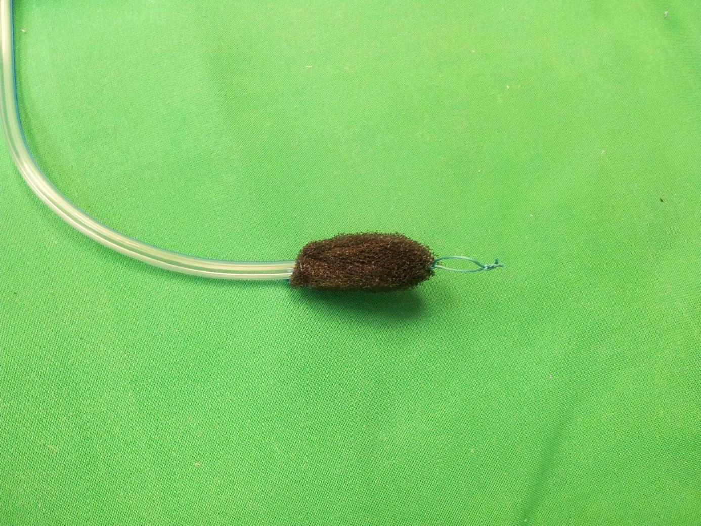

**Figure 2. Over-the-Scope Clip mounted on a gastroscope.**

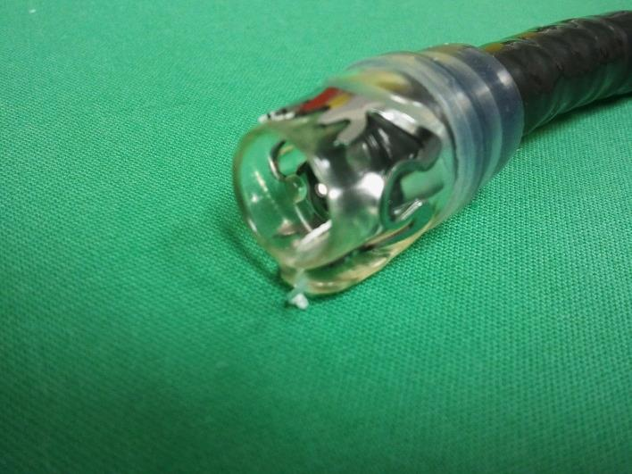

**Figure 3. Dehiscence of an esophagogastric stapler anastomosis with esophago-bronchial fistula in a 65-year old woman: endoscopic vacuum therapy and OTSC application.**

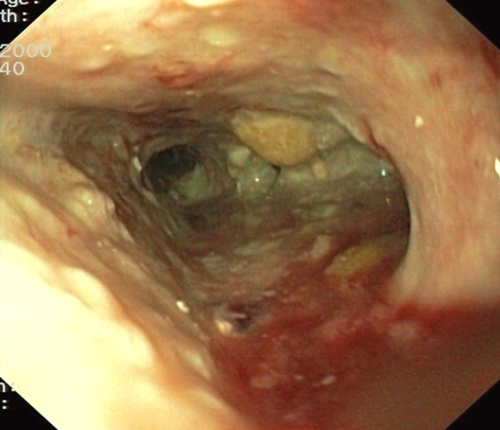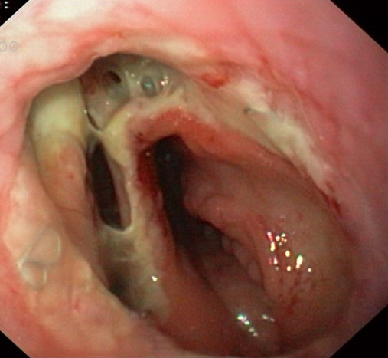

**A: Anastomotic dehiscence   
(after extraction of a covered stent).**

**B: Mediastinal cavity.**

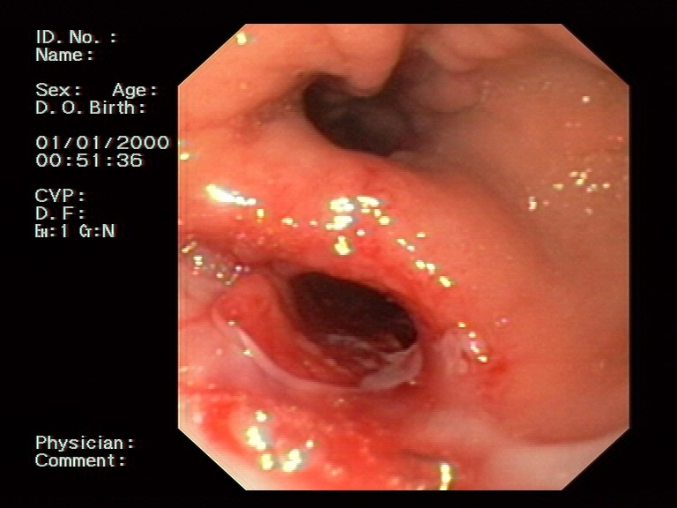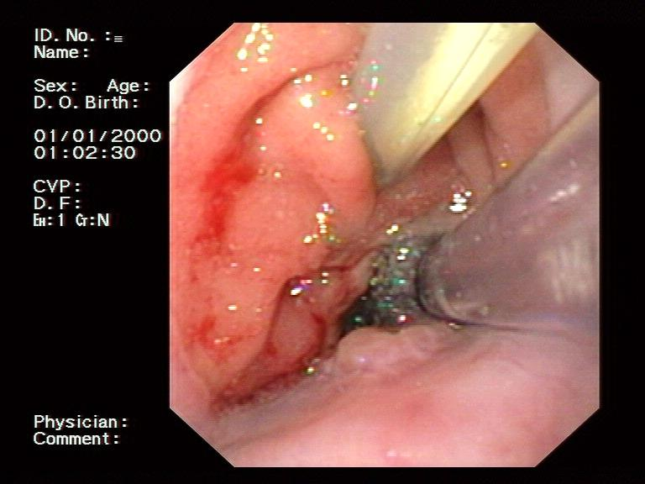**C: Endoscopic vacuum therapy.** Gastric tube with sponge placed in the defect (center), additional tube placed in the duodenum for enteral nutrition.**D: Persistent fistula (below) after endoscopic vacuum therapy.**

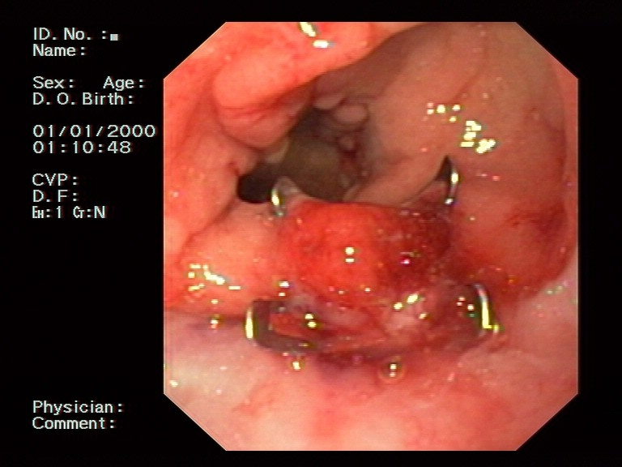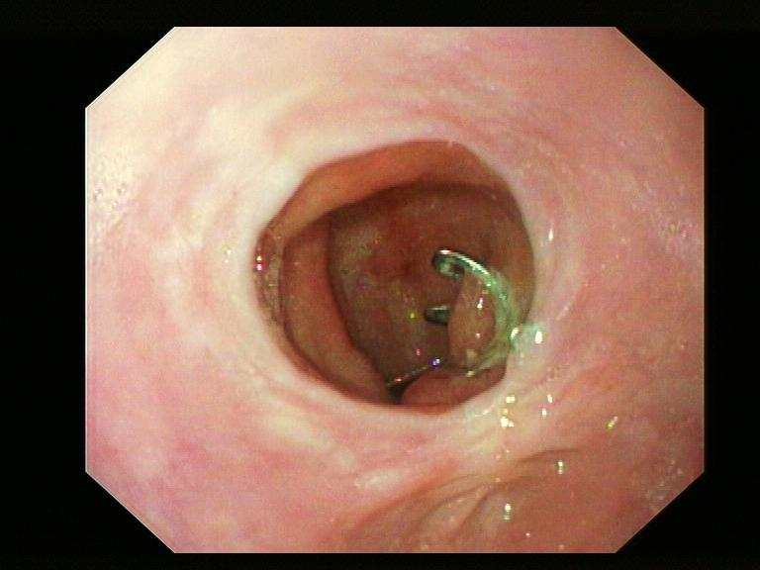

**E: OTSC closure of the fistula.**

**F: 11 months after OTSC closure.**

**References**

1 Junemann-Ramirez M, Awan MY, Khan ZM, Rahamim JS. Anastomotic leakage post-esophagogastrectomy for esophageal carcinoma: retrospective analysis of predictive factors, management and influence on longterm survival in a high volume centre. *Eur J Cardiothorac Surg* 2005; **27**(1): 3-7 [PMID: 15621463 DOI: 10.1016/j.ejcts.2004.09.018]

2 van Boeckel PG, Sijbring A, Vleggaar FP, Siersema PD. Systematic review: temporary stent placement for benign rupture or anastomotic leak of the oesophagus. *Aliment Pharmacol Ther* 2011; **33**(12): 1292-1301 [PMID: 21517921 DOI: 10.1111/j.1365-2036.2011.04663.x]

3 Tuebergen D, Rijcken E, Mennigen R, Hopkins AM, Senninger N, Bruewer M. Treatment of thoracic esophageal anastomotic leaks and esophageal perforations with endoluminal stents: efficacy and current limitations. *J Gastrointest Surg* 2008; **12**(7): 1168-1176 [PMID: 18317849 DOI: 10.1007/s11605-008-0500-4]

4 Loske G, Muller C. [Vacuum therapy of an esophageal anastomotic leakage--a case report]. *Zentralbl Chir* 2009; **134**(3): 267-270 [PMID: 19387934 DOI: 10.1055/s-0028-1098764]

5 Loske G, Schorsch T, Muller C. Endoscopic vacuum sponge therapy for esophageal defects. *Surg Endosc* 2010; **24**(10): 2531-2535 [PMID: 20333402 DOI: 10.1007/s00464-010-0998-x]

6 Wedemeyer J, Schneider A, Manns MP, Jackobs S. Endoscopic vacuum-assisted closure of upper intestinal anastomotic leaks. *Gastrointest Endosc* 2008; **67**(4): 708-711 [PMID: 18374029 DOI: 10.1016/j.gie.2007.10.064]

7 Kirschniak A, Kratt T, Stuker D, Braun A, Schurr MO, Konigsrainer A. A new endoscopic over-the-scope clip system for treatment of lesions and bleeding in the GI tract: first clinical experiences. *Gastrointest Endosc* 2007; **66**(1): 162-167 [PMID: 17591492 DOI: 10.1016/j.gie.2007.01.034]

8 Whooley BP, Law S, Murthy SC, Alexandrou A, Wong J. Analysis of reduced death and complication rates after esophageal resection. *Ann Surg* 2001; **233**(3): 338-344 [PMID: 11224620 PMCID: 1421248]

9 Ahrens M, Schulte T, Egberts J, Schafmayer C, Hampe J, Fritscher-Ravens A, Broering DC, Schniewind B. Drainage of esophageal leakage using endoscopic vacuum therapy: a prospective pilot study. *Endoscopy* 2010; **42**(9): 693-698 [PMID: 20806153 DOI: 10.1055/s-0030-1255688]

10 Pross M, Manger T, Reinheckel T, Mirow L, Kunz D, Lippert H. Endoscopic treatment of clinically symptomatic leaks of thoracic esophageal anastomoses. *Gastrointest Endosc* 2000; **51**(1): 73-76 [PMID: 10625803]

11 Crestanello JA, Deschamps C, Cassivi SD, Nichols FC, Allen MS, Schleck C, Pairolero PC. Selective management of intrathoracic anastomotic leak after esophagectomy. *J Thorac Cardiovasc Surg* 2005; **129**(2): 254-260 [PMID: 15678033 DOI: 10.1016/j.jtcvs.2004.10.024]

12 Page RD, Shackcloth MJ, Russell GN, Pennefather SH. Surgical treatment of anastomotic leaks after oesophagectomy. *Eur J Cardiothorac Surg* 2005; **27**(2): 337-343 [PMID: 15691693 DOI: 10.1016/j.ejcts.2004.10.053]

13 Rodella L, Laterza E, De Manzoni G, Kind R, Lombardo F, Catalano F, Ricci F, Cordiano C. Endoscopic clipping of anastomotic leakages in esophagogastric surgery. *Endoscopy* 1998; **30**(5): 453-456 [PMID: 9693892 DOI: 10.1055/s-2007-1001307]

14 Adler DG, McAfee M, Gostout CJ. Closure of an esophagopleural fistula by using fistula tract coagulation and an endoscopic suturing device. *Gastrointest Endosc* 2001; **54**(5): 652-653 [PMID: 11677492]

15 Fritscher-Ravens A, Cuming T, Eisenberger CF, Ghadimi M, Nilges A, Meybohm P, Schiffmann S, Jacobsen B, Seehusen F, Niemann H, Knoefel WT. Randomized comparative long-term survival study of endoscopic and thoracoscopic esophageal wall repair after NOTES mediastinoscopy in healthy and compromised animals. *Endoscopy* 2010; **42**(6): 468-474 [PMID: 20333608 DOI: 10.1055/s-0029-1244019]

16 Tuebergen D, Rijcken E, Mennigen R, Hopkins AM, Senninger N, Bruewer M. Treatment of thoracic esophageal anastomotic leaks and esophageal perforations with endoluminal stents: efficacy and current limitations. *J Gastrointest Surg* 2008; **12**(7): 1168-1176 [PMID: 18317849 DOI: 10.1007/s11605-008-0500-4]

17 Salminen P, Gullichsen R, Laine S. Use of self-expandable metal stents for the treatment of esophageal perforations and anastomotic leaks. *Surg Endosc* 2009; **23**(7): 1526-1530 [PMID: 19301070 DOI: 10.1007/s00464-009-0432-4]

18 Doniec JM, Schniewind B, Kahlke V, Kremer B, Grimm H. Therapy of anastomotic leaks by means of covered self-expanding metallic stents after esophagogastrectomy. *Endoscopy* 2003; **35**(8): 652-658 [PMID: 12929059 DOI: 10.1055/s-2003-41509]

19 Hunerbein M, Stroszczynski C, Moesta KT, Schlag PM. Treatment of thoracic anastomotic leaks after esophagectomy with self-expanding plastic stents. *Ann Surg* 2004; **240**(5): 801-807 [PMID: 15492561 PMCID: 1356485]

20 Kauer WK, Stein HJ, Dittler HJ, Siewert JR. Stent implantation as a treatment option in patients with thoracic anastomotic leaks after esophagectomy. *Surg Endosc* 2008; **22**(1): 50-53 [PMID: 17704867 DOI: 10.1007/s00464-007-9504-5]

21 Schubert D, Scheidbach H, Kuhn R, Wex C, Weiss G, Eder F, Lippert H, Pross M. Endoscopic treatment of thoracic esophageal anastomotic leaks by using silicone-covered, self-expanding polyester stents. *Gastrointest Endosc* 2005; **61**(7): 891-896 [PMID: 15933696]

22 Vikatmaa P, Juutilainen V, Kuukasjarvi P, Malmivaara A. Negative pressure wound therapy: a systematic review on effectiveness and safety. *Eur J Vasc Endovasc Surg* 2008; **36**(4): 438-448 [PMID: 18675559 DOI: 10.1016/j.ejvs.2008.06.010]

23 Glitsch A, von Bernstorff W, Seltrecht U, Partecke I, Paul H, Heidecke CD. Endoscopic transanal vacuum-assisted rectal drainage (ETVARD): an optimized therapy for major leaks from extraperitoneal rectal anastomoses. *Endoscopy* 2008; **40**(3): 192-199 [PMID: 18189215 DOI: 10.1055/s-2007-995384]

24 Weidenhagen R, Gruetzner KU, Wiecken T, Spelsberg F, Jauch KW. Endoscopic vacuum-assisted closure of anastomotic leakage following anterior resection of the rectum: a new method. *Surg Endosc* 2008; **22**(8): 1818-1825 [PMID: 18095024 DOI: 10.1007/s00464-007-9706-x]

25 Brangewitz M, Voigtlander T, Helfritz FA, Lankisch TO, Winkler M, Klempnauer J, Manns MP, Schneider AS, Wedemeyer J. Endoscopic closure of esophageal intrathoracic leaks: stent versus endoscopic vacuum-assisted closure, a retrospective analysis. *Endoscopy* 2013; **45**(6): 433-438 [PMID: 23733727 DOI: 10.1055/s-0032-1326435]

26 Kuehn F, Schiffmann L, Rau BM, Klar E. Surgical endoscopic vacuum therapy for anastomotic leakage and perforation of the upper gastrointestinal tract. *J Gastrointest Surg* 2012; **16**(11): 2145-2150 [PMID: 22948839 DOI: 10.1007/s11605-012-2014-3]

27 Schorsch T, Muller C, Loske G. Endoscopic vacuum therapy of anastomotic leakage and iatrogenic perforation in the esophagus. *Surg Endosc* 2013; **27**(6): 2040-2045 [PMID: 23247743 DOI: 10.1007/s00464-012-2707-4]

28 Schniewind B, Schafmayer C, Voehrs G, Egberts J, von Schoenfels W, Rose T, Kurdow R, Arlt A, Ellrichmann M, Jurgensen C, Schreiber S, Becker T, Hampe J. Endoscopic endoluminal vacuum therapy is superior to other regimens in managing anastomotic leakage after esophagectomy: a comparative retrospective study. *Surg Endosc* 2013; **27**(10): 3883-3890 [PMID: 23708716 DOI: 10.1007/s00464-013-2998-0]

29 Wedemeyer J, Brangewitz M, Kubicka S, Jackobs S, Winkler M, Neipp M, Klempnauer J, Manns MP, Schneider AS. Management of major postsurgical gastroesophageal intrathoracic leaks with an endoscopic vacuum-assisted closure system. *Gastrointest Endosc* 2010; **71**(2): 382-386 [PMID: 19879566 DOI: 10.1016/j.gie.2009.07.011]

30 Weidenhagen R, Hartl WH, Gruetzner KU, Eichhorn ME, Spelsberg F, Jauch KW. Anastomotic leakage after esophageal resection: new treatment options by endoluminal vacuum therapy. *Ann Thorac Surg* 2010; **90**(5): 1674-1681 [PMID: 20971288 DOI: 10.1016/j.athoracsur.2010.07.007]

31 Mennigen R, Colombo-Benkmann M, Senninger N, Laukoetter M. Endoscopic closure of postoperative gastrointestinal leakages and fistulas with the Over-the-Scope Clip (OTSC). *J Gastrointest Surg* 2013; **17**(6): 1058-1065 [PMID: 23400507 DOI: 10.1007/s11605-013-2156-y]

32 Loske G, Muller C. Endoscopic vacuum-assisted closure of upper intestinal anastomotic leaks. *Gastrointest Endosc* 2009; **69**(3 Pt 1): 601-602; author reply 602 [PMID: 19231507 DOI: 10.1016/j.gie.2008.06.058]

33 Yoshikane H, Hidano H, Sakakibara A, Ayakawa T, Mori S, Kawashima H, Goto H, Niwa Y. Endoscopic repair by clipping of iatrogenic colonic perforation. *Gastrointest Endosc* 1997; **46**(5): 464-466 [PMID: 9402126]

34 Rodella L, Laterza E, De Manzoni G, Kind R, Lombardo F, Catalano F, Ricci F, Cordiano C. Endoscopic clipping of anastomotic leakages in esophagogastric surgery. *Endoscopy* 1998; **30**(5): 453-456 [PMID: 9693892 DOI: 10.1055/s-2007-1001307]

35 Jayaraman V, Hammerle C, Lo SK, Jamil L, Gupta K. Clinical Application and Outcomes of Over the Scope Clip Device: Initial US Experience in Humans. *Diagn Ther Endosc* 2013; **2013**: 381873 [PMID: 23935261 PMCID: 3727083 DOI: 10.1155/2013/381873]

36 Albert JG, Friedrich-Rust M, Woeste G, Strey C, Bechstein WO, Zeuzem S, Sarrazin C. Benefit of a clipping device in use in intestinal bleeding and intestinal leakage. *Gastrointest Endosc* 2011; **74**(2): 389-397 [PMID: 21612776 DOI: 10.1016/j.gie.2011.03.1128]

37 Arezzo A, Verra M, Reddavid R, Cravero F, Bonino MA, Morino M. Efficacy of the over-the-scope clip (OTSC) for treatment of colorectal postsurgical leaks and fistulas. *Surg Endosc* 2012; **26**(11): 3330-3333 [PMID: 22580885 DOI: 10.1007/s00464-012-2340-2]

38 Baron TH, Song LM, Ross A, Tokar JL, Irani S, Kozarek RA. Use of an over-the-scope clipping device: multicenter retrospective results of the first U.S. experience (with videos). *Gastrointest Endosc* 2012; **76**(1): 202-208 [PMID: 22726484 DOI: 10.1016/j.gie.2012.03.250]

39 Coker AM, Jacobsen GR, Acosta G, Talamini MA, Savides TJ, Horgan S. Initial Experience with an Innovative Endoscopic Clipping System. *Surg Technol Int* 2012; **XXII** [PMID: 23225590]

40 Disibeyaz S, Koksal AS, Parlak E, Torun S, Sasmaz N. Endoscopic closure of gastrointestinal defects with an over-the-scope clip device. A case series and review of the literature. *Clin Res Hepatol Gastroenterol* 2012; **36**(6): 614-621 [PMID: 22704818 DOI: 10.1016/j.clinre.2012.04.015]

41 Galizia G, Napolitano V, Castellano P, Pinto M, Zamboli A, Schettino P, Orditura M, De Vita F, Auricchio A, Mabilia A, Pezzullo A, Lieto E. The over-the-scope-clip (OTSC) system is effective in the treatment of chronic esophagojejunal anastomotic leakage. *J Gastrointest Surg* 2012; **16**(8): 1585-1589 [PMID: 22396090 DOI: 10.1007/s11605-012-1862-1]

42 Gubler C, Bauerfeind P. Endoscopic closure of iatrogenic gastrointestinal tract perforations with the over-the-scope clip. *Digestion* 2012; **85**: 302-307 [PMID: 22614286 DOI: 10.1159/000336509]

43 Hagel AF, Naegel A, Lindner AS, Kessler H, Matzel K, Dauth W, Neurath MF, Raithel M. Over-the-scope clip application yields a high rate of closure in gastrointestinal perforations and may reduce emergency surgery. *J Gastrointest Surg* 2012; **16**(11): 2132-2138 [PMID: 22903364 DOI: 10.1007/s11605-012-1983-6]

44 Kirschniak A, Subotova N, Zieker D, Konigsrainer A, Kratt T. The over-the-scope clip (OTSC) for the treatment of gastrointestinal bleeding, perforations, and fistulas. *Surg Endosc* 2011; **25**(9): 2901-2905 [PMID: 21424197 DOI: 10.1007/s00464-011-1640-2]

45 Manta R, Manno M, Bertani H, Barbera C, Pigo F, Mirante V, Longinotti E, Bassotti G, Conigliaro R. Endoscopic treatment of gastrointestinal fistulas using an over-the-scope clip (OTSC) device: case series from a tertiary referral center. *Endoscopy* 2011; **43**(6): 545-548 [PMID: 21409741 DOI: 10.1055/s-0030-1256196]

46 Monkemuller K, Peter S, Toshniwal J, Popa D, Zabielski M, Stahl RD, Ramesh J, Wilcox CM. Multipurpose use of the 'bear claw' (over-the-scope-clip system) to treat endoluminal gastrointestinal disorders. *Dig Endosc* 2013 [PMID: 23855514 DOI: 10.1111/den.12145]

47 Nishiyama N, Mori H, Kobara H, Rafiq K, Fujihara S, Kobayashi M, Oryu M, Masaki T. Efficacy and safety of over-the-scope clip: including complications after endoscopic submucosal dissection. *World J Gastroenterol* 2013; **19**(18): 2752-2760 [PMID: 23687412 PMCID: 3653149 DOI: 10.3748/wjg.v19.i18.2752]

48 Parodi A, Repici A, Pedroni A, Blanchi S, Conio M. Endoscopic management of GI perforations with a new over-the-scope clip device (with videos). *Gastrointest Endosc* 2010; **72**(4): 881-886 [PMID: 20646699 DOI: 10.1016/j.gie.2010.04.006]

49 Pohl J, Borgulya M, Lorenz D, Ell C. Endoscopic closure of postoperative esophageal leaks with a novel over-the-scope clip system. *Endoscopy* 2010; **42**(9): 757-759 [PMID: 20806160 DOI: 10.1055/s-0030-1255634]

50 Repici A, Arezzo A, De Caro G, Morino M, Pagano N, Rando G, Romeo F, Del Conte G, Danese S, Malesci A. Clinical experience with a new endoscopic over-the-scope clip system for use in the GI tract. *Dig Liver Dis* 2009; **41**(6): 406-410 [PMID: 18930700 DOI: 10.1016/j.dld.2008.09.002]

51 Sandmann M, Heike M, Faehndrich M. Application of the OTSC system for the closure of fistulas, anastomosal leakages and perforations within the gastrointestinal tract. *Z Gastroenterol* 2011; **49**(8): 981-985 [PMID: 21811949 DOI: 10.1055/s-0029-1245972]

52 Schlag C, Wilhelm D, von Delius S, Feussner H, Meining A. EndoResect study: endoscopic full-thickness resection of gastric subepithelial tumors. *Endoscopy* 2013; **45**(1): 4-11 [PMID: 23254401 DOI: 10.1055/s-0032-1325760]

53 Seebach L, Bauerfeind P, Gubler C. "Sparing the surgeon": clinical experience with over-the-scope clips for gastrointestinal perforation. *Endoscopy* 2010; **42**(12): 1108-1111 [PMID: 21120779 DOI: 10.1055/s-0030-1255924]

54 Surace M, Mercky P, Demarquay JF, Gonzalez JM, Dumas R, Ah-Soune P, Vitton V, Grimaud J, Barthet M. Endoscopic management of GI fistulae with the over-the-scope clip system (with video). *Gastrointest Endosc* 2011; **74**(6): 1416-1419 [PMID: 22136786 DOI: 10.1016/j.gie.2011.08.011]

55 Voermans RP, Le Moine O, von Renteln D, Ponchon T, Giovannini M, Bruno M, Weusten B, Seewald S, Costamagna G, Deprez P, Fockens P. Efficacy of endoscopic closure of acute perforations of the gastrointestinal tract. *Clin Gastroenterol Hepatol* 2012; **10**(6): 603-608 [PMID: 22361277 DOI: 10.1016/j.cgh.2012.02.005]

56 von Renteln D, Denzer UW, Schachschal G, Anders M, Groth S, Rosch T. Endoscopic closure of GI fistulae by using an over-the-scope clip (with videos). *Gastrointest Endosc* 2010; **72**(6): 1289-1296 [PMID: 20951989 DOI: 10.1016/j.gie.2010.07.033]