**Name of journal: World Journal of Biological Chemistry**

**ESPS Manuscript NO: 5195**

**Columns: ORIGINAL ARTICLES**

**Effect of alcohol exposure on hepatic superoxide generation and hepcidin expression**

**Harrison-Findik DD *et al*.** Acute alcohol, superoxide and hepcidin

Duygu Dee Harrison-Findik, Sizhao Lu, Emily M Zmijewski, Jocelyn Jones,Matthew C Zimmerman

**Duygu Dee Harrison-Findik, Sizhao Lu, Emily M Zmijewski,** Department of Internal Medicine, University of Nebraska Medical Center, Omaha, NE 68198, United States

**Jocelyn Jones,Matthew C Zimmerman**, Department of Cellular and Integrative Physiology, University of Nebraska Medical Center, Omaha, NE 68198, United States

**Author contributions:** Lu S, Zmijewski EM and Jones J performed the experiments and helped with the manuscript; Harrison-Findik DD and Zimmerman MC designed the study, and wrote and edited the manuscript.

**Supported by** Grant to Harrison-Findik DD, No. NIH R01AA017738; University of Nebraska Medical Center Undergraduate Scholarship to Lu S EPR spectroscopy studies were conducted in the EPR Core Facility, which is supported by the University of Nebraska-Lincoln Redox Biology Center, No. NIH 1 P30 GM103335

**Correspondence to: Duygu Dee Harrison-Findik**, **PhD,** Department of Internal Medicine, University of Nebraska Medical Center, Emile St, Omaha, NE 68198-5820, United States. dharrisonfindik@unmc.edu

**Telephone:** +1-402-5596355 **Fax:** +1-402-5596494

**Received:** August 21, 2013 **Revised:** November 5, 2013

**Accepted:** November 15, 2013

**Published online:**

**Abstract**

**AIM:** To understand the role of mitochondrial-produced superoxide (O2•-) in the regulation of iron-regulatory hormone, hepcidin by alcohol in the liver.

**METHODS**: For alcohol experiments, manganese superoxide dismutase knockout mice heterozygous for *Sod2* gene expression (*Sod2*+/-) and age-matched littermate control mice (LMC), expressing *Sod2* gene on both alleles, were exposed to either 10% (w/v) ethanol in the drinking water or plain water (control) for 7 d. Total cellular O2•- levels in hepatocytes isolated from the livers of mice were measured by electron paramagnetic resonance spectroscopy. The mitochondrial-targeted, O2•--sensitive fluorogenic probe, MitoSOX Red and flow cytometry were utilized to measure O2•- in mitochondria. Gene and protein expression were determined by Taqman real-time quantitative PCR and western blotting, respectively.

**RESULTS:** *Sod2*+/- mice expressed 40% less MnSOD protein (SOD2) in hepatocytes compared to LMC mice. The deletion of *Sod2* allele did not alter the basal expression level of hepcidin in the liver. 10% ethanol exposure for 1 wk inhibited hepatic hepcidin mRNA expression three-fold both in *Sod2*+/- and LMC mice. O2•- levels in hepatocytesof untreated *Sod2*+/- mice were three-fold higher than in untreated LMC mice, as observed by electron paramagnetic resonance spectroscopy. O2•- levels in mitochondria of *Sod2*+/ mice were four-fold higher than in mitochondria of untreated LMC mice, as measured by MitoSOX Red fluorescence and flow cytometry. Alcohol induced a two-fold higher increase in O2•- levels in hepatocytesof LMC mice than in *Sod2*+/- mice compared to respective untreated counterparts. In contrast, 1 wk alcohol exposure did not alter mitochondrial O2•- levels in both *Sod2*+/- and control mice.

**CONCLUSION**: Mitochondrial O2•- is not involved in the inhibition of liver hepcidin transcription and thereby regulation of iron metabolism by alcohol. These findings also suggest that short-term alcohol consumption significantly elevates O2•- levels in hepatocytes, which appears not to originate from mitochondria.

© 2013 Baishideng Publishing Group Co., Limited. All rights reserved.

**Key words:** Hepcidin; Alcohol; Iron; Superoxide; Superoxide dismutase; Liver; Mitochondria; Manganese superoxide dismutase; Electron paramagnetic resonance

**Core tip:** Patients with alcoholic liver disease frequently exhibit iron overload, which contributes to liver injury. Our previous research has shown that suppression of iron-regulatory hormone, hepcidin by alcohol-mediated oxidative stress in the liver is involved. This manuscript investigates the role of superoxide and mitochondria in this process by using MnSOD (*Sod2*) knockout mice.

Harrison-Findik DD, Lu S, Zmijewski EM, Jones J,Zimmerman MC. Effect of alcohol exposure on hepatic superoxide generation and hepcidin expression.

**Available from: URL:**

**DOI:**

**INTRODUCTION**

Alcoholic liver disease (ALD) patients frequently display evidence of iron overload[1-4]. Even moderate alcohol consumption can elevate serum iron indices[5]. Both iron and alcohol individually cause oxidative stress, which culminate in liver injury[6]. Hepcidin is an antimicrobial peptide, which is synthesized in the hepatocytes of the liver[7, 8]. It plays a central role in the regulation of iron metabolism by inhibiting intestinal iron transport and the release of iron from macrophages[9, 10]. Hepcidin achieves this by binding to the iron exporter ferroportin and inducing its internalization and degradation[11]. We have previously demonstrated that short-term and moderate alcohol exposure is sufficient to suppress hepcidin synthesis in the liver, which in turn causes an increase in the expression of intestinal iron transporters *in vivo*[12]. Vitamin E and N-acetylcysteine (NAC) administration *in vivo* abolishes the effect of alcohol on both liver hepcidin and duodenal iron transporters[12]. Vitamin E is a peroxyl radical scavenger and inhibits lipid peroxidation of cellular membranes[13]. NAC can either directly interact with reactive oxygen species (ROS) via its free thiol group or exert an indirect antioxidant effect as a precursor of reduced glutathione (GSH)[14, 15]. Our findings therefore suggest that early changes in free radical scavenging and antioxidant defense mechanisms induced by alcohol are involved in the inhibition of hepcidin expression and alcohol-induced accumulation of iron.

Superoxide (O2•-) can initiate lipid peroxidation, and iron can interact with O2•- and hydrogen peroxide to yield the highly reactive hydroxyl radical[16, 17]. The antioxidant enzyme, superoxide dismutase (SOD) catalyzes the dismutation of O2•- into hydrogen peroxide and oxygen[18-20]. Mammalian cells express three types of SOD with different subcellular localization and metal requirements. CuZnSOD (SOD1) is primarily localized in the cytoplasm, but is also found in mitochondria and the nucleus. MnSOD (SOD2) is strictly targeted to the mitochondrial matrix and SOD3 (EC-SOD) is secreted into the extracellular space. The effect of short-term alcohol intake on SOD expression and O2•- production in the liver is unclear. Chronic alcohol consumption however has been shown to elevate SOD2 expression in livers of monkeys and in sera of ALD patients[21, 22]. Another study with liver biopsies from ALD patients reported a decrease in SOD1 expression, which correlated with liver fibrosis[23]. Rats with chronic ethanol ingestion also exhibited a decrease in liver SOD1 activity[24]. Delivery of adenoviral SOD1 into rats with chronic alcohol exposure has been reported to reduce alcohol-induced liver injury[25]. Kessova *et al*[26] reported necrosis, inflammation and apoptosis in the livers of knockout mice homozygous for *Sod1* (*Sod1*-/-) following alcohol exposure. In patients with ALD or in other experimental models of ALD, alcohol induces lipid accumulation and elevates GSH in the liver[27, 28]. In contrast, *Sod1*-/- mice exhibited milder lipid accumulation and decreased GSH in the liver compared to alcohol-fed wildtype control mice[26]. Curry-McCoy *et al*[29] also reported atypical responses to chronic alcohol consumption in *Sod1*-/- mice.

Mitochondriaplay a key role in iron biogenesis, and alcohol metabolism[30]. In mitochondria, O2•- is mainly produced from complex I (NADH-ubiquinone oxidoreductase) and complex III (ubiquinol-cytochrome *c* oxidoreductase) of the electron transport chain. Both complex I and complex III have been shown to be involved in alcohol-mediated ROS production[31]. Separate clinical studies with French alcoholic cirrhosis patients suggested that a genetic polymorphism in the mitochondrial targeting sequence of SOD2, which enhances the mitochondrial import of SOD2, increases the risk for iron accumulation in hepatocytes and hepatocellular carcinoma[32, 33]. However, another independent study with ALD patients did not find an association between SOD2 genetic polymorphisms and alcohol-induced oxidative stress or liver fibrosis[34]. Over expression of SOD2 by recombinant adenovirus has been reported to prevent liver injury induced by intragastric chronic alcohol feeding in rats.[35] In contrast, another study with mice has shown that elevated SOD2 expression worsens the effect of prolonged alcohol consumption but is protective when mice receive a single intragastric dose of alcohol (*i.e.,* an alcohol binge)[36]. Larosche *et al*[37] have reported that an alcohol binge further decreases SOD2 activity in mice lacking one *Sod2* allele but further increases it in mice overexpressing SOD2.

The effect of moderate short-term alcohol exposure on SOD2 expression and O2•- generation, and the role of O2•- in the regulation of hepcidin transcription in the liver requires further investigation. This study aims to address these questions by using knockout mice heterozygous for *Sod2* and control mice as a model.

**MATERIALS AND METHODS**

***Animal experiments***

Animal experiments were approved by the Institutional Animal Care and Use committee at the University of Nebraska Medical Center. Manganese superoxide dismutase (MnSOD) knockout mice lacking the expression of *Sod2* gene, on a C57BL/6 genetic background, were generated, as described[38]. We employed knockout mice heterozygous for *Sod2* gene expression (*Sod2*+/-) and age-matched littermate control mice (LMC) expressing *Sod2* gene on both alleles. All mice were maintained on a regular chow diet (Harlan Teklad 7012). For alcohol experiments, 6-8 wk old male mice were housed in individual cages and exposed to either 10% (w/v) ethanol in the drinking water or plain water (control) for 7 d, as described previously[12, 39], at which time livers were collected. Before harvesting, livers were perfused with warm phosphate-buffered saline (PBS) buffer (pH 7.4) to eliminate blood. Livers isolated from mice were snap frozen in liquid nitrogen and stored at -80 °C until further use. For electron paramagnetic resonance (EPR) spectroscopy, fresh livers were subjected to a standard perfusion protocol to isolate viable hepatocytes, as described below.

***Liver perfusion***

To isolate viable hepatocytes, mice livers were perfused, as described[40]. Briefly, livers were perfused (7 mL/min) *via* the inferior vena cava with warm and gassed KRH buffer (250 mmol/L HEPES, 1149 mmol/L NaCl, 45 mmol/L KCl, 10 mmol/L KH2PO4, 0.5mmol/LEGTA, pH 7.6) followed by KRH buffer containing 2 mmol/L Ca2+ and collagenase (0.214 mg/mL, Sigma C5138). Hepatocytes, isolated by centrifugation (50 × *g*, 2 min), were washed thrice with ice-cold KRH buffer containing 2 mmol/L Ca2+ and 2% BSA. Dead hepatocytes were discarded by Percoll centrifugation (129 × *g*, 5 min 4ºC) and cell viability was determined by Trypan Blue staining. Hepatocytes with ≥ 78% viability were employed for experiments.

***Electron paramagnetic resonance spectroscopy***

Electron paramagnetic resonance (EPR) was used to measure total cellular O2•- levels in hepatocytes isolated from the livers of *Sod2*+/- and control littermate mice fed either with plain (control) or ethanol-supplemented water, as described above. 0.5 × 106 cells were incubated with the cell permeable and O2•- sensitive spin probe, 1-hydroxy-3-methoxycarbonyl-2,2,5,5-tetramethylpyrrolidine (CMH, 200 µmol/L) for 15 min at 37ºC in EPR buffer (99 mmol/L NaCl, 4.69 mmol/L KCl, 2.5 mmol/L CaCl2, 1.2 mmol/L MgSO4, 25 mmol/L NaHCO3, 1.03 mmol/L KH2PO4, 5.6 mmol/L D(+)-glucose, 20 mmol/L Na-Hepes, pH 7.4) freshly supplemented with metal chelators, 5µmol/L diethyldithiocarbamic (DETC) acid (sodium salt) and 25 µmol/L deferoxamine methanesulfonate. 50 µL of cell suspension was loaded into a glass capillary tube, which was then inserted into the capillary holder of a Bruker e-scan EPR spectrometer. The following EPR settings were used for all experiments: field sweep width, 60 G; microwave frequency, 9.75 kHz; microwave power, 21.90 mW; modulation amplitude, 2.37 G; conversion time, 10.24 ms; time constant, 40.96 ms. The EPR amplitude, which is directly proportional to the levels of O2•- in the sample, were normalized to the number of hepatocytes in each sample.

***Flow cytometry with MitoSOX***

MitoSOX Red fluorescence was used to measure mitochondrial-localized O2•- levels in hepatocytes isolated from the livers of *Sod2*+/- and control littermate mice fed either with plain water (control) or ethanol, as described above. 0.5 × 106 viable cells were incubated with 2 µmol/L MitoSOX™Red dye (Invitrogen) or buffer for 10 min in a 37ºC shaker in the dark. Samples were washed to eliminate free dye and MitoSOX Red fluorescence was collected using a FACSCalibur flow cytometer and analyzed with Cell Quest Pro (BD Biosciences, San Jose, CA). Standard instrument configuration was used as follows: excitation at 488 nmol/L and the fluorescence collected at 585/42 (FL2) and 670LP (FL3) channel. Analysis of the FL2 signal is presented here and data are expressed as mean channel number compared to an unstained (buffer control) sample.

***RNA isolation, cDNA synthesis, Real-time quantitative PCR, and RT-PCR analysis***

RNA isolation, cDNA synthesis and real-time quantitative PCR were performed, as published previously[12, 41]. Primers (sense 5’-ACTCGGACCCAGGCTGC-3’; antisense 5’-AGATAGGTGGTGCTGCTCAGG-3’) and Taqman fluorescent probe [5’ 6-(FAM)-TGTCTCCTGCTTCTCCTCCTTGCCA-3’ (TAMRA-Q)] flanking about 70 base pairs of open reading frame sequences of mouse hepcidin genes, *Hamp1* and *Hamp2* were designed by the Primer Express 1.5 program (Applied Biosystems). Glyceraldehyde-3-phosphate dehydrogenase (gapdh) gene probe was used as the endogenous control. For RT-PCR, cDNA was amplified using primers for *Sod1* (sense 5’-ATGGCGATGAAAGCGGTGT-3’; antisense 5’-CCTTGTGTATTGTCCCCATACTG-3’), *Sod2* (sense 5’-CAGACCTGCCTTACGACTATGG-3’; antisense 5’-CTCGGTGGCGTTGAGATTGTT-3’), or gapdh (sense 5’-GTGGAGATTGTTGCCATCAACGA-3’; antisense 5’- CCCATTCTCGGCCTTGACTGT-3’) by Taq polymerase for 23 cycles (95 ºC for 1 min., 60 ºC for 30 s, 72 ºC for 30 s and a final extension at 72 ºC for 5 min) following the initial denaturation step at 95ºC for 5 min. PCR products separated on 2% agarose gel were stained with ethidium bromide and visualized under UV transillimunation.

***Mitochondria and cell lysate preparation, and western blotting***

To isolate mitochondria-enriched fractions, mice livers were homogenized in ice-cold mitochondria buffer [20 mmol/L Hepes, 10 mmol/L KCl, 1.5 mmol/L MgCl2, 1 mmol/L EGTA, 1 mmol/L EDTA, 1 mmol/L DTT, 250 mmol/L Sucrose, 0.1 mmol/L PMSF, pepstain A, protease inhibitor cocktail (Sigma P2714), pH 7.5] and centrifuged at 800 × *g* for 10 min. at 4 ºC. The resultant supernatant was centrifuged at 16000 × *g* for 20 min. at 4 ºC. The pellet was collected and washed twice in ice-cold mitochondria buffer by centrifugation (16000 × *g* for 20 min). The washed pellet fraction was subsequently lysed in Buffer B [10 mmol/L Tris-HCl, 5 mmol/L CaCl2, 0.5% Triton X-100, 0.1 mmol/L PMSF, pepstain A, protease inhibitor cocktail (Sigma P2714), pH 8.0] on ice for 10 min. The lysates were centrifuged briefly (100 × *g*, 3 min, 4ºC) to discard cellular debris and the supernatants were kept frozen until further use. To isolate total cell lysates, mice livers were homogenized in a cell lysis buffer [10 mmol/L Tris-HCl, 100 mmol/L NaCl, 5 mmol/L EDTA, 10% glycerol, 0.1 mmol/L PMSF, pepstain A, protease inhibitor cocktail (Sigma P2714), phosphatase inhibitor cocktail A (Santa Cruz, sc-45044), 1% Triton-X-100, (pH 7.4)]. The homogenates were subsequently incubated on ice for 20 min and centrifuged (3000 × *g*) for 5 min at 4°C. Supernatants were employed for western blotting. Anti-MnSOD (SOD2), anti-CuZnSOD (SOD1), anti-cytochrome C, anti-COX4, and anti-gapdh antibodies were obtained commercially (Santa Cruz). Standard Western blots analysis was performed, as described previously[41, 42].

***Caspase-3 assay***

Mice livers were homogenized in lysis buffer (20 mmol/L KCl, 20 mmol/L MOPS, 2 mmol/L MgCl2, 1 mmol/L EDTA, 0.5% Triton X-100, pH 7.2) and incubated on ice for 30 min. Following centrifugation (14500 × *g*, 30 min, 4°C), the supernatants were collected and used for the assay. Caspase-3 enzyme activity was measured by using Ac-DEVD-AMC caspase-3 fluorogenic substrate (BD Biosciences) and quantifying the amount of AMC released with a Perkin-Elmer Luminescence Spectrophotometer LS 55. Commercially obtained free AMC (Sigma) was used to create a standard curve. Caspase-3 enzyme activity is expressed as nmoles of AMC released per mg of protein. The protein concentrations in liver lysates were determined by the Bradford protein assay.

***Statistical analysis***

Statistical analysis of differences in treatment groups was performed using the parametric Anova, non-parametric Mann-Whitney tests, and unpaired two-tailed Student’s *t* test. *P*-value less than 0.05 was considered statistically significant.

**RESULTS**

***Hepatic Sod1 and Sod2 mRNA expression in MnSOD (Sod2) knockout mice***

We have previously shown the involvement of acute alcohol-induced oxidative stress in the regulation of hepcidin transcription in the liver *in vivo*[12]. In order to study the effect of mitochondrial-produced O2•- in this process, we employed *Sod2* transgenic mice (see Methods). Knockout mice homozygous for Sod2 (*Sod2*-/-) are not viable while heterozygous (*Sod2*+/-) mice, which express 48%-55% of mitochondrial MnSOD activity, are viable[38]. *Sod2*+/- mice expressing both mutant and wildtype *Sod2* alleles, and littermate control (LMC) mice expressing only wildtype *Sod2* allele were identified by genotyping, as described (Figure 1A)[38]. To determine the hepatic *Sod1* and *Sod2* gene expression levels, hepatocytes from the livers of *Sod2*+/- and LMCmice were isolated by a standard perfusion protocol, as described in Materials and Methods. The expression level of *Sod2* mRNA, in *Sod2*+/- mice was significantly lower than that in LMC (control) mice, as determined by RT-PCR (Figure 1B). In contrast, the mRNA expression level of *Sod1* in *Sod2*+/- mice was similar to that in LMC mice (Figure 1B). RT-PCR analysis with the whole liver tissues isolated from *Sod2*+/- and LMCmice yielded similar results (data not shown).

***The effect of alcohol and O2•- on hepcidin expression in the liver***

For alcohol studies, *Sod2*+/- and LMCmice were administered 10% ethanol in the drinking water or plain water (as control) for 1 wk, as described in Materials and Methods. Short-term alcohol exposure did not induce any lipid accumulation or other histological changes in the livers of both *Sod2*+/- and LMCmice, as determined by HE staining of liver sections (Figure 2). Real-time quantitative PCR experiments were performed to determine the expression of hepcidin mRNA in the livers of control and alcohol-fed *Sod2*+/- and LMCmice. In alcohol-fed LMC mice, hepcidin mRNA expression was significantly inhibited three-fold (0.313 ± 0.144), compared to water-fed LMC mice (Figure 3). As compared to untreated LMC mice, basal hepcidin expression in the livers of *Sod2*+/- mice (1.05 ± 0.276) was unchanged (Figure 3). Alcohol also decreased hepcidin mRNA expression in *Sod2*+/- mice three-fold (0.297 ± 0.121), compared to water-fed LMC and SOD2+/- mice (Figure 3).

***Short-term alcohol exposure and O2•- levels in hepatocytes***

Hepcidin is primarily synthesized in hepatocytes of the liver[7]. In order to study the effect of acute alcohol exposure on O2•- levels, hepatocytes from the livers of in *Sod2*+/- and LMCmice were isolated. Superoxide levels were quantified by EPR spectroscopy, as described in Materials and Methods. Levels of O2•- in untreated *Sod2*+/- mice (1.2 × 106 arbitrary units) were elevated three-fold as compared to untreated LMC mice (0.46 × 106 arbitrary units) (Figure 4A, C, E). Alcohol treatment for 1 wk was sufficient to significantly elevate O2•- levels in hepatocytes collected from both *Sod2*+/- (2.24 × 106 arbitrary units)and LMC(1.62 × 106 arbitrary units) mice (Figure 4B, D, E). Alcohol intake induced a four-fold (3.63 ± 1.1) increase in the levels of O2•- in LMC mice as compared to untreated LMC mice. The levels of O2•- in alcohol-fed *Sod2*+/- mice were two-fold (2.06 ± 0.33) higher than in untreated *Sod2*+/- mice (Figure 4E).

To specifically measure O2•- in mitochondria, the mitochondrial-targeted, O2•--sensitive fluorogenic probe, MitoSOX Red and flow cytometry were utilized. FACS analysis histograms and quantification of mean fluorescent intensities show that alcohol did not significantly alter fluorescent intensity of MitoSOX in hepatocytes of alcohol-treated LMC mice compared to untreated LMC mice fed with plain water (Figure 5A-D and I). The deletion of one allele of *Sod2* gene elevated MitoSOX fluorescence four-fold in untreated *Sod2*+/- mice (3.967 ± 0.71) compared to untreated LMC control mice (1 ± 0) (Figure 5E, F and I), thus, indicating an increase in basal mitochondrial O2•- levels. Similar to LMC mice, one week long alcohol intake did not further increase MitoSOX fluorescence in hepatocytes of *Sod2*+/- mice (Figure 5E-H and I).

***Alcohol and SOD protein expression***

In order to determine the effect of alcohol on MnSOD protein (SOD2) expression, we performed western blot analysis with whole cell lysates isolated from the hepatocytes of untreated or alcohol-fed *Sod2*+/- and LMCmice livers, as described in Materials and Methods (Figure 6A). The level of SOD2 expression in hepatocytes of *Sod2*+/- mice was 40% lower than that in LMCmice (Figure 6A, B). 1 wk long alcohol exposure did not alter SOD2 protein expression in hepatocytes of LMC mice (Figure 6A, B). Alcohol induced an increase in SOD2 protein expression in *Sod2*+/- mice, which was, however, not significant (Figure 6A, B). Hepatic *Sod2* mRNA levels were also not significantly altered by alcohol exposure in LMC or *Sod2*+/- mice, as determined by real-time quantitative PCR (data not shown). CuZnSOD protein (SOD1) is mainly expressed in the cytosol and chronic alcohol consumption has been suggested to decrease SOD1 protein expression[23, 24]. Western blot analysis revealed that short-term alcohol administration does not have an effect on SOD1 protein expression in hepatocytes of both *Sod2*+/- and LMC mice (Figure 7A, B).

***The role of alcohol and O2•- in apoptosis in the liver***

Mitochondria and O2•- are known to play a role in cell death. We therefore examined levels of apoptosis in livers from untreated and alcohol-treated *Sod2*+/- and LMC mice by measuring cytochrome C release from mitochondria and caspase-3 enzyme activity, as described in Materials and Methods. Liver mitochondria and cytosolic fractions isolated from *Sod2*+/- and LMC mice were employed to measure cytochrome C release by western blotting. Levels of cytochrome C protein in mitochondria from untreated and alcohol-treated LMC mice were similar (Figure 8A). The deletion of *Sod2* gene or administration of alcohol did not induce cytochrome C release from mitochondria in *Sod2*+/- mice livers (Figure 8A). A negligible amount of cytochrome C protein was detected in cytosolic fractions, which was similar in all the samples (Figure 8B). The deletion of *Sod2* gene on one allele and O2•- accumulation in mitochondria did not significantly induce caspase-3 enzyme activity in the livers of *Sod2*+/- mice, compared to untreated LMC mice (Figure 8C). Similarly, 1 wk long alcohol exposure did not significantly activate caspase-3 enzyme in the livers of LMC or *Sod2*+/- mice (Figure 8C). However, the livers of C57BL/6 wildtype mice injected with Fas-agonist antibody, Jo2, which were used as internal control, exhibited a significant increase in caspase 3 activity (Figure 8C).

**DISCUSSION**

The liver is important for both iron and alcohol metabolism. It is the main site of synthesis for the key iron-regulatory hormone, hepcidin[7]. Transgenic mice deficient in hepcidin expression exhibit severe iron overload in the liver and other organs[43]. The oxidation of ethanol by alcohol dehydrogenase following alcohol consumption occurs in the liver. Alcohol and iron metabolism generate free radicals and lipid peroxidation products[28]. Similar to patients with alcoholic liver disease (ALD), mice with short-term alcohol exposure exhibit reduced hepcidin expression and increased intestinal iron absorption[12, 44-46]. We have previously reported that the inhibition of the activity of transcription factor, C/EBPα in the liver is one of the mechanisms involved in the suppression of hepcidin transcription by alcohol[12, 39]. We have also shown that 1 wk long alcohol exposure is sufficient to cause oxidative stress in the liver[12]. The administration of antioxidants, vitamin E or NAC reversed the effect of alcohol on the inhibition of both C/EBPα DNA-binding activity and hepcidin expression in the liver as well as on the induction of the intestinal iron transporter expression[12]. The current study investigates the role of O2•- in the inhibition of hepcidin transcription by alcohol.

Mitochondria are important for iron homeostasis and are involved the pathogenesis of ALD. Alcohol consumption has been shown to increase ROS generation by liver mitochondria[30, 47, 48]. Considering mitochondria are a primary source of O2•- production in cells, we employed knockout mice deficient in the expression of SOD2, a mitochondrial-targeted O2•- scavenging enzyme for these studies. A 1 wk long alcohol exposure model was chosen to study the regulation of hepcidin by mitochondrial O2•- for the following reasons: (1) The disturbances in the redox balance of the cell are one of the early events in the progression of ALD; (2) We have shown that this model causes oxidative stress and inhibits hepcidin expression in the absence of any lipid accumulation, inflammation or injury in the liver[12]; and (3) The effects of short-term alcohol consumption on O2•- levels in the liver are unclear.

Our previously published *in vivo* studies and other *in vitro* studies employed dihydroethidium staining or ROS-sensitive probe 2’,7’- -dichlorofluorescin diacetate (DCFH-DA) to evaluate ROS production in the liver induced by short-term alcohol administration[12, 48]. In this study, we quantified both total and mitochondrial O2•- levels by EPR analysis, and MitoSOX Red and flow cytometry, respectively. For these studies, hepatocytes freshly isolated from the livers of alcohol-treated and control mice were employed because hepcidin is primarily synthesized in hepatocytes of the liver.

The deletion of one *Sod2* allele was sufficient to elevate both total and mitochondrial O2•- levels in hepatocytes by three-fold and four-fold, respectively. In addition, the administration of alcohol for one week caused a significant increase in the level of total O2•- in both *Sod2*+/- and LMC mice. When compared to untreated counterparts, alcohol-induced fold increases in total O2•- levels were higher in LMC mice than in *Sod2*+/- mice. However, 1 wk alcohol intake did not affect mitochondrial O2•- levels in both *Sod2*+/- and control mice, as shown by our MitoSOX Red and flow cytometry studies. Taken together, these findings suggest that short-term alcohol consumption elevates O2•- levels in cytoplasm and/or extracellular space, but not in mitochondria of hepatocytes. We can not however exclude the possibility of O2•- leaking out of mitochondriainto the cytoplasm or alcohol-induced O2•- being rapidly converted to hydrogen peroxide, which is eliminated by glutathione peroxidase-1 in mitochondria and cytosol[15]. It is therefore possible that the livers of *Sod2*+/- mice are capable of preventing O2•- accumulation in mitochondria following short-term alcohol consumption.

Activated Kupffer cells (liver macrophages) are believed to be an important source of oxidants and play a pivotal role in the initial stages of ALD pathogenesis[28, 49]. However, this study indicates that hepatocytes are also a significant contributor to the enhanced levels of free radical, particularly O2•-, in the very early stages of alcohol consumption. Furthermore, our previously published studies indicate that Kupffer cells or the cytokine, TNFα are not involved in the inhibition of hepcidin transcription by short-term alcohol exposure[50]. Kupffer cells have also been shown not to play a role in the regulation of hepcidin expression by iron or endotoxin *in vivo*[51].

Chronic alcohol consumption has been shown to elevate liver SOD2 expression but the effect of short-term alcohol intake is unclear[22]. We observed an increase in SOD2 protein expression in hepatocytes isolated from the livers of *Sod2*+/- mice following one week alcohol administration. However, this increase, which was absent in alcohol-treated LMC control mice, was not significant. Similarly, alcohol did not induce any significant changes in *Sod2* mRNA levels in LMC control or *Sod2*+/- mice. Published studies report conflicting results regarding the role of SOD2 expression in ALD pathogenesis. Adenoviral delivery of SOD2 into rats has been shown to prevent liver injury following prolonged intragastric infusion of alcohol[35]. In contrast, another study reported that SOD2 over expression in mice worsens liver mitochondrial DNA depletion following prolonged alcohol consumption but prevents it after a single intragastric dose of alcohol exposure (*i.e.,* binge model)[36]. Accordingly, some dose-response studies have suggested that the addition or over expression of SOD can either be beneficial or detrimental by exacerbating cell injury or death (*i.e.,* hormesis)[16].

Of note, mitochondria are involved in the intrinsic pathway of apoptosis leading to the release of cytochrome C and caspase activation[52]. Van Remmen *et al*[53] reported apoptosis in cardiac tissues of *Sod2*+/- mice. Despite significant O2•- accumulation, the livers of untreated or short-term alcohol-fed *Sod2*+/- mice did not exhibit any caspase activation or mitochondrial cytochrome C release. Similarly, the livers of both global and liver-specific *Sod2* knockout mice have been shown not to exhibit any obvious morphological abnormalities[38, 54]. Furthermore, studies by Cyr *et al*[55] using liver-specific *Sod2* knockout mice strongly suggest that hepatocytes have a reserve capacity to cope with the presence of mitochondrial ROS. Our findings therefore suggest that the existing defense mechanisms in the liver are sufficient to prevent both the accumulation of mitochondrial O2•- and apoptosis following short-term alcohol exposure.

Short-term alcohol exposure inhibited hepcidin transcription by three-fold in the livers of both *Sod2*+/- and LMC control mice. The fact that alcohol induced a similar level of hepcidin inhibition despite its differential effects on total O2• productionin LMC and *Sod2*+/- mice strongly suggests that O2•- is not involved in the regulation of hepcidin transcription by alcohol. Furthermore, the deletion of one allele of *Sod2* significantly elevated both total and mitochondrial O2• levels but did not alter basal hepcidin expression in the livers of *Sod2*+/- mice compared to LMC mice. Hepcidin expression has been shown to be regulated by H2O2 in tissue culture cell models[56]. We can not exclude a role for other free radicals in the regulation of hepcidin and thereby iron metabolism in ALD, which will be investigated in future studies.

In a conclusion,Patients with alcoholic liver disease (ALD) and animal models of ALD frequently exhibit iron overload. Hepcidin, which is primarily synthesized in the hepatocytes of the liver, is the pivotal regulator of iron homeostasis. We have previously demonstrated that the inhibition of liver hepcidin expression (and the accompanying increase in intestinal iron absorption) by short-term alcohol exposure can be prevented by antioxidants, vitamin E and N-acetylcysteine *in vivo*. This study investigates the role of mitochondrial O2•- in this process by using knockout mice heterozygous for *Sod2* (*Sod2*+/-) and littermate control (LMC) mice. EPR analysis indicated that 1 week of moderate alcohol consumption is sufficient to significantly elevate O2•- levels in hepatocytes freshly isolated from the livers of untreated and alcohol-treated *Sod2*+/-and LMC mice. This alcohol-mediated increase in O2•- did not however originate from mitochondria, as shown by MitoSOX and flow cytometry studies. Despite the significant differences in hepatic O2•- levels, *Sod2*+/- and LMC mice displayed a similar level of hepcidin inhibition following alcohol administration. O2•- accumulation in untreated *Sod2*+/- mice did not alter the basal expression level of hepcidin in the liver. Collectively, our studies strongly suggest that mitochondrial superoxide is not involved in the inhibition of liver hepcidin expression and thereby regulation of iron metabolism by alcohol. Further, our data indicate that hepatocytes are a significant source of oxidants in the very early stages of ALD progression.

**COMMENTS**

***Background***

Patients with alcoholic liver disease (ALD) and animal models of ALD frequently exhibit iron overload. However, the underlying mechanisms are not well understood. The authors’ laboratory and others have shown that both short-term and long-term alcohol intake inhibits the expression of hepcidin in the liver *in vivo*.

***Research frontiers***

Iron and alcohol act synergistically to induce liver injury. Hepcidin, which is primarily synthesized in the hepatocytes of the liver, is the pivotal regulator of iron homeostasis. Alcohol-induced oxidative stress in the liver is involved in the pathogenesis of ALD. It is therefore important to understand the regulation of hepcidin by alcohol-induced oxidative stress.

***Innovations and breakthroughs***

The authors have previously demonstrated that short-term and moderate alcohol consumption is sufficient to inhibit liver hepcidin expression leading to an increase in intestinal iron transporter expression *in vivo*. Interestingly, both of these processes were abolished by antioxidants, vitamin E and N-acetylcysteine, strongly suggesting a role for alcohol-induced oxidative stress. Several elegant studies have shown the importance of oxidative stress and mitochondria in alcohol-induced liver injury but the individual role of free radicals is unclear. This study investigates the role of alcohol-induced superoxide generation in the regulation of hepcidin in the liver.

***Applications***

The findings in this study suggest that hepatocytes are a significant source of oxidants in the very early stages of ALD progression. Moderate and short-term alcohol consumption is sufficient to significantly elevate hepatic superoxide levels, which do not however originate from mitochondria. Further, alcohol-induced superoxide is not involved in the inhibition of liver hepcidin expression. These findings will help us to further understand the mechanisms of liver injury with the ultimate aim of developing novel diagnostic and treatment strategies for ALD.

***Terminology***

Liver is important for both alcohol and iron metabolism. The generation of free radicals and lipid peroxidation plays a major role in the pathogenesis of ALD. The free radical, superoxide (O2•-) can initiate lipid peroxidation, and iron can interact with O2•- and hydrogen peroxide to yield hydroxyl radical, which is highly reactive and detrimental. The antioxidant enzyme, superoxide dismutase (SOD) plays a protective role by catalyzing the dismutation of O2•- into hydrogen peroxide and oxygen.

***Peer review***

This work utilizes *Sod2*+/- mice to address the role of SOD2 and superoxide in alcohol-mediated regulation of hepcidin and iron metabolism. The authors are pioneers in this field.

**REFERENCES**

1 **Kohgo Y**, Ohtake T, Ikuta K, Suzuki Y, Hosoki Y, Saito H, Kato J. Iron accumulation in alcoholic liver diseases. *Alcohol Clin Exp Res* 2005; **29**: 189S-193S [PMID: 16344607 DOI: 10.1097/01.alc.0000189274.00479.62]

2 **Friedman IM**, Kraemer HC, Mendoza FS, Hammer LD. Elevated serum iron concentration in adolescent alcohol users. *Am J Dis Child* 1988; **142**: 156-159 [PMID: 3341315]

3 **Whitfield JB**, Zhu G, Heath AC, Powell And LW, Martin NG. Effects of alcohol consumption on indices of iron stores and of iron stores on alcohol intake markers. *Alcohol Clin Exp Res* 2001; **25**: 1037-1045 [PMID: 11505030 DOI: 10.1111/j.1530-0277.2001.tb02314.x]

4 **Harrison-Findik DD**. Role of alcohol in the regulation of iron metabolism. *World J Gastroenterol* 2007; **13**: 4925-4930 [PMID: 17854133]

5 **Ioannou GN**, Dominitz JA, Weiss NS, Heagerty PJ, Kowdley KV. The effect of alcohol consumption on the prevalence of iron overload, iron deficiency, and iron deficiency anemia. *Gastroenterology* 2004; **126**: 1293-1301 [PMID: 15131790 DOI: 10.1053/j.gastro.2004.01.020]

6 **McCord JM**. Iron, free radicals, and oxidative injury. *Semin Hematol* 1998; **35**: 5-12 [PMID: 9460805]

7 **Pigeon C**, Ilyin G, Courselaud B, Leroyer P, Turlin B, Brissot P, Loréal O. A new mouse liver-specific gene, encoding a protein homologous to human antimicrobial peptide hepcidin, is overexpressed during iron overload. *J Biol Chem* 2001; **276**: 7811-7819 [PMID: 11113132 DOI: 10.1074/jbc.M008923200]

8 **Park CH**, Valore EV, Waring AJ, Ganz T. Hepcidin, a urinary antimicrobial peptide synthesized in the liver. *J Biol Chem* 2001; **276**: 7806-7810 [PMID: 11113131 DOI: 10.1074/jbc.M008922200]

9 **Nicolas G**, Viatte L, Bennoun M, Beaumont C, Kahn A, Vaulont S. Hepcidin, a new iron regulatory peptide. *Blood Cells Mol Dis* 2002; **29**: 327-335 [PMID: 12547223]

10 **Nemeth E**, Ganz T. Regulation of iron metabolism by hepcidin. *Annu Rev Nutr* 2006; **26**: 323-342 [PMID: 16848710 DOI: 10.1146/annurev.nutr.26.061505.111303]

11 **Nemeth E**, Tuttle MS, Powelson J, Vaughn MB, Donovan A, Ward DM, Ganz T, Kaplan J. Hepcidin regulates cellular iron efflux by binding to ferroportin and inducing its internalization. *Science* 2004; **306**: 2090-2093 [PMID: 15514116 DOI: 10.1126/science.1104742]

12 **Harrison-Findik DD**, Schafer D, Klein E, Timchenko NA, Kulaksiz H, Clemens D, Fein E, Andriopoulos B, Pantopoulos K, Gollan J. Alcohol metabolism-mediated oxidative stress down-regulates hepcidin transcription and leads to increased duodenal iron transporter expression. *J Biol Chem* 2006; **281**: 22974-22982 [PMID: 16737972 DOI: 10.1074/jbc.M602098200]

13 **Traber MG**, Atkinson J. Vitamin E, antioxidant and nothing more. *Free Radic Biol Med* 2007; **43**: 4-15 [PMID: 17561088 DOI: 10.1016/j.freeradbiomed.2007.03.024]

14 **Aruoma OI**, Halliwell B, Hoey BM, Butler J. The antioxidant action of N-acetylcysteine: its reaction with hydrogen peroxide, hydroxyl radical, superoxide, and hypochlorous acid. *Free Radic Biol Med* 1989; **6**: 593-597 [PMID: 2546864 DOI: 10.1016/0891-5849(89)90066-X]

15 **Marí M**, Morales A, Colell A, García-Ruiz C, Fernández-Checa JC. Mitochondrial glutathione, a key survival antioxidant. *Antioxid Redox Signal* 2009; **11**: 2685-2700 [PMID: 19558212 DOI: 10.1089/ARS.2009.2695]

16 **McCord JM**. Superoxide dismutase, lipid peroxidation, and bell-shaped dose response curves. *Dose Response* 2008; **6**: 223-238 [PMID: 18846257 DOI: 10.2203/dose-response.08-012.McCord]

17 **Andreo U**, Elkind J, Blachford C, Cederbaum AI, Fisher EA. Role of superoxide radical anion in the mechanism of apoB100 degradation induced by DHA in hepatic cells. *FASEB J* 2011; **25**: 3554-3560 [PMID: 21757500 DOI: 10.1096/fj.11-182725]

18 **Gutteridge JM**, Halliwell B. Free radicals and antioxidants in the year 2000. A historical look to the future. *Ann N Y Acad Sci* 2000; **899**: 136-147 [PMID: 10863535 DOI: 10.1111/j.1749-6632.2000.tb06182.x]

19 **McCord JM**, Fridovich I. Superoxide dismutase. An enzymic function for erythrocuprein (hemocuprein). *J Biol Chem* 1969; **244**: 6049-6055 [PMID: 5389100]

20 **Liochev SI**, Fridovich I. Copper- and zinc-containing superoxide dismutase can act as a superoxide reductase and a superoxide oxidase. *J Biol Chem* 2000; **275**: 38482-38485 [PMID: 11005823 DOI: 10.1074/jbc.M007891200]

21 **Keen CL**, Tamura T, Lönnerdal B, Hurley LS, Halsted CH. Changes in hepatic superoxide dismutase activity in alcoholic monkeys. *Am J Clin Nutr* 1985; **41**: 929-932 [PMID: 4039529]

22 **Thome J**, Foley P, Gsell W, Davids E, Wodarz N, Wiesbeck GA, Böning J, Riederer P. Increased concentrations of manganese superoxide dismutase in serum of alcohol-dependent patients. *Alcohol Alcohol* 1997; **32**: 65-69 [PMID: 9131893 DOI: 10.1093/oxfordjournals.alcalc.a008235]

23 **Zhao M**, Matter K, Laissue JA, Zimmermann A. Copper/zinc and manganese superoxide dismutases in alcoholic liver disease: immunohistochemical quantitation. *Histol Histopathol* 1996; **11**: 899-907 [PMID: 8930633]

24 **Farbiszewski R**, Chwiecko M, Holownia A, Pawlowska D. The decrease of superoxide dismutase activity and depletion of sulfhydryl compounds in ethanol-induced liver injury. *Drug Alcohol Depend* 1991; **28**: 291-294 [PMID: 1752203 DOI: 10.1016/0376-8716(91)90063-5]

25 **Wheeler MD**, Kono H, Yin M, Rusyn I, Froh M, Connor HD, Mason RP, Samulski RJ, Thurman RG. Delivery of the Cu/Zn-superoxide dismutase gene with adenovirus reduces early alcohol-induced liver injury in rats. *Gastroenterology* 2001; **120**: 1241-1250 [PMID: 11266387 DOI: 10.1053/gast.2001.23253]

26 **Kessova IG**, Ho YS, Thung S, Cederbaum AI. Alcohol-induced liver injury in mice lacking Cu, Zn-superoxide dismutase. *Hepatology* 2003; **38**: 1136-1145 [PMID: 14578852 DOI: 10.1053/jhep.2003.50450]

27 **Hirano T**, Kaplowitz N, Tsukamoto H, Kamimura S, Fernandez-Checa JC. Hepatic mitochondrial glutathione depletion and progression of experimental alcoholic liver disease in rats. *Hepatology* 1992; **16**: 1423-1427 [PMID: 1446896 DOI: 10.1002/hep.1840160619]

28 **Tsukamoto H**, Takei Y, McClain CJ, Joshi-Barve S, Hill D, Schmidt J, Deaciuc I, Barve S, Colell A, Garcia-Ruiz C, Kaplowitz N, Fernandez-Checa JC, Yokoyama H, Okamura Y, Nakamura Y, Ishii H, Chawla RK, Barve S, Joshi-Barve S, Watson W, Nelson W, Lin M, Ohata M, Motomura K, Enomoto N, Ikejima K, Kitamura T, Oide H, Hirose M, Bradford BU, Rivera CA, Kono H, Peter S, Yamashina S, Konno A, Ishikawa M, Shimizu H, Sato N, Thurman R. How is the liver primed or sensitized for alcoholic liver disease? *Alcohol Clin Exp Res* 2001;**25**: 171S-181S [PMID: 11391068]

29 **Curry-McCoy TV**, Osna NA, Nanji AA, Donohue TM. Chronic ethanol consumption results in atypical liver injury in copper/zinc superoxide dismutase deficient mice. *Alcohol Clin Exp Res* 2010; **34**: 251-261 [PMID: 19951287 DOI: 10.1111/j.1530-0277.2009.01088.x]

30 **Cunningham CC**, Bailey SM. Ethanol consumption and liver mitochondria function. *Biol Signals Recept* 2001; **10**: 271-282 [PMID: 11351133 DOI: 10.1159/000046892]

31 **Bailey SM**, Pietsch EC, Cunningham CC. Ethanol stimulates the production of reactive oxygen species at mitochondrial complexes I and III. *Free Radic Biol Med* 1999; **27**: 891-900 [PMID: 10515594 DOI: 10.1016/S0891-5849(99)00138-0]

32 **Nahon P**, Sutton A, Pessayre D, Rufat P, Degoul F, Ganne-Carrie N, Ziol M, Charnaux N, N'kontchou G, Trinchet JC, Gattegno L, Beaugrand M. Genetic dimorphism in superoxide dismutase and susceptibility to alcoholic cirrhosis, hepatocellular carcinoma, and death. *Clin Gastroenterol Hepatol* 2005; **3**: 292-298 [PMID: 15765450 DOI: 10.1016/S1542-3565(04)00718-9]

33 **Degoul F**, Sutton A, Mansouri A, Cepanec C, Degott C, Fromenty B, Beaugrand M, Valla D, Pessayre D. Homozygosity for alanine in the mitochondrial targeting sequence of superoxide dismutase and risk for severe alcoholic liver disease. *Gastroenterology* 2001; **120**: 1468-1474 [PMID: 11313317 DOI: 10.1053/gast.2001.24051]

34 **Stewart SF**, Leathart JB, Chen Y, Daly AK, Rolla R, Vay D, Mottaran E, Vidali M, Albano E, Day CP. Valine-alanine manganese superoxide dismutase polymorphism is not associated with alcohol-induced oxidative stress or liver fibrosis. *Hepatology* 2002; **36**: 1355-1360 [PMID: 12447859 DOI: 10.1053/jhep.2002.36940]

35 **Wheeler MD**, Nakagami M, Bradford BU, Uesugi T, Mason RP, Connor HD, Dikalova A, Kadiiska M, Thurman RG. Overexpression of manganese superoxide dismutase prevents alcohol-induced liver injury in the rat. *J Biol Chem* 2001; **276**: 36664-36672 [PMID: 11477087]

36 **Mansouri A**, Tarhuni A, Larosche I, Reyl-Desmars F, Demeilliers C, Degoul F, Nahon P, Sutton A, Moreau R, Fromenty B, Pessayre D. MnSOD overexpression prevents liver mitochondrial DNA depletion after an alcohol binge but worsens this effect after prolonged alcohol consumption in mice. *Dig Dis* 2010; **28**: 756-775 [PMID: 21525761 DOI: 10.1159/000324284]

37 **Larosche I**, Lettéron P, Berson A, Fromenty B, Huang TT, Moreau R, Pessayre D, Mansouri A. Hepatic mitochondrial DNA depletion after an alcohol binge in mice: probable role of peroxynitrite and modulation by manganese superoxide dismutase. *J Pharmacol Exp Ther* 2010; **332**: 886-897 [PMID: 20016022 DOI: 10.1124/jpet.109.160879]

38 **Li Y**, Huang TT, Carlson EJ, Melov S, Ursell PC, Olson JL, Noble LJ, Yoshimura MP, Berger C, Chan PH, Wallace DC, Epstein CJ. Dilated cardiomyopathy and neonatal lethality in mutant mice lacking manganese superoxide dismutase. *Nat Genet* 1995; **11**: 376-381 [PMID: 7493016 DOI: 10.1038/ng1295-376]

39 **Harrison-Findik DD**, Klein E, Crist C, Evans J, Timchenko N, Gollan J. Iron-mediated regulation of liver hepcidin expression in rats and mice is abolished by alcohol. *Hepatology* 2007; **46**: 1979-1985 [PMID: 17763462 DOI: 10.1002/hep.21895]

40 **Seglen PO**. Preparation of isolated rat liver cells. *Methods Cell Biol* 1976; **13**: 29-83 [PMID: 177845 DOI: 10.1016/S0091-679X(08)61797-5]

41 **Gerjevic LN**, Liu N, Lu S, Harrison-Findik DD. Alcohol Activates TGF-Beta but Inhibits BMP Receptor-Mediated Smad Signaling and Smad4 Binding to Hepcidin Promoter in the Liver. *Int J Hepatol* 2012; **2012**: 459278 [PMID: 22121494 DOI: 10.1155/2012/459278]

42 **Gerjevic LN**, Lu S, Chaky JP, Harrison-Findik DD. Regulation of heme oxygenase expression by alcohol, hypoxia and oxidative stress. *World J Biol Chem* 2011; **2**: 252-260 [PMID: 22216371 DOI: 10.4331/wjbc.v2.i12.252]

43 **Nicolas G**, Bennoun M, Devaux I, Beaumont C, Grandchamp B, Kahn A, Vaulont S. Lack of hepcidin gene expression and severe tissue iron overload in upstream stimulatory factor 2 (USF2) knockout mice. *Proc Natl Acad Sci U S A* 2001; **98**: 8780-8785 [PMID: 11447267 DOI: 10.1073/pnas.151179498]

44 **Duane P**, Raja KB, Simpson RJ, Peters TJ. Intestinal iron absorption in chronic alcoholics. *Alcohol Alcohol* 1992; **27**: 539-544 [PMID: 1476557]

45 **Flanagan JM**, Peng H, Beutler E. Effects of alcohol consumption on iron metabolism in mice with hemochromatosis mutations. *Alcohol Clin Exp Res* 2007; **31**: 138-143 [PMID: 17207112 DOI: 10.1111/j.1530-0277.2006.00275.x]

46 **Ohtake T**, Saito H, Hosoki Y, Inoue M, Miyoshi S, Suzuki Y, Fujimoto Y, Kohgo Y. Hepcidin is down-regulated in alcohol loading. *Alcohol Clin Exp Res* 2007; **31**: S2-S8 [PMID: 17331161 DOI: 10.1111/j.1530-0277.2006.00279.x]

47 **Kukiełka E**, Dicker E, Cederbaum AI. Increased production of reactive oxygen species by rat liver mitochondria after chronic ethanol treatment. *Arch Biochem Biophys* 1994; **309**: 377-386 [PMID: 8135551 DOI: 10.1006/abbi.1994.1127]

48 **Bailey SM**, Cunningham CC. Contribution of mitochondria to oxidative stress associated with alcoholic liver disease. *Free Radic Biol Med* 2002; **32**: 11-16 [PMID: 11755312 DOI: 10.1016/S0891-5849(01)00769-9]

49 **Takei Y**, Arteel GE, Bergheim I, Lambert JC, McMullen MR, Nagy LE, Enomoto N, Sato N. Roles of Kupffer cells in alcoholic liver disease. *Alcohol Clin Exp Res* 2005; **29**: 1116-1120 doi: 10.1097/01.ALC.0000168169.20591.64

50 **Harrison-Findik DD**, Klein E, Evans J, Gollan J. Regulation of liver hepcidin expression by alcohol in vivo does not involve Kupffer cell activation or TNF-alpha signaling. *Am J Physiol Gastrointest Liver Physiol* 2009; **296**: G112-G118 [PMID: 19008338 DOI: 10.1152/ajpgi.90550.2008]

51 **Lou DQ**, Lesbordes JC, Nicolas G, Viatte L, Bennoun M, Van Rooijen N, Kahn A, Renia L, Vaulont S. Iron- and inflammation-induced hepcidin gene expression in mice is not mediated by Kupffer cells in vivo. *Hepatology* 2005; **41**: 1056-1064 [PMID: 15793843 DOI: 10.1002/hep.20663]

52 **Green DR**, Kroemer G. The pathophysiology of mitochondrial cell death. *Science* 2004; **305**: 626-629 [PMID: 15286356 DOI: 10.1126/science.1099320]

53 **Van Remmen H**, Williams MD, Guo Z, Estlack L, Yang H, Carlson EJ, Epstein CJ, Huang TT, Richardson A. Knockout mice heterozygous for Sod2 show alterations in cardiac mitochondrial function and apoptosis. *Am J Physiol Heart Circ Physiol* 2001; **281**: H1422-H1432 [PMID: 11514315]

54 **Ikegami T**, Suzuki Y, Shimizu T, Isono K, Koseki H, Shirasawa T. Model mice for tissue-specific deletion of the manganese superoxide dismutase (MnSOD) gene. *Biochem Biophys Res Commun* 2002; **296**: 729-736 [PMID: 12176043 DOI: 10.1016/S0006-291X(02)00933-6]

55 **Cyr AR**, Brown KE, McCormick ML, Coleman MC, Case AJ, Watts GS, Futscher BW, Spitz DR, Domann FE. Maintenance of mitochondrial genomic integrity in the absence of manganese superoxide dismutase in mouse liver hepatocytes. *Redox Biol* 2013; **1**: 172-177 [PMID: 24024150 DOI: 10.1016/j.redox.2013.01.001]

56 **Millonig G**, Ganzleben I, Peccerella T, Casanovas G, Brodziak-Jarosz L, Breitkopf-Heinlein K, Dick TP, Seitz HK, Muckenthaler MU, Mueller S. Sustained submicromolar H2O2 levels induce hepcidin via signal transducer and activator of transcription 3 (STAT3). *J Biol Chem* 2012; **287**: 37472-37482 [PMID: 22932892 DOI: 10.1074/jbc.M112.358911]

**P-Reviewers:** Pantopoulos K, Xu J  **S-Editor:** Wen LL  **L-Editor:**  **E-Editor:**

**Figure 1** **Genotyping and expression.** A: Genotyping of mice. Genomic DNA, isolated from the tails of mice by using a commercial kit (Promega*),* was employedto amplify wildtype and mutant *Sod2* allele by PCR, as described[38]*.* Heterozygous *(Sod2*+/-) mice were expressing both mutant (197 bp) and wildtype (457 bp) *Sod2* alleles whereas littermate control (LMC) mice were expressing only wildtype (197bp) *Sod2* allele, as shown by the agarose gel stained by ethidium bromide; B: Hepatic *Sod1* and *Sod2* mRNA expression in *Sod2*+/-andLMC mice were determined by RT-PCR, as described in Methods. Gapdh was used as the endogenous control gene.

**Figure 2 Liver histology.** Fixed liver sections of littermate control (LMC) and heterozygous (*Sod2*+/-)mice fed with plain water (H2O) or 10% ethanol for 1 wk were stained with hematoxylin and eosin (original magnification ×10).

**Figure 3 Alcohol and** **hepcidin mRNA expression**. cDNA, synthesized from RNA isolated from the livers of *Sod2*+/-and LMCmice fed with 10% ethanol or plain water (H2O) for one week, was used as a template for real-time quantitative PCR. Hepcidin mRNA expression in alcohol-treated LMC and *Sod2*+/- mice was expressed as fold expression of that in water-treated LMC mice. Asterisks indicate statistical significance (*P <* 0.05).

**Figure 4** **Effect of alcohol on superoxide levels**. Hepatocytes, isolated by perfusion from the livers of littermate control (LMC) and *Sod2*+/-mice fed with 10% ethanol or plain water (H2O), were subjected to electron paramagnetic resonance (EPR) spectroscopy, as described in Methods. A-D: Representative EPR spectra; E: Summary of data presented as average ± SD, *n* = 6. Asterisks indicate statistical significance (*P <* 0.05).

**Figure 5** **Alcohol and mitochondrial superoxide production**. Hepatocytes, isolated from the livers of LMC (A-D) and *Sod2*+/- (E-H) mice fed with plain water (H2O; A, B, E, F) or 10% ethanol (EtOH; C, D, G, H), were incubated with buffer, as control (A, C, E, G) or MitoSox Red (B, D, F, H) and analyzed by flow cytometry, as described in Methods. A-H: Representative histograms; I: Quantitative analysis showing fold changes in mean fluorescent intensity in hepatocytes of water-fed *Sod2*+/-, and alcohol-treated LMC and *Sod2*+/- compared to that of littermate control (LMC) mice fed with plain water. Samples incubated with MitoSOX Red were normalized for background fluorescence by subtracting the values of control (buffer only) incubations. Asterisks indicate statistical significance (*P <* 0.05).

**Figure 6 Manganese superoxide dismutase (SOD2) expression.** A: Whole cell lysate proteins, isolated from the hepatocytes of *Sod2*+/- and LMC mice livers treated with 10% ethanol or plain water (H2O) for 1 wk, were resolved by SDS-Polyacrylamide gel electrophoresis and subjected to western blotting by using an antibody against mouse SOD2. An anti-gapdh antibody was used as control to confirm equal protein loading; B: Autoradiographs were scanned, and SOD2 expression was quantified by normalizing to gapdh protein expression. Normalized protein expression in water-fed *Sod2*+/- and alcohol-fed *Sod2*+/- or littermate control mice was expressed as fold expression of that in water-fed littermate control mice. Asterisks indicate statistical significance (*P <* 0.05).

**Figure 7 CuZn superoxide dismutase (SOD1) expression.** A: Whole cell lysate proteins, isolated from the hepatocytes of *Sod2*+/- and littermate control mice livers treated with 10% ethanol or plain water (H2O) for 1 wk, were resolved by SDS-Polyacrylamide gel electrophoresis and subjected to western blotting by using an antibody against mouse SOD1. An anti-gapdh antibody was used as the loading control; B: Autoradiographs were scanned, and SOD1 expression was quantified by normalizing to gapdh expression. Normalized protein expression in water-fed *Sod2*+/- and alcohol-fed *Sod2*+/- and control mice was expressed as fold expression of that in water-fed control mice.

**Figure 8** **Detection of apoptosis in *Sod2*+/- mice with alcohol exposure.** Liver protein lysates, isolated from mitochondria (A) or cytosol (B) of littermate control (LMC) and *Sod2*+/- mice fed with 10% ethanol (EtOH) or plain water (H2O), were resolved by SDS-Polyacrylamide gel electrophoresis and subjected to western blotting by using an anti-cytochrome c antibody. Anti-COX4 (A) and gapdh (B) antibodies were used as loading controls; C: Whole cell lysate (WCL) proteins isolated from the livers of LMC and *Sod2*+/- mice fed with 10% ethanol or plain water were employed to measure caspase-3 activity, as described in Methods. WCL isolated from the livers of C57BL/6 strain wild-type male mice 6 h after the injection (*ip*) of anti-mouse Fas agonist antibody, Jo2 (0.32 µg/g. b.w., Millipore) were used as internal control for caspase-3 assays.

**FIGURES**

**A**

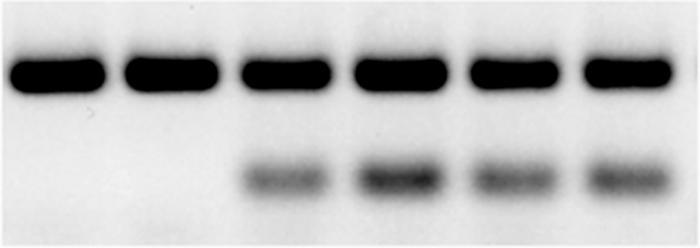

wildtype *Sod2* allele

mutant *Sod2* allele

LMC LMC *Sod2*+/- *Sod2*+/- *Sod2*+/- *Sod2*+/-

**B**



*Sod2*

LMC LMC *Sod2*+/- *Sod2*+/- *Sod2*+/- *Sod2*+/-



*Sod1*

LMC LMC *Sod2*+/- *Sod2*+/- *Sod2*+/- *Sod2*+/-

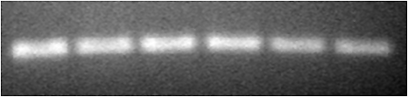

gapdh

LMC LMC *Sod2*+/- *Sod2*+/- *Sod2*+/- *Sod2*+/-

**Figure 1**

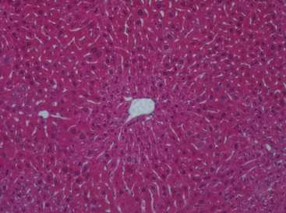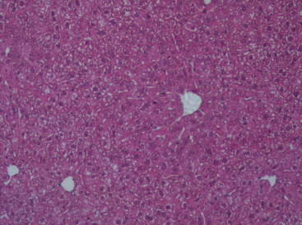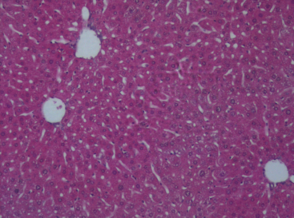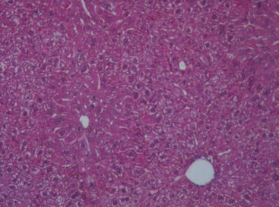

LMC H2O LMC Ethanol

*Sod2+/-* H2O *Sod2+/-* Ethanol

**Figure 2**



**\***

**\***

H2O Ethanol H2O Ethanol

LMC *Sod2*+/-

**Figure 3**

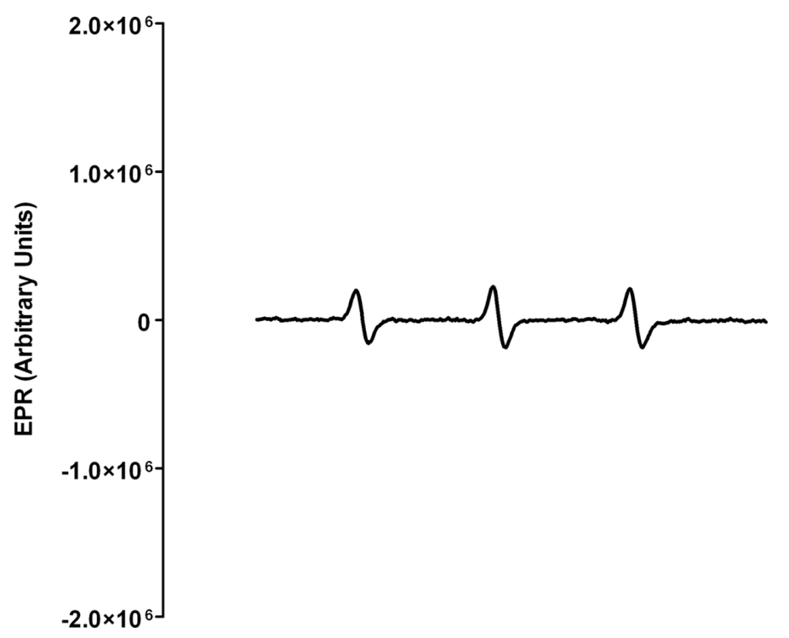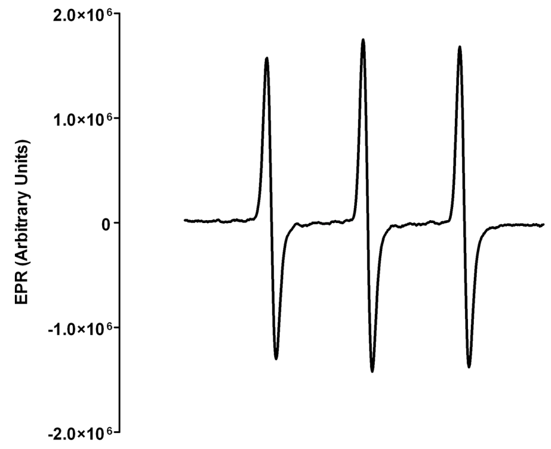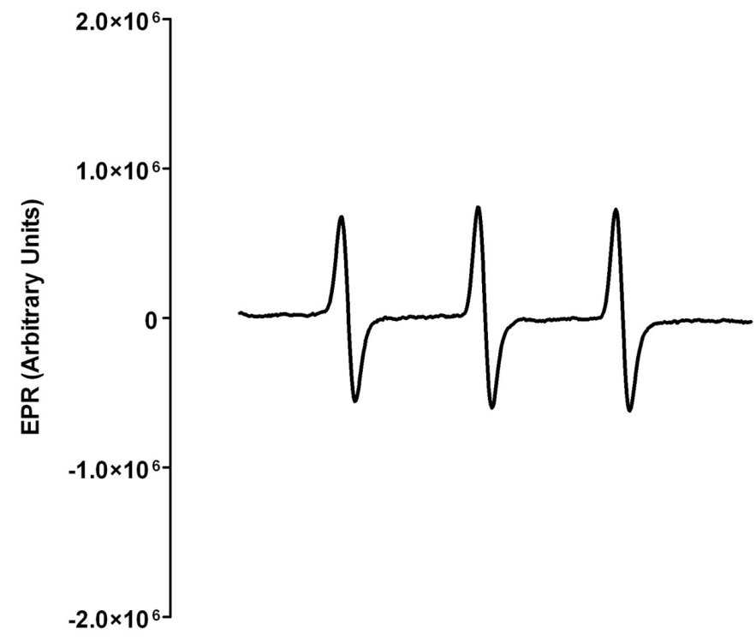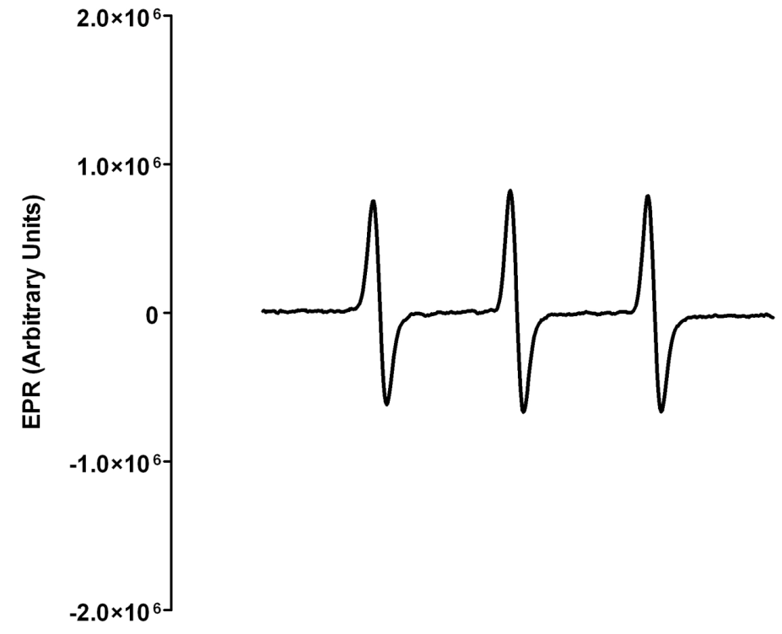

LMC Ethanol

**D**

**B**

**A**

**C**

LMC H2O

**E**

*Sod2*+/- H2O

*Sod2+/-* Ethanol



**\***

**\***

**\***

H2O Ethanol H2O Ethanol

LMC *Sod2*+/-

**Figure 4**

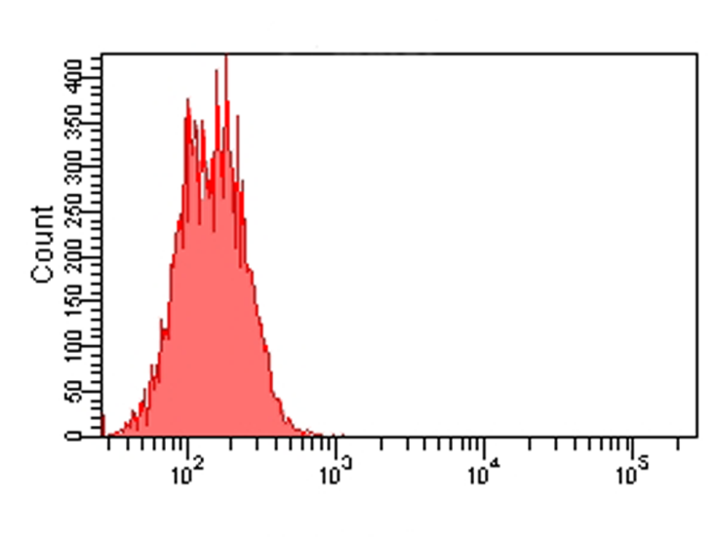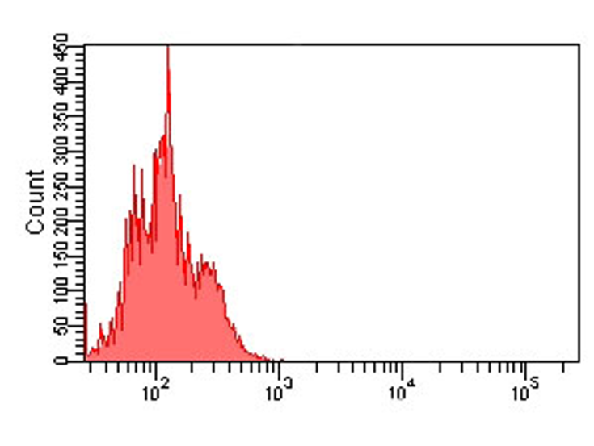

*Sod2*+/- H2O (buffer) *Sod2*+/- H2O (MitoSOX) *Sod2*+/- EtOH (buffer) *Sod2*+/- EtOH (MitoSOX)

LMC H2O (buffer) LMC H2O (MitoSOX) LMC EtOH (buffer) LMC EtOH (MitoSOX)

**A**

**E**

**A**

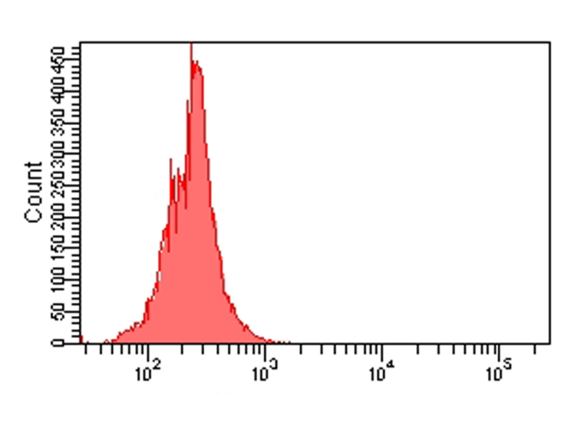

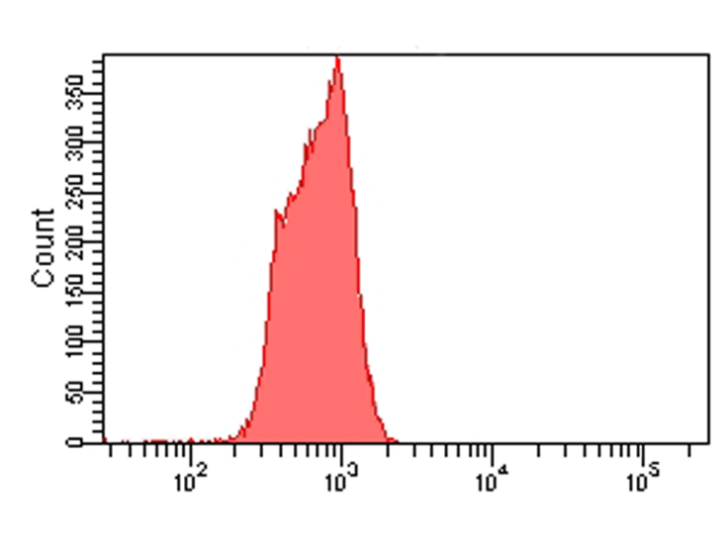

H2O EtOH H2O EtOH

LMC *Sod2*+/-

**B**

**F**

**B**

**I**

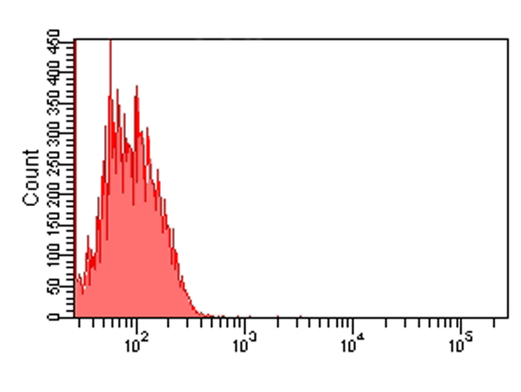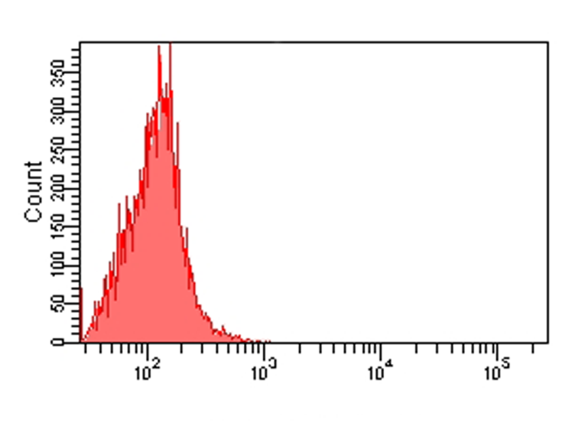

*

**C**

**G**

**C**

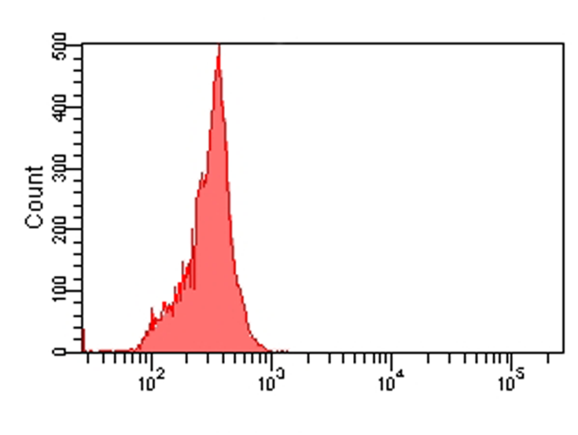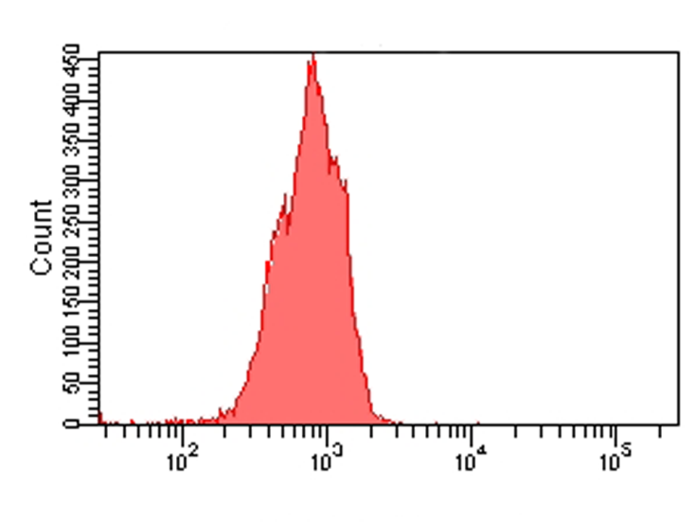

**Figure 5**

**H**

**D**

**A**



MnSOD

(SOD2)

H2O Ethanol Ethanol H2O H2O Ethanol Ethanol

LMC *Sod2*+/-

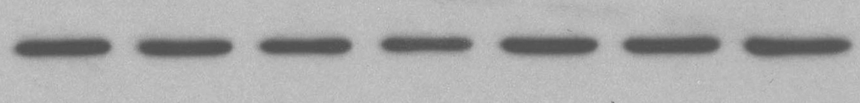

gapdh

H2O Ethanol Ethanol H2O H2O Ethanol Ethanol

LMC *Sod2*+/-



**B**

**\***

H2O Ethanol H2O Ethanol

LMC *Sod2*+/-

**Figure 6**

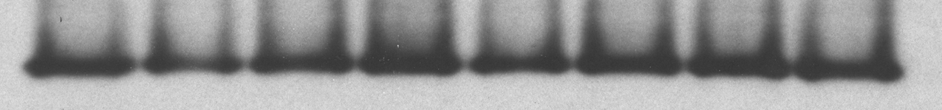

**A**

CuZnSOD

(SOD1)

H2O Ethanol Ethanol H2O H2O Ethanol Ethanol H2O

LMC *Sod2*+/-

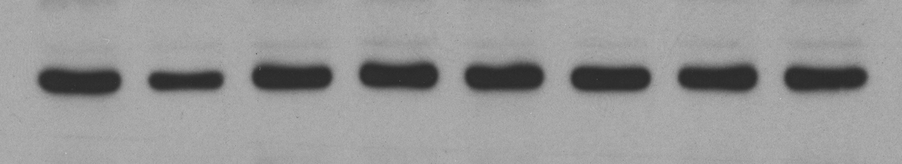

gapdh

H2O Ethanol Ethanol H2O H2O Ethanol Ethanol H2O

LMC *Sod2*+/-



**B**

H2O Ethanol H2O Ethanol

LMC *Sod2*+/-

**Figure 7**

**A**

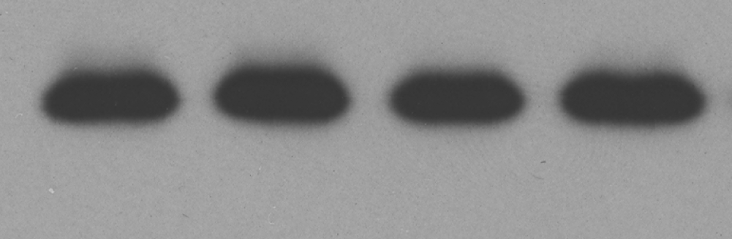

cytochrome C

*(mitochondria)*

**A**

**A**

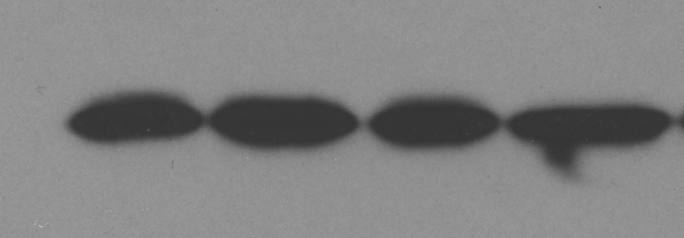

COX4

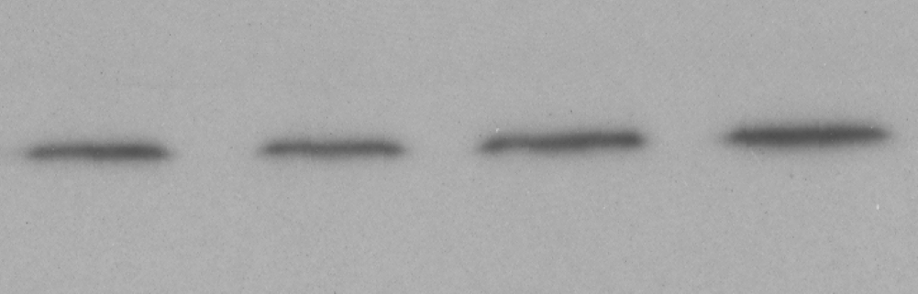

H2O EtOH H2O EtOH

LMC *Sod2*+/-

**B**

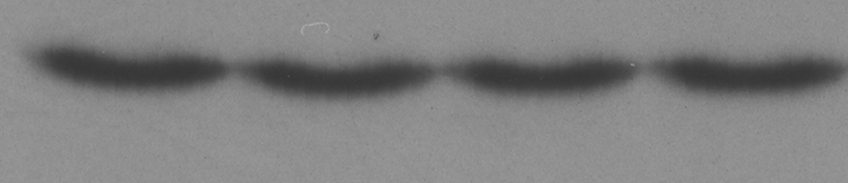

cytochrome C

*(cytosol)*

gapdh

H2O EtOH H2O EtOH

LMC *Sod2*+/-

**Z:\Emily's folder\MICE DIET exps, sacrifices\Alcohol in water, mice, 1 week\MnSOD\CASPASE ASSAYS 2011 & 2012\crop5.tif**

**C**

H2O EtOH H2O EtOH Jo2

LMC *Sod2*+/-  C57BL/6

**Figure 8**