**Name of Journal:** *World Journal of Gastrointestinal Oncology*

**Manuscript NO:** 81765

**Manuscript Type:** ORIGINAL ARTICLE

***Basic Study***

**Identification of tumor antigens and immune subtypes of hepatocellular carcinoma for mRNA vaccine development**

Lu TL *et al.* Antigens for HCC mRNA vaccines

Tai-Liang Lu, Cheng-Long Li, Yong-Qiang Gong, Fu-Tao Hou, Chao-Wu Chen

**Tai-Liang Lu, Fu-Tao Hou, Chao-Wu Chen,** Department of General Surgery, Hunan Provincial People’s Hospital, The First Affiliated Hospital of Hunan Normal University, Changsha 410005, Hunan Province, China

**Cheng-Long Li, Yong-Qiang Gong,** Department of Gastrointestinal Surgery, Hunan Provincial People’s Hospital, The First Affiliated Hospital of Hunan Normal University, Changsha 410005, Hunan Province, China

**Author contributions:** Lu TL conceived the study, performed the literature search and bioinformatics analysis, and prepared the figures; Li CL, Gong YQ, and Hou FT helped with data collection, analysis, and interpretation; Lu TL and Chen CW wrote and revised the manuscript.

**Corresponding author: Chao-Wu Chen, MD, Chief Physician,** Department of General Surgery, Hunan Provincial People’s Hospital, The First Affiliated Hospital of Hunan Normal University, No. 61 Jiefang Xi Road, Furong District, Changsha 410005, Hunan Province, China. dr.chencw@hunnu.edu.cn

**Received:** June 13, 2023

**Revised:** August 10, 2023

**Accepted:** September 18, 2023

**Published online:**

**Abstract**

BACKGROUND

mRNA vaccines have been investigated in multiple tumors, but limited studies have been conducted on their use for hepatocellular carcinoma (HCC).

AIM

To identify candidate mRNA vaccine antigens for HCC and suitable subpopulations for mRNA vaccination.

METHODS

Gene expression profiles and clinical information of HCC datasets were obtained from International Cancer Genome Consortium and The Cancer Genome Atlas. Genes with somatic mutations and copy number variations were identified by cBioPortal analysis. The differentially expressed genes with significant prognostic value were identified by Gene Expression Profiling Interactive Analysis 2 website analysis. The Tumor Immune Estimation Resource database was used to assess the correlation between candidate antigens and the abundance of antigen-presenting cells (APCs). Tumor-associated antigens were overexpressed in tumors and associated with prognosis, genomic alterations, and APC infiltration. A consensus cluster analysis was performed with the Consensus Cluster Plus package to identify the immune subtypes. The weighted gene coexpression network analysis (WGCNA) was used to determine the candidate biomarker molecules for appropriate populations for mRNA vaccines.

RESULTS

*AURKA, CCNB1, CDC25C, CDK1, TRIP13, PES1, MCM3, PPM1G, NEK2, KIF2C, PTTG1, KPNA2*, and *PRC1* were identified as candidate HCC antigens for mRNA vaccine development. Four immune subtypes (IS1-IS4) and five immune gene modules of HCC were identified that were consistent in both patient cohorts. The immune subtypes showed distinct cellular and clinical characteristics. The IS1 and IS3 immune subtypes were immunologically “cold”. The IS2 and IS4 immune subtypes were immunologically “hot”, and the immune checkpoint genes and immunogenic cell death genes were upregulated in these subtypes. IS1-related modules were identified with the WGCNA algorithm. Ultimately, five hub genes (*RBP4, KNG1, METTL7A, F12,* and *ABAT*) were identified, and they might be potential biomarkers for mRNA vaccines.

CONCLUSION

*AURKA, CCNB1, CDC25C, CDK1, TRIP13, PES1, MCM3, PPM1G, NEK2, KIF2C, PTTG1, KPNA2*, and *PRC1* have been identified as candidate HCC antigens for mRNA vaccine development. The IS1 and IS3 immune subtypes are suitable populations for mRNA vaccination. *RBP4, KNG1, METTL7A, F12,* and *ABAT* are potential biomarkers for mRNA vaccines.

**Key Words:** mRNA vaccine; Hepatocellular carcinoma; Immunotype; Antigens; Immune subtypes

Lu TL, Li CL, Gong YQ, Hou FT, Chen CW. Identification of tumor antigens and immune subtypes of hepatocellular carcinoma for mRNA vaccine development. *World J Gastrointest Oncol* 2023; In press

**Core Tip:** In this study, bioinformatics methods were used to explore novel hepatocellular carcinoma (HCC)-specific antigens for mRNA vaccine development and construct an immune subtype of HCC to select the appropriate vaccination population. Tumor-specific antigens were defined as highly expressed, genetically altered, and prognostic genes associated with antigen-presenting cell infiltration. *AURKA, CCNB1, CDC25C, CDK1, TRIP13, PES1, MCM3, PPM1G, NEK2, KIF2C, PTTG1, KPNA2,* and *PRC1* were recognized candidate HCC antigens for mRNA vaccine development. The IS1 and IS3 immune subtypes of HCC were suitable populations for mRNA vaccination. *RBP4, KNG1, METTL7A, F12*, and *ABAT* were potential biomarkers for mRNA vaccines.

**INTRODUCTION**

Primary liver cancer is one of the leading causes of malignant tumor death in China. According to the latest cancer report published in Advances in Cancer Science[1], there were 389000 new cases of liver cancer in China, ranking fourth among malignant tumors. With an annual death rate of 336400, liver cancer is the second leading cause of cancer deaths; thus, it leads to a heavy disease burden[1]. Early diagnosis and treatment of liver cancer are critical. The five-year survival rate of patients with early-stage liver cancer is more than 50%, and the treatment cost is low[2]. However, the five-year survival rate of patients with advanced liver cancer is only 0%-20%, and the treatment is expensive[2]. In the past decade, the surgical technique for liver cancer has developed considerably, and its treatment effect has improved, making it more accurate and safer. Efficient minimally invasive endoscopic and ablation procedures and perioperative management can significantly reduce the surgical trauma of patients, but the surgical resection rate is only 20%-30%[3]. Hepatocellular carcinoma (HCC) is not sensitive to conventional chemotherapy and radiotherapy[4]. However, drug therapy, represented by targeted therapy and immunotherapy, has progressed dramatically[5]. Immunotherapy may be an essential therapeutic tool to improve the clinical outcomes of HCC.

With the impact of coronavirus disease 2019 (COVID-19), mRNA technology has entered a new fast track of development, and mRNA vaccines, as a future shield against COVID-19, have also attracted attention[6]. Moreover, mRNA vaccines have attracted much attention in cancer treatment[7-11]. Immunotherapy, which suppresses tumor development by altering or enhancing the immune system, is the mainstream tumor immune treatment and serves a new direction for tumor treatment. mRNA vaccines have become an important platform for cancer immunotherapy. At present, mRNA vaccine research has made progress in prostate cancer[12], non-small cell lung cancer[13], and melanoma[8]. mRNA cancer vaccines are a promising alternative to traditional vaccine approaches due to their high efficiency, safe administration, rapid development potential, and low-cost production[14]. DNA vaccines, dendritic cell vaccines, and peptide vaccines[15-17] are currently available for patients with HCC. In a clinical trial of the tumor vaccine phosphatidylglycan in patients with advanced HCC, patients with high cytotoxic T-cell expression had a median progression-free survival (mPFS) of 12.2 mo *in vivo*; the mPFS of patients with low cytotoxic T-cell expression was 8.5 mo[18]. mRNA cannot integrate into the genome and thus does not cause insertion mutations. The therapeutic HCC vaccine HePAVAC-101 was first tested in phase I/II clinical trials[19]. The results provided preliminary evidence for the safety and immunogenicity of the vaccine. Although tumor antigens have the characteristics of diversity and heterogeneity, with tremendous individual differences, mRNA sequences can be designed and modified to encode any pathological antigen. Thus, mRNA vaccines are ideally suited for targeting tumor-specific antigens[20,21]. Therefore, it is feasible and urgently necessary to develop and apply mRNA vaccines to improve the prognosis of HCC patients. It is also vital to identify HCC patient subpopulations who are suitable for vaccination.

The antigens encoded by mRNA vaccines can be classified as tumor-associated antigens (TAAs) and tumor-specific antigens (TSAs)[22]. The core mechanism of mRNA cancer vaccines is to encode specific antigens based on the characteristics of cancer, which are successfully recognized by immune cells to activate the immune response[23]. TSAs, also known as "tumor neoantigens", are derived from gene mutations in cancer cells, so they are theoretically not constrained by immune tolerance[23]. The differences in mutation profiles of different tumors provide the possibility of tailoring highly individualized cancer vaccines.

This study aimed to explore novel HCC-associated antigens for mRNA vaccine development and construct an immune subtype of HCC to select the appropriate vaccination population. TSAs were overexpressed in tumors and associated with prognosis, genomic alterations, and antigen-presenting cell (APC) infiltration. By integrating multiomics data, 13 potential tumor antigens were identified for HCC mRNA vaccine development. The high expression of these antigens was associated with a poor prognosis and positively correlated with APC infiltration. Based on the clustering of immune-related genes *via* consensus clustering analysis, we defined four robust immune subtypes of HCC and identified an immune subtype population with “cold” tumors suitable for vaccination, which was validated in an independent cohort. Furthermore, five functional modules and five potential biomarkers for mRNA vaccines were identified by weighted gene coexpression network analysis (WGCNA). This study will provide new insights into developing HCC mRNA vaccines and screening suitable patients for vaccination.

**MATERIALS AND METHODS**

***Data collection and processing***

The RNA-seq and clinicopathological data of 371 HCC patients (Supplementary Table 1) were downloaded from The Cancer Genome Atlas (TCGA, https://www.cancer.gov/tcga). The normalized gene expression and clinical follow-up data of 235 HCC patients (Supplementary Table 1) were downloaded from the International Cancer Genome Consortium (ICGC, https://www.icgc-argo.org). The immune subtype data of the TCGA HCC samples were obtained from supplementary material in a previously published study[24]. A total of 2108 immune-related genes (Supplementary Table 2) were obtained from previously published research[25]. First, samples with incomplete clinicopathological and follow-up data were removed. Then, genes that were not expressed in all samples were removed. In the TCGA cohort, we excluded 377 genes and 6 samples and finally obtained the expression matrix of 20153 genes in 365 samples. In the ICGC cohort, no genes or samples were excluded, and an expression matrix of 22911 genes in 235 samples was obtained. The gene expression was converted into log2 (TPM + 1). Finally, 2012 immune-related genes expressed in both the TCGA and ICGC datasets were included for the subsequent analysis.

***Gene differential expression and mutation analysis***

Gene Expression Profiling Interactive Analysis (GEPIA) 2 (http://gepia2.cancer-pku.cn) is a free public website for gene differential expression analysis and prognostic analysis of TCGA using a standard processing pipeline. The differentially expressed genes were identified using ANOVA by |Log2FC| > 1 and *q* value < 0.01. A chromosome distribution map of differentially expressed genes in HCC was downloaded from this website. The cBioCancer Genomics Portal (cBioPortal, http://www.cbioportal.org) was used for gene mutation analysis of HCC patients from TCGA. The overexpressed genes were regarded as potential tumor antigens filtered by analyzing amplification of copy number variation categories and mutation counts in individual samples. *P* values < 0.05 were considered statistically significant.

***Survival analysis and*** ***Tumor Immune Estimation Resource analysis***

The R package “survival” was used to analyze the correlation between candidate tumor antigen genes and overall survival (OS) and recurrence-free survival (RFS) of HCC patients. The HCC patients from TCGA were divided into two groups according to the median cutoff. A *P* value < 0.05 was considered statistically significant. Tumor Immune Estimation Resource (https://cistrome.shinyapps.io/timer/) was used to analyze the correlation between the candidate tumor antigen genes and APCs (B cells, macrophages, and dendritic cells). The *P* value cutoff was set as 0.05.

***Identification and validation of immune subtypes***

The 33 significant immune-related survival genes were identified *via* univariate Cox hazard analysis in TCGA datasets with a *P* value less than 0.05. Then, the R package “ConsensusClusterPlus”[26] was used to determine the immune subtypes of HCC in the TCGA datasets (training sets) and ICGC datasets (validation sets). The distance parameter was set to “Pearson”, and the reps and pItem parameters were set to 1000 and 0.8, respectively. The maxk was set to 10, and the optimal k was defined by evaluating the consensus matrix and the consensus cumulative distribution function.

***Estimation of clinicopathological characteristics and prognosis of immune subtypes***

The clinical characteristics of patients with different immune subtypes, such as age, sex, grade, p stage, T stage, N stage, and M stage, were explored. The log-rank test was used to estimate the prognostic value of different immune subtypes. The tumor mutational burden (TMB) of each patient was obtained from the cBioPortal database. The differences in TMB, mutation count, and fraction genome altered between immune subtypes were tested by the Kruskal-Wallis test. A *P* value less than 0.05 was considered statistically significant.

***Immune microenvironment and molecular characteristics of different immune subtypes***

ssGSEA[27] was used to calculate the immune enrichment scores of 28 immune cells for TCGA and ICGC HCC samples. The 28 immune signatures were obtained from a previously published study[28]. The R package “estimate” was used to calculate the immune score, stromal score, and estimate score of each sample. Immune cell death modulator (ICD)- and immune checkpoint (ICP)-related genes (Supplementary Tables 3 and 4) were obtained from previous studies[29]. The *t* test was used to determine the differences between the scores and the molecular characteristics of immune subtypes.

***WGCNA***

WGCNA[30] was used to find modules associated with immune subtypes and identify the hub genes of these modules. These hub genes may be potential mRNA vaccine biomarkers. The TCGA dataset was used for WGCNA, and eight gene modules were identified. Univariate Cox regression analysis was performed to assess the prognostic value of different gene modules. The GO and KEGG enrichment analysis of interesting module genes was performed *via* the R package “clusterProfiler”[31].

**RESULTS**

***Screening of candidate tumor antigen genes in HCC***

The workflow of this study is shown in Figure 1. A total of 1482 overexpressed genes in HCC were identified by the GEPIA database (Figure 2A, Supplementary Table 5), and these genes were considered potential tumor antigens. Then, a total of 13678 mutant genes and 11519 amplified genes were identified in individual samples by the cBioPortal website (Figure 2B and C). Tenascin N, tumor protein p53, catenin beta 1, cub and sushi multiple domains 3, pkdh1-like 1, and transcriptional repressor GATA binding 1 were found to be the top frequently mutated genes in terms of both altered genome fraction and mutation counts (Figure 2D and E). In addition, thyroglobulin, TBC1 domain family member 31, CUB and sushi multiple domains 1, and fer-1-like family member 6 were among the top 10 genes with altered genome fractions (Figure 2D). High mutation counts were also observed in t-SNARE domain containing 1, thyrotropin releasing hormone receptor, annexin A13, and ryanodine receptor 2 (Figure 2E). Altogether, 472 genes were identified as candidate tumor antigen genes.

***Identification of tumor antigens associated with HCC prognosis and antigen presentation***

The prognostic value of the candidate tumor antigen genes was estimated to identify the candidate genes for developing mRNA vaccines. Thirteen genes were closely related to OS and RFS in HCC (Figure 3A). High expression levels of *AURKA, CCNB1, CDC25C, CDK1, TRIP13, PES1, MCM3, PPM1G, NEK2, KIF2C, PTTG1, KPNA2*, and *PRC1* were found to be associated with a poor OS and RFS (Figure 3B to N, Supplementary Figure 1). mRNA vaccines should be recognized by APCs, which include B cells, dendritic cells, and macrophages. Therefore, we further evaluated the correlation between tumor antigens and these APCs. The results showed that all the 13 genes positively correlated with the abundance of macrophages, dendritic cells, and B cells (Supplementary Figure 2). These results implied that these 13 genes were promising candidates for developing mRNA vaccines against HCC.

***Identification of immune subtypes of HCC***

Immunotyping could help screen suitable patients for immunotherapy and vaccination. The TCGA datasets were chosen as the training set. Thirty-three out of 2012 immune-related genes were identified as associated with the prognosis of HCC patients *via* univariate Cox regression analysis and were selected for subsequent cluster analysis. The results showed that 365 samples in the TCGA datasets could be clustered into four groups (Figure 4A to C). The survival analysis showed that the OS significantly differed among the four subtypes (IS1, IS2, IS3, and IS4) (Figure 4D). IS4 and IS1 were associated with a better prognosis, whereas IS2 had the poorest survival probability. Next, we used the ICGC datasets as the validation set to verify the clustering stability. Consistent with the results obtained with the TCGA cohort (Figure 4E to G), the immune subtype was prognostically relevant in the ICGC cohort as well (Figure 4H). The clinicopathological characteristics of the immune subtypes were analyzed. As shown in the heatmap (Figure 5A and B), the candidate mRNA vaccine genes were highly expressed in the immune subtypes with a worse prognosis in both the TCGA and ICGA cohorts. In addition, the distribution of immune subtypes in different pathological stages of patients was similar in both the TCGA and ICGC cohorts (Figure 5C and D). Altogether, these data showed that HCC samples could be classified into four distinct immune subtypes, which could be used to predict the prognosis of HCC patients.

***Correlation between immune subtypes and tumor mutational landscape***

Studies have shown that a high TMB is correlated with tumor immunotherapy and mRNA vaccine therapy. Therefore, we next analyzed the correlation between immune subtypes and genomic heterogeneity in HCC. There were no significant differences in the mutational landscape among the four immune subtypes (Figure 6A), and consistently, there were no differences in TMB or the number of mutations (Figure 6B and C). However, the frequency of altered genome fractions was higher in IS2 and IS3 than in IS1 and IS4 (Figure 6D). These results suggest that TMB may not predict the immune response to mRNA vaccines.

***Immune microenvironment characteristics of immune subtypes***

The immune microenvironment of HCC affects the immunotherapy response rate, including the mRNA vaccine effect. First, we calculated the immune and stromal scores for the immune subtypes of the TCGA and ICGC cohorts using the R package “estimate”. The results showed that in the TCGA cohort, the IS2 and IS4 subtypes had higher immune scores (Figure 7A to C). Similarly, in the ICGC cohort, immune scores were higher in the IS2 and IS4 subtypes (Figure 7D to F). Second, we evaluated the infiltrating abundance of 28 immune cells in both TCGA and ICGC cohort samples using the ssGSEA algorithm with the 28 previously reported immune cell signatures. In the TCGA cohort, the abundance of immune cell infiltration was consistently higher in the IS2 and IS4 subtypes than in the IS1 and IS3 subtypes (Figure 7G). Consistent results were also observed in the ICGC cohort. The abundance of immune cell infiltration was higher in the IS2 and IS4 subtypes in ICGC than in the IS1 and IS3 subtypes (Figure 7H). Therefore, the IS2 and IS4 subtypes belong to the immunological “hot” phenotypes, while the IS1 and IS3 subtypes belong to the immunological “cold” phenotypes. These results suggested that our immunotyping could reflect the immune status of HCC patients. Now that antigen stimulation by mRNA vaccines can remodel the tumor immune microenvironment, subtypes with lower immune infiltration, referred to as “cold” tumors, may be suitable for mRNA vaccines.

***Association between immune subtypes and ICP/ICD-related genes***

Antitumor immunity is closely related to regulating ICPs and ICDs. Hence, we further analyzed the correlation between immunophenotypes and the expression levels of ICPs and ICD regulators. Sixty ICP regulatory genes and 34 ICD regulatory genes were included in the TCGA and ICGC cohorts for differential expression analysis between immune subtypes. Figure 8A and B shows that the expression of most ICP genes was different among the immune subtypes. Moreover, in the TCGA cohort, most ICP genes were highly expressed in IS2 and IS4. Similarly, in the ICGC cohort, most ICP genes were also highly expressed in IS2 and IS4. In addition, the differential expression trend of ICD genes in the TCGA and ICGC cohorts was similar to that of ICP genes (Figure 8C and D). Therefore, immunotyping correlated with the expression levels of ICPs and ICD modulators, indicating that they might be used as potential therapeutic biomarkers for mRNA vaccines.

***Identification of immune gene co-expression modules***

We identified the coexpression modules of immune-related genes by clustering the samples using the WGCNA algorithm (Supplementary Figure 3A). The soft threshold was set at 3 for a scale-free network (Supplementary Figure 3B). After selecting the soft threshold, the adjacency matrix and topological overlap matrix were constructed based on the gene matrix using the adjacency function and TOMsimilarity function. Each gene module contained at least 30 genes, and five coexpressed gene modules were obtained (the gray module was not counted) (Supplementary Figure 3C and D). We further analyzed the relationship between each module and the prognosis of gastric cancer patients by univariate Cox regression analysis. The yellow and green modules were significantly associated with the prognosis of HCC (*P* < 0.01) (Supplementary Figure 3E). Next, we analyzed the distribution of the two immune subtypes in eigengenes of five modules and found that only four modules were significantly different (Figure 9A). The IS1 subtype showed the highest eigengenes in yellow and the lowest eigengenes in the green module. In contrast, IS2 showed the highest eigengenes in the green module and the lowest eigengenes in the yellow module (Figure 9A). Moreover, we analyzed the relationship between the modules and the clinical traits of HCC samples. We found that the yellow and green modules were the most significantly associated with the IS1 and IS2 subtypes (Figure 9B). We extracted genes from the yellow module and performed GO and KEGG enrichment analyses. The results showed that these genes were involved in multiple immune-related functions and cell adhesion functions, such as T-cell activation, leukocyte proliferation, lymphocyte proliferation, the JAK-STAT signaling pathway, antigen processing and presentation, Th17 cell differentiation, and the regulation of leukocyte cell-cell adhesion (Figure 9C and D). However, the hub genes extracted from the green module were mainly associated with the cell cycle. Therefore, we further analyzed the prognosis-relevant genes of the yellow module. The results showed that higher expression scores were associated with a better prognosis in the TCGA cohorts (Figure 9E and F). The six previously reported pancancer immune subtypes showed that the C4 subtype was lymphocyte depleted. We compared the immune subtypes with the former immune cluster and found that IS1 was associated with C4 (Figure 9G). Accordingly, patients in the IS1 subtype with high expression of genes clustered into the yellow module might be candidates for mRNA vaccines. Five hub genes (*RBP4, KNG1, METTL7A, F12,* and *ABAT*) with a more than 80% correlation with the yellow module were identified, and these genes might be potential biomarkers for mRNA vaccines.

**DISCUSSION**

HCC is a malignant tumor with a high mortality rate due to its unique blood supply, nerve distribution, and functional characteristics. Traditional surgery and medical treatment are not ideal for treating advanced HCC. Immunotherapy can be combined with surgery and medical treatment in the future because of its high specificity and minor side effects to achieve the ideal treatment goal of advanced HCC. mRNA tumor vaccines target TSAs and are innovative immunotherapies[21]. The mRNA cannot be integrated into the genome and can be degraded by cellular RNases. mRNA has a short and controllable half-life *in vivo* and has good safety[32,33]. However, only DNA vaccines, dendritic cell vaccines, and peptide vaccines are currently available for liver cancer. Studies on mRNA vaccines for HCC are limited.

In this study, we integrated the mutational and mRNA sequencing data of the TCGA-LICH cohort and identified a series of targeted antigens, of which *AURKA, CCNB1, CDC25C, CDK1, TRIP13, PES1, MCM3, PPM1G, NEK2, KIF2C, PTTG1, KPNA2,* and *PRC1* are promising candidates for mRNA vaccines. The overexpression of these genes was not only associated with a poor OS and RFS but also positively correlated with the abundance of macrophages, dendritic cells, and infiltrating B cells. Therefore, these antigens play a crucial role in the development of HCC and can be recognized by APCs and presented to B cells to promote lymphocyte infiltration in the tumor microenvironment and induce an immune attack. Previous studies have shown that *AURKA* is upregulated in HCC tissues and is associated with distant metastasis[34]. It can regulate the epithelial-mesenchymal transition and cancer stemness through the PI3K/AKT pathway[35]. High expression of *CCNB1* is closely related to the poor prognosis of HCC patients[36,37]. *CDK1* encodes a Ser/Thr protein kinase essential for cellular G1/S and G2/M phase transitions. *CDK1* may play an important oncogenic role in HCC progression[38]. *CDC25C* is a novel TAA that is overexpressed in several cancers, including lung cancer[39], stomach cancer[40], bladder cancer[41], prostate cancer[42], esophageal squamous cell carcinoma[43], breast cancer[44], acute myeloid leukemia[45], and colon cancer[46]. *TRIP13* is highly expressed in multiple tumors and is associated with a poor prognosis[47]. The abnormal expression of *TRIP13* can lead to chromosomal instability and aneuploidy, which may promote tumorigenesis[47]. *PES1*, also known as Pescadillo or *NOP7*, encodes a protein involved in DNA replication and ribosome biogenesis[48]. Studies have found that *PES1* is involved in the regulation of cell proliferation, and its abnormal expression can lead to tumorigenic transformation and tumor progression[48]. A series of studies have shown that *PES1* is highly expressed in various tumors and is associated with a poor prognosis. Thus, it may play a role in promoting tumor development[49-51]. This implies that *PES1* may serve as a molecular target for cancer therapy. Previous studies have shown that *MCM3* is highly expressed in medulloblastoma[52], melanoma[53], and prostate cancer[54] and is associated with nonanchored cell growth, cell migration, and invasion ability. High *MCM3* expression was associated with high AFP levels and a poor OS and RFS[55]. *PPM1G* is highly expressed in HCC and is associated with a poor prognosis[56]. PPM1G can promote the progression of HCC by phosphorylating and regulating the alternative splicing protein SRSF3[56]. *NEK2* encodes a serine/threonine kinase that is highly expressed in multiple tumors and promotes tumorigenesis through abnormal cell cycle regulation. NEK2 can affect the expression of PD-L1, thereby mediating tumor immune escape[57]. *KIF2C* encodes an important cell cycle regulator that is highly expressed in multiple tumors and is associated with a poor prognosis. Its abnormal expression can promote tumor progression[58]. *PTTG1* is a proto-oncogene involved in proliferation, metabolism, cell cycle progression, DNA damage/repair, and apoptosis[59]. Previous studies have shown that *PTTG1* is overexpressed in HCC cell lines and HCC tissues[60]. *KPNA2* encodesa member of the nuclear transporter family also known as importin α1. Recent studies have shown that *KPNA2* is highly expressed in various cancers and is a poor prognostic marker[61]. *PRC1* is associated with tumor proliferation, metastasis, and tumorigenesis. It is highly expressed in multiple tumors and is regulated by nuclear β-catenin and WNT expression[62]. Additionally, some studies have reported that PRC1 controls chromatin structure mainly through posttranslational histone modifications. Taken together, reports from previous studies of these genes support their potential for the development of mRNA vaccines.

Individual differences in the tumor microenvironment affect the efficacy of immunotherapy and vaccine response for liver cancer. To screen the appropriate population for mRNA vaccines, we used consensus cluster analysis to classify HCC patients into four immune subtypes based on the expression of immune-related genes. The ICGC cohort was also used to verify the robustness of the immune subtypes. There were significant survival differences among patients with different immune subtypes. Subtypes with better prognoses had lower expression levels of candidate mRNA vaccine antigens. This is consistent with the results of our analysis mentioned earlier. In the TCGA cohort, IS1 and IS4 had better prognoses and contained more stage I HCC patients. IS2 had the worst prognosis and contained more stage IV HCC patients. The same results were observed in the ICGC cohort. This indicates that immunophenotyping can predict the prognosis of HCC patients and is more accurate than traditional staging. Interestingly, there were no significant differences in the mutation landscape, TMB, or mutation counts among the four immune subtypes. This may be related to the fact that the threshold for high TMB should differ in different cancers[63]. TMB may not predict the immune response to mRNA vaccines in HCC. Published literature has reported that the tumor immune microenvironment varies among different individuals, including the “cold” and “hot” types of microenvironment[24]. Patients with a “cold” tumor immune microenvironment respond poorly to immunotherapy. In the TCGA cohort, the immune scores and the abundance of immune cell infiltration were higher in IS2 and IS4 subtypes than in IS1 and IS3 subtypes. Hence, IS2 and IS4 are immunologically “hot” phenotypes, while IS1 and IS3 are immunologically “cold” phenotypes. Consistent results were also observed in the ICGC cohort. ICD is vital in transforming tumors from “cold” to “hot”. However, high expression of ICP-related genes represents an immunosuppressive tumor microenvironment, which may suppress the immune response to mRNA vaccines. Therefore, we further evaluated the differential expression of ICPs and ICDs among the four immune subtypes. The results showed that ICPs were highly expressed in the IS2 and IS4 subtypes. Similarly, high ICD expression was observed in the IS2 and IS4 subtypes in both the TCGA cohort and ICGC cohort. To verify the robustness of immunotyping, we compared the immune subtypes with the former immune cluster. We found that IS1 in the TCGA cohort was associated with the C4 subtype, which was lymphocyte depleted. This further shows that IS1 is suitable for mRNA vaccines. We also found that IS4 in the TCGA cohort was associated with C3, which was associated with superior prognoses. These results were consistent with a better survival probability of IS4. In conclusion, IS1 in the TCGA cohort and IS2 in the ICGC cohort may be suitable populations for mRNA vaccination.

To further explore the marker molecules for predicting the appropriate population for mRNA vaccines, we used the WGCNA algorithm to identify five coexpression modules of immune-related genes. The yellow module was associated with prognosis and positively associated with IS1. The genes extracted from the yellow module were involved in multiple immune-related functions and cell adhesion functions, such as T-cell activation, leukocyte proliferation, lymphocyte proliferation, the JAK-STAT signaling pathway, antigen processing and presentation, Th17 cell differentiation, and regulation of leukocyte cell-cell adhesion. Ultimately, five hub genes (*RBP4, KNG1, METTL7A, F12,* and *ABAT*) with a more than 80% correlation with the yellow module were identified, which might be potential biomarkers for mRNA vaccines. *RBP4* encodes a protein that belongs to the lipoprotein family and is the main transport protein of hydrophobic retinol[64]. Previous studies have shown that RBP4 plays a crucial role in maintaining the self-renewing ability of colon cancer and promoting tumorigenesis[65]. Studies have found that RBP4 is overexpressed in ovarian cancer and promotes the proliferation and metastasis of ovarian cancer cells by regulating the RhoA/Rock1 pathway[66]. The protein encoded by *KNG1* is degraded to kinin in malignant gliomas, which further activates TH-1 immunity. Thus, it may become a therapeutic target for malignant gliomas[67]. *KNG1* has been identified as a biomarker for advanced colorectal cancer[68], lung squamous cell carcinoma[69], and multiple myeloma[70]. The role of *METTL7A* in cancers has rarely been investigated. Previous studies have shown that *METTL7A* may be involved in the development of thyroid cancer[71]. *METTL7A* can participate in adipocyte-induced myeloma drug resistance by regulating lncRNA m6A methylation[72]. F12, produced by hepatocytes, is underexpressed in colorectal[73], gastric[74], and lung cancers[75] and is involved in antigen processing and presentation and glutathione metabolism. Studies have shown that *ABAT* expression is downregulated in HCC, and low *ABAT* expression is associated with a poor prognosis, which is an independent risk factor for HCC patients[76]. These data suggest that these hub genes may play a key role in HCC tumorigenesis and progression.

**CONCLUSION**

In conclusion, *AURKA, CCNB1, CDC25C, CDK1, TRIP13, PES1, MCM3, PPM1G, NEK2, KIF2C, PTTG1, KPNA2,* and *PRC1* have been identified as candidate HCC antigens for mRNA vaccine development. The IS1 and IS3 immune subtypes are suitable populations for mRNA vaccination. *RBP4, KNG1, METTL7A, F12*, and *ABAT* are potential biomarkers for mRNA vaccines.

**ARTICLE HIGHLIGHTS**

***Research background***

Primary liver cancer is one of the leading causes of malignant tumor death in China. Hepatocellular carcinoma (HCC) is not sensitive to conventional chemotherapy and radiotherapy. However, drug therapy, represented by targeted therapy and immunotherapy, has progressed dramatically. mRNA vaccines have become an important platform for cancer immunotherapy. mRNA vaccines have been investigated in multiple tumors, but limited studies have been conducted on their use for HCC.

***Research motivation***

mRNA vaccines are ideally suited for targeting tumor-specific antigens. It is feasible and urgently necessary to develop and apply mRNA vaccines to improve the prognosis of HCC patients. It is also vital to identify HCC patient subpopulations who are suitable for vaccination.

***Research objectives***

The present study aimed to identify candidate mRNA vaccine antigens for HCC and suitable subpopulations for mRNA vaccination in order to provide new insights into developing HCC mRNA vaccines and screening suitable patients for vaccination.

***Research methods***

Gene expression profiles and clinical information of HCC datasets were obtained from International Cancer Genome Consortium and The Cancer Genome Atlas. Genes with somatic mutations and copy number variations were identified by cBioPortal analysis. The differentially expressed genes with significant prognostic value were identified by Gene Expression Profiling Interactive Analysis 2 website analysis. The Tumor Immune Estimation Resource database was used to assess the correlation between candidate antigens and the abundance of antigen-presenting cells (APCs). Tumor-associated antigens were overexpressed in tumors and associated with prognosis, genomic alterations, and APC infiltration. A consensus cluster analysis was performed with the Consensus Cluster Plus package to identify the immune subtypes. The weighted gene coexpression network analysis (WGCNA) was used to determine the candidate biomarker molecules for appropriate populations for mRNA vaccines.

***Research results***

*AURKA, CCNB1, CDC25C, CDK1, TRIP13, PES1, MCM3, PPM1G, NEK2, KIF2C, PTTG1, KPNA2,* and *PRC1* were identified as candidate HCC antigens for mRNA vaccine development. Four immune subtypes (IS1-IS4) and five immune gene modules of HCC were identified that were consistent in both patient cohorts. The immune subtypes showed distinct cellular and clinical characteristics. The IS1 and IS3 immune subtypes were immunologically “cold”. The IS2 and IS4 immune subtypes were immunologically “hot”, and the immune checkpoint genes and immunogenic cell death genes were upregulated in these subtypes. IS1-related modules were identified with the WGCNA algorithm. Ultimately, five hub genes *(RBP4, KNG1, METTL7A, F12*, and *ABAT*) were identified, and they might be potential biomarkers for mRNA vaccines.

***Research conclusions***

*AURKA, CCNB1, CDC25C, CDK1, TRIP13, PES1, MCM3, PPM1G, NEK2, KIF2C, PTTG1, KPNA2,* and *PRC1* have been identified as candidate HCC antigens for mRNA vaccine development. The IS1 and IS3 immune subtypes are suitable populations for mRNA vaccination. *RBP4, KNG1, METTL7A, F12*, and *ABAT* are potential biomarkers for mRNA vaccines.

***Research perspectives***

Immunotherapy may be an essential therapeutic tool to improve the clinical outcomes of HCC. The immunotherapy of HCC should be studied in more dimensions.

**REFERENCES**

1 **Zheng R,** Zhang S, Zeng H, Wang S, Sun K, Chen R, Li L, Wei W, He J. Cancer incidence and mortality in China, 2016. J Nat Cancer Cent 2022; 2: 1-9 [DOI: 10.1016/j.jncc.2022.02.002]

2 **Lin J**, Zhang H, Yu H, Bi X, Zhang W, Yin J, Zhao P, Liang X, Qu C, Wang M, Hu M, Liu K, Wang Y, Zhou Z, Wang J, Tan X, Liu W, Shao Z, Cai J, Tang W, Cao G. Epidemiological Characteristics of Primary Liver Cancer in Mainland China From 2003 to 2020: A Representative Multicenter Study. *Front Oncol* 2022; **12**: 906778 [PMID: 35800051 DOI: 10.3389/fonc.2022.906778]

3 **Zeng H**, Chen W, Zheng R, Zhang S, Ji JS, Zou X, Xia C, Sun K, Yang Z, Li H, Wang N, Han R, Liu S, Li H, Mu H, He Y, Xu Y, Fu Z, Zhou Y, Jiang J, Yang Y, Chen J, Wei K, Fan D, Wang J, Fu F, Zhao D, Song G, Chen J, Jiang C, Zhou X, Gu X, Jin F, Li Q, Li Y, Wu T, Yan C, Dong J, Hua Z, Baade P, Bray F, Jemal A, Yu XQ, He J. Changing cancer survival in China during 2003-15: a pooled analysis of 17 population-based cancer registries. *Lancet Glob Health* 2018; **6**: e555-e567 [PMID: 29653628 DOI: 10.1016/S2214-109X(18)30127-X]

4 **Chakraborty E**, Sarkar D. Emerging Therapies for Hepatocellular Carcinoma (HCC). *Cancers (Basel)* 2022; **14** [PMID: 35681776 DOI: 10.3390/cancers14112798][](https://sci-hub.se/10.3390/cancers14112798)

5 **Pinter M**, Jain RK, Duda DG. The Current Landscape of Immune Checkpoint Blockade in Hepatocellular Carcinoma: A Review. *JAMA Oncol* 2021; **7**: 113-123 [PMID: 33090190 DOI: 10.1001/jamaoncol.2020.3381]

6 **Yang L**, Tang L, Zhang M, Liu C. Recent Advances in the Molecular Design and Delivery Technology of mRNA for Vaccination Against Infectious Diseases. *Front Immunol* 2022; **13**: 896958 [PMID: 35928814 DOI: 10.3389/fimmu.2022.896958]

7 **Chen J**, Ye Z, Huang C, Qiu M, Song D, Li Y, Xu Q. Lipid nanoparticle-mediated lymph node-targeting delivery of mRNA cancer vaccine elicits robust CD8(+) T cell response. *Proc Natl Acad Sci U S A* 2022; **119**: e2207841119 [PMID: 35969778 DOI: 10.1073/pnas.2207841119]

8 **Ping H**, Yu W, Gong X, Tong X, Lin C, Chen Z, Cai C, Guo K, Ke H. Analysis of melanoma tumor antigens and immune subtypes for the development of mRNA vaccine. *Invest New Drugs* 2022; **40**: 1173-1184 [PMID: 35962880 DOI: 10.1007/s10637-022-01290-y]

9 **Tang TY**, Huang X, Zhang G, Lu MH, Liang TB. mRNA vaccine development for cholangiocarcinoma: a precise pipeline. *Mil Med Res* 2022; **9**: 40 [PMID: 35821067 DOI: 10.1186/s40779-022-00399-8]

10 **Valentin A**, Bergamaschi C, Rosati M, Angel M, Burns R, Agarwal M, Gergen J, Petsch B, Oostvogels L, Loeliger E, Chew KW, Deeks SG, Mullins JI, Pavlakis GN, Felber BK. Comparative immunogenicity of an mRNA/LNP and a DNA vaccine targeting HIV gag conserved elements in macaques. *Front Immunol* 2022; **13**: 945706 [PMID: 35935984 DOI: 10.3389/fimmu.2022.945706]

11 **You W**, Ouyang J, Cai Z, Chen Y, Wu X. Comprehensive Analyses of Immune Subtypes of Stomach Adenocarcinoma for mRNA Vaccination. *Front Immunol* 2022; **13**: 827506 [PMID: 35874675 DOI: 10.3389/fimmu.2022.827506]

12 **Zheng X**, Xu H, Yi X, Zhang T, Wei Q, Li H, Ai J. Tumor-antigens and immune landscapes identification for prostate adenocarcinoma mRNA vaccine. *Mol Cancer* 2021; **20**: 160 [PMID: 34872584 DOI: 10.1186/s12943-021-01452-1]

13 **Valanparambil RM**, Carlisle J, Linderman SL, Akthar A, Millett RL, Lai L, Chang A, McCook-Veal AA, Switchenko J, Nasti TH, Saini M, Wieland A, Manning KE, Ellis M, Moore KM, Foster SL, Floyd K, Davis-Gardner ME, Edara VV, Patel M, Steur C, Nooka AK, Green F, Johns MA, O'Brein F, Shanmugasundaram U, Zarnitsyna VI, Ahmed H, Nyhoff LE, Mantus G, Garett M, Edupuganti S, Behra M, Antia R, Wrammert J, Suthar MS, Dhodapkar MV, Ramalingam S, Ahmed R. Antibody Response to COVID-19 mRNA Vaccine in Patients With Lung Cancer After Primary Immunization and Booster: Reactivity to the SARS-CoV-2 WT Virus and Omicron Variant. *J Clin Oncol* 2022; **40**: 3808-3816 [PMID: 35759727 DOI: 10.1200/JCO.21.02986]

14 **McNamara MA**, Nair SK, Holl EK. RNA-Based Vaccines in Cancer Immunotherapy. *J Immunol Res* 2015; **2015**: 794528 [PMID: 26665011 DOI: 10.1155/2015/794528]

15 **Mizukoshi E**, Nakagawa H, Tamai T, Kitahara M, Fushimi K, Nio K, Terashima T, Iida N, Arai K, Yamashita T, Yamashita T, Sakai Y, Honda M, Kaneko S. Peptide vaccine-treated, long-term surviving cancer patients harbor self-renewing tumor-specific CD8(+) T cells. *Nat Commun* 2022; **13**: 3123 [PMID: 35660746 DOI: 10.1038/s41467-022-30861-z]

16 **Cai Z**, Su X, Qiu L, Li Z, Li X, Dong X, Wei F, Zhou Y, Luo L, Chen G, Chen H, Wang Y, Zeng Y, Liu X. Personalized neoantigen vaccine prevents postoperative recurrence in hepatocellular carcinoma patients with vascular invasion. *Mol Cancer* 2021; **20**: 164 [PMID: 34903219 DOI: 10.1186/s12943-021-01467-8]

17 **Sun K**, Wang L, Zhang Y. Dendritic cell as therapeutic vaccines against tumors and its role in therapy for hepatocellular carcinoma. *Cell Mol Immunol* 2006; **3**: 197-203 [PMID: 16893500]

18 **Nobuoka D**, Yoshikawa T, Sawada Y, Fujiwara T, Nakatsura T. Peptide vaccines for hepatocellular carcinoma. *Hum Vaccin Immunother* 2013; **9**: 210-212 [PMID: 23442593 DOI: 10.4161/hv.22473]

19 **Löffler MW**, Gori S, Izzo F, Mayer-Mokler A, Ascierto PA, Königsrainer A, Ma YT, Sangro B, Francque S, Vonghia L, Inno A, Avallone A, Ludwig J, Alcoba DD, Flohr C, Aslan K, Mendrzyk R, Schuster H, Borrelli M, Valmori D, Chaumette T, Heidenreich R, Gouttefangeas C, Forlani G, Tagliamonte M, Fusco C, Penta R, Iñarrairaegui M, Gnad-Vogt U, Reinhardt C, Weinschenk T, Accolla RS, Singh-Jasuja H, Rammensee HG, Buonaguro L. Phase I/II Multicenter Trial of a Novel Therapeutic Cancer Vaccine, HepaVac-101, for Hepatocellular Carcinoma. *Clin Cancer Res* 2022; **28**: 2555-2566 [PMID: 35421231 DOI: 10.1158/1078-0432.CCR-21-4424]

20 **Luo W**, Yang G, Luo W, Cao Z, Liu Y, Qiu J, Chen G, You L, Zhao F, Zheng L, Zhang T. Novel therapeutic strategies and perspectives for metastatic pancreatic cancer: vaccine therapy is more than just a theory. *Cancer Cell Int* 2020; **20**: 66 [PMID: 32158356 DOI: 10.1186/s12935-020-1147-9]

21 **Pardi N**, Hogan MJ, Porter FW, Weissman D. mRNA vaccines - a new era in vaccinology. *Nat Rev Drug Discov* 2018; **17**: 261-279 [PMID: 29326426 DOI: 10.1038/nrd.2017.243]

22 **Lin MJ**, Svensson-Arvelund J, Lubitz GS, Marabelle A, Melero I, Brown BD, Brody JD. Cancer vaccines: the next immunotherapy frontier. *Nat Cancer* 2022; **3**: 911-926 [PMID: 35999309 DOI: 10.1038/s43018-022-00418-6]

23 **Saxena M**, van der Burg SH, Melief CJM, Bhardwaj N. Therapeutic cancer vaccines. *Nat Rev Cancer* 2021; **21**: 360-378 [PMID: 33907315 DOI: 10.1038/s41568-021-00346-0]

24 **Wellenstein MD**, de Visser KE. Cancer-Cell-Intrinsic Mechanisms Shaping the Tumor Immune Landscape. *Immunity* 2018; **48**: 399-416 [PMID: 29562192 DOI: 10.1016/j.immuni.2018.03.004]

25 **Wang G**, Gao Y, Chen Y, Wang K, Zhang S, Li G. Identification of Novel Tumor Antigens and the Immune Landscapes of Bladder Cancer Patients for mRNA Vaccine Development. *Front Oncol* 2022; **12**: 921711 [PMID: 35814377 DOI: 10.3389/fonc.2022.921711]

26 **Wilkerson MD**, Hayes DN. ConsensusClusterPlus: a class discovery tool with confidence assessments and item tracking. *Bioinformatics* 2010; **26**: 1572-1573 [PMID: 20427518 DOI: 10.1093/bioinformatics/btq170]

27 **Hänzelmann S**, Castelo R, Guinney J. GSVA: gene set variation analysis for microarray and RNA-seq data. *BMC Bioinformatics* 2013; **14**: 7 [PMID: 23323831 DOI: 10.1186/1471-2105-14-7]

28 **Charoentong P**, Finotello F, Angelova M, Mayer C, Efremova M, Rieder D, Hackl H, Trajanoski Z. Pan-cancer Immunogenomic Analyses Reveal Genotype-Immunophenotype Relationships and Predictors of Response to Checkpoint Blockade. *Cell Rep* 2017; **18**: 248-262 [PMID: 28052254 DOI: 10.1016/j.celrep.2016.12.019]

29 **Garg AD**, De Ruysscher D, Agostinis P. Immunological metagene signatures derived from immunogenic cancer cell death associate with improved survival of patients with lung, breast or ovarian malignancies: A large-scale meta-analysis. *Oncoimmunology* 2016; **5**: e1069938 [PMID: 27057433 DOI: 10.1080/2162402X.2015.1069938]

30 **Langfelder P**, Horvath S. Fast R Functions for Robust Correlations and Hierarchical Clustering. *J Stat Softw* 2012; **46** [PMID: 23050260 DOI: 10.18637/jss.v046.i11]

31 **Wu T**, Hu E, Xu S, Chen M, Guo P, Dai Z, Feng T, Zhou L, Tang W, Zhan L, Fu X, Liu S, Bo X, Yu G. clusterProfiler 4.0: A universal enrichment tool for interpreting omics data. *Innovation (Camb)* 2021; **2**: 100141 [PMID: 34557778 DOI: 10.1016/j.xinn.2021.100141]

32 **Mockey M**, Bourseau E, Chandrashekhar V, Chaudhuri A, Lafosse S, Le Cam E, Quesniaux VF, Ryffel B, Pichon C, Midoux P. mRNA-based cancer vaccine: prevention of B16 melanoma progression and metastasis by systemic injection of MART1 mRNA histidylated lipopolyplexes. *Cancer Gene Ther* 2007; **14**: 802-814 [PMID: 17589432 DOI: 10.1038/sj.cgt.7701072]

33 **Grunwitz C**, Kranz LM. mRNA Cancer Vaccines-Messages that Prevail. *Curr Top Microbiol Immunol* 2017; **405**: 145-164 [PMID: 28401358 DOI: 10.1007/82_2017_509]

34 **Wu M**, Zhou Y, Fei C, Chen T, Yin X, Zhang L, Ren Z. ID1 overexpression promotes HCC progression by amplifying the AURKA/Myc signaling pathway. *Int J Oncol* 2020; **57**: 845-857 [PMID: 32705157 DOI: 10.3892/ijo.2020.5092]

35 **Chen C**, Song G, Xiang J, Zhang H, Zhao S, Zhan Y. AURKA promotes cancer metastasis by regulating epithelial-mesenchymal transition and cancer stem cell properties in hepatocellular carcinoma. *Biochem Biophys Res Commun* 2017; **486**: 514-520 [PMID: 28322787 DOI: 10.1016/j.bbrc.2017.03.075]

36 **Chai N**, Xie HH, Yin JP, Sa KD, Guo Y, Wang M, Liu J, Zhang XF, Zhang X, Yin H, Nie YZ, Wu KC, Yang AG, Zhang R. FOXM1 promotes proliferation in human hepatocellular carcinoma cells by transcriptional activation of CCNB1. *Biochem Biophys Res Commun* 2018; **500**: 924-929 [PMID: 29705704 DOI: 10.1016/j.bbrc.2018.04.201]

37 **Zhuang L**, Yang Z, Meng Z. Upregulation of BUB1B, CCNB1, CDC7, CDC20, and MCM3 in Tumor Tissues Predicted Worse Overall Survival and Disease-Free Survival in Hepatocellular Carcinoma Patients. *Biomed Res Int* 2018; **2018**: 7897346 [PMID: 30363964 DOI: 10.1155/2018/7897346]

38 **Tavakolian S**, Goudarzi H, Faghihloo E. Cyclin-dependent kinases and CDK inhibitors in virus-associated cancers. *Infect Agent Cancer* 2020; **15**: 27 [PMID: 32377232 DOI: 10.1186/s13027-020-00295-7]

39 **Chen CY**, Hsu YL, Tsai YC, Kuo PL. Kotomolide A arrests cell cycle progression and induces apoptosis through the induction of ATM/p53 and the initiation of mitochondrial system in human non-small cell lung cancer A549 cells. *Food Chem Toxicol* 2008; **46**: 2476-2484 [PMID: 18511169 DOI: 10.1016/j.fct.2008.04.016]

40 **Kim M**, Ju H, Lim B, Kang C. Maspin genetically and functionally associates with gastric cancer by regulating cell cycle progression. *Carcinogenesis* 2012; **33**: 2344-2350 [PMID: 22962304 DOI: 10.1093/carcin/bgs280]

41 **Skowron KB**, Pitroda SP, Namm JP, Balogun O, Beckett MA, Zenner ML, Fayanju O, Huang X, Fernandez C, Zheng W, Qiao G, Chin R, Kron SJ, Khodarev NN, Posner MC, Steinberg GD, Weichselbaum RR. Basal Tumor Cell Isolation and Patient-Derived Xenograft Engraftment Identify High-Risk Clinical Bladder Cancers. *Sci Rep* 2016; **6**: 35854 [PMID: 27775025 DOI: 10.1038/srep35854]

42 **Al Nakouzi N**, Cotteret S, Commo F, Gaudin C, Rajpar S, Dessen P, Vielh P, Fizazi K, Chauchereau A. Targeting CDC25C, PLK1 and CHEK1 to overcome Docetaxel resistance induced by loss of LZTS1 in prostate cancer. *Oncotarget* 2014; **5**: 667-678 [PMID: 24525428 DOI: 10.18632/oncotarget.1574]

43 **Li BZ**, Chen ZL, Shi SS, Feng XL, Tan XG, Zhou F, He J. Overexpression of Cdc25C predicts response to radiotherapy and survival in esophageal squamous cell carcinoma patients treated with radiotherapy followed by surgery. *Chin J Cancer* 2013; **32**: 403-409 [PMID: 23470146 DOI: 10.5732/cjc.012.10233]

44 **Yan M**, Zhang L, Li G, Xiao S, Dai J, Cen X. Long noncoding RNA linc-ITGB1 promotes cell migration and invasion in human breast cancer. *Biotechnol Appl Biochem* 2017; **64**: 5-13 [PMID: 26601916 DOI: 10.1002/bab.1461]

45 **Yoshimi A**, Toya T, Kawazu M, Ueno T, Tsukamoto A, Iizuka H, Nakagawa M, Nannya Y, Arai S, Harada H, Usuki K, Hayashi Y, Ito E, Kirito K, Nakajima H, Ichikawa M, Mano H, Kurokawa M. Recurrent CDC25C mutations drive malignant transformation in FPD/AML. *Nat Commun* 2014; **5**: 4770 [PMID: 25159113 DOI: 10.1038/ncomms5770]

46 **Natarajan G**, Ramalingam S, Ramachandran I, May R, Queimado L, Houchen CW, Anant S. CUGBP2 downregulation by prostaglandin E2 protects colon cancer cells from radiation-induced mitotic catastrophe. *Am J Physiol Gastrointest Liver Physiol* 2008; **294**: G1235-G1244 [PMID: 18325984 DOI: 10.1152/ajpgi.00037.2008]

47 **Lu S**, Qian J, Guo M, Gu C, Yang Y. Insights into a Crucial Role of TRIP13 in Human Cancer. *Comput Struct Biotechnol J* 2019; **17**: 854-861 [PMID: 31321001 DOI: 10.1016/j.csbj.2019.06.005]

48 **Li YZ**, Zhang C, Pei JP, Zhang WC, Zhang CD, Dai DQ. The functional role of Pescadillo ribosomal biogenesis factor 1 in cancer. *J Cancer* 2022; **13**: 268-277 [PMID: 34976188 DOI: 10.7150/jca.58982]

49 **Cheng L**, Li J, Han Y, Lin J, Niu C, Zhou Z, Yuan B, Huang K, Li J, Jiang K, Zhang H, Ding L, Xu X, Ye Q. PES1 promotes breast cancer by differentially regulating ERα and ERβ. *J Clin Invest* 2012; **122**: 2857-2870 [PMID: 22820289 DOI: 10.1172/JCI62676]

50 **Jiang Z**, Zhang Y, Chen X, Wang Y, Wu P, Wu C, Chen D. microRNA-1271 impedes the development of prostate cancer by downregulating PES1 and upregulating ERβ. *J Transl Med* 2020; **18**: 209 [PMID: 32448371 DOI: 10.1186/s12967-020-02349-1]

51 **Wang J**, Sun J, Zhang N, Yang R, Li H, Zhang Y, Chen K, Kong D. PES1 enhances proliferation and tumorigenesis in hepatocellular carcinoma *via* the PI3K/AKT pathway. *Life Sci* 2019; **219**: 182-189 [PMID: 30630006 DOI: 10.1016/j.lfs.2018.12.054]

52 **Lau KM**, Chan QK, Pang JC, Li KK, Yeung WW, Chung NY, Lui PC, Tam YS, Li HM, Zhou L, Wang Y, Mao Y, Ng HK. Minichromosome maintenance proteins 2, 3 and 7 in medulloblastoma: overexpression and involvement in regulation of cell migration and invasion. *Oncogene* 2010; **29**: 5475-5489 [PMID: 20661220 DOI: 10.1038/onc.2010.287]

53 **Nodin B**, Fridberg M, Jonsson L, Bergman J, Uhlén M, Jirström K. High MCM3 expression is an independent biomarker of poor prognosis and correlates with reduced RBM3 expression in a prospective cohort of malignant melanoma. *Diagn Pathol* 2012; **7**: 82 [PMID: 22805320 DOI: 10.1186/1746-1596-7-82]

54 **Stewart PA**, Khamis ZI, Zhau HE, Duan P, Li Q, Chung LWK, Sang QA. Upregulation of minichromosome maintenance complex component 3 during epithelial-to-mesenchymal transition in human prostate cancer. *Oncotarget* 2017; **8**: 39209-39217 [PMID: 28424404 DOI: 10.18632/oncotarget.16835]

55 **Zhang L**, Yuan L, Li D, Tian M, Sun S, Wang Q. Identification of potential prognostic biomarkers for hepatocellular carcinoma. *J Gastrointest Oncol* 2022; **13**: 812-821 [PMID: 35557563 DOI: 10.21037/jgo-22-303]

56 **Chen D**, Zhao Z, Chen L, Li Q, Zou J, Liu S. PPM1G promotes the progression of hepatocellular carcinoma *via* phosphorylation regulation of alternative splicing protein SRSF3. *Cell Death Dis* 2021; **12**: 722 [PMID: 34290239 DOI: 10.1038/s41419-021-04013-y]

57 **Huang X**, Zhang G, Tang T, Gao X, Liang T. One shoot, three birds: Targeting NEK2 orchestrates chemoradiotherapy, targeted therapy, and immunotherapy in cancer treatment. *Biochim Biophys Acta Rev Cancer* 2022; **1877**: 188696 [PMID: 35157980 DOI: 10.1016/j.bbcan.2022.188696]

58 **Ritter A**, Kreis NN, Louwen F, Wordeman L, Yuan J. Molecular insight into the regulation and function of MCAK. *Crit Rev Biochem Mol Biol* 2015; **51**: 228-245 [PMID: 27146484 DOI: 10.1080/10409238.2016.1178705]

59 **Perramón M**, Jiménez W. Pituitary Tumor-Transforming Gene 1/Delta like Non-Canonical Notch Ligand 1 Signaling in Chronic Liver Diseases. *Int J Mol Sci* 2022; **23** [PMID: 35805898 DOI: 10.3390/ijms23136897]

60 **Cho-Rok J**, Yoo J, Jang YJ, Kim S, Chu IS, Yeom YI, Choi JY, Im DS. Adenovirus-mediated transfer of siRNA against PTTG1 inhibits liver cancer cell growth *in vitro* and in vivo. *Hepatology* 2006; **43**: 1042-1052 [PMID: 16628636 DOI: 10.1002/hep.21137]

61 **Han Y**, Wang X. The emerging roles of KPNA2 in cancer. *Life Sci* 2020; **241**: 117140 [PMID: 31812670 DOI: 10.1016/j.lfs.2019.117140]

62 **Melo GA**, Calôba C, Brum G, Passos TO, Martinez GJ, Pereira RM. Epigenetic regulation of T cells by Polycomb group proteins. *J Leukoc Biol* 2022; **111**: 1253-1267 [PMID: 35466423 DOI: 10.1002/JLB.2RI0122-039R]

63 **Heine A**, Juranek S, Brossart P. Clinical and immunological effects of mRNA vaccines in malignant diseases. *Mol Cancer* 2021; **20**: 52 [PMID: 33722265 DOI: 10.1186/s12943-021-01339-1]

64 **Steinhoff JS**, Lass A, Schupp M. Biological Functions of RBP4 and Its Relevance for Human Diseases. *Front Physiol* 2021; **12**: 659977 [PMID: 33790810 DOI: 10.3389/fphys.2021.659977]

65 **Karunanithi S**, Levi L, DeVecchio J, Karagkounis G, Reizes O, Lathia JD, Kalady MF, Noy N. RBP4-STRA6 Pathway Drives Cancer Stem Cell Maintenance and Mediates High-Fat Diet-Induced Colon Carcinogenesis. *Stem Cell Reports* 2017; **9**: 438-450 [PMID: 28689994 DOI: 10.1016/j.stemcr.2017.06.002]

66 **Wang Y**, Wang Y, Zhang Z. Adipokine RBP4 drives ovarian cancer cell migration. *J Ovarian Res* 2018; **11**: 29 [PMID: 29642915 DOI: 10.1186/s13048-018-0397-9]

67 **Monteiro AC**, Scovino A, Raposo S, Gaze VM, Cruz C, Svensjö E, Narciso MS, Colombo AP, Pesquero JB, Feres-Filho E, Nguyen KA, Sroka A, Potempa J, Scharfstein J. Kinin danger signals proteolytically released by gingipain induce Fimbriae-specific IFN-gamma- and IL-17-producing T cells in mice infected intramucosally with Porphyromonas gingivalis. *J Immunol* 2009; **183**: 3700-3711 [PMID: 19687097 DOI: 10.4049/jimmunol.0900895]

68 **Wang J**, Wang X, Lin S, Chen C, Wang C, Ma Q, Jiang B. Identification of kininogen-1 as a serum biomarker for the early detection of advanced colorectal adenoma and colorectal cancer. *PLoS One* 2013; **8**: e70519 [PMID: 23894665 DOI: 10.1371/journal.pone.0070519]

69 **Wang W**, Wang S, Zhang M. Evaluation of kininogen 1, osteopontin and α-1-antitrypsin in plasma, bronchoalveolar lavage fluid and urine for lung squamous cell carcinoma diagnosis. *Oncol Lett* 2020; **19**: 2785-2792 [PMID: 32218831 DOI: 10.3892/ol.2020.11376]

70 **Chanukuppa V**, Taware R, Taunk K, Chatterjee T, Sharma S, Somasundaram V, Rashid F, Malakar D, Santra MK, Rapole S. Proteomic Alterations in Multiple Myeloma: A Comprehensive Study Using Bone Marrow Interstitial Fluid and Serum Samples. *Front Oncol* 2020; **10**: 566804 [PMID: 33585190 DOI: 10.3389/fonc.2020.566804]

71 **Zhou S**, Shen Y, Zheng M, Wang L, Che R, Hu W, Li P. DNA methylation of METTL7A gene body regulates its transcriptional level in thyroid cancer. *Oncotarget* 2017; **8**: 34652-34660 [PMID: 28416772 DOI: 10.18632/oncotarget.16147]

72 **Wang Z**, He J, Bach DH, Huang YH, Li Z, Liu H, Lin P, Yang J. Induction of m(6)A methylation in adipocyte exosomal LncRNAs mediates myeloma drug resistance. *J Exp Clin Cancer Res* 2022; **41**: 4 [PMID: 34980213 DOI: 10.1186/s13046-021-02209-w]

73 **Battistelli S**, Stefanoni M, Lorenzi B, Dell'Avanzato R, Varrone F, Pascucci A, Petrioli R, Vittoria V. Coagulation factor levels in non-metastatic colorectal cancer patients. *Int J Biol Markers* 2008; **23**: 36-41 [PMID: 28207105 DOI: 10.5301/JBM.2008.4255]

74 **Roeise O**, Sivertsen S, Ruud TE, Bouma BN, Stadaas JO, Aasen AO. Studies on components of the contact phase system in patients with advanced gastrointestinal cancer. *Cancer* 1990; **65**: 1355-1359 [PMID: 1689607 DOI: 10.1002/1097-0142(19900315)65:6<1355::aid-cncr2820650618>3.0.co;2-1]

75 **Pan J**, Qian Y, Weiser P, Zhou X, Lu H, Studelska DR, Zhang L. Glycosaminoglycans and activated contact system in cancer patient plasmas. *Prog Mol Biol Transl Sci* 2010; **93**: 473-495 [PMID: 20807657 DOI: 10.1016/S1877-1173(10)93020-2]

76 **Gao X**, Jia X, Xu M, Xiang J, Lei J, Li Y, Lu Y, Zuo S. Regulation of Gamma-Aminobutyric Acid Transaminase Expression and Its Clinical Significance in Hepatocellular Carcinoma. *Front Oncol* 2022; **12**: 879810 [PMID: 35847853 DOI: 10.3389/fonc.2022.879810]

**Footnotes**

**Institutional review board statement:** This article is a bioinformatics analysis and does not involve experiments on humans or animals. So Institutional Review Board Approval Form or Document is not applicable.

**Conflict-of-interest statement:** The authors declare no conflict of interest for this article.

**Data sharing statement:** The datasets ANALYZED for this study can be found in The Cancer Genome Atlas (TCGA, https://www.cancer.gov/tcga) and International Cancer Genome Consortium (ICGC, https://www.icgc-argo.org).

**Open-Access:** This article is an open-access article that was selected by an in-house editor and fully peer-reviewed by external reviewers. It is distributed in accordance with the Creative Commons Attribution NonCommercial (CC BY-NC 4.0) license, which permits others to distribute, remix, adapt, build upon this work non-commercially, and license their derivative works on different terms, provided the original work is properly cited and the use is non-commercial. See: https://creativecommons.org/Licenses/by-nc/4.0/

**Provenance and peer review:** Unsolicited article; Externally peer reviewed.

**Peer-review model:** Single blind

**Peer-review started:** June 13, 2023

**First decision:** July 25, 2023

**Article in press:**

**Specialty type:** Oncology

**Country/Territory of origin:** China

**Peer-review report’s scientific quality classification**

Grade A (Excellent): A, A

Grade B (Very good): 0

Grade C (Good): 0

Grade D (Fair): 0

Grade E (Poor): 0

**P-Reviewer:** Jiraviriyakul A, Thailand; Sahin TT, Turkey **S-Editor:** Lin C **L-Editor:** Wang TQ **P-Editor:**

**Figure Legends**

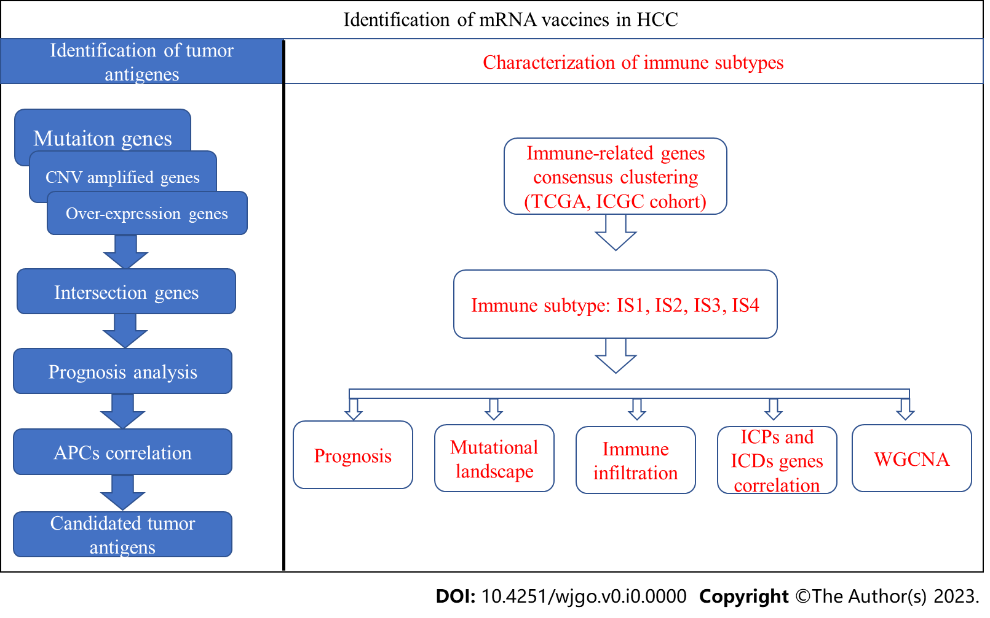

**Figure 1 Workflow of this study.** APCs: Antigen-presenting cells; CNV: Copy number variation; HCC: Hepatocellular carcinoma; ICGC: International Cancer Genome Consortium; ICPs: Immune checkpoints; ICDs: Immune cell death modulators; TCGA: The Cancer Genome Atlas; WGVNA: Weighted gene coexpression network analysis.

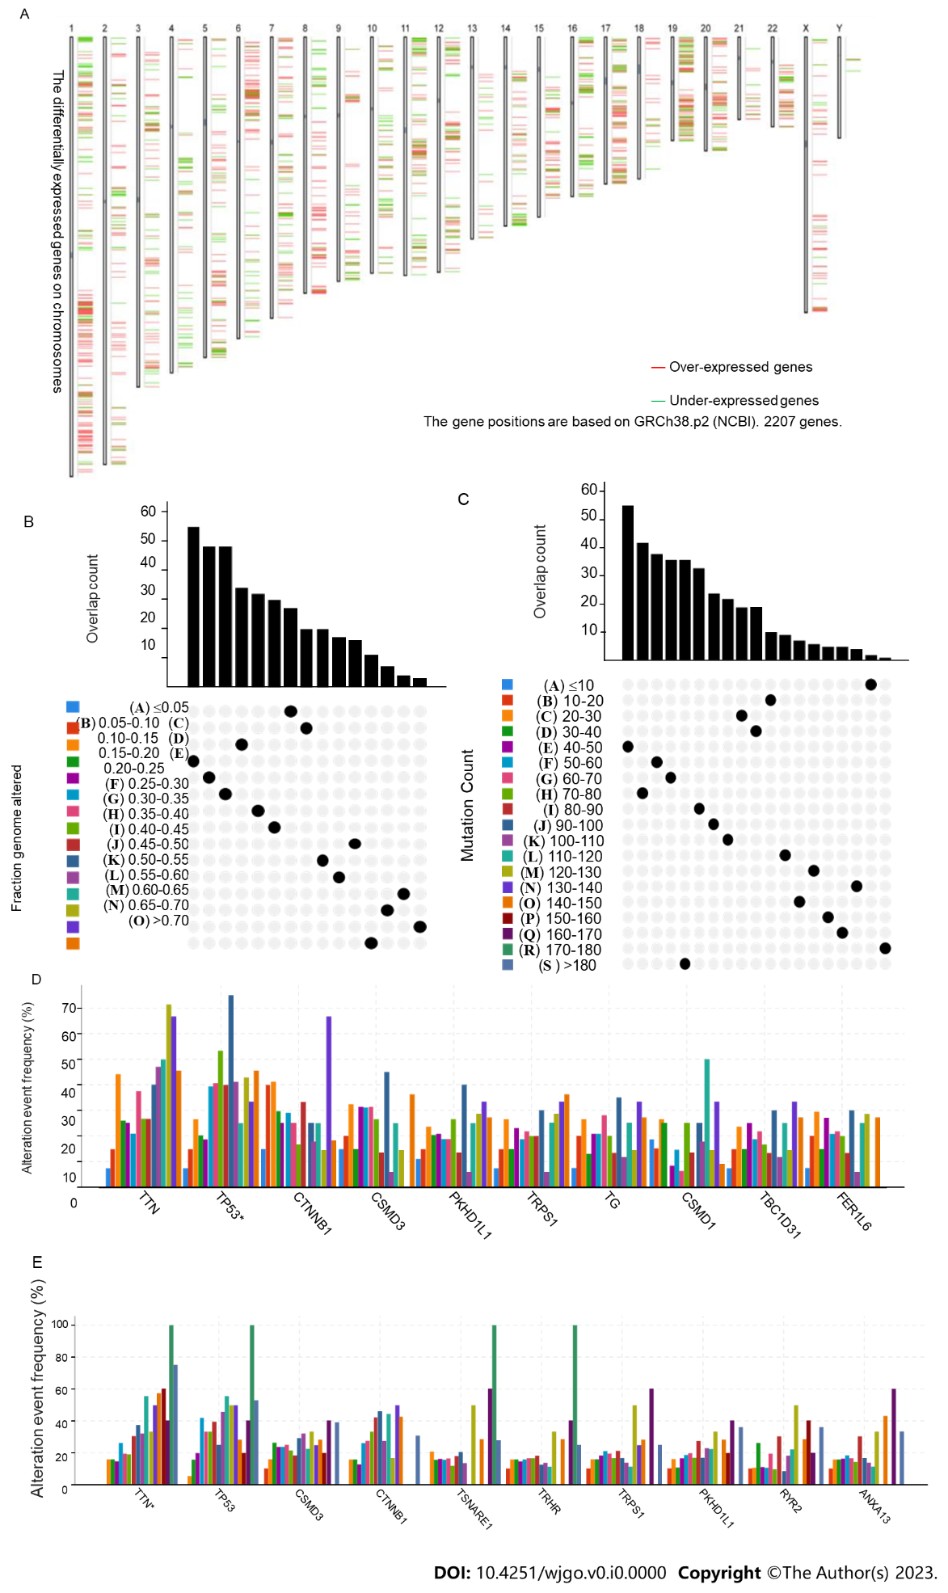

**Figure 2 Screening of candidate tumor antigen genes in hepatocellular carcinoma.** A: Chromosome distribution of differentially expressed genes; B: Overlapping samples in altered genome fraction groups; C: Overlapping samples in mutation count groups; D: Genes with the highest frequency in altered genome fraction groups; E: Genes with the highest frequency in mutation count groups.

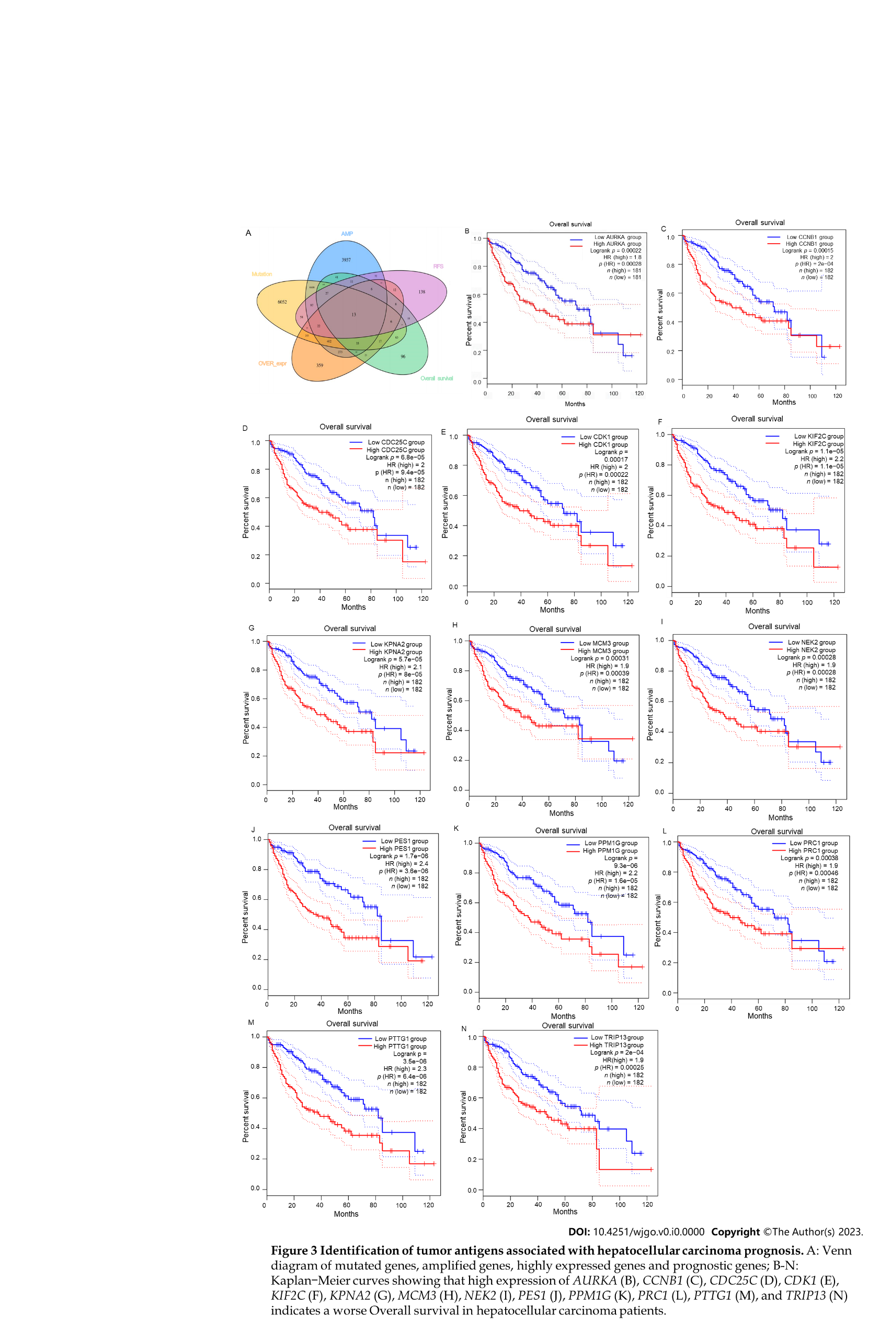

**Figure 3 Identification of tumor antigens associated with hepatocellular carcinoma prognosis.** A: Venn diagram of mutated genes, amplified genes, highly expressed genes, and prognostic genes; B-N: Kaplan-Meier curves showing that high expression of *AURKA* (B), *CCNB1* (C), *CDC25C* (D), *CDK1* (E), *KIF2C* (F), *KPNA2* (G), *MCM3* (H), *NEK2* (I), *PES1* (J), *PPM1G* (K), *PRC1* (L), *PTTG1* (M), and *TRIP13* (N) indicates a worse overall survival in hepatocellular carcinoma patients. AMP: Amplification; HR: Hazard ratio; RFS: Recurrence-free survival.

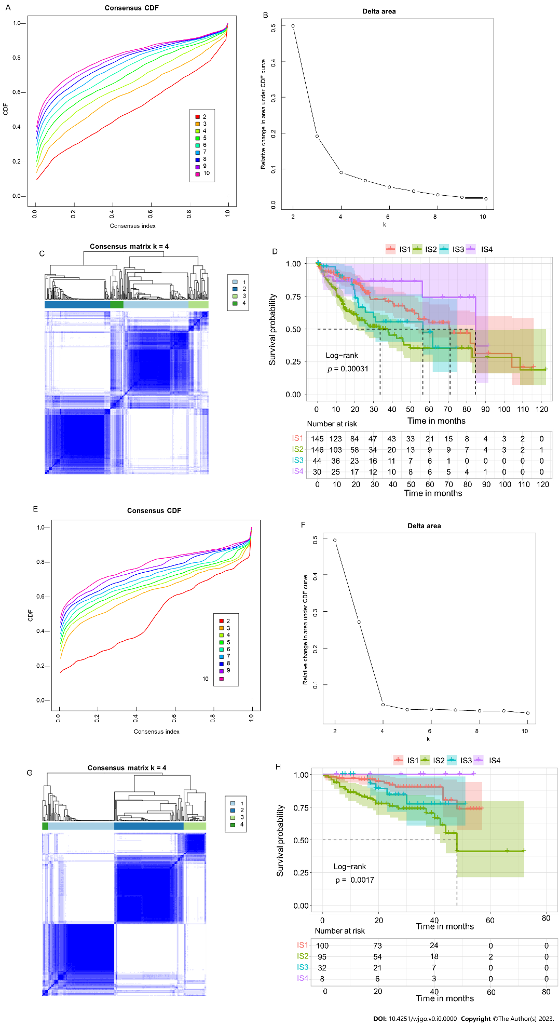

**Figure 4 Identification of immune subtypes of hepatocellular carcinoma.** A: Cumulative distribution function curve of immune-related genes in the The Cancer Genome Atlas (TCGA) cohort; B: Delta area of immune-related genes in the TCGA cohort; C: Sample clustering heatmap in the TCGA cohort; D: Kaplan-Meier curves showing the overall survival of the hepatocellular carcinoma immune subtypes in the TCGA cohort; E: Cumulative distribution function curve of immune-related genes in the International Cancer Genome Consortium (ICGC) cohort; F: Delta area of immune-related genes in the ICGC cohort; G: Sample clustering heatmap in the ICGC cohort; H: Kaplan-Meier curves showing the overall survival of the hepatocellular carcinoma immune subtypes in the ICGC cohort. CDF: Cumulative Distribution Function.

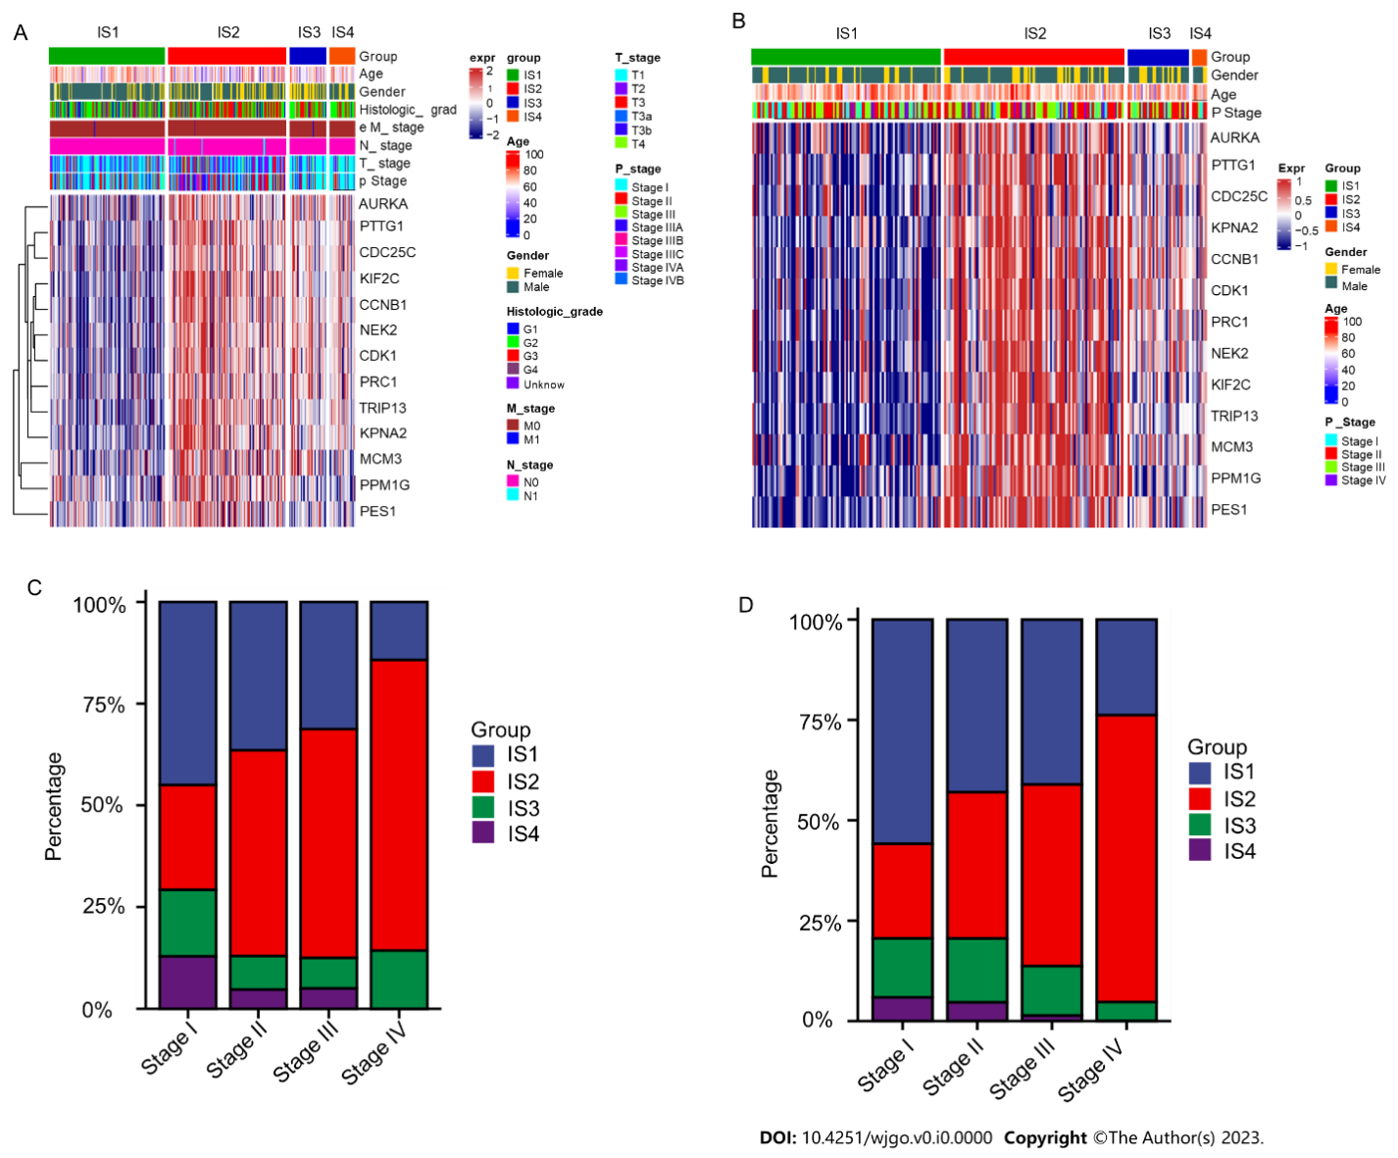

**Figure 5 Clinicopathological characteristics of immune subtypes of hepatocellular carcinoma.** A and B: Complex heatmap of clinicopathological characteristics of immune subtypes of hepatocellular carcinoma (HCC) patients in the The Cancer Genome Atlas (TCGA) (A) and International Cancer Genome Consortium (ICGC) (B) cohorts; C and D: Distribution of immune subtypes across HCC pStage in the TCGA (C) and ICGC (D) cohorts.

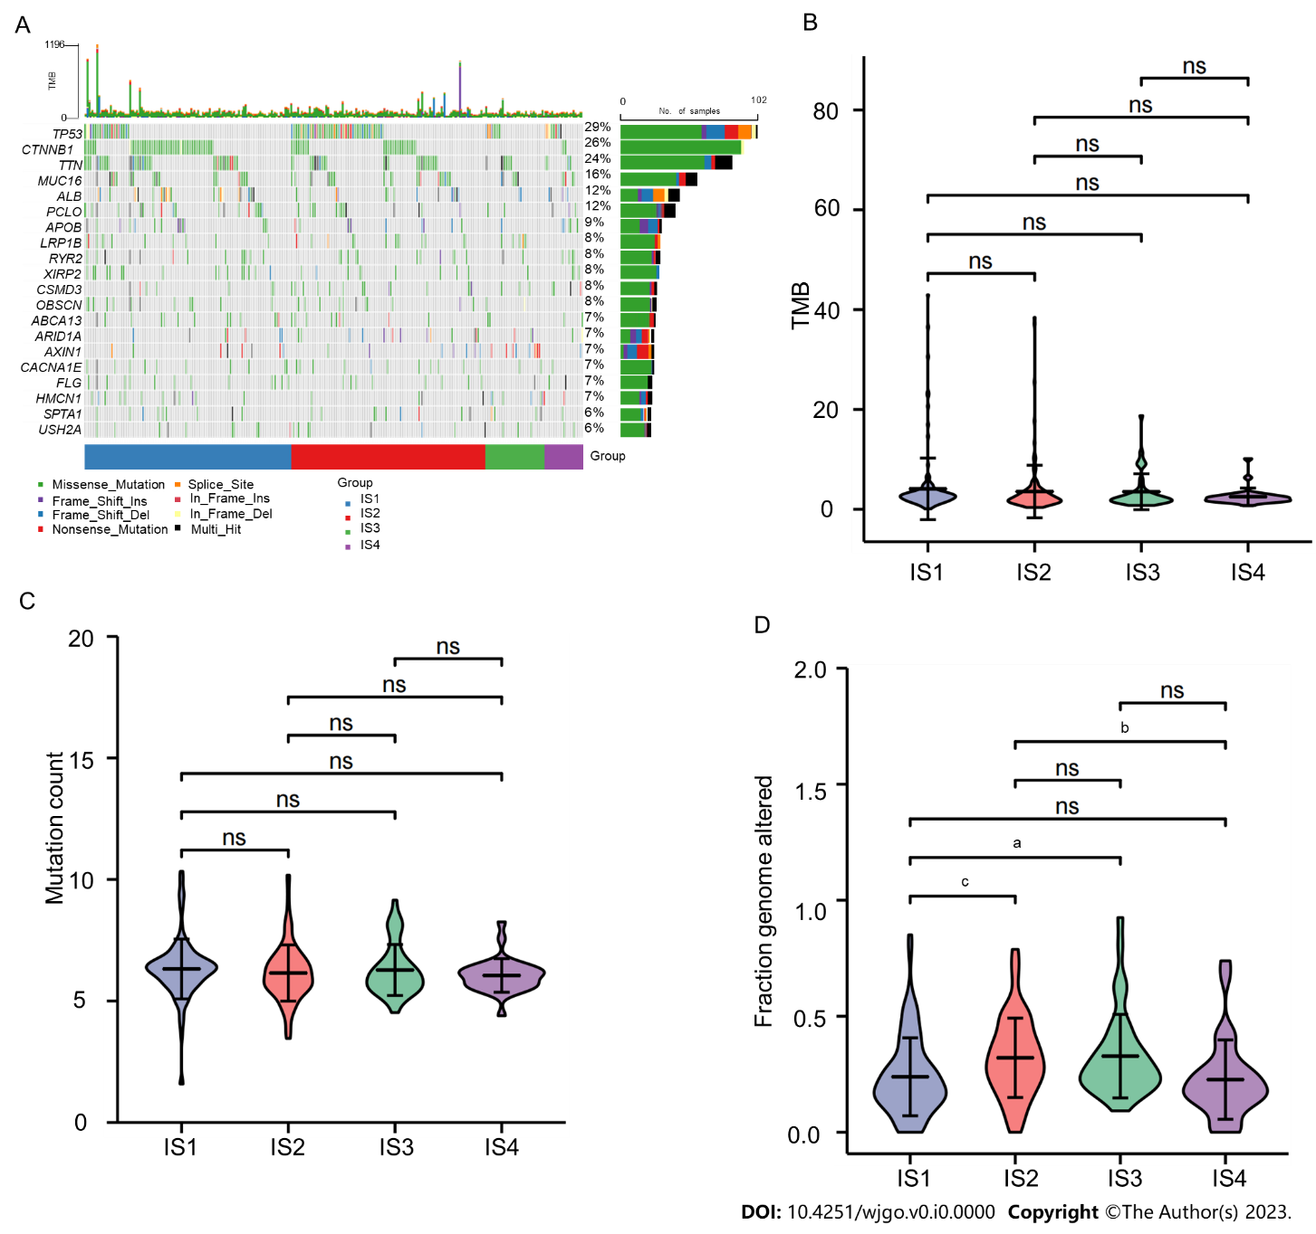

**Figure 6 Mutational landscape of distinct immune subtypes.** A: Mutational landscape oncoplot of the top 20 mutated genes in the hepatocellular carcinoma (HCC) immune subtypes; B to D: Tumor mutational burden (B), mutation number (C), and altered genome fractions (D) in HCC IS1-IS4. a*P* value < 0.05; b*P* value < 0.01; c*P* value < 0.001; TMB: Tumor mutational burden; ns: Not significant.

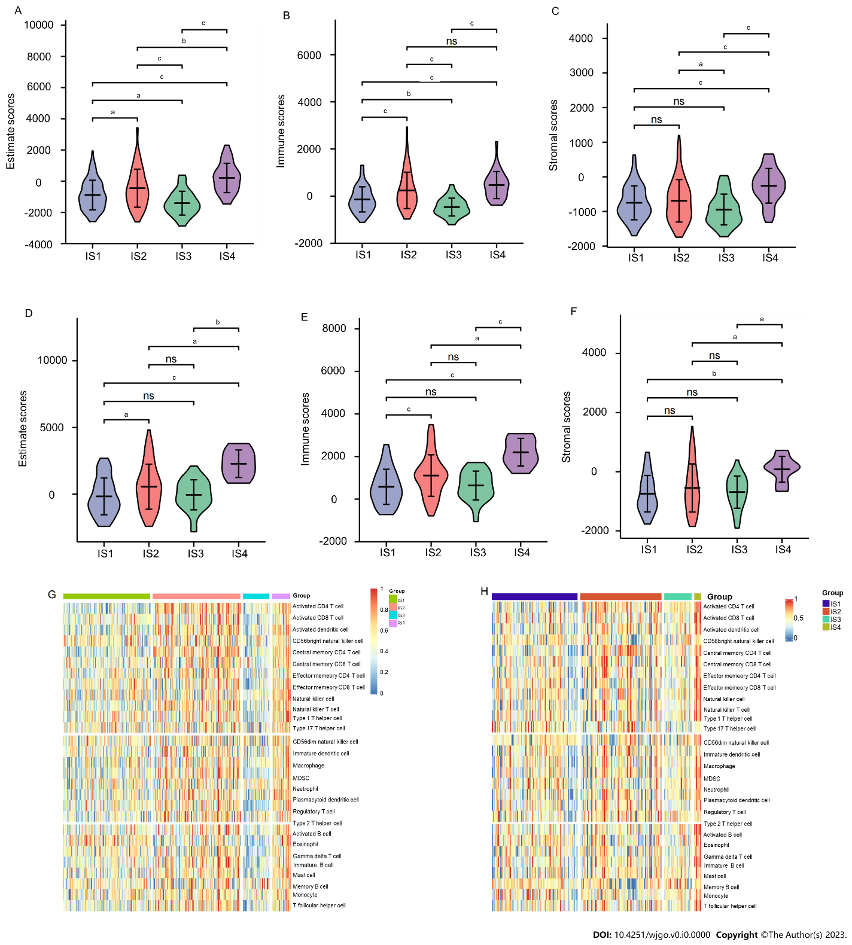

**Figure 7 Immune microenvironment characteristics of immune subtypes.** A to C: Estimate scores (A), immune scores (B), and stromal scores (C) of hepatocellular carcinoma (HCC) immune subtypes in The Cancer Genome Atlas (TCGA) cohort; D to F: Estimate scores (D), immune scores (E), and stromal scores (F) of HCC immune subtypes in International Cancer Genome Consortium (ICGC) cohort; G and H: Heatmap of enrichment scores of 28 immune cell signatures among HCC immune subtypes in the (G) TCGA and (H) ICGC cohorts. a*P* value < 0.05; b*P* value < 0.01; c*P* value < 0.001; ns: Not significant.

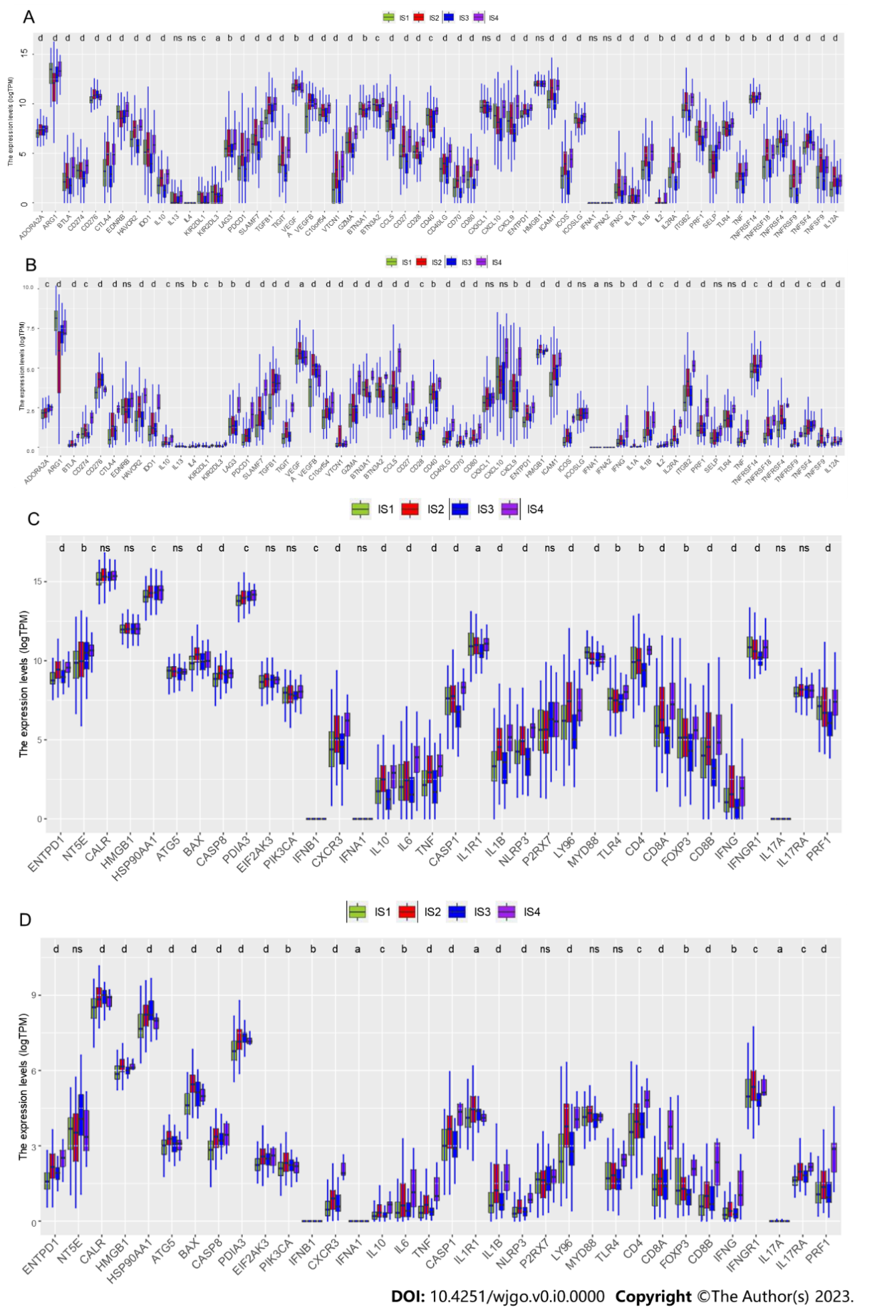

**Figure 8 Association between immune subtypes and immune checkpoint/immune cell death modulator-related genes.** A and B: Box plot of differential expression of immune checkpoint genes among immune subtypes in the The Cancer Genome Atlas (TCGA) (A) and International Cancer Genome Consortium (ICGC) (B) cohorts; C and D: Box plot of differential expression of immune cell death modulator genes among immune subtypes in the TCGA (C) and ICGC (D) cohorts. a*P* value < 0.05; b*P* value < 0.01; c*P* value < 0.001; d*P* value < 0.0001; ns: Not significant.

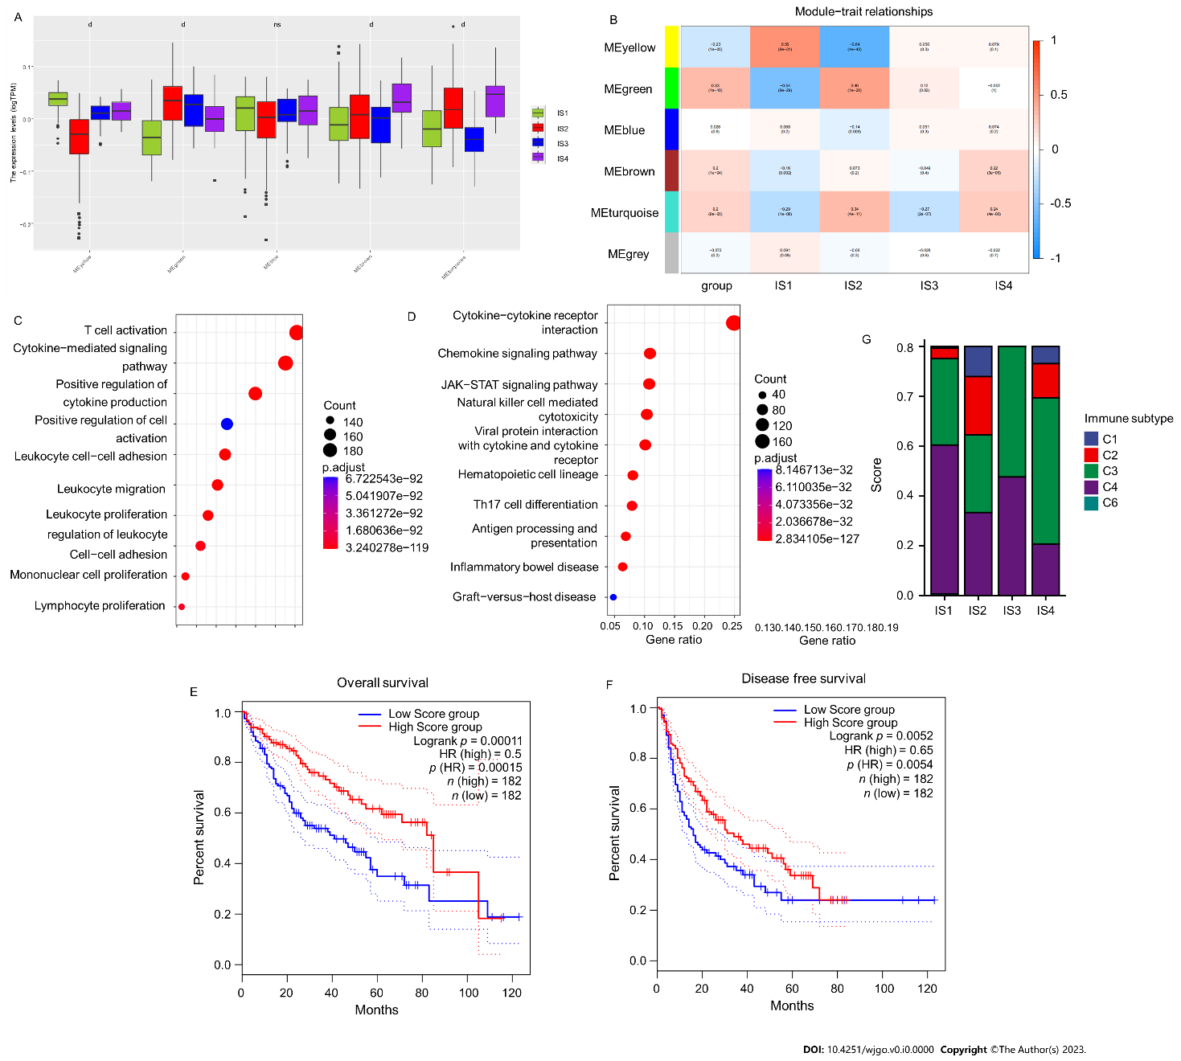

**Figure 9 Identification of potential biomarkers for mRNA vaccines.** A: Differential distribution of module eigengenes among distinct hepatocellular carcinoma immune subtypes; B: Heatmap of module trait relationships; C: Dot plot showing the top 10 GO terms in the yellow module; D: Dot plot showing the top 10 KEGG terms in the yellow module; E and F: Kaplan-Meier plots showing overall survival (E) and recurrence-free survival (F) of the yellow module prognostic gene expression score; G: Distribution of six previously reported pancancer immune subtypes among IS1-IS4. d*P* value < 0.0001; ns: Not significant; HR: Hazard ratio.