**Name of Journal:** *World Journal of Clinical Cases*

**Manuscript NO:** 45224

**Manuscript Type:** META-ANALYSIS

**Maternal serum level of resistin is associated with risk for gestational diabetes mellitus: A meta-analysis**

Hu SM *et al.* Resistin and GDM

Shi-Min Hu, Meng-Shi Chen, Hong-Zhuan Tan

Shi-Min Hu, Meng-Shi Chen, Hong-Zhuan Tan, Department of Epidemiology and Health Statistics, Xiangya School of Public Health, Central South University, Changsha 410078, Hunan Province, China

**ORCID number:** Shi-Min Hu (0000-0002-3284-2494); Meng-Shi Chen (0000-0002-9100-0967); Hong-Zhuan Tan (0000-0002-4292-5947).

**Author contributions:** Hu SM contributed to data acquisition, analysis, and interpretation and manuscript drafting; Chen MS contributed to data acquisition, analysis, and interpretation; Tan HZ contributed to data interpretation and manuscript revision; all authors approved the final version.

**Supported by** the National Natural Science Foundation of China, No. 81373088 and No. 81773535.

**Conflict-of-interest statement:** The authors deny any conflict of interest.

**PRISMA 2009 Checklist statement:** The authors have read the PRISMA 2009 Checklist, and the manuscript was prepared and revised according to the PRISMA 2009 Checklist.

**Open-Access:** This article is an open-access article which was selected by an in-house editor and fully peer-reviewed by external reviewers. It is distributed in accordance with the Creative Commons Attribution Non Commercial (CC BY-NC 4.0) license, which permits others to distribute, remix, adapt, build upon this work non-commercially, and license their derivative works on different terms, provided the original work is properly cited and the use is non-commercial. See: http://creativecommons.org/licenses/by-nc/4.0/

**Manuscript source:** Unsolicited manuscript

**Corresponding author:** **Hong-Zhuan Tan, PhD, Professor,** Department of Epidemiology and Health Statistics, Xiangya School of Public Health, Central South University, 110 Xiangya Road, Changsha 410008, Hunan Province, China. tanhz99@qq.com

Telephone**:** +86-731-88858435

**Fax:** +86-731-84805454

**Received:** December 18, 2018

**Peer-review started:** December 20, 2018

**First decision:** January 12, 2019

**Revised:** February 2, 2019

**Accepted:** February 18, 2019

**Article in press:** February 18, 2019

**Published online:** March 6, 2019

Abstract

***BACKGROUND***

Resistin is most likely involved in the pathogenesis of gestational diabetes mellitus (GDM), but the existing findings are inconsistent.

***AIM***

To review the literature investigating the associations of the risk of GDM with serum level of resistin.

***METHODS***

A systematic literature search was performed using MEDLINE, EMBASE, and Web of Science (all databases). This meta-analysis included eligible studies that: (1) investigated the relationship between the risk of GDM and serum resistin; (2) included GDM cases and controls without GDM; (3) diagnosed GDM according to the oral glucose-tolerance test; (4) were performed in humans; (5) were published as full text articles in English; and (6) provided data with median and quartile range, median and minimum and maximum values, or mean and standard deviation. The pooled standardized mean difference (SMD) and 95% confidence interval (CI) were calculated to estimate the association between the risk of GDM and serum resistin. To analyze the potential influences of need for insulin in GDM patients and gestational age at blood sampling, we performed a subgroup analysis. Meta-regression with restricted maximum likelihood estimation was performed to assess the potentially important covariate exerting substantial impact on between-study heterogeneity.

***RESULTS***

The meta-analysis for the association between serum resistin level and GDM risk included 18 studies (22 comparisons) with 1041 cases and 1292 controls. The total results showed that the risk of GDM was associated with higher serum resistin level (SMD = 0.250, 95%CI: 0.116, 0.384). The “after 28 wk” subgroup, “no need for insulin” subgroup, and “need for insulin” subgroup indicated that higher serum resistin level was related to GDM risk (“after 28 wk” subgroup: SMD = 0.394, 95%CI: 0.108, 0.680; “no need for insulin” subgroup: SMD = 0.177, 95%CI: 0.018, 0.336; “need for insulin” subgroup: SMD = 0.403, 95%CI: 0.119, 0.687). The “before 14 wk” subgroup, “14-28 wk” subgroup, and “no information of need for insulin” subgroup showed a nonsignificant association between serum resistin level and GDM risk (“before 14 wk” subgroup: SMD = 0.087, 95%CI: -0.055, 0.230; “14-28 wk” subgroup: SMD = 0.217, 95%CI: -0.003, 0.436; “no information of need for insulin” subgroup: SMD = 0.356, 95%CI: -0.143, 0.855). The postpartum subgroup included only one study and showed that higher serum resistin level was related to GDM risk (SMD = 0.571, 95%CI: 0.054, 1.087) The meta-regression revealed that no need for insulin in GDM patients, age distribution similar between cases and controls, and ELISA all had a significant impact on between-study heterogeneity.

***CONCLUSION***

This meta-analysis supports that the maternal serum resistin level is associated with GDM risk.

Key words:Resistin; Gestational diabetes mellitus; Meta-analysis; Gestational age

**© The Author(s) 2019.** Published by Baishideng Publishing Group Inc. All rights reserved.

Core tip: We conducted a meta-analysis of relevant high-quality studies, which revealed that the maternal serum resistin level is associated with gestational diabetes mellitus risk.

Citation: Hu SH, Chen MS, Tan HZ. Maternal serum level of resistin is associated with risk for gestational diabetes mellitus: A meta-analysis. *World J Clin Cases* 2019; 7(5): 585-599

**URL:** https://www.wjgnet.com/2307-8960/full/v7/i5/585.htm

**DOI:** https://dx.doi.org/10.12998/wjcc.v7.i5.585

INTRODUCTION

Gestational diabetes mellitus (GDM) is defined by varying degrees of glucose intolerance that is first detected during pregnancy[1]. In recent decades, the prevalence of GDM has been increasing and fluctuates from 1.7% to 11.6%[2]. Poorly controlled GDM is associated with an increase in the incidence of gestational hypertension, preeclampsia, polyhydramnios, fetal macrosomia, birth trauma, operative delivery, and neonatal hypoglycemia[3-5]. During pregnancy, insulin resistance is enhanced physiologically, which parallels the growth of the fetoplacental unit and facilitates the diversion of glucose to the fetus. When the compensatory increase in insulin is not sufficient to maintain glycemic homeostasis, pregnant women develop GDM.

Resistin, which was named after its insulin resistance ability by Steppan *et al*[6] in 2001, is a hormone with a molecular weight of 12.5 kDa that consists of 108 amino acids. Steppan *et al*[6] found anti-diabetic drugs called thiazolidinediones, which markedly lowered serum resistin levels in mice during treatment. The immunoneutralization of endogenous resistin improved blood glucose and insulin action in this model of type 2 diabetes. The treatment of normal mice with recombinant resistin impaired glucose tolerance and insulin action. Insulin-stimulated glucose uptake by adipocytes was enhanced by neutralization of resistin and reduced by resistin treatment[6]. The association between elevated circulating resistin and insulin resistance in patients with type 2 diabetes has also been revealed[7-11].

The results of studies on the association between resistin and GDM risk vary greatly. Some studies have suggested that elevated circulating resistin is a risk factor for GDM[12-26], while some have suggested that elevated circulating resistin is a protective factor[27-30], and others have suggested that resistin circulating level is not associated with GDM risk[31-52]. Variations in gestational age at sample collection, assay methods, fasting state, sample size, ethnicity, diagnosis criteria, severity of GDM, and definitions of controls could account for the considerable differences of the results of these studies. In a study performed by Steppan *et al*[6], they found that resistin expression was adipocyte-specific. However, recent reports suggest that resistin is also expressed in multiple other tissues, such as pancreatic islets, skeletal muscles, mononuclear cells, placenta, and liver cells[51,53,54]. During pregnancy, the placenta synthesizes and secretes resistin into the maternal circulation[55,56]. One study found that resistin protein expression in placental tissue was much higher than that in subcutaneous adipose tissue in pregnant women’s abdomens, suggesting that the placenta is a major contributor of resistin in pregnancy[57]. Several studies have shown that the maternal circulating level of resistin gradually increases with gestational age and decreases significantly after delivery[17-19,23,37,40,42,44]. This process of change is consistent with the growth and delivery of the placenta.

Notably, a previous meta-analysis published in 2013 that included 10 papers showed no association between circulating resistin levels and GDM[58]. However, the authors suggested that these results should be interpreted with caution owing to the large heterogeneity among the studies. Since 2013, there have been many high-quality articles on serum resistin levels and GDM. Therefore, we think it is necessary to conduct another meta-analysis, and since there is a sufficient number of articles, we can perform a meta-regression analysis and subgroup analysis to explore possible influencing factors. The purpose of this study was to review the literature on the association of resistin and GDM risk, and attempt to find potential influence factors to interpret the considerable differences of the results of these studies.

MATERIALS AND METHODS

***Literature search***

The databases MEDLINE, EMBASE, and Web of Science (all databases, including Web of Science Core Collection, BIOSIS Citation Index, *etc*.) were searched up to October 11, 2018 to find articles focused on the relationship between the risk of GDM and serum resistin level. The following keywords were used in PubMed and Web of Science: (“Diabetes, Gestational” [Mesh] OR “GDM” OR “gestational diabetes” OR “gestational diabetic” OR “diabetic pregnancy”) AND (“resistin” [MeSH] OR resistin OR RETN OR ADSF OR RSTN OR XCP1 OR FIZZ3 OR RETN1). The following keywords were used in EMBASE: (“pregnancy diabetes mellitus”/exp OR “gestational diabetes” OR “gestational diabeti” OR “diabetic pregnancy” OR “gdm”) AND (“resistin”/exp OR “resistin” OR “RETN” OR “ADSF” OR ”RSTN” OR ”XCP1” OR ”FIZZ3” OR ”RETN1”). We manually searched all the reference lists of the included studies and relevant reviews to find additional eligible studies.

***Eligible studies,*** ***data extraction, and quality evaluation***

This meta-analysis included eligible studies that: (1) investigated the relationship between the risk of GDM and serum resistin; (2) included GDM cases and controls without GDM; (3) diagnosed GDM according to the oral glucose-tolerance test; (4) were performed in humans; (5) were published as full text articles in English; and (6) provided data with median and quartile range, median and minimum and maximum values, or mean and standard deviation (SD). We excluded the studies with overlapping data. Information of the first author, study location (country), study design, year of publication, diagnostic criteria, number of patients and controls, gestational age at the time of blood sampling, assay methods, need for insulin in GDM patients, and the mean and SD of serum resistin levels was extracted. The quality of each included study was evaluated based on the Newcastle-Ottawa Scale (NOS) recommended by the Agency for Healthcare Research and Quality of the US[59]. Comparability of cases and controls on the basis of the design or analysis was evaluated based on whether the gestational age and body mass index (BMI) at blood sampling matched. The NOS total score of the literature included had to be greater than or equal to 5 points. Disputes were resolved by discussion with a third author during data extraction and quality evaluation. The equation “” was used to calculate SD from the standard error of the mean (SEM). If we need to merge the data of subgroups, we used the following equations: *n* = n1 + n2, and[60]. The equation “SD = interquartile range/1.35” was used to calculate SD from interquartile ranges. And we treated the medians as means[61]. However, if we were provided with the minimum and maximum values, we calculated means and SDs according to the equations in the study of Hozo *et al*[62]. When serum resistin levels were measured in both nonfasting and fasting blood samples at the same gestational age, we chose the fasting result here.



***Statistical analysis***

The pooled standardized mean difference (SMD) and 95% confidence interval (CI) were used to estimate the relationship between the risk of GDM and serum resistin. Subgroup analyses were performed to detect whether “need for insulin” or “gestational age at blood sampling” influenced the relationship between the risk of GDM and serum resistin. We divided the subjects into four subgroups according to the gestational age at blood sampling (“before 14 wk”, “14–28 wk”, “after 28 wk”, and “postpartum”). If the gestational age of the included study did not completely overlap with the gestational age of the subgroup, we would assign the study into the subgroup with the most overlap with the gestational age of the study. The study of Kuzmicki *et al*[14] was assigned to the “14-28 wk” subgroup. The studies of Kralisch *et al*[39], Siddiqui *et al*[25], and Palik *et al*[17] were assigned to the subgroup of “after 28 wk”. Additionally, based on the “need for insulin in GDM patients”, the subjects were divided into three subgroups: (1) need for insulin; (2) no need for insulin; and (3) no information. The *Z* test was used to determine the significance of the pooled SMD, with α set at 0.05.

The *Q* test and the *I*2 statistic were used to estimate the heterogeneity across studies[63,64]. If *P* < 0.1 in the *Q* test, and *I*2 > 50%, we used the random effects model to pool the data; and meta-regression with restricted maximum likelihood estimation (REML) was performed to assess the potentially important covariate exerting substantial impact on between-study heterogeneity. The following covariates were included in the meta-regression analysis: need for insulin (no need for insulin, need for insulin, OR no information; dummy variable), assay method (ELISA OR others), and maternal age distribution (similar between cases and controls OR different between cases and controls) in each study. Begg’s funnel plot and Egger’s test and sensitivity analysis were used to assess the publication bias and the stability of the results. STATA 12.0 software (Stata Corporation, College Station, TX) was the only analysis software in this meta-analysis. The statistical methods of this study were reviewed by Jun-Xia Yan from Department of Epidemiology and Health Statistics, Central South University, China.

RESULTS

***Study selection***

The process of study selection is shown in Figure 1. Three hundred and one records of potentially relevant studies were identified. Of these, 199 records were excluded based on their title and/or abstract (“repetitive publications”: *n* = 132; “conference abstracts”: *n* = 18; “reports of animal studies”: *n* = 6; “reports of studies that investigated outcomes irrelevant to this meta-analysis”: *n* = 31; “adipokines other than resistin”: *n* = 1; “studies of which the biological material was not maternal blood”: *n* = 11). A further 77 full-text articles were excluded because these were: (1) review, editorial, and opinion articles (*n* = 49); (2) studies in which interviewees were not grouped according to whether they had GDM (*n* = 11); (3) a study in which the controls were not pregnant women and had never been pregnant (*n* = 1); (4) papers with plasma resistin concentrations reported (*n* = 13); (5) non-full-text articles in English (*n* = 2); and (6) *RETN* gene study (*n* = 1). After in-depth analysis, seven more studies were excluded. The specific reasons for the exclusion and the detailed information of these seven papers are shown in Supplementary Table 1. The 18 studies (22 comparisons) that were ultimately selected for our meta-analysis included 1041 cases and 1292 controls (Tables 1 and 2).

***Association between the risk of GDM and serum resistin level***

The meta-analysis included 18 studies (22 comparisons) with 1041 cases and 1292 controls. The total results showed that higher serum resistin was associated with the risk of GDM (SMD = 0.250, 95%CI: 0.116, 0.384) (Table 3 and Figure 2). The “after 28 wk”, “no need for insulin”, and “need for insulin” subgroups indicated that higher serum resistin was related to the risk of GDM (“after 28 wk” subgroup: SMD = 0.394, 95%CI: 0.108, 0.680; “no need for insulin” subgroup: SMD = 0.177, 95%CI: 0.018, 0.336; “need for insulin” subgroup: SMD = 0.403, 95%CI: 0.119, 0.687). The “before 14 wk” subgroup, “14-28 wk” subgroup, and “no information of need for insulin” subgroup showed a nonsignificant association between serum resistin level and GDM risk (“before 14 wk” subgroup: SMD = 0.087, 95%CI: -0.055, 0.230; “14-28 wk” subgroup: SMD = 0.217, 95%CI: -0.003, 0.436; “no information of need for insulin” subgroup: SMD = 0.356, 95%CI: -0.143, 0.855). The postpartum subgroup included only one study and showed that higher serum resistin level was related to GDM risk (SMD = 0.571, 95%CI: 0.054, 1.087) (Table 3, Figures 3 and 4).

Table 4 summarizes results of meta-regression; “no need for insulin in GDM patients”, “age distribution similar between cases and controls”, and ELISA all had a significant impact on between-study heterogeneity. REML estimate of between-study variance tau2 decreased from 0.0482 to 0.02687, indicating that these variables can account for 44.3% of heterogeneity sources. No association was statistically significant when meta-regression was performed on the three strategies considered one by one. In the sensitivity analysis, no changes were observed in the significance of the results or in the corresponding pooled SMD (Figure 5). In the publication bias analysis, the results of Begg’s funnel plot and the modified Egger linear regression test (Figure 6) showed no publication bias (*Z* = 1.30, *P* = 0.195; *t* = 1.10, *P* = 0.284).

DISCUSSION

The results of the studies focused on the association of maternal serum resistin level and GDM risk varied widely due to differences in study design type, ethnicity, diagnostic criteria for GDM, insulin use in GDM patients, inclusion criteria of the control group, the distribution equilibrium of maternal age, BMI, gestational age at sampling, sample size, serum/plasma selection, sample storage methods, and assay methods. To obtain a more reliable meta-analysis result, we set a threshold for the diagnostic criteria of GDM. To explore the possible influencing factors of the results, we performed subgroup analyses according to the gestational age at sampling and need for insulin in GDM patients. The total results showed that serum resistin level was associated with GDM. The results of the third trimester, “no need for insulin”, and “need for insulin” subgroups were consistent with the total result.

The effect of resistin on blood glucose was confirmed in animal studies by highly evidence-based studies[6,65]. In a mouse model, Steppan *et al*[6] found that resistin levels were increased in diet-induced obesity, as well as in genetic models of obesity and insulin resistance. Neutralization of resistin reversibly reduced hyperglycemia in this model of diet-induced insulin resistance. The ability of recombinant resistin to produce glucose intolerance and insulin resistance is consistent with the opposite effects of immunoneutralization of endogenous resistin. Similar effects of resistin, *i.e*., decreasing insulin-stimulated glucose uptake, were confirmed *in vitro* by using 3T3-L1 adipocytes[6]. Banerjee *et al*[65] studied the mechanism by which resistin regulates blood glucose, and they found that mice lacking resistin exhibited low blood glucose levels after fasting due to the impairment of hepatic glucose output. Resistin normally acts on the liver to inhibit the activation of adenosine monophosphate–activated protein kinase (AMPK). The key gluconeogenic enzymes glucose 6-phosphatase (*G6Pase*) and phosphoenolpyruvate carboxykinase (*PEPCK*) genes are both downregulated by activation of AMPK. Gene expression of *G6Pase* and *PEPCK* was markedly decreased in the liver of the resistin-null mice[65]. There have been no animal studies related to circulating resistin level and GDM risk.

The association between elevated serum resistin level and GDM was only found in the third-trimester subgroup when we divided the studies into four subgroups according to the gestational age. This may be because the serum level of resistin increases with gestational age[17-19,23,37,40,42,44], and the gap in resistin levels between GDM and the controls may also increase with increasing gestational age. Figure 3 shows this trend. Therefore, a study focusing on the association between the serum resistin level and GDM risk in the first and second trimesters would require a larger sample size than one focusing only on the third trimester. Choi *et al*[12] found higher circulating resistin levels in women with pGDM than in women with normal glucose tolerance during pregnancy and one year after delivery, suggesting that in addition to the placenta, other secretory organs such as adipose tissue may also contribute to the occurrence of GDM. A study on circulating resistin and fat mass compartments in pregnancy revealed that resistin levels are not related to BMI, total body fat mass, or abdominal subcutaneous fat mass but are related to abdominal visceral fat mass[66]. In this meta-analysis, the postpartum subgroup included only one study. Further research may be needed to focused on the postpartum. The results of the subgroup analysis, according to the need for insulin, showed that the pooled SMD of “need for insulin in GDM patients” was higher than the pooled SMD of “no need for insulin in GDM patients”, suggesting that the serum level of resistin may be related to the severity of GDM. The research of Huang *et al*[13] showed that among pregnant women with GDM, the serum resistin levels of women with satisfactory glycemic control were lower than those in women with unsatisfactory glycemic control[13].

Studies on *RETN* (gene encoded resistin) mRNA and SNPs have also suggested that resistin is associated with GDM risk. The mRNA expression of *RETN* was increased in adipose tissue from GDM when compared to a non-GDM group, was related to insulin resistance level, and could be regulated by adrenomedullin and an adrenomedullin antagonist[13,67,68]. *RETN* rs1423096 and -420 C/G were found to be associated with GDM risk[48,69], and it has been reported that the G allele of -420 C/G in the *RETN* gene promoter was associated with an increase in circulating resistin[70,71].

In summary, our meta-analysis showed that higher maternal serum resistin level is related to GDM risk and suggested that the serum level of resistin may be related to the severity of GDM. Studies focusing on the association between the serum resistin level and GDM risk in the first and second trimesters would require a larger sample size than ones focusing only on the third trimester.

**ARTICLE HIGHLIGHTS**

***Research background***

Resistin is most likely involved in the pathogenesis of gestational diabetes mellitus (GDM), but the existing findings are inconsistent.

***Research motivation***

To explore the sources of heterogeneity in the existing literature, we made the literature heterogeneity within an acceptable range by setting reasonable inclusion criteria. Based on this, we aimed to explore the relationship between serum level of resistin and GDM risk.

***Research objectives***

This article aims to review the studies investigating the association of GDM risk with serum resistin level.

***Research methods***

A systematic literature search was performed using MEDLINE, EMBASE, and Web of Science (all databases). We did subgroup analysis according to the need for insulin in GDM patients and gestational age at blood sampling. Meta-regression with restricted maximum likelihood estimation was performed to assess the potentially important covariate exerting substantial impact on between-study heterogeneity.

***Research results***

The meta-analysis included 18 studies (22 comparisons) with 1041 cases and 1292 controls. The total results showed that the risk of GDM was associated with serum resistin level. The results of subgroup are consistent with the total results. The meta-regression revealed that no need for insulin in GDM patients, age distribution similar between cases and controls, and ELISA all had a significant impact on between-study heterogeneity.

***Research conclusions***

This meta-analysis supports that the maternal serum resistin level is associated with GDM risk.

***Research perspectives***

In summary, our meta-analysis showed that higher maternal serum resistin level is related to GDM risk and suggested that the serum level of resistin may be related to the severity of GDM.

REFERENCES

1 **Buchanan TA**, Xiang AH. Gestational diabetes mellitus. *J Clin Invest* 2005; **115**: 485-491 [PMID: 15765129 DOI: 10.1172/Jci200524531]

2 **Schneider S**, Bock C, Wetzel M, Maul H, Loerbroks A. The prevalence of gestational diabetes in advanced economies. *J Perinat Med* 2012; **40**: 511-520 [PMID: 23120759 DOI: 10.1515/jpm-2012-0015]

3 **Li X**, Tan H, Huang X, Zhou S, Hu S, Wang X, Xu X, Liu Q, Wen SW. Similarities and differences between the risk factors for gestational hypertension and preeclampsia: A population based cohort study in south China. *Pregnancy Hypertens* 2016; **6**: 66-71 [PMID: 26955775 DOI: 10.1016/j.preghy.2015.11.004]

4 **He XJ**, Qin FY, Hu CL, Zhu M, Tian CQ, Li L. Is gestational diabetes mellitus an independent risk factor for macrosomia: a meta-analysis? *Arch Gynecol Obstet* 2015; **291**: 729-735 [PMID: 25388922 DOI: 10.1007/s00404-014-3545-5]

5 **Hartling L**, Dryden DM, Guthrie A, Muise M, Vandermeer B, Donovan L. Benefits and harms of treating gestational diabetes mellitus: a systematic review and meta-analysis for the U.S. Preventive Services Task Force and the National Institutes of Health Office of Medical Applications of Research. *Ann Intern Med* 2013; **159**: 123-129 [PMID: 23712381 DOI: 10.7326/0003-4819-159-2-201307160-00661]

6 **Steppan CM**, Bailey ST, Bhat S, Brown EJ, Banerjee RR, Wright CM, Patel HR, Ahima RS, Lazar MA. The hormone resistin links obesity to diabetes. *Nature* 2001; **409**: 307-312 [PMID: 11201732 DOI: 10.1038/35053000]

7 **Srinivasan M**, Meadows ML, Maxwell L. Assessment of Salivary Adipokines Resistin, Visfatin, and Ghrelin as Type 2 Diabetes Mellitus Biomarkers. *Biochem Res Int* 2018; **2018**: 7463796 [PMID: 29487749 DOI: 10.1155/2018/7463796]

8 **Tokuyama Y**, Osawa H, Ishizuka T, Onuma H, Matsui K, Egashira T, Makino H, Kanatsuka A. Serum resistin level is associated with insulin sensitivity in Japanese patients with type 2 diabetes mellitus. *Metabolism* 2007; **56**: 693-698 [PMID: 17445546 DOI: 10.1016/j.metabol.2006.12.019]

9 **Heidemann C**, Sun Q, van Dam RM, Meigs JB, Zhang C, Tworoger SS, Mantzoros CS, Hu FB. Total and high-molecular-weight adiponectin and resistin in relation to the risk for type 2 diabetes in women. *Ann Intern Med* 2008; **149**: 307-316 [PMID: 18765700 DOI: 10.7326/0003-4819-149-5-200809020-00005]

10 **Majdi MA**, Mohammadzadeh NA, Lotfi H, Mahmoudi R, Alipour FG, Shool F, Moghanloo MN, Porfaraj S, Zarghami N. Correlation of Resistin Serum Level with Fat Mass and Obesity-Associated Gene (FTO) rs9939609 Polymorphism in Obese Women with Type 2 Diabetes. *Diabetes Metab Syndr* 2017; **11** Suppl 2: S715-S720 [PMID: 28566238 DOI: 10.1016/j.dsx.2017.05.004]

11 **Santilli F**, Liani R, Di Fulvio P, Formoso G, Simeone P, Tripaldi R, Ueland T, Aukrust P, Davì G. Increased circulating resistin is associated with insulin resistance, oxidative stress and platelet activation in type 2 diabetes mellitus. *Thromb Haemost* 2016; **116**: 1089-1099 [PMID: 27709225 DOI: 10.1160/th16-06-0471]

12 **Choi SH**, Kwak SH, Youn BS, Lim S, Park YJ, Lee H, Lee N, Cho YM, Lee HK, Kim YB, Park KS, Jang HC. High plasma retinol binding protein-4 and low plasma adiponectin concentrations are associated with severity of glucose intolerance in women with previous gestational diabetes mellitus. *J Clin Endocrinol Metab* 2008; **93**: 3142-3148 [PMID: 18492757 DOI: 10.1210/jc.2007-1755]

13 **Huang H**, Xiao L, Wang A, Gu J, Ke H, Yan Y, Yang X. Correlation of resistin expression in maternal serum and subcutaneous adipose tissue with insulin resistance in gestational diabetes mellitus. *Int J Clin Exp Med* 2016; **9**: 18721-18727

14 **Kuzmicki M**, Telejko B, Szamatowicz J, Zonenberg A, Nikolajuk A, Kretowski A, Gorska M. High resistin and interleukin-6 levels are associated with gestational diabetes mellitus. *Gynecol Endocrinol* 2009; **25**: 258-263 [PMID: 19408175 DOI: 10.1080/09513590802653825]

15 **Liu DY**, Yu J, Zhou SX, Zhou Y, Li QM, Shi XY, Lin F, Shi QF. Study of levels of resistin in patients with gestational diabetes mellitus. *Dalian Yike Daxue Xuebao* 2008; **30**: 334-335, 343

16 **Oncul M**, Tuten A, Erman H, Gelisgen R, Benian A, Uzun H. Maternal and cord blood apelin, resistin and visfatin levels in gestational diabetes mellitus. *Minerva Med* 2013; **104**: 527-535 [PMID: 24101110 DOI: 10.1186/1471-2296-14-145]

17 **Palik E**, Baranyi E, Melczer Z, Audikovszky M, Szöcs A, Winkler G, Cseh K. Elevated serum acylated (biologically active) ghrelin and resistin levels associate with pregnancy-induced weight gain and insulin resistance. *Diabetes Res Clin Pract* 2007; **76**: 351-357 [PMID: 17010469 DOI: 10.1016/j.diabres.2006.09.005]

18 **Vitoratos N**, Deliveliotou A, Dimitrakaki A, Hassiakos D, Panoulis C, Deligeoroglou E, Creatsas GK. Maternal serum resistin concentrations in gestational diabetes mellitus and normal pregnancies. *J Obstet Gynaecol Res* 2011; **37**: 112-118 [PMID: 21159034 DOI: 10.1111/j.1447-0756.2010.01327.x]

19 **Chen D**, Fang Q, Chai Y, Wang H, Huang H, Dong M. Serum resistin in gestational diabetes mellitus and early postpartum. *Clin Endocrinol* (Oxf) 2007; **67**: 208-211 [PMID: 17547683 DOI: 10.1111/j.1365-2265.2007.02862.x]

20 **Akdeniz FT**, Akbulut Z, Sarı H, Aydın H, Dalan AB, Şit D, İspir T, Demirel GY. Effect of pro-inflammatory markers on gestational diabetes. *Turkish J Immunology* 2017; **5**: 45-50 [DOI: 10.25002/tji.2017.586]

21 **Bagci H**, Melekoglu R, Gursu MF, Akyol A, Bulmus FG. Associations between serum levels of adiponectin and resistin and metabolic parameters in pregnant women with gestational diabetes mellitus. *Clin Exp Obstet Gynecol* 2018; **45**: 539-543 [DOI: 10.12891/ceog4348.2018]

22 **Oh ES**, Han JH, Han SM, Im JA, Rhee EJ, Park CY, Oh KW, Lee WY. Adipokine Concentrations in Pregnant Korean Women with Normal Glucose Tolerance and Gestational Diabetes Mellitus. *Korean Diabetes J* 2009; **33**: 279-288 [DOI: 10.4093/kdj.2009.33.4.279]

23 **Noureldeen AF**, Qusti SY, Al-Seeni MN, Bagais MH. Maternal leptin, adiponectin, resistin, visfatin and tumor necrosis factor-alpha in normal and gestational diabetes. *Indian J Clin Biochem* 2014; **29**: 462-470 [PMID: 25298627 DOI: 10.1007/s12291-013-0394-0]

24 **Shang M**, Dong X, Hou L. Correlation of adipokines and markers of oxidative stress in women with gestational diabetes mellitus and their newborns. *J Obstet Gynaecol Res* 2018; **44**: 637-646 [PMID: 29399931 DOI: 10.1111/jog.13586]

25 **Siddiqui K**, George TP, Nawaz SS, Shehata N, El-Sayed AA, Khanam L. Serum adipokines (adiponectin and resistin) correlation in developing gestational diabetes mellitus: pilot study. *Gynecol Endocrinol* 2018; **34**: 502-506 [PMID: 29207892 DOI: 10.1080/09513590.2017.1411472]

26 **Zheng L**, Zhang H, Du J. Study on the Correlation of Serum Adiponectin and Resistin with Gestational Diabetes Mellitus Pregnant Women. *Zhongguo Yike Daxue Xuebao* 2011; **40**: 645-648 [DOI: 10.1007/s12264-011-1035-3]

27 **McManus R**, Summers K, de Vrijer B, Cohen N, Thompson A, Giroux I. Maternal, umbilical arterial and umbilical venous 25-hydroxyvitamin D and adipocytokine concentrations in pregnancies with and without gestational diabetes. *Clin Endocrinol* (Oxf) 2014; **80**: 635-641 [PMID: 24102192 DOI: 10.1111/cen.12325]

28 **Megia A**, Vendrell J, Gutierrez C, Sabaté M, Broch M, Fernández-Real JM, Simón I. Insulin sensitivity and resistin levels in gestational diabetes mellitus and after parturition. *Eur J Endocrinol* 2008; **158**: 173-178 [PMID: 18230823 DOI: 10.1530/EJE-07-0671]

29 **Park S**, Kim MY, Baik SH, Woo JT, Kwon YJ, Daily JW, Park YM, Yang JH, Kim SH. Gestational diabetes is associated with high energy and saturated fat intakes and with low plasma visfatin and adiponectin levels independent of prepregnancy BMI. *Eur J Clin Nutr* 2013; **67**: 196-201 [PMID: 23385969 DOI: 10.1038/ejcn.2012.207]

30 **Hossein-nezhad A**, Mirzaei K, Maghbooli Z, Rahmani M, Larijani B. Resistin, adiponectin and visfatin; can adipocytokines predict gestational diabetes mellitus and early post partum metabolic syndrome? *Iranian J Diabetes Lipid Disorders* 2010; **9**: 1-8

31 **Akdeniz N**, Kuyumcuoğlu U, Kale A, Arikan S, Kale E, Erdemoğlu M. Resistin may not associate with gestational diabetes mellitus although insulin resistance. *Clin Exp Obstet Gynecol* 2011; **38**: 236-238 [PMID: 21995154 DOI: 10.1111/j.1524-4741.2010.01035.x]

32 **Boyadzhieva M**, Atanasova I, Zacharieva S, Kedikova S. Adipocytokines during pregnancy and postpartum in women with gestational diabetes and healthy controls. *J Endocrinol Invest* 2013; **36**: 944-949 [PMID: 23685996 DOI: 10.3275/8968]

33 **Cortelazzi D**, Corbetta S, Ronzoni S, Pelle F, Marconi A, Cozzi V, Cetin I, Cortelazzi R, Beck-Peccoz P, Spada A. Maternal and foetal resistin and adiponectin concentrations in normal and complicated pregnancies. *Clin Endocrinol* (Oxf) 2007; **66**: 447-453 [PMID: 17302882 DOI: 10.1111/j.1365-2265.2007.02761.x]

34 **Fugmann M**, Uhl O, Hellmuth C, Hetterich H, Kammer NN, Ferrari U, Parhofer KG, Koletzko B, Seissler J, Lechner A. Differences in the serum nonesterified Fatty Acid profile of young women associated with a recent history of gestational diabetes and overweight/obesity. *PLoS One* 2015; **10**: e0128001 [PMID: 26011768 DOI: 10.1371/journal.pone.0128001]

35 **Georgiou HM**, Lappas M, Georgiou GM, Marita A, Bryant VJ, Hiscock R, Permezel M, Khalil Z, Rice GE. Screening for biomarkers predictive of gestational diabetes mellitus. *Acta Diabetol* 2008; **45**: 157-165 [PMID: 18496643 DOI: 10.1007/s00592-008-0037-8]

36 **Karatas A**, Tunçay Işikkent N, Ozlü T, Demirin H. Relationship of maternal serum resistin and visfatin levels with gestational diabetes mellitus. *Gynecol Endocrinol* 2014; **30**: 355-358 [PMID: 24512558 DOI: 10.3109/09513590.2014.887670]

37 **Guelfi KJ**, Ong MJ, Li S, Wallman KE, Doherty DA, Fournier PA, Newnham JP, Keelan JA. Maternal circulating adipokine profile and insulin resistance in women at high risk of developing gestational diabetes mellitus. *Metabolism* 2017; **75**: 54-60 [PMID: 28935125 DOI: 10.1016/j.metabol.2017.08.003]

38 **Kleiblova P**, Dostalova I, Bartlova M, Lacinova Z, Ticha I, Krejci V, Springer D, Kleibl Z, Haluzik M. Expression of adipokines and estrogen receptors in adipose tissue and placenta of patients with gestational diabetes mellitus. *Mol Cell Endocrinol* 2010; **314**: 150-156 [PMID: 19682537 DOI: 10.1016/j.mce.2009.08.002]

39 **Kralisch S**, Stepan H, Kratzsch J, Verlohren M, Verlohren HJ, Drynda K, Lössner U, Blüher M, Stumvoll M, Fasshauer M. Serum levels of adipocyte fatty acid binding protein are increased in gestational diabetes mellitus. *Eur J Endocrinol* 2009; **160**: 33-38 [PMID: 18849305 DOI: 10.1530/EJE-08-0540]

40 **Kulik-Rechberger B**, Mora-Janiszewska O. [Serum resistin concentrations in cases of gestational diabetes mellitus with good glycemic control and in cord blood]. *Ginekol Pol* 2009; **80**: 432-436 [PMID: 19642599 DOI: 10.1055/s-0029-1185793]

41 **Lain KY**, Daftary AR, Ness RB, Roberts JM. First trimester adipocytokine concentrations and risk of developing gestational diabetes later in pregnancy. *Clin Endocrinol* (Oxf) 2008; **69**: 407-411 [PMID: 18284645 DOI: 10.1111/j.1365-2265.2008.03198.x]

42 **Lobo TF**, Torloni MR, Mattar R, Nakamura MU, Alexandre SM, Daher S. Adipokine levels in overweight women with early-onset gestational diabetes mellitus. *J Endocrinol Invest* 2018 [PMID: 29696612 DOI: 10.1007/s40618-018-0894-0]

43 **Nanda S**, Poon LC, Muhaisen M, Acosta IC, Nicolaides KH. Maternal serum resistin at 11 to 13 weeks' gestation in normal and pathological pregnancies. *Metabolism* 2012; **61**: 699-705 [PMID: 22146093 DOI: 10.1016/j.metabol.2011.10.006]

44 **Pagán A**, Sabater-Molina M, Olza J, Prieto-Sánchez MT, Blanco-Carnero JE, Parrilla JJ, Gil Á, Larqué E. A gene variant in the transcription factor 7-like 2 (TCF7L2) is associated with an increased risk of gestational diabetes mellitus. *Eur J Obstet Gynecol Reprod Biol* 2014; **180**: 77-82 [PMID: 25048152 DOI: 10.1016/j.ejogrb.2014.06.024]

45 **Ravnsborg T**, Andersen LL, Trabjerg ND, Rasmussen LM, Jensen DM, Overgaard M. First-trimester multimarker prediction of gestational diabetes mellitus using targeted mass spectrometry. *Diabetologia* 2016; **59**: 970-979 [PMID: 26818149 DOI: 10.1007/s00125-016-3869-8]

46 **Rottenkolber M**, Ferrari U, Holland L, Aertsen S, Kammer NN, Hetterich H, Fugmann M, Banning F, Weise M, Sacco V, Kohn D, Freibothe I, Hutter S, Hasbargen U, Lehmann R, Grallert H, Parhofer KG, Seissler J, Lechner A. The Diabetes Risk Phenotype of Young Women With Recent Gestational Diabetes. *J Clin Endocrinol Metab* 2015; **100**: E910-E918 [PMID: 25742512 DOI: 10.1210/jc.2014-3898]

47 **Skvarca A**, Tomazic M, Krhin B, Blagus R, Janez A. Adipocytokines and insulin resistance across various degrees of glucose tolerance in pregnancy. *J Int Med Res* 2012; **40**: 583-589 [PMID: 22613419 DOI: 10.1177/147323001204000220]

48 **Takhshid MA**, Zare Z. Resistin - 420 C/G polymorphism and serum resistin level in Iranian patients with gestational diabetes mellitus. *J Diabetes Metab Disord* 2015; **14**: 37 [PMID: 25945322 DOI: 10.1186/s40200-015-0165-y]

49 **Tsiotra PC**, Halvatsiotis P, Patsouras K, Maratou E, Salamalekis G, Raptis SA, Dimitriadis G, Boutati E. Circulating adipokines and mRNA expression in adipose tissue and the placenta in women with gestational diabetes mellitus. *Peptides* 2018; **101**: 157-166 [PMID: 29337272 DOI: 10.1016/j.peptides.2018.01.005]

50 **Vitoratos N**, Dimitrakaki A, Vlahos NF, Gregoriou O, Panoulis K, Christopoulos P, Creatsas G. Maternal and umbilical resistin levels do not correlate with infant birth weight either in normal pregnancies and or in pregnancies complicated with gestational diabetes. *J Matern Fetal Neonatal Med* 2010; **23**: 1019-1023 [PMID: 20082598 DOI: 10.3109/14767050903551459]

51 **Lappas M**, Yee K, Permezel M, Rice GE. Release and regulation of leptin, resistin and adiponectin from human placenta, fetal membranes, and maternal adipose tissue and skeletal muscle from normal and gestational diabetes mellitus-complicated pregnancies. *J Endocrinol* 2005; **186**: 457-465 [PMID: 16135665 DOI: 10.1677/joe.1.06227]

52 **Verhaeghe J**, van Bree R, Lambin S, Caluwaerts S. Adipokine profile and C-reactive protein in pregnancy: effects of glucose challenge response versus body mass index. *J Soc Gynecol Investig* 2005; **12**: 330-334 [PMID: 15979544 DOI: 10.1016/j.jsgi.2005.02.002]

53 **Minn AH**, Patterson NB, Pack S, Hoffmann SC, Gavrilova O, Vinson C, Harlan DM, Shalev A. Resistin is expressed in pancreatic islets. *Biochem Biophys Res Commun* 2003; **310**: 641-645 [PMID: 14521959 DOI: 10.1016/j.bbrc.2003.09.061]

54 **Sheng CH**, Di J, Jin Y, Zhang YC, Wu M, Sun Y, Zhang GZ. Resistin is expressed in human hepatocytes and induces insulin resistance. *Endocrine* 2008; **33**: 135-143 [PMID: 18446452 DOI: 10.1007/s12020-008-9065-y]

55 **Street ME**, Viani I, Ziveri MA, Volta C, Smerieri A, Bernasconi S. Impairment of insulin receptor signal transduction in placentas of intra-uterine growth-restricted newborns and its relationship with fetal growth. *Eur J Endocrinol* 2011; **164**: 45-52 [PMID: 20930063 DOI: 10.1530/EJE-10-0752]

56 **Hauguel-de Mouzon S**, Guerre-Millo M. The placenta cytokine network and inflammatory signals. *Placenta* 2006; **27**: 794-798 [PMID: 16242770 DOI: 10.1016/j.placenta.2005.08.009]

57 **Zhou Y**, Zhang M, Guo W, Yu M, Xue K, Huang S, Chen Y, Zhu H, Xu L, Guo T. Expression of resistin protein in normal human subcutaneous adipose tissue and pregnant women subcutaneous adipose tissue and placenta. *J Huazhong Univ Sci Technolog Med Sci* 2006; **26**: 288-291 [PMID: 16961271 DOI: 10.1007/BF02829553]

58 **Lobo TF**, Torloni MR, Gueuvoghlanian-Silva BY, Mattar R, Daher S. Resistin concentration and gestational diabetes: a systematic review of the literature. *J Reprod Immunol* 2013; **97**: 120-127 [PMID: 23432878 DOI: 10.1016/j.jri.2012.10.004]

59 **Wells G**, Shea B, O'Connell J. The Newcastle-Ottawa Scale (NOS) for assessing the quality of nonrandomised studies in meta-analyses. 2018. Available from: URL: http://www.ohri.ca/programs/clinical_epidemiology/oxford.asp

60 **Zhang T**, Zhong W, editors. Applied methodology for evidence-based medicine. Changsha, China: Central South University Press, 2011

61 **Higgins JPT**, Green S, editors. Cochrane Handbook for Systematic Reviews of Interventions version 5.1.0. The Cochrane Collaboration, 2011

62 **Hozo SP**, Djulbegovic B, Hozo I. Estimating the mean and variance from the median, range, and the size of a sample. *BMC Med Res Methodol* 2005; **5**: 13 [PMID: 15840177 DOI: 10.1186/1471-2288-5-13]

63 **Whitehead A**, Whitehead J. A general parametric approach to the meta-analysis of randomized clinical trials. *Stat Med* 1991; **10**: 1665-1677 [PMID: 1792461 DOI: 10.1002/sim.4780101105]

64 **Higgins JP**, Thompson SG. Quantifying heterogeneity in a meta-analysis. *Stat Med* 2002; **21**: 1539-1558 [PMID: 12111919 DOI: 10.1002/sim.1186]

65 **Banerjee RR**, Rangwala SM, Shapiro JS, Rich AS, Rhoades B, Qi Y, Wang J, Rajala MW, Pocai A, Scherer PE, Steppan CM, Ahima RS, Obici S, Rossetti L, Lazar MA. Regulation of fasted blood glucose by resistin. *Science* 2004; **303**: 1195-1198 [PMID: 14976316 DOI: 10.1126/science.1092341]

66 **Ozias MK**, Li S, Hull HR, Brooks WM, Carlson SE. Relationship of circulating adipokines to body composition in pregnant women. *Adipocyte* 2014; **4**: 44-49 [PMID: 26167401 DOI: 10.4161/adip.29805]

67 **Dong Y**, Chauhan M, Betancourt A, Belfort M, Yallampalli C. Adipose Tissue Inflammation and Adrenomedullin Overexpression Contribute to Lipid Dysregulation in Diabetic Pregnancies. *J Clin Endocrinol Metab* 2018; **103**: 3810-3818 [PMID: 30020508 DOI: 10.1210/jc.2018-00905]

68 **Houshmand-Oeregaard A**, Hansen NS, Hjort L, Kelstrup L, Broholm C, Mathiesen ER, Clausen TD, Damm P, Vaag A. Differential adipokine DNA methylation and gene expression in subcutaneous adipose tissue from adult offspring of women with diabetes in pregnancy. *Clin Epigenetics* 2017; **9**: 37 [PMID: 28413567 DOI: 10.1186/s13148-017-0338-2]

69 **Urbanek M**, Hayes MG, Lee H, Freathy RM, Lowe LP, Ackerman C, Jafari N, Dyer AR, Cox NJ, Dunger DB, Hattersley AT, Metzger BE, Lowe WL Jr. The role of inflammatory pathway genetic variation on maternal metabolic phenotypes during pregnancy. *PLoS One* 2012; **7**: e32958 [PMID: 22479352 DOI: 10.1371/journal.pone.0032958]

70 **Cho YM**, Youn BS, Chung SS, Kim KW, Lee HK, Yu KY, Park HJ, Shin HD, Park KS. Common genetic polymorphisms in the promoter of resistin gene are major determinants of plasma resistin concentrations in humans. *Diabetologia* 2004; **47**: 559-565 [PMID: 14740159 DOI: 10.1007/s00125-003-1319-x]

71 **Osawa H**, Yamada K, Onuma H, Murakami A, Ochi M, Kawata H, Nishimiya T, Niiya T, Shimizu I, Nishida W, Hashiramoto M, Kanatsuka A, Fujii Y, Ohashi J, Makino H. The G/G genotype of a resistin single-nucleotide polymorphism at -420 increases type 2 diabetes mellitus susceptibility by inducing promoter activity through specific binding of Sp1/3. *Am J Hum Genet* 2004; **75**: 678-686 [PMID: 15338456 DOI: 10.1086/424761]

**P-Reviewer:** Das U, Kai K **S-Editor:** Ji FF **L-Editor:** Wang TQ **E-Editor:** Bian YN

**Specialty type:** Medicine, research and experimental

**Country of origin:** China

**Peer-review report classification**

Grade A (Excellent): A

Grade B (Very good): 0

Grade C (Good): C

Grade D (Fair): 0

Grade E (Poor): 0

Records identified through

Web of Science (all databases, *n* = 110)

Records identified through

EMBASE (*n* = 132)

Records identified through

MEDLINE (*n* = 59)

Records excluded after screening of

titles and/or abstracts (*n* = 67)

Records after duplicates removed (*n* = 169)

Records retrieved for more detailed evaluation (*n* = 102)

Records excluded after full-text reading (*n* = 77)

Resistin gene = 1

Grouped not according to GDM diagnosis = 11

The control group did not have pregnancy = 1

Review, editorial, and opinion articles = 49

Papers with plasma resistin = 13

Non-full-text in English = 2

Studies included in meta-analysis

(*n* = 18, Table 1)

Studies excluded after in-depth analysis

(*n* = 7, Supplementary Table 1)

Figure 1 PRISMA flow diagram of the study selection process. GDM:Gestational diabetes mellitus.

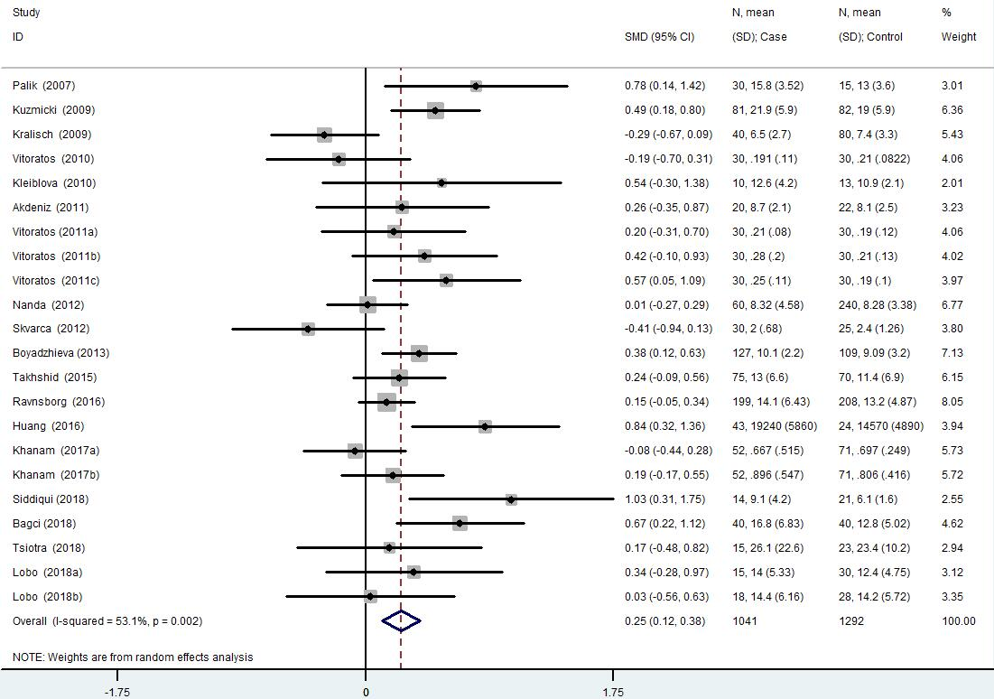

Figure 2 Meta-analysis for the association of serum resistin level with **gestational diabetes mellitus** risk using a random effects model.

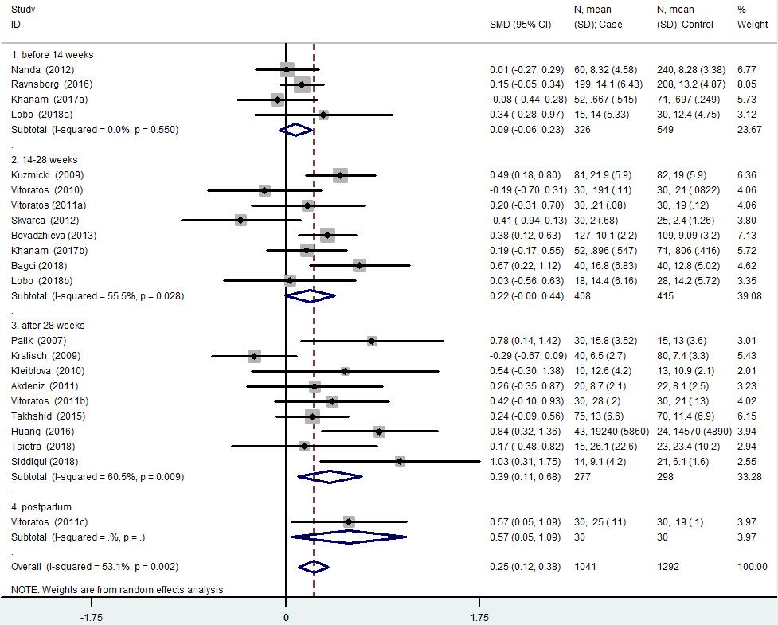

Figure 3 Gestational age at blood sampling subgroup analysis using a random effects model.

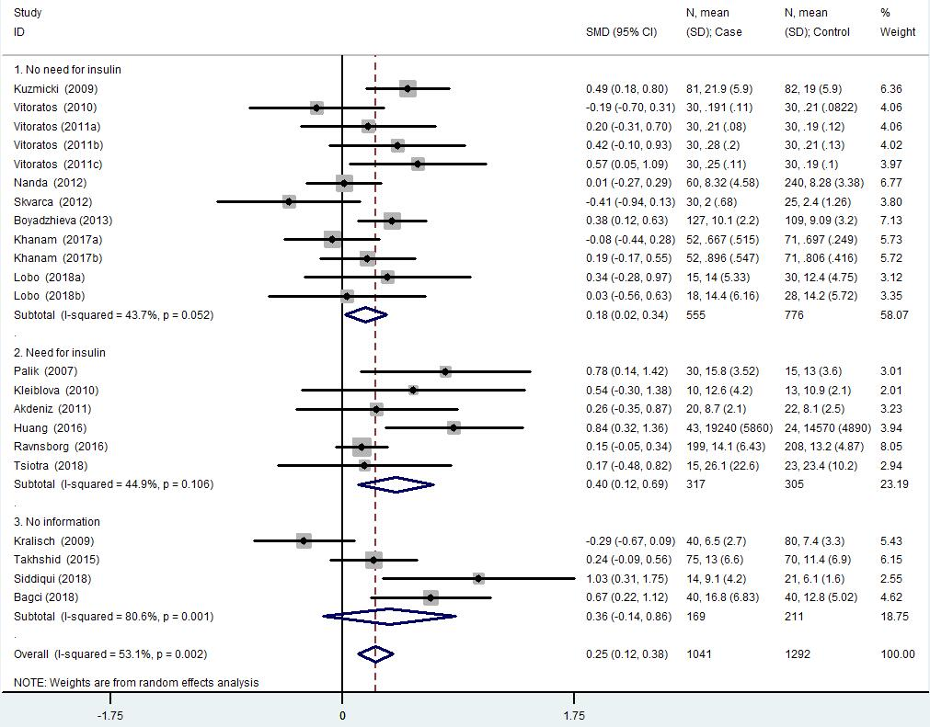

Figure 4 Need for insulin subgroup analysis using a random effects model.



Figure 5 Results of sensitivity analysis of serum resistin level with **gestational diabetes mellitus** risk.



Figure 6 Begg’s funnel plot for publication bias test of serum resistin level with **gestational diabetes mellitus** risk. SMD: Standardized mean difference.

Table 1 Detailed characteristics of all eligible studies for the association between serum resistin levels and **gestational diabetes mellitus**

|  |  |  |  |  |  |  |  |  |  |  |
| --- | --- | --- | --- | --- | --- | --- | --- | --- | --- | --- |
| **Ref.** | **Location** | **Study design** | **Number GDM/C** | **GDM diagnosis** | **Time for sampling** | **Assay method** | **Need for insulin *n* (%)** | **Resistin level, ng/mL mean (SD)** | | |
| **GDM** | **Control** | *P* |
| Tsiotra *et al*[49], 2018 | Greece | CC | 15/23 | 75 g ADA | 39 wk | LUMINEX  xMAP | 4 (26.7) | 26.147 (7.337) | 23.440 (1.567) | NS |
| Lobo *et al*[42], 2018 | Brazil | CC | 15/30 | 75 g IADPSG | <14 wk | ELISA | 0 | 14.047 (5.334) | 12.357 (4.747) | NS |
|  |  |  | 18/28 |  | 14-20 wk |  | 0 | 14.420 (6.157) | 14.219 (5.721) | NS |
| Siddiqui *et al*[25], 2018 | Saudi Arabia | CC | 14/21 | 100 g ADA | 24-32 wk | Randox evidence  biochip analyzer | NI | 9.1 (4.2) | 6.1 (1.6) | 0.02 |
| Bagci *et al*[21], 2018 | Turkey | CC | 40/40 | 100 g NDDG | 24-28 wk | ELISA | NI | 16.78 (6.83) | 12.79 (5.02) | 0.004 |
| Khanam *et al*[37], 2017 | Australia | Cohort | 52/71 | 75 g ADIPS | 14 wk | Multiplex  assay kits | 0 | 0.667 (0.515) | 0.697 (0.249) | NS |
|  |  |  | 52/71 |  | 18 wk |  | 0 | 0.896 (0.547) | 0.806 (0.416) | NS |
| Ravnsborg *et al*[45], 2016 | Denmark | CC | 199/208 | 75 g 2 h ≥ 9.0 mmol/L | 8+1-13+6 wk | ELISA | 78 (39.2) | 14.06 (6.43) | 13.22 (4.87) | NS |
| Huang *et al*[13], 2016 | China | CC | 43/24 | 75 g IADPSG | 37-40 wk | ELISA | 17 (39.5) | 19240 (5860) | 14570 (4890) | <0.05 |
| Takhshid and Zare[48], 2015 | Iran | CC | 75/70 | 100 g Carpenter and Coustan | 30 wk | ELISA | NI | 13.0 (6.6) | 11.4 (6.9) | NS |
| Boyadzhieva *et al*[32], 2013 | Bulgaria | CC | 127/109 | 75 g IADPSG | 24-28 wk | BioVendor® kits | 0 | 10.11 (2.2) | 9.09 (3.2) | NS |
| Nanda *et al*[43], 2012 | UK | CC | 60/240 | 75 g fasting ≥ 6.0 mmol/L or  2 h ≥ 7.8 mmol/L | 11-13 wk | ELISA | 0 | 8.32 (4.58) | 8.28 (3.38) | NS |
| Skvarca *et al*[47], 2012 | Slovenia | CS | 30/25 | 100 g Carpenter and Coustan | Approximately 27 wk | ELISA | 0 | 2.00 (0.68) | 2.40 (1.26) | NS |
| Akdeniz *et al*[31], 2011 | Turkey | CC | 20/22 | ADA | Before delivery | ELISA | 20 (100) | 8.7 (2.1) | 8.1 (2.5) | NS |
| Vitoratos *et al*[18], 2011 | Greece | Cohort | 30/30 | 100 g Carpenter and Coustan | 26-28 wk | Sandwich immunoassay  kit | 0 | 0.21 (0.08) | 0.19 (0.12) | NS |
|  |  |  | 30/30 |  | 38 wk |  | 0 | 0.28 (0.2) | 0.21 (0.13) | 0.02 |
|  |  |  | 30/30 |  | The third postpartum day |  | 0 | 0.25 (0.11) | 0.19 (0.10) | 0.03 |
| Kleiblova *et al*[38], 2010 | Czech Republic | CC | 10/13 | 75 g Czech Diabetes Association | At delivery | ELISA | 10 (100) | 12.6 (4.2) | 10.9 (2.1) | NS |
| Vitoratos *et al*[50], 2010 | Greece | CC | 30/30 | 100 g Carpenter and Coustan | 24-26 wk | Sandwich immunoassay  kit | 0 | 0.1913 (0.1096) | 0.21 (0.0822) | NS |
| Kralisch *et al*[39], 2009 | Germany | CC | 40/80 | 75 g ADA | G: 29 ± 3 wk  C: 28 ± 4 wk | ELISA | NI | 6.5 (2.7) | 7.4 (3.3) | NS |
| Kuzmicki *et al*[14], 2009 | Poland | CC | 81/82 | 75 g WHO | 24-31 wk | Quantikine  immunoassay kit | 0 | 21.9 (5.9) | 19.0 (5.9) | <0.001 |
| Palik *et al*[17], 2007 | Hungary | CS | 30/15 | 75 g WHO | 26-30 wk | ELISA | 30 (100) | 15.76 (3.52) | 13.0 (3.60) | <0.001 |

CC: Case-control study; CS: Cross-sectional study; ADA: American Diabetes Association; IADPSG: International Association of Diabetic Pregnancy Study Group; WHO: World Health Organization; NDDG: National Diabetes Data Group; ADIPS: Australasian Diabetes in Pregnancy Society; RIA: Radio Immunoassay; NI: No information; NS: Non-significant.

Table 2 Quality assessment of the included studies based on scores of Newcastle-Ottawa Scale (case-control study version and cohort version)

|  |  |  |  |  |  |  |  |  |  |
| --- | --- | --- | --- | --- | --- | --- | --- | --- | --- |
| **Ref.** | **Case definition adequacy** | **Representativeness of cases** | **Selection of controls** | **Definition of controls** | **Comparability of cases and controls** | **Ascertainment of exposure** | **Same method of ascertainment for cases and controls** | **Non-response rate** | **Total quality score** |
| Tsiotra *et al*[49], 2018 | 1 | 0 | 0 | 1 | 1 | 1 | 1 | NI | 5 |
| Lobo *et al*[42], 2018 | 1 | 1 | 1 | 1 | 2 | 1 | 1 | 1 | 9 |
| Siddiqui *et al*[25], 2018 | 1 | 0 | 0 | 1 | 1 | 1 | 1 | NI | 5 |
| Bagci *et al*[21], 2018 | 1 | 0 | 0 | 1 | 1 | 1 | 1 | NI | 5 |
| Ravnsborg *et al*[45], 2016 | 1 | 1 | 1 | 1 | 2 | 1 | 1 | 1 | 9 |
| Huang *et al*[13], 2016 | 1 | 0 | 0 | 1 | 2 | 1 | 1 | NI | 6 |
| Takhshid and Zare[48], 2015 | 1 | 0 | 0 | 1 | 2 | 1 | 1 | NI | 6 |
| Boyadzhieva *et al*[32], 2013 | 1 | 1 | 1 | 1 | 1 | 1 | 1 | NI | 7 |
| Nanda *et al*[43],2012 | 1 | 1 | 0 | 1 | 1 | 1 | 1 | NI | 6 |
| Skvarca *et al*[47], 2012 | 1 | 0 | 0 | 1 | 2 | 1 | 1 | NI | 6 |
| Akdeniz *et al*[31], 2011 | 1 | 0 | 0 | 1 | 1 | 1 | 1 | NI | 5 |
| Kleiblova *et al*[38], 2010 | 1 | 0 | 0 | 1 | 1 | 1 | 1 | NI | 5 |
| Vitoratos *et al*[50], 2010 | 1 | 0 | 0 | 1 | 2 | 1 | 1 | NI | 6 |
| Kralisch *et al*[39], 2009 | 1 | 0 | 0 | 1 | 2 | 1 | 1 | NI | 6 |
| Kuzmicki *et al*[14], 2009 | 1 | 0 | 0 | 1 | 2 | 1 | 1 | NI | 6 |
| Palik *et al*[17], 2007 | 1 | 0 | 0 | 1 | 1 | 1 | 1 | NI | 5 |
| **Ref.** | **Representativeness of the exposed cohort** | **Selection of the non-exposed cohort** | **Ascertainment of exposure** | **Demonstration that outcome of interest was not present at start of study** | **Comparability of cohorts** | **Assessment of outcome** | **Follow-up long enough for outcomes to occur** | **Adequacy of follow -up of cohorts** | **Total quality score** |
| Khanam *et al*[37], 2017 | 0 | 1 | 1 | 1 | 2 | 1 | 1 | 0 | 7 |
| Vitoratos *et al*[18], 2011 | 0 | 1 | 1 | 1 | 2 | 1 | 1 | 1 | 8 |

NI: No information.

Table 3 Summary of different comparative results of serum resistin level with **gestational diabetes mellitus** risk

|  |  |  |  |  |  |  |  |  |  |
| --- | --- | --- | --- | --- | --- | --- | --- | --- | --- |
| **Category** |  | **No. of comparisons** | **No. of cases** | **No. of controls** | **SMD (95%CI)** | **Z** | ***P*** | ***I*2%** | ***P*het** |
| Overall |  | 22 | 1041 | 1292 | 0.250 (0.116, 0.384) | 3.65 | 0.000 | 53.1 | 0.002 |
| Gestational age at blood sampling | Before 14 wk | 4 | 326 | 549 | 0.087 (-0.055, 0.230) | 1.20 | 0.229 | 0.0 | 0.550 |
|  | 14-28 wk | 8 | 408 | 415 | 0.217 (-0.003, 0.436) | 1.93 | 0.053 | 55.5 | 0.028 |
|  | After 28 wk | 9 | 277 | 298 | 0.394 (0.108, 0.680) | 2.70 | 0.007 | 60.5 | 0.009 |
|  | Postpartum | 1 | 30 | 30 | 0.571 (0.054, 1.087) | - | - | - | - |
| Need for insulin | No need for insulin | 12 | 555 | 776 | 0.177 (0.018, 0.336) | 2.18 | 0.029 | 43.7 | 0.052 |
|  | Need for insulin | 6 | 317 | 305 | 0.403 (0.119, 0.687) | 2.78 | 0.005 | 44.9 | 0.106 |
|  | No information | 4 | 169 | 211 | 0.356 (-0.143, 0.855) | 1.40 | 0.162 | 80.6 | 0.001 |

*P*het: *P* value for heterogeneity; OR: Odds ratio; CI: Confidence interval; SMD: Standardized mean difference.

Table 4 Meta-regression analysis results

|  |  |  |  |  |  |  |
| --- | --- | --- | --- | --- | --- | --- |
| **Covariate** | **Coefficient** | **Std. error** | ***t*** | ***P*** | **95%CI**  **lower** | **95%CI**  **upper** |
| No need for insulin | -0.482 | 0.183 | -2.64 | 0.017 | -0.868 | -0.097 |
| Need for insulin | -0.169 | 0.190 | -0.89 | 0.388 | -0.570 | 0.233 |
| Age distribution similar | 0.298 | 0.126 | 2.37 | 0.030 | 0.033 | 0.563 |
| ELISA | -0.399 | 0.160 | -2.50 | 0.023 | -0.737 | -0.062 |