Name of Journal: World Journal of Clinical Cases
Manuscript NO: 86513
Manuscript Type: ORIGINAL ARTICLE

Retrospective Study
Oncologic efficacy of gonadotropin-releasing hormone agonist in hormone receptor-positive very young breast cancer patients treated with neoadjuvant chemotherapy

Choi HJ et al. GnRH agonist in very young BC

Hee Jun Choi, Jun Ho Lee, Chang Shin Jung, Jai Min Ryu, Byung Joo Chae, Se Kyung Lee, Jong Han Yu, Seok Won Kim, Seok Jin Nam, Jeong Eon Lee, Youn Joo Jung, Hyun Yul Kim

Hee Jun Choi, Jun Ho Lee, Chang Shin Jung, Department of Surgery, Samsung Changwon Hospital, Sungkyunkwan University School of Medicine, Changwon 51353, South Korea

Jai Min Ryu, Byung Joo Chae, Se Kyung Lee, Jong Han Yu, Seok Won Kim, Seok Jin Nam, Jeong Eon Lee, Division of Breast Surgery, Department of Surgery, Samsung Medical Center, Sungkyunkwan University School of Medicine, Seoul 06351, South Korea

Youn Joo Jung, Hyun Yul Kim, Department of Surgery, Pusan National University Yangsan Hospital, Pusan National University School of Medicine, Gyeongnam 50612, South Korea

Author contributions: Choi HJ is the first author, planed and wrote this manuscript; all played a role in the data organization and modulation of this article; Kim HY planed, revised, edited and submitted this article.

Corresponding author: Hyun Yul Kim, MD, PhD, Associate Professor, Department of Surgery, Pusan National University Yangsan Hospital, Pusan National University School of Medicine, Beomeo-ri, Mulgeum-eup, Yangsan-si, Gyeongnam 50612, South Korea. isepa102@naver.com

Received: June 23, 2023
Revised: July 17, 2023
Accepted: August 25, 2023
Published online: September 26, 2023

Abstract
BACKGROUND
Breast cancer in young women has been shown to have an aggressive behavior and poor prognosis.

AIM
To evaluate the outcomes of young hormone receptor (HR)-positive patients with breast cancer treated with neoadjuvant chemotherapy (NAC), and the oncologic efficacy of gonadotropin-releasing hormone (GnRH) agonists.

METHODS
This retrospective study involved a prospectively enrolled cohort. We included patients diagnosed with invasive breast cancer who were treated with NAC followed by curative surgery at the Samsung Medical Center and Samsung Changwon Hospital between January 2006 and December 2017. Among patients with HR-positive and human epidermal grow factor 2 (HER2)-negative breast cancer, we analyzed the characteristics and oncology outcomes between the patients equal to or younger than 35 years and the patients older than 35 years.

RESULTS
Among 431 patients with NAC and HR-positive/HER2-negative breast cancer, 78 were 35 years old or younger, and 353 patients were older than 35 years. The median follow-up was 71.0 months. There was no statistically significant difference in disease free survival (DFS, P = 0.565) and overall survival (P = 0.820) between the patients equal to or younger than 35 years and the patients older than 35 years. The two groups differed in that the GnRH agonist was used more frequently in the group of patients equal to or younger than 35 years than in the other group (52.4% vs 11.2%, P < 0.001). Interestingly, for the DFS according to the GnRH agonist in the group of patients equal to or younger than 35 years, patients treated with the GnRH agonist had better DFS (P = 0.037).

CONCLUSION
Administration of GnRH agonists might improve the DFS rate of HR-positive/HER2-negative breast cancer in the equal to or younger than 35 years group of patients with NAC.

Key Words: Gonadotropin-releasing hormone Agonist; Young; Breast; Cancer

©The Author(s) 2023. Published by Baishideng Publishing Group Inc. All rights reserved.

Citation: Choi HJ, Lee JH, Jung CS, Ryu JM, Chae BJ, Lee SK, Yu JH, Kim SW, Nam SJ, Lee JE, Jung YJ, Kim HY. Oncologic efficacy of gonadotropin-releasing hormone agonist in hormone receptor-positive very young breast cancer patients treated with neoadjuvant chemotherapy. World J Clin Cases 2023; 11(27): 6398-6406
URL: https://www.wjgnet.com/2307-8960/full/v11/i27/6398.htm
DOI: https://dx.doi.org/10.12998/wjcc.v11.i27.6398

Core Tip: The treatment of ovarian suppression was effected a better oncology outcome in the group with clinical high risk, hormone receptor (+) breast cancer. However few studies have compared the efficacy of gonadotropin-releasing hormone (GnRH) agonists for 2 years in patients with neoadjuvant chemotherapy. The aim of our study was to evaluate the efficacy of GnRH agonist treatment in young breast cancer patients.

INTRODUCTION
In Western countries, approximately 4% of the patients with breast cancer are younger than 35 years^{[1,2]}. In Asian countries, approximately 5%-6% of patients with breast cancer are diagnosed at a young age, with the mean age at diagnosis being 10 years younger than that in Western countries^{[3-5]}. According to data from the Korean Breast Cancer Society, 5.3% of patients with breast cancer are aged < 35 years^{[6]}.
Previous studies have reported that younger patients diagnosed with breast cancer may have more advanced stages and more aggressive tumor biology. Younger patients had higher-grade tumors that were poorly differentiated, hormone receptor (HR)-negative, and human epidermal growth factor 2 (HER2)-positive, a higher grade^{[7,8]}. Additionally, young patients with breast cancer show a poorer response to treatment than older patients. Therefore, these patients had worse outcomes than older patients^{[9,10]}. Younger patients also exhibited higher rates of recurrence and mortality risk than older patients, and HR-positive/HER2-negative tumors were significantly different in terms of oncological outcomes between the younger and older groups^{[11,12]}.
Recently, the suppression of ovarian function trial (SOFT) and the tamoxifen and exemestane trial (TEXT) demonstrated that treatment of ovarian suppression resulted in a better oncology outcome in the clinically high-risk group. Patients who were 35 years or younger exhibited better survival with this treatment than with tamoxifen^{[13-15]}. Treatment efficacy, adherence, and quality of life among women younger than 35 years were evaluated according to the International Breast Cancer Study Group SOFT and TEXT adjuvant endocrine therapy trials^{[16]}. However, few studies have compared the efficacy of gonadotropin-releasing hormone (GnRH) agonists over 2 years in patients receiving neoadjuvant chemotherapy (NAC). The aim of our study was to investigate survival differences in HR-positive/HER2-negative breast cancer patients treated with NAC and to evaluate the efficacy of GnRH agonist treatment in young patients with breast cancer.

MATERIALS AND METHODS
We reviewed the medical records of a prospectively collected cohort. We included patients diagnosed with invasive breast cancer who were treated with NAC followed by curative surgery at the Samsung Medical Center and Samsung Changwon Hospital between January 2006 and December 2017. This study included 431 patients with HR-positive/HER2-negative breast cancer patients. We compared the characteristics and oncological outcomes between the equal-to-or-younger-than-35-years group (n = 78) and the older-than-35-years group (n = 353) (Figure 1).
We included patients newly diagnosed with primary invasive breast cancer who were treated with NAC between 2006 and 2017. Patients with metastatic, bilateral, HER2-positive breast cancer, and triple-negative breast cancers were excluded. In HER2-positive breast cancer and triple-negative breast cancers, GnRH agonist treatment is administered before NAC for ovarian protection; however, continuous GnRH agonist treatment is not administered. Therefore, this study included only HR-positive/HER2-negative breast cancer patients who had undergone GnRH treatment for more than two years, excluding HER2-positive breast cancer and triple-negative breast cancer. The two treatment groups were analyzed in this study. One patient received a GnRH agonist concurrent with NAC for fertility preservation and ovarian suppression over the course of two years, and the other received NAC alone during the same period.
We used anti-ER and anti-PgR monoclonal antibodies on 10% formalin-fixed, paraffin-embedded tissues. Only nuclear (non cytoplasmic) staining was performed. A positive test was defined as one having positive staining greater than or equal to 1% of the tumor cells. A negative test result was defined as one having staining of less than 1% of the tumor cells. We also combined our report with the Allred score interpretation system, which includes intensity (0-3) and proportion scores (0-5). We used an anti-HER2 monoclonal antibody in 10% formalin-fixed paraffin-embedded tissues. Incomplete membrane staining that is faint /barely perceptible and in > 10% of tumor cells is “1+”. No staining is observed or membrane staining that is incomplete and is faint/barely perceptible and in ≤ 10% of tumor cells is “0”. A negative test result was defined as a staining score of 0/1 +.
Most patients were administered anthracycline- and/or taxane-based regimens. These regimens include anthracycline plus cyclophosphamide, followed by a taxane-based regimen. Adjuvant radiotherapy (RT) was performed using tangential fields in all patients after breast conserving surgery.
We used the chi-square test and Spearman’s correlation coefficient to compare discrete variables, and conducted survival analysis using the log-rank test. Using the Kaplan-Meier method, we constructed survival curves to determine the statistical significance of survival. Differences were considered significant when the P value was less than 0.05. We performed chi-square tests and calculated the logistic regression using SPSS version 22. This study was approved by the Institutional Review Board of 000, Seoul, South Korea (IRB file No. 2017-12-118-002).

RESULTS
Among 431 patients with NAC and HR-positive/HER2-negative breast cancer, 78 patients were equal to or younger than 35 years old, and 353 patients were older than 35 years old. There were no specific differences in the patient characteristics according to age. The pCR of patients equal to or younger than 35 years and patients older than 35 years is both low (4.8% and 3.9%, respectively). However, GnRH agonists were more frequently used in patients younger than 35 years than in patients older than 35 years (52.4% vs 11.2%, P < 0.001) (Table 1). There were no specific differences in patient characteristics according to GnRH agonist treatment in patients younger than 35 years (Table 2).
The 5 year-disease free survival (DFS) rate of patients equal to or younger than 35 years was 71.8%, and that of patients older than 35 years was 77.6%. There was no statistically significant difference in DFS (P = 0.565) and overall survival (P = 0.820) rates between the patients equal to or younger than 35 years and those older than 35 years (Figure 2).
Interestingly, among the 78 patients who were 35 years old or younger, 30 were treated with an additional GnRH agonist, and three experienced recurrences. However, 48 patients were not treated with GnRH agonists, and 19 patients experienced recurrence. Among the patients equal to or younger than 35 years, those who were treated with a GnRH agonist had a lower DFS (89.3% vs 62.0%, P = 0.037) and there was no statistically significant difference in OS (P = 0.341) rates (Figure 3).

DISCUSSION
Young patients with HR-positive breast cancer were treated with tamoxifen and ovarian suppression with a GnRH agonist after surgery and had a greater advantage in DFS than patients from a previous period^{[17]}. Since the young patients with HR-positive/HER2-negative breast cancer with NAC were treated with tamoxifen and GnRH agonist, our study demonstrates that oncologic outcomes of HR-positive/HER2-negative breast cancer patients equal to or younger than 35 years of age have improved overall with time.
The pCR rate and proliferation index decreased more in HR-positive tumors than in other breast cancer subtypes. For HR-positive tumors, the pCR rate was low and unrelated to survival in a previous neoadjuvant study^{[18-20]}. Therefore, neoadjuvant trials could not determine the oncological efficacy in HR-positive tumors because of the low pCR rate and the absence of any relationship with survival. Understanding the effect on the frequency of recurrence would help clinicians make decisions regarding additional treatment options for patients receiving neoadjuvant treatment for ER-positive breast cancer. The persistence of amenorrhea may help prevent relapses. This study demonstrated that young patients with breast cancer treated with GnRH agonists exhibited improved oncological outcomes.
For the SOFT trial, even though there was no statistical significance in treating with an additional GnRH agonist in the first report from this trial, patients aged 35 years or younger exhibited improved survival with this treatment than with tamoxifen. The benefits of tamoxifen combined with a GnRH agonist versus tamoxifen alone were apparent at the highest composite risk. Moreover, the SOFT cohort included more young patients with less lymph node involvement and smaller tumors than the TEXT cohort. Despite these differences, the patients who received chemotherapy exhibited better oncological outcomes than those who received chemotherapy in the SOFT trial. The TEXT subjects were concurrently administered adjuvant ovarian suppression using a GnRH agonist^{[21]}. Early start and persistence of amenorrhea with active endocrine treatment may be important in HR-positive/HER2-negative younger breast cancer patients receiving NAC. Evidence has demonstrated that complete ovarian suppression treatment improves oncological outcomes in younger HR-positive/HER2-negative breast cancer patients.
Advancements in oncological outcomes were found to be statistically significant for HR-positive/HER2-negative patients in the younger age group, which may be related to the greater use of tamoxifen and the introduction of GnRH agonists^{[17,22]}. Administering GnRH agonists to young patients with breast cancer and NAC had the effect of prolongs amenorrhea during chemotherapy^{[23]}. Treating with GnRH agonists can safely be considered in young women with breast cancer in terms of oncological outcomes^{[24]}. The recent initiation of GnRH agonist treatment may be the main reason for the improved survival of younger patients with breast cancer.
This study had several limitations. First, only HR-positive/HER2-negative breast cancer treated with NAC were included. Therefore, a small sample size was used for this study. Second, this retrospective study was limited to two comprehensive cancer institutions. Despite these limitations, this study is valuable, because many young patients with breast cancer have the HR-positive/HER2-negative subtype. This type of NAC is associated with a low pCR rate. In addition, many young women with breast cancer struggle with the competing interests of optimizing personal survival and maintaining ovarian function^{[25]}. GnRH agonists are effective in preserving ovarian function and may have oncologic efficacy against breast cancer.

CONCLUSION
Administration of GnRH agonists might improve the DFS outcome of HR-positive/HER2-negative breast cancer patients who are 35 years or younger with NAC. Therefore, HR-positive/HER2-negative breast cancer patients and those younger than 35 with NAC are encouraged to be treated with GnRH agonist.

ARTICLE HIGHLIGHTS
Research background
There are many younger breast cancer patients in Korea than in the West, and they are known to have a poor prognosis.

Research motivation
To improve the prognosis of hormone receptor (HR) positive young breast cancer patients.

Research objectives
To investigate the efficacy of gonadotropin-releasing hormone (GnRH) agonist treatment in HR positive young breast cancer patients.

Research methods
We analyzed the characteristics and oncology outcomes between the equal-to-or-younger-than-35-years group (n = 78) and the older-than-35-years group (n = 353).

Research results
GnRH agonist was more significantly used in patients younger than 35 years old than in patients older than 35 years (52.4% vs 11.2%, P < 0.001).

Research conclusions
The GnRH agonists might improve the disease free survival outcome of HR-positive/HER2-negative breast cancer patients.

Research perspectives
Administration of GnRH agonist with anti-hormonenal therapy is helpful in young breast cancer patients.

REFERENCES
1 Chung M, Chang HR, Bland KI, Wanebo HJ. Younger women with breast carcinoma have a poorer prognosis than older women. Cancer 1996; 77: 97-103 [PMID: 8630946 DOI: 10.1002/(SICI)1097-0142(19960101)77:1<97::AID-CNCR16>3.0.CO;2-3]
2 Winchester DP. Breast cancer in young women. Surg Clin North Am 1996; 76: 279-287 [PMID: 8610264 DOI: 10.1016/s0039-6109(05)70439-4]
3 Chen HL, Zhou MQ, Tian W, Meng KX, He HF. Effect of Age on Breast Cancer Patient Prognoses: A Population-Based Study Using the SEER 18 Database. PLoS One 2016; 11: e0165409 [PMID: 27798652 DOI: 10.1371/journal.pone.0165409]
4 Sivasubramaniam PG, Zhang BL, Zhang Q, Smith JS, Zhang B, Tang ZH, Chen GJ, Xie XM, Xu XZ, Yang HJ, He JJ, Li H, Li JY, Fan JH, Qiao YL. Breast Cancer Disparities: A Multicenter Comparison of Tumor Diagnosis, Characteristics, and Surgical Treatment in China and the U.S. Oncologist 2015; 20: 1044-1050 [PMID: 26240131 DOI: 10.1634/theoncologist.2014-0290]
5 Wang K, Ren Y, Li H, Zheng K, Jiang J, Zou T, Ma B, Li H, Liu Q, Ou J, Wang L, Wei W, He J, Ren G. Comparison of Clinicopathological Features and Treatments between Young (≤ 40 Years) and Older (> 40 Years) Female Breast Cancer Patients in West China: A Retrospective, Epidemiological, Multicenter, Case Only Study. PLoS One 2016; 11: e0152312 [PMID: 27031236 DOI: 10.1371/journal.pone.0152312]
6 Lee HB, Han W. Unique features of young age breast cancer and its management. J Breast Cancer 2014; 17: 301-307 [PMID: 25548576 DOI: 10.4048/jbc.2014.17.4.301]
7 Anders CK, Hsu DS, Broadwater G, Acharya CR, Foekens JA, Zhang Y, Wang Y, Marcom PK, Marks JR, Febbo PG, Nevins JR, Potti A, Blackwell KL. Young age at diagnosis correlates with worse prognosis and defines a subset of breast cancers with shared patterns of gene expression. J Clin Oncol 2008; 26: 3324-3330 [PMID: 18612148 DOI: 10.1200/JCO.2007.14.2471]
8 Gogia A, Raina V, Deo SV, Shukla NK, Mohanti BK, Sharma DN. Inflammatory breast cancer: a single centre analysis. Asian Pac J Cancer Prev 2014; 15: 3207-3210 [PMID: 24815472 DOI: 10.7314/apjcp.2014.15.7.3207]
9 Aalders KC, Postma EL, Strobbe LJ, van der Heiden-van der Loo M, Sonke GS, Boersma LJ, van Diest PJ, Siesling S, van Dalen T. Contemporary Locoregional Recurrence Rates in Young Patients With Early-Stage Breast Cancer. J Clin Oncol 2016; 34: 2107-2114 [PMID: 26976422 DOI: 10.1200/JCO.2015.64.3536]
10 Azim HA Jr, Partridge AH. Biology of breast cancer in young women. Breast Cancer Res 2014; 16: 427 [PMID: 25436920 DOI: 10.1186/s13058-014-0427-5]
11 Aebi S, Gelber S, Castiglione-Gertsch M, Gelber RD, Collins J, Thürlimann B, Rudenstam CM, Lindtner J, Crivellari D, Cortes-Funes H, Simoncini E, Werner ID, Coates AS, Goldhirsch A. Is chemotherapy alone adequate for young women with oestrogen-receptor-positive breast cancer? Lancet 2000; 355: 1869-1874 [PMID: 10866443 DOI: 10.1016/s0140-6736(00)02292-3]
12 Goldhirsch A, Gelber RD, Yothers G, Gray RJ, Green S, Bryant J, Gelber S, Castiglione-Gertsch M, Coates AS. Adjuvant therapy for very young women with breast cancer: need for tailored treatments. J Natl Cancer Inst Monogr 2001; 44-51 [PMID: 11773291 DOI: 10.1093/oxfordjournals.jncimonographs.a003459]
13 Francis PA, Regan MM, Fleming GF, Láng I, Ciruelos E, Bellet M, Bonnefoi HR, Climent MA, Da Prada GA, Burstein HJ, Martino S, Davidson NE, Geyer CE Jr, Walley BA, Coleman R, Kerbrat P, Buchholz S, Ingle JN, Winer EP, Rabaglio-Poretti M, Maibach R, Ruepp B, Giobbie-Hurder A, Price KN, Colleoni M, Viale G, Coates AS, Goldhirsch A, Gelber RD; SOFT Investigators; International Breast Cancer Study Group. Adjuvant ovarian suppression in premenopausal breast cancer. N Engl J Med 2015; 372: 436-446 [PMID: 25495490 DOI: 10.1056/NEJMoa1412379]
14 Regan MM, Francis PA, Pagani O, Fleming GF, Walley BA, Viale G, Colleoni M, Láng I, Gómez HL, Tondini C, Pinotti G, Price KN, Coates AS, Goldhirsch A, Gelber RD. Absolute Benefit of Adjuvant Endocrine Therapies for Premenopausal Women With Hormone Receptor-Positive, Human Epidermal Growth Factor Receptor 2-Negative Early Breast Cancer: TEXT and SOFT Trials. J Clin Oncol 2016; 34: 2221-2231 [PMID: 27044936 DOI: 10.1200/JCO.2015.64.3171]
15 Pagani O, Regan MM, Walley BA, Fleming GF, Colleoni M, Láng I, Gomez HL, Tondini C, Burstein HJ, Perez EA, Ciruelos E, Stearns V, Bonnefoi HR, Martino S, Geyer CE Jr, Pinotti G, Puglisi F, Crivellari D, Ruhstaller T, Winer EP, Rabaglio-Poretti M, Maibach R, Ruepp B, Giobbie-Hurder A, Price KN, Bernhard J, Luo W, Ribi K, Viale G, Coates AS, Gelber RD, Goldhirsch A, Francis PA; TEXT and SOFT Investigators; International Breast Cancer Study Group. Adjuvant exemestane with ovarian suppression in premenopausal breast cancer. N Engl J Med 2014; 371: 107-118 [PMID: 24881463 DOI: 10.1056/NEJMoa1404037]
16 Saha P, Regan MM, Pagani O, Francis PA, Walley BA, Ribi K, Bernhard J, Luo W, Gómez HL, Burstein HJ, Parmar V, Torres R, Stewart J, Bellet M, Perelló A, Dane F, Moreira A, Vorobiof D, Nottage M, Price KN, Coates AS, Goldhirsch A, Gelber RD, Colleoni M, Fleming GF; SOFT; TEXT Investigators; International Breast Cancer Study Group. Treatment Efficacy, Adherence, and Quality of Life Among Women Younger Than 35 Years in the International Breast Cancer Study Group TEXT and SOFT Adjuvant Endocrine Therapy Trials. J Clin Oncol 2017; 35: 3113-3122 [PMID: 28654365 DOI: 10.1200/JCO.2016.72.0946]
17 Yoon TI, Hwang UK, Kim ET, Lee S, Sohn G, Ko BS, Lee JW, Son BH, Kim S, Ahn SH, Kim HJ. Survival improvement in hormone-responsive young breast cancer patients with endocrine therapy. Breast Cancer Res Treat 2017; 165: 311-320 [PMID: 28601930 DOI: 10.1007/s10549-017-4331-4]
18 von Minckwitz G, Untch M, Blohmer JU, Costa SD, Eidtmann H, Fasching PA, Gerber B, Eiermann W, Hilfrich J, Huober J, Jackisch C, Kaufmann M, Konecny GE, Denkert C, Nekljudova V, Mehta K, Loibl S. Definition and impact of pathologic complete response on prognosis after neoadjuvant chemotherapy in various intrinsic breast cancer subtypes. J Clin Oncol 2012; 30: 1796-1804 [PMID: 22508812 DOI: 10.1200/JCO.2011.38.8595]
19 Villarreal-Garza C, Bargallo-Rocha JE, Soto-Perez-de-Celis E, Lasa-Gonsebatt F, Arce-Salinas C, Lara-Medina F, Reynoso-Noverón N, Matus-Santos J, Cabrera P, Alvarado-Miranda A, Mohar A. Real-world outcomes in young women with breast cancer treated with neoadjuvant chemotherapy. Breast Cancer Res Treat 2016; 157: 385-394 [PMID: 27189008 DOI: 10.1007/s10549-016-3811-2]
20 Loibl S, Jackisch C, Lederer B, Untch M, Paepke S, Kümmel S, Schneeweiss A, Huober J, Hilfrich J, Hanusch C, Gerber B, Eidtmann H, Denkert C, Costa SD, Blohmer JU, Nekljudova V, Mehta K, von Minckwitz G. Outcome after neoadjuvant chemotherapy in young breast cancer patients: a pooled analysis of individual patient data from eight prospectively randomized controlled trials. Breast Cancer Res Treat 2015; 152: 377-387 [PMID: 26109347 DOI: 10.1007/s10549-015-3479-z]
21 Regan MM, Pagani O, Fleming GF, Walley BA, Price KN, Rabaglio M, Maibach R, Ruepp B, Coates AS, Goldhirsch A, Colleoni M, Gelber RD, Francis PA; International Breast Cancer Study; GroupSOFT and TEXT Investigators. Adjuvant treatment of premenopausal women with endocrine-responsive early breast cancer: design of the TEXT and SOFT trials. Breast 2013; 22: 1094-1100 [PMID: 24095609 DOI: 10.1016/j.breast.2013.08.009]
22 Kim I, Ryu JM, Paik HJ, Park S, Bae SY, Lee SK, Yu J, Kim SW, Nam SJ, Lee JE. Fertility Rates in Young Korean Breast Cancer Patients Treated with Gonadotropin-Releasing Hormone and Chemotherapy. J Breast Cancer 2017; 20: 91-97 [PMID: 28382099 DOI: 10.4048/jbc.2017.20.1.91]
23 Kim HJ, Yoon TI, Chae HD, Kim JE, Chae EY, Yu JH, Sohn G, Ko BS, Lee JW, Son BH, Ahn SH. Concurrent Gonadotropin-Releasing Hormone Agonist Administration with Chemotherapy Improves Neoadjuvant Chemotherapy Responses in Young Premenopausal Breast Cancer Patients. J Breast Cancer 2015; 18: 365-370 [PMID: 26770243 DOI: 10.4048/jbc.2015.18.4.365]
24 Kim J, Kim M, Lee JH, Lee H, Lee SK, Bae SY, Jun SY, Kil WH, Lee JE, Kim SW, Nam SJ. Ovarian function preservation with GnRH agonist in young breast cancer patients: does it impede the effect of adjuvant chemotherapy? Breast 2014; 23: 670-675 [PMID: 25088482 DOI: 10.1016/j.breast.2014.07.005]
25 Partridge AH. Fertility preservation: a vital survivorship issue for young women with breast cancer. J Clin Oncol 2008; 26: 2612-2613 [PMID: 18509170 DOI: 10.1200/JCO.2008.16.1976]

Footnotes
Institutional review board statement: This study was approved by the Institutional Review Board of the Samsung Medical Center, Seoul, Korea (IRB file No. 2017-12-118-002). To protect personal information, patient records and information were anonymized and identities were removed prior to analysis.

Informed consent statement: Patients were not required to give informed consent to the study because the analysis used anonymous clinical data that were obtained after each patient agreed to treatment by written consent.

Conflict-of-interest statement: The authors have no conflicts of interest to declare.

Data sharing statement: Dataset available from the corresponding author at isepa102@naver.com.

Open-Access: This article is an open-access article that was selected by an in-house editor and fully peer-reviewed by external reviewers. It is distributed in accordance with the Creative Commons Attribution NonCommercial (CC BY-NC 4.0) license, which permits others to distribute, remix, adapt, build upon this work non-commercially, and license their derivative works on different terms, provided the original work is properly cited and the use is non-commercial. See: https://creativecommons.org/Licenses/by-nc/4.0/

Provenance and peer review: Unsolicited article; Externally peer reviewed.
Peer-review model: Single blind

Peer-review started: June 23, 2023
First decision: July 4, 2023
Article in press: August 25, 2023

Specialty type: Oncology
Country/Territory of origin: South Korea
Peer-review report’s scientific quality classification
Grade A (Excellent): 0
Grade B (Very good): B, B
Grade C (Good): C
Grade D (Fair): 0
Grade E (Poor): 0

P-Reviewer: Gupta S, Brazil; Yang JS, China S-Editor: Yan JP L-Editor: A P-Editor: Yan JP
Figure Legends
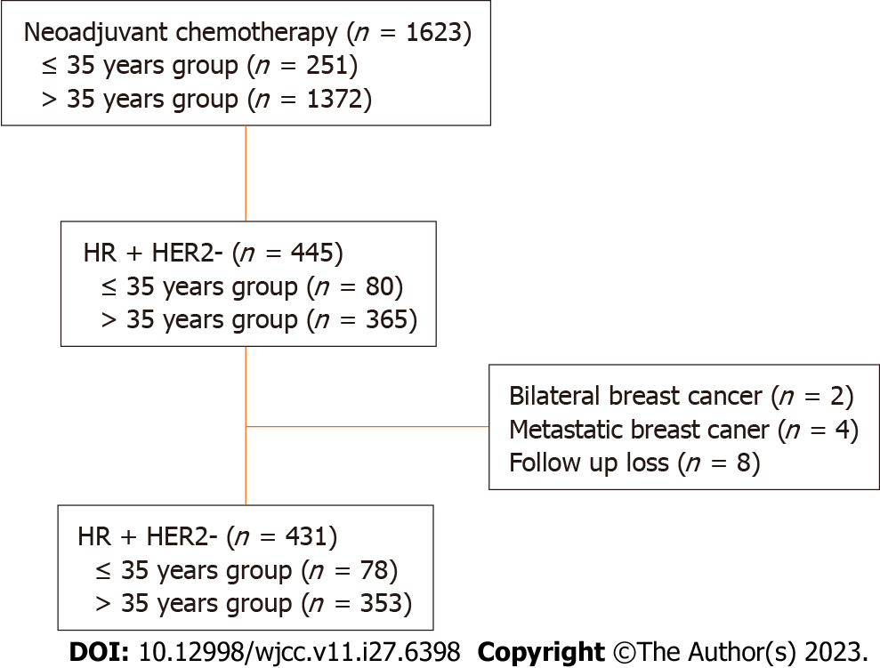
Figure 1 Algorithm of patient selection with strong hormone receptor-positive/ human epidermal grow factor 2-negative breast cancer. HR: Hormone receptor; HER2: Human epidermal grow factor 2.

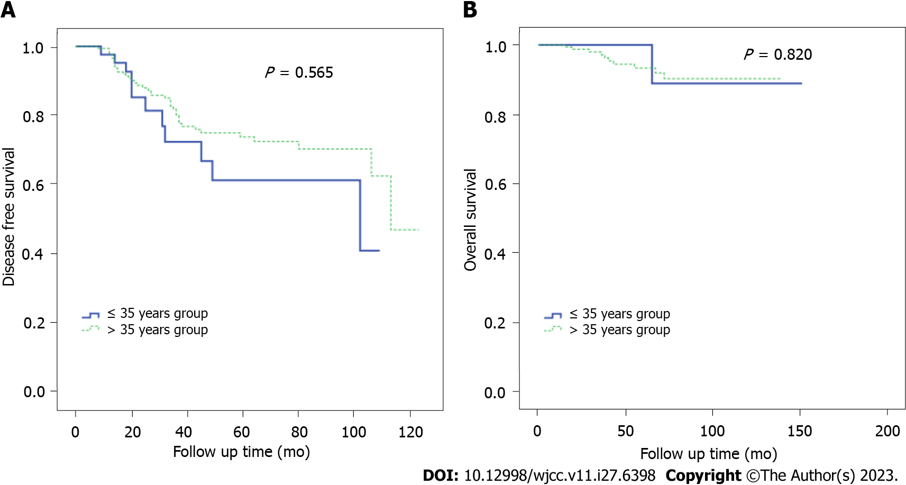
Figure 2 Kaplan-Meier survival curves for disease free survival rates and overall survival rates between patients equal to or younger than 35 years and patients older than 35 years. A: Disease free survival rates; B: Overall survival rates.

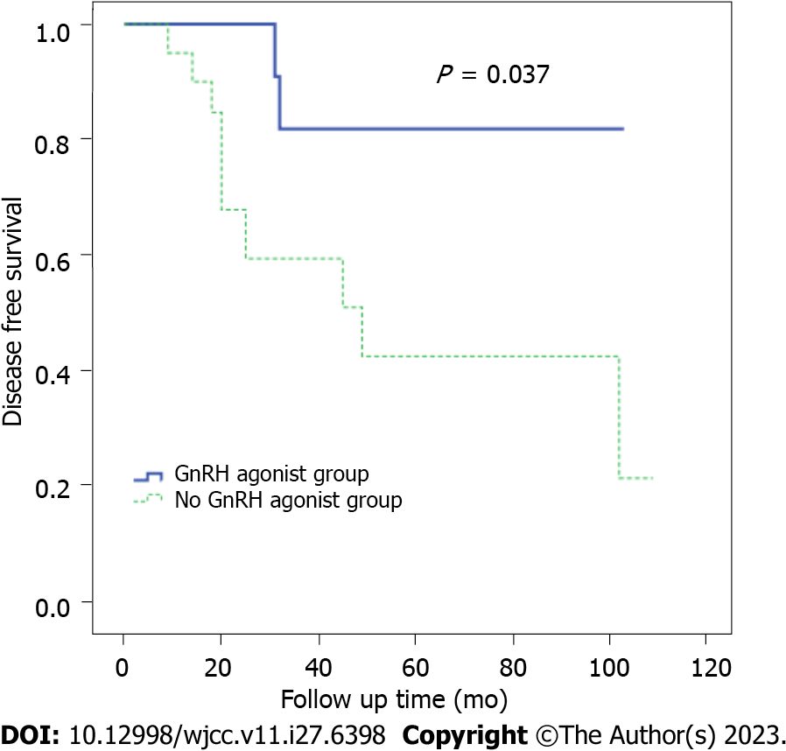
Figure 3 Kaplan-Meier survival curves for disease free survival according to gonadotropin-releasing hormone agonist among younger than 35 years group. GnRH: Gonadotropin-releasing hormone.

Table 1 Patient characteristics according to age group
Variable | ≤ 35 yr group (n = 78), n (%) | > 35 yr group (n = 353), n (%) | P value
BMI |  |  | 0.064
≤ 25 | 56 (71.8) | 211 (59.7)
> 25 | 22 (28.2) | 142 (40.23
Clinical tumor stage |  |  | 0.187
cT1 | 8 (10.26) | 15 (4.25)
cT2 | 36 (46.15) | 184 (52.12)
cT3 | 26 (33.33) | 120 (33.99)
cT4 | 8 (10.26) | 34 (9.63)
Clinical node stage |  |  | 0.237
cN1 | 14 (17.95) | 96 (27.20)
cN2 | 40 (51.28) | 162 (45.89)
cN3 | 24 (30.77) | 95 (26.91)
Pathologic tumor stage |  |  | 0.101
ypT0-is | 15 (19.23) | 34 (9.63)
ypT1 | 23 (29.49) | 116 (32.86)
ypT2 | 25 (32.05) | 111 (31.44)
ypT3 | 15 (19.23) | 84 (23.80)
ypT4 | 0 (0.00) | 8 (2.27)
Pathologic node stage |  |  | 0.336
ypN0 | 25 (32.05) | 110 (31.16)
ypN1 | 30 (38.46) | 111 (31.44)
ypN2 | 18 (23.08) | 86 (24.36)
ypN3 | 5 (6.41) | 46 (13.03)
Lymphovascular invasion |  |  | 0.739
Present | 38 (48.72) | 168 (47.59)
Absent | 32 (41.03) | 157 (44.48)
Unknown | 8 (10.26) | 28 (7.93)
Surgery |  |  | 0.195
Breast conserving | 43 (55.13) | 166 (47.03)
Mastectomy | 35 (44.87) | 187 (52.97)
Nuclear grade |  |  | 0.697
Low | 11 (14.10) | 37 (10.48)
Intermediate | 32 (41.03) | 165 (46.74)
High | 27 (34.62) | 121 (34.28)
Unknown | 8 (10.26) | 30 (8.50)
Radiation therapy |  |  | 0.642
Yes | 75 (96.15) | 335 (94.90)
No | 3 (3.85) | 18 (5.10)
GnRH agonist |  |  | < 0.001
Yes | 22 (52.4) | 20 (11.2)
No | 20 (47.6) | 158 (88.8)
GnRH: Gonadotropin-releasing hormone; BMI: Body mass index.

Table 2 Patient characteristics according to gonadotropin-releasing hormone agonist treatment in equal to or younger than 35 years patients
Variable | GnRH agonist (n = 30), n (%) | No. of GnRH agonist (n = 48), n (%) | P value
BMI |  |  | 0.999
≤ 25 | 25 (83.33) | 40 (83.33)
> 25 | 5 (16.67) | 8 (16.67)
Clinical tumor stage |  |  | 0.150
cT1 | 2 (6.67) | 6 (12.50)
cT2 | 13 (43.33) | 23 (47.92)
cT3 | 14 (46.67) | 12 (25.00)
cT4 | 1 (3.33) | 7 (14.58)
Clinical node stage |  |  | 0.185
cN1 | 8 (26.67) | 6 (12.50)
cN2 | 12 (40.00) | 28 (58.33)
cN3 | 10 (33.33) | 14 (29.17)
Pathologic tumor stage |  |  | 0.706
ypT0-is | 7 (23.33) | 8 (16.67)
ypT1 | 8 (26.67) | 15 (31.25)
ypT2 | 8 (26.67) | 17 (35.42)
ypT3 | 7 (23.33) | 8 (16.67)
ypT4 | 0 (0.00) | 0 (0.00)
Pathologic node stage |  |  | 0.061
ypN0 | 9 (30.00) | 16 (33.33)
ypN1 | 10 (33.33) | 20 (41.67)
ypN2 | 7 (23.33) | 11 (22.92)
ypN3 | 4 (13.33) | 1 (2.08)
Lymphovascular invasion |  |  | 0.754
Present | 13 (43.33) | 25 (52.08)
Absent | 14 (46.67) | 18 (37.50)
Unknown | 3 (10.00) | 5 (10.42)
Surgery |  |  | 0.472
Breast conserving | 15 (50.00) | 28 (58.33)
Mastectomy | 15 (50.00) | 20 (41.67)
Nuclear grade |  |  | 0.984
Low | 4 (13.33) | 7 (14.58)
Intermediate | 13 (43.33) | 19 (39.58)
High | 10 (33.33) | 17 (35.42)
Unknown | 3 (10.00) | 5 (10.42)
Radiation therapy |  |  | 0.555
Yes | 28 (93.33) | 47 (97.92)
No | 2 (6.67) | 1 (2.08)
GnRH: Gonadotropin-releasing hormone; BMI: Body mass index.

Published by Baishideng Publishing Group Inc
7041 Koll Center Parkway, Suite 160, Pleasanton, CA 94566, USA
Telephone: +1-925-3991568
E-mail: bpgoffice@wjgnet.com
Help Desk: https://www.f6publishing.com/helpdesk
https://www.wjgnet.com

© 2023 Baishideng Publishing Group Inc. All rights reserved.

