**Name of Journal:** *World Journal of Gastrointestinal Surgery*

**Manuscript NO:** 86092

**Manuscript Type:** MINIREVIEWS

**Minimally invasive surgery for post cholecystectomy biliary stricture: current evidence and future perspectives**

Kalayarasan R *et al*. Minimally invasive surgery for biliary stricture

Raja Kalayarasan, Pothugunta Sai Krishna

**Raja Kalayarasan, Pothugunta Sai Krishna,** Surgical Gastroenterology, Jawaharlal Institute of Postgraduate Medical Education & Research, Puducherry 605006, India

**Author contributions:** Kalayarasan R and Sai Krishna P did the literature search; Sai Krishna P wrote the first draft of the review; Kalayarasan R conceptualized the work, supervised the writing, gave intellectual inputs, and critically revised the manuscript.

**Corresponding author: Raja Kalayarasan, FRCS (Ed), MBBS, MCh, MS, Additional Professor,** Surgical Gastroenterology, Jawaharlal Institute of Postgraduate Medical Education & Research, Dhanvantri nagar, Puducherry 605006, India. kalayarasanraja@yahoo.com

**Received:** May 30, 2023

**Revised:** August 1, 2023

**Accepted:** August 17, 2023

**Published online:** October 27, 2023

**Abstract**

Postcholecystectomy bile duct injury (BDI) remains a devastating iatrogenic complication that adversely impacts the quality of life with high healthcare costs. Despite a decrease in the incidence of laparoscopic cholecystectomy-related BDI, the absolute number remains high as cholecystectomy is a commonly performed surgical procedure. Open Roux-en-Y hepaticojejunostomy with meticulous surgical technique remains the gold standard surgical procedure with excellent long-term results in most patients. As with many hepatobiliary disorders, a minimally invasive approach has been recently explored to minimize access-related complications and improve postoperative recovery. Since patients with gallstone disease are often admitted for a minimally invasive cholecystectomy, laparoscopic and robotic approaches for repairing postcholecystectomy biliary stricture are attractive. While recent series have shown the feasibility and safety of minimally invasive post-cholecystectomy biliary stricture management, most are retrospective analyses with small sample sizes. Also, long-term follow-up is available only in a limited number of studies. The principles and technique of minimally invasive repair resemble open repair except for the extent of adhesiolysis and the suturing technique with continuous sutures commonly used in minimally invasive approaches. The robotic approach overcomes key limitations of laparoscopic surgery and has the potential to become the preferred minimally invasive approach for the repair of postcholecystectomy biliary stricture. Despite increasing use, lack of prospective studies and selection bias with available evidence precludes definitive conclusions regarding minimally invasive surgery for managing postcholecystectomy biliary stricture. High-volume prospective studies are required to confirm the initial promising outcomes with minimally invasive surgery.

**Key Words:** Robotics; Laparoscopy; Surgery; Biliary stricture; Cholecystectomy; Gallstones

**©The** **Author(s) 2023.** Published by Baishideng Publishing Group Inc. All rights reserved.

**Citation**: Kalayarasan R, Sai Krishna P. Minimally invasive surgery for post cholecystectomy biliary stricture: current evidence and future perspectives. *World J Gastrointest Surg* 2023; 15(10): 2098-2107

**URL**: https://www.wjgnet.com/1948-9366/full/v15/i10/2098.htm

**DOI**: https://dx.doi.org/10.4240/wjgs.v15.i10.2098

**Core Tip:** Minimally invasive postcholecystectomy biliary stricture repair is an attractive and controversial option to manage this iatrogenic injury with serious health and litigation consequences. Recent evidence suggests a potential role of minimally invasive approaches especially robotic surgery. Refinements in minimally invasive techniques can widen the scope of minimally invasive surgery. Future studies should overcome the current evidence's limitations and help choose the most suitable method for repair in a patient with bile duct injury.

**INTRODUCTION**

Iatrogenic post-cholecystectomy bile duct injury (BDI) resulting in biliary stricture is a devastating complication for any patient who experiences it and can be a nightmare to the surgeon responsible for it. The incidence of BDI following laparoscopic cholecystectomy is about 0.2% to 0.6% and slightly less following an open cholecystectomy (0.1%-0.2%)[1,2]. Recent series have shown comparable incidences of BDI between open and laparoscopic cholecystectomy[2,3]. However, considering the number of cholecystectomies done for gallstone disease worldwide, even this lower incidence turns into a substantial absolute number. On admission for elective laparoscopic cholecystectomy, often done as an outpatient procedure, the patient expects a prompt postoperative recovery. Hence, consequences of BDI like large abdominal incisions, the need for multiple drains and stents, a prolonged hospital stay, and the inability to continue routine work make it difficult for the patient to accept, often ending with litigations against the operating surgeon[4,5].

The implication of postcholecystectomy biliary stricture on quality of life mandates a meticulous surgical repair with utmost care. Roux-en-Y hepaticojejunostomy (RYHJ) is the gold standard surgical treatment for benign biliary stricture[5,6]. The reported success rate at 30 mo follow up period is as high as 80%-90%[6]. Conventionally, an open approach is used for performing RYHJ in postcholecystectomy biliary stricture patients. A minimally invasive approach for repairing postcholecystectomy biliary stricture is considered controversial as often the injury is a consequence of a laparoscopic approach. However, in recent years, the application of laparoscopy has yielded promising results in managing complex biliary tract diseases, including the repair of iatrogenic bile duct injuries[7-10].Also, the robotic platform with a stable camera, tremor filtration, immersive 3-dimensional imaging, intuitive movement of surgeon’s wrist, and enhanced dexterity allow the performance of complex procedures with increased precision[11-13].Better cosmetic outcomes and early postoperative recovery with laparoscopic and robotic approaches could decrease the patient’s attitude towards litigations[11].However, literature on laparoscopic and robotic approaches for managing postcholecystectomy biliary stricture is still limited. The current evidence is reviewed to give an overview of the minimally invasive management of postcholecystectomy biliary strictures and future perspectives.

**SEARCH STRATEGY**

Both authors independently did a PubMed search of relevant articles. Further, the reference lists of selected manuscripts were searched for additional appropriate studies. The keywords and combinations included in the search were: “Bile leak”; OR “hepaticojejunostomy”; OR “biliary anastomosis”; OR “bile duct injury repair”; OR “iatrogenic bile duct injury”; OR “biliary anastomosis,” OR “laparoscopic cholecystectomy”; “hepaticojejunostomy” AND “laparoscopic”; “hepaticojejunostomy” AND “robotic”. The search was limited to publications in English literature till March 2023. Case reports and case series with less than five patients were not included in the review. All the authors agreed that the articles selected for review were relevant.

**SURGICAL TECHNIQUE: IS MINIMALLY INVASIVE SURGERY DIFFERENT FROM OPEN SURGERY**

The fundamental principles of surgical repair in a patient with postcholecystectomy biliary stricture are exposure of well-vascularized ducts, tension-free anastomosis and drainage of all segments[6].While the principles of surgical repair remain the same in both open and minimally invasive approaches, the critical differences in operative steps between both approaches are highlighted in this section. In most series, elective repair is undertaken after a waiting period of 6-10 wk or even longer if an uncomplicated external biliary fistula is present[10-12]. Several case studies report applying minimally invasive methods for the on-table repair of BDI[10-12]. However, the availability of expert Hepato-Pancreato-Biliary surgeons to repair BDI is a challenge and can be considered in the presence of adequate expertise. Also, the rate of conversion to open surgery is high (31%) for on-table BDI repair[11,12]. As a minimally invasive approach is still not a standard technique to repair benign biliary stricture, appropriate informed consent and shared decision making is imperative.

***Patient positioning and port placement***

The patient is positioned supine or supine with a leg split, with the operating surgeon standing on the left side of the patient or between the patient’s legs. Trocar position is determined after creating the pneumoperitoneum and initial exploratory laparoscopy. In the laparoscopic approach, commonly, five trocars are placed in a semi-circular line at the level of the umbilicus[9,10].In patients undergoing robotic repair, four robotic trocars are placed in a straight line at the level of the umbilicus, with an assistant trocar placed in the infraumbilical region.

***Adhesiolysis***

Most patients with postcholecystectomy biliary have dense intra-abdominal adhesions that require careful adhesiolysis. In open surgery, perihepatic adhesions are completely released before reaching the hepatic hilum. Whereas in minimally invasive surgery, perihepatic adhesions, if present, are left undisturbed because they serve as a natural source of liver retraction facilitating exposure and dissection of the hilum (Figure 1)[10].In biliary stricture patients undergoing robotic repair, docking of the robotic arms is usually done after laparoscopic intra-abdominal adhesiolysis.

***Identification of base of segment IV and left hepatic artery***

The dissection started in the inferior surface of the liver to identify the base of segment four. Gastro hepatic ligament is taken down to facilitate the same. Dissection proceeds towards the umbilical fissure with careful identification and preservation of the left hepatic artery, as this may be the sole artery supplying the liver and bile duct in patients with associated right hepatic artery injury (Figure 1). The lack of tactile sensation of palpating blood vessels in minimally invasive surgery is compensated by visualization of pulsations under magnified vision[11,12]. While intravenous indocyanine green (ICG) can be used to identify the blood vessels, it is often used to determine the ductal anatomy.

***Identification of hepatic duct and lowering the hilar plate***

After delineation of the porta hepatis, the next step is identifying the left hepatic duct and lowering the hilar plate. In patients with internal fistula, frequently with the duodenum, dismantling the fistula facilitates duct identification (Figure 2). ICG is frequently used in minimally invasive approaches to identify the hepatic ducts (Figure 3). Identification of biliary anatomy is facilitated by intravenous injection at least 6 h before the procedure to minimize background liver fluorescence. However, background fluorescence interferes with ductal anatomy delineation once an intraoperative bile leak occurs.

Lowering the hilar plate is achieved by dissection between the Glissonean sheath surrounding portal structures and Laennec’s capsule surrounding the liver (Figure 3). Magnified vision in a minimally invasive approach facilitates the identification of the correct plane to lower the hilar plate. Once the left hepatic duct is identified, it is widely opened, and its confluence with the right hepatic duct is defined (Figure 4). In patients with type IV and V stricture, coring of hilar liver tissue or partial resection of segment IV may be required to have good exposure to the ducts. Delineation of the distal bile duct is neither required nor recommended, as it may result in vascular injury.

***Creation of Roux limb and performance of RYHJ***

The loop of the jejunum about 30 cm from the duodenojejunal flexure is identified and divided using an endoscopic bowel stapler. Creation of a Roux limb can be technically challenging, especially in a robotic approach due to changes in the quadrant. Similarly, the creation of a mesocolic window in minimally invasive surgery is complex in patients with extensive periduodenal adhesions and inflammation. A wide side-to-side tension-free hepaticojejunostomy to the healthy bile duct, ensuring complete drainage of all the bile ducts, is a crucial step of the surgical procedure (Figure 5). Due to difficulty in handling multiple sutures, stay sutures on the hepatic duct are not commonly used in a minimally invasive approach. Also, continuous sutures are frequently used in minimally invasive surgery, especially the laparoscopic approach[8-10]. Absorbable suture materials are preferred for anastomosis. As in the open technique, 3-0 or 4-0 polydioxanone sutures are commonly used to create hepaticojejunostomy. Barbed sutures, initially used in tendon repair to reduce the need for knot tying and increase gripping strength, are increasingly used in minimally invasive pancreatobiliary surgeries, including BDI repair for anastomosis. Avoidance of repeated suture tightening and traction after each stitch during continuous suturing is the primary advantage of barbed sutures. However, more evidence is required regarding its safety in BDI repair, especially in patients with thin bile ducts.

Preservation of perihepatic adhesions, frequent use of ICG to delineate ducts and anastomosis technique are some of the critical technical differences in the minimally invasive repair of postcholecystectomy biliary stricture compared to open RYHJ.

**LAPAROSCOPIC REPAIR OF POST-CHOLECYSTECTOMY BILIARY STRICTURE**

The feasibility of laparoscopic repair of postcholecystectomy biliary stricture was first reported in 2002 by Crema *et al*[14].Despite the encouraging results, the laparoscopic approach was not widely used, and publications were limited only to case reports. Apprehension of abdominal adhesion due to previous bile leak and technical challenges in dissecting the scarred tissues were the primary reasons for surgeon’s hesitation to adopt a minimally invasive approach. In 2016, Cuendis-Velázquez *et al*[7] published the first laparoscopic reconstruction series, which included 29 patients with post-cholecystectomy biliary strictures. The authors have given a detailed description of the procedure and reported excellent outcomes with minimal morbidity. During a median follow-up of 36 mo, one patient developed hepatico-jejunostomy stricture requiring endoscopic intervention. While most laparoscopic series had a single study arm, Javed *et al*[10], in a retrospective study, compared the outcomes of 29 patients who underwent laparoscopic repair with 34 patients who underwent open RYHJ.More than three fourth of patients in both groups had high strictures (Strasberg E3, E4 and E5 types). While median operative time was comparable between the two groups (210 *vs* 200 min, *P* = 0.93), the mean blood loss (50 *vs* 200 mL, *P* = 0.001), time to resume oral diet (2 *vs* 4 d, *P*= 0.023), and duration of hospital stay (6 *vs* 8 d, *P* = 0.04) were significantly less in the laparoscopic group. While all patients in the open group underwent RYHJ, hepaticoduodenostomy for biliary reconstruction was used in more than half of the patients included in the laparoscopic group. Median operative time (190 *vs* 230 min, *P* = 0.034) was significantly less in the laparoscopic hepaticoduodenostomy group as it requires single anastomosis compared to additional small bowel anastomosis with hepaticojejunostomy.

Hepaticoduodenostomy is commonly used for reconstruction following choledochal cyst excision in the pediatric age group[15-17].However, its use in postcholecystectomy biliary stricture is documented only in a single series[10]. Authors suggested that in patients with choledochoduodenal fistula or those with dense adhesion of the duodenum to the hilum, hepaticoduodenostomy can be safely performed without difficulties in mobilizing the duodenal knuckle. Hepaticoduodenostomy is primarily used in Strasberg E1-2 and some E3 strictures. In addition to the single anastomosis, the feasibility of the endoscopic intervention in patients with postoperative stricture is an added advantage of hepaticoduodenostomy. More severe presentation of anastomotic leak compared to hepaticojejunostomy is the primary risk with hepaticoduodenostomy. As the current evidence is limited, more studies are required to document the safety of hepaticoduodenostomy in patients with a postcholecystectomy biliary stricture. A few other series published from high-volume centres with significant experience in advanced laparoscopic hepatobiliary procedures report that the laparoscopic approach may be equivalent, if not better, for managing post-cholecystectomy biliary strictures[18-21]. Published laparoscopic case series with at least ten patients included in the analysis are summarized in Table 1.

**ROBOTIC REPAIR OF POST-CHOLECYSTECTOMY BILIARY STRICTURE**

With the development of Devol's first robotic machines using a magnetic process controller in the 1940s, robotic surgery made immense progress in recent years[22]. Since the first robotic cholecystectomy performed by Himpens in 1997, the use of robotics in hepatobiliary and pancreatic surgery, including complex surgeries, has shown noticeable growth[23,24].The initial case series on the use of robots for biliary stricture repair was published by Giulianotti *et al*[11] in 2018, which analyzed fourteen patients. Interestingly, 42.9% of included patients had Bismuth type II injuries underscoring the careful selection of patients for the robotic approach in the initial phase. However, complex reconstructions were also performed in their series. Two patients, one with isolated right hepatic duct stricture and the other with type IV stricture because of small duct size, underwent Robotic assisted Kasai procedure. One patient with previous Roux en-y gastric bypass underwent dismantling of gastric bypass, sleeve gastrectomy of the remnant stomach, and an anastomosis between the gastric pouch and sleeve gastrectomy portion with the use of Roux limb for biliary anastomosis. The authors highlighted the potential advantage of the robotic approach over the laparoscopic repair of bile duct injuries: improved magnification (10X), enhanced range of motion, ambidextrous handling with precise dissection and tremor filtration with better ergonomics. The study concluded that robot-assisted biliary reconstruction for postcholecystectomy biliary stricture is feasible and safe in expert hands[11]. Marino *et al*[12] published the only prospective series on Robotic assisted repair of biliary stricture in 2019. Twelve patients who underwent robotic repair from 2014 to 2017 were analyzed. However, the duration of follow-up was only 12 mo. Sucandy *et al*[13] compared the robotic approach with open surgery and reported less blood loss in the robotic group (50 *vs* 150 mL). However, the study had only eight patients in the robotic arm. Since then, a few other series have documented the usefulness of the robotic approach, although the number of patients included was small with a short follow-up period[25-27]. Published robotic case series with at least five patients included in the analysis are summarized in Table 2[12].

**ROBOTIC VERSUS LAPAROSCOPIC REPAIR OF POST-CHOLECYSTECTOMY BILIARY STRICTURE**

Only one study compared the outcomes of two minimally invasive approaches for biliary reconstruction in post-cholecystectomy biliary stricture patients[28]. Of the 75 patients included in the study 40 were managed laparoscopically, and 35 underwent robotic reconstruction. The BDI types were as follows: E1 (7.5% *vs* 14.3%), E2 (22.5% *vs* 14.3%), E3 (40% *vs* 42.9%), E4 (22.5% *vs* 28.6%), and E5 (7.5% *vs* 0), for laparoscopic hepaticojejunostomy and robotic-assisted hepaticojejunostomy respectively. The blood loss, operative times, length of hospital stay and anastomotic patency rate at the 90-day index period were comparable between the two groups (Table 3). Though overall morbidity and anastomotic patency rate were slightly superior in the robotic group, the difference was not statistically significant. The authors concluded that both minimally invasive approaches are safe and effective for biliary reconstruction in a high-volume centre[28]. However robotic approach has technical superiority over the laparoscopic approach. As the duration of follow-up was different in the two groups, the 90-day-index treatment period rather than the actuarial anastomotic patency rate was compared, which is a limitation of the study. Also, the selection of patients for the robotic and laparoscopic approach was based on the availability of the equipment, which could result in selection bias. A cost-effective analysis between the two approaches was not performed as the robot adds cost to the surgical procedure.

**LIMITATIONS OF MINIMALLY INVASIVE SURGERY FOR REPAIR OF POST-CHOLECYSTECTOMY BILIARY STRICTURE**

Although minimally invasive surgery has gained immense popularity in recent years for treating various hepatobiliary and pancreatic disorders, it has limitations, especially in complex procedures[29]. The technical drawbacks related to the laparoscopic approach are an unsteady surgical field, restricted degrees of freedom of movement, a steep learning curve and difficulties in complex suturing[30]. The complexity of the surgery and the steep learning curve comes from the fact that most patients with BDI would have suffered a bile leak and peritonitis, resulting in extensive adhesions, and altered anatomy[30,31]. Also, most patients with BDI have complex strictures (Strasberg E3-E5 types). The need to anastomose delicate and supple lobar ducts to the jejunum necessitates steady vision and a high degree of laparoscopic suturing skills. Difficulty in handling multiple sutures during minimally invasive surgery results in increased usage of continuous suture technique. While meta-analysis comparing two suture techniques has reported comparable outcomes, the evidence in the setting of postcholecystectomy biliary stricture is limited[32]. Hence, the long-term patency rate with the continuous suture technique commonly used in minimally invasive surgery must be analyzed. As documented in most studies, laparoscopic repair of postcholecystectomy biliary stricture was performed by surgeons who have completed more than 30 complex hepatopancreatobiliary surgeries, including laparoscopic Whipple’s procedure[18]. On the other hand, the robotic repair of biliary strictures has documented advantages over the laparoscopic approach in terms of magnification, stable vision, and a greater degree of freedom of movement with ease of intracorporeal suturing[11]. However, robotic repair of biliary stricture is not without limitations, the foremost being the availability of equipment, high equipment and maintenance costs restricting its availability to a few centres.Undoubtedly robotic approach increases the treatment cost for patients with severe economic hardships due to the disease.

Regarding drawbacks in the published literature on minimally invasive surgery, most studies were retrospective analyses with several reporting biases. The diagnostic criteria for postoperative complications, timing, and duration of follow-up were non-homogenous. It eventually translated to difficulty in acquiring raw data for some long-term follow-up parameters, including the anastomotic patency rate. Upcoming studies have to consider reporting long-term follow-up and ten year patency rates of bilio-enteric anastomosis, which could confirm the better quality of life with the minimally invasive repair of BDI.

**FUTURE PERSPECTIVE – A NEW ERA OF BILE DUCT REPAIR**

Studies published in the last five years, despite their limitations, provide hope that minimally invasive procedures could play a greater role in the management, thereby offering short- and long-term advantages to patients experiencing this devastating complication. The availability and expertise of a hepatobiliary surgeon are of prime importance in managing BDI patients, and the application of minimally invasive procedures would complement the surgery results. As minimally invasive surgery can be relatively easily employed in patients with Strasberg E1-E3 strictures, future prospective trials should compare open and minimally invasive approaches in this subgroup of patients. As postcholecystectomy biliary stricture repair requires fine dissection in a small, narrow operating field along with extreme accuracy in suture placement, robotic surgery could have a greater role. In the economic foreground, the robotic approach can increase the total cost of BDI management compared to the laparoscopic approach. However, with the availability of new robotic platforms, the cost of the robotic approach is expected to decrease in the near future. While three-dimensional (3D) laparoscopy could overcome some of the limitations of conventional laparoscopy, more studies are required to compare the outcomes of BDI repair done with 3D laparoscopic and robotic approaches. There is significant potential for artificial intelligence and computer-guided technology in surgery for postcholecystectomy biliary stricture. Lopez-Lopez *et al*[33] demonstrated the use of machine learning to develop a risk-scoring model and improve the accuracy of predicting the success of surgical repair in managing iatrogenic BDI. Also, artificial intelligence and computer-guided technology could avoid misidentifying critical structures during minimally invasive BDI repair. Future advancements could widen the application of minimally invasive surgery, offering patients a better quality of life and psychological benefits in addition to the traditional benefits of the minimal access approach. Upcoming studies have to consider reporting long-term follow-up and ten-year patency rates of bilio-enteric anastomosis, which could confirm the better quality of life with the minimally invasive repair of BDI. Early referral to high-volume centres with expertise in advanced minimally invasive hepatopancreatobiliary procedures could widen the scope of minimally invasive surgery. Also, multiple benefits to patients could preclude them from filing lawsuits against surgeons thereby benefitting the surgical community.

**CONCLUSION**

Open surgical repair remains the gold standard for managing postcholecystectomy biliary stricture, a dreadful complication with severe health and litigation consequences. However, the available evidence suggests that minimally invasive surgery in carefully selected patients could help eliminate the trauma and devastation suffered by these patients, thereby offering superior quality of life. With its unique advantages, the robotic approach can potentially become the preferred minimally invasive approach for repairing postcholecystectomy biliary stricture. Experts from high-volume centres should take the lead in conducting prospective trials to compare different approaches for managing postcholecystectomy biliary stricture with long-term follow-up.

**REFERENCES**

1 **Alexander HC**, Bartlett AS, Wells CI, Hannam JA, Moore MR, Poole GH, Merry AF. Reporting of complications after laparoscopic cholecystectomy: a systematic review. *HPB (Oxford)* 2018; **20**: 786-794 [PMID: 29650299 DOI: 10.1016/j.hpb.2018.03.004]

2 **Kaman L**, Sanyal S, Behera A, Singh R, Katariya RN. Comparison of major bile duct injuries following laparoscopic cholecystectomy and open cholecystectomy. *ANZ J Surg* 2006; **76**: 788-791 [PMID: 16922899 DOI: 10.1111/j.1445-2197.2006.03868.x]

3 **Fletcher R**, Cortina CS, Kornfield H, Varelas A, Li R, Veenstra B, Bonomo S. Bile duct injuries: a contemporary survey of surgeon attitudes and experiences. *Surg Endosc* 2020; **34**: 3079-3084 [PMID: 31388804 DOI: 10.1007/s00464-019-07056-7]

4 **Booij KAC**, de Reuver PR, van Dieren S, van Delden OM, Rauws EA, Busch OR, van Gulik TM, Gouma DJ. Long-term Impact of Bile Duct Injury on Morbidity, Mortality, Quality of Life, and Work Related Limitations. *Ann Surg* 2018; **268**: 143-150 [PMID: 28426479 DOI: 10.1097/SLA.0000000000002258]

5 **Schreuder AM**, Busch OR, Besselink MG, Ignatavicius P, Gulbinas A, Barauskas G, Gouma DJ, van Gulik TM. Long-Term Impact of Iatrogenic Bile Duct Injury. *Dig Surg* 2020; **37**: 10-21 [PMID: 30654363 DOI: 10.1159/000496432]

6 **Marichez A**, Adam JP, Laurent C, Chiche L. Hepaticojejunostomy for bile duct injury: state of the art. *Langenbecks Arch Surg* 2023; **408**: 107 [PMID: 36843190 DOI: 10.1007/s00423-023-02818-3]

7 **Cuendis-Velázquez A**, Morales-Chávez C, Aguirre-Olmedo I, Torres-Ruiz F, Rojano-Rodríguez M, Fernández-Álvarez L, Cárdenas-Lailson E, Moreno-Portillo M. Laparoscopic hepaticojejunostomy after bile duct injury. *Surg Endosc* 2016; **30**: 876-882 [PMID: 26092013 DOI: 10.1007/s00464-015-4282-y]

8 **Sahoo MR**, Ali MS, Sarthak S, Nayak J. Laparoscopic hepaticojejunostomy for benign biliary stricture: A case series of 16 patients at a tertiary care centre in India. *J Minim Access Surg* 2022; **18**: 20-24 [PMID: 33885013 DOI: 10.4103/jmas.JMAS_223_20]

9 **Goméz D**, Cabrera LF, Pedraza-Ciro M, Mendoza A, Pulido J. Laparoscopic Roux-en-Y hepaticojejunostomy reconstruction after iatrogenic bile duct injury: case series report. *Cir Cir* 2020; **88**: 608-616 [PMID: 33064715 DOI: 10.24875/CIRU.20001541]

10 **Javed A**, Shashikiran BD, Aravinda PS, Agarwal AK. Laparoscopic versus open surgery for the management of post-cholecystectomy benign biliary strictures. *Surg Endosc* 2021; **35**: 1254-1263 [PMID: 32179999 DOI: 10.1007/s00464-020-07496-6]

11 **Giulianotti PC**, Quadri P, Durgam S, Bianco FM. Reconstruction/Repair of Iatrogenic Biliary Injuries: Is the Robot Offering a New Option? Short Clinical Report. *Ann Surg* 2018; **267**: e7-e9 [PMID: 28657946 DOI: 10.1097/SLA.0000000000002343]

12 **Marino MV**, Mirabella A, Guarrasi D, Lupo M, Komorowski AL. Robotic-assisted repair of iatrogenic common bile duct injury after laparoscopic cholecystectomy: Surgical technique and outcomes. *Int J Med Robot* 2019; **15**: e1992 [PMID: 30773791 DOI: 10.1002/rcs.1992]

13 **Sucandy I**, Jabbar F, Syblis C, Crespo K, App S, Ross S, Rosemurgy A. Robotic Versus Open Extrahepatic Biliary Reconstruction for Iatrogenic Bile Duct Injury. *Am Surg* 2022; **88**: 345-347 [PMID: 34730011 DOI: 10.1177/00031348211047472]

14 **Crema E**, Silva AA, Lenza RM, de Oliveira CB, Bridi VA, Martins A Jr. Excluded-loop hepatojejunal anastomosis with use of laparoscopy in late management of iatrogenic ligature of the bile duct. *Surg Laparosc Endosc Percutan Tech* 2002; **12**: 110-114 [PMID: 11948297 DOI: 10.1097/00129689-200204000-00007]

15 **Yeung F**, Chung PH, Wong KK, Tam PK. Biliary-enteric reconstruction with hepaticoduodenostomy following laparoscopic excision of choledochal cyst is associated with better postoperative outcomes: a single-centre experience. *Pediatr Surg Int* 2015; **31**: 149-153 [PMID: 25433691 DOI: 10.1007/s00383-014-3648-x]

16 **Yeung F**, Fung ACH, Chung PHY, Wong KKY. Short-term and long-term outcomes after Roux-en-Y hepaticojejunostomy versus hepaticoduodenostomy following laparoscopic excision of choledochal cyst in children. *Surg Endosc* 2020; **34**: 2172-2177 [PMID: 31342261 DOI: 10.1007/s00464-019-07004-5]

17 **Narayanan SK**, Chen Y, Narasimhan KL, Cohen RC. Hepaticoduodenostomy versus hepaticojejunostomy after resection of choledochal cyst: a systematic review and meta-analysis. *J Pediatr Surg* 2013; **48**: 2336-2342 [PMID: 24210209 DOI: 10.1016/j.jpedsurg.2013.07.020]

18 **Dokmak S**, Amharar N, Aussilhou B, Cauchy F, Sauvanet A, Belghiti J, Soubrane O. Laparoscopic Repair of Post-cholecystectomy Bile Duct Injury: an Advance in Surgical Management. *J Gastrointest Surg* 2017; **21**: 1368-1372 [PMID: 28349333 DOI: 10.1007/s11605-017-3400-7]

19 **Chowbey PK**, Soni V, Sharma A, Khullar R, Baijal M. Laparoscopic hepaticojejunostomy for biliary strictures: the experience of 10 patients. *Surg Endosc* 2005; **19**: 273-279 [PMID: 15580446 DOI: 10.1007/s00464-003-8288-5]

20 **Julian D**, Martín S, Martín P, Rodrigo SC, Guillermo A, Oscar M, Juan P. Role of laparoscopy in the immediate, intermediate, and long-term management of iatrogenic bile duct injuries during laparoscopic cholecystectomy. *Langenbecks Arch Surg* 2022; **407**: 663-673 [PMID: 35080643 DOI: 10.1007/s00423-022-02452-5]

21 **Gupta V**, Jayaraman S. Role for laparoscopy in the management of bile duct injuries. *Can J Surg* 2017; **60**: 300-304 [PMID: 28930036 DOI: 10.1503/cjs.003317]

22 **Abbott P**.The McGraw‐Hill Illustrated Encyclopedia of Robotics and Artificial Intelligence.*Assem Autom*1998; **18**: 89-89[DOI:10.1108/aa.1998.18.1.89.1][](https://sci-hub.se/10.1108/aa.1998.18.1.89.1)

23 **Himpens J**, Leman G, Cadiere GB. Telesurgical laparoscopic cholecystectomy. *Surg Endosc* 1998; **12**: 1091 [PMID: 9685550 DOI: 10.1007/s004649900788]

24 **Shukla A**, Gnanasekaran S, Kalayarasan R, Pottakkat B. Early experience with robot-assisted Frey's procedure surgical outcome and technique: Indian perspective. *J Minim Invasive Surg* 2022; **25**: 145-151 [PMID: 36601487 DOI: 10.7602/jmis.2022.25.4.145]

25 **Prasad A**, De S, Mishra P, Tiwari A. Robotic assisted Roux-en-Y hepaticojejunostomy in a post-cholecystectomy type E2 bile duct injury. *World J Gastroenterol* 2015; **21**: 1703-1706 [PMID: 25684934 DOI: 10.3748/wjg.v21.i6.1703]

26 **Cuendis-Velázquez A**, Bada-Yllán O, Trejo-Ávila M, Rosales-Castañeda E, Rodríguez-Parra A, Moreno-Ordaz A, Cárdenas-Lailson E, Rojano-Rodríguez M, Sanjuan-Martínez C, Moreno-Portillo M. Robotic-assisted Roux-en-Y hepaticojejunostomy after bile duct injury. *Langenbecks Arch Surg* 2018; **403**: 53-59 [PMID: 29374315 DOI: 10.1007/s00423-018-1651-8]

27 **D'Hondt M**, Wicherts DA. Robotic biliary surgery for benign and malignant bile duct obstruction: a case series. *J Robot Surg* 2023; **17**: 55-62 [PMID: 35312931 DOI: 10.1007/s11701-022-01392-y]

28 **Cuendis-Velázquez A**, Trejo-Ávila M, Bada-Yllán O, Cárdenas-Lailson E, Morales-Chávez C, Fernández-Álvarez L, Romero-Loera S, Rojano-Rodríguez M, Valenzuela-Salazar C, Moreno-Portillo M. A New Era of Bile Duct Repair: Robotic-Assisted Versus Laparoscopic Hepaticojejunostomy. *J Gastrointest Surg* 2019; **23**: 451-459 [PMID: 30402722 DOI: 10.1007/s11605-018-4018-0]

29 **van Hilst J**, de Rooij T, Bosscha K, Brinkman DJ, van Dieren S, Dijkgraaf MG, Gerhards MF, de Hingh IH, Karsten TM, Lips DJ, Luyer MD, Busch OR, Festen S, Besselink MG; Dutch Pancreatic Cancer Group. Laparoscopic versus open pancreatoduodenectomy for pancreatic or periampullary tumours (LEOPARD-2): a multicentre, patient-blinded, randomised controlled phase 2/3 trial. *Lancet Gastroenterol Hepatol* 2019; **4**: 199-207 [PMID: 30685489 DOI: 10.1016/S2468-1253(19)30004-4]

30 **Cubisino A**, Dreifuss NH, Cassese G, Bianco FM, Panaro F. Minimally invasive biliary anastomosis after iatrogenic bile duct injury: a systematic review. *Updates Surg* 2023; **75**: 31-39 [PMID: 36205829 DOI: 10.1007/s13304-022-01392-5]

31 **Guerra F**, Coletta D, Gavioli M, Coco D, Patriti A. Minimally invasive surgery for the management of major bile duct injury due to cholecystectomy. *J Hepatobiliary Pancreat Sci* 2020; **27**: 157-163 [PMID: 31945263 DOI: 10.1002/jhbp.710]

32 **Hajibandeh S**, Hajibandeh S, Parente A, Bartlett D, Chatzizacharias N, Dasari BVM, Hartog H, Perera MTPR, Marudanayagam R, Sutcliffe RP, Roberts KJ, Isaac JR, Mirza DF. Meta-analysis of interrupted versus continuous suturing for Roux-en-Y hepaticojejunostomy and duct-to-duct choledochocholedochostomy. *Langenbecks Arch Surg* 2022; **407**: 1817-1829 [PMID: 35552518 DOI: 10.1007/s00423-022-02548-y]

33 **Lopez-Lopez V**, Maupoey J, López-Andujar R, Ramos E, Mils K, Martinez PA, Valdivieso A, Garcés-Albir M, Sabater L, Valladares LD, Pérez SA, Flores B, Brusadin R, Conesa AL, Cayuela V, Cortijo SM, Paterna S, Serrablo A, Sánchez-Cabús S, Gil AG, Masía JAG, Loinaz C, Lucena JL, Pastor P, Garcia-Zamora C, Calero A, Valiente J, Minguillon A, Rotellar F, Ramia JM, Alcazar C, Aguilo J, Cutillas J, Kuemmerli C, Ruiperez-Valiente JA, Robles-Campos R. Machine Learning-Based Analysis in the Management of Iatrogenic Bile Duct Injury During Cholecystectomy: a Nationwide Multicenter Study. *J Gastrointest Surg* 2022; **26**: 1713-1723 [PMID: 35790677 DOI: 10.1007/s11605-022-05398-7]

**Footnotes**

**Conflict-of-interest statement:** All authors have no conflicts of interest to report.

**Open-Access:** This article is an open-access article that was selected by an in-house editor and fully peer-reviewed by external reviewers. It is distributed in accordance with the Creative Commons Attribution NonCommercial (CC BY-NC 4.0) license, which permits others to distribute, remix, adapt, build upon this work non-commercially, and license their derivative works on different terms, provided the original work is properly cited and the use is non-commercial. See: https://creativecommons.org/Licenses/by-nc/4.0/

**Provenance and peer review:** Invited article; Externally peer reviewed.

**Peer-review model:** Single blind

**Corresponding Author's Membership in Professional Societies:** International Hepato-Pancreato Biliary Association, No.M02056.

**Peer-review started:** May 30, 2023

**First decision:** July 18, 2023

**Article in press:** August 17, 2023

**Specialty type:** Gastroenterology and hepatology

**Country/Territory of origin:** India

**Peer-review report’s scientific quality classification**

Grade A (Excellent): 0

Grade B (Very good): 0

Grade C (Good): C, C, C

Grade D (Fair): 0

Grade E (Poor): E

**P-Reviewer:** Bencini L, Italy; Głuszyńska P Poland; Shelat VG, Singapore; Sugimoto M, Japan **S-Editor:** Lin C **L-Editor:** A **P-Editor:** Xu ZH

**Figure Legends**

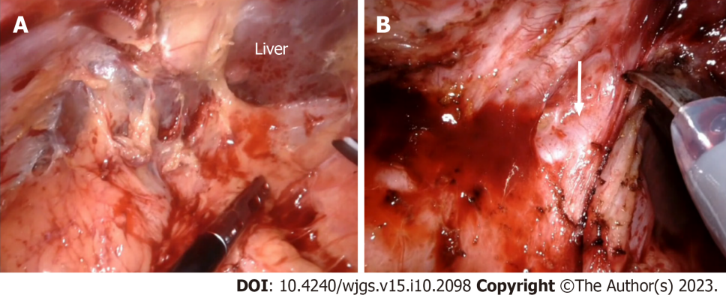

**Figure 1 Adhesiolysis and initial dissection phase.** A: Perihepatic adhesions are left undisturbed to facilitate liver retraction and exposure of the hilum; B: Dissection proceeds towards the umbilical fissure with careful identification and preservation of the left hepatic artery (arrow).

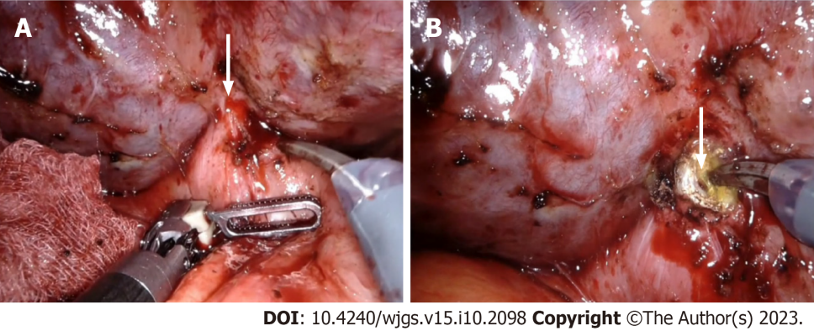

**Figure 2 Identification of hepatic duct.** A: Internal fistula between the hepatic duct and duodenum (arrow); B: Division of the fistula facilitates visualization of the hepatic duct (arrow).

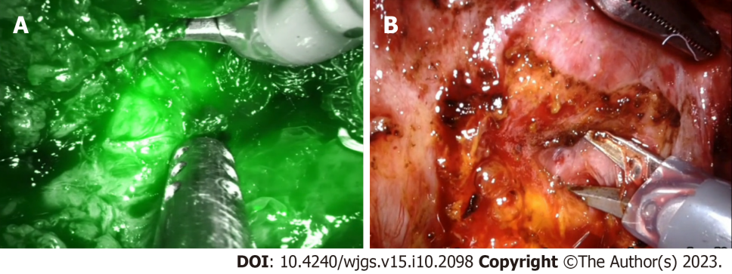

**Figure 3 Lowering the hilar plate.** A: Indocyanine green fluorescence facilitates hepatic duct identification; B: Hilar plate lowered by dissection between the Glissonean sheath and Laennec’s capsule.

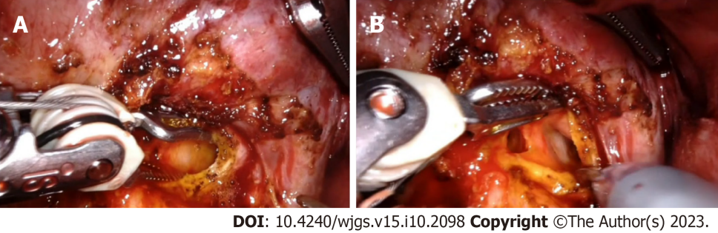

**Figure 4 Opening the hepatic duct.** A: Identification and opening of the left hepatic duct; B: Confluence of left hepatic duct with right hepatic duct identified.

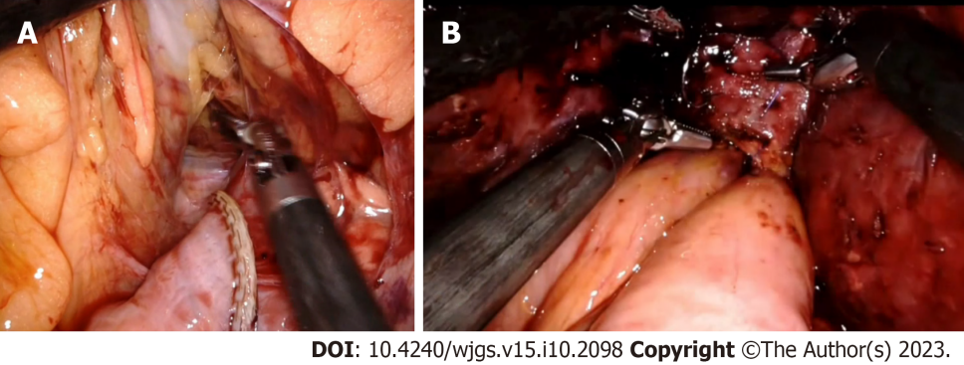

**Figure 5 Roux-en-Y hepaticojejunostomy.** A: Roux limb of jejunum taken to the supracolic compartment through the mesocolic window; B: Completed hepaticojejunostomy.

**Table 1 Studies on laparoscopic repair of postcholecystectomy biliary stricture**

|  |  |  |  |  |  |  |  |  |  |  |  |
| --- | --- | --- | --- | --- | --- | --- | --- | --- | --- | --- | --- |
| **Ref.** | **Year** | **Patients** | **Strasberg injury type** | **Method of reconstruction** | **Mean operative time (min)** | **Blood loss (mL)** | **Conversion to open** | **Overall morbidity** | **Specific biliary complications** | **Length of stay (d)** | **Follow up** |
| Cuendis-Velázquez *et al*[7] | 2016 | 29 | C, E1-E4 | HJ | 240 | 200 | 1 | 31.03 | Bile leak–5 patients. One patient required laparotomy and drainage of bile collection | 8 | 36 (range 7-36) mon, Anastomotic patency rate 96.6% |
| Gomez *et al*[9] | 2020 | 20 | E1-E4 | HJ | 146.5 | 15-50 | None | 10% | One patient had bile leak and was managed conservatively | 4.5 (mean) | 5 yr–no long-term complications |
| Sahoo *et al*[8] | 2021 | 16 |  | HJ | 280 | 176 | None | 12.5% | Two patients had bile leak and were managed conservatively | 8.5 | 28 mo |
| Javed *et al*[10] | 2021 | 29 | E1-E5 | HJ-13 patients, HD-16 patients | 210 | 50 | None | 20% | Four patients had bile leak and were managed conservatively | 6 | 9 mo–one patient had anastomotic strictest and managed with repeater dilations |

HJ: Hepaticojejunostomy; HD: Hepaticoduodenostomy.

**Table 2 Studies on robotic repair of postcholecystectomy biliary stricture**

|  |  |  |  |  |  |  |  |  |  |  |
| --- | --- | --- | --- | --- | --- | --- | --- | --- | --- | --- |
| **Ref.** | **Year** | **Patients** | **Strasberg injury type** | **Method of reconstruction** | **Operative time (min)** | **Blood loss (mL)** | **Overall morbidity** | **Length of stay (d)** | **Specific complications** | **Follow up** |
| Giulianotti *et al*[11] | 2018 | 14 | E1-E5 | HJ-12 patients, Kasai procedure-2 patients | 280.6 | 135 | 28.6% | 8.4 | Bile leak-two patients and 1 patient required pigtail catheter insertion. Subhepatic abscess-one patient | 36.1 mo, 2 patients had mild HJ stenosis and cholangitis. Managed by PTBD and multiple transhepatic dilatations |
| Marino *et al*[12] | 2019 | 12 | E1-E4 | HJ | 260 | 252 | 16.7% | 9.4 | 1 patient developed subhepatic abscess and required pigtail catheter insertion | 12 mo–1 patient had anastomotic stenosis and revision robotic HJ was done |
| Sucandy*et al*[13] | 2021 | 8 |  | HJ | 259 | 50 | 14% | 8 | None | 22 mo–1 patient had anastomotic stenosis at 10 mo and required transhepatic dilatation |

HJ: Hepaticojejunostomy; PTBD: Percutaneous transhepatic biliary drainage.

**Table 3 Study comparing laparoscopic and robotic repair of postcholecystectomy biliary stricture**

|  |  |  |  |  |  |  |  |  |  |  |  |
| --- | --- | --- | --- | --- | --- | --- | --- | --- | --- | --- | --- |
| **Ref.** | **Year** | **Patients** | **Strasberg injury type** | **Method of reconstruction** | **Mean operative time (min)** | **Blood loss (mL)** | **Conversion to open** | **Overall morbidity** | **Specific complications** | **Length of stay (d)** | **Follow up (mo)** |
| Cuendis-Velázquez *et al*[28] | 2019 | 75 (laparoscopic–40, robotic–35) | E1-E5 | Roux-en-Y hepaticojejunostomy | Laparoscopic–240, Robotic–270 | Laparoscopic–215, Robotic–150 | 1 patient in laparoscopic group due to dense adhesions | Laparoscopic–27.5, Robotic–22.8 | Bile leak, laparoscopic–2 patients, robotic–1 patient, one patient in each group underwent laparotomy, lavage with additional drain placement for bile leak | Laparoscopic–7, Robotic–6 | Laparoscopic–49, anastomotic patency rate–92.5%, robotic–16, anastomotic patency rate–100% |



Published by **Baishideng Publishing Group Inc**

7041 Koll Center Parkway, Suite 160, Pleasanton, CA 94566, USA

**Telephone:** +1-925-3991568

**E-mail:** bpgoffice@wjgnet.com

**Help Desk:** https://www.f6publishing.com/helpdesk

https://www.wjgnet.com



**© 2023 Baishideng Publishing Group Inc. All rights reserved.**