**Name of journal:** *World Journal of Gastroenterology*

**ESPS Manuscript NO: 2040**

**Columns: CASE REPORT**

**Retroperitoneal cavernous hemangioma resected by a pylorus preserving pancreaticoduodenectomy**

**Hanaoka M *et al.*** Retroperitoneal hemangioma resected by PpPD

Marie Hanaoka, Masaji Hashimoto, Kazunari Sasaki, Masamichi Matsuda, Takeshi Fujii, Kenichi Ohashi, Goro Watanabe

**Marie Hanaoka, Masaji Hashimoto, Kazunari Sasaki, Masamichi Matsuda, Goro Watanabe,** Department of Digestive Surgery, Toranomon Hospital**,** Tokyo 105-8470, Japan

**Takeshi Fujii,** Department of Pathology, Toranomon Hospital, Tokyo 105-8470, Japan

**Kenichi Ohashi,** Department of Diagnostic Pathology, Yokohama City University Hospital, Kanagawa 236-0004, Japan

**Author contributions:** Hanaoka M and Hashimoto M designed the report; Hashimoto M, Sasaki K, Matsuda M, and Watanabe G were attending doctors for the patient and performed the surgical operation; Ohashi K and Fujii T performed the pathological examination; Hanaoka M wrote the paper.

**Correspondence to: Marie Hanaoka, MD,** Department of Digestive Surgery, Toranomon Hospital, 2-2-2 Toranomon, Minato-ku, Tokyo 105-8470, Japan. fujimarimarie@yahoo.co.jp

**Telephone:** +81-3-35881111 **Fax:** +81-3-35827068

**Received:** January 22, 2013  **Revised:** April 8, 2013

**Accepted:** May 8, 2013

**Published online:**

**Abstract**

A retroperitoneal hemangioma is a rare disease. We report on the diagnosis and treatment of a retroperitoneal hemangioma which had uncommonly invaded into both　the pancreas and duodenum, thus requiring a pylorus preserving pancreaticoduodenectomy (PpPD). A 36-year-old man presented to our hospital with abdominal pain. An enhanced computed tomography scan without contrast enhancement revealed a 12 cm × 9 cm mass between the pancreas head and right kidney. Given the high rate of malignancy associated with retroperitoneal tumors, surgical resection was performed. Intraoperatively, the tumor was inseparable from both the duodenum and pancreas and PpPD was performed due to the invasive behavior. Although malignancy was suspected, pathological diagnosis identified the tumor as a retroperitoneal cavernous hemangioma for which surgical resection was the proper diagnostic and therapeutic procedure. Reteoperitoneal cavernous hemangioma is unique in that it is typically separated from the surrounding organs. However, clinicians need to be aware of the possibility of a case, such as this, which has invaded into the surrounding organs despite its benign etiology. From this case, we recommend that combined resection of inseparable organs should be performed if the mass has invaded into other tissues due to the hazardous nature of local recurrence. In summary, this report is the first to describe a case of retroperitoneal hemangioma that had uniquely invaded into surrounding organs and was treated with PpPD.

© 2013 Baishideng. All rights reserved.

**Key words:** Retroperitoneal tumor; Retroperitoneal cavernous hemangioma; Cavernous hemangioma; Pancreaticoduodenectomy; Pylorus preserving pancreaticoduodenectomy

**Core tip:** A retroperitoneal cavernous hemangioma is a rare disease. This case of retroperitoneal hemangioma had uniquely invaded into the duodenum and pancreas head, and thus required treatment with pylorus preserving pancreaticoduodenectomy. Although hemangiomas are typically benign, clinicians should be aware of the possibility of invasion into the surrounding organs such as with this case. In the event of invasion, we recommend a combined resection of both the tumor and affected organs to reduce the chance of local recurrence that may be associated with inadequate resection.

Hanaoka M, Hashimoto M, Sasaki K, Matsuda M, Takeshi Fujii, Ohashi K, Watanabe G. Retroperitoneal cavernous hemangioma resected by a pylorus preserving pancreaticoduodenectomy. *World J Gastroenterol* 2013;

**Available from:** URL: http://www.wjgnet.com/esps/

**DOI:** http://dx.doi.org/10.3748/wjg.v19.i0.0000

**INTRODUCTION**

A retroperitoneal hemangioma is an uncommon disease in adulthood[1-3]. Only 23 cases of adult retroperitoneal hemangioma have been reported in the literature since 1950. Among those, five cases, including the case detailed in this report, needed combined resection of surrounding organs because of adhesion of the tumor. In this report, we describe the diagnosis and treatment of a retroperitoneal hemangioma that had uniquely invaded into the pancreas and duodenum and required a pylorus preserving pancreatico- duodenectomy (PpPD).

**CASE REPORT**

A 36-year-old man came to a local hospital with right upper quadrant pain since the day before admission. He had no specific medical history or family history. A screening-enhanced computed tomography (CT) scan revealed a bulky tumor between the dorsal side of the pancreatic head and the right kidney. The tumor was diagnosed as a retroperitoneal sarcoma and the patient was referred to Toranomon Hospital for the operation. On physical examination, the patient was found to have no palpable mass. The results of urine, blood, and adrenal cortex functional tests were within normal limits. An abdominal enhanced CT scan showed a 12 cm × 9 cm tumor without marked contrast enhancement, pushing the pancreas to ventral side (Figure 1A). The mass was distinct from the surrounding organs, including the duodenum, pancreas, kidney and retroperitoneal spaces as observed from the CT scan and therefore appeared to be resectable. An abdominal ultrasound showed an uneven echoic lesion in the same area as observed by CT. T1-weighted image of magnetic resonance imaging (MRI) showed low and a few part of relatively high intensity area inside the tumor (Figure 1B). On fat suppression examination of the MRI image, the tumor was not suppressed to any degree. T2-weighted image also showed heterogeneous finding; there were high intensity area with a few part of intermediate signal intensity area. However, there were no typical findings which suggest the type of retroperitoneal tumor on diagnostic images. Based on the qualitative assessments, the tumor was diagnosed as a retroperitoneal mesenchymal tumor. Because of the high rate of malignancy associated with retroperitoneal tumors, surgical resection was performed.

Intraoperatively, the mass measured 12 cm × 9 cm in diameter. We initially tried to perform a tumor excision without combined resection of surrounding organs. However, the intraoperative findings revealed that the mass encroached on the head of the pancreas and duodenum (Figure 2). As such, we performed Kocher’s mobilization of the duodenum and tried to separate the tumor from the duodenum and pancreas; however, the tumor could not be successfully separated from these organs. After the tumor was lifted from the retroperitoneal space, we tried again to separate the tumor from the pancreas head and duodenum. The tumor adhered strongly to both tissues and could only be removed completely by PpPD. The duration of surgery was four h and 16 min and the total blood loss was 561 mL. The patient was discharged from the hospital on postoperative day 24 and was in good health without recurrence over two and a half years after the operation.

Gross pathologic examination revealed a 120 mm × 95 mm × 50 mm hemangioma composed of multi-oculated cysts containing intra-cystic hemorrhages (Figure 3). The diagnosis on pathological examination was a cavernous hemangioma with a few focal areas of venous hemangioma (Figure 4A). As defined by the pathologist, the lesion had invaded　into the muscle layer of the duodenum and the pancreas head (Figure 4B-D). Immunohistochemical analysis of tissue sections revealed that the lumina were positive for CD31 and CD34, markers of endothelial cells (Figure 4E), and partially weak positive for podoplanin/D2-40 (Figure 4F), a marker of lymphatic endothelial cells. Less angiogenic invasion was observed toward the retroperitoneal side of the tumor than toward the pancreas and duodenum. Interestingly, both macroscopically and microscopically, the tumor extended into both the pancreas and duodenum and not into the retroperitoneal space.

**DISCUSSION**

In this report, we describe a patient with retroperitoneal hemangioma that required PpPD. A retroperitoneal tumor is a very rare tumor that accounts for less than 0.2% of all tumor types[1]. Among malignant tumors located in the retroperitoneal space, liposarcomas and leiomyosarcomas are the most frequent, while teratomas, cysts and neurinomas are common benign masses. In the current case, the tumor was diagnosed initially as a retroperitoneal sarcoma; retroperitoneal liposarcomas are the most common malignant tumors of the retroperitoneal soft tissue[2]. Indeed, accurate diagnosis of a retroperitoneal hemangioma is classically difficult preoperatively and prior to pathological examination of the tissue.

An analysis of other retroperitoneal tumor types reveals subtle, yet distinct, differences in symptom presentation, localization, and radiographic features. Among retroperitoneal tumors, imaging studies of leiomyosarcomas demonstrate a non-specific mass but are helpful in delineating the relationship to adjacent structures[3]. Angiosarcomas classically present with cutaneous involvement of the head and neck region in elderly patients[4]. The solid growth pattern and epithelioid cytology can be easily confused with poorly differentiated carcinoma[5]. Most patients with lymphanginoleiomyomatosis (LAM), characterized by proliferation of smooth muscle cells, present with pulmonary symptoms, whereas extrapulmonary LAM is rare and typically presents in premenopausal females[6]. Cystic lymphangioma is a well-known benign tumor and its cystic abnormalities of the lymphatic vessels are predominantly congenital. By CT scan, the tumor is typically well-circumscribed and polycystic with thin septa similar in appearance to the cystadenomas[7]. Kaposiform hemangioendothelioma mainly occurs during childhood. MRI of the affected region is accepted as the diagnostic imaging technique of choice[8]. Concerning hemangiomas arising from other tissues, pancreatic and mesenteric hemangiomas have been reported[9,10], which are extremely rare. MRI shows a common characteristic of pancreatic hemangiomas[9].Mesenteric hemangiomas shows heterogeneous enhancement by enhanced CT and changes its shape during intestinal peristalsis[10].

Pancreatic tissue

E

Pancreatic tissue

A muscle wall of

the duodenum

D

C

A

Duodenum

Duodenum

A

B

A

Duodenum

Pancreas

Tumor

IVC

Ao.

Ao.

Ao.

Duodenum

As for pathological findings, gross pathological findings showed the tumor included multi-oculated cysts filled with blood.This cyst is suggested to be a pseudocyst which is a result of repeats of hemorrhage[14]. D2-40,　reliable podoplanin antibody clone,　has been described in a variety of lymphovascular neoplasms including lymphangioma, Kaposi sarcoma, and hemangioendothelioma[11]. Because lymphatic endothelial cells express high levels of podoplanin[15], we suggest that the weakly positive findings of d2-40 in the current case do not support a diagnosis of lymphangima. In addition to macroscopic and immunohystological findings, microscopic finding of almost all of lumen are filled with red blood cells supported the diagnosis as hemangioma.

Retroperitoneal hemangioma in the adult is extremely rare and confirmed in only 1%-3% of all retroperitoneal tumors[12]. Only 23 cases of adult retroperitoneal hemangioma have been reported in literature since 1950.

Retroperitoneal tumors are difficult to diagnose preoperatively[13] because there are usually no initial symptoms until tumors have grown large enough to produce patient discomfort[14]. Furthermore, retroperitoneal cavernous hemangiomas have features similar to ischemic tumors, but differ from hemangiomas arising from other tissues such as the skin or liver[14].

As for imaging studies of retroperitoneal cavernous hemangiomas, because they are usually only discovered when large enough to develop thrombi and organization at the center[16], these tumors often show slight to no enhancement in normal enhanced CT[12-14]. In the present case, the CT scan revealed a cystic mass with minor contrast enhancement, similar to cases reported previously[17,18]. In addition, retroperitoneal cavernous hemangiomas typically lack the complete fill-in or cotton-wool appearance in enhanced CT or high echoic areas with the same density as the abdominal echo, which is usually only seen in cavernous hemangiomas of the liver[14]. On T1-weighted image of MRI, relatively high intensity area inside the tumor is suggested to be hemorrhage and hyalinization of the tissue. A part of high intensity area of T2-weighted image suggests blood contain and relatively high signal intensity area shows hyalinization and fibrillization. However, these findings were suggested to be secondary change of structure, which don’t indicate any typical tumors. With few clues for diagnosis, very few cases of retroperitoneal hemangiomas have been diagnosed preoperatively. Therefore, surgical resection is a choice for both diagnostic and therapeutic procedures.

One feature of a cavernous hemangioma is that it may be locally destructive by virtue of the pressure exerted on neighboring tissues[19]. In the present case, the pressure of the tumor affected the duodenum and pancreas, leading to invasion and destruction of these organs. Among the 23 reported retroperitoneal hemangiomas, five cases, including ours, needed combined resection of surrounding organs because of an adhesion (Table 1)[18,20-22]. Among the five cases, four cases performed complete combined resection of surrounding organs. In one case, subtotal resection was performed due to technical difficulties caused by firm adherence to the adjacent organs and the major blood vessels[22].　Like this case, which did not demonstrate findings typical of hemangioma from the contrast-enhanced CT, three cases including ours showed hypovascularity, while two cases showed hypervascularity. Pathologically, four cases, including this, were diagnosed as cavernous hemangiomas and one was diagnosed as a venous hemangioma. Hence, we conclude that vascularity from CT analysis and pathological diagnosis are not always directly correlated with adhesion to other organs.

The recommended treatment for retroperitoneal hemangioma has been surgical resection[13,14,23]. Hemangiomas are non-malignant, but patients run the risk of rupture and bleeding[24]. Therefore, surgical treatment is recommended for high-risk tumors, such as with those of large masses[25]. Although hemangiomas are benign, local recurrence has been reported with inadequate resection[26]. In this case, the decision was made to combine the tumor resection with resection of the surrounding organs to avoid local recurrence in the pancreas and duodenum from residual tumor tissue. Therefore, the PpPD procedure for this case was appropriate. From a treatment standpoint, we support a combined resection of both the tumor and the compromised organs if the tumor is invasive and cannot be removed cleanly because of adhesion.

In conclusion, a retroperitoneal cavernous hemangioma is an uncommon disease. Clinicians need to be aware of the possibility of a case that has invaded into surrounding organs despite its benign pathology. This case of a retroperitoneal hemangioma had uniquely invaded into the duodenum and pancreas and this is the first report of treatment using PpPD.

**REFERENCES**

1 **Pack GT**, Tabah EJ. Primary retroperitoneal tumors: a study of 120 cases. *Int Abstr Surg* 1954; **99**: 313-341 [PMID: 13205424]

2 **McCallum OJ**, Burke JJ, Childs AJ, Ferro A, Gallup DG. Retroperitoneal liposarcoma weighing over one hundred pounds with review of the literature. *Gynecol Oncol* 2006; **103**: 1152-1154 [PMID: 17007913 DOI: 10.1016/j.ygyno.2006.08.005]

3 **Yang J**, Du X, Chen K, Ylipää A, Lazar AJ, Trent J, Lev D, Pollock R, Hao X, Hunt K, Zhang W. Genetic aberrations in soft tissue leiomyosarcoma. *Cancer Lett* 2009; **275**: 1-8 [PMID: 18649996 DOI: 10.1016/j.canlet.2008.06.013]

4 **Yoo C**, Kim JE, Yoon SK, Kim SC, Ahn JH, Kim TW, Suh C, Lee JL. Angiosarcoma of the retroperitoneum: report on a patient treated with sunitinib. *Sarcoma* 2009; **2009**: 360875 [PMID: 19478954 DOI: 10.1155/2009/360875]

5 **Allison KH**, Yoder BJ, Bronner MP, Goldblum JR, Rubin BP. Angiosarcoma involving the gastrointestinal tract: a series of primary and metastatic cases. *Am J Surg Pathol* 2004; **28**: 298-307 [PMID: 15104292 DOI: 10.1097/00000478-200403000-00002]

6 **Matsui K**, Tatsuguchi A, Valencia J, Yu Zx, Bechtle J, Beasley MB, Avila N, Travis WD, Moss J, Ferrans VJ. Extrapulmonary lymphangioleiomyomatosis (LAM): clinicopathologic features in 22 cases. *Hum Pathol* 2000; **31**: 1242-1248 [PMID: 11070117 DOI: 10.1053/hupa.2000.18500]

7 **Gureş N**, Gurluler E, Alim A, Berber I, Gurkan A. Cystic pancreatic lymphangioma. *Rare Tumors* 2012; **4**: e27 [PMID: 22826784 DOI: 10.4081/rt.2012.e27]

8 **Fernández Y**, Bernabeu-Wittel M, García-Morillo JS. Kaposiform hemangioendothelioma. *Eur J Intern Med* 2009; **20**: 106-113 [PMID: 19327597 DOI: 10.1016/j.ejim.2008.06.008]

9 **Mundinger GS**, Gust S, Micchelli ST, Fishman EK, Hruban RH, Wolfgang CL. Adult pancreatic hemangioma: case report and literature review. *Gastroenterol Res Pract* 2009; **2009**: 839730 [PMID: 19421421 DOI: 10.1155/2009/839730]

10 **Chin KF**, Khair G, Babu PS, Morgan DR. Cavernous hemangioma arising from the gastro-splenic ligament: a case report. *World J Gastroenterol* 2009; **15**: 3831-3833 [PMID: 19673030 DOI: 10.3748/wjg.15.3831]

11 **Kalof AN**, Cooper K. D2-40 immunohistochemistry--so far! *Adv Anat Pathol* 2009; **16**: 62-64 [PMID: 19098468 DOI: 10.1097/PAP.0b013e3181915e94].]

12 **Braasch JW**, Mon AB. Primary retroperitoneal tumors. *Surg Clin North Am* 1967; **47**: 663-678 [PMID: 6022980]

13 **Takeda M**, Koyanagi K, Nakagawa M, Kanai T, Matsumoto K, Kameyama K. A case of a rapid growing retroperitoneal cavernous hemangioma that was difficult to diagnose preoperativery. *J Jpn Surg Assoc* 2009; **70**: 1541-1545

14 **Murakami J**, Aoyama K, Nishiki Y, Uotani H, Yamashita J. A case of cavernous hemangioma in the retroperitoneum. *Diagnostic Imaging of the Abdomen* 1995; **15**: 811-818

15 **Malhotra D**, Fletcher AL, Astarita J, Lukacs-Kornek V, Tayalia P, Gonzalez SF, Elpek KG, Chang SK, Knoblich K, Hemler ME, Brenner MB, Carroll MC, Mooney DJ, Turley SJ. Transcriptional profiling of stroma from inflamed and resting lymph nodes defines immunological hallmarks. *Nat Immunol* 2012; **13**: 499-510 [PMID: 22466668 DOI: 10.1038/ni.2262]

16 **Tomonaga T**, Okuyama K, Nagao K, Tabata Y, Enomoto K, Koh Z, Hiura T, Sato H, Isono K. [Retroperitoneal liposarcoma with various histological figures]. *Gan No Rinsho* 1986; **32**: 927-932 [PMID: 3747152]

17 **Adam YG**, Alberts W. Retroperitoneal hemangioma. *Am Surg* 1990; **56**: 374-376 [PMID: 1972007]

18 **Tseng TK**, Lee RC, Chou YH, Chen WY, Su CH. Retroperitoneal venous hemangioma. *J Formos Med Assoc* 2005; **104**: 681-683 [PMID: 16276446]

19 **Enzinger FM**, Weiss SW. Benign tumors of peripheral nerves In Soft Tissue Tumors. 5th ed. St. Louis: Eds. Mosby, 2008: 636-651

20 **Takaha N**, Hosomi M, Sekii K, Nakamori S, Itoh K, Sagawa S, Kido T, Satani M, Kawamoto S, Sato K. [Retroperitoneal cavernous hemangioma: a case report]. *Hinyokika Kiyo* 1991; **37**: 725-728 [PMID: 1927773]

21 **Ogura Y**, Sugaya K, Matsuzaki A, Suzuki T, Sato K, Kato T. Retroperitoneal cavernous hemangioma: a case report. *Nishi Nihon Hinyokika* 1989; **80**: 139-140

22 **Syo M**, Yamada Y, Watanabe A, Kanehiro H, Nakano H, Tsutsumi M, Konishi Y. A case of retrioeritoneal cavernous hemangioma. *J Jpn Surg Assoc* 1993; **54**: 2407-2411

23 **He H**, Du Z, Hao S, Yao L, Yang F, Di Y, Li J, Jiang Y, Jin C, Fu D. Adult primary retroperitoneal cavernous hemangioma: a case report. *World J Surg Oncol* 2012; **10**: 261 [PMID: 23216883 DOI: 10.1186/1477-7819-10-261]

24 **Kobayashi H**, Kaneko G, Uchida A. Retroperitoneal venous hemangioma. *Int J Urol* 2010; **17**: 585-586 [PMID: 20438591 DOI: 10.1111/j.1442-2042.2010.02522.x]

25 **Igarashi J**, Hanazaki K. Retroperitoneal venous hemangioma. *Am J Gastroenterol* 1998; **93**: 2292-2293 [PMID: 9820421 DOI: 10.1111/j.1572-0241.1998.00642.x]

26 **Sasaki S**, Kishimoto T, Maekawa M, Murakami K. Retroperitoneal hemangioma connected with cutaneous lesion. *Hinyokika Kiyo* 1974; **20**: 499-507

**P-Reviewers** Li W, Kir G **S-Editor** Gou SX  **L-Editor E-Editor**

**Figure 1 12 cm × 9** **cm tumor was detected by** **computed tomography and** **magnetic resonance imaging.** A: Abdominal enhanced computed tomography in early phase showed tumor without marked contrast. The tumor had pushed the pancreas to the ventral side; B: T1-weighted image of magnetic resonance imaging showed low and relatively high intensity area inside the tumor; C: T2-weighted image showed high intensity area with a few part of intermediate signal intensity area. IVC: Inferior vena cava. Ao: Aorta.

A

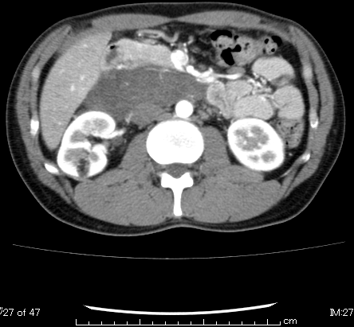

Duodenum

Tumor

Ao.

Ao.

IVC

Ao.

**C:\Users\Marie\AppData\Local\Microsoft\Windows\Temporary Internet Files\Content.Word\ｎａｒｉｋａｗａ　静脈相.bmp**

B

**C:\Users\Marie\AppData\Local\Microsoft\Windows\Temporary Internet Files\Content.Word\ｎａｒｉｋａｗａ　静脈相.bmp**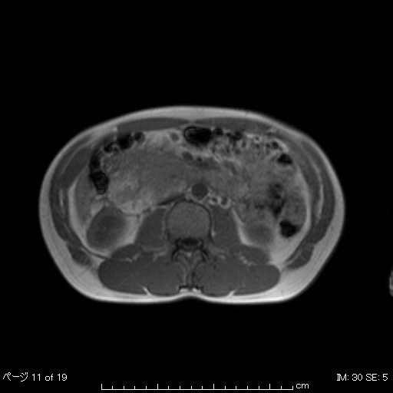

Tumor

C



Tumor

**C:\Users\Marie\AppData\Local\Microsoft\Windows\Temporary Internet Files\Content.Word\ｎａｒｉｋａｗａ　静脈相.bmp**

**C:\Users\Marie\AppData\Local\Microsoft\Windows\Temporary Internet Files\Content.Word\ｎａｒｉｋａｗａ　静脈相.bmp**

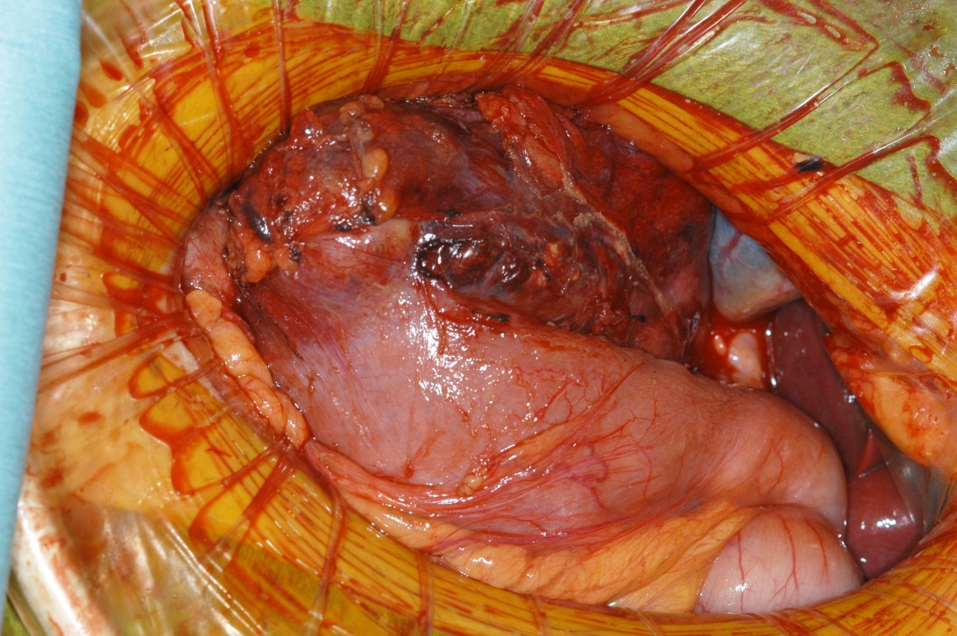

Duodenum

**Figure 2 Macroscopic view of intraoperative findings.** The mass was attached to both the duodenum and the pancreas head and required surgical resection by pylorus preserving pancreaticoduodenectomy. The circle denotes the tumor.

A

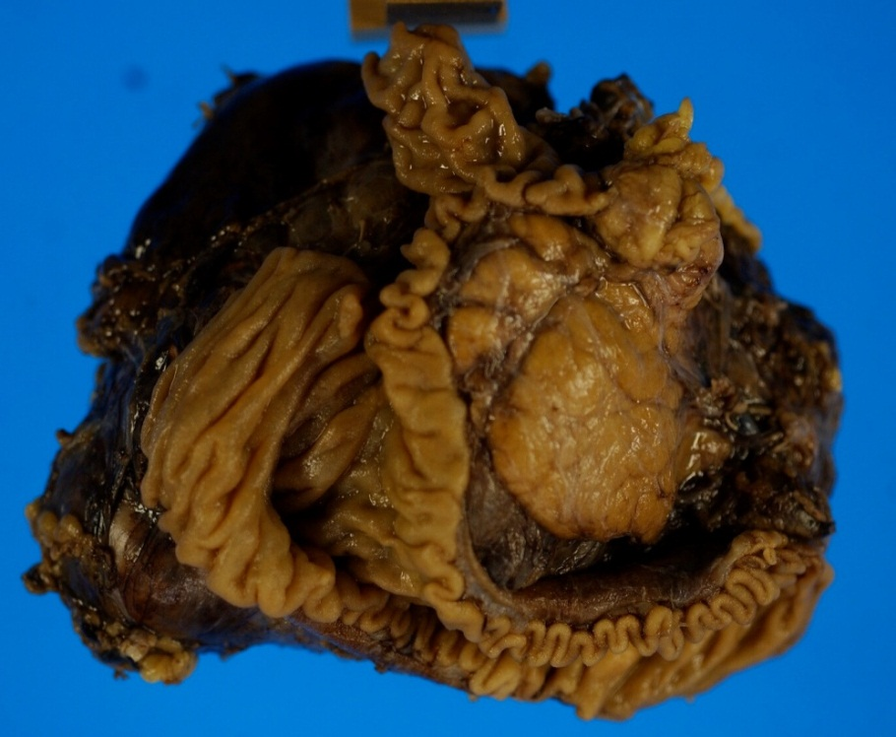

B

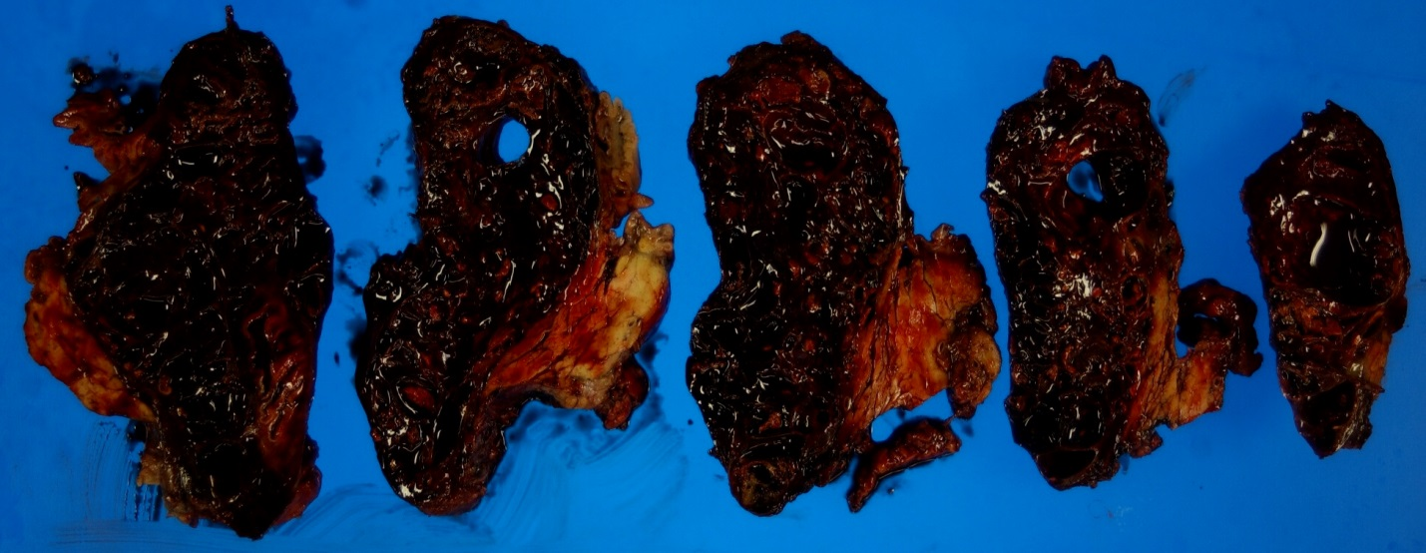

**Figure 3 Macroscopic findings of the resected specimen.** A:A 120 mm × 95 mm × 50 mm tumor was resected. Scale bar, 70 mm; B: The tumor contained multi-oculated cysts containing intra-cystic hemorrhages.

A

B

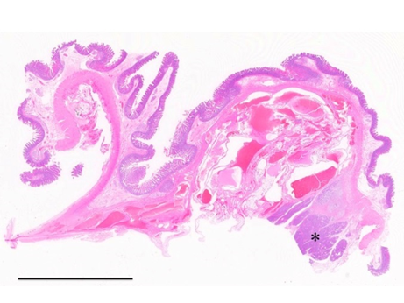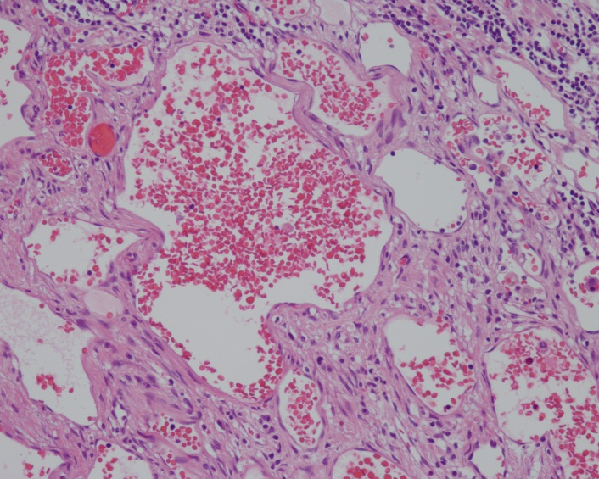

Duodenum

C

D

A

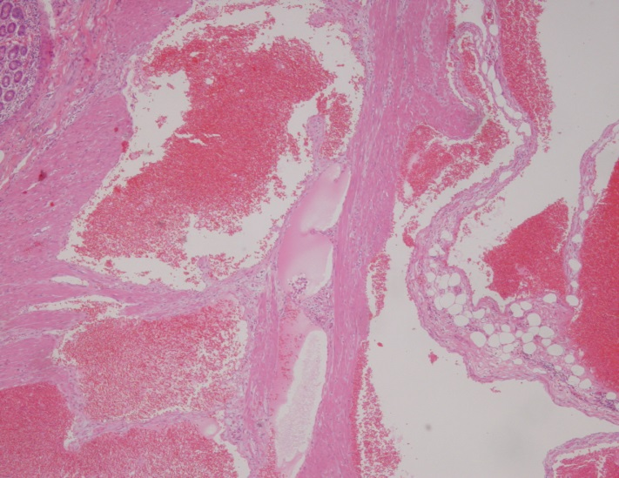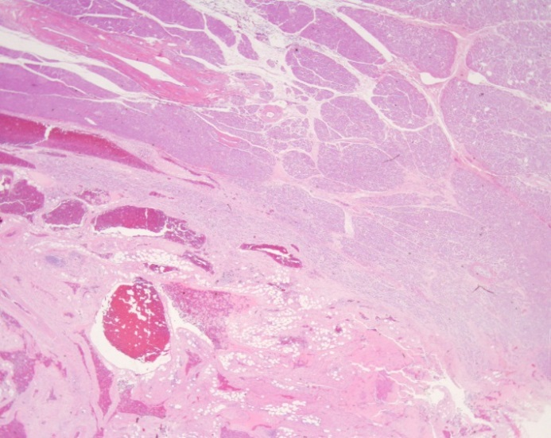

Pancreatic tissue

Duodenum

E

F

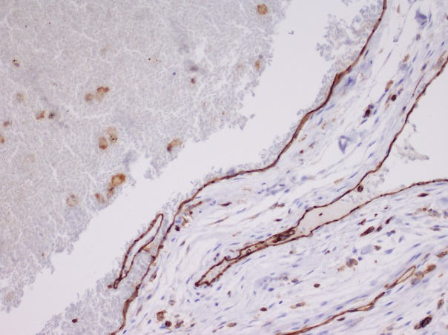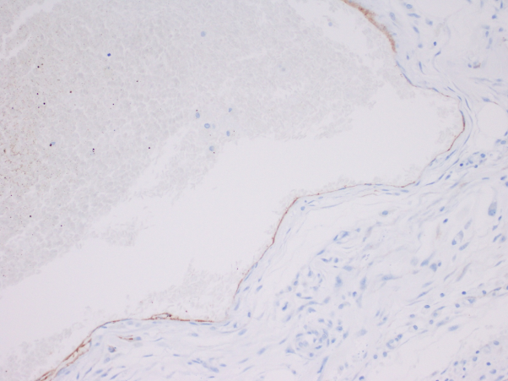

**Figure 4 Pathological analysis by** **hematoxylin and eosin staining and immunohistochemistry.** A: A representative tissue section from the main region of the cavernous hemangioma (hematoxylin and eosin, HE, 200 × magnification);B: The loupe view demonstrates a portion of cavernous hemangioma infiltrating the pancreatic head (asterisk) and duodenal wall (HE). The scale represents 10 mm; C: Tumor invasion into the muscle layer of the duodenum (HE, 4 × magnification);D: Tumor invasion into the pancreas head (HE, 1 × magnification); E: Positive immunostaining for CD31 supports the diagnosis of hemangioma (20 × magnification); F: The lumen showed partial and weakly positive staining for podoplanin/D2-40 (20 × magnification).

**Table 1 Reported cases of retroperitoneal hemangioma with combined resection of surrounding organs**

|  |  |  |  |  |  |  |  |
| --- | --- | --- | --- | --- | --- | --- | --- |
| **Authors** | **Age (yr)** | **Sex** | **Tumor**  **size, cm3** | **Hyper-**  **vascularity** | **Curative**  **resection** | **Pathological**  **diagnosis** | **Organ(s) of**  **combined resection** |
| Ogura *et al*[21], 1989 | 73 | M | 23 × 14 × 9 | - | + | Cavernous | Left kidney |
| Takaha *et al*[20], 1991 | 55 | M | 10 × 9 × 9 | + | + | Cavernous | Spleen, Diaphragm,  Chest wall |
| Syo *et al*[22], 1993 | 72 | F | 9 × 7 × 7 | - | + | Cavernous | Right ovarian artery |
| Tseng *et al*[18], 2005 | 61 | F | NA | + | - | Venous | NA |
| Hanaoka *et al*, 2013 | 36 | M | 12 × 19 × 5 | - | + | Cavernous  and Venous | Duodenum,  Pancreas head |

Five cases, including this, needed combined resection of surrounding organs. In four cases, a complete combined resection of surrounding organs was performed, while in one case a subtotal resection was performed (Tseng *et al*). NA: Not available.