**Name of Journal: *World Journal of Hematology***

**ESPS Manuscript NO: 23508**

**Manuscript Type: Review**

**Changing insights in the diagnosis and classification of autosomal recessive and dominant von Willebrand diseases 1980-2015**

Michiels JJ *et al*. VWD diagnosis and classification

**Jan Jacques Michiels, Angelika Batorova, Tatiana Prigancova, Petr Smejkal, Miraslov Penka, Inge Vangenechten, Alain Gadisseu**

**Jan Jacques Michiels,** Goodheart Institute in Nature Medicine and Health, Blood Coagulation and Vascular Medicine Center, 3069 Rotterdam, The Netherlands

**Jan Jacques Michiels,** Bloodcoagulation Research Laboratory, University Hospital Antwerp, B-2650 Edegem, Belgium

**Angelika Batorova, Tatiana Prigancova,** National Hemophilia and von Willebrand Disease Center, Department of Hematology and Blood Transfusion, University Hospital, Antolska 11, Bratislava, Slovakia

**Petr Smejkal,** **Miraslov Penka,** Department of Clinical Hematology, University Hospital Marssasyk University, 601 77 Brno, Czech Republic

**Inge Vangenechten, Alain Gadisseur,** Hemostase Research Unit, University Hospital Antwerp, B-2650 Edegem, Belgium

**Authors contributions:** Michiels JJ, Vangenechten I and Gadisseur A analysed the literature and wrote the manuscript; All authors participate in the prospective von Willebrand Disease (VWD) Research study to validate the European Clinical, Laboratory and molecular classification of VWD.

**Conflict-of-interest statement:** The authors declare no conflicts of interest.

**Open-Access:** This article is an open-access article which was selected by an in-house editor and fully peer-reviewed by external reviewers. It is distributed in accordance with the Creative Commons Attribution Non Commercial (CC BY-NC 4.0) license, which permits others to distribute, remix, adapt, build upon this work non-commercially, and license their derivative works on different terms, provided the original work is properly cited and the use is non-commercial. See: <http://creativecommons.org/licenses/by-nc/4.0/>

**Correspondence to:** **Jan Jacques Michiels, MD, PhD, Investigator, Senior Internist,** International Hematology and Bloodcoagulation Research Center, Goodheart Insititute and Foundation in Nature Medicine and Health, Erasmus Tower, Veenmos 13, 3069 Rotterdam, The Netherlands. [goodheartcenter.@upcmail.nl](mailto:Goodheartcenter.@upcmail.nl)

**Telephone:** +31-62-6970534

**Received:** November 26, 2015

**Peer-review started:** November 30, 2015

**First decision:** January 15, 2016

**Revised:** March 29, 2016

**Accepted:** April 14, 2016

**Article in press:**

**Published online:**

**Abstract**

The European Clinical Laboratory and Molecular (ECLM) criteria define 10 distinct Willebrand diseases (VWD): recessive type 3, severe 1, 2C and 2N; dominant VWD type 1 secretion/clearance defect (1-SCD), 2A, 2B, 2E, 2M and 2D; and mild type 1 VWD (usually carriers of recessive VWD). Recessive severe 1 and 2C VWD are featured by secretion and multimerization defect caused by mutations in the D1-D2 domain. Recessive 2N VWD is a mild hemophilia due to D’-FVIII-von Willebrand Factor (VWF) binding site mutations. Dominant 2E VWD caused by heterozygous missense mutations in the D3 domain is featured by a secretion-clearance-multimerization VWF defect. Dominant VWD type 2M due to loss of function mutations in the A1 domain is characterized by decreased RIPA and VWF:RCo, normal VWF multimers and VWF:CB, a poor response of VWF:RCo and good response of VWF:CB to DDAVP. Dominant VWD type 2A induced by heterozygous mutations in the A2 domain result in hypersensitivity of VWF for proteolysis by ADAMTS13 into VWF degradation products resulting in loss of large VWF multimers with triplet structure of each individual VWF band. Dominant VWD type 2B due a gain of function mutation in the A1 domain is featured by spontaneous interaction between platelet glycoprotein Ib (GPIb) and mutated VWF A1 followed by increased proteolysis with loss of large VWF multimers and triplet structure of each VWF band. A new category of dominant VWD type 1 secretion or clearance defect due to mutations in the D3 domain or D4–C1-C5 domains consists of two groups: those with normal or smeary pattern of VWF multimers.

**Key words:** Von Willebrand disease; Von Willebrand factor; ADAMTS13; DDAVP; Von Willebrand factor assays; Von Willebrand gene mutations

**© The Author(s) 2016.** Published by Baishideng Publishing Group Inc. All rights reserved.

**Core tip:** The European Clinical Laboratory and Molecular criteria define at least 10 distinct phenotypes of von Willebrand diseases (VWD) that have significant therapeutic implications. High quality von Willebrand Factor (VWF) multimeric analysis and responses to desmopressin of FVIII:C and VWF parameters are of critical diagnostic importance to document the contribution of VWF secretion, clearance, proteolysis and multimerization defects to real life phenotyping of each individual VWD patient.

Michiels JJ, Batorova A, Prigancova T, Smejkal P, Penka M, Vangenechten I, Gadisseu A. Changing insights in the diagnosis and classification of autosomal recessive and dominant von Willebrand diseases 1980-2015. *World J Hematol* 2016; In press

**INTRODUCTION**

Von Willebrand factor (VWF) is biosynthesized exclusively in vascular endothelium and megakaryocytes. The precursor protein consists of signal peptide (22 amino acids, aa), propeptide (741 aa) and mature VWF monomer (2050 aa) (Figure 1)[1,2]. The intracellular uncleaved VWF (2791 aa) has 14 distinct domains from left to right: D1, D2, D’, D3, A1, A2, A3, D4, B1-3, C1, C2 and CK (Figure 1). The exons which encode each domain are shown in Figure 1 above the VWF domain. The areas of VWF involved in binding specific functional factors are shown in Figure 1 below the VWF domains[1,2]. During the translocation of proVWF to the endoplasmatic reticulum (ER) the signal peptide is cleaved off, and the proVWF forms dimers in a tail-to-tail fashion through cysteines in its carboxyterminal cysteine knot (CK) domain (Figure 2)[3-5]. ProVWF dimers transit to the Golgi apparatus as multimers through disulphide bonds between cysteine-residues in the D1-3 multmerization domain. Meanwhile, D1-D2 domains are cleaved off to form VWF propeptide (VWFpp, 741 aa), while the remaining domains from D’ to CK form mature VWF (2050 aa, Figures 1 and 2). In the trans Golgi netwotk (TGN) VWFpp promotes high molecular weight (HMW) multimer formation in tubular structures and subsequently parkaged in Weibel Pallade Bodies (WPB)[3-5]. When the endothelium is exposed to certain stimuli such as DDAVP, WPB undergo exostosis and release their contents to the circulation or present them on the cell surface[3,4]. Upon exostosis of WPB, high molecular weight VWF forms string-like structures on the cell surface that recruite platelets from the circulating blood to bind, upon which the ultralarge VWF can become cleaved into the normal spectrum of high intermediated and small strings (multimers) by the VWF cleavage protease ADAMTS13 at high shear stress in the endarterial circulation (Figure 2)[4,5]. At time that VWF is secreted from endothelial cell WPB the VWF propeptide (VWFpp = D1D2 domain) is cleaved off again at the Furin cleavage site (Figure 3). Mutations in the D1 and D2 propeptide VWF cannot cleave off VWFpp with the consequence of a VWF secretion and multimerisation defect as the explanation of the loss large VWF multimers in recessive severe type 1 and 2C (Figure 3).

***VWF-FVIII:C and VWF-platelet interactions***

VWF circulates as a multimeric plasma glycoprotein with coagulation factor VIII (FVIII:C) bound to the D’ domain of VWF[6]. FVIII:C is cleaved off from VWF by thrombin at sites of vascular injury. VWF circulates as large multimers as a function of the D3 multimerization and CK dimerisation domains. Activated VWF and platelet mediates platelet adhesion to subendothelial and platelet aggregation at sites of vascular injury (Figure 4)[6]. At sites of vascular injury and high shear activated platelets and activated VWF aggregates through binding of platelet GpIb to the A1 domain. In the equilibrium state, with intact endothelial cells and no injured vessel resting platelets and resting VWF circulates as globules in blood (Figure 4, upper left). In this state, VWF is incapable of mediating platelet adhesion. After an injury of the endothelial cells, the activated VWF interacts with exposed collagen *via* VWF domains A1 and A3 and triggers the adhesion of activated platelets *via* VWF domain A1 (Figure 4, lower left). At low shear there is no binding between VWF domain A1 and platelet GPIb. At high shear rate the VWF globules elongate and made the VWF A1 domain accessible by the dissociation of domain A1 from A2 Figure 4). High shear flow detaches the A2 domain from domain A1. Binding between GPIb of activated platelet to the GPIb receptor of VWF is immediately followed by cleavage of VWF in the A2 domain by ADAMTS13 (Figure 4).

***VWD type 1, 2 and 3***

The introduction of FVIIIR:Ag (VWF:Ag), ristocetin-based assays VWF:RCo and RIPA combined with VWF multimeric analysis in the 1970s was the first step the classification of VWD[7,8]. In 1973, Firkin *et al*[7] discovered VWD increased ristocetine induced platelet aggregation (RIPA) as a pathohnomonic characteristic finding of VWD type IIB as a distinct bleeding diathesis. Ruggeri *et al*[8] confirmed the association of RIPA (heightened interaction between platelets and VWF) in type IIB VWD. In contrast, RIPA was decreased or absent in type IIA VWD. The 1986 Zimmerman Classification of VWD[9] could distinguish five main variants of type 2 VWD IIA, IIB, IIC, IIE and IID (Figure 5). Loss of large VWF multimers due to increased proteolysis into 176 kDa and 140 kDa degradation products is seen in VWD type IIA and IIB. In contrast, proteolytic VWF fragments (degradation products) are absent in VWD type IIC, IIE and IID as compared to VWF multimers in normal plasma[2,9,10]. Consequently, the loss of large VWF multimers in VWD 2C and 2E is not due to increased proteolysis, but caused by a multimerisation defect due to mutations in the D1-D2 and D3 domains (Figures 6 and 7)[3,11,12].

Three main categories of VWD can be distinguished: first a category of recessive type 3 , severe type 1 and 2C; second a category of dominant type 1 and 2, and third large category of mild VWD with no or low penetrance of bleeding manifestations[12-20]. Recessive VWD type 3, a hemophilia-like bleeding disorder with the complete absence of VWF and FVIII:C is caused by double non-sense mutation in the VWF gene[21-23]. Recessive severe “type 1” VWD differs from “type 3” VWD by double heterozygosity for a non-sense/missence or two missence mutation with the presence of detectable VWF:Ag and FVIII:C levels between 0.09 and 0.40 U/mL[24-33]. Double null mutations in recessive type 3 VWD are distributed over all domains and exons of the VWF gene. Missense mutations as the cause of recessive severe type 1 are mainly located in the exons 3 to 11 of the D1-D2 domains (D47H, S85P, Y87S, D141Y, D141N, C275S, W377C, I427N, and in exons 36 to 52 of the D4, B1-3, C1-2, CK domains (P2063S, C2174G, C2362F, N2546Y, C2671Y, C2754W, and C2804Y[24-33]. The 2N mutations E787K, T791M and R816W are severe with less than 10% FVIII binding (FVIIIB) to VWF. Homozygous or double heterozygous R854Q mutations are most frequent and associated mild with FVIII binding defect of around 25%[6,34,35]. A normal multimer distribution is observed in non-cystein mutated VWD 2N patients in whom bleeding episode are similar to those in patients with mild/moderate hemophilia A, with bleedings occurring after trauma or surgery. Type 2N mutations that involve a cysteine (C788R/Y, Y795C, C804F, and C858S/F) are associated with aberrant multimerization, poor secretion and reduced FVIII binding[34,35]. Three mutations (T791M, R816W and R845W) account for the majority of typical 2N cases with normal VWF multimers[33,34]. Patients with mild 2N VWD (e.g. homozygous R854W) can be treated for minor bleeds by DDAVP administration[18,35]. Obligate carriers of recessive type 3, recessive severe type 1 and recessive 2N VWD are heterozygous for a nonsense (null) or missense mutation, and are usually asymptomatic at VWF levels around 50 U/mL[16,32,33].

***Translation of VWD IIC, IIE, IIA, IIB and IID into 2C, 2E, 2M, 2A, 2B and 2D***

The ISTH classification of VWD is based on 5 insensitive laboratory tests (FVIII:C, VWF:Ag, VWF:RCo, RIPA and VWF multimers in low resolution gels (Table 1)[13-15]. The ISTH criteria cannot clearly distinct the various variants of pronounced type 1, 2N, 2M and 2E VWD at VWF levels around and below 0.15 U/mL[15]. The ISTH mainly used a “lumping” instead of the “splitting” approach for the classification of type 2 VWD (Table 1). The ISTH criteria lumped several variants of VWD IIA, IIC, IID, IIE as 2A with loss of large VWF multimers[13-15]. The loss of large multimers in VWD 2 is due to various mechanisms: increased proteolysis in dominant 2A and 2B VWD, defective multimerization of VWF in recessive 2C and dominant 2E, and defective dimerization of VWF (CK domain) in 2D VWD (Figures 7 and 8)[10-12,17-22]. Decreased RIPA due to loss of function in the interaction of platelet-GPIb-VWF is a typical feature of VWD 2M[18]. VWD 2M usually presents as pronounced type 1 VWD with normal VWF multimerization pattern[18,20]. VWD type 2M frequently labeled by the ISTH classification as 2U, 2A-like or variant 2A with decreased RIPA and some loss of large VWF multimers[17,36]. VWD type Vicenza has “supranormal” VWF multimers and type 1 phenotype due to increased clearance[18,32]. In the ISTH classification VWD 2N has normal VWF multimers, typical type 1 VWD phenotype with low FVIII:C and decreased FVIII/VWF:Ag ratio[13-15]. Between 2001 and 2009 Schneppenheim and Budde[10,11,20], Michiels *et al*[17] translated and changed the ISTH classification of VWD type IIA, IIB, IIC and IIE (Table 1) into the European clinical, Laboratory and Molecular (ECLM) criteria (Table 2) for VWD recessive 2C, recessive 2N, dominant 2E, 2M, 2A, 2B, 2CBD and 2D (Figures 6, 7 and 8)[32,33,37-39]. The distinction of the dominant type 2 VWDs in the ECLM classification is based on typical VWF multimeric pattern for each type 2 VWD variant in high resolution gel concentration (1.5%)[10,11,20]. Pronounced dominant type 1 VWD with VWF levels around and below 0.15 U/L using the ISTH criteria is seen in VWD type 1 secretion or clearance defects, and in VWD type 2E and 2M (Figure 8)[17,18,20]. Diagnostic differentiation of so-called severe type 1 VWD using the ISTH criteria remains a persistant problem in routine daily practice anno 2011 (Table 1). This can easily overcome by the use and correct interpretation of VWF mulitimeric analysis and FVIII:C/VWF response curves to DDAVP[18-20]. VWF multimeric analysis using low and medium resolution gels clearly distinct VWD type 2A, 2B, 2E and 2M (Figure 8 middle part)[32]. The responses of FVIII and VWF parameter to intravenous DDAVP is an essential tool in the spitting approach of the ECLM classification, will distinguish the various variants of dominant type 1 and 2, and will elucidate the molecular differences between homozygous or compound heterozygous recessive type 3 and severe type 1 VWD[16,33]. The ECLM splitting approach uses sensitive and specific diagnostic tools in view of structure and function defects of mutant VWF proteins (Table 2).

***Characeristics of dominant type 1 VWD Secretion Defect (SD), 2M and 2E***

FVIII and VWF parameters in dominant VWD type 1 secretion defect are featured by increased FVIII/VWF:Ag ratio before and after DDAVP with restricted responses of VWF parameters as compared to FVIII to DDAVP (Figure 9)[18]. This discrepancy of increased FVIII/VWF:Ag ratio and restricted responses to DDAVP of all VWF parameters is diagnostic for pronouced VWD type 1 secretion defect[18,19]. We studied three family index cases with pronounced autosomal dominant cases of VWD type 1, in whom the response to DDAVP of all VWF parameters were very restictive, whereas FVIII:C levels reached very high levels around 2.0 U/mL. Such cases with restricted responses of all VAF parameters and a high FVIII:C/VWF:Ag ratio is diagnostic for dominant VWD type 1 secretion defect (SD) and clearly different from VWD 2M (Figure 9)[18,20]. VWD 2M has normal VWF multimers before and after DDAVP (Figures 9 and 10) and the responses to DDAVP are poor for VWF:RCo, fairly good for VWF:CB, FVII:C and VWF:Ag followed by shortened half life times of FVIII:C, VWF:Ag and VWF:CB indicative for a clearance defect (Figures 9 and 10)[18,20,36,37]. The response to DDAVP in a case of dominant VWD type 2E due to W1120S mutation in the A3 domain induced transient correction of PFA-100 closure time and restricted increase of VWF parameters from around 0.20-0.40 U/mL to around 1.0 U/mL (Figure 10). The VWD type 2E usually present as laboratory phenotype 1 or 2, but the the multimeric pattern is charaterized by loss of large multimers and the absence of triplet structure of VWF bands due to mutations in the D3 multimerization domain (Figure 8)[38,39].

***Dominant VWD type 2A Group I and II***

The missense mutations V1607D, S1506L, L1540P and R1568del resulted in poor or no secretion of high molecular weight due to intracellular proteolysis and impaired transport of VWF multimers between the endoplasmatic reticulum and the Golgi complex (so-called VWD 2A Group 1 defect)[40,44]. Eight missense mutations in the A2 domain R1597W, G1505E, I1628T, L1503Q, M1528V, G1609R, I1628T, G1629E, G1631D and E1638K result in normal secretion of high molecular weight multimers, which are hypersensitive to ADMAMTS13 induced increased proteolysis (so-called VWD 2A Group 2 defect)[40-43]. VWF of severe VWD 2A Group I is already proteolysed in endothelial cells before secretion, whereas VWF in mild to moderate VWD 2A Group II is secreted as large multimers, which after secretion from endothelial are proteolysed due to hypersensitivity to ADAMST13[40-44].

Dominant VWD type 2A mutation V1499E in a large Dutch family is featured by normal RIPA, loss of large VWF multimers and increase of intermediate and small VWF multimers in low resolution gels (VWF multimeric pattern before DDAVP, Figure 11, lower left)[43,44]. The responses to DDAVP are normal for FVIII:C but restricted for the functional VWF:RCF and VWF:CB are restricted to about 1 U/mL 1 h post-DDAVP. Transient correction of Ivy bleeding times was asspociated with transient reapppearance of large VWF multimers indicating that the mutation V1499E belongs to VWD 2A Group II (Figure 11). The multimeric pappern of the V1499E mutant VWF was studied in three different laboratories. Low resolution gels in two laboratories clearly show the absence of large VWF multimers but no clear triplets of individual VWF bands (Figure 11). The triplet structure of the individual VWF bands diagnostic for VWD type 2A was only seen in the meduim resolution gels (right lanes) (Figure 11). Severe VWD 2A Group I is featured by pronounced triplet structure, absence of RIPA and prolonged Ivy bleeding times as shown in our case with the S1506L mutation in the A2 domain (Figure 12). The poor **r**esponses to DDAVP of VWF parameters is completely in line with impaired assembling transport and proteolysis of intracelllar VWF multimers seen in severe VWD 2A Group I caused by mutations like S1506L (Figure 12).

***Dominant VWD type 2B***

The key feature of VWD 2B is the loss of large VWF multimers (Figure 8, Table 2) due to increased protelolysis caused by increased interaction of platelets and mutated VWF in the A1 domain (increased RIPA)[18,20,45,46]. In that process of increased VWF-GpIb-platelet interaction of mutant VWF in VWD 2B starts as soon as the mutant VWF enters the circulation (Figure 4). Clumps of mutant VWF-platelets are cleared from the circulation leading to thrombocytopenia upon DDAVP or stress. Federici *et al*[46] evaluated the clinical and molecular predictors of thrombocytopenia and the risk of bleeding in 67 VWD 2B patients from 38 unrelated families. Thrombocytopenia was found in 30% at baseline and in 57% after stress conditions in only those with pronounced VWD 2B carrying the mutation[46]. Thrombocytopenia did not occur in 16 patients (24%) from 5 families with mild VWD 2B carrying the P1266L or R1308L mutation[46]. The P1288L and R1308L mutations are associated with a mild type 1 variant of VWD 2B with normal VWF:RCo/Ag ratios of 0.9 and 0.8 respectively consistent with P1266L mutated VWF in VWD Malmo and New York VWD phenotype 1B), who do have a mild bleeding ilness with normal VWF:RCo/VWF:Ag ratios consistent with a laboratory VWD type 1B phenotype with increased RIPA[17,18].

**MYSTIFICATIONS AROUND ISTH DEFINED VWD TYPE 1**

**The European (EU) study on ISTH defined type 1 VWD study[44,45] involved twelve partners based in nine European countries. The EU study aimed to recruit the whole spectrum of patients diagnosed by referring centres as having type 1 VWD, including the more severe and mildest cases, to try and represent the range of patients seen by other centers diagnosing type 1 VWD.** The EU MCMDM-1VWD study recruited 148 evaluable families. **The Canadian type 1 VWD study recruited 124 families from 13 Haemophilia Centres across Canada[47-49]. Analysis at both the recruitment centre and central laboratory of plasma samples was obtained on at least two occasions.** The EU and Canadian VWD 1 multi-centre national/international studies have provided new insights on the molecular pathogenesis of type 1 VWD. In 2008, 117 different VWF mutations (80% missense, about 10% nonsence and about 10% splice site or transcription) were reported to be associated with type 1 VWD were included in the ISTH VWF mutation database. When comparing the ECLM criteria in table 2 with the ISTH criteria in Tables 1 and 3, there are several misclassifications of VWD in the European MCMDM-1VWD study. The European MCMDM-1VWD study did contain typical examples of recessive or heterozygous VWD type 2N (heterozygous R816W, R854W and R854W/R924Q, R854W/null) and typical cases of VWD 2M (D1277-E78delinsl, R1315C, R1342CR1374C, R1374H, G1415D I1416N)[44]. There were 3 cases with typical 2M VWD with abnormal multimers and 2 mutations (R1315H/P1266L, R1315L/R934Q and R1374C/P2145S) in which the 2M mutation has a dominant negative effect on the VWD type 1 mutation[47]. The mutations in exon 26, D3 domain, R1130R/G/F, W1144G, Y1146C and C1190R usually present with a laboratory phenotype VWD 1 but have abnormal VWF multimers with typical features of VWD 2E[39,49]. The majority of mild type 1 VWD cases in the Canadian study were in fact carriers of recessive severe type 1 VWD heterozygous for mutations mainly located in the D1-D2 and D’domains (K762E, M771I, P812fs, Exon 21 skip, R924Q, R924W and C996E)[50,51]. The minority of ISTH defined type 1 VWD patients in the canadian study had missense mutations in the D3 (S1024fs, I1094T, in fact VWD 1/2E), A1 (F1280fs, R1379C, P1413L, Q1475X, in fact VWD 2M) or A2 domain (R1583W, and Y1584C)[52-54]. The combination of C1584/bloodgroup O is rather frequent and typically show a good to normal response to DDAVP[53,54]. Carriers of recessive VWD type 3 or severe recessive type 1 VWD are asymptomatic or may manifest mild bleeding in partiular when associated with blood group O[16,33].

cit_b**REFERENCES**

1 **Goodeve A**, Peake I. A standard nomenclature for von Willebrand factor gene mutations and polymorphisms. *Best Pract Res Clin Haematol* 2001; **14**: 235-240 [PMID: 11686097 DOI: 10.1053/beha.2001.0131]

2 **Ruggeri ZM**. Structure of von Willebrand factor and its function in platelet adhesion and thrombus formation. *Best Pract Res Clin Haematol* 2001; **14**: 257-279 [PMID: 11686099 DOI: 10.1053/beha.2001.0133]

3 **Zhou YF**, Eng ET, Nishida N, Lu C, Walz T, Springer TA. A pH-regulated dimeric bouquet in the structure of von Willebrand factor. *EMBO J* 2011; **30**: 4098-4111 [PMID: 21857647 DOI: 10.1038/emboj.2011.297]

4 **Valentijn KM**, Eikenboom J. Weibel-Palade bodies: a window to von Willebrand disease. *J Thromb Haemost* 2013; **11**: 581-592 [PMID: 23398618 DOI: 10.1111/jth.12160]

5 **Springer TA**. von Willebrand factor, Jedi knight of the bloodstream. *Blood* 2014; **124**: 1412-1425 [PMID: 24928861 DOI: 10.1182/blood-2014-05-378638]

6 **Krishnaswamy S**. FVIII-VWF dos-à-dos. *Blood* 2015; **126**: 923-924 [PMID: 26294711 DOI: 10.1182/blood-2015-06-652073]

7 **Firkin B**, Firkin F, Stott L. Von Willebrand's disease type B: a newly defined bleeding diathesis. *Aust N Z J Med* 1973; **3**: 225-229 [PMID: 4125893 DOI: 10.1111/j.1445-5994.1973.tb03086.x]

8 **Ruggeri ZM**, Pareti FI, Mannucci PM, Ciavarella N, Zimmerman TS. Heightened interaction between platelets and factor VIII/von Willebrand factor in a new subtype of von Willebrand's disease. *N Engl J Med* 1980; **302**: 1047-1051 [PMID: 6767976 DOI: 10.1056/NEJM198005083021902]

9 **Budde U**, Dent JA, Berkowitz SD, Ruggeri ZM, Zimmerman TS. Subunit composition of plasma von Willebrand factor in patients with the myeloproliferative syndrome. *Blood* 1986; **68**: 1213-1217 [PMID: 3535924]

10 **Schneppenheim R**, Budde U, Ruggeri ZM. A molecular approach to the classification of von Willebrand disease. *Best Pract Res Clin Haematol* 2001; **14**: 281-298 [PMID: 11686100 DOI: 10.1053/beha.2001.0134]

11 **Schneppenheim R**, Budde U. Phenotypic and genotypic diagnosis of von Willebrand disease: a 2004 update. *Semin Hematol* 2005; **42**: 15-28 [PMID: 15662612 DOI: 10.1053/j.seminhematol.2004.10.002]

12 **Budde U**, Pieconka A, Will K, Schneppenheim R. Laboratory testing for von Willebrand disease: contribution of multimer analysis to diagnosis and classification. *Semin Thromb Hemost* 2006; **32**: 514-521 [PMID: 16862525 DOI: 10.1055/s-2006-947866]

13 **Sadler JE**. A revised classification of von Willebrand disease. *Throm Haemostas* 1994; **71**: 251-279

14 **Sadler JE**, Mannucci PM, Berntorp E, Bochkov N, Boulyjenkov V, Ginsburg D, Meyer D, Peake I, Rodeghiero F, Srivastava A. Impact, diagnosis and treatment of von Willebrand disease. *Thromb Haemost* 2000; **84**: 160-174 [PMID: 10959685]

15 **Sadler JE**, Budde U, Eikenboom JC, Favaloro EJ, Hill FG, Holmberg L, Ingerslev J, Lee CA, Lillicrap D, Mannucci PM, Mazurier C, Meyer D, Nichols WL, Nishino M, Peake IR, Rodeghiero F, Schneppenheim R, Ruggeri ZM, Srivastava A, Montgomery RR, Federici AB. Update on the pathophysiology and classification of von Willebrand disease: a report of the Subcommittee on von Willebrand Factor. *J Thromb Haemost* 2006; **4**: 2103-2114 [PMID: 16889557]

16 **Michiels JJ**, Berneman Z, Gadisseur A, van der Planken M, Schroyens W, van de Velde A, van Vliet H. Characterization of recessive severe type 1 and 3 von Willebrand Disease (VWD), asymptomatic heterozygous carriers versus bloodgroup O-related von Willebrand factor deficiency, and dominant type 1 VWD. *Clin Appl Thromb Hemost* 2006; **12**: 277-295 [PMID: 16959681 DOI: 10.1177/1076029606291401]

17 **Michiels JJ**, Berneman Z, Gadisseur A, van der Planken M, Schroyens W, van de Velde A, van Vliet H. Classification and characterization of hereditary types 2A, 2B, 2C, 2D, 2E, 2M, 2N, and 2U (unclassifiable) von Willebrand disease. *Clin Appl Thromb Hemost* 2006; **12**: 397-420 [PMID: 17000885 DOI: 10.1177/1076029606293422]

18 **Michiels JJ**, van de Velde A, van Vliet HH, van der Planken M, Schroyens W, Berneman Z. Response of von Willebrand factor parameters to desmopressin in patients with type 1 and type 2 congenital von Willebrand disease: diagnostic and therapeutic implications. *Semin Thromb Hemost* 2002; **28**: 111-132 [PMID: 11992235 DOI: 10.1055/s-2002-27814]

19 **Michiels JJ**, van Vliet HH, Berneman Z, Gadisseur A, van der Planken M, Schroyens W, van der Velden A, Budde U. Intravenous DDAVP and factor VIII-von Willebrand factor concentrate for the treatment and prophylaxis of bleedings in patients With von Willebrand disease type 1, 2 and 3. *Clin Appl Thromb Hemost* 2007; **13**: 14-34 [PMID: 17164493 DOI: 10.1177/1076029606296399]

20 **Schneppenheim R**, Budde U. von Willebrand factor: the complex molecular genetics of a multidomain and multifunctional protein. *J Thromb Haemost* 2011; **9** Suppl 1: 209-215 [PMID: 21781257 DOI: 10.1111/j.1538-7836.2011.04324.x]

21 **Schneppenheim R**, Krey S, Bergmann F, Bock D, Budde U, Lange M, Linde R, Mittler U, Meili E, Mertes G. Genetic heterogeneity of severe von Willebrand disease type III in the German population. *Hum Genet* 1994; **94**: 640-652 [PMID: 7989040 DOI: 10.1007/BF00206958]

22 **Zhang ZP**, Blombäck M, Egberg N, Falk G, Anvret M. Characterization of the von Willebrand factor gene (VWF) in von Willebrand disease type III patients from 24 families of Swedish and Finnish origin. *Genomics* 1994; **21**: 188-193 [PMID: 8088787 DOI: 10.1006/geno.1994.1241]

23 **Eikenboom JC**, Castaman G, Vos HL, Bertina RM, Rodeghiero F. Characterization of the genetic defects in recessive type 1 and type 3 von Willebrand disease patients of Italian origin. *Thromb Haemost* 1998; **79**: 709-717 [PMID: 9569178]

24 **Allen S**, Abuzenadah AM, Hinks J, Blagg JL, Gursel T, Ingerslev J, Goodeve AC, Peake IR, Daly ME. A novel von Willebrand disease-causing mutation (Arg273Trp) in the von Willebrand factor propeptide that results in defective multimerization and secretion. *Blood* 2000; **96**: 560-568 [PMID: 10887119]

25 **Castaman G**, Lattuada A, Mannucci PM, Rodeghiero F. Factor VIII: C increases after desmopressin in a subgroup of patients with autosomal recessive severe von Willebrand disease. *Br J Haematol* 1995; **89**: 147-151 [PMID: 7833254 DOI: 10.1111/j.1365-2141.1995.tb08921.x]

26 **Castaman G**, Eikenboom JC, Lattuada A, Mannucci PM, Rodeghiero F. Heightened proteolysis of the von Willebrand factor subunit in patients with von Willebrand disease hemizygous or homozygous for the C2362F mutation. *Br J Haematol* 2000; **108**: 188-190 [PMID: 10651743 DOI: 10.1046/j.1365-2141.2000.01807.x]

27 **Castaman G**, Novella E, Castiglia E, Eikenboom JC, Rodeghiero F. A novel family with recessive von Willebrand disease due to compound heterozygosity for a splice site mutation and a missense mutation in the von Willebrand factor gene. *Thromb Res* 2002; **105**: 135-138 [PMID: 11958803 DOI: 10.1016/S0049-3848(02)00007-5]

28 **Tjernberg P**, Castaman G, Vos HL, Bertina RM, Eikenboom JC. Homozygous C2362F von Willebrand factor induces intracellular retention of mutant von Willebrand factor resulting in autosomal recessive severe von Willebrand disease. *Br J Haematol* 2006; **133**: 409-418 [PMID: 16643449 DOI: 10.1111/j.1365-2141.2006.06055.x]

29 **Castaman G**, Bertoncello K, Bernardi M, Eikenboom JC, Budde U, Rodeghiero F. Autosomal recessive von Willebrand disease associated with compound heterozygosity for a novel nonsense mutation (2908 del C) and the missense mutation C2362F: definite evidence for the non-penetrance of the C2362F mutation. *Am J Hematol* 2007; **82**: 376-380 [PMID: 17109387 DOI: 10.1002/ajh.20803]

30 **Schneppenheim R**, Budde U, Obser T, Brassard J, Mainusch K, Ruggeri ZM, Schneppenheim S, Schwaab R, Oldenburg J. Expression and characterization of von Willebrand factor dimerization defects in different types of von Willebrand disease. *Blood* 2001; **97**: 2059-2066 [PMID: 11264172 DOI: 10.1182/blood.V97.7.2059]

31 **Michiels JJ**, Gadisseur A, van der Planken M, Schroyens W, Berneman Z. Laboratory and molecular characteristics of recessive von Willebrand disease type 2C (2A subtype IIC) of variable severity due to homozygous or double heterozygous mutations in the D1 and D2 domains. *Acta Haematol* 2009; **121**: 111-118 [PMID: 19506357 DOI: 10.1159/000214851]

32 **Gadisseur A**, Hermans C, Berneman Z, Schroyens W, Deckmyn H, Michiels JJ. Laboratory diagnosis and molecular classification of von Willebrand disease. *Acta Haematol* 2009; **121**: 71-84 [PMID: 19506352 DOI: 10.1159/000214846]

33 **Gadisseur A**, Berneman Z, Schroyens W, Michiels JJ. Pseudohemophilia of Erik von Willebrand (VF) caused by one nucleotide deletion in exon 18 of the von Willebrand factor gene. *World J Hematol* 2013; **2**: 99-108

34 **Shiltagh N**, Kirkpatrick J, Cabrita LD, McKinnon TA, Thalassinos K, Tuddenham EG, Hansen DF. Solution structure of the major factor VIII binding region on von Willebrand factor. *Blood* 2014; **123**: 4143-4151 [PMID: 24700780 DOI: 10.1182/blood-2013-07-517086]

35 **Michiels JJ**, Hansen F, Dingle R, Batorova A, Smejkal P, Schneppenheim R, Vangenechten I, Gadisseur A. Novel insights in the molecular etiology of recessive von Willebrand disease 2N duet D’D3 Factor VIII-binding site mutations of von Willebrand factor. *Blood* 2000; **95**: 6

36 **Hermans C**, Batlle J. Autosomal dominant von Willebrand disease type 2M. *Acta Haematol* 2009; **121**: 139-144 [PMID: 19506360 DOI: 10.1159/000214854]

37 **Gadisseur A**, van der Planken M, Schroyens W, Berneman Z, Michiels JJ. Dominant von Willebrand disease type 2M and 2U are variable expressions of one distinct disease entity caused by loss-of-function mutations in the A1 domain of the von Willebrand factor gene. *Acta Haematol* 2009; **121**: 145-153 [PMID: 19506361 DOI: 10.1159/000214855]

38 **Schneppenheim R**, Michiels JJ, Obser T, Oyen F, Pieconka A, Schneppenheim S, Will K, Zieger B, Budde U. A cluster of mutations in the D3 domain of von Willebrand factor correlates with a distinct subgroup of von Willebrand disease: type 2A/IIE. *Blood* 2010; **115**: 4894-4901 [PMID: 20351307 DOI: 10.1182/blood-2009-07-226324]

39 **Gadisseur A**, Berneman Z, Schroyens W, Michiels JJ. Laboratory diagnosis of von Willebrand disease type 1/2E (2A subtype IIE), type 1 Vicenza and mild type 1 caused by mutations in the D3, D4, B1-B3 and C1-C2 domains of the von Willebrand factor gene. Role of von Willebrand factor multimers and the von Willebrand factor propeptide/antigen ratio. *Acta Haematol* 2009; **121**: 128-138 [PMID: 19506359 DOI: 10.1159/000214853]

40 **Hassenpflug WA**, Budde U, Obser T, Angerhaus D, Drewke E, Schneppenheim S, Schneppenheim R. Impact of mutations in the von Willebrand factor A2 domain on ADAMTS13-dependent proteolysis. *Blood* 2006; **107**: 2339-2345 [PMID: 16322474 DOI: 10.1182/blood-2005-04-1758]

41 **Lyons SE**, Bruck ME, Bowie EJ, Ginsburg D. Impaired intracellular transport produced by a subset of type IIA von Willebrand disease mutations. *J Biol Chem* 1992; **267**: 4424-4430 [PMID: 1537829]

42 **Sutherland JJ**, O'Brien LA, Lillicrap D, Weaver DF. Molecular modeling of the von Willebrand factor A2 Domain and the effects of associated type 2A von Willebrand disease mutations. *J Mol Model* 2004; **10**: 259-270 [PMID: 15322948 DOI: 10.1007/s00894-004-0194-9]

43 **van den Heuvel E**, de Laat B, Eckmann CM, Michiels JJ, Schneppenheim R, Budde U, van Mourik JA, Versteegh FG. A novel type 2A von Willebrand factor mutation (V1499E) associated with variable clinical expression. *J Pediatr Hematol Oncol* 2009; **31**: 277-280 [PMID: 19346881 DOI: 10.1097/MPH.0b013e31819d9119]

44 **Michiels JJ**, van Vliet HH. Dominant von Willebrand disease type 2A groups I and II due to missense mutations in the A2 domain of the von Willebrand factor gene: diagnosis and management. *Acta Haematol* 2009; **121**: 154-166 [PMID: 19506362 DOI: 10.1159/000214856]

45 **Favaloro EJ**. Laboratory monitoring of therapy in von Willebrand disease: efficacy of the PFA-100 and von Willebrand factor: collagen-binding activity as coupled strategies. *Semin Thromb Hemost* 2006; **32**: 566-576 [PMID: 16977567 DOI: 10.1055/s-2006-949662]

46 **Federici AB**, Mannucci PM, Castaman G, Baronciani L, Bucciarelli P, Canciani MT, Pecci A, Lenting PJ, De Groot PG. Clinical and molecular predictors of thrombocytopenia and risk of bleeding in patients with von Willebrand disease type 2B: a cohort study of 67 patients. *Blood* 2009; **113**: 526-534 [PMID: 18805962 DOI: 10.1182/blood-2008-04-152280]

47 **Goodeve A**, Eikenboom J, Castaman G, Rodeghiero F, Federici AB, Batlle J, Meyer D, Mazurier C, Goudemand J, Schneppenheim R, Budde U, Ingerslev J, Habart D, Vorlova Z, Holmberg L, Lethagen S, Pasi J, Hill F, Hashemi Soteh M, Baronciani L, Hallden C, Guilliatt A, Lester W, Peake I. Phenotype and genotype of a cohort of families historically diagnosed with type 1 von Willebrand disease in the European study, Molecular and Clinical Markers for the Diagnosis and Management of Type 1 von Willebrand Disease (MCMDM-1VWD). *Blood* 2007; **109**: 112-121 [PMID: 16985174 DOI: 10.1182/blood-2006-05-020784]

48 **Goodeve AC**. The genetic basis of von Willebrand disease. *Blood Rev* 2010; **24**: 123-134 [PMID: 20409624 DOI: 10.1016/j.blre.2010.03.003]

49 **Budde U**, Schneppenheim R, Eikenboom J, Goodeve A, Will K, Drewke E, Castaman G, Rodeghiero F, Federici AB, Batlle J, Pérez A, Meyer D, Mazurier C, Goudemand J, Ingerslev J, Habart D, Vorlova Z, Holmberg L, Lethagen S, Pasi J, Hill F, Peake I. Detailed von Willebrand factor multimer analysis in patients with von Willebrand disease in the European study, molecular and clinical markers for the diagnosis and management of type 1 von Willebrand disease (MCMDM-1VWD). *J Thromb Haemost* 2008; **6**: 762-771 [PMID: 18315556 DOI: 10.1111/j.1538-7836.2008.02945.x]

50 **James PD**, Notley C, Hegadorn C, Leggo J, Tuttle A, Tinlin S, Brown C, Andrews C, Labelle A, Chirinian Y, O'Brien L, Othman M, Rivard G, Rapson D, Hough C, Lillicrap D. The mutational spectrum of type 1 von Willebrand disease: Results from a Canadian cohort study. *Blood* 2007; **109**: 145-154 [PMID: 17190853 DOI: 10.1182/blood-2006-05-021105]

51 **James P**, Lillicrap D. The role of molecular genetics in diagnosing von Willebrand disease. *Semin Thromb Hemost* 2008; **34**: 502-508 [PMID: 19085649 DOI: 10.1055/s-0028-1103361]

52 **Cumming A**, Grundy P, Keeney S, Lester W, Enayat S, Guilliatt A, Bowen D, Pasi J, Keeling D, Hill F, Bolton-Maggs PH, Hay C, Collins P. An investigation of the von Willebrand factor genotype in UK patients diagnosed to have type 1 von Willebrand disease. *Thromb Haemost* 2006; **96**: 630-641 [PMID: 17080221 DOI: 10.1160/th06-07-0383]

53 **Collins PW**, Cumming AM, Goodeve AC, Lillicrap D. Type 1 von Willebrand disease: application of emerging data to clinical practice. *Haemophilia* 2008; **14**: 685-696 [PMID: 18510569 DOI: 10.1111/j.1365-2516.2008.01757.x]

54 **Michiels JJ**, Berneman Z, Gadisseur A, van der Planken M, Schroyens W, van Vliet HH. Laboratory diagnosis and molecular basis of mild von Willebrand disease type 1. *Acta Haematol* 2009; **121**: 85-97 [PMID: 19506353 DOI: 10.1159/000214847]

**P-Reviewer:** Fukuda S, Imashuku S, Liberal PCR, Vijayan KV **S-Editor:** Qiu S **L-Editor: E-Editor:**

|  |
| --- |
| **Table 1 Classification of Von Willebrand Disease according to international society onthrombosis and haemostasis guidelines 1994-2007[13-15]** |
| 1. Inherited VWD caused by genetic mutations at the VWF locus includes a broad spectrum of recessive and dominant variants of VWD |
| 1. VWD Type 1 is quantitative deficiency of VWF mainly based on a normal VWF:Ag/VWFRCo ratio. Type 2 VWD is a qualitative deficiency of VWF as documented by a decreased VWF:Ag/VWF:RCo ratio. Type 3 refers to virtually complete deficiency of VWF |
| 1. VWD Type 2 refers to qualitative variants with absence of high molecular weight VWF multimers and distinguishes 2A (IIA, IIB, IIE, and IID) 2B, 2M and 2 N |
| 1. VWD Type 2M or 2U is a distinct entity with decreased platelet dependent function (VWF:RCo) and presence of large VWF multimers |
| 1. VWD Type 2A (IIA, IIC, IIE and IID) refers to qualitative variants with absence of HMW multimers, normal or decreased RIPA and decreased VWF:RCo/Ag ratio |
| 1. VWDType 2B is a qualitative variant with absence of HMW multimers, decreased VWF:RCo/Ag ratio and increased RIPA |
| 1. VWD Type 2N is a mild hemophilia due to FVIII binding defect of VWF, presence of large VWF multimers, normal VWF:RCo/VWF:Ag ratio and decreased FVIII/VWF:Ag ratio |

VWD: Von Willebrand disease; VWF: Von Willebrand factor; RIPA: Radio immunoprecipitation assay.

**Table 2 Economic community for livestock and meat classification von Willebrand disease**

|  |
| --- |
| Mild type 1: VWF withAg < 35%, normal VWF:CB/Ag and VWF:Rco/Ag ratio > 0.7  Type 1 with VWF:Ag above 35% with manifest bleeding can be included.  Autosomal recessive VWD  Type 3 recessive with VWF:Ag and FVIII:C undetectable  Type 1 severe recessive VWD with VWF:Ag and VWF:RCo detectable < 5%, high FVIII/VWF ratio in particular after DDAVP  Type 2C recessive with increased FVIII:C/VWF:Ag ratio (secretion defect) and loss of large VWF mutimers due a mulimerization defect caused by homozygous or double heterozygous mutations in the D1-D2 of the VWF gene (Figure 8)  Type 2N recessive with FVIII:c/VWF:Ag ratio < 0.5 due to FVIII-VWF binding defect caused by mutations in the D’ FVIII-binding domain (Figure 8) |
| Type 2 Autosomal dominant VWD 2A, 2B, 2E and 2M (Figure 8)  2A/2M: Decreased RIPA (Ristocetin Induced Platelet Aggregometry, 2B increased RIPA, decreased VWF:RCo/VWF:Ag ratio < 0.7  2A: Loss of large MM due to increased VWF proteolysis due to mutaions in the A2 domain of the VWF gene  2B: Increased RIPA (0.8 mg/mL) and thrombocytopenia with VWD type 2 due to gain of function mutation in the GpIb receptor in the A1 domain  2E: type 1/2, loss of large multimers due to multimerization defect and increased clearance due to mutations in the D3 multimerization domain  2M: Decreased VWF:RCo/VWF:Ag ratio (< 0.6), normal VWF:CB/VWF:Ag ratio (> 0.7), decrased RIPA due to loss of function mutation in the A1 domain  2M-CBD: Collagen binding defect, VWF:RCo/VWF:Ag ratio > 0.7 and VWF:CB/VWF:Ag ratio < 0.7 due to mutation in the A3 domain |

VWD: Von Willebrand disease; VWF: Von Willebrand factor.

**Table 3 DDAVP challenge test (0.3 ug/kg in 100 mL physiological saline intravenously over 30 min) proposed by the international society onthrombosis and haemostasis and used at the Goodheart Institute**

|  |  |  |  |  |  |  |
| --- | --- | --- | --- | --- | --- | --- |
| **Blood sample**  **DDAVP** | **at 15 min** | **After DDAVP**  **1 h** | **4 h** | **6 h** | **12 h** | **After DDAVP**  **24 h** |
| Ivy BT | + | - | + | - | - | + |
| PFA-100 | + | + | + | + | + | + |
| RIPA | + | + | + | + | + | + |
| FVIII:C | + | + | + | + | + | + |
| VWF:Ag | + | + | + | + | + | + |
| VWF:RCo | + | + | + | + | + | + |
| VWF:CB | + | + | + | + | + | + |
| VWF:MM | + | + | + | + | + | + |
| VWF Propeptide | + | + | + | + | + | + |

Rotterdam since 1992 to calculate the recovery and half life times of FVIII:C and VWF parameters for the diagnosis and charaterization of VWD type 1, 2 and 3[18]. VWD: Von Willebrand disease; VWF: Von Willebrand factor.

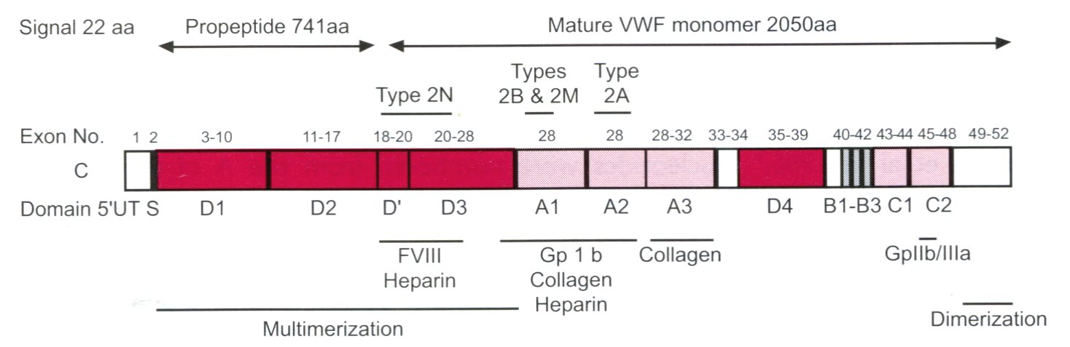

**Figure 1 Structure and function relationship of the von Willebrand factor domains[1].** The VWF is synthesized in endothelial cells as a large protein of 2813 amino acid (aa): signal prepetide 22aa, propeptide 741aa, and the mature VWF monomer 2050aa. D1-D2 pro-peptide is cleaved off at the Furin cleavage site at time of secretion. VWF circulates bound the FVIII at the D’ FVIII binding domain. Below the figure are the areas of VWF involved in binding specific factors. VWF circulates as large multimers as a function of the D3 multimerization and CK dimerisation domains Source Goodeve and Peake[1]. VWF: Von Willebrand factor.

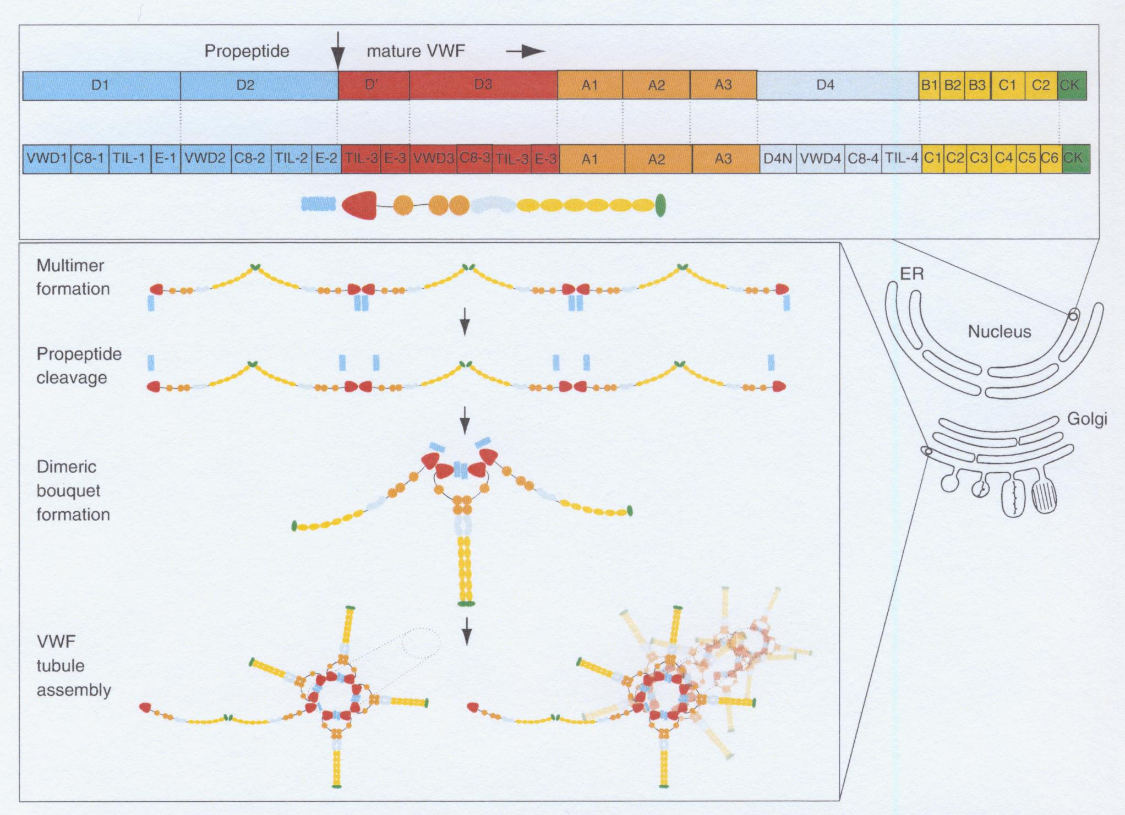

**Figure 2 Von Willebrand factor domain structure and assembly throughout the biosynthetic pathways in endothelial cells[3-5].** The top panel shows the diferent domains of VWF as it is synthesized in the endoplasmatic reticulum (ER)[4]. The arrow between te D2 domain and the D’domain indicates the furin cleavage site at 764 leading to the production of the VWF propeptide (VWFpp) D1-D2 (blue) and the mature VWD protein with the domains D’, D3, A1, A2, D4, C1-6 and the cystein knot (CK). The lower panel shows the assembly of VWF into multimers in the Golgi compartment, the cleavage VWFpp (blue), and te assembly of VWF into the demeric bouquet at the trans Golgi network (TNG). During the translocation of proVWF to the endoplasmatic reticulum (ER) the signal peptide is cleaved off, and the provWF forms dimers in a tail-to-tail fashion through cysteines in its carboxyterminal cysteine knot domain. ProVWF dimers transit to the Golgi apparatus to assemble into multimers in a “head-to-head” fashion through the formation of intermolecular disulphide bonds between cysteine-residues in the D3 (multmerization) domain[4]. This is followed by the assembly of VWF in the Golgi network. VWF: Von Willebrand factor.

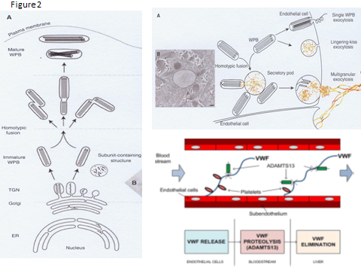

**Figure 3 A left. Biosynthesis pathway of Weibel-Palede Body (WPB)[4].** A: The different steps in WPB synthesis of von Willebrand factor (VWF) assembly at the level of endoplasmatic reticulum (ER), at the trans-Golgi network (TGN) level (B), and VWF tubules are assembled and packed into budding vesicles prior to immature WPB formation. Homotypic fusion of WPB gives rise to the formation of WPB with different shapes. As WPB mature they became more electron-dense and reach the plasma membrane. A righ: Different modes of WPB exostosis and VWF string formation on endothelial cells. In single WPB exostosis mode, a single wPB fuses with the plasmamembrane and ultra large VWF multimers (MM) is secreted. In lingering-kiss exostosis mode (middle), WPB round up and a small pore is formed with the plasma membrane, allowing the secretion of ultra large VWF MM. In multigranular exostosis mode (bottom), WPB undergo homotypic fusion leading to the formation of a secretory pod that permits pooling of ultra large VWF MM prior to secretion[4]. After release the ultralarge vWF strings stick to the endothelial cell surface, attrack platelets through platelet GpIb ligand and VWF GpIb receptor interaction thereby activating the VWF cleavage site to be cleaved by ADAMTS13 at high shear stress in the endarterial circulation. WPB: Weibel-Palede Body.

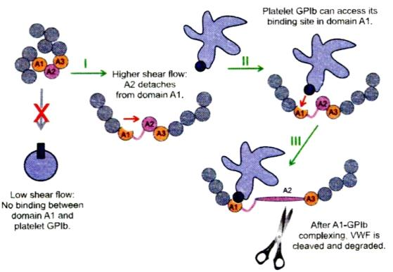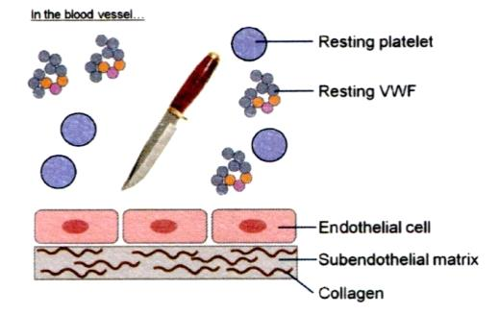

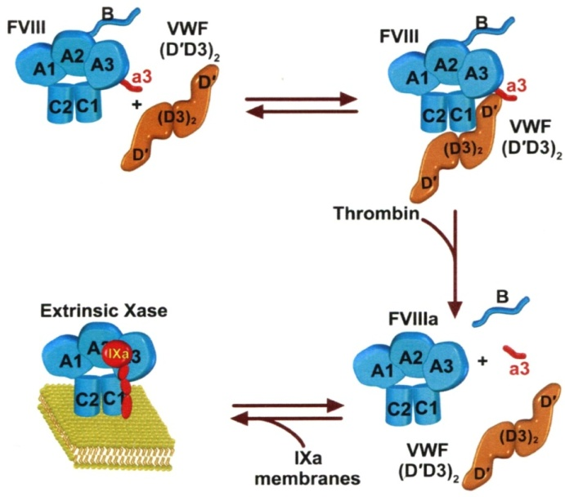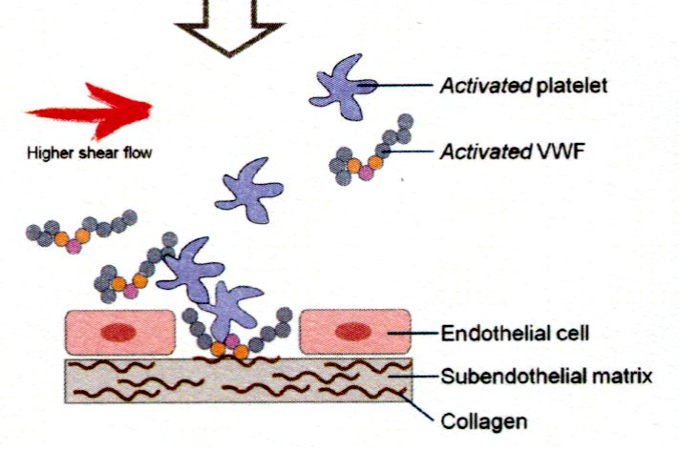

**Figure 4 In the equilibrium state, with intact endothelial cells and no injured vessel resting platelets and resting von Willebrand factor circulates as globules in blood (upper left).** In this state, VWF is incapable of mediating platelet adhesion. After an injury of the endothelial cells, the activated VWF interacts with exposed collagen *via* vWF domains A1 and A3 (orange parts) and triggers the adhesion of activated platelets *via* VWF domain A1 (lower left).At low shear there is no binding between VWF domain A1 and platelet GPIb. At high shear rate the VWF globules elongate and made the VWF A1 domain accessible by the dissociation of domain A1 from A2. High shear flow detaches the A2 domain from domain A1 (I). Binding between GPIb of activated platelet to the GPIb receptor of VWF (II), which is immediately followed by cleavage of VWF in the A2 domain by ADAMST13 (III). Courtesy of Dr Sandra Posch. Insitute of Biophysics. Linz, Austria: [sandra.posch@jku.at](mailto:sandra.posch@jku.at). FVIII:C is a heterodimer with a domain structure of A1-A2-B-A3-C1-C2 (upper left, Blue). FVIII:C circulates in complex with VWF through binding to the D’D3 domain, the FVIII binding site on VWF. Thrombin cleavage of FVIII liberates the a3 peptide and the B domain of FVIII, resulting in the dissociation of VWF from FVIII[6].

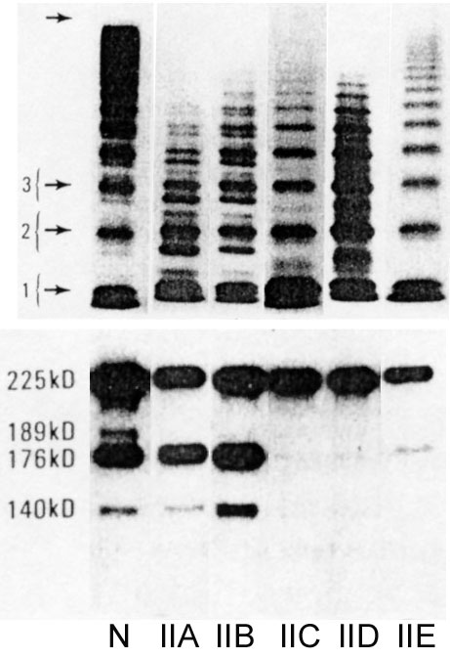 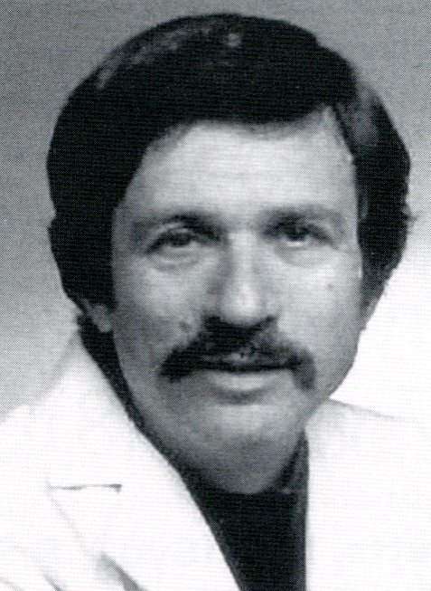

**Figure 5 The 1986 Zimmerman Classification of VWD type IIA, IIB, IIC, IID and IID[9] and Dr. Ted Zimmerman 1937-1988.** SDS-agarose multimeric analysis of plasma VWF in normal plasma (N) and in VWD type IIA, IIB, IIC,IIE and IID. Left lower part: Immunoblots of VWF proteolytic degradation products show increased proteolysis in VWD type IIA and IIB, but not or even absent in VWD type IIC, IIE and IID (N = normal plasma). VWD: Von Willebrand disease; VWF: Von Willebrand factor.

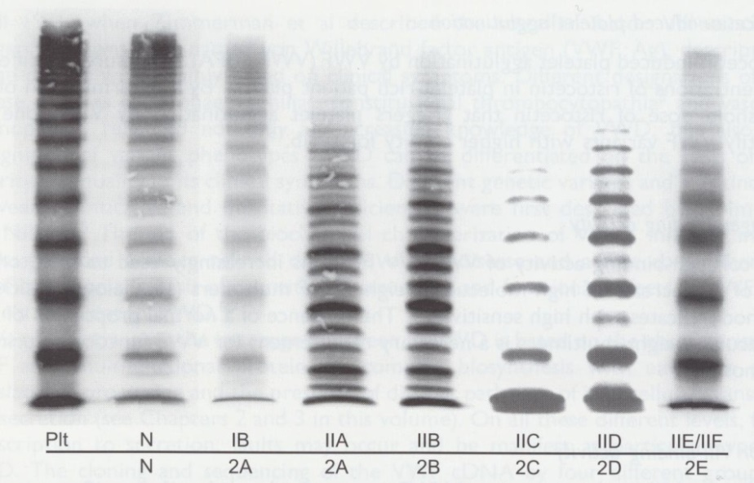

**Figure 6 Multimeric pappern**. Von Willebrand factor from plasma of patients with von Willebrand disease classified according to the ISTH criteria for VWD type IIA, IIB, IIC and IIE and the translation into the 2001 Hannover criteria for 1B = 2M (not 2A), 2A, 2B, 2C, 2D and 2E anno 2001 compared to a normal control in high resolution gel concentration (1.5%) according to Budde and Schneppenheim[10]. Plt = Platelet VWF. N=normal. Dominant 1B relative reduced of large vWF mutimers (MM) = 2M (Michiels). Dominant IIA = 2A lack of large molecular weight MM and the outer sub-bands of the individual triplets are markedly pronounced indicating increased proleolysis as the cause of 2A. Dominant 2B cannot be distinguished from 2A by MM alone. Recessive IIC = 2C lack of large MM and absence of triplets. Low MM and especially the first band, which probable reflects protomer (dimer) and a tetramer are markedly pronounced. IID = 2D intervening vWF band and an odd number of MM. 2E lack or relative decrease of large MM and absence of the outer sub-bands of the normal triplet structure. Triplets are lacking in 2C, 2D, 2E and 1B = 2M are lacking indicating the absence of proteolysis. VWD: Von Willebrand disease; VWF: Von Willebrand factor.

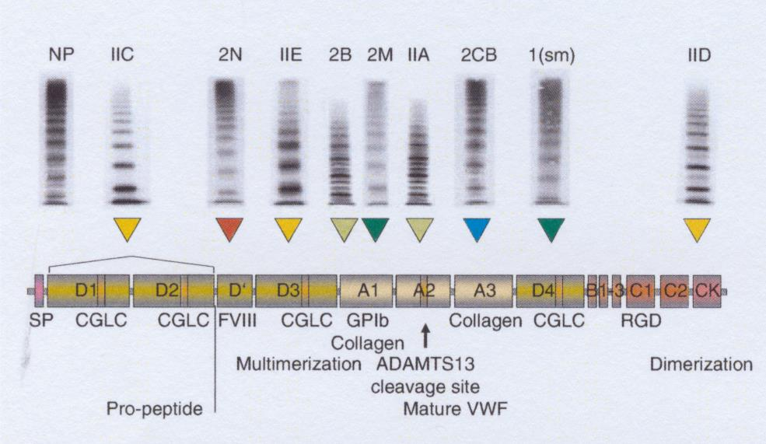

**Figure 7 Translation and integration of the 2006 ISTH and the 2009 Hannover classification**. VWD type 2 variants[20] (recessive IIC, recessive 2N, dominant IIE, 2B, 2M, IIA, 2CB 1(sm) and IID related to clustered distribution of VWF gene mutations in the D1-D2 propeptide, D’, D3, A1, A1, A2 A3 D4 and CK domains respectively. For explanation see figure 8: from left to right recessive 2N, recessive IIC 🡪 2C, and dominant IIE 🡪 2E, IIA 🡪 2E, 2B, 2M, IIA 🡪 2A, 2 CB (collagen binding defect), 1 smeary pattern (sm) and IID 🡪 2D[20]. VWD: Von Willebrand disease; VWF: Von Willebrand factor.

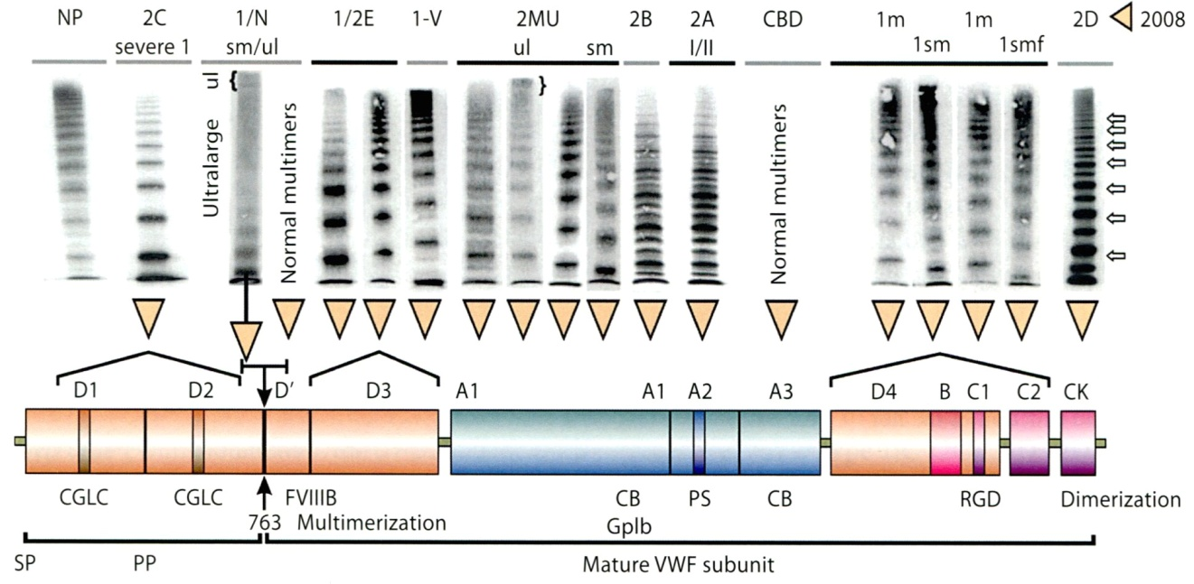

**Figure 8 Structure and function of normal von Willebrand factor protein[20].** Mutations in the D1D2 domain prohibit the cleavage of VWFpp from mature VWF leading to a severe secretion and multimerisation defects in recessive VWD 2C[16,31,33]. FVIII binding defects in the VWF D’ domain either homozygousor double heterozygous causes recessive VWD 2N[34,35]. Dominant VWD type 2E due to heterozygous missence mutations in the D3 leads to a secretion clearance multimerization defect, VWD 2E[20,38,39]. Loss of function mutations in the VWF GpIb of the A1 domain induce dominant VWD 2M[18,36,37]. Dominant VWD 2A due to mutations in the A2 domain makes the mutant VWF hypersensitive to the VWF cleavage protease ADAMTS13 at the VWF cleavage site (1605-1606)[44-44]. Immediately after secretion the 2A mutated VWF is proteolysed with loss of large VWF multimers and typical triplet structur of each VWF band. Dominant VWD 2B due to gain of function mutation in the A1 domain accelerates the interaction of platelet-GpIb and VWF A1 followed by VWF proteolysis by ADAMTS 13 interaction[17,46]. This process starts immediately after secretion of the 2B mutated VWF and causes VWD 2B with loss of large multimers and typical triplet structure of each VWF band. A new category of VWD type 1 secretion defect (SD) is due to mutations in the D4,B1-3,C1-2[39,49] domains relabelled as the C1, C2, C3, C4, C5 and C6 domains of the VWF gene/protein[3-5]. Heterozygous mutations in the D4, C1-C6 domains result in VWD type 1 secretion defect (SD) and have either normal multimers or abnormal multimers. Homozygous or double heterozugous mutations in the D4, C1-C6 domains are associated with severe VWD type 1[26-29]. Cysteine mutation in the CK dimerization domain either heterozygous and homozygous or double heterozygous are associated with VWD 2D[30]. VWD: Von Willebrand disease; VWF: Von Willebrand factor.

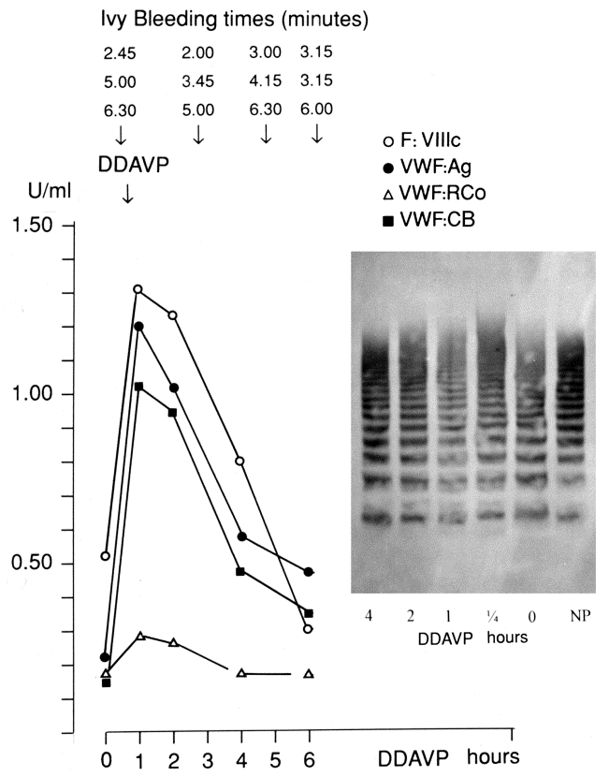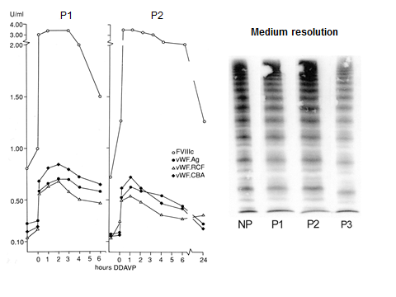

**Figure 9 Restricted response of von Willebrand factor parameters to desmopressin.** In pronounced dominant VWD type 1 secretion defect (high FVIII:C/VWF:Ag ratio) with restricted response of VWF parameters to DDAVP as compared to completely normal responses of FVIII (high FVIII:C/VWF:Ag ratio) is indicative for VWD type 1 secretion defect (Left). Diagnostic differentiaton of pronounced 1 VWD 1 secretion defect (SD) with normal VWF multimers (VWF MM according to Budde)and restricted decreased response to DDAVP of all von Willebrand factor (VWF) parameters in two members of one family (proband and her brother) *vs* pronounced case of dominant VWD 2M (Right) with normal VWF multimers before and after DDAVP[18], a poor response of VWF:RCo to DDAVP and fairly good responses to DDAVP of FVIII:C, VWF:Ag and VWF:CB followed by shortened half life times of FVIII:C, VWF:Ag and VWF:CB indicative for rapid clearance defect (CD). Dominant VWD type 2M (Michiels) is featured by loss of function mutation in the A1 domain, normal multimers, decreased to zero RIPA, low VWF:RCo activity, a secretion defect and rapid clearance[18]. VWD: Von Willebrand disease; VWF: Von Willebrand factor.

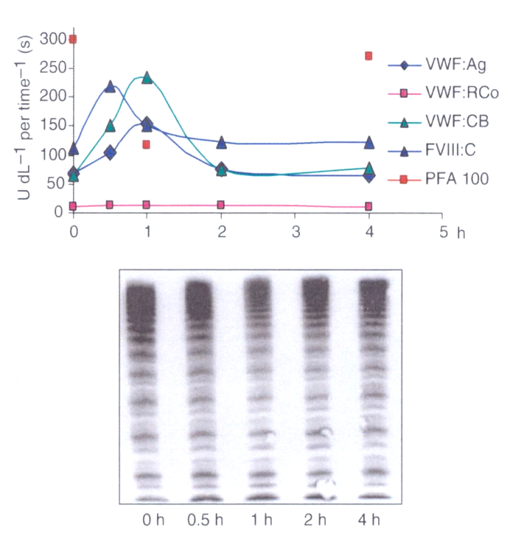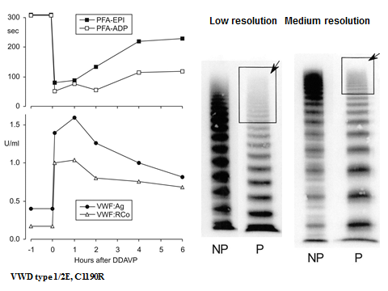

**Figure 10 Left VWD 2E and right von Willebrand disease 2M.** Dominant VWD type 2E mulitimeriztion defect with loss of large VWF multimers to W1120S mutation in the A3 domain. DDAVP induced transient correction of PFA-100 closure time and restricted increase of VWF parameters from around 0.20-0.40 U/mL to around 1.0 U/mL. In VWD type 2 E VWF multimeric pattern is charaterized by a lack or relative decrease of large multimers and the absence of th outer sub-band of the normal triplet structure. Medium resolution gel according to Budde. Right VWD 2M:Poor response of VWF:RCo to DDAVP, normal VWF multimers before and after DDAVP and good responses of FVIII, VWF:Ag and VWF:CB followed by shortenend half-lfe time indicating rapid clearance defect of the FVIII-VWF complex on top of loss of VWF:RCo function in VWD 2M[20]. Medium resolution gel according to Budde. For comparison figure 12 show characteristic responses of the VWF multimeric structure to DDAVP in a healthy control (left) and in VWD 2E (right) in a medium resolution gel according to Budde. VWD: Von Willebrand disease; VWF: Von Willebrand factor.

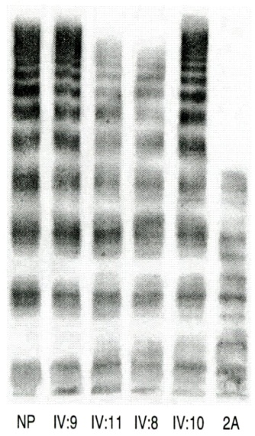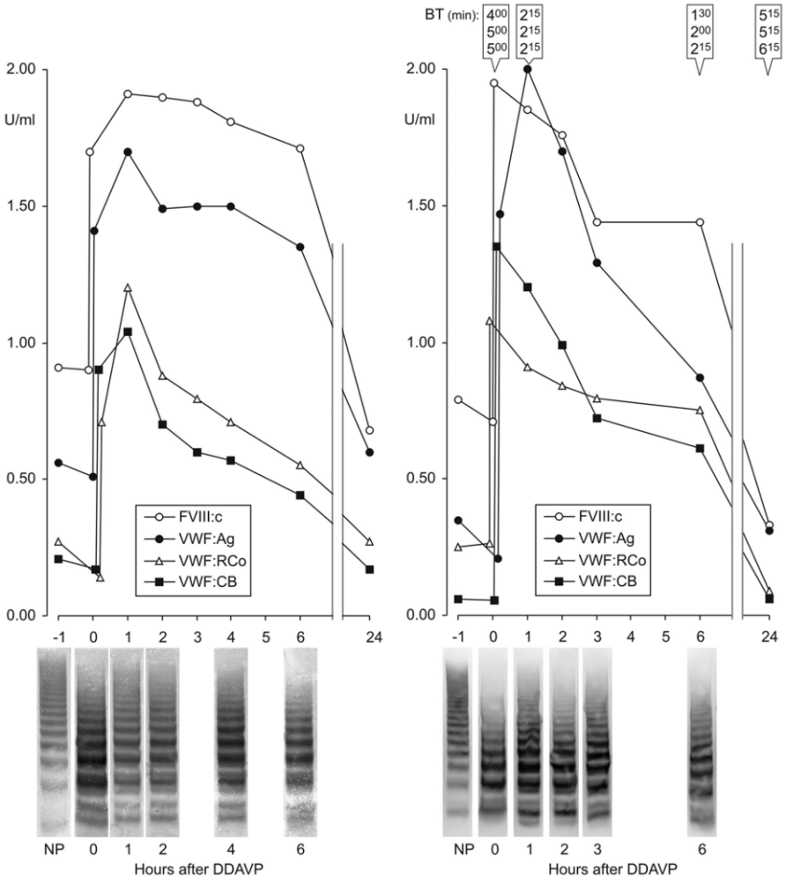

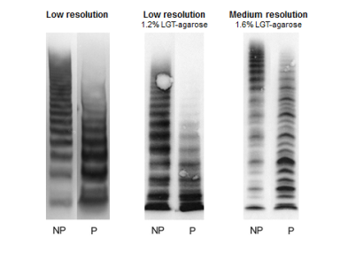

**Figure 11 Dominant von Willebrand disease type 2A mutation V1499E is featured by a normal radio immunoprecipitation assay.** The loss of largest VWF multimers and increase of intermediate and small VWF multimers in low resolution gels (VWF multimeric pattern before DDAVP, lower left)[43,44]. The responses to DDAVP of FVIIIc and von Willebrand factor antigen (VWF:Ag) are normal. The responses to DDAVP of the functional VWF:RCF and VWF:CB are restricted to about 1 U/mL 1 h post-DDAVP with transient correction of Ivy bleeding times and transient reapppearance of large VWF multimers in two cases of moderate dominant VWD type 2A (mutation V1499E). As compared to VWF{Ag and FVIII:C the half life times of VWF:RCo and VWF:CB are shortened due to increased proteolysis of VWF multimers (Left). Lower right: Please note that the VWF multimers in low resolution gels in the Rotterdam laboratory and in the Hamburg Laboratory (Budde, middle lanes) clearly show the absence of large VWF multimers and no triplet of the individual VWF bands. The typical triplet structure of the individual VWF bands diagnostic for VWD type 2A was only seen in the meduim resolution gels (right lanes) according to Budde. Upper right: The multimeric analysis of VWF from affected patients from the large Dutch family with dominant V1499E mutated VWD 2A in a third laboratory (Amsterdam)[43] show the loss of the largest VWF multimers as shown for 2 affected cases (IV:8 and IV:11) as compared to normal (NP) and 2 non-affected family members (IV:9 and IV:10). The loss of large in V1499E mutated VWD patients was less pronounced as compared to a case of typival VWD 2A with the loss of large and some of the intermediate VWF multimer and a typical triplet structure of each VWF band in that laboratory[43]. VWD: Von Willebrand disease; VWF: Von Willebrand factor.



**Figure 12 Absence of large and intermediate von Willebrand factor multimers in severe dominant von Willebrand disease type 2 A, with absence of radio immunoprecipitation assay and strongly prolonged Ivy bleeding times in a case with the S1506L mutation[44].** The **r**esponses of VWF parameters to DDAVP are very poor with no correction of Ivy bleeding times (BT) and no re-appearance of large VWF multimers in this case with dominant severe VWD 2A Group I indicating impaired assembling transport and proteolysis of intracelllar VWF multimers caused by the mutation S1506L near to the VWF cleavage site in the A2 domain of the VWF gene. VWD: Von Willebrand disease; VWF: Von Willebrand factor.