**Name of Journal:** *World Journal of Gastrointestinal Surgery*

**Manuscript NO:** 78585

**Manuscript Type:** CASE REPORT

**Preoperative blood circulation modification prior to pancreaticoduodenectomy in patients with celiac trunk occlusion: Two case reports**

Colella M *et al*. Pancreaticoduodenectomy in celiac artery occlusion

Marco Colella, Kohei Mishima, Taiga Wakabayashi, Yoshiki Fujiyama, Malek A Al-Omari, Go Wakabayashi

**Marco Colella, Kohei Mishima, Taiga Wakabayashi, Yoshiki Fujiyama, Malek A Al-Omari, Go Wakabayashi,** Center for Advanced Treatment of HBP Diseases, Ageo Central General Hospital, Ageo 362-8588, Saitama, Japan

**Author contributions:** Colella M and Mishima K wrote the manuscript; Mishima K treated the patients; Wakabayashi G, Wakabayashi T, Fujiyama Y, and Al-Omari MA, critically reviewed the manuscript; all authors read and approved the final manuscript.

**Corresponding author: Kohei Mishima, MD, Surgeon,** Center for Advanced Treatment of HBP Diseases, Ageo Central General Hospital, 1 Chome-10-10 Kashiwaza, Ageo 362-8588, Saitama, Japan. mishima0930@gmail.com

**Received:** July 15, 2022

**Revised:** September 24, 2022

**Accepted:** October 19, 2022

**Published online:** November 27, 2022

**Abstract**

BACKGROUND

Celiac trunk stenosis or occlusion is a common condition observed in patients undergoing pancreaticoduodenectomy (PD). The risk of upper abdominal organ ischemia or failure increases if the blood circulation in the celiac arterial system is not maintained after the surgery.

CASE SUMMARY

We present two cases of elderly patients with distal cholangiocarcinoma and celiac trunk occlusion who underwent PD. We performed blood circulation modification preoperatively with transcatheter coil embolization of the arterial arcades of the pancreatic head *via* the superior mesenteric artery to develop collateral communication between the superior mesenteric artery and the common hepatic or splenic arteries to ensure arterial blood flow to the upper abdominal organs. The postoperative course was marked by delayed gastric emptying, but no major surgical complications, such as biliary or pancreatic fistula, or clinical, biochemical, or radiological evidence of ischemic disease, was observed.

CONCLUSION

Preoperative blood circulation modification may be a valid alternative procedure for elderly patients with celiac trunk occlusion who are ineligible for interventional or surgical revascularization.

**Key Words:** Preoperative blood circulation modification; Cholangiocarcinoma; Pancreaticoduodenectomy; Whipple procedure; Celiac trunk occlusion; Atherosclerosis; Transcatheter coil embolization; Case report

**©The** **Author(s) 2022.** Published by Baishideng Publishing Group Inc. All rights reserved.

**Citation:** Colella M, Mishima K, Wakabayashi T, Fujiyama Y, Al-Omari MA, Wakabayashi G. Preoperative blood circulation modification prior to pancreaticoduodenectomy in patients with celiac trunk occlusion: Two case reports. *World J Gastrointest Surg* 2022; 14(11): 1310-1319

**URL**: https://www.wjgnet.com/1948-9366/full/v14/i11/1310.htm

**DOI**: https://dx.doi.org/10.4240/wjgs.v14.i11.1310

**Core Tip:** Celiac trunk stenosis or occlusion is a common condition observed in patients undergoing pancreaticoduodenectomy (PD). Celiac trunk occlusion may increase the risk of upper abdominal organ ischemia or failure. In this case report, we present two elderly patients who underwent PD for distal cholangiocarcinoma with celiac trunk occlusion. We performed blood circulation modification preoperatively with transcatheter coil embolization of the arterial arcades of the pancreatic head to develop collateral communication between the superior mesenteric and the common hepatic or splenic artery.

**INTRODUCTION**

Celiac trunk stenosis is a common condition observed in up to 10% of patients undergoing pancreaticoduodenectomy (PD)[1,2]. If undiagnosed, it can lead to fatal ischemia of the upper abdominal organs after the surgery because the blood supply *via* the pancreatic head arcades is sacrificed intraoperatively due to the ligation of the gastroduodenal artery (GDA)[1-4]. Herein we describe two elderly patients who underwent PD following a novel blood circulation modification with transcatheter coil embolization of the arterial arcades of the pancreatic head.

**CASE PRESENTATION**

***Chief complaints***

**Case 1**: In June 2019, an 83-year-old man with a history of hypertension, chronic kidney disease, and chronic obstructive pulmonary disease was referred to our hospital for liver dysfunction during a blood test, fever, and anorexia.

**Case 2:** An 84-year-old man with a history of cervical spondylosis, chronic obstructive pulmonary disease, and atrial fibrillation was admitted to our institution in August 2019 with a 1-mo history of epigastric pain, weight loss, and dyspepsia.

***History of present illness***

**Case 1:** A computed tomography (CT) scan revealed celiac artery (CeA) occlusion due to atherosclerosis, with thickening of the extrahepatic bile duct wall and luminal stenosis, resulting in mild upstream bile duct dilatation, and the possibility of cholangitis or distal cholangiocarcinoma was enlightened.

Distal cholangiocarcinoma was suspected following magnetic resonance cholangiopancreatography (MRCP), which revealed a stricture of the extrahepatic bile duct and mild dilatation of the intrahepatic bile duct (Figure 1A and B). An ERCP with brushing cytology was performed to confirm the diagnosis, and a plastic stent was placed.

**Case 2:** CT revealed dilatation of the entire bile duct system, with 15-mm tissue obstructing the wall and lumen of the pancreatic tract of the common bile duct without pancreatic duct dilatation. Additionally, a small lymph node was observed around the hepatic hilum and abdominal aorta (Figure 1C and D). Distal bile duct cancer was suspected, and the patient underwent MRCP and ERCP with brushing cytology, which confirmed the diagnosis.

***Laboratory examinations***

**Case 1:** Distal cholangiocarcinoma cT2N0M0 stage IIA was diagnosed according to the American Joint Committee on Cancer (AJCC) 8th classification, and PD was scheduled.

**Case 2:** According to the AJCC 8th edition classification, a diagnosis of distal cholangiocarcinoma cT2N1M0 stage IIB was made, and PD was scheduled. A plastic stent was placed in the common hepatic duct preoperatively.

***Imaging examinations***

**Case 1:** An angiographic study and CT with 3D reconstruction were performed; complete occlusion of the CeA and complex anomalous arterial anatomy were observed (Figure 2). The inferior pancreaticoduodenal artery (IPDA), which branches from the superior mesenteric artery (SMA), supplied the celiac arterial system's primary blood supply, while the dorsal pancreatic artery (DPA) supplied the right hepatic arteries (RHA) and splenic arteries (SPA). Preoperatively, we embolized the arterial arcades of the pancreatic head using a coil to increase blood flow *via* the SMA to the RHA and SPA (Figure3). Both post-procedural CT and angiography confirmed the development of blood flow sustained by the DPA, and no radiological signs of ischemic complications were observed.

**Case 2:** On preoperative CT, complete CeA obstruction due to atherosclerosis and a well-developed collateral pathway between the SMA and CeA were observed (Figure 4). Angiography revealed complete celiac trunk occlusion, maintenance of the major backflow to the celiac arterial system by two main pathways (the pancreatic head arcades), and linkage of the DPA to the common hepatic artery (CHA). We speculated that celiac arterial blood flow could be supplied *via* the DPA; however, ligating the GDA would cause blood flow reduction. Hence, there was a high risk of severe ischemia of the upper abdominal organs.

**FINAL DIAGNOSIS**

***Case 1***

Pathological diagnosis identified pT3apN1pM0, stage IIB, poorly differentiated biliary tract cancer. Of the 24 lymph nodes retrieved, only one was involved, and the lesion was completely included in the resection margin (R0 resection). The operative time was 7 h and 55 min, and the estimated blood loss was 700 mL.

***Case 2***

Pathological diagnosis identified pT2pN1pM0, stage IIB, intermediate-grade biliary tract cancer, which involved 3 of 20 lymph nodes retrieved.

The nodes and the lesion were completely included in the resection margin (R0 resection). The operation time was 6 h and 32 min, and the estimated blood loss was 200 mL.

**TREATMENT**

***Case 1***

An open-approach Whipple procedure with D2 lymphadenectomy was performed in August 2019 (10 d after the TAE). During lymph node dissection around the hepatoduodenal ligament, the collateral artery from the DPA to RHA was successfully preserved.

***Case 2***

To reduce this risk, we decided to embolize the arterial arcades of the pancreatic head using a coil to increase the blood flow from the DPA to the CHA preoperatively. After embolization, angiography and CT confirmed blood re-flow from the DPA through the entire celiac arterial system, and no radiological signs of parenchyma or bowel ischemia were found. A standard open-approach Whipple procedure with D2 Lymphadenectomy was performed in September 2019 (10 d after the TAE). During the operation, the DPA was identified and preserved (Figure 5).

**OUTCOME AND FOLLOW-UP**

***Case 1***

Postoperatively, the patient developed blue toe syndrome and delayed gastric emptying but did not show any major surgical complications, such as biliary or pancreatic fistula; additionally, there was no clinical, biochemical, or radiological evidence of ischemic disease. The patient was discharged on postoperative day (POD) 56. The patient was not followed up; hence, no evidence of recurrence or delayed complications was obtained on the scheduled 6-mo CT scan.

***Case 2***

Postoperatively, the patient developed pneumonia, pulmonary embolism, and delayed gastric emptying but did not show any major surgical complications and was discharged on POD 41. No evidence of recurrence was observed at the 3-year follow-up.

**DISCUSSION**

Stenosis of the celiac trunk is a frequent occlusive vascular disease that can be observed in 2%-11% of patients who undergo PD[2-5]. Occlusion of the celiac axis is a rare situation encountered in 1%-3% of patients and is associated with a higher risk of ischemic consequences on the liver and both hepaticojejunal and pancreatico-jejunal anastomoses[6].

The main causes of stenosis or total occlusion of the celiac trunk are compression by the medial arcuate ligament (MAL) followed by atherosclerosis, which accounts for nearly 90% of the causes, including aortic dissection, congenital causes, inflammatory disease, invasion of malignancy, and iatrogenicity[7].

The typical symptoms of celiac trunk stenosis include postprandial abdominal pain, nausea, vomiting, and weight loss; nevertheless, clinically significant ischemic disease is rarely encountered owing to the development of rich collateral vessels from the SMA[8]. The diagnosis of CeA stenosis can be easily accessed through CT and arteriography, with a detection rate of 91.5%[4]; evaluation of all the collateral pathways is essential for any preoperative planning. When considering PD, any anatomical variant that may affect surgical planning should be evaluated using CT along with 3D reconstruction[9] and, in selective cases, angiographic studies. However, most surgeons do not routinely perform angiographic studies, and while preoperative imaging is often diagnostic, if an angiographic study is not performed in case of doubt, vascular sufficiency can be assessed intraoperatively.

Bull *et al*[3] endorsed a well-known maneuver that tested the pulsation of the hepatic artery before GDA ligation to ensure adequate patency of the collateral pathways. GDA ligation at its origin is an essential step during PD, and in the event of celiac trunk stenosis, the procedure can lead to ischemia of the liver, stomach, spleen, and residual pancreas, resulting in complications such as organ failure, abscess, and anastomotic leakage[4,5]. Berney *et al*[9] reported two cases of postoperative transient ischemic liver dysfunction and two cases of disruption of the pancreatic jejunal anastomosis in patients with CeA stenosis without preoperative or intraoperative revascularization procedures. Gaujoux *et al*[4] reported 545 patients who underwent PD and identified 23 CeA compressions by MAL, 2 CeA, and 2 SMA atherosclerotic stenoses. After PD, ischemic complications accounted for one-third of the 2.6% postoperative mortality, suggesting that ischemic complications account for significant morbidity and mortality after PD. Zhou *et al*[10] retrospectively analyzed the risk for biliary fistula in 508 patients who underwent PD, of which 84 had CeA stenosis due to atherosclerotic disease. The incidence of biliary fistulas was 2.1% in patients with mild CeA stenosis (1/47) and 27% in those with severe stenosis.

Different options have been proposed to treat CeA stenosis encountered during PD, majorly depending on the underlying disease. In cases of extrinsic compression caused by MAL, division of the median arcuate ligament can be performed intraoperatively[11]. In cases of atherosclerotic stenosis, percutaneous transcatheter angioplasty or stenting can be performed[12]. In cases of severe stenosis or complete occlusion, percutaneous revascularization with angioplasty or stenting of the CeA was not possible. Therefore, endovascular treatment *via* arcades of the pancreatic head[13] or surgical treatment with vascular reconstruction should be considered. Several surgical revascularization methods have been reported in the literature: Bypass grafting using autologous or prosthetics graft[14,15], end-to-end or end-to-side arterial anastomosis method[14-16] (Table 1), *etc.* Vascular reconstruction with PD increases the risk of thromboembolism and postoperative bleeding (caused by pancreatic fistula) and carries an intrinsic risk of thrombosis and leakage of the vascular anastomosis.

In our study, we treated two elderly patients with severe comorbidities and atherosclerotic diseases. In such cases, arterial bypass could be technically difficult because of diffuse atherosclerotic disease, and the risk of thrombosis and leakage of vascular anastomoses could be very high.

Considering the patients’ advanced age and risk of comorbidities as well as to avoid the risk of fatal ischemic complications after PD, we decided to embolize the arterial arcades of the pancreatic head before the operation to increase the blood flow from the SMA to the celiac arterial system.

This expedient minimizes the risk of fatal ischemic complications after PD, ensuring that the entire collateral pathway and hypertrophy of the collateral vessels are preserved during the operation. We observed delayed gastric emptying, which was correlated with slight transient gastric ischemia. Repetitive postoperative CT showed strong hypertrophy of the collateral vessels, with good blood flow of the celiac arterial system and no vascular complications.

In elderly patients with severe stenosis or complete occlusion who are not eligible for interventional revascularization or surgical reconstruction, this technique is simple, feasible, repeatable in case of failure, and less prone to complications than any previous vascular reconstruction method. However, the use of CT and angiographic studies to evaluate vascular anatomy and eventually plan blood flow modification prior to the surgical procedure is crucial.

**CONCLUSION**

In elderly patients with celiac trunk occlusion, PD can lead to a severe risk of postoperative complications, and preoperative blood circulation modification can reduce the risk of ischemic accidents. Precise preoperative anatomical studies of the vascular pathway and an optimal surgical or radiological technique must be chosen on a case-by-case basis to avoid unfavorable postoperative outcomes.

**REFERENCES**

1 **Sugae T**, Fujii T, Kodera Y, Kanzaki A, Yamamura K, Yamada S, Sugimoto H, Nomoto S, Takeda S, Nakao A. Classification of the celiac axis stenosis owing to median arcuate ligament compression, based on severity of the stenosis with subsequent proposals for management during pancreatoduodenectomy. *Surgery* 2012; **151**: 543-549 [PMID: 22001637 DOI: 10.1016/j.surg.2011.08.012]

2 **Nara S**, Sakamoto Y, Shimada K, Sano T, Kosuge T, Takahashi Y, Onaya H, Yamamoto J. Arterial reconstruction during pancreatoduodenectomy in patients with celiac axis stenosis--utility of Doppler ultrasonography. *World J Surg* 2005; **29**: 885-889 [PMID: 15951921 DOI: 10.1007/s00268-005-7878-x]

3 **Bull DA**, Hunter GC, Crabtree TG, Bernhard VM, Putnam CW. Hepatic ischemia, caused by celiac axis compression, complicating pancreaticoduodenectomy. *Ann Surg* 1993; **217**: 244-247 [PMID: 8095781 DOI: 10.1097/00000658-199303000-00005]

4 **Gaujoux S**, Sauvanet A, Vullierme MP, Cortes A, Dokmak S, Sibert A, Vilgrain V, Belghiti J. Ischemic complications after pancreaticoduodenectomy: incidence, prevention, and management. *Ann Surg* 2009; **249**: 111-117 [PMID: 19106685 DOI: 10.1097/SLA.0b013e3181930249]

5 **Soonawalla Z**, Ganeshan A, Friend P. Celiac artery occlusion encountered during pancreatic resection: a case report. *Ann R Coll Surg Engl* 2007; **89**: W15-W17 [PMID: 17316515 DOI: 10.1308/147870807X160344]

6 **Sakorafas GH**, Sarr MG, Peros G. Celiac artery stenosis: an underappreciated and unpleasant surprise in patients undergoing pancreaticoduodenectomy. *J Am Coll Surg* 2008; **206**: 349-356 [PMID: 18222391 DOI: 10.1016/j.jamcollsurg.2007.09.002]

7 **Oikawa R**, Ito K, Takemura N, Mihara F, Shida Y, Tajima T, Kokudo N. Risk Factors of Atherosclerotic Celiac Artery Stenosis Among Patients Undergoing Pancreaticoduodenectomy. *Pancreas* 2022; **51**: e15-e17 [PMID: 35404901 DOI: 10.1097/MPA.0000000000001988]

8 **Wakabayashi T,** Felli E, Pessaux P. Celiac axis stenosis caused by median arcuate ligament in pancreaticoduodenectomy. J Pancreas 2019; 20: 101-102

9 **Berney T**, Prêtre R, Chassot G, Morel P. [Ischemic risk in the case of celiac trunk occlusion in patients undergoing pancreatodeodenectomy. Multicenter study and review of literature]. *Ann Chir* 1999; **53**: 273-279 [PMID: 10327689]

10 **Zhou Y**, Wang W, Shi Y, Lu X, Zhan Q, Chen H, Deng X, Peng C, Shen B. Substantial atherosclerotic celiac axis stenosis is a new risk factor for biliary fistula after pancreaticoduodenectomy. *Int J Surg* 2018; **49**: 62-67 [PMID: 29258887 DOI: 10.1016/j.ijsu.2017.11.054]

11 **Kurosaki I,** Hatakeyama K, Nihei K, Oyamatsu M. Celiac axis stenosis in pancreaticoduodenectomy. J HepatoBil Pancreat Surg 2004; 11: 119-124 [DOI:10.1007/s00534-003-0871-6]

12 **Ikeda O**, Tamura Y, Nakasone Y, Yamashita Y. Celiac artery stenosis/occlusion treated by interventional radiology. *Eur J Radiol* 2009; **71**: 369-377 [PMID: 18562143 DOI: 10.1016/j.ejrad.2008.05.005]

13 **Farma JM**, Hoffman JP. Nonneoplastic celiac axis occlusion in patients undergoing pancreaticoduodenectomy. *Am J Surg* 2007; **193**: 341-4; discussion 344 [PMID: 17320531 DOI: 10.1016/j.amjsurg.2006.09.027]

14 **Okamoto H**, Suminaga Y, Toyama N, Konishi F, Kawahito H. Autogenous vein graft from iliac artery to splenic artery for celiac occlusion in pancreaticoduodenectomy. *J Hepatobiliary Pancreat Surg* 2003; **10**: 109-112 [PMID: 12918470 DOI: 10.1007/s10534-002-0831-7]

15 **Portolani N**, Tiberio GA, Coniglio A, Baiocchi G, Vettoretto N, Giulini SM. Emergency celiac revascularization for supramesocolic ischemia during pancreaticoduodenectomy: report of a case. *Surg Today* 2004; **34**: 616-618 [PMID: 15221559 DOI: 10.1007/s00595-004-2755-z]

16 **Halazun KJ**, Kotru A, Menon KV, Patel J, Prasad KR. Stenting of coeliac axis stenosis facilitates pancreatectomy. *Eur J Surg Oncol* 2006; **32**: 811-812 [PMID: 16784835 DOI: 10.1016/j.ejso.2006.04.017]

**17 Hayashibe A**, Sakamoto K, Shinbo M, Makimoto S, Nakamoto T, Higashiue S, Toyonaga T. A resected case of advanced duodenal carcinoma with occlusion of the celiac artery. *J Surg Oncol* 2005; **91**: 270-272 [PMID: 16121352 DOI: 10.1002/jso.20319]

18 **Smith SL**, Rae D, Sinclair M, Satyadas T. Does moderate celiac axis stenosis identified on preoperative multidetector computed tomographic angiography predict an increased risk of complications after pancreaticoduodenectomy for malignant pancreatic tumors? *Pancreas* 2007; **34**: 80-84 [PMID: 17198187 DOI: 10.1097/01.mpa.0000240607.49183.7e]

19 **El-Ghazaly Harb ST**, O'Sullivan AW, Marangoni G, Heaton ND, Rela M. Managing arterial collaterals due to coeliac axis stenosis during pancreaticoduodenectomy. *JOP* 2009; **10**: 547-549 [PMID: 19734635]

20 **Berselli M**, Sperti C, Ballotta E, Beltrame V, Pedrazzoli S. Pancreaticoduodenectomy with unusual artery reconstruction in a patient with celiac axis occlusion: report of a case. *Updates Surg* 2010; **62**: 117-120 [PMID: 20845012 DOI: 10.1007/s13304-010-0015-x]

21 **Yi HT**, Lee WL, Liu TJ, Ting CT, Su CS. Endovascular Angioplasty of Celiac Axis Obstruction Prior to Pancreaticoduodenectomy in a Patient with Pancreatic Neuroendocrine Carcinoma. *Acta Cardiol Sin* 2014; **30**: 165-168 [PMID: 27122784]

22 **Beane JD**, Schwarz RE. Vascular challenges from pancreatoduodenectomy in the setting of coeliac artery stenosis. *BMJ Case Rep* 2017; **2017** [PMID: 28302657 DOI: 10.1136/bcr-2016-217943]

23 **Tagkalos E**, Jungmann F, Lang H, Heinrich S. One visceral artery may be enough; successful pancreatectomy in a patient with total occlusion of the celiac and superior mesenteric arteries. *BMC Surg* 2018; **18**: 26 [PMID: 29769055 DOI: 10.1186/s12893-018-0352-0]

**Footnotes**

**Informed consent statement:** Informed written consent was obtained from the patients for the publication of this report and any accompanying images.

**Conflict-of-interest statement:** The authors declare that they have no conflict of interest to disclose.

**CARE Checklist (2016) statement:** The authors have read the CARE Checklist (2016), and the manuscript was prepared and revised according to the CARE Checklist (2016).

**Open-Access:** This article is an open-access article that was selected by an in-house editor and fully peer-reviewed by external reviewers. It is distributed in accordance with the Creative Commons Attribution NonCommercial (CC BY-NC 4.0) license, which permits others to distribute, remix, adapt, build upon this work non-commercially, and license their derivative works on different terms, provided the original work is properly cited and the use is non-commercial. See: https://creativecommons.org/Licenses/by-nc/4.0/

**Provenance and peer review:** Unsolicited article; Externally peer reviewed.

**Peer-review model:** Single blind

**Peer-review started:** July 15, 2022

**First decision:** September 12, 2022

**Article in press:** October 19, 2022

**Specialty type:** Surgery

**Country/Territory of origin:** Japan

**Peer-review report’s scientific quality classification**

Grade A (Excellent): 0

Grade B (Very good): B

Grade C (Good): C

Grade D (Fair): 0

Grade E (Poor): 0

**P-Reviewer:** Chiu CC, Taiwan; Zhao K, China **S-Editor:** Chen YL **L-Editor:** Wang TQ **P-Editor:** Chen YL

**Figure Legends**

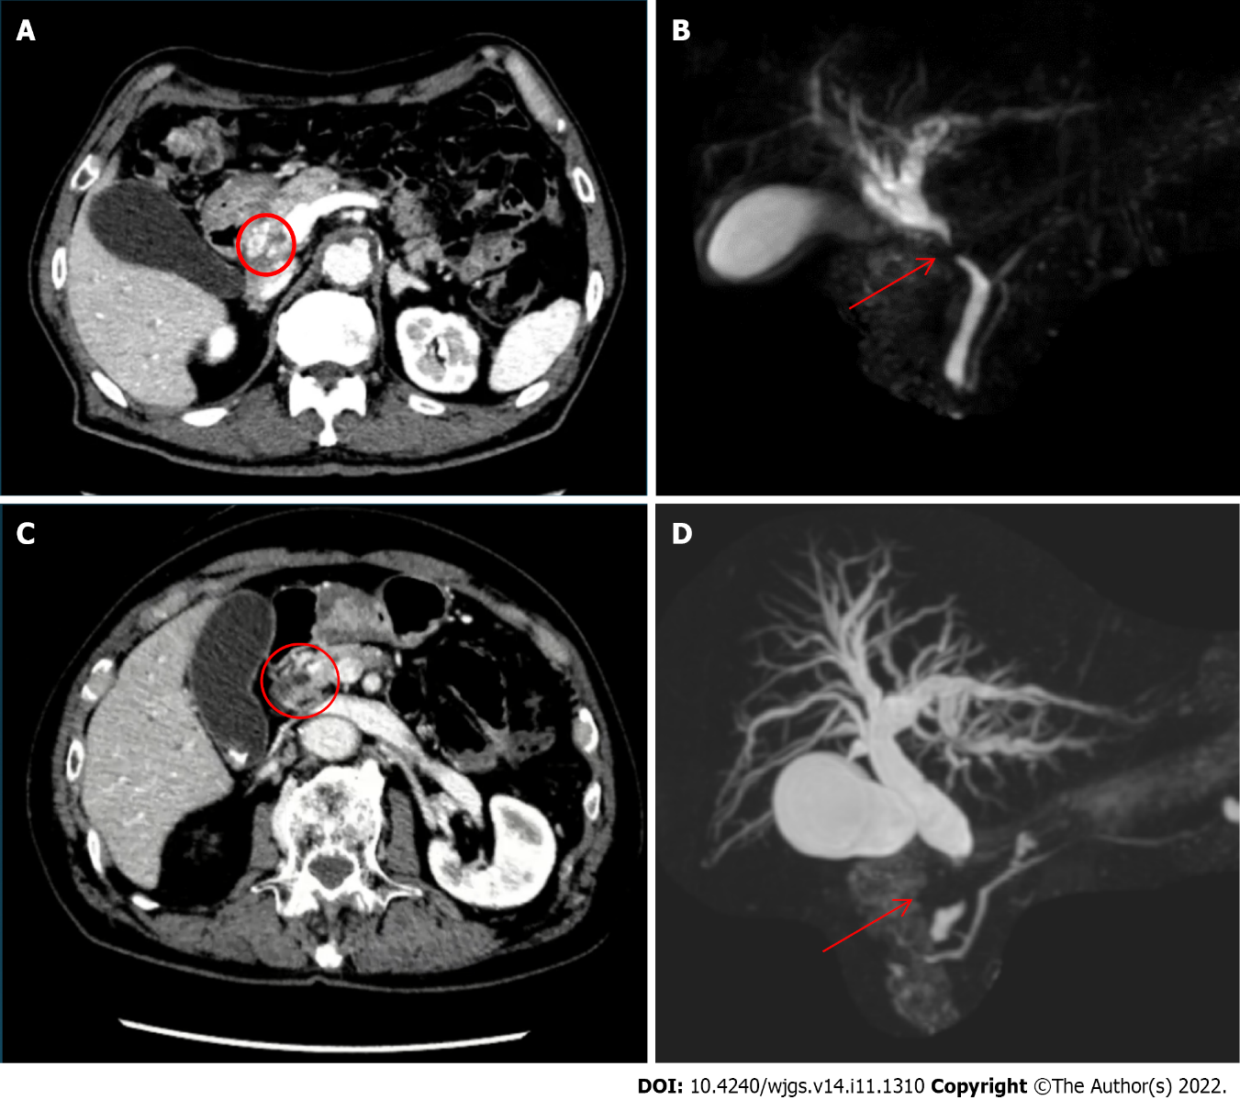

**Figure 1 Imaging examinations.** A: Dynamic computed tomography (case 1) showing common bile duct wall thickening at the ductal confluence (circle) and mild dilatation of the intrahepatic bile duct; B: Magnetic resonance cholangiopancreatography showing stricture of common bile duct (arrow) and dilatation of the intrahepatic bile duct; C: Dynamic computed tomography (case 2) showing bile duct wall thickening at the upper pancreatic margin level (circle) with dilatation of the entire bile duct system without pancreatic duct dilatation; D: Magnetic resonance cholangiopancreatography showing stenosis of the distal common hepatic duct (arrow) and dilatation of the intrahepatic bile duct.

B

A

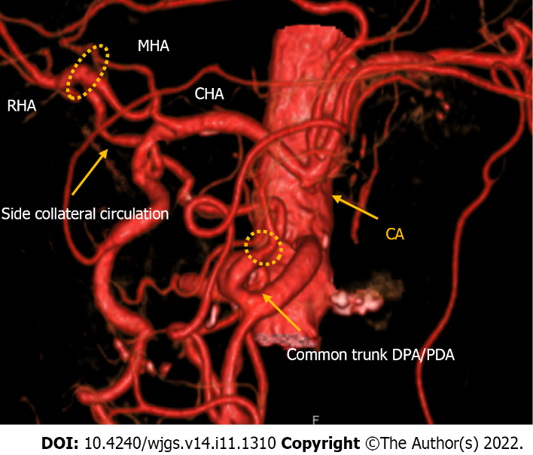

**Figure 2** **Computed tomography with 3D reconstruction of the vascular anatomy in case 1**. Computed tomography showed a right hepatic artery (RHA) and middle hepatic artery originating from the common hepatic artery, the usual pancreaticoduodenal arcade originating from the gastroduodenal artery, a common trunk between the dorsal pancreatic artery and pancreaticoduodenal artery originating from the superior mesenteric artery, an additional arcade originating from the common trunk and passing through the dorsal surface of the pancreatic head and linking directly to the RHA, and a replaced left hepatic artery originating from the left gastric artery. RHA: Right hepatic artery; MHA: Middle hepatic artery; CHA: Common hepatic artery; PDA: Pancreaticoduodenal artery; SMA: Superior mesenteric artery.

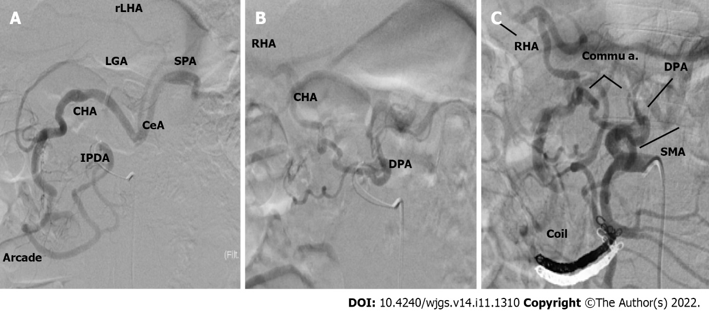

**Figure 3 Angiographic study.** A: The inferior pancreaticoduodenal artery was responsible for the main back flow to the celiac artery; B: The dorsal pancreatic artery (DPA) was responsible for the blood flow of the right hepatic artery; C: Blood re-flow post embolization and the DPA was responsible for the main flow to the celiac artery. IPDA: Inferior pancreaticoduodenal artery; DPA: Dorsal pancreatic artery; SPA: Splenic arteries; RHA: Right hepatic artery; MHA: Middle hepatic artery; CHA: Common hepatic artery; GDA: Gastroduodenal artery; SMA: Superior mesenteric artery; LHA: Left hepatic artery; LGA: Left gastric artery; CeA: Celiac artery.

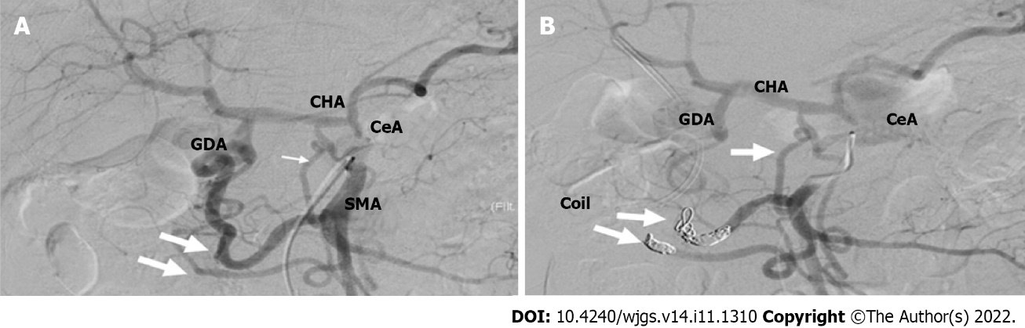

**Figure 4 Angiographic study.** A: Pre-embolizationangiography showed that the main backflow to the celiac artery was granted from the GDA; B: Post embolization angiography showed that after blood flow modification, the main backflow was granted from the dorsal pancreatic artery (arrow). CHA: Common hepatic artery; GDA: Gastroduodenal artery; SMA: Superior mesenteric artery; CeA: Celiac artery.

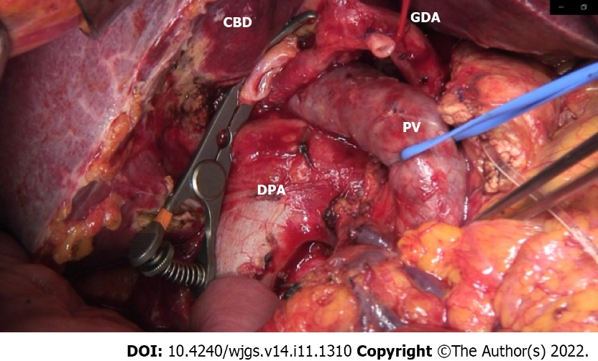

**Figure 5 Intraoperative image.** The common bile duct was clipped with a bulldog, the gastroduodenal artery was ligated, and the portal vein was surrounded by a vessel loop at the bottom of the dorsal pancreatic artery hypertrophy. DPA: Dorsal pancreatic artery; CBD: Common bile duct; PV: Portal vein; GDA: Gastroduodenal artery.

**Table 1 Outcome of treatment in case of CA stenosis due to atherosclerosis**

|  |  |  |  |  |  |  |  |  |
| --- | --- | --- | --- | --- | --- | --- | --- | --- |
| **Ref.** | **Number of cases** | **Age, yr** | **Disease** | **Degree of CA stenosis** | **Treatment** | **Time between vascular reconstruction and surgery** | **Outcome** | **Discharged POD** |
| Berney *et al*[9], 1999 | 13 | 69 median ages | Pancreatic adenocarcinoma | 9 occlusion, 5 subtotal stenosis, 1 partial stenosis | 2 GDA preservation | IO | Pancreatic fistula | N/A |
|  |  |  | Pancreatic adenocarcinoma |  | 1 aortohepatic bypass | IO | No complications |  |
|  |  |  | 2 Pancreatic adenocarcinoma, 5 chronic pancreatitis, 1 ampullary cancer, 1 duodenal adenoma |  | 9 no reconstruction | IO | 2 liver ischemia  3 pancreatic fistulas |  |
|  |  |  | Pancreatic adenocarcinoma |  | 1 CeA reimplantation | IO | No complications |  |
| Nara *et al*[2], 2005 | 2 | 57 | Duodenal cancer | Occlusion | Middle colic right gastroepiploic anastomosis | IO | Transient liver ischemia | 35 d |
|  |  | 61 | Duodenal cancer | Occlusion | Preservation of replaced RHA | IO | Pancreatic fistula | 128 d |
| Hayashibe *et al*[17], 2005 | 1 | 75 | Duodenal cancer | Occlusion | Aorta-CHA venous bypass | IO | No complications | 35 d |
| Halazun *et al*[16], 2006 | 1 | 65 | CCA | 50% | Preoperative stent | 1 d | No complications | N/A |
| Soonawalla *et al*[5], 2007 | 1 | 60 | Pancreatic adenocarcinoma | Occlusion | CeA reimplantation into aorta | IO | No complications | N/A |
| Smith *et al*[18], 2007 | 10 | 76 median ages (73-86) | Adenocarcinoma, ampullary tumor, islet cell tumor, papillary tumor | 3 pt 30%; 1 pt 20%; 2 pt 50%; 1 pt 25%; 2 pt 60%; 1 pt occlusion | 10 no reconstruction | IO | 1 death for MOF, 1 GI bleeding | N/A |
| Gaujoux *et al*[4], 2009 | 3 | 72 | Malignant ampulloma | N/A | Aortohepatic bypass | IO | Pancreatic fistula | N/A |
|  | 59 | Pancreatic adenocarcinoma | N/A | Preoperative CeA stent | 3 wk | Pancreatic fistula | N/A |  |
|  | 77 | Malignant ampulloma | N/A | Postoperative CeA stent | 0 POD | Pancreatic fistula | N/A |  |
| El-Ghazaly *et al*[19], 2009 | 1 | 70 | Pancreatic adenocarcinoma | Occlusion | Anterior pancreaticoduodenal arcade resected and anastomosed end-to-end | IO | No complications | 10 d |
| Berselli *et al*[20], 2010 | 1 | 72 | Branch type IPMN | Occlusion | Side to side anastomosis SPPDA to the IPPDA | IO | Pancreatic fistula, GI bleeding, Splenic artery pseudoaneurysm | 97 d |
| Yi *et al*[21], 2014 | 1 | 51 | NET | N/A | Preoperative angioplasty and stent of CA | 1 mo | No complications | 7 d |
| Beane *et al*[22], 2017 | 1 | 69 | Pancreatic cancer | Occlusion | SMA to HA venous bypass | IO | Pancreatic fistula, GI bleeding, pseudoaneurysm of graft; hepatic abscess (4 mo after discharge) | 30 d |
| Zhou *et al*[10], 2018 | 84 | 73 median ages (61-88) | N/A | 47 pt (mild 1%-49%); 37 pt (substantial 50%-99%) | No treatment | IO | 2 deaths, 2 GI bleeding, 11 biliary fistulas, 8 pancreatic fistulas | 21 d median (8-21 POD) |
| Tagkalos *et al*[23], 2018 | 1 | 64 | Pancreatic adenocarcinoma | Occlusion (postoperative diagnosis) | Heparinization | 3 POD | Transient liver ischemia | 14 d |
| Oikawa *et al*[7], 2022 | 1 | 80 | CCA | Occlusion | No reconstruction | IO | Pancreatic fistula | 41 d |

IO: Intraoperative; CCA: Cholangiocarcinoma; N/A: Not applicable; POD: Postoperative day.



Published by **Baishideng Publishing Group Inc**

7041 Koll Center Parkway, Suite 160, Pleasanton, CA 94566, USA

**Telephone:** +1-925-3991568

**E-mail:** bpgoffice@wjgnet.com

**Help Desk:** https://www.f6publishing.com/helpdesk

https://www.wjgnet.com



**© 2022 Baishideng Publishing Group Inc. All rights reserved.**