**Appendix 1. Search strategy**

MEDLINE (July 5th 2018)

1. "Cholecystectomy"[Mesh] OR "Cholecystectomy, Laparoscopic"[Mesh] OR (cholecystecto* OR colecystecto*) OR "Cholecystectomy"[tiab]

2. (“Cystic Duct”[MeSH] OR (cystic AND duct)) OR "cystic duct"[tiab] OR “cysticus”[tiab]

3. “Ligation”[MeSH] OR closure OR loop OR haemoclip OR hemoclip OR staple OR stapler OR endoclip OR ligation OR ligature OR ligatures OR clip OR tie OR suture OR “clipless”[tiab] OR “harmonic”[tiab]OR OR “ultrasonic”[tiab]

4. 1 AND 2 AND 3

Embase (July 5th 2018)

1. laparoscop* or exp laparoscopy/ or exp laparoscopic surgery/ or cholecystectomy.mp. or exp cholecystectomy/ or (cholecystect* or colecystect*).af.

2. (cystic and duct).af. or exp cystic duct/ or cystic duct.mp.

3. exp ligation/ or exp bile duct ligation/ or ligation.mp. or (ligation or closure or loop or haemoclip or staple or stapler or endoclip or ligature or ligatures or clip or tie or suture).af. or exp surgical equipment/

4. 1 AND 2 AND 3

Cochrane Library (July 5th 2018 )

1. MeSH descriptor: [Cholecystectomy, Laparoscopic] explode all trees

2. MeSH descriptor: [Cholecystectomy] explode all trees

3. (laparoscop*) AND (cholecystecto* OR colecystecto*)

4. 1 or 2 or 3

5. MeSH descriptor: [Cystic Duct] explode all trees

6. cystic duct

7. 5 or 6

8. ligation or closure or loop or haemoclip or staple or stapler or endoclip or ligature or ligatures or

clip or tie or suture

9. MeSH descriptor: [Ligation] explode all trees

10. 8 or 9

11. 4 and 7 and 10

**Appendix 2 Excluded studies**

|  |  |  |  |  |
| --- | --- | --- | --- | --- |
| **Study, year, country** | **Study design** | **Type of intervention** | **Conclusion** | **Reason for exclusion** |
| Rajnish[53], 2018, India | PS | Titanium clips | Harmonic scalpel assisted cholecystectomy (by dissecting the cystic artery) has no advantage when compared to conventional LC | Small sample size |
| Sundholm Tepper[54], 2017, Sweden-USA | PS | LigaTie *vs* 2 hemoclips | The LigaTie may have an advantage in minimally invasive surgery, especially of the cystic duct in complicated patients. | Ex vivo study |
| Yoshida[55], 2017, Japan | PS | Biodegradable clip *vs* titanium clips | The novel clip was usefull to seal the cystic duct in dogs, and formed fewer artifacts than metallic clips. | Not in humans |
| Tartaglia [56], 2016, Italy | RS | Unknown | Antegrade dissection of the gallbladder is an easier technique. | Manner of CD closure not described |
| Malik et al [57], 2016, Pakistan | PS | Harmonic scalpel *vs* ‘traditional clips’ | LC with HS is quicker and the best suitable technique to close the cystic duct | CDL rate not described |
| Abdallah et al[58], 2015, Egypt | RS | Harmonic scalpel (Harmonic ACE, Ethicon Endo-Surgery) and Ligasure | HS is safer than clips in LC, Ligasure is not safe | Ex vivo study |
| Baloch et al [59], 2015, Pakistan | PS | Harmonic scalpel *vs* titanium clips | The use of HS in LC is safe and does not increase complication rate | CDL rate not described |
| Downes et al[60], 2015, Bahamas | RS | Ligasure | Ligasure decreases the difficulty of LC, operating time and blood loss | Small sample size |
| Park et al[61], 2014, Korea | RS | Clips | SILC is safe and effective | CDL rate not described |
| Zanghi et al [62], 2014, Italy | RCT | Harmonic scalpel (Harmonic ACE, Ethicon Endo-Surgery) *vs* metal clips | A broader use of the Harmonic scalpel does not offer such advantages to make it the preferred technique | Small sample size |
| Idani et al[63], 2013, Japan | RS | Unknown | “Hook and roll” technique is safe and allows complete dissection of the critical view of safety | Manner of CD closure not described |
| Bulus et al, [64], 2013, Turkey | RCT | Harmonic scalpel, bipolar vessel sealer and clips | HS en bipolar vessel sealer may be safe in LC | Small sample size |
| Sasaki et al[65], 2012, Japan | RS | Unknown | SILC is feasible and safe | CDL rate not described |
| El-Geidie et al [66], 2012, Egypt | RS | Harmonic scalpel | SILC with HS is safe and feasible | Small sample size |
| Kavlakoglu et al [67], 2011, Turkey | PS | PlasmaKinetic Sealer *vs* harmonic scalpel | HS is more effective than a plasmakinetic sealer in sealing the cystic duct | Small sample size |
| Azeez[68], 2011, Egypt | RS | Ultrasonic shear (Johnson & Johnson) | The use of ultrasonic shears is safe and a secure method for closing the cystic duct | Small sample size |
| Solomon et al [69], 2010, USA | PS | Clips | The learning curve of SILC is maximal after ten cases | Small sample size |
| Kavlakoglu et al[70], 2010, Turkey | PS | Harmonic scalpel *vs* clips | HS is as reliable as a single clip | Small sample size |
| Faccini et al [71], 2009, Italy | PS | Harmonic shears (Ultracision, Johnson & Johnson) *vs* clips | By using Ultracision faster, safer and more accurate surgery is possible | Small sample size |
| Eisenstein et al, 2008, USA[72] | RS | Unknown | CDL should result in ERCP and stent for the patient. Operative correction should only be done in the most serious cases | Manner of closure not described for total group, only for CDL |
| Vu et al [73], 2008, UK | PS | Harmonic scalpel | Harmonic scalpel provided total closure of the cystic duct. Not recommended in cystic duct greater than 6mm. | Small sample size |
| Mir et al [74], 2007, India | RS | Vicryl sutures | LC is safe, provided that proper equipment is available and well-trained surgeons are present | CDL rate not reported |
| Yeh et al [75], 2004, Taiwan | PS | Endo-GIA (US Surgical Corp.) | Endo-GIA is safe and effective in the closure of the dilated cystic duct and difficult LC | Small sample size |
| Ibn Ouf et al [76], 2002, Sudan | RS | Absorbable ntracorporeal ligation (2/0 polygactin Vicryl, Ethicon) | Intracorporeal ligation is easy and cost-effective in the occlusion of the cystic duct | CDL rate not described |
| Miroshnik et al [77], 2002, Australia | RS | Not described | Morbidity of LC is decreasing since the introduction and now comparable to open surgery | Manner of closure of cystic duct not named |
| Prakash et al [78], 2002, India | RS | Not described | LC for acute cholecystitis is safe | Manner of closure of cystic duct not named |
| Matthews et al[79], 2001, USA | PS | Ligasure, bipolar vessel sealer and clips | Ligasure and the bipolar vessel sealer should not be used for the division of the cystic duct | Ex-vivo study |
| Saha et al [80], 2000, UK | PS | Absorbable ntracorporeal ligation (polygactin) | Ligation of the cystic duct by absorbable thread should be standard treatment | CDL rate not described |
| Veronese et al [81], 1999, Italy | RS | Absorbable clips (Absolok, Ethicon) | Absolok clips are safe | CDL rate not described |
| Tan et al, 1999, Japan[82] | PS | Absorbable locking clips (Laproclip, Davis and Geck) | Laproclip should be recommended in minimally invasive surgery, although more research may be necessary | Small sample size |
| Rohr et al [83], 1997, France | RCT | Absorbable clip (Laproclip, Davis and Geck) *vs* metal clips (titan clip, Ethicon) | The absorbable clips are as effective as metal clips in the occlusion of the cystic duct | CDL rate not described |
| Lim et al [84], 1996, USA | RS | Intracorporeal ligation (coated vicryl tie 1-0) | The Intracorporeal ligation of the cystic duct yields positive results | Small sample size |
| Amaral et al [85], 1995, USA | RS | Ultrasonic energy and others | Ultrasonic scalpel can replace electrosurgical instruments in LC | Manner of closure of cystic duct not specifically named |
| Hawasli et al [86], 1994, USA | RCT | Absorbable clip (Laproclip, Davis and Geck) *vs* metal clips | Absorbable clips are as effective as metal clips | Small sample size |
| Löhde et al[87], 1993,  Germany [87] | RS | Absolok clip (Ethicon) | No clip-associated complications when using the Absolok clip | CDL rate not reported |
| Nowzaradan et al [88], 1992, USA | RS | Endoloop (Ethicon) | Ligation of an enlarged cystic duct in acute cholecystitis with an Endoloop may be safer than occlusion with an Endoclip. | Small sample size |

RCT; Randomized Controlled Trial, PS; Prospective study, RS; Retrospective Study, LC; Laparoscopic cholecystectomy, HS; Harmonic Scalpel, CDL; cystic duct leakage, pts; patients,

**Appendix 3a. Overview of risk of bias in non-randomized studies – part 1 – studies from 2015 -2009**

|  |  |  |  |  |  |  |  |  |  |  |  |  |  |  |  |  |  |
| --- | --- | --- | --- | --- | --- | --- | --- | --- | --- | --- | --- | --- | --- | --- | --- | --- | --- |
| MINORS score[11] | *Singal 2018* | *Ramos 2015* | *Yang 2014* | *Suo 2013* | *Wills 2013* | *Sinha 2012* | *Màtsui 2012* | *Agresta 2011* | *Feroci 2011* | *Lee 2011* | *Wu 2011* | *Schulze 2010* | *Gemini 2010* | *Patel 2010* | *Shah 2010* | *Ou 2009* | *Carvalho 2009* |
| 1. A clearly stated aim | 2 | 1 | 2 | 2 | 2 | 1 | 2 | 2 | 2 | 2 | 2 | 2 | 2 | 2 | 1 | 0 | 2 |
| 2. Inclusion of consecutive patients | 0 | 1 | 1 | 2 | 0 | 1 | 0 | 0 | 1 | 0 | 0 | 2 | 1 | 1 | 0 | 0 | 2 |
| 3. Prospective collection of data | 2 | 2 | 1 | 1 | 1 | 1 | 2 | 2 | 1 | 1 | 1 | 2 | 1 | 2 | 2 | 1 | 1 |
| 4. Endpoint appropriate to the aim of the study | 1 | 1 | 2 | 1 | 1 | 0 | 1 | 0 | 2 | 2 | 2 | 0 | 0 | 2 | 0 | 0 | 0 |
| 5. Unbiased assessment of the study endpoint | 0 | 0 | 0 | 0 | 0 | 0 | 0 | 0 | 0 | 0 | 0 | 0 | 0 | 0 | 0 | 0 | 0 |
| 6. FU period appropriate to the aim of the study | 0 | 0 | 0 | 0 | 0 | 0 | 0 | 0 | 2 | 2 | 2 | 0 | 2 | 2 | 0 | 1 | 0 |
| 7. Loss to FU < 5% | 0 | 0 | 0 | 0 | 0 | 0 | 0 | 0 | 0 | 0 | 0 | 0 | 0 | 0 | 0 | 0 | 0 |
| 8. Prospective calculation of the study size | 0 | 0 | 0 | 0 | 0 | 0 | 0 | 0 | 0 | 0 | 0 | 0 | 0 | 0 | 0 | 0 | 0 |
| Total score | 5 | 5 | 8 | 6 | 4 | 3 | 5 | 4 | 8 | 7 | 7 | 6 | 6 | 9 | 3 | 1 | 5 |

The items are scored 0 (not reported), 1 (reported but inadequate) or 2 (reported and adequate).

**Appendix 3b. Overview of risk of bias in non-randomized studies – part 2 – studies from 2008 -2000**

|  |  |  |  |  |  |  |  |  |  |  |  |  |  |  |  |  |
| --- | --- | --- | --- | --- | --- | --- | --- | --- | --- | --- | --- | --- | --- | --- | --- | --- |
| MINORS score[11] | *Golash 2008* | *Ojima 2007* | *Talebpour 2007* | *Lewandowski 2006* | *Rohatgi 2006* | *Tebala 2006* | *Fullum 2005* | *Westervelt 2004* | *Lee 2004* | *Hüscher 2003* | *Yan0 2003* | *Power 2000* | *Dolan 1999* | *Leung 1996* | *Wise Unger 1996* | *Feussner 1991* |
| 1. A clearly stated aim | 0 | 2 | 2 | 0 | 2 | 0 | 2 | 2 | 1 | 2 | 2 | 2 | 2 | 2 | 2 | 2 |
| 2. Inclusion of consecutive patients | 2 | 0 | 1 | 0 | 2 | 2 | 2 | 2 | 2 | 2 | 0 | 2 | 2 | 0 | 0 | 0 |
| 3. Prospective collection of data | 0 | 1 | 2 | 0 | 1 | 0 | 0 | 2 | 1 | 2 | 1 | 1 | 1 | 1 | 1 | 1 |
| 4. Endpoint appropriate to the aim of the study | 0 | 2 | 0 | 0 | 0 | 0 | 0 | 0 | 2 | 2 | 2 | 0 | 0 | 1 | 0 | 0 |
| 5. Unbiased assessment of the study endpoint | 0 | 0 | 0 | 0 | 0 | 0 | 0 | 0 | 0 | 0 | 0 | 0 | 0 | 0 | 0 | 0 |
| 6. FU period appropriate to the aim of the study | 0 | 0 | 0 | 0 | 0 | 0 | 2 | 0 | 0 | 2 | 0 | 0 | 0 | 2 | 0 | 0 |
| 7. Loss to FU < 5% | 0 | 0 | 0 | 0 | 0 | 0 | 0 | 0 | 0 | 0 | 0 | 0 | 0 | 0 | 0 | 0 |
| 8. Prospective calculation of the study size | 0 | 0 | 0 | 0 | 0 | 0 | 0 | 0 | 0 | 0 | 0 | 0 | 0 | 0 | 0 | 0 |
| Total score | 2 | 5 | 5 | 0 | 5 | 2 | 6 | 6 | 6 | 10 | 5 | 5 | 5 | 6 | 3 | 3 |

The items are scored 0 (not reported), 1 (reported but inadequate) or 2 (reported and adequate).

**Appendix 4. Funnel plots of included studies**

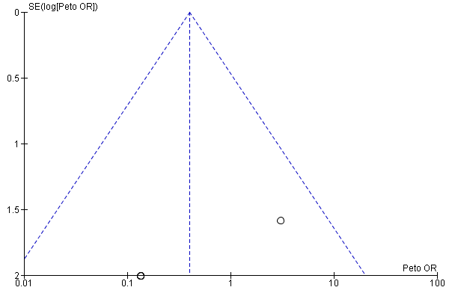**A**

Funnel plot of the comparison of figure 3; harmonic scalpel *vs* metal clips on CDL

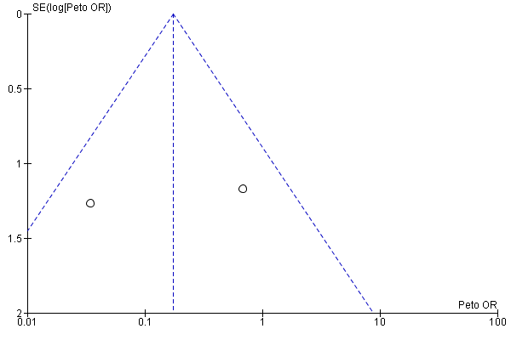B

Funnel plot of the comparison of figure 4; Locking *vs* non-locking clips on CDL

C

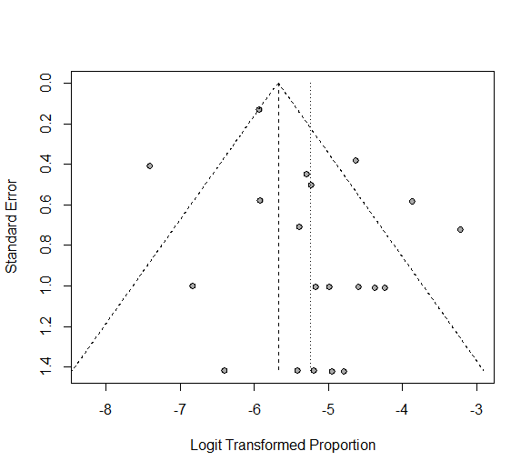

Funnel plot of CDL after application of metal clips

D



Funnel plot of CDL after the use of harmonic shears/scalpel

E

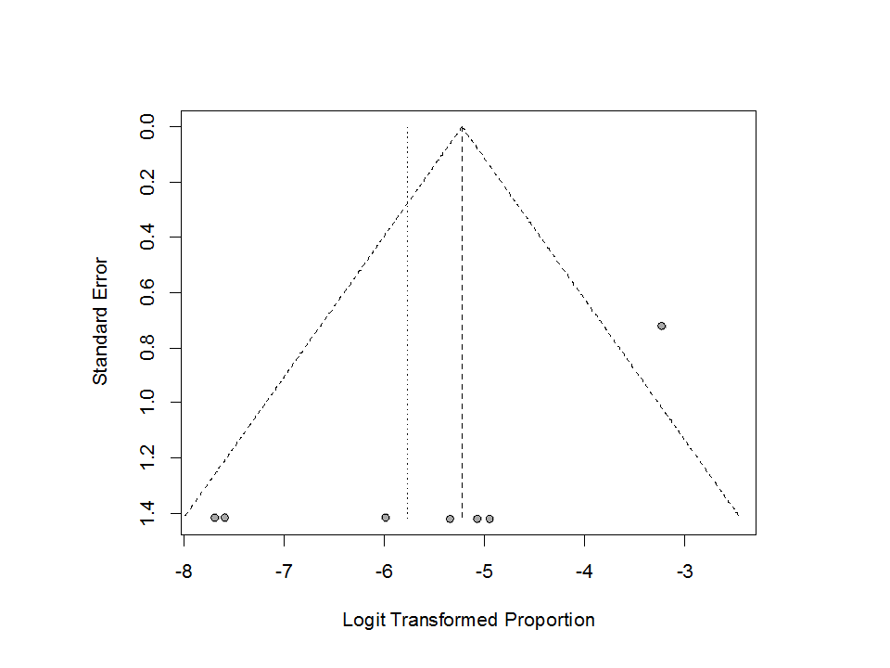

Funnel plot of CDL after the use of ligatures

F



Funnel plot of CDL after the use of locking clips.

53. Rajnish K *et al.* Harmonic Scalpel-Assisted Laparoscopic Cholecystectomy vs. Conventional Laparoscopic Cholecystectomy - A Non-randomized Control Trial. *Cureus* 2018; 10(1): e2084.

54. Sundholm Tepper AJ *et al.* Cystic duct pressures after ligation with a novel absorbable device in an ex vivo caprine cholecystectomy model. *Can J Vet Res* 2017; 81(3): 223–227.

55. Yoshida T *et al.* Development of a new biodegradable operative clip made of a magnesium alloy: Evaluation of its safety and tolerability for canine cholecystectomy. *Surgery* 2017; 161(6): 1553–1560.

56. Tartaglia N *et al.* Laparoscopic antegrade cholecystectomy: a standard procedure? *Open Med* 2016; 11(1): 429–432

57. Malik R *et al.* Comparative study between clipless (CL) laparoscopic cholecystectomy using harmonal scalpel vs traditional cholecystectomy (TM) using electrocautery and titanium clips. *Pakistan J Med Heal Sci J Med Heal Sci* 2016; 10(3): 794–795.

58. Abdallah E *et al.* Is LigaSure a safe cystic duct sealer? An ex vivo study. *Asian J Surg* 2015; 38(4): 187–90.

59. Baloch S *et al.* Use of Harmonic shear vs Titanium clips in Laparoscopic Cholecystectomy: Experience in Nawaz Sharif Social Security Teaching Hospital Lahore. *Pakistan J Med Heal Sci* 2015; 9(3): 999–1001.

60. Downes RO *et al.* Single incision cholecystectomy using a clipless technique with LigaSure in a resource limited environment: The Bahamas experience. *Int J Surg Case Rep* 2015; 11: 104–9

61. Park HJ *et al.* The real-world application of single incision laparoscopic cholecystectomy. *Int J Surg* 2014; 12(12): 1254–1257.

62. Zanghì A *et al.* Laparoscopic cholecystectomy: ultrasonic energy versus monopolar electrosurgical energy. *Eur Rev Med Pharmacol Sci* 2014; 18(2 Suppl): 54–9.

63. Idani H *et al.* “Hook and roll technique” using an articulating hook cautery to provide a critical view during single-incision laparoscopic cholecystectomy. *Acta Med Okayama* 2013; 67(4): 259–63.

64. Bulus H *et al.* Evaluation of three instruments for laparoscopic cholecystectomy: harmonic scalpel, bipolar vessel sealer, and conventional technique. *Minerva Chir* 2013; 68(6): 537–42.

65. Sasaki K *et al.* Single-incision Laparoscopic Cholecystectomy. *Surg Laparosc Endosc Percutan Tech* 2012; 22(2): 108–113.

66. El-Geidie AA-R. Single-incision laparoscopic cholecystectomy (SILC) using harmonic scalpel. *J Surg Res* 2012; 176(1): 50–4.

67. Kavlakoglu B *et al.* Clipless Cholecystectomy: Which Sealer Should be Used? *World J Surg* 2010; 35(4): 817–823.

68. Abdel Azeez T, Mahran KM. Transumbilical laparoscopic cholecystectomy: towards a scarless abdominal surgery. *Hepatogastroenterology* 58(106): 298–300.

69. Solomon D *et al.* Single-port cholecystectomy: small scar, short learning curve. *Surg Endosc* 2010; 24(12): 2954–7.

70. Kavlakoglu B *et al.* Verification of clipless closure of cystic duct by harmonic scalpel. *J Laparoendosc Adv Surg Tech A* 2010; 20(7): 591–5.

71. Faccini M *et al.* [Ultrasonic videolaparoscopic cholecystectomy: evolution of a revolutionary technique]. *Minerva Chir* 2009; 64(2): 205–10.

72. Eisenstein S *et al.* Cystic duct stump leaks: after the learning curve. *Arch Surg* 2008; 143(12): 1178–83

73. Vu T *et al.* Clipless technique of laparoscopic cholecystectomy using the harmonic scalpel. *Ann R Coll Surg Engl* 2008; 90(7): 612.

74. Mir IS *et al.* Is intra-operative cholangiography necessary during laparoscopic cholecystectomy? A multicentre rural experience from a developing world country. *World J Gastroenterol* 2007; 13(33): 4493–7.

75. Yeh C-N *et al.* Endo-GIA for ligation of dilated cystic duct during laparoscopic cholecystectomy: an alternative, novel, and easy method. *J Laparoendosc Adv Surg Tech A* 2004; 14(3): 153–7.

76. Ibn Ouf AM, Al Arabi Y. Intracorporeal vicryl ligatures reduces cost in some countries. *Saudi J Gastroenterol* 2002; 8(1): 14–6.

77. Miroshnik M. Saafan A. Koh S. Farlow J. Neophyton J. Lizzio J. Yee F. Ethell T. Bean A. Fenton-Lee D. Biliary tract injury in laparoscopic cholecystectomy: Results of a single unit. *ANZ J Surg* 2002: 867–870.

78. Prakash K *et al.* Laparoscopic cholecystectomy in acute cholecystitis. *Surg Endosc* 2002; 16(1): 180–3

79. Matthews BD *et al.* Effectiveness of the ultrasonic coagulating shears, LigaSure vessel sealer, and surgical clip application in biliary surgery: a comparative analysis. *Am Surg* 2001; 67(9): 901–6.

80. Saha SK. Ligating the cystic duct in laparoscopic cholecystectomy. *Am J Surg* 2000; 179(6): 494–6.

81. Veronese E *et al.* [Our experience with the use of Absolok polydioxanone resorbable clips in laparoscopic surgery]. *Minerva Chir* 1999; 54(3): 195–7.

82. Tan TM, Okada M. The efficiency of absorbable clips in minimally invasive surgery. *Surg Today* 1999; 29(8): 828–31.

83. Rohr S. De Manzini N. Vix J. Tiberio G. Wantz C. Meyer Ch. Contribution of resorbable clips in laparoscopic cholecystectomy. A prospective randomized study. *J Chir (Paris)* 1997: 180–184.

84. Lim BS. Intracorporeal ligation of the cystic duct during laparoscopic cholecystectomy. *Surg Laparosc Endosc* 1996; 6(5): 388–91.

85. Amaral JF. Laparoscopic cholecystectomy in 200 consecutive patients using an ultrasonically activated scalpel. *Surg Laparosc Endosc* 1995; 5(4): 255–62.

86. Hawasli A. The use of absorbable clips in laparoscopic cholecystectomy. *J Laparoendosc Surg* 1994; 4(5): 333–8.

87. Löhde E *et al.* [Ligation of the cystic duct--experience in 1,750 laparoscopic cholecystectomies]. *Chirurg* 1993; 64(10): 789–3.

88. Nowzaradan Y *et al.* Laparoscopic management of enlarged cystic duct. *Surg Laparosc Endosc* 1992; 2(4): 323–6.