**Name of Journal: *World Journal of Critical Care Medicine***

**ESPS Manuscript NO: 21826**

**Manuscript Type: Review**

**Antithrombin in the treatment of burn trauma**

Kowal-Vern A *et al.* Antithrombin in burn trauma

**Areta Kowal-Vern, Bruce A Orkin**

**Areta Kowal-Vern, Bruce A Orkin,** Department of General Surgery, Rush University Medical Center, Chicago, IL 60612, United States

**Author contributions:** Kowal-Vern A had made substantial contributions to: (1) conception and design of the review, acquisition of the literature, and analysis and interpretation of data and literature; (2) drafting the article and making critical revisions related to important intellectual content of the manuscript; and (3) final approval of the version of the article to be published; Orkin BA has made substantial contributions to: (1) analysis and interpretation of data and literature; (2) making critical revisions related to important intellectual content of the manuscript; and (3) final approval of the version of the article to be published.

**Conflict-of-interest** **statement:** None.

**Open-Access:** This article is an open-access article which was selected by an in-house editor and fully peer-reviewed by external reviewers. It is distributed in accordance with the Creative Commons Attribution Non Commercial (CC BY-NC 4.0) license, which permits others to distribute, remix, adapt, build upon this work non-commercially, and license their derivative works on different terms, provided the original work is properly cited and the use is non-commercial. See: <http://creativecommons.org/licenses/by-nc/4.0/>

**Correspondence to: Areta Kowal-Vern, MD, FCAP, FASCP, CTBS**, **Assistant Professor,** Department of General Surgery, Rush University Medical Center, Professional Building, Suite 1138, 1725 Harrison Street, Chicago, IL 60612, United States. [akvern@comcast.net](mailto:akvern@comcast.net)

**Telephone:** +1-312-9427088

**Fax:** +1-312-942-7081

**Received:** July 29, 2015

**Peer-review started:** July 29, 2015

**First decision:** October 13, 2015

**Revised:** October 28, 2015

**Accepted:** November 24, 2015

**Article in press:**

**Published online:**

**Abstract**

Antithrombin (AT) is a natural anticoagulant with anti-inflammatory properties that has demonstrated value in sepsis, disseminated intravascular coagulation and in burn and inhalation injury. With high doses, AT may decrease blood loss during eschar excision, reducing blood transfusion requirements. There are no human randomized, placebo-controlled studies, which have tested the true benefit of this agent in these conditions. Two main forms of AT are either plasma-derived antithrombin (phAT) and recombinant antithrombin (rhAT). Major ovine studies in burn and smoke inhalation injury have utilized rhAT. There have been no studies which have either translated the basic rhAT research in burn trauma, or determined the tolerance and pharmacokinetics of rhAT concentrate infusions in burn patients. Advantages of rhAT infusions are no risk of blood borne diseases and lower cost. However, the majority of human burn patient studies have been conducted utilizing phAT. Recent Japanese clinical trials have started using phAT in abdominal sepsis successfully. This review examines the properties of both phAT and rhAT, and analyzes studies in which they have been utilized. We believe that it is time to embark on a randomized placebo-controlled multi-center trial to establish the role of AT in both civilian and military patients with burn trauma.

**Key words:** Antithrombin; Burn trauma; Burn injury; Inhalation injury; Recombinant antithrombin

**© The Author(s) 2015.** Published by Baishideng Publishing Group Inc. All rights reserved.

**Core tip:** Based on ovine and rat research, and civilian population studies, antithrombin (AT) therapy with either human plasma-derived antithrombin or recombinant antithrombin (rhAT) may be a valuable adjunct treatment in patients with ≥ 25% total body surface area burn. AT has anticoagulant and anti-inflammatory properties, a positive effect on cardiopulmonary function, and wound healing, with concomitant decreases in pneumonia and mortality. Studies in human volunteers with endotoxemia have shown that rhAT doses as high as 200% and 500% are tolerated safely. With adequate high doses, AT may decrease blood loss during eschar excision, and reduce blood transfusion requirements.

Kowal-Vern A, Orkin BA. Antithrombin in the treatment of burn trauma. *World J Crit Care Med* 2015; In press

**BACKGROUND**

World-wide, there are an estimated 265000 deaths per year attributed to burns and inhalation injury, mainly in countries with lower incomes, especially in the [World Health Organization](http://www.baidu.com/link?url=nCajzVmyPTvj97qJUGVQ9RAiVaJ8Y42nL6gLLSTYQ17" \t "_blank) (WHO) South-East Asia area[1]. In the United States alone, the American Burn Association 2015 Fact Sheet compiled data estimates that there have been 3240 deaths from fire and smoke inhalation, 486000 burn injuries requiring medical treatment, and 40000 requiring hospitalization with a survival rate of 96.7%[2].In spite of major improvements in burn care during the past 30 years, inhalation injury has not been adequately addressed, and is often the main reason patients die even when they have recovered from their burns. Currently, there are no definitive clinical trials for agents that would reverse or improve the inflammatory response, cytokine release, capillary leakage, pulmonary edema, and cellular influx into the lung parenchyma in these patients. It has been well documented in the literature that burn and inhalation injury patients have varying degrees of disseminated intravascular coagulation (DIC), hypercoagulability with thromboembolism, and systemic inflammatory response syndrome (SIRS). Current beneficial relevance of antithrombin (AT) to burn trauma has not been proven[3-6].Human and ovine studies have shown that AT can have an impact on the morbidity and mortality associated with burn trauma[7,8].In this review we will examine the utility of AT as a natural anticoagulant and anti-inflammatory agent in the treatment of ≥ 25% total body surface area (TBSA) burns and inhalation injury. The review will describe the status quo of overall research in the field and problems that have been resolved.

***Human plasma-derived antithrombin***

Paul Morawitz[9] was the first to coin the word “antithrombin” (as an inhibitor of thrombin) in his review in 1904. AT was then identified in 1939 as a co-factor of heparin in preventing thrombin formation and inactivating thrombin by forming the thrombin-AT complex[10].

Plasma-derived antithrombin (phAT) is a 58200 kDa serine protease inhibitor of the serpin family which, as a natural anticoagulant: Neutralizes activated serine proteases like factors X, IX, XI, X12; complexes with and deactivates thrombin (factor II); and increases the rate of dissociation of factor VIIa-tissue factor complex to reduce factor VIIa activity[11,12]. Since the anticoagulant activity of phAT is potentiated by interactions with endothelial heparin sulfates, this effect is localized to the blood vessels where it competes with heparin for the glycosaminoglycans through thrombomodulin to activate the release of prostacyclin[11,12]. phAT also has anti-inflammatory properties: It complexes with thrombin, removes it from circulation, and decreases production of TNF-alpha which plays a major role in the SIRS syndrome initiated cytokine proliferation[13,14]. phAT may improve wound healing in a hypercoagulable system by reducing thrombosis and maintaining a more vascularized subcutaneous tissue[15,16]. If there is a decrease of thrombosis and microthrombi under the burned skin due to AT-treatment, there would be increased intensity of heat shock protein (hsp) expression in the underlying tissue of the burned area, leading to more viable cells expressing the hsp genes[16]. phAT-treated burned skin had a significantly increased intensity of expression of hps70 (*P* < 0.02 and of grp78 (*P* < 0.01) compared to controls[16].

AT plasma levels in healthy blood donors are age-related; between the ages of 25-30 years, women have lower phAT levels compared to men; between the ages of 35 and 50 years, the levels are the same; and over 50 years of age, women have higher phAT levels and increased levels of Factor VII and fibrinogen[17,18].phAT was used successfully in patients with hereditary AT deficiency[19].

In the past 20 years, published human studies and case reports have documented benefit from the use of phAT in patients with DIC and sepsis[20-23].The Kybersept study of 2314 septic patients (multi-national, randomized, placebo controlled) was undertaken to determine if there was decreased mortality in patients with phAT treatment (30000 units over 4 d); there was no significant benefit of AT in 28 day mortality rates[24]. In addition, the subset of patients who received heparin with phAT had increased risk of bleeding episodes[24]. However, in this study, there was no adjustment of the AT dose for weight, and burn trauma patients were not included. In a subset of the Kybersept septic patients who had clinical DIC, Kienast *et al*[25] found that patients treated only with phAT did not have increased bleeding compared to controls.These results had a negative and cautionary impact on further investigations of phAT in in critically ill patients with DIC and sepsis[25].

***Recombinant antithrombin***

Recombinant antithrombin (rhAT) as a sterile lyophilized powder became available in the 1990s. As a recombinant product, it eliminates the morbidity of blood borne pathogens and is less expensive than phAT[26]. It is currently FDA approved for hereditary AT deficient patients[26].A detailed biochemical analysis found that rhAT transgenically produced from goat milk is comparable to clinical grade human plasma-derived AT with respect to specific activity, purity, amount of aggregates, primary sequence, secondary and tertiary structure[26]. Recombinant AT has a shorter half- life than phAT (10.16 ± 1.28 h *vs* 2.8-3.8 d)[26,27]. rhAT also has a greater affinity for heparin than phAT, which may be due to differences in glycosylation[26].Because rhAT is cleared faster from the circulation compared to phAT, it is usually administered as a continuous intravenous infusion.It has been studied in an ovine model of burn and inhalation injury. Other rhAT formulations are produced from the Chinese hamster ovary cells, baby hamster kidney cells and a methylotropic yeast, Pichia pastoris[28].The primary available rhAT product is Atryn™ (GTC BioTherapeutics, Framingham, MA). It is approved for use in patients with congenital AT deficiency, and is well tolerated and effective[29]. Leitner *et al*[30] studied the effects of rhAT in 30 healthy volunteers. rhAT was infused to increase AT plasma levels to 200% and 500% of normal in a randomized, double-blind, placebo-controlled fashion[30]. Then endotoxin (LPS), 2 ng/kg was administered. Infusion of rhAT dose-dependently decreased coagulation activation (*P* < 0.01), and interleukin-6 levels (*P* < 0.01)[30]. rhAT also decreased peak interleukin-6 levels by 40% in both study groups (222 pg/mL and 216 pg/mL *vs* 357 pg/mL in the placebo group, (*P* < 0.001)[30].In summary, rhAT dose-dependently inhibited tissue factor-triggered coagulation[30]. While rhAT has been used in normal volunteers and in patients with hereditary AT deficiency, there have been no human studies in patients with burn and inhalation injuries.

***phAT studies in burn trauma***

Table 1 is a compendium of six studies using phAT in human subjects. Of these, 5 reported patient benefits in terms of either pulmonary function, wound healing or mortality. All the studies used different treatment methods and could not be compared to each other. The results in the Danielsson study were compromised by the use of very low doses of phAT, which were continued for 3-4 d[31]. The study had a total of only 6 patients, with small and large burns in one cohort, each of whom were administered a different dose of phAT, without achieving levels above the “normal”[31]. In addition, the authors started heparin on day 3 in both the phAT-treated and non-treated patients, further complicating the clinical picture and data analysis[31].Therefore, the study conclusion that phAT was not of benefit in burn trauma was based on inadequate numbers, low AT levels, and overall inconclusive evidence[31].

In contrast, Del Principe reported a significant decrease in mortality with the use of infused phAT to > 100% of normal in an Italian pediatric population[32].

In the Niedermayr *et al*[33] study, burn and inhalation patients were followed by daily AT plasma levels and received AT concentrates to correct any deficiencies to physiologic levels of 70%-120%. Controls had less inhalation injury (14% *vs* 50%) and the %TBSA was much lower (17 ± 17 *vs* 36 ± 24); one might, therefore, expect the control arm with less injury severity to have a significantly lower mortality (7% *vs* 36%)[33]. In this study, all patients received heparin to maintain an APTT of 50 s[33]. Pharmacokinetics of bolus *vs* continual infusion of phAT revealed that continual infusion consumed less drug over time and sustained fewer unintentional decreases in plasma once the steady state was reached; this also provided a cost benefit for the patient[33].

Lavrientieva *et al*[34] published a prospective, randomized study of 31 severely burned patients comparing phAT-treated patients with controls. AT administration was started from the 1st post-burn day and continued for the next 3 d[34]. The AT dose was titrated to the target value of plasma AT activity > 150%[34]. The baseline AT in controls was 54.7% ± 26% on admission and increased to 70.4% ± 19% on day 4; the baseline AT in the phAT-treated patients was 44.3% ± 16% and increased to 121.2% ± 18%[34]. On the basis of specific coagulation markers for DIC such as thrombin-antithrombin complex (TAT) and D-dimer, 19 (61.3%) of patients had non-overt DIC on admission and 9 (29%) had overt DIC on admission[34]. The study did not provide subset analyses of their patients, separating the less injured %TBSA from the more severely injured ones[34].

Kowal-Vern *et al*[15] prospectively studied 18 patients with ≥ 20% TBSA burns ± inhalation injury to assess phAT concentrate infusions for safety and efficacy, and impact on pulmonary function. Since phAT had not been previously utilized in burn trauma, patients were consented on the basis of their decision to either receive the concentrate or to enter as a control patient, not randomized. Nine patients received q 8 h phAT concentrate infusions to raise the plasma level in the first 72 h of hospitalization[15]. The empiric choice, to maintain a high level at > 175% plasma levels was not adequate in treating these patients, to prevent thrombosis of blood vessels, DIC, and stymie the SIRS response that was initiated by release of the thrombin into the circulation (Figure 1)[15].

The loading dose and q 8 h dosing strategy showed variable levels of phAT in patients over the course of 3 d, (Figure 2)[15].

Changes in coagulation activation, fibrinolysis, and anti-inflammatory effects did not extend past the last phAT concentrate dose[15]. More than likely, the half-life of phAT was decreased due to the consumption and loss during the acute resuscitative period. By day 5, control patient AT levels were returning to normal in the less severe cases; liver production of AT was, therefore, intact in most cases unless liver failure developed during treatment[15,35]. Aspartate aminotransferase (AST) levels are markedly elevated in burn patients compared to other liver enzymes most likely as a reaction to the inflammation that is occurring rather than liver disease or failure on admission[35].

Several investigators recommended that phAT concentrates be given to achieve > 200% plasma level for adequate anticoagulation and anti-inflammatory activity[36-39]. One patient with 80% TBSA and inhalation injury received the higher recommended doses of phAT concentrate and the four extremity eschar was easily separated from the viable subcutaneous tissues with no blood loss and no excision[40].Figure 3 shows the severity of the burn with a well-defined escharotomy scar on the lower extremity. Figure 4 shows how easily the eschar is peeled back off the viable subcutaneous tissue below. Histopathology showed viable sebaceous glands and a vascular bed at the separation edge beneath the burnt non-viable skin[40].

***Human and ovine studies of*** *AT* ***concentrates for pulmonary injury in burn trauma***

Utilizing AT concentrates as replacement therapy for burn trauma, there has been one human studyassessing pulmonary function and a number of ovine model studies evaluating burn trauma and specifically lung pathophysiology. Although a small study, the Loyola group compared nine phAT-treated burn patients to 23 control patients[7].Forty-three percent of controls and 23% of phAT-treated patients developed pneumonia, *P* < 0.01[7]. With potential decreased airway resistance and increased oxygenation, phAT-treated patients had significantly fewer episodes of pneumonia compared to controls[7]. AT concentrate infusions were judged safe and a good option to shorten hospital stay, promote graft viability and survival, and improve pulmonary function in burn injury[7,15].

In a later comparison study of 11 Inhalation injury patients to 11 inhalation+burn injury patients, the inhalation group had a significantly lower 5% ± 4% TBSA compared to 37% ± 24% TBSA in the inhalation+burn group, *P* < 0.001[41].phAT plasma levels were significantly decreased in inhalation±burn injury patients (41% + 16% of normal) compared to those with inhalation injury (81% ± 26%), *P* < 0.003[41]. The bronchoalveolar lavage (BAL) did not show any AT levels in the inhalation only patients, but the inhalation + burn injury patients had 1% ± 3% phAT in the lavage[41]. TNF-α levels were significantly increased in BAL compared to plasma on admission and days 3-6 in both groups, *P* < 0.001[41]. BAL IL-6 levels increased in severity through days 3-6, in contrast to plasma levels which decreased in intensity by days 3-6[41]. This increase and persistence of BAL TNF-alpha and IL-6 may have contributed to the pulmonary perturbations of these patients.

The major work on lung pathophysiology in burn trauma and smoke inhalation injury has been performedat the University of Texas Medical Branch in Houston, Texas[8,42-44].They have shown therapeutic benefits of rhAT on burn injury and pulmonary function in their well-established ovine burn and smoke inhalation-induced model of acute lung injury (ALI)/acute respiratory distress syndrome (ARDS)[8,42-44].The ovine model is a 48 h protocol of burn and smoke inhalation injury in sheep with different medication regimens[8,42-44].Murakami *et al*[8] investigated the treatment impact of rhAT on sepsis after smoke inhalation in sheep and found that rhAT attenuated the septic shock and the acute lung injury and maintained platelet counts at baseline.Enkhbaatar *et al*[42] were able to prevent the formation of airway fibrin clots causing airway obstruction and Acute Lung Injury and ARDS, with aerosolized anticoagulants (rhAT and heparin) and attenuated all the expected pulmonary pathophysiology.

In contrast to the Kybersept trial where the combination of phAT and heparin increased bleeding episodes, there was no increased bleeding noted by the combination of intravenous rhAT and aerosolized heparin[42]. This may possibly be a result of the increased affinity of rhAT to heparin, and less competition for attachment to the endothelial surfaces of blood vessels. The other explanation may be that the mode of agent delivery by separate intravenous and aerosolized routes results in different modes of interaction with the coagulation cascade and fibrinolysis. Rehberg *et al*[43] put together a useful compendium of their research with the ovine model and pulmonary pathophysiology in burn trauma[43]. Two centers have described the phenomenon of leukocyte activation contributing to pulmonary vascular permeability and pulmonary edema in conjunction with inflammatory agents such as thrombin which promotes systemic capillary leakage and systemic interstitial edema[44,45].

***DIC***

DIC is defined by the International Society on Thrombosis and Hemostasis (ISTH) as an “acquired syndrome characterized by the intravascular activation of coagulation with loss of localization arising from different causes”[46].It is a clinicopathologic diagnosis and requires the following laboratory diagnostic tests in an acute care setting: Platelets ≤ 100000/mm3, increased fibrin related markers as D-dimer or fibrin degradation products (FDP), a prolonged prothrombin time (PT), a prolonged activated Partial Thromboplastin Time (aPTT), and a fibrinogen (Fbg) < 1 g per liter[46]. Depending on the score, it can be diagnostic of either overt or non-overt DIC[46].These required parameters for diagnosing DIC have not always been utilized by studies on burn in the literature. The clearest indication for use of AT replacement in trauma may be in the treatment of severe thermal burns. Hemostatic interactions are composed of the coagulation system, the fibrinolytic system, cellular elements (platelets, endothelium), and vasculature balanced in an intricate interrelationship to maintain homeostasis. Most of the global markers of hemostasis as PT, aPTT, and Fbg are not sensitive enough to detect a hypercoagulable state, changes in fibrinolysis, or non-overt DIC. Thus, PT, aPTT, and Fbg levels provide only a superficial impression of hemostasis and become abnormal only when severe coagulation-related disorders are established. Acute thermal injury initiates an activation of coagulation and fibrinolysis resulting in either an overt or non-overt DIC, which increases in severity with the severity of the injury (%TBSA/inhalation injury[35,47,48]. These hemostatic abnormalities are a result of increased consumption of coagulation and fibrinolytic factors, dilution by the resuscitative fluids, and loss of plasma and fluids through the injured integument. AT concentrates have been used successfully in patients with DIC[20-23].

Significant coagulation abnormalities in burned patients have been demonstrated in the literature for the past 30 years. A detailed discussion of these would deserve a separate review. Prior to providing phAT concentrates to burn trauma patients, both Kowal-Vern *et al*[35] and Lavrentieva *et al*[47] investigated the coagulation and fibrinolytic markers in these burn patient populations to determine the extent of the coagulopathy present. Most pronounced was the decrease in AT, which was significantly suppressed on the first day of burn injury and correlated with the degree of burn injury; it was also the earliest to recover by day 5 to within normal levels[35]. These abnormalities caused an increased state of fibrinolysis and thrombogenicity in the patients, which was confirmed by specific markers of activation such as D-dimer, TAT complex, plasminogen activator inhibitor-1 (PAI-1), and tissue plasminogen activator (tPA)[35,47].

The DIC pathophysiology initiates coagulation and fibrinolysis through endothelial cells or tissue injury, with release of cytokines and other acute phase reactants. Once activated, the proteolytic enzymes, thrombin and plasmin, circulate systemically; their respective concentration determines either a bleeding or thrombotic tendency. AT protects the body against excess clotting by neutralizing thrombin; it is the most important physiological inhibitor of thrombin and factor Xa. In all instances of significant trauma, AT is consumed and plasma AT levels may rapidly decrease to levels at which the process of coagulation will proceed unchecked, quickly leading to deficits in oxygenation, organ failure and shock. There is a significant body of literature that correlates low levels of plasma AT following severe injury and trauma, with an increase of organ failure and death. AT replacement may affect the outcome of all of these conditions.

***SIRS***

The human body maintains homeostasis with all systems such as coagulation, inflammation, and innate immunity on a daily basis; any insult such as burn, inhalation, infection, sepsis induces a SIRS reaction to control and heal the injury imposed on the body[49]. The cytokine cascade initiates pulmonary inflammation even in the absence of smoke inhalation. AT is a key protagonist affecting not only the coagulation cascade, but also modulating the cytokine release and a major anti-inflammatory agent in plasma, counteracting the boundless SIRS release on the homeostasis of an acutely injured burn patient. AT promotes the release of prostacyclin on the endothelial surface which, as an anti-inflammatory agent, counteracts the production of monocytes and inhibits the release of cytokines such as TNF-alpha[13,14]. Hur *et al*[50] evaluated 67 burn patients with 27 cytokines and found that IL-1RA, IL-6, and MCP-1 may be used to predict mortality[50].It appears that the presence and intensity of cytokines, chemokines and growth factors in the pulmonary bronchi and alveoli corresponds to the severity of the inhalation injury[51].Neonatal rats receiving 100% oxygen for nine days developed pulmonary edema and hypercellularity on days 1-3 which resolved by days 6-9; this condition was accompanied by the production of TNF-alpha and IL-6 in the bronchoalveolar lavage which were not present in the control rats[52].Intra-alveolar TNF-alpha and IL-6 were also significantly increased in a rat model subjected to burn and inhalation injury[53].

***Thrombosis and thromboembolism***

There is an interrelationship between the degree of burn and the extent of thrombosis in burned tissue[54].A second-degree burn has thrombi in the venules only, and a third-degree burn has thrombi in the venules and arterioles[55]. Cotran *et al*[56]  have elegantly demonstrated by electron microscopy, in a rat model, that after a mild thermal injury and at the periphery of more severe burns, there is an increase in vascular permeability produced by gaps in the endothelium with no demonstration of endothelial damage[56]. As the severity ofthermal injury increases, arterioles, small vessels, and capillaries undergo endothelial necrosis or stasis; larger vessels may continue to leak[56]. When stasis occurs, an amorphous material, chylomicra or thrombi of platelets, and necrotic debris clog the vascular lumen[56].Animal studies have shown that the presence of infection and sepsis induces a significant increase in thrombosis and distant pyogenic abscesses[56-58].Autopsy cases have shown pulmonary microthrombi and partially dissolved fibrin in vessels of burn patients contributing to sludging of cells in vessels[59].However,there have been no prior published histopathological representations of “normal” and phAT-treated human third degree burnt skin, Figure 5 (unpublished data). Subcutaneous tissue vascular thrombi and debris are depicted in Figure 6 (unpublished data).

***Cardiac function***

Burn patients are known to have myocardial dysfunction which increases in severity with the severity of the injury and is worse if there are any cardiac co-morbidities present. In their ovine burn and smoke inhalation model, Rehberg *et al*[60] have noted that post injury infusion of 6 u/kg per hour of rhAT for 48 h improved myocardial contractility and decreased myocardial oxygen consumption. In addition, TNF alpha and interleukin 6 were not released and the sheep did not accumulate as much systemic fluid[60].

***Bacterial translocation***

Many of the infections seen in burn patients appear to come from the bacteria transferred from the gut into the systemic circulation to provide the nidus for the infectious complications of burn patients[61]. The ovine model of burn and smoke inhalation injury documented that when the lung is injured, gut bacteria are transported systemically during acute injury because blood is shunted from the intestinal tract into the cardiopulmonary system, and through the systemic capillary leakage[43]. Using an Albino rat model, Herek infused the animals with phAT with 250 u/kg phAT prior to infecting them and creating a burned surface; phAT-treated rats had reduced intestinal villi degeneration and decreased bacterial translocation to mesenteric lymph nodes, spleen and liver compared to sham and control rat (*P* < 0.02)[62]. This study followed the work of Ozden who showed that an infusion of phAT prevented an ischemic reperfusion injury in the rat[63].

**DISCUSSION**

There are two forms of AT used in these studies-rhAT and phAT. rhAT has been primarily used in basic/animal research studies, while phAT has been used in clinical studies. This may lead to questions about the relevance of the basic science studies to human care. The safety of the commercially produced phAT and rhAT concentrates in treating acquired and congenital AT (H) deficiencies has been well documented.High dose AT replacement has been supported in polytrauma and patients with septic shock and DIC[20,23,25].

AT use in disseminated intravascular coagulopathy and sepsis has been evaluated but has not yet been proven useful conclusively[3-6]. It is still worthwhile to pursue AT as a potential treatment in burn and inhalation injury[64]. AT would be of extreme value to the (3%-9% of burn patients with ≥ 25% BSA) as well as to inhalation injury patients. With the research recommendations for high AT dosing (> 200%), the lack of bleeding during burn eschar removal may eliminate the need for blood transfusions, an intervention known to increase infectious complications and mortality in burn patients[65].There are no new products in development with both anticoagulant and anti-inflammatory potential such as those possessed by phAT and rhAT to treat severe thermal burns. Not only do rhAT and phAT have the potential to inhibit thrombin and thrombin generation, they can also reduce the systemic inflammatory response that contributes to pulmonary and organ failure, and shock. The vast majority of products in active clinical development for the treatment of burns and inhalation injury does not address systemic injury and falls into the following categories: topical wound healing formulations, artificial skin products and temporary wound coverings, products for the control of bacterial colonization at wound sites, cultured skin and cells for dermal tissue repair, and proteolytic enzymes.

***Future research to maximize the practical impact on the field***

AT research requires a multicenter randomized placebo-controlled clinical trial. Accrual may be challenging because of smaller numbers (3%-9% of the burn population) than those of patients with sepsis or DIC, but 100-200 patients with reproducible and creditable results would likely determine the utility of AT therapy. This is certainly attainable.

Going forward, primary research objectives should be to determine whether rhAT can safely replace phAT and can maintain AT plasma levels between 200%-250% (normal AT plasma level = 80%-120%) in the first three days post-burn. Secondary objectives are to determine whether patients who receive rhAT or phAT realize significant reductions in pneumonia rates, extent of grafting needed, acute care stays, mechanical ventilation, the number of days of supplemental oxygen, positive end-expiratory pressure (PEEP), and mortality. Decreases in the frequency of organ failure may also be found. It would also be quite worthwhile to assess the effect of high-dose AT on burn eschar “peeling off” to decrease the need for operative excision.

The lower cost of rhAT may also allow for dissemination of this treatment approach in lower income international communities, where burn injuries are prevalent, highly morbid and often fatal.

**CONCLUSION**

AT therapy for patients with major burn and inhalation injuries may be a very valuable adjunct to standard treatment. The current literature has shown, albeit in small studies in the civilian population and animal research, that AT therapy has a positive effect on pulmonary function, wound healing, with a decrease in pneumonia and mortality. rhAntithrombin may be a very viable option because the literature has shown that it is safe in humans and animals. AT infusions have shown a positive effect on capillary leakage, pulmonary function, wound healing, DIC, inflammation, cardiac function and decreasing bacterial translocation systemically, pneumonia and mortality. Human study volunteers, given endotoxin and rhAT concentrates in doses as high as 200% and 500% of normal AT levels, tolerated them safely. It is time for a multicenter, randomized, placebo-controlled. Standardization of burn trauma patients should include the DIC scoring system guidelines recommended by the International Society of Thrombosis and Hemostasis[46]. AT levels should be targeted to more than therapeutic levels (200%-250%) over a four day period after injury for the most beneficial clinical response in burn patients with ≥ 25%TBSA. rhAT pharmacokinetics should be initiated in burn and inhalation patients to determine the appropriate dosage for treatment response. Each of the proposal elements represents a significant technological challenge and medical advance. The development of this treatment modality has universal benefits for severe burn trauma patients, both on the battlefield or in the civilian sector. In addition, the broad benefits of AT treatment may be widely applicable in a variety of traumatic injuries and acute care settings.

**REFERENCES**

1 **WHO.** Burns, fact sheet N°365. [updated 2014 Apr; accessed 2015 Jul 5]. Available from: URL: http://www.who.int/mediacentre/factsheets/fs365/en/

2 **Burn Incidence and Treatment in the United States**: 2015. [accessed 2015 Jul 5]. Available from: URL: http: //www.ameriburn.org/resources\_factsheet.php

3 **Afshari A**, Wetterslev J, Brok J, Møller AM. Antithrombin III for critically ill patients. *Cochrane Database Syst Rev* 2008; **(3)**: CD005370 [PMID: 18646125 DOI: 10.1002/14651858.CD005370.p002]

4 **Afshari A**, Wetterslev J, Brok J, Møller A. Antithrombin III in critically ill patients: systematic review with meta-analysis and trial sequential analysis. *BMJ* 2007; **335**: 1248-1251 [PMID: 18037615 DOI: 10.1136/bmj.39398.682500.25]

5 **LaRosa SP**, Opal SM. Clinical trials of Novel anticoagulants for severe sepsis: a tale of three molecules. *Adv Sepsis* 2004; **4**: 17-23

6 **Lavrentieva A**. Coagulopathy in burn patients: one part of a deadly trio. *Burns* 2015; **41**: 419-420 [PMID: 25681959]

7 **Kowal-Vern A**, Walenga JM, McGill V, Gamelli RL. The impact of antithrombin (H) concentrate infusions on pulmonary function in the acute phase of thermal injury. *Burns* 2001; **27**: 52-60 [PMID: 11164666]

8 **Murakami K**, McGuire R, Cox RA, Jodoin JM, Schmalstieg FC, Traber LD, Hawkins HK, Herndon DN, Traber DL. Recombinant antithrombin attenuates pulmonary inflammation following smoke inhalation and pneumonia in sheep. *Crit Care Med* 2003; **31**: 577-583 [PMID: 12576969]

9 **Morawitz P**. The Chemistry of Blood Coagulation. Thomas. Translated by Hartmann RC, Guenther PF. Originally published as Die Chemie der Blutgerinnung in Ergebnisse der Physiologie 4 307-423, 1905. “A monograph in the Bannerstone Division of American lectures in hematology.” Springfield, IL, 1958

10 **Brinkhous KM**, Smith HP, Warner ED, Seegers WH. The inhibition of clotting: an unidentified substance which acts in conjunction with heparin to prevent the conversion of prothrombin into thrombin. *Am J Physiol* 1939; **125**: 683-687

11 **Wada H**, Asakura H, Okamoto K, Iba T, Uchiyama T, Kawasugi K, Koga S, Mayumi T, Koike K, Gando S, Kushimoto S, Seki Y, Madoiwa S, Maruyama I, Yoshioka A. Expert consensus for the treatment of disseminated intravascular coagulation in Japan. *Thromb Res* 2010; **125**: 6-11 [PMID: 19782389 DOI: 10.1016/j.thromres.2009.08.017]

12 **Milton BA**, Steineck A, Talavera F, Conrad ME, Besa EC. Antithrombin Deficiency: Background, Pathophysiology, Antithrombin Gene Structure. [Viewed on 7-11-2015]. Available from: URL: http://emedicine.medscape.com/article/198573-overview

13 **Okajima K**. Regulation of inflammatory responses by natural anticoagulants. *Immunol Rev* 2001; **184**: 258-274 [PMID: 11918684]

14 **Wiedermann ChJ**, Römisch J. The anti-inflammatory actions of antithrombin--a review. *Acta Med Austriaca* 2002; **29**: 89-92 [PMID: 12168569 DOI: 10.1046/j.1563-2571.2002.02012.x]

15 **Kowal-Vern A**, McGill V, Walenga JM, Gamelli RL. Antithrombin(H) concentrate infusions are safe and effective in patients with thermal injuries. *J Burn Care Rehabil* 2000; **21**: 115-127 [PMID: 10752744 DOI: 10.1097/00004630-200021020-00007]

16 **Kowal-Vern A**, Goral J, Gamelli RL, McGill V, Clancy J. hsp70, hsp32, and grp78 are increased in thermally injured skin with and without antithrombin(human) concentrate infusion. *J Burn Care Rehabil* 2000; **21**: 213-219 [PMID: 10850902 DOI: 10.1097/00004630-200021030-00006]

17 **Meade TW**, Dyer S, Howarth DJ, Imeson JD, Stirling Y. Antithrombin III and procoagulant activity: sex differences and effects of the menopause. *Br J Haematol* 1990; **74**: 77-81 [PMID: 2310699 DOI: 10.1111/j.1365-2141.1990.tb02541.x]

18 **Tait RC**, Walker ID, Davidson JF, Islam SI, Mitchell R. Antithrombin III activity in healthy blood donors: age and sex related changes and prevalence of asymptomatic deficiency. *Br J Haematol* 1990; **75**: 141-142 [PMID: 2375917]

19 **Schwartz RS**, Bauer KA, Rosenberg RD, Kavanaugh EJ, Davies DC, Bogdanoff DA. Clinical experience with antithrombin III concentrate in treatment of congenital and acquired deficiency of antithrombin. The Antithrombin III Study Group. *Am J Med* 1989; **87**: 53S-60S [PMID: 2679072 DOI: 10.1016/0002-9343(89)80533-9]

20 **Fuse S**, Tomita H, Yoshida M, Hori T, Igarashi C, Fujita S. High dose of intravenous antithrombin III without heparin in the treatment of disseminated intravascular coagulation and organ failure in four children. *Am J Hematol* 1996; **53**: 18-21 [PMID: 8813091]

21 **Wisecarver JL**, Haire WD. Disseminated intravascular coagulation with multiple arterial thromboses responding to antithrombin-III concentrate infusion. *Thromb Res* 1989; **54**: 709-717 [PMID: 2781511 DOI: 10.1016/0049-3848(89)90135-7]

22 **Gando S**, Kameue T, Nanzaki S, Nakanishi Y. Disseminated intravascular coagulation is a frequent complication of systemic inflammatory response syndrome. *Thromb Haemost* 1996; **75**: 224-228 [PMID: 8815564]

23 **Tagami T**, Matsui H, Fushimi K, Yasunaga H. Supplemental dose of antithrombin use in disseminated intravascular coagulation patients after abdominal sepsis. *Thromb Haemost* 2015; **114**: 537-545 [PMID: 25948492 DOI: 10.1160/TH15-01-0053]

24 **Warren BL**, Eid A, Singer P, Pillay SS, Carl P, Novak I, Chalupa P, Atherstone A, Pénzes I, Kübler A, Knaub S, Keinecke HO, Heinrichs H, Schindel F, Juers M, Bone RC, Opal SM. Caring for the critically ill patient. High-dose antithrombin III in severe sepsis: a randomized controlled trial. *JAMA* 2001; **286**: 1869-1878 [PMID: 11597289 DOI: 10.1001/jama.286.15.1869]

25 **Kienast J**, Juers M, Wiedermann CJ, Hoffmann JN, Ostermann H, Strauss R, Keinecke HO, Warren BL, Opal SM. Treatment effects of high-dose antithrombin without concomitant heparin in patients with severe sepsis with or without disseminated intravascular coagulation. *J Thromb Haemost* 2006; **4**: 90-97 [PMID: 16409457 DOI: 10.1111/j.1538-7836.2005.01697.x]

26 **Edmunds T**, Van Patten SM, Pollock J, Hanson E, Bernasconi R, Higgins E, Manavalan P, Ziomek C, Meade H, McPherson JM, Cole ES. Transgenically produced human antithrombin: structural and functional comparison to human plasma-derived antithrombin. *Blood* 1998; **91**: 4561-4571 [PMID: 9616152]

27 **Thrombate III**. [accessed 2015 Jul 9]. Available from: URL: http://www.thrombate.com/en/web/thrombate/home

28 **Kuwae S**, Ohyama M, Ohya T, Ohi H, Kobayashi K. Production of recombinant human antithrombin by Pichia pastoris. *J Biosci Bioeng* 2005; **99**: 264-271 [PMID: 16233787 DOI: 10.1263/jbb.99.264]

29 **Paidas MJ**, Forsyth C, Quéré I, Rodger M, Frieling JT, Tait RC. Perioperative and peripartum prevention of venous thromboembolism in patients with hereditary antithrombin deficiency using recombinant antithrombin therapy. *Blood Coagul Fibrinolysis* 2014; **25**: 444-450 [PMID: 24686101 DOI: 10.1097/MBC.0000000000000076]

30 **Leitner JM**, Firbas C, Mayr FB, Reiter RA, Steinlechner B, Jilma B. Recombinant human antithrombin inhibits thrombin formation and interleukin 6 release in human endotoxemia. *Clin Pharmacol Ther* 2006; **79**: 23-34 [PMID: 16413239]

31 **Danielsson P**, Nilsson L, Nettelblad H, Sjöberg F. Is there a need for antithrombin III substitution early after burn injury? *Burns* 1997; **23**: 300-305 [PMID: 9248638 DOI: 10.1016/S0305-4179(96)00135-0]

32 **Del Principe D**. [Antithrombin III in burned children]. *Minerva Anestesiol* 2003; **69**: 376-380 [PMID: 12768170]

33 **Niedermayr M**, Schramm W, Kamolz L, Andel D, Römer W, Hoerauf K, Zimpfer M, Andel H. Antithrombin deficiency and its relationship to severe burns. *Burns* 2007; **33**: 173-178 [PMID: 17118562 DOI: 10.1016/j.burns.2006.06.011]

34 **Lavrentieva A**, Kontakiotis T, Bitzani M, Parlapani A, Thomareis O, Scourtis H, Tsotsolis N, Lazaridis L, Giala MA. The efficacy of antithrombin administration in the acute phase of burn injury. *Thromb Haemost* 2008; **100**: 286-290 [PMID: 18690349 DOI: 10.1160/TH07-11-0684]

35 **Kowal-Vern A**, Gamelli RL, Walenga JM, Hoppensteadt D, Sharp-Pucci M, Schumacher HR. The effect of burn wound size on hemostasis: a correlation of the hemostatic changes to the clinical state. *J Trauma* 1992; **33**: 50-6; discussion 56-7 [PMID: 1635106 DOI: 10.1097/00005373-199207000-00011]

36 **Penner J**. Antithrombin deficiency in special clinical syndromes--Part II: trauma/burns. *Semin Hematol* 1995; **32**: 42-47; discussion 48 [PMID: 8821209]

37 **Uchiba M**, Okajima K, Murakami K. Effects of various doses of antithrombin III on endotoxin-induced endothelial cell injury and coagulation abnormalities in rats. *Thromb Res* 1998; **89**: 233-241 [PMID: 9645917 DOI: 10.1016/S0049-3848(98)00012-7]

38 **Dickneite G**. Antithrombin III in animal models of sepsis and organ failure. *Semin Thromb Hemost* 1998; **24**: 61-69 [PMID: 9515781 DOI: 10.1055/s-2007-995824]

39 **Fourrier F**, Chopin C, Huart JJ, Runge I, Caron C, Goudemand J. Double-blind, placebo-controlled trial of antithrombin III concentrates in septic shock with disseminated intravascular coagulation. *Chest* 1993; **104**: 882-888 [PMID: 8365305 DOI: 10.1378/chest.104.3.882]

40 **Kowal-Vern A**, Latenser BA. Antithrombin (human) concentrate infusion in pediatric patients with & gt; 50% TBSA burns. *Burns* 2003; **29**: 615-618 [PMID: 12927992 DOI: 10.1016/S0305-4179(03)00138-4]

41 **Kowal-Vern A**, Bourdon P, Latenser BA, Wiley DE, Dennis AJ, Casey L. Comparison of plasma and bronchoalveolar lavage antithrombin and pro-inflammatory cytokine levels in burn patients. # 65 at the 37th Annual ABA Meeting, Chicago, IL May10-13, 2005. *J Burn Care Rehabil* 2005; (Suppl) **26**: S78

42 **Enkhbaatar P**, Cox RA, Traber LD, Westphal M, Aimalohi E, Morita N, Prough DS, Herndon DN, Traber DL. Aerosolized anticoagulants ameliorate acute lung injury in sheep after exposure to burn and smoke inhalation. *Crit Care Med* 2007; **35**: 2805-2810 [PMID: 18074480 DOI: 10.1097/01.CCM.0000291647.18329.83]

43 **Rehberg S**, Maybauer MO, Enkhbaatar P, Maybauer DM, Yamamoto Y, Traber DL. Pathophysiology, management and treatment of smoke inhalation injury. *Expert Rev Respir Med* 2009; **3**: 283-297 [PMID: 20161170 DOI: 10-1586/ERS.09.21]

44 **Rehberg S**, Yamamoto Y, Sousse LE, Jonkam C, Zhu Y, Traber LD, Cox RA, Prough DS, Traber DL, Enkhbaatar P. Antithrombin attenuates vascular leakage via inhibiting neutrophil activation in acute lung injury. *Crit Care Med* 2013; **41**: e439-e446 [PMID: 24107637 DOI: 10.1097/CCM.0b013e318298ad3a]

45 **Johansson J**, Steinvall I, Herwald H, Lindbom L, Sjöberg F. Alteration of Leukocyte Count Correlates With Increased Pulmonary Vascular Permeability and Decreased PaO2: FiO2 Ratio Early After Major Burns. *J Burn Care Res* 2015; **36**: 484-492 [PMID: 25501784 DOI: 10.1097/BCR.0000000000000211]

46 **Toh CH**, Hoots WK. The scoring system of the Scientific and Standardisation Committee on Disseminated Intravascular Coagulation of the International Society on Thrombosis and Haemostasis: a 5-year overview. *J Thromb Haemost* 2007; **5**: 604-606 [PMID: 17096704 DOI: 10.1111/j.1538-7836.2007.02313.x]

47 **Lavrentieva A**, Kontakiotis T, Bitzani M, Papaioannou-Gaki G, Parlapani A, Thomareis O, Tsotsolis N, Giala MA. Early coagulation disorders after severe burn injury: impact on mortality. *Intensive Care Med* 2008; **34**: 700-706 [PMID: 18193192 DOI: 10.1007/s00134-007-0976-5]

48 **García-Avello A**, Lorente JA, Cesar-Perez J, García-Frade LJ, Alvarado R, Arévalo JM, Navarro JL, Esteban A. Degree of hypercoagulability and hyperfibrinolysis is related to organ failure and prognosis after burn trauma. *Thromb Res* 1998; **89**: 59-64 [PMID: 9630308 DOI: 10.1016/S0049-3848(97)00291-0]

49 **Rehberg S**, Traber DL, Enkhbaatar P. Update on Antithrombin for the treatment of burn trauma and smoke inhalation. Yearbook of Intensive Care and Emergency Medicine. Ed. Vincent J-L. Chapter IX. 2010: 285-296

50 **Hur J**, Yang HT, Chun W, Kim JH, Shin SH, Kang HJ, Kim HS. Inflammatory cytokines and their prognostic ability in cases of major burn injury. *Ann Lab Med* 2015; **35**: 105-110 [PMID: 25553289 DOI: 10.3343/alm.2015.35.1.105]

51 **Albright JM**, Davis CS, Bird MD, Ramirez L, Kim H, Burnham EL, Gamelli RL, Kovacs EJ. The acute pulmonary inflammatory response to the graded severity of smoke inhalation injury. *Crit Care Med* 2012; **40**: 1113-1121 [PMID: 22067627 DOI: 10.1097/CCM.0b013e3182374a67]

52 **Ben-Ari J**, Makhoul IR, Dorio RJ, Buckley S, Warburton D, Walker SM. Cytokine response during hyperoxia: sequential production of pulmonary tumor necrosis factor and interleukin-6 in neonatal rats. *Isr Med Assoc J* 2000; **2**: 365-369 [PMID: 10892391]

53 **Stromps JP**, Fuchs P, Demir E, Grieb G, Reuber K, Pallua N. Intraalveolar TNF-α in combined burn and inhalation injury compared with intraalveolar interleukin-6. *J Burn Care Res* 2015; **36**: e55-e61 [PMID: 25522155 DOI: 10.1097/BCR.00000000000000108]

54 **Order SE**, Mason AD, Walker HL, Lindberg RF, Switzer WE, Moncrief JA. The pathogenesis of second and third degree burns and conversion to full thickness injury. *Surg Gynecol Obstet* 1965; **120**: 983-991 [PMID: 14269849]

55 **Robb HJ**. Dynamics of the microcirculation during a burn. *Arch Surg* 1967; **94**: 776-780 [PMID: 4226075 DOI: 10.1001/archsurg.1967.01330120030007]

56 **Cotran RS**, Remensnyder JP. The structural basis of increased vascular permeabiligy after graded thermal injury--light and electron microscopic studies. *Ann N Y Acad Sci* 1968; **150**: 495-509 [PMID: 5248763]

57 **McLean NR**, Harrop-Griffiths K, Shaw HJ, Trott PA. Fine needle aspiration cytology in the head and neck region. *Br J Plast Surg* 1989; **42**: 447-451 [PMID: 2765739 DOI: 10.1016/0007-1226(89)90153-7]

58 **Allen KS**, Sawheny E, Kinasewitz GT. Anticoagulant modulation of inflammation in severe sepsis. *World J Crit Care Med* 2015; **4**: 105-115 [PMID: 25938026 DOI: 10.5492/wjccm.v4.i2.105]

59 **Wells S**, Sissons M, Hasleton PS. Quantitation of pulmonary megakaryocytes and fibrin thrombi in patients dying from burns. *Histopathology* 1984; **8**: 517-527 [PMID: 6735362 DOI: 10.1111/j.1365-2559.1984.tb02361.x]

60 **Rehberg S**, Yamamoto Y, Bartha E, Sousse LE, Jonkam C, Zhu Y, Traber LD, Cox RA, Traber DL, Enkhbaatar P. Antithrombin attenuates myocardial dysfunction and reverses systemic fluid accumulation following burn and smoke inhalation injury: a randomized, controlled, experimental study. *Crit Care* 2013; **17**: R86 [PMID: 23663695 DOI: 10.1186/cc12712]

61 **Magnotti LJ**, Deitch EA. Burns, bacterial translocation, gut barrier function, and failure. *J Burn Care Rehabil* 2005; **26**: 383-391 [PMID: 16151282 DOI: 10.1097/01.bcr.0000176878.79267.e8]

62 **Herek O**, Yılmaz M, Kaleli I, Cevahir N, Demirkan N. Antithrombin III Prevents Early Bacterial Translocation in Burn Injury. *Ann Burns Fire Disasters* 2006; **19**: 196-200 [PMID: 21991051]

63 **Ozden A**, Tetik C, Bilgihan A, Calli N, Bostanci B, Yis O, Düzcan E. Antithrombin III prevents 60 min warm intestinal ischemia reperfusion injury in rats. *Res Exp Med* (Berl) 1999; **198**: 237-246 [PMID: 10209759 DOI: 10.1007/s004330050107]

64 **Korte W**, Graf L. Burn injuries: is antithrombin back on stage in critical care? *Thromb Haemost* 2008; **100**: 177-178 [PMID: 18690333 DOI: 10.1160/TH08-07-0433]

65 **Palmieri TL**, Caruso DM, Foster KN, Cairns BA, Peck MD, Gamelli RL, Mozingo DW, Kagan RJ, Wahl W, Kemalyan NA, Fish JS, Gomez M, Sheridan RL, Faucher LD, Latenser BA, Gibran NS, Klein RL, Solem LD, Saffle JR, Morris SE, Jeng JC, Voigt D, Howard PA, Molitor F, Greenhalgh DG. Effect of blood transfusion on outcome after major burn injury: a multicenter study. *Crit Care Med* 2006; **34**: 1602-1607 [PMID: 16607231 DOI: 10.1097/01.CCM.0000217472.97524.0E]

**P-Reviewer:** Coban Y, Levine EM **S-Editor:** Ji FF **L-Editor: E-Editor:**

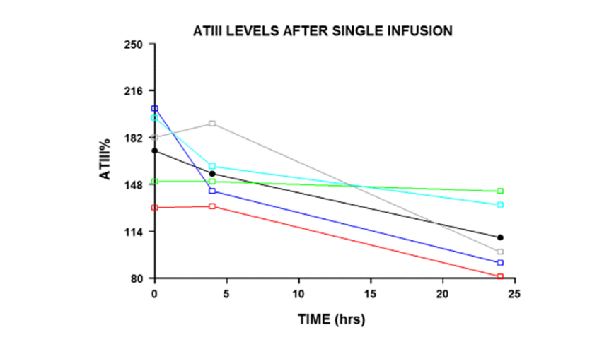

**Figure 1 ATIII levels after calculations for bolus single infusions to attain > 175% plasma antithrombin levels (personal file AKV).** AT: Antithrombin.

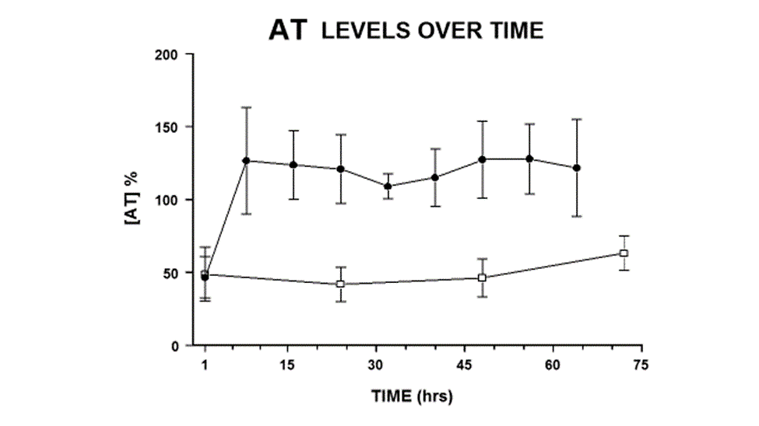

**Figure 2 A 72 h depiction of q 8 h dosage coefficient of variations for the antithrombin-treated burn patients (black dots) compared to control plasma antithrombin levels (white squares) (personal file AKV).** AT: Antithrombin.

**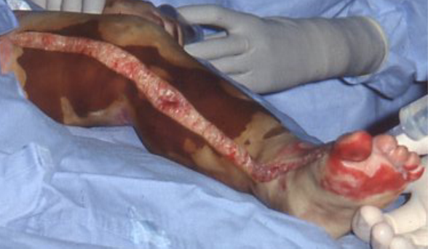**

**Figure 3 The severity of injury requiring an escharotomy in a burn patient with 80% total body surface area (personal file AKV).**

****

**Figure 4 The “peeling off” of the eschar, not requiring knife excision with exposed viable subcutaneous tissue and minimal bleeding (personal file AKV).**

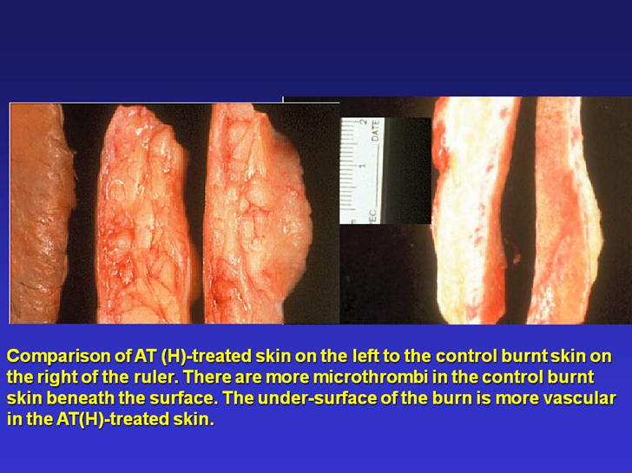

**Figure 5 A representation of the pathology in third degree burnt skin from a patient treated with plasma-derived antithrombin and in patient without plasma-derived antithrombin treatment.** Whereas the skin beneath the control eschar is dead and non-viable with clotted and coagulated blood vessels, the skin and subcutaneous tissue beneath the phAT-treated skin is more viable in comparison with fewer thrombi (personal file AKV). phAT: Plasma-derived antithrombin.

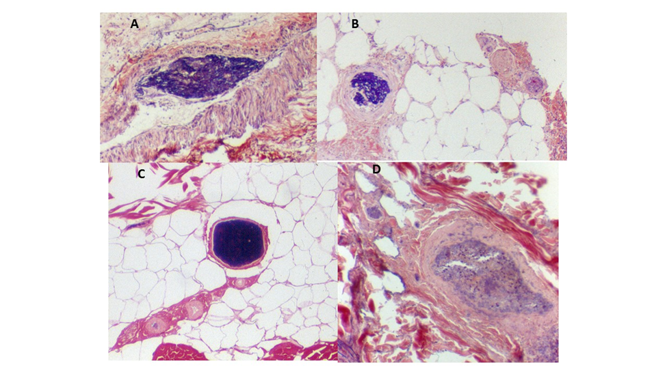

**Figure 6 The thrombi, sludge and necrotic debris in burnt skin subcutaneous tissue blood vessels.** A: Illustrates a blood vessel with sludge and fibrin debris; B: Depicts a small vessel with fibrin debris; C: Shows a clotted vessel; D: A larger vessel occluded with amorphous material. Magnification 40 ×, PTAH staining (personal file AKV).

**Table 1 Literature review of plasma-derived antithrombin studies in human burn patients**

|  |  |  |  |  |  |  |  |  |  |  |  |
| --- | --- | --- | --- | --- | --- | --- | --- | --- | --- | --- | --- |
| **Ref.** | **# phAT patients** | **#**  **controls** | **Age**  **(yr) mean** | **%TBSA** | **# doses** | **Admit AT % levels** | **phAT dose**  **units** | **AT % level desired** | **AT % level achieved** | **AT Level predict Mortality** | **Other** |
| **1Danielsson *et al***[31],  **1997** | **6** | **8** | **37**  **(20-56)** | **49**  **(26-75)** | **9 days** | **< 50** | **333-3800** | **> 70** | **50-75** | **None** | **Heparin also** |
| **3Kowal-Vern *et al***[7,15], **2000-2001** | **9** | **9** | **45-30** | **40-45** | **9 q 8 h** | **45**  **(35-55)** | **97 u/kg/dose** | **175** | **120**  **(95-145)** | **None** | **Pneumonia↓ in AT-treated** |
| **3Kowal-Vern *et al***[40], **2003** | **2** | **0** | **1.8** | **70** | **9 q 8 h** | **25-66** | **1000 u/dose** | **200** | **173**  **(114-224)** | **None** | **None** |
| **Del Principe *et al***[32], **2003** | **50** | **0** | **<16** | **>30** | **9 q 8 h** | **--** | **--** | **100** | **105**  **(85-125)** | ***P* = 0.0005** | **None** |
| **2Niedermayr *et al***[33], **2007** | **108** | **93** | **53**  **(30-76)** | **36**  **(12-60)** | **--** | **85**  **(63-107)** | **--** | **70-120** | **70-120** | ***P* = 0.003** | **Heparin also (APTT-50 sec)** |
| **4Lavrentieva *et al***[34], **2008** | **15** | **16** | **22-66** | **44**  **(22-66)** | **3 d** | **44**  **(28-81)** | **65 u/kg per day** | **> 150** | **124**  **(106-148)** | **None** | **AT-treated ↑ survival *P* = 0.004** |

In age, %TBSA. 1AT-treated group received continuous unfractionated heparin from day 3. One thousand six hundred and sixty-seven u/patient daily as did the controls; 2The controls had less inhalation injury (14% *vs* 50%) and the %TBSA was much lower (17 ± 17 *vs* 36 ± 24); 3Calculations for the loading dose were 97 u/kg per loading dose and the next 9 doses were At 2/3 of the loading dose; 4Unknown if AT given q 8 h or as a continuous infusion. AT: Antithrombin; phAT: Plasma-derived antithrombin; TBSA: Total body surface area.