**Name of Journal:** *World Journal of Gastroenterology*

**Manuscript NO:** 86872

**Manuscript Type:** ORIGINAL ARTICLE

***Basic Study***

**Tousled-like kinase 1 promotes gastric cancer progression by regulating the tumor growth factor-beta signaling pathway**

Sun RC *et al. TLK1* promotes gastric cancer progression

Ruo-Chuan Sun, Jing Li, Ya-Xian Li, Hui-Zhen Wang, Emre Dal, Ming-Liang Wang, Yong-Xiang Li

**Ruo-Chuan Sun, Jing Li, Ya-Xian Li, Hui-Zhen Wang, Ming-Liang Wang, Yong-Xiang Li,** Department of General Surgery, The First Affiliated Hospital of Anhui Medical University, Hefei 230022, Anhui Province, China

**Emre Dal,** Department of Oncological Sciences, University of Utah, Salt Lake City, UT 84112, United States

**Co-first authors:** Ruo-Chuan Sun and Jing Li.

**Co-corresponding authors:** Ming-Liang Wang and Yong-Xiang Li.

**Author contributions:** Li YX and Wang ML conceived the study design; Wang HZ and Dal E wrote the manuscript. Sun RC and Li J performed the experiments; Li YX participated in the cell culture and *in vitro* experiments; All authors contributed to the article and approved the final submitted version. Li YX and Wang ML contributed equally to this work as co-corresponding authors. The reasons for designating Li YX and Wang ML as co-corresponding authors are twofold. First, the main design of this project is completed by Li YX and Wang ML, which makes our project more rigorous. Second, the choice of these researchers as co-corresponding authors acknowledges and respects this equal contribution, while recognizing the spirit of teamwork and collaboration of this study. Sun RC and Li J contributed equally to this work as co-first authors. The reasons for designating Sun RC and Li J as co-first authors are also twofold. Sun RC and Li J completed all *in vitro* and *in vivo* experiments of this study, and made great contributions to this study. They contributed efforts of equal substance throughout the research process. Second, the research was performed as a collaborative effort, and the designation of co-first authorship accurately reflects the distribution of responsibilities and burdens associated with the time and effort required to complete the study and the resultant paper. This also ensures effective communication and management of post-submission matters, ultimately enhancing the paper's quality and reliability. summary, we believe that designating Li YX and Wang ML as co-corresponding authors and Sun RC and Li J as co-first authors of is fitting for our manuscript as it accurately reflects our team's collaborative spirit, equal contributions, and diversity.

**Supported by** the Key Programs of the Educational Commission of Anhui Province, No. 2023AH053313; and the Research Project of Higher Education in Anhui Province in 2022, No. 2022AH051192.

**Corresponding author: Yong-Xiang Li, Doctor,** Department of General Surgery, The First Affiliated Hospital of Anhui Medical University, No. 218 Jixi Road, Shushan District, Hefei 230022, Anhui Province, China. [liyongxiang@ahmu.edu.cn](mailto:liyongxiang@ahmu.edu.cn)

**Received:** July 20, 2023

**Revised:** October 23, 2023

**Accepted:** November 14, 2023

**Published online:** November 28, 2023

**Abstract**

BACKGROUND

The role of Tousled-like kinase 1 (TLK1) in in gastric cancer (GC) remains unclear.

AIM

To investigate the expression, biological function, and underlying mechanisms of TLK1 in GC.

METHODS

We measured TLK1 protein expression levels and localized TLK1 in GC cells and tissues by western blot and immunofluorescence, respectively. We transfected various GC cells with lentiviruses to create TLK1 overexpression and knockdown lines and established the functional roles of TLK1 through *in vitro* colony formation, 5-ethynyl-2`-deoxyuridine, and Transwell assays as well as flow cytometry. We applied bioinformatics to elucidate the signaling pathways associated with TLK1. We performed *in vivo* validation of TLK1 functions by inducing subcutaneous xenograft tumors in nude mice.

RESULTS

TLK1 was significantly upregulated in GC cells and tissues compared to their normal counterparts and was localized mainly to the nucleus. TLK1 knockdown significantly decreased colony formation, proliferation, invasion, and migration but increased apoptosis in GC cells. TLK1 overexpression had the opposite effects. Bioinformatics revealed, and subsequent experiments verified, that the tumor growth factor-beta signaling pathway was implicated in TLK1-mediated GC progression. The *in vivo* assays confirmed that TLK1 promotes tumorigenesis in GC.

CONCLUSION

The findings of the present study indicated that TLK1 plays a crucial role in GC progression and is, therefore, promising as a therapeutic target against this disease.

**Key Words:** Gastric cancer; Tousled-like kinase 1; Tumor growth factor-beta; Tumour progression; Targeted therapy

**©The** **Author(s) 2023.** Published by Baishideng Publishing Group Inc. All rights reserved.

**Citation**: Sun RC, Li J, Li YX, Wang HZ, Dal E, Wang ML, Li YX. Tousled-like kinase 1 promotes gastric cancer progression by regulating the tumor growth factor-beta signaling pathway. *World J Gastroenterol* 2023; 29(44): 5919-5934

**URL**: https://www.wjgnet.com/1007-9327/full/v29/i44/5919.htm

**DOI**: https://dx.doi.org/10.3748/wjg.v29.i44.5919

**Core Tip:** We demonstrated that Tousled-like kinase 1 (TLK1) is highly expressed in gastric cancer (GC), localized mainly to the nucleus, significantly promotes GC cell proliferation, invasion, and migration, and inhibits apoptosis. TLK1 may facilitate GC progression by modulating tumor growth factor-beta expression. We believe that TLK1 could be a crucial therapeutic target for GC, and propose that future investigations evaluate the feasibility and practicality of targeting TLK1 in GC treatment.

**INTRODUCTION**

Gastric cancer (GC) is the fifth most prevalent cancer and the third leading cause of cancer-related mortality worldwide[[1](#_ENREF_1" \o "Bray, 2018 #1)]. Endoscopy is the mainstay of early-stage GC treatment whereas advanced GC must be managed through surgery and other interventions including chemotherapy and targeted therapy[[2](#_ENREF_2" \o "Smyth, 2020 #2)]. Despite significant progress in GC control, however, its overall survival remains unsatisfactory. Hence, potential therapeutic targets against this disease are urgently required.

Tousled kinase and Tousled-like kinase (TLK) are serine-threonine enzymes implicated in DNA replication[3], transcription[4,5], and chromatin assembly[6]. TLK promotes glioma progression[[7](#_ENREF_7" \o "Han, 2005 #7)] and modulates latent viral activation[8]. Thus, it plays a critical role in various cellular processes. The two known TLK genes are TLK1 and TLK2. However, the former has received more research attention than the latter, and prior investigations focused primarily on the mechanisms by which TLK1 regulates DNA replication and repair. It interacts with Aurora kinase and chromatin assembly factors, and together they precisely control spindle assembly and S-phase progression[9]. The ataxia-telangiectasia-mutated-checkpoint kinase (Chk1)-TLK pathway uses TLK1 as a target to direct chromatin assembly[10,11]. TLK1 collaborates with Chk1 to regulate RAD9 checkpoint clamp component A (Rad9A) phosphorylation and, by extension, modulate the DNA damage response[12,13]. It also confers resistance to ultraviolet irradiation and, therefore, helps maintain cellular integrity and survival[14-17].

Recent research efforts have aimed to clarify the roles of TLK1 in cancers. TLK1 mediates prostate cancer progression via the TLK1-MAPK-activated protein kinase 5 and TLK1-NIMA-related kinase 1 axes[18-21]. The phenothiazine analog J54 is a potent TLK1 inhibitor and a possible therapeutic agent against prostate cancer[22]. TLK1 may promote the progression of glioma[23-25] and oral cancer[26]. However, the expression patterns and functional relevance of TLK1 in GC remain to be determined. Hence, the present study aimed to elucidate the functional significance of TLK1 in GC cells and potentially identify a novel therapeutic target against this disease.

**MATERIALS AND METHODS**

***Bioinformatics analysis***

The RNA-sequencing data obtained from The Cancer Genome Atlas (TCGA) website (https://portal.gdc.cancer.gov/) was subjected to a transcriptome analysis in R v. 4.1.2 (R Core Team, Vienna, Austria) to determine the functional relevance of TLK1 to GC. Differential gene expression between the high- and low-TLK1 expression groups was evaluated. The differentially expressed genes were then subjected to a Kyoto Encyclopedia of Genes and Genomes analysis (http://www.kegg.jp/) to identify and characterize the enrichment pathways with which they were associated. A gene set enrichment analysis was then used to analyze specific pathways and identify the interactions between them and TLK1 in GC. This multifaceted approach established novel molecular mechanisms and regulatory pathways underlying TLK1-mediated GC progression and elucidated GC biology.

***Cell culture***

The normal gastric epithelial cell line GES-1 as well as the AGS, SGC7901, MGC803, BGC823, and HGC27 GC cell lines were sourced from GeneChem (Shanghai, China) in December 2021. Short tandem repeat analyses verified the authenticity of each cell line and the final test was conducted on March 30, 2022. The cells were cultured in PMIS-1640 medium (Corning Inc., Corning, NY, United States) supplemented with 10% fetal bovine serum (FBS; Clark Bioscience, Richmond, VA, United States), 1% penicillin, and 1% streptomycin (HyClone Laboratories, Logan, UT, United States) and incubated in a Thermo Fisher incubator (Thermo Fisher Scientific, Waltham, MA, United States) under a 5% CO2 atmosphere at 37°C. They were then subcultured after they reached 80% confluence and maintained in the log phase. Strict quality control measures including regular mycoplasma testing were implemented to mitigate the risk of contamination.

***Western blotting***

Total protein was extracted with M-PER Mammalian Protein Extraction Reagent (Thermo Fisher Scientific) supplemented with phosphatase and protease inhibitors (BBI Life Sciences Corporation, Shanghai, China). Denatured sodium dodecyl sulfate-polyacrylamide gel electrophoresis was used to separate the proteins and they were then blotted onto polyvinylidene fluoride (PVDF) membranes. The latter were blocked with 5% skim milk for 1 h and incubated at 4°C overnight with primary antibodies including anti-GAPDH (1:2,500; No. 7074T; Cell Signaling Technology, Danvers, MA, United States), anti-TLK1 (1:1,000; No. 13564-1-AP; Proteintech Group, Rosemont, IL, United States), and anti-tumor growth factor-beta (TGF-β) (1:1,000; No. 346599; ZenBio, Chengdu, China) to detect the protein expression levels. The PVDF membranes were then washed with Tris-buffered saline with Tween-20 (TBST), incubated with secondary antibody at room temperature for 1 h, rinsed again with TBST, and visualized by enhanced chemiluminescence (ECL; Bridgen, Beijing, China). The ECL signals were captured on a Tanon-5200 multi-platform (Tanon Science & Technology Co. Ltd., Shanghai, China). The protein band gray values were then quantified with ImageJ software (National Institutes of Health (NIH), Bethesda, MD, United States).

***Immunofluorescence staining***

Sterile slides were placed in a 24-well plate, drops of cell suspension were dispensed onto them, and they were incubated overnight. The following day, the cells were fixed with 4% formaldehyde, blocked with 5% bovine serum albumin (BSA) for 1 h, and incubated at 4°C overnight with anti-TLK1 antibody (1:1,000; No. 13564-1-AP; Proteintech Group). The next day, the slides were subjected to fluorescent secondary antibody (1:250; No. A11012; Thermo Fisher Scientific) at room temperature for 1 h. Then 4`,6-diamidino-2-phenylindole (DAPI; 1:100; No. D9542; Sigma-Aldrich Corp., Roedermark, Germany) nuclear stain was applied to them for 15 min and they were observed and photographed under a confocal laser scanning microscope (CLSM; No. LSM800; Carl Zeiss AG, Jena, Germany).

***Lentivirus infection***

Three distinct small hairpin RNAs (shRNAs) targeting human TLK1 and a lentiviral TLK1 overexpression construct were procured from GeneChem (Shanghai, China). Cells were seeded in 12-well plates and the lentiviral particles were added to them at a multiplicity of infection = 10 in the presence of a transfection aid per the manufacturer’s instructions. The medium was replaced and the cells were passaged after 24 h and 48 h, respectively. Successful lentiviral infection was confirmed by screening the cells with a medium containing puromycin. Transfection efficiency was assessed *via* protein extraction. The shRNA sequences used in the experiment were as follows: sh1: 5`-GAUACAGAUACGUUUUGUACAdTdT-3`; sh2: 5`-CUCGUAGGGUAGAAACCAAUAdTdT-3`; and sh3: 5`-GCAGGCACUUACUGGUAUUUAdTdT-3`.

***Colony formation assay***

Cells were seeded in six-well plates at a density of 800/well and incubated with gentle agitation under optimal conditions. The culture medium was renewed every 3 d and the experiment was terminated when cell colonies emerged. The cells were then fixed with 4% formaldehyde for 20 min, washed thrice with phosphate-buffered saline (PBS), stained with 0.1% crystal violet for 15 min, air-dried, and imaged.

***5-ethynyl-2`-deoxyuridine assay***

An 5-ethynyl-2`-deoxyuridine (EdU) Kit (No. C0078S; Beyotime Biotechnology, Shanghai, China) was utilized for this assay. Sterile slides were aseptically placed in 12-well plates. Cells were seeded onto them and incubated overnight until the optimal cell density was attained. The next day, a 2 × EdU solution was prepared according to the manufacturer’s instructions and mixed in equal proportions with the culture medium. The mixture was then added to the 12-well plates and incubated at 37°C for 2 h. The culture medium was removed and the cells were fixed with 4% paraformaldehyde for 15 min and washed with PBS containing 3% BSA (Beyotime Biotechnology). Then 0.3% Triton X-100 was added and the cells were incubated at room temperature for 15 min. The cells were rinsed and a pre-configured Click reaction solution was added to the 12-well plates. The cells were incubated for 30 min and their nuclei were stained with Hoechst33342 for 10 min. An anti-quenching agent was added and the cells were viewed under a microscope (Leica Microsystems GmbH, Wetzlar, Germany).

***Transwell assays***

Cells in the log phase were seeded at optimal density and subjected to serum deprivation for 24 h. Matrigel Basement Membrane Matrix (BD Biosciences, Shanghai, China) was diluted to a working concentration and uniformly spread onto the upper layer of a Transwell chamber (Corning Inc.). The latter was incubated at 37°C for 5 h. The cell concentration was adjusted and maintained at 8 × 105/mL. One hundred microliters cell suspension was added to the upper chamber, 650 µL high-serum medium was added to the lower chamber, and the Transwell was incubated in a suitable environment. After a predetermined incubation period, the Transwell chambers were extracted. Their contents were then fixed with 4% paraformaldehyde, stained with 0.1% crystal violet, and observed and photographed under a microscope (Leica Microsystems GmbH).

***Flow cytometry***

An Annexin V-fluorescein isothiocyanate (FITC)/propidium iodide (PI) Apoptosis Kit (Yeasen Biotechnology, Shanghai, China) was used for this assay. Cell supernatant and digested cells were collected in a centrifuge tube, washed with PBS, and resuspended in 100 µL of 1 × binding buffer. Then 5 µL Annexin V-FITC and 10 µL PI staining solution were added and the suspension was incubated in the dark at room temperature for 15 min. Then a CytoFLEX Flow Cytometry Platform (Beckman Coulter, Brea, CA, United States) was used to detect apoptosis.

***Xenograft mouse model***

Four-Week-old male BALB/C nude mice were obtained from GemPharmatech, Jiangsu, China, and maintained under specific pathogen-free conditions. The control and experimental groups each included six mice. SGC7901 cells were digested and resuspended in PBS and 5 x 106 were subcutaneously injected into the left underarm of each mouse. During the experiment, the mice were provided with sufficient food and water, and their body weight was periodically measured. The volumes of any subcutaneous tumors that had formed were determined every 4 d. Humane euthanasia was performed when the body weight decreased by ≥ 20% and/or the tumor diameter was > 1.5 cm.

***Immunohistochemical staining***

Immunohistochemical (IHC) staining was conducted per established methods[27]. Protein expression levels were independently evaluated by two pathologists blinded to the clinical information of the patients. The IHC score was calculated based on the staining intensity and area to assess the protein expression levels.

***Statistical analysis***

All data were analyzed with SPSS v. 22.0 (SPSS Inc., Chicago, IL, United States), GraphPad Prism v. 7.0 (GraphPad Software, La Jolla, CA, United States), and R v. 4.1.2 (R Core Team, Vienna, Austria). Student’s *t*-test or one-way ANOVA was used to detect significant differences between treatments. *P* < 0.05 was considered statistically significant (a*P* < 0.05).

**Ethics statement**

Studies involving human participants were reviewed and approved (No. 20180323) by the Ethics Committee of Anhui Medical University, Anhui, China. All patients and participants provided written informed consent. All animal experiments were approved (No. 20180345) by the Institutional Animal Care and Use Committee of Anhui Medical University.

**RESULTS**

***TLK1 was significantly upregulated in GC cells and tissues and localized mainly to the nucleus***

We performed a bioinformatics analysis using TCGA to determine TLK1 expression and localization in GC. We found that TLK1 was upregulated in GC and other tumors of the digestive tract (Figure 1A). We then conducted a western blot analysis to determine the TLK1 expression levels in the GC cells and tissues. We measured TLK1 protein expression in normal gastric epithelial cells (GES-1) and the GC cells AGS, SGC7901, MGC803, BGC823, and HGC27 to clarify the association between the expression and localization of TLK1 in GC. TLK1 expression was significantly higher in GC than in GES-1 cells (Figure 1B and C). We then measured TLK1 expression in GC and their adjacent normal tissues and found that it was significantly higher in the former than in the latter (Figure 1D and E). We then subjected HGC27 and MGC803 GC cells to immunofluorescence staining and observed that TLK1 was localized mainly to their nuclei (Figure 1F). The foregoing findings suggest that TLK1 is upregulated in GC cells and tissues and is localized to the nucleus.

***TLK1 significantly enhanced GC cell clonogenesis, proliferation, invasion, and migration in vitro***

We increased TLK1 expression in SGC7901 cells *via* lentiviral transfection and verified its upregulation *via* western blot to elucidate its role in GC cells (Figure 2A). We then used a colony formation assay to assess the impact of TLK1 overexpression on GC cell proliferation. TLK overexpression substantially increased the number of SGC7901 cell colonies compared to the control (Figure 2B and C). The EdU assay demonstrated a dramatic increase in the proportion of proliferative SGC7901 cells in response to TLK1 overexpression (Figure 2D and E). The preceding experiments showed that TLK1 overexpression augments SGC7901 cell proliferation.

A Transwell assay showed that TLK1 overexpression significantly increased SGC7901 GC cell migration and invasion relative to the control (Figure 2F and G). Overall, TLK1 overexpression promoted clonal expansion, proliferation, invasion, and migration in SGC7901 GC cells.

***TLK1 knockdown inhibited GC cell clonal formation, invasion, and migration***

We transfected AGS and HGC27 cells with three lentiviral sequences designed to knock down/silence TLK1 and used western blot analysis to assess transfection efficiency. We selected sh2 and sh3 for the subsequent experiments as they exhibited superior knockdown efficacy (Figure 3A). A colony formation assay demonstrated that TLK1 knockdown markedly reduced the number of AGS and HGC27 cell colonies compared with the control (Figure 3B and C).

A Transwell assay revealed that TLK1 knockdown significantly diminished AGS GC cell invasion and migration relative to the control (Figure 3D and E). Similar results were obtained for HGC27 cells subjected to TLK1 knockdown (Figure 3F and G). The foregoing findings suggest that TLK1 knockdown effectively suppresses clonal formation, invasion, and migration in GC cells.

***TLK1 knockdown diminished proliferation and augmented apoptosis in GC cells***

An EdU assay disclosed that TLK1 knockdown substantially inhibited AGS cell proliferation compared to the control (Figure 4A and B). Similar results were obtained for HGC27 cells (Figure 4C and D). Flow cytometry also showed that TLK1 knockdown considerably increased the apoptosis ratios in AGS and HGC27 relative to the control (Figure 4E and F).

***TLK1 promotes GC progression by regulating the TGF-β signaling pathway***

We applied bioinformatics to identify the genes associated with TLK1 and elucidate the mechanisms by which TLK1 affects GC cell clonal formation, proliferation, invasion, and migration. The expression levels of DDB1- and CUL4-associated factor 17 (DCAF17), enhancer of polycomb homolog 2 (EPC2), and membrane-associated ring-CH-type finger 7 (MARCH7) were positively correlated with that of TLK1 (Figure 5A) whereas those of COPI coat complex subunit epsilon (COPE), RNA pseudouridine synthase domain containing 1 (RPUSD1), and protein phosphatase 4, catalytic subunit (PPP4C) were negatively correlated with it (Figure 5B).

We then discovered that the TGF-β signaling pathway might mediate the impact of TLK1 on the clonal formation, proliferation, invasion, and migration of GC cells (Figure 5C and D). We then used western blot to measure TGF-β protein expression in GC cells subjected to TLK1 knockdown and overexpression. We observed that the former downregulated TGF-β in AGS and HGC27 cells whereas the latter upregulated TGF-β in SGC7901 cells. Hence, TGF-β signaling determines the influence of TLK1 on GC progression (Figure 5E-G).

***In vivo* *assays confirmed that TLK1 drives GC progression***

We then validated the impact of TLK1 on GC progression through subcutaneous xenograft tumor induction in nude mice. The study included control and TLK1 overexpression groups (Figure 6A). Compared to the former, the latter presented significantly larger tumor size, volume, and mass (Figure 6B–D). Western blot and IHC verified that the TLK1 and TGF-β expression levels were considerably higher in the treatment group presenting large tumors than in the control group exhibiting small tumors (Figure 6E-G).

Antigen Kiel 67 staining of the tumors revealed that cancer proliferation was markedly higher in the TLK1 overexpression group than in the control group (Figure 6H and I). Hematoxylin and eosin and terminal deoxynucleotidyl transferase dUTP nick end labeling staining exposed substantially greater apoptotic necrosis in the control group than in the TLK1 overexpression group (Figure 6J and K).

**DISCUSSION**

The mortality rate of advanced GC remains high despite the progress that has been made in the therapeutic approaches used against it[28]. Hence, novel treatments for GC are urgently needed. TLK promotes the progression of various malignancies. Therefore, research on TLK in the context of cancer therapy should be prioritized[18-21,23-26]. Here, we examined TLK1 expression in GC cells, investigated its effects on their functions, and used *in vivo* experiments to clarify how it modulates GC progression.

Previous studies reported that TLK1 was upregulated in gliomas[23,25]. In the present work, we discovered that TLK1 was significantly overexpressed in GC cells and tissues (Figure 1B–E). Immunofluorescence staining also revealed that TLK1 was localized mainly to GC cell nuclei (Figure 1F).

We then assessed the impact of TLK1 on GC cell function. TLK1 was overexpressed in the SGC7901 cell line (Figure 2A). Colony formation, EdU, and Transwell assays disclosed that TLK1 overexpression promoted SGC7901 cell proliferation, invasion, and migration (Figure 2B–G). TLK1 knockdown had the opposite effects on AGS and HGC27 cell lines (Figures 3 and 4). An earlier study reported similar findings for the roles of TLK1 in other cancer types[25]. Taken together, these results suggest that TLK1 contributes to GC progression. Our bioinformatics analysis revealed that the mechanism of TLK1 was associated with the TGF-β signaling pathway in GC (Figure 5C and D). The TGF-β signaling pathway comprises TGF-β itself, activins, nodal, bone morphogenetic proteins, growth and differentiation factors, and other factors[29,30] and plays vital roles in human embryonic development and homeostasis[31]. A recent study showed that alterations in TGF-β signaling may result in immunocompromise, fibrosis, and carcinogenesis[32]. The TGF-β signaling pathway may either inhibit or promote tumorigenesis depending upon the tumor microenvironment or cancer stage[29,33,34]. We used western blot to measure TGF-β expression in response to TLK1 overexpression or knockdown and found a positive correlation between TLK1 and TGF-β (Figure 5E and F). Thus, TLK1 may promote GC progression by upregulating TGF-β. We validated this mechanism *in vivo* by inducing subcutaneous xenograft tumor formation in nude mice (Figure 6) and substantiated the critical role of TLK1 in GC progression. To the best of our knowledge, the present work is one of the first to delineate the expression, localization, and functional impact of TLK1 in GC.

**CONCLUSION**

We demonstrated that TLK1 is highly expressed in GC, localized mainly to the nucleus, significantly promotes GC cell proliferation, invasion, and migration, and inhibits apoptosis. TLK1 may facilitate GC progression by modulating TGF-β expression. We believe that TLK1 could be a crucial therapeutic target for GC, and propose that future investigations evaluate the feasibility and practicality of targeting TLK1 in GC treatment.

**ARTICLE HIGHLIGHTS**

***Research background***

Gastric cancer (GC) is the fifth most prevalent cancer and the third leading cause of cancer-related mortality worldwide. Endoscopy is the mainstay of early-stage GC treatment whereas advanced GC must be managed through surgery and other interventions including chemotherapy and targeted therapy. Despite significant progress in GC control, however, its overall survival remains unsatisfactory.

***Research motivation***

Potential therapeutic targets against GC are urgently required.

***Research objectives***

The present study aimed to elucidate the functional significance of Tousled-like kinase 1 (TLK1) in GC cells and potentially identify a novel therapeutic target against this disease.

***Research methods***

We measured TLK1 protein expression levels and localized TLK1 in GC cells and tissues by western blot and immunofluorescence, respectively. We transfected various GC cells with lentiviruses to create TLK1 overexpression and knockdown lines and established the functional roles of TLK1 through *in vitro* colony formation, 5-ethynyl-2`-deoxyuridine, and Transwell assays as well as flow cytometry. We applied bioinformatics to elucidate the signaling pathways associated with TLK1. We performed *in vivo* validation of TLK1 functions by inducing subcutaneous xenograft tumors in nude mice.

***Research results***

TLK1 was significantly upregulated in GC cells and tissues compared to their normal counterparts and was localized mainly to the nucleus. TLK1 knockdown significantly decreased colony formation, proliferation, invasion, and migration but increased apoptosis in GC cells. TLK1 overexpression had the opposite effects. Bioinformatics revealed, and subsequent experiments verified, that the tumor growth factor-beta (TGF-β) signaling pathway was implicated in TLK1-mediated GC progression. The *in vivo* assays confirmed that TLK1 promotes tumorigenesis in GC.

***Research conclusions***

We demonstrated that TLK1 is highly expressed in GC, localized mainly to the nucleus, significantly promotes GC cell proliferation, invasion, and migration, and inhibits apoptosis. TLK1 may facilitate GC progression by modulating TGF-β expression. We believe that TLK1 could be a crucial therapeutic target for GC.

***Research perspectives***

Future investigations evaluate the feasibility and practicality of targeting TLK1 in GC treatment.

**ACKNOWLEDGEMENTS**

The authors thank the personnel at the Center for Scientific Research of the First Affiliated Hospital of Anhui Medical University for their valuable assistance with our experiments.

**REFERENCES**

1 **Bray F**, Ferlay J, Soerjomataram I, Siegel RL, Torre LA, Jemal A. Global cancer statistics 2018: GLOBOCAN estimates of incidence and mortality worldwide for 36 cancers in 185 countries. *CA Cancer J Clin* 2018; **68**: 394-424 [PMID: 30207593 DOI: 10.3322/caac.21492]

2 **Smyth EC**, Nilsson M, Grabsch HI, van Grieken NC, Lordick F. Gastric cancer. *Lancet* 2020; **396**: 635-648 [PMID: 32861308 DOI: 10.1016/S0140-6736(20)31288-5][](https://sci-hub.se/10.1016/S0140-6736(20)31288-5)

3 **Silljé HH**, Takahashi K, Tanaka K, Van Houwe G, Nigg EA. Mammalian homologues of the plant Tousled gene code for cell-cycle-regulated kinases with maximal activities linked to ongoing DNA replication. *EMBO J* 1999; **18**: 5691-5702 [PMID: 10523312 DOI: 10.1093/emboj/18.20.5691]

4 **Han Z**, Saam JR, Adams HP, Mango SE, Schumacher JM. The C. elegans Tousled-like kinase (TLK-1) has an essential role in transcription. *Curr Biol* 2003; **13**: 1921-1929 [PMID: 14614817 DOI: 10.1016/j.cub.2003.10.035]

5 **Giménez AC**, Tamajón LG. Analysis of the third-order structuring of Shalom Schwartz's theory of basic human values. *Heliyon* 2019; **5**: e01797 [PMID: 31198868 DOI: 10.1016/j.heliyon.2019.e01797]

6 **Silljé HH**, Nigg EA. Identification of human Asf1 chromatin assembly factors as substrates of Tousled-like kinases. *Curr Biol* 2001; **11**: 1068-1073 [PMID: 11470414 DOI: 10.1016/s0960-9822(01)00298-6]

7 **Han Z**, Riefler GM, Saam JR, Mango SE, Schumacher JM. The C. elegans Tousled-like kinase contributes to chromosome segregation as a substrate and regulator of the Aurora B kinase. *Curr Biol* 2005; **15**: 894-904 [PMID: 15916946 DOI: 10.1016/j.cub.2005.04.019]

8 **Dillon PJ**, Gregory SM, Tamburro K, Sanders MK, Johnson GL, Raab-Traub N, Dittmer DP, Damania B. Tousled-like kinases modulate reactivation of gammaherpesviruses from latency. *Cell Host Microbe* 2013; **13**: 204-214 [PMID: 23414760 DOI: 10.1016/j.chom.2012.12.005]

9 **Li Z**, Gourguechon S, Wang CC. Tousled-like kinase in a microbial eukaryote regulates spindle assembly and S-phase progression by interacting with Aurora kinase and chromatin assembly factors. *J Cell Sci* 2007; **120**: 3883-3894 [PMID: 17940067 DOI: 10.1242/jcs.007955]

10 **Krause DR**, Jonnalagadda JC, Gatei MH, Sillje HH, Zhou BB, Nigg EA, Khanna K. Suppression of Tousled-like kinase activity after DNA damage or replication block requires ATM, NBS1 and Chk1. *Oncogene* 2003; **22**: 5927-5937 [PMID: 12955071 DOI: 10.1038/sj.onc.1206691]

11 **Groth A**, Lukas J, Nigg EA, Silljé HH, Wernstedt C, Bartek J, Hansen K. Human Tousled like kinases are targeted by an ATM- and Chk1-dependent DNA damage checkpoint. *EMBO J* 2003; **22**: 1676-1687 [PMID: 12660173 DOI: 10.1093/emboj/cdg151]

12 **Sunavala-Dossabhoy G**, De Benedetti A. Tousled homolog, TLK1, binds and phosphorylates Rad9; TLK1 acts as a molecular chaperone in DNA repair. *DNA Repair (Amst)* 2009; **8**: 87-102 [PMID: 18940270 DOI: 10.1016/j.dnarep.2008.09.005]

13 **Kelly R**, Davey SK. Tousled-like kinase-dependent phosphorylation of Rad9 plays a role in cell cycle progression and G2/M checkpoint exit. *PLoS One* 2013; **8**: e85859 [PMID: 24376897 DOI: 10.1371/journal.pone.0085859]

14 **Sen SP**, De Benedetti A. TLK1B promotes repair of UV-damaged DNA through chromatin remodeling by Asf1. *BMC Mol Biol* 2006; **7**: 37 [PMID: 17054786 DOI: 10.1186/1471-2199-7-37]

15 **Sunavala-Dossabhoy G**, Balakrishnan SK, Sen S, Nuthalapaty S, De Benedetti A. The radioresistance kinase TLK1B protects the cells by promoting repair of double strand breaks. *BMC Mol Biol* 2005; **6**: 19 [PMID: 16156902 DOI: 10.1186/1471-2199-6-19]

16 **Canfield C**, Rains J, De Benedetti A. TLK1B promotes repair of DSBs *via* its interaction with Rad9 and Asf1. *BMC Mol Biol* 2009; **10**: 110 [PMID: 20021694 DOI: 10.1186/1471-2199-10-110]

17 **Sunavala-Dossabhoy G**, Fowler M, De Benedetti A. Translation of the radioresistance kinase TLK1B is induced by gamma-irradiation through activation of mTOR and phosphorylation of 4E-BP1. *BMC Mol Biol* 2004; **5**: 1 [PMID: 15070431 DOI: 10.1186/1471-2199-5-1]

18 **Khalil MI**, De Benedetti A. The TLK1-MK5 Axis Regulates Motility, Invasion, and Metastasis of Prostate Cancer Cells. *Cancers (Basel)* 2022; **14** [PMID: 36497211 DOI: 10.3390/cancers14235728]

19 **Khalil MI**, Singh V, King J, De Benedetti A. TLK1-mediated MK5-S354 phosphorylation drives prostate cancer cell motility and may signify distinct pathologies. *Mol Oncol* 2022; **16**: 2537-2557 [PMID: 35064619 DOI: 10.1002/1878-0261.13183]

20 **Singh V**, Khalil MI, De Benedetti A. The TLK1/Nek1 axis contributes to mitochondrial integrity and apoptosis prevention *via* phosphorylation of VDAC1. *Cell Cycle* 2020; **19**: 363-375 [PMID: 31914854 DOI: 10.1080/15384101.2019.1711317]

21 **Singh V**, Jaiswal PK, Ghosh I, Koul HK, Yu X, De Benedetti A. The TLK1-Nek1 axis promotes prostate cancer progression. *Cancer Lett* 2019; **453**: 131-141 [PMID: 30928383 DOI: 10.1016/j.canlet.2019.03.041]

22 **Singh V**, Bhoir S, Chikhale RV, Hussain J, Dwyer D, Bryce RA, Kirubakaran S, De Benedetti A. Generation of Phenothiazine with Potent Anti-TLK1 Activity for Prostate Cancer Therapy. *iScience* 2020; **23**: 101474 [PMID: 32905878 DOI: 10.1016/j.isci.2020.101474]

23 **Wang Z**, Chen X, Liang Q, An Y, Wei M, Shi W. Inhibiting of circ-TLK1 inhibits the progression of glioma through down-regulating PANX1 *via* targeting miR-17-5p. *J Mol Histol* 2021; **52**: 1007-1020 [PMID: 34181173 DOI: 10.1007/s10735-021-09993-x]

24 **Zhang Z**, Liu S. The interaction between ASF1B and TLK1 promotes the malignant progression of low-grade glioma. *Ann Med* 2023; **55**: 1111-1122 [PMID: 36947060 DOI: 10.1080/07853890.2023.2169751]

25 **Ibrahim K**, Abdul Murad NA, Harun R, Jamal R. Knockdown of Tousled‑like kinase 1 inhibits survival of glioblastoma multiforme cells. *Int J Mol Med* 2020; **46**: 685-699 [PMID: 32468002 DOI: 10.3892/ijmm.2020.4619]

26 **Hu S**, Wang H, Yan D, Lu W, Gao P, Lou W, Kong X. Loss of miR-16 contributes to tumor progression by activation of tousled-like kinase 1 in oral squamous cell carcinoma. *Cell Cycle* 2018; **17**: 2284-2295 [PMID: 30252587 DOI: 10.1080/15384101.2018.1526601]

27 **Sun R**, Wu J, Chen Y, Lu M, Zhang S, Lu D, Li Y. Down regulation of Thrombospondin2 predicts poor prognosis in patients with gastric cancer. *Mol Cancer* 2014; **13**: 225 [PMID: 25262009 DOI: 10.1186/1476-4598-13-225]

28 **Joshi SS**, Badgwell BD. Current treatment and recent progress in gastric cancer. *CA Cancer J Clin* 2021; **71**: 264-279 [PMID: 33592120 DOI: 10.3322/caac.21657]

29 **David CJ**, Massagué J. Contextual determinants of TGFβ action in development, immunity and cancer. *Nat Rev Mol Cell Biol* 2018; **19**: 419-435 [PMID: 29643418 DOI: 10.1038/s41580-018-0007-0]

30 **Saito A**, Horie M, Nagase T. TGF-β Signaling in Lung Health and Disease. *Int J Mol Sci* 2018; **19** [PMID: 30127261 DOI: 10.3390/ijms19082460]

31 **Xu X**, Zheng L, Yuan Q, Zhen G, Crane JL, Zhou X, Cao X. Transforming growth factor-β in stem cells and tissue homeostasis. *Bone Res* 2018; **6**: 2 [PMID: 29423331 DOI: 10.1038/s41413-017-0005-4]

32 **Liu S**, Ren J, Ten Dijke P. Targeting TGFβ signal transduction for cancer therapy. *Signal Transduct Target Ther* 2021; **6**: 8 [PMID: 33414388 DOI: 10.1038/s41392-020-00436-9]

33 **Neuzillet C**, Tijeras-Raballand A, Cohen R, Cros J, Faivre S, Raymond E, de Gramont A. Targeting the TGFβ pathway for cancer therapy. *Pharmacol Ther* 2015; **147**: 22-31 [PMID: 25444759 DOI: 10.1016/j.pharmthera.2014.11.001]

34 **Colak S**, Ten Dijke P. Targeting TGF-β Signaling in Cancer. *Trends Cancer* 2017; **3**: 56-71 [PMID: 28718426 DOI: 10.1016/j.trecan.2016.11.008]

**Footnotes**

**Institutional review board statement: Institutional review board statement:** The study was reviewed and approved by the the Ethics Committee of Anhui Medical University (Approval No. 20180323).

**Institutional animal care and use committee statement:** All procedures involving animals were reviewed and approved by the Institutional Animal Care and Use Committee of Anhui Medical University (No. 20180345).

**Conflict-of-interest statement:** The authors have no conflict of interest to declare.

**Data sharing statement:** Technical appendix, statistical code, and dataset available from the corresponding author at liyongxiang@ahmu.edu.cn.

**ARRIVE guidelines statement:** The authors have read the ARRIVE Guidelines, and the manuscript was prepared and revised according to the ARRIVE Guidelines.

**Open-Access:** This article is an open-access article that was selected by an in-house editor and fully peer-reviewed by external reviewers. It is distributed in accordance with the Creative Commons Attribution NonCommercial (CC BY-NC 4.0) license, which permits others to distribute, remix, adapt, build upon this work non-commercially, and license their derivative works on different terms, provided the original work is properly cited and the use is non-commercial. See: https://creativecommons.org/Licenses/by-nc/4.0/

**Provenance and peer review:** Unsolicited article; Externally peer reviewed.

**Peer-review model:** Single blind

**Peer-review started:** July 20, 2023

**First decision:** October 9, 2023

**Article in press:** November 14, 2023

**Specialty type:** Gastroenterology and hepatology

**Country/Territory of origin:** China

**Peer-review report’s scientific quality classification**

Grade A (Excellent): 0

Grade B (Very good): B, B

Grade C (Good): C

Grade D (Fair): 0

Grade E (Poor): 0

**P-Reviewer:** Buechler C, Germany; Cucu D, Romania; Ocker M, Germany **S-Editor:** Lin C **L-Editor:** A **P-Editor:** Chen YX

**Figure Legends**

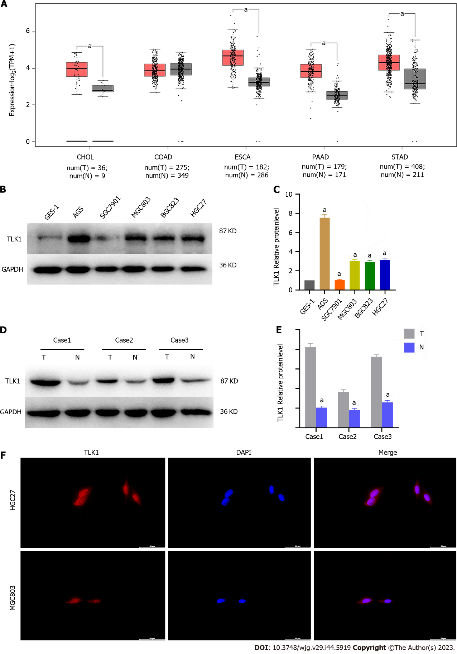

**Figure 1 Tousled-like kinase 1 was upregulated and localized mainly to the nucleus in gastric cancers.** A: Tousled-like kinase 1 (TLK1) expression in various tumors was explored using The Cancer Genome Atlas database; B and C: Western blot measuring TLK1 expression in normal gastric epithelial cells GES-1 and in gastric cancer (GC) cell lines; D and E: Western blot detecting differential TLK1 expression between GC and adjacent non-neoplastic tissues; F: Immunofluorescence detecting subcellular TLK1 compartmentalization in HGC27 and MGC803 cell lines. a*P* < 0.05. TLK1: Tousled-like kinase 1; CHOL: Cholangiocarcinoma; COAD: Colon adenocarcinoma; ESCA: Esophageal carcinoma; PAAD: Pancreatic adenocarcinoma; STAD: Stomach adenocarcinoma.

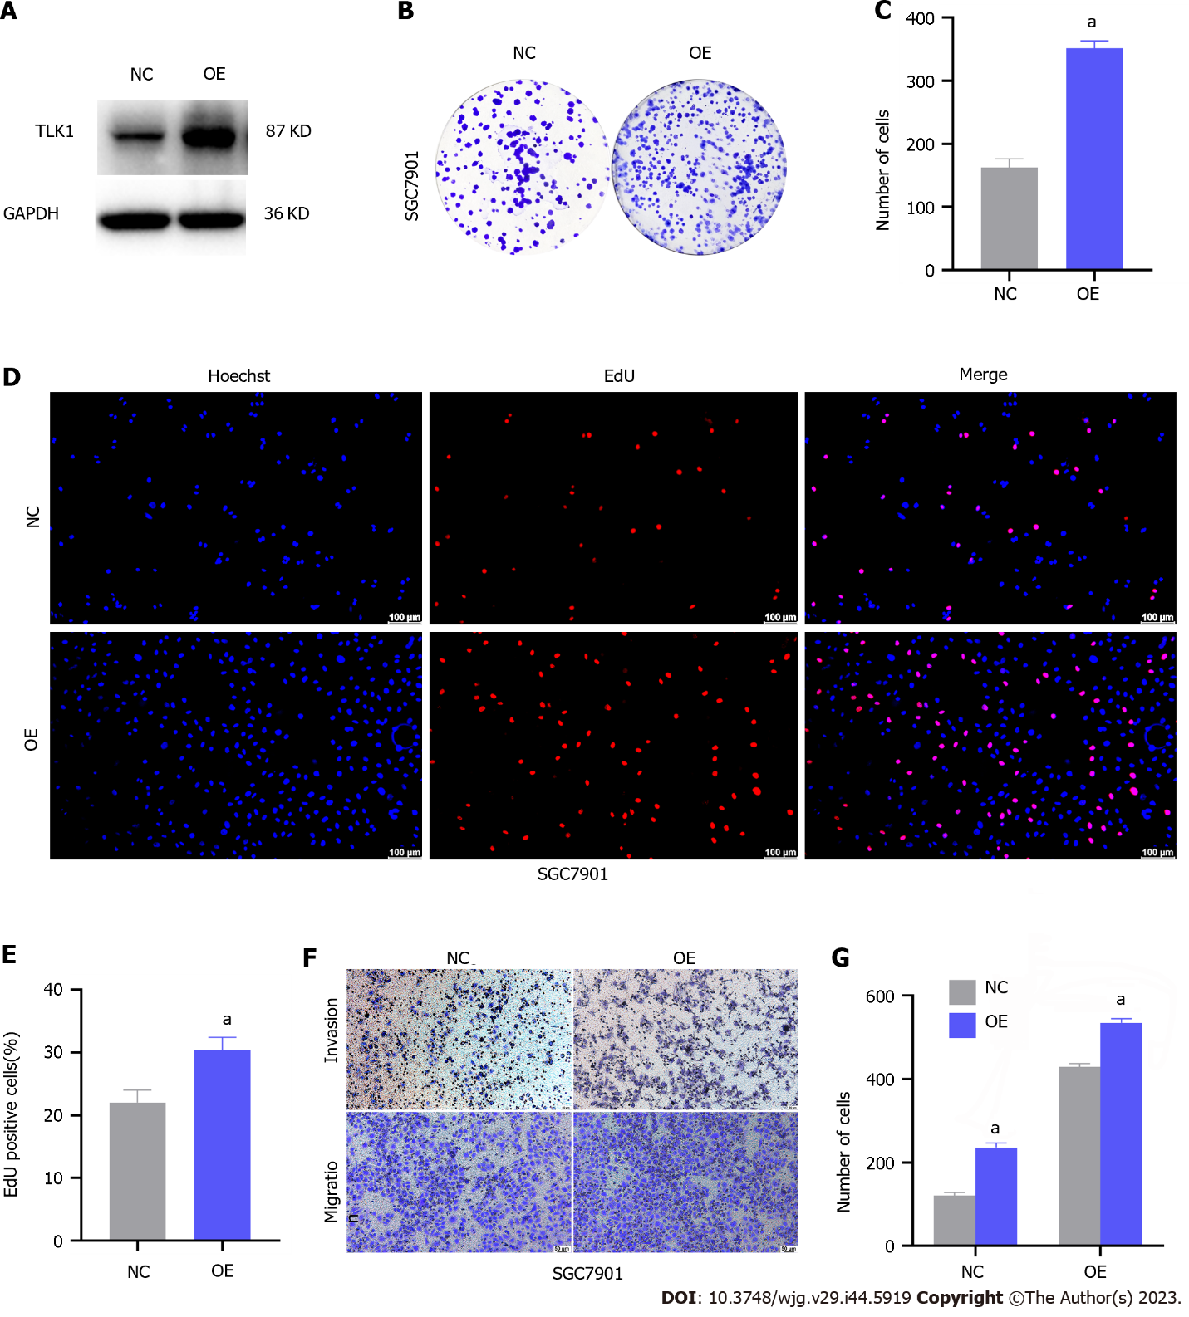

**Figure 2 Tousled-like kinase 1 upregulation potentiated tumorigenesis in gastric cancer cell lines.** A: Western blot demonstrated the effects of Tousled-like kinase 1 (TLK1) overexpression in SGC7901 cells; B and C: Impact of TLK1 overexpression on clonogenesis in SGC7901 cells; D and E: 5-ethynyl-2`-deoxyuridine assay evaluating the influence of TLK1 overexpression on SGC7901 cell proliferation; F and G: Transwell assay showing the effects of TLK1 overexpression on SGC7901 cell invasion and migration. a*P* < 0.05. TLK1: Tousled-like kinase 1; NC: Negative control; OE: Overexpression; EdU: 5-ethynyl-2`-deoxyuridine.

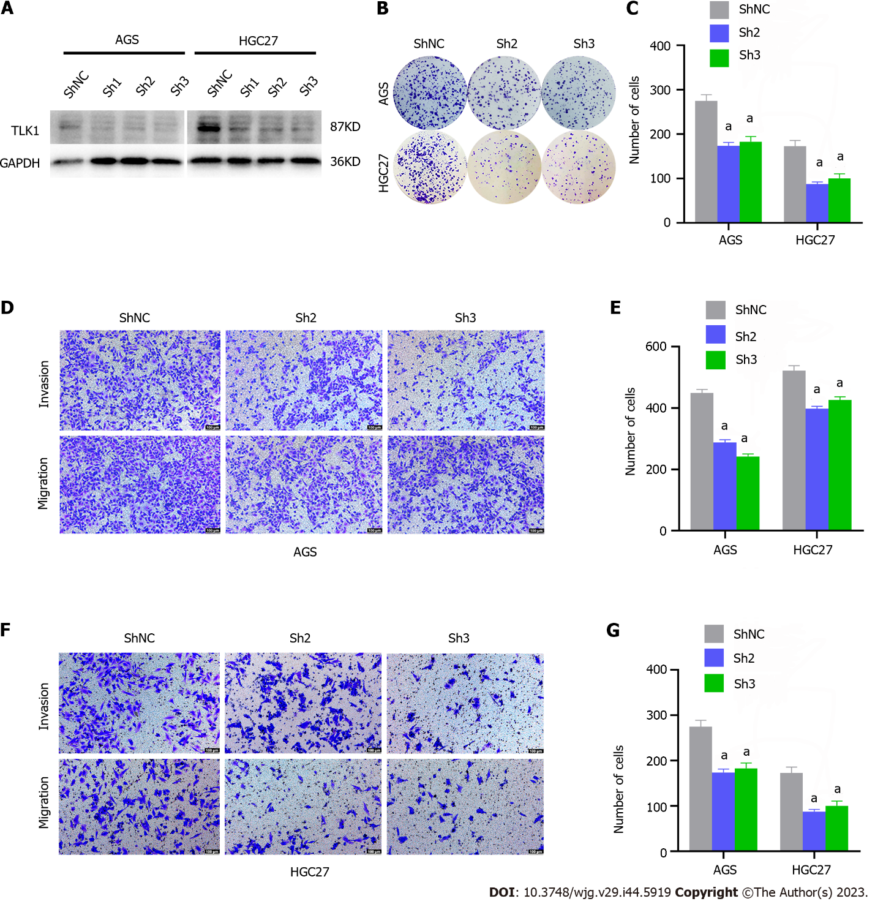

**Figure 3 Tousled-like kinase 1 knockdown attenuated clonal formation, invasion, and migration in gastric cancer cell lines.** A: Western blot revealing the impact of Tousled-like kinase 1 (TLK1) knockdown on AGS and HGC27 cell lines; B and C: Effects of TLK1 suppression on clonogenesis in AGS and HGC27 cell lines; D and E: Transwell assay disclosing the effects of TLK1 knockdown on AGS cell invasion and migration; F and G: Transwell assay demonstrating the influences of TLK1 suppression on HGC27 cell invasion and migration. a*P* < 0.05. TLK1: Tousled-like kinase 1; shNC: Short hairpin RNA of negative control.

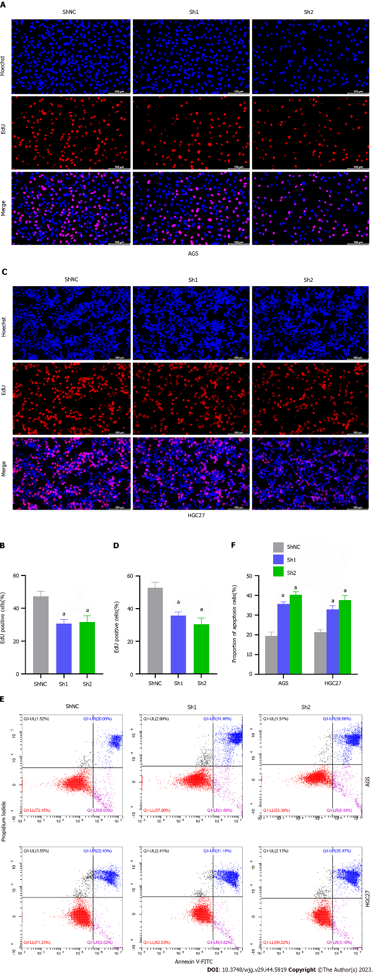

**Figure 4 Tousled-like kinase 1 inhibition diminished proliferation and augmented apoptosis in gastric cancer cell lines.** A and B: 5-ethynyl-2`-deoxyuridine (EdU) assay showing the effects of Tousled-like kinase 1 (TLK1) suppression on AGS cell proliferation; C and D: EdU assay revealing the impact of TLK1 knockdown on HGC27 cell proliferation; E and F: Flow cytometry evaluating the effects of TLK1 inhibition on apoptosis in AGS and HGC27 cell lines. a*P* < 0.05. EdU: 5-ethynyl-2`-deoxyuridine; shNC: Short hairpin RNA of negative control.

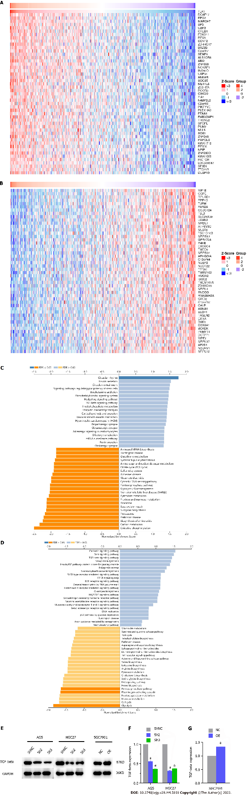**Figure 5 Tousled-like kinase 1 drives gastric cancer progression by modulating the tumor growth factor-beta signaling pathway.** A and B: Genes positively and negatively correlated with Tousled-like kinase 1 (TLK1) were identified from The Cancer Genome Atlas database; C: Kyoto Encyclopedia of Genes and Genomes analysis identifying the differentially expressed genes and their associated enriched pathways; D: Gene set enrichment analysis of pathway enrichment; E–G: Western blot evaluating tumor growth factor-beta expression in gastric cancer cell lines in response to TLK1 knockdown or overexpression. a*P* < 0.05. TGF-beta: Tumor growth factor-beta; shNC: Short hairpin RNA of negative control; NC: Negative control; OE: Overexpression.

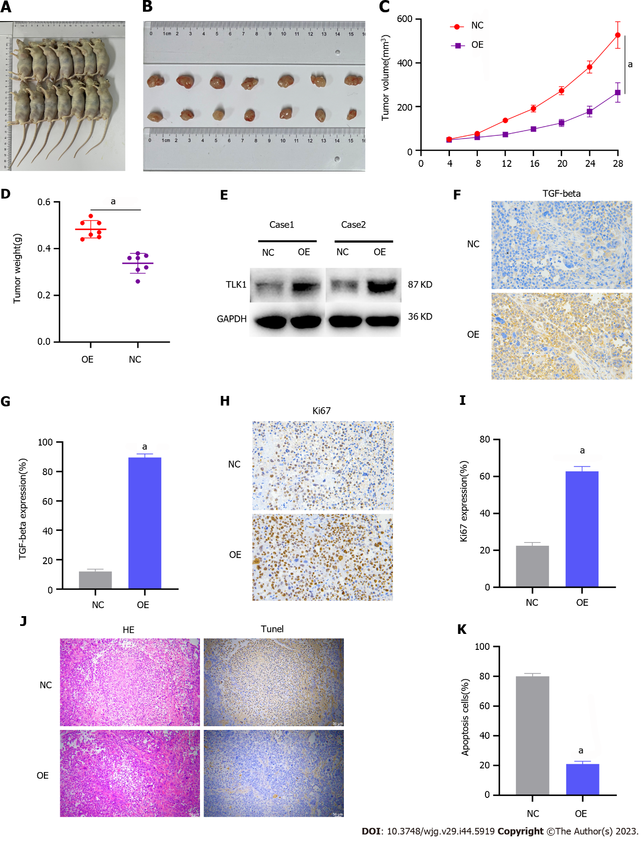

**Figure 6 *In vivo* confirmation of the role of Tousled-like kinase 1 in gastric cancer progression.** A and B: Relative tumorigenesis between the control and Tousled-like kinase 1 (TLK1) overexpression groups; C and D: Differences in tumor volume and mass between the control and TLK1 overexpression groups; E: Western blot verifying differential TLK1 expression in tumor tissues; F and G: Immunohistochemical (IHC) staining detecting the differences in tumor growth factor-beta expression between the control and TLK1 overexpression groups; H and I: IHC staining showing the differences in Ki-67 expression between the control and TLK1 overexpression groups; J and K: IHC and HE staining disclosing the differences in apoptosis between the control and TLK1 overexpression groups. a*P* < 0.05. TGF-beta: Tumor growth factor-beta; NC: Negative control; OE: Overexpression.



Published by **Baishideng Publishing Group Inc**

7041 Koll Center Parkway, Suite 160, Pleasanton, CA 94566, USA

**Telephone:** +19253991568

**Email:** bpgoffice@wjgnet.com

**Help Desk:** https://www.f6publishing.com/helpdesk

https://www.wjgnet.com



**© 2023 Baishideng Publishing Group Inc. All rights reserved.**