**Name of Journal:** *World Journal of Transplantation*

**Manuscript NO:** 61064

**Manuscript Type:** META-ANALYSIS

**Belatacept in renal transplantation in comparison to tacrolimus and molecular understanding of resistance pattern: Meta-analysis and systematic review**

Kumar J *et al*. Belatacept in renal transplantation

Jayant Kumar, Isabella Reccia, Francesco Virdis, Mauro Podda, Ajay Kumar Sharma, Ahmed Halawa

**Jayant Kumar, Isabella Reccia,** Department of Cancer and Surgery, Imperial College, London w12 0HS, United Kingdom

**Francesco Virdis,** Department of Emergency General Surgery, Royal Free Hospital, London NW3 2QG, United Kingdom

**Mauro Podda,** Department of Surgery, General, Emergency and Robotic Surgical Unit, San Francesco Hospital, Nuoro 08100, Italy

**Ajay Kumar Sharma,** Department of Transplantation, Royal Liverpool University Hospital, Liverpool L7 8XP, United Kingdom

**Ahmed Halawa,** Department of Surgery, Sheffield Teaching Hospitals, Sheffield S10 2JF, United Kingdom

**Author contributions:** Halawa A and Sharma AK designed the idea of study; Reccia I and Kumar J contributed to literature review and data collection; Kumar J, Reccia I, Podda M, Halawa A, and Sharma AK contributed to manuscript writing and critical revision.

**Corresponding author: Jayant Kumar, MD, MSc, PhD, Academic Fellow, Attending Doctor, Senior Research Fellow,** Department of Cancer and Surgery, Imperial College, DuCane, London w12 0HS, United Kingdom. jkumar@ic.ac.uk

**Received:** November 23, 2020

**Revised:** December 23, 2020

**Accepted:** February 12, 2021

**Published online:**

**Abstract**

BACKGROUND

The T-cell costimulation blocking agent belatacept has been identified as a possible substitute for calcineurin inhibitors, however, no consensus has been established against its use over the standard care agent Tacrolimus.

AIM

To evaluate the effectiveness of belatacept based maintenance immunosuppressive regimens in comparison to tacrolimus in renal transplantion.

METHODS

We did extensive search of all the available literature comparing the role of belatacept to tacrolimus in renal transplant recipients by searching the PubMed, Embase, Cochrane, Crossref, Scopus, clinical trials registry on October 5, 2020.

RESULTS

The literature search identified four randomized controlled trials (*n* = 173 participants) comparing belatacept with tacrolimus. There was no significant difference in estimated renal function at 12 mo [mean difference 4.12 mL/min/1.73 m2, confidence interval (CI): -2.18 to 10.42, *P* = 0.20]. Further, belatacept group was associated with significant increase in biopsy proven acute rejection [relative risk (RR) = 3.27, CI: 0.88 to 12.11, *P* = 0.08] and worse 12 mo allograft survival (RR = 4.51, CI: 1.23 to 16.58, *P* = 0.02). However, incidence of new onset diabetes mellitus was lower with belatacept at 12 mo (RR = 0.26, CI: 0.07 to 0.99, *P* = 0.05).

CONCLUSION

The evidence reviewed in this meta-analysis suggested that belatacept-based maintenance immunosuppression regimens were associated with an increased risk allograft loss in renal transplant recipients with equivalent renal functioning against standard tacrolimus; however, observed significantly reduced new onset diabetes mellitus after transplantation incidence and lower serum low density lipid profile levels in belatacept group. In addition, the adaptation of belatacept in renal transplantation has been forestalled by increased rates of rejection and resistance owing to development of various effector memory T cells through, parallel differentiation and immunological plasticity.

**Key Words:** Adverse events; Calcineurin inhibitors; Belatacept; Tacrolimus; Graft failure; Kidney transplantation

Kumar J, Reccia I, Virdis F, Podda M, Sharma AK, Halawa A. Belatacept in renal transplantation in comparison to tacrolimus and molecular understanding of resistance pattern: Meta-analysis and systematic review. *World J Transplant* 2021; In press

**Core Tip:** This meta-analysis suggested that belatacept-based maintenance immunosuppression regimens were associated with an increased risk allograft loss in renal transplant recipients with equivalent renal functioning against standard tacro-limus.

**INTRODUCTION**

The success immunosuppression in kidney transplantation has added a significant number of productive years to the life of chronic kidney disease patients[1]. The calcineurin inhibitors (CNIs), cyclosporine A and tacrolimus (Tac) were introduced in clinical practice in 1980’s and form the cornerstone of immunosuppressive therapy in renal transplant recipients. Globally most of the kidney transplant recipients have been initially get treated with a calcineurin inhibitor (usually tacrolimus), an antimetabolite (preferentially mycophenolate), and steroids plus in many instances require an additional agent of induction as basiliximab or thymoglobulin. Various studies including randomized controlled trials (RCT) and meta-analysis reported that these immunosuppressive regimens have been associated with more than 90% one-year graft survival whilst extending a rejection rate of below 15%-20%[2-4].

However, the superlative results of short-term allograft survival have not been maintained for long owing to renal and non-renal toxicities of these drugs which produce slow, steady decline in renal functioning[5]. The non-renal toxicities as cardiovascular adverse events and malignancies are considered to be the most important determinants of death with functioning graft in renal transplant recipients[6]. In addition, CNIs have been associated with development of various cardiovascular risk factors such as hyperlipidemia, hypertension, and new onset diabetes mellitus after transplantation (NODAT)[7,8].

In the given circumstances, it is important to note, that, CNI induced nephrotoxicity as a consequence to interstitial fibrosis and tubular atrophy represents a major obstacle to the long-term success of the renal transplant. The pathophysiology behind CNI induced nephrotoxicity involves increased production of vasoconstrictors, *e.g.*, thromboxane and endothelin, with limited secretion of the vasodilators, such as nitric oxide, prostaglandin E2, and prostacyclin. The long-term graft failure has been observed in 96.8% of allograft biopsies[9,10]. In addition, the biggest challenge with immunosuppression therapy is to maintain the balance of immunosuppression in order to avert any rejection episode, whilst keeping the check on the toxicities. Studies have shown that a reduction or withdrawal from a CNI can significantly improve renal function[11-14].

In last decade, T-cell costimulation blocking agent belatacept has been identified as possible substitute to CNI therapy and obtained United States Food and Drug Administration approval in 2011 for the prevention of rejection in kidney transplant recipients[15-18]. Belatacept is a human fusion protein, which selectively binds to CD80 and CD86 with higher affinity than CD28. Thus blocks the interaction between CD86-CD28, hence, inhibits the complete activation of T-cells and promotes anergy and apoptosis[19,20] (Figure 1). Additional studies have demonstrated that costimulation blockade modulates T cell mediated immune processes which ought to abridge the dependence on the traditional maintenance immunosuppressive drugs[21].

These distinct immunological properties and limited nephrotoxic potential of belatacept have prevailed clinicians to use them as a surrogate to CNIs; cyclosporine A and Tac[22,23]. Given these findings, clinical trials in humans were undertaken to investigate the possibilities of belatacept as an adjunct to CNI based regimens. A recent, meta-analysis conducted by Talawila *et al*[24], included five trials to better elucidate the usefulness of belatacept in juxtaposition to cyclosporine. The group outlined the potential benefit for belatacept by reducing the risk of CNI toxicity, especially renal function, without any increased evidence of acute rejection at 12 mo.

Indeed, most of the kidney transplant recipients approximately 90% in the United States have been initially managed with a calcineurin inhibitor of which Tac is primarily used agent in 92% whilst cyclosporine is alternative option in 2%. The primary reason behind preferring Tac over cyclosporine includes decreased acute rejection rates, better tolerability, relatively lower requirement of mycophenolate mofetil (MMF)[3,4,25-27]. A meta-analysis conducted by Webster *et al*[3] included 30 studies (4102 patients) comparing tacrolimus and cyclosporine, demonstrated that tacrolimus significantly lowered the risk of graft loss following six months of renal transplantation [relative risk (RR): 0.56, 95% confidence interval (CI): 0.36-0.86]. Further, tacrolimus continued to favour allograft loss and reported 1-year, 2-year and 3-years graft loss of RR: 0.77 (CI: 0.58-1.02), RR: 0.74 (CI: 0.46-1.21) and RR: 0.71 (CI: 0.52-0.96) respectively. Moreover, tacrolimus also decreased the risk of acute rejection at one year (RR: 0.66, 95%CI: 0.6-0.79).

However, it was very unfortunate that till 2016 only one prospective study had been conducted to assess the usefulness of *de novo* belatacept over Tac. However, to bridge this lack of evidence Muduma *et al*[28] performed an “indirect treatment comparison” of belatacept to Tac. Here, they simultaneously conducted two consecutive meta-analyses comparing Tac to cyclosporine and cyclosporine to belatacept respectively and then compared the results of these analyses with each other to generate a direct comparison between Tac to belatacept. However, the review failed to find any conclusive evidence of difference towards the beneficence of belatacept as primary maintenance immunosuppressive agent in place of Tac.

Despite the availability of enormous literature on the applicability of belatacept in renal transplantation, intriguingly many questions are yet to be answered such as what is the true potential of this drug in current practice of renal transplantation with the principle of primum non nocere? Hence, the present study aimed to systematically review and where possible meta-analyze the available data on the clinical effectiveness of *de novo* belatacept as an alternative to Tac in patients undergoing renal transplantation and further highlighted the immunological basis for the development of belatacept-resistant rejection (BRR).

**MATERIALS AND METHODS**

The present meta-analysis was conducted following completion of registration (CRD42018086032) in PROSPERO an international database of prospectively registered systematic reviews. A detailed literature search was made on National Library of Medicine Database (PubMed), Embase, Cochrane, Crossref, Scopus databases, clinical trial registries on October 5, 2020 to determine the immunosuppressive role of belatacept as an alternative to Tac. The search covered the period 2005 (the year of the first reported use of belatacept) to October 5, 2020[17,29]. The search strategy designed according to the guidelines mentioned in the Cochrane Handbook for Systematic Reviews of Interventions and reported as per the guidelines proposed by Meta-analysis of Observational Studies in Epidemiology. The medical subject headings terms and free text words were searched in various permutations and combinations: “Adverse events”, “Calcineurin Inhibitors”, “Tacrolimus”, “Belatacept”, “Graft Rejection”, “Graft Survival”, “Kidney Transplantation”, to complete the analysis. In addition, a manual search was conducted for conference abstracts, bibliographies and citations list of the relevant articles were examined for additional studies.

***Inclusion criteria***

Only prospectively, systematically and quantitatively done RCT, comparing *de novo* belatacept with Tac in both living and/or deceased kidney transplant recipient were included. All other studies or publications types as retrospective studies, editorials, reviews, posters and letters were excluded. The primary outcome of interest was renal function, estimated glomerular filtration rate, and secondary outcomes were biopsy proven acute rejection (BPAR), patient and graft survival, NODAT, blood pressure, hyperlipidaemia, CMV viremia, and polyomavirus infection (Table 1).

***Data extraction***

Two separate physician reviewers (Kumar K and Reccia I) employed a two-stage method to conduct study screening independently. At the first stage, titles and abstracts were scrutinized for excluding obviously ineligible studies. At the second stage, the full texts were read carefully for further excluding any ineligible studies. Disagreements were resolved *via* consensus, and matters for which consensus could not be made were settled after much deliberation with senior author. The Preferred Reporting Items for Systematic Reviews and Meta-analyses guidelines were used here to complete search strategy and study selection (Figures 2 and 3).

***Statistical analysis***

The internal validity of pre-specified inclusion and exclusion criteria of the included studies were determined by independently by the authors using the Cochrane Risk of Bias tool. Each study was thoroughly analyzed to evaluate the above mentioned parameters (Table 2).

The Cochrane Collaboration, Review Manager (RevMan) Version 5.3 can analyze minimum of two trials and available continuous and dichotomous trial data. The data formulated as RR for dichotomous data, mean difference for continuous outcomes including 95%CI, heterogeneity between the trials compared and *I*2statistic of more than 30% determined as significant. *I*2statistic of more than 30% was determined to be significant. In the stance of significant heterogeneity, the random effects model assessment was used following the evaluation of forest plot while fixed-effect model was applied in the situation of low heterogeneity. In perspective of significant heterogeneity, the random effects model assessment was done following the evaluation of forest plot of involved trials[30,31]. Publication bias formally assessed through funnel plots but that requires at least 10 trials unfortunately present meta-analysis involved only four trials, so, we couldn’t assess publication bias[32].

**RESULTS**

Our literature searches yielded a total of 158 manuscripts. After careful evaluation, 154 articles were excluded based on our selection criteria mentioned above. After resolution of differences between reviewers a total of four studies were retrieved for further review and data extraction[33-36].

These include three published papers, and one unpublished data from clinical trial registry (Table 2). In a study conducted by Ferguson *et al*[33] they compared two belatacept based regimen, hence to maintain uniformity we considered analysis regimen including belatacept, and MMF only without sirolimus[33]. Similarly for study by Newel *et al*[35,36] and trial 1856257 we only did analysis with regimen including belatacept with MMF only without Tac[33-36]. The detailed data of all the studies related with the renal functioning, BPAR, survival and adverse events were summarized in Tables 3-5. The results of these data analysis were outlined below.

***Renal function***

There was no significant difference in estimated renal function in the either groups at 12 mo (four trials, 154 patients, mean difference 4.12 mL/ min/1.73 m2, CI: -2.18 to 10.42, *P* = 0.20, *I*2 = 0%); (Figure 4A).

***Biopsy proven acute rejection***

The incidence of BPAR was significantly higher in belatacept groups compared to Tac groups (four trials, 173 patients, RR = 3.27, CI: 0.88 to 12.11, *P* = 0.08, *I*2 = 59%) over 12 mo (Figure 4B).

***Graft survival***

At 12 mo, the rates of graft survival were significantly worse for belatacept groups than Tac groups (four trials, 173 patients, RR = 4.51, CI: 1.23 to 16.58, *P* = 0.02, *I*2 = 0%) (Figure 4C).

***Adverse events***

Adverse events are summarized in Table 3. Over 12 mo, there was no significant difference in the incidence of serious adverse events/infection between the either groups (three trials, 129 patients, RR = 0.92, CI: 0.71 to 1.21, *P* = 0.56, *I*2 = 0%) (Figure 4D). Four trials reported comparable incidence of BK virus or polyomavirus infection, in both group (Four trials, 173 patients, RR = 2.09, CI: 0.60 to 7.21, *P* = 0.24, *I*2 = 19%) (Figure 4E).

***Metabolic outcomes***

The metabolic parameters as blood pressure and lipid profile of all four studies are outlined in Table 5. The incidence of NODAT was significantly lower with belatacept over 12 mo (four trials, 173 patients, RR = 0.26, CI: 0.07 to 0.99, *P* = 0.05, *I*2= 0%) (Figure 4F). Belatacept therapy resulted in no significant changes in systolic (four trials, 150 patients, MD = -3.77 mmHg, CI: -9.29 to 1.75, *P* = 0.18, *I*2 = 0%) (Figure 5A) and diastolic blood pressure (four trials, 150 patients, MD = -1.27 mmHg, CI = -5.90 to 3.37, *P* = 0.59, *I*2 = 35%) at 12 mo (Figure 5B).

There total serum cholesterol level and total triglycerides were comparable in both groups (two trials, 52 patients, MD = -2.85 mg/dL, CI: -23.68 to 17.98, *P* = 0.79, *I2* = 0%) and (two trials, 52 patients, MD = -6.56 mg/dL, CI: -59.79 to 46.67, *P* = 0.81, *I2* = 26%) respectively at 12 mo (Figure 5C and D). The serum low density lipoprotein (LDL) levels were lower for belatacept at 12 mo (two trials, 52 patients, MD = -25.68 mg/dL, CI: -48.15 to -3.22, *P* = 0.03, *I*2 = 0%) (Figure 5E).

**DISCUSSION**

To our knowledge, this is the first meta-analysis assessing the efficacy and safety of belatacept based immunosuppressive maintenance regimen with Tac in kidney transplant recipients. The meta-analysis demonstrated that belatacept has been associated with an increased risk of allograft loss, following an increased risk of acute rejection in the first year of renal transplantation. These findings are in contrast to the previous notion, where studies have reported better allograft functioning without any significant change in patient and allograft survival over 12 mo’ study period for the belatacept *vs* CNI groups, however, almost all of these studies have drawn this conclusion following comparison of belatacept to cyclosporine, not Tac[24]. Further, the above finding could be reflection of limited number available study assessing the role of belatacept in comparison to Tac or benefit could be sought following long duration of therapy.

Owing to the limited number of studies the data regarding the comparative studies of Tac based immunosuppression with belatacept is quite lucid, nevertheless, the outcomes of this meta-analysis will play a crucial role in formulating future studies. The renal function was assessed in all four trials and pooled analysis of data suggested that there is no significant difference present in either group. Along with that, the present meta-analysis also demonstrated a significant rise in BPAR in belatacept group. These outcomes have been further translated in terms of lower allograft and patient survival, and poor outcomes in renal transplant recipients who received belatacept.

Previous studies been shown that cardiovascular disease and its associated underlying risk factors as NODAT, hypertension and dyslipidemia are major cause of mortality in kidney transplant recipients[37,38]. The reported incidence of NODAT in current literature is approximately 10%-30% in renal transplant recipients following CNI therapy[39-41]. Our finding supports previous literature comparing cyclosporine with belatacept and outlined significantly reduced odds for NODAT at 12 mo following belatacept in contrast to Tac[20,24].

Experimental studies have demonstrated that serum lipids nephrotoxicity play important role in the progression of chronic kidney disease[42]. Sandhu *et al*[43], conducted a meta-analyses involving 26 RCT and outlined that lowering serum LDL cholesterol positively influence the rate of reduction of glomerular filtration by approximately 1 mL/min per year. Our, the data analysis revealed lower LDL level in belatacept treated patients, hence, making it safer drug alternative for maintenance immunosuppression considering the renal and cardiac perspective, however, these benefits are do not outweigh the risks of other associated perils of belatacept based therapy. Further, studies assessed the impact of transition to belatacept during maintenance phase, which have outlined similar metabolic benefits, however, more research is required to elucidate true potential of these immunosuppressive regimen[44,45]. As mentioned in the results, the present meta-analysis did not demonstrate any significant difference in terms of adverse events in the belatacept group compared with the Tac based regimen. Further, it did not show any statistically significant increase in incidence of BK virus infection in the belatacept group (Figure 6).

The outcomes of this meta-analysis were quite dreary to the speculation that belatacept could further enhance the benefits of renal transplantation. However, every cloud has silver lining and the received setbacks provide enormous learning opportunities and open doors for development of newer drugs. Hence, further investigations are required to better elucidate reasons behind the observed outcome with belatacept, including the cipher of BRR. Belatacept binds to CD80 and/or CD86 on antigen-presenting cells (APCs) and fosters T-cell anergy by depriving T-cells with co-stimulatory signal[16,46]. Belatacept's adoption as a mainstay immunosuppressive therapy has been tempered by increased BPAR and resistance to treatment. Further probe into the underlying mechanisms of resistance and rejection has been done not only to enhance the knowledge regarding clinical applicability of belatacept but also to avail the development of tailored immunosuppressive strategies.

However, recent evidence suggests the plausible explanations for the development of resistance to the clinical usefulness and limitations of belatacept based immunosuppression, further in the discussion we have tried to interpret the reason behind the deceptive behaviour of current costimulatory inhibitors through the review of the available literature.

Firstly, an aggressive, T cell-mediated allogeneic responses observed in belatacept treated patients clearly explicate the actions of memory T-cells that are less or not susceptible to co-stimulatory blockade pathway CD28-CD80/86[47-50]. This could be explained by the fact that belatacept inhibits T-cell proliferation in a dose-dependent manner. However, even with the higher dosages of belatacept, the inhibition of T cell proliferation does not exceed more than ± 70%, hence gives a window for residual T cells proliferation up to ± 30%[51].

Secondly, the plasticity theory of sequential, parallel differentiation and immunological synapse throws light on the development and maintenance of resistant effector memory T cell in belatacept treated patients[50,52,53]. This fact broaches a concern that, witnessed resistance to belatacept might be explained by the biological underpinning causing cross-connection between naïve, effector and memory T cells populations. The precise underlying mechanism remains obscure, however, it is possibly conferred by the development of the interaction between the B7 protein on APCs and CD28 (also known as cytotoxic T-lymphocyte-associated protein 4) on T cells[54,55]. Following differentiation, the expression of CD28 is markedly downregulated and the resulting memory T cells are no longer able to reinstate co-stimulation for the secondary immune responses[56,57]. Furthermore, the downregulation persuades T cell migration and extravasation at inflammatory sites through the expression of adhesion molecules over vascular endothelium. The molecules as LFA-1 and VLA-4 bind intercellular adhesion molecule-1 and vascular cell adhesion molecule-1 while CD2 promotes T-cell activation and adhesion by binding to LFA-3 on APCs[58-60]. Hence, the belatacept induced CD28 downregulation not only instigates effector memory cells proliferation but also promotes cellular infiltration into the renal allograft, which disrupts the bridge to achieve adequate immunosuppression in the transplant recipient[61,62].

In addition, an elevated profile of T-cell mediated allogeneic responses with variability in cell surface phenotype are detected following belatacept treatment. The lymphocyte repertoire transforms itself substantially over time as a ramification of environmental pathogen exposure, which forms the basis for the down regulation of the CD28 expression on the membrane of effector-memory T-cells following belatacept treatment. Such CD8+CD28− T cells are highly cytotoxic and bring imperil to the traditional immunosuppressive shield, however, lack in the proliferative capacity[63,64]. Hence, D28-CD80/86 pathway is not the sole explanation of the development of BRR[65,66]. Mou *et al*[66] outlined, the loss of CD28 expression as a major requisite towards the development of BRR, however, it was not sole attribute for the instigation of BRR and highlighted certain other plausible explanations. The study demonstrated increased rejection with the expression of CD57 on the membrane of CD28 negative T cells populations with cytolytic potential. This notion was further supported by demonstrating the infiltration of CD57+ CD4 T cells in renal allograft biopsies in patients developing rejection in spite of being on belatacept. Hence, CD57+CD4+CD28- T cells represent a potential therapeutic target and act as a practical screening tool to identify patients at risk for ACR while on belatacept. However, the identification of such phenotype (CD57+CD4+CD28-) T cells in the peripheral blood of patients awaiting renal transplantation may aid in identifications of recipients’ not amenable for belatacept-based therapy.

An another kind of effector memory CD8+CD28++ EMRA T cells that has caught attention as a possible explanation for the development of resistance in belatacept patients[67,68]. However, de Graav *et al*[51] reported that absolute numbers or proportions of pretransplant CD28++ cells within the CD8+ EMRA T cell population did not increase BRR.

Differences in rate and severity of BRR in patients with pre-emptive transplantations lies within the differentiation, immunological synapse and plasticity that helps in modulating the effector memory T cell in belatacept treated renal transplant recipients. Hence at present, we can’t rule out the possibility of the presence of any other memory cell or mixed effect of these cells as a possible mechanism for development BRR. The above mentioned facts do not mean that there is a failure of any kind it actually opens the way for instigation of better drugs and modified regimen, which can be used in much-tailored way to preserve the renal allograft functioning for long. The development of humoral response through production *de novo* donor-specific antibodies following renal transplantation is considered as the one of the primary reason for late-onset renal allograft failure.

The precise mechanisms by which belatacept is involved in the control of humoral responses requires thorough investigation. Studies outlined that belatacept minimizes humoral immune response including plasmablast differentiation, immunoglobulin production, and the expression of the intricate transcription factor implicated in the functioning of the plasma cell, activation of the STAT3 transcription factor in functioning B cells and reduced the expression of CD86 and blocked CD28-mediated activation of T helper cells. Lately, Leibler *et al*[69] reasoned these facts as a plausible explanation towards the lesser degree of *de novo* donor-specific antibodies generation in the belatacept treated renal allograft recipients than conventional immunosuppression regimen. Hence, attention is now turning towards the development of target costimulatory molecules which become advantageous in the field of transplantation and autoimmune conditions (Figure 7).

The present meta-analysis has certain limitations, which needs to be acknowledged. Here, we only identified four trials and thus further large-scale trials would provide much-needed data to allow firmer conclusions, regarding the use of belatacept. However, considering costs and ethical concerns owing to the increased risk of renal graft loss, conducting such a study is a matter of debate. Second, publication bias can only be tested with formal statistical tests in the case of ≥ 10 included studies. Therefore, we cannot exclude the possibility that the results from meta-analyses involving < 10 studies could be driven by publication bias.

**CONCLUSION**

The present meta-analysis showed that belatacept-based maintenance immunosuppression regimens were associated with an increased risk allograft loss for renal transplant recipients with equivalent renal functioning when compared to standard of care agent Tac. The widespread adaptation of belatacept in renal transplantation has been limited by increased rates of rejection, which is conferred owing to development of resistance secondary to differentiation into various types of effector memory T cells. Henceforth, the applicability of belatacept should be tailored according to the need of transplant recipients particularly as a transition to belatacept in the maintenance phase of immunosuppression. In light of present evidence the applicability of belatacept does look like foe, however, it still has some explicit potential role, particularly in situations such as Caucasian recipients with two-haplotype identical human leukocyte antigen, living related allografts and obesity. Additional factors ought to be considered are the cardiovascular and hemodynamic complications associated with poor allograft function, along with the immunological risk as role of belatacept is never reported in the recipients with PRA > 30%. Further research are required to assess the safety and efficacy of belatacept in the setting of immunological sensitizationand to better elucidate the mechanism of resistance and development of therapeutic strategies with focus on adhesion molecule blockade or abrogation of memory-specific responses.

**ARTICLE HIGHLIGHTS**

***Research background***

The T-cell costimulation blocking agent belatacept is considered as possible substitute for calcineurin inhibitors, however, no consensus has been established against its standard immunusuppressive drug Tacrolimus.

***Research motivation***

To find the alternative to current immunosuppressive medicine tacrolimus because of its high toxic adverse effects.

***Research objectives***

To understand the effectiveness of belatacept based maintenance immunosuppressive regimens in comparison to tacrolimus in renal transplantion through meta-analysis.

***Research methods***

The present meta-analysis was conducted following completion of registration (CRD42018086032) in Prospero an international database of prospectively registered systematic reviews. A detailed literature search was made on National Library of Medicine Database (PubMed), Embase, Cochrane, Crossref, Scopus databases, clinical trial registries on December 5, 2018 to determine the immunosuppressive role of belatacept as an alternative to Tac and analyis of data was performed through The Cochrane Collaboration, Review Manager (RevMan) Version 5.3.

***Research results***

The literature search revealed four prospective randomized control studies (*n* = 173 participants) comparing belatacept with tacrolimus. There was no significant difference in estimated renal function at 12 mo [mean difference 4.12 mL/min/1.73 m2, confidence interval (CI): -2.18 to 10.42, *P* = 0.20]. Further, belatacept group was associated with significant increase in biopsy proven acute rejection [relative risk (RR) = 3.27, CI: 0.88 to 12.11, *P* = 0.08] and worse 12 mo allograft survival (RR = 4.51, CI: 1.23 to 16.58, *P* = 0.02). Although, the incidence of new onset diabetes mellitus was lower with belatacept at 12 mo (RR = 0.26, CI: 0.07 to 0.99, *P* = 0.05).

***Research conclusions***

The meta-analysis demonstrated that belatacept-based maintenance immunosuppression regimens were associated with an increased risk allograft loss in renal transplant recipients with equivalent renal functioning against standard tacrolimus. Further, the inclusion of belatacept as routine immunosuppresive agent in renal transplantation has been thwarted by increased rates of rejection and resistance owing to development of various effector memory T cells through, parallel differentiation and immunological plasticity.

***Research perspectives***

Study required to determine the safety and efficacy of belatacept in the setting of immunological sensitization and to better elucidate the mechanism of resistance and development of therapeutic strategies with focus on adhesion molecule blockade or abrogation of memory-specific responses.

**REFERENCES**

1 **Salvadori M**, Bertoni E. Is it time to give up with calcineurin inhibitors in kidney transplantation? *World J Transplant* 2013; **3**: 7-25 [PMID: 24175203 DOI: 10.5500/wjt.v3.i2.7]

2 **Knops N**, Levtchenko E, van den Heuvel B, Kuypers D. From gut to kidney: transporting and metabolizing calcineurin-inhibitors in solid organ transplantation. *Int J Pharm* 2013; **452**: 14-35 [PMID: 23711732 DOI: 10.1016/j.ijpharm.2013.05.033]

3 **Webster AC**, Woodroffe RC, Taylor RS, Chapman JR, Craig JC. Tacrolimus *vs* ciclosporin as primary immunosuppression for kidney transplant recipients: meta-analysis and meta-regression of randomised trial data. *BMJ* 2005; **331**: 810 [PMID: 16157605 DOI: 10.1136/bmj.38569.471007.AE]

4 **Ekberg H**, Tedesco-Silva H, Demirbas A, Vítko S, Nashan B, Gürkan A, Margreiter R, Hugo C, Grinyó JM, Frei U, Vanrenterghem Y, Daloze P, Halloran PF; ELITE-Symphony Study. Reduced exposure to calcineurin inhibitors in renal transplantation. *N Engl J Med* 2007; **357**: 2562-2575 [PMID: 18094377 DOI: 10.1056/NEJMoa067411]

5 **Diekmann F**, Andrés A, Oppenheimer F. mTOR inhibitor-associated proteinuria in kidney transplant recipients. *Transplant Rev (Orlando)* 2012; **26**: 27-29 [PMID: 22137729 DOI: 10.1016/j.trre.2011.10.003]

6 **Krieger NR**, Becker BN, Heisey DM, Voss BJ, D'Alessandro AM, Becker YT, Odorico JS, Kalayoglu M, Pirsch JD, Sollinger HW, Knechtle SJ. Chronic allograft nephropathy uniformly affects recipients of cadaveric, nonidentical living-related, and living-unrelated grafts. *Transplantation* 2003; **75**: 1677-1682 [PMID: 12777855 DOI: 10.1097/01.TP.0000063830.60937.06]

7 **Flechner SM**, Goldfarb D, Solez K, Modlin CS, Mastroianni B, Savas K, Babineau D, Kurian S, Salomon D, Novick AC, Cook DJ. Kidney transplantation with sirolimus and mycophenolate mofetil-based immunosuppression: 5-year results of a randomized prospective trial compared to calcineurin inhibitor drugs. *Transplantation* 2007; **83**: 883-892 [PMID: 17460558 DOI: 10.1097/01.tp.0000258586.52777.4c]

8 **Flechner SM**. Sirolimus in kidney transplantation indications and practical guidelines: de novo sirolimus-based therapy without calcineurin inhibitors. *Transplantation* 2009; **87**: S1-S6 [PMID: 19384179 DOI: 10.1097/TP.0b013e3181a059a1]

9 **Cornell LD**, Colvin RB. Chronic allograft nephropathy. *Curr Opin Nephrol Hypertens* 2005; **14**: 229-234 [PMID: 15821415 DOI: 10.1097/01.mnh.0000165888.83125.07]

10 **Li C**, Yang CW. The pathogenesis and treatment of chronic allograft nephropathy. *Nat Rev Nephrol* 2009; **5**: 513-519 [PMID: 19636333 DOI: 10.1038/nrneph.2009.113]

11 **Hamdy AF**, El-Agroudy AE, Bakr MA, Mostafa A, El-Baz M, El-Shahawy el-M, Ghoneim MA. Comparison of sirolimus with low-dose tacrolimus *vs* sirolimus-based calcineurin inhibitor-free regimen in live donor renal transplantation. *Am J Transplant* 2005; **5**: 2531-2538 [PMID: 16162204 DOI: 10.1111/j.1600-6143.2005.01064.x]

12 **Oberbauer R**, Segoloni G, Campistol JM, Kreis H, Mota A, Lawen J, Russ G, Grinyó JM, Stallone G, Hartmann A, Pinto JR, Chapman J, Burke JT, Brault Y, Neylan JF; Rapamune Maintenance Regimen Study Group. Early cyclosporine withdrawal from a sirolimus-based regimen results in better renal allograft survival and renal function at 48 mo after transplantation. *Transpl Int* 2005; **18**: 22-28 [PMID: 15612979 DOI: 10.1111/j.1432-2277.2004.00052.x]

13 **Kumar J**, Bridson JM, Sharma A, Halawa A. Systematic Review on Role of Mammalian Target of Rapamycin Inhibitors as an Alternative to Calcineurin Inhibitors in Renal Transplant: Challenges and Window to Excel. *Exp Clin Transplant* 2017; **15**: 241-252 [PMID: 27915965 DOI: 10.6002/ect.2016.0270]

14 **Kumar J**, Reccia I, Kusano T. Is Early Conversion to mTOR Inhibitors Represent a Suitable Choice in Renal Transplant Recipients? A Systemic Review of Medium-term Outcomes. *Int J Organ Transplant Med* 2017; **8**: 68-76 [PMID: 28828166]

15 **Vincenti F**, Larsen C, Durrbach A, Wekerle T, Nashan B, Blancho G, Lang P, Grinyo J, Halloran PF, Solez K, Hagerty D, Levy E, Zhou W, Natarajan K, Charpentier B; Belatacept Study Group. Costimulation blockade with belatacept in renal transplantation. *N Engl J Med* 2005; **353**: 770-781 [PMID: 16120857 DOI: 10.1056/NEJMoa050085]

16 **Larsen CP**, Pearson TC, Adams AB, Tso P, Shirasugi N, Strobert E, Anderson D, Cowan S, Price K, Naemura J, Emswiler J, Greene J, Turk LA, Bajorath J, Townsend R, Hagerty D, Linsley PS, Peach RJ. Rational development of LEA29Y (belatacept), a high-affinity variant of CTLA4-Ig with potent immunosuppressive properties. *Am J Transplant* 2005; **5**: 443-453 [PMID: 15707398 DOI: 10.1111/j.1600-6143.2005.00749.x]

17 **Wekerle T**, Grinyó JM. Belatacept: from rational design to clinical application. *Transpl Int* 2012; **25**: 139-150 [PMID: 22151353 DOI: 10.1111/j.1432-2277.2011.01386.x]

18 **Vincenti F**, Dritselis A, Kirkpatrick P. Belatacept. *Nat Rev Drug Discov* 2011; **10**: 655-656 [PMID: 21878974 DOI: 10.1038/nrd3536]

19 **Grinyó JM**, Budde K, Citterio F, Charpentier B. Belatacept utilization recommendations: an expert position. *Expert Opin Drug Saf* 2013; **12**: 111-122 [PMID: 23206310 DOI: 10.1517/14740338.2013.748747]

20 **Vanrenterghem Y**, Bresnahan B, Campistol J, Durrbach A, Grinyó J, Neumayer HH, Lang P, Larsen CP, Mancilla-Urrea E, Pestana JM, Block A, Duan T, Glicklich A, Gujrathi S, Vincenti F. Belatacept-based regimens are associated with improved cardiovascular and metabolic risk factors compared with cyclosporine in kidney transplant recipients (BENEFIT and BENEFIT-EXT studies). *Transplantation* 2011; **91**: 976-983 [PMID: 21372756 DOI: 10.1097/TP.0b013e31820c10eb]

21 **Garnock-Jones KP**. Belatacept: in adult kidney transplant recipients. *BioDrugs* 2012; **26**: 413-424 [PMID: 22928660 DOI: 10.2165/11208900-000000000-00000]

22 **Masson P**, Henderson L, Chapman JR, Craig JC, Webster AC. Belatacept for kidney transplant recipients. *Cochrane Database Syst Rev* 2014: CD010699 [PMID: 25416857 DOI: 10.1002/14651858.CD010699.pub2]

23 **Wéclawiak H**, Kamar N, Ould-Mohamed A, Cardeau-Desangles I, Rostaing L. Biological agents in kidney transplantation: belatacept is entering the field. *Expert Opin Biol Ther* 2010; **10**: 1501-1508 [PMID: 20726688 DOI: 10.1517/14712598.2010.514901]

24 **Talawila N**, Pengel LH. Does belatacept improve outcomes for kidney transplant recipients? A systematic review. *Transpl Int* 2015; **28**: 1251-1264 [PMID: 25965549 DOI: 10.1111/tri.12605]

25 **Krämer BK**, Montagnino G, Krüger B, Margreiter R, Olbricht CJ, Marcen R, Sester U, Kunzendorf U, Dietl KH, Rigotti P, Ronco C, Hörsch S, Banas B, Mühlbacher F, Arias M; European Tacrolimus *vs* Ciclosporin Microemulsion Renal Transplantation Study Group. Efficacy and safety of tacrolimus compared with ciclosporin-A in renal transplantation: 7-year observational results. *Transpl Int* 2016; **29**: 307-314 [PMID: 26565071 DOI: 10.1111/tri.12716]

26 **Margreiter R**; European Tacrolimus *vs* Ciclosporin Microemulsion Renal Transplantation Study Group. Efficacy and safety of tacrolimus compared with ciclosporin microemulsion in renal transplantation: a randomised multicentre study. *Lancet* 2002; **359**: 741-746 [PMID: 11888584 DOI: 10.1016/S0140-6736(02)07875-3]

27 **Saudek F**, Malaise J, Boucek P, Adamec M; Euro-SPK Study Group. Efficacy and safety of tacrolimus compared with cyclosporin microemulsion in primary SPK transplantation: 3-year results of the Euro-SPK 001 trial. *Nephrol Dial Transplant* 2005; **20 Suppl 2**: ii3-i10, ii62 [PMID: 15814547 DOI: 10.1093/ndt/gfh1076]

28 **Muduma G**, Hart WM, Patel S, Odeyemi AO. Indirect treatment comparison of belatacept *vs* tacrolimus from a systematic review of immunosuppressive therapies for kidney transplant patients. *Curr Med Res Opin* 2016; **32**: 1065-1072 [PMID: 26907083 DOI: 10.1185/03007995.2016.1157463]

29 **McIntyre JA**, Fernández D. Belatacept: Treatment of transplant rejection. *Drugs Future* 2005; **30**: 873-876 [DOI: 10.1358/dof.2005.030.09.936694]

30 **Chootrakool H**, Shi JQ, Yue R. Meta-analysis and sensitivity analysis for multi-arm trials with selection bias. *Stat Med* 2011; **30**: 1183-1198 [PMID: 21538449 DOI: 10.1002/sim.4143]

31 **Mavridis D**, Welton NJ, Sutton A, Salanti G. A selection model for accounting for publication bias in a full network meta-analysis. *Stat Med* 2014; **33**: 5399-5412 [PMID: 25316006 DOI: 10.1002/sim.6321]

32 **Deeks JJ**, Higgins JP, Altman DG. Analysing Data and Undertaking Meta-Analyses. In: Cochrane Handbook for Systematic Reviews of Interventions: Cochrane Book Series; 2008: 243-296 [DOI: 10.1002/9780470712184.ch9]

33 **Ferguson R**, Grinyó J, Vincenti F, Kaufman DB, Woodle ES, Marder BA, Citterio F, Marks WH, Agarwal M, Wu D, Dong Y, Garg P. Immunosuppression with belatacept-based, corticosteroid-avoiding regimens in de novo kidney transplant recipients. *Am J Transplant* 2011; **11**: 66-76 [PMID: 21114656 DOI: 10.1111/j.1600-6143.2010.03338.x]

34 **de Graav GN**, Baan CC, Clahsen-van Groningen MC, Kraaijeveld R, Dieterich M, Verschoor W, von der Thusen JH, Roelen DL, Cadogan M, van de Wetering J, van Rosmalen J, Weimar W, Hesselink DA. A Randomized Controlled Clinical Trial Comparing Belatacept With Tacrolimus After De Novo Kidney Transplantation. *Transplantation* 2017; **101**: 2571-2581 [PMID: 28403127 DOI: 10.1097/TP.0000000000001755]

35 **Newell KA**, Mehta AK, Larsen CP, Stock PG, Farris AB, Mehta SG, Ikle D, Armstrong B, Morrison Y, Bridges N, Robien M, Mannon RB. Lessons Learned: Early Termination of a Randomized Trial of Calcineurin Inhibitor and Corticosteroid Avoidance Using Belatacept. *Am J Transplant* 2017; **17**: 2712-2719 [PMID: 28556519 DOI: 10.1111/ajt.14377]

February 12, 2021 **Newell K**.Open-Label Phase 2 Trial of a Steroid-Free, CNI-Free, Be-latacept-Based Immunosuppressive Regimen, 17 December, 2020 [cited 19 January, 2021]. In: National Institute of Allergy and Infectious Diseases. ClinicalTrials.gov Identifier: NCT01856257 Available from: https://clinicaltrials.gov/ct2/show/results/NCT01856257?cond=01856257&rank=1§=X01256

37 **Meier-Kriesche HU**, Baliga R, Kaplan B. Decreased renal function is a strong risk factor for cardiovascular death after renal transplantation. *Transplantation* 2003; **75**: 1291-1295 [PMID: 12717218 DOI: 10.1097/01.TP.0000061602.03327.E2]

38 **Fellström B**, Jardine AG, Soveri I, Cole E, Neumayer HH, Maes B, Gimpelewicz C, Holdaas H; ALERT Study Group. Renal dysfunction is a strong and independent risk factor for mortality and cardiovascular complications in renal transplantation. *Am J Transplant* 2005; **5**: 1986-1991 [PMID: 15996249 DOI: 10.1111/j.1600-6143.2005.00983.x]

39 **Ojo AO**. Cardiovascular complications after renal transplantation and their prevention. *Transplantation* 2006; **82**: 603-611 [PMID: 16969281 DOI: 10.1097/01.tp.0000235527.81917.fe]

40 **Svensson M**, Jardine A, Fellström B, Holdaas H. Prevention of cardiovascular disease after renal transplantation. *Curr Opin Organ Transplant* 2012; **17**: 393-400 [PMID: 22790074 DOI: 10.1097/MOT.0b013e3283560a3b]

41 **Vanrenterghem YF**, Claes K, Montagnino G, Fieuws S, Maes B, Villa M, Ponticelli C. Risk factors for cardiovascular events after successful renal transplantation. *Transplantation* 2008; **85**: 209-216 [PMID: 18212625 DOI: 10.1097/TP.0b013e318160254f]

42 **Moorhead JF**, Chan MK, El-Nahas M, Varghese Z. Lipid nephrotoxicity in chronic progressive glomerular and tubulo-interstitial disease. *Lancet* 1982; **2**: 1309-1311 [PMID: 6128601 DOI: 10.1016/s0140-6736(82)91513-6]

43 **Sandhu S**, Wiebe N, Fried LF, Tonelli M. Statins for improving renal outcomes: a meta-analysis. *J Am Soc Nephrol* 2006; **17**: 2006-2016 [PMID: 16762986 DOI: 10.1681/ASN.2006010012]

44 **Gupta S**, Rosales I, Wojciechowski D. Pilot Analysis of Late Conversion to Belatacept in Kidney Transplant Recipients for Biopsy-Proven Chronic Tacrolimus Toxicity. *J Transplant* 2018; **2018**: 1968029 [PMID: 29854421 DOI: 10.1155/2018/1968029]

45 **Vincenti F**, Blancho G, Durrbach A, Grannas G, Grinyó J, Meier-Kriesche HU, Polinsky M, Yang L, Larsen CP. Ten-year outcomes in a randomized phase II study of kidney transplant recipients administered belatacept 4-weekly or 8-weekly. *Am J Transplant* 2017; **17**: 3219-3227 [PMID: 28758341 DOI: 10.1111/ajt.14452]

46 **Huurman VA**, Unger WW, Koeleman BP, Oaks MK, Chandraker AK, Terpstra OT, Roep BO. Differential inhibition of autoreactive memory- and alloreactive naive T cell responses by soluble cytotoxic T lymphocyte antigen 4 (sCTLA4), CTLA4Ig and LEA29Y. *Clin Exp Immunol* 2007; **150**: 487-493 [PMID: 17924973 DOI: 10.1111/j.1365-2249.2007.03513.x]

47 **Durrbach A**, Pestana JM, Pearson T, Vincenti F, Garcia VD, Campistol J, Rial Mdel C, Florman S, Block A, Di Russo G, Xing J, Garg P, Grinyó J. A phase III study of belatacept *vs* cyclosporine in kidney transplants from extended criteria donors (BENEFIT-EXT study). *Am J Transplant* 2010; **10**: 547-557 [PMID: 20415898 DOI: 10.1111/j.1600-6143.2010.03016.x]

48 **Weaver TA**, Charafeddine AH, Agarwal A, Turner AP, Russell M, Leopardi FV, Kampen RL, Stempora L, Song M, Larsen CP, Kirk AD. Alefacept promotes co-stimulation blockade based allograft survival in nonhuman primates. *Nat Med* 2009; **15**: 746-749 [PMID: 19584865 DOI: 10.1038/nm.1993]

49 **Lo DJ**, Weaver TA, Stempora L, Mehta AK, Ford ML, Larsen CP, Kirk AD. Selective targeting of human alloresponsive CD8+ effector memory T cells based on CD2 expression. *Am J Transplant* 2011; **11**: 22-33 [PMID: 21070604 DOI: 10.1111/j.1600-6143.2010.03317.x]

50 **Kaech SM**, Tan JT, Wherry EJ, Konieczny BT, Surh CD, Ahmed R. Selective expression of the interleukin 7 receptor identifies effector CD8 T cells that give rise to long-lived memory cells. *Nat Immunol* 2003; **4**: 1191-1198 [PMID: 14625547 DOI: 10.1038/ni1009]

51 **de Graav GN**, Hesselink DA, Dieterich M, Kraaijeveld R, Weimar W, Baan CC. Down-Regulation of Surface CD28 under Belatacept Treatment: An Escape Mechanism for Antigen-Reactive T-Cells. *PLoS One* 2016; **11**: e0148604 [PMID: 26919152 DOI: 10.1371/journal.pone.0148604]

52 **Grakoui A**, Bromley SK, Sumen C, Davis MM, Shaw AS, Allen PM, Dustin ML. The immunological synapse: a molecular machine controlling T cell activation. *Science* 1999; **285**: 221-227 [PMID: 10398592 DOI: 10.1126/science.285.5425.221]

53 **Chang JT**, Wherry EJ, Goldrath AW. Molecular regulation of effector and memory T cell differentiation. *Nat Immunol* 2014; **15**: 1104-1115 [PMID: 25396352 DOI: 10.1038/ni.3031]

54 **Deeths MJ**, Mescher MF. B7-1-dependent co-stimulation results in qualitatively and quantitatively different responses by CD4+ and CD8+ T cells. *Eur J Immunol* 1997; **27**: 598-608 [PMID: 9079798 DOI: 10.1002/eji.1830270305]

55 **Guerder S**, Carding SR, Flavell RA. B7 costimulation is necessary for the activation of the lytic function in cytotoxic T lymphocyte precursors. *J Immunol* 1995; **155**: 5167-5174 [PMID: 7594526]

56 **Shin T**, Yoshimura K, Shin T, Crafton EB, Tsuchiya H, Housseau F, Koseki H, Schulick RD, Chen L, Pardoll DM. In vivo costimulatory role of B7-DC in tuning T helper cell 1 and cytotoxic T lymphocyte responses. *J Exp Med* 2005; **201**: 1531-1541 [PMID: 15897272 DOI: 10.1084/jem.20050072]

57 **Mandelbrot DA**, McAdam AJ, Sharpe AH. B7-1 or B7-2 is required to produce the lymphoproliferative phenotype in mice lacking cytotoxic T lymphocyte-associated antigen 4 (CTLA-4). *J Exp Med* 1999; **189**: 435-440 [PMID: 9892625 DOI: 10.1084/jem.189.2.435]

58 **Selvaraj P**, Plunkett ML, Dustin M, Sanders ME, Shaw S, Springer TA. The T lymphocyte glycoprotein CD2 binds the cell surface ligand LFA-3. *Nature* 1987; **326**: 400-403 [PMID: 2951597 DOI: 10.1038/326400a0]

59 **Bachmann MF**, McKall-Faienza K, Schmits R, Bouchard D, Beach J, Speiser DE, Mak TW, Ohashi PS. Distinct roles for LFA-1 and CD28 during activation of naive T cells: adhesion *vs* costimulation. *Immunity* 1997; **7**: 549-557 [PMID: 9354475 DOI: 10.1016/s1074-7613(00)80376-3]

60 **Lamphear JG**, Stevens KR, Rich RR. Intercellular adhesion molecule-1 and leukocyte function-associated antigen-3 provide costimulation for superantigen-induced T lymphocyte proliferation in the absence of a specific presenting molecule. *J Immunol* 1998; **160**: 615-623 [PMID: 9551895]

61 **Yusuf-Makagiansar H**, Anderson ME, Yakovleva TV, Murray JS, Siahaan TJ. Inhibition of LFA-1/ICAM-1 and VLA-4/VCAM-1 as a therapeutic approach to inflammation and autoimmune diseases. *Med Res Rev* 2002; **22**: 146-167 [PMID: 11857637 DOI: 10.1002/med.10001]

62 **Anderson ME**, Siahaan TJ. Targeting ICAM-1/LFA-1 interaction for controlling autoimmune diseases: designing peptide and small molecule inhibitors. *Peptides* 2003; **24**: 487-501 [PMID: 12732350 DOI: 10.1016/s0196-9781(03)00083-4]

63 **Ford ML**, Adams AB, Pearson TC. Targeting co-stimulatory pathways: transplantation and autoimmunity. *Nat Rev Nephrol* 2014; **10**: 14-24 [PMID: 24100403 DOI: 10.1038/nrneph.2013.183]

64 **Gourley TS**, Wherry EJ, Masopust D, Ahmed R. Generation and maintenance of immunological memory. *Semin Immunol* 2004; **16**: 323-333 [PMID: 15528077 DOI: 10.1016/j.smim.2004.08.013]

65 **Xu H**, Perez SD, Cheeseman J, Mehta AK, Kirk AD. The allo- and viral-specific immunosuppressive effect of belatacept, but not tacrolimus, attenuates with progressive T cell maturation. *Am J Transplant* 2014; **14**: 319-332 [PMID: 24472192 DOI: 10.1111/ajt.12574]

66 **Mou D**, Espinosa JE, Stempora L, Iwakoshi NN, Kirk AD. Viral-induced CD28 Loss evokes costimulation independent alloimmunity. *J Surg Res* 2015; **196**: 241-246 [PMID: 25801976 DOI: 10.1016/j.jss.2015.02.033]

67 **Espinosa J**, Herr F, Tharp G, Bosinger S, Song M, Farris AB 3rd, George R, Cheeseman J, Stempora L, Townsend R, Durrbach A, Kirk AD. CD57(+) CD4 T Cells Underlie Belatacept-Resistant Allograft Rejection. *Am J Transplant* 2016; **16**: 1102-1112 [PMID: 26603381 DOI: 10.1111/ajt.13613]

68 **Mathews DV**, Wakwe WC, Kim SC, Lowe MC, Breeden C, Roberts ME, Farris AB, Strobert EA, Jenkins JB, Larsen CP, Ford ML, Townsend R, Adams AB. Belatacept-Resistant Rejection Is Associated With CD28+ Memory CD8 T Cells. *Am J Transplant* 2017; **17**: 2285-2299 [PMID: 28502128 DOI: 10.1111/ajt.14349]

69 **Leibler C**, Thiolat A, Hénique C, Samson C, Pilon C, Tamagne M, Pirenne F, Vingert B, Cohen JL, Grimbert P. Control of Humoral Response in Renal Transplantation by Belatacept Depends on a Direct Effect on B Cells and Impaired T Follicular Helper-B Cell Crosstalk. *J Am Soc Nephrol* 2018; **29**: 1049-1062 [PMID: 29321143 DOI: 10.1681/ASN.2017060679]

**Footnotes**

**Conflict-of-interest statement:** None of the contributing authors have any conflict of interest, including specific financial interests or relationships and affiliations relevant to the subject matter or materials discussed in the manuscript.

**PRISMA 2009 Checklist statement:** The authors have read the PRISMA 2009 Checklist, and the manuscript was prepared and revised according to the PRISMA 2009 Checklist.

**Open-Access:** This article is an open-access article that was selected by an in-house editor and fully peer-reviewed by external reviewers. It is distributed in accordance with the Creative Commons Attribution NonCommercial (CC BY-NC 4.0) license, which permits others to distribute, remix, adapt, build upon this work non-commercially, and license their derivative works on different terms, provided the original work is properly cited and the use is non-commercial. See: http://creativecommons.org/Licenses/by-nc/4.0/

**Manuscript source:** Invited manuscript

**Peer-review started:** November 23, 2020

**First decision:** December 21, 2020

**Article in press:**

**Specialty type:** Transplantation

**Country/Territory of origin:** United Kingdom

**Peer-review report’s scientific quality classification**

Grade A (Excellent): 0

Grade B (Very good): B

Grade C (Good): C

Grade D (Fair): 0

Grade E (Poor): 0

**P-Reviewer:** Cantarovich F, Kute VB **S-Editor:** Zhang L **L-Editor: P-Editor:**

**Figure Legends**

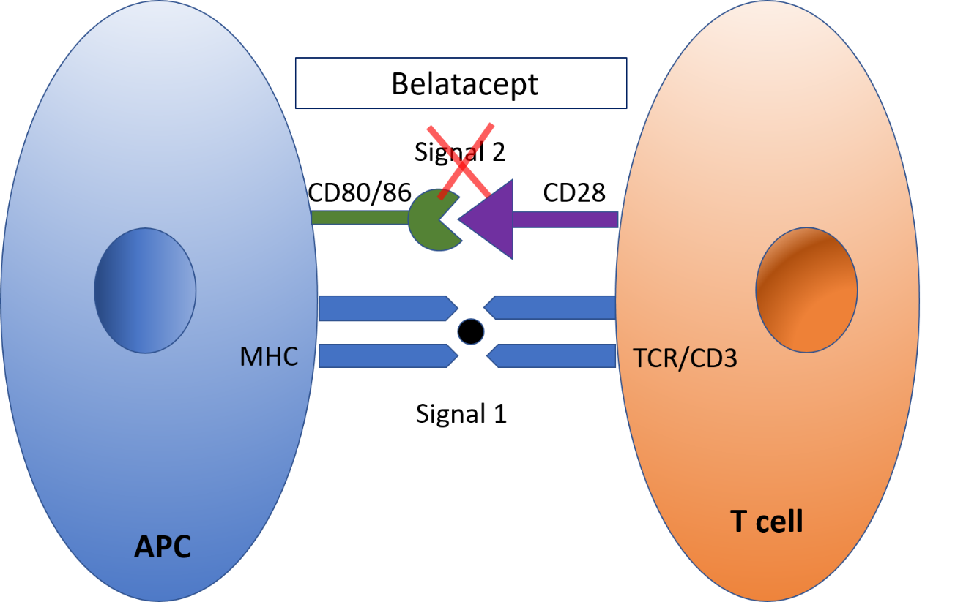

**Figure 1 Pictorial depiction of mechanism of action of belatacept.** APC: Antigen-presenting cell.

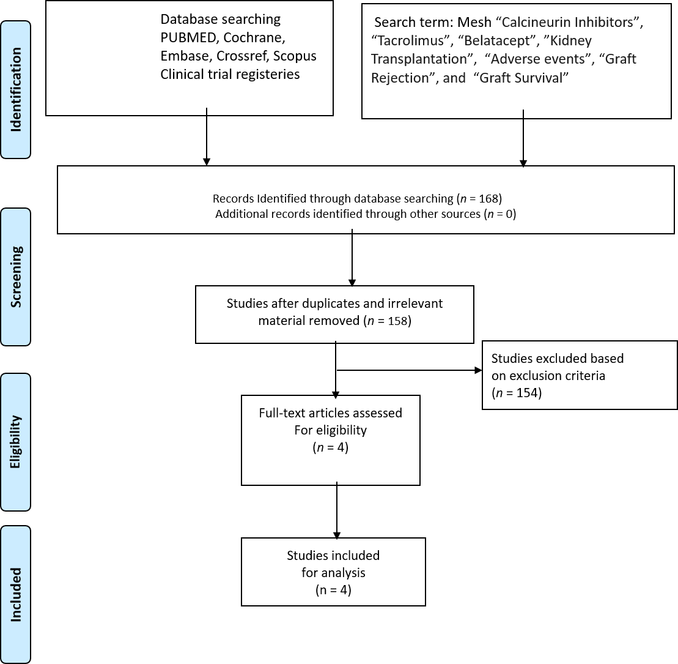

**Figure 2 Search strategy and selections strategy applied in this meta-analysis as per PRISMA protocol.**



**Figure 3 Risk of bias summary: review authors' judgements about each risk of bias item for each included study.**

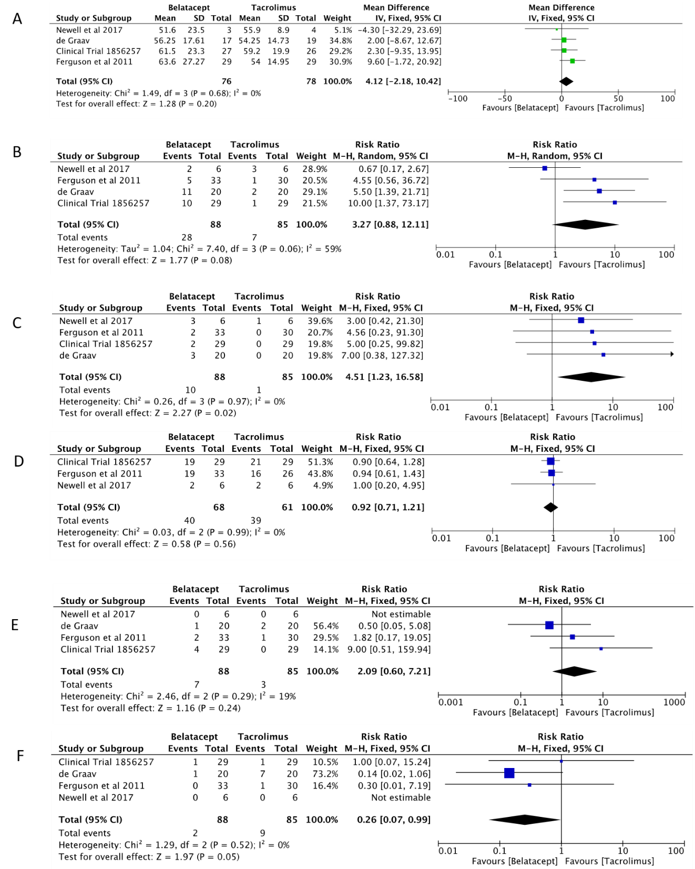

**Figure 4 Forest plot represents the changes at 12 mo in kidney transplant recipients when treated with belatacept or tacrolimus.** Squares represent size effects of studies, comparing the weight of the study in the meta-analysis. 95 percent confidence intervals represented in horizontal bars. A: The eGFR at 12 mo in kidney transplant recipients; B: The biopsy proven acute rejection over 12 mo in kidney transplant recipients. The diamond shows significant favour towards tacrolimus group following random effect analysis; C:  Graft survival over 12 mo in kidney transplant recipients. The diamond shows significant favour towards tacrolimus group following fixed effect analysis; D: The adverse events over 12 mo in kidney transplant recipients. The diamond doesn't suggest any significant difference following fixed effects analysis; E: The BK virus infection over 12 mo in kidney transplant recipients. The diamond doesn't suggest any significant difference following fixed effects analysis; F: The new onset diabetes mellitus after transplantation over 12 mo in kidney transplant recipients. The diamond suggests significant favour towards belatacept group following fixed effects analysis.

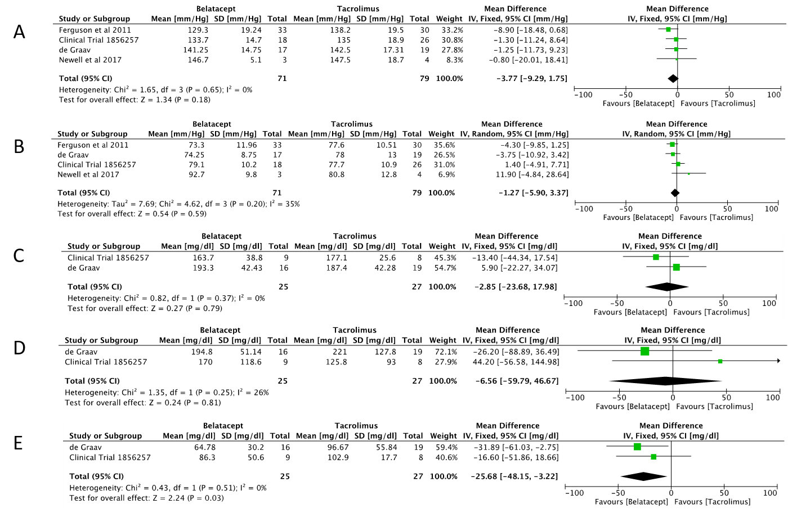

**Figure 5 Forest plot represents the changes at 12 mo in kidney transplant recipients when treated with belatacept or tacrolimus.** Squares represent size effects of studies, comparing the weight of the study in the meta-analysis. 95 percent confidence intervals represented in horizontal bars. A: The systolic blood pressure at 12 mo in kidney transplant recipients. The diamond doesn't suggest any significant difference following fixed effects analysis; B: The diastolic blood pressure at 12 mo in kidney transplant recipients. The diamond doesn't suggest any significant difference following random effects analysis; C: Serum total cholesterol at 12 mo in kidney transplant recipients. The diamond doesn't suggest any significant difference following fixed effects analysis; D: Serum triglycerides at 12 mo in kidney transplant recipients. The diamond doesn't suggest any significant difference following fixed effects analysis; E: Serum low density lipoprotein at 12 mo in kidney transplant recipients. The diamond suggests favour towards belatacept group following fixed effects analysis.

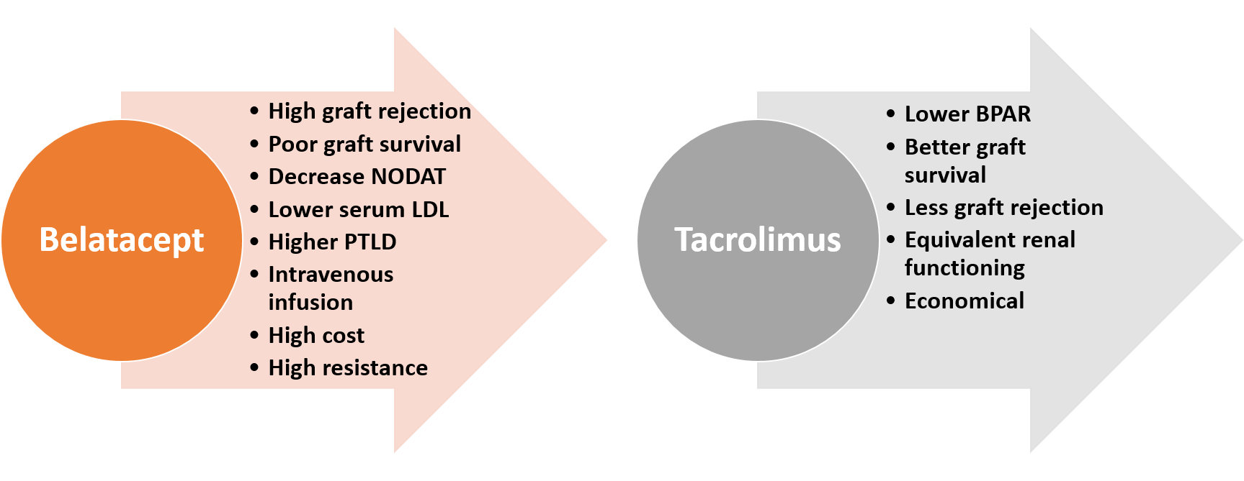

**Figure 6 Factors modified by belatacept and tacrolimus based regimen.** BPAR: Biopsy proven acute rejection; NODAT: New onset diabetes mellitus after transplantation; Serum LDL: Serum low density lipoprotein.

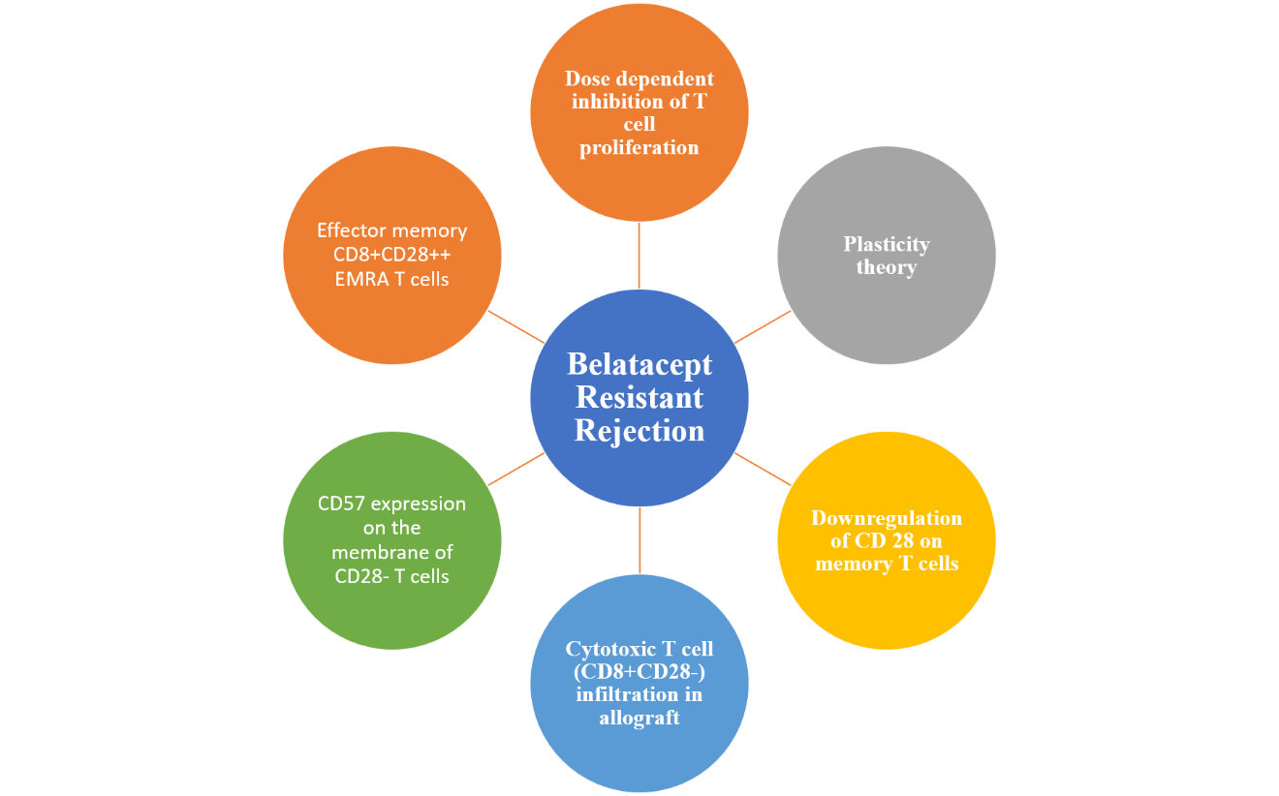

**Figure 7 Mechanism of the development of resistance to belatacept.**

**Table 1 Criteria for the inclusion of studies**

|  |  |
| --- | --- |
| **Type** | |
| Study design | Prospective cohort design with a well-defined study population |
| Study group | Post renal transplant |
| Study size | Any |
| Length of follow-up | Any |
| Source | Peer-reviewed journals |
| Language | English |
| Outcome measure | Renal function, patient safety, adverse events, and graft functioning and survival |

**Table 2 Characteristics of included studies**

|  |  |  |  |  |  |
| --- | --- | --- | --- | --- | --- |
| **Ref.** | **Study design** | **Donor type** | **Belatacept based (group 1)** | **Tacrolimus based (group 2)** | **Belatacept based (group 3)** |
| Ferguson *et al*[33], 2011 (25) | Multicentre, prospective, randomized (93 patients, 1 yr) | Living and deceased | Belatacept 10 mg/kg on day 1 and 5, then once every 2 wk through 3 mo, every 4 wk through 6 mo and 5 mg/kg from 7 mo onwards; MMF: 1 mg twice daily; Induction: Thymoglobulin + Corticosterids | Tac 0.2 mg/kg divided into two doses; Tac 0.2 mg/kg divided into two doses; Induction: Thymoglobulin + Corticosterids | Belatacept 10 mg/kg on day 1 and 5, then once every 2 wk through 3 mo, every 4 wk through 6 mo and 5 mg/kg from 7 mo onwards; SRL initiated on day 1 and dose level 7-12 ng/mL. Induction: Thymoglobulin + Corticosterids |
| de Graav *et al*[34], 2017 (26) | Single centre, prospective, randomized (40 patients, 1 yr) | Living | Belatacept 10 mg/kg on day 0, 4, 15, 30, 60, 90 d of transplant, following that 5 mg/kg till 12 mo | Tac 0.2 mg/kg divided into two doses. Target concentration 10 to 15 ng/mL (week 1-2); 8 to 12 ng/mL (week 3-4); 5-10 ng/mL (week > 5) | NA |
| Newell *et al*[35], 2017 (27) | Multicentre, prospective, randomized (19 patients, 1 yr) | Living and deceased | Belatacept 10 mg/kg on day 0 (day of transplant) and then on days 4, 14, 28, 56, and 84. After day 84, participants received a maintenance dose of 5 mg/kg every 4 wk until completion of the trial; MMF: 1 mg twice daily; Induction: Thymoglobulin, rapid methylprednisolone taper | Tac 0.1 mg/kg divided into two doses; Target concentration  8 to 12 ng/mL (week 24), then 5 to 8 ng/mL (week > 24); MMF: 1 mg twice daily; Induction: Thymoglobulin, rapid methylprednisolone taper | Belatacept 10 mg/kg on day 0 (day of transplant) and then on days 4, 14, 28, 56, and 84. After day 84, participants received a maintenance dose of 5 mg/kg every 4 wk. Tac 0.1 mg/kg divided into two doses then adjusted to target trough levels: 8-12 ng/mL by Day 29, 5-8 ng/mL by Day 57, 3-5 ng/mL by Day 85 then stopped. MMF: 1 mg twice daily; Tac: 5 to 8 ng/mL (till 24 wk); Induction: Basiliximab + Corticosteroids |
| Trial 1856257 (28) | Multicentre, prospective, randomized (69 patients, 1 yr) | Living and deceased | Belatacept 10 mg/kg on day 1 (24 h of transplant) and then on days 5, 14, 28, 56, and 84. MMF: 1 mg twice daily; Induction: Thymoglobulin + Corticosteroids | Tac started on day 0/1; Target concentration 8 to 12 ng/mL (week 24), then 5 to 8 ng/mL (week > 24); MMF: 1 mg twice daily; Induction: Thymoglobulin + Corticosteroids | Belatacept 10 mg/kg on day 1 (24 h of transplant) and then on days 5, 14, 28, 56, and 84. Tac started on day 0/1; Target concentration 8 to 12 ng/mL (day 1-84) and then decreased by 1/3 at day 84 and by 1/3 at week 16. If trough levels were less than or equal to 3 ng/mL at week 20 then all tac was stopped. Otherwise, the dose was reduced by 1/2 and stopped at week 24. MMF: 1 mg twice daily; Induction: Basiliximab + Corticosteroids + Tac |

MMF: Mycofenolate mofetil; NA: Not applicable; SRL: Sirolimus; Tac: Tacrolimus.

**Table 3 Summary of outcomes in clinical trials**

|  |  |  |  |  |
| --- | --- | --- | --- | --- |
| **Ref.** | **Renal function (Gp 1 *vs* Gp 2)** | **BPAR (Gp 1 *vs* Gp 2)** | **Adverse event (Gp1 or *vs* Gp 2)** | **Remarks** |
| Ferguson *et al*[33], 2011 (25) | 12 mo; Sr. Cr: NA; eGFR: 63.6 ± 27.27 *vs* 54.0 ± 14.95 mL/min; (*P* = 0.14) | 15.2% (5/33) *vs* 3.3% (1/30) (*P* = 0.24) | SAE/Infection: 57.5% (19/33) *vs* 53.3% (16/30); (*P* = 0.007); CMV infection: 3.0% (1/33) *vs* 3.3% (1/30) (*P* = 0.96); BK infection: 6.0% (2/33) *vs* 3.3% (1/30) (*P* = 0.59); NODAT: 0% (0/33) *vs* 3.3% (1/30) (*P* = 0.47) | Graft survival: 93.93% (31/33) *vs* 100% (30/30) (*P* = 0.51); Patient survival 93.93% (31/33) *vs* 100% (30/30) (*P* = 0.51) |
| de Graav *et al*[34], 2017 (26) | 12 mo; Sr. Cr: 133.5 ± 39.26 *vs* 127.5 ± 28.87 μmol/L (*P* = 0.80); eGFR: 56.25 ± 17.61 *vs* 54.25 ± 14.73 mL/min (*P* = 0.57) | 55% (11/20) *vs* 10% (2/20) (*P* = 0.006) | SAE/Infection: 10.25 ± 4.18 *vs* 11.90 ± 5.43 (*P* = 0.41); CMV infection: 10% (2/20) *vs* 5% (1/20) (*P* = 0.96); BK infection: 5% (1/20) *vs* 3.3% (2/20) (*P* = 0.54); NODAT: 5% (1/20) *vs* 35% (7/20) (*P* = 0.04) | Graft survival: 85% (17/20) *vs* 100% (20/20) (*P* = 0.22); Patient Survival 100% (20/20) *vs* 95% (19/20) (*P* = 0.31) |
| Newell *et al*[35], 2017 (27) | 12 mo; Sr Cr: NA; eGFR: 51.6 ± 23.5 *vs* 55.9 ± 8.9 mL/min (*P* = 0.74) | 33.3% (2/6) *vs* 50% (3/6) (*P* = 0.55) | SAE/Infection: 33.3% (2/6) *vs* 33.3% (2/6) (*P* = 1.0); CMV infection: 0% (0/6) *vs* 16.6% (1/6) (*P* = 0.29); BK infection: 0% (0/6) *vs* 0% (0/6) (*P* = 1.00); NODAT: 0% (0/6) *vs* 0% (0/6) (*P* = 1.00) | Graft survival: 50% (3/6) *vs* 83.33% (5/6) (*P* = 0.85); Patient survival 100% (6/6) *vs* 83.33% (5/6) (*P* = 0.29) |
| Clinicaltrial.gov 1856257, 2017 (28) | 12 mo, Sr. Cr: NA, eGFR: 61.5 ± 23.3 *vs* 59.2 ± 19.9 mL/min (*P* = 0.70) | 37.9% (11/29) *vs* 6.8% (2/29) (*P* = 0.009) | SAE/Infection: 72.41% (21/29) *vs* 65.5% (19/29) (*P* = 0.77); CMV infection: 20.6% (6/29) *vs* 3.4% (1/29) (*P* = 1.0); BK infection: 13.7% (4/29) *vs* 0% (0/29) (*P* = 0.11); NODAT: 3.4% (1/29) *vs* 3.4% (1/29) (*P* = 1.0) | Graft survival: 93.1% (27/29) *vs* 100% (29/29) (*P* = 0.49); Patient survival: 93.1% (27/29) *vs* 100% (29/29) (*P* = 0.49) |

CMV: Cytomegalovirus; eGFR: Estimated glomerular filtration rate; Gp: Group; SAE: Serious adverse experiences; Sr Cr: Serum creatinine; NODAT: New onset diabetes mellitus after transplantation.

**Table 4 Summary of biopsy proven acute rejection in clinical trials**

|  |  |  |  |  |  |  |  |  |  |  |  |  |  |  |
| --- | --- | --- | --- | --- | --- | --- | --- | --- | --- | --- | --- | --- | --- | --- |
| Ref. | IA | | IB | | IIA | | IIB | | III | | Mixed | |  | |
|  | **Gp1 (Belatacept)** | **Gp2 (Tacrolimus)** | **Gp1 (Belatacept)** | **Gp2 (Tacrolimus)** | **Gp1 (Belatacept)** | **Gp2 (Tacrolimus)** | **Gp1 (Belatacept)** | **Gp2 (Tacrolimus)** | **Gp1 (Belatacept)** | **Gp2 (Tacrolimus)** | **Gp1 (Belatacept)** | **Gp2**  **(Tacrolimus)** | **Gp1**  **(Belatacept)** | **Gp2**  **(Tacrolimus)** |
| Ferguson *et al*[33], 2011 (25) | 0 | 0 | 0 | 0 | 3 | 0 | 2 | 1 | 0 | 0 |  |  |  |  |
| de Graav *et al*[34], 2017 (26) | 0 | 0 | 1 | 1 | 2 | 1 | 6 | 0 | 1 | 0 | 1 | 0 |  |  |
| Newell *et al*[35], 2017 (27) | 1 | 0 | 0 | 0 | 0 | 0 | 1 | 0 | 0 | 0 |  |  | 1 | 0 |
| Clinicaltrial.gov 1856257, 2017 (28) | 3 | 0 | 1 | 1 | 4 | 0 | 0 | 0 | 2 | 0 |  |  | 1 | 1 |

BPAR: Biopsy proven acute rejection; Gp: Group; AMR: Antibody mediated rejection.

**Table 5 Summary of metabolic outcomes in clinical trials**

|  |  |  |  |  |  |  |  |  |
| --- | --- | --- | --- | --- | --- | --- | --- | --- |
| Parameters | Ferguson *et al*[33], 2011 (25) | | de Graav *et al*[34], 2017 | | Newell *et al*[35], 2017 (27) | | Clinicaltrial.gov 1856257, 2017 (28) | |
|  | **Gp1 (Belatacept)** | **Gp2 (Tacrolimus)** | **Gp1 (Belatacept)** | **Gp2 (Tacrolimus)** | **Gp1 (Belatacept)** | **Gp2 (Tacrolimus)** | **Gp1 (Belatacept)** | **Gp2 (Tacrolimus)** |
| Total CH, Mean (SD) (mg/dL) | NA | NA | 193.34 ± 42.43 | 187.41 ± 42.28 | 187.0 | 156.0 ± 30.4 | 163.7 ± 38.8 | 177.1 ± 25.6 |
| Total TG, Mean (SD) (mg/dL) | NA | NA | 194.86 ± 51.14 | 221 ± 127.87 | 187.0 | 319.3 ± 294.0 | 170.0 ± 118.6 | 125.8 ± 93.0 |
| LDL, Mean (SD) (mg/dL) | NA | NA | 64.78 ± 30.20 | 96.67 ± 55.84 | 114.0 | 69.5 ± 38.0 | 86.3 ± 50.6 | 102.9 ± 17.7 |
| BP mm/Hg (SBP/DBP) (12 mo) | 129.3 ± 19.24/73.3 ± 11.96 | 138.2 ± 19.50/77.6 ± 10.51 | 141.25 ± 14.75/74 .25 ± 8.75 | 142.5 ± 17.31/78.0 ± 13.0 | 146.7 ± 5.1/92.7 ± 9.8 | 147.5 ± 18.7/80.8 ± 12.8 | 133.7 ± 14.7/79.1 ± 10.2 | 135.0 ± 18.9/77.7 ± 10.9 |

Lipid parameters represented in mean change from baseline to month 12 post transplantation.