**Name of journal:** ***World Journal of*** ***Gastroenterology***

**Manuscript NO: 36511**

**Manuscript Type: Original Article**

***Retrospective Study***

**Association between white opaque substance under magnifying colonoscopy and lipid droplets in colorectal epithelial neoplasms**

Kawasaki K *et al*. WOS and lipid droplets

Keisuke Kawasaki, Makoto Eizuka, Shotaro Nakamura, Masaki Endo, Shunichi Yanai, Risaburo Akasaka, Yosuke Toya, Yasuko Fujita, Noriyuki Uesugi, Kazuyuki Ishida, Tamotsu Sugai, Takayuki Matsumoto

**Keisuke Kawasaki, Shotaro Nakamura, Shunichi Yanai, Risaburo Akasaka, Yosuke Toya, Takayuki Matsumoto**, Division of Gastroenterology, Department of Internal Medicine, Iwate Medical University, Morioka 020-8505, Japan

**Makoto Eizuka, Yasuko Fujita, Noriyuki Uesugi, Kazuyuki Ishida, Tamotsu Sugai**, Department of Diagnostic Pathology, Iwate Medical University, Morioka 020-8505, Japan

**Masaki Endo**, Kaiunbashi Endoscopy Clinic, Morioka 020-0022, Japan

**ORCID number**: Keisuke Kawasaki (0000-0003-2645-4417); Makoto Eizuka (0000-0003-4815-1273); Shotaro Nakamura (0000-0001-8166-2599); Masaki Endo (0000-0001-7249-2540); Shunichi Yanai (0000-0003-1871-2412); Risaburo Akasaka (0000-0001-7087-3016); Yosuke Toya (0000-0002-0990-9304); Yasuko Fujita (0000-0002-3988-9076); Noriyuki Uesugi (0000-0002-4388-6660); Kazuyuki Ishida (0000-0002-2804-4588); Tamotsu Sugai (0000-0002-4896-3557); Takayuki Matsumoto (0000-0001-9786-3854).

**Author contributions:** Kawasaki K designed the study, and was involved in patients’ management, performed endoscopic examinations and drafted the manuscript. Eizuka M reviewed the histological specimens and was responsible for the pathological diagnosis. Nakamura S, Endo M, Yanai S, Akasaka R, Toya Y, Fujita Y, Uesugi N and Ishida K participated in helped to draft the manuscript. Sugai T reviewed the histological specimens and was responsible for the pathological diagnosis. Matsumoto T critically reviewed and revised the manuscript. All authors have read and approved the final version of the manuscripts.

**Institutional review board statement:** The protocol of this retrospective study was approved by the Institutional Review Board at Iwate Medical University.

**Informed consent statement:** Patients were not required to give informed consent as this is a retrospective study.

**Conflict-of-interest statement:** The authors have no conflicts of interest to declare.

**Data sharing statement:** No additional data are available.

**Open-Access:** This article is an open-access article which was selected by an in-house editor and fully peer-reviewed by external reviewers. It is distributed in accordance with the Creative Commons Attribution Non Commercial (CC BY-NC 4.0) license, which permits others to distribute, remix, adapt, build upon this work non-commercially, and license their derivative works on different terms, provided the original work is properly cited and the use is non-commercial. See: http://creativecommons.org/licenses/by-nc/4.0/

**Manuscript source:** Invited manuscript

**Correspondence to: Keisuke Kawasaki, MD, PhD,** **Doctor,** Division of Gastroenterology, Department of Internal Medicine, Iwate Medical University, 19-1, Uchimaru, Morioka 020-8505, Japan. [kkeisuke@iwate-med.ac.jp](mailto:kkeisuke@iwate-med.ac.jp)

**Telephone:** +81-19-6515111

**FAX:** +81-19-6526664

**Received:** October 25, 2017

**Peer-review started:** October 26, 2017

**First decision:** November 21, 2017

**Revised:** November 30, 2017

**Accepted:** December 5, 2017

**Article in press:**

**Published online:**

**Abstract**

***AIM***

To examine the association between white opaque substance (WOS) and histologically verified lipid droplets in colorectal epithelial neoplasms.

***METHODS***

We reviewed colonoscopy records at our institution from 2014 to 2016 and identified cases of endoscopically or surgically resected colorectal epithelial neoplasms observed by magnifying narrow-band imaging (M-NBI) colonoscopy. Immunohistochemistry was used to stain tumors with a monoclonal antibody specific to adipophilin as a marker of lipids. The expression and distribution of adipophilin were compared between WOS-positive and WOS-negative lesions and among tumors classified by histologic type and depth of invasion.

***RESULTS***

Under M-NBI colonoscopy, 81 lesions were positive for WOS and 48 lesions were negative for WOS. The rate of adipophilin expression was significantly higher in WOS-positive lesions (95.1%) than in WOS-negative lesions (68.7%) (*P =* 0.0001). The incidence of deep adipophilin expression was higher in WOS-positive lesions (24.7%) than in WOS-negative lesions (4.2%) (*P =* 0.001). The incidence of deep expression was predominant among cancers with massive submucosal invasion (62.5%) compared to adenoma (7.2%) and high-grade dysplasia or cancers with slight submucosal invasion (12.7%) (*P =* 0.0001).

***CONCLUSION***

The distribution of lipid droplets may be closely associated with the visibility of WOS under M-NBI colonoscopy, and with histologic grade and depth of tumor invasion.

**Key words:** White opaque substance; Adipophilin; Magnifying narrow-band imaging; Colorectal neoplasm; Magnifying endoscopy

**© The Author(s) 2017.** Published by Baishideng Publishing Group Inc. All rights reserved.

**Core tip:** We investigated the association between the distribution of the lipid droplets and endoscopically-verified white opaque substance (WOS) in colorectal neoplasms. The incidence of deep adipophilin expression was higher in WOS-positive lesions than in WOS-negative lesions. The incidence of deep expression was predominant among cancers with massive submucosal invasion compared to adenoma and high-grade dysplasia or cancers with slight submucosal invasion. We thus concluded that the distribution of lipid droplets may be closely associated with the visibility of WOS, and also with histologic grade and depth of tumor invasion.

Kawasaki K, Eizuka M, Nakamura S, Endo M, Yanai S, Akasaka R, Toya Y, Fujita Y, Uesugi N, Ishida K, Sugai T, Matsumoto T. Association between white opaque substance under magnifying colonoscopy and lipid droplets in colorectal epithelial neoplasms. *World J Gastroenterol* 2017; In press

**INTRODUCTION**

White opaque substance (WOS) under magnifying narrow-band imaging (M-NBI) endoscopy has been reported to be a novel endoscopic finding in gastric neoplasms[1]. Yao *et al*[1] reported that WOS is valuable for distinguishing between gastric adenocarcinoma and gastric adenoma. WOS has also been observed in other gastrointestinal tract neoplasms, such as esophageal adenocarcinoma originating from esophageal glands, duodenal neoplasms, and colorectal neoplasms[2-4]. We recently reported that irregular distribution of WOS in colorectal neoplasms may be a sign of massively invading submucosal colorectal cancer[5].

In gastric and duodenal neoplasms, WOS has been shown to represent an accumulation of lipid droplets[3,6]. Lipid staining for gastric and duodenal epithelial neoplasms has demonstrated that most gastric neoplasms with WOS are positive for oil red O staining[6], and the distribution of Sudan IV-positive lipid droplets corresponds approximately with that of WOS in duodenal neoplasms[3]. To date, however, only a single study investigated the histopathological features of WOS in colorectal epithelial neoplasms[7]. In that study, Imamura *et al*[7] reported that WOS in colorectal epithelial neoplasms was composed of lipid droplets. However, the association between the distribution of the lipid droplets and endoscopically-verified WOS in colorectal neoplasms remains unclear.

We conducted a single-center, retrospective analysis to examine the association between lipid droplets and WOS in colorectal epithelial neoplasms. We also compared the distribution of lipid droplets among tumors classified by histologic type and depth of invasion.

**MATERIALS AND METHODS**

***Study population and data collection***

The present investigation was based on retrospective data collection. We reviewed the endoscopy database at our institution from 2014 to 2016, and identified all patients with a diagnosis of colorectal epithelial neoplasm removed by endoscopic submucosal dissection (ESD) or laparoscopic surgery. Among those tumors, we excluded colorectal epithelial neoplasms, which cannot be observed by M-NBI colonoscopy. We also excluded cancers invading the proper muscular layer. The protocol of this retrospective study was approved by the Institutional Review Board at Iwate Medical University.

Demographics of study subjects were extracted via chart review. Evaluated characteristics included age, sex, colonoscopic findings (size, location, and morphology), and M-NBI colonoscopic findings. The location of each lesion was classified as right side (cecum to transverse colon) or left side (descending colon to rectum). The gross morphology was defined as protruding type or flat-elevated type, based on the Paris classification[8].

***Definition of white opaque substance***

As has been reported previously[5], we defined WOS as a whitish area on M-NBI colonoscopy that obscures the microvascular pattern within the colorectal epithelial neoplasm (Figure 1). When M-NBI colonoscopy revealed an area of WOS, the lesion was considered WOS-positive. WOS was further classified into regular and irregular WOS based on the classifications proposed by Yao *et al*[1] and by our group[5]. Regular WOS was defined as WOS observed in a well-organized and symmetrical distribution with a regular reticular, maze-like, or speckled pattern. In contrast, irregular WOS was defined as WOS that appeared in a disorganized and asymmetrical distribution with an irregular reticular or speckled pattern (Figure 1).

***Histopathological evaluation***

Histological diagnosis was based on the WHO classification proposed in 2000[9].The grade of dysplastic change was classified as adenoma, high-grade dysplasia (HGD), or carcinoma. Carcinoma was defined as neoplastic glands that had invaded the submucosal layer. Carcinomas were further classified as those with massive submucosal invasion (mSM) and those with slight submucosal invasion (sSM). mSM carcinoma was defined as having a vertical invasion depth > 1000 μm, while sSM carcinoma was defined as having an invasion depth < 1000 μm[8,10].

***Immunohistochemical staining***

All sections were deparaffinized in xylene and rehydrated in a graded ethanol series. Slides were autoclaved in citrate buffer (pH 9.0) at 97 ℃ for 20 min by PT Link (Dako EnVision System, Denmark). To clarify lipid accumulation, a primary antibody against adipophilin (pre-dilution, AP125; Fitzgerald Industries International, Concord, MA, United States) was used. Immunostaining for adipophilin was performed using an autoimmunostaining system (Dako EnVision System, Denmark).

The intensity of adipophilin expression was tabulated as negative, weak, moderate and strong. When the intensity of adipophilin-positive neoplastic cells was moderate or strong, the lesion was regarded as being adipophilin-positive. Depth of adipophilin expression was scored as 0 (negative), 1 (superficial expression), and 2 (deep expression) (Figure 2). When the depth of proper mucosal layer was divided into five equal layers, score 1 (superficial expression) was defined as having a vertical adipophilin expression no more than one-fifth, while score 2 (deep expression) was defined as having a vertical adipophilin expression more than one-fifth.

Scores were determined by two pathologists (ME and TS). When any difference in scoring occurred, the pathologists discussed the case until a consensus was obtained.

***Statistical analysis***

Parametric data are expressed as mean ± SD. Nonparametric data are expressed as numbers and percentages. Comparisons between any two or among any three groups were performed by chi-squared test, the Tukey honestly significant difference test, or Student’s *t* test where appropriate. *P* < 0.05 were considered significant. All statistical computations were performed with JMP version 11 (Statistical Discovery Program, Cary, NC, United States).

**RESULTS**

***Demographic data***

A total of 129 lesions in 120 patients were included in this study. Overall, 81 lesions in 74 patients were regarded as WOS-positive and 48 lesions in 46 patients as WOS-negative (Figure 1). Neither age at the time of diagnosis of colorectal epithelial neoplasms (70.6 ± 8.6 years in patients with WOS-positive lesions and 68.6 ± 9.1 years in the remaining patients) nor gender (55.4% male in patients with WOS-positive lesions and 45.8% in the remaining patients) differed between patient groups.

Comparisons of endoscopic and histological characteristics between WOS-positive and WOS-negative lesions are shown in Table 1. No differences in tumor size, tumor location, gross morphology, or histologic type were observed between the two groups.

***Association between adipophilin expression and white opaque substance under magnifying narrow-band imaging colonoscopy***

Table 2 compares adipophilin positivity rates between WOS-positive and WOS-negative lesions. Overall, 77 of the 81 WOS-positive lesions (95.1%) were adipophilin-positive, while 33 of the 48 WOS-negative lesions (68.7%) were adipophilin-positive (Figures 1 and 2). The adipophilin positivity rate was significantly higher in WOS-positive lesions than in WOS-negative lesions (*P =* 0.0001).

Figure 3 compares the distribution of adipophilin expression between WOS-positive and WOS-negative lesions. The score for depth of adipophilin expression was significantly different between the two groups (*P =* 0.001), with a predominance of score 2 (deep expression) (Figure 2) in WOS-positive lesions (24.7%) compared to 4.2% in WOS-negative lesions.

WOS-positive lesions were further classified as having regular WOS (65 lesions) or irregular WOS (16 lesions) (Figure 1). Figure 4 compares the distribution of adipophilin between lesions with regular vs. irregular WOS. Deep adipophilin expression was more frequent in lesions with irregular WOS (56.3%) than in those with regular WOS (16.9%) (*P =* 0.0006) (Figure 2).

***Association between histologic type/depth of invasion and adipophilin expression***

Histologically, the 129 lesions included 42 adenomas, 63 HGDs, 8 sSM carcinomas, and 16 mSM carcinomas. Figure 5 compares adipophilin expression between adenomas, HGD/sSM carcinomas, and mSM carcinomas. A score of 2 (deep expression) was more frequent in mSM carcinomas (62.5%) than in adenomas (7.2%) and HGDs/sSM carcinomas (12.7%) (*P =* 0.0001). Figure 6 shows a case of mSM carcinoma with irregular WOS.

**DISCUSSION**

In this study, we confirmed that colorectal neoplasms with positive WOS under M-NBI colonoscopy had more profound accumulation of adipophilin compared to those without WOS. We also confirmed that the depth of adipophilin accumulation within tumors was associated with the visibility and morphology of WOS. Furthermore, we showed that the depth of adipophilin accumulation was associated with histologic grade of dysplasia and depth of invasion in colorectal tumors.

WOS under M-NBI endoscopy appears as a white deposit that obscures the subepithelial microvascular pattern in gastric neoplasms, duodenal neoplasms, esophageal adenocarcinoma originating from esophageal glands, and colorectal neoplasms, as well as in gastric and colorectal hyperplasic polyps[1-5,11,12]. WOS has been histopathologically and immunohistochemically verified to be a consequence of intramucosal accumulation of lipid droplets. Gastric neoplasms with WOS have been shown to be positive for oil red O staining and adipophilin[6,13-15], and duodenal neoplasms with WOS have been reported to be positive for Sudan IV[3].

Only a single clinicopathologic study that evaluated WOS in colorectal neoplasms has been published[7]. In that study, Imamura *et al*[7] reported that 19 (47.5%) of 40 colorectal lesions with WOS were positive for oil red O staining, while only 5 (5%) of 40 colorectal lesions without WOS were positive. Moreover, the investigators reported that 40 (100%) of 40 colorectal lesions with WOS were positive for adipophilin, while 25 (62.5%) of 40 colorectal lesions without WOS were positive. In the present study, we observed similar trends in the association between WOS and adipophilin expression. Thus, it seems possible that as in gastric and duodenal neoplasms, WOS in colorectal tumors represents accumulation of lipid droplets in the neoplastic epithelium.

The incidence of lipid droplets in gastric neoplasms without WOS has been reported in the literature to be extremely low. Yao *et al*[6] reported that only 1 (4.3%) of 23 WOS-negative lesions was positive for oil red O. Ueo *et al*[13] also reported a similar trend: only 2 (7.4%) of 27 WOS-negative lesions were positive for adipophilin. With regards to colorectal neoplasms, only 2 (5%) of 40 WOS-negative lesions were positive for oil red O[7]. As observed in our present investigation, however, Imamura *et al*[7] reported a much higher rate (62.5%) of adipophilin-positive expression in biopsy specimens obtained from WOS-negative colorectal tumors. The study investigators[7] also observed a significantly lower density of adipophilin in WOS-negative lesions compare to WOS-positive lesions. These observations strongly suggest that WOS under M-NBI is less sensitive for the detection of lipid droplets in colorectal tumors than in gastric tumors.

In the present study, we also investigated the histological distribution of lipid droplets in colorectal lesions that were completely resected by endoscopy or surgery. Thus, we were able to assess the depth of adipophilin expression in the samples. We found that deep expression of adipophilin was more frequent in WOS-positive lesions than in WOS-negative lesions. Thus, it seems possible that WOS under M-NBI may be representative of the total volume of lipid droplets in colorectal tumors.

The present results also showed that deep adipophilin expression was more frequent in mSM carcinomas than in adenomas or HGDs/sSM carcinomas. Yao *et al*[6] reported that 10 (36.5%) of 26 gastric neoplasms were positive for oil O red staining within surface epithelial cells, while 16 (61.5%) of 26 gastric neoplasms were positive for oil O red both in surface epithelial cells and in the subepithelial region. Ueo *et al*[13] reported that surface plus cryptal accumulation of adipophilin was frequent in gastric cancers, while surface accumulation was observed in most gastric adenomas. It thus seems possible that the intraepithelial localization of lipid droplets in gastric tumors differs according to the histological grade of dysplasia. However, the association between lipid droplet accumulation and tumor invasion depth has not been examined in gastric epithelial tumors to date. In contrast, our results suggested that the depth of adipophilin expression may be correlated with the depth of invasion, rather than the histologic grade, in colorectal tumors.

In our previous analysis, the incidence of mSM carcinoma was significantly and conspicuously higher among lesions with irregular WOS (82.4%) than among those with regular WOS (1.4%)[5]. In the present study, lesions with irregular WOS had deeper adipophilin expression than those with regular WOS. It thus seems possible that irregular WOS may be a consequence of massive lipid droplet accumulation in colorectal tumors. This speculation appears to partially explain the high rate of submucosal invasion in lesions with irregular WOS. Lipid droplets may be directly or indirectly associated with the malignant potential of colorectal neoplasms.

The present study has several limitations. First, since we included only lesions removed by ESD or surgery and did not include small lesions, it remains unclear whether the present observations are applicable to smaller colorectal lesions. Second, the present results were based on a retrospective analysis in a single center. A need exists for prospective analysis of a greater number of colorectal epithelial neoplasms to determine the association between lipid droplets and WOS under NBI, and also the clinical significance of WOS for the diagnosis and treatment of colorectal tumors.

In conclusion, the present immunohistochemical study showed that WOS observed in colorectal tumors under M-NBI colonoscopy represents lipid droplets. In addition, the distribution of lipid droplets may be closely associated with the visibility of WOS under M-NBI colonoscopy, and also with histologic grade and depth of tumor invasion. Further prospective studies are warranted to establish the clinical significance of WOS for the diagnosis and treatment of colorectal epithelial tumors and the association between lipid droplets and WOS under NBI.

**ARTICLE HIGHLIGHTS**

***Research background***

White opaque substance (WOS) under magnifying narrow-band imaging (M-NBI) endoscopy is a novel endoscopic finding for the diagnosis of gastrointestinal tract neoplasms. In previous studies, WOS has been shown to contain lipid droplets. However, the association between the distribution of the lipid droplets and endoscopically verified WOS in colorectal neoplasms remains unclear.

***Research motivation***

The elucidation of WOS or lipid droplets in colorectal epithelial tumors will help the diagnosis and treatment of colorectal epithelial tumors.

***Research objectives***

To examine the association between WOS and histologically verified lipid droplets in colorectal epithelial neoplasms.

***Research methods***

We conducted this retrospective study involving 129 lesions of endoscopically or surgically resected colorectal epithelial neoplasms observed by M-NBI colonoscopy. Immunohistochemistry was used to stain tumors with a monoclonal antibody specific to adipophilin as a marker of lipids. The expression and distribution of adipophilin were compared between WOS-positive and WOS-negative lesions and among tumors classified by histologic type and depth of invasion.

***Research results***

81 lesions were positive for WOS and 48 lesions were negative for WOS. The rate of adipophilin expression was significantly higher in WOS-positive lesions (95.1%) than in WOS-negative lesions (68.7%) (*P =* 0.0001). The incidence of deep adipophilin expression was higher in WOS-positive lesions (24.7%) than in WOS-negative lesions (4.2%) (*P =* 0.001). The incidence of deep expression was predominant among cancers with massive submucosal invasion (62.5%) compared to adenoma (7.2%) and high-grade dysplasia or cancers with slight submucosal invasion (12.7%) (*P =* 0.0001).

***Research conclusions***

The distribution of lipid droplets may be closely associated with the visibility of WOS under M-NBI colonoscopy, and with histologic grade and depth of tumor invasion.

***Research perspectives***

Our study showed that WOS under M-NBI colonoscopy appears to represent lipid droplets and the distribution of lipid droplets may be closely associated with the visibility of WOS with histologic grade and depth of tumor invasion. The accumulation of lipid droplets may directly or indirectly represent the malignant potential of colon cancer cells. Further prospective studies are warranted to establish the clinical significance of WOS for the diagnosis and treatment of colorectal epithelial tumors and the association between lipid droplets and WOS under NBI.

**REFERENCES**

1 **Yao K**, Iwashita A, Tanabe H, Nishimata N, Nagahama T, Maki S, Takaki Y, Hirai F, Hisabe T, Nishimura T, Matsui T. White opaque substance within superficial elevated gastric neoplasia as visualized by magnification endoscopy with narrow-band imaging: a new optical sign for differentiating between adenoma and carcinoma. *Gastrointest Endosc* 2008; **68**: 574-580 [PMID: 18656862 DOI: 10.1016/j.gie.2008.04.011]

2 **Yoshii S**, Kato M, Honma K, Fujinaga T, Tsujii Y, Maekawa A, Inoue T, Hayashi Y, Akasaka T, Shinzaki S, Nishida T, Iijima H, Tsujii M, Morii E, Takehara T. Esophageal adenocarcinoma with white opaque substance observed by magnifying endoscopy with narrow band imaging. *Dig Endosc* 2015; **27**: 392-396 [PMID: 25041337 DOI: 10.1111/den.12331]

3 **Yoshimura N**, Goda K, Tajiri H, Ikegami M, Nakayoshi T, Kaise M. Endoscopic features of nonampullary duodenal tumors with narrow-band imaging. *Hepatogastroenterology* 2010; **57**: 462-467 [PMID: 20698209]

4 **Hisabe T**, Yao K, Imamura K, Ishihara H, Hirai F, Matsui T, Iwashita A. White opaque substance visualized using magnifying endoscopy with narrow-band imaging in colorectal epithelial neoplasms. *Dig Dis Sci* 2014; **59**: 2544-2549 [PMID: 24828918 DOI: 10.1007/s10620-014-3204-5]

5 **Kawasaki K**, Kurahara K, Yanai S, Oshiro Y, Eizuka M, Uesugi N, Ishida K, Nakamura S, Fuchigami T, Sugai T, Matsumoto T. Significance of a white opaque substance under magnifying narrow-band imaging colonoscopy for the diagnosis of colorectal epithelial neoplasms. *Gastrointest Endosc* 2015; **82**: 1097-1104 [PMID: 26234694 DOI: 10.1016/j.gie.2015.06.023]

6 **Yao K**, Iwashita A, Nambu M, Tanabe H, Nagahama T, Maki S, Ishikawa H, Matsui T, Enjoji M. Nature of white opaque substance in gastric epithelial neoplasia as visualized by magnifying endoscopy with narrow-band imaging. *Dig Endosc* 2012; **24**: 419-425 [PMID: 23078433 DOI: 10.1111/j.1443-1661.2012.01314.x]

7 **Imamura K**, Yao K, Hisabe T, Nambu M, Ohtsu K, Ueo T, Yano S, Ishihara H, Nagahama T, Kanemitsu T, Yamasaki K, Matsui T, Tanabe H, Iwashita A, Daa T, Yokoyama S, Matsunaga K, Enjoji M. The nature of the white opaque substance within colorectal neoplastic epithelium as visualized by magnifying endoscopy with narrow-band imaging. *Endosc Int Open* 2016; **4**: E1151-E1157 [PMID: 27853741 DOI: 10.1055/s-0042-116487]

8 The Paris endoscopic classification of superficial neoplastic lesions: esophagus, stomach, and colon. *Gastrointest Endosc*. 2003; **58**: S3-S43.

9 **Hamilton SR,** Adaltonen LA, editors. World Health Organization classification of tumors: pathology and genetics of tumors of the digestive system. Lyon (France): International Agency for Research on Cancer; 2000. P. 103-119.

10 **Kitajima K**, Fujimori T, Fujii S, Takeda J, Ohkura Y, Kawamata H, Kumamoto T, Ishiguro S, Kato Y, Shimoda T, Iwashita A, Ajioka Y, Watanabe H, Watanabe T, Muto T, Nagasako K. Correlations between lymph node metastasis and depth of submucosal invasion in submucosal invasive colorectal carcinoma: a Japanese collaborative study. *J Gastroenterol* 2004; **39**: 534-543 [PMID: 15235870 DOI: 10.1007/s00535-004-1339-4]

11 **Ueyama H**, Matsumoto K, Nagahara A, Gushima R, Hayashi T, Yao T, Watanabe S. A white opaque substance-positive gastric hyperplastic polyp with dysplasia. *World J Gastroenterol* 2013; **19**: 4262-4266 [PMID: 23864793 DOI: 10.3748/wjg.v19.i26.4262]

12 **Hisabe T**, Yao K, Imamura K, Ishihara H, Yamasaki K, Yasaka T, Matsui T, Iwashita A. Novel Endoscopic Findings as Visualized by Magnifying Endoscopy with Narrow-Band Imaging: White Opaque Substance Is Present in Colorectal Hyperplastic Polyps. *Digestion* 2016; **93**: 127-131 [PMID: 26636961 DOI: 10.1159/000441841]

13 **Ueo T**, Yonemasu H, Yada N, Yano S, Ishida T, Urabe M, Takahashi K, Nagamatsu H, Narita R, Yao K, Daa T, Yokoyama S. White opaque substance represents an intracytoplasmic accumulation of lipid droplets: immunohistochemical and immunoelectron microscopic investigation of 26 cases. *Dig Endosc* 2013; **25**: 147-155 [PMID: 23368762 DOI: 10.1111/j.1443-1661.2012.01364.x]

14 **Enjoji M**, Kohjima M, Ohtsu K, Matsunaga K, Murata Y, Nakamuta M, Imamura K, Tanabe H, Iwashita A, Nagahama T, Yao K. Intracellular mechanisms underlying lipid accumulation (white opaque substance) in gastric epithelial neoplasms: A pilot study of expression profiles of lipid-metabolism-associated genes. *J Gastroenterol Hepatol* 2016; **31**: 776-781 [PMID: 26513060 DOI: 10.1111/jgh.13216]

15 **Ueo T**, Yonemasu H, Yao K, Ishida T, Togo K, Yanai Y, Fukuda M, Motomura M, Narita R, Murakami K. Histologic differentiation and mucin phenotype in white opaque substance-positive gastric neoplasias. *Endosc Int Open* 2015; **3**: E597-E604 [PMID: 26716119 DOI: 10.1055/s-0034-1393177]

**P-Reviewer:** Arya V, Alberti LR **S-Editor:** Chen K **L-Editor: E-Editor:**

**Specialty type:** Gastroenterology and hepatology

**Country of origin:** Japan

**Peer-review report classification**

Grade A (Excellent): A

Grade B (Very good): B

Grade C (Good): 0

Grade D (Fair): 0

Grade E (Poor): 0

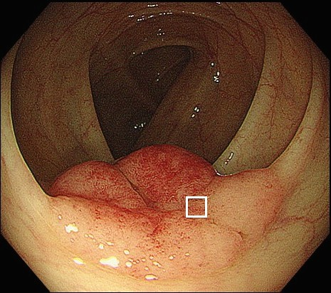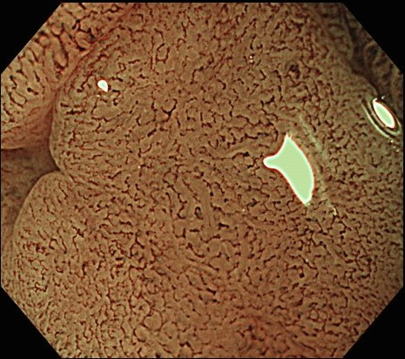

B

A

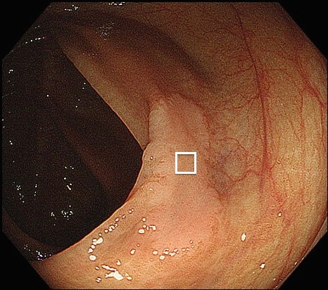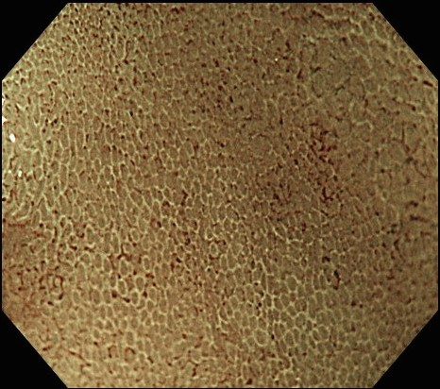

D

C

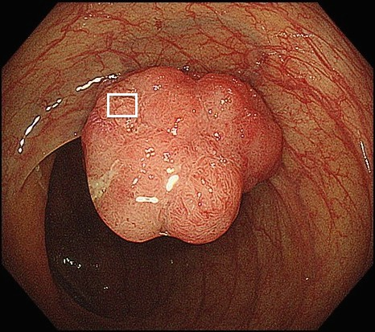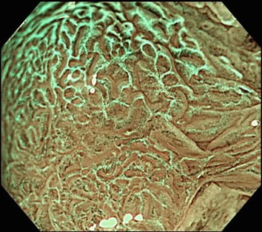

F

E

**Figure 1 Magnifying endoscopic features with narrow-band imaging.** A: Conventional view. A protruding lesion is detected in the transverse colon. B: M-NBI of the box in Figure 1a shows a clear microvascular pattern without WOS;C: Conventional view. A flat-elevated lesion is detected in the ascending colon. D: M-NBI of box in Figure 1C shows WOS obscuring the microvascular pattern. This WOS is regarded as regular WOS, since it is well-organized and distributed symmetrically with a regular reticular pattern.E: Conventional view. A protruding lesion is detected in the ascending colon.F: M-NBI of the box in Figure 1e shows WOS obscuring the microvascular pattern. This WOS is regarded as irregular WOS, since it is disorganized and distributed asymmetrically with an irregular speckled pattern. M-NBI: Narrow-band imaging; WOS: White opaque substance.

**Figure 2**

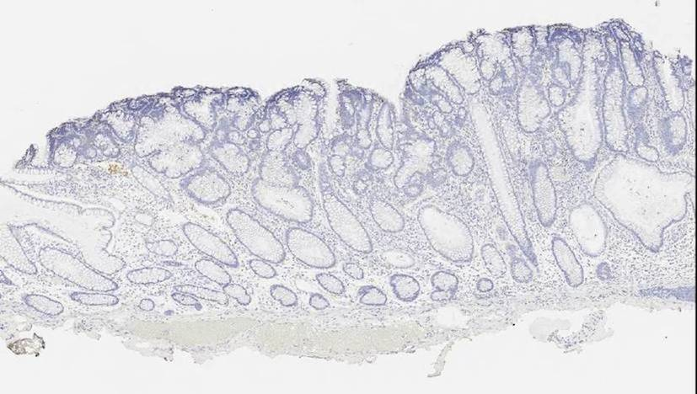

A

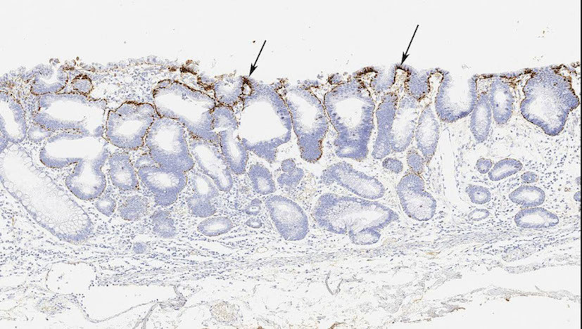

B

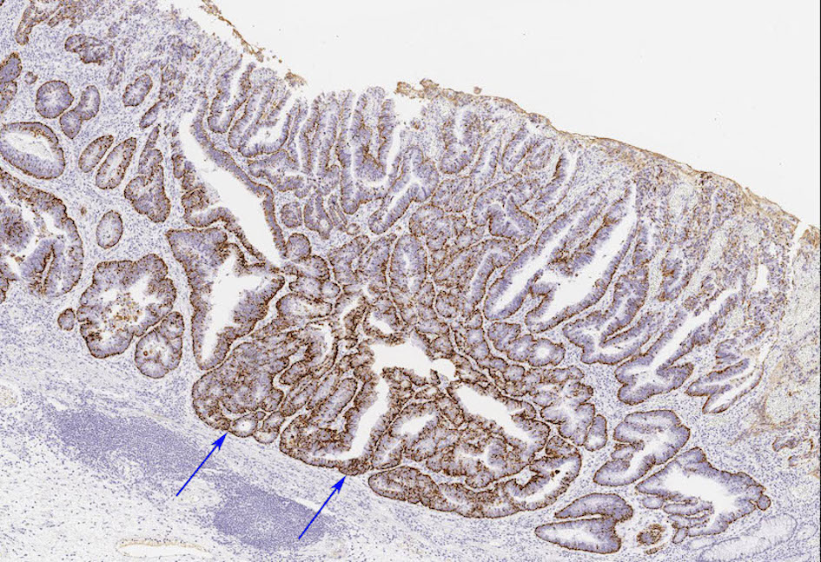

C

**Figure 2 Histopathological findings: Adipophilin immunostaining.** A: Score 0, adipophilin is not detected within the neoplastic epithelium; B: Score 1, adipophilin is detected within the neoplastic epithelium. The depth of adipophilin expression is superficial (black arrows); C: Score 2, adipophilin is detected within the neoplastic epithelium. Adipophilin expression is deep (blue arrows).

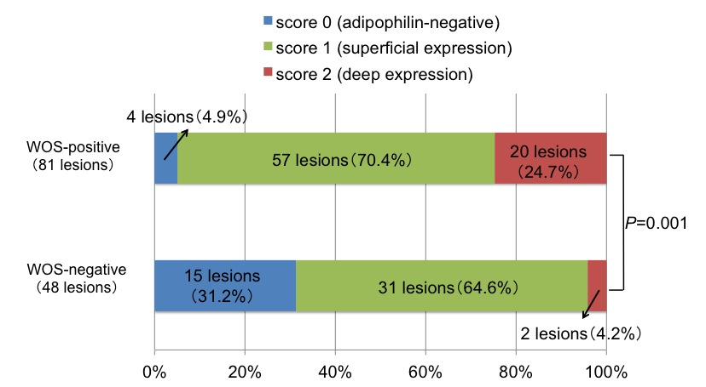

**Figure 3 Comparison of the distribution of adipophilin between white opaque substance (WOS)-positive and WOS-negative lesions.** The scores for adipophilin expression depth are significantly different between the two groups of lesions (*P =* 0.001), with a predominance of score 2 (deep expression) in WOS-positive lesions (24.7%) compared to WOS-negative lesions (4.2%).

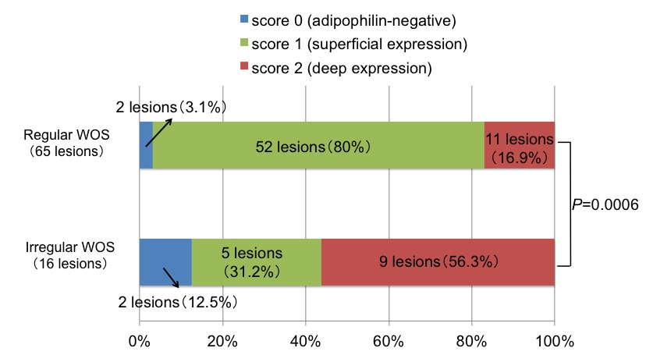

**Figure 4 Comparison of the distribution of adipophilin between regular white opaque substance (WOS) and irregular WOS lesions.** Score 2 (deep expression) is more frequent in lesions with irregular WOS (56.3%) than in lesions with regular WOS (16.9%) (*P =* 0.0006).

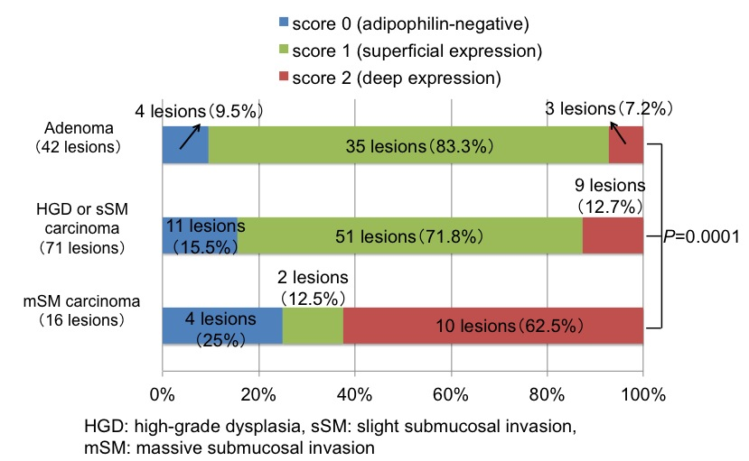

**Figure 5 Immunohistochemical findings of colorectal lesions by histologic type.** Score 2 (deep expression) is more frequent in mSM carcinomas (62.5%) than in adenomas (7.2%) or in HGDs/sSM carcinomas (12.7%) (*P =* 0.0001).

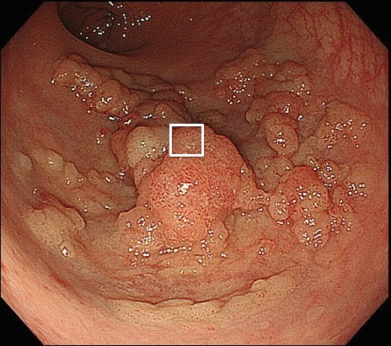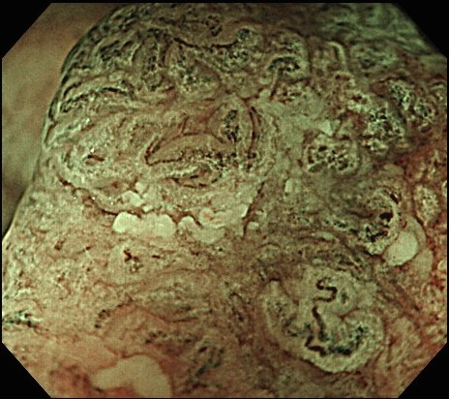

A

B

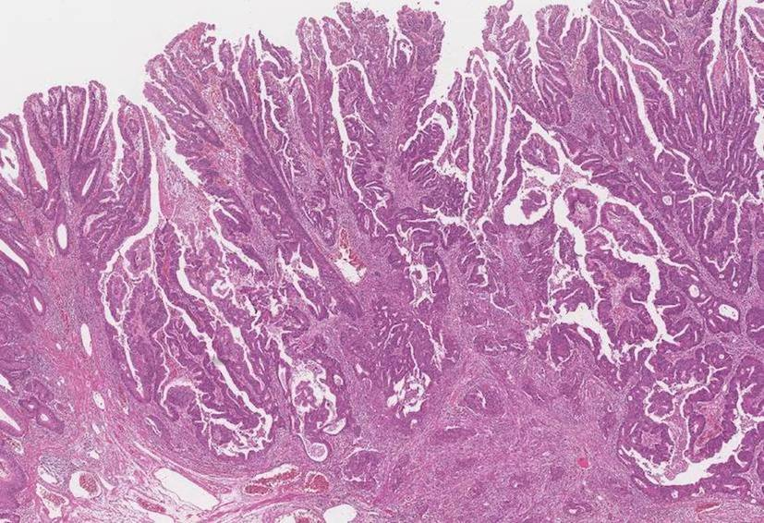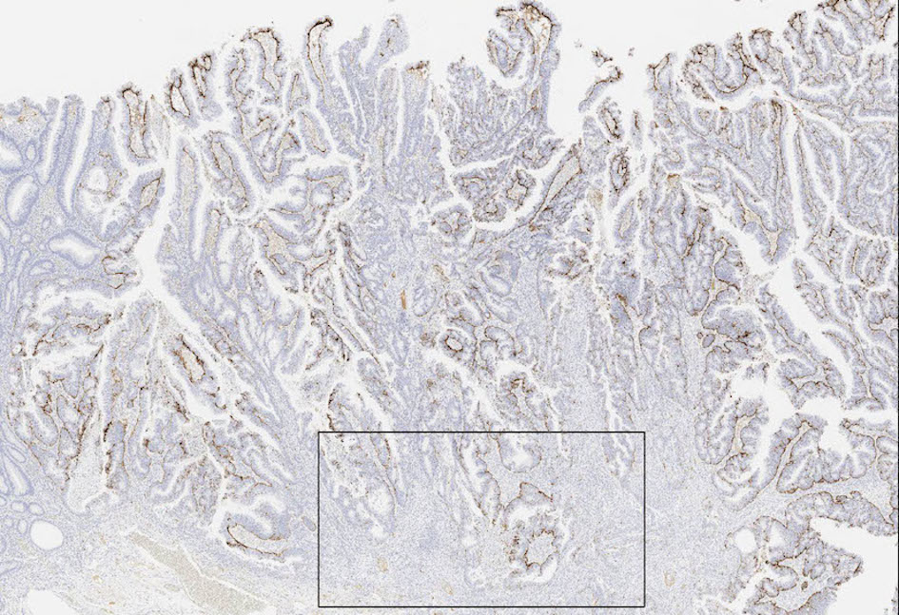

D

C

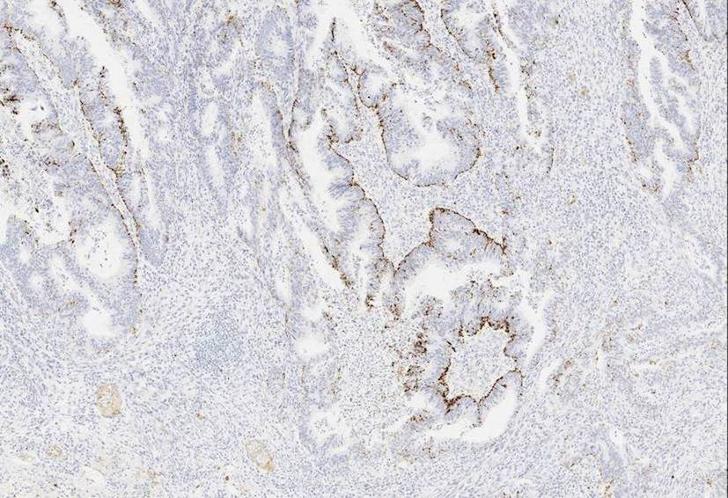

E

**Figure 6 Endoscopic and histologic features of a lesion with irregular white opaque substance.** A: Colonoscopy shows a protruding lesion in the rectum; B: Magnifying endoscopic findings with narrow-band imaging of box in Figure 6a show irregular WOS. WOS is disorganized and asymmetrical; C: Histological examination of the resected specimen shows well to moderately differentiated adenocarcinoma invading the deep submucosal layer (invasion depth; 4,320 μm); D: A low-power view with adipophilin staining shows that the depth of adipophilin expression is deep; E: A high-power view of the box in Figure 6d shows that adipophilin is detected within the neoplastic epithelium. WOS: White opaque substance.

|  |  |  |  |  |
| --- | --- | --- | --- | --- |
| **Table 1 Endoscopic and histologic characteristics of white opaque substance-positive and white opaque substance-negative lesions *n* (%)** | | | | |
|  |  | **WOS-positive** | **WOS-negative** | ***P*-value** |
|  |  | **(81 lesions)** | **(48 lesions)** |
| Size (mm), mean ± SD |  | 32.8 ± 16.4 | 34.7 ± 18.3 | 0.51 |
| Location | Right side of the colon | 51 (63) | 22 (45.8) | 0.07 |
|  | Left side of the colon | 30 (37) | 26 (54.2) |
| Morphology | Protruded type | 20 (24.7) | 14 (29.2) | 0.68 |
|  | Flat-elevated type | 61 (75.3) | 34 (70.8) |
| Histologic type | Adenoma | 22 (27.2) | 20 (41.7) | 0.12 |
|  | HGD or carcinoma | 59 (72.8) | 28 (58.3) |
| WOS: White opaque substance; SD: Standard deviation; HGD: High-grade dysplasia. | | | | |

|  |  |  |  |  |
| --- | --- | --- | --- | --- |
| **Table 2 Immunohistochemical analysis of adipophilin expression in white opaque substance-positive and white opaque substance-negative lesions *n* (%)** | | | | |
|  |  | **WOS-positive** | **WOS-negative** | ***P*-value** |
|  |  | **(81 lesions)** | **(48 lesions)** |
| Adipophilin | Positive | 77 (95.1) | 33 (68.7) | 0.0001 |
| Negative | 4 (4.9) | 15 (31.3) |
| WOS: White opaque substance. | | | | |